Smart and connected devices
Visualising IOT data
nathan morgan 1801338
2020
Contents
Abstract 1
Displayed data 2
Searching the data 2
Graphing the data 3
Security measures 3
References 4

Abstract
In this report I talk about visualising data from the internet of things, and how we can make them more digestible for the user, and the different methods for presenting them. The measures taken to find and display the data.

Displayed data
Throughout my website I have displayed data in plain text, and with graphs for visual aid.
The first set of data I displayed was the average amount per sensor. This was easily achieved using base SQL functions as seen here
Then the next set of data displayed in text is the highest amount recorded per sensor and the lowest amount, the lowest amount is slightly futile due to having a value for no rain on each sensor, this would be more useful if the data was more varied or I limited the date range and instead displayed it on a per day basis.
Finding the min and max values using SQL is relatively simple and allowed the code to quickly return the max value of the data and display it seamlessly as seen here.
And to find the minimum I simply changed MAX(mydata) to MIN(mydata) and this works exactly as you expect it would. [1]

Searching the data
In my search bar it allows the user to search by ID of the entry in the database, the volume of rain and the date, with a select box for picking between the sensors or all sensors, this reduces the chance of user error, on the data field I included a wild card to ensure that the search returns something even if the search is incomplete, allowing a user to just type 2019 for example and returning all results from 2019, rather than typing the full format of 2019-12-14 00:00:00.28
The wildcard essentially fills the rest of the line out and returns any results like the entered search content
To achieve using a wildcard in a prepared statement I had to make use of concat to enclose the “?” with wildcard characters as shown below [1]
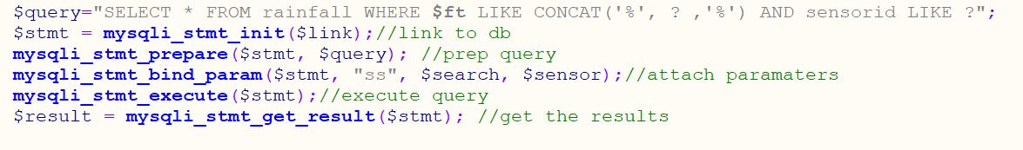
Here the programmer could have had the sensor id variable not included in the prepared statement like $ft is not included because the input is predefined and received from the page with radio buttons and select options so this data can only be modified within the code.
so, this might as well stay in a prepared statement, but it is not necessary. For searching by anything other than date the code will not include wild cards and instead just sent the query normally as seen
After designing the dynamic query, the programmer looked further into prepared statements and fully implemented the code to ensure the searches and login forms used prepared statements and sanitized the inputs.

Graphing the data
After implementing a graph using phpmygraph I looked at the design of it and I was not pleased, so I started investigating for solutions for designing the graph the way I desired.
I faced several design concerns that I wanted to overcome, so first I looked at a Javascript library I had previously used called ChartJS [2] to graph forex data, but this worked out not in my favour due to technical limitations and having to parse all data into a format the graph could take would have been far too much adapting to be viable.
I then went on to look at another graphing library built in php, but this was a premium service and the free version I looked at had a horrible watermark on every graph, so I ruled that out and reverted to the suggested graph phpmygraph.
My initial issue with provided library was styling it and styling it with the specific criteria of hiding certain aspects like the average line, setting data points and styling the data. Once I had looked through the code for the library, I found the function that handled the $cfg of the graph and found mostly what I was looking for, the issue remained of making the background transparent.
Once I figured out what I wanted from the graphs I then set out to implement 3 different graph types, the first to display data per sensor, the next for displaying periods of consecutive rain on a per sensor basis and finally for displaying the longest period of no rain on a per sensor basis.
Initially for this I had a file for each graph, then I was shown how to effectively use $_get to pass an argument in the URL for the graph, passing data I needed into a function to draw the relevant graphs from one PHP file that is passed different arguments.
I initially tried to call the file outside of the img url, and pass it an argument with a function call, but that didn’t work as the header of the file returned it as an image so this was effectively turning the page into an image, and wouldn’t display anything else. That’s when I decided this was inadequate and sought out help.

Security measures
Throughout my pages I have used prepared queries to reduce the chances of SQL injection, mostly reducing the chance of user error or special characters being used that could change desired operation of the sent queries. 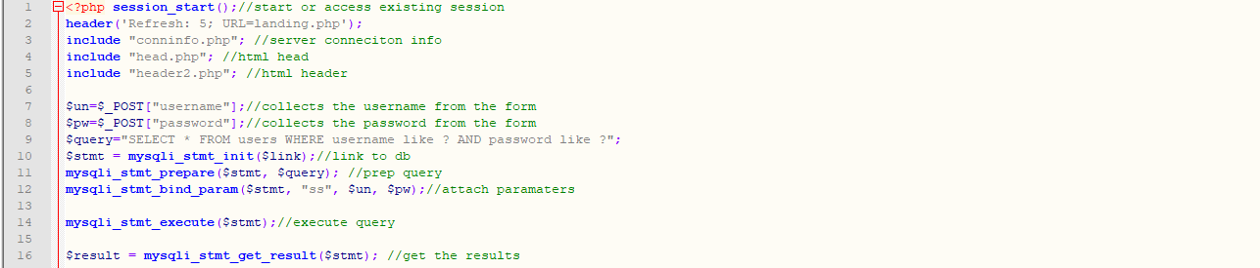
With the use of redirects, session cache’s and SQL users must have a valid username and password on the server to access any of the content locked behind the session check. [3]
To do this the code will query the server with the entered username and password, and if it returns a result it will assign the username to the session, and if doesn’t return a result from the database it will redirect them back to the login page and ask them to try again.
Now on each page the code will access the session and check if the username is not empty, if it is empty, the php will return them back to the landing page, and after doing this on every page it is new secure to some extent, I understand this security method isn’t considered industry standard and it has its flaws.
Also, on the form that captures the password, I have set the field type to be of the password type, blocking the input from the screen so it is not in plain text.

References

[1] | W3, “SQL Tutorial,” [Online]. Available: https://www.w3schools.com/sql/.
[2] | [Online]. Available: http://gionkunz.github.io/chartist-js/.
[3] | W3, “W3 Schools PHP tutorial,” [Online]. Available: https://www.w3schools.com/php/.

