The formal analysis and critical evaluation of a selected adaptation.

Corrigan (2012, p.1) explains that, ‘...the relationship between film and literature is a history of ambivalence, confrontation, and mutual dependence...these two ways of seeing and describing the world have at different times despised each other, redeemed each other, learned from each other, and distorted each other self-proclaimed integrity.’

Wiseguy by Pileggi is the text chosen to analyse, Goodfellas (Scorsese, 1990) is the film adaptation of the text. The scene chosen to analyse specifically is the fate of William "Billy Batts" Bentvena, played by Frank Vincent and how the events in the film differ slightly from that of the account in Pileggi’s book Wiseguy. However it doesn’t belittle or take away from Henry Hills account of the event. This analysis looks at how the scene of Billy Batts demise is played out over one evening in the film, while in the book it’s actually takes a couple weeks for events to unfold.

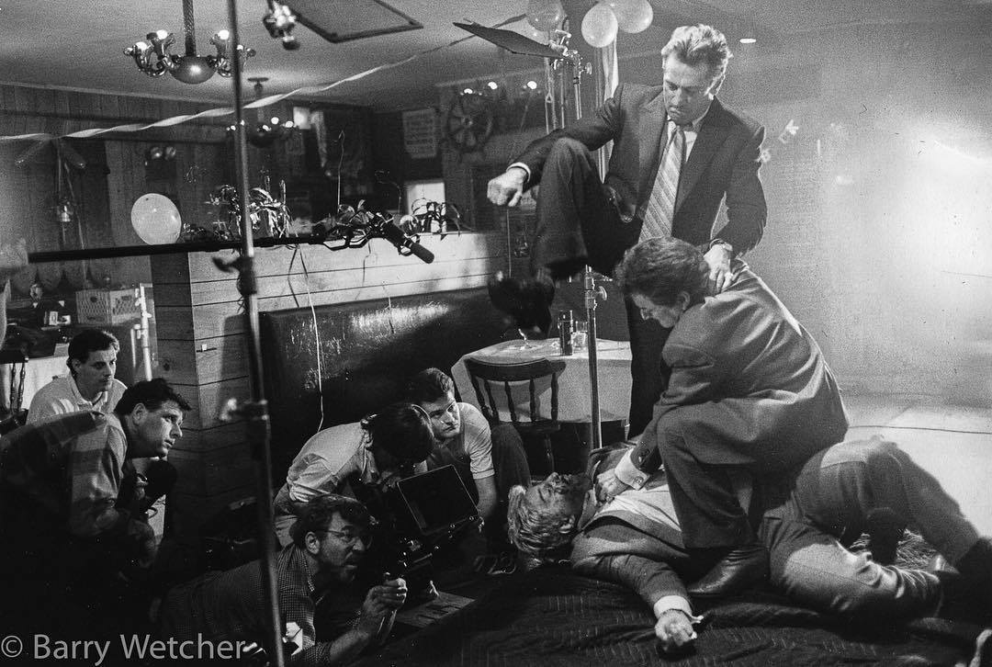
Fig 1.

Ebert (1990, p.1) explains that, ‘...the mood of the characters lingered within me, refusing to leave. It was a mood of guilt and regret, of quick stupid decisions leading to wasted lifetimes, of loyalty turned into betrayal.’
This particularly sums up the characters of Tommy DeVito in the film, (Thomas Anthony DeSimone in the book) played by Joe Pesci and Jimmy (James) Conway in the film, (Jimmy "The Gent" Burke in the book) played by Robert De Niro. Both characters have very volatile temperaments, even the most casual remark or gesture could receive an extreme reaction, any level-headed person would more often or not shrug off those type of remarks.
Ebert (1990, p.1) observers that Tommy is ‘a likable guy except that his fearsome temper can explode in a second, with fatal consequences.’
Tommy and Jimmy would often and instantly take offence to what they perceived as a snide remark. That doesn’t mean that Henry Hill played by Ray Liotta was an angle by any means, but he seems the one who always steps in to try and defuse the situation especially where Tommy is concerned. He felt that it was his job to try and keep some kind of piece and that sometimes Tommy and Jimmy went a little too far by using too much force or violence than was needed, they always seemed to use a sledgehammer to crack a nut particularly when it wasn’t necessary.
They all enjoyed the violent side of being a wiseguy, being foot soldiers for the mob they revelled in the violence, to them it was a sense of achievement, a rite of passage securing their place within the family. They also saw it as a licence to do just about anything they desired providing they kept within the mob rules.

Up until this point in the book and film all three had lived a way of life that, if they wanted something or even someone, they just simply took it, there were no rules for them outside of the family. The only rules they had to follow where set out by the Mafia, especially those of Paul Cicero played by Paul Sorvino.
Maybe they felt invincible and untouchable by the law, but Kowalski (2009, p.31-52) explains that ‘Perhaps worrying about the mob is worse than worrying about the cops.’
Out of the three Tommy felt he had more to prove than the others because of his brother as he saw it betrayal of his Mafia family.
Verevis (2007, p.209-223) says that, ‘As in Pileggi’s Wiseguy, Goodfellas sets out to present a realistic portrayal of organized crime and how it operates by approaching the social milieu and attitudes of the Mafia not from the top, but rather by taking up the position at the bottom, alongside the rank and file “the Mafia foot soldiers” who have to work within the conventions and power relations of the system.’
All three were about to break one of the most important Mafia commands, especially Tommy by losing his temper with Billy Batts, who was a ‘made man’. This went against everything they were told to do, it could also have been seen as a challenge to the authority of the leadership of Paul Cicero. Nobody was allowed to even lift a finger against a ‘made man’ and they all knew this. But Tommy had to continually prove himself to not only Henry and Jimmy but to himself and the other gang members. He wasn’t the type to back down he always had to make a statement. It was all about respect he also had to show that he was much tougher than anyone else. This is where things between Billy Batts and Tommy start to deteriorate especially when as Kowalski (2009, p.31-52) explains ‘.... Billy reminds everyone in the joint that Tommy used to shine shoes.’ This remark by Billy enrages Tommy and he demands some respect especially now that he sees himself on the way to becoming a ‘made man’ himself. But Billy doesn’t see that way, and still sees Tommy as a shoe shine boy who certainly doesn’t deserve his respect. Billy keeps on goading Tommy.
The event of Billy’s beating and eventual murder in the film only takes an evening to play out which helps to keep up the overall pace of the film, this is also helped by the music track of Atlantis (Donovan 1968) playing in the back ground. Which makes it a bit surreal. And may also suggest the three’s detachment from what they were doing to Billy.
In the book its plays out over a couple of weeks, if it had followed the same time frame in the film it wouldn’t have helped Scorsese to keep the pace of the story that he wanted to tell.
Bradshaw (2017, p.1) says that, ‘The very words Goodfellas or Wiseguy are steeped in duplicitous, aggressive comedy; no one rules a situation like a guy who’s just got a laugh at someone else’s expense. Goodfellas is a compelling, black-comic nightmare’.
Billy’s beating in the film has a sense of realism and grittiness about you can feel the tension building between both Tommy and Billy.
But you can also see that Henry is very nervous and on edge as well, because he knows there’s no stopping Tommy from getting the respect, he thinks he deserves from Billy. Even if it does mean going against the Mafia rules of not being able to touch a ‘made man’.
Tommy doesn’t care anymore, he has lost all control and no matter what Henry does or says there’s no stopping Tommy now.
Smith (2015, p.1) comments that, ‘Billy Batts...breaks ball-busting etiquette in two ways. One, he’s not really one of the guys (he belongs to another crime family), and two, in the guise of breaking Tommy’s balls, he brings up something serious, something that truly bothers Tommy: that he once worked as a shoeshine boy. Billy must die...’
In the scene from the film Goodfellas (1990) Tommy asks Jimmy to keep Billy in the bar while he takes his girlfriend home and tells him that he will be back. When he returns the unsuspecting Billy is set upon by not only Tommy but Jimmy as well, this really unnerves Henry but out of sense of loyalty he helps them to get rid of Billy. They use a table cloth to wrap Billy’s body in and put into the car. And as far all three are aware Billy is dead.
The event in the book takes place over a couple weeks and probably give Tommy more time to think about how to get rid of Billy. During Tommy’s first encounter with Billy he was just drinking with Jimmy and Henry. But the second time he walked into the bar with his girlfriend while Billy was drinking there, he immediately sent his girlfriend away which is the same as the scene in the film. Tommy tells Henry to keep Billy there no matter what he also tells him he’s going to get a body bag which again makes Henry nervous because he’s knows what’s about to happen. There’s far more detail in the same scene in the book and you can certainly image being in the shoes of Henry, as he looks on with a sense of disbelief and apprehension about what Tommy and Jimmy are about to do. Especially when Tommy walks through the door with a body bag and pistol in his hand, ready to exact his revenge on Billy which to him was probably a through away remark he made to Tommy after all he was only “busting his balls”.
Jimmy played a big part in this, because he wanted to get on the good side of Tommy by any means necessary, because he knew that one day that Tommy would be a ‘made man’, if they got away with dealing with Billy. But Henry knew this could be the end for all of them, because of the friendship or maybe fear of Tommy and Jimmy he went along with it.
Henry could have been fearful of Jimmy because he reminded him of his father so much, especially when he saw him starting to beat Billy, Jimmy had the same look on his face. It may have reminded him of his father’s beatings especially when he missed school. Scorsese cleverly used a graphic match between the two scenes to add once again another layer to the story.
Wenzell (2016, p.1) says that, ‘However, the murderous cabal now found themselves in jeopardy for violating a Mafia cardinal rule by murdering a "made man" without the official prior consent/ approval of his family's leadership- an unforgivable offense in La Cosa Nostra’.
There is no doubt that Scorsese and Pileggi’s vison for Goodfellas (1990) was to transport the audience into the world of the Wiseguy and to also stay true to Henry Hill’s account of life with the mob. Scorsese also gets the audience to invest in Henry, Tommy and Jimmy by placing the murder of Billy Batts at the beginning of the film. Your hook because you know this can only end badly for these three central characters.
The account of Billy’s beating and murder in the book does give you an insight into the volatile world of the Wiseguy. However the film adds a new dimension to the story of the Wiseguy especially Henry, Tommy and Jimmy and their vain, reckless lives.
Scorsese explains in Verevis (2007) essay that, ‘I wanted a very fluid style...but I also wanted it [Goodfellas] to be as if I had been doing a ...Maysles cinema documentary of these [wise]guys for twenty-five years with the ability to walk in and out of the rooms with cameras.’

Growing up with and around people like Henry Hill gives Scorsese a real insight into that way of life, and also the right to comment about it through his film.
Ebert (2002, p.1) comments that, ‘the screenplay by Nicholas Pileggi and Scorsese is based on Pileggi’s book about Hill, Wiseguy: Life in a Mafia Family. It is equally based, probably, on Scorsese’s own memories of Little Italy.’
Scorsese and Pileggi have achieved what they originally set out to do, and that is to draw us into the world of the Wiseguy and of Henry Hill, there’s a definite since of realism to the film, which was one of the aims.
Adaption is a process and is open to interpretation by the filmmaker screenwriter and maybe the actor as well.
Denby (1990, p.32-33) explains in his article that,
‘As Scorsese and Pileggi discussed possible scenes, Scorsese would work them out visually and Pileggi would write down some of Scorsese's inventions. Then, each with a copy of the sequences, they would go off separately, revising what they had. The movie is a true collaboration’
Both Scorsese and Pileggi collaboration has created a true masterpiece of cinema.
Word Count 1981

Reference List.
Bradshaw, P. (2017) Goodfellas review – a brash, menacing hightail through the death of the mob. Available at: https://www.theguardian.com/film/2017/jan/19/goodfellas-review-martin-scorsese-robert-de-niro-joe-pesci-ray-liotta (Accessed: 19 February 2019).

Corrigan, T. (ed.) (2012) ‘Introduction’, Film and Literature an Introduction and Reader. Abington: Routledge.

Denby, D. (1990) ‘Brutally Realistic, Goodfellas is Scorsese and Pileggi’s Dark Mob Comedy: Movies’, New Yorker, vol.23 no.35, pp.32-33.

Ebert, R. (1990) Goodfellas. Available at: https://www.rogerebert.com/reviews/goodfellas-1990 (Accessed: 30 January 2019).

Ebert, R. (2002) Goodfellas. Available at: https://www.rogerebert.com/reviews/great-movie-goodfellas-1991
(Accessed: 19 February 2019).

Smith, K. (2015) Women are not capable of understanding ‘GoodFellas’.
Available at: https://nypost.com/2015/06/10/sorry-ladies-youll-never-understand-why-guys-love-goodfellas/ (Accessed: 30 January 2019).

Verevis, C. (2007) ‘Way of Life: Goodfellas and Casino’, in Silver, A. and Ursini, J. (eds.) Gangster Film Reader. New Jersey: Limelight Editions, pp. 209-223.

Wenzell, P. (2016) Goodfellas: Why is Tommy killed for killing Billy Batts, but Jimmy and Henry are not? Available at: https://www.quora.com/Goodfellas-Why-is-Tommy-killed-for-killing-Billy-Batts-but-Jimmy-and-Henry-are-not (Accessed: 19 February 2019).

Filmography

Fig1. Wetcher, B. (1990) Fig1.Goodfellas (Scorsese 1990) Bill Batts scene. Available at: https://fdb.pl/osoba/17721-frank-vincent-i/pictures# (Accessed: 8 February 2019).

Bibliography for the Goodfellas

Abrams, J.J. (2009) ‘The Cinema of Madness, Friedrich Nietzsche and the Films of Martin Scorsese’, in Conard, M.T. (ed.) The Philosophy of Martin Scorsese. Lexington: The University Press of Kentucky, pp.75-91.

Bradshaw, P. (2017) Goodfellas review – a brash, menacing hightail through the death of the mob. Available at: https://www.theguardian.com/film/2017/jan/19/goodfellas-review-martin-scorsese-robert-de-niro-joe-pesci-ray-liotta (Accessed: 19 February 2019).

D’Arpino, A. (2016) 24 Things You Might Not Know About Goodfellas. Available at:
http://mentalfloss.com/article/60948/24-things-you-might-not-know-about-goodfellas
(Accessed: 19 February 2019).

Corrigan, T. (ed.) (2012) Film and Literature an Introduction and Reader. Abington: Routledge.

Chasing the frog. Goodfellas (1990) Available at: http://www.chasingthefrog.com/reelfaces/goodfellas.php (Accessed: 30 January 2019).

Denby, D. (1990) ‘Brutally Realistic, Goodfellas is Scorsese and Pileggi’s Dark Mob Comedy: Movies’, New Yorker, vol.23 no.35, pp.32-33.

Ebert, R. (1990) Goodfellas. Available at: https://www.rogerebert.com/reviews/goodfellas-1990 (Accessed: 30 January 2019).

Ebert, R. (2002) Goodfellas. Available at: https://www.rogerebert.com/reviews/great-movie-goodfellas-1991
(Accessed: 19 February 2019).

GQ. (2010) Martin Scorsese's Goodfellas: A Complete Oral History. Available at: https://www.gq.com/story/goodfellas-making-of-behind-the-scenes-interview-scorsese-deniro (Accessed: 30 January 2019)

Kowalski, D. (2009) ‘Goodfellas, Gyges, and the Goodlife’, in Conard, M.T. (ed.) The Philosophy of Martin Scorsese. Lexington: The University Press of Kentucky, pp. 31-52.

Paoletti, G. (2017) The Real-Life Goodfellas: Meet The Mobsters Behind The Movie. Available at: https://allthatsinteresting.com/henry-hill-real-life-goodfellas
(Accessed: 30 January 2019).

Pileggi, N. (1985) Wiseguy. New York: Pocket Books.

Simmons, A. (2018) GoodFellas: five films that influenced Martin Scorsese’s gangster classic. Available at: https://www.bfi.org.uk/news-opinion/news-bfi/features/goodfellas-martin-scorsese-influences (Accessed: 30 January 2019).

Smith, K. (2015) Women are not capable of understanding ‘GoodFellas’.
Available at: https://nypost.com/2015/06/10/sorry-ladies-youll-never-understand-why-guys-love-goodfellas/ (Accessed: 30 January 2019).

Verevis, C. (2007) ‘Way of Life: Goodfellas and Casino’, in Silver, A. and Ursini, J. (eds.) Gangster Film Reader. New Jersey: Limelight Editions, pp. 209-223.

Wenzell, P. (2016) Goodfellas: Why is Tommy killed for killing Billy Batts, but Jimmy and Henry are not? Available at: https://www.quora.com/Goodfellas-Why-is-Tommy-killed-for-killing-Billy-Batts-but-Jimmy-and-Henry-are-not (Accessed: 19 February 2019).

