

Research on Road Roughness Detection Method Based on LSTM
by
Yinan Yan

Supervisor: Stephen Mosey
Second Marker:

Project submitted as part of the requirements for the award of MSc Data Science and Analytics

November 2021

Abstract
The condition of the road is of significance for driving safety and vehicle performance. The recognition of road roughness is a key step in the study of road surface problems. Although there are many traditional methods, which have good performance on road roughness recognition, the instruments of recognition are expensive and the recognition efficiency is low. With the development of computer technology, the recognition method based on neural network appears correspondingly, which provides a new direction with broad application prospects for road roughness recognition.
The road roughness recognition method based on neural network refers to the establishment of the mapping relationship through the neural network based on the vehicle response and road roughness data obtained in the previous period under the condition that the vehicle model is unknown. After the model training is completed, Corresponding road roughness can be obtained by the vehicle response. This dissertation proposes solutions to the problems of too simple vehicle models, small number of input responses, complex input response screening methods, and algorithm recognition effects that need to be improved. The specific contents are as follows:
(1) The principle of road roughness recognition based on neural network is introduced, and the measurement method of vehicle response is summarized, and the response that is difficult to measure in reality is eliminated; the road roughness is obtained by filtering the white noise model and the ride comfort seven degree of freedom model. After that, the neural network of LSTM is built and evaluation indicators of the related models are introduced. The input responses are screened by the MIV method and compared with the NARX neural network. The study found that LSTM performs better than NARX and MIV method can improve the recognition results of the model by filtering input responses
(2) The ride comfort seven degree of freedom model was replaced by the dynamics simulation software Carsim, and the reasons for the poor recognition results under the Carsim model were analyzed. The improved MIV-LSTM road roughness recognition method was proposed, that is, the road roughness is identified through vehicle response and the amount of response change. After that the final road roughness is obtained through conversion correction. The study found that this method can greatly improve the recognition effect of the model. As the correction interval is shortened, the evaluation indicator will be better.
(3) The road roughness recognition is extended and applied through the SVM model, and it is actually applied to the road grade recognition.
Declaration
I, Yinan Yan declare that I am the sole author of this Project; that all references cited have been consulted; that I have conducted all work of which this is a record, and that the finished work lies within the prescribed word limits. This has not previously been accepted as part of any other Masters' submission.
Signed: 
Date: 11st November 2021

Form of Consent
I, Yinan Yan hereby consent that my Project, submitted in candidature for the M.Sc. Data Science and Analytics, if successful, may be made available for inter-library loanor photocopying (subject to the law of copyright), and that the title and abstract may be made available to outside organisations.
Signed:
Date: 11st November 2021

Acknowledgement
During the year at UWTSD, I learned a lot. Due to the epidemic, I could not go to school offline to study, but the school’s online teaching was well prepared, which gave us strong learning atmosphere. In the course of studying the course, I would like to express my sincere thanks to our classmates and teachers. In the practice of the master project in the past few months, I also sincerely thank the teachers and students who have helped me. Although I regret not being able to go to school, I believe that I will visit my alma mater after the epidemic. I hope that the school, classmates and teachers will get better and better.

Content
Abstract II
Declaration IV
Form of Consent IV
Acknowledgement V
List of Figures VIII
List of Tables IX
Chapter 1: Introduction 1
1.1 Research Background 1
1.2 Motivation for the research 1
1.3 Aim and objectives of research 3
1.4 Structure of dissertation 3
Chapter 2: Literature review 5
2.1 Introduction 5
2.1 Review of Literature under Road Roughness Model 5
2.2 Review of Literature under Road Classification 9
2.1.3 Review of Literature under Road Roughness Recognition 10
2.1.4 Summary of Research Status 15
2.2 Questions of Road Roughness Detection 16
Chapter 3: Road Roughness Recognition under the Ride Comfort Seven Degrees of Freedom Model 18
3.1 Principle of Road Roughness Recognition Based on Neural Network 18
3.2 Choice of Input Response 20
3.3 Modeling and Simulation Based on Simulink 23
3.3.1 Filtered White Noise Road Surface Excitation Model 23
3.3.2 Ride Comfort Seven Degree of Freedom Model 25
3.3.3 Simulation Results 30
3.4 Road Roughness Recognition Based on LSTM 32
3.4.1 Basic Principles of LSTM 32
3.4.2 Evaluation index 36
3.4.3 Implementation of the Model 37
3.4.4 Indicator Screening Based on MIV 41
3.5 Road Roughness Recognition Based on NARX 44
3.5.1 Basic Principles of NARX 45
3.5.2 Road Roughness Recognition Based on NARX 46
3.6 Chapter Summary 49
Chapter 4 Road Roughness Recognition under the Carsim Model 51
4.1 Carsim Model 51
4.1.1 Carsim Introduction 52
4.1.2 The Establishment of Carsim Model 54
4.2 Recognition Result Analysis 57
4.3 Improved MIV-LSTM Road Roughness Recognition Method 60
4.4 Chapter Summary 66
Chapter 5: Application Extension of Road Roughness Recognition 67
5.1Introduction 67
5.2 Road Grade Recognition without Correction 67
5.2.1 Basic Principles of SVM 69
5.2.2 Evaluation indicator 71
5.2.3 Road Grade Recognition Result 72
5.3 Chapter Summary 73
Chapter 6: Conclusion 74
6.1 Research Summary 74
6.2 Research Outlook 75
Reference 77

List of Figures
Figure 1 Research Technology Roadmap 4
Figure 2 Chapter 3 Structure Diagram 18
Figure 3 Principle of Road Roughness Recognition Based on Neural Network 20
Figure 4 Filtered White Noise Four-Wheel Model 25
Figure 5 Ride Comfort Seven Degree of Freedom Model 26
Figure 6 Ride Comfort Simulink Model with Seven Degrees of Freedom 30
Figure 7 Road Roughness and Power Spectral Density of the Left Front Wheel 31
Figure 8 Road Roughness and Power Spectral Density of the Right Front Wheel 32
Figure 9 Acceleration Response 32
Figure 10 Calculation of gates in LSTM 33
Figure 11 The Calculation of candidate memory cells in LSTM 34
Figure 12 The Calculation of Memory Cells in LSTM 35
Figure 13 The Calculation of Hidden State in LSTM 35
Figure 14 Recognition Result of LSTM 41
Figure 15 NARX Open Loop Structure Diagram 45
Figure 16 NARX Closed Loop Structure Diagram 46
Figure 17 Matlab Neural Network Toolbox 46
Figure 18 The Recognition Results of NARX 48
Figure 19 Chapter 4 Structure Diagram 51
Figure 20 Carsim’s Function and interface 52
Figure 21 Simplified Vehicle Model in Carsim 53
Figure 22 Vehicle Model Subsystem in Carsim 53
Figure 23 Vehicle: Assembly Interface 54
Figure 24 Carsim and Simulink Co-simulation Process 57
Figure 25 LSTM Recognition Results of Carsim Model 58
Figure 26 NARX Recognition Results of Carsim Model 58
Figure 27 Correlation Coefficient Heat Map 59
Figure 28 Recognition Result of LSTM Road Roughness Variation 60
Figure 29 Cumulative Result of Road Roughness Variation 61
Figure 30 Correction Results of Road Roughness Recognition 62
Figure 31 Improved Road Roughness Recognition Methods Based on LSTM 62
Figure 32 Correction Result of Road Roughness Recognition after Screening by MIV method (Interval 300m) 64
Figure 33 Correction Result of Road Roughness Recognition after Screening by MIV method (Interval 100m） 65
Figure 34 Recognition Results of Road Roughness Variation of Different Road Grades 68
Figure 35 Support Vector and Interval 69
Figure 36 Confusion Matrix Visualization for Road Grade Recognition 72

List of Tables
Table 1 Road Roughness Recognition Method Based on "Black Box" 15
Table 2 Vehicle Response Type 22
Table 3 8-level Classification Standard for Road Roughness 24
Table 4 Ride Comfort Seven Degree of Freedom Model Symbol 26
Table 5 Ride Comfort Seven Degree of Freedom Model Parameter Values 31
Table 6 Neural network layer number determination experiment 39
Table 7 Test Set Evaluation Indicator of Number of LSTM Layers’s Experiment 39
Table 8 Test Set Evaluation Indicator of Number of Neurons’s Experiment 40
Table 9 Test Set Evaluation Indicator of LSTM and bidirectional LSTM’s Experiment 40
Table 10 The Relative Contribution Rate of the Input Variable's MIV 43
Table 11 The Evalution Indicator of Different input schemes’s LSTM 44
Table 12 NARX Training Algorithm Determination Experiment 47
Table 13 NARX Neuron Number Determination Experiment 47
Table 14 NARX Delay Order Determination Experiment 48
Table 15 Comparison of LSTM and NARX Evaluation Indicators 49
Table 16 Part of the Model Parameters 54
Table 17 Carsim Related Variables 55
Table 18 The Evaluation Indicator of Different Input Schemes’s LSTM 63
Table 19 Comparison of Evaluation Indicator of Different Models Based on Carsim 66
Table 20 Selected Features and Expressions 68
Table 21 Common Kernel Functions 70
Table 22 Evaluation Indicator for Road Grade Recognition 72

Chapter 1: Introduction

1.1 Research Background
The rapid development of China’s economy is inseparable from the advancement of infrastructure over the years. In the field of transportation, China’s highway mileage was 1.6798 million kilometers in 2000, and it has climbed to 5.0123 million kilometers in 2019, which has tripled in the past 20 years. With the improvement of road network, in order to facilitate the management of the road, how to judge and analyze the condition of the road becomes important. On the other hand, the number of cars in China has been increasing year by year, reaching 281 million by 2020. The driving performance of the vehicle is closely related to the road surface, which highlights the importance of road-related research.

1.2 Motivation for the research
Road roughness is the key to the research of road problems. It has been shown [1] that road roughness refers to the deviation of the road surface from the ideal plane, and it is usually used to describe the degree of undulation of the road surface and is the main incentive during the driving of a car. The research on road roughness spans multiple academic areas. In the fields of transportation engineering, it affects transportation efficiency, traffic safety, road maintenance and so on. In the field of vehicle engineering, it also affects the ride comfort and braking performance of vehicles, vehicle handling stability, fatigue life of parts, fuel consumption and so on. In general, the research is of great significance.
On the one hand, the road roughness data can be used for road management. Relevant highway management departments can understand road conditions and facilitate road maintenance. On the other hand, it can also be used for vehicle ride comfort analysis, suspension optimization design, vehicle design etc. in the field of vehicle engineering. It has broad application scenarios, other research [2] has proven. According to the different ways of obtaining road roughness data, it can be divided into two methods: measurement and identification.
The measurement of road roughness refers to the use of related equipment to obtain road roughness data. For example, Doumiati et al [3] have used APL road profile measuring instrument, Dickerson et al [4] have used TRL high-speed road meter and Dembski et al [5] have used laser measuring instrument. According to whether the instrument is in contact with the road surface, it can be divided into contact measurement and non-contact measurement. Other research [6] has proven, although it can accurately obtain road roughness data, it requires specialized equipment and sensors, which are expensive, low in measurement efficiency, and time-consuming and laborious.
With the development of automotive intelligent networking, more and more sensors are installed on vehicles, such as body acceleration sensors, suspension displacement sensors, etc. These sensors can provide a large amount of data to the cloud while the vehicle is driving. On the other hand, neural network models have been used in more and more fields with the computer technology. In this context, researches on the use of neural networks to identify road surface roughness based on vehicle response appear accordingly. Compared with traditional methods, it has the advantages of low price and high efficiency, and provides a new direction with broad application prospects for obtaining road roughness data. Therefore, it has important theoretical research value and practical application value.

1.3 Aim and objectives of research
This dissertation first combs the road roughness model and road roughness recognition methods, draws on the relevant experience in the construction of the three-dimensional road roughness model, and summarizes the shortcomings of the existing road roughness recognition research. On this basis, a new road roughness recognition algorithm was proposed. Compared with the traditional method, and the influence of different input schemes on the recognition effect was considered. The method was further verified in the dynamic simulation software and compared with the recognition result under the seven-degree-of-freedom model. Analyzed the specific reasons for the poor recognition results and proposed solutions. Then, studied the influence of different conditions on the road roughness recognition results. Finally, proposed a comprehensive application plan for road recognition. Considering the road surface level recognition problem, the virtual three-dimensional road roughness was recognized under the simulation environment.

1.4 Structure of dissertation
The overall technical route of this dissertationr is shown in Figure 1.
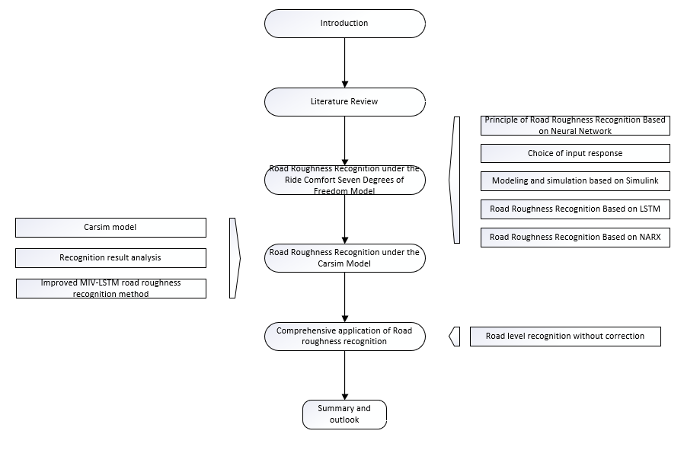
Figure 1 Research Technology Roadmap

Chapter 2: Literature review

2.1 Introduction
The purpose of the dissertation is to propose an implementable LSTM-based road roughness recognition method, so in this process we need to learn and understand the road roughness model, and also need to learn the existing road roughness recognition and road classification methods. Therefore, the literature review will cover research status on road roughness model, road classification and road roughness recognition in this chapter.

2.1 Review of Literature under Road Roughness Model
Simulating road surface excitation is a very important basic work for vehicle ride comfort testing and suspension control system design. Scholars at home and abroad have done a lot of research on road roughness simulation.
In 1984, the International Organization for Standardization proposed the "Draft Road Roughness Representation Method" in the document ISO/TC 108/SC2N67. In 1987, the Changchun Automobile Research Institute drafted GB 7031 "Vehicle Vibration Input-Road Surface Degree Representation", the document describes the power spectral density of the road surface. For the simulation study of two-dimensional road roughness, the models used mainly include:
(1) Power spectrum model. The power spectrum model expresses the road roughness through the spectral density function. It is the earliest road roughness model, and is relatively the most mature and widely used model. In the power spectrum model, the harmonic superposition method [7] and the filtered white noise method [8] are the most common, and the Poisson model [9] and the power spectrum sampling numerical simulation method [10] are relatively less studied.
(2) Time series analysis model. The time series analysis model can establish an appropriate road statistical model based on the limited road roughness measurement values. Commonly used time series models include the ARMA model and the AR model. Since this model is difficult to ensure that the generated road is stable, it relies on the measured data of road roughness, so it is subject to certain restrictions in practical applications [11].
(3) Fractal analysis model. In fractal analysis, the analysis dimension can be used to describe the degree of irregularity of an object. By studying the relationship between the fractal dimension and the measured value of the road roughness, the relevant expression of the road roughness can be obtained. However, there is no corresponding relationship between the fractal dimension and the power spectrum, it depends on the measured data of road roughness, and it is impossible to simulate a certain type of road surface, which has certain shortcomings [12].
Predecessors’ simulation research on two-dimensional road roughness has been relatively mature, but the two-dimensional road roughness can only reflect the situation of a certain longitudinal section of the road, and the vehicle is actually driving on the three-dimensional road surface. In order to better simulate the road surface and more accurately reflect the effect of the road on the vehicle, a three-dimensional Virtual road is necessary. With the increase of computer computing, the level of computer simulation has gradually improved, and scholars' research on road roughness has gradually expanded from two-dimensional to three-dimensional.
Xu et al [13] states that they used Matlab to use the sine wave superposition method to generate a three-dimensional random road spectrum program of any level, and used the generated road surface with ADAMS to simulate the dynamic performance of the vehicle. The results show that it is very convenient to use the three-dimensional road surface simulated by this method and the virtual prototype in conjunction with the performance analysis of the vehicle.
Zhang et al [14] used a dual-independent variable time series model to simulate a three-dimensional random road surface on the basis of a single-independent variable time series model, and stated the modeling process and implementation steps of the three-dimensional road time series model. And then, compared with standard road spectrum, the results show that the road surface reconstruction performance of this method is good.
Wang et al [15] used Matlab to compile a two-dimensional road surface roughness based on time series, and then imported the data into the VPG software to obtain three-dimensional road surface models of straight roads, curved roads and ramps. The research results show that the established road surface model is versatile and highly adaptable.
Lin et al [16] used Fast Fourier Transformation and triangular plane elements in Matlab to construct a three-dimensional model of the C-level road surface, and then imported the obtained road surface data into ADAM software for vehicle ride comfort simulation. Compared with the simulation results of the standard road spectrum, the results show that the method has good reliability [16].
Xie et al [17] used Vortex software to establish a dynamic model of tracked vehicles, used sine wave superposition method to expand the two-dimensional road surface, and generated a three-dimensional road spectrum that meets national standards. After that, imported the road elevation data into Multigen Creator to reconstruct the three-dimensional virtual road. In the vehicle ride comfort simulation experiment, the response of passing the D-class road surface at a constant speed is obtained, and the results show that the method has good virtual immersion and real-time performance.
Luo et al [18] used the two-dimensional Fourier transform method to construct a three-dimensional road model, and compared the simulated road surface sampling with the standard road power spectrum after spectral estimation. The research results show that the road surface spectrum has high similarity and it has high speed of computing.
Guo et al [19] designed a 3D road model reconstruction method based on Matlab and Carsim. First, use the two-dimensional road surface roughness data obtained by the harmonic superposition method in Matlab, and then import it into Carsim, establish a B-level road surface three-dimensional model with trapezoidal speed bumps, and further carry out the control simulation experiment of the semi-active suspension.
Wang et al [20] used the harmonic superposition method to derive the self-power spectrum and cross-power spectral density function of the left and right wheel road surfaces. Based on the left and right wheel coherence functions, they studied the coherence relationship between the phase angles of the harmonic superposition components of the left and right wheels. A three-dimensional road roughness model that considers the correlation between the left and right wheels had been built. The simulation results show that the model has a high degree of credibility.
Lu et al [21] proposed a three-dimensional road spectrum reconstruction method based on fractal theory. According to the time domain expression of the two-dimensional random road spectrum proposed by the national standard, the box-counting dimension method is used to calculate the fractal dimension of different grades of roads, and the random midpoint displacement method and the principle of fractal Brownian motion are used to expand the traditional two-dimensional road spectrum to three-dimensional road spectrum, and the established three-dimensional road model is used in TruckSim software.
Looking at previous studies, it can be found that the method for generating three-dimensional road surface roughness is mainly based on the original two-dimensional road surface roughness generation method. The research pays more attention to the coherence between the road surface roughness of the left and right wheels. The methods mainly include harmonic superposition method, Fourier transform method, and Time Series method. Among them, the harmonic superposition method is the most widely used. In addition, there are also studies on modeling three-dimensional roads based on fractal theory, but the amount of this method is less. The research also generally combines three-dimensional road modeling with multibody dynamics software, and imports the three-dimensional road elevation value simulated by Matlab into the multibody dynamic software, and further carries out related simulation experiments of vehicles. Commonly used dynamic simulation software includes: ADAMS, VPG, Carsim, TruckSim, Vortex, etc.

2.2 Review of Literature under Road Classification
In addition to the research on road roughness recognition, related road surface recognition research also includes road surface classification. Among them, the classification of road surface can be classified as classification problems, and the recognition of road roughness can be classified as regression problems. Although the purpose of the research is different, if the road surface roughness recognition result is accurate, the road surface category and road abnormal event can be judged naturally. It can be said that the road surface classification research is a method of road surface recognition that is the second choice, and it is also relatively easy.
For road classification research, Wang et al [22] first selected typical roads through fuzzy C-mean clustering, and then used the transfer function to identify the road surface spectrum with the vertical vibration acceleration of the wheels as input; Yao et al [23] used the real vertical vibration acceleration signal to identify the road and the dirt road, and proposed that the different excitation of the road can be judged through the frequency domain analysis of the signal; Li et al [24] used particle swarm algorithm and fuzzy support vector machine to identify five types of road surfaces by measuring the vertical load of the wheels of the vehicle;Hu et al [25] used the Max-Relevance and Min-Redundancy (MRMR) algorithm to optimize the feature subset, and then used the PNN and random forest algorithm to identify different grades of roads through the three signals of sprung acceleration, suspension dynamic stroke and wheel acceleration of 1/4 vehicle model; Qin et al [26] used Carsim to obtain the sprung mass acceleration, suspension dynamic deflection and wheel vertical acceleration signals of the vehicle, and then used sparse auto-encoding and Softmax regression to identify the road surface grade. The study showed that that the classifier using wheel acceleration signals has the highest classification accuracy; Zhang et al [27] used 1/4 vehicle model to obtain sprung mass acceleration and wheel acceleration data, and then used the convolution method to obtain the common characteristics of the acceleration response of the front and rear vehicles, and extracts 9 features from 76 features through sequenyial feature extraction method, and finally recognizes different road levels through ANN; Wang et al [28] built a semi-vehicle model of a tracked vehicle, processed the signal of the vertical acceleration of the center of mass obtained from the simulation, and then used the BP neural network to construct a road classification algorithm. Finally, a small track model was used to analyze the uneven road surface, the paved road surface and grass were identified.
It can be found that the classification research of road surface has gradually changed from the research of different types of road surface recognition to the research of road surface classification in recent years, and the methods are mostly machine learning algorithms. This is because road types such as grass and stone roads lack uniform standards and are difficult to judge. In the simulation environment, it is difficult to build road models, and different road levels have corresponding standards, which makes it easy to build models. On the other hand, with the improvement of computer performance. At the simulation level, it has become a research trend to first construct the corresponding algorithm through a large amount of data, and machine learning has certain advantages in processing large amounts of data.

2.1.3 Review of Literature under Road Roughness Recognition
Road roughness recognition methods can be divided into two methods based on "white box" and "black box" [2]:
The "white box"-based identification method refers to the use of certain algorithms when the specific parameters of the vehicle are known, such as Kalman filter [29], synovial observer [30], inverse model [31], etc. Solving the model by vehicle response, and then get the road roughness data. The disadvantage of this method is that the vehicle model parameters need to be known, but in fact the vehicle model parameters are difficult to obtain and the numerical accuracy is difficult to guarantee. This method is more suitable for experimental testing in small batches and is difficult to apply on a large scale.
The "black box" recognition method refers to the use of certain algorithms to establish the mapping relationship based on the vehicle response and road roughness data obtained in the previous period under the condition that the vehicle model is unknown. After the model training is completed, the vehicle response can be input to obtain the corresponding road roughness data. Although this method relies heavily on the collection of early data and the realization of the algorithm, the amount of calculation is large and the recognition accuracy is limited, but it can be adapted to the current data-driven model and the development of intelligent networked vehicles, and has a broad future. This dissertation adopts the "black box" identification method, and the relevant research status at home and abroad is as follows.
Ngwangwa et al [32] established a truck model with 8 degrees of freedom. Based on the vehicle acceleration information, the road surface roughness and road defects were identified through the NARX neural network, and then the power spectrum density of the road surface roughness was calculated. In the meantime, they also analyzed the influence of road level and speed on the recognition effect.
Yousefzadeh et al [33] proposed a solution for road contour estimation using artificial neural network. This method uses acceleration data obtained from a validated vehicle model in ADAMS software, uses a neural network for training, and evaluates the performance of the neural network by comparing the estimated road profile with the actual simulated road profile.
Ali et al [34] proposed a road contour estimation method based on wavelet neural network, which uses the acceleration data obtained by Simulink software from a 7-degree-of-freedom vehicle dynamics model to train the neural network. By comparing the road profile estimated by the model with the actual road profile, it proves the effectiveness of the wavelet neural network for road contour recognition [39].
Ngwangwa et al [35] used Land Rover Defender 110 as a test vehicle, and measured the vertical acceleration of the right front body, left rear body, and left front body through three acceleration sensors installed on the vehicle, using them as input and used ANN neural network to identify the tested road surface in Belgium. The results show that the RMSE of the road surface roughness identified is above 0.1, and the power spectral density error is relatively small.
Nitsche et al [36] and others used multi-layer perceptrons, support vector machines and random forests to predict weighted road elevation based on vehicle acceleration and wheel speed data collected by vehicle sensors, and compared them with actual road surfaces to prove that the accuracy of prediction using the above three machine learning algorithms, and they found that the prediction results of the support vector machine was the best.
Cui et al [37] used the four-degree-of-freedom ride comfort model of the car as input, and used the BP neural network to identify the road power spectral density. The research results show that the average error between the power spectral density identified by this method and the actual power spectral density is only 1.23%, and the recognition accuracy is high.
Gu et al [38] established a fourteen-degree-of-freedom model of dump truck ride comfort space, using the measured seat acceleration as the input of the neural network, introducing genetic algorithms on the basis of the BP neural network, and optimizing the initial weights and threhold of the BP neural network, and then the road roughness of the fitted roads of different grades, pits and dump trucks under different loads is identified.
Zhang et al [39] established a 7-degree-of-freedom vehicle vibration model. The vertical acceleration of the body's center of mass and pitch angular acceleration were used as the input samples of the RBF neural network, and the road surface roughness was used as the output sample of the network, then identifying the road roughness of B-level and C-level road. The results show that the method has ideal recognition accuracy and anti-noise ability, and the relative error of the identified C-level road surface roughness is larger than that of the B-level road surface roughness.
Qin et al [40] proposed a road estimation and classification method based on adaptive neuro-fuzzy inference system and wavelet transform. The identified road excitation is used to control the semi-active suspension. The simulation results show that the proposed control strategy is better than that of the passive system.
Zhang et al [41] proposed a road contour reconstruction method based on wavelet decomposition and NARX neural network. The article uses 1/4 vehicle model to simulate the sprung mass acceleration under different road grades, and further normalizes it to ignore the influence of speed, and then performs 5-level decomposition through the wavelet function DB3. The results show that the data after wavelet decomposition has smaller recognition error than the original data, which proves the superiority of this method.
Gu et al [42] establish a road surface roughness filtering white noise model and a ride confort 4-degree-of-freedom model. The vehicle response and road surface roughness are obtained through simulation as the input and output of the BP neural network, and 44 vehicle response input schemesare trained and tested, and select the optimal input scheme. The research results show that under the conditions of common road surface and vehicle speed, the optimal input scheme to identify the road surface roughness of the front and rear wheels is the vertical acceleration of the wheels, the vertical displacement of the wheels and the dynamic deflection of the suspension.
Li et al [43] studied and summarized the training process and structural design of NARX neural network, established a road roughness filtering white noise model and a ride comfort 4-degree-of-freedom plane model, and obtained road roughness and vehicles response through simulation. The correlation coefficient and root mean square error are used as the evaluation indicator of NARX neural network to recognize the road roughness, and the method of orthogonal experiment design is introduced to determine the optimal input scheme.
Li et al [44] studied 4 typical neural networks used for road roughness recognition and their application selection, input scheme optimization and evaluation indicators, and proposed 4 typical neural network input selection and input combination optimization solutions and compared those 4 neural networks. The article established a 4-degree-of-freedom plane model of the vehicle system vibration. The input and output of the neural network were obtained through the simulation on the commonly used B-level road surface and the vehicle speed of 60 km/h, and the orthogonal experimental design was used to determine the 32 kinds of input scheme, the optimal input scheme of each kind of neural network is selected through analysis of variance. The research results show that among the 4 typical neural networks, the NARX neural network is the optimal neural network for identifying road roughness. The correlation coefficient and root mean square error of the optimal input scheme are 96.75% and 0.0033.
Lin et al [45] used ADAMS software to build a complete vehicle model of an SUV model. Taking the left front and right rear suspension dynamic deflection, the body center of mass pitch angle displacement, the body's roll angle velocity around the center of mass, the left front and right rear wheel vertical acceleration, and the body center of mass vertical acceleration, a total of 7 vehicle response data sample points are used as the input of the neural network. Taking the corresponding road roughness as the output of the neural network, the NARX neural network model is established. The results show that the correlation coefficients of the NARX neural network for the four levels of road recognition are all above 90%.

2.1.4 Summary of Research Status
Table 1 Road Roughness Recognition Method Based on "Black Box"
Algorithm model | Input response | Vehicle Model
ANN | Body acceleration, vertical wheel acceleration | Adams/car
NARX | Vertical acceleration of the vehicle body, vertical acceleration of the front wheels | 8-DOF
WNN | Body acceleration, vertical wheel acceleration | 7-DOF
ANN | Body vertical acceleration | Actual
MLP、SVW、RF | Body acceleration, vertical wheel acceleration | Actual
WT+ANFIS | Dynamic stroke, dynamic stroke derivative, wheel acceleration and displacement | 2-DOF
WD+NARX | Body vertical acceleration | 2-DOF
BP | Body vertical acceleration, pitch acceleration | 4-DOF
GA+BP | Seat acceleration | 14-DOF
RBF | Body vertical acceleration, pitch acceleration | 7-DOF
BP | Multi-response | 4-DOF
OE+NARX | Multi-response | 4-DOF
OE+ various algorithms | Multi-response | 4-DOF
NARX | Multi-response | Adams/car
There is the summary of algorithm models of the above-mentioned documents in Table 1. It can be found that the recognition algorithm based on the "black box" is mainly a neural network method. The NARX neural network is also used in many studies to identify the optimal neural network for road roughness. Input responses selected by different studies are different, and the number is affected by the vehicle model. Most of them are acceleration response. For the whole vehicle model, seven responses of body acceleration (vertical, pitch, roll) and the acceleration of the four wheels are used as the input signals of the neural network. For the vehicle model, seven responses of body acceleration (vertical, pitch, roll) and the acceleration of four wheels are used as the input signals of the neural network. As the degree of freedom of the vehicle model increases, there are many input responses, how to determine the optimal combination of input responses has also begun to attract some scholars' attention.
In addition, in fact, if the road surface roughness recognition accuracy is high, the road surface grade and the location of abnormal road surface events can be understood by relying on the recognized road surface roughness; when the road surface roughness recognition accuracy is not high, the road surface grade and pits’s location can also screen and correct the identified road roughness. However, the existing research in the directions is relatively isolated. Although some scholars have carried out a certain degree of road surface grade and pit recognition on the basis of road roughness recognition, they have not established a deep internal connection between each direction.

2.2 Questions of Road Roughness Detection
In summary, there are several problems in the related research of predecessors as follows:
(1) Road roughness recognition algorithms are mostly traditional machine learning algorithms. With the development of deep learning, more and more complex neural network models have begun to appear. The accuracy of road roughness recognition is expected to reach a new level；
(2) Most of the models are quarter-vehicle or half-vehicle models, resulting in fewer vehicles that can be selected for the model. To a certain extent, the research lacks persuasiveness;
(3) The responses of vehicles selected in different studies are different, the optimal input combination problem is less considered, the existing orthogonal experiment method is cumbersome and the explanatory is not strong;
(4) The input vehicle response data often comes from a certain condition, and less consideration is given to the impact of changes in other conditions on the recognition effect;
(5) The practicability of the two-dimensional road roughness identified by a single vehicle is limited, and further research and application of related issues are lacking;

Chapter 3: Road Roughness Recognition under the Ride Comfort Seven Degrees of Freedom Model
This chapter first introduces the principle of road roughness recognition based on neural network, and then screens the response of vehicles in consideration of the actual situation, and obtains vehicle response and road roughness data on the basis of the filtered white noise model and the ride comfort seven degree of freedom model. , Built an LSTM neural network, introduced some evaluation indicators for the model, and used the MIV method to optimize input responses, and further evaluated the NARX and LSTM on the performance of road roughness recognition to provide an algorithm basis for subsequent applications in dynamics software. The structure of this chapter is shown in Figure 2.
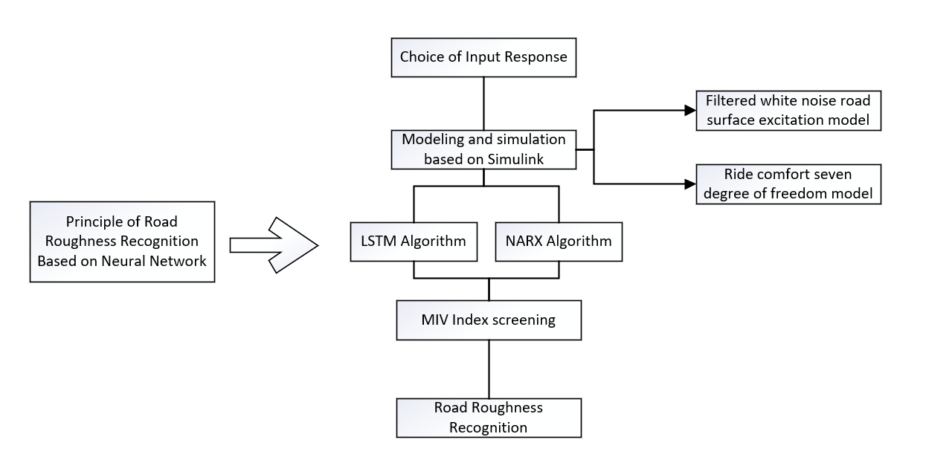
Figure 2 Chapter 3 Structure Diagram

3.1 Principle of Road Roughness Recognition Based on Neural Network
When a vehicle is driving on an uneven road, it will produce vibrations, that is, the response of the vehicle. These vibrations also reflect the degree of undulation of the road: the greater the undulation of the road, the greater the amplitude of the vehicle's vibration. Although the vehicle dynamics model can link the vehicle response with road roughness, it requires related vehicle parameters as a bridge. Because different vehicle parameters are different and parameter acquisition is difficult, which brings certain inconvenience. Recognizing road roughness through neural network can overcome this problem. It can use a large amount of data to find the nonlinear mapping relationship between vehicle response and road roughness. After the model is establishe, the corresponding road roughness can be obtained by input response automatically, and the source of the data required to establish the model can also be obtained through simulation, which greatly reduces the difficulty of actual operation. The steps mainly include:
① Acquisition of road roughness and vehicle response data: It can be obtained by simulation or actual measurement methods. Since a large amount of data is needed during the neural network model building stage, simulation methods are appropriate at this time;
② Neural network training: take most of the data as the training set. The vehicle response is the input, and the corresponding road roughness is the output. After setting the relevant parameters, the model can be trained;
③ Neural network testing: take another part of the data as the test set, and the vehicle response as input. The road roughness (predicted value) is obtained through the trained neural network. In order to compare with the real value, the pros and cons of the model are judged by evaluation indicators. Further, the parameters in step ② can be continuously adjusted to optimize the neural network model so that the evaluation index of the test set is the best;
④ Application of neural network model: if the built-up neural network model has good recognition results in the test set, it can be used in the actual vehicle recognition stage, and the road roughness can be identified by obtaining response data from the sensors installed on the vehicle.
The principle structure diagram of road roughness recognition based on neural network is shown in Figure 3.
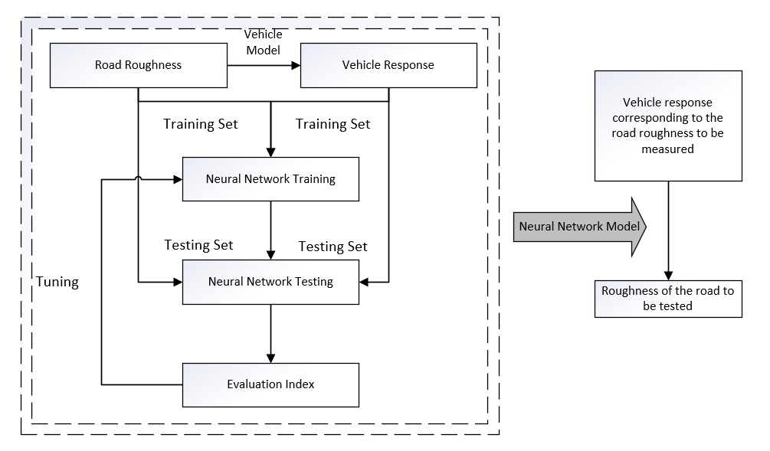
Figure 3 Principle of Road Roughness Recognition Based on Neural Network

3.2 Choice of Input Response
Although there are many responses from vehicles during driving, many responses are difficult to be measured by actual sensors. Therefore, it is necessary to consider the measurement possibility of sensors to eliminate vehicle responses that are difficult to measure in reality.
During the operation of the car, in order to control the chassis and realize ABS, ASR, ESP and other functions, on-board sensors are necessary. The most common chassis vehicle sensor is the Micro Electro Mechanical Systems acceleration sensor, which has the advantages of small size, light weight, low cost, strong reliability and easy mass production. It mainly includes piezoresistive, capacitive, and resonant sensors, which are widely used in modern cars [46]. Different vehicles have different numbers and positions of acceleration sensors according to their needs. Some are installed in the ESC independently near the center of gravity of the vehicle to approximate the lateral acceleration of the center of gravity, and some are placed on the shock absorber bracket near the wheel to approximate the vertical acceleration of the wheels, some car bodies are equipped with multiple sensors for active suspension control. In addition, relying on the three vertical acceleration sensors ${\ddot{z}}_{b1}$, ${\ddot{z}}_{b2}$, ${\ddot{z}}_{b3}$ installed on the vehicle body caculate the vertical acceleration of the center of mass ${\ddot{z}}_{b}$, the pitch angular acceleration ${\ddot{z}}_{by}$ and the roll angular acceleration ${\ddot{z}}_{bx}$:
${\ddot{z}}_{bi}={\ddot{z}}_{b}±a_{i}{\ddot{ z}}_{by}±l_{i} {\ddot{z}}_{bx}; i= 1,2,3$ （3-1）
$a_{i}$ is the x-axis distance from the $i$ sensor to the center of mass in the vehicle driving coordinate system. The distance is negative in front of the center of mass, and positive at the back.$l_{i}$ is the y-axis distance from the $i$ sensor to the center of mass in the vehicle driving coordinate system. The distance is negative on the right side of the center of mass, and positive on the left side.
MEMS gyroscope can be used to measure the angular velocity of three axes. It has the advantages of low cost, low quality, easy mass production, easy integration, etc. MEMS gyroscope has been widely used in many fields, and is often used in suspension control and anti-rolling in some high-end vehicles. But it has the problem of zero drift. In order to improve the accuracy, further data compensation and signal denoising processing are needed [47].
Although the acceleration sensor and the gyroscope can theoretically obtain the displacement and angle of the object when they are in motion through integration. In fact, the accumulated error will be very large over time. In order to measure the movement posture of an object in three-dimensional space, an acceleration sensor and a gyroscope are often combined to measure the three-axis acceleration and three-axis angular velocity of the object relative to the inertial space, that is, IMU (Inertial Measurement Unit), which is indispensable for autonomous vehicles. The IMU can calculate the three-dimensional static angle through the acceleration sensor, and at the same time use the angular velocity value of the gyroscope to correct it, and finally determine the real-time spatial attitude angle, but compared to a single sensor, the calibration algorithm is more demanding, and the current accuracy is relatively low.
The body height sensor is a sensor used in the car to measure the attitude change of the body, which can be used for active suspension control and automatic front headlight adjustment. Type of this sensor often is Hall type or photoelectric type, installed above the suspension, which can approximate the dynamic deflection of the suspension.
The wheel force sensor is a sensor that is widely used in vehicle detection and road simulation tests to measure the force of the wheels of vehicles. The measured wheel force is the direct force of the ground on the wheel, and it is the collective term for the forces and moments on the wheels, the sensor needs to be installed on the wheel rim, and the data needs to be further decoupled, which is more complicated and has certain technical difficulties [48].
Based on the above analysis, the vehicle response can be divided into three categories according to the degree of difficulty and recognition accuracy of the response acquisition. Among them, the vertical speed of the body center of mass and the vertical displacement of the body center of mass are difficult to measure, so they are not included in the output response.
Table 2 Vehicle Response Type
Type | Name
Easy to obtain (high precision) | Vertical acceleration of body center of mass
Easy to obtain (high precision) | Body pitch angular acceleration
Easy to obtain (high precision) | Body roll angular acceleration
Easy to obtain (high precision) | Wheel vertical acceleration
Easy to obtain (high precision) | Body pitch angular speed
Easy to obtain (high precision) | Body roll angular speed
Easy to obtain (high precision) | Suspension dynamic deflection
Difficult to obtain (low precision) | Body pitch angular
Difficult to obtain (low precision) | Body roll angular
Difficult to obtain (low precision) | Wheel vertical dynamic load
Hard to obtain | Vertical speed of body center of mass  Vertical displacement of body center of mass

3.3 Modeling and Simulation Based on Simulink

3.3.1 Filtered White Noise Road Surface Excitation Model
The basic idea of the filtered white noise model is to abstract the random fluctuations of the road elevation as white noise that meets certain conditions, and the time domain model of random road roughness can be fitted after the system transforms [49]. It is currently the most commonly used road surface roughness simulation method, which can meet the relevant international and Chinese standards. It has the advantages of high accuracy and fast speed. Simulink can be used for simulation, which is more convenient than other methods.
First, the road roughness of the left front wheel $q_{1}(t)$ can be expressed as:
${\dot{q}}_{1}\left(t\right)=-2πn_{q}uq_{1}(t)+2πn_{0}\sqrt{G_{q}\left(n_{0}\right)u} w(t)$ （3-2）
In the formula, $n_{q}$ is the lower cutoff frequency in the space, which is 0.01. $u$is the vehicle speed. $n_{0}$ is the reference spatial frequency, which is 0.1.$G_{q}\left(n_{0}\right)$ is the road surface roughness coefficient.$w(t)$ is the standard Gaussian white noise.
According to the correlation of the road surface roughness of the left and right wheels, the road surface roughness of the right front wheel $q_{2}(t)$ can be expressed as [50]:
${\dot{q}}_{2}\left(t\right)=\left(\frac{2u}{B}+2πn_{q}u\right)q_{1}\left(t\right)-\frac{2u}{B}q_{2}\left(t\right)-2πn_{0}\sqrt{G_{q}\left(n_{0}\right)u} w\left(t\right)$ （3-3）
In the formula, B is the wheelbase.
For the road roughness of the left and right rear wheels $q_{3}(t)$ and $q_{4}(t)$, the time delay $t_{d}$ can be added on the basis of the previous formula:
$q_{3}(t)=q_{1}(t-t_{d})$ （3-4）
$q_{4}(t)=q_{2}(t-t_{d})$ （3-5）
In the formula, $t_{d}$ is the ratio of wheelbase to vehicle speed.
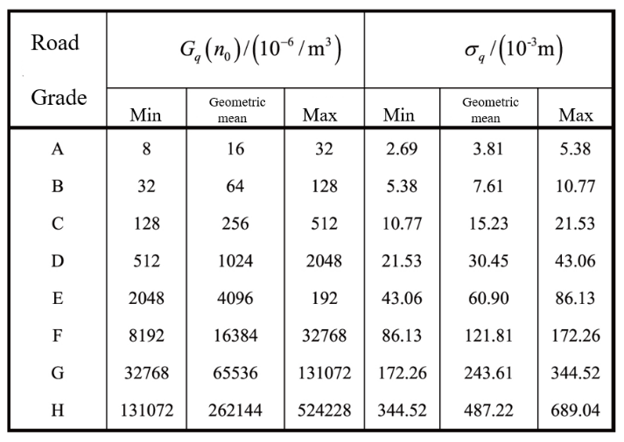
For the road roughness coefficient $G_{q}\left(n_{0}\right)$, the value can be taken according to the eight-level classification standard of road roughness [51], the standards is shown in Table 3.
Table 3 8-level Classification Standard for Road Roughness

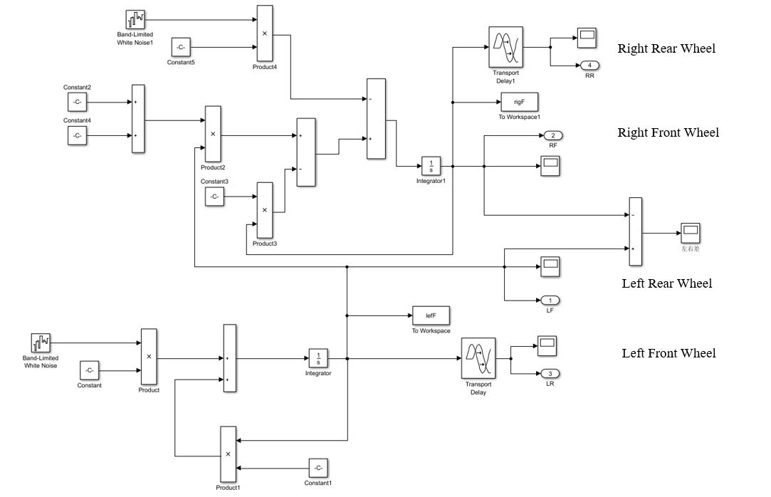
From the above formula, the corresponding model can be built in Simulink, as shown in Figure 4.
Figure 4 Filtered White Noise Four-Wheel Model

3.3.2 Ride Comfort Seven Degree of Freedom Model
Figure 5 Ride Comfort Seven Degree of Freedom Model
The ride comfort seven degree of freedom model includes seven degrees of freedom in the vertical motion, pitch motion, roll motion and vertical motion of the four wheels. It can describe the pitch, roll, jump and other motion conditions of the wheel completely. As shown in Figure 5 [52].
The meaning of the symbols in the figure is shown in Table 4.
Table 4 Ride Comfort Seven Degree of Freedom Model Symbol
Symbol | Meaning | Symbol | Meaning
$$m_{b}$$ | Sprung mass ($kg$) | $$z_{b}$$ | Vertical displacement of body center of mass)
$$m_{bx}$$ | rolling moment of inertia of sprung mass ($kg∙m^{2}$) | $$z_{bx}$$ | Body roll angle displacement ($rad$)
$$m_{by}$$ | pitching moment of inertia of sprung mass ($kg∙m^{2}$) | $$z_{by}$$ | Body pitch angle displacement ($rad$)
$$m_{1}$$ | Left front unsprung mass ($kg$) | $$z_{1}$$ | Vertical displacement of left front wheel ($m$)
$$m_{2}$$ | Right front unsprung mass ($kg$) | $$z_{2}$$ | Vertical displacement of right front wheel ($m$)
$$m_{3}$$ | Left rear unsprung mass ($kg$) | $$z_{3}$$ | Vertical displacement of left rear wheel ($m$)
$$m_{4}$$ | Right rear unsprung mass ($kg$) | $$z_{4}$$ | Vertical displacement of right rear wheel ($m$)
$$B_{f}$$ | The lateral distance from the front wheel to the center of mass ($m$) | $$q_{1}$$ | Road roughness of left front wheel ($m$)
$$B_{r}$$ | Lateral distance from rear wheel to center of mass ($m$) | $$q_{2}$$ | Road roughness of right front wheel ($m$)
$$a$$ | Longitudinal distance from front axle to center of mass ($m$) | $$q_{3}$$ | Road roughness of left rear wheel ($m$)
$$b$$ | Longitudinal distance from rear axle to center of mass ($m$) | $$q_{4}$$ | Road roughness of right rear wheel ($m$)
$$c_{s1}$$ | Left front suspension damping coefficient ($N∙m/s$)
$$c_{s2}$$ | Right front suspension damping coefficient ($N∙m/s$)
$$c_{s3}$$ | Damping coefficient of left rear suspension ($N∙m/s$)
$$c_{s4}$$ | Damping coefficient of right rear suspension ($N∙m/s$)
$$k_{s1}$$ | Stiffness coefficient of left front suspension ($N/m$)
$$k_{s2}$$ | Stiffness coefficient of right front suspension ($N/m$)
$$k_{s3}$$ | Stiffness coefficient of left rear overhang ($N/m$)
$$k_{s4}$$ | Stiffness coefficient of right rear overhang ($N/m$)
$$k_{t1}$$ | Stiffness coefficient of left front wheel ($N/m$)
$$k_{t2}$$ | Stiffness coefficient of right front wheel ($N/m$)
$$k_{t3}$$ | Stiffness coefficient of left rear wheel ($N/m$)
$$k_{t4}$$ | Stiffness coefficient of right rear wheel ($N/m$)
The differential equations of motion with seven degrees of freedom can be written into a unified matrix form [38]
$M\ddot{Z}+C\dot{Z}+KZ=K_{t}Q$ （3-6）
In the formula,$Z$ is the displacement vector of the respective degrees of the vehicle. $M$ is the mass matrix. $K$ is the stiffness matrix of the vehicle; $C$ is the damping matrix of the vehicle. $K_{t}$ is the tire stiffness matrix.$Q$ is the road input vector, and its specific value is as follow:
$M=\left[\begin{aligned}m_{b} \\ \\ \\ ⋮ \\ \\ \\ 0\end{aligned} \begin{aligned} \\ m_{by} \\ \\ \\ \\ \\ \end{aligned} \begin{aligned} \\ \\ m_{bx} \\ \\ \\ \\ \end{aligned} \begin{aligned}… \\ \\ \\ m_{1} \\ \\ \\ … \end{aligned} \begin{aligned} \\ \\ \\ \\ m_{2} \\ \\ \end{aligned} \begin{aligned} \\ \\ \\ \\ \\ m_{3} \\ \end{aligned} \begin{aligned}0 \\ \\ \\ ⋮ \\ \\ \\ m_{4}\end{aligned}\right]$；$K_{t}=\left[\begin{aligned}0 \\ 0 \\ 0 \\ k_{t1} \\ 0 \\ 0 \\ 0\end{aligned} \begin{aligned}0 \\ 0 \\ 0 \\ 0 \\ k_{t2} \\ 0 \\ 0\end{aligned} \begin{aligned}0 \\ 0 \\ 0 \\ 0 \\ 0 \\ k_{t3} \\ 0\end{aligned} \begin{aligned}0 \\ 0 \\ 0 \\ 0 \\ 0 \\ 0 \\ k_{t4}\end{aligned}\right]$；$Q=\left[\begin{aligned}q_{\begin{aligned}1 \\ \end{aligned}} \\ q_{\begin{aligned}2 \\ \end{aligned}} \\ q_{\begin{aligned}3 \\ \end{aligned}} \\ q_{\begin{aligned}4 \\ \end{aligned}}\end{aligned}\right]$；
$C=\left[\begin{aligned}c_{11} \\ \\ \\ \\ \\ \\ \end{aligned} \begin{aligned}c_{12} \\ c_{22} \\ \\ Symmetry \\ \\ \\ \end{aligned} \begin{aligned}c_{13} \\ c_{23} \\ c_{33} \\ \\ \\ \\ \end{aligned} \begin{aligned}{-c}_{s1} \\ ac_{s1} \\ {-B}_{f}c_{s1} \\ c_{s1} \\ \\ \\ \end{aligned} \begin{aligned}{-c}_{s2} \\ ac_{s2} \\ B_{f}c_{s2} \\ 0 \\ c_{s2} \\ \\ \end{aligned} \begin{aligned}{-c}_{s3} \\ -bc_{s3} \\ {-B}_{r}c_{s3} \\ 0 \\ 0 \\ c_{s3} \\ \end{aligned} \begin{aligned}{-c}_{s4} \\ -bc_{s4} \\ {-B}_{r}c_{s4} \\ 0 \\ 0 \\ 0 \\ c_{s4}\end{aligned}\right]$；
$c_{11}=c_{s1}+c_{s2}+c_{s3}+c_{s4}$；$c_{12}=a(c_{s1}+c_{s2})+b( c_{s3}+c_{s4} )$；
$c_{13}=B_{f}(c_{s1}-c_{s2})+B_{r}( c_{s3}-c_{s4} )$；$c_{22}=a^{2}(c_{s1}+c_{s2})+b^{2}( c_{s3}+c_{s4} )$；
$c_{23}=aB_{f}({c_{s2}-c}_{s1})+bB_{r}( c_{s3}-c_{s4} )$；
$c_{33}=B_{f}^{2}(c_{s1}+c_{s2})+B_{r}^{2}( c_{s3}+c_{s4} )$；
$K=\left[\begin{aligned}k_{11} \\ \\ \\ \\ \\ \\ \end{aligned} \begin{aligned}k_{12} \\ k_{22} \\ \\ Symmetry \\ \\ \\ \end{aligned} \begin{aligned}k_{13} \\ k_{23} \\ k_{33} \\ \\ \\ \\ \end{aligned} \begin{aligned}{-k}_{s1} \\ ak_{s1} \\ {-B}_{f}k_{s1} \\ k_{s1}+k_{t1} \\ \\ \\ \end{aligned} \begin{aligned}{-k}_{s2} \\ ak_{s2} \\ B_{f}k_{s2} \\ 0 \\ k_{s2}+k_{t2} \\ \\ \end{aligned} \begin{aligned}{-c}_{s3} \\ -bk_{s3} \\ {-B}_{r}c_{s3} \\ 0 \\ 0 \\ k_{s3}+k_{t3} \\ \end{aligned} \begin{aligned}{-k}_{s4} \\ -bk_{s4} \\ {-B}_{r}k_{s4} \\ 0 \\ 0 \\ 0 \\ k_{s4}+k_{t4}\end{aligned}\right]$；
$k_{11}=k_{s1}+k_{s2}+k_{s3}+k_{s4}$；$k_{12}=－a(k_{s1}+k_{s2})+b( k_{s3}+k_{s4} )$；
$k_{13}=B_{f}(k_{s1}-k_{s2})+B_{r}( k_{s3}-k_{s4} )$；
$k_{22}=a^{2}(k_{s1}+k_{s2})+b^{2}( k_{s3}+k_{s4} )$；
$k_{23}=aB_{f}({k_{s2}-k}_{s1})+bB_{r}( k_{s3}-k_{s4} )$；
$k_{33}=B_{f}^{2}(k_{s1}+k_{s2})+B_{r}^{2}( k_{s3}+k_{s4} )$；
The dynamic load of the wheel is as follow:
$F_{di}=k_{ti} \left( z_{i} － q_{i} \right); i = 1,2,3,4$ （3-7）

Suspension dynamic deflection is as follow:
$f_{d1} = z_{b} － az_{by} + B_{f} z_{bx} － z_{1}$ （3-8）
$f_{d2} = z_{b} － az_{by}- B_{f} z_{bx} － z_{2}$ （3-9）
$f_{d3} = z_{b} +bz_{by}+ B_{r} z_{bx} － z_{3}$ （3-10）
$f_{d4} = z_{b}+ bz_{by}- B_{r} z_{bx} － z_{4}$ （3-11）
From the above formula, $X={[Z,\dot{Z}]}^{T}$, the corresponding system state space equation can be established:
$\left\{\begin{aligned}\dot{X}=AX+BU \\ Y=CX+DU\end{aligned}\right.$ （3-12）
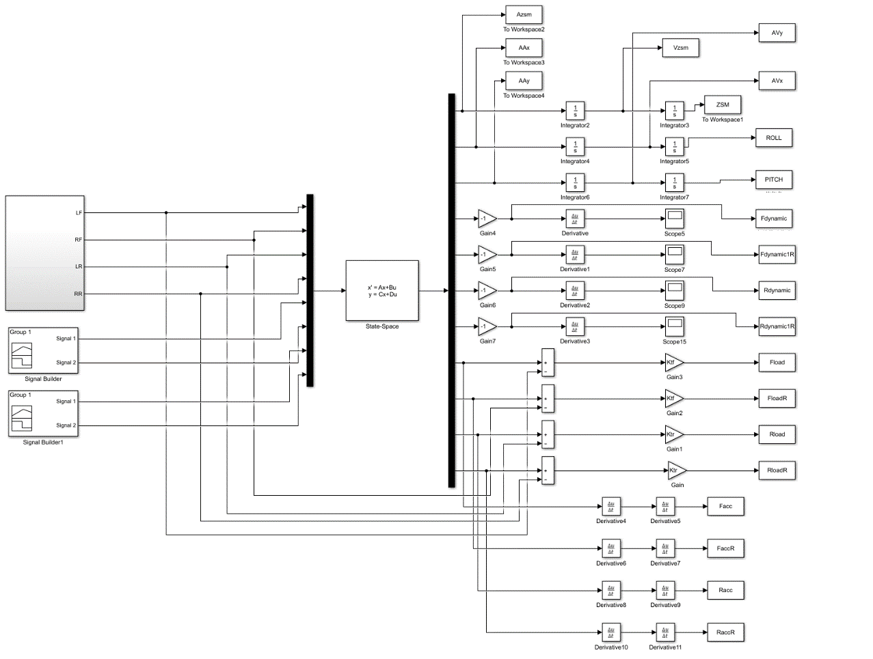
The corresponding model can be built in Simulink, as shown in Figure 6.
Figure 6 Ride Comfort Simulink Model with Seven Degrees of Freedom

3.3.3 Simulation Results
The values of the vehicle parameters are shown in Table 5. The road surface level is selected as B-level, the vehicle speed is 20m/s, the simulation time is 50s, the intensity of the white noise module is 1, and the noise-related time is 0.01s, then the total length of the simulated road section is 1000m, the number of sampling points is 30003. The road surface roughness and power spectrum density of the left and right front wheels are shown in Figure 7 and Figure 8. Because the road surface roughness of the left and right rear wheels only shifts a certain distance based on the road surface roughness of the front wheels, it does not list one by one.
Table 5 Ride Comfort Seven Degree of Freedom Model Parameter Values
Symbol | Value | Symbol | Value
$$m_{b}$$ | 800 ($kg$) | $$c_{s1}、c_{s2}$$ | 1000($N∙m/s$)
$$m_{bx}$$ | 380.2 ($kg∙m^{2}$) | $$c_{s3}、c_{s4}$$ | 1000($N∙m/s$)
$$m_{by}$$ | 780.8($kg∙m^{2}$) | $$k_{s1}、k_{s2}$$ | 30000($N/m$)
$$m_{1} m_{2}$$  $$m_{3} m_{4}$$  $$B_{f}、B_{r}$$  $$a$$  $$b$$ | 28.8($kg$)  62.5($kg$)  0.62($m$)  1.2($m$)  1.35($m$) | $$k_{s3}、k_{s4}$$  $$k_{t1}、k_{t2}$$  $$k_{t3}、k_{t4}$$ | 30000($N/m$)  180000($N/m$)  180000($N/m$)

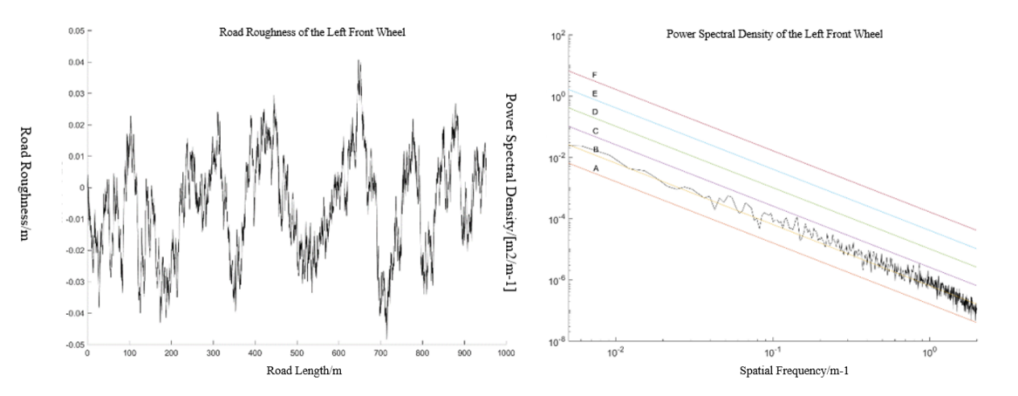
Figure 7 Road Roughness and Power Spectral Density of the Left Front Wheel
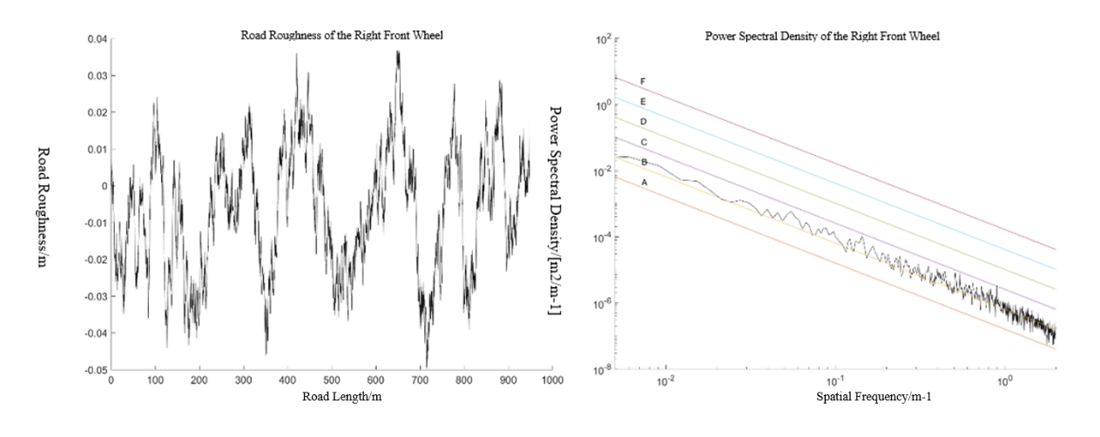
Figure 8 Road Roughness and Power Spectral Density of the Right Front Wheel
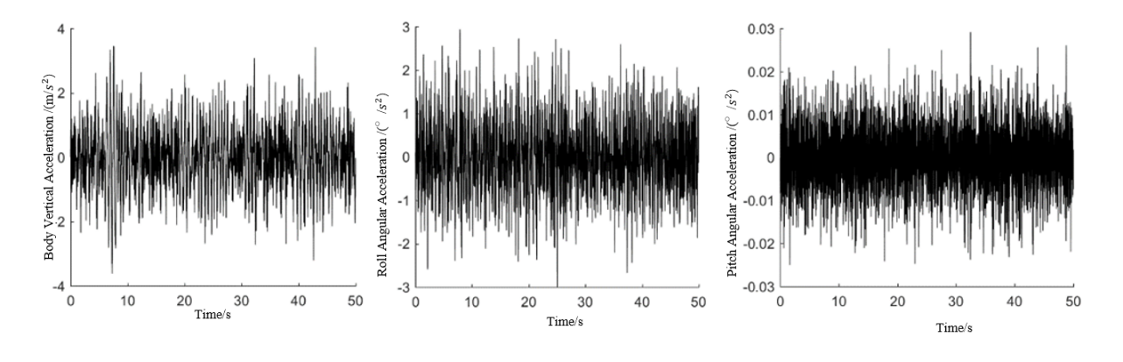
Taking the vertical acceleration of the body mass center, the pitch acceleration of the body and the body roll acceleration as examples, the simulation results are shown in Figure 9.
Figure 9 Acceleration Response

3.4 Road Roughness Recognition Based on LSTM

3.4.1 Basic Principles of LSTM
Long Short-Term Memory (LSTM) was proposed by Sepp Hochreiter et al [53] in 1997. It is a special recurrent neural network to solve gradient disappearance and gradient explosion problem in the training process of long sequence data. LSTM often performs better than RNN in long sequence prediction. At present, the LSTM neural network model has been widely used in various fields, and is commonly used to solve time-related problems such as text recognition, traffic forecasting, and stock price forecasting.
The basic structure of the LSTM model is introduced in the following four parts [54].
- Forgotten gate, input gate and output gate
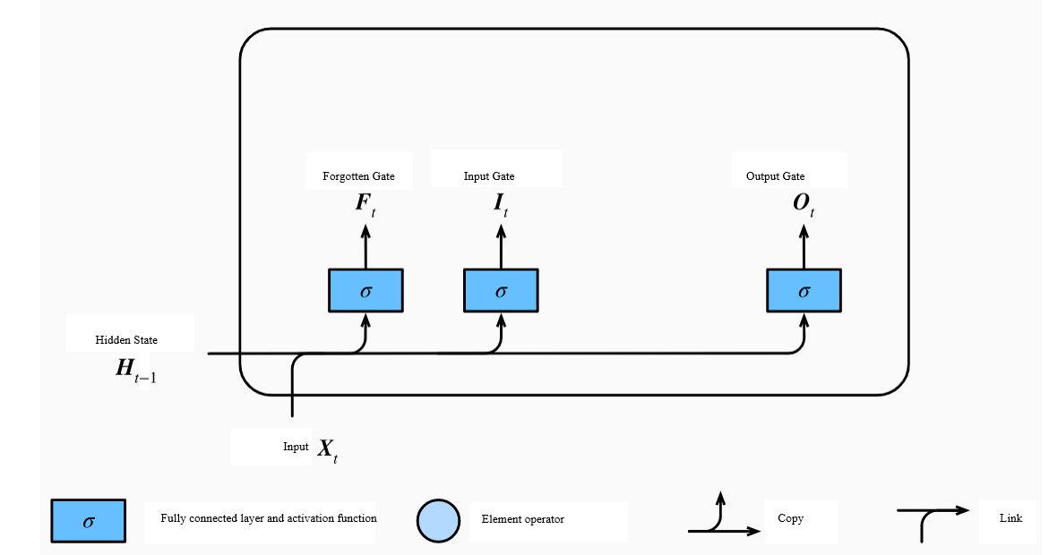
Figure 10 Calculation of gates in LSTM
LSTM uses three gates to filter the content of the memory cell, which are forgetten gate, input gate and output gate. The input of the gate is composed of the network input $X_{t}$ at the current moment and the hidden state at the previous moment $H_{t-1}$. The activation functions are all $Sigmoid$ functions, so that the value range of the three gate elements is [0, 1], as shown in the Figure 10.
If the number of hidden units is assumed to be h, the input of the network at the current moment $X_{t}∈R^{n×d}$ (n is the number of samples, d is the input dimension) and the hidden state at the previous moment $H_{t-1}∈R^{n×h}$, the calculation formulas of the gate at the current time t are:
$F_{t}=Sigmoid(X_{t}W_{xf}+H_{t-1}W_{hf}+b_{f})$ （3-13）
$I_{t}=Sigmoid(X_{t}W_{xi}+H_{t-1}W_{hi}+b_{i})$ （3-14）
$O_{t}=Sigmoid(X_{t}W_{xo}+H_{t-1}W_{ho}+b_{o})$ （3-15）
In the formula, $F_{t}$、$I_{t}$、$O_{t}∈R^{n×h}$, $W_{xf}$、$W_{xi}$、$W_{xo}∈R^{d×h}$ and $W_{hf}$、$W_{hi}$、$W_{ho}∈R^{h×h}$are the weight parameters, $b_{f}$、$b_{i}$、$b_{o}$ are offset items.
The expression of the $Sigmoid$ function is:
$σ(z)=\frac{1}{1+e^{-z}}$ （3-16）
- Candidate memory cells
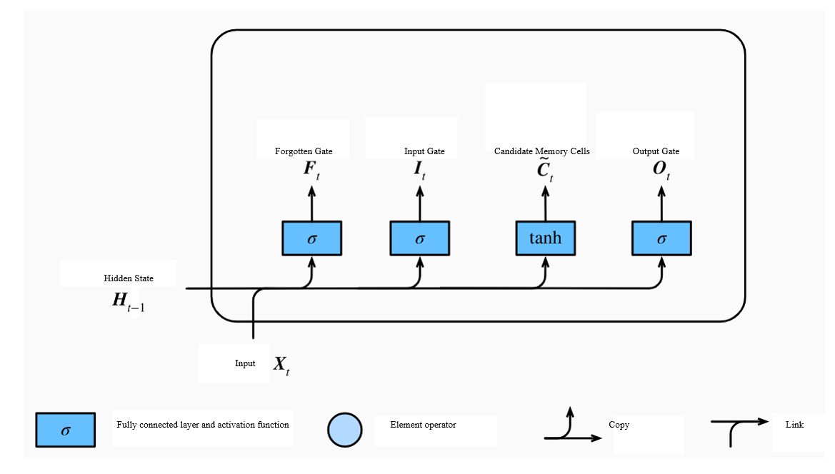
The calculation of the candidate memory cell ${\tilde{C}}_{t}$ is similar to the calculation of the gate, but the activation function uses the $tanh$ function, so that its value range is [-1, 1], as shown in Figure 11.
Figure 11 The Calculation of Candidate Memory Cells in LSTM
The calculation formula of candidate memory cells ${\tilde{C}}_{t}$ at current time t is:
${\tilde{C}}_{t}=tanh(X_{t}W_{xc}+H_{t-1}W_{hc}+b_{c})$ （3-17）
In the formula, ${\tilde{C}}_{t}∈R^{n×h}$, $W_{xc}∈R^{d×h}$ and $W_{hc}∈R^{h×h}$ are the weight parameters, and $b_{c}$ is the bias term.
The $tanh$ function expression is:
$tanh(z)=\frac{e^{z}-e^{-z}}{e^{z}+e^{-z}}$ （3-18）
- Memory cells
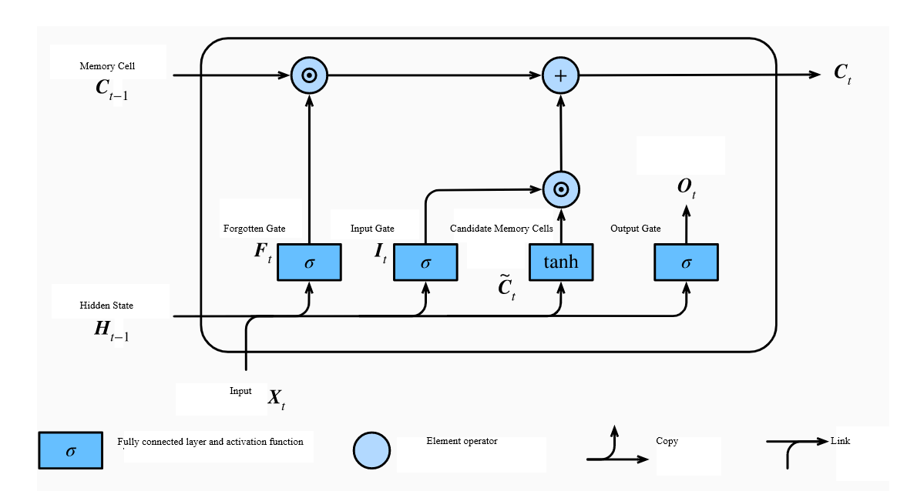
The memory cell $C_{t}$ at the current moment needs to be composed of the memory cell at the previous moment $C_{t-1}$ and the candidate memory cell ${\tilde{C}}_{t}$ at the current moment, and the information needs to be filtered through the forgotten gate $F_{t}$ and the input gate $I_{t}$, as shown in the Figure 12. If the forgotten gate is 1 and the input gate is 0, then the memory cell will record all historical information; On the contrary, if the forgotten gate is 0 and the input gate is 1, then all the information of the memory cell comes from the external input at the current moment. The advantage of this design is that it can well deal with the gradient attenuation problem and avoid the long-term dependency problem of RNN.
Figure 12 The Calculation of Memory Cells in LSTM
The calculation formula is as follow：
$C_{t}=F_{t}⨀C_{t-1}+I_{t}⨀{\tilde{C}}_{t}$ （3-19）
In the formula,$C_{t}∈R^{n×h}$，$⨀$ is Hadamard product.
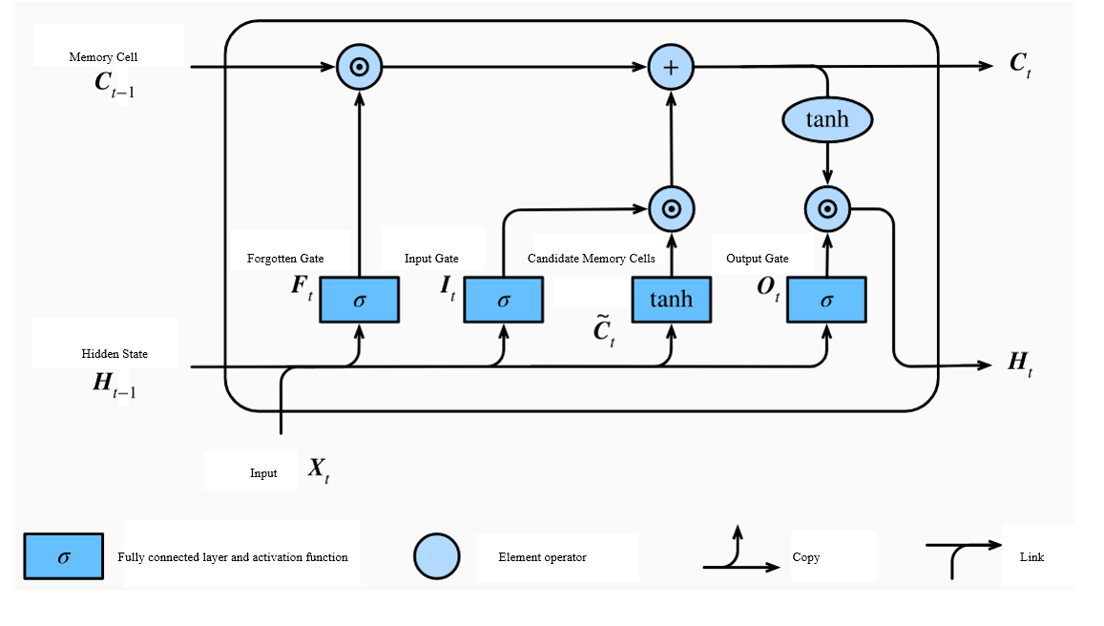
- Hidden state
Figure 13 The Calculation of Hidden State in LSTM
The hidden state $H_{t}$ is jointly determined by the memory cell $C_{t}$ and the output gate $O_{t}$, and the output gate controls how much information flows out of the memory cell. When the output gate is 1, the information of the memory cell will be transmitted to the hidden state; when the output gate is 0, the information of the memory cell will not flow out, as shown in Figure 13.
The calculation formula is as follow：
$H_{t}=O_{t}⨀tanh (C_{t})$ （3-20）
In the formula, $H_{t-1}∈R^{n×h}$，$⨀$ is Hadamard product.

3.4.2 Evaluation index
In order to evaluate the recognition effect of the neural network, the root mean square error (RMSE), mean absolute error (MAE), correlation coefficient (R) and coefficient of determination (R²) are introduced as evaluation indicators.
- RMSE
Root Mean Square Error (RMSE) can be used to measure the deviation between the predicted value and the true value. It is the most commonly used indicator in machine learning to deal with regression problems. The smaller the RMSE value, the better the prediction effect of the model. Because it belongs to the L2 norm, RMSE is more sensitive to outliers. If a certain predicted value has a large error from the true value, it will have a greater impact on RMSE.
$RMSE=\sqrt{\frac{\sum_{i=1}^{m}{{(a_{i}-y_{i})}^{2}}}{m}}$ （3-21）
- MAE
Mean Absolute Error (MAE) can directly reflect the error between the predicted value and the true value. The smaller the value, the better the prediction effect of the model. Because it belongs to the L1 norm, it is less affected by outliers than RMSE.
$MAE=\frac{\sum_{i=1}^{m}{\left|a_{i}-y_{i}\right|}}{m}$ （3-22）
- R
Correlation Coefficient (R) is an index to evaluate the correlation between two variables, and it can also be used to evaluate the fitting effect of the model in regression problems. The value range of the correlation coefficient is [-1, 1], -1 means a complete negative correlation, 0 means no correlation, and 1 means a complete positive correlation. After taking the absolute value of the correlation coefficient, the correlation can be roughly judged according to its distribution: 0-0.2 means very weak or irrelevant, 0.2-0.4 means weak correlation, 0.4-0.6 means moderate correlation, 0.6-0.8 means strong correlation, 0.8 -1.0 means very strong correlation. Although R is not often used in machine learning to deal with regression problems, it is widely used in the literature on road roughness identification problems, so it is also included in the evaluation index.
$R=\frac{\sum_{i=1}^{m}{(a_{i}-\overline{a})(y_{i}-\overline{y})}}{\sqrt{\sum_{i=1}^{m}{{(a_{i}-\overline{a})}^{2}}}\sqrt{\sum_{i=1}^{m}{{(y_{i}-\overline{y})}^{2}}}}$ （3-23）
- R²
Coefficient of Determination (R²) measures the ratio of the amount of information captured by the model to the amount of information contained in the true label. It is often used in regression models to evaluate the degree of agreement between the predicted value and the actual value. The closer R² is to 1, Indicates that the prediction curve fits the real curve better.
$R^{2}=1-\frac{\sum_{i=1}^{m}{{({a_{i}-y}_{i})}^{2}}}{\sum_{i=1}^{m}{{(a_{i}-\overline{a})}^{2}}}$ （3-24）
In the above four formulas, $a$ is the true value,$y$ is the predicted value, $\overline{a}$ is the average true value, $y$ is the average predicted value, and $m$ is the number of samples.

3.4.3 Implementation of the Model
The related LSTM model is written in the Jupyter compiler using the Python language and implemented using the deep learning framework Keras.
- Data source and preprocessing
From the previous road white noise model and the ride comfort seven degree of freedom model, the road roughness data and the corresponding vehicle response data can be obtained in Matlab. According to the analysis in Chapter 3 above, the vehicle responses selected in this study include: vertical acceleration of the center of mass of the vehicle body ${\ddot{z}}_{b}$, pitch angular acceleration of the vehicle body ${\ddot{z}}_{by}$, roll angular acceleration of the vehicle body ${\ddot{z}}_{bx}$, and wheel acceleration $\ddot{z_{1}}$、$\ddot{z_{2}}$、$\ddot{z_{3}}$、$\ddot{z_{4}}$, body pitch angular velocity ${\dot{z}}_{by}$, body roll angular velocity ${\dot{z}}_{bx}$, body pitch angle $z_{by}$, body roll angle $z_{bx}$, wheel dynamic load $F_{d1}$、$F_{d2}$、$F_{d3}$、$F_{d4}$, suspension dynamic deflection $f_{d1}$、$f_{d2}$、$f_{d3}$、$f_{d4}$, a total of 19 input responses.
The input data is first normalized. Normalization is a simple method of dimensionless data, which can effectively avoid numerical problems caused by excessive input values, and is beneficial to the acceleration of neural network convergence. Its expression is as follows:
$x^{*}=\frac{x-min⁡(x)}{\max\left(x\right)-min⁡(x)}$ （3-25）
In the formula,$x$ is the original value,$\max\left(x\right)$ is the maximum value of the sample data, $min⁡(x)$ is the minimum value of the sample data, $x^{*}$ is the normalized value, and the value range is [0, 1].
- LSTM model parameters and recognition results
In order to obtain better recognition results, this dissertation compares the different neural network layers, the number of neurons and the bidirectional LSTM of the LSTM model. The study uses the first 70% of the input data as the training set and the last 30% as the test set. Due to the randomness of the actual training process, the neural network training process is repeated 5 times to weaken the fluctuations predicted by the model.
For other hyper-parameters, this dissertation adopts common choices: the activation function of the fully connected layer uses the sigmoid function, the optimization algorithm is Adam, the loss function uses the mean square error function, the epochs are 50 and the size of each batch is 256, and the learning rate is 0.01.
Increasing the number of neural network layers can often improve the accuracy of the model, but too many layers will cause the model to become complex and increase the amount of computation. For time sequence issues, it should not have too many LSTM layers. The number of LSTM network layers is usually within three layers, so the specific parameter settings are shown in Table 6.
Table 6 Neural network layer number determination experiment
Model | Number of LSTM layers | Number of neurons in each layer
Model | Number of LSTM layers | Layer 1 | Layer 2 | Layer 3
1 | 1 | 128
2 | 2 | 128 | 64
3 | 3 | 128 | 64 | 32
The average value of each evaluation index after 5 trainings is shown in Table 7. It can be found that when the number of LSTM layers is 1, the recognition effect of the model is the best, and its time is the least.
Table 7 Test Set Evaluation Indicator of Number of LSTM Layers’s Experiment
Model | Number of LSTM layers | RMSE | MAE | R | R²
1 | 1 | 0.0030 | 0.0024 | 0.990 | 0.962
2 | 2 | 0.0036 | 0.0029 | 0.988 | 0.945
3 | 3 | 0.0033 | 0.0028 | 0.981 | 0.914
The number of neurons is similar to the number of neural network layers, and the recognition effect is not ideal when there are less or more. When the number of LSTM layers is 1, compare and determine the optimal value of the number of neurons. The experimental results are shown in Table 8. It can be found that the best recognition effect is achieved when the number of neurons is 256.

Table 8 Test Set Evaluation Indicator of Number of Neurons’s Experiment
Model | Number of neurons | RMSE | MAE | R | R²
1 | 32 | 0.0034 | 0.0027 | 0.987 | 0.951
2 | 64 | 0.0036 | 0.0029 | 0.988 | 0.946
3 | 128 | 0.0030 | 0.0024 | 0.990 | 0.962
4 | 256 | 0.0025 | 0.0020 | 0.990 | 0.973
5 | 512 | 0.0027 | 0.0023 | 0.990 | 0.969
LSTM can only predict the output at the next moment based on the time sequence information of the previous moment. For the identification of road roughness, considering the continuity of the road, the current moment value may also be related to the future state, so the bidirectional LSTM model is used for comparison experiment. The model consists of two LSTMs superimposed on top of each other, and the output is determined by the state of the two LSTMs. For some problems, the time sequence processing ability is stronger. Under the condition that the number of LSTM layers is 1 and the number of neurons is 256, the recognition effect of LSTM and bidirectional LSTM is shown in Table 9. It can be found that the recognition effect of bidirectional LSTM is slightly higher than that of LSTM.

Table 9 Test Set Evaluation Indicator of LSTM and bidirectional LSTM’s Experiment
Model | Optimization | RMSE | MAE | R | R²
1 | LSTM | 0.0025 | 0.0020 | 0.990 | 0.973
2 | Bidirectional LSTM | 0.0025 | 0.0019 | 0.990 | 0.974
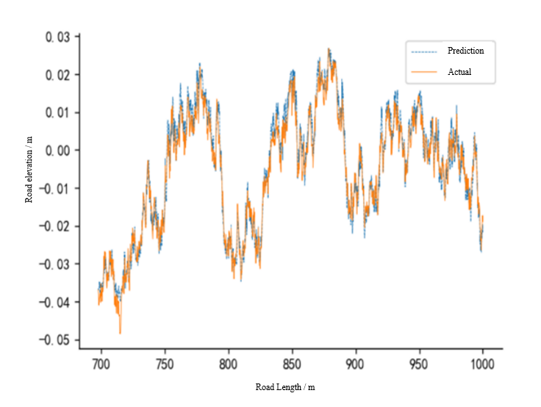
In summary, the specific structure adopted by the model is: bidirectional LSTM, single-layer network, and the number of neurons is 256. The recognition effect of the test set of road roughness on the left front wheel is shown in Figure 14. It can be seen that the trend of the model fitting result is very similar to the trend of the real value.
Figure 14 Recognition Result of LSTM

3.4.4 Indicator Screening Based on MIV
There are 19 vehicle responses that can be used to input the LSTM. Too many input variables will cause the network to be too large, the convergence speed will be slow, the network calculation will increase, and the generalization of the model will also deteriorate. Variables are screened in order to improve the performance of the model. There are many ways to filter input variables, and Mean Impact Value is considered to be one of the best indicators for evaluating the correlation of variables in neural networks[55]. This article adopts this method to evaluate input variables. .
MIV is an indicator used to determine the magnitude of the influence of input neurons on output neurons. Its sign represents the relevant direction, and the absolute value represents the relative importance of the influence. The specific operation steps are as follow [56]:
①Based on the trained network model, with p input variables and m sample numbers, the i input variable in the training sample (set to X) can be increased by $δ$ and decreased by $δ$ on the basis of the original value to form two new training samples ${X1}_{i}$ and ${X2}_{i}$.

${X1}_{i}=\left[\begin{matrix}x_{11} & x_{12} & … & x_{1m} \\ ⋮ & ⋮ & … & ⋮ \\ x_{i1}(1+δ) & x_{i2}(1+δ) & … & x_{im}(1+δ) \\ ⋮ & ⋮ & … & ⋮ \\ x_{p1} & x_{p2} & ⋯ & x_{pm}\end{matrix}\right]$ （3-26）
${X2}_{i}=\left[\begin{matrix}x_{11} & x_{12} & … & x_{1m} \\ ⋮ & ⋮ & … & ⋮ \\ x_{i1}(1-δ) & x_{i2}(1-δ) & … & x_{im}(1-δ) \\ ⋮ & ⋮ & … & ⋮ \\ x_{p1} & x_{p2} & ⋯ & x_{pm}\end{matrix}\right]$ （3-27）
②Taking ${X1}_{i}$ and ${X2}_{i}$ as training samples respectively, and calculating on the established neural network, two results can be obtained respectively ${Y1}_{i}$ and ${Y2}_{i}$.
${Y1}_{i}=\left[\begin{matrix}{y1}_{i1} & {y1}_{i2} & ⋯ & {y1}_{im}\end{matrix}\right]$ （3-28）
${Y2}_{i}=\left[\begin{matrix}{y2}_{i1} & {y2}_{i2} & ⋯ & {y2}_{im}\end{matrix}\right]$ （3-29）
③Calculate the difference between ${Y1}_{i}$ and ${Y2}_{i}$, that is, the impact value (IV) of the output value after the variable changes, and the IV is averaged according to the number of sample points to be the input variable to the output Mean influence value (MIV);
${MIV}_{i}=\frac{{Y1}_{i}-{Y2}_{i}}{m}$ （3-30）
④From the above formula, we can further obtain the relative contribution rate of the i input variable to the output $μ_{i}$.
$μ_{i}=\frac{\left|{MIV}_{i}\right|}{\sum_{i}^{p}{\left|{MIV}_{i}\right|}}×100$ （3-31）
In this study, δ is 10%. For the recognitiom of the road roughness of the left front wheel, the relative contribution rate of each input variable is shown in Table 10.

Table 10 The Relative Contribution Rate of the Input Variable's MIV
Input variable | relative contribution rate-$μ$ | Ranking
$${\ddot{z}}_{b}$$ | 3.34 | 9
$${\ddot{z}}_{by}$$ | 0.68 | 18
$${\ddot{z}}_{bx}$$ | 2.19 | 15
$$\ddot{z_{1}}$$ | 3.90 | 7
$$\ddot{z_{2}}$$ | 2.62 | 14
$$\ddot{z_{3}}$$ | 3.25 | 10
$$\ddot{z_{4}}$$ | 4.05 | 6
$${\dot{z}}_{by}$$ | 3.58 | 8
$${\dot{z}}_{bx}$$ | 0.42 | 19
$$z_{by}$$ | 35.24 | 1
$$z_{bx}$$ | 5.23 | 4
$$F_{d1}$$ | 4.06 | 5
$$F_{d2}$$ | 2.80 | 13
$$F_{d3}$$ | 3.23 | 11
$$F_{d4}$$ | 3.09 | 12
$$f_{d1}$$ | 10.34 | 2
$$f_{d2}$$ | 9.13 | 3
$$f_{d3}$$ | 1.12 | 17
$$f_{d4}$$ | 1.69 | 16
In order to further determine the optimal input plan, the input variables are sequentially filtered out according to the cumulative correlation contribution rate, and then the neural network is constructed and evaluated. The evaluation indicator result is the average of 5 training sessions. The results are shown in Table 11.

Table 11 The Evalution Indicator of Different input schemes’s LSTM
Methods | Cumulative relative contribution rate | Numberof input variables | RMSE | MAE | R | R²
All | 100% | 19 | 0.0025 | 0.0019 | 0.990 | 0.974
$$μ>1$$ | 98% | 17 | 0.0024 | 0.0019 | 0.991 | 0.974
$$μ>2$$ | 95% | 15 | 0.0024 | 0.0020 | 0.992 | 0.975
$$μ>3$$ | 88% | 12 | 0.0026 | 0.0021 | 0.991 | 0.971
$$μ>4$$ | 70% | 6 | 0.0032 | 0.0025 | 0.986 | 0.958
$$μ=max$$ | 35% | 1 | 0.0048 | 0.0039 | 0.953 | 0.902
It can be found that deleting input variables with a relative contribution rate of less than 2 is the optimal input scheme. In this situation, there are 15 input variables, deleting the body pitch angular acceleration ${\ddot{z}}_{by}$, the body roll angular velocity ${\dot{z}}_{bx}$ and rear Suspension dynamic deflection $f_{d3}$、$f_{d4}$. Its RMSE is 0.0024, MAE is 0.0020, R is 0.992, and R2 is 0.974. Compared with no MIV indicator screening, the number of input variables of the model is reduced, the training time is reduced, and The recognition result has not changed much. When the number of input variables is reduced again, the model effect will become worse and worse. It is worth noting that the correlation coefficient between the body pitch angle $z_{by}$ and the road roughness is very high, and its relative contribution rate is as high as 35 %. If it is only used as an input variable, a good prediction effect can be achieved. If the pitch angle is removed from the input response, the recognition effect will be greatly reduced.

3.5 Road Roughness Recognition Based on NARX

3.5.1 Basic Principles of NARX
Nonlinear Auto Regressive models with Exogenous Inputs (NARX) is the most widely used neural network in nonlinear dynamic systems. Because the neural network contains multi-step input and output delays, it can reflect the historical state information of the system and is a neural network with memory function [57]. NARX is more suitable for modeling and prediction of unknown models, and it is widely used in climate prediction, financial analysis, logistics planning, etc. The model can be defined as follow:
$y(t)=f[y\left(t-1\right),y\left(t-2\right),···y\left(t-d_{y}\right),x\left(t-1\right),x\left(t-2\right),···x\left(t-d_{x}\right)]$ （3-32）
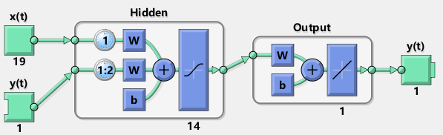
In the formula,$f(·)$ represents the nonlinear process function realized by neural network,$y(t)$ is the output time sequence about time $t$, $x(t)$ is the input time sequence about time $t$, $d_{y}$ and $d_{x}$ represent the lag order of output and input. It can be understood that the output at time $t$ depends on the first $d_{y}$ output values and the first $d_{x}$ input values. The basic structure is shown in Figure 15. This structure mode is Series-Parallel mode (Open-loop), and It can be called the open loop mode.
Figure 15 NARX Open Loop Structure Diagram
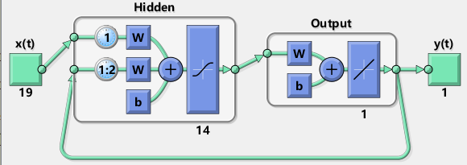
NARX has another structural mode-Parallel mode (Close-loop), which can also be called closed-loop mode, as shown in Figure 16. The difference between these two modes is that the open-loop NARX delays the expected output and then feeds it back to the input, while the closed-loop NARX delays the predicted output and feeds it back to the input. When the output sequence is known, the open-loop mode is often used, because the closed-loop mode takes longer to train, and the prediction effect is often not as good as the open-loop mode; but for unknown input sequences, or when multi-step prediction is required , You need to use the closed loop mode [58].
Figure 16 NARX Closed Loop Structure Diagram

3.5.2 Road Roughness Recognition Based on NARX
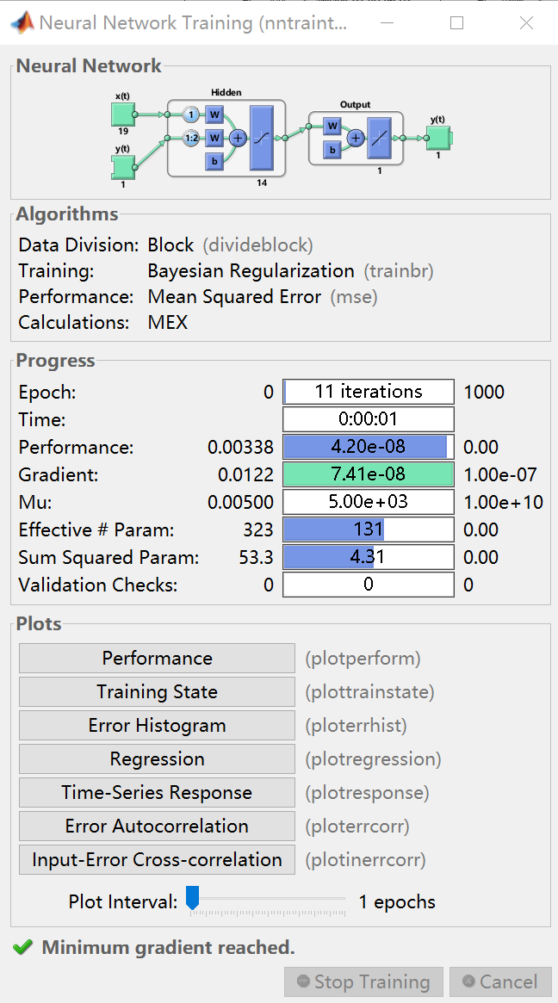
The related NARX model is implemented by the Matlab neural network toolbox, as shown in Figure 17.
Figure 17 Matlab Neural Network Toolbox
The data source and preprocessing are the same as the LSTM model. The first 70% of the input data is used as the training set, and the last 30% is used as the test set. The average value of the evaluation indicators of 5 trainings is used to evaluate the model. Because it is a multi-step prediction, it is necessary to use the closeloop function to change the trained NARX model from open-loop mode to closed-loop mode when making predictions on the test set. For the selection of model parameters, the loss function adopts the mean square error function (MSE), the hidden layer is set to a single layer, and other hyperparameters including training algorithm, number of neurons and delay order are also analyzed by comparative experiments.
The NARX training algorithm is similar to the BP neural network, the default is trainlm (Levenberg-Marquardt), and NARX is more commonly used as trainbr (Bayesian regularization), so the two algorithms are compared, and the results are shown in Table 12. It can be found that the evaluation indicators of the trainbr algorithm are better than those of the trainlm algorithm.
Table 12 NARX Training Algorithm Determination Experiment
Model | Number of neurons | Delay order | Training algorithm | RMSE | MAE | R | R²
1 | 14 | Input: output  1：2 | trainlm | 0.0103 | 0.0067 | 0.802 | 0.561
2 | 14 | Input: output  1：2 | trainbr | 0.0068 | 0.0056 | 0.921 | 0.801
For the number of hidden layer neurons, the selection is often similar to the BP neural network, and the commonly used formula is as follow:
$l=\sqrt{(n+m)}+a$ （3-32）
In the formula,$l$ is the number of hidden layer neurons, $n$ is the number of input layer neurons, $m$ is the number of output layer neurons, and $a$ is a constant between 0-10. For a single hidden layer, $n$ is the number of input variables, and $m$ is the number of output variables. For example, if $a$ is 10, then $l$ is 14. The comparison experiment takes a value of about 14 for analysis. The results are shown in Table 13. The model performs best when the number of neurons is 14.
Table 13 NARX Neuron Number Determination Experiment
Model | Training algorithm | Delay order | Number of neurons | RMSE | MAE | R | R²
1 | trainbr | Input and Output  1：2 | 10 | 0.0091 | 0.0077 | 0.881 | 0.652
2 | trainbr | Input and Output  1：2 | 14 | 0.0068 | 0.0056 | 0.921 | 0.801
3 | trainbr | Input and Output  1：2 | 18 | 0.0101 | 0.0085 | 0.837 | 0.580
The default value of NARX's input and output delay order is 1:2, that is, the current output value is determined by the input value and output value of the previous two moments. When the training algorithm is trainbr and the number of neurons is 22, the comparative experiment results are shown in Table 14. It can be found that the model performs best when the input and output delay orders are both 1:2.
Table 14 NARX Delay Order Determination Experiment
Model | Input delay order | Onput delay order | RMSE | MAE | R | R²
1 | 1：1 | 1：2 | 0.0075 | 0.0062 | 0.910 | 0.765
2 | 1：2 | 1：1 | 0.0333 | 0.0288 | -0.302 | -3.608
3 | 1：2 | 1：2 | 0.0068 | 0.0056 | 0.921 | 0.801
4 | 1：3 | 1：3 | 0.0074 | 0.0061 | 0.913 | 0.775
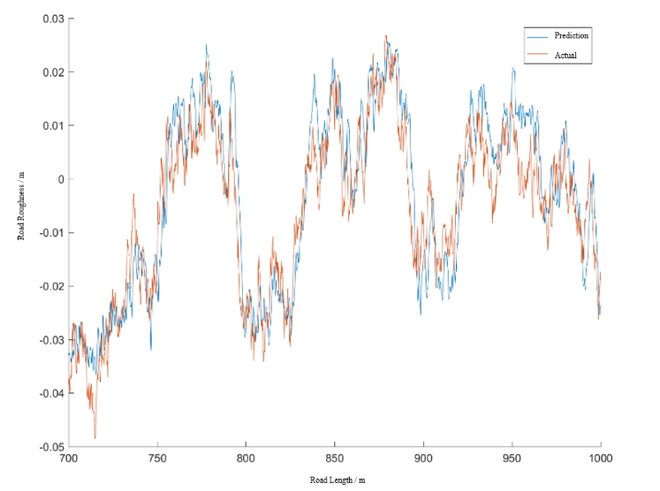
In summary, the final model parameters adopted are: trainbr algorithm, the number of neurons is 14, the input delay order is 1:2, and the output delay order is 1:2. The recognition result of the test set is shown in Figure 18, and it can be found that the NARX model can also identify road roughness well.
Figure 18 The Recognition Results of NARX
Similarly, use MIV to filter the input variables of NARX. Based on the 19 input responses, the roll angular acceleration ${\ddot{z}}_{bx}$, the roll angular velocity ${\dot{z}}_{bx}$, the vertical acceleration of the right front wheel $\ddot{z_{2}}$, and the rear wheel acceleration $\ddot{z_{3}}$、$\ddot{z_{4}}$, a total of 5 variables whose relative contribution rate is less than 2. Its RMSE is 0.0051, MAE is 0.0040, R is 0.948, and R2 is 0.893, which is a significant improvement compared to the evaluation indicators before variable screening.
Table 15 Comparison of LSTM and NARX Evaluation Indicators
Model | RMSE | MAE | R | R2
LSTM | 0.0025 | 0.0019 | 0.990 | 0.974
MIV-LSTM | 0.0024 | 0.0020 | 0.992 | 0.975
NARX | 0.0068 | 0.0056 | 0.921 | 0.801
MIV-NARX | 0.0051 | 0.0040 | 0.948 | 0.893
Statistics on the evaluation indicators identified by different models, as shown in the Table 15, both LSTM and NARX can better identify road roughness. LSTM performs better than NARX. The MIV method has a more significant effect on NARX: after deleting the number of input variables, the evaluation indicators have also been improved.

3.6 Chapter Summary
First, this chapter introduces the basic principles of identifying road roughness based on vehicle response. Then briefly analyzes the measurement of wheel response, eliminating the difficult-to-measure response. And then, the roughness data and corresponding vehicle response data is obtained by filtering the white noise model and the vehicle ride comfort seven degree of freedom model. After that, built the LSTM model and NARX model and adjusted the parameters, proposed the MIV method to filter the input variables, and finally compared the two models, and found that LSTM performed better than NARX and MIV is effective. The content of this chapter provides a certain theoretical basis for the following article. Although the recognition result is excellent, the vehicle model is relatively simple, and the obtained response value is quite different from the actual situation. The research needs to be further developed.

Chapter 4 Road Roughness Recognition under the Carsim Model
The previous article proves the superiority of MIV-LSTM for road roughness recognition, but the ride comfort seven degree of freedom model used is too simple. In this chapter, based on the vehicle dynamics simulation software Carsim, the problem of road surface roughness recognition is studied in more depth, and propose the improvement plan which has greatly improved the evaluation indicators. The structure of this chapter is shown in Figure 19.
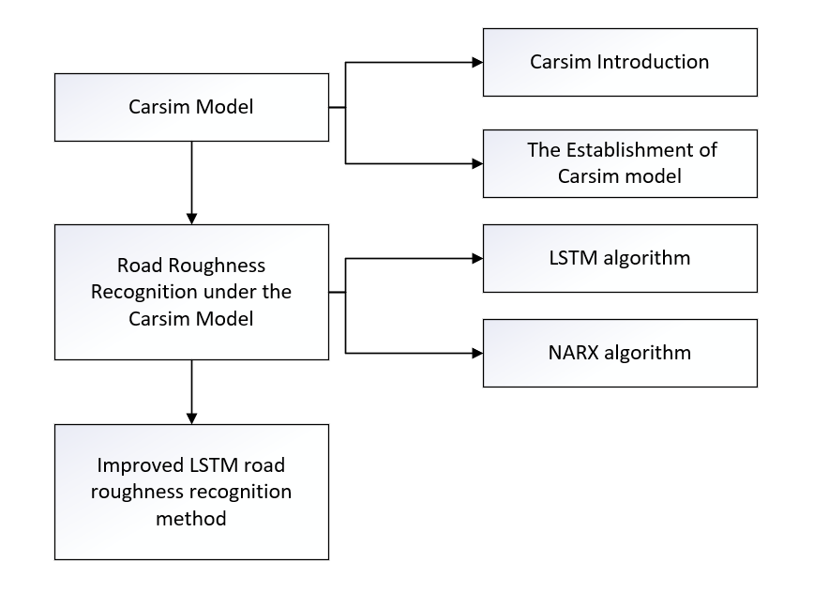
Figure 19 Chapter 4 Structure Diagram

4.1 Carsim Model

4.1.1 Carsim Introduction
Carsim was developed by MSC (Mechanical Simulation Corporation). The model is based on the theoretical and practical results of the Institute of Transportation of the University of Michigan for many years. As a vehicle dynamics simulation software, it is suitable for various vehicle types. It can flexibly define vehicle working conditions and driving environment, and accurately analyze the major performances of the entire vehicle. It has the advantages of fast calculation, good compatibility, and strong reliability. It is widely used by major automobile manufacturers and universities at home and abroad [58].
The main body of Carsim can be divided into three modules:
①Graphical user interface: It is used to define the specific parameters and test conditions of the vehicle. There are many models and operating conditions in the Carsim database, which can be changed according to requirements.
②Mathematical model solver: used for specific operations, and as an interface for co-simulation with other software.
③Data post-processing module: used for 3D animation display of vehicle operation and drawing of data graph.
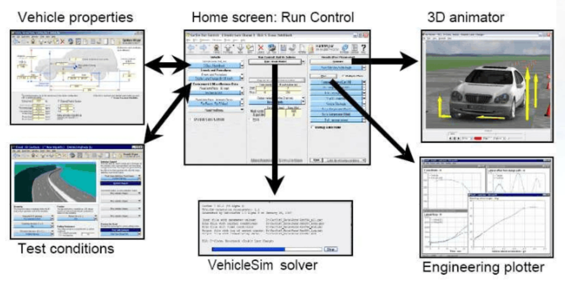
Figure 20 Carsim’s Function and interface
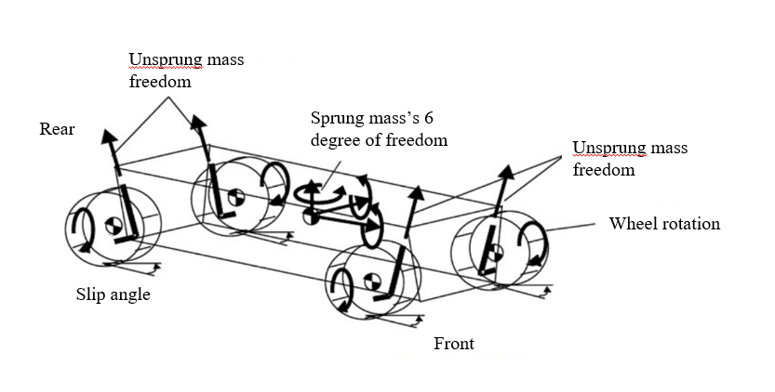
As shown in Figure 21, Carsim abstracts and simplifies the vehicle. The model is divided into 10 rigid bodies: car body, 4 unsprung masses, 4 wheels and engine. There are 27 degrees of freedom in total: 3 degrees of freedom of movement of sprung masses, 3 degrees of freedom of sprung mass rotation, 4 degrees of freedom of unsprung mass, 4 degrees of freedom of wheel rotation, 1 degree of freedom of power train rotation, 8 degrees of freedom of tire transient characteristics and 4 degrees of freedom of braking pressure.
Figure 21 Simplified Vehicle Model in Carsim

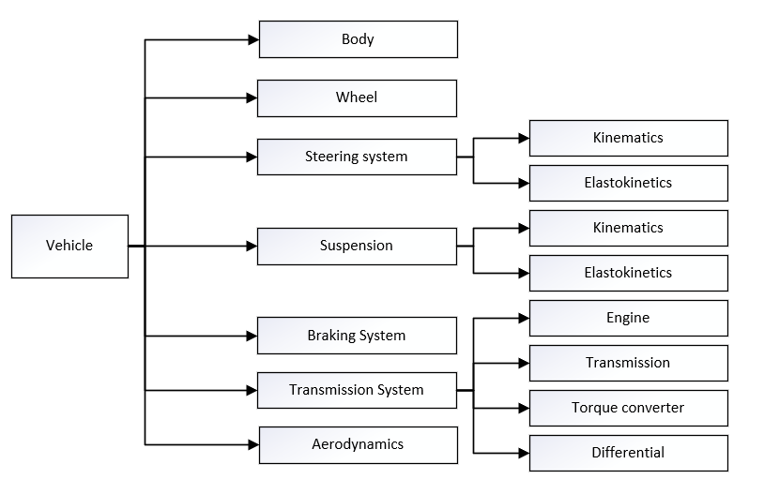
Figure 22 Vehicle Model Subsystem in Carsim
Carsim uses the multi-body dynamics modeling method when building the whole vehicle model. The vehicle is divided into seven major subsystems: car body, tires, steering, suspension, braking, transmission and aerodynamics, as shown in Figure 22. Each subsystem has a corresponding operation interface. When building a model, the corresponding parameters in the subsystem can be changed according to requirements, which is very convenient.

4.1.2 The Establishment of Carsim Model
The Carsim version used is 8.02, and the specific steps for model establishment include:
- Selection of model and working conditions
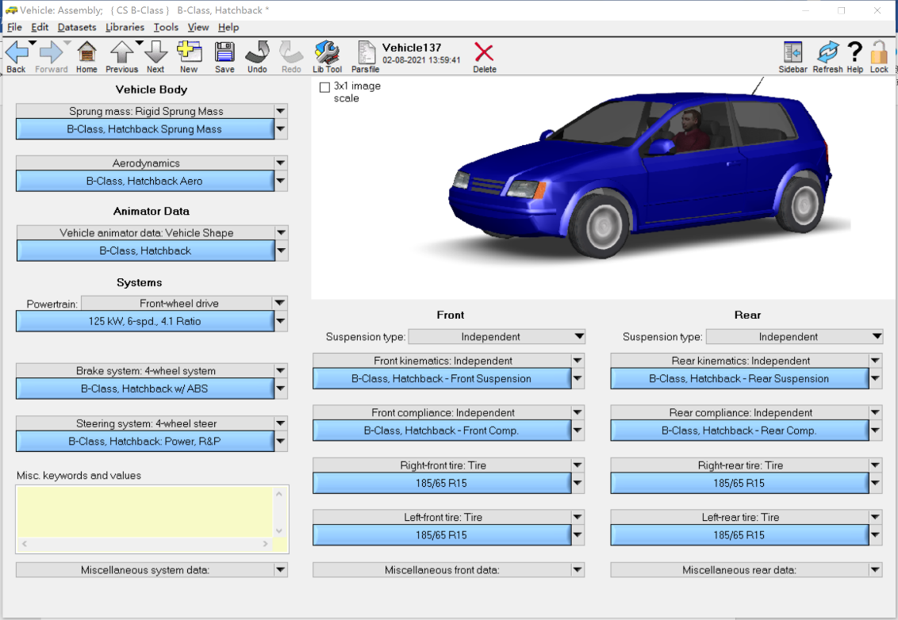
The vehicle model selects the system default B-Class Hatchback model. The specific parameters can be changed in the Vehicle: Assembly interface. Some parameters are shown in Table 16.
Figure 23 Vehicle: Assembly Interface

Table 16 Part of the Model Parameters
Vehicle parameters | Value | Vehicle parameters | Value
Vehicle mass | 1231kg | Front wheel base | 1481mm
Sprung mass | 1111kg | Rear wheel base | 1486mm
Height of center of mass | 540mm | Rigidity of front suspension | 28N/m
Wheel base | 2600mm | Rigidity of rear suspension | 35N/m
Distance from front axle to center of mass | 1040mm | Tire specifications | 185/65 R15
Pitch moment of inertia | 2031.4kg/m2 | Rolling radius of tire | 304mm
Roll moment of inertia | 288 kg/m2
The simulation conditions of the vehicle can be parameterized under Procedure. The speed is set to 72km/h (20m/s), no brake, no steering, and the gearbox is set to the default setting (AT 6th Mode). The simulation is carried out until the entire distance is driven.
- Choice of response
There are many output responses that can be selected in Carsim. From the vehicle response analysis in Chapter 3 , the names of the parameters in the Carsim software are shown in Table 17:
Table 17 Carsim Related Variables
Type | Abbreviation | Unit | Meaning | Symbol
Body | Az_SM | g | Vertical acceleration of mass center | $${\ddot{z}}_{b}$$
Body | AAx | rad/s2 | Roll angular acceleration | $${\ddot{z}}_{bx}$$
Body | AAy | rad/s2 | Pitch angular acceleration | $${\ddot{z}}_{by}$$
Body | AVx | deg/s | Roll angular | $${\dot{z}}_{bx}$$
Body | AVy | deg/s | Pitch angular | $${\dot{z}}_{by}$$
Body | Roll | deg | Roll angle | $$z_{bx}$$
Body | Pitch | deg | Pitch angle | $$z_{by}$$
Suspension | CmpD_(L1\L2\R1\R2) | mm | Reduction of damping | $$f_{di}$$
Suspension | CmpS_(L1\L2\R1\R2) | mm | Reduction of spring | $$f_{di}$$
Wheel | Fz_(L1\L2\R1\R2)  Az_(L1\L2\R1\R2) | N  g | Vertical dynamic load of wheel  Vertical acceleration of wheel | $$F_{di}$$  $$\ddot{z_{i}}$$
Although there is no corresponding variable of suspension dynamic deflection in Carsim, it is equivalent to the combined effect of damping compression and spring compression, and the changes of the two are highly similar (the correlation coefficient is up to 0.99), so choosing the spring compression CmpS_(L1\L2\R1\R2) replace suspension dynamic deflection.
- Co-simulation with Simulink
In order to facilitate the import of road roughness data and export the response simulated by Carsim, the data can be imported into Matlab in the form of co-simulation with Simulink. Specific operations include:
①The Import option can select input variables according to the needs of the model, and select the vertical displacement of the four wheels as input;
②Select the 19 variables selected above in Export;
③Create an empty mdl file in Simulink and save it in a certain path, and enter the path on the Simulink Model in the interface;
④You can choose the working directory of Simulink and send the sim file to the specified location;
⑤The simulation step length can be set, here is 0.01s;
⑥Back to the Carsim initial interface, click Send to Simulink, select the CarSim S-Function module in Simulink, enter the name of the sim file simfile.sim, and then import the road roughness data used in the previous article, and then the data can send to Matlab through the to file function, the data is of Timeseries type by default, and the format is mat.
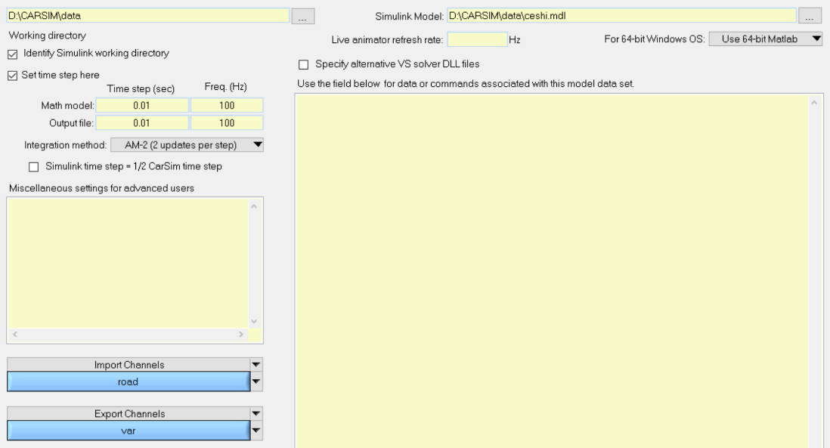
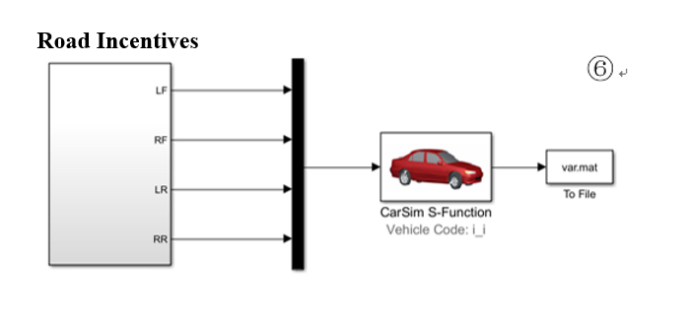
Figure 24 Carsim and Simulink Co-simulation Process
①
②
④
⑤
③

4.2 Recognition Result Analysis
Use the LSTM model to identify the data obtained by Carsim simulation. Because the simulation step in Carsim is 0.01 and the vehicle speed is 20m/s, the number of sampling points is 5001, which is less than the number of sample points based on the ride comfort seven degree of freedom model mentioned above, so epochs and batch need to be changed, while other hyper-parameters still use the comparison method to select the best.
After a certain comparison and selection, the specific parameters of the LSTM model used are: the activation function of the fully connected layer uses the sigmoid function, the optimization algorithm is Adam, the loss function uses the mean square error function (MSE), the epochs is 100 and the size of each batch is 64, the learning rate is 0.01, the two-way LSTM, single-layer network, and the number of neurons are 512. Through the MIV method, it is found that the evaluation indicator is the highest when the full variable is input. Its RMSE is 0.0143, MAE is 0.0112, R is 0.446, and R² is 0.119. The recognition results are shown in Figure 25.
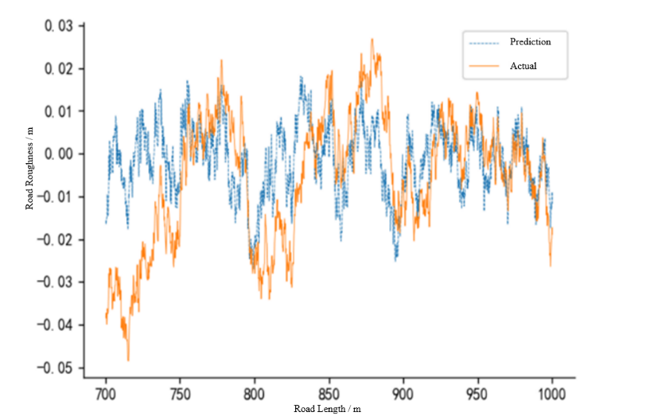
Figure 25 LSTM Recognition Results of Carsim Model

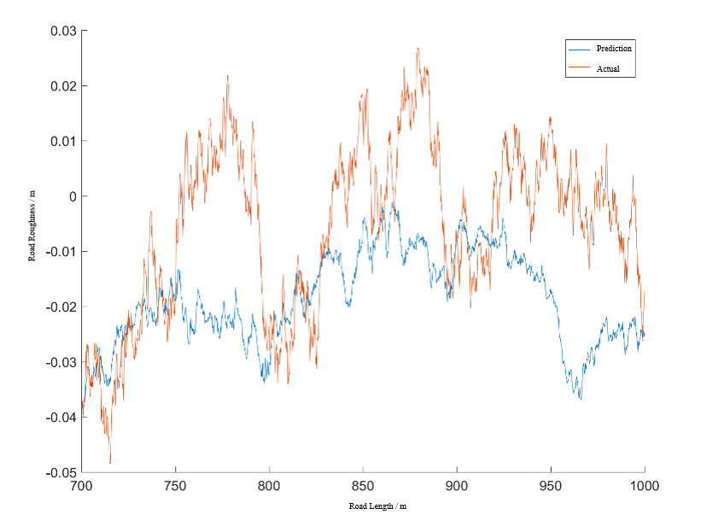
Similarly, using NARX for identification, the selected model parameters remain unchanged, and the roll angular acceleration ${\ddot{z}}_{bx}$, the roll angular velocity ${\dot{z}}_{bx}$, the vertical acceleration of the right front wheel $\ddot{z_{2}}$, and the rear wheel acceleration $\ddot{z_{3}}$、$\ddot{z_{4}}$ are deleted through the MIV method. The RMSE is 0.0191, MAE is 0.0156, R is 0.439, R² is -0.563, the recognition result is shown in Figure 26.
Figure 26 NARX Recognition Results of Carsim Model
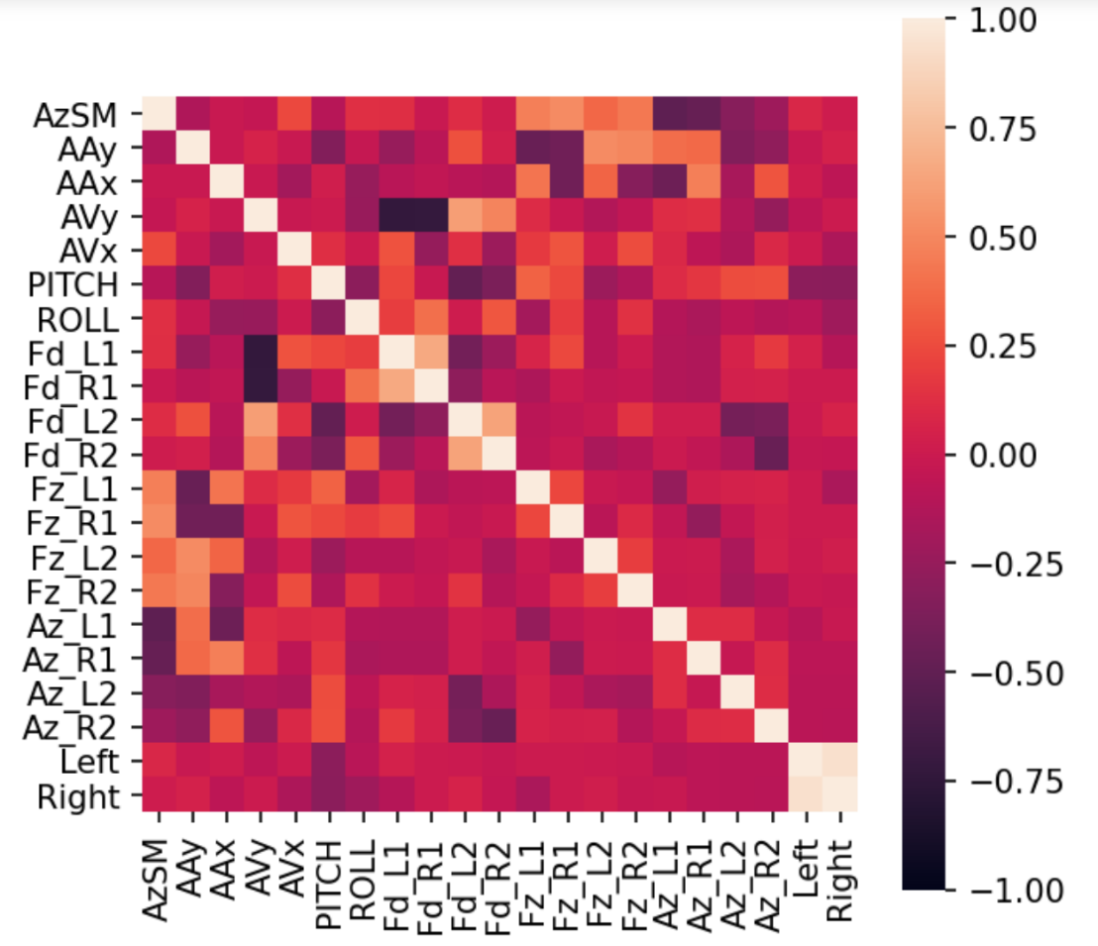
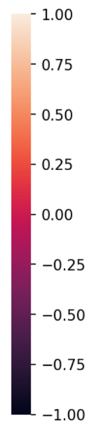
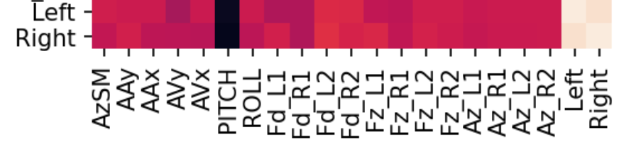
It can be seen that both LSTM and NARX are not good for the road roughness recognition results under Carsim, and there is a big gap between the recognition evaluation indicators in the previous chapter. The main reason for this difference is the increase in the complexity of the Carsim model. Based on the seven degree of freedom model, multiple subsystems such as tire models are added. The direct impact is that the correlation coefficient between the pitch angle and the road roughness is greatly reduced, from the original above -0.9 to below -0.3, as shown in Figure 27, It can be said that the pitch angle alone can have a good recognition effect under the seven-degree of freedom model. Although the vehicle response recognition effect under the Carsim model is poor, it is more in line with the real situation of each response during the movement of the vehicle.
Figure 27 Correlation Coefficient Heat Map
Seven degree of freedom model
Carsim模型
Although the recognition effect is poor, the performance of LSTM is still better than NARX. From the point of view of the algorithm principle, NARX uses the output of the previous moment as the input of the nonlinear system at the next moment, because it is an open-loop system, which leads to large recognition error at time will affect the predicted value at the next time. In Figure 26, although the error is small in the range of 700-750m, as the road surface roughness changes, the error will increase. And then the error become larger, the LSTM performs relatively better because the gate control can filter the input information.

4.3 Improved MIV-LSTM Road Roughness Recognition Method
Because the pitch angle with the highest correlation with the road roughness has been difficult to obtain a better recognition effect, and the non-linear mapping relationship between other input responses and the road surface roughness is not strong, which leads to a large recognition error. To improve the recognition effect, you can start with the input and output data of the neural network.
Subjectively, responses such as the vertical acceleration of the center of mass of the vehicle body reflect more the degree of road surface roughness, that is, the amount of change in road surface roughness, rather than the specific value of road surface roughness. The roughness is identified, as shown in Figure 27, which shows that although the change trend of the identified data and the target data is similar, its value is difficult to correspond one-to-one.
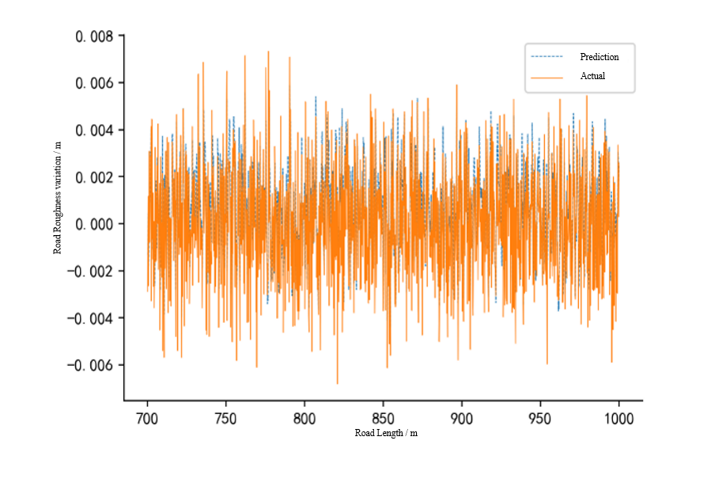
From this point of view, the output data of the model is changed from the road roughness at different moments to the difference between the road roughness at the current time and the previous time, and then the model is trained. The relevant model parameters are consistent with the above. The recognition results are shown in Figure 28. Its RMSE is 0.0014, MAE is 0.0011, R is 0.841, and R² is 0.643.
Figure 28 Recognition Result of LSTM Road Roughness Variation

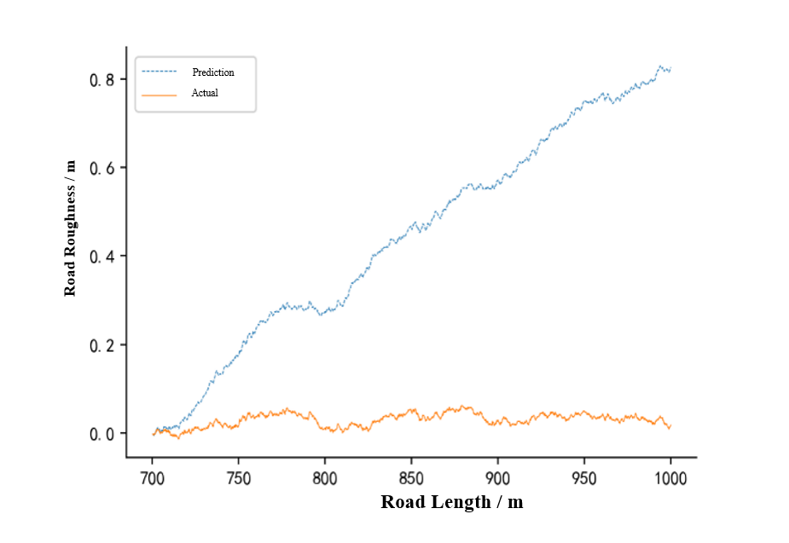
Although the evaluation indicator has improved a lot compared to the direct recognition of road roughness, the performance of the road roughness amount of change data is not intuitive enough. It is still necessary to restore the data to the form of road roughness. Therefore, the identified road roughness amount of change is accumulated and restored, and the result is shown in Figure 29.
Figure 29 Cumulative Result of Road Roughness Variation
From the above figure, it can be found that due to the influence of the accumulated error, there is a large deviation between the predicted value and the true value. In order to correct the error, assuming that the road roughness value at 1000m is known, the coordinates of the predicted result can be calculated based on this rotation, the rotation matrix formula is:
$M(θ)=\left[\begin{matrix}cosθ & -sinθ \\ sinθ & cosθ\end{matrix}\right]$ （4-1）
In the formula, $θ$ is the angle of rotation, because the length of the road is known, it can be determined by the predicted and true values of the initial and end positions
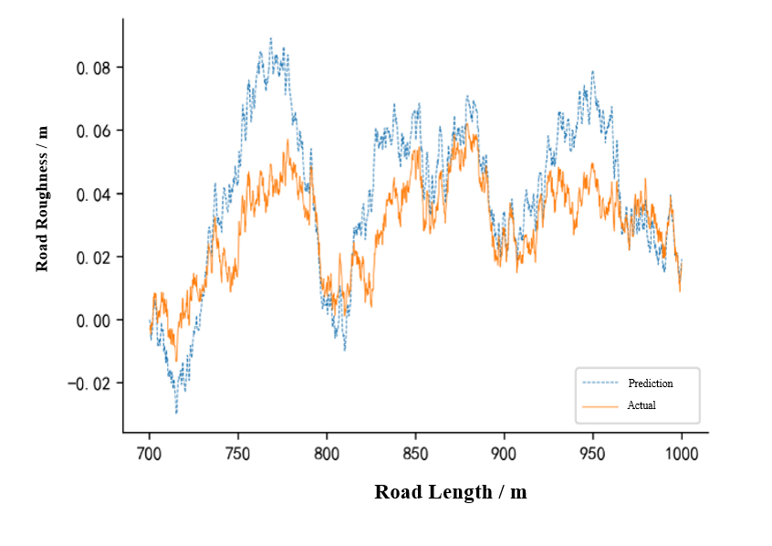
The corrected result is shown in Figure 30. Its RMSE is 0.0171, MAE is 0.0135, R is 0.871, R² is 0.557, and the values of R and R² have been greatly improved.
Figure 30 Correction Results of Road Roughness Recognition
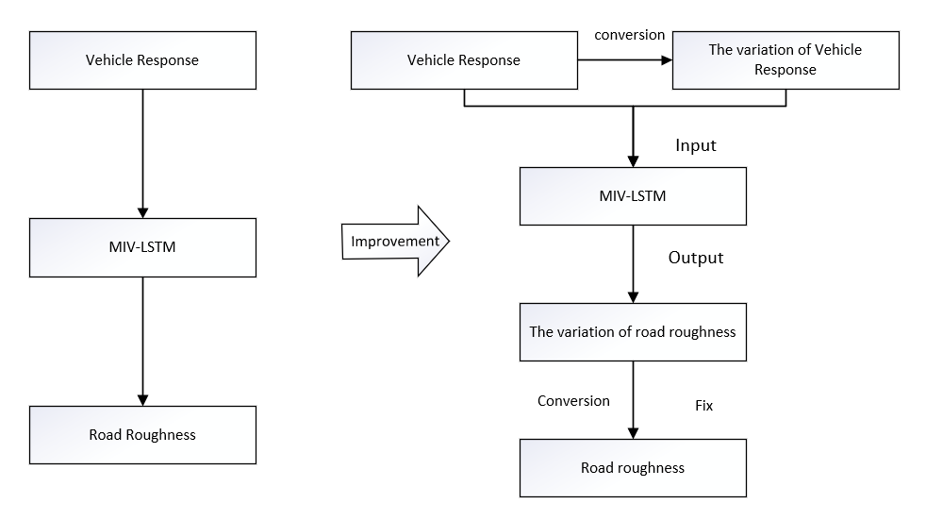
Figure 31 Improved Road Roughness Recognition Methods Based on LSTM
By changing the output data and then performing conversion and correction, the recognition effect of the model has been improved to a certain extent, but there may be a certain correlation between part of the response and the road roughness. When the recognition result is changed to the change of the road roughness, it may be more appropriate to change the corresponding input data to the amount of change in the response angle, but this correlation is difficult to judge subjectively. In order to solve this problem, all input responses are incorporated into the input of the neural network, and then filtered through the MIV method to improve the performance of the model, as shown in Figure 31.
There are 19 original input variables, and there are 38 input variables after adding the response amount of change. As shown in Table 18, the variables whose relative contribution rate $μ$ is less than 2 are filtered by the MIV method, and the pitch angular acceleration ${\ddot{z}}_{by}$, roll angular velocity ${\dot{z}}_{bx}$, pitch angle $z_{by}$, left front suspension dynamic deflection $f_{d1}$, four-wheel vertical dynamic load $F_{d1}$、$F_{d2}$、$F_{d3}$、$F_{d4}$, the vertical acceleration of the left rear wheel $\ddot{z_{3}}$, the vertical acceleration change of the center of mass $∆{\ddot{z}}_{b}$, the change of the pitch angle acceleration $∆{\ddot{z}}_{by}$, the change of the roll angle acceleration $∆{\ddot{z}}_{bx}$, the change of the pitch angle velocity $∆{\dot{z}}_{by}$, front left Suspension dynamic deflection change $∆f_{d1}$, right rear suspension dynamic deflection change ${∆f}_{d4}$, left front wheel vertical dynamic load change $∆F_{d1}$, left front wheel vertical acceleration change $∆\ddot{z_{1}}$, right rear wheel vertical acceleration change $∆\ddot{z_{4}}$ are retained. There are 18 variables, the RMSE is 0.0113, the MAE is 0.0010, R is 0.912, and R² is 0.614 (the evaluation index is the modified value of the model 300m). Although the value of MAE and R is the best for the scheme with μ>3, the difference between R² and $μ>2$ is large, so it is not classified as optimal.
Table 18 The Evaluation Indicator of Different Input Schemes’s LSTM
Methods | Cumulative relative contribution rate | Number of input variables | RMSE | MAE | R | R²
Full input | 100% | 38 | 0.0193 | 0.0168 | 0.900 | 0.255
$$μ>1$$ | 92% | 26 | 0.0172 | 0.0151 | 0.910 | 0.295
$$μ>2$$ | 80% | 18 | 0.0113 | 0.0100 | 0.912 | 0.614
$$μ>3$$ | 63% | 11 | 0.0113 | 0.0098 | 0.916 | 0.495
$$μ>4$$ | 46% | 6 | 0.0221 | 0.0178 | 0.445 | -3.493
$$μ=max$$ | 21% | 1 | 0.0218 | 0.0179 | 0.519 | -4.694
From the screening results, the input variable with the largest cumulative relative contribution rate is the vertical dynamic load change of the front left vehicle $∆F_{d1}$, rather than the pitch angle $z_{by}$ of the seven-degree-of-freedom model in the previous chapter. For example, the left front wheel dynamic deflection $f_{d1}$ and its variation $∆f_{d1}$ are used as inputs to improve the recognition effect of the model, but for example, the pitch angle $z_{by}$ and the centroid vertical acceleration variation $∆{\ddot{z}}_{b}$ are all separately included in the input variables, which is more subjectively. It is difficult to judge whether the factor that affects the recognition result of road roughness anount of change is the vehicle response itself or its change. In the case of full input, the evaluation index is far inferior to the model filtered by the MIV method, which also highlights the importance of filtering input variables.
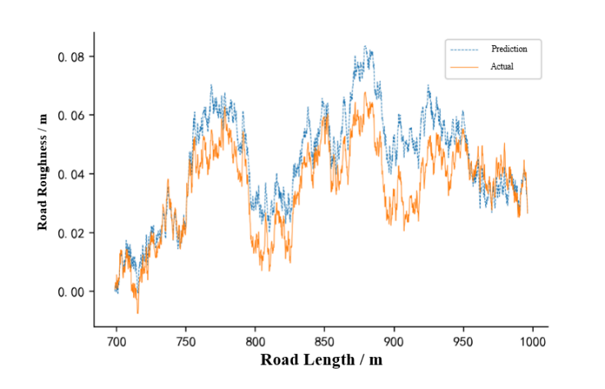
Figure 32 Correction Result of Road Roughness Recognition after Screening by MIV method (Interval 300m)
The recognition results after screening by the MIV method are shown in Figure 32. It can be found that the recognition effect is better when near the start and end positions, while the recognition effect in the middle part is poor. This is also due to the limitations of the correction method. Further, in order to improve the recognition effect, the correction frequency of the accumulated value of the road roughness variation can be shortened. In the previous article, the data was corrected at the end point, that is, at an interval of 300m. For example, every 100m was corrected. The result is shown in Figure 33. The RMSE is 0.0053, the MAE is 0.0043, the R is 0.947, and the R² is 0.880. If you continue to shorten the correction interval, the evaluation index will be further improved.
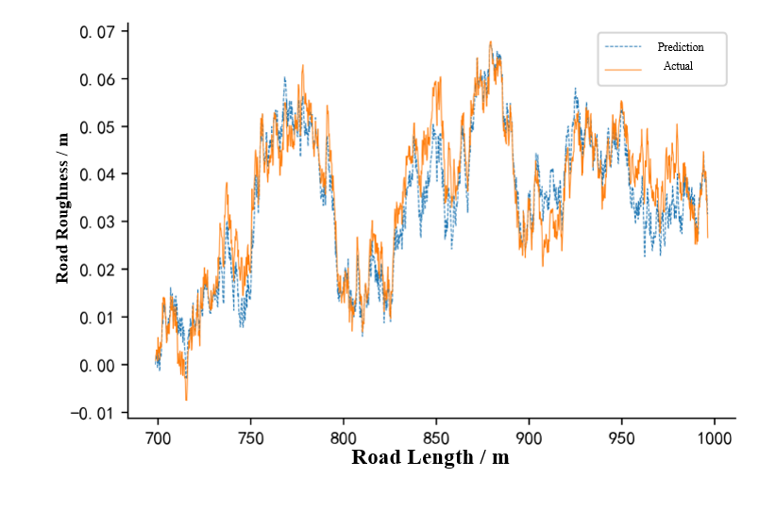
Figure 33 Correction Result of Road Roughness Recognition after Screening by MIV method (Interval 100m）
Finally, the evaluation indicators of different models are summarized, and the statistics are shown in Table 19. The results show that the method of identifying the change of road roughness and then restoring it is better than the method of directly identifying the road roughness. It also reflects the superiority of LSTM compared with NARX and the effectiveness of MIV method. In addition, among the remaining 18 input variables, as shown in Table 2, if the remaining 6 related variables that are not suitable for acquisition are eliminated, the recognition effect will be poor, indicating that although the pitch angle and the vertical dynamic load of the wheel are difficult to obtain in practice, but it is an indispensable input variable for road roughness recognition.

Table 19 Comparison of Evaluation Indicator of Different Models Based on Carsim
Model | Data changes | Input variable | Correction interval | RMSE | MAE | R | R²
MIV-NARX | No | 14/19 | No | 0.0191 | 0.0156 | 0.439 | -0.563
LSTM | No | 19/19 | No | 0.0143 | 0.0112 | 0.446 | 0.119
LSTM | Output | 19/19 | 300m | 0.0171 | 0.0135 | 0.871 | 0.557
LSTM | Output | 19/19 | 100m | 0.0187 | 0.0146 | 0.859 | 0.474
LSTM | Input and output | 38/38 | 300m | 0.0193 | 0.0168 | 0.900 | 0.255
LSTM | Input and output | 38/38 | 100m | 0.0094 | 0.0075 | 0.923 | 0.752
MIV-LSTM | Input and output | 18/38 | 300m | 0.0113 | 0.0100 | 0.912 | 0.614
MIV-LSTM | Input and output | 18/38 | 100m | 0.0053 | 0.0043 | 0.947 | 0.880
MIV-LSTM | Input and output | 12/38 | 300m | 0.0156 | 0.0128 | 0.605 | -1.43
MIV-LSTM | Input and output | 12/38 | 100m | 0.0153 | 0.0129 | 0.642 | -2.19

4.4 Chapter Summary
This chapter changes the data source method of vehicle response simulation based on the previous chapter. The road surface roughness is identified by the simulation results of the dynamics simulation software Carsim; the recognition results under the seven degree of freedom model are compared, and analyze the reason for the poor performance of the algorithm under Carsim. An improved MIV-LSTM road roughness recognition method is proposed: the method of identifying the change of the road roughness through the response and the change of the response, and then performing the conversion correction method, this method can greatly improve the recognition effect of the model, and as the correction interval is shortened, the evaluation index will also be improved.

Chapter 5: Application Extension of Road Roughness Recognition

5.1Introduction
This chapter is based on the previous research. The research content is about identifying the road surface grade

5.2 Road Grade Recognition without Correction
From the chapter above, it can be seen that the improved LSTM road roughness recognition method has a good recognition performance. After the recognized road roughness is converted into the power spectrum density, the road grade of the recognized road surface can be naturally judged. However, this method has certain limitations. It must be corrected every interval to reduce the error caused by the accumulation of road roughness amount of change, which brings certain inconvenience. If no correction is made, the value of the road roughness cannot be obtained more accurately, and it is difficult to judge the road surface level.
The recognition result of the amount of road roughness change can also reflect part of the road surface. If the road surface grade is recognized directly through it, the necessary step of data correction can be bypassed. In order to verify this point of view, the model trained in Chapter 4 is used to identify the amount of road roughness change under four different road levels (each level of road length is 1000m), and the results are shown in Figure 34.
It can be found that there are obvious differences in the amount of road roughness changes identified by the model under different road grades, which also proves the rationality of the above viewpoints. In order to identify the road grade, it is necessary to extract the features in these data. The features selected in this chapter are shown in Table 20.
Figure 34 Recognition Results of Road Roughness Variation of Different Road Grades
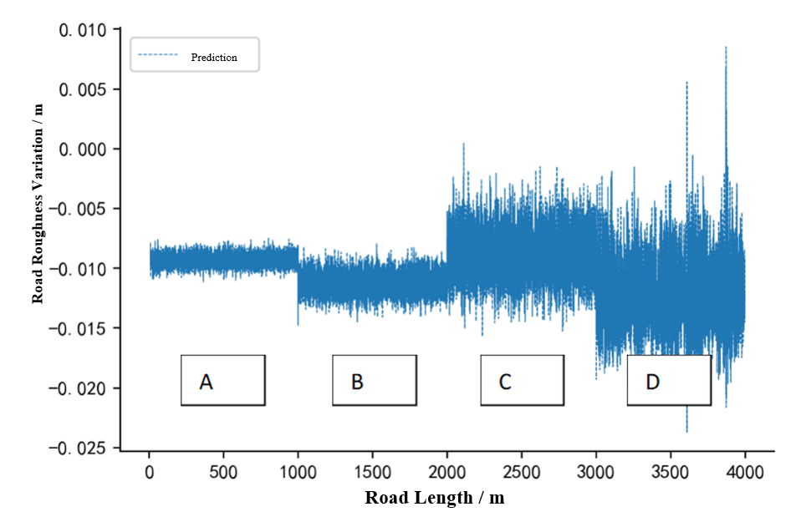
Table 20 Selected Features and Expressions
Features | Symbol | Expressions
Mean | $$F_{1}$$ | $$\frac{\sum_{n=1}^{N}{x(n)}}{N}$$
Variance | $$F_{2}$$ | $$\sqrt{\frac{\sum_{n=1}^{N}{{(x\left(n\right)-F_{1})}^{2}}}{N-1}}$$
Square Root Amplitude | $$F_{3}$$ | $${\left(\frac{\sum_{n=1}^{N}{\sqrt{\left|x(n)\right|}}}{N}\right)}^{2}$$
Root Mean Square | $$F_{4}$$ | $$\sqrt{\frac{\sum_{n=1}^{N}{{(x(n))}^{2}}}{N}}$$
Peak | $$F_{5}$$ | $$max\left|x(n)\right|$$
There are many algorithms for classification problems. This chapter uses Support Vector Machine (SVM) model.

5.2.1 Basic Principles of SVM
SVM is a commonly used classification algorithm in machine learning. It is widely used in digital recognition, face recognition, and industrial diagnosis. It has good performance for small sample, non-linear and high-dimensional feature classification problems. The core idea of SVM is to find an optimal hyperplane in a given sample space for dividing different types of data. When the sample is linearly inseparable, it needs to be mapped to a higher-dimensional space and then divided [59].
The hyperplane used for classification can be expressed as:
$w^{T}x+b=0$ （6-1）
In the formula, $w^{T}$ is the weight vector, which determines the direction of the hyperplane. $b$ is the offset, which determines the distance from the hyperplane to the origin. Assuming that the hyperplane （$w^{T}$，$b$） can correctly classify the sample, it can be expressed as:
$\left\{\begin{aligned}w^{T}x_{i}+b≥1,y_{i}=+1 \\ w^{T}x_{i}+b≤-1,y_{i}=-1\end{aligned}\right.$ （6-2）
In the formula, $x_{i}$ is the feature of the sample, $y_{i}$ is the label, and the classification is correct when the signs of $w^{T}x_{i}+b$ and $y_{i}$ are consistent
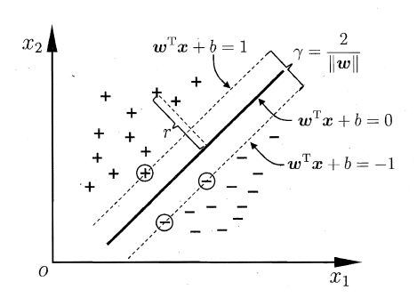
Figure 35 Support Vector and Interval
As shown in Figure 35, to obtain the optimal hyperplane, you need to constantly adjust the values of $w$ and $b$ to maximize the interval $\frac{2}{\left|\left|w\right|\right|}$, and maximizing $\frac{1}{\left|\left|w\right|\right|}$is equivalent to minimizing ${\left\|w\right\|}^{2}$, so the basic expression of SVM is formula-(5-3), which transforms the target classification problem into a problem of solving a constrained target minimum
$\begin{matrix}\min_{w,b}{\frac{1}{2}{\left\|w\right\|}^{2}} \\ s.t. y_{i}\left(w^{T}x_{i}+b\right)≥1,i=1,2,..m \end{matrix}$ （6-3）
In order to solve the above formula, the Lagrange operator $α$ can be introduced to convert it into a dual problem.
$\begin{matrix} \\ \begin{matrix}\max_{α}{\sum_{i=1}^{m}{α_{i}-\frac{1}{2}\sum_{i=1}^{m}{\sum_{j=1}^{m}{α_{i}α_{j}y_{i}y_{j}x_{i}^{T}x_{j}}}}} \\ s.t. \sum_{i=1}^{m}{α_{i}}y_{i}=0 \\ { α}_{i}≥0,i=1,2,..m\end{matrix} \end{matrix}$ （6-4）
After solving $α$ by formula (5-4), the optimal hyperplane can be obtained by finding $w$ and $b$. However, in the face of the linear inseparability problem of the data set (that is, the data cannot be separated by a straight line), It is necessary to use the kernel function to map the data set to a higher dimensional space to become a linearly separable problem, which can be obtained by solving the equation (6-4):
$f\left(x\right)=\sum_{i=1}^{m}{α_{i}}y_{i}k\left(x,x_{i}\right)+b$ （6-5）
In the formula, $k\left(x,x_{i}\right)$ is the kernel function, and the commonly used kernel functions are shown in Table 21.
Table 21 Common Kernel Functions
Name | Expressions | Parameters
Linear Kernel | $$k\left(x_{i},x_{j}\right)=x_{i}^{T}x_{j}$$
Polynomial Kernel | $$k\left(x_{i},x_{j}\right)={{(x}_{i}^{T}x_{j})}^{d}$$ | $d≥1$, d is the degree of polynomial
Gaussian Kernel | $$k\left(x_{i},x_{j}\right)=exp⁡\left(-\frac{{\left\|x_{i}-x_{j}\right\|}^{2}}{2σ^{2}}\right)$$ | $σ>0$, $σ$ is the bandwidth of the Gaussian kernel
Laplace Kernel | $$k\left(x_{i},x_{j}\right)=exp⁡\left(-\frac{\left\|x_{i}-x_{j}\right\|}{σ}\right)$$ | $$σ>0$$
Sigmoid Kernel | $$k\left(x_{i},x_{j}\right)=tanh⁡(βx_{i}^{T}x_{j}+θ)$$ | $tanh$ is the hyperbolic tangent function，$β>0,σ<0$
According to the above-mentioned basic principles of SVM, it can be found that it is only suitable for two classification problems, and when performing multi-classification, it is necessary to construct multiple SVM classifiers, and then obtain the final recognition target category according to a series of SVM classifier results.

5.2.2 Evaluation indicator
Commonly used classification evaluation indicators include precision, recall and F1 score. The precision refers to the proportion of the number of correctly classified positive samples to the positive samples determined by the classifier, and the recall rate refers to the proportion of the number of correctly classified positive samples to the true positive samples. F1 score is the weighted sum average of precision and recall. F1 score can be used to compare different classification models. The expressions are:
$precision=\frac{TP}{TP+FP}$ （6-6）
$recall=\frac{TP}{TP+FN}$ （6-7）
$f1 score=\frac{2*precision*recall}{precision+recall}$ （6-8）
In the formula, TP (Ture Positive) is is the number of positive classes predicted by positive class, FP (False Positive) is the number of positive classes predicted by negative class, and FN (False Negative) is the number of positive classes predicted by positive class. For multi-classification problems, each category can be regarded as a positive category, and other categories can be regarded as a negative category. The evaluation indicator of each category is calculated separately. The average value of the evaluation indicator can be regarded as a comprehensive evaluation of the classification performance of the model.

5.2.3 Road Grade Recognition Result
Sample the data in Figure 34. every 5m, calculate the characteristics of the sampled data and then add the corresponding road grade label to obtain the data set for the road grade classification model, with a total of 800 samples.

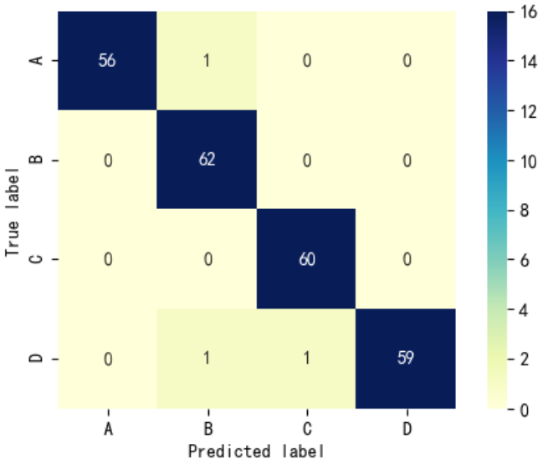
The relevant model is implemented in the Jupyter compiler using the machine learning framework Sklearn. The kernel function of the model adopts linear, and other hyperparameters are set as default values. In the sample, 70% is randomly selected as the training set, and the other 30% is the testing set. The confusion matrix is shown in Figure 36, and the evaluation indicators are shown in Table 22.
Figure 36 Confusion Matrix Visualization for Road Grade Recognition
Table 22 Evaluation Indicator for Road Grade Recognition
Road Grade | Precision | Recall | F1 score | Frequency
A | 1 | 0.98 | 0.99 | 57
B | 0.97 | 1 | 0.98 | 62
C | 0.98 | 1 | 0.99 | 60
D | 1 | 0.97 | 0.98 | 61
Average | 0.99 | 0.99 | 0.99
It can be seen that in the 64 B-grade road samples, 2 samples are recognized as A-grade and D-grade, and 61 C-grade road samples are recognized as D-grade. The recognition accuracy of other road surfaces has reached 100%. The average value of the evaluation indicator is as high as 0.99, which fully proves the effectiveness of SVM for its classification.

5.3 Chapter Summary
This chapter mainly studies the extended application of road roughness recognition. The road surface classification recognition without correction is studied, and the SVM model is used to prove that it has a high recognition accuracy.

Chapter 6: Conclusion

6.1 Research Summary
Road roughness is the key to the study of road problems. The road roughness can directly reflect the state of the road surface, and the road surface grade can also describe the road surface condition to a certain extent. This dissertation uses the LSTM algorithm to use the vehicle response to identify the road surface roughness. On this basis, it is difficult to obtain a more accurate road surface roughness without correction. The SVM algorithm is proposed to identify the road surface grade, which improves the road roughness recognition process. The main contents of the full text study are as follows:
(1) The importance of road roughness is summarized, and the application value of road roughness recognition based on vehicle response is discussed; Road roughness model, road classification based on vehicle response, and road roughness recognition based on vehicle response are summarized. The current domestic and foreign research status, analyzes the shortcomings of the existing road roughness recognition research.
(2) The principle of road roughness recognition based on neural network is introduced, and the vehicle response is screened in consideration of the actual situation; the road roughness and vehicle response data are obtained on the basis of the filtered white noise model and the ride comfort seven degree of freedom model, and the LSTM is built. The neural network introduces correlation coefficient, coefficient of determination, root mean square error and average absolute error as the evaluation indicators of the model, and uses the MIV method to screen each input response, and further evaluates the performance of NARX and LSTM in road roughness recognition; It is found that LSTM performs better than NARX. Filtering the input response through the MIV method can effectively improve the recognition results of the model
(3) The ride comfort seven degree of freedom model was replaced by the dynamics simulation software Carsim, and the recognition results of the same algorithm under Carsim were found to be poor, and the specific reasons were analyzed. An improved MIV-LSTM road roughness recognition method was proposed, which is based on vehicle response. And the response change to identify the change in road roughness, and then perform conversion correction to obtain the final road roughness. The study found that this method can greatly improve the recognition effect of the model. As the correction interval is shortened, the evaluation indicator will be better.
(4) In the case of MIV-LSTM without correction, SVM is used to identify the road surface grade through the variation of road roughness. The average F1 score of road grade recognition reaches 0.99, which is effective for road grade recognition.

6.2 Research Outlook
Although this dissertation has done a little work on the research and application of road roughness recognition, and achieved certain research results, due to time, personal academic ability, and scientific research conditions, there are still some defects in the research part, and it needs to be done in the following aspects:
(1) The LSTM algorithm is only a common algorithm for sequence problems in deep learning. Although this article compares it with the NARX algorithm commonly used by others, there are many similar algorithms. What kind of neural network is the best algorithm for identifying road roughness needs further study;
(2) For the vehicle response, especially the pitch angle and the vertical dynamic load of the wheel, which are indispensable in the recognition of road roughness, there are certain errors in the actual measurement, although the research results in this article show that the random noise of the vehicle response take small impact, but after all, it is carried out at the simulation level. In the actual measurement, for the accuracy of the signal, it also involves filtering and other algorithms. The impact on the final recognition result remains to be studied;
（3）The vehicle models used in Carsim in this article are all built-in software models. The impact of the specific parameters of the suspension, wheels and other subsystems on road roughness recognition is still to be studied.
(4) For the simulated vehicle operating conditions, this article is limited to straight-line and constant-speed driving. For the case of non-linear shifting, the effect of this method still needs a lot of data support and verification, which needs to be further in-depth.

Reference
- H. M. Duan, F. Shi, F. Xie and K. B. Zhang, “A Survy of Road Roughness Study,” (路面不平度综述) Journal of Vibration and Shock, vol.28, no. 9, pp.95-101+216, 2009
- Z. W. Zhang, “Power Function Model Identification of Road Statistical Characteristics Based on International Roughness Index and Vehicle Vibration Response,” Ph.D. dissertation, Coll. Auto. Eng., Jilin Univ., Changchun, China, 2019
- Doumiati M, Erhart S, Martinez J, “Adaptive control scheme for road profile estimation: application to vehicle dynamics,” IFAC Proceedings Volumes, vol.47, no. 3 pp.8445-8450, 2014
- Dickerson R S, Mace D．A high speed profilometer preminary description. TRRL Report SR 182 UC, Crowthorne, 1976.
- Dembski N, Rizzoni G, Soliman A．An improved design of a vehicle based off-Road terrain profile measurement system. Commercial Vehicle Engineering Congress & Exhibition, 2018.
- X. X. Guo, Z. Xu, M. L. Li, B. Yang and B. Wang, “A Survy of Road Roughness Study,” (路面不平度测量技术研究综述) Journal of China and Foreign Highway, vol.29, no. 5, pp.47-51, 2009
- Y. L. Zhang, “Time Domainmodel of Road Irregularities Simulated Using the Harmony Superposition Method,” (用谐波叠加法重构随机道路不平顺高程的时域模型) Transactions of the CSAE, vol.19, no. 6, pp.32-35, 2003
- J. Yin, X. B. Chen, L. X. Wu and Y. L. Liu, “Simulation Method of Road Excitation in Time Domain Using Filtered White Noise and Dynamic Analysis of Suspension,” (滤波白噪声路面时域模拟方法与悬架性能仿真) Journal of Tongji University (Natural Science), vol.45, no. 3, pp.398-407, 2017
- X. W. Zhang and Z. Y. He, “A Numerical Simulation of Two-Dimension Poisson Process and its Application in Simulation of an Uneven Road,” (二维泊松过程的数值模拟及其在道路模型中的应用) Journal of Chongqing University, vol.17, no. 4, pp.12-16, 1994
- X. D. Liu, Z. D. Deng and F. Gao, “Research on the Method of Simulating Road Roughness Numerically,” (公路路面不平度的数值模拟方法研究) Journal of Beijing University of Aeronautics and Astronautics, vol.29, no. 9, pp.843-846, 2003
- Mattia F, Le Toan T, “Backscattering Properties of Multi-Scale Rough Surfaces,” Journal of Electromagnetic Waves and Applications, vol.13, no. 4, pp.493-527, 2014
- B. Z. Zhang, H. P. Wang, Z. Zhang and M. W. Cheng, “Fractal Construction Method of 2D Road Roughness,” (二维路面不平度的分形构造方法) ACTA Armamentarh, vol.41, no. 12, pp.47-51, 2020
- Y. H. Xu, “Computer Simulation on Stochastic Road Irregularities,” (随机路面谱的计算机模拟) Transactions of The Chinese Society of Agricultural Machinery, vol.38, no. 1, pp.33-36+29, 2007
- Y. L. Zhang, Q. W. Yi, S. Y. Ding and W. P. Wang, “Research on Time Series Modeling Method of 3D Stochastic Road,” (三维随机路面时序建模研究) Journal of Wuhan University of Technology, vol.29, no. 8, pp.92-95, 2007
- G. L. Wang, J. G. Qian and J. Liu, “Study on Methods for Creating 3D Stochastic Road Model in VPG,” (VPG中三维随机路面模型建立方法研究) Machinery Design & Manufacture, vol.2010, no. 10, pp.194-196, 2010
- Lin M, Zhang X W, Cheng S Y, “Simulation of General 3D Virtual Stochastic Road Model,” Applied Mechanics and Materials, 2011
- Xie M X, Wei Y D, Zhou X J, “Modeling and Dynamic Simulation of Tracked Vehicle in Vortex,” Advanced Materials Research, pp. 295-297:1764-1767, 2011
- Z. H. Luo, Y. D. Wei, X. J. Z. Zhou, F. C. Yang and M. X. Xie, “3D Random Excitation Road Surface Modeling and Simulation,” (随机激励三维路面空间域模型建模与仿真) Journal of Vibration and Shock, vol.31, no. 21, pp.68-72, 2012
- J. H. Guo, “Simulation Study of Semi-active Suspension’s Control Strategy Based on Carsim Software,” M.S. thesis, Coll. Auto. Eng., Chang’an Univ., Xi’an, China, 2017
- H. P. Wang, Z. Zhang and Q. Li, “Coherence of Phase Angle of Harmonic Superposition Components in Time Domain Simulation of Road Roughness for Right and Left Wheel Tracks,” (路面时域模拟的谐波叠加组分中相位角的相干性研究) Trancations of Beijing Institute of Technology, vol.39, no. 10, pp.1034-1038, 2019
- Y. J. Lu, Z. Y. Li, W. Q. Huai and W. H. Huang, “Reconstruction of Three-Dimensional Pavement Spectrum Based on Fractal Theory and Its Application in Multi-Body Dynamic Software,” (基于分形理论的三维路面谱重构及在多体动力学软件中的应用) Journal of Graphics, vol.40, no. 2, pp.328-334, 2019
- R. P. Wang, X. Z. Jiao and G. L. Wang, “A Study on Road Surface Spectrum Identification of Typical Roads Based on the Vertical Acceleration of Vehicle Body,” (基于汽车车身垂直加速度的典型道路路面谱识别研究) Automotive Engineering, vol.30, no. 12, pp.1047-1051, 2008
- M. T. Yao, J. F. Guan and G. Liang, “Research on Road Identification Based on Vehicle Vibration Acceleration Response,” (基于车辆振动加速度响应的路面识别研究) Tractor & Farm Transporter, vol.38, no. 1, pp.28-31, 2011
- Z. G. Li, J. Hou, K. Wang and Q. H. Liu, “Application of Fuzzy Support Vector Machine on Road Type Recognition,” (模糊支持向量机在路面识别中的应用) Journal of Data Acquisition and Processing, vol.29, no. 1, pp.146-151, 2014
- Y. Q. Hu and F. Zhao, “Research on Road Profile Classification Based on Multi-sensor Information Fusion,” (基于多传感器信息融合的路面等级识别研究) Vehicle & Power Technology, vol.2017, no. 3, pp.15-19, 2017
- Yechen Q, Reza L, Zhenfeng W, “Road excitation classification for semi-active suspension system with deep neural networks,” Journal of Intelligent and Fuzzy Systems, vol. 33, no. 3, pp. 1907-1918, 2011
- Zhiming Z, Chao S, Raj B, et al., “Application of a Machine Learning Method to Evaluate Road Roughness from Connected Vehicles,” Journal of Transportation Engineering, vol. 33, no. 3, pp. 1907-1918, 2017
- Y. Q. Hu and F. Zhao, “Research on Road Profile Classification Based on Multi-sensor Information Fusion,” (基于多传感器信息融合的路面等级识别研究) Vehicle & Power Technology, vol.2017, no. 3, pp.15-19, 2017
- Yu W, Zhang X, Guo K, et al., “daptive real-time estimation on road disturbancesproperties considering load variation via vehicle vertical dynamics,” MathematicalProblems in Engineering, vol. 2013, pp. 1-9, 2013
- Arat M A, Taheri S, Holweg E., “Road profile estimation for active suspension applications,” SAE International Journal of Passenger Cars - Mechanical Systems, vol. 8, no. 2, pp. 492-500, 2015
- Ward C C, Iagnemma K., “Speed-independent vibration-based terrain classification for passenger vehicles,” Vehicle System Dynamics, vol. 47, no. 9 pp. 1095-1113, 2009
- Ngwangwa H M, Heyns P S, Labuschagne F J J, et al., “Reconstruction of road defects and road roughness classification using vehicle responses with artificial neural networks simulation,” Journal of Terramechanics, vol. 47, no. 2, 2009
- Yousefzadeh M, Azadi S, Soltani A., “Road profile estimation using neural network algorithm,” Journal of Mechanical Science and Technology, vol. 24, no. 3 pp. 743-754, 2010
- Ali S, Shahram A, Reza K., “Road profile estimation using wavelet neural network and 7-DOF vehicle dynamic systems,” Journal of Mechanical Science and Technology, vol. 26, no. 10 pp. 3029-3036, 2012
- Ngwangwa H M, Heyns P S, Breytenbach H G A, et al., “Reconstruction of road defects and road roughness classification using Artificial Neural Networks simulation and vehicle dynamic responses: Application to experimental data,” Journal of Terramechanics, vol. 53, 2014
- Philippe N, Rainer S, Michael, et al., “Comparison of machine learning methods for evaluating pavement roughness based on vehicle response (Article),” Journal of Computing in Civil Engineering, vol. 28, no. 4, 2014
- D. D. Cui, C. Q. Zhang and D. Han, “Road Roughness Detection and Simulation Based on BP Neural Network,” (基于BP神经网络的路面不平度检测与仿真) Computer Integrated Manufacturing Systems, vol.31, no. 5, pp.162-166, 2014
- Z. Q. Gu, Y. F. Zhu, S. Zhang and X. K. Ma, “Identification of Mining Road Roughness Based on GA-BP Neural Network,” (基于GA-BP网络的矿山路面不平度辨识) China Mechanical Engineering, vol.25, no. 23, pp.3232-3238, 2014
- L. X. Zhang, H. M. Zhang, and F. Q. Pan, “Study on Road Surface Roughness Identification of Freeways,” (高速公路路面不平度识别研究) Structural Engineers, vol.30, no. 4, pp.105-111, 2014
- Yechen Q, Mingming D, Reza L, et al., “Adaptive Hybrid Control of Vehicle Semiactive Suspension Based on Road Profile Estimation,” Shock & Vibration, vol. 2015, no. 0, pp.1-13, 2015
- Zhiming Z, Chao S, Raj B, Mingxuan S., “Road profile reconstruction using connected vehicle responses and wavelet analysis,” Journal of Terramechanics, vol. 80, 2018
- S. F. Gu, J. Gu, L. L. Zhen, Q. Zhao and J. Li, “Road Roughness Identification Based on BP Neural Network,” (基于BP神经网络的路面不平度识别) Chinese Journal of Automotive Engineering, vol.9, no. 4, pp.252-259, 2019
- J. Li, W. C. Guo, S. F. Gu and Q. Zhao, “Road Roughness Identification Based on NARX Neural Network,” (基于NARX神经网络的路面不平度识别) Automotive Engineering, vol.41, no. 7, pp.807-814, 2019
- J. Li, W. C. Guo, S. F. Gu and Q. Zhao, “Road Roughness Identification Based on Four Typical Neural Network,” (基于4种典型神经网络识别路面不平度的研究) Automotive Engineering, vol.42, no. 1, pp.100-107, 2020
- C. Lin and Y. Shi, “Road roughness recognition based on NARX neural network,” (于非线性有源自回归神经网络的路面不平度识别) Journal of Nanjing University of Science and Technology, vol.44, no. 3, pp.296-302, 2020
- L. B. Jiang, Automotive Sensors and Their Applications, 4th ed. Beijing, China, Publishing House of Electronics Industry,2010.
- . Y. Z. Huo, “Research in Measurement of MEMS Gyroscope Random Drift Compensation,” M.S. thesis, Scho. Instru. Sci. & Eng., Southeast Univ., Nanjing, China, 2015
- L. Shang, “The Design and Implementation of Wheel Force Transducer with Motion Perception Ability,” M.S. thesis, Scho. Instru. Sci. & Eng., Southeast Univ., Nanjing, China, 2018
- Y. L. Zhang, “Study on Numerical Modeling and Computer Simulation of Stochastic Road of Vehicles,” Ph.D. dissertation, Scho. Mech. Sci. & Eng., Huazhong Sci. & Tech. Univ., Wuhan, China, 2010
- W. Wang, “Cooperative Research and Simulation Realization of Automobile Ride Comfort and Handing Stability,” M.S. thesis, Coll. Auto. Eng., Jilin Univ., Changchun, China, 2016
- Z. S. Yu, Vehicle Theory, 3th ed. Beijing, China, Publishing House of Mechanical Industry,2000.
- Q. Zhao, W. Wang, L. Luo and J. Li, “Motion Simulation of a New High Overload Flight Simulator,” (基于空间模型的轿车平顺性时域建模和仿真) Sicence Technology and Engineering, vol.17, no. 4, pp.99-104, 2017
- Hochreiter S., Schmidhuber J., “Long Short-Term Memory,” Neural Computation, vol. 9, no. 8, pp.1735-1780, 1997
- Aston. Zhang, M. Li Hands-on Deep Learning, 5th ed. Beijing, China, Post & Telecom Press,2019
- . Y. Li, X. C. Wang, L. Yu et al. Analysis of 43 Cases of MATLAB Neural Network, 5th ed. Beijing, China, Beihang University Press,2013
- Xu G, Schwarz P, Yang H., “Determining China's CO2 emissions peak with a dynamic nonlinear artificial neural network approach and scenario analysis,” Energy Policy, vol. 9, no. 8, pp.752-762, 2019
- Q. L. Zhao, F. Qiu and J. Yang, “Application of NARX Neural Network Model in Environmental Air Quality Prediction in Kunming,” (NARX神经网络模型在昆明市环境空气质量预测中的应用) Environmental Monitoring in China, vol.35, no. 3, pp.42-48, 2019
- W. J. Chen, “Construction and Prediction of Stock Market Sentiment Index Based on PCA and NARX Dynamic Neural Network,” M.S. thesis, Sch. Math., Lanzhou Univ., Lanzhou, China, 2016
- Z. H. Zhou, Machine Learning, 5th ed. Beijing, China, Tsinghua University Press,2016.

