Engineering Management: Management, innovation and sustainability
ACHA5012 & ACMA5007
Preston Thomas (2305918)
Contents
1.0 Introduction to project. 2
2.0 Roles of team members & their responsibilities. 3
3.0 Skills and personality traits needed for my role. 4
4.0 Detailed list of my tasks. 5
5.0 Significant milestones for the whole project. 6
5.1 Creating a Plan. 6
5.2 Research Complete 7
5.3 Analytical Work 7
5.4 Design Creation 7
5.5 Experimental Work 7
5.6 Modelling Work 8
5.7 Viva Work and Presentation 8
6.0 Gateway objective. 8
7.0 Areas of concern within my section and suitable measures to mitigate the risk. 9
8.0 Overall summary Gantt chart for the whole project. 9
8.1 Group Gantt Chart 9
9.0 Detailed plan for my section of the project. 10
9.1 Personal Gantt Chart 10
References 11

Introduction to project.
In this group project we will be working as a team to design, build and test an active rear wing system that works effectively in a real-life scenario. The project is guided by a design brief which presents the scenario that an automotive manufacturer wishes to produce a performance version of one of their vehicles. We are tasked with creating an active rear wing system that will increase the downforce of the vehicle as well as increasing drag to assist with deceleration.
The project is split into 5 key groups: aerodynamics, structural design, control system design, mechatronics components and vehicle performance assessment. This is to ensure that the work is divided between team members and that everyone contributes to the final project.
There are technical regulations given by the manufacturer that we need to adhere to for each section. This will help us keep our designs realistic but still give us a chance to explore our options with different designs.
To measure the success of our project and make sure we stay on track, we will have weekly team meetings to keep up to date with each other on our progress, share information and updates and make sure that the group is working efficiently. Along the way, we will have specific milestones to hit to help us track our progress. By the end of the project, we will have a fully functional rear wing and a presentation on how we designed and created it.

2.0 Roles of team members & their responsibilities.
Roles | Name of team members | Responsibilities
Aerodynamics | Alex Griffiths & Mohammed Mahmood | Responsible for CFD analysis and model testing in the wind tunnel.
Structural Design | Nevin Jyothis & Jacob Gough | Designing components based on the data other groups supply.  Testing the designs using SolidWorks.  Material selection.  Creating a prototype.
Control System Design & Mechatronics Components | Jacob Ling, Preston Thomas & James Evans | Use of Arduino I/O devices.  Data Handling and MATLAB programming.  Selecting components for both the prototype and full-scale versions.  Creation of control algorithms to help move the wing to the required angles which are given in correlation with the simulation and aero groups.
Project Management | Alex Griffiths | Group organization such as setting up meetings and group documents.  Resource management and making sure the group stays on task.  Budget & cost projection.
Vehicle Performance Assessment | Emily Dawes & Angel Stanley | Responsible for figuring out response times.  Making sure everything works on prototypes.  Gathering the necessary figures for each group to be able to input the correct data.

3.0 Skills and personality traits needed for my role.
In my role I am responsible for learning MATLAB and coding the wing. This role is vital for the functionality of the wing; therefore, I must be precise and accurate with my code. In order to fulfill my role, I must remain levelheaded and ensure that I thoroughly check all elements of the code to guarantee it is correct.
Belbin’s team role theory notes two attributes that each individual brings to a team. Firstly, their competencies, meaning their specific skills, experiences and qualifications known as the ‘task focus’. Secondly, their ability to collaborate within a team – this is known as the ‘team focus’.
Regarding my ‘task focus’, to do my role, I need to be methodical and exact. I fulfill these traits as I am very systematic with what I do, meaning I can ensure accuracy. I demonstrate a useful task focus for my role as I have gained valuable experience through studying Motorsports throughout my time at university. This has helped me gain important skills that make me adaptable for a coding role such as improving my mathematics and scientific skills. In the past year, I have studied MATLAB which has honed my computer skills making me suitable for a coding role.
In terms of the team focus aspect, Belbin discovered nine distinctive behavioral clusters. For my role, the most useful behavior cluster is the ‘implementer’ (Belbin, n.d.). This category of people turns ideas into reality. This is especially important within my role as a control system designer as I am responsible for taking the team’s desired outcomes and creating a code that fulfills this. I think I am well suited to the implementer team focus as I am determined and will ensure that the code is completed.

4.0 Detailed list of my tasks.

Task | Description of the task. | Hours needed to complete task & dates completed | Preliminary bill of materials. | Specialist equipment.
Complete the MATLAB Onramp | Go through MATLAB Onramp online course and become familiar with the equipment | 8 hours, 15/10/2024 | £128 wage cost (calculated at £16/hour).  MATLAB is free with university (if we had to pay MATLAB is £800 for the year) | MATLAB
Complete the Simulink Onramp | Go through the Simulink Onramp online course and become familiar with the skills needed | 7 hours, 17/10/2024 | £112 wage cost  MATLAB is free with university. | MATLAB
Learn about PID | Watch the PID videos in the teams channel to gain an understanding of PIDs | 6 hours, 18/10/2024 | £96 Wage cost | N/A
Signal Filtering Research | Filter PWM to variable voltage: Research converting pulse width modulation (PWM) to a variable voltage | 8 hours, 22/10/2024 | £128 wage cost  MATLAB is free with university. | MATLAB
Circuit Board Research | Learn about relevant circuit boards and there uses. | 5 hours, 23/10/2024 | £80 wage cost | N/A
General control research | Research control equipment and find out what the best for us to go about coding it would be. | 10 hours, 31/10/2024 | £160 Wage cost | N/A
Go through Arduino script documents | Go through the compiled documents on Arduino use and scripts to gain further knowledge on it. | 9 hours 02/11/2024 | £144 Wage Cost  MATLAB is free with the university.  Arduino is free with the university (if we had to purchase the Arduino it would cost £18.08) | MATLAB  Arduino
Arduino Demo | Complete our first demo so we can begin improving the code to meet our own requirements. | 20 hours, 11/11/2024 | £320 Wage Cost  MATLAB is free with the university.  Arduino is free with the university. | MATLAB  Arduino
Circuit bread research | Research the use of bread boards and how it may be useful to us. | 6 hours, 14/11/2024 | £96 Wage Cost | N/A

The final cost while using university resources would be £1264. If we were not using university resources, it would cost £2082.08.

5.0 Significant milestones for the whole project.

5.1 Creating a Plan.
Creating a plan is a key part of the project as it allows for us to gain an idea of the steps we need to complete the task and visualize the pathway to completing the project. This milestone also allows us to create other milestones and is the building blocks for the group project. Without this milestone we would struggle to track progress and stay on topic.

5.2 Research Complete
Once the research is complete, we can start making the bigger decisions as we have the necessary data and information to do so. This is a key part, as we can start setting some integral objectives for each subgroup so progress can remain steady throughout the rest of the project. This also means we are able to make educated changes to the plan and can continue to expand our knowledge throughout. If we had left the research portion till later on, we could have run into issues where the logistics of the plan we had were unattainable due to lack of knowledge on the subjects. This demonstrates how vital this milestone is for the rest of the project.

5.3 Analytical Work
Doing analytical work would require us to complete some research and do the calculations that are needed for us to continue. This would entail the aero subgroup discovering the figures for maximum force that is exerted on the wing when experiencing lift and drag. Without this work we wouldn’t be able to create a design that would meet these parameters and would struggle to continue past this point. This work would greatly decrease the amount of trial error we would have to do to gain the information we need. This milestone is a bigger focus on the group’s efficiency and helping us stay ahead of schedule more than it is for the design’s performance.

5.4 Design Creation
Creating designs would give us some figures necessary for us to continue with the project. If this milestone is not completed before we continue, we would struggle to perform any tests, or even begin to create a model as we would be unaware of the capabilities and parameters of the piece. This would majorly hold us back; however, this could not be completed before the research as we need the research to be able to begin this section. Creating the design will also give the team a clearer focus as we are aware of exactly what we are creating and can boost team morale.

5.5 Experimental Work
Experimenting with different ideas and running some tests will help us understand what changes and improvements we need to make to the designs we have created. This is especially important in the control subgroup as we will need to run multiple tests on the code before we put it to use on the actual model - this is to make sure we don’t put strain on any of the components and damage them. This is important because although we can change figures in code quite simply, recreating and fabricating parts of the rear wing is a harder and more expensive task. Therefore, experimenting at the earlier stage of the initial coding helps us avoid more costly and detrimental mistakes.

5.6 Modelling Work
Creating our first model would be our first full look at our project and would allow us to see if it works. This would give us a greater understanding of any changes needed as to the actual design or code as we can see it working. These changes could be making the code more flexible, generous to light taps to the brakes, or adjusting the size of the wing to that it fits better. Having an actual model would mean we can have visual representation of what we have completed and be able to examine the project to make any necessary adjustments and changes. Once we have a fully completed and working model, we will know our project has been successful. This illustrates why this is such an important milestone.

5.7 Viva Work and Presentation
Practicing our presentation and going through it as a group will allow us to rehearse and make sure we can discuss all our points in the timeframe allocated to us. This is important because we don’t want to talk about topics that aren’t particularly relevant, but we still need to get our point across and explain them properly. We want to make sure that we have a valid explanation for our reasoning as to the decisions we made throughout our project. Practicing our presentation will help us spot and mistakes, ensure our information is cohesive and feel more confident before our final presentation.

6.0 Gateway objective.
A gateway objective that I think would help track progress is testing the code in MATLAB via simulation. This would give us a better understanding of how the project is performing, as well as keeping us on track for completion. Simulating the code would help us validate the code’s functionality and is quite a large milestone in this section of the project. This simulation test will help us figure out if the code works in all the relevant scenarios such as acceleration, braking and cornering. These cases would all require the rear wing to act differently. Using a MATLAB simulation, we could repeat the tests in the same conditions to allow for optimization of the code so that the rear wing works exactly how intended.
If the code run correctly in the simulation, then we will be confident and ready to begin building a model, as we now know the code is consistent and reliable. We can then move onto the next gateway objective which could involve using a prototype and making sure it works on a moving model. If we note errors during the simulation, we can tweak the code to remedy them. Doing the simulations early on in the project gives us time to go back and make any changes needed.

7.0 Areas of concern within my section and suitable measures to mitigate the risk.
A potential risk could be inputting incorrect data or mistyping part of the code. This could be known as a syntax error which occurs when the computer can not output the expected result, due to a missing or invalid piece of code. This simple but common mistake can be prevented by reading the code to check for any mistakes. Coding systems also normally have a system in place to pick up on incorrect code when you test it, it typically highlights the line with the problem to assist the user in finding the issue and resolving it. This risk is therefore easily mitigatable as long as I take my time and check the code thoroughly.
Another issue I may come across is run time errors. This is where the code runs perfectly fine on one computer, but when loaded up on another computer, it may not work due to a difference in settings, or versions of MATLAB software. If the software is running on different versions, we will just have to update the computer to the correct version before we plan on testing. If we find that both the versions are the same, then it must be a problem with the secondary devices settings in MATLAB which we will also have to check through before conducting any tests.

8.0 Overall summary Gantt chart for the whole project.

8.1 Group Gantt Chart
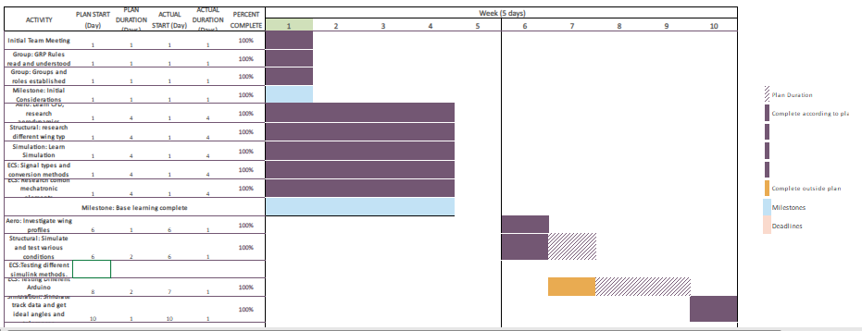

9.0 Detailed plan for my section of the project.

9.1 Personal Gantt Chart
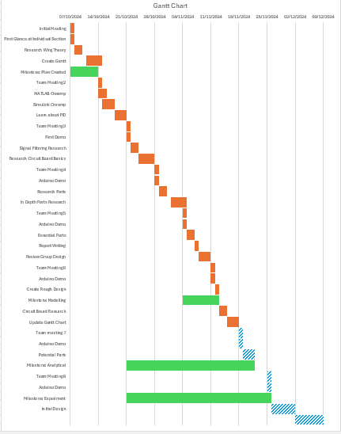

References
Belbin, D. M. (n.d.). The Nine Belbin Team Roles. Retrieved from Belbin: https://www.belbin.com/about/belbin-team-roles

