  Data Manipulation |   Module: Advanced Statistical Programming  Module code: ACCA7022  Lecturer: Dr Aliyu Sambo  Student name: Alexei Nica  Student ID number: 2232919  Submission deadline:  23rd October 2026

Table of Contents

Introduction 2
A. Explanation of Code and Logic 2
B. Justification of Programming Choices 4
C. Testing and Validation 4
D. Efficiency and Scalability Reflection 5
E. Reflection on Learning and Use of Generative AI 6
Appendix A. Detailed flowcharts 7
Appendix B. Testing evidence 13
Separate calculations 13
Separate calculations and comparison with section E 13

Introduction

This report explains how I used R to simulate warehouse activity and analyse the generated data. The aim was to turn individual records into useful summaries and identify unusual processing values. It discusses the programming choices, checks on the results and limitations of the approach, followed by a reflection on what I learned.

Explanation of Code and Logic

The script follows warehouse activity from generating records to producing summaries and checking unusual values. Figure 1 shows the sequence, with detailed flowcharts in Appendix A (Figures 2-7). Each stage builds on the data created earlier.
In section A (see Figure 2), I used three nested for loops to cover 28 days, five zones and six product categories. This produces 840 records, with one row for each combination. The dataframe is created first, then each completed row is added using rbind(). Units processed are calculated from the base value, zone, category and a random variation between -12 and +12. Processing time is calculated afterwards because it depends on the units processed, multiplied by 0.85. A fixed seed makes the generated values repeatable, while displaying the first ten rows and the dimensions provides an initial check of the dataset.
Sections B (Figure 3) and C (Figure 4) use a similar process to summarise these records. For each zone, an inner loop checks every row, and an if condition selects the units belonging to that zone. The total restarts at zero before moving to the next zone, preventing values from the previous zone being included. For category processing times, the loop adds matching times and counts the records included. The completed result is then stored in the summary table.
In task D, I included both interpretations of the anomaly calculation because they examine different aspects of production. In D (Figure 5), each category record is compared with the average of the six categories for the same day and zone. One inner loop calculates that average, a second checks the records against its +/- 15% limits. This order matters because the average must be complete before the comparisons begin. Two vectors store the averages and anomaly results in positions matching the original rows. Each anomaly result starts as FALSE and changes to TRUE only when a value falls outside the limits.
D1 (Figure 6) instead combines all categories into one daily total per zone, producing 140 rows. The zone total from B is divided by 28 to obtain its average daily production. Each daily total is compared with the average for that same zone.
Finally, section E (Figure 7) calculates daily totals for each zone and keeps the highest value found, together with its day. Both are updated whenever a larger total appears, ensuring that the stored day corresponds to the stored maximum. The completed table identifies the most productive day for each zone.

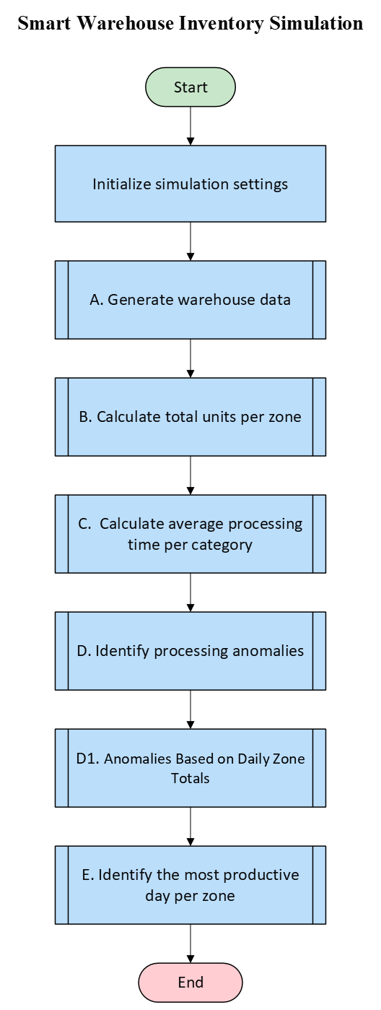
Figure 1. Smart Warehouse Inventory Simulation Flowchart

B. Justification of Programming Choices

I chose for loops because the ranges of days, zones and categories are known in advance. A while loop could perform the same calculations but would require counters to be updated manually and stopping conditions to be managed. Using for keeps the repeated steps easier to follow and reduces the chance of forgetting to advance a counter. The if conditions then select which records contribute to each calculation.
The anomaly task caused uncertainty because the two comparisons answer different questions. Keeping both results in separate tables made this difference clear. With the fixed seed, D produced 47 anomalies and D1 produced none.
I used rbind() to add one completed row at a time because this was easy to follow and check. Another option would be to prepare empty vectors, fill them during the loops and create the table at the end, as in task D. The table would then be built only once, but each result would need to go into the correct vector position.
A dataframe keeps related values together in each row, while named columns make it easier to select the information needed for each calculation.
With a larger dataset, repeatedly scanning every record for each group could become slow. Preparing storage in advance or collecting totals during fewer scans could help. For 840 records, I prioritised steps that I could follow and check.
The simulation assumes the same processing time per unit for every category. This keeps the calculation simple but does not account for products that may take longer to process.

C. Testing and Validation

I selected three checks to examine the processing-time formula, anomaly calculations and peak-day result. For the first record, multiplying the units processed by 0.85 reproduced the stored processing time (Appendix B). Table 1 summarises the comparisons, with supporting results in Appendix B.

Table 1. Selected validation checks
Calculation checked | Expected result | Script result | Evidence
A: first record’s processing time | 125 × 0.85 = 106.25 minutes | 106.25 minutes | Appendix B, Table 2
D: day 1, zone 1 anomalies | Only 148 falls outside limits 104.4083–141.2583 | Only category 6  identified as an anomaly | Appendix B, Table 2
D1 and E: zone 1 daily totals | Totals 724–780 are within limits 636.3161–860.8982; maximum is 780 on day 6 | No daily anomalies;  peak day 6 with 780 units | Appendix B, Table 3

For D, I checked the six category records from day 1, zone 1. Their average and 15% limits were calculated separately, then compared with the anomaly results. This allowed both outcomes to be checked: values outside the limits should be TRUE, while those insides should remain FALSE (Appendix B, Table 2).
D1 produced no anomalies. To investigate this result, I compared zone 1’s minimum and maximum daily totals with its limits. Both were within the limits, supporting the absence of anomalies for that zone. Comparing the same daily totals also confirmed that day 6 had the highest production, matching E (Appendix B, Table 3).
These checks supported the selected results but did not cover every zone or possible input. The peak-day comparison also used daily totals calculated in D1, so it checked agreement between the two sections rather than independently verifying every daily total.

D. Efficiency and Scalability Reflection

For 840 records, this approach is manageable and the steps are easy to follow. With more days, zones or categories, however, the repeated searches through warehouse_data would become a concern. In D, every day-zone combination involves two searches through the whole table, including records that do not belong to that group. As the dataset grows, more time would be spent repeating these checks.
Adding rows with rbind() could also become slower because the growing table may need to be copied. Preparing the storage before the loops and collecting totals in fewer searches would be possible improvements.
For future changes, I would replace repeated values such as 28, 5 and 6 with named settings. This would allow the simulation to be extended without editing several loops. The current version supports learning, but its organisation would need review for larger datasets.

E. Reflection on Learning and Use of Generative AI

The most challenging part was understanding what the anomaly calculation should compare. At first, I expected the two interpretations to produce similar results. Working through them showed me that an average only makes sense when its comparison group is clear. Keeping both versions helped explain why individual categories could be flagged while daily zone totals remained within their limits.
I also became more comfortable with the difference between storing individual records and building summary tables. Following how totals, counters and vector positions changed through the loops made the calculations easier to understand.
AI supported the organisation of the report and helped rephrase explanations more clearly. Some suggestions were too complicated or did not match what I meant, so they needed questioning and revision. Also, AI helped me explore R concepts in more detail through step-by-step explanations, building on the module examples that I tested to understand how they worked in practice.

Appendix A. Detailed flowcharts
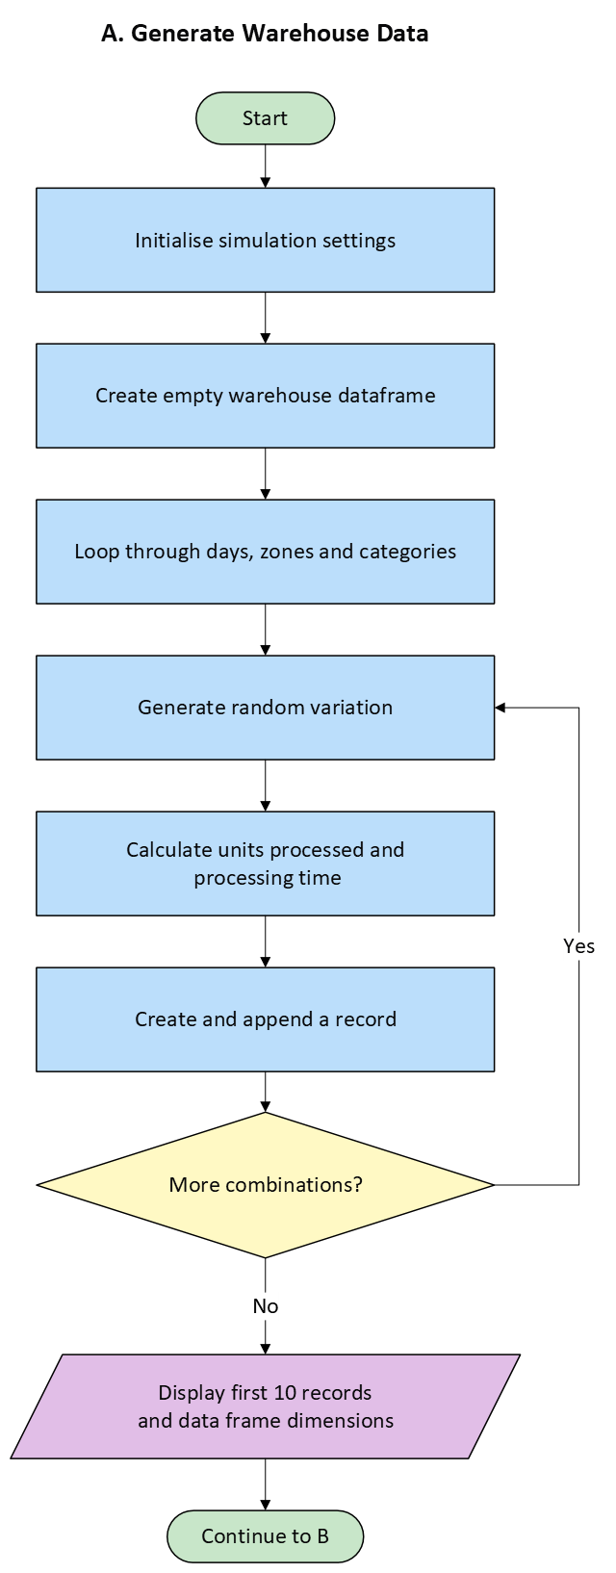
Figure 2. Generate Warehouse Data
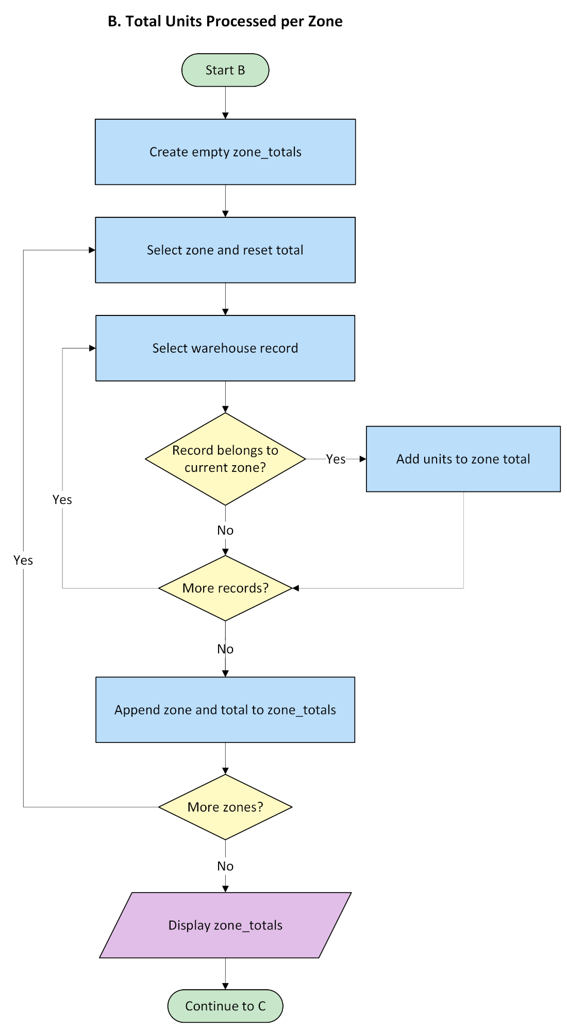
Figure 3. Total Units Processed per Zone

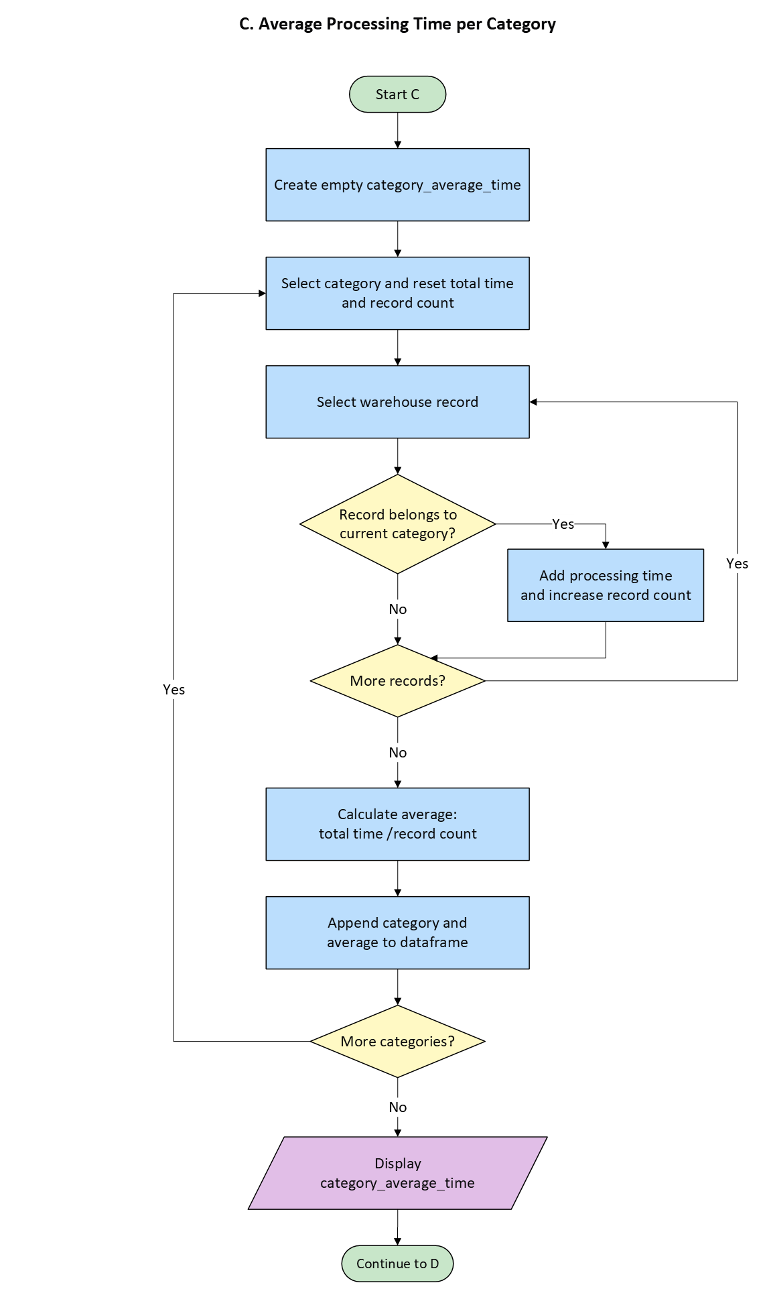
Figure 4. Average Processing Time per Category
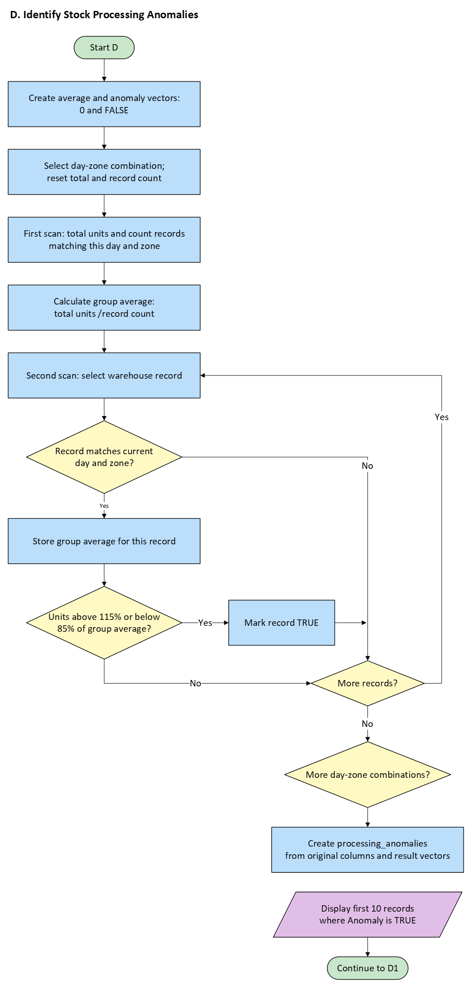
Figure 5. Identify Stock Processing Anomalies

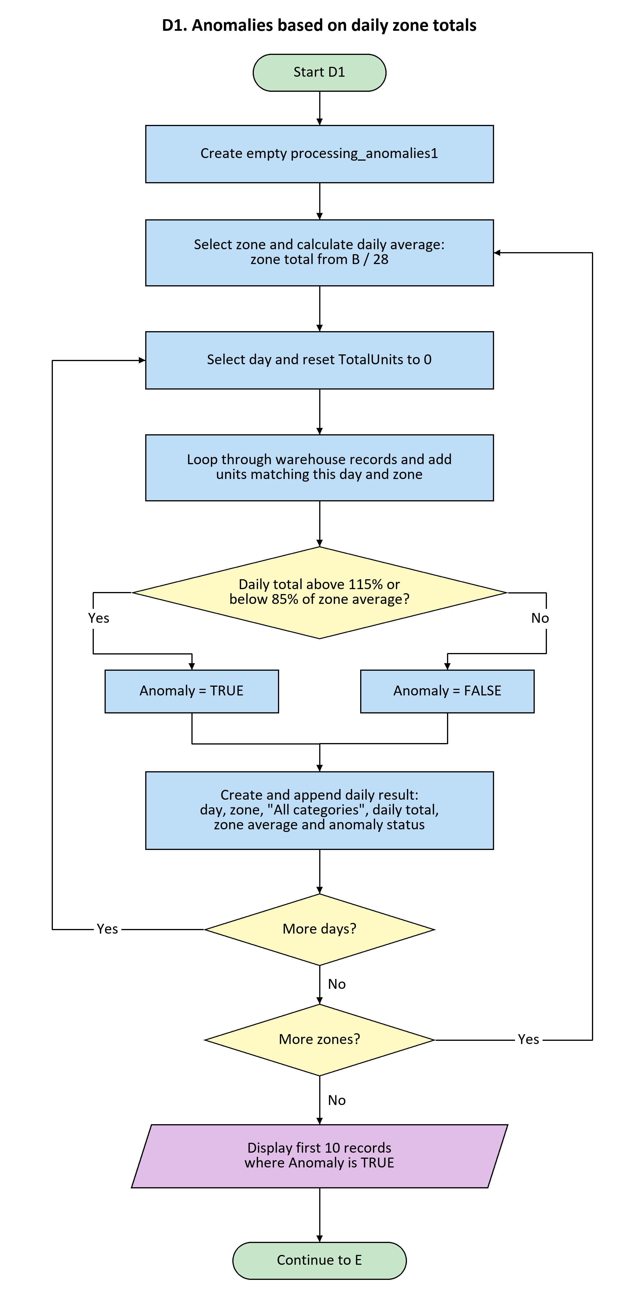
Figure 6. Anomalies Based on Daily Zone Totals

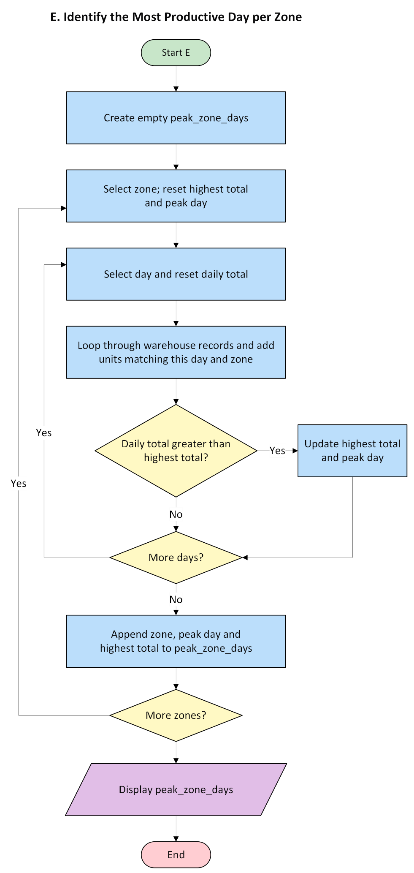
Figure 7. Identify the Most Productive Day per Zone

Appendix B. Testing evidence

Table 2. Day 1, zone 1: processing time and category anomalies
Category | Units  Processed | Processing  Time (min) | Daily Zone  Average | Anomaly
1 | 125 | 106.25 | 122.8333 | FALSE
2 | 109 | 92.65 | 122.8333 | FALSE
3 | 117 | 99.45 | 122.8333 | FALSE
4 | 116 | 98.60 | 122.8333 | FALSE
5 | 122 | 103.70 | 122.8333 | FALSE
6 | 148 | 125.80 | 122.8333 | TRUE

Separate calculations
Processing time for the first record: 125 × 0.85 = 106.25 minutes.
Total units: 125 + 109 + 117 + 116 + 122 + 148 = 737.
Average units: 737 ÷ 6 = 122.8333.
Lower limit: (737 ÷ 6) × 0.85 = 104.4083.
Upper limit: (737 ÷ 6) × 1.15 = 141.2583.
Only 148 falls outside these limits. Category 6 is the only anomaly in this group, matching the result in processing_anomalies.

Separate calculations and comparison with section E

Sum of the 28 daily totals: 20,961 units. Daily average: 20,961 ÷ 28 = 748.6071.
Limits: (20,961 ÷ 28) × 0.85 = 636.3161; (20,961 ÷ 28) × 1.15 = 860.8982.
The minimum daily total is 724 and the maximum is 780. Both are within the limits, supporting the FALSE results for zone 1.
The highest daily total is 780 on day 6. The stored result in peak_zone_days is Zone 1, Day 6, TotalUnits 780, which agrees with this comparison.

Table 3. Zone 1: daily totals and anomaly results
Day | UnitsProcessed | DailyZoneAverage | Anomaly
1 | 737 | 748.6071 | FALSE
2 | 732 | 748.6071 | FALSE
3 | 749 | 748.6071 | FALSE
4 | 749 | 748.6071 | FALSE
5 | 739 | 748.6071 | FALSE
6 | 780 | 748.6071 | FALSE
7 | 761 | 748.6071 | FALSE
8 | 746 | 748.6071 | FALSE
9 | 737 | 748.6071 | FALSE
10 | 744 | 748.6071 | FALSE
11 | 724 | 748.6071 | FALSE
12 | 739 | 748.6071 | FALSE
13 | 747 | 748.6071 | FALSE
14 | 767 | 748.6071 | FALSE
15 | 761 | 748.6071 | FALSE
16 | 743 | 748.6071 | FALSE
17 | 758 | 748.6071 | FALSE
18 | 740 | 748.6071 | FALSE
19 | 766 | 748.6071 | FALSE
20 | 740 | 748.6071 | FALSE
21 | 731 | 748.6071 | FALSE
22 | 761 | 748.6071 | FALSE
23 | 750 | 748.6071 | FALSE
24 | 752 | 748.6071 | FALSE
25 | 765 | 748.6071 | FALSE
26 | 734 | 748.6071 | FALSE
27 | 754 | 748.6071 | FALSE
28 | 755 | 748.6071 | FALSE

