Workplace Culture and its impact on Organizational Efficiency

How do broader external Environmental factors Along with the COVID-19 effect Organizational culture and Its performance

Lecture: Syed Jaffery
Cod assessment: BMSW5105
Student name: Ailene Tudor Alexandru
Student No: 1817993

Executive Summary

This report is set out to address the impact of Environmental factors and COVID-19 on organisations culture and performance of Unilever. Various management theories has been used to provide guidance and assistance to the organization. These models and theories help in evaluating the performance of the company in order to enhance its functions so that the organization can achieve its objectives. Also, the company culture has been examined and appropriate techniques are implemented to improve its performance. The theories are critically evaluated and mentioned in this report and a number of recommendations has been outlined.
Table of content

Introduction 4
Company Overview (Unilever) 4
Management Theories 5
Figure: Management Theories 6
Source: (Medhekar, 2020). 6
Impact of organizational theories on the culture and performance of Unilever 15
Present organizational culture 16
Corporate objective and Social Responsibilities of Unilever 19
Integrity and Ethical Standards 21
Reference list 23

Introduction

The report briefly evaluates all the concepts and provides a brief description of each topic. The focal points of discussion are management theories, models to ensure better working in the organizational structure, and an effective environment. Firstly these theories are broadly explained and then their applicability and suitability on the working and operations of the environment of organization Unilever are described. In this context, the present culture of the organization is also described. The values and beliefs of the organization to ensure sustainable development in the organization are also described in detail in this report.

Company Overview (Unilever)

The company Unilever is a British-Dutch multinational company that deals in consumer goods. The headquarters of the company is situated in Rotterdam and London. It is a public limited company and was established in 1929. It has completed almost 91 years of existence. The area of operation of the company is worldwide and it deals with products like breakfast cereal, tea, soft drinks, chewing gum, juice, ice creams, candy, mineral water, consumer health care products, coffee, and personal care, skincare, and cleaning agents. Currently, more than 155000 employees are working in the organization. It owns several brands and the revenue from operations of the organization is very high. The company has assured continuous growth and development since its establishment. It is one of the largest international companies. The legal structure of the company comprises of registered head office and several other subsidiaries. The branding and advertising of the company are done by its unique U shaped logo. This increases the corporate value of the company. The identity of the brands of the company is based upon the idea of adding vitality to life. It uses many social media and online platforms to promote its products. It is a fast-moving consumer goods company. The company owns approximately 310 factories and the operations of the company are diversified more than 70 countries. The network channel of the company comprises 400 warehouses globally. The objective of the organization is to provide unique opportunities to create a positive change in society it will help the company to achieve its objective of growing its business and sustainable living and development. The success of the organization depends upon the users of the products or customers of the company. More than 2.5 billion people use the products of the company every day. More than 400 products of Unilever are used globally. The turnover of the company is about Euro 52 billion according to the recent reports.


Figure: Unilever
Source: (Paine et al., 2019)

Management Theories

It is termed as a collection of thoughts that suggest a general system and regulations to effectively run the business enterprise. These theories also address how supervisors implement the strategies in the organization. These strategies help in accomplishing organizational goals. They motivate the employees to perform excellently and come up with their highest abilities. The concepts from different management theories are applied to improve the culture of the company. They serve as the framework to run business organizations in today's era. The management theories in this contrast are defined in detail below along with their significance and implications (Medhekar, 2020).

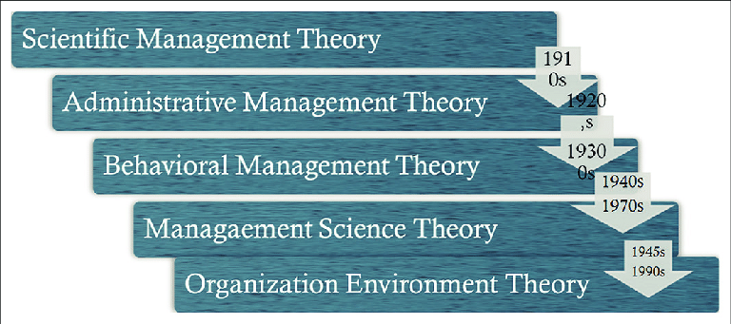

Figure: Management Theories

Source: (Medhekar, 2020).

Scientific management theory
It was developed by Fredrick Taylor as he was the first person to study the position of work effectively. The principles described by Taylor are also opposed by some leaders. The philosophy of his theory described that people should work hard to gain more efficient and productive results in their workplace. He recommended that complex tasks must be divided into small jobs to be accomplished on time. He also suggested that leaders must assign jobs to the rest of the team members according to their capabilities and also provide them with training to bring out their efficient role for the organization. This theory of management emphasizes achieving maximum efficiency and advantage at the workplace so that the best possible way to the optimum achievement of goals of the organization can be drawn. The theory has not much significance and implication in today's era. But overall this theory is very helpful in achieving the objectives of the organization. This theory also emphasizes collaboration between workers and supervisors. The major principles are defined below:
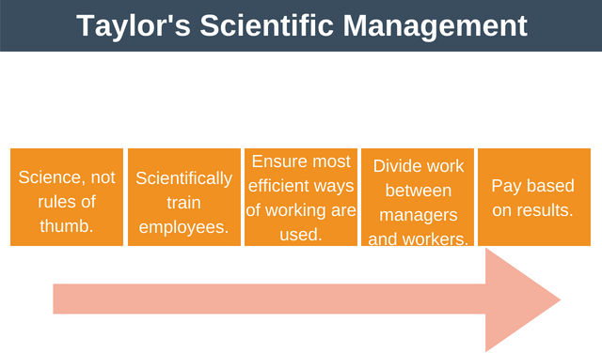
Figure: Scientific management theory
Source: (Gines and Vasco).

Science not the rule of thumb
As per this principle, each job and the technique of doing it must be usually based on scientific study or analysis and not the trial or error method. The job that has to be performed must be effectively designed. The work to be done must be determined through an objective study (Gines and Vasco).

Harmony not discord
The second principle states that there must be healthy collaboration among employers and workers. Taylor also advocates complete cerebral revolution on the part of both employees and owners. Management must take a progressive approach and distribute productivity profits with employees. Employees on their part must job with loyalty and discipline.

Maximum, not restricted output
The third principle indicates that disagreement between management and employees arises usually in the surplus division. Taylor recommended that the effective way to decide the conflict is to raise the surplus size so that each side should have a wider share. Workers and management have the same interest in raising output.

Division of work and responsibility
In the fourth principle, Taylor has recommended the separation of planning from work of operation. The owner must make more focus on the preparation of the employee’s jobs and employees must focus on work performance (Oberoi, 2016).

Scientific selection, training, and development of workers
The next principle indicates that workers should be selected and trained keeping in view the job requirements. Every worker should be encouraged to develop his full potential (Sasidhar, 2020).

Standardization
This principle indicates that the tools, work methods, equipment, and conditions of working must be standardized to improve quality and efficiency.

Mental Revolution
The last and the final principle indicate that the basic change in attitudes on the part of both employers and employees should consider employers as partners in the industry. Similarly, employees must treat their employer as their father figure and well-wisher (Asadullah and Hyder).

Principles of administrative management theory
This theory is suggested by Henri Fayol who was a French Industrialist. He has described 14 principles of management in his book "General and Industrial Management" which was published in 1929. He has classified business activities into six categories which are based on technical, commercial, financial, security, accounting, and managerial functions (Rudani, 2020). The principles given by Fayol are described here in detail.

Initiative
The first principle indicates that employees at different levels must be confident to think about and effectively perform the given tasks. It is a great source of strength for the business. Therefore subordinates of the organization must give the inspiration to suggest improvements in the formulation and implementation of plans.

Equity
The second principle suggests that a manager must treat the workers with justice and kindness. There must be equality of treatment in dealing with subordinates and no unfairness must be a draw between the workers of the organization. Favoritism and Nepotism must not exist as these are unhealthy for the morale of the workers (Prasad, 2020).

Scalar chain
It refers to the chain of superiors ranging from the ultimate power to the lowest rank of the organization. Normally the prescribed chain of order should be followed and communications should flow through the established chain of command. However for facilitating quick communication between two links in the chain a gangplank or commonly known as direct contact may be created.
Remuneration of personnel
The remuneration of the amount owed to the employees must be fair, reasonable, and satisfactory both to the employers and the workers. It must reward efforts so that it can help in motivation for higher productivity. The amount of remuneration and the method of wage payment should both be fair and rewarding.

Unity of direction
This principle is one of the most important principles and suggests that there should be a single plan and single head for the group activities with the same aim. In other words, each group activity with a similar aim must have a plan of action and should be under the control of only one manager. Without it, unity of action and management of efforts are not feasible (Prasad, 2020).

Discipline
It implies respect of obedience, authority, and observance of the recognized regulations and rules. It is vital for the best and effective running of every business. According to Fayol best supervision at all levels of the business, clear and light rules, and a built-in system of penalties will aid to make discipline (Dahlgaard-Park et al., 2018).

Division of work
This principle indicates that the total task must be divide into compact jobs and allocation of these compact jobs to different persons so that the employees can concentrate and perform efficiently on one type of work. It aids in improving efficiency by avoiding time wastage and effort caused by a change from one type of work to another.

Authority and responsibility
Authority defines the power and right to get work done from others and responsibility in other words is the obligation and accountability to do the given task. Anyone who exercises authority should believe responsibility for his work. Similarly, a person who is held responsible must be provided the essential authority for purpose of exercising his power. These both are simultaneous and must go hand in hand. Authority without responsibility leads to immature behavior while responsibility without authority makes an individual ineffective. There must be parity and equality between both (Edwards, 2018).

Unity of command
This is one of the important principles. An employee must receive orders as per this principle from an ultimate superior only and must be answerable and accountable to him only. No other people may serve several masters or bosses at a similar time. If a subordinate has more than a single boss, the double command will weaken discipline weakens the authority, divide loyalty, delay and develop confusion, etc. It is very pertinent in modern and large organizations as it aids in the smooth working of the organization (Murphy and Murphy, 2018).

Subordination of interests of the individual
A business is bigger than people. The objective or interests of the firm must overcome the individual interests of the peoples. To attain supremacy of group or ordinary interests, owners should set the best example and they should be firm but rational in dealing with various subordinates. Stable management is important to check the promotion of personal interests at the business cost.

Centralization
Everything that raises the importance of role of subordinates is decentralization and everything that decreases it is centralization. Both are a matter of amount and the right proportion between them must be decided to keep in view the situation of the particular case. A proper balance between centralization and decentralization must be there as it is essential (Rudani, 2020).

Order
This principle focuses on the social order and material in the business. Material orders imply a correct place for everything and everything in its right place. Social order refers to a place for everyone, and everyone is appointed in the place. The right man in the right job and at right time is important for the successful functioning of the organization.

Stability of tenure
For an employee it takes a lot of time to learn and obtain use to the job. Rational security of service must be given to all workers. The constancy of tenure aids to make loyalty and addition on the part of workers. Needless labor turnover or alteration of personnel raises the cost of training and selection and damage the company image.

Bureaucratic management theory
This theory was developed by Max Weber and focuses on structuring the organization in a hierarchy so the organization may get clear rules for clear governance in the organization. This principle was created by him including separation of a personal, chain of command, and organizational assets of the manager, clear division of labor, harsh and reliable rules and systems, careful record keeping and certification, selection and promotion of those workers which are well qualified and best suited for the organization. The theory played an essential role in setting suitable standards and best processes for the betterment of the organization. The characteristics of this theory include impersonality, formal rules, and regulations, career orientation, formal selection process, division of labor, hierarchical management structure. The five duties included in this theory foresight, organizational implementation, command, coordination, control. The formal hierarchical structure, specific based management, impersonal, employment, and technical based qualification, up focused and in focused mission and functional specialty organization (Meisenbach and Jensen, 2017).
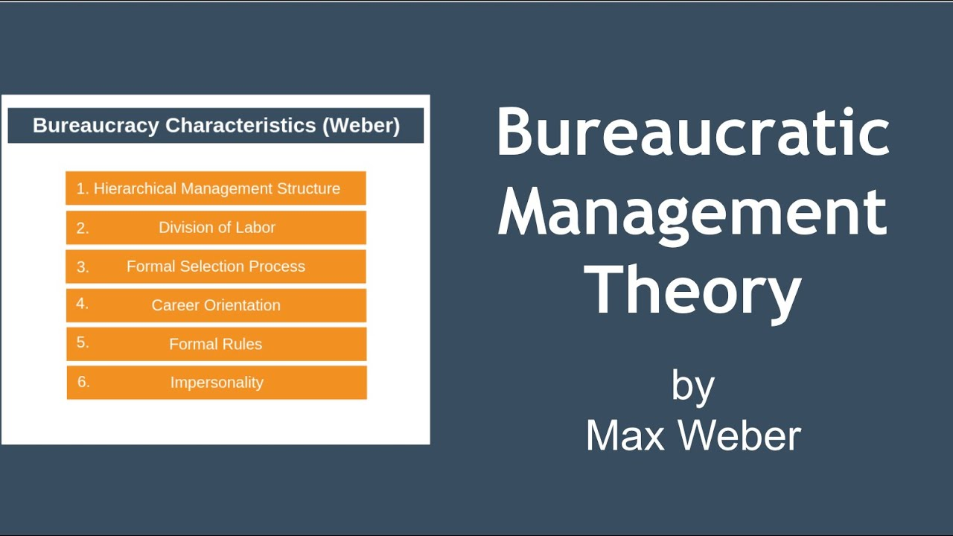
Figure: Bureaucratic management theory
Source:(Meisenbach and Jensen, 2017)

Human relations theory
It was developed by Elton Mayo and he conducted various experiments and it is intended to make productivity improvement and provided the foundation for human relations improvement. The more focus while preparation of this theory was on making changes in work conditions like break times, lighting, and working hours of the day of the employee. The initiatives and changes in the theory were made by him to meet with the improvement in the performance. The theories concluded by providing research material based on making them feel more valued (Oyerinde, 2017).

Systems management theory
This theory discusses the various components that should work collaboratively for a better system of the business so that all the functions of the organization may run optimally. The success of the organization depends upon synergy, interrelations, and interdependence between the subsystems. The theory is practically based on the assumption that employees are the most important components of the organization. All the workgroups, departments, and business units are the most necessary basics needed for a successful business (Galliers et al., 2020).
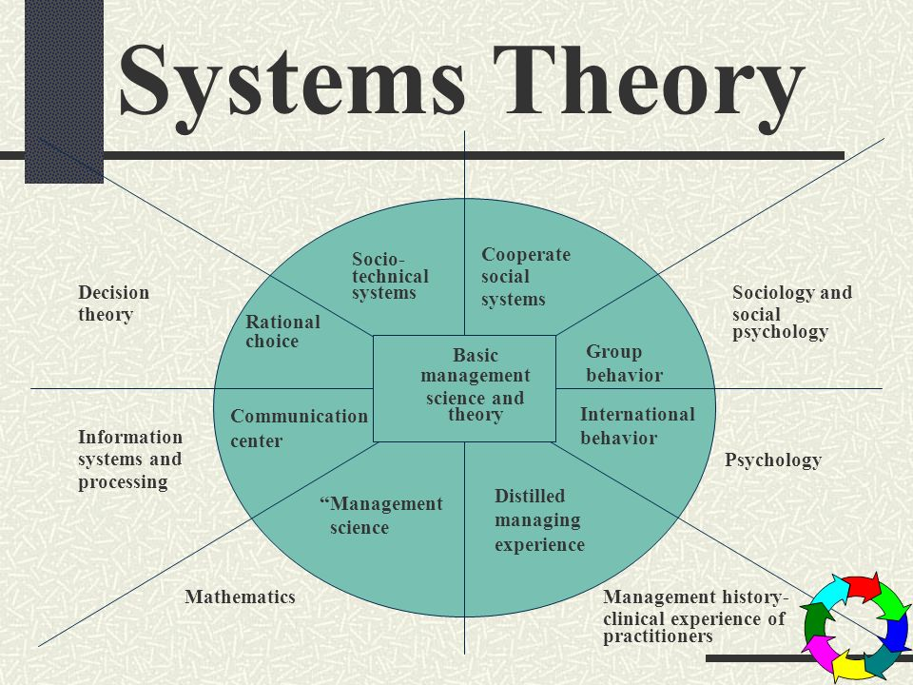
Figure: Systems management theory
Source:(Galliers et al., 2020)

Contingency management theory
This theory was developed by Fred Fiedler and the theory primarily focuses on the principle that no one theory is implemented in the organization. The framework of the organizational structure is based on numerous elements and theories. He asserted that leadership traits must be applied to every situation of the organization. The leader must be flexible to adapt to changes in the business environment. The organizational system in this theory must use careful management systems to satisfy and balance the situations of the current business circumstances. The management of the organization must be concerned about the smooth functioning of the organization. This theory is based on the situational approach. This theory describes the task of motivated leaders and relational theory. It is greatly beneficial for the organization (Alves et al., 2017).
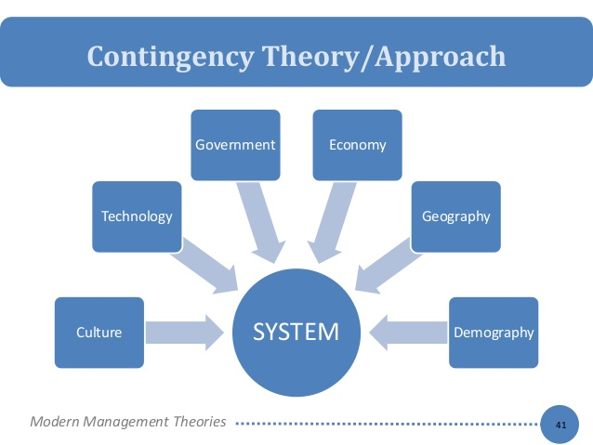
Figure: Contingency management theory
Source:(Alves et al., 2017).

Theory X and Y
This theory of Prof Douglas McGregor has described two opposite sets of expectations on views of management and employees. This theory discusses the behavior of people in the workplace. In theory X employees inherently dislike the work they have to be corrected and whenever possible they will attempt to avoid it. The second assumption about the theory is that the workers dislike the work so they have to be controlled, corrected, or threatened with punishment and rewards to achieve the target. The employees of the organization will avoid their responsibilities and seek formal directions whenever it is possible. Commonly the workers place security above all other factors associated with work and will display little ambition about the efficiency of work (Aithal and Kumar, 2016).

The assumptions of theory Y includes workers may now work as natural rest or play. The individual of the organization will work out self-content and self-direction if they are dedicated to objectives. The standard valued individual may leave to accept even self-responsibility. The ability to draw innovative decision is usually dispersed throughout the organization and is not essentially the role province of this in management performance. This will improve the performance of the organization (Murphy and Murphy, 2018).
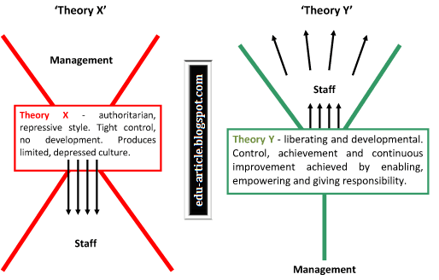
Figure: Theory X and Y
Source:(Aithal and Kumar, 2016).

Impact of organizational theories on the culture and performance of Unilever

The organizational theories of management had a great implication and impact on the performance of Unilever. It is very significant for the output of the employees. The corporate culture has its importance and criteria to bring out the determined amount of output and adequacy. The main implications of the above mentioned organizational theories are upon quality management, focus on performance, and efficiency. The scientific and administrative theories help the organization in developing strategies that are widely spread and validate the competitors of the organization. By effective implication of these theories, the management is trying to satisfy its customers and the employees (Elsbach and Stigliani, 2018). All the principles of management are applicable in the present business scenario of the organization Unilever. All the theories suit particularly every situation of the business world. The facts, relevance, and modification are required in the theories according to the working conditions of Unilever are that the overall work of the organization cannot be done by anyone person so the modification related to the degree of division of work must be differentiated according to the structure of the organization. The authority and responsibility in the organization must go hand in hand and discipline is necessary for the smooth functioning of the organization (Reza). The modification in the principle of discipline can be done by the organization. Unity of command must be usually followed and employees are responsible to answer the boss for their work. In the principle of unity of direction, the departments of the organization must strictly work according to this principle and matrix structure can also be used by the organization (Farmer, 2020). The subordination of individual interests for common interests is for the benefit of the organization. Many employees of the organization Unilever does not follow this principle must sometimes they must keep aside their interest and think for the benefit of the organization. Remuneration is fairly and timely distributed among all the employees and workers of the organization. The organizational structure of Unilever is centralized and decentralized according to the distribution of work at every level. The proper use of the scalar chain, order, and equity must be followed in the organization. Tenure is stable in the organization and the organization is working for the interests of the employees. They are also taking various initiatives that are useful for the organization and its employees too. Many companies have to retrench their employees. The principle of esprit de corps is relevant for the organization. From time to time advancement in technology is necessarily required for reaching the heights in the competitive business world. the principles of management are universally accepted. The company is producing multiple brands and they can affect the overall community of life. the focus of the company is implementing the above managerial theories is to enlighten the strategic management in their business (Paine et al., 2019).

Present organizational culture

Unilever focuses on selling those products that are loved by the customers and can make difference too. The CEO of the company promises to fulfill their commitment to their customers. The purpose of the company is not about putting ahead the profits but it is about the purpose that drives the profits. The brands of the company are familiar and favorite all over the world. They use unique insights and innovation to make sure that the products of the company can provide satisfaction to the customers. They also make sure that remedial actions are taken as soon as possible to solve the issues of the customers. The company wants their business to flourish and ensure sustainable and long term growth for the company. They have also introduced their sustainable living plan to help billion of people to improve their health and wellbeing. They are ensuring 100% sourcing of the agricultural products and enhance the livelihood of the people. The vision of the company is to be lead globally in sustainable business by improving wellbeing of the people, health confidence and also improving the health of the planet and contribute to a safe, fair, and more socially inclusive world. They are also reshaping their values to deliver long-term and superior value to their stakeholders which comprises customers, shareholders, staff members, the planet, and society (Walker, 2020).

The innovation policy of the company is to grow technically and develop their products based on modern technology. They are using innovation to use new ways and ideas to grow sustainably. They also conduct research to provide world-class facilities and develop those products which meet the requirements and needs of the people. They are investing to create a brighter future by providing the portfolio of the company.

PESTLE Analysis
The impact of COVID 19 on the working and performance of the company Unilever can be seen by analysis of its political, economic, social, technological, legal, and environmental factors. A brief description of these factors is described here:

Political influence: The working of Unilever has slow down because of the adverse effects of the coronavirus disease. The government of every country at the global level imposed lockdowns and markets were completely closed for almost three months. The production process was stopped and they were not able to sell more because of no demand in the market.

Economical influence: The profits of the organization have reduced and they were not able to meet the daily requirements of the organization. many of the employees and workers of the organization have been kicked out of the premises and they were not provided with the salaries.

Social influence: The world is dealing with this unseen disease and yet no vaccine is available for cure. The working of the organization is disturbed and they are not able to carry out their social benefit programs
.
Technological influence: The technological effects on the organization is that they are not able to purchase any new technology from outside. Along with this, they are not able to export their new innovative products in the market.

Legal influence: The legal impacts upon the working of the organization is that they have to follow the strict norms and guidelines of production issued by the government during and after lockdown.

Environmental influence: There are no such environmental issues, on the other hand, the quality of air has improved because of complete lockdown and the pollution is reduced which is a positive effect for the organization.

Porter Five Forces
This model may help businesses to gain competitive advantage. Porter Five Model mainly involve five aspects which are described below:

Competitive Rivalry (High): Unilever is a multinational company that operates its services in several countries. At present, the consumer retailer is facing tough competition from Kraft and Nestle. These competitors offer high quality products to customers at affordable prices.

Threat of Substitutes (Moderate): Nowadays, Potential customers are mainly attracted towards cheaper products. Unilever has maintained good reputation in marketplace. Thus, the consumer retailer does not face much threat from substitutes.

Supplier Power (low): Unilever has maintained strong coordination with suppliers to achieve highest quality standards. The supplier’s loyalty will be a beneficial factor for consumer goods industry.
Buyer Power (high): Customers are attracted towards competitors due to innovative practices and ideas. This makes difficult for Unilever to retain old customers.

Threat of new Entrants (low): Unilever face less threat from new entrants due to its strong position in market. The company create sustainable products to win customer confidence and trust.

Corporate objective and Social Responsibilities of Unilever
Unilever mainly positioned itself as sustainable brand among customers. The company has established several goals to protect environment from carbon emissions. Unilever tried to demonstrate greater accountability and transparency towards their stakeholders. The company has pledged to improve the wellbeing of people. The company has reduced water abstraction around 47%. The consumer retailer mainly establish ethical standards to achieve customer satisfaction.
The values and relationships of the company are to develop a systematic approach to manage the corporate social responsibility of the company to serve in diversified societies. The corporate social responsibility approach of the company is to impact and interact with the society and its people belonging to the distinct areas of the operations of the company. In 1998, Unilever focused on developing a process of methodology that helped the company in measuring and managing the performance of the company. They created a framework for demonstrating their CSR in context to the relationships with society. They consider customers, suppliers, employees, government, local communities, and societies as their stakeholders. The corporate purpose of the company is to meet the everyday requirements of the customers. They anticipate the aspirations of the customers. The customers also respond creatively to the branded products of the company and it also helps in improving the quality of life of the people (Yan, 2017).
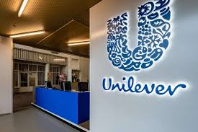
Figure: Unilever
Source: (Ma, 2017).
The roots of Unilever in the local market and cultures around the world are unparalleled. It inherits the foundation of the company to ensure future growth. Along with the products of the company they are bringing a wealth of knowledge and international expertise to their customers by their services to the local customers. The long term success to be achieved by the organization requires fulfillment of commitment to the exceptional standards of the company to improve the performance and productivity. The organization must focus on working together effectively to learn new ideas and trends in the market. Unilever believes to succeed by the acquirement of the highest standards of corporate behavior towards the consumers, employees, and society in which we live and the organization is operating. This is how Unilever has created a road to sustainable development to ensure long-term value creation and profitable growth of the company.

The organization has set its goal to develop a sustainable living plan to increase corporate social impact. The three main goals decided by the organization under this sustainable plan are to improve wellbeing and health of more than one million people. They are also trying to reduce the adverse impact of the products on the environment. They are also focusing to enhance the livelihood of millions of people. Unilever mainly focuses on integrity and aspect to perform certain objectives concisely. The main purpose of Unilever is to make a sustainable living place and collaborate with local communities. The consumer retailer tries to create sustainable products for potential buyers and creates a brighter future. Since 2009, Unilever mainly focuses on two things which are public relations and corporate social responsibility. The company has completely transformed itself into a sustainable leader in the global sector. Unilever always makes better efforts to reduce greenhouse gas across its value chain activities and sourcing our raw materials through ethical trading practices. The company always gives the highest priority to customer needs and expectations. Unilever mainly believes that satisfied customers may bring greater revenue and boosts sales collections. The company is trying to create social responsibility culture for staff members. Unilever encourages its staff members to take active participation in business projects. The company mainly promotes good hygienic practices among people. Apart from this, Unilever tries to improve quality of life through basic nutrition, access to clean water, and enhancing self-esteem. The company is collaborating with non-governmental organizations to bring sustainable change in society (Bowen, 2013).

Unilever has taken active participation in community projects to contribute towards societal development. The company has established a strong partnership with UNICEF to tackle societal issues. This partnership has helped Unilever to gain large expertise in sustainable products or services. The company has also developed a Sustainability plan to drive business growth and build mutual trust among stakeholders. Unilever has generated 70% of its majority growth to develop a future journey and increase positive social impact. The company is very passionate about protecting the environment from carbon emissions. Unilever chairman has also rolled out a new strategy to tackle ecological challenges and become more profitable in the market. The company is highly committed to sustainability leadership and encourages its staff members to conserve electricity. Even in difficult situations, Unilever does not neglect climate change (Hahn and Kim, 2016).

Integrity and Ethical Standards

Unilever has formulated ethical policies for their staff members. The company wants to become an ambassador for ethical standards. On the other side, Unilever is entirely based upon certain values which are responsibility, respect, and integrity. The company is closely working with their distributors to fight against corruption and bribery practices. The consumer goods retailer offers all relevant instructions and learning materials to their staff members. Unilever mainly hires the right suppliers and skilled workforce to accomplish its business objectives. The company tries to embrace innovation and integrity among staff members. Apart from this, Unilever offers corporate ownership to their staff members. The company is entirely based upon certain principles which are described below:

Prevention: Unilever has mainly established a culture of integrity at all levels (Latta et al., 2020).

Response: The Company used the necessary tools and equipment to avoid data breaches and identify improvement areas.

Detection: Unilever mainly encourages their staff members to speak their voices regarding business policies and operations (van Ruth and de Pagter-de Witte, 2020).

From the above discussion, it is stated that Unilever is quite successful in positioning itself as a sustainable brand among customers. The company mainly encourages staff members to explore new things and handle complex situations. Unilever pays much attention to employee development and delivers better services to customers. The company has an efficient HR team that boosts employee confidence. Unilever has adopted multiple approaches to social responsibility. The company offers fair compensation and better working conditions for their employees. Unilever has mainly adopted ethical practices to accomplish their long term objectives and enhance customer experiences. The company provides clear direction to its staff members regarding career growth. Thus, Sustainability may provide potential benefits to the organization and strengthen their competitive advantage. It may help businesses to understand customer needs and expectations. Unilever mainly focuses on the continuous improvement of products and services (Ma, 2017).

Conclusion
The principle aim of this report is to provide solutions for Unilever about the impact of environmental factors and COVID-19 on their organisations’ culture and performance. The report provided several implication for the Unilever by applying several managerial theories on different levels of the company. The major portion of the discussion in this report is managerial theories and its implications on Unilever's environment and culture. In addition, the report used effective strategic management tools such as PESTLE Analysis and Porter Five Forces in order to understand company situation form different dimensions. The report concluded by evaluating the working culture of the company, it corporate social responsibility and its relationship with customers. The report recommends that Unilever should focus on sustainability in order to improve its competitive advantage.

Reference list

Aithal, P.S. and Kumar, P.M., 2016. Comparative analysis of theory X, theory Y, theory Z, and Theory A for managing people and performance. International Journal of Scientific Research and Modern Education (IJSRME), ISSN (Online), pp.2455-5630.
Alves, M.W.F.M., de Sousa Jabbour, A.B.L., Kannan, D. and Jabbour, C.J.C., 2017. Contingency theory, climate change, and low-carbon operations management. Supply Chain Management: An International Journal.
Asadullah, M. and Hyder, S.I., Development of Effective Management Theories.
Bowen, H.R., 2013. Social responsibilities of the businessman. University of Iowa Press.
Dahlgaard-Park, S.M., Reyes, L., and Chen, C.K., 2018. The evolution and convergence of total quality management and management theories. Total Quality Management & Business Excellence, 29(9-10), pp.1108-1128.
Edwards, R., 2018. An Elaboration of the Administrative Theory of the 14 Principles of Management by Henri Fayol. International Journal for Empirical Education and Research, 1(1), pp.41-51.
Elsbach, K.D., and Stigliani, I., 2018. Design thinking and organizational culture: A review and framework for future research. Journal of Management, 44(6), pp.2274-2306.
Farmer, D.C., 2020. Case study: WSUP and Unilever–Clean Team Ghana. In Demystifying Social Finance and Social Investment (pp. 184-187). Routledge.
Galleries, R.D., Leidner, D.E., and Simeonova, B. eds., 2020. Strategic Information Management: Theory and Practice. Routledge.
Gines, N.L., and Vasco, M.A.C., Evolution of Modern Human Resource Management Theories: An Ancient Philosophy.
Hahn, Y. and Kim, D., 2016. Corporate social responsibility: A comparison analysis. The Journal of Business Economics and Environmental Studies, 6(4), pp.13-17.
Latta, G.F., Clottey, E., Dugan, M. and Chikeleze, M., 2020. Developing Ethical Leaders: Innovations in Promoting Ethical Decision-making, I sing Discretionary Power & Overcoming Immunity to Moral Integrity. Journal of Leadership, Accountability and Ethics, 17(2), pp.73-87.
Ma, L., 2017. Financial Analysis of Unilever Company.
Medhekar, P., 2020. Management Theories.
Meisenbach, R.J. and Jensen, P.R., 2017. Bureaucratic theory. The International Encyclopedia of Organizational Communication, pp.1-13.
Murphy, P.E. and Murphy, C.E., 2018. Sustainable Living: Unilever. In Progressive Business Models (pp. 263-286). Palgrave Macmillan, Cham.
Oberoi, R., 2016. Frederick Wilson Taylor’s Scientific Management Theory.
Oyerinde, O.F., 2017. Team management in the 21 st century: A human relations theory angle. Nigerian School Library Journal, 16, pp.125-136.
Paine, L.S., Costas, R. and Zogbi, P., 2019. Mãe Terra and Unilever (A).
Prasad, L.M., 2020. Principles and practice of management. Sultan Chand & Sons.
Reza, M.H., Marketing Strategy and Sustainable Plan of Unilever.
Rudani, R.B., 2020. Principles of management. McGraw-Hill Education.
Sasidhar, P.V.K., 2020. Unit-2 Theories and Approaches of Management. Indira Gandhi National Open University, New Delhi.
Van Ruth, S.M. and de Pagter-de Witte, L., 2020. Integrity of organic foods and their suppliers: Fraud vulnerability across chains. Foods, 9(2), p.188.
Walker, R., 2020. Communication Perspectives on Organizational Culture and Organizational Identification. International Journal of Business Communication, p.2329488420957073.
Yan, M., 2017. The Corporate Objective Revisited: Part II. Business Lawyer, 38(2).

