Construction Fundamentals
Assignment 1
UWTSD
Student Number: 2115966
Sam Davies
Hand in Date – 06/01/2022

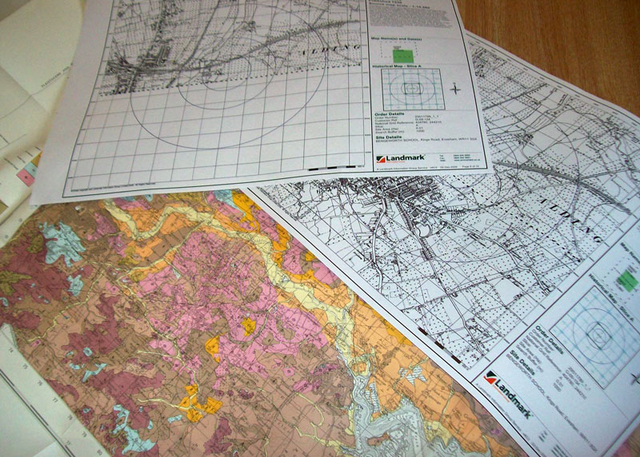

I am a junior construction professional and have been asked to report on the requested site as follows in the attached images below. I will be carrying out a preliminary study and also carrying out desktop studies to review the sites historical background and its ground conditions. In turn I will be doing a full site investigation. I will also be picking a suitable foundation and explaining my reasoning for choosing it. The below image is the site I will be investigating–
The site is located between the Marriot hotel and the county hall in Swansea. The building is to have an estimated size of 300 square feet at ground floor level. The building is to contain the restaurant, café bar, ice-cream parlour, kitchen, food-stores etc. First floor is to be a designated staff area with mangers apartment. The project is done under a design and build project.
Site Description
The site is located near the south dock in Swansea Marina. It is next to the Marriott hotel and the county hall in Swansea.
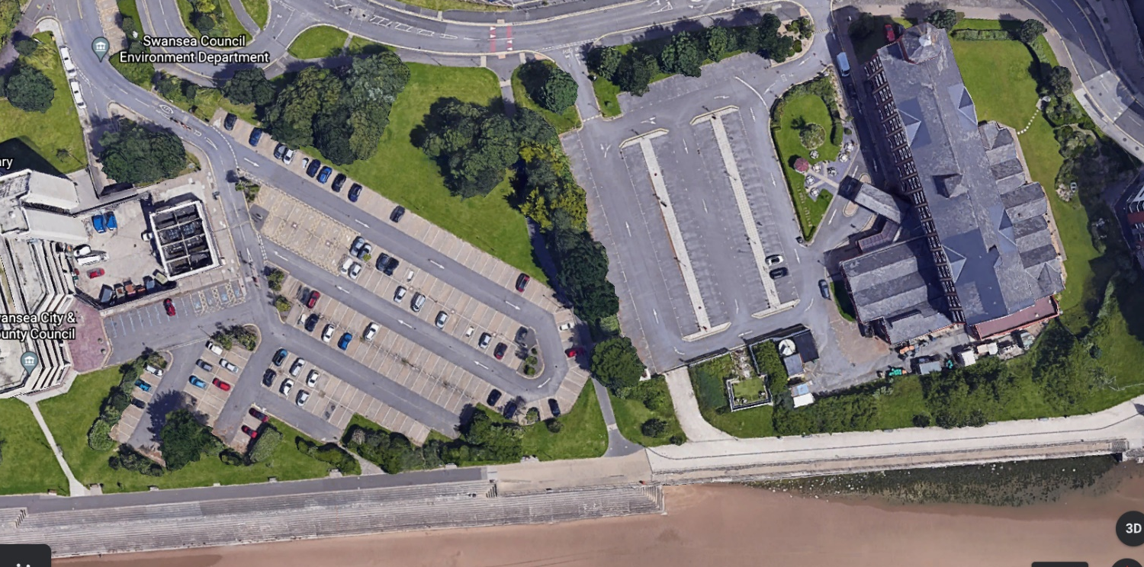

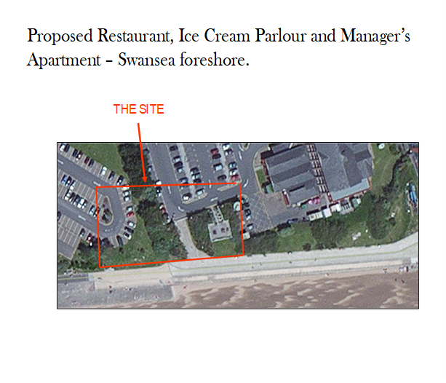

- Describe the historical background of the site and local area via a preliminary desktop study, drawing upon archival material. Your study should include plans and photographs, with full referencing of both illustration and archival information gained.
Swansea went through a big industrial boom in the mid 1800’s and the south dock was involved in transporting copper and coal. Trainlines were used around the south dock to transport coal and copper to the docks. The arrival of south Wales railways heavily increased the amount of industrial work being carried out in the area, it allowed more transportation to be done and also made transportation easier from coal to be transported from mines in the valleys.
Information obtained in regards to the historical background of the site can show us ground conditions, possible industrial use of the site, contaminated land etc.
I can see from the Ordnance survey shown below that the land we are building on used to be occupied by buildings very close to it. Train lines can also be seen below the buildings. A “copper ore and goods shed” can also been seen that’s marked out. The area has a chance of contamination due to the docks and industrial work that used to take place around this area. A map from 1897 also indicates that a building was occupying this land/very close to the land. After furthering my investigation, it is clear that there were multiple buildings that had industrial use around the proposed site.
Trees can also be seen on the site which need to be surveyed to determine if any are preserved.
After looking at the coal authority’s website, there are no mines close to the proposed site. The nearest mine is x miles away as shown on the below image.
Tramlines also used to occupy the land which could mean the land is contaminated.
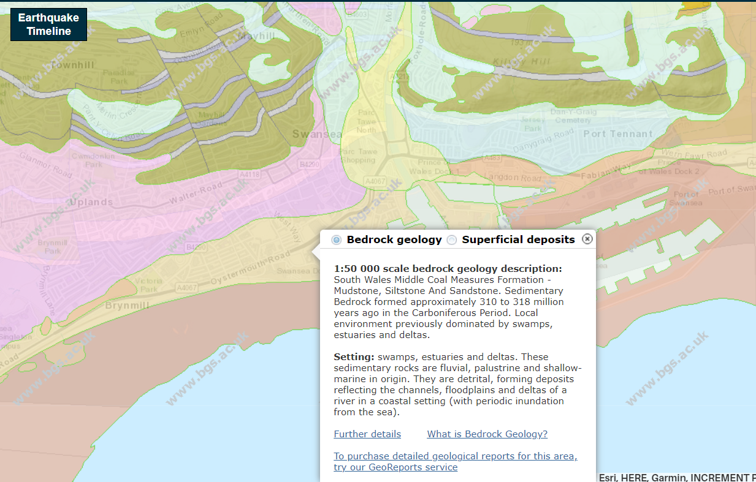
On the British geological survey map it shows that the ground is made up of Mudstone, Siltstone and Sandstone that has been formed roughly 310 to 318 million years ago in the Carboniferous period. It also states that the area was previously dominated by swamps, estuaries and deltas. Voids can be expected within the ground due to this so borehole tests are recommended. Nearest boreholes to the area are around x kilometres away and show findings of fine sand and clay. Foundation type will be determined later on in the report due to the ground conditions. A table of the results are shown below. Boreholes in this area range from a depth of 20m to 30m.

Other borehole results in the area are similar. They show findings of sand on the top layer with boulder clay and gravel further down into the ground.
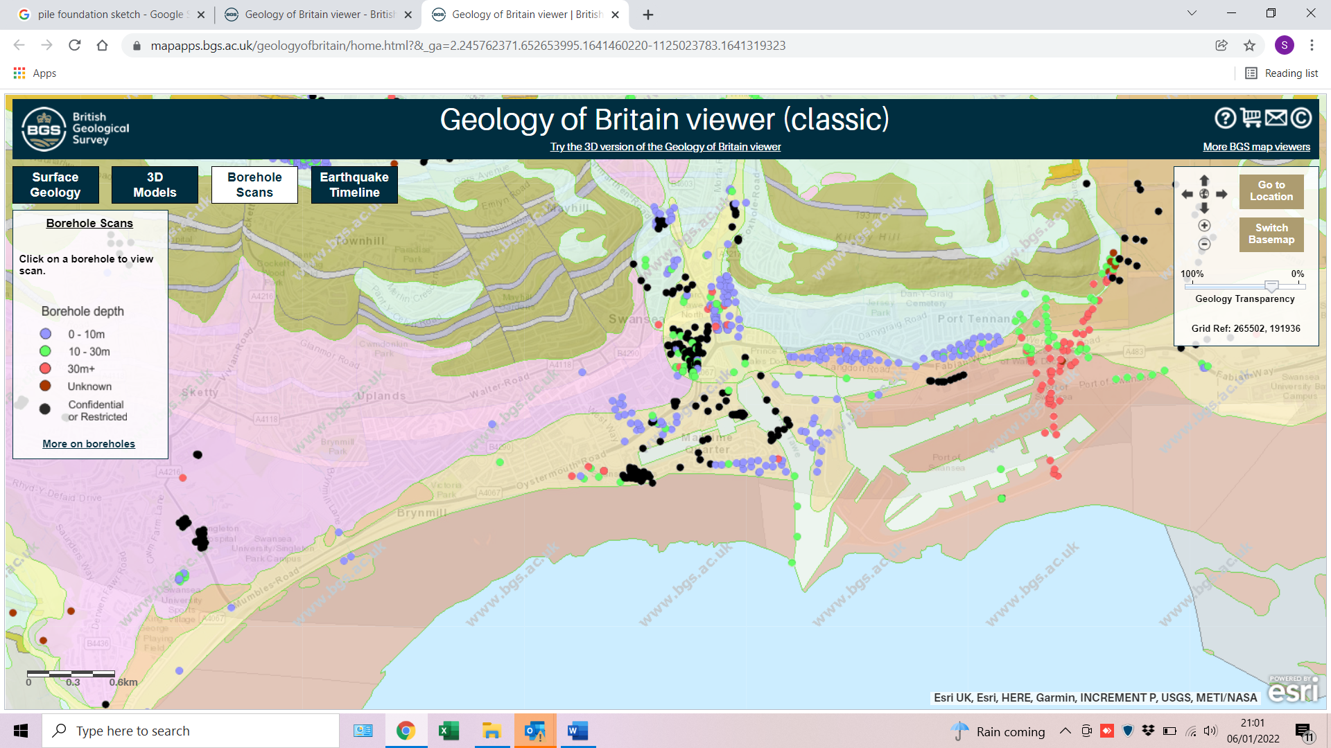
This image taken from BGS online website shows us where certain boreholes are in the area. The black dots signify confidential ones I did not have access to.

Surface water features include the dock which is located approximately x meters from the dock. No underground water sources can be identified from a desktop study and must be carried out on a site investigation using different methods.
My investigation shows no current or past landfills that are on the site.
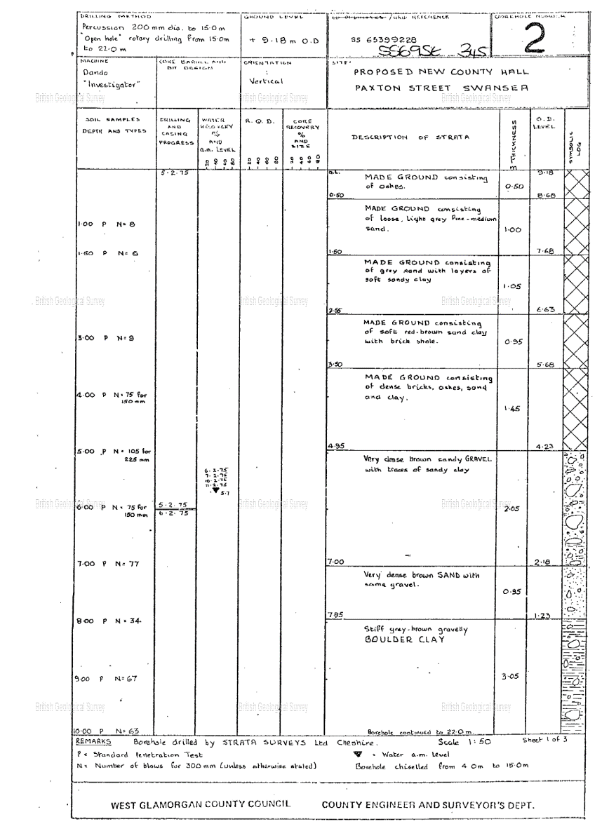
This is one of the boreholes I found on British Geotechnical Survey Maps and it is taken near the area where the site investigation is taking place.
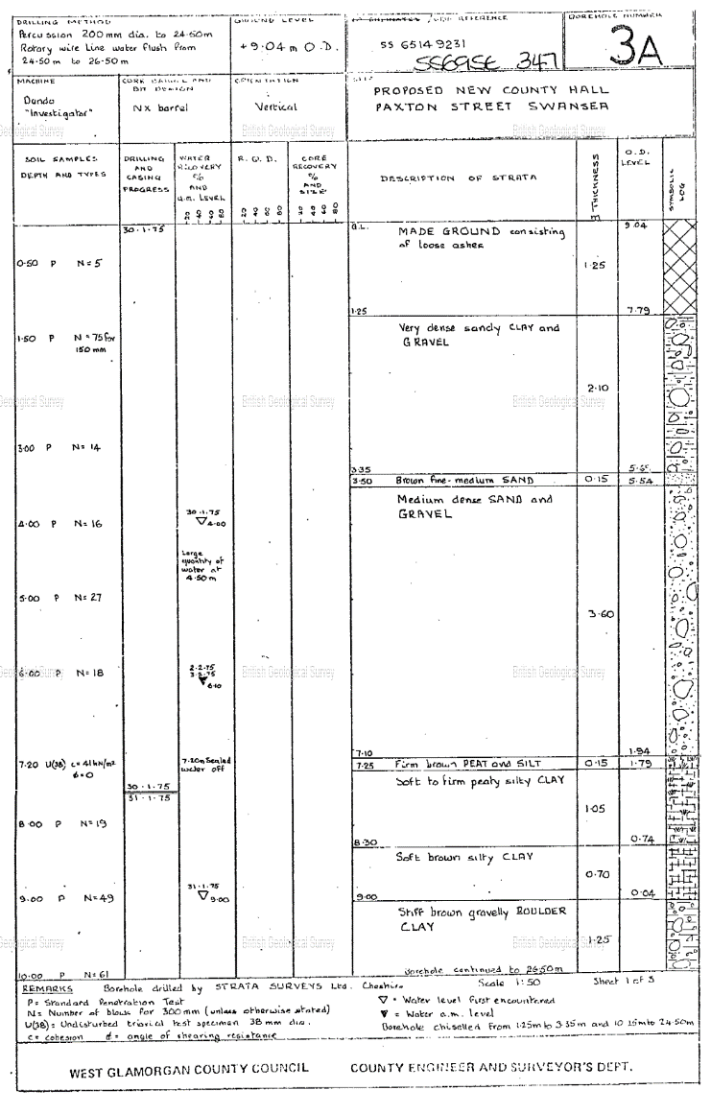

- Describe, given the historic background, your recommendations for the contents of a detailed site investigation (which is to be undertaken by a specialist geotechnical contractor). You must advise them of which elements of the site investigation you consider being most significant and applicable to this particular site, given its historic background, and where you believe the greatest risk lies.
I believe the greatest risk lies in the type of ground being constructed on. The ground is subject to voids, fine sand and clay which are very poor ground conditions. Boreholes right on the area could not be accessed for my use so I would suggest having one carried out on site before construction starts. There are no mines in the ground so I am not concerned however I am still concerned about voids in the ground as the area is subject to water sources so erosion and voids have to be considered in the process of construction. No investigating is needed to say that the location of the site is right on the coast so it will be heavily prone to weathering over time. Furthermore, the land also used to be used by trams/trains so possible contamination in the ground could be possible. Copper and coal were heavily used in this area and could’ve polluted the ground. A contamination risk assessment or contamination report is now needed under local planning authority rules. These would be carried out initially at desktop study stage and then later done physically on site to depending on the history of the site. Cable detection can be done with a CAT and genny, an underground utility survey will have to be done as previous buildings have been on the land. In addition to this there are things like street lights and other buildings are close so any type of excavation to the ground must not be carried out until a full survey is completed as cable strikes are a risk. Other utilities such as water mains, gas mains etc. will need to be carried out by professionals eg. Welsh Water etc.
Consideration of livestock in the ground should also be considered. On BGS website it is mentioned that large amounts of fish remain are in the area so this could lead to the possibility of methane in the ground.
When considering the environment and the sustainability, architecture of the building will also have to be thought out for example, will the building be steel frame concrete frame, building materials like glass will also have to be considered to the area being prone to high winds and storms.
As we’ve seen in Swansea new development schemes, sustainability will want to be attainted in different aspects of a project. For example, a new development for offices in the mariner will not have vehicle access to the site and no car parking available as it is easily accessible by walking or cycle paths. This site has great access via cycle roues that lead down from the beach cycle routes. Due to the intention of the restaurant, it is likely that most customers will use it when walking on the beach or already around the beach. You must however by vigilant that car parking could be a concern when trying to attract customers. 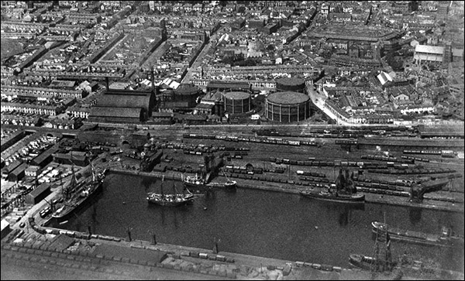

Health and safety of the site.
There is good access to the site as there is a car park right next to it. This allows ease of access for emergency services if needed. Potential risks of the site could involve site contamination with dangerous gases present e.g. radon gas, methane. As the top layer of strata is also sand unstable ground is also a big concern as the sand will take in moisture and become hard and then dry up and become loose.
People at risk in regards to possible contamination, –
- Construction workers (during construction phase)
- Neighbouring site occupants (residential and commercial properties within close proximity to site)
- Future site users – eg. Adults, children and staff.
- Maintenance workers.
Land ownership in the area is a big concern as part of the site lies on car parks which are privately owned by the Marriott hotel. Land agreements and ownership rights must be agreed with them privately. It is also on the Swansea Council offices car park but assuming they are the client and funding this project there would be no concern on their side.
Surveys must also be completed to ensure there is no wildlife or protected species of animals on the site.
From what I can see from my surveys the land has not been previously built on so there would be no concern for potential Asbestos in the ground.
Coal is likely underground due to the areas previous industrial use. The associated gases with coal are Methane, Hydrogen Sulphide, and Carbon Dioxide. All of these gases are considered detrimental to human health. Methane is potentially explosive in particular concentrations while Hydrogen Sulphide and Carbon Dioxide are considered to be asphyxiants.
No drainage can be observed from the desktop study so drainage will have to be inspected on site. Manhole covers should indicate where any active drainage is leading to. Plans should also be available from local authorities for drainage in the area.
- State the Building Regulations / Codes of Practice from which your recommendations are derived. State any necessary involvement of local authorities.
Part C of the building regulations applies to this build. Summary of the regulation is as follows below –
Approved Document C provides instruction on resistance to contaminants and moisture, including ensuring buildings are protected from both weather and water damage, from dangerous substances such as radon and methane, and that guidelines are followed when preparing a site for construction to take place. This regulation ensures everyone’s safety during constructing phase and post completion.
“Guidance is provided on preparing a building site and its foundations for construction, detailing precautions that must be taken in advance. Steps must be taken to guarantee new building foundations will not be damaged by pre-existing foundations, vegetation, tree roots or topsoil. Ground moisture must be contained and removed, using suitable drainage pipes to avert damage to buildings. Contaminated ground must be cleared in advance of any contaminants, adhering to health and safety procedures.”
It states that if the ground is contaminated then sub vents will have to be installed on the building to decrease the rate at which harmful gases get into the proposed building. Gas membranes can also be used to decrease the risk of harmful gases getting into the building.
British Standard 10175 (Investigation of potentially contaminated sites) must be adhered to.
What is a code of practice?
“Codes of practice (often just referred to as “codes” or CoPs) typically give authoritative and practical guidance about how those in a particular profession or activity should behave or undertake tasks in order to comply with legal or professional obligations.” (Design buildings wiki).
These standards are in place so we can gain the knowledge and have the full understanding of the geology of the area before we excavate or test them so we can construct in the safest way possible.
In this instance these standards share guidance on how contaminated land should be dealt with and approached by contractors and construction workers.
- With the aid of sketches, describe a suitable foundation detail for the building, based on your preliminary observations and archival data.
The best foundation choice for the proposed building would be a pile foundation. The reason for chosen this is based on the strata of the site. As we are building on fine sand for the top layer of ground and then clay/boulders further down into the ground. I feel this would be most effective and need less remedial work in the future. The piles could be driven down into more stable ground such as the clay between 7 and 8m deep. Bored piles would be used due to their popularity in urban areas as they are un affected by vibration. These are also used when building next to other buildings which we are. One of my drawings in this report shows that if you pile down to approximately 7-8m you will get clay and boulders this is compacted ground so the piles would not sink.
A foundation like a raft foundation wouldn’t be as effective as it would be subject to changing ground conditions (sand) and would move around a lot causing cracks within the foundation.
A strip foundation can be used however I still feel pile would be the best as it is sturdier in this type of strata. The area is also at high risk from windy conditions so a good foundation will contribute to the building’s sturdiness.
The below is an example sketch of a pile foundation -
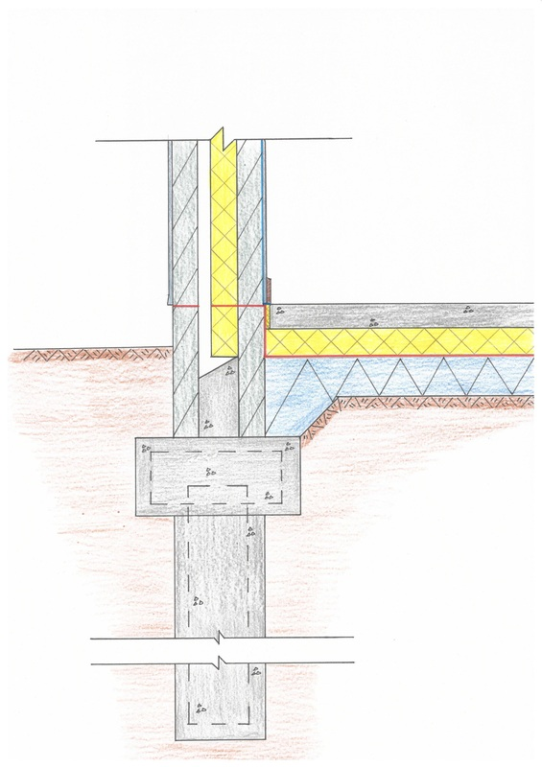

Conclusion
Both Geotechnical and Geoenvironmental hazards may be both encountered on this site. Although we have gained a rough understanding of what the ground conditions are on site, we still need to have a full understanding of what they are in regards to the direct area we are building on, therefore a full ground investigation should be carried out to confirm the ground conditions, groundwater levels, and ground gas at the proposed location. These should be done along with an assessment of potential contamination on and beneath the site.

References
https://www.labc.co.uk/news/raft-foundation-basics#:~:text=A%20raft%20foundation%20is%20a,the%20pressure%20on%20the%20ground
https://www.planningportal.co.uk/info/200135/approved_documents/65/part_c_-_site_preparation_and_resistance_to_contaminants_and_moisture
https://shop.bsigroup.com/products/investigation-of-potentially-contaminated-sites-code-of-practice-code-of-practice/standard
https://historypoints.org/index.php?page=swansea-marina
https://www.designingbuildings.co.uk/wiki/Code_of_practice
www.labc.co.uk. (n.d.). Raft foundation basics | LABC. [online] Available at: https://www.labc.co.uk/news/raft-foundation-basics#:~:text=A%20raft%20foundation%20is%20a.
Garrett, J. (n.d.). Part C - Site preparation and resistance to contaminants and moisture. [online] www.planningportal.co.uk. Available at: https://www.planningportal.co.uk/info/200135/approved_documents/65/part_c_-_site_preparation_and_resistance_to_contaminants_and_moisture.
shop.bsigroup.com. (n.d.). Loading... [online] Available at: https://shop.bsigroup.com/products/investigation-of-potentially-contaminated-sites-code-of-practice-code-of-practice/standard [Accessed 6 Jan. 2022].
Designingbuildings.co.uk. (2019). Code of practice. [online] Available at: https://www.designingbuildings.co.uk/wiki/Code_of_practice.

