
APPENDIX GA36c

LEVEL 6 ASSESSMENT SPECIFICATION

Student name: | Tom Farley | Student ID number: | 265044
Programme:
Module: | Usability Engineering
Module code: | ACCB6017 | Contribution to Overall Module Assessment (%): | 50%
Lecturer: | Pauline Greenaway | Internal Verifier: | Gaynor Thomas
Assignment Title: | Prototyping & Testing | Word count (or equivalent): | 3000
Submission deadline: | 24.03.2023 | Return date of provisional marks & written feedback: | TBA
Submission method: | All written assessments, where practical and possible, must be submitted via Turnitin unless otherwise instructed by the Lecturer. (Please DO NOT put this assessment specification into Turnitin or it will match many similarities with other students’ submissions.)  Alternative submission method (if applicable):  Late submission of the assessment will result in a late penalty mark. Penalties for late submission: Up to one week late, maximum mark of 40%. Over one week late, 0%. Only the Extenuating Circumstances Panel may approve a change to submission dates.
Academic honesty / referencing: | Academic honesty is required. In the main body of your submission you must give credit to authors on whose research and ideas your work is based. Append to your submission a reference list that indicates the books, articles, etc. that you have used, cited or quoted in order to complete this assessment.
Module Learning Outcomes
(from module syllabus)
Upon the successful completion of this module, the student should be able to:
- Research and evaluate cognitive and social information processing
- Select, apply and analyse critically techniques of interface evaluation
- Synthesize a solution to a complex design problem from the concepts and principles of usability engineering and software development
- Critically analyse, individually and as part of a team exercise, input and output hardware appropriate for specialised applications, for example for use by disabled people, and for three-dimensional modelling applications

TASK DESCRIPTION

Task 1
Twitter (2006) and Mastodon (2016) are two short-form messaging applications. On both systems, users can publish short messages (which may include images) to their followers, who may in turn “like” them, forward them to their own followers, or message the original author. Due to the recent changes at Twitter many users have decided to delete their accounts and move to Mastodon instead.

After downloading and using these applications, write a short report that discusses the following issues:

- How do the applications use psychology, usability, and design to engage and maintain user interest in the conversation space?
- What user experience lessons has Mastodon learned from Twitter and how does it make itself appealing to its target audience?
- How do the differences between the applications provide different social experiences for their users?
The report should include appropriate illustrations and references to research literature (8-10 references are sufficient, and at least two thirds of these should be books/journal papers).

Your submission should be presented in the form of a report that includes the following sections:
- (15%) A (very!) brief description of the applications, including similarities and differences in their mechanics and interfaces.
- (15%) Consideration of the target user groups for the applications. Is there any overlap or potential to encourage users of one application to migrate to the other?
- (40%) What elements of psychology, usability, design and copyrighting are significant and how these interact to provide an emotionally satisfying user experience?
- (20%) Are there any elements that don’t work? If a user of one application decides to try the other application then what elements are likely to feel comfortable or uncomfortable? Are there any features that might be missed?

The final 10% will be awarded for document presentation and appropriate references to the research literature.

The report should be submitted through Turnitin. Do not submit the assignment brief document with this.

Task 2

The boardgame CLUEDO is familiar to many as one that requires players to move their pieces around a board that represents a country mansion, finding clues that will help them solve the murder of Dr Black.
You are to design a UWTSD version of this as a computer game.

“Oh no! The Vice-Chancellor has been murdered! Who did it?”

You may set the game on any or all of the university campuses, and may include up to 8 players who should represent different parts of the university. This task represents your initial user research and design ideas for the game interface. In the next assignment you will develop your ideas further into a full colour design.

You should submit a report containing the following:
- A set of four detailed personas with associated scenarios and an indication of the main user and experience requirements relating to each persona;
- An appropriate information architecture for your game with justification for its structure;
- An initial set of wireframe storyboards;
- A description of the process used to collect feedback on your storyboard prototypes and a summary of the positive and negative feedback elicited.
The report should include appropriate illustrations and references to research literature (at least two thirds of these should be books/journal papers).

Your submission should be presented in the form of a report that includes the following sections:
- (20%) Who are your test personas? What are their user and experience requirements? Remember that students are not all able-bodied 18-21 year olds living in the Swansea area.

- (20%) How did you gather information to support the design of your personas? Discuss the results of any focus groups you held to elicit this information. Lists of user and experience requirements, categorised using the MoSCoW criteria, should be provided in an appendix.

- (20%) What information is necessary for the game to be a success? How does this need to be structured to make it easy to use? What information is location-sensitive, and how does this fit into the app?

- (20%) Storyboards should be wireframe only, rather than full colour design. They should show all of the major functionality of the app at a size appropriate for a mobile phone, and should take all of the usual aspects of interaction design theory into account in the design. The complete set of storyboards should be presented in an appendix but significant elements such as the main screen designs should be discussed in the main body of the report. These can be created using any suitable software; Adobe XD is a good choice for this, but other packages are fine provided that you remember to show not only the screens but how the user moves between the screens.

- (10%) How did you collect feedback on your prototypes? How did you ensure that your test subjects covered the range of personas you defined earlier? What feedback did you get, both in terms of usability and of emotional response? Were these what you expected and, if not, why not?

The final 10% will be awarded for document presentation and appropriate references to the research literature.

The report should be submitted through Turnitin. Do not submit the assignment brief document with this.

GUIDANCE FOR Students IN THE COMPLETION OF TASKS

NOTE: The guidance offered below is linked to the five generic assessment criteria overleaf.

- Engagement with Literature Skills
Your work must be informed and supported by scholarly material that is relevant to and focused on the task(s) set; you should make use of scholarly reviews and primary sources, where appropriate (for example, refereed research articles and/or original materials appropriate to the discipline). You should provide evidence that you have accessed a wide range of sources, which may be academic, governmental and industrial; these sources may include academic journal articles, textbooks, current news articles, organisational documents, and websites. You should consider the credibility of your sources; academic journals are normally highly credible sources while websites require careful consideration/selection and should be used sparingly. Any sources you use should be current and up-to-date, mostly published within the last five years or so, though seminal/important works in the field may be older. You must provide evidence of your research/own reading throughout your work, using a suitable referencing system, including in-text citations in the main body of your work and a reference list at the end of your work.

Guidance specific to this assessment: Task 1: Remember that although you should present your opinions of the user interface, you should justify those opinions with reference to the relevant areas of the literature. Task 2: Remember to justify your choices for the design with reference to research literature.

- Knowledge and Understanding Skills
At level 6, you should be able to demonstrate coherent and detailed knowledge and a systematic understanding of the subject area, at least some of which is informed by the latest research and/or advanced scholarship within the discipline. You should be aware of the uncertainty, ambiguity and limits of knowledge. Your work must demonstrate the growing extent of your knowledge and systematic understanding of concepts and underlying principles associated with the subject area. Knowledge relates to the facts, information and skills you have acquired through your learning. You demonstrate your understanding by interpreting the meaning of the facts and information (knowledge). This means that you need to select and include in your work the concepts, techniques, models, theories, etc. appropriate to the task(s) set. You should be able to explain the theories, concepts, etc. meaningfully to show your understanding. Your mark/grade will also depend upon the extent to which you demonstrate your knowledge and understanding; ideally each should be complete and detailed, with comprehensive coverage.

Guidance specific to this assessment: Task 1: Consider the elements of the interfaces and of the gameplay – what works, what doesn’t work, and why? Task 2: Not applicable.

- Cognitive and Intellectual Skills
You should be able to: critically evaluate evidence, arguments, assumptions, abstract concepts and data some of which are at the forefront of a discipline (and that may be incomplete) to devise and sustain arguments, to make judgements and/or solve problems; describe and comment upon particular aspects of current research, or equivalent advanced scholarship, in the discipline Your work must contain evidence of logical, analytical thinking, evaluation and synthesis. For example, to examine and break information down into parts, make inferences, compile, compare and contrast information. This means not just describing what! But also justifying: Why? How? When? Who? Where? At what cost? At all times, you must provide justification for your arguments and judgements. Evidence that you have reflected upon the ideas of others within the subject area is crucial to you providing a reasoned and informed debate within your work. Furthermore, you should provide evidence that you are able to make sound judgements and convincing arguments using data and concepts. Sound, valid conclusions are necessary and must be derived from the content of your work. Where relevant, alternative solutions and recommendations may be proposed.

Guidance specific to this assessment: Task 1: How transferrable are skills learned between the two games? Task 2: You should produce appropriately detailed personas and use these to help guide your information architecture design.

- Practical Skills
At level 6, you should be able to apply the methods and techniques that you have learned to review, consolidate, extend and apply your knowledge and understanding, and to initiate and carry out projects. You will deploy accurately established techniques of analysis and enquiry relevant to the discipline, and apply them in complex and unpredictable contexts, to devise and sustain arguments and/or to solve problems. You should be able to frame appropriate questions to achieve a solution - or identify a range of solutions. You should be able to demonstrate how the subject-related concepts and ideas relate to real world situations and/or a particular context. How do they work in practice? You will deploy models, methods, techniques, and/or theories, in that context or circumstances, to assess current situations, perhaps to formulate plans or solutions to solve problems, or to create artefacts, some of which may be innovative and creative. This is likely to involve, for instance, the use of real world artefacts, examples and cases, the application of a model within an organisation and/or benchmarking one theory or organisation against others based on stated criteria. You should show awareness of the limitations of concepts and theories when applied in particular contexts.

Guidance specific to this assessment: Task 1: Not applicable. Task 2: You should produce a full interface for this prototype design, using an appropriate workplace tool. This should be tested with real users rather than simply relying upon designer tests. Remember that you can perform user tests via Zoom or Teams.

- Transferable Skills for Life and Professional Practice
Your work must provide evidence of the qualities and transferable skills necessary for graduate-level employment requiring the exercise of initiative and personal responsibility and decision-making in complex and unpredictable circumstances. This includes demonstrating: the learning ability for professional development to advance existing skills and acquire new competences of a professional nature that will enable you to assume significant responsibility within organisations; that you can initiate and complete tasks and procedures, whether individually and/or collaboratively; that you can use appropriate media to effectively communicate information, arguments and analysis in a variety of forms to specialist and non-specialist audiences; fluency of expression; clarity and effectiveness in presentation and organisation. Work should be coherent and well-structured in presentation and organisation.

Guidance specific to this assessment: Tasks 1 and 2: This is a report, not a paper, so no abstract is needed. Ensure that your report looks professional. You should show how you’re using common professional techniques like task analysis effectively. Remember to write the report in an academic manner with numerical referencing, correct captioning of illustrations, appropriate technical English.

Student FEEDBACK FORM

This section details the extent to which the assessment criteria are demonstrated by you, which in turn determines your mark. The marks available for each category of skill are shown. Lecturers will use the space provided to comment on the achievement of the task(s), including those areas in which you have performed well and areas that would benefit from development/improvement.

Generic Assessment Criteria | Marks available | Marks  awarded
1. Engagement with Literature Skills
.
Brief explanation of Twitter and Mastadon provided as well as brief comparison between similarities and differences. This section should have been more detailed. Statistical analysis of users discussed, although image included should have been correctly referenced. Discussion of cognitive psychology related to perception theory has been provided although this area could have been discussed using more wide-ranging theories. Usability design theories have been well-applied with good use of supporting references to justify points made within your discussion. Again, this could have been more detailed. In Task 2, key screens have been annotated in the report, with appropriate reference made to interaction design theories. |  | 20
 | 30 | 20
2. Knowledge and Understanding Skills

 | 0
3. Cognitive and Intellectual Skills

 | 0
4. Practical Application Skills

You have produced four user personas for the Cluedo game as a result of focus group findings with summary of user requirements provided in accordance with MOSCOW criteria, although this could have been explained. Prototype wireframes produced using Adobe XD are detailed and well-designed. Navigation is clearly illustrated in the screenshot provided. Feedback obtained from user personas, with Nielsen’s Heuristics used as the basis of obtaining this. This is detailed and key suggestions for improvement have been identified. |  | 35
 | 50 | 35
5. Transferable Skills for Life and Professional Practice

Detailed HTA created illustrating the tasks/sub-tasks required to play and complete the game, together with relevant plans. This is also supported by a sitmap and flow chart which have been created to support the proposed information architecture.  Report is generally well-expressed throughout. However, it would have benefitted from introductory and concluding paragraphs. If you are using the same source and referring to it within your discussion, you should use the same number when applying Vancouver referencing conventions. |  | 13
 | 20 | 13

Assessment Mark (Assessment marks are subject to ratification at the Exam Board. These comments and marks are to give feedback on module work and are for guidance only until they are confirmed. ) | Late Submission Penalties (tick if appropriate) |  | 68%
 | Up to 1 week late (40% Max) |  | 68%
 | Over 1 week late (0%) |  | 68%

GENERIC ASSESSMENT CRITERIA

Level 6
In accordance with the Framework for Higher Education Qualifications, at the end of Level 6 students should have coherent and detailed knowledge and a systematic understanding of their subject area, at least some of which is informed by the latest research and/or advanced scholarship within the discipline. They will be able to accurately deploy established techniques of analysis and enquiry within a discipline, using their conceptual understanding to devise and sustain arguments and/or to solve problems. They should be aware of the uncertainty, ambiguity and limits of knowledge. They should be able to critically evaluate evidence, arguments, assumptions, abstract concepts and data (that may be incomplete), to make judgements, and to frame appropriate questions to achieve a solution - or identify a range of solutions. They will apply the methods and techniques that they have learned to review, consolidate, extend and apply their knowledge and understanding, and to initiate and carry out projects. They will have the ability to manage their own learning, and to make use of scholarly reviews and primary sources (for example, refereed research articles and/or original materials appropriate to the discipline). They will demonstrate the qualities and transferable skills necessary for employment requiring: the exercise of initiative and personal responsibility; decision-making in complex and unpredictable contexts; the learning ability needed to undertake appropriate further training of a professional or equivalent nature.

Level 6 | FAIL | MARGINAL FAIL | SATISFACTORY  (3rd / Pass) | GOOD  (2.2 / Pass) | VERY GOOD  (2.1 / Merit) | EXCELLENT  (1st / Distinction) | EXCEPTIONAL  (1st / Distinction)
Category | 0-29% | 30-39% | 40-49% | 50-59% | 60-69% | 70-84% | 85-100%
Engagement with literature (including reading, referencing,  academic conventions and  academic honesty) | Little or no evidence of reading and/or reliance on inappropriate sources.  Views and findings mostly unsupported and non-authoritative.  Referencing conventions used incoherently or largely absent. | Poor engagement with essential reading. No evidence of wider reading. Reliance on inappropriate sources, and/or indiscriminate use of sources. Heavily reliant on information gained through class contact. Inconsistent and weak use of referencing. | Engagement with a limited range of mostly relevant and credible sources. Some omissions and minor errors.  Referencing conventions evident though not always applied accurately or consistently. | Engagement with an appropriate range of research-informed literature, including sources retrieved independently. Some over-reliance on texts. Referencing may show minor inaccuracies or inconsistencies. | Engagement with a wide range of research-informed literature, including sources retrieved independently.  Selection of relevant and credible sources. Very good use of referencing, with no/very few inaccuracies or inconsistencies. | Engagement with an extensive range of relevant and credible literature, informed by the latest research. Consistently accurate application of referencing. | Exceptional engagement with an extensive range of relevant and credible literature, informed by the latest research. High-level referencing skills consistently and professionally applied.
Knowledge and understanding (Coherent and detailed knowledge and systematic understanding of the subject area, at least some of which is informed by the latest research and/or advanced scholarship within the discipline.) | Major gaps in knowledge and systematic understanding of the subject matter. Substantial inaccuracies. No awareness of knowledge of the latest research and/or advanced scholarship within the discipline. | Gaps in knowledge, with only superficial systematic understanding. Some significant inaccuracies and/or irrelevant material. No awareness of knowledge of the latest research and/or advanced scholarship within the discipline. | Limited knowledge and systematic understanding of the relevant concepts and principles within the subject area which to some limited extent, is informed by current research and scholarship. | Knowledge is reasonably detailed, accurate with a good systematic understanding of the field of study and to some extent, current research and scholarship. | Knowledge is reasonably extensive coherent and detailed. Exhibits very good understanding of the breadth and depth of established views, and the work is, at least in part, well-informed by current research and scholarship. | Excellent coherent and detailed knowledge and systematic understanding of the principles and theories of current research and scholarship. Clear awareness of challenges to established views and the limitations of the knowledge base. | Exceptionally coherent and detailed knowledge and systematic understanding of the principles and theories of the subject, well-informed by current research and scholarship. A critical, sophisticated and nuanced awareness of the ambiguities and limitations of knowledge.
Cognitive and intellectual skills  (Conceptual and critical thinking, analysis, synthesis and evaluation of research, assumptions, abstract concepts and data (that may be incomplete); logic, argument and judgement.) | Wholly or almost wholly descriptive work. Little or no analysis, synthesis or evaluation.  Failure to develop arguments, leading to illogical or invalid judgements. Unsubstantiated generalisations, made without use of any credible evidence. | Largely descriptive work, with superficial use of critical evaluation. Weak development of arguments and judgements. Information accepted uncritically, uses generalised statements made with scant evidence and unsubstantiated opinions. Ideas sometimes illogical and contradictory. | Limited attempt at critical thinking, analysis, synthesis and evaluation, tending towards description.  Some evidence to support emerging arguments and judgements but these may be underdeveloped or with a little inconsistency / mis-interpretation.  Asserts rather than argues a case. | Some critical thinking, analysis, synthesis and evaluation. Can analyse new and/or abstract concepts and data without guidance.  An emerging awareness of different stances and ability to use evidence (that may be incomplete) to support the argument.  Mostly valid arguments and logical judgements. Some tendency to assert/state opinion rather than argue on the basis of reason and evidence. | Sound critical thinking, analysis, synthesis and evaluation demonstrating critical thinking. Ability to devise and sustain persuasive arguments, and to review the reliability, validity and significance of evidence (that may be incomplete) to make mostly appropriate and valid judgements. | Excellent critical thinking, analysis, synthesis and evaluation. Ability to investigate contradictory or incomplete information and make strong, persuasive, arguments and sophisticated judgements. Some evidence of independent thought and ability to ‘see beyond the question’, suggesting a grasp of the broader field and wider concepts. | Exceptional critical thinking, analysis, synthesis and evaluation based on judiciously selected evidence.  Ability to investigate contradictory or incomplete information and make strong, persuasive, arguments and sophisticated, nuanced, judgements. Evidence of independent thought and ability to ‘see beyond the question’, suggesting an outstanding grasp of the broader field and wider concepts.
Practical skills  (Apply/deploy accurately established tools and techniques; initiate and carry out projects; formulate solutions to solve problems in complex and unpredictable contexts.) | Limited or no use of methods, materials, tools and/or techniques.  Little or no appreciation of the context of the application.  Limited understanding of the application of theory to practice or making appropriate links between the two.  Very weak problem-solving skills in complex and unpredictable contexts. | Rudimentary application of methods, materials, tools and/or techniques but without consideration and competence. Flawed appreciation of the context of the application.  Weak understanding of the application of theory to practice, with only occasional evidence of making appropriate links between the two. Weak problem-solving skills in complex and unpredictable contexts. | An adequate awareness and mostly appropriate application of well-established methods, materials, tools and/or techniques.  Basic appreciation of the context of the application. Theoretical knowledge and understanding applied in practice, but not always making logical links between the two.  Can identify problems and propose basic solutions in complex and unpredictable contexts without fully appreciating the complexity. | A good and appropriate application of standard methods, materials, tools and/or techniques.  Clear appreciation of the context of the application. Mainly consistent, accurate and logical application of theory to practice, making appropriate links between the two  Can identify problems and propose mostly appropriate solutions in complex and unpredictable contexts. | A very good application of a range of methods, materials, tools and/or techniques.  Very good consideration of the context of the application, with perceptive insights. Can identify problems and propose appropriate solutions in complex and unpredictable contexts.  Evidence of some innovation and creativity. | An advanced application of a range of methods, materials, tools and/or techniques.  The context of the application is well considered, and insightful.  Application and deployment extend beyond established conventions. Can identify complex problems and propose excellent solutions. Innovation and creativity evident. | Exceptional levels of application and deployment skills in unpredictable, practical contexts, drawing skilfully on the latest research within the discipline. Can identify complex problems and propose sophisticated solutions. Assimilation and development of cutting edge processes and techniques.
Transferable skills for life and professional practice  (Exercise of initiative and personal responsibility; professional development; initiate and complete tasks and procedures: individually and/or collaboratively; use appropriate media to communicate effectively; fluency of expression; clarity and effectiveness in presentation and organisation.) | Communication medium is inappropriate or misapplied.  Work is poorly structured, disorganised and/or confusingly expressed. Very weak use of language and/or very inappropriate style. Little or no evidence of autonomy (or collaboration, where relevant) in the completion of tasks. Little or no evidence of the skills required in graduate employment. | Communication medium is poorly designed and/or not suitable for the audience.  Work is poorly presented in a disjointed manner. It is loosely, and at times incoherently, structured, with information and ideas often poorly expressed. Weak use of language and/or inappropriate style. Weak independent initiative (or collaboration, if relevant). Limited evidence of the skills required in graduate employment. | Can communicate in a suitable medium but with some room for improvement.  Mostly ordered presentation and structure in which relevant ideas / concepts are reasonably expressed. Work may lack coherence in places. Can work as part of a team, but with limited involvement in group activities.  Demonstrates the basic skills required in graduate employment, with some areas of minor weakness. | Can communicate effectively in a suitable format, but may have minor errors.  Mostly coherent, organised work, in a suitable structure and is for the most part clearly expressed. Can work effectively independently and/or as part of a team, with clear contribution to group activities.  Demonstrates the skills required in graduate employment, with some areas of strength and some of minor weakness. | Can communicate well, confidently and consistently in a suitable format.  Work is coherent, fluent, well-structured and organised. Can work very well autonomously and/or as part of a team, with very good contribution to group activities.  Demonstrates very good graduate employment skills, with just occasional minor weakness. | Can communicate professionally confidently and consistently in a suitable format.  Work is coherent, very fluent and is presented professionally. Can work autonomously with initiative. Where relevant can work professionally within a team, showing leadership skills as appropriate, managing conflict and meeting obligations. Demonstrates excellent graduate employment skills and an appetite for further development. | Can communicate with an exceptionally high level of professionalism.  Work is exceptionally coherent, very fluent and is presented professionally. Can work exceptionally well and professionally within a team, showing advanced leadership skills. Demonstrates exceptional graduate employment skills and an appetite for further development.

THIS DOCUMENT IS ALSO AVAILABLE IN WELSH

Contents
Contents 11
Task 1 12
What is Twitter? 12
What is Mastodon? 12
Similarities & Differences Between Twitter & Mastodon 12
User Groups 13
Encouraging of Application Migration 13
Elements of Psychology, Usability, Design & Copyrighting 13
Elements That Do Not Work 15
What Would Users Miss? 15
Task 2 16
Test Personas 16
Information Used for Design of Personas 18
Information Necessary for the Game to be Successful 19
Flowchart – Make A Guess 19
Sitemap of the App 20
Hierarchical Task Analysis – Winning/Solving the Crime 21
Storyboard Wireframes 22
Home Page Wireframe 23
Game Mode Selection Page Wireframe 24
Rules Page Wireframe 25
Settings Page Wireframe 26
Character Selection Page Wireframe 27
Gameboard Page Wireframe 28
Guess Sheet Page Wireframe 29
Dice Roll Page Wireframe 30
Feedback 31
Feedback – Dennis 31
Feedback – Carol 31
Feedback – Matthew 32
Feedback – Charlotte 32
References 33

Task 1

What is Twitter?
Twitter is a short form messaging application formed in 2006, that allows users to post short posts named Tweets. Elon Musk is the current CEO which has caused some backlash with ‘More than half of the 17.5 million respondents’(1) to a poll voted yes for Musk to step down. Tweets can be up to 280 characters long and can appear on the Twitter home screen by a user ‘Tweeting’ or ‘Retweeting’ other users’ Tweets onto their timeline. The home screen on Twitter is filled with text and images from Twitter users that have been followed. Twitter users tend to “follow people and organisations with similar academic and personal interests to” themselves. (2)

What is Mastodon?
Mastodon is an alternative social media to Twitter which was released in March 2016. Mastodon is open-source software that allows posts to include text, audio, video, images and more. Users posts ‘Toots’ instead of Tweets. Mastodon gained popularity when Elon Musk took control of Twitter and gained “30,000 new users in a single day” (3).

Similarities & Differences Between Twitter & Mastodon
The similarities between the two applications include them utilising following, followers, hashtags and timelines. Their interfaces are similar with the home page being a continuous page of content from accounts or topics followed. Both applications have their navigation at the bottom including buttons to navigate to the home page, search the application and notifications. Mastodon has an account button at the bottom right where Twitter has direct messages. Twitter’s account navigation is in the top left. Other differences include the naming of certain things. For example, Twitter has Tweets where Mastodon has Toots, Twitter now has Like (since November 2015) and Mastodon has Favourites, Twitter has Retweets whereas Mastodon has Boosts. The character limit differs, with Twitter’s increased limit now at 280 characters whereas Mastodon’s limit is at 500. Mastodon differs as it does not allow promotion on the app however Twitter allows accounts to promote Tweets by paying a fee.

User Groups
The main user groups for Twitter are those aged between 25 and 34 (4) with the majority coming from America with 76.9M. Other countries which provide many users include (5) Japan with 58.95M and India with 23.6M. Twitter does not have a balanced gender user count with 68.1% of male users and 31.9% female. The total number of monthly active Twitter users in 2023 is 450 million. (6) 80% of those users view Twitter on a mobile device and on average an American adult will spend 8 minutes on Twitter per day.
For Mastodon, the active monthly user count, as of January 2023, is only 1.8 million. Mastodon’s website gained 3.4M visits in February, which is a decrease from 6.5M in December. Like Twitter, Mastodon’s largest user base is from America which is where just under 30% of its users come from. Mastodon and Twitter share similar age and gender demographics with 69.2% of users being male and the most popular age range of users is aged between 25 and 34, responsible for 33.53% of its users. The number of Mastodon users tends to increase when Elon Musk makes decisions as can be seen in this graph (7). If Musk were to make another huge change to Twitter, then an increase in Mastodon users could be predicted.

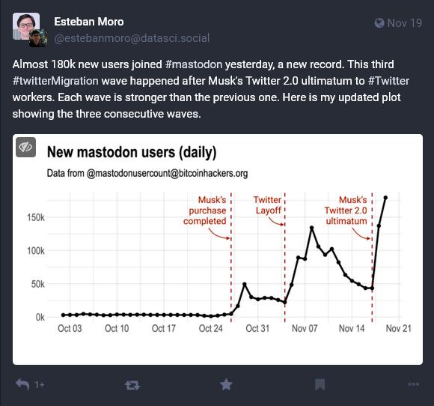

Encouraging of Application Migration

There is no encouragement for Twitter users to migrate to Mastodon. When an influx of users were migrating to Mastodon after Elon Musk acquired the position of CEO at Twitter, Musk took matters into his own hands. Twitter “suspended the official Twitter account of rival Mastodon” (8). Twitter started to mark links to Mastodon accounts as unsafe. Twitter blocked tweets with Mastodon links and was stopping users adding links to their Mastodon profiles to their Twitter bio. There is no official way of migrating from platform to platform.

Elements of Psychology, Usability, Design & Copyrighting
If someone uses both Twitter and Mastodon, they can refer to their long-term memory as both interfaces look similar. The symbols within the app do not provide text information to decipher what they are or do. This would require the user to have a prior understanding which can be forged from their long-term memory. Depending on user experience can affect the user’s cognition. If the user has experience with social media, then it would require experiential cognition which is where the user would be able to react ‘intuitively, instinctively and effortlessly’. Whereas an inexperienced user would require reflective cognition as they would have to involve ‘mental effort, attention, judgement and decision making’ (9). Both apps utilise Gestalt principles in their designs. When a user ‘Tweets’ or ‘Toots’ proximity comes into effect. The proximity between these shows a single line, separating between one Tweet to the next. Objects on both apps can also be perceived as the same. Each ‘Tweet’ and ‘Toot’ are designed the same so that the user can understand that they function the same way. (10)

Dix provides usability principles that should be conveyed within interface design. Of those principles, Twitter and Mastodon’s interfaces follow learnability and flexibility. Learnability is ‘how easy it is for users to accomplish a task the first time they encounter the interface’ (11). The applications do this through familiarity and consistency, if the user has prior knowledge, then they can use them effectively. Users would be able to use guesses as they both have similar interfaces to other social media. Twitter also uses predictability with its ‘For You’ section. It determines the Tweets that a user sees based on what tweets they view and like and who they follow. Flexibility is how the ‘user and the system exchange information’(12). Both accomplish this through multithreading and customizability. Both interfaces are customizable by changing display text size, having media previews or having dark mode turned on. A Twitter user can do more than one task at a time, multithreading. They could be in a Space, a live audio conversation, and still tweet and message at the same time. Both apps provide robustness. They provide recoverability as Tweets can be deleted and Toots can be deleted and edited. They provide observability when refreshing the main page with a spinning circle to indicate loading. This can also be viewed as responsiveness as users can use the spinning circle to see how long the system has got left before updating.

The significant design elements can be taken from Shniederman’s 8 golden rules of interface design. The principles include strive for consistency, enable frequent users to use shortcuts, offer informative feedback, design dialogue to yield closure, offer simple error handling, permit easy reversal of actions, support internal locus of control and reduce short-term memory load. As mentioned before, both apps provide strong consistency throughout. Shortcuts are available on Twitter as Tweets can be bookmarked so that they are kept in a separate folder so that they can be accessed easier. Certain direct messages can be pinned to the top of the messages page which can allow for quicker access. Both sites offer keyboard shortcuts. The app’s navigation bars allow for informative feedback as the design of the symbols becomes bolder and the colour scheme inverts when a user is at that section. When an error is made it is easy to reverse the error. On both apps, if like/favourite or retweet/boost has been clicked, this can be reversed easily by pressing it again. The user is aware of reversal similar to navigation. When liking a tweet, the heart symbol becomes red and when clicked again it is no longer red. This happens for favouriting on Mastodon as well as retweeting and boosting. When Tweeting or Tooting a message will appear when public.

According to Mastodon’s website, everybody owns Mastodon. They state that the developers do not own any copyright (13). This is due to Mastodon being a free and open-source software. However, Instances on Mastodon can be at risk as they are available to a copyright strike. Twitter is different, and unlike Mastodon, has a copyright policy. This details the copyright of what is posted to Twitter, how to submit a complaint and the implications involved.

Both apps provide an emotionally satisfying user experience by providing familiarity and consistency to ensure that the user does not need to learn how to use the apps. This is where the user can use their experiential cognition rather than their reflective cognition. The previous experience of users can give them satisfaction when using Mastodon and Twitter. A user can feel satisfied when their expectations are met when using the apps when in comparison to other social media apps.

Elements That Do Not Work
The usability elements that do not work for Twitter include predictability, synthesizability and responsiveness. Twitter now has a ‘For You’ page. This will try and predict content that the user will want to see based on what they have interacted with. However, with this change, many users have complained that they are seeing too many of Elon Musk’s tweets. Twitter can be very responsive, yet there are instances where a user is scrolling through, and their feed is automatically updated without any user control. There was no use of multithreading in Mastodon which differs from Twitter.

Of those 8 golden rules of interface coined by Shniederman, there are some that Twitter and Mastodon do not offer to users. Through using both apps, it appears that there are not many examples of supporting internal locus of control. Both applications offer error messaging. However, do not offer meaningful fixes (below).
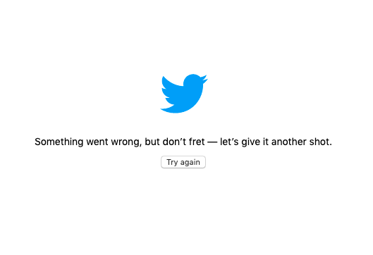
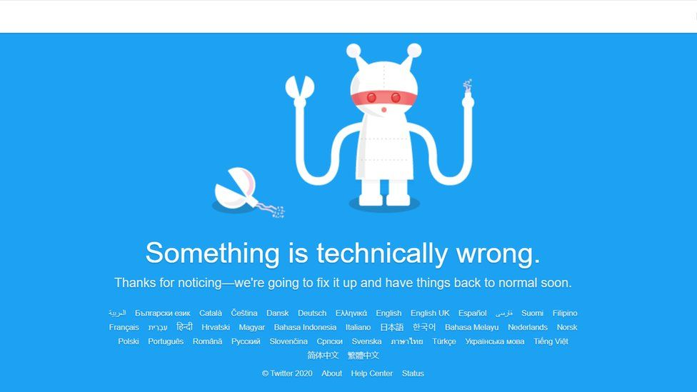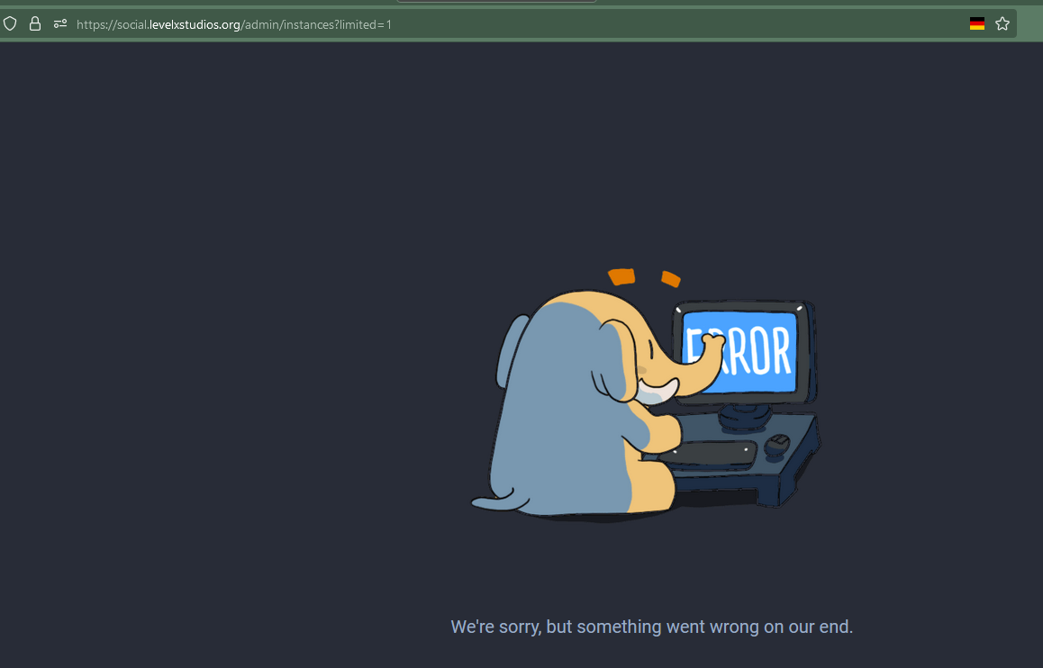
As both apps are well used, it is not a surprise that they are aligned with the golden rules of interface design.

What Would Users Miss?
Both interfaces are similar between Twitter and Mastodon however there could be features missed that could make users uncomfortable. For businesses, Twitter allows promotion of Tweets whereas Mastodon does not. Mastodon does not offer an insight into how many views each Toot has. If data protection is a key factor in which to use, Mastodon appears a lot safer as Twitter is more susceptible to cyber-attacks which has happened in the past. Mastodon offers a way to edit Toots whereas this is a feature that users need to pay for when using Twitter. Mastodon offers a visual graphic of what is trending whereas Twitter states the number of Tweets. Another thing that could influence whether using Mastodon or Twitter is the user count. Your favourite celebrity might post to Twitter but not Mastodon. However, both apps offer a similar service and there is no need to only use one.

Task 2

Test Personas

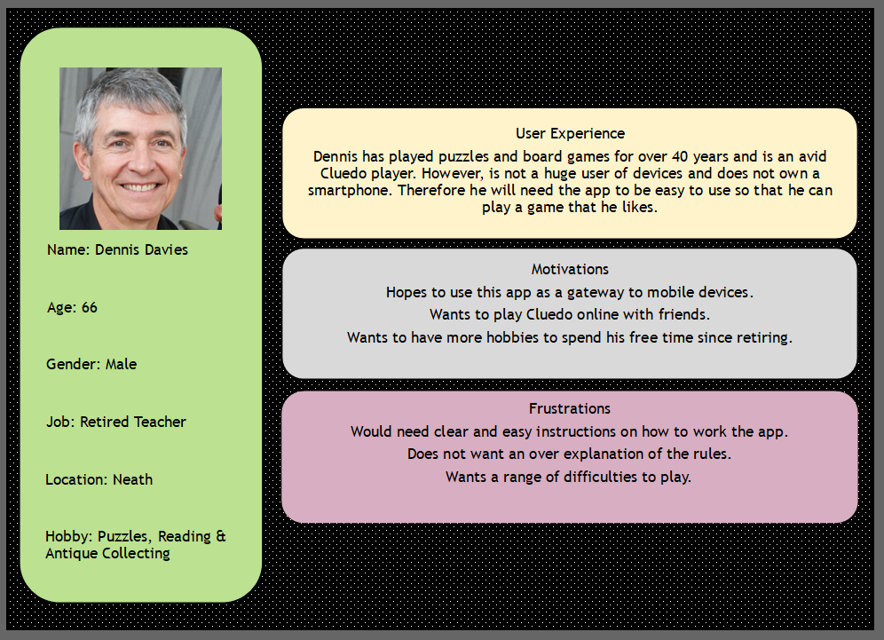

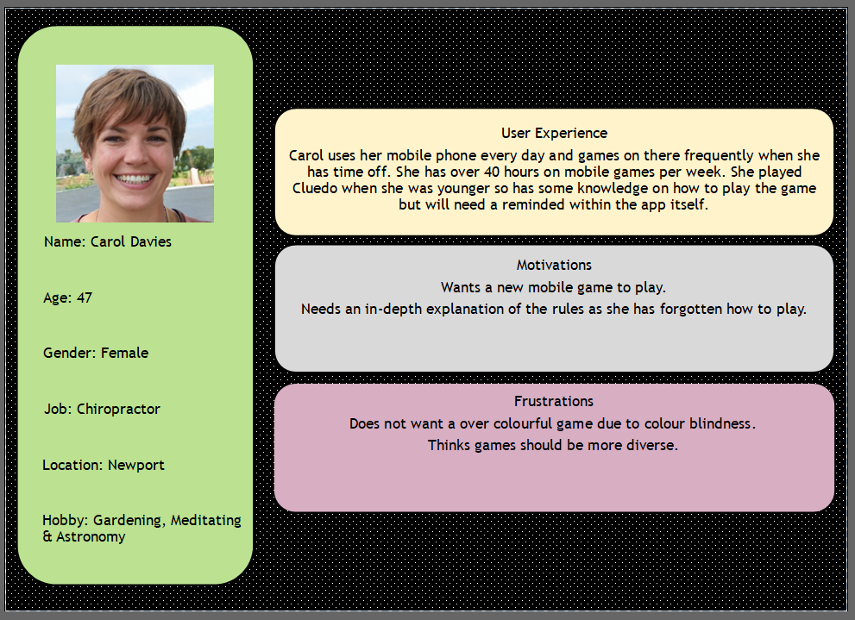

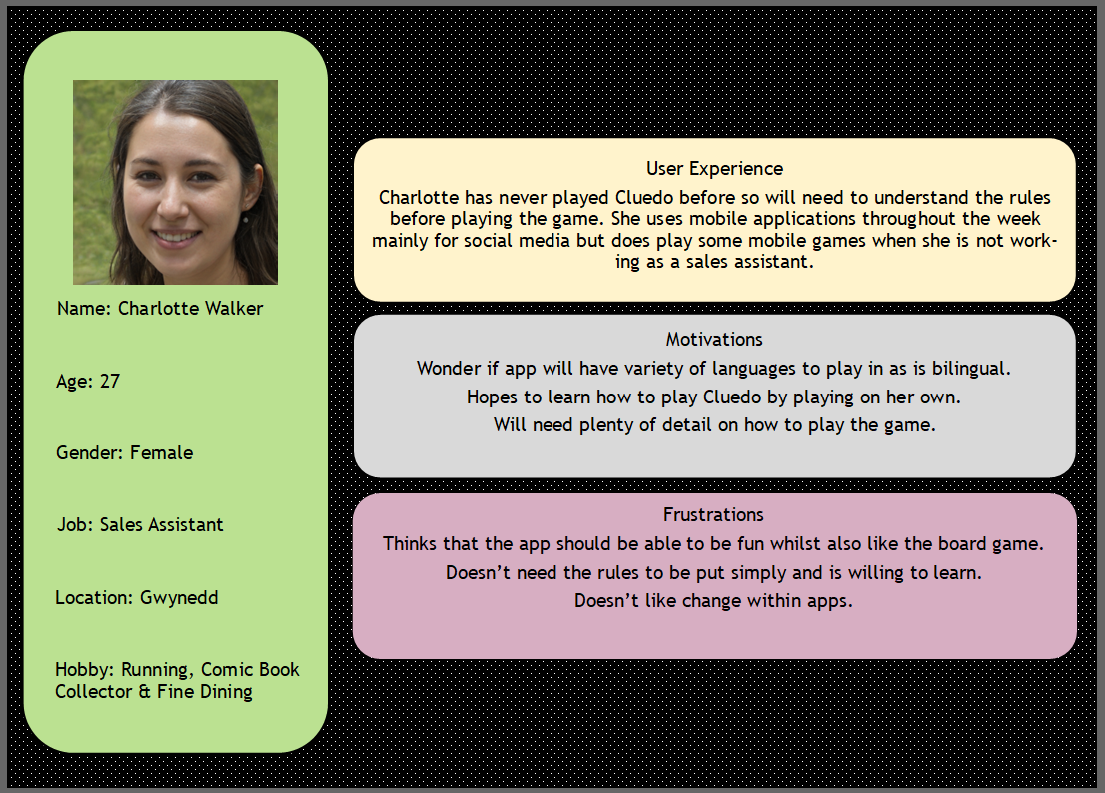

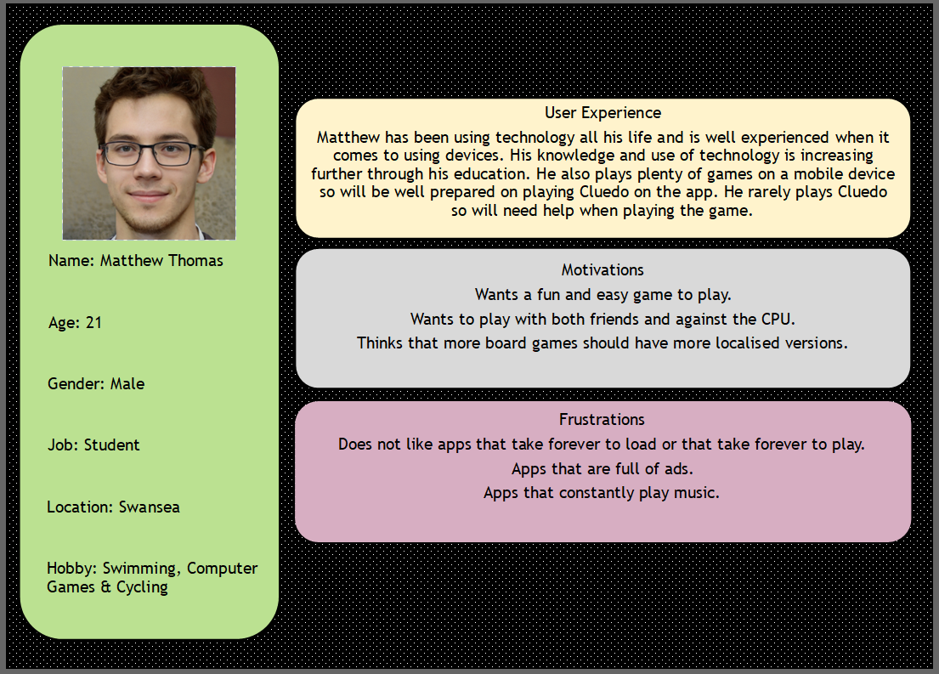

Information Used for Design of Personas

A focus group was used to gather the information used in the personas above. The focus groups included questions on a person’s experience with both Cluedo and device experience, and questions to understand their frustrations and motivations. Their requirements for the application can be put into the MoSCoW criteria which can be found below.

Persona | Must-have | Should-have | Could-have | Won’t-have
Dennis | Clear instructions on how to use the app. | An online feature so that Dennis can play with friends | A range of difficulties to play when playing single player | An overload in instructions on how to play Cluedo.
Carol | Explanation of Cluedo’s rules | Easy to view colours for those who are colour blind | Language selector for those who do not speak English. | An overload of colours as she will struggle to differentiate what the colours are/mean
Matthew | Easy to understand buttons and fun gameplay experience. | List of all rules of Cluedo  An option to turn the music down. | A friends list to play online | Slow loading times.  Lots of adverts.
Charlotte | Consistent design so that I don’t need to go looking for key functionality | A similar feel to other apps that I play to keep me interested. | Diversity in the game | Text filled screens when not needed

Information Necessary for Game Success
The game will be designed on the information gathered from the MoSCoW criteria from the personas. This will ensure that the app appeals to all, not just able-bodied 18–21-year-old students from Swansea. The game will also be a success if the app is designed in alignment with interface design theorists. The work of Norman, Dix, Shneiderman and Nielsen will be used to ensure that the app provides an emotionally satisfying user experience.

Flowchart – Make A Guess
This flowchart is designed on how a user in the Cluedo app will win the game. Their main goal is to reach the staff room and make a correct accusation. The user needs to roll the dice to reach the staff room, and only there they may make their final accusation. If this is correct the user will win the game and the game will end. However, if this accusation in the staff room is incorrect, then the user will lose and cannot make any more accusations and can no longer win.
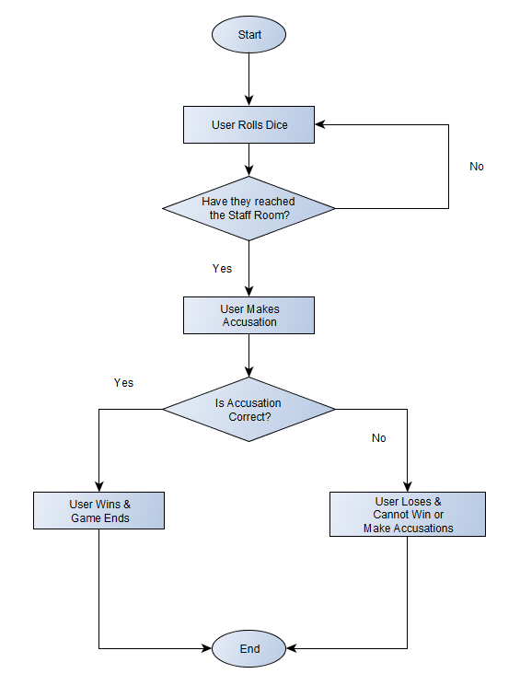

Sitemap of the App
The sitemap of the app can be seen above. The main features of the home page are buttons where the user can either try to play the game, view the rules or change the settings. From pressing the play button, the user can then choose the game mode they wish to play. Whether it be single-player, online multiplayer or offline multiplayer. Once they have chosen a game mode, they must choose a character and can play the game. If the user does not know how to play Cluedo then they can click on the rules button on the home page. This will then provide them with rules on the set-up, moving, accusations, rumours, turns, suspects, cards and how to win. The other option from the home page is settings which will allow the user to change the volume of aspects within the app and change the language.
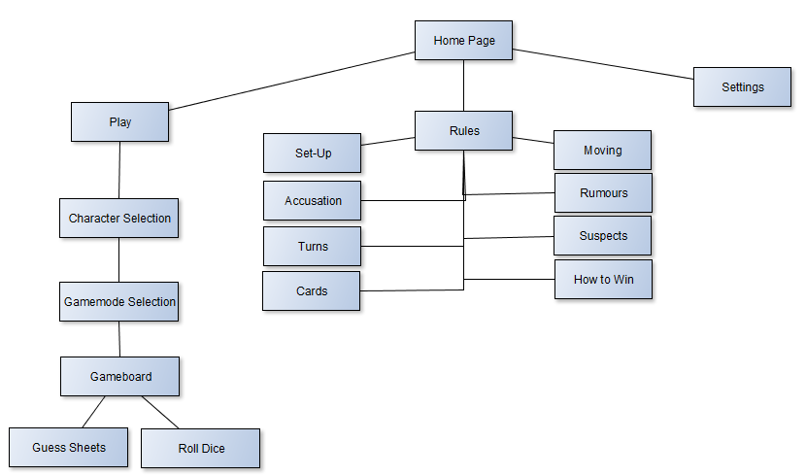

Hierarchical Task Analysis – Winning/Solving the Crime
Similar to the flowchart, this task analysis will explain how to win the game. First, the set-up must take place. This includes selecting the play button on the home page, then selecting the game mode and then selecting the character they wish to play. Once they have done 1.1, 1.12 and 1.13 the user can continue. This is when they start to play the game. They must roll the dice and if they roll two numbers then they can move the combined number on both dice. However, if they were to roll a question mark then they would collect an intrigue card and then move the number on the die that does not have a question mark on its face. To make a guess the user must move to a room, then guess which room, suspect and weapon they believe to have been responsible for the death. They then view the player to the left’s cards if they have any that the user has just chosen. If they show, or not, the user can then mark off rooms, suspects and weapons on the guess sheet. Then in terms of winning the user must have to travel to the staff room. Once there, the user can make their final guess. If correct then the user has won, but if not then they have lost and can no longer win.
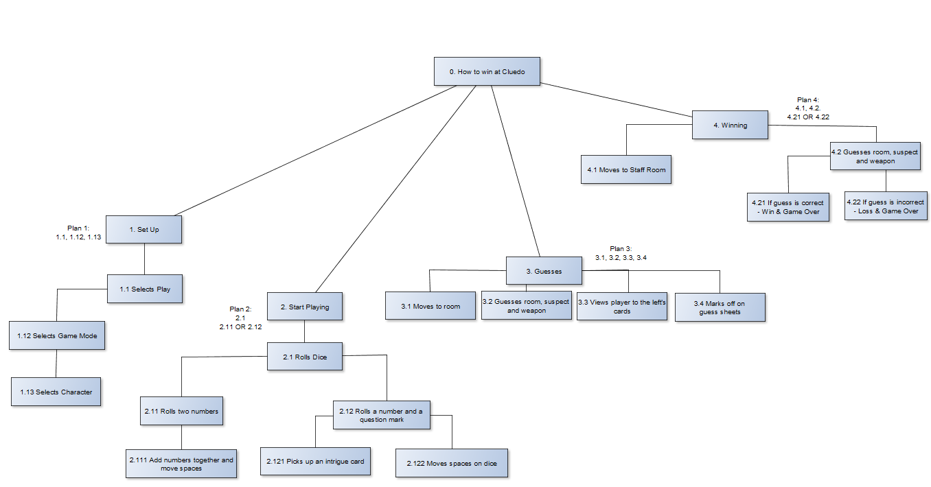

Storyboard Wireframes

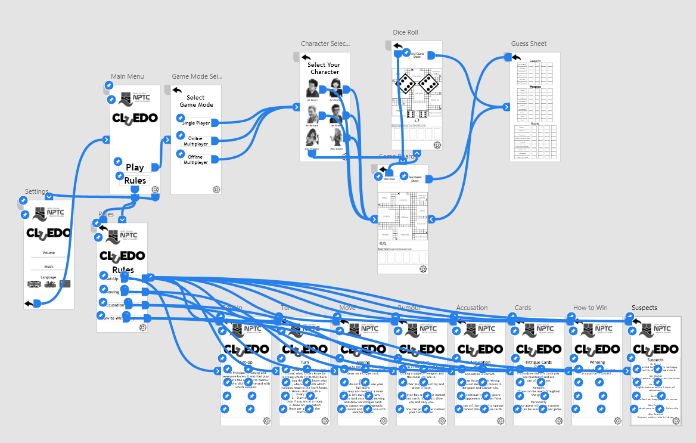

Adobe XD was the software chosen to create the storyboard wireframes. By using the prototype tool within XD buttons could be created that would take the user from screen to screen. The blue arrows that can be seen here are the navigations within the application. On the home page, the user can either click play, rules or settings. The settings button takes the user to the settings page and can return by pressing the back arrow. When the rules button is clicked the user is met with a list of rules in button form. When clicked a description of rules appear and once read the user can return to view other rules or to go to the main menu. If the user were to press play, then they would have to choose what game mode they would like to play. When confirmed they then choose which character they would like to play as then they can play the game.

Home Page Wireframe
The settings button uses an ideogram which is a symbol instead of a word. The symbol used is of a gear which is a common symbol as it has been utilised since Windows 95. This is an example of Alan Dix’s design rules encapsulating learnability through familiarity (14). Experienced users will be aware of what the gear means. This would allow the user to use their short-term memory (15)

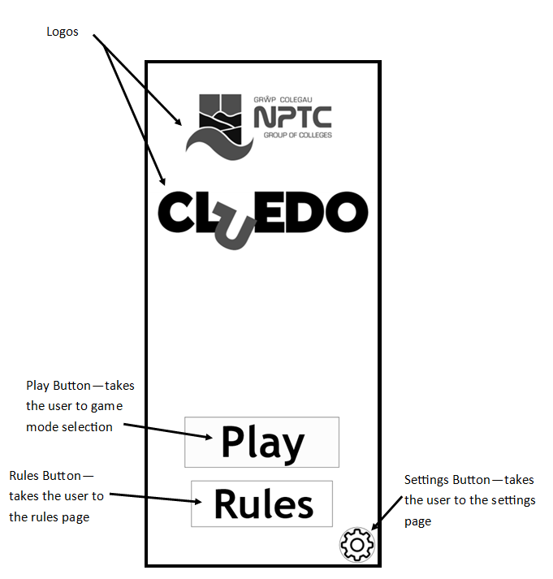

Game Mode Selection Page Wireframe
The settings button can be seen again in the bottom right. By having this in the same place it coincides with another principle of Dix, learnability through consistency (16). This is to ensure that the user becomes familiar with where features are within the app.
The back button is another use of an ideogram. This will take them to the previous page. The arrow is a universal symbol for directions (17). The arrow is commonly used throughout interfaces. This would support Norman’s statement on experiential cognition. (18)

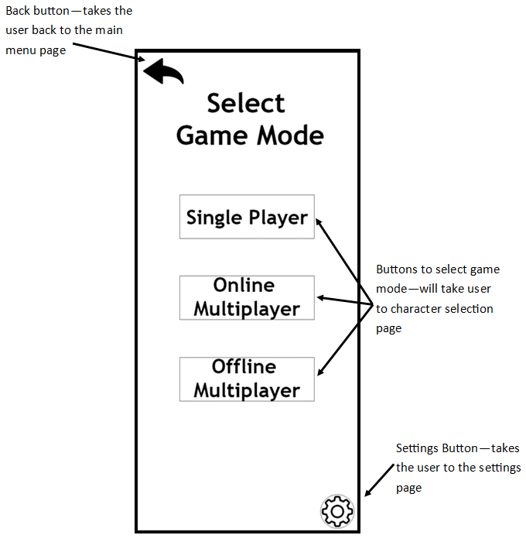

Rules Page Wireframe
Both settings and back buttons are in the same location to ensure consistency (19). The user is met with buttons which replaces a rulebook in a physical game of Cluedo. These buttons will take the user to a page where the relevant information will be given to them. Cluedo can be a complex game to learn which is why the rules are on separate pages. The interface needs to be easy to use due to the complexity. The rules pages aim to refresh the user’s long-term memory as it might have decayed.

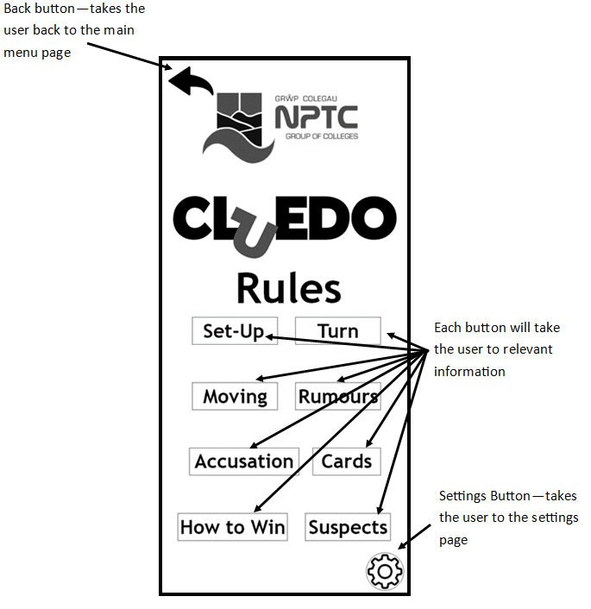

Settings Page Wireframe
Sliders are used as an easy way to control volume for the user. Using this will benefit the user through instant response and feedback. This is an example of a principle of robustness, responsiveness (20). When the slider is used there will be visual confirmation that the volume has changed. This is part of Shneiderman’s 8 golden rules of interface design as it shows support internal locus of control (21). The use of flags to depict changing language is an example of familiarity (22) as the flags symbolize what language the app will change to. This is also the way that NPTC’s Moodle is designed. This page introduces flexibility (23) as it allows the user to customise the user interface and the system.

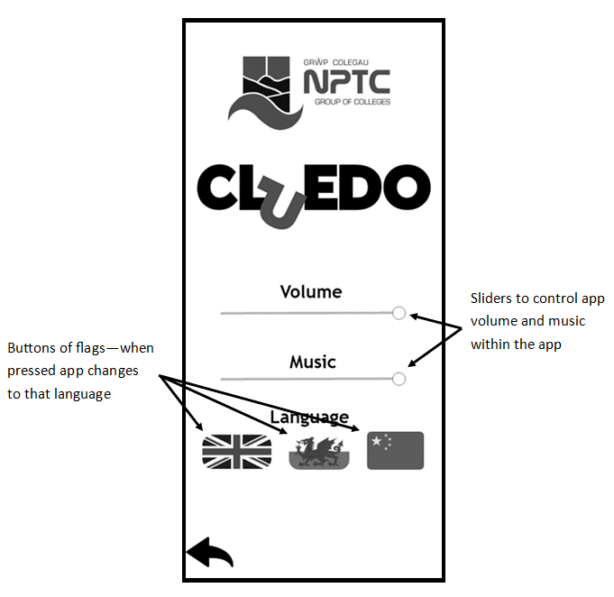

Character Selection Page Wireframe
The use of images as well as names for the characters can reduce the user’s short-term memory load, which complies with Shneiderman (24). There are visual clues to aid the user find which character they would like to play as. The use of these images will help the user transmit the text faster and could trigger emotions (25).

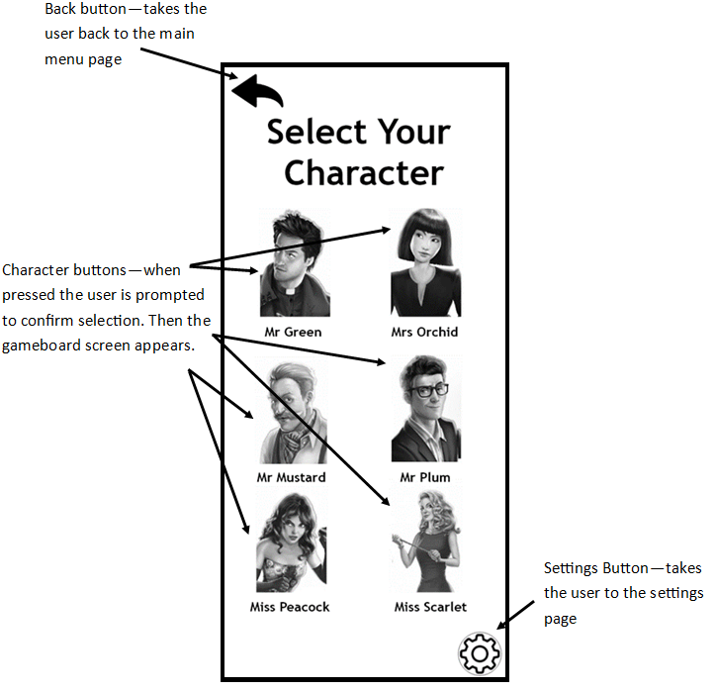

Gameboard Page Wireframe
Another ideogram is used on this page with the magnifying glasses. The buttons at the top of the page are an example of robustness through task conformance (26). The user’s tasks within Cluedo are rolling the dice and checking off the guess sheet. These are placed together to aid ease of use.

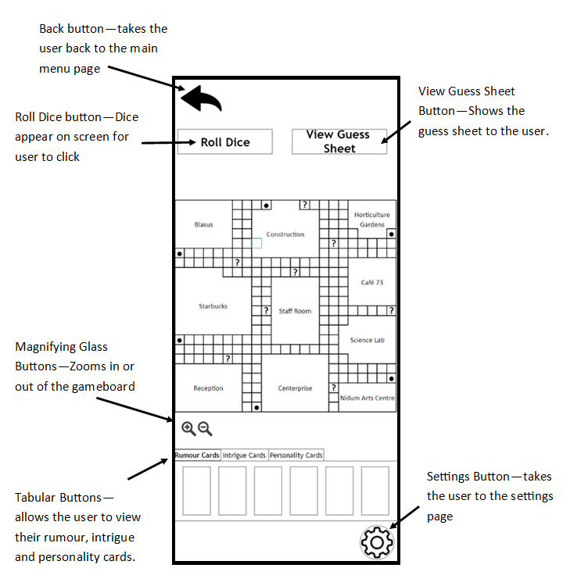

Guess Sheet Page Wireframe
This page has imitated the paper guess sheets that are given out when playing the physical game of Cluedo. This page will need users to use reflective cognition (27) as the guess sheets require decision making and critical thinking. With this requiring detailed thought by the user, it was important to be easy to use.

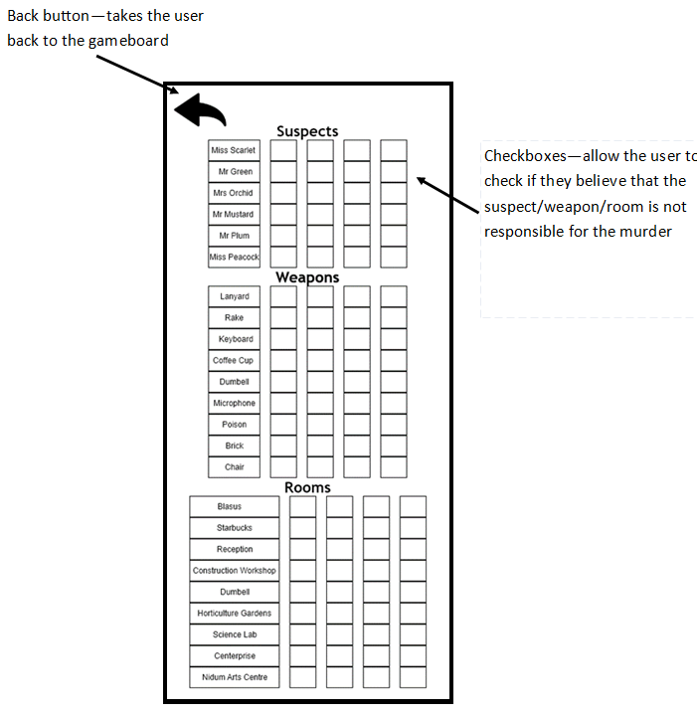

Dice Roll Page Wireframe
When the user clicks the roll dice button on the gameboard page the dice will appear on the page. When the user clicks the smaller dice, an animation of the dice rolling will appear and when they have finished rolling, they will increase in size so that the user can see what they have rolled. This is an example of robustness through observability (28). The dice rolling would be a backend process and the animation would be a visualization of this process.

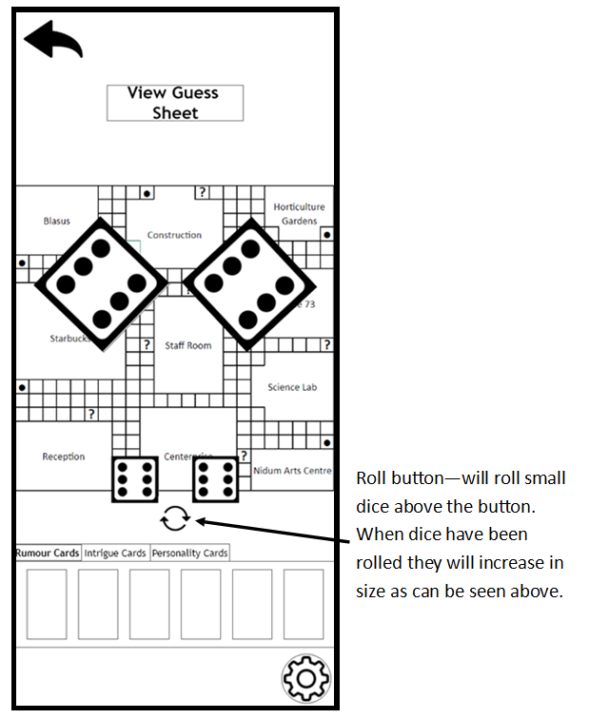

Feedback
The feedback was gathered through Jakob Nielsen’s design heuristics (29). Those who participated in both the personas and MoSCoW criteria table gave feedback on the prototype. By doing this it ensured that the feedback managed to cover the range of the personas defined. They were asked to complete a heuristic evaluation using severity factors.

Feedback – Dennis
Jakob Nielsen’s Usability Heuristic | Severity Factors | Comments
Visibility of System Status | 1 | Only happens when the user rolls the dice.
Match Between System and Real World | 0 | The rules and the game are exactly like Cluedo.
User Control and Freedom | 2 | No undo anywhere but there is a back button.
Consistency and Standards | 0 | No problem here as app is very consistent.
Error Prevention | 2 | I did make errors but only because I am inexperienced.
Recognition Rather Than Recall | 2 | It was easy to use however maybe adding a how to play button mainly for the app and not Cluedo could be a good idea.
Flexibility and Efficiency of Use | 0 | N/A
Aesthetic and Minimalist Design | 0 | Not a problem as only black and white design. Had relevant information in rules pages.
Help Users Recognise, Diagnose and Recover from Errors | N/A | There were no errors to be made in this prototype as the game could not be fully played.
Help and Documentation | 0 | This was clear on where to access help when needed. Possibly add this feature on the gameboard for people who do not know how to play the game.

Feedback – Carol
Jakob Nielsen’s Usability Heuristic | Severity Factors | Comments
Visibility of System Status | 3 | No visibility of system status. This could be added for a loading when a button is pressed. That’s what I see on some games
Match Between System and Real World | 0 | The menus are similar to other games and the game itself is similar to the real board game.
User Control and Freedom | 2 | Only back buttons and no undo. The logo also does not take you back to the home page which happens online sometimes.
Consistency and Standards | 0 | The app is very consistent.
Error Prevention | N/A | I did not make errors when testing.
Recognition Rather Than Recall | 0 | What I needed to do was clear both in the menus and gameplay.
Flexibility and Efficiency of Use | 1 | I appreciate the use of different languages however maybe changing the British flag to English considering the app is in English.
Aesthetic and Minimalist Design | 0 | Rules page was very helpful to remind me of how to play the game. Very minimalistic due to black and white design.
Help Users Recognise, Diagnose and Recover from Errors | N/A | I did not make errors when testing.
Help and Documentation | 2 | You must know how to play the game before pressing play. In the gameboard screen there was no explanation of the rules.

Feedback – Matthew
Jakob Nielsen’s Usability Heuristic | Severity Factors | Comments
Visibility of System Status | 1 | There is obviously a change in system status. This could be conveyed in maybe a loading symbol or that of a hourglass.
Match Between System and Real World | 0 | Very similar to other designs of games that I play.
User Control and Freedom | 0 | Easy to navigate through the different pages of the app.
Consistency and Standards | 0 | A very consistent design with no issues that I spotted.
Error Prevention | 0 | As this is a prototype I understand that not all settings could be pressed as if they pressed the back button then it would not have taken them to the correct page.
Recognition Rather Than Recall | 0 | The game instructions were easy to follow.
Flexibility and Efficiency of Use | 0 | As an experienced mobile gamer, I understood all tasks
Aesthetic and Minimalist Design | 0 | The relevant information could be found in the rules page. Not pages oversaturated with unnecessary information.
Help Users Recognise, Diagnose and Recover from Errors | 0 | There is a back button on every page which allows users recover from any errors they make
Help and Documentation | 3 | When on the gameboard screen there is no pause or help button that could be added to help users mid game.

Feedback – Charlotte
Jakob Nielsen’s Usability Heuristic | Severity Factors | Comments
Visibility of System Status | 0 | I did not notice any need for visibility of system status as it was a quick loading process.
Match Between System and Real World | 0 | Board looked like a Cluedo board and terminology was recognised.
User Control and Freedom | 1 | Back button in all pages however on the rules page it changes from the top left in all screens to bottom left.
Consistency and Standards | 1 | See above.
Error Prevention | 0 | I did not make any errors when using the app.
Recognition Rather Than Recall | 0 | From my memory I was able to understand what to do within the app.
Flexibility and Efficiency of Use | 1 | Potentially add more languages to change into, maybe Arabic?
Aesthetic and Minimalist Design | 1 | Was a black and white design but understandably this is a prototype but I expected to see more colours.
Help Users Recognise, Diagnose and Recover from Errors | 0 | The back button appears on every page except the home page so that can be used to recover from errors
Help and Documentation | 0 | Once I remembered how to play Cluedo I did not need any help within the application.

The feedback that could be acted upon includes:

Undo features | Help on the gameboard | Adding more languages
How to use the app explanation | Loading symbols | All back buttons working
Colours | Logo hyperlink to home page | Possible pause button

References

1. M. O’Brien, ‘Twitter poll closes, majority of users vote for Musk to step down as CEO’, 19th December 2022. [Accessed 13th January 2023] Available at: https://www.pbs.org/newshour/nation/twitter-poll-closes-majority-of-users-vote-for-musk-to-step-down-as-ceo

2. Technology, Pedagogy and Education Association, ‘What is Twitter?’. [Accessed 13th January 2023] Available at: https://tpea.ac.uk/lessons/what-is-twitter/

3. E. Rochko, ‘Twitter buyout puts Mastodon into spotlight’, 26th April 2022. [Accessed 13th January 2023] Available at: https://blog.joinmastodon.org/2022/04/twitter-buyout-puts-mastodon-into-spotlight/

4. S. Dixon, ‘Distribution of Twitter users worldwide as of April 2021, by age group’, 29th March 2022. [Accessed 17th March 2023] Available at: https://www.statista.com/statistics/283119/age-distribution-of-global-twitter-users/

5. S. Dixon, ‘Leading countries based on number of Twitter users as of January 2022’, 22nd November 2022. [Accessed 17th March 2023] Available at: https://www.statista.com/statistics/242606/number-of-active-twitter-users-in-selected-countries/

6. S. Aslam, ‘Twitter by the Numbers: Stats, Demographics & Fun Facts’, 9th March 2023. [Accessed 17th March 2023] Available at: https://www.omnicoreagency.com/twitter-statistics/

7. ThinkImpact, ‘Mastodon Statistics’. [Accessed 17th March 2023] Available at: https://www.thinkimpact.com/mastodon-statistics

8. B. Fung, ‘Elon Musk’s Twitter blocked links to rival Mastodon. That could raise alarms among regulators’, 20th December 2022. [Accessed 17th March] Available at: https://edition.cnn.com/2022/12/16/tech/mastodon-twitter-links/index.html

9. Norman D. The Design of Everyday Things. 2013. London. MIT Press

10. Radiant Digital, ‘Gestalt Psychology – Inspiring Exceptional UX Design With The Power Of Perception’, 2023. [Accessed 24th March 2023] Available at: https://radiant.digital/gestalt-psychology-inspiring-exceptional-ux-design-with-the-power-of-perception/

11. A. Joyce, ‘How to Measure Learnability of a User Interface’, 20th October 2019. [Accessed 20th March 2023] Available at: https://www.nngroup.com/articles/measure-learnability

12. Computer Science Department University of Cape Town, ‘MSc-IT Study Material - Design Principles - Chapter 6. Design Guides’, June 2010. [Accessed 20th March 2023] Available at: https://www.cs.uct.ac.za/mit_notes/human_computer_interaction/htmls/ch06s06.html

13. Mastodon, ‘Mastodon Help – Who Owns Mastodon’. [Accessed 20th March 2023] Available at: https://mastodon.help/

14. A. Dix et al, ‘Human-Computer Interaction’, 1993. [Accessed 24th March 2023] Available at: https://paragnachaliya.in/wp-content/uploads/2017/08/HCI_Alan_Dix.pdf

15. Norman D. The Design of Everyday Things. 2013. London. MIT Press

16. A. Dix et al, ‘Human-Computer Interaction’, 1993. [Accessed 24th March 2023] Available at: https://paragnachaliya.in/wp-content/uploads/2017/08/HCI_Alan_Dix.pdf

17. Dr P Symonds, ‘How to Design and Use Arrows on Signage for Wayfinding’, 17th January 2023. [Accessed 21st March 2023] Available at: https://www.travelwayfinding.com/design-arrows-wayfinding-signage/

18. Norman D. The Design of Everyday Things. 2013. London. MIT Press

19. A. Dix et al, ‘Human-Computer Interaction’, 1993. [Accessed 24th March 2023] Available at: https://paragnachaliya.in/wp-content/uploads/2017/08/HCI_Alan_Dix.pdf

20. A. Dix et al, ‘Human-Computer Interaction’, 1993. [Accessed 24th March 2023] Available at: https://paragnachaliya.in/wp-content/uploads/2017/08/HCI_Alan_Dix.pdf

21. B. Shneiderman, ‘The Eight Golden Rules of Interface Design’, 2016. [Accessed 24th March 2023] Available at: https://www.cs.umd.edu/users/ben/goldenrules.html

22. A. Dix et al, ‘Human-Computer Interaction’, 1993. [Accessed 24th March 2023] Available at: https://paragnachaliya.in/wp-content/uploads/2017/08/HCI_Alan_Dix.pdf

23. A. Dix et al, ‘Human-Computer Interaction’, 1993. [Accessed 24th March 2023] Available at: https://paragnachaliya.in/wp-content/uploads/2017/08/HCI_Alan_Dix.pdf

24. B. Shneiderman, ‘The Eight Golden Rules of Interface Design’, 2016. [Accessed 24th March 2023] Available at: https://www.cs.umd.edu/users/ben/goldenrules.html

25. March B. Caplan, ‘3 Reasons to Liven Up Your Marketing with Visual Content’, 13th February 2023. [Accessed 21st 2023] Available at: https://www.score.org/resource/blog-post/3-reasons-liven-your-marketing-visual-content

26. A. Dix et al, ‘Human-Computer Interaction’, 1993. [Accessed 24th March 2023] Available at: https://paragnachaliya.in/wp-content/uploads/2017/08/HCI_Alan_Dix.pdf

27. Norman D. The Design of Everyday Things. 2013. London. MIT Press

28. A. Dix et al, ‘Human-Computer Interaction’, 1993. [Accessed 24th March 2023] Available at: https://paragnachaliya.in/wp-content/uploads/2017/08/HCI_Alan_Dix.pdf

29. J. Nielsen, ‘10 Usability Heuristics for User Interface Design’, 24th April 1994. [Accessed 24th March 2023] Available at: https://www.nngroup.com/articles/ten-usability-heuristics/

