Shafia Bibi | 1711966
LECTURER | Paul Bocij
Strategic Management for SMEs
Module Code: BMSW6104

CONTENTS
INTRODUCTION 2
CANDY KITTENS CURRENT STRATEGIC DIRECTION 3
Porter’s 5 Forces 3
VMOST Analysis 3
Balanced Scorecard 5
INTERNAL AND EXTERNAL ENVIRONMENT 5
Pestle Analysis 5
SWOT Analysis 7
STAKEHOLDER ANALYSIS 8
NEW STRATEGY PROPOSAL 10
RECCOMENDATIONS FOR FUTURE DEVELOPMENTS 12
The SAFe Framework 13
The Change Management Model 14
The Change Curve Model 15
CONCLUSION 16
REFERENCES 17

INTRODUCTION

This report will stress the importance of strategic management for SMEs. It will critically assess Candy Kittens strategic direction using models and theories, which would involve environmental scanning. Some of the tools that will be included are: PESTLE Analysis, SWOT Analysis and a VMOST Framework. This report also evaluates stakeholder expectations. By the end of the report, a proposal of new strategies will be given for a boost in Candy Kittens sustainable growth.

Early 2012, Candy Kittens (a private limited company) was founded in London by Jamie Laing, an actor and an entrepreneur, and his friend Ed Williams. Laing who is heir to the McVitie’s biscuit company had grown up with a fantasy of one day having his own sweets shop. Having met Williams through university, they both became very good friends and shared the same vision of making cool sweets in which adults could enjoy, just as much as children. With vegan and vegetarian sweets in mind, their astonishing journey had begun, and as a result of this today, their net worth is almost £2million (Company Check, 2020). The accounts suggest this is a rapid increase from its previous years. Laing and Williams grew inspiration from other brands. Their unique sweets can be found in places such as Tesco, Sainsbury’s, Superdrug, Amazon, and Holland & Barrett.

CANDY KITTENS CURRENT STRATEGIC DIRECTION

Porter’s 5 Forces

Candy Kittens mission is to “create the very best sweets, taking on the big guys and delivering more for our people and planet. Just like the fashion brands that we draw inspiration from, at Candy Kittens we want to constantly develop and move forward.” Williams (n.d.b). This statement suggests they want to continually build and move forward.

Strategic direction is like a business roadmap. It involves planning, scanning, implementation and evaluation. Porter’s 5 Forces are factors that assess a business’ strategy and competitiveness. One of the factors include threat of new entry. If it is easy and cheap to enter the market, Candy Kittens are at a big risk of losing customers to other entrants. According to Terrelonge and Schutte (2017), in 2015 Laing and Williams were seeking a £300,000 investment and they had reached a third of that at the time. This was a huge investment, which is not easily attainable so there is a low threat of new entrants.

Another factor to be considered is competitive rivalry. Candy Kittens have a lot of competitors such as Haribo, SugarSin, Sweet Pete, Nassau Candy, Sugarfina, and many more. To stay on top of the game, Candy Kittens should broaden their products to give customers more choices. They should also consider affordability for customers, so they do not go elsewhere. They are catering for vegans and vegetarians which means they are reaching out to a lot of customers; however, they should create more flavours to reach a greater number of people. The greater number of people they have, the more buyer power the company has.

Candy Kittens provide a variety of packs, including size and shapes. They provide wholesale, bundles, full collections, personalised sweets, sweet bags, gifting and currently Christmas offers. This shows they are taking into consideration different occasions, which is a positive move for having a competitive advantage. it is important to consider many suppliers rather than one or two, to gain advantage over supplier power. Candy Kittens should ensure their products are unique so that there is a lower threat of substitution. People cannot imitate easily.

VMOST Analysis

To improve the business strategy, Candy Kittens can use the VMOST Analysis to see how they can make vital changes, whilst maintaining their long-term vision. The framework is made up of vision and strategies. This could help Candy Kittens analyse their current strategy and values can be added to help the company move in the right direction. The VMOST framework will also enable workers to identify goals at every level. It is a top-down structured method, so this ensures the main priority is not forgotten about, as this is usually the case in some businesses. Some employees tend to give so much attention to daily activities that the whole strategy is forgotten, and they underachieve.

The framework was founded by Sondhi in 1999 (B2B Frameworks, 2019). He suggested that to use this framework, it must be decided whether to look at the business as a whole or only a particular part. The pyramid starts with a vision, which should be the top priority. Every activity should be linked to the vision. Candy Kittens do not have a clear vision, or perhaps they do but this is not evident like their mission statement. Or maybe it is combined with their mission statement. This is something Candy Kittens should clearly identify on their website.

A vision is where the company is going, however a mission is the reason for its existence and long-term intention. As mentioned before, they have a mission statement, and it could be said that it is engaging. It will draw attention and seems very optimistic, taking into consideration its people and the environment.

Objectives are SMART goals that link in with the mission. Candy Kittens have a mobile Candy Van and permanent stores in 15 different countries. They intend to expand this number and sell in other countries. Candy Kittens may have a SMART target for this, but this was not apparent when conducting research. According to Appear Here (2019), Candy Kittens are developing new products and flavours in summer. They were also considering reducing plastics and that was due to be revealed in six months. A year has passed since, and they are still using plastic packaging. According to their website, they are using recyclable plastics (Williams, n.d.a). In addition, they want to become B-Corp certified, make products 100% vegan, and become a carbon neutral business in the near future. They regularly update their website, however there is not a date specified.

Strategies is the plan of action, created to achieve long term goals. Candy Kittens need to ensure everyone is working towards the same path, which is to achieve the vision of the business. Without everyone on board, the business will struggle.

Lastly, tactics are the detailed activities that have to be met to pass each stage of the plan. This can be adjusted for better performance. The most important thing to learn from this framework is that each tier is linked to another so these must be encountered to see progress.

Balanced Scorecard

Another way of analysing Candy Kittens strategic direction is by using a Balanced Scorecard. This technique assists with the management and performance of any business. It focuses on internal aspects of a business and its external outcomes. According to Tarver (2020), it is better to provide quantitative data for managers to examine the business and for better decision-making processes. There are four areas to consider: learning and growth, business processes, customer perspectives, and financial data. All four play a part towards the vision and strategy of a business, so Candy Kittens can use this to collect data, analyse their competitive advantage, and enhance business.

INTERNAL AND EXTERNAL ENVIRONMENT

Every business should do environmental scanning to assess their strengths and weaknesses, in order to gain better insights into their position in the market. A PESTLE analysis looks at the macro environment, whereas a SWOT analysis is used for the microenvironment. Together with these, Candy Kittens can identify what improvements could be made for its long-term health.

Pestle Analysis

PESTLE, which stands for Political, Economic, Sociological, Technological, Legal, and Environmental, is a concept that analyses external factors influencing a business (PESTLE Analysis, 2020). This would enable Candy Kittens to evaluate their business from different angles and help them make judgements. However, this tool can be time consuming. Rastogi (2016) suggests some people may overthink ideas causing themselves stress or the business, or perhaps underestimate the importance of the tool and provide insufficient information. It should be used regularly.

Political factors are government influences that may be present, for example tax policies, trade restrictions, foreign trade policy, labour law and political stability. Candy Kittens should make themselves aware of the policies so they can take proper precautions when selling their products and planning budgets or it could impact long term plans.

Economic involves activities that are directly linked to the business that could also have long term impacts if not considered carefully. An example of this is a rise in inflation. Candy Kittens may be required to change their pricing on products and services. This could affect buyer or supplier power. Other factors include employment rates, interest rates and foreign exchange rates.

Sociological factor is the social situation of the market. This includes cultural factors, demography, population, age, beliefs and attitudes (Professional Academy, n.d.). These elements would enable Candy Kittens to assess their target market, and what they desire from the company. With the current pandemic, Candy Kittens have partnered with the HEROES appeal to help frontline workers. They are donating 10p from every sale they make, both in store and online (Candy Kittens, 2020). This goes to show they are aware of social situations and in doing so, are creating a better social stance, which could see them more profits.

Technological factors involve awareness and the use of innovation in technology. This could be achieved through production, distribution and communication. Candy Kittens are keeping up to date with modern ways of communication and advertising. They use social media, emails, and have their own website.

Legal factors are laws that can affect the business internally and externally. Some are created by the company and some are from the government. Business strategies would be formed around these rules and regulations, for example health and safety, discrimination law, employment law and data protection laws, cited by Business-to-you (2016). Candy Kittens must be aware of these laws in order to trade successfully and ethically, especially as they sell in other countries where they may have separate laws. It is imperative to stay up to date with any changes.

Environmental factors have become very popular over the years due to pollution and carbon footprints, as a result of people and businesses. They involve aspects such as climate, weather, pollution, crime, poverty levels and climate change (Dobbs, 2019). Candy Kittens are aware of this and are taking responsibility and promoting sustainability. According to their Facebook page (Candy Kittens UK, 2020), they want to give back to the planet by planting a tree with every sale on their website, in partnership with TreeSisters. Also, instead of Black Friday, they are having Green Friday, where customers can apply a 40% discount code at checkout. They promote sustainability by avoiding harmful ingredients such as animal gelatine and palm oil. They are still using plastics; however, they are recyclable (Williams, n.d.a).

SWOT Analysis

A SWOT analysis can help identify competition in the industry. It looks at Strengths, Weaknesses, Opportunities and Threats. Using this tool can enhance knowledge and understanding and identify the advantages and disadvantages there may be. Furthermore, this tool can help make decisions in future. Below is a SWOT analysis of Candy Kittens.

Strengths | Weaknesses
- Large market presence  - Variety of products  - Digital marketing  - Regular updates  - Vegan and vegetarian products  - Offers and discounts  - Same day delivery  - Wholesale | - Lack of flavours  - Staff absences  - Lack of knowledge or experience
Opportunities | Threats
- Expand worldwide  - Expand suppliers for better deals  - More candy vans  - More variety of flavours and designs | - Competition  - Media can influence potential customers  - Health regulations  - Stores closing due to Covid 19

It can be seen from the above table that there are a lot to consider. Candy Kittens have a lot of strengths and opportunities, and more can be added, but there are threats and weaknesses to evaluate, as this can cause problems for their future. Competition being one of the biggest threats to any company, this cannot be eliminated however it can be reduced. Candy Kittens need to stay on top of their game by analysing who and what is around them and how they can defeat them.

One of their strongest assets is the same day delivery. Not all competitors offer this choice, so having same day delivery with companies like Amazon can draw a lot of customers. This is made possible because Candy Kittens offer wholesale on products. Smaller retailers can then go on Amazon and sell these products on there. However, customers would require Amazon Prime to benefit from same day delivery and without this, they cannot take advantage of the service.

STAKEHOLDER ANALYSIS

Stakeholders can range from internal and external individuals to groups. They have a direct or an indirect link to a business and can have an effect on business plans (Writer, 2019). They may also be impacted by plans, so it is important to place them in the correct positions. To do this, a stakeholder analysis could be done through mapping. Stakeholder mapping can be used to plan the project, make improvements, build trust, identify important and vital roles, and stay in lead of the competition.

A stakeholder map can identify people of high or low interest, with a high or low level of power. An individual or group with low power but high interest should be kept completely informed, however an individual or group of high power and high interest should be managed very closely. An individual or group with a low level of interest and low power should be kept into account with minimal contact, but an individual or group with low level of interest but high power should have their needs and expectations met. This can be seen in the grid below:

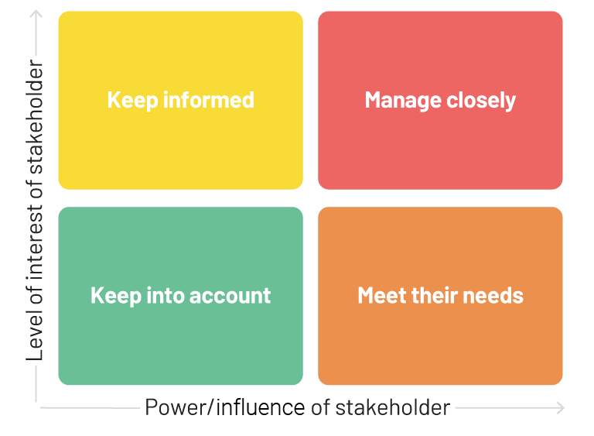

(Source: Gregoire, 2020).

The grid below shows stakeholders of Candy Kittens:
Level of Interest
- Employees  - Customers  - Suppliers  - Small retailers | - Directors  - Government  - Local council  - Shareholders
- Community  - Employees | - Suppliers  - Media

Level of Power

As it can be seen in the grid above, some stakeholders can fit into different categories, for example employees. Employees such as admin or website developers can have low levels of power, however a mixture of interest. A web developer’s job is to create a unique website, and depending on the type of website produced, this would then attract or detract customers. the developer may not be interested in the products they are creating the site for, but it will impact how it is received. Therefore, it is important to assess each and every stakeholder and identify ways of how to deal with them.

Employees need to be monitored and kept informed. Candy Kittens should ensure they are happy in their job in order to receive the best performance from them. If the employees are not satisfied in their jobs, they will not produce their best, which would in turn affect business success.

Media can play an important role in a business too. They could capture all the negative or positive and have a big influence on the business. It is essential for Candy Kittens to ensure media will not be affecting them in a negative way, so they must do everything they can to keep on the good side of media. Also, they should be careful what they upload on social media as this can be shared a million times and even reach many countries.

The government has very high power and could have high or medium interest. Candy Kittens must ensure to abide by all rules to keep the government on side. If they cannot adhere to them, the government could close them down. Also, as they are selling sweets, they must ensure their products are really made of what they say they are. Also, it is important to consider people’s health, so if they say a product is suitable for vegans and vegetarians, Candy Kittens have to ensure they are otherwise this would be deceiving the public.

The community can be placed anywhere in between high and low interest. They could also have high or low influential powers but their interests in the business can impact its growth. If the community can see the positive effects of having sustainable vegan and vegetarian sweets, they may want to promote this by having events to support or sponsor them. This could gain the business competitive advantage. However, if the community do not see a desire for this, or if there is noise or litter pollution caused by Candy Kittens services, they could take this further to the council and make complaints, gaining signatures to have the shop permanently closed or hours of opening reduced. Either way, the community deserves to be made happy, meeting their needs.

NEW STRATEGY PROPOSAL

Candy Kittens strategic direction is very good. They are regularly updating their services and offers and are also meeting customer demands. They use current technology to promote their products. They should continue to do this but do regular monitoring to identify any changes with competitors, government laws or even the environment. This will make their business sustainable and gain them competitive advantage. Also, they can be ready to tackle any challenges in future, which includes environmental challenges that can affect customers or the business itself.

Candy Kittens should continue to take responsibility of sustainability and ethics. Doing right by the environment and its people means more competitive advantage and they would gain a better retail presence. According to Charter College (2020), business and social media ethics can bring out a good reputation for the company. Treating customers, employees and the community rightfully will make people want more participation and services of the business. Also, it helps keep the business out of trouble with the law, and being a positive role model, their employees will have more confidence in the business and will be happier to work for them. Candy Kittens will see more profits if they are more ethical. Therefore, regular environmental scanning and improvements are essential. A sudden need for a change or resource could cost the company a lot of money or time so it is vital to monitor changes. According to the BBC (2020), an increase in costs would mean less profits, so in order to increase profits, more products will need to be sold and that is added pressure for the company. If this cannot be achieved, prices on products or services will have to be increased which means there is a risk of losing customers.

In order to stay in lead, Candy Kittens may use different strategies to analyse their current position in the market. One of the strategies they could use to move forward is the Value Chain Analysis. Zamora (2020) suggests, the value chain analysis was founded by Porter in 1985. The value chain helps gain competitive advantage and identifies different stages of production, which involves the conception, formation, distribution and the end result. When it passes through different departments, more value is added. An example of this could be seen in quality inspection. If the sweets or packaging are not up to standards, they would go back to the previous stage and improvements would be made. However, this should not increase costs. The value chain encourages cost leadership and cost reduction, hence increasing product and service value.

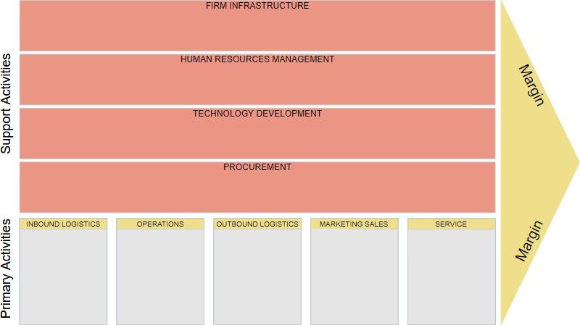

(Source: Visual Paradigm, 2020).

The value chain analysis can help defeat competitors in the long run. It is important for Candy Kittens to maintain their position and make improvements to gain more competitive advantage. By using the value chain, Candy Kittens can reduce costs, improve value for customers and gain better employee engagement. The value chain can also help with product differentiation. This enables unique products and services to be created, which would rely on a lot of research and development.

The value chain is divided into two sections: primary and secondary activities. Inbound logistics being the most vital aspects in primary, bringing the most value to business, this focuses more on materials. Operations calculates the workers and identifies each role. This also monitors the workers whereabouts, which can be achieved through a GPS system. Outbound logistics is the delivery of products to customers, planning routes and saving time. Drones could be considered for delivery. Marketing is the method of advertising, such as online catalogues or social media. Marketing also involves a paying system like PayPal. Service is ensuring the products are in excellent conditions. Service also includes staff training. More use of technology can bring competitive advantage.

The secondary activities do not necessarily bring value to the business however they are vital to run the business. Procurement means buying what the organisation needs. This could be done in bulk to save costs, ensuring there is enough stock. Paying systems need to be in place. Availability of products will bring in more customers and profits, increasing competitive advantage. Also, in procurement, this is where the business can see how many customers are viewing their services and products. Technology development is how products are made, used or handled. An example of this could be seen in online planning. An architecture could be used to create this. Human resource management deals with personal, such as online recruitment processes, interviews, staff rotas, training, project management, synchronizing information, analysing employee performance, and tracking speed of delivery. Firm infrastructure is the admin side of things.

Logistics should be the main area of focus as this is the main area for improvements. 40% of savings come from logistics. The supple chain can make a big difference. The bigger and the better the supply chain, the better the logistics, which means a better competitive advantage. The biggest cost comes from delivery of supply to the business.

RECCOMENDATIONS FOR FUTURE DEVELOPMENTS

For future development, Candy Kittens should continue to monitor and improve their products and services. They should also ensure their employees, customers and the community are happy. The main factors to consider are sustainability and cost reduction but bear in mind the problems which may arise such as financing and slow sales. Candy Kittens should ensure to be prepared for the challenges they may have to face. In addition, competitors will also be improving. Are Candy Kittens prepared to match them or beat them? Do they have to provide huge discounts or sales? Will there be more seasonal products? According to Companies House (2020), there are currently eight directors, with one that has resigned. Is there a particular reason there are so many directors? Is a couple not sufficient? Does the business really need that many directors? These are the sorts of questions Candy Kittens need to be asking themselves. Perhaps with one leader, they could be more efficient and productive in the business.

The SAFe Framework

The SAFe framework could be used to assess which strategy would be the most efficient in running a business. SAFe, which stands for Suitability, Accessibility, and Feasibility, is a scoring system that evaluates the best option. The one with the highest score would be the ideal one (Lucidity, 2020). However, it is important to bear in mind these frameworks can be time consuming and need to be completed before implementing. Also, if two options score the same, what could be done about that? Below is an example of this:

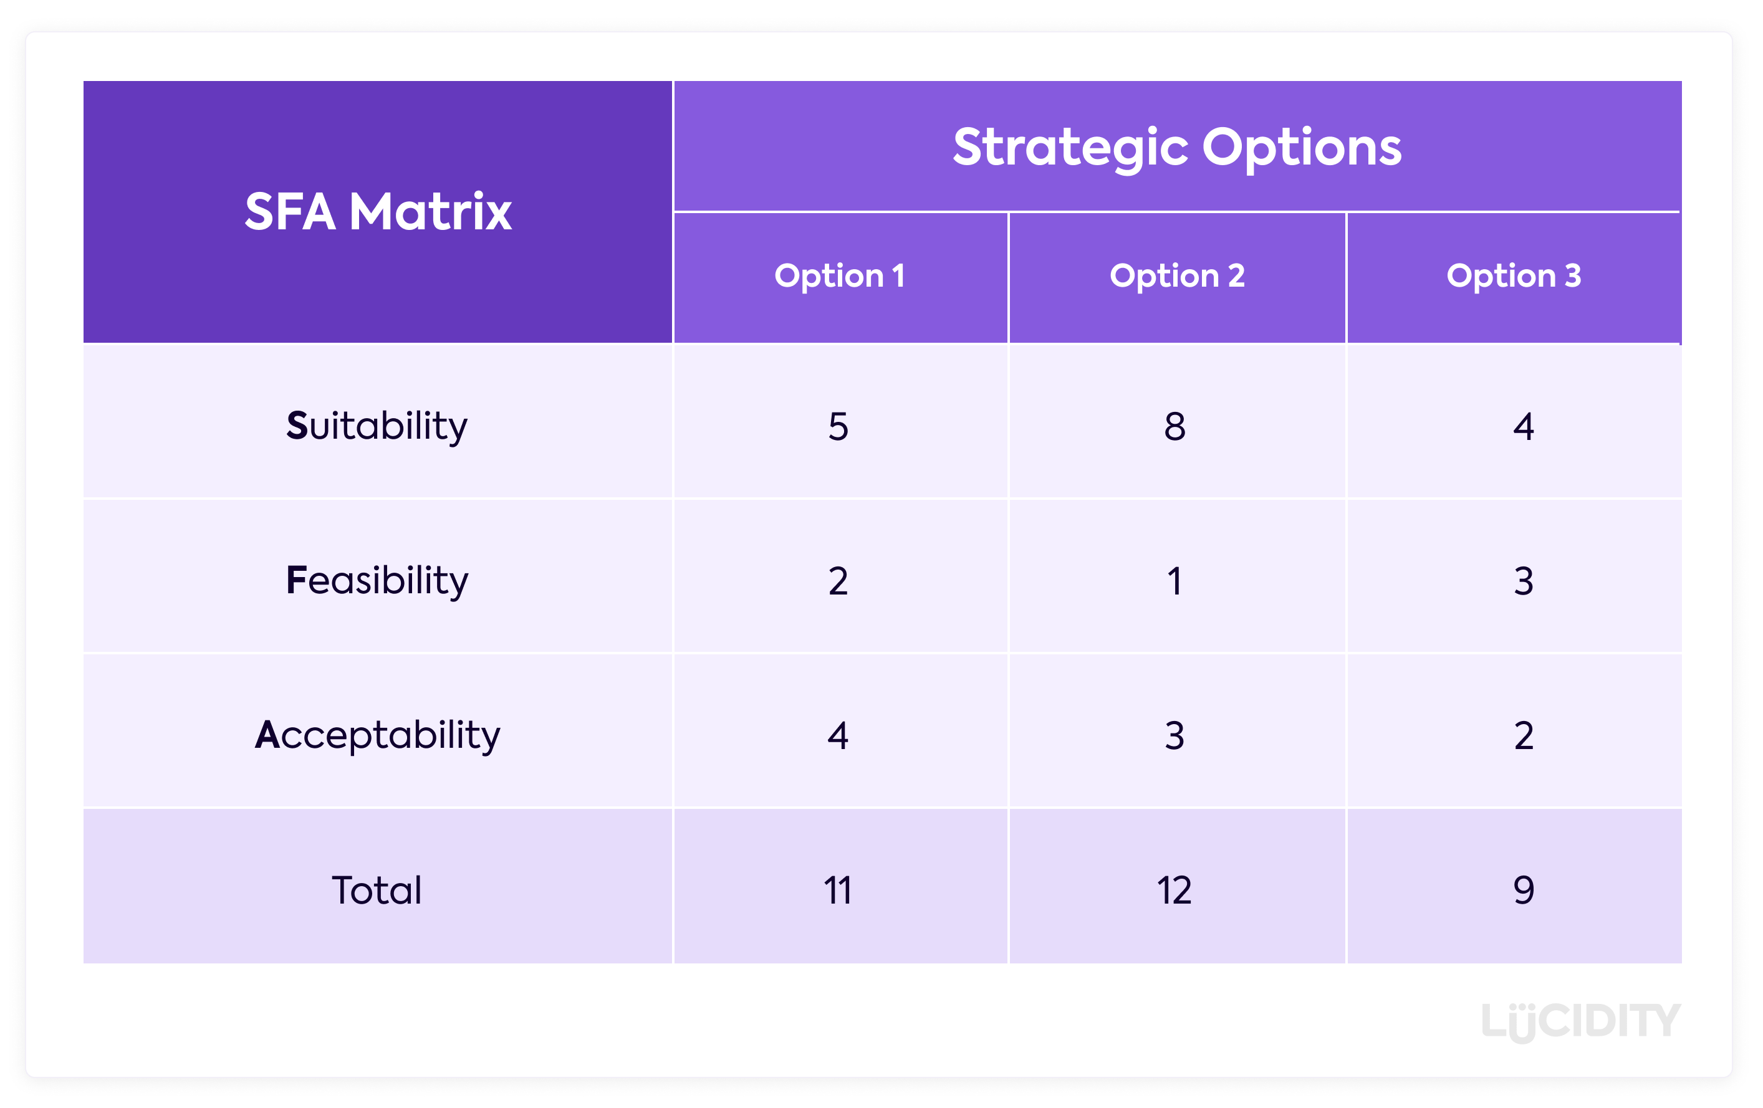
(Source: Lucidity, 2020).

Suitability looks at the company’s goals and whether this can be achieved. It would also look at any threats to the company. This is almost like the SWOT analysis that was done earlier, so suitability would look at strengths, weaknesses, opportunities and threats.

Acceptability considers any potential risks. This would identify risks as well as profits. It would also recognise if there are any value to be added to the current strategy. Furthermore, it would detect any financial problems which could occur. A balance score card could be used here to look closely at matters as some people have different views. Also, stakeholders play a crucial part here so they must be informed (Lucidity, 2020).

Feasibility focuses on the financial side of things. Does the company have enough funds to take the next steps? Resources? What will the competitors do at this stage? Will they increase or lower their prices? Does Candy Kittens have the opportunity to buy out other companies to reduce threats?

Below is an example of what Candy Kittens SAFe framework could look like:

 | - Leadership | - Cost Reduction | Organisational Structure
Suitability | 5 | 8 | 3
Acceptability | 5 | 8 | 5
Feasibility | 6 | 3 | 2
Total | 16 | 19 | 10

This framework suggests a cost reduction approach would be the most appropriate for Candy Kittens. It would be suitable and what company does not want to reduce costs? If everyone can see the benefits, they would accept this. It may not be easy to carry out however people would try harder. This would save them money in the long run, and perhaps they could buy out smaller competitors with the profits that they gain. Cost reduction could be achieved by improving sales or changing suppliers.

The Change Management Model

Once this is accepted, this can be implemented by using the Change Management Model. According to Cleverism (2020), the change management model was invented by Kurt Lewin in the 1950’s. This model consists of three different stages: unfreeze, change and freeze. Unfreeze means to get people on board. Make them understand the changes required. Explain the importance of the change to the business and its people. Change is the transition period, where new ideas become the norm. people would need time to adjust. Freeze is the process of refreezing the current strategy and getting people use to the change, even if it means having regular meetings or reviewing.
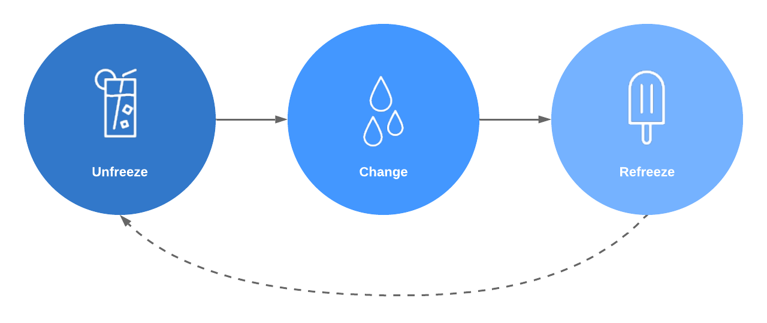

(Source: Ludichart, 2020).

The Change Curve Model

The Change Curve Model was founded by Elizabeth Kubler-Ross. She stated that there are different stages people go through with change: shock, denial, frustration, depression, experiment, decision and integration (ChangeQuest, 2020). The change curve model can also be used to get people on board with changes and make them easier to handle.
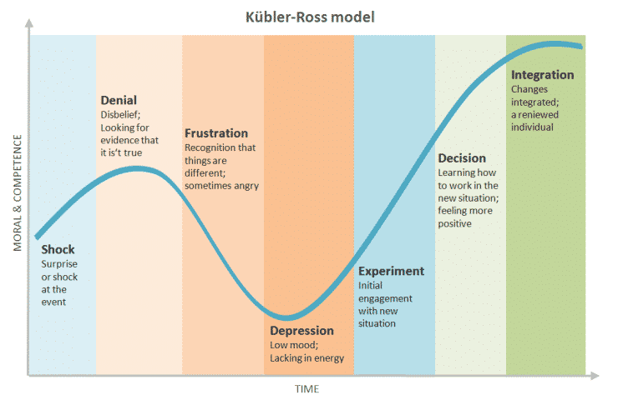

(Source: Belyh, 2020).

CONCLUSION

Candy Kittens current strategic direction is quite clear. It is putting their customers first, and they are in line with current rules and regulations. They are aware of the current pandemic and are providing needs under these circumstances. Their mission is to provide sustainable and ethical products and services and they are taking this seriously. Candy Kittens ae taking their responsibility in looking after the environment. They are also ensuring they have maximum advertising methods, which means they are reaching a greater number of customers and profits. They do have competitive advantage as their starting point was of a huge investment and they are continuing to provide the very best. Candy Kittens should continue to monitor and assess potential threats to the company, and they should remain ethical. They should expand on the flavours and add a little more value to customers.

REFERENCES

- Appear Here (2019) ‘Candy Kittens: How to Build Your Retail Presence’, Appear Here [blog]. 11 July. Available at: https://www.appearhere.co.uk/inspire/blog/candy-kittens-how-to-build-your-retail-presence (Accessed: 21 November 2020).

- B2B Frameworks (2019) VMOST. Available at: https://www.b2bframeworks.com/vmost (Accessed: 20 November 2020).

- BBC (2020) Business Revenue, Costs and Profits. Available at: https://www.bbc.co.uk/bitesize/guides/zb2shbk/revision/4 (Accessed: 1st December 2020).

- Belyh, A. (2020) Understanding the Kubler-Ross Change Curve. Available at: https://www.cleverism.com/understanding-kubler-ross-change-curve/ (Accessed: 2nd December 2020).

- Business-to-you (2016) Scanning the Environment: PESTLE Analysis. Available at: https://www.business-to-you.com/scanning-the-environment-pestel-analysis/ (Accessed: 25 November 2020).

- Candy Kittens (2020) Be a Hero and Help Our Heroes. Available at: https://candykittens.co.uk/pages/heroes (Accessed: 25 November 2020).

- Candy Kittens UK (2020) [Facebook] 25 November. Available at: https://www.facebook.com/CandyKittensUK/ (Accessed: 25 November 2020).

- ChangeQuest (2020) Kubler-Ross Change Curve. Available at: https://www.changequest.co.uk/resources/kubler-ross-change-curve/ (Accessed: 2nd December 2020).

- Company Check (2020) Candy Kittens Limited. Available at: https://companycheck.co.uk/company/07917735/CANDY-KITTENS-LIMITED/financials (Accessed: 20 November 2020).

- Charter College (2020) Why Are Good Ethics So Important to Businesses? Available at: https://www.chartercollege.edu/news-hub/why-are-good-ethics-so-important-businesses (Accessed: 1st December 2020).

- Companies House (2020) Candy Kittens Limited. Available at: https://find-and-update.company-information.service.gov.uk/company/07917735/officers (Accessed: 2nd December 2020).

- Dobbs, B. (2019) ‘Making the Best of PESTLE’, Modern English Teacher, 28(2), p.78.

- Gregoire, P. (2020) How Stakeholder Mapping Tools Can Improve Your Stakeholder Management. [Image] Available at: https://www.boreal-is.com/blog/stakeholder-mapping-identify-stakeholders/ (Accessed: 30th November 2020).

- Lucidity (2020) Guide to The SFA Matrix. Available at: https://getlucidity.com/strategy-resources/guide-to-the-sfa-matrix/ (Accessed: 2nd December 2020).

- Ludichart (2020) 7 Fundamental Change Management Models. Available at: https://www.lucidchart.com/blog/7-fundamental-change-management-models (Accessed: 2nd December 2020).

- PESTLE Analysis (2020) What is PESTLE Analysis? An Important Business Analysis Tool. Available at: https://pestleanalysis.com/what-is-pestle-analysis/ (Accessed: 24 November 2020).

- Professional Academy (n.d.) Marketing Theories – PESTLE Analysis. Available at: https://www.professionalacademy.com/blogs-and-advice/marketing-theories---pestel-analysis (Accessed: 24 November 2020).

- Rastogi, N. (2016) ‘Pestle Technique - A Tool to Identify External Risks in Construction Projects’, International Research Journal of Engineering and Technology (IRJET), 3(1), p.388.

- Tarver, E. (2020) Balanced Scorecard. Available at: https://www.investopedia.com/terms/b/balancedscorecard.asp (Accessed: 21 November 2020).

- Terrelonge, Z. and Schutte, S. (2017) Why Candy Kittens went from 500 Crowdfunding Investors to Just Seven. Available at: https://realbusiness.co.uk/candy-kittens-500-shareholders-to-seven/ (Accessed: 21 November 2020).

- Visual Paradigm (2020) What is Value Chain Analysis. Available at: https://www.visual-paradigm.com/guide/strategic-analysis/what-is-value-chain-analysis/ (Accessed: 2nd December 2020).

- Williams, E. (n.d.a) Sustainability. Available at: https://candykittens.co.uk/pages/sustainability (Accessed: 25 November 2020).

- Williams, E. (n.d.b) The Mission Behind the Sweets. Available at: https://candykittens.co.uk/pages/mission (Accessed: 20 November 2020).

- Writer, S. (2019) Why Do You Need to Perform A Stakeholder Analysis? Available at: https://reqtest.com/requirements-blog/why-you-need-to-perform-stakeholder-analysis/ (Accessed: 30th November 2020).

- Zamora, E. A. (2020) Value Chain Analysis: A Brief Overview. Asian Journal of Innovation and Policy, 5(2), pp.116-128.

