

An Analysis of Self-Employment Status Within the UK Private Security Industry and Its Impact on Workers
by Emma-Lisa Beaumont
P1804423

Dissertation submitted as part of the requirements for the award of BA (Hons) Business Management
2020

DECLARATION
This work has not previously been accepted in substance for any degree and is not being concurrently submitted in candidature for any degree.
Signed……………………………………………
Date………………………………………………

STATEMENT 1
This dissertation is being submitted in partial fulfilment of the requirements for the degree of BA.
Signed…………………………………………….
Date………………………………………………

STATEMENT 2
This dissertation is the result of my own independent work/investigation, except where otherwise stated.
Other sources are acknowledged by footnotes giving explicit references. A bibliography is appended.
Signed……………………………………………
Date………………………………………………

STATEMENT 3
I hereby give consent for my dissertation, if accepted, to be available for photocopying and for interlibrary loan, and for the title and summary to be made available to outside organisations.
Signed………………………………………………
Date………………………………………………....

STATEMENT 4
I hereby give consent for my dissertation, if accepted, to be available on the university’s IT system to those who have consent to use the system.
Signed………………………………………………
Date…………………………………………………

2019-20 COVID-19 Pandemic

After the Severe Acute Respiratory Syndrome Coronavirus 2 (SARS-Cov-2) outbreak reached the UK in March 2020, its Government implemented a 24-hour curfew. This included enforcing social distancing and restricted movement for all citizens. As a result of this, University of Wales Trinity Saint David (UWTSD) closed university buildings for the safety of its staff and students.
UWTSD took steps to support the research student and research during the curfew and closures. Formal supervision meetings continued as frequently as possible. These were arranged via suitable meeting software, with documents shared electronically.
Some research was at greater risk to delays, for example projects requiring physical presence to undertake interviews, fieldwork, or data collection. Supervisors and research students urgently reviewed their research plans. UWTSD understands that some students’ projects and dissertations were planned to require in-person research and data collection that is not possible in this period of remote learning. Digital research activities that advance the studies, were prioritised. If it was no longer possible to continue with the existing plan then consideration to changes to the project plan should be considered to offset, wherever possible, undue future delays to the project/dissertation submission. All fieldwork conducted by students occurred remotely using electronic means wherever possible.
Students, with the help of their supervisors, are urged to document the extent of the disruption to their research.
However, despite this, there was considerable stress and disruption caused to the work of these students due to the COVID-19 pandemic that may have impacted the overall quality of the work presented.
The researcher of this project added extra steps to their data collection methods to ensure the demographic targeted understood the need for their answers to be outside the context of the pandemic.

Acknowledgements

To the incredible teaching staff at UWTSD, without whom this wouldn’t be possible. To my supervisor Dr Gareth Hughes for his extraordinary patience, enthusiasm and understanding, not only throughout this dissertation but in the last few years of my studies. I would also like to thank Dr Caroline Jawad for her unwavering motivation and profound belief in all her students and Julie Hayward for her compassion and invaluable insight, which has changed my perspective on the world considerably.
My husband-to-be Iestyn, for being an unrelenting pillar of support and comfort. For reading endless versions of this dissertation, for never giving up on me even in my weakest moments and for being proud of me no matter what.
Amy Fielding, Catie-Louise Jones, Clive Raymond, and Jade Brookman for friendship I can never thank them enough for. I will forever appreciate what you all have done for me throughout this journey.
Finally, I would like to dedicate this dissertation to those who have ever been told they cannot achieve against the odds they face. I truly believe my education has saved my life, and I am forever grateful for the ability to disregard those who have discouraged me from pursuing my dreams. I hope in some way this dissertation can prove that no matter what barriers you may encounter, anything is possible.

Abstract
The purpose of this dissertation was to analyse the self-employment status of those working within the UK private security industry and subsequently its impact on workers.
The researcher began the dissertation by outlining the issues currently facing self-employed people in the UK, and in industries such as construction. The researcher then gave a comprehensive overview of extant literature in relation to the subject, in order to both promote understanding of the subject and to form the basis of the primary research.
An online questionnaire was undertaken in order to gain primary data with the intention of using this data to form a comparison between the participants viewpoint and the rules and guidelines already in place for self-employment. 194 participants answers were eventually used in crosstabulation in order to identify the prevalence of self-employment and whether those who identified as self-employed were likely to be considered so by authorities such as Her Majesty’s Revenue and Customs.
The findings of the questionnaire and subsequent analysis show that many of the criteria for identifying self-employment as set by HMRC, ACAS and GOV.UK do not match the experience of those working within the security industry.
The dissertation then makes recommendations for change in order to make these guidelines work for the security industry and promote a fairer system for those workers such as those made in the construction industry. The dissertation also makes recommendations for further research.

Contents

2019-20 COVID-19 Pandemic 4
Acknowledgements 6
Abstract 7
Contents 8
Abbreviations 10
1. Introduction 11
1.1 Background 11
1.2 Rationale 12
1.3 Aims and Objectives 13
1.4 Structure 14
Chapter Two: Literature Review 15
2.1 Definitions of Key Terms 15
2.1.1 Self-Employment Status (UK) 15
2.1.2 Dependent Self-Employment 17
2.1.3 Gig Economy 19
2.1.4 Zero Hour Contracts 21
2.2 Comparable Industry 21
2.2.1 Dependent self-employment in the construction industry 21
2.2.2 Contract work in the Security industry 23
2.3 Negative Effects of Self-Employment 24
2.3.1 Self-employment and Impact on Mental Health 24
2.3.2 Self-employment and Financial Issues 24
2.4 The Attraction of Self-Employment 26
2.5 Models and Theories 27
2.5.1 Maslow’s Hierarchy of Needs 27
2.5.2 Hertzberg’s Motivation-Hygiene Theory 28
2.6 Conclusion 29
Chapter 3: Research Methodology 31
3.1 Methodology 31
3.1.2 Philosophy 33
3.4 Sample 34
3.4.1 Collection Method 35
3.5 Approach 36
3.6 Questionnaire Design 37
3.6 Question and Literature Review Matrix 38
3.7 Analysis 40
3.8 Reliability and Validity 41
3.9 Limitations 41
3.10 Ethical Consideration 42
3.11 Conclusion 44
Chapter 4 – Results and Findings 45
4. Introduction 45
4.1 Methods 45
4.2 Demographics 46
4.3 Employment Status 47
4.3.1 Self-Employment Questions 48
4.3.2 Attitudes in the Security Industry 50
4.4 Crosstabulations 51
4.4.1 Subset A 51
4.4.2 Subset B 60
4.5 Analysis 66
Chapter 5 – Conclusion 67
5.1 Introduction 67
5.2 Objectives Achieved 68
5.3 Main Findings 68
5.4 Recommendations 69
5.5 Final Limitations 69
5.6 Further research 70
5.7 Conclusion 70
Self-Reflection 72
Final Summary 73
Appendix A: Citizens’ Advice Bureau – Low income rates by employment status – derived from DWP statistics (Citizens Advice Bureau, 2016) 91
Appendix B - Citizens’ Advice Bureau – Proportion of people in a family behind with a bill payment – derived from Family Resources Survey statistics (Citizens Advice Bureau, 2016) 92
Appendix C - Ethics Form 94
Appendix D - Blank Questionnaire 106

List of Figures

Figure 1: Maslow’s Hierarchy of Needs (McLeod, 2018 – Adapted from Maslow, 1943) 28
Figure 2: Hertzberg’s Motivation-Hygiene Theory (Balogh, 2015 – Adapted from Hertzberg et al., 1959). 29
Figure 3: The Research Onion (Source: Saunders et al., 2007) 33
Figure 4: Graph of Participants by Licence Held 47
Figure 5: Chart of Participants by Licence Ownership 48
Figure 6: Chart of Participant Employment Status 48
Figure 7: Graph of Self-Identified Employment Status 49
Figure 8: Participants Answer Self-Employment Status Questions 50
Figure 9: Participants by Number of Jobs 50
Figure 10: Responses to Questions Regarding Attitudes in Security Industry 51

List of Tables

Table 1: Questions in the questionnaire and how they relate to Chapter Two: Literature Review. 41
Table 2: When working as a self-employed security guard/door supervisor... [I am responsible for the success or failure of the job ] 52
Table 3: When working as a self-employed security guard/door supervisor... [I have several customers at the same time] 53
Table 4: When working as a self-employed security guard/door supervisor... [I can decide how, when and where I do the work] 54
Table 5: When working as a self-employed security guard/door supervisor... [I can hire other people at my expense to help me, or do the job for me] 55
Table 6: When working as a self-employed security guard/door supervisor... [I provide the main items of equipment to carry out the work (radios, uniform, hi-vis etc)] 56
Table 7: When working as a self-employed security guard/door supervisor... [I am responsible for finishing any unsatisfactory work in my own time] 56
Table 8: When working as a self-employed security guard/door supervisor... [I can charge a price I chose, agreed with the client at the beginning of the job] 57
Table 9: When working as a self-employed security guard/door supervisor... [I invoice the company for my pay] 58
Table 10: When working as a self-employed security guard/door supervisor... [I am given a contract for the job] 58
Table 11: When working as a self-employed security guard/door supervisor... [The company I am working for at the time do not prevent me working elsewhere] 59
Table 12: When working as a security guard/door supervisor... [I have relied on one company for work, even if I don't have fixed hours with them] 60
Table 13: When working as a security guard/door supervisor... [My income changes from month to month] 61
Table 14: When working as a security guard/door supervisor... [I have income protection cover for periods of sickness?] 61
Table 15: When working as a security guard/door supervisor... [It is expected to remain loyal to one company] 62
Table 16: When working as a security guard/door supervisor... [I can afford to have time off throughout the year] 63
Table 17: When working as a security guard/door supervisor... [I have worked more than 48 hours per week] 63
Table 18: When working as a security guard/door supervisor... [I have claimed benefits due to lack of available work] 64

Abbreviations
ACAS – Advisory, Conciliation and Arbitration Service
DSE – Dependent Self Employment
HMRC – Her Majesty’s Revenue and Customs
SIA – Security Industry Authority

1. Introduction
This dissertation aims to analyse self-employment status within the UK private security sector, and its impact on workers. It will specifically focus on workers with an active or recent SIA (Security Industry Authority) license who are self-employed. It will consider whether their self-employment status is genuine by looking at official guidelines (HMRC, 2019; ACAS, 2019; GOV.UK, 2019), or whether it could constitute dependent self-employment (Horodnic and Williams, 2019). It will then look at the overall effect of this employment status on the workers involved. Although there are studies which detail the prevalence and effect of self-employment in the construction industry (Seely, 2019; Behling and Harvey, 2015), there is scarce research into its prevalence within the security industry.

1.1 Background
The private security industry has grown considerably since the introduction of the Security Industry Authority in 2006. Security Guards and Door Supervisors are now a staple part of society, with Door Supervisors becoming mandatory for many licenced premises (South Derbyshire Council, 2014; Ryan, 2020) - increasingly so as police numbers in the UK decline (Dawson, 2015).

1.2 Rationale
Academic research and the collection of data by professional bodies into the frequency of self-employed workers and the effects of this employment status on the people and industries who depend on it, is currently gaining momentum (Bennett, 2019; Thörnquist, 2019; Abraham et al., 2020). However, there exists a paucity of academic literature which identifies the specific prevalence and rationale of its use within the security industry.
Available studies which explore the increase of high rates of self-employed contractors within individual industries are those which focus on Dependent Self-Employment (DSE). Williams and Horodnic (2019 pp. 70-72) define genuine self-employment as:
“(1) Having more than one client; (2) having the authority to hire staff; and (3) having the authority to make important strategic decisions about their business.”
They further classify dependent self-employment into two groups: pure dependent self-employment and grey dependent self-employment. Although there is no agreed definition of dependent self-employment within the EU, the authors are clear in that the total absence of the above criteria for genuine self-employment would therefore qualify as dependent self-employment, anything else being deemed as “grey”.
A study by Boheim and Muehlberger (2006), identified that those who are in DSE lose their employment rights under labour laws and the protection of trade unions. This study highlighted that there existed a correlation between low levels of education and those who find themselves in DSE. However, it also identified that firms adopt this type of self-employment to increase labour flexibility.
Although the rise of the ‘zero-hour contract’ in the UK is heavily criticised as being unfair to the finances and wellbeing of those working under them (Pyper and Harari, 2013; BBC, 2019). However, contracts of this type are entitled to all legislated employment rights (ACAS, 2017; GOV.UK 2020a). Therefore, this literature cannot apply to those who are primarily using self-employed status. There is limited literature available on the implications of a company relying heavily upon self-employed status workers and the effects on those who work this way in the UK private security industry.
As such, the rationale underpinning the proposed research is to collate the available data, theories and research and correlate this information to the security industry by way of original research.

1.3 Aims and Objectives
The study aims to analyse the use and prevalence of self-employment within the UK Door Supervision industry to gain an understanding of the legitimacy of its application, and its effects on workers. These aims will be achieved using the following objectives:
1. To critically analyse existing academic literature, alongside data collected by professional bodies, to understand how self-employment affects workers in this type of industry.
2. To conduct primary research using online questionnaires, to explore the use of self-employment within the security industry.
3. To analyse the data collected to understand how self-employment is being used within the security industry.
4. To synthesise extant literature and primary research to make recommendations regarding how self-employment can best be implemented in the industry and be most beneficial to workers who adopt this method.

1.4 Structure
To achieve the above aims and objectives of this study, chapter two will examine and analyse the existing academic literature and available statistics around the topic of self-employment, gig economy and contract work. This analysis aims to identify any gaps within current research to detect opportunities to enhance this existing literature with primary research.
Chapter three outlines and justifies the methods and methodology which will be used for the purposes of this study. This will be based upon the gaps in extant literature identified within chapter two.
Chapter four will analyse data collected through primary research, namely questionnaires and aims to use a number of crosstabulation tests to assess the hypothesis presented.
Chapter five will complete the objectives presented in this study. It will discuss the findings from primary research, as well highlighting any implications. Recommendations and limitations will also be discussed in this chapter, with potential for further research.

Chapter Two: Literature Review
This chapter aims to address the first research objective of this dissertation:
- To critically analyse existing academic literature, alongside data collected by professional bodies, to understand how self-employment affects workers in this type of industry.

The objective will be achieved by analysing a mixture of sources including academic peer-reviewed journals, textbooks and academic literature, trade publications and reputable online publications. The chapter will first aim to provide definitions of key terms. It will then continue by discussing relevant and significant theoretical perspectives around the subject, particularly those which can be directly applied to the issue at hand. Finally, it will identify the limitations of the available research and identify the paucity in academic literature on the subject.

2.1 Definitions of Key Terms

2.1.1 Self-Employment Status (UK)
The core of this dissertation revolves around the application of self-employment within the UK Door Supervision industry. To successfully analyse these issues, it is first important to understand the criteria set out by the UK authorities to define self-employment. According to the Office of National Statistics (ONS), as of September 2019, there are 4.95m people in the UK are working as self-employed – around 15.1% of the working population (ONS, 2019).
As per guidelines published by The Advisory, Conciliation and Arbitration Service (ACAS), there are 3 main types of employment status under the law – employee, worker and self-employed (ACAS, 2019).
In the UK, the criteria for self-employment are set both by HM Revenue and Customs (HMRC) for tax purposes, and by employment law for employee rights. Although the HMRC definition would be the first port of call for someone who is attempting to understand their employment status, the definition is not watertight. As of December 2019, the HMRC recommends self-employed persons would fit the following guidelines:
- Run your business for yourself and take responsibility for its success or failure
- Have several customers at the same time
- Can decide how, where and when you do your work
- Can hire other people at your own expense to help you or to do the work for you
- Provide the main items of equipment to do your work
- Are responsible for finishing any unsatisfactory work in your own time
- Charge an agreed fixed price for your work
- Sell goods or services to make a profit (including through websites or apps)” (HMRC, 2019)
The UK Government also gives the following outlines as those who are most likely working as ‘self-employed contractors’:
- They put in bids or give quotes to get work
- They’re not under direct supervision when working
- They submit invoices for the work they’ve done
- They’re responsible for paying their own National Insurance and tax
- They don’t get holiday or sick pay when they’re not working
- They operate under a contract (sometimes known as a ‘contract for services’ or ‘consultancy agreement’) that uses terms like ‘self-employed’, ‘consultant’ or an ‘independent contractor’ (GOV.UK, 2019).
Under employment law, according to the Advisory, Conciliation and Arbitration Service (ACAS), self-employment can be recognised from the following distinguishing features:
- Are responsible for how and when you work
- Are the owner of a company or are a freelancer
- Invoice for your pay
- Get contracts to provide services for clients
- Are able to send someone else to do the work for you, if appropriate
- Are able to work for different clients and charge different fees
- Do not get paid holiday or sick leave (ACAS, 2019).

By understanding the comparison of these definitions, it becomes apparent that while they do have similar features, self-employment status is not always easy to define.

2.1.2 Dependent Self-Employment
The term ‘dependent self-employment’ has become more prevalent within research in the last 10 to 15 years, as employment styles change. It is also known as disguised employment (ILO, 2016), pseudo-self-employment (GOT, 2018) and bogus self-employment (Citizens Advice Bureau, 2015). The traditional ‘employee’ role has changed and an increasing number of workers in the UK are defined as being in the self-employed bracket (Jones, 2018). This has led to self-employment increasing from 3.3 million in 2001, to 4.8 million in 2017 (Sidhu, 2018).
The majority of available studies which explore the increase of high rates of self-employed contractors within individual industries are those which focus on Dependent Self-Employment (DSE). The most recent and substantial research on the subject by Williams and Horodnic (2019 pp. 70-72) defines genuine self-employment as:
“(1) Having more than one client; (2) having the authority to hire staff; and (3) having the authority to make important strategic decisions about their business.”
It is important to note that this observation of genuine self-employment is one obtained from understanding employment status over many EU countries but mirrors the previous UK definitions from HMRC and ACAS.
The researchers further classify dependent self-employment into two groups: pure dependent self-employment and grey dependent self-employment. Although there is no agreed definition of dependent self-employment within the EU, the authors are clear in that the total absence of the above criteria for genuine self-employment would therefore qualify as dependent self-employment, anything else being deemed as “grey” (Williams, Horodnic, 2019).
The legitimacy of using self-employment in this way is a relatively new research interest. The leading academic text on this subject is that of Williams and Horodnic (2019). Within their study, the researchers have gathered a significant amount of data surrounding the topic, from 32 countries within the European Union, including the United Kingdom. The text clarifies the position of self-employment and DSE and highlights the term itself is split into two main categories - and acknowledges a grey area exists within current definitions. The text theorises, by analysing the 35 European Social Policy Network (ESPN) report, that there is currently no clear-cut distinction in this definition. The research tests several hypotheses regarding the demographics most at risk from the effects of this style of employment, including the hypothesis that marginalised populations are more likely to be deemed in DSE (Boheim, Muehlberger, 2006).
These principles are backed up by other high-profile academic papers on the subject, including that of Böheim and Mühlberger (2009). This paper identified DSE workers as having a volatile labour market attachment, and that such workers find themselves involved in DSE due to necessity. It is, however, important to note that there is criticism of the idea of DSE, which is instead identified by Broughton et al., (2018) as the “gig economy” (see: 2.1.3 Gig Economy) (Boheim, Muehlberger, 2009).
Trade unions have estimated that around 500,000 self-employed people are dependently self-employed when working for a single employer and should be classed as an employee. This is perhaps due to adopting this practice in an attempt to pay less tax. However, the compromise of paying less tax and national insurance while receiving less statutory advantages (such as holiday pay) is not always an informed choice and can be undertaken due to naivete (Mason, 2017).

2.1.3 Gig Economy
Also known as the ‘on-demand economy’ (ILO, 2016), the gig economy can be described as temporary work or employment which is limited to a specific period based on the needs of the organisation. The gig economy often refers to those using digital apps to procure temporary work, such as those driving for Uber and Deliveroo (Taylor, 2017). The work is not guaranteed and has been referred to as insecure platform work and disposable labour (Partington, 2019).
The Chartered Institute of Personnel and Development (CIPD) approximate that around 1.3 million people (4% of all employment) are working within the gig economy in the UK, with some evidence to suggest that this is supplementing permanent contract (CIPD, 2017a).
According to research completed by the CIPD:
- 57% of those working within the gig economy agreed that the firms implementing gig economy work are exploiting lack of industry regulation in order to obtain faster growth.
- 50% of workers also agreed that workers within the gig economy industry are sacrificing employment security and statutory benefits to have flexibility and independence in work.
- The median income earned per hour from the gig economy is £6 - £7.70 per hour – less than the National Living Wage. (CIPD. 2017b)
Gig economies have been criticised for failing to be a safe form of employment for those in contact with the public.
For example, in the case of Uber, who had their operating licence suspended due to questions surrounding failures to complete necessary background checks (BBC News, 2017). In 2016 app Uber lost the right to use drivers who were classified as self-employed instead of employing them as the system meant that drivers were not being paid National Minimum Wage due to being self-employed and Uber taking commission from them (Osbourne, 2016).

2.1.4 Zero Hour Contracts
Also known as ‘casual contracts’, these types of contracts were initially intended for use with one off or on-call jobs, such as interpreters, where hours are not guaranteed (Gov.uk, 2020). As of 2017, around 905,000 people (or 2.5% of those in employment) were reported to be on zero hour contracts (Taylor, 2017). These contracts became under heavy scrutiny in the UK, as they did not provide guaranteed work and often left workers in financial disarray (BBC, 2019). Academic evidence from University College London found that workers on zero-hour contracts were much more likely to report symptoms of mental anguish and feeling less healthy than those on fixed hour contracts (O’Connor, 2019).
In 2017, the Taylor Report recommended employers should be required by law to pay a dividend on employees who are put on zero-hour contracts in order to deter overuse (Taylor, 2017).
However, in April 2017 – McDonald’s offered 115,000 of its UK workers the opportunity to move to fixed-hours contracts after complaints that lack of guaranteed income was affecting their ability to receive credit. The company discovered around 80% of workers opted to continue with flexible contracts (Taylor, 2017).

2.2 Comparable Industry

2.2.1 Dependent self-employment in
of a construction company they must be deemed an employee, and the company becomes liable for national insurance contributions.
In 2014, after the government investigated claims of dependent self-employment within the construction industry, they announced new guidelines. These established that if a worker is “under the control, direction and supervision” of a company within the construction industry, that they must be deemed an employee. These guidelines also suggested that the company in these instances would become liable for national insurance contributions. In response to these changes, workers are compelled to work via “umbrella companies” paying themselves a very small salary and reporting substantial dividends, to avoid tax (Mason, 2017).
Dependent self-employment has been identified within the construction industry with it becoming an issue which attracted the attention of unions such as Unite. In 2014, the UK coalition Government announced that they would put measures in place to tackle the activities of employment intermediaries of specific significance to the construction industry, by concealing employment as self-employment. This preceded the introduction of the CIS (Construction Industry Scheme), designed to lay out a series of clear rules for how contractors should make payments to sub-contractors, with an aim to prevent the loss of tax to the Exchequer (HM Treasury, 2014).
However, since the implementation of the CIS scheme, unions such as Unite have announced that after having conducted research, they believe the “vast majority” of workers on the scheme are bogusly self-employed due to the nature of their engagement. As there has also been an 18% increase in the scheme since 2018. Due to this, around half of the entire construction industry is paid in this way. This saves employers paying 13.8% of each worker’s eligible earnings in national insurance contributions but denies workers even the most basic employment rights and means they can be dismissed without warning (Unite, 2018).
This issue has much literature behind it, questioning an industry with such a saturated self-employed workforce. Some of the earliest insights into this industry came from Winch (1998), who explored issues surrounding the growth in labour-only subcontracting on a self-employment basis in the construction industry in the previous 30 years

2.2.2 Contract work in the Security industry
Although the literature relating directly to the security industry is sparse, there are both notable direct examples, and literature surrounding the same subject within the construction industry.
In 2015, trade union Unison published findings surrounding the issues arising from zero-hour and gig contracts. Their findings highlighted the “security fiasco” during the 2012 Olympics when security supplier G4S, was unable to meet their contracted staffing obligations. This was largely blamed on the terms of the contract – no mutuality of obligation, and no employment rights. It is apparent that in this instance, the attempted use of zero-hours contracts for cost cutting cost the company £50m (Unison, 2015).
In 2020, Trade Union Congress found that as zero hours contracts are driven by the private sector, security guards are at least twice as likely to be on zero hours contracts than the workforce as a whole. The congress also describes that 10 per cent of security guards are likely to be on zero hours contracts (TUC, 2020).
A study has also found that outsourcing and subcontracting are associated with a deterioration in pay, terms and conditions of employment, and with lower quality service delivery. The study also found that outsourcing and subcontracting directly led to the replacement of experienced employees with young and inexperienced people, for less pay and often poorer working conditions (Petersen et al., 2012; Vrangbaek et al., 2015)

2.3 Negative Effects of Self-Employment

2.3.1 Self-employment and Impact on Mental Health
In 2019, a study was published which examined the correlation between dependent self-employment and self-reported negative mental health symptoms, in South Korea. The definition of dependent self-employment in South Korea, according to the study, is eminently like that of the UK.
The study cites a report which outlines that dependent self-employed workers have low job security (Oostveen et al., 2013) and often attempt to compensate for their low and unstable income by working long and irregular hours (Lee, 2016). In a meta-analysis of evidence undertaken of 243 records from 46 papers by Wong (2019), there is evidence-based understanding that long hours are detrimental to health. This type of working in turn can be related to inflated risk of physical health conditions such as diabetes mellitus and cardiovascular diseases – as well as mental health conditions such as depression and anxiety (Wong et al., 2019). There is further evidence that employment insecurity itself, can cause sleep disturbance (Mai et al., 2019), depression and depressive symptoms (Kim and Kim, 2018; Kim and Knesebeck, 2015).
This information suggests that people who are dependent self-employed are more likely to be depressed or get sick (Wong et al. 2019), but are not eligible for sick pay and therefore many of the rights and protections of someone with employed worker status (Klair, 2019).

2.3.2 Self-employment and Financial Issues
Research undertaken by the Citizen’s Advice Bureau (2015a) not only revealed that one in ten of survey participants were likely wrongly self-employed, but also provided context to the effects of this on the workers and the government. The report identifies a £314m potential loss in tax and national insurance contributions to the government. It also outlines the loss of, on average, £1,200 per year in holiday pay for those wrongly self-employed (Citizens Advice Bureau, 2015b).
Self-employed workers are not entitled to maternity or sick pay, and therefore must support themselves in these circumstances (Mason, 2017).
According to a Citizens Advice Bureau report, there has been a rise in self-employment in the UK over the last 10 years. This has been accompanied by a large rise in self-employed people working in low wage occupations (see Appendix A). The report also found that although self-employed people were more likely to own their house outright, they were also on average, 8% more in mortgage debt (see Appendix B) (Citizens Advice Bureau, 2016).
This is also mirrored in statistics released by Business Debtline – a support agency for self-employed people in debt - which shows that 61% of their callers in debt had used personal credit to pay for self-employment costs such as equipment, taxes or transport costs (Money Advice Trust, 2018). The charity also explained how lack of essential business management skills were contributing to the financial issues faced by the self-employed (Delves, 2018) as workers are new to self-employment, they are less likely to have knowledge to find and apply for grants, understand tax efficiently etc.
These statistics show that not only does being self-employed mean that a person is more likely to be in debt, but also that if people are forced to go self-employed to find work within an industry, they are likely to be ill equipped to succeed.
Further research shows that one in seven people who are self-employed in the UK earn an average income of £14,655 (Evans, 2017); almost half of the average wage of £29,400 (ONS, 2019). This low wage is deemed by the Trades Union Congress as “poverty pay” (Klair, 2019).

2.4 The Attraction of Self-Employment
Despite the evidence of negative consequences to the surge of self-employment, many people choose to become self-employed. This is shown by Office of National Statistics figures which demonstrate a rise from 12% of UK workforce being self-employed in 2001, to 15.1% of the workforce in 2017 (ONS, 2018). It is also clear that indeed many work for the types of contract which appear to lead to dependent self-employment.
According to research commissioned by the UK government in 2018, approximately 4.4% of the populace had worked within the gig economy in the previous year – roughly 2.8 million people (Department for Business, Energy and Industrial Strategy, 2018). These types of employment are generally infrequent and do not require an extensive amount of commitment. Gig working jobs are becoming more readily available, with the gig economy doubling in volume over three years. Trade Union officials warn that many people feel forced to accept causal and insecure work, frequently alongside other jobs (Partington, 2019).
For younger workers, students and retirees, the flexibility gig and infrequent working offers is appealing. There is generally no need for workers to become skilled or even possess specific education, as gig economy jobs are generally low skill and nearly immediate start (Towers-Clark, 2019).
According to a YouGov survey, majority of those participating in gig economy working self-classified their employment status as “working full time”. This highlights the point that many people involved in the gig economy are doing so to top-up or supplement more regular earnings (Department for Business, Energy and Industrial Strategy, 2018).

2.5 Models and Theories

2.5.1 Maslow’s Hierarchy of Needs
Maslow’s Hierarchy of Needs (1943) is a pyramid model which comprises of five needs which are required for a human to thrive. Physiological needs are the base of the pyramid, and therefore required to reach before any other level. This is followed by safety, social needs, esteem, and self-actualisation. Maslow (1943) describes motivation fluctuating depending on which needs can be successfully met.
In the context of employee engagement and well-being, it could be said that bogus self-employment would not allow for physiological needs or safety needs to be met. This is due to the fluctuation of security of employment, and therefore pay. This of course would indicate that this form of employment may lead to basic human needs not being met.

Figure 1: Maslow’s Hierarchy of Needs (McLeod, 2018 – Adapted from Maslow, 1943)

By understanding this theory of motivation, it poses questions around how workers are expected to motivate themselves within their jobs. If workers are unable to meet basic needs such as food, housing, rent etc due to unstable work, they are less likely to excel within their role. In an industry such as security, this poses questions surrounding safety and efficiency in a role which requires dedication and focus.

2.5.2 Hertzberg’s Motivation-Hygiene Theory
Hertzberg’s Motivation-Hygiene Theory (also known as two-factor theory) (1959) outlines that there are one set of factors which create job satisfaction in the workplace and separate factors which cause job dissatisfaction.
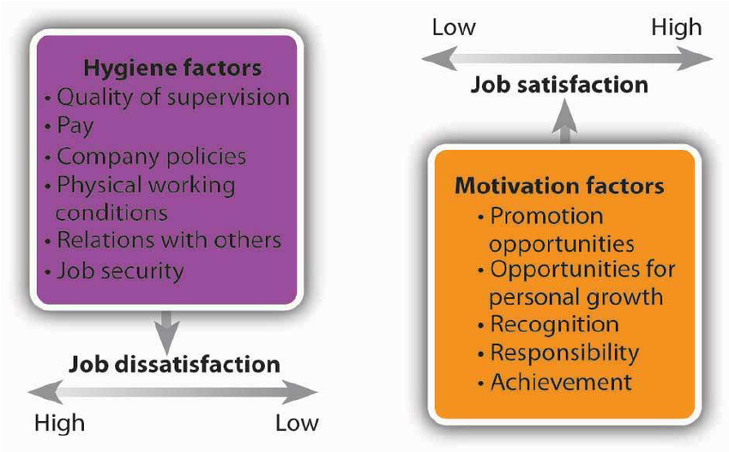
Figure 2: Hertzberg’s Motivation-Hygiene Theory (Balogh, 2015 – Adapted from Hertzberg et al., 1959).
According to Hertzberg (1959), it is hygiene factors which causes dissatisfaction among workers. These hygiene factors are often those which are found within the working styles described so far; with job security, supervision, pay and working conditions and often poor or sub-standard compared to employed workers (Manyika et al., 2016).
It can be deduced that contract work or work within dependent self-employment or the gig economy may well fall under the ‘Low Hygiene and Low Motivation’ combination as described by Hertzberg (1959). This would mean workers in these jobs are unlikely to have job satisfaction and are likely to feel dissatisfied with their role in general (Chartered Management Institute, 2019). As previously seen in Maslow’s Theory of Motivation (1943), this is potentially a hazard within the security profession due to the level of dedication and focus required.

2.6 Conclusion
Although there is a lack of relevant statistics around employment status for the security industry, it must be highlighted that 50% of the construction industry is self-employed. Although measures have been put into place for the construction industry, these are still flawed and leaving workers vulnerable (Dobson, 2020).
Current statistics involving the private security industry are often skewed by technicality and add to the problem of hidden dependent self-employment. For example, Standard Industrial Classification of Economic Activity (SIC Code) 80100 Private Security Activity would cover door supervisors, but only those who are registered with Companies House. This does not cover those who are contract working or self-employed and not using SIC codes. SIC codes have subsequently been criticised for failing to adjust to a changing labour market (Odgers Connect, 2017).
Gig economy jobs are often those which do not require any qualifications or pre-requisites. Those in the security industry must pay around £160 for training (Get Licenced, 2020) and £190 every three years for licencing (SIA, 2020a). Door Supervisor training further includes specific physical intervention training (SIA, 2020b) and is therefore a job with physical risk to the worker involved. It is therefore clear that these jobs cannot be regarded as anything other than skilled. It has also been noted that the risk to all private security industry workers has grown, especially to Door Supervisors since the fall of police officers began, with a notable rise in work related deaths to those workers (Townsend, 2019).
As demonstrated, the informal or self-employed job market is rapidly increasing. This leads to more people becoming self-employed to obtain available work. However, many people find that self-employment creates confusion surrounding tax, legal issues and understanding their rights (Citizens Advice Bureau, 2015; Cameron, 2018). This can also leave people with large tax bills they cannot afford (McCammond, 2019).
More people are becoming both self-employed and employed as they must work more than one job. The average income for those who are self-employed is around £240 a week (ONS, 2019) and therefore suggests that self-employment is being used as top-up work.
If indeed research should show that the security industry may be relying heavily upon gig economy or bogus self-employment, it will be apparent that reforms must be made to the industry, such as those made in the construction industry.

Chapter 3: Research Methodology
As seen in Chapter 2: Literature Review, there is a clear gap in current literature regarding the use of self-employment and contract or gig workers within the security industry. To further comprehend this, this chapter aims to complete the second objection of the study:
To conduct primary research using online questionnaires, to explore the use of self-employment within the security industry.
To complete this objective, the researcher has recognised the most appropriate and optimal method for the successful collection of primary data on this subject. A mono method approach was considered most suitable for this purpose, due to the heavily statistic-based literature available for comparison. This method would be via the medium of online questionnaire with variety of question subtypes – including multiple choice and Likert scale.
Saunders (2016) research onion will form the basis of the structure for the rest of this chapter (Saunders, et al, 2016). This will be used to assist the researcher to identify the most effective method of research strategy for the study alongside data collection, processes, and analysis methods.

3.1 Methodology
Research is widely accepted to be defined as a “systematic investigation, including research development, testing and evaluation, designed to develop or contribute to generalizable knowledge” (Snider, 1997, p. 30). It can be considered a broad term, which covers all methods of finding answers to important questions through such investigations (Dellis et al., 2013) in order to obtain knowledge and information about a specific area or problem (Kapil, 2014).
The creation of a robust research strategy is of the highest importance to successful research. The method of research both primary and secondary chosen by the researcher, will be identified, explained, and justified using the ‘Research Onion’ from Saunders et al (2016).
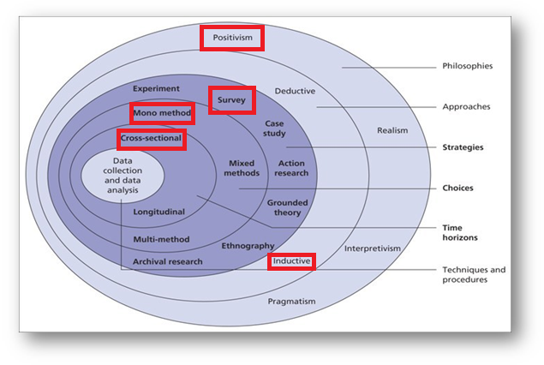
Figure 3: The Research Onion (Source: Saunders et al., 2007)
Each layer of the ‘onion’ correlates to a specific stage of the research process. The premise of following the Research Onion is that by following the ‘layers’, a complete and effective research strategy will be achieved. The onion is adaptable to many types of research methodology and can be utilised in a wide range of contexts (Bryman, 2015).
Working from the outside layer in, the researcher has chosen to take the epistemological position of positivism to undertake this research. Positivism has etymology based on the verb ‘posit’, meaning to put forward and open to criticism and scrutiny (Hammond, 2018). The research will provide insight into literature from Chapter 2 to apply to the data, for the purpose of understanding. This justification was made following the information contained in texts by Saunders et al. (2006), Patel (2015) and Aliyu et al. (2014 p.79).
Following on from the justification of a positivist approach, the research will therefore be deductive as the researcher is testing a hypothesis. This allows the study to confirm the observation based on the paucity of academia already established (Burney and Saleem, 2008).
Moving to the ‘strategy’ layer, surveys will be executed to generate primary research data. Through surveys, the researcher intends to obtain a large sample of relevant quantitative data (See: 3.1.3 Collection Method). Moving to the ‘choice’ layer of the onion, the researcher has identified that data collection will be mono method as only surveys will be carried out in order to supply quantitative data for analysis.
As seen in the Research Onion, time horizon can be split into one of two categories -longitudinal or cross sectional. The researcher has identified that the optimum method for this study is cross-sectional, as this is a short-term study. It will also provide a snapshot in time of the prevalence and effects of DSE within the security industry and has potential to enable further research.
Finally, the onion’s core represents the collection and analysis of original data sources. Data collection will be via Google Forms and data will subsequently be analysed using Microsoft Excel.

3.1.2 Philosophy
Epistemology is defined as “the branch of philosophy that studies the nature of knowledge and the process by which knowledge is acquired and validated” (Gall, Gall, & Borg, 2003, p. 13). It is through the application of this philosophy, which will lead this research via values of truth, belief, and justification (Marian, 2001). This philosophy will be implemented with the focus of post-positivism. The epistemological position of post-positivism, much like traditional positivism is objectivity. This is then enhanced by acknowledging that “knowledge cannot be divorced from ontology and personal experience” (Ryan, 2008, p. 16).
Through this combined philosophical method of research, the researcher aims to become an objective observer, to gather and analyse information without affecting or disturbing what they observe (Wilson, 2014). These philosophies will be combined with an induction approach, which allows for a “bottom-up” style of research, whereby a conclusion can be created from the premise of information collected (Saleem & Burney, 2008).

3.4 Sample
Non-probability purposive sampling will be used to gather data for this study in order to select responses from the correct homogenous group. This type of sampling is described by Etikan (2016 pp.160) as:
“The deliberate choice of a participant due to the qualities the participant possesses. It is a non-random technique that does not need underlying theories or a set number of participants. […] The researcher decides what needs to be known and sets out to find people who can and are willing to provide the information by virtue of knowledge or experience.” (Etikan 2016 pp.160)

For this research, the questionnaire was placed onto industry-specific groups on Facebook for those working within the private security industry. The groups contain 10,000 or more members and are more likely to gain attention. The data gathered will then form a non-probability purposive sample, also known as an expert or judgemental sample, which can be reasonably presumed to be an accurate representation of the populace to which the research relates (Lavrakas, 2008).
As suggested by Collis and Hussey (2014), a poor or inaccurate sample can lead to misleading data and invalidate research, therefore the sample size was set by the researcher to 200 - around 0.05% of the SIA front-line licenced population (SIA, 2020a). According to Collis and Hussey (2014), this is an acceptable participant number due to the time constraints for the research, allowing for the study to be feasibly completed within the timeframe.

3.4.1 Collection Method
This research will primarily focus on the conduction of an online survey, to be delivered through an online survey administration app, Google Forms. This survey will be distributed to the target demographic using social media; specifically, industry focused Facebook groups. This method of data gathering is appropriate for the study and can be delivered to a large sample of the industry without limit to the researcher’s local area. The results of the survey will provide the researcher with a patterned insight into self-employment within the industry. The questionnaire will be initially piloted amongst peers as a precaution to ensure its fitness for purpose before widespread delivery.
For the purpose of this research, a mono-method approach using surveys only were implemented. As the spread of front-line SIA staff is even throughout the UK, the implementation of an online-only sample collection was chosen. This allows for a fair selection of participants as data collection was not targeted to any individual, age or gender.

3.5 Approach
In this study, the researcher will use exclusion criteria to actively seek participants with the correct experience and SIA license with the purpose of best exploring the aims of the study (see 1.4 Aims and Objectives). The sample size will consist of over 200 participants who have either an active SIA Door Supervisor licence or have held one within the last five years. The minimum sample size of 200 is set as such, due to the positivist focus of this research, as it will allow for appropriate statistical analysis of the industry (Wlison, 2014) and is likely to provide more statistically significant data (Zamboni, 2018). In line with industry criteria, all participants will be over eighteen years of age (SIA, 2018).
As described by Thomas (2006) researcher will be using an inductive approach to ‘establish clear links between the evaluation or research objectives and the summary findings derived from the raw data’ (Thomas, 2006. p 238).
Quantitative data is described by Babbie (2010), as data which is objective and is primarily statistical, mathematical, or numerical information gathered through primary research or the computational manipulation of pre-existing data for the research. Data gathered through this study will be in quantitative form, to be statistically analysed through the means of crosstabulation (Babbie, 2010).
Qualitative data is defined by Denzin et al. (2005) as information which has an emphasis upon the qualities and meanings of information, which are not experimentally examined or measured mathematically. This is often applied if the researcher intends to gather qualitative data to provide context to what is potentially an issue with sociological and ethical effects and is known as methodological pluralism (Denzin et al., 2005).
Using a mono method approach of using quantitative data, the researcher intends to create a piece of statistical significance. This type of information gathering is in line with the post-positivist research approach (Wildemuth, 1993).

3.6 Questionnaire Design
A questionnaire is a research tool consisting of a series of questions implemented with the intention of gathering information from participants (Vannette & Krosnick, 2019).
The online questionnaire provided to participants of this study was comprised of 10 questions including two multi-item matrix questions. The questionnaire used contingency questions as a method of screening, therefore allowing only those eligible to answer and therefore aims to enhance the procurement of accurate information. Multi-item scales were used to encourage participation, due to ease of answering, time saving for participants and making efficient use of space (Vanette & Krosnick, 2019).
The questions were kept clear and concise, as pragmatic theory suggests ambiguity within questionnaires impairs the study significantly (Tourangeau et al., 2000). The questionnaire used closed questions with a survey style, with the aim of procuring higher response rates and gain statistical insights rather than qualitative (Farrell, 2016). This style of questioning also allows for future research to easily replicate the survey, in different geographical or time locations.
A pilot study was performed to ensure the questionnaire was easy-to-understand, fair and worked correctly. This task was undertaken by a convenience sample of the researcher’s peers. This allowed for questions to be edited and amended as appropriate.

3.6 Question and Literature Review Matrix
Questions in Survey | Relation to Literature Review & Objectives
Section 1:  I understand this survey should be answered as if COVID-19 were not affecting my work.  I hereby acknowledge that the data collected by this survey will be anonymous and confidential and will be used by the University of Wales Trinity Saint David for academic and educational purposes only. | Screening questions to gain consent and clarity (Saunders, 2009).
Section 2:  Do you currently hold a front-line SIA licence? | Screening question to ensure relevant sample (Saunders, 2009).
Section 3:  Have you held a front-line SIA licence in the last 5 years? | Screening question to ensure recent and relevant understanding of the industry.
Section 5:  Which type of employment do you currently have? | Screening question to understand both working type of participant and for review of self-identification (Saunders, 2009).
Section 6:  When working as a self-employed security guard/door supervisor...  I am responsible for the success or failure of the job  I have several customers at the same time  I can decide how, when and where I do the work  I can hire other people at my expense to help me, or do the job for me  I provide the main items of equipment to carry out the work (radios, uniform, hi-vis etc)  I am responsible for finishing any unsatisfactory work in my own time  I can charge a price I chose, agreed with the client at the beginning of the job  I invoice the company for my pay  I am given a contract for the job  The company I am working for at the time do not prevent me working elsewhere  When working as a self-employed security guard/door supervisor...  I also work for a company who pay me directly | Section 6a  GOV.UK, 2019  ACAS, 2019  HMRC, 2019  Section 6b  Partington, 2019  DBEIS, 2018
Section 7:  When working as a security guard/door supervisor...  I have relied on one company for work, even if I don't have fixed hours with them  My income changes from month to month  I have income protection cover for periods of sickness  It is expected to remain loyal to one company  I can afford to have time off throughout the year  I have worked more than 48 hours per week  I have claimed benefits due to lack of available work | Section 7a)  CIPD, 2017a  b & c) Citizens Advice Bureau, 2015b  Mason, 2017  d & e) Citizens Advice Bureau, 2015b  f) Lee, 2016  DBEIS, 2018  g) Kim & Kim, 2018  Hertzberg, 1959
Table 1: Questions in the questionnaire and how they relate to Chapter Two: Literature Review.

3.7 Analysis
To analyse the quantitative data collected through the online questionnaire, answers supplied by participants will be turned into numerical data and analysed using dimensional tables. The data will be analysed using a series of crosstabulations. As crosstabulation is typically used to analyse categorical data, the researcher will be using this test to apply a number of ACAS, HMRC and Government criteria for self-employment against the participant’s self-identified employment status, as well as analysing the data for any common themes or unexpected results. The analysis will be undertaken using Microsoft Excel.

3.8 Reliability and Validity
Validity in research is frequently cited as Hammersley’s (1987 p.69) definition of an account, or evidence, being justifiable or true if it accurately represents the features of the phenomena which it is attempting to explain, describe or theorise. It is for these reasons that the researcher has made every attempt to use an appropriate method of collection and has decided to use a quantitative approach with screening questions to ensure strong validity of primary data (Winter, 2000). Quantitative research is often chosen because of its repeatability and therefore its reliability. The researcher has chosen this method as it is likely to facilitate the undertaking of further research (Saunders, 2009).
Reliability can be described as how dependable the data is and if the data would be consistent. This can be judged on whether the outcomes would be roughly the same should the study be repeated. This concept is described succinctly by Black and Champion (1976, pp.232-234) to be the “ability to measure consistently”. The large sample size of 200 chosen by the researcher aims to gain an accurate snapshot of the attitude and perspective of those working within the industry at the present time.

3.9 Limitations
It is crucial to gain a holistic understanding of any study undertaken (Moura, 2017). Part of this understanding is to understand and be able to define, and attempt to mitigate, any limitations. As is true in the majority of studies, this study is also subject to limitations.
The primary limitation of this study is the limitation in sample size (Hackshaw, 2008; Faber and Fonseca, 2014). Although as previously discussed the sample size is relative to the time frame (Collis and Hussey, 2014), this is only around 0.05% of the licenced front-line security professionals. To mitigate this, the researcher has ensured to use a limited number of clear questions derived from government and official body criteria. This will allow for analysis of the clearest and most succinct results possible to gain a clear understanding of those surveyed. It is also suggested by Hackshaw (2008), that testing a new theory with a small number of subjects initially is favourable.
The secondary limitation of the study is the time constraint. As this study is part of an undergraduate dissertation, time is limited in comparison to larger studies. However, as much thought has been put into the sample, and the reliability and validity of the study this factor should indeed also be mitigated.
There is also a notable sub-limitation regarding the COVID-19 pandemic, which prevented many in the security industry from working. To mitigate this, the researcher added an extra qualifying question to the beginning of the questionnaire, requesting that participants express their understanding that they should answer as if the pandemic were not happening – or before the pandemic happened.

3.10 Ethical Consideration
Research ethics relates to how we approach all aspects of research, from formulation to collection and analysing of data (Saunders et al., 2009). Ethical consideration has been the forefront of the researcher’s consideration from the early stages of the project (Oliver, 2010 pp.9). This research has also been subject to all ethical considerations undertaken by the university and has been approved by the UWTSD ethics board as well as the supervisor and co-ordinator. Overall, the study aims to promote the ethical research principals of beneficence and avoid non-malfeasance (Townsend et al., 2010).
Online questionnaires were created using a reputable and secure platform and were anonymised. This allows for confidentiality to be maintained, and for results to be stored security and remotely using Google Forms cloud saving feature. This data will be password protected. The questionnaires also have screening questions which obtain informed consent for the use of the information given for the educational purposes of this study (Oliver, 2010 pp. 29).
The research should not cause any ethical concern as it is entirely voluntary, questions those only over the age of 18 and are professionals within the private security industry. The questionnaire has been designed to be easy to answer and does not require any particularly personal or emotional information to be disclosed.
There is minimal ethical risk regarding this research. All participants will be over the age of 18, no vulnerable populations will be used, and all participation is entirely voluntary.
Information collected will be anonymised in line with the Information Commissioner’s Office (ICO) ‘Anonymisation: managing data protection risk code of practice’ (ICO, 2012), remain confidential, and will be stored on secure password-protected cloud servers. Any information gathered using non-computerised methods will be stored under lock and key and will be destroyed in an appropriate confidential waste disposal bin after computerisation. Full details of ethical consideration can be found in Appendix C – Ethics Form.

3.11 Conclusion
This chapter has clearly explained the research methodology implemented in this study and justified the inductive and positivist approach to be undertaken. It also takes into consideration the reliability and validity of the study, as well as its limitations and ethical implications. The chapter has demonstrated exactly how the researcher intends to pursue the collection of primary data, and their intent to analyse and interpret this. This will be followed by Chapter Four which will present the analysis and findings which these methods have collected.

Chapter 4 – Results and Findings

4. Introduction
The purpose of this chapter is to analyse the data which was been collected to achieve objective three:
To analyse the data collected to understand how self-employment is being used within the security industry.
The data collected in this study was mono-method using online questionnaires and was answered by 203 people. Three responses were not used, as these participants were screened out by the questionnaire as they either a) did not hold a current licence or b) had not held a licence in the last five years. All participants indicated their consent for the use of their data within this study.

4.1 Methods
The questionnaires were implemented with the aim of gaining quantitative data in order to test this with a number of quantitative crosstabulation tests. The analysis will be undertaken using crosstabulation in order to examine the data within categorical groups. This approach will be taken in order to identify relationships within the data and
This will therefore allow the criteria set out in Chapter 2 (See: 2.1.1 Self-Employment Status (UK)) to be applied to the participants answers to understand any potential relationship.
The researcher chose not to use sex, gender, age, or other identifiable variables as they did not deem them important to the overall view of the industry. The key objective of the data is to understand how self-employment is being used in comparison to government and agency criteria, as seen in Chapter 3 (See: 3.2.2 Question and Literature Review Matrix).

4.2 Demographics
Socio-demographics such as age and gender were not deemed a priority for this study. With this in mind, the researcher chose to focus on participants by licence(s) held. The overwhelming majority of the participants held a Door Supervisor licence.
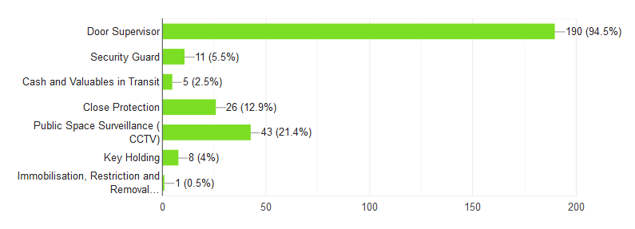
Figure 4: Graph of Participants by Licence Held

97% of participants indicated they currently held a front-line SIA licence. Six participants indicated they did not, but of those six, four indicated they had held a front-line licence in the last 5 years. Those who had not held licences in the last 5 years were not included in order to keep answers relevant to the industry in its current form.
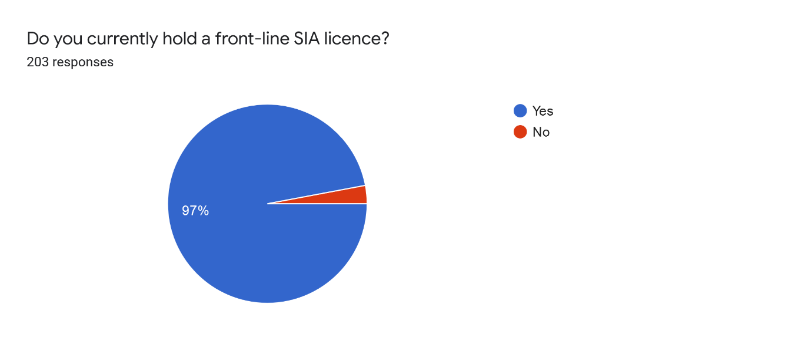
Figure 5: Chart of Participants by Licence Ownership

4.3 Employment Status
The majority of participants identified themselves as self-employed or self-employed alongside employment, with only 21.9% of those surveyed believing themselves to be registered employed. This means a significant 74.1% of those surveyed are self-employed in some respect while working within the private security industry.

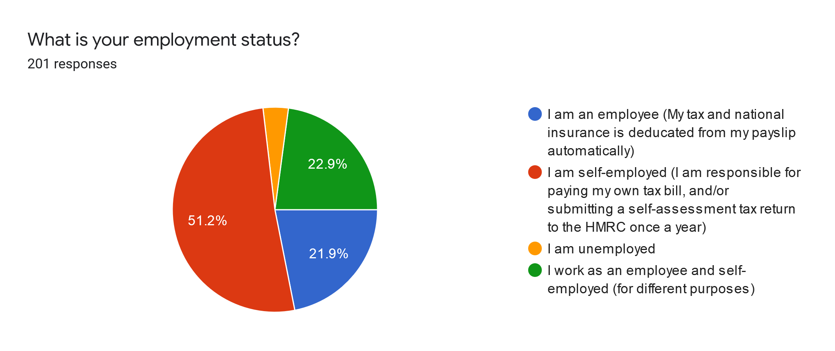
Figure 6: Chart of Participant Employment Status
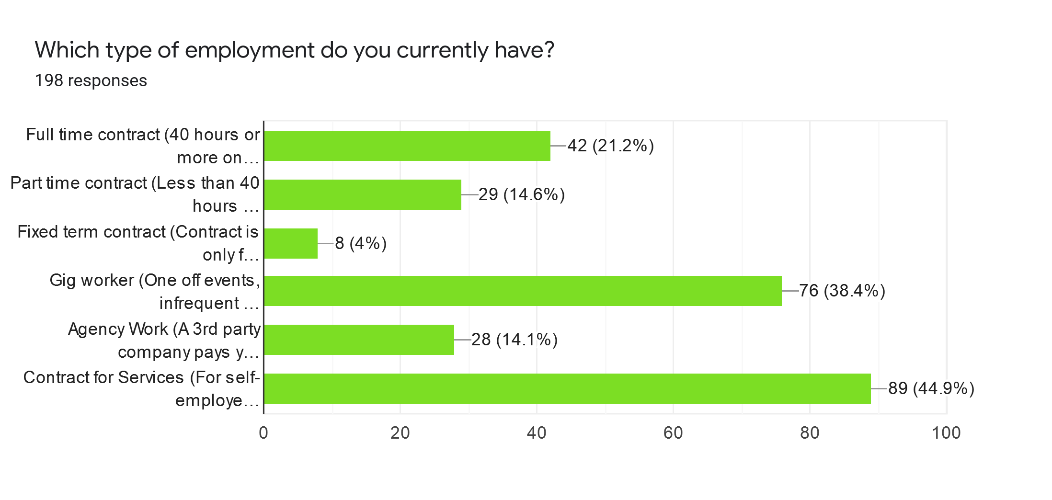
Figure 7: Graph of Self-Identified Employment Status

4.3.1 Self-Employment Questions
Those participants who answered that they considered themselves self-employed were asked a series of questions relating to their experience of being self-employed. These questions were created in line with government and other agencies’ criteria for true self-employment (see: 3.2.2 Question and Literature Review Matrix). The results were largely unanimous, with only 3 questions being divisive.

Figure 8: Participants Answer Self-Employment Status Questions
These answers will be used in a crosstabulation in order to fully understand their application to self-employment criteria (See: Chapter 5 – Analysis).
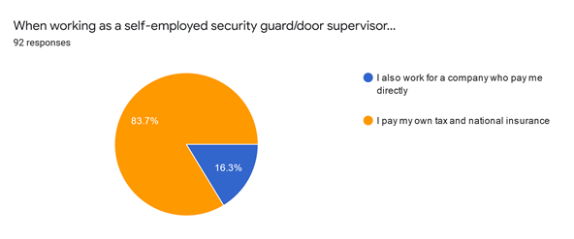
Figure 9: Participants by Number of Jobs
The majority of the participants indicated paying their own tax and national insurance, with a small number also working directly for a company as an employee.

4.3.2 Attitudes in the Security Industry
A number of questions were asked of all participants, regardless of employment status. These were intended to gain a reflection of the security industry holistically.

Figure 10: Responses to Questions Regarding Attitudes in Security Industry

4.4 Crosstabulations
In order to successfully understand the questions posed from the perspective of all 3 category types, crosstabulations will be used here to provide a holistic view of the data gathered.
Crosstabulations are used to understand the relationship between two categorical variables. For the purpose of the research, this type of analysis was engaged to understand the differences between those working in the security industry who self-identified as employed, self-employed or both employed and self-employed. It is important to understand the differences in employment status in order to understand if any issues highlighted are those of the self-employed within the industry, or of the industry as a whole.

4.4.1 Subset A
Subset A was a 3-point Likert scale which was only presented to those who indicated they were self-employed or had both self-employed and employed work - a total of 149 participants. The questions were presented as statements and the participant was asked to select agree, disagree or not sure. These questions were designed to indicate whether participants who were self-employed were working in line with the recommended guidelines on self-employment set by the UK Tax Office and ACAS.
Table 2: When working as a self-employed security guard/door supervisor... [I am responsible for the success or failure of the job ]
 | AGREE | DISAGREE | NOT SURE
SELF-EMPLOYED | 25 | 45 | 33 | 103
BOTH | 9 | 3 | 34 | 46
TOTAL | 34 | 48 | 67 | 149

Most participants selected not sure or disagree options for this statement. This shows a clear trend in results which suggest these workers may not be entirely confident of what their employment type is. HMRC guidelines for self-employment state that you must “run your business yourself and take responsibility for success or failure” (HMRC, 2019) in order to be deemed truly self-employed. Therefore, this indicates an issue with either the understanding of those who are working in self-employed roles or with companies who are contracting self-employed workers.

Table 3: When working as a self-employed security guard/door supervisor... [I have several customers at the same time]
 | AGREE | DISAGREE | NOT SURE
SELF-EMPLOYED | 14 | 57 | 32 | 103
BOTH | 9 | 3 | 34 | 46
TOTAL | 23 | 60 | 66 | 149

A large majority of participants either were not sure or disagreed with this statement. These results directly conflict with the HMRC guidelines which state that self-employed workers are those who have several customers at the same time (HMRC, 2019). The 44% of respondents who applied not sure to this statement must not be overlooked. It is important to question in this instance why a worker would not know how many customers they have if they are indeed self-employed. Gig or contract workers may feel they are not sure if this statement applies to them or may not be sure if a customer is in fact an employer. This is an important factor to understand, as this is a potential red flag indicating dependent self-employment (Williams and Horodnic, 2019; Böheim and Mühlberger, 2009)

Table 4: When working as a self-employed security guard/door supervisor... [I can decide how, when and where I do the work]
 | AGREE | DISAGREE | NOT SURE
SELF-EMPLOYED | 9 | 62 | 32 | 103
BOTH | 7 | 5 | 34 | 46
TOTAL | 16 | 67 | 66 | 149

Again, the majority of participants either disagreed or were not sure when answering this statement. This is also directly in conflict with HMRC guidelines which clearly state “I can decide how, where and when you do you work” as a key indicator of self-employment (HMRC, 2019). This is also in conflict with ACAS guidelines which state you “are responsible for how and when you work”. (ACAS, 2019)
This is an indication that participants may have been contracted or gig workers who are told when and where to work by agencies. These workers are unlikely to be deemed genuinely self-employed, although would be required to file self-assessment tax returns in the same way a genuinely self-employed person would. This is likely be a further indication of dependent self-employment (Williams and Horodnic, 2019; Böheim and Mühlberger, 2009).

Table 5: When working as a self-employed security guard/door supervisor... [I can hire other people at my expense to help me, or do the job for me]
 | AGREE | DISAGREE | NOT SURE
SELF-EMPLOYED | 5 | 65 | 33 | 103
BOTH | 3 | 8 | 35 | 46
TOTAL | 8 | 73 | 68 | 149

The trend in a majority of participants who selected disagree and not sure responses continues here. This contradicts the HMRC guideline you “can hire people at your expense to help you or do the work for you” (HMRC, 2019) and also ACAS guideline “are able to send someone else to do the work for you if appropriate.”
This statement is potentially more complex in the security industry than most others, as SIA licencing regulations may apply to the job. Therefore, the person completing the work in someone’s place must be properly licenced and vetted (SIA, 20). Someone who employs security guards to do work for them must also have a non-front-line SIA licence in order to manager, supervisor and employ those who carry out front-line operations (SIA, 2020a). This raises questions around whether self-employed contractors, or indeed gig workers, can ever truly work within the security industry as they would otherwise be unable to use the work of another licenced guard without correct SIA licencing (SIA 2020b).

Table 6: When working as a self-employed security guard/door supervisor... [I provide the main items of equipment to carry out the work (radios, uniform, hi-vis etc)]
 | AGREE | DISAGREE | NOT SURE
SELF-EMPLOYED | 11 | 58 | 34 | 103
BOTH | 2 | 9 | 35 | 46
TOTAL | 13 | 67 | 69 | 149

This statement also had majority answers of disagree or not sure. Again, the answers to this statement are directly in conflict with HMRC guidelines (HMRC, 2019). The not sure responses could be due to different security roles were not being specified within the statement. Those participants which disagreed are likely to be those of people not in truly self-employed roles. It is generally expected that self-employed people would provide the tools of their trade when hired to carry out a role, such as cleaners, carpenters, or plumbers for example (Solihull Metropolitan Borough Council, 2018).

Table 7: When working as a self-employed security guard/door supervisor... [I am responsible for finishing any unsatisfactory work in my own time]
 | AGREE | DISAGREE | NOT SURE
SE | 3 | 68 | 32 | 103
BOTH | 4 | 7 | 35 | 46
TOTAL | 7 | 75 | 67 | 149

Over half of participants disagreed with this statement. HMRC guidelines are directly in conflict with this (HMRC, 2019) which suggests that this is another flag to participants not being genuinely self-employed. This can be likened to another other tradesperson, for example a plumber of builder, who would be expected to return and complete unsatisfactory work should it occur; or could potentially face civil action (Nickson, 2020). It is important point to note that again the security industry fails to fit into these criteria.

Table 8: When working as a self-employed security guard/door supervisor... [I can charge a price I chose, agreed with the client at the beginning of the job]
 | AGREE | DISAGREE | NOT SURE
SELF-EMPLOYED | 5 | 66 | 32 | 103
BOTH | 3 | 9 | 34 | 46
TOTAL | 11 | 80 | 102 | 149

An overwhelming majority of the participants either disagreed or were not sure when reading this statement. Once again, this is in conflict with ACAS guidelines which state “you are able to work for different clients and charge different fees” (ACAS, 2019). This suggests that participants either already know the price of the job being offered before they undertake it, or the job may have fixed hourly pay. Regardless of reasoning, this does not apply to genuine self-employment. This data suggests that for the majority or participants this is not something they know about, or they feel they can do. There is therefore no negotiation in this process and is more reflective of an employee/employer relationship.

Table 9: When working as a self-employed security guard/door supervisor... [I invoice the company for my pay]

 | AGREE | DISAGREE | NOT SURE
SELF-EMPLOYED | 64 | 7 | 32 | 103
BOTH | 11 | 1 | 34 | 46
 | 75 | 8 | 66 | 149

Most of the participants agreed with this statement. Both UK Government and ACAS guidelines state that this is a key indicator of someone who is self-employed (UK.GOV 2019; ACAS, 2019).
This data must be understood in context with the other answers throughout this subset. Since most of the participants who identified as self-employed tended to answer in paradox to the guidelines provided, it is interesting that on this point they did not. This suggests that although those offering work to self-employed contractors may want the freedom of workers being responsible for their own tax and national insurance, they may not be providing their workers with the freedoms and responsibilities that self-employment should traditionally hold (O’Connor, 2015; Heyes and Hastings, 2017).

Table 10: When working as a self-employed security guard/door supervisor... [I am given a contract for the job]
 | AGREE | DISAGREE | NOT SURE
SELF-EMPLOYED | 34 | 37 | 32 | 103
BOTH | 4 | 7 | 35 | 46
 | 38 | 44 | 67 | 149

Most participants chose the disagree or not sure options for this statement. ACAS guidelines state that self-employed workers must obtain contracts to provide services, whereas UK Government guidelines state that self-employed workers operate under a contract under the terms self-employed, consultant or independent contractor (ACAS, 2019; UK.GOV, 2019). This data suggests that participants may not have understood this statement which raises questions as to a) the understanding of self-employed people in the industry of the rules and guidelines for genuine self-employment and b) ethical questions around those employing these workers.

Table 11: When working as a self-employed security guard/door supervisor... [The company I am working for at the time do not prevent me working elsewhere]
 | AGREE | DISAGREE | NOT SURE
SELF-EMPLOYED | 34 | 36 | 33 | 103
BOTH | 8 | 3 | 35 | 46
TOTAL | 42 | 39 | 68 | 149

The answers to this statement are divisive, however the majority of participants selected not sure. ACAS guidelines are clear that to be considered self-employed, workers must be able to work for different clients and charge different fees (ACAS, 2019). It is concerning to find that most participants were not sure about their eligibility to work for others, since all participants within the subset identified that they worked in some form of self-employment. This, however, conflicts with subsection b, which questions if it is expected to remain loyal to one company in the industry with which most participants agreed. This suggests while preventing workers from working elsewhere may not be overt, there appears to be a covert attitude of company loyalty recognised by these participants.

4.4.2 Subset B
Subset B was a 3-point Likert scale which was presented to all currently employed - a total of 193 participants. Similarly, to Subset A, the participant was presented with a number of statements and asked to select agree, disagree or not sure.
Table 12: When working as a security guard/door supervisor... [I have relied on one company for work, even if I don't have fixed hours with them]
 | AGREE | DISAGREE | NOT SURE
SELF-EMPLOYED | 81 | 22 | 0 | 103
EMPLOYED | 32 | 10 | 2 | 44
BOTH | 26 | 20 | 0 | 46
TOTAL | 139 | 52 | 2 | 193

On analysing this crosstabulation, it is shown that the majority of self-employed people indicated having been in a situation where they have relied on one company for work even if the company is unable to supply them with regular hours. This could suggest that these participants are casual workers, or that they are unable to find other work outside of these companies. It may also suggest that the participant feels they must be loyal to one company or cannot work for another company. This is a potential red flag for dependent self-employment (Williams & Lapeyre, 2017).

Table 13: When working as a security guard/door supervisor... [My income changes from month to month]
 | AGREE | DISAGREE | NOT SURE
SELF-EMPLOYED | 95 | 6 | 2 | 103
EMPLOYED | 29 | 12 | 3 | 44
BOTH | 42 | 3 | 1 | 46
TOTAL | 166 | 21 | 6 | 193

From this crosstabulation we can see that self-employed participants are overwhelmingly finding that they do not have a stable income whilst working in the security industry. This is correlated by the findings that workers with both self-employed and employed jobs indicate similar results. This should be cause for concern, as fluctuating wages not only put people at risk of financial problems but also leave them unable to successfully claim benefits such as Universal Credit should they need it (Ghelani, 2018; McCammond 2019).
Table 14: When working as a security guard/door supervisor... [I have income protection cover for periods of sickness?]
 | AGREE | DISAGREE | NOT SURE
SELF-EMPLOYED | 10 | 74 | 19 | 103
EMPLOYED | 5 | 29 | 10 | 44
BOTH | 4 | 40 | 2 | 46
TOTAL | 19 | 143 | 31 | 193

The data gathered here shows that lack of income protection for periods of sickness is a common theme amongst all participating groups. However, those who are not ‘employed’ do not have the same rights to sick pay as those who are. This could mean that the self-employed participants, or those who are both employed and self-employed, are more vulnerable to financial issues should they become ill. This question also had the most frequent “don’t know” responses, which could indicate that either participants were not aware of this cover or did not know if it was being provided for them elsewhere.
Table 15: When working as a security guard/door supervisor... [It is expected to remain loyal to one company]
 | AGREE | DISAGREE | NOT SURE
SELF-EMPLOYED | 59 | 25 | 19 | 103
EMPLOYED | 25 | 12 | 7 | 44
BOTH | 23 | 17 | 6 | 46
TOTAL | 107 | 54 | 32 | 193

The data gathered here highlights this statement as being divisive between employment types. An interesting point raised here is more self-employed participants felt that their loyalty was expected than those employed or with dual employment status put together. This could be a potential indicator for dependent self-employment and when combined with the data for those who indicated they had relied on one company for work despite the company not having hours for them highlights a potential problem within the industry (Mason, 2017).

Table 16: When working as a security guard/door supervisor... [I can afford to have time off throughout the year]
 | AGREE | DISAGREE | NOT SURE
SELF-EMPLOYED | 46 | 55 | 2 | 103
EMPLOYED | 21 | 17 | 6 | 44
BOTH | 23 | 21 | 2 | 46
TOTAL | 90 | 93 | 10 | 193

These statistics reflect the risks of self-employment over employment within the security industry, as the majority of those self-employed guards disagree that they can afford to have time off throughout the year. This mirrors previous discussion within Chapter 2, which denotes that those who are self-employed lose out on £1,200 per year in holiday pay (Citizens Advice Bureau, 2015b) and that working in this way can cause many physical and mental health issues (Kim and Kim, 2018; Kim and Knesebeck, 2015; Mai et al., 2019; Wong et al., 2019).
Table 17: When working as a security guard/door supervisor... [I have worked more than 48 hours per week]
 | AGREE | DISAGREE | NOT SURE
SELF-EMPLOYED | 95 | 8 | 0 | 103
EMPLOYED | 32 | 8 | 4 | 44
BOTH | 39 | 7 | 0 | 46
TOTAL | 166 | 23 | 4 | 193

48 hours a week is the maximum anyone can work under the working time directive in the UK. However, individuals may sign an agreement with an employer in order to opt out. These results show that self-employed security staff have overwhelmingly worked more than 48 hours in a much higher response rate than any other employment status. Mirroring a similar effect to those who cannot afford holiday pay, this can have an extensive effect on physical and mental health issues (Kim and Kim, 2018; Kim and Knesebeck, 2015; Mai et al., 2019; Wong et al., 2019) and for many in contract work means working the same jobs as employed security guards but without the benefit of a cap on their working hours.
Table 18: When working as a security guard/door supervisor... [I have claimed benefits due to lack of available work]
 | AGREE | DISAGREE | NOT SURE
SELF-EMPLOYED | 38 | 63 | 2 | 103
EMPLOYED | 7 | 32 | 5 | 44
BOTH | 10 | 33 | 3 | 46
TOTAL | 55 | 128 | 10 | 193

Although the majority of participants answered that they had not claimed benefit due to lack of available work, this could be for a number of reasons. It is with hope that this figure is due to work being readily available. However, it must be noted that this figure could be due to fluctuation in wages as this is a significant barrier to claiming benefits such as Universal Credit (Ghelani, 2018).

4.5 Analysis
When combining these two subsets of results it is evident that although many of those participants working in the security industry are doing so under the umbrella of self-employment, the way in which they are working does not always correlate with the version of self-employment set out by official guidelines (HRMC, 2019; ACAS, 2019; GOV.UK, 2019).
There are many inconsistencies within this sample of the security industry when applied to the guidelines. This presents ethical issues regarding whether these workers are truly aware of what they should be able to expect as self-employed workers. Furthermore, this raises questions surrounding the prevalence of this type of self-employment within the security industry, and whether this should be addressed in the same way as the construction industry has been.
The results also highlight the volume of workers within the industry who, in their own selections are “not sure” when asked questions regarding their employment. This leaves the participants involved in a state of equilibrium.
SIA regulation in general when applied to these guidelines also becomes problematic. With managerial style licencing required when employing or supervising licensable activity, it is questionable that anyone is eligible to work in a gig working or self-employed capacity within the security industry.
This questionnaire asked people to self-identify their employment status, and many identified themselves as self-employed. As the analysis of this data has shown, this is likely to be incorrect in many cases.
As self-employed workers have both identified through this data that they both feel they should remain loyal to their company, and also that they have relied on one company for work despite the company not having hours for them highlights a potentially detrimental trend within this industry.

Chapter 5 – Conclusion

5.1 Introduction
The intention of this chapter is to fulfil objective four:
To synthesise extant literature and primary research to make recommendations regarding how self-employment can best be implemented in the industry and be most beneficial to workers who adopt this method.
This will be achieved by discussing the main findings of the research, limitations faced by the researcher and recommendations both for industry consideration and for future research.

5.2 Objectives Achieved
1. Existing academic literature, alongside data collected by professional bodies, has been critically analyses to understand how self-employment affects workers in this type of industry. This was completed within chapter two which gave a broad understanding of the industry and subject at hand, alongside more specific context.
2. Primary research was conducted using online questionnaires, which explored the use of self-employment within the security industry. The theory and methodology behind this were identified in chapter three, alongside justification for the researcher’s chosen method.
3. The data collected was analysed to understand how self-employment is being used within the security industry in chapter four; by combining this primary data alongside extant literature identified in chapter two.

5.3 Main Findings
The findings presented in chapter two and the data analysed in chapter four support the discussion that self-employment within the security industry in the UK is being used in a problematic way when compared to the current legislation and guidelines surrounding what genuine self-employment can be defined as.
The answers given by the participants in this research clearly identify a problem within this type of employment, and when combined with existing literature present a case for further investigation of the potential misuse of self-employment in the industry. Furthermore, the results have the potential to raise questions around the prevalence of dependent self-employment within the private security sector.

5.4 Recommendations
The primary issue highlighted within this research is that of self-employment criteria by governing bodies such as HMRC and ACAS being incompatible with the style of working within the security industry as reported by the participants of this study. An initial recommendation would be for these guidelines to be reviewed; however, this would lead to larger, more complex questions to be answered. These guidelines would need to be revised by these governing bodies in order to successfully encompass the types of workers identified within this research. Alternatively, the companies which utilise self-employed contractors must be held accountable for the issues which arise for the workers in the context of the industry involved.
A second recommendation would be that trade unions lobby for these workers to be more fairly represented under current employment law. As the health and financial disadvantages of this type of work have been highlighted, it would be appropriate for trade unions to ensure that security industry workers gain protection from this type of working in the same way initially undertaken for the construction industry.

5.5 Final Limitations
Although the researcher’s initial aim was to cross-tabulate the opinions and attitudes of current security workers against HMRC and ACAS guidelines for self-employment, the researcher failed to include further which would have provided more depth to the discussion. These could have included those around the working time directive and whether workers had voluntarily opted out and including gender and age in the initial stages of the questionnaire. This may have given further context which would have more deeply understood the attitude of those working within the industry. A mixed-method approach to include quantitative data may also have been useful, as this would have provided further context as to the motivation of such workers.

5.6 Further research
There is much scope for further research following on from the issues highlighted within this dissertation. Firstly, although this research gives the perspective of current workers within the industry, further research could bring the perspective of companies which employ these workers. This would lead to a more holistic view of the issues at hand and may provide further insight into the motivations behind why this is a prevalent issue within the security industry.
Further research from a government perspective would bring another dimension into the research surrounding this subject. As mentioned in chapter two, the UK government faces £314m potential loss in tax per annum (Citizens Advice Bureau, 2015b) due to companies using self-employed workers in this way.

5.7 Conclusion
This study has successfully been able to reach the aims and objectives initially set and has successfully analyses self-employed status within the UK private security industry and subsequently the impact of self-employment on those who work within the industry. The dissertation was able to identify the attitudes and perspective of its research participants, which are a satisfactory sample of a large industry.
This preliminary investigation via research into self-employment in the industry did not require the testing of a hypothesis as there was a clear need to correlate the already existing rules and guidelines (ACAS, 2019; GOV.UK, 2019; HMRC, 2019) against the perspectives of those working within the industry.
From the results of this research it is clear that questions must be asked in order to protect the workers of the UK private security industry from not only financial loss but damage to physical and mental wellbeing.
Chapter two was able to identify that this form of employment has already been highlighted in other industries as problematic and unfair (Unite, 2018) and is becoming problematic across the UK and EU as gig and contract working increases (Horodnic and Williams, 2019). Chapter three successfully outlined a strategy and methodology for conducting this research for analysis and application. Chapter four was able to critically analyse the data against governing body guidelines in order to successfully highlight the issues presented and present a solid case for further research and industry change.
In conclusion, it is clear that there is an issue within the security industry and in order to promote a fair and healthy industry it is pivotal that these issues be addressed whether in the form of further research, industry change or guideline review – just as was done within the construction industry.

Self-Reflection
The researcher of this study wanted to gain a better insight into the security industry following 10 years of front-line door supervision work. This interest was piqued following her time studying BA Business Management as she developed an interest in ethics.
This dissertation has proven challenging but has taught the researcher an extensive amount of researching skills and developed knowledge in the fields of data analysis which had not been previously used.
The researcher gained a vast amount of insight into the issues surrounding self-employment within the private security industry and have motivated her to research the subject further in the future.
It is clear to the researcher that business ethics are particularly important, especially when the health and wellbeing of workers is at stake. It is crucial that within any industry these types of issues are highlighted in order to create and maintain a fair working system for everyone.

Final Summary
This dissertation has contributed to the ongoing understanding and knowledge building of how self-employment is being used within the UK private security industry, and the potential effect it is having on the workers who depend on it. It has identified areas which require further research and makes recommendations for change.

References
- Abdul Rehman, A. and Alharthi, K. (2016) ‘An introduction to research paradigms’, 3.
- Abraham, K. G., Hershbein, B. J. and Houseman, S. N. (2020) Most Self-Employed Workers Are Independent Contractors. W.E. Upjohn Institute for Employment Research. doi: 10.17848/pb2020-24.
- ACAS (2017) Zero Hour Contracts, Rights, Law, Rules & Benefits. Available at: https://www.acas.org.uk/index.aspx?articleid=4468 (Accessed: 13 October 2019).
- ACAS (2019) Checking your employment rights | Acas. Available at: https://www.acas.org.uk/checking-your-employment-rights (Accessed: 19 December 2019).
- Aliyu, A. A. et al. (2014) ‘Positivist and Non-Positivist Paradigm in Social Science Research: Conflicting Paradigms or Perfect Partners?’, Journal of Management and Sustainability, 4(3), p. p79. doi: 10.5539/jms.v4n3p79.
- Antony, S. (2019) ‘Self-employment in the construction industry’, House of Commons Briefing Paper, 196.
- Aprameya (2016) Cross Tabulation: How It Works and Why You Should Use It, Atlan | Humans of Data. Available at: https://humansofdata.atlan.com/2016/01/cross-tabulation-how-why/ (Accessed: 11 July 2020).
- Austin, Z. and Sutton, J. (2014) ‘Qualitative Research: Getting Started’, The Canadian Journal of Hospital Pharmacy, 67(6), pp. 436–440.
- Babbie, E. R. (2010) The practice of social research. Belmont, CA; London: Wadsworth ; Cengage Learning [distributor].
- Balogh, L. (no date) Figure 23: Herzberg’s two -factor theory, ResearchGate. Available at: https://www.researchgate.net/figure/Herzbergs-two-factor-theory_fig18_288835900 (Accessed: 7 July 2020).
- Bam, K. (1992) ‘Research methods for business and management’.
- BBC News (2017) ‘Uber’s licence suspended in Sheffield’, BBC News, 7 December. Available at: https://www.bbc.com/news/business-42270020 (Accessed: 20 December 2019).
- BBC News (2019) ‘“I had to substitute heating for eating”’, BBC News, 5 November. Available at: https://www.bbc.com/news/uk-scotland-50302862 (Accessed: 22 January 2020).
- BBC News (2019) ‘Zero-hour staff “do more night shifts”’, 11 February. Available at: https://www.bbc.com/news/business-47193809 (Accessed: 12 November 2019).
- Behling, F. and Harvey, M. (2015) ‘The evolution of false self-employment in the British construction industry: a neo-Polanyian account of labour market formation’, Work, Employment and Society, 29(6), pp. 969–988. doi: 10.1177/0950017014559960.
- Bennett, F. (2019) ‘Social protection for the self-employed in the UK: the disappearing contributions increase’, Journal of Poverty and Social Justice, 27(2), pp. 235–251. doi: 10.1332/175982718X15451304773174.
- Black, J. A. and Champion, D. J. (1976) Methods and issues in social research. New York: Wiley.
- Böheim, R. and Muehlberger, U. (2006) ‘Dependent Forms of Self-employment in the UK: Identifying Workers on the Border between Employment and Self-employment’, p. 26.
- Böheim, R. and Mühlberger, U. (2009) ‘Dependent self-employment: workers between employment and self-employment in the UK’, Zeitschrift für ArbeitsmarktForschung, 42(2), pp. 182–195. doi: 10.1007/s12651-009-0014-x.
- Borg, W., Gall, J. and Gall, M. (2002) Educational Research: An Introduction (7th Edition). Allyn & Bacon.
- Broughton A, Gloster R, Marvell R, Green M, Langley J, Martin A (2018) The experiences of individuals in the gig economy. Available at: http://www.employment-studies.co.uk/resource/experiences-individuals-gig-economy (Accessed: 27 October 2019).
- Burke, M. E. (2007) ‘Making choices: research paradigms and information management: Practical applications of philosophy in IM research’, Library Review, 56(6), pp. 476–484. doi: 10.1108/00242530710760373.
- Burney and Saleem, H. (2008) ‘Inductive and Deductive Research Approach’. Unpublished. doi: 10.13140/RG.2.2.31603.58406.
- Burney, S. M. A. and Saleem, H. (2008) ‘Inductive and Deductive Research Approach’, 1 March. doi: 10.13140/RG.2.2.31603.58406.
- Cameron, J. (2018) Seasonal work spells tax confusion | Tax Adviser. Available at: https://www.taxadvisermagazine.com/article/seasonal-work-spells-tax-confusion (Accessed: 3 August 2020).
- Chartered Management Institute (no date) Frederick Herzberg The hygiene Motivation theory, 2019.
- CIPD (2017a) Gig economy boosts income for many of its 1.3 million workers – but thousands could be missing out on employment rights, CIPD. Available at: https://www.cipd.co.uk/about/media/press/170317-gig-economy (Accessed: 22 January 2020).
- CIPD (2017b) To gig or not to gig? Stories from the modern economy. Available at: https://www.cipd.co.uk/Images/to-gig-or-not-to-gig_2017-stories-from-the-modern-economy_tcm18-18955.pdf (Accessed: 22 January 2020).
- Citizens Advice Bureau (2015a) Bogus self-employment costing millions to workers and Government. Available at: http://www.citizensadvice.org.uk/cymraeg/about-us/how-citizens-advice-works/media/press-releases/bogus-self-employment-costing-millions-to-workers-and-government/ (Accessed: 19 December 2019).
- Citizens Advice Bureau (2015b) Neither one thing nor the other, p. 22. Available at: https://www.citizensadvice.org.uk/Global/CitizensAdvice/Work%20Publications/Neither%20one%20thing%20nor%20the%20other.pdf (Accessed: 27 October 2019).
- Citizens Advice Bureau (2015c) Going for broke: how self-employed people move in and out of debt. Available at: http://www.citizensadvice.org.uk/about-us/policy/policy-research-topics/work-policy-research-surveys-and-consultation-responses/work-policy-research/going-for-broke-how-self-employed-people-move-in-and-out-of-debt/ (Accessed: 18 June 2020).
- Collis, J. and Hussey, R. (2014) Business research: a practical guide for undergraduate & postgraduate students. Fourth edition. Houndmills, Basingstoke, Hampshire ; New York, NY: Palgrave Macmillan.
- Dawson, C. R. (2015) ‘Research on Violence Reduction - Report’, p. 183.
- Dellis, A., Skolarikos, A. and Papatsoris, A. G. (2014) ‘Why should I do research? Is it a waste of time?’, Arab Journal of Urology. (Teaching and Training in Urology), 12(1), pp. 68–70. doi: 10.1016/j.aju.2013.08.007.
- Delves, A. (2018) Self-employed debt tens of thousands high, says charity. Available at: https://www.simplybusiness.co.uk/knowledge/articles/2018/11/self-employed-debt-reaches-thousands/ (Accessed: 20 June 2020).
- Department for Business, Energy and Industrial Strategy (2018) The Characteristics of Those in the Gig Economy. Available at: https://assets.publishing.service.gov.uk/government/uploads/system/uploads/attachment_data/file/687553/The_characteristics_of_those_in_the_gig_economy.pdf (Accessed: 21 June 2020).
- Dobson, D. (2020) Coronavirus Exposes Construction’s Bogus Self-Employment. Available at: https://tribunemag.co.uk/2020/03/coronavirus-crisis-exposes-construction-industrys-bogus-self-employment (Accessed: 7 July 2020).
- Etikan, I. (2016) ‘Comparison of Convenience Sampling and Purposive Sampling’, American Journal of Theoretical and Applied Statistics, 5(1), p. 1. doi: 10.11648/j.ajtas.20160501.11.
- Evans, L. (2017) 80% of the self-employed live in poverty - Turn2us. Available at: https://www.turn2us.org.uk/About-Us/News/80-of-self-employed-live-in-poverty (Accessed: 20 June 2020).
- Faber, J. and Fonseca, L. M. (2014) ‘How sample size influences research outcomes’, Dental Press Journal of Orthodontics, 19(4), pp. 27–29. doi: 10.1590/2176-9451.19.4.027-029.ebo.
- Farrell, S. (2016) Open-Ended vs. Closed-Ended Questions in User Research, Nielsen Norman Group. Available at: https://www.nngroup.com/articles/open-ended-questions/ (Accessed: 22 June 2020).
- Fox, N. (2008). Post-positivism. Available: https://www.researchgate.net/publication/261287946_Post-positivism. Last accessed 7th May 2020
- Franklin, N. (2019) Gig economy and freelance workers would prefer secure work - Workplace Insight. Available at: https://workplaceinsight.net/gig-economy-and-freelance-workers-would-swap-income-for-more-security/ (Accessed: 20 December 2019).
- Frey, B. (2018) ‘Selection Bias’ The SAGE Encyclopedia of Educational Research, Measurement, and Evaluation. doi: 10.4135/9781506326139.n618.
- Get Licenced (2020) SIA Door Supervisor Training Courses | Trusted by 300,000+ Customers. Available at: https://www.get-licensed.co.uk/door-supervisor (Accessed: 7 July 2020).
- Ghelani, D. (2018) ‘Fluctuating earnings and Universal Credit: Rough Justice?’, Policy in Practice, 10 August. Available at: http://policyinpractice.co.uk/fluctuating-earnings-and-universal-credit-rough-justice/ (Accessed: 11 July 2020).
- Given, L. (2019) ‘The SAGE Encyclopedia of Qualitative Research Methods’. doi: 10.4135/9781412963909.
- GOV.UK (2020a) Contract types and employer responsibilities, GOV.UK. Available at: https://www.gov.uk/contract-types-and-employer-responsibilities/zero-hour-contracts (Accessed: 3 August 2020).
- GOV.UK (2020b) Employment status, GOV.UK. Available at: https://www.gov.uk/employment-status/selfemployed-contractor (Accessed: 21 June 2020).
- GOV.UK (2020c) Maximum weekly working hours, GOV.UK. Available at: https://www.gov.uk/maximum-weekly-working-hours (Accessed: 25 July 2020).
- GSO (2018) Contractors vs. Hidden Employment: Knowing the Difference, Global Outsourcing Team. Available at: https://globaloutsourcingteam.com/blog/contractors-vs-hidden-employment-knowing-the-difference (Accessed: 19 December 2019).
- Hackshaw, A. (2008) ‘Small studies: strengths and limitations’, European Respiratory Journal, 32(5), pp. 1141–1143. doi: 10.1183/09031936.00136408.
- Hammersley, M. (1987) ‘Some Notes on the Terms “Validity” and “Reliability”’, British Educational Research Journal, 13(1), pp. 73–82. doi: 10.1080/0141192870130107.
- Hammond, R. (2018) Positivism, University of Warwick. Available at: https://warwick.ac.uk/fac/soc/ces/research/current/socialtheory/maps/positivism/ (Accessed: 21 June 2020).
- Hannah, F. (2016) 80% of self-employed people in Britain live in poverty, The Independent. Available at: http://www.independent.co.uk/money/spend-save/80-of-self-employed-people-in-britain-live-in-poverty-a7070561.html (Accessed: 20 June 2020).
- Herzberg, F., Mausner, B. and Snyderman, B. B. (1959) The motivation to work. 2. ed. New York: Wiley.
- Heyes, J. and Hastings, T. (2017) ‘The Practices of Enforcement Bodies in Detecting and Preventing Bogus Self-Employment’. EU Programme for Employment and Social Innovation. Available at: https://ec.europa.eu/social/BlobServlet?docId=17971&langId=en.
- HM Treasury (2014) ‘Overview of Tax Legislation and Rates 19 March 2014’, p. 172.
- HMRC (2019) Working for yourself - GOV.UK. Available at: https://www.gov.uk/working-for-yourself (Accessed: 19 December 2019).
- ICO (2012) ‘Anonymisation: managing data protection risk code of practice’, p. 108.
- ILO (2016) Disguised employment / Dependent self-employment. Available at: http://www.ilo.org/global/topics/non-standard-employment/WCMS_534833/lang--en/index.htm (Accessed: 19 December 2019).
- Jones, L. (2018) Going solo: The rise of self-employment - BBC News. Available at: https://www.bbc.co.uk/news/business-44887623 (Accessed: 19 December 2019).
- Jooha, L. (2017) Papers - New Self-Employment and the Gap-Eul Relationship : Focusing on Dependent SelfEmployed Workers and Franchise Businesses. Available at: http://www.welfarestate.re.kr/beluxe_JLkW05/2750 (Accessed: 18 June 2020).
- Kim, T. J. and von dem Knesebeck, O. (2016) ‘Perceived job insecurity, unemployment and depressive symptoms: a systematic review and meta-analysis of prospective observational studies’, International Archives of Occupational and Environmental Health, 89(4), pp. 561–573. doi: 10.1007/s00420-015-1107-1.
- Kim, Y. and Kim, S.-S. (2018) ‘Job insecurity and depression among automobile sales workers: A longitudinal study in South Korea’, American Journal of Industrial Medicine, 61(2), pp. 140–147. doi: 10.1002/ajim.22805.
- Klair, A. (2019) Almost half the self-employed are on poverty pay. Available at: https://www.tuc.org.uk/blogs/almost-half-self-employed-are-poverty-pay (Accessed: 20 June 2020).
- Krosnick, J. A. (2018) ‘Questionnaire Design’, in Vannette, D. L. and Krosnick, J. A. (eds) The Palgrave Handbook of Survey Research. Cham: Springer International Publishing, pp. 439–455. doi: 10.1007/978-3-319-54395-6_53.
- Landman Economic (2017) The impact of increased self-employment and insecure work on the public finances. Available at: https://www.tuc.org.uk/research-analysis/reports/impact-increased-self-employment-and-insecure-work-public-finances (Accessed: 11 July 2020).
- Lavrakas, P. (2020) ‘Encyclopedia of Survey Research Methods’. Thousand Oaks, California. doi: 10.4135/9781412963947.
- Lewis, S. (2015) ‘Qualitative Inquiry and Research Design: Choosing Among Five Approaches’, Health Promotion Practice, 16(4), pp. 473–475. doi: 10.1177/1524839915580941.
- Mai, Q. D. et al. (2019) ‘Employment insecurity and sleep disturbance: Evidence from 31 European countries’, Journal of sleep research, 28(1), p. e12763. doi: 10.1111/jsr.12763.
- Manyika, J. et al. (2016) Independent work: Choice, necessity, and the gig economy | McKinsey. Available at: https://www.mckinsey.com/featured-insights/employment-and-growth/independent-work-choice-necessity-and-the-gig-economy (Accessed: 7 July 2020).
- Martin, C. (2019) Construction industry scheme CIS. Available at: https://www.designingbuildings.co.uk/wiki/Construction_industry_scheme_CIS (Accessed: 20 December 2019).
- Mason, P. (2017) ‘Bogus self-employment exploits workers and scams the taxman | Paul Mason’, The Guardian, 13 March. Available at: https://www.theguardian.com/commentisfree/2017/mar/13/bogus-self-employment-exploits-workers-scams-tax-philip-hammond-national-insurance-uneven-taxation (Accessed: 19 December 2019).
- McCammond, D. (2019) Any questions? I can’t pay my tax bill, due on 31 Jan. What should I do? | Low Incomes Tax Reform Group. Available at: https://www.litrg.org.uk/latest-news/news/190115-any-questions-i-can%E2%80%99t-pay-my-tax-bill-due-31-jan-what-should-i-do (Accessed: 7 July 2020).
- McDonald, J. (2015) Hypothesis testing - Handbook of Biological Statistics. Available at: http://www.biostathandbook.com/hypothesistesting.html (Accessed: 8 July 2020).
- Meredith, M. (2019) Universal credit payment problems – could HMRC hold the key? | Low Incomes Tax Reform Group. Available at: https://www.litrg.org.uk/latest-news/news/190225-universal-credit-payment-problems-%E2%80%93-could-hmrc-hold-key (Accessed: 11 July 2020).
- Mohamad, M. M. et al. (2015) ‘Measuring the Validity and Reliability of Research Instruments’, Procedia - Social and Behavioral Sciences, 204, pp. 164–171. doi: 10.1016/j.sbspro.2015.08.129.
- Money Advice Trust (2018) Rising self-employment comes at a cost for tens of thousands in debt. Available at: http://www.moneyadvicetrust.org/media/news/Pages/Rising-self-employment-comes-at-a-cost-for-tens-of-thousands-in-debt-.aspx (Accessed: 19 June 2020).
- Nickson, C. (2020) What If Your Plumber Makes Mistakes? Available at: http://www.consumerrightsexpert.co.uk/what-if-your-plumber-makes-mistakes.html (Accessed: 3 August 2020).
- O’Connor, S. (2015) ‘Bogus’ self-employment deprives workers of their rights. Available at: https://www.ft.com/content/e6231ad6-45a6-11e5-af2f-4d6e0e5eda22 (Accessed: 3 August 2020).
- O’Connor, S. (2019) Zero-hours work takes huge physical and mental toll, Financial Times. Available at: https://www.ft.com/content/d8d82ebe-9cbc-11e8-88de-49c908b1f264 (Accessed: 22 January 2020).
- O’Dwyer, L. M. and Bernauer, J. A. (2013) Quantitative Research for the Qualitative Researcher. SAGE Publications.
- Odgers Connect (2017) Odgers Connect IPPR Report. Available at: https://www.odgersconnect.com/fileadmin/uploads/ob/Documents/Odgers_Connect___IPPR_Report_28.11.17.pdf (Accessed: 3 August 2020).
- Office for National Statistics (2019a) EMP14: Employees and self-employed by industry - Office for National Statistics. Available at: https://www.ons.gov.uk/employmentandlabourmarket/peopleinwork/employmentandemployeetypes/datasets/employeesandselfemployedbyindustryemp14 (Accessed: 20 December 2019).
- Office for National Statistics (2019b) Trends in self-employment in the UK - Office for National Statistics. Available at: https://www.ons.gov.uk/employmentandlabourmarket/peopleinwork/employmentandemployeetypes/articles/trendsinselfemploymentintheuk/2018-02-07 (Accessed: 7 July 2020).
- Office for National Statistics (2020a) Average household income, UK - Office for National Statistics. Available at: https://www.ons.gov.uk/peoplepopulationandcommunity/personalandhouseholdfinances/incomeandwealth/bulletins/householddisposableincomeandinequality/financialyearending2019provisional (Accessed: 20 June 2020).
- Office for National Statistics (2020b) MP14: Employees and self-employed by industry - Office for National Statistics. Available at: https://www.ons.gov.uk/employmentandlabourmarket/peopleinwork/employmentandemployeetypes/datasets/employeesandselfemployedbyindustryemp14 (Accessed: 13 October 2019).
- Oostveen, A. et al. (2013) Self-employed or not self-employed? Working conditions of ‘economically dependent workers’: background paper | VOCEDplus, the international tertiary education and research database. Available at: https://www.voced.edu.au/content/ngv%3A60592 (Accessed: 18 June 2020).
- Osborne, H. (2016) ‘Uber loses right to classify UK drivers as self-employed’, The Guardian, 28 October. Available at: https://www.theguardian.com/technology/2016/oct/28/uber-uk-tribunal-self-employed-status (Accessed: 7 July 2020).
- Partington, R. (2019) ‘Gig economy in Britain doubles, accounting for 4.7 million workers’, The Guardian, 27 June. Available at: https://www.theguardian.com/business/2019/jun/28/gig-economy-in-britain-doubles-accounting-for-47-million-workers (Accessed: 20 June 2020).
- Patel, S. (2015) ‘The research paradigm – methodology, epistemology and ontology – explained in simple language’, Salma Patel, 15 July. Available at: http://salmapatel.co.uk/academia/the-research-paradigm-methodology-epistemology-and-ontology-explained-in-simple-language/ (Accessed: 21 June 2020).
- Paul, O. (2010) The Student’s Guide To Research Ethics. McGraw-Hill Education (UK).
- Petersen, O. H. et al. (2012) ‘Effects of contracting out public sector tasks A research-based review of Danish and international studies from 2000-2011’. AKF. Available at: https://forskning.ruc.dk/en/publications/effects-of-contracting-out-public-sector-tasks-a-research-based-r (Accessed: 20 June 2020).
- Pyper, D. and Harari, D. (2013) Zero-hours contracts. Available at: https://fullfact.org/sites/fullfact.org/files/SN06553.pdf (Accessed: 12 November 2019).
- Randstad (2020) gig economy | Randstad UK. Available at: https://www.randstad.co.uk/gig-economy/ (Accessed: 7 July 2020).
- Ryan, A. B. (2006) ‘Post-Positivist Approaches to Research’, in Antonesa, M. et al. (eds) Researching and Writing your Thesis: a guide for postgraduate students. MACE: Maynooth Adult and Community Education, pp. 12–26. Available at: http://mural.maynoothuniversity.ie/874/ (Accessed: 26 October 2019).
- Ryan, B. (2020) Former manager of Crewe bar disqualified over licensing breaches, CheshireLive. Available at: https://www.cheshire-live.co.uk/news/chester-cheshire-news/former-manager-crewe-bar-disqualified-17863660 (Accessed: 3 August 2020).
- Saunders, M. N. K., Lewis, P. and Thornhill, A. (2009) Research methods for business students. 5th ed. New York: Prentice Hall.
- Seely, A. (2019) ‘Self-employment in the construction industry’. Available at: https://researchbriefings.parliament.uk/ResearchBriefing/Summary/SN00196 (Accessed: 13 October 2019).
- Sharma, A. (2017) Challenges in Private Security Industry. Available at: https://www.linkedin.com/pulse/challenges-private-security-industry-alok-sharma-1 (Accessed: 27 October 2019).
- SIA (2018) Before You Apply. Available at: https://www.sia.homeoffice.gov.uk/Pages/licensing-before.aspx (Accessed: 26 October 2019).
- SIA (2019a) Licensable Activities. Available at: https://www.sia.homeoffice.gov.uk/Pages/licensing-activities.aspx (Accessed: 13 October 2019).
- SIA (2019b) Licensing Statistics. Available at: https://www.sia.homeoffice.gov.uk/pages/licensing-stats.aspx (Accessed: 13 October 2019).
- SIA (2020a) Do I Need a Licence? Available at: https://www.sia.homeoffice.gov.uk/pages/licensing-requirement.aspx (Accessed: 3 August 2020).
- SIA (2020b) Licence Identifier. Available at: https://www.sia.homeoffice.gov.uk/pages/licensing-identifier.aspx (Accessed: 3 August 2020).
- SIA (2020c) Licensing Statistics. Available at: https://www.sia.homeoffice.gov.uk/pages/licensing-stats.aspx (Accessed: 22 June 2020).
- SIA (2020d) Physical Intervention Skills: Trainer Training. Available at: https://www.sia.homeoffice.gov.uk/pages/training-trainer-training.aspx (Accessed: 7 July 2020).
- SIA (2020e) How Much Does a Licence Cost? Available at: https://www.sia.homeoffice.gov.uk/Pages/licensing-cost.aspx (Accessed: 7 July 2020).
- Sidhu, S. (2018) Trends in self-employment in the UK - Office for National Statistics. Available at: https://www.ons.gov.uk/employmentandlabourmarket/peopleinwork/employmentandemployeetypes/articles/trendsinselfemploymentintheuk/2018-02-07 (Accessed: 19 December 2019).
- Snider, D. E. and Stroup, D. F. (1997) ‘Defining research when it comes to public health.’, Public Health Reports, 112(1), pp. 29–32.
- Solihull Metropolitan Borough Council (2018) ‘Employed or Self-Employed?’ Available at: https://www.solihull.gov.uk/Portals/0/SocialServicesAndHealth/Employed_or_Self-Employed.pdf (Accessed: 3 August 2020).
- South Derbyshire Council (2014) ‘Licencing Act 2003 - Pool of Model Conditions’. Available at: https://www.google.com/url?sa=t&rct=j&q=&esrc=s&source=web&cd=&ved=2ahUKEwixgbe5g8DqAhXVuXEKHQCiDToQFjAQegQICRAB&url=https%3A%2F%2Fwww.southderbyshire.gov.uk%2Fassets%2Fattach%2F139%2FPool%2520of%2520Model%2520Conditions%2520-%2520Nov%25202014_tcm21-270178.pdf&usg=AOvVaw0ypWYmldh1F7gqj_tVHDfm.
- Steup, M. (ed.) (2001) Knowledge, truth, and duty: essays on epistemic justification, responsibility, and virtue. Oxford ; New York: Oxford University Press.
- Taylor, M. (2017) ‘Good work: the Taylor review of modern working practices’, p. 116.
- Thörnquist, A. (2019) ‘Truck Drivers in the Grey Area between Employment and Self-employment: Swedish Experiences’, Nordic Journal of Working Life Studies, 9. doi: 10.18291/njwls.v9iS6.114690.
- Tourangeau, R., Rips, L. J. and Rasinski, K. A. (2000) The psychology of survey response. Cambridge, U.K. ; New York: Cambridge University Press.
- Towers-Clark, C. (2019) The Uberization Of Work: Pros And Cons Of The Gig Economy, Forbes. Available at: https://www.forbes.com/sites/charlestowersclark/2019/07/08/the-uberization-of-work-pros-and-cons-of-the-gig-economy/ (Accessed: 20 June 2020).
- Townsend, A., Cox, S. M. and Li, L. C. (2010) ‘Qualitative Research Ethics: Enhancing Evidence-Based Practice in Physical Therapy’, Physical Therapy, 90(4), pp. 615–628. doi: 10.2522/ptj.20080388.
- Townsend, M. (2019) ‘Death on the door: how security industry risk has grown as police numbers fall’, The Observer, 5 January. Available at: https://www.theguardian.com/uk-news/2019/jan/05/private-security-industry-risk-grows-as-police-numbers-fall (Accessed: 27 October 2019).
- Townsend, M. (2019) ‘Death on the door: how security industry risk has grown as police numbers fall’, The Observer, 5 January. Available at: https://www.theguardian.com/uk-news/2019/jan/05/private-security-industry-risk-grows-as-police-numbers-fall (Accessed: 7 July 2020).
- TUC (2020) International justice day for cleaners and security guards. Available at: https://www.tuc.org.uk/research-analysis/reports/international-justice-day-cleaners-and-security-guards (Accessed: 20 June 2020).
- UK Government (GOV.uk) (2019) Contract types and employer responsibilities, GOV.UK. Available at: https://www.gov.uk/c2ontract-types-and-employer-responsibilities/zero-hour-contracts (Accessed: 22 January 2020).
- Unison (2015) ‘Zero Hours Factsheet’. Available at: https://www.unison.org.uk/content/uploads/2014/05/TowebZero-Hours-Factsheet2.pdf (Accessed: 23 January 2020).
- Unite (2018) Construction bogus self-employment rises again. Available at: https://unitetheunion.org/news-events/news/2018/july/construction-bogus-self-employment-rises-again/ (Accessed: 20 December 2019).
- Vannette, D. L. and Krosnick, J. A. (eds) (2018) The Palgrave handbook of survey research. Cham: Palgrave Macmillan (Palgrave handbooks).
- Vrangbæk, K., Petersen, O. H. and Hjelmar, U. (2015) ‘Is Contracting Out Good or Bad for Employees? A Review of International Experience’, Review of Public Personnel Administration, 35(1), pp. 3–23. doi: 10.1177/0734371X13511087.
- Wildemuth, B. (1993) ‘Post-Positivist Research: Two Examples of Methodological Pluralism’ The Library Quarterly, 63(4), pp. 450–468. doi: 10.1086/602621.
- Williams, C. and Lapeyre, F. (2017) ‘Dependent Self-Employment: Trends, Challenges and Policy Responses in the EU’, SSRN Electronic Journal. doi: 10.2139/ssrn.3082819.
- Williams, C. C. and Horodnic, I. A. (2019) Dependent self-employment: theory, practice and policy. Northampton: Edward Elgar Publishing.
- Wilson, J. (2014) Essentials of business research: a guide to doing your research project. Second edition. Los Angeles: SAGE.
- Winch, G. (1998) ‘The growth of self-employment in British construction’, Construction Management and Economics, 16(5), pp. 531–542. doi: 10.1080/014461998372079.
- Winter, G. (2000) ‘A Comparative Discussion of the Notion of “Validity” in Qualitative and Quantitative Research’, The Qualitative Report, 4(3), pp. 1–14.
- Woiceshyn, J. and Daellenbach, U. (2018) ‘Evaluating inductive vs deductive research in management studies: Implications for authors, editors, and reviewers’, Qualitative Research in Organizations and Management: An International Journal, 13(2), pp. 183–195. doi: 10.1108/QROM-06-2017-1538.
- Won, G. et al. (2019) ‘The association between dependent self-employment and self-reported depression/anxiety and sleep disorder in South Korea’, Annals of Occupational and Environmental Medicine, 31. doi: 10.35371/aoem.2019.31.e13.
- Wong, K., Chan, A. H. S. and Ngan, S. C. (2019) ‘The Effect of Long Working Hours and Overtime on Occupational Health: A Meta-Analysis of Evidence from 1998 to 2018’, International Journal of Environmental Research and Public Health, 16(12). doi: 10.3390/ijerph16122102.
- Ye, Z. (2018) Research Method Blog Post, Medium. Available at: https://medium.com/@ziningy1/research-method-blog-post-cebd7245ac2e (Accessed: 26 October 2019).
- Zamboni, J. (2018) The Advantages of a Large Sample Size. Available at: https://sciencing.com/advantages-large-sample-size-7210190.html (Accessed: 26 October 2019).

Appendices

Appendix A: Citizens’ Advice Bureau – Low income rates by employment status – derived from DWP statistics (Citizens Advice Bureau, 2016)
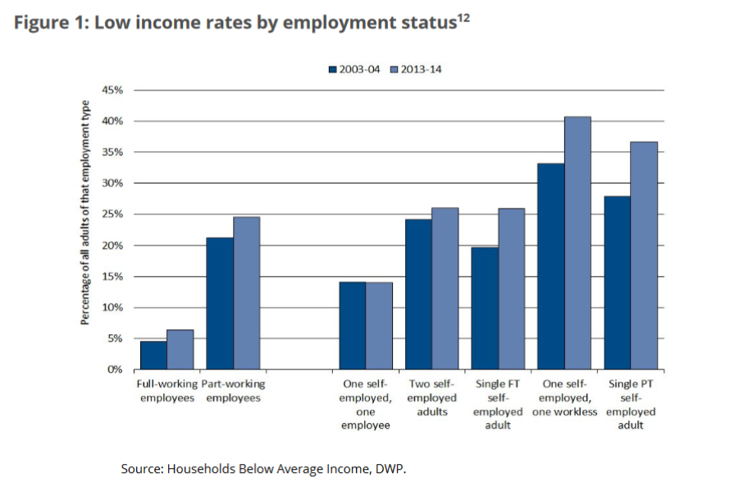

Appendix B - Citizens’ Advice Bureau – Proportion of people in a family behind with a bill payment – derived from Family Resources Survey statistics (Citizens Advice Bureau, 2016)
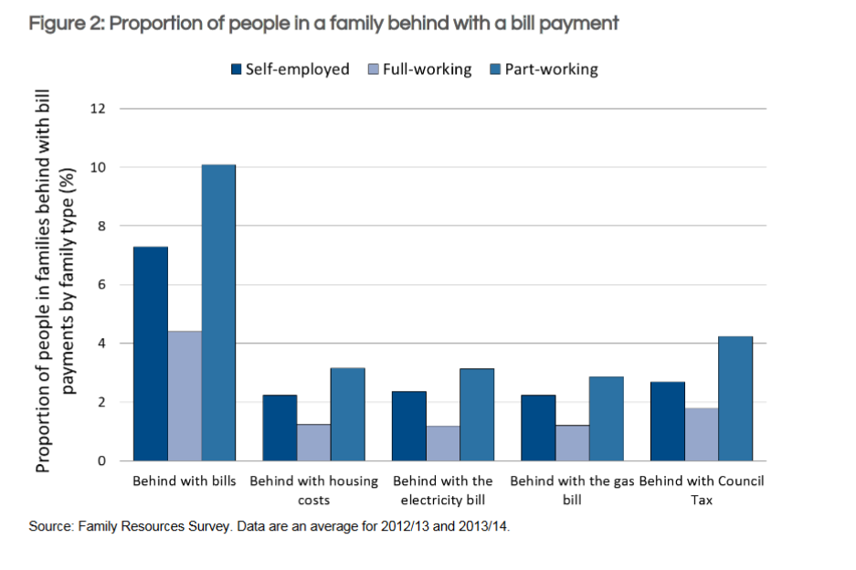

Appendix C - Ethics Form
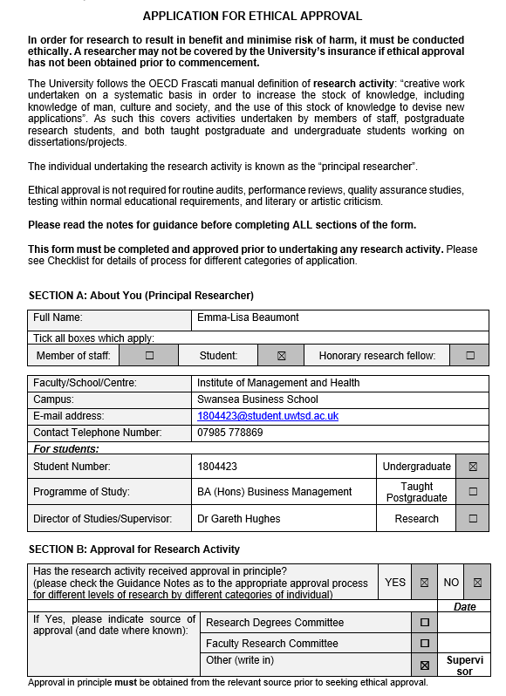

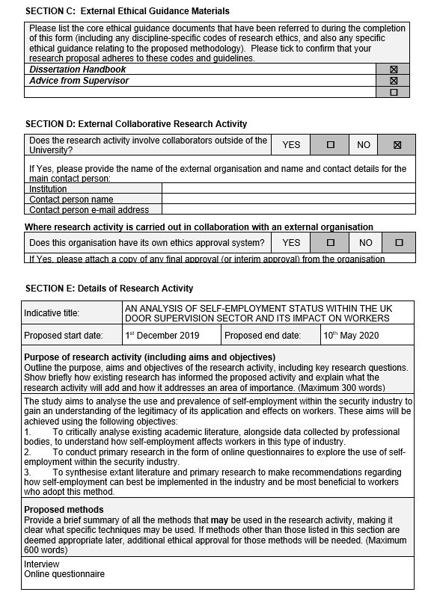

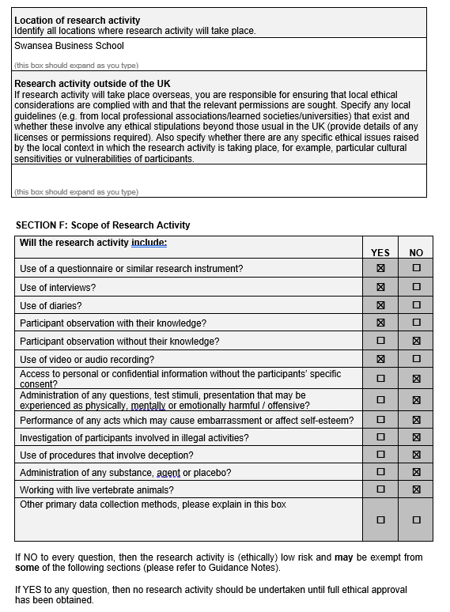

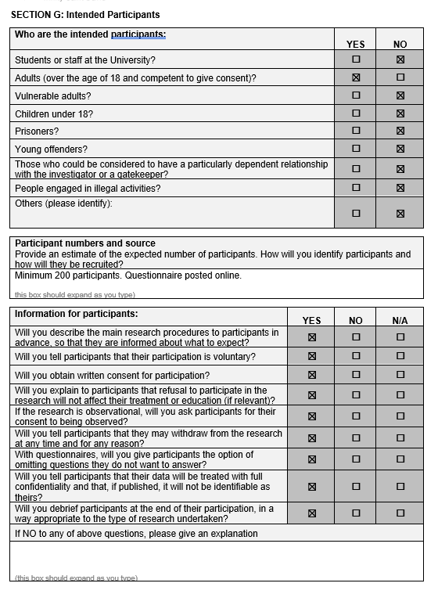

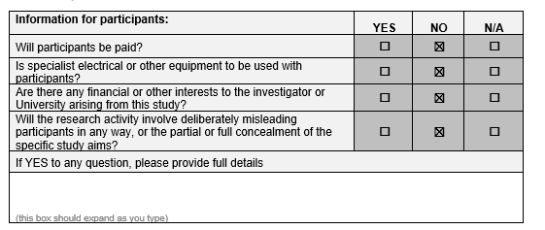

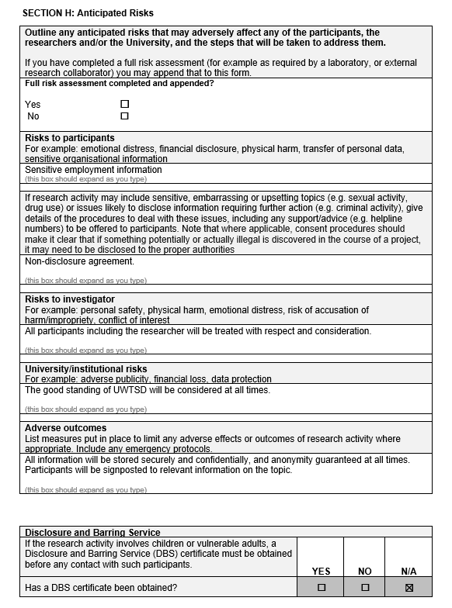

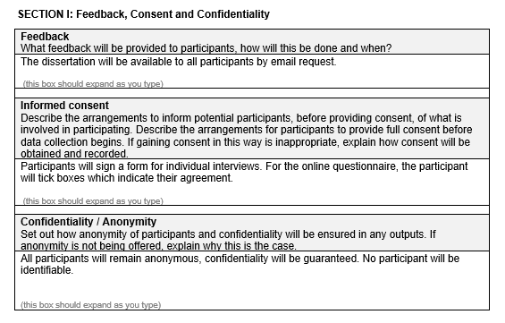

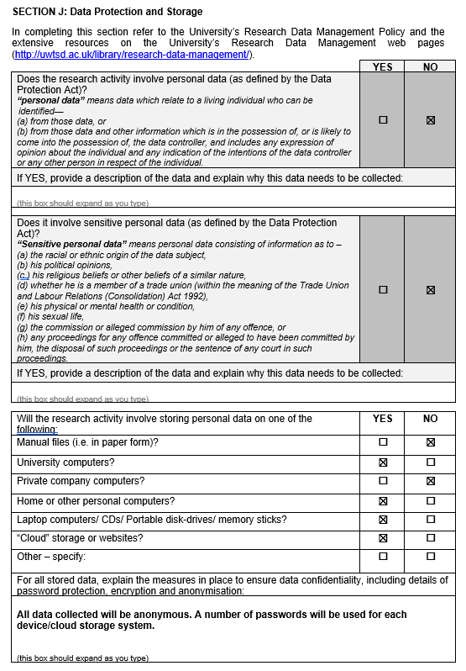

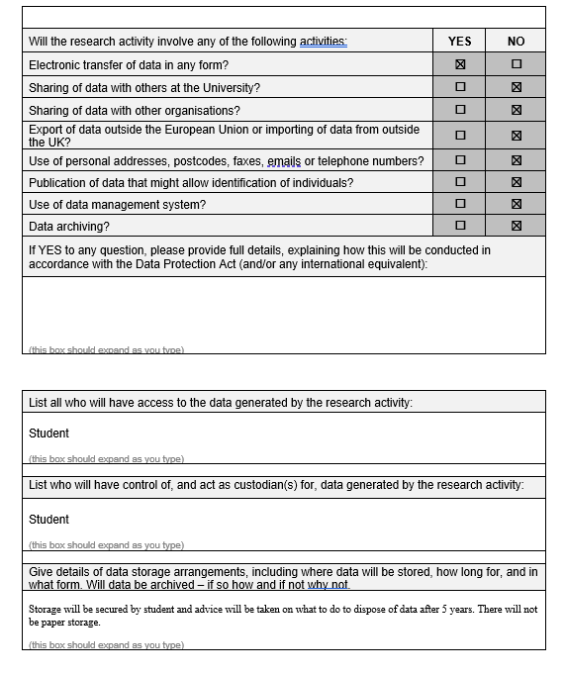

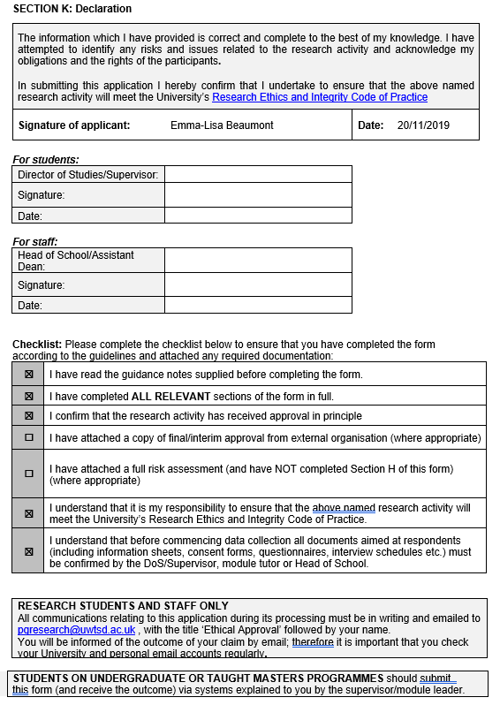

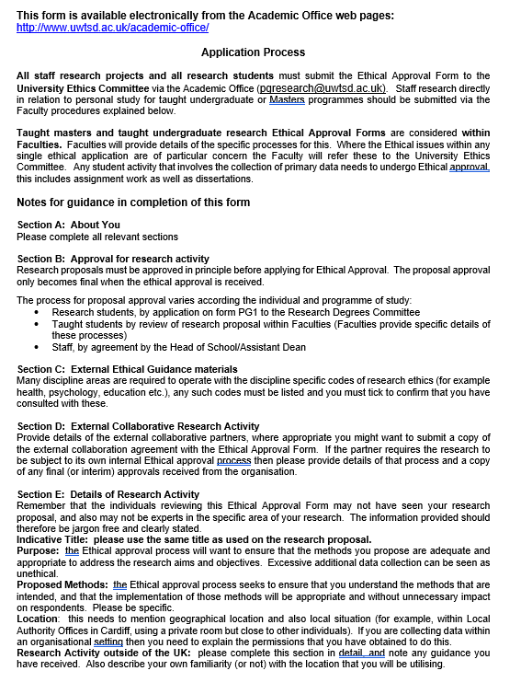

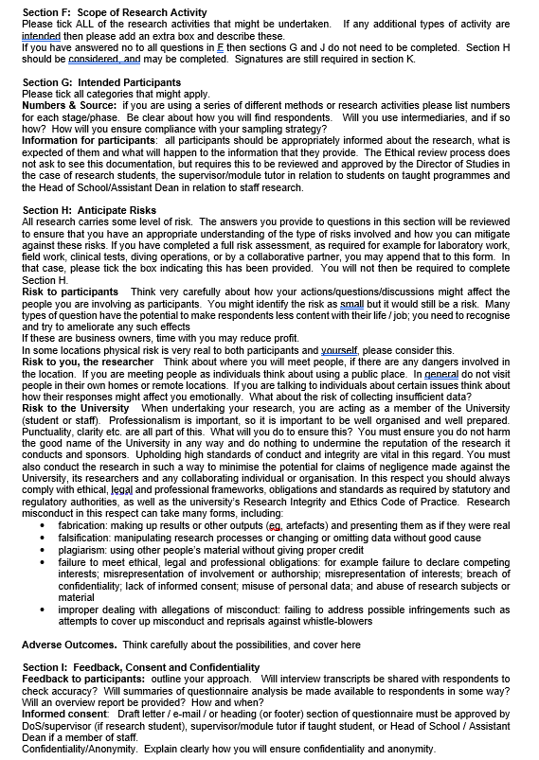

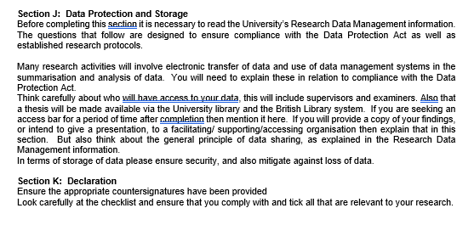

Appendix D - Blank Questionnaire

Self-Employment in the Security Industry
The purpose of this research is to analyse the use and prevalence of self-employment within the UK Door Supervision industry. This questionnaire should take around 5 minutes to complete. The questionnaire will form part of an undergraduate final year research project. If any participant wishes to contact me regarding the questionnaire, please email me at 1804423@student.uwtsd.ac.uk. Thank you for taking the time to participate in this research.

IMPORTANT: Although I understand work within the industry is unfortunately very difficult to find at the moment, please answer this questionnaire as if the COVID-19 pandemic was not affecting your work.
*Required

- I understand this survey should be answered as if COVID-19 were not affecting my work. *
Mark only one oval.
Yes No

- I hereby acknowledge that the data collected by this survey will be anonymous and confidential, and will be used by the University of Wales Trinity Saint David for academic and educational purposes only. *
Mark only one oval.
I accept
I decline

Licence Holding
- Do you currently hold a front-line SIA licence? *
Mark only one oval.

Yes Skip to question 5
No Skip to question 4

Past Licences
- Have you held a front-line SIA licence in the last 5 years? *
Mark only one oval.
Yes Skip to question 5
No

Licence History
- Which licence(s) do you hold/have you held? Please tick all that apply. *
Tick all that apply.

Door Supervisor Security Guard
Cash and Valuables in Transit Close Protection
Public Space Surveillance (CCTV) Key Holding
Immobilisation, Restriction and Removal of Vehicles (Northern Ireland only)

- What is your employment status? *
Mark only one oval.

I am an employee (My tax and national insurance is deducated from my payslip automatically)
I am self-employed (I am responsible for paying my own tax bill, and/or submitting a self- assessment tax return to the HMRC once a year)
I am unemployed
I work as an employee and self-employed (for different purposes)

Employment Details

- Which type of employment do you currently have? *

Tick all I/lat apply.

Full time contract (40 hours or more on a permanent/ongoing basis) Part time contract (Less than 40 hours on a permanent/ongoing basis) Fixed term contract (Contract is only for a few weeks or months)
Gig worker (One off events, infrequent shifts)
Agency Work (A 3rd party company pays you to work for another) Contract for Services (For self-employed)

- When working as a self-employed security guard/door supervisor... *

Mark only one oval per row.

Agree Disagree Not

sure
I am responsible for the success or failure of the job


I have several customers at the same time
I can decide how, when and where I do the work


I can hire other people at my expense to help me, or do the job for me
I provide the main items of equipment to carry out the work(radios, uniform, hi-vis etc)

I am responsible for finishing
any unsatisfactory

work in my own time
I can charge a price I chose, agreed with the client at

the beginning of the job
I invoice the company for my pay

I am given a contract for the job
The company I am working for at the time
do not  prevent me
working
elsewhere

- When working as a self-employed security guard/door supervisor... *

Mark only one oval.

I also work for a company who pay me directly
Option 2

- When working as a security guard/door supervisor... *

Mark only one oval per row.

Agree Disagree Not
Sure
I have relied on one company for work, even if I don't have fixed hours with them


My income changes
from month to

month

I have income protection cover for periods of sickness?



It is expected to remain loyal to one company
I can afford to have time off throughout the year

I have worked more than 48 hours per week

