Student Self Evaluation Form

This section repeats in brief the common assessment criteria detailed on previous pages. The extent to which these are demonstrated by you determines your mark. Using these criteria, tick the box that best indicates the level of achievement you feel you have achieved with regard to each of them.
Common Assessment Criteria Applied
Common Assessment Criteria Applied | REFER |  | D |  | C |  | B | A
 | OUTRIGHT FAIL | UNSATISFACTORY | SATISFACTORY | GOOD |  | VERY GOOD |  | EXCELLENT
1. Subject Knowledge and Understanding (which includes using research-informed literature and knowledge and understanding of the subject)
 |  |  | /
2. Intellectual Skills (Analysis)
2. Intellectual Skills (Analysis) |  | /
3. Pedagogic and Professional Applications (Practical Application and Deployment)
 |  | /
4. Key Transferable Skills
4. Key Transferable Skills |  |  | /
PLEASE COMMENT ON AREAS IN WHICH YOU FEEL THAT YOU HAVE PERFORMED WELL | PLEASE COMMENT ON AREAS you feel that you need TO DEVELOP
I felt I was able to collect some evidence and reflect on the child overall | I felt that I have struggled with this assignment. With planning lessons, bridging activities and trying to do this assignment as well as personal commitments I have not completed this to the best of my ability and did not have time to complete the word count.
Student’s Name | 0800218 | Date | 30/05/2018
Student’s Signature | 0800218

0800218
‘Supporting pupil progress: a detailed analysis of one child’s holistic development, with justification for the next steps in learning.’
Introduction
The school is a Voluntary aided Church school in West Wales in an area of high deprivation with 40.1% of children having free school meals, which is well above the average for Wales. The school has 138 pupils in 5 mixed-year classes including a number of traveller families and looked after children. There is a nurture group every morning for certain children and 40% of the children have Additional Learning Needs, well above the national average of 25%. The main language at the school is English and nearly all the pupils come from homes where English is the main language. Being a Church school the pupils have a religious assembly everyday as well as saying prayers before lunch and before going home. The child I chose to observe is 6 years old, in year 1 and will be referred to as Child A throughout this paper so that confidentiality is adhered to (Alderson and Morrow, 2011). Child A has two older siblings, a brother and a sister and is from a family where his parents have separated however he spends time with both parents regularly.
Data Collection
The method of collecting the data for this paper was taken from the Mosaic Approach created by Alison Clark and Peter Moss. The Mosaic approach is a collection of evidence and documents put together to form a living picture children’s lives, hence the term Mosaic. The approach gives practitioners the opportunity to listen, consult with children and find out their views. This multi method approach gives children opportunities to try new ways of expressing their views, as well as encouraging children to reflect on what is important to them (Clark and Moss, 2011; Clark, 2001). The Mosaic approach has three stages, the first stage is the observation stage where children and adults will gather and document information from children’s and adults perspectives. These observations will be qualitative data as it will be non-numerical and will look at the way the child perceives the world, as well as how they interact in their school environment (Brooks et al., 2014; Clark and Moss, 2005). The observations will be participant observations as the observer will be involved and interacting with the children when asking questions. The observer will therefore be immersed in the situation which will be conducted in the learner’s natural school setting (Papathedorou et al., 2011). The different types of evidence include observations that are narrative accounts, child conferencing, children taking photos, tours given by the children, map-making and interviews to gain the child’s perspective (Alderson and Morrow, 2011). The narrative account is one of the simplest observational methods as it involves no advanced preparation. The only things you need are a pen and paper then you can simply write what you are seeing and gives an all-round picture of the child. The limitations with this observation method are that you may not have an idea of what or how much to record and so you can end up with lots of unstructured data. This can then make it difficult to compare observations and see what the child has achieved (Fawcett, 2009). Photographs provide another way for children to communicate and show their favourite places or things that are important to them. Children can also communicate their feelings, ideas and experiences through photographs (Clark and Moss, 2011; Papathedorou et al., 2011; Clark, 2001). When children take adults on tours of the school it gives the children control of where they want to go and what they want to show you as well as giving them the feeling that they are important. These tours give you an insight into what the children find important in school and how they feel about certain parts of the school or people in the school (Clark, 2001). When interviewing children child conferencing can be used to get children’s perspectives on particular topics. Adults can come up with a list of questions they would like to have answered and then ask a small group of children the questions but by having it as more of a discussion than an interview children will feel more at ease. For example interviewing the children whilst they are painting, the children are relaxed and at ease doing an activity and when talking to them even though you are asking questions it is more of a group discussion than an uneasy interview (Clark, 2001).
Once all the evidence has been collected stage two is where the evidence is pieced together for dialogue reflection, action and interpretation. The pieces of work are put together like a mosaic and then discussed to see what children’s priorities are and their achievements and feelings (Clark, 2001). When looking at the evidence collected you can now get an overview of what is important to the child, how they may feel about certain aspects of school or certain parts of school. Looking at samples of children’s work you can then assess how they are doing and what they need to move onto next or whether they need more support for that particular focus (Papathedorou et al., 2011). This then leads on to Stage three which is about deciding on the next steps for the child and any changes or support that need to be made.
Firstly consent was obtained from the school and the class teacher before any evidence or interviews were conducted as evidenced in appendix 1. The consent of the learner was also obtained and they were made aware of the fact that they could withdraw consent at any time. The learners consent was requested to show respect for the child by following the United Nations Convention on the Rights of the Child (UNCRC) as in Article 12 children’s views should be respected and listened to. In Article 14 where children have freedom of thought and so are able to withdraw consent whenever they wish to with no consequences (Alderson and Morrow, 2011; Fawcett, 2009).
Analysis of learner
The data collected on child A was examples of work including literacy and numeracy. The child also gave a tour of the school and favourite areas and displays were discussed. An informal interview was also conducted with a group of children asking them about their favourite parts of school and asking about teachers as well. The child was given an ipad to take pictures of favourite parts of school however the child had a finger over the camera and so each picture was of a finger. The pictures were discussed afterwards as the child could relay where each picture was taken from memory and discuss why the places were important to the child. The examples of work and interview answers are included in the appendix (Appendix 2 to appendix 8). The overview of the data shows that child A works hard in school and finishes every piece of work they are given with and without adult support. Child A is confident, friendly and likes to discuss their opinions to their friends or other adults. This child is quite happy to discuss favourite areas of the school, favourite topics and topics that they do not like as well.
The first subject looked at is mathematics and how child A has done compared to what the learning objective and success criteria are for the work. The skill for the maths lesson was take from the Foundation Phase Framework (Welsh Government, 2015). The strand was using geometry skills and the element was shape. The year 1 skills used for this lesson were to ‘recognise and name common 2D shapes (square, triangle, rectangle, circle and semi-circle) and 3D shapes (cube, cuboid, cone and sphere) in order to begin to compare and sort’ and ‘recognise and complete a symmetrical picture or simple shape’. However the year 2 and reception skill were also looked at for this lesson as it is a mixed year group class. The skills are similar for each group depending on their age and ability however the individual activities are then differentiated for each group. Child A is in the Elephant group which are the middle ability group, however some of the children in this group including child A complete the maths skills and even do some extension tasks above their ability. The Learning Objective for child A was to identify common 2D and 3D shapes and their properties. The success criteria and learning objective were put on their skill slips and explained to the children. Once the week of lessons are completed the children fill in the skill slip to see what they feel they have achieved and then an adult checks this and discusses the work with the children. Child A was based on the activities from that week work towards the learning objective. As evidenced in Appendix 3 from the skill slip child A was aware that they needed extra support/ focus in certain areas. When discussed with the teacher feedback, child A stated that some more lessons on shapes and using mirrors more to experiment with symmetry could help them achieve the learning objective. In this way the child is being an active participant in their own learning and learning how to self-assess their own learning (Black and Wiliam, 1998). The next week the same skill was looked at however the children had a different success criteria and different activities to participate in. During this week child A developed more skills and was able to achieve more of the learning objective than the previous week. Child A was also able to look at the Literacy and Numeracy Framework skill and talk about what shapes some everyday items were around the classroom thus using the skills they had developed that week.

When doing literacy in Child A’s school they follow the Read, Write, Inc. framework every day and so the planning for these lessons is already determined in advance. However there are opportunities for literacy skills to be developed during topic lessons as demonstrated in appendix 8. A number of skills were used for this lesson including oracy when talking about what they are going to write, using descriptive words when writing, using word mats for support and practicing their cursive writing (Welsh Government, 2015). The learning objective was to talk about the royal wedding from the week before and then write down what they saw using descriptive words. First we talked about the wedding and what they saw, then we discussed descriptive words and came up with examples and then they wrote down what they had discussed. Child A achieved most of the learning objective however needs to work on the formation of the letters and remember to use full stops at the end of a sentence. The slip was discussed with the child and when asked what they thought they could do next they were not as confident in giving an answer as they were in the mathematics.
When feedback was given it was about the work and the success criteria related to the learning objective so that the child could have a clear understanding of what needed to be worked on and needed to be achieved (Black and Wiliam, 1998). This kind of formative assessment is for moving children on in their learning as well as increasing their self-esteem (Barnes, 2015). Children that are aware of the learning intention and success criteria understand tasks better and are no longer afraid of making mistakes. These children are able to admit difficulties and then work with the teacher to move their learning forward (Barnes, 2015). This discussing the skill slips and talking about what needs to be worked on and the fact that they were unsure about the literacy next steps supports some of the answers given to the interview questions. Child A when answering interview questions stated that they did not like Read, Write, Inc and preferred being outside or painting and doing role play inside however they do well in achieving and working towards the learning objective in mathematics. The well-being of children can also be observed through their body language and visual cues (Fawcett, 2009). This is where narrative observation could be useful in observing child well-being.
The data collected from the pieces of work is one part of the child as it shows what they can do academically however it does not show the whole picture of the child. The interview questions and talking to the child can give some idea of their well-being as well as narrative observations. The only issue with narrative observations is finding the time to just sit and observe children and make notes which is not an easy thing to do when looking after a class of thirty children. When the child gave a tour of the school their favourite areas were outside and the role play area. The child did spend a bit of time showing us around the hall and so I would interpret that this is important to them as this is where they have their lunch.
From the data collected child A is a happy healthy 6 year old who enjoys spending time with friends and being outside. Child A does well in mathematics and literacy even though they say they do not like writing as much as other topics.

Next Steps
The first step would be to get an overview of the other children in the class and then using the Digital Competence Framework (DCF) find out if a number of children need more focus on this area or whether it is an area child A needs more focus on. This can then be included in the planning and lessons for the next topic to develop their DCF skills effectively.
I believe due to the child’s dislike of writing that more cross curricular activities would be appropriate to develop these skills. If the child has the opportunity to write about something they enjoy then they may be more inclined to enjoy writing. Listening to the child and involving them in their learning will make them feel valued and important (Clark and Moss, 2005). The child also expressed their interest in outdoors so trying to incourporate as much outddor learning as is feasible would be another step forward for this child’s learning. As the preschools of Reggio Emilia in Italy suggest the environment is the third teacher and so moving any activities that can be done outside may give some children more enthusiasm and cause them to make more effort in some topics that they may not normally enjoy (Clark, 2005). By involving children’s thoughts and decisions in their next steps it shows children that their thoughts and views are valued and have been included in their own learning (Clark and Moss, 2011). This also gives practitioners the opportunity to plan lessons that support children’s individualness and discover what children know and understand (Welsh Assembly Government, 2008).
Using the mosaic approach and assessment for learning the next steps would be to ensure all lessons are cross-curricular and that where possible lessons are conducted outside. The children will still be made aware of the learning intention and the success criteria. The next step with this would be to involve the children in the success criteria and ask them what they think they need to achieve and how they could achieve it. If the children are involved in the success criteria and the planning of activities then they will have ownership over that lesson causing them to want to do well and want to achieve the learning objective. Child A needs to also have extended activities ready for when they finish their work to stretch their mind and see what different ways they could work things out.

Conclusions
The mosaic approach due to its multi method form of collecting evidence allows practitioners to collect lots of different evidence to put together to create a holistic view of the child. By having the child in the centre and then the different areas and evidence around the child to make up the whole picture of the child’s learning and development (Fawcett, 2009). The mosaic approach is much like the Te Whaarki approach from New Zealand in that they use Learning Stories which are filled with children’s work and evidence of what children can do or how they feel (Fawcett, 2009). The approach gives children a living picture of their lives and when brought together with understanding the learning intention and success criteria, children then have greater control over their learning. The approach gives children the opportunity to be active participants in their learning and lives which in turn will improve their self-esteem. The Mosaic approach is about children being experts in their own lives, being the holders of their rights, making meaning in their lives and being skilful communicators (Clark and Moss, 2011). It is up to practitioners to ensure they plan cross-curricular and meaningful experiences for children to participate in to improve and nurture their own learning. As long as practitioners provide children with these lessons and give children the opportunity to be involved in the assessment and next steps of their learning then these children will grow up to be ambitious, capable learners who are ready to learn and enterprising, creative contributors who are ready to play a full part in life and work (Dauncey, 2015).

Reference List
Alderson, P. and Morrow, V. (2011) The Ethics of Research with Children and Young People. London: Sage Publications Ltd, [e-book]. Available at: https://www-dawsonera-com.ezproxy.uwtsd.ac.uk/abstract/9781446209387 [Accessed: 29th May 2018].
Barnes, J. (2015) Cross-Curricular Learning 3-4. London: Sage Publications Ltd.
Black, P. and Wiliam, D. (1998) Inside the Black Box. Maidenhead: Open University Press.
Black, P., Harrison, C., Lee, C., Marshall, B. and Wiliam, D. (2003) Assessment for Learning. Maidenhead: Open University Press, [e-book]. Available at: https://www-dawsonera-com.ezproxy.uwtsd.ac.uk/abstract/9780335224296 [Accessed: 29th May 2018].
Brooks, R., Riele, K. and Maguire, M. (2014) Ethics and Education Research. London: Sage Publications Ltd.
Clark, A. (2001) ‘Say your piece’ Available at: https://www.nurseryworld.co.uk/nursery-world/news/1087815/piece [Accessed: 29th May 2018].
Clark, A. and Moss, P. (2005) Spaces to Play. London: National Children’s Bureau.
Clark, A. and Moss, P. (2011) Listening to young children. London: National Children’s Bureau.
Dauncey, M. (2015) ‘Donaldson Review: The’purposes’ and content of a curriculum for Wales’ Available at: https://seneddresearch.blog/2015/03/17/donaldson-review-the-purposes-and-content-of-a-curriculum-for-wales/ [Accessed: 30th May 2018].
Fawcett, M. (2009) Learning Through Child Observation. London: Jessica Kingsley Publishers, [e-book]. Available at: https://www-dawsonera-com.ezproxy.uwtsd.ac.uk/abstract/9781846429644 [Accessed: 29th May 2018].
Papathedorou, T., Luff, P. and Gill, J. (2011) Child Observation for Learning and Research. Harlow: Pearson Education Limited, [e-book]. Available at: https://www-dawsonera-com.ezproxy.uwtsd.ac.uk/abstract/9781408262368 [Accessed: 29th May 2018].
Welsh Assembly Government. (2008) Observing Children. Cardiff: Department for Childcare, Education, Lifelong Learning and Skills.
Welsh Government. (2015) ‘Foundation Phase Framework’ Available at: https://beta.gov.wales/sites/default/files/publications/2018-02/foundation-phase-framework-revised-2015.pdf [Accessed: 30th May 2018].

Appendix 1
RE: Primary PGCE student assignment: permission and confirmation that work has been undertaken in school for assignment ‘School Development and Pupil Progress’, Summer 2018.

Dear class/senior mentor,
For the university module named above, trainees are required to identify one learner within the class in which they are based and, over the course of the Professional Teaching Experience, explore their learning in detail. The evidence that they need to gather could include:
- observation;
- asking the learner to identify places/things that help him/her learning;
- discussing what helps the pupil learn and how they feel about learning with the pupil and/or teacher;
- collecting samples of work which might show something about the learner’s progress and development.
They are asked to focus on knowledge, attitude and skills in language, mathematics, wellbeing and at least two other areas of the curriculum to gain an holistic picture of the child. They then suggest the next steps for the learner, and indicate how these will be achieved. Trainees are expected to undertake this work independently whereever possible, and have been given ethical guidelines to follow (although undertaking the work above would be in line with typical classroom practice). The trainees have been asked not to reveal the identify of the learner or the school within their assignment. Students have been asked to:
- Seek permission for this work (by consulting with the class teacher and learner)
- Provide verification that the work has taken place.
We would therefore be grateful if you could confirm that permission has been sought and that tasks have been undertaken by signing below:

STUDENT NAME (PLEASE PRINT): __0800218 ______________________________

SCHOOL NAME (PLEASE PRINT): _________________________________

SENIOR MENTOR/CLASS MENTOR NAME (PLEASE PRINT):

SENIOR MENTOR/CLASS MENTOR NAME (PLEASE SIGN):

If you have any queries regarding this, please contact the Programme Lead Helen Lewis: h.e.lewis@uwtsd.ac.uk

Many thanks in advance,

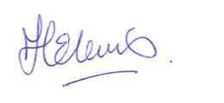Helen Lewis, 5.3.18

SIGNED COPY TO BE INCLUDED IN APPENDIX OF ASSIGNMENT

Appendix 2
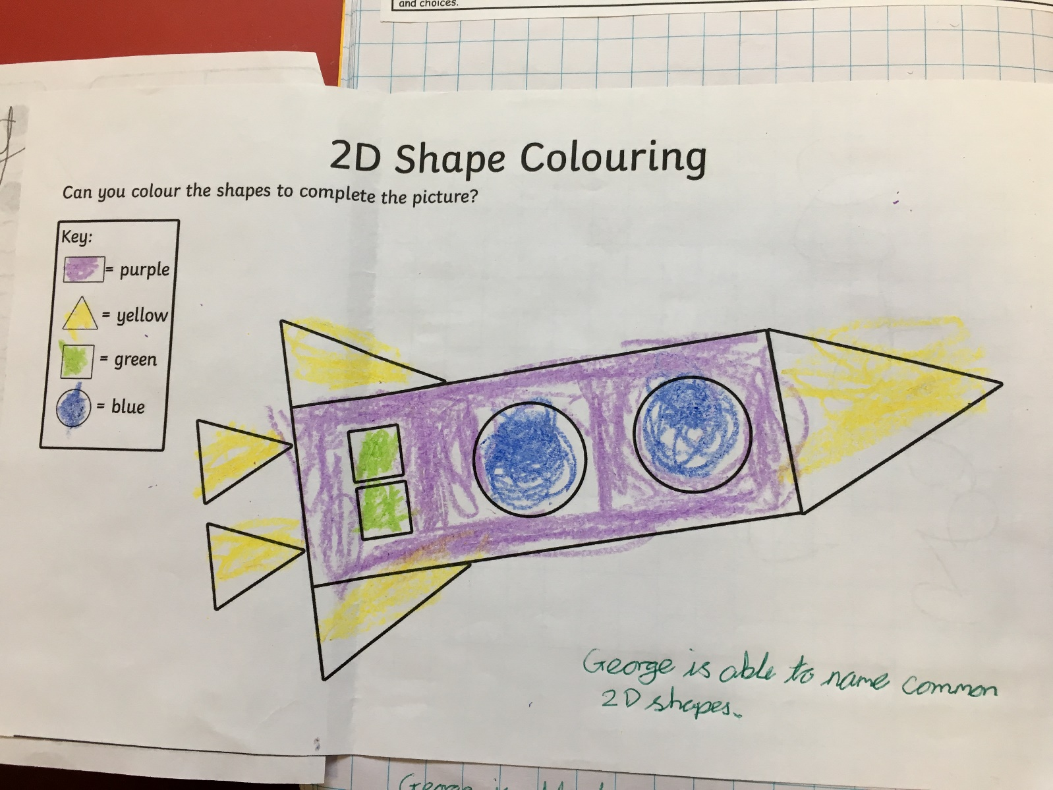

Appendix 3
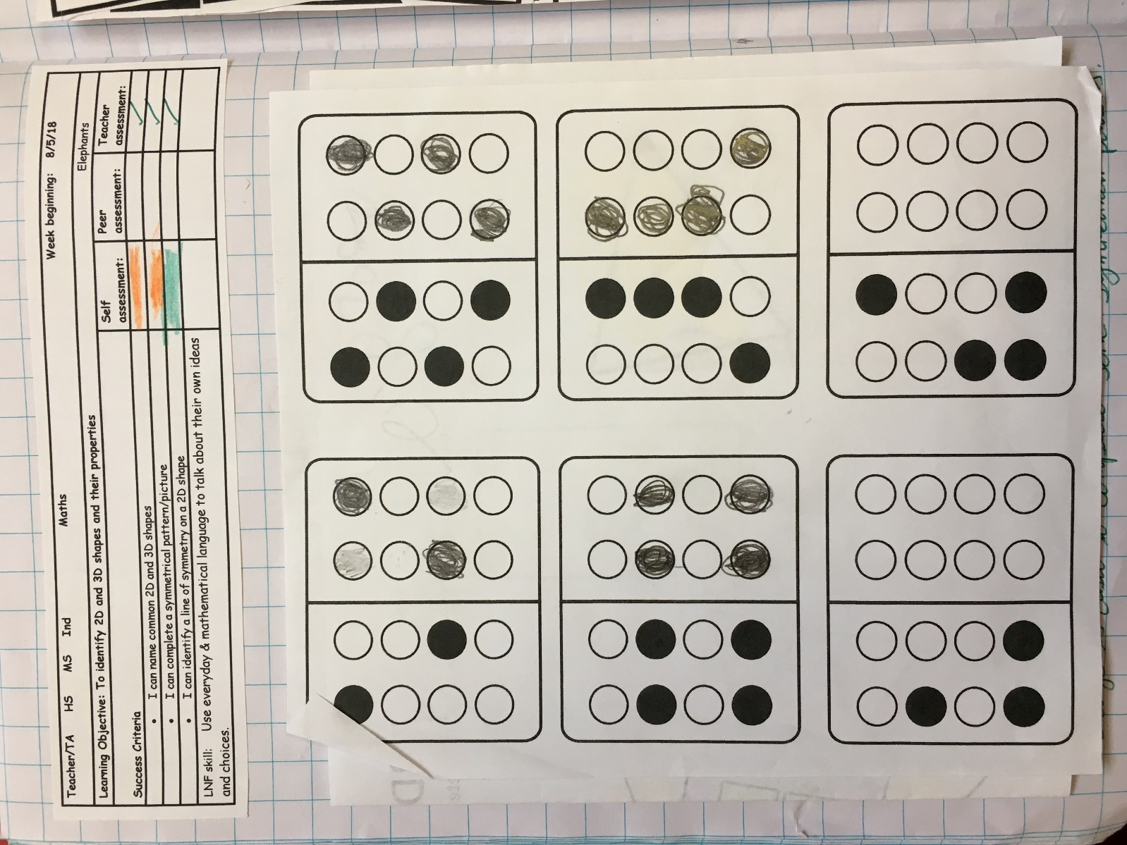

Appendix 4
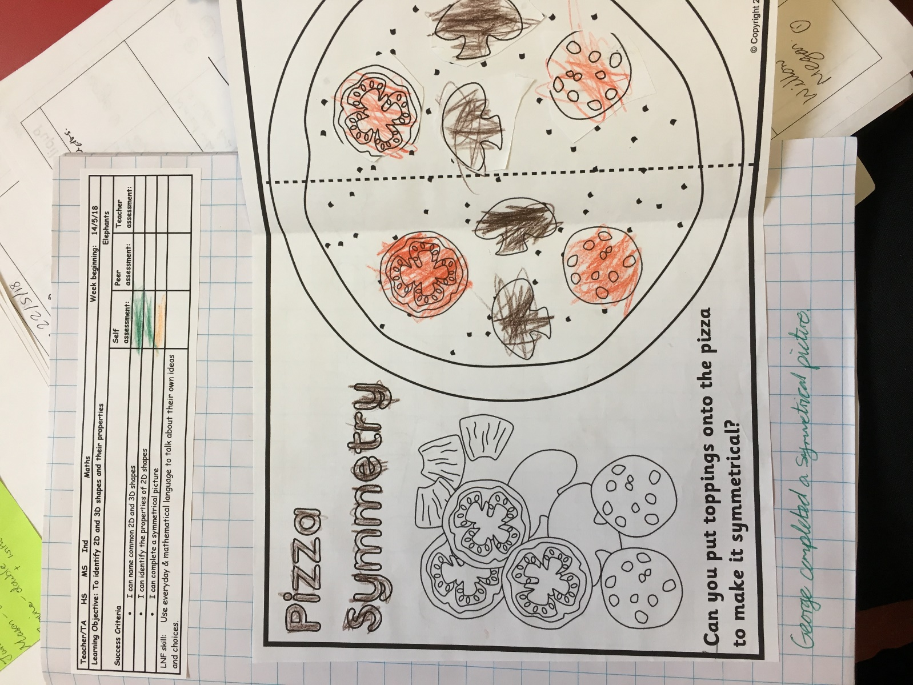

Appendix 5
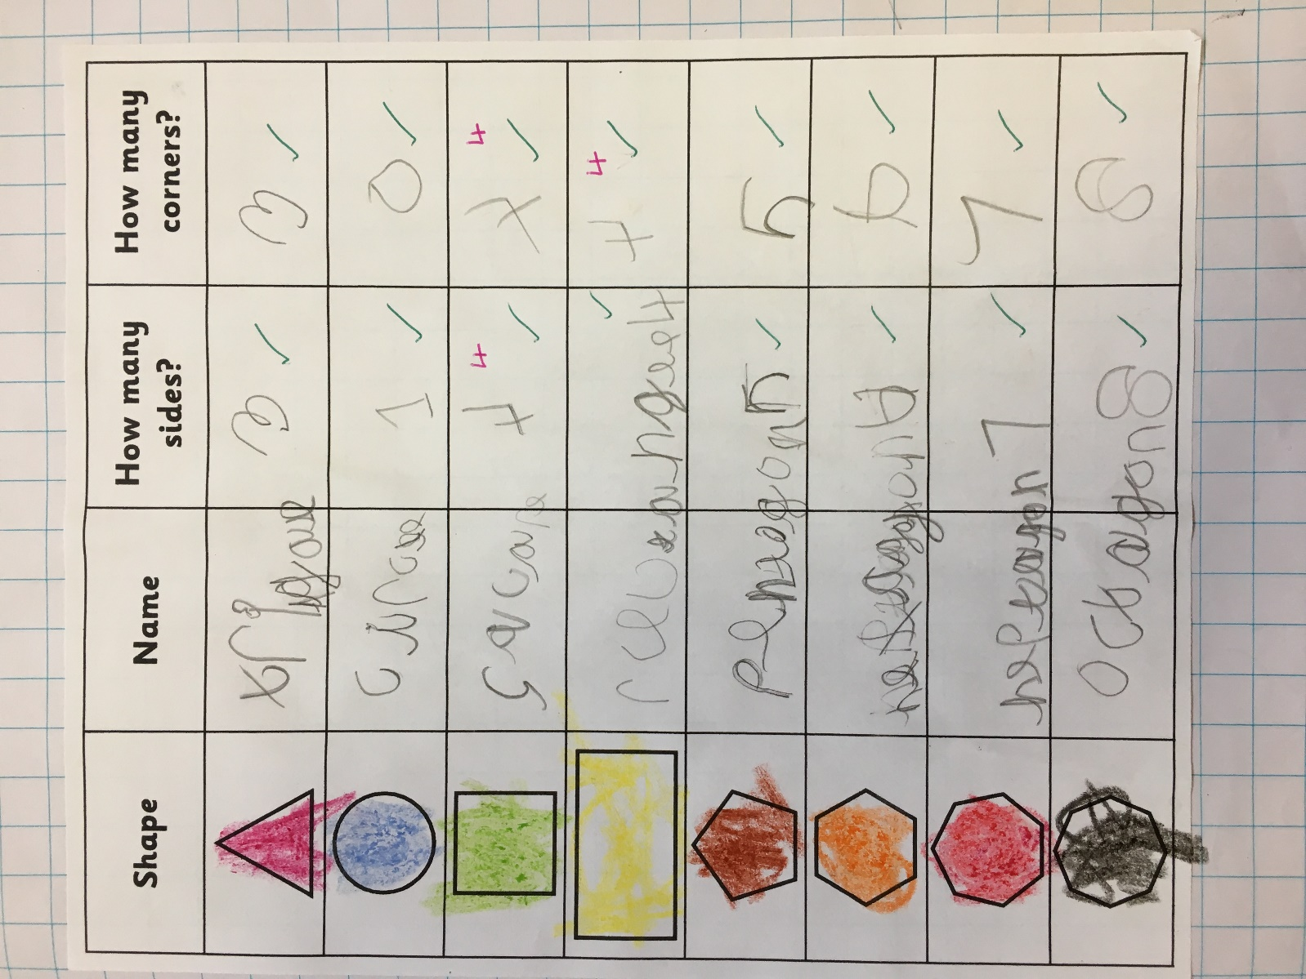

Appendix 6
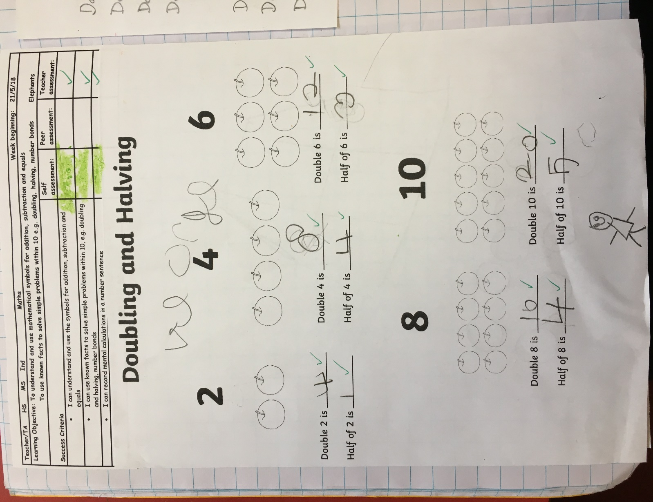

Appendix 7
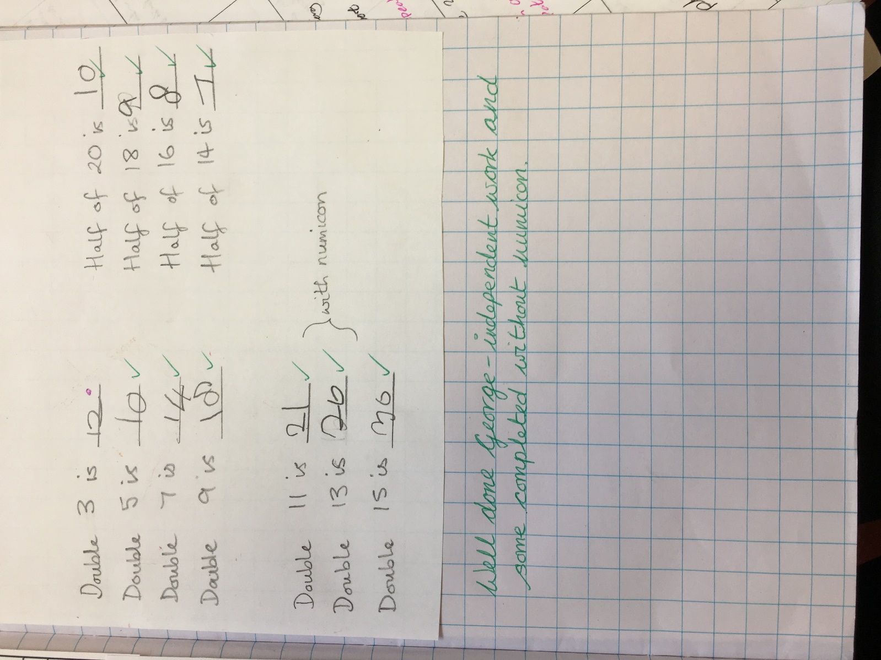

Appendix 8


