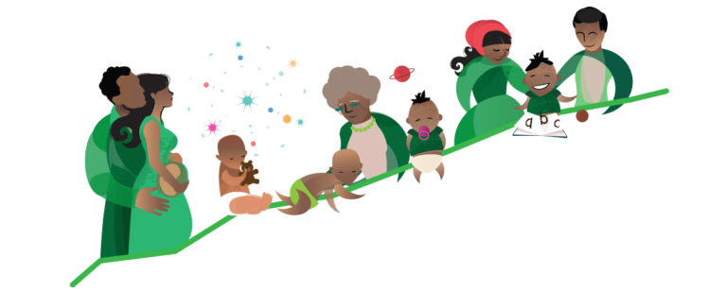
First 1000 days

Why is the first 1000 days important?
The first 1000 days is when the foundation of lifelong health begin. "it’s a unique period of opportunity when the foundations of optimum health, growth, and neurodevelopment across the lifespan are established." Cusick., Georgriff (2013). In many countries and personal cases where poverty and malnutrition are high its often found to affect a child's lifelong health and brain development. "For children who grow up in poverty, there are impacts that go way beyond the fact of material shortages. Children experience poverty as an environment that is damaging to their mental, physical, emotional and spiritual development,” Young (2019)
The first 1000 days set up a good health life, ensuring babies have the correct vitamins and nutrition for the first 1000 days helps babies to fight infections, allowing a baby’s brain to develop and allow them to meet their full development potential. Babies need -
- a loving relationship
- stable home
- healthy environment
- healthy food
- time to play.
"Being hungry or exposed to stress and or abuse during this time it’s known to have a lifelong effect on a child's development. Since the brain is closely linked to the rest of the body and is still developing, an unsafe or unhealthy environment in the first 1,000 days can affect a child's physical health in later life too". Pregnancy birth (no date)
Research has shown a mother who can be put under stress during pregnancy can affects a baby's nervous system while in the womb:
"A growing body of research indicates that maternal stress during pregnancy exerts influence on the development of the unborn (Van den Bergh et al., 2017). Recent studies underline the long-term influence on a variety of developmental domains in the offspring, such as metabolic functioning, cognitive and emotional development" Nazaari (2019)
We'll be looking at two major theorists which are Maslows theory and Alison gopnick's theory throughout this scrapbook. Both of these outline the fundamental factors of a child’s life.

Maslow
The below video describes who Maslow is and what his theories are
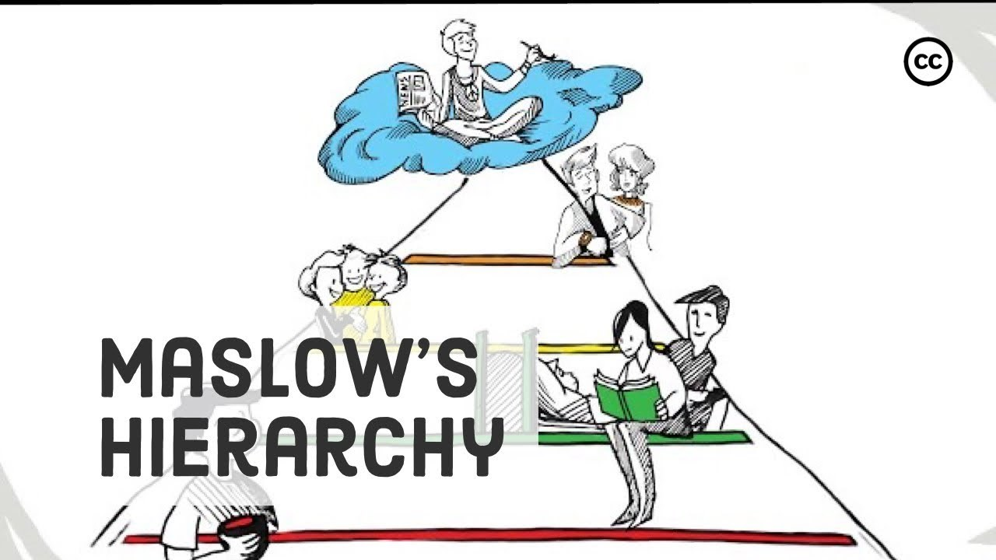
Maslows theory is important as it relevant to the organisation as it links with human motivation, including the needs of psychological, love, security belonging and esteem needs. "Maslow was cited as being one of the forefathers of modern psychology, who emphasised the value of understanding the inherent positive qualities of an individual, beyond a collection of symptoms." Eco (2021). If a child's basic needs are not fulfilled, they will struggle to move a higher level, also moving backwards as the primary needs won’t be met.
psychological needs- this being the first tear in the pyramid theory of maslow. These are all basic needs such as, food, water, warmth, a home a designed area to use the toilet. Although psychological needs are food, warm home etc its often important to remember a good mental health allows children to think more clearly, develop social skills and learn new day to day skills.
Basics for a child’s good mental health:
- Unconditional love from family
- Self-confidence and self-esteem
- The opportunity to play with other children and peers
- Safe and secure surroundings and home security
- Appropriate guidance and discipline
Security needs- This focuses on the need to feel secure and safe. including a safe environment for the child this includes a home or a childcare setting. Love, security and acceptance should be the heart of the family. it’s important for parents or caregivers to know that acceptance and love does not depend on a child's accomplishments
Esteem needs- Encouraging positive thoughts and needs for your child. Making them feel respected and confident. encouraging children to explore and participate in activities helps build not only their esteem needs but their confidence encourages children to not only do their best but to enjoy what they’re doing. It’s important for parents to not put an unhealthy amount of pressure on their children and to remember that love, support and care can aspire and push children more towards life goals and development.
Nurture children’s confidence and self-esteem.
- Praise Them - Encouraging children’s first steps or their ability to learn a new game helps them develop a desire to explore and learn about their surroundings. Allow children to explore and play in a safe area where they cannot get hurt. Assure them by smiling and talking to them often. Be an active participant in their activities. Your attention helps build their self-confidence and self-esteem.
- Set Realistic Goals - Young children need realistic goals that match their ambitions with their abilities. With your help, older children can choose activities that test their abilities and increase their self-confidence.
- Be Honest - Do not hide your failures from your children. It is important for them to know that we all make mistakes. It can be very re-assuring to know that adults are not perfect.
- Avoid Sarcastic Remarks - If a child loses a game or fails a test, find out how he or she feels about the situation. Children may get discouraged and need a pep talk. Later, when they are ready, talk and offer assurance. MHA (No date)

Social needs- Play time is not only just fun for children it develops their creativity to learn to problem solve and discover their strength and weaknesses. It’s important for children to have time with their peers, this builds their confidence and social skills. Every child should have access to a play area and time with other children.

Alison Gopnick's Theory
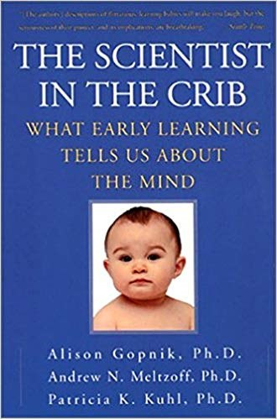
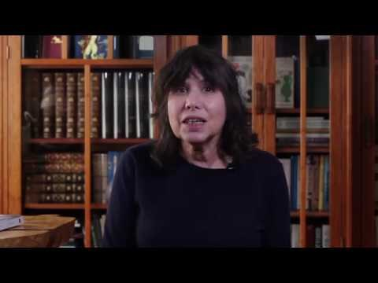
1 - Alison Gopnick spend a wide part of her career as a child psychologist studying what goes on in a child's mind and how do they learn? Alison undertook a crackers and broccoli study to which she laid out some crackers and broccoli to see which of two toddlers would choose. Firstly, the children chose the crackers as most would, however the researcher picked up the broccoli to taste and made a face of delight, next picking up the crackers and pulling a express of disgust. While the 18th month old was watching this the researcher asked if the child could hand her some, for a second the child had to think and handed her broccoli, meanwhile the 15 month old was still confused and handed the researcher some crackers.
what does this demonstrate? it shows that the 18th month old toddler is aware of the preferences of others, they start to realise that other people like different things. This study helped dismantle the old way of thinking. according to Sherk (2019), “through multiple experiments, Gopnik demonstrates that since children have greater mental flexibility, elasticity, and creativity than adults, they’re better at testing hypotheses than adults" Gopnicks research explores how young children come to know the world around them, this is classed as 'theory theory' the idea of change and child development. "In collaboration with computer scientists, we are using the Bayes Net formalism to help explain how children are able to learn causal structure from patterns of data, and we have demonstrated that young children have much more powerful causal learning mechanisms than was previously supposed." Gopnick (2019)

How Covid 19 Affected a child's development?
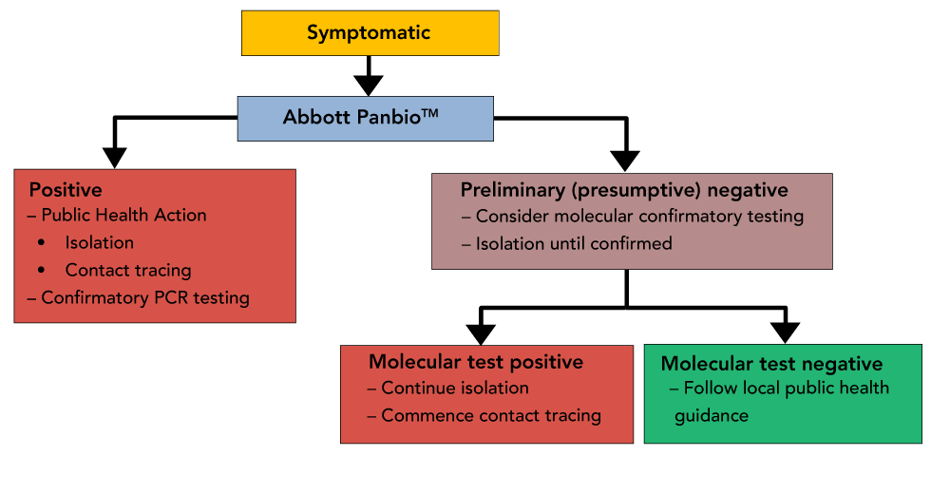
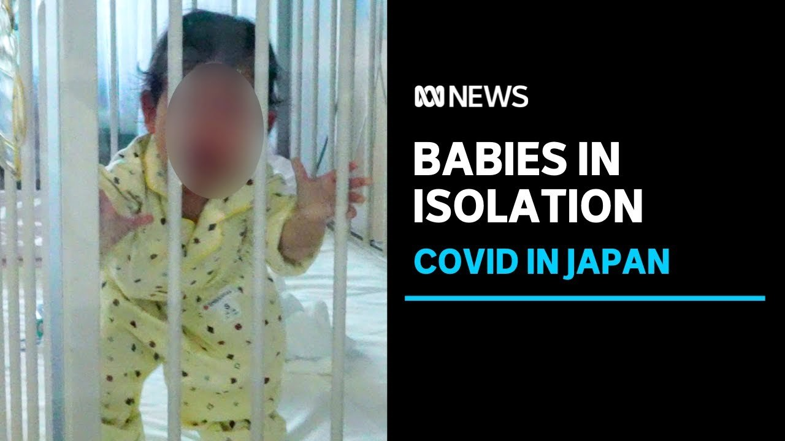
The first few months of a child's life is vital for their development, social and learning skills and their long-term health. Babies born after March 11th, 2020, may never have met anyone who is not their parent. They did not have the same opportunities as those born before the pandemic. While researchers are unsure of the full extent of how the pandemic affected babies the first few months of a child's life is vitally important for their long-term health and brain development. During a baby’s first year of life their brain doubles in size, early development crucially lies on experience and social experience which stimulates the brain. During the first few months of a child's life born in a pandemic it’s clear that due to all activities being shut and unable to meet other individuals that their social skills was not met or even developed. during the pandemic there has been studies made that many women’s mental health suffered. "Unfortunately, support systems for babies and their families have been profoundly disrupted by the pandemic. As is sadly often the case, it is the most vulnerable and disadvantaged children who depend on these services and support networks the most" Ucl (2021) Babies need stimulation and social contact to allow their brain to development also to allow their social skills to meet the development stages. Almost all babies born in the Covid 19 pandemic missed out on the opportunity to meet other babies and stimulate their play, this affects a child's social skills as they grow older. many babies who are now toddlers after being born in the pandemic take longer to warm up to people or even extended family members. "Oxford Brookes University has conducted a study focused on how the pandemic is affecting children of the youngest ages, and in due course will provide us with much-needed insights”. Ucl (2021) Children who have spent long periods of time away from family and friends and even in isolation have a greater risk of developing issues such as separation anxiety and post-traumatic stress.

Birth - 6 months
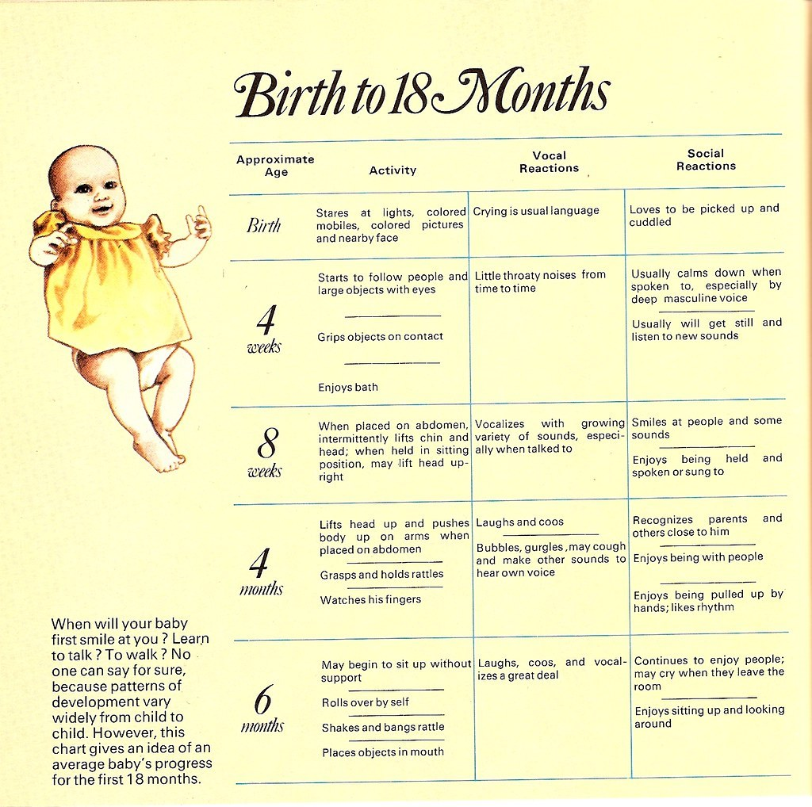
As babies grow so do their skills. Babies develop at their own rate some learning skills before others, while your baby may be advanced in walking, they may lack the skills of talking. Not all babies develop all their skills at once.
gross motor skills-
1 Month- Kicks feet when on back
2 Months- Can slightly lift their head up while laying on their stomach
3 Months- Can lift their head off the surface around 2inchs, also being able to push their arms up while laying on their stomach
4 Months- Able to straighten their legs out while touching a flat surface
5 Months- Able to roll sideways on their tummy
6 Months- Can sit up without the support from parent.

Fine motor skills-
1 Month - Hands are mostly clenched
2 Months- Able to hold a soft small toy or rattle in their hand
3 Months- Able to reach towards a person’s face or toy
4 Months- Plays with their own fingers and hands
5 Months- Can reach and grasp for a toy
6 Months- Moves toys from one hand to another

Congestive skills -
1 Month- Cuddles when being held, also able to look at peoples face or electronic devices
2 Months- eyes start to follow when a person leaves or enters a room
3 months- Enjoys playful interaction, touches their own hands and feet
4 months- focuses on sounds with their eyes
5 months- able to find a toy that's hidden under a blanket
6 months- likes to be with people.

Straight from birth babies are absorbing, learning, and reacting to the world around them through their senses. Their brains are developing, and they will rapidly start to show the early signs of communication (through gaze, smiles, and noises). Dr gummer (2021)
Why is the birth - 6 months stage important?
During the first few months to the first year of a baby’s life their relationship starts to build with their main care giver and parents, this deeply effects their mental, emotional and social behaviour, optimizing a child's early years of life gives them the best investment for their futures. According to K. Smith., Et all. Pg 88 (2002) 'Behaviour after birth is strongly influenced by cultural practices and expectations and if the infant is taken away to soon after birth in the hospital'
Bera sig (2003:19) summarises evidence from brain research that matches with the psychological view as follows:
- everything that goes on around a child influence and changes the brain
- everything the baby sees hears, smells and touches influences the developing network in the brain cells
- babies and young children have a powerful learning capacity
- radically deprived environments may influence development

Cognitive development
Cognitive development is when we explore how a child thinks, figure things out and understanding and producing language. Cognitive development is about change and how drastically a child's thinking changes. Babies are born with cognitive skills that allow them to recognize other people’s voices and to be able to respond. they are immediately able to to develop a relationship with their main care giver/parent. There is a large amount of change during all areas of development, between when a baby is born and when they turn three years of age. When your baby is a few weeks old, they realise that they can make things happen. But their ability to remember that they can make things happen will only develop over time. Lewsley (No date)
Here’s a look at new-born cognitive development, covering the major topics:
- how new-borns can recognize your voice and develop a relationship.
- what new-borns are learning about language and development skills
- the specific interest that babies show in motion and faces and response
- new-born cognitive development and spatial skill
- evidence that new-borns learn and develop during their sleep
Babies learn all about language in the mother’s womb, that's why when a baby is born they know their mothers own voice by responding with facial expressions or slight movements towards the mother when they speak.
Experiments show that babies actively prefer to be addressed this distinctive way, and for good reason. It’s harder to make sense of speech when it’s fast and monotone. Dewar (2020)
According to Malik, Marwaha, (2021) 'Piaget suggested that when young infants experience an event, they process new information by balancing between assimilation and accommodation. '
Jean Piaget separated the four development stages into separate sections. The first stage being sensorimotor (age 0-2) this is when a child master two phenomena, casualty and object permeance. They start to understand their motor skills.
2-7 age where children start to use mental representations and language.
7-11 age where children start to use logical questions when solving problems
12 years age and up- where an adolescence can use logical operations with the ability to use abstractions.

looking at significant aspects of development and stages to be a logical thinker, Piaget work comes into force. children gradually structure their minds-
the sensorimotor stage 0-2 years: learning is a form through physical action.
Piaget’s theory argued that learning consists of a constant effort to adapt to each environment, learning takes place through the process of adaption. Waller (2009) pg 34

6-12 Months
by 6 months babies will have formed a strong relationship with their parents/main care givers. Babies will be discovering more about themselves and noticing the difference between both parents. Cognitive and brain development outlines the learning process, language, thinking, and understanding. A child's learning language is more than just saying mama and dada it’s about listening, understanding, and knowing the names of people in their family and outside the family circle. It’s important for parents to remember the way they love, cuddle and care for their child will greatly help their mental and social development. at this age babies will also be adapting to new foods such as solids. During this time, they may also be able to:
- clap their hands
- move objects to their mouths
- roll from tummy back and forth
- have strong head control
- starts to show an interest in toys and other objects
- able to sit for long periods of time
- making babbling noises as they try to talk
- able to focus and examine objects
by the time your baby turns 7 months old you'll start to notice some changes, they start to understand their surroundings more. during this month they may be able to
- respond to their name from parents or others.
- be able to stand
- have full colour vision
- have improved vision
- find objects that have been hidden
- Talk when others are talking
- enjoys play time
- be fascinated by mirror images
By 8 Months your baby will be able to
- sit well without their support
- able to look for family members when asked
- bang blocks together
- try to feed themselves
- able to say mama and dada
- display separation anxiety
- loves to play games such as peekaboo
- understand the word no, even though they might not obey it.
by - & 10-months babies will be able to-
- pull themselves up
- hold bite and chew food
- be afraid of strangers
- have favourite toys
- watch objects as they fall
- stand with support
- follow pictures in books
- poke objects with index finger
- wave bye as a person is leaving
- say mama and dada and understand the meaning
11&12 months -
- enjoy finding and exploring hidden objects
- use body language to communicate
- enjoy music
- place objects in container
- fear situations
- put arm and leg out while getting dresses
- starts to explore objects as in shake, bang, and throw
- try to imitate your words
Babies learn a lot from playing with their parents, they learn from exploring with their hands, mouth and eyes. A baby’s brain develops more in the first year of life than any other. Baby’s absorbers the most information/feelings during this time. Its often expressed as said when babies are like sponges.

References
Cusick, S. Georgiff, M K. (2013) The first 1000 days of life: the brains window opportunity, Available at :
https://www.unicef-irc.org/article/958-the-first-1000-days-of-life-the-brains-window-of-opportunity.html (Accessed: 6th January 2022)
Dewer,W.(2020) Newborn cognitive development: what are babies learning and thinking? Available at https://parentingscience.com/newborn-cognitive-development/ (Accessed 7th January 2022)
Dr gummer (2021) Developing milestones Available at:
https://www.goodplayguide.com/child-development-advice-including-special-needs/developmental-milestones-0-6-months/ (Accessed 7th January 2022)
Ecoportal (2021). Applying maslows hierarchy of needs to a modern workplace. Available at https://www.ecoportal.com/blog/maslows-hierarchy-of-needs (Accessed 6th January 2022)
Gopnick, A. (2019) Berkeley Psychology Available at: https://psychology.berkeley.edu/people/alison-gopnik (Accessed 7th January 2022)
Lewsley, J. (no date) understanding your baby's cognitive development Available at: https://www.babycentre.co.uk/a1047257/understanding-your-babys-cognitive-development (Accessed 13th january 2022)
Mha (No date). What every child needs for good mental health. Available at https://www.mhanational.org/what-every-child-needs-good-mental-health (Accessed 7th January 2022)
Malik,F. Marwaha, R.(2021) Cognitive development. Available at https://www.ncbi.nlm.nih.gov/books/NBK537095/ (Accessed 13th January 2022)
Nazarri, S. (2019) emotional stress during pregnancy- associations with maternal anxiety disorders, infant cortisol, reactivity, and mother- child interaction at pre school. Available at https://www.frontiersin.org/articles/10.3389/fpsyg.2019.02179/full Accessed 14th January 2022)
Peter, K, Smith., Et al. (2002) Pg 88. Understanding children's development. Sixth edition. West sussex, John wiley and sons ltd.
Pregnancybirth&baby (no date) The first 1000 days. Available at https://www.pregnancybirthbaby.org.au/the-first-1000-days Accessed 14th January 2022
Sherk, J (2019). What does Alison Gopnick teach us about how kids think? Available at: https://www.online-psychology-degrees.org/study/alison-gopnik-how-kids-think/ (Accessed 7th January 2022)

UCL (2021) Pandemic babies Available at: https://www.ucl.ac.uk/news/2021/mar/opinion-pandemic-babies-how-covid-19-has-affected-child-development Accessed (7th janauary 2022)
Weller,T. (2009) pg12 an introduction to early development. 2nd edn. London: sage publications ltd
Weller,T. (2009) pg 34. an introduction to early development. 2nd edn. London: Sage publications ltd
Young, E. (2019) The psychological impacts of poverty disguised, Available at https://digest.bps.org.uk/2019/12/03/the-psychological-impacts-of-poverty-digested/ (Accessed :6th January 2022)

