  Yummy Bites Group (YBG), REPORT (5th August 2022)  Assessment two | LECTURER: Muno Zuwirai  STUDENT: Madalina Larisa Vasile, 2022389  Management Economics (LCBB5003)

TABLE OF CONTENTS

INTRODUCTION 2
INFLATION 2
POSSIBLE EFFECTS OF THE STANCE (BANK OF ENGLAND) 3
EFFECTS OF INTEREST RATE INCREASES 4
CONCLUSION 5
RECOMMENDATION 7
REFERENCE 8

Yummy Bites Group (YBG)
(report)

TO: Yummy Bites Group (YBG) Management
FROM: Business Planning Manager, Larisa M. Vasile
DATE: 5th August, 2022
SUBJECT : Maintaining the business

INTRODUCTION
In the world have been many unexpected events this year that will affect many countries. The people who are in the lower and middle classes will suffer a lot as a result of these political debates which will be presented below, and businesses will also decrease in profit because unexpected aspects hit the value of money in real time. The involvement of banks, the effects on companies such as YBG, the effects on consumers, the effects on import and export, the advantages and disadvantages in similar situations will be analyzed.
They will be explained both in general and in the case of the YBG business. Because, in order to understand the movements of a business, the reasons must be understood, in order to understand the reasons why a business is pushed to make certain movements, it is necessary to understand the causes, in order to understand why we take measures on the causes, there must also be the definition of certain principles.

INFLATION
The definition refers to the increase in prices of goods and services (from an economic point of view), and through this general increase in prices, each unit of the existing currency automatically changes its old value to a weaker one (that is, the purchase of goods and services continues, but less than usual). Therefore, inflation is the reduction of the purchasing power of money.This type of event is never permanent, it only exists for a certain period of time. In general, the Central Bank and the government are under the control of this event (inflation) where the monetary policy is applied which boils down to the change of interest rates. Of course, there are several policies to reduce inflation, and the most common and important ones are: exchange rate and wage control.
It has already been established that inflation is caused by a gradual increase in the prices of goods and services throughout the economy. But inflation has weak points and strong points. That is, if the inflation has a decent percentage (low/moderate) then there can be more advantages, but an inflation with an exaggerated high percentage (much higher than the percentage of a person's salary) can cause serious problems. Pushing costs and attracting demand are two causes of inflation (in fact, among the most common). Of course, although they lead to the same result (increasing prices), they work differently.
In the case of demand pull, the relationship with consumers is tight (consumer demand pushes prices up). That is, if YBG offers goods or a services under a limited number of 30 (possible service offers or possible existing goods in number), but YBG has a number of 40 customers looking for this service/goods, then it must act to the advantage business to increase profit. In the example above, YBG is in the position where its goods/services are in demand, so this aspect makes YBG increase the prices of this good/service knowing that there is demand from customers because that will bring profit.
In the example above, it is a situation where there are not enough goods/services to keep up with consumer demand, thus causing their prices to rise.
In the case of cost increases, they occur when supply costs are changed and thus (force YBG) forcing higher prices. It also suffers during inflation. As a debtor, you win in this aspect because you have to repay creditors with money that has little value (from the point of view of the purchasing power of this money). But, obviously, as a creditor, you lose because you lend money in general when its value is high and (obviously and automatically) you get it back when the value of the money has been lost compared to the initial one with which you borrowed.

POSSIBLE EFFECTS OF THE STANCE (BANK OF ENGLAND)
Generally speaking, banks earn money when interest rates increase (they take advantage of the difference: the interest payment of customers and the interest earned by the bank and possibly invested). That is, banks can pay clients (in full percentage) less than they earn (earning through investments from short-term interest rates). But it must be specified that the Central Bank and the government try to estimate/predict possible unpleasant events, but in the recent case (with the events of the war) Andrew Bailey from the Bank of England declares that such an aspect could not have been predicted. (Larry, 2022)
It can be summarized from what has been stated that there will be a problem in purchasing food (even the mandatory ones) because import and export will become more difficult. This means that YBG must find an intelligent supply alternative because this high inflation (from the point of view of import and export) leads to a decrease in the value of pounds (weak). That is, if until now YBG relied on the export of oil (taking the case declared harmful by Andrew Bailey) where it purchased weekly as much as it needed (after the closure, calculating, analyzing and estimating how much it will need) most likely it will no longer be possible to purchase weekly, but monthly (taking into account only the case of oil). (Larry, 2022)
Taking the case under two different aspects. If before the oil for the purchase of a box (that is, 6 bottles of oil) was at the price of 4 pounds and the bottle of oil was sold for 1 pound, there is a medium but continuous profit. Now, the purchase of a box of oil is 6 pounds, and the production price automatically pushes YBG to also increase the selling price, which will no longer be 1 pound (but 1,30 pounds). This aspect can create chaos among YBG customers and push them to purchase the product in bulk (that is, in a higher percentage than usual) in order to avoid buying in the following days, considering that the price of this product may increase more (but this type of massive purchase pushes the demand for this product, this means that YBG has to purchase more, and this leads to the mandatory price change in the idea of ​​profit). YBG has to purchase more barrels of oil than expected before. Possible ideas: to purchase as before (risking the production price increase again), to purchase more (but there must be storage space) or to purchase from neighboring stores (if the neighboring selling price is estimated to be equal to or lower than costs for export and storage that YBG should cover). (William & Stephen, 2015)

EFFECTS OF INTEREST RATE INCREASES
There are effects of the increase in interest rates. When they increase, businesses and consumers will automatically reduce expenses. Obviously, this aspect leads to a decrease in earnings (and to a decrease in share prices). However, when these (interest rates) decrease, businesses and consumers will increase spending, thus causing the increase in share prices (similar example noted above). Therefore, high interest rates moderate economic growth, increase the cost of borrowing, and reduce disposable income. Also, of course, this increase in interest rates affects business. With this increase, companies that have credit cards or even existing loans may have high interest payments, lower disposable income and higher general expenses. High interest rates make borrowing expensive (for example, the middle-class person is put in the position of paying huge mortgage costs, but most higher-income homeowners don't immediately feel the impact or even manage to to avoid it). Business can be affected: customers who have large debts are left with little monetary income to spend (because they have to pay high interest to creditors), and in the end sales drop considerably.
The effects of these increased interest rates (decision made by the bank) will change the value of the money. The money becomes expensive, if the money becomes expensive then there will be fewer loans (people borrow less), if there will be fewer loans automatically people in general start to calculate their expenses differently, buying only the necessary things for the house, and the fact that people spend less leads to less money in circulation that affects (such as YBG). Because the low and medium classes are affected (as Andrew Bailey declares). If these classes are affected (they have limited resources at their disposal), it means that they will spend less. That is, if the regular clients of YBG had allocated 120 pounds every two weeks to spend (the 100 pounds for the necessary/mandatory goods, and the 20 pounds for the desired goods or services in the form of pleasure), currently with these events, YBG customers will not be able to allocate the 20 pounds for shopping at YBG. Customers will prefer to cook with the food already bought with the 100 pounds (necessary/mandatory products). This case leads to decrease in YBG's profit. (Larry, 2022) (William & Stephen, 2015)

CONCLUSION
In conclusion, all these declared events can be analyzed in advance, but there are cases (risks) in which not even those who deal with the change in interest rates and the change in people's salaries (although when inflation increases, the salary percentage does not automatically increase, i.e. it is lost the value of money in real time) they could not think. I mean, the case well presented above, but even for these critical cases there are advantages and disadvantages. The so-called "trade cycle" intervenes, which refers to a series of stages of the economy (expansion and contraction). That is, a constant repetition of an event similar to the one declared by Andrew Bailey from the Bank of England (the increase and decrease of a gross domestic product in a country). Which shows that even after a decline, the analysis always leads to profit. (Larry, 2022)
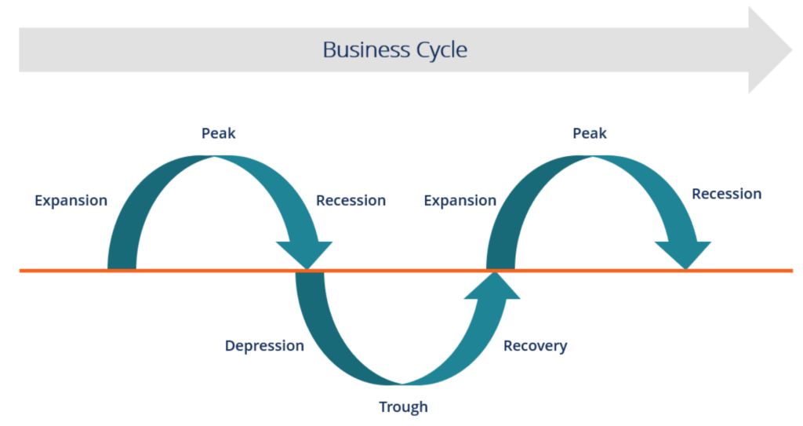 (CFI Team, 2022)
A business must go through one boom and one contraction in sequence to complete a cycle. A boom is the period in which a business has rapid economic growth (in profits, of course). Recession is the period when growth was relatively stagnant. Depression can be understood as a decrease in sales and automatically in profit, maybe even the period when financial help from the government or banks (bank loans) is necessary. The time period is not necessarily defined, but it is called "business cycle length". Under a more formal explanation, the stages in the top diagram are the stages of the business cycle, and the middle right line is the line of constant growth along which this "business cycle" moves.
- The first stage is the expansion where there are positive economic indicators (that is, there is a workforce, there is income, there is production, there are wages, there are profits, there is healthy demand and supply).
- A second stage is the peak, which shows that the maximum growth limit has been reached. When this stage is reached, consumers tend to make budget changes because it is a stage that marks the economic decline.
- A third stage is recession. That is, everything that is in the first stage (especially demand and supply) is reduced.
- A fourth stage is depression (where unemployment also appears) which is an illustration of economic events falling below the middle line.
- Trough is a fifth stage, where it is shown that the growth of the economy actually becomes negative, that is, national revenues and expenses have been exhausted.
- A sixth stage is recovery, that is, the economy begins to recover. Although it seems like a positive event, it brings a reversal of the situation in the economy. If prices are low, the demand starts to increase, and consequently the supply is bound to increase. In this stage everything that is in stage one begins to grow positively. All this happens until the economy returns to constant growth levels. This step leads to the completion of a business cycle (the boom is reached again).
(CFI Team, 2022)
And as an economic gossip, it is considered by great economists that growth fluctuations in the economy are the result of innovation and not of monetary shocks. But as a valid truth, as can be understood from what has been reported so far, the reasons are multiple, but the main ones have been presented so far. (CFI Team, 2022)

RECOMMENDATION
Recommendations considering that history shows that interest rates do not remain low or high forever are of a general type. But as it is well described above, attention must be paid to these interest rates because valuable opportunities (for profit) can be lost in an environment with increasing rates. As an investor you should buy shares from companies that use and consume raw materials, or create and grow a portfolio of bonds, storing money by buying materials and then selling them when this crisis is over.
Or even the examples mentioned above, the different purchase (to avoid import-export problems), the start of own cultivation or if there is already valid stock in own business warehouse to increase the price like other stores will do. It is important to follow the events and to analyze them in good time because some decisions must be made quickly.

REFERENCE

CFI Team. (2022, 05 07). Business Cycle . Retrieved 08 05, 2022, from Corporate Finance Institute: https://corporatefinanceinstitute.com/resources/knowledge/economics/business-cycle/
Larry, E. (2022, 05 16). Business. Retrieved 05 08, 2022, from The Guardian: https://www.theguardian.com/business/2022/may/16/apocalyptic-food-prices-will-be-disastrous-for-worlds-poor-says-bank-governor?fbclid=IwAR3Fu4mNwt6R8NA3zkuCFhbTdQGnpEvkZTnmCW4-5nErihPLTH9qFDiaV8U
William, S. F., & Stephen, M. G. (2015). Managerial Economics (8 ed.). Wiley.

