Software Development- ACCB4017

Software Development - Assessment 1

Stoyan Tsvetanov | Student ID: 1920708

University of Wales Trinity Saint David

BSc Cloud Computing Level 4 Term 2 Group 1

London

Date: 25/08/2021

Table of Contents
Introduction 2
Part A 2
Part B 10
Reference 13

Introduction
Python is a powerful and user-friendly programming language. It has efficient high-level data structures and a basic yet effective object-oriented programming technique. Python's attractive syntax, dynamic typing, and interpreted nature make it a great language for scripting and rapid application development on a variety of platforms. Python provides a facility for the programmers to do their work in fewer lines of code and quickly. In this report, we’ll learn about some features of python and will see some codes of a given problem. Python language is used for web development, software development, system scripting and mathematics (Python Language Introduction - GeeksforGeeks, 2021).

Part A
A1: Describe the many forms of control structures used in programming. Explain in detail how the if..elif structure in Python has been used to handle selection control structures with appropriate examples.
Control structure uses to control the flow of the code, we can control the order of execution of the statements according to our requirement. As we know, basically python has three types of control structures- sequential, selection and iteration. Specific problems can be solved by the combination of all these control structures. Sequential is default control structure in python, which means that it executes statements sequentially in a specific order. Selection structure helps to test any condition. Iteration structure is used to execute the part of program frequently as long as appeared condition is true.
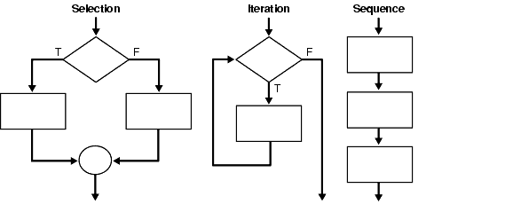
Fig: Different Control Structures
Sequential Control Structure

The sequential control structure is the simplest form in all control structures. The phrase "sequence control structure" refers to the execution of statements in the same order they occur in the program, line by line. Statements are performed one by one in a sequential control structure. They may do a series of reading or write operations, as well as variable assignments and arithmetic, for example. Python uses sequential order as the default control structure, but sometimes we need to jump from one statement to another statement or need to skip any part of the code or need to run any part frequently. That’s why it is necessary to use other control structures (selection and iteration).

Iteration Control Structure

In this control structure, operations are performed to every item of the block or a statement is executed until it reaches a certain condition. It uses some keywords such as for, repeat, while or do…until. It can repeat some codes. In this control structure, statements are executed repeatedly until the condition will be false.

Selection Control Structure

In the selection control structure, if a certain situation is true, then execution goes to another level and if a condition is false, then it allows another action set to be executed. It has two basic types of control structures, first one is the selection type which is used for comparison and the second one is the loop type, it repeats certain instruction sets until it met to a specific situation.
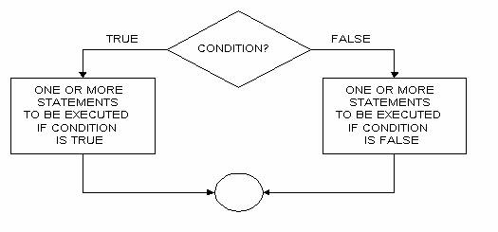
Fig: Selection Control Structure

If…elif…else is used to make decisions. Decision making is necessary to execute code when a specific condition is fulfilled. As we can see in the above figure when a condition is true, it executes one or more than one statement and if the condition is false, then it executes another block which can be one or more than one statement.

If…elif…else syntax
if test expression:
statement
elif test expression:
statement
else:
statement
As we can see in the above syntax, if “if” statement is true, then its body will be executed, if it is false then the body of “elif” will be executed. If all test expressions are false, at last body of “else” will be executed. Block “if” can have more than one “elif” and it can have only one “else”. “elif” allows us to use multiple conditional expressions after the “if”. It mentions between if and else.
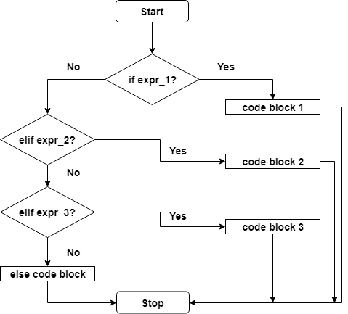
Fig: Flowchart
Now, we’ll take an example of if…elif keywords. The following screenshot shows how if..elif..else works.
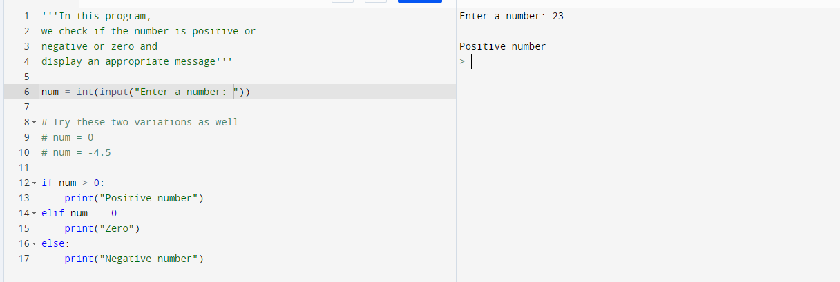

A2: Do a comparison between different types of python loops. Describe “for” loop in detail with a suitable example.
Python has three types of loops to fulfil its looping needs. It gives different ways
to execute the loops. These different loops look familiar but their syntax and functionalities are different. Sometimes, we need to run a specific part of the program repeatedly, this is called loops. Loops have set number iterations. In python, while and for are the loops, these are same but for loop is moderately different here (Difference Between For loop and While loop (With Table), 2021).
While loop

This loop first checks the condition is true or not, if it is not true then it simply abort the statement of while block and execute the next immediate statement. If it is true then it executes the while block. If we do not know about the iteration number then while is required (Python while Loop, 2021).

Syntax:
While Condition:
Statement Block

As we can see above while syntax, if while a condition is true, then it executes the statement block. Now, we’ll see a program using a while loop.
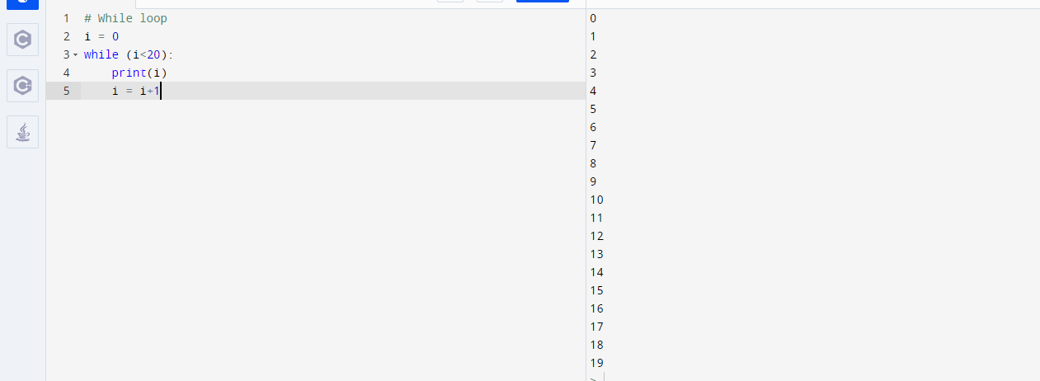
As we can see in the above screenshot, I initiated at 0 and whenever the value of I is smaller than 20, it’ll return i. Then, I will be incremented by 1.
Nested loop
When a loop is used inside the loop, this will be called a nested loop. In python, we can use a loop inside another loop. To understand this, we can take an example like we can use while loop inside for loop, for loop inside while loop and so on. Inner loop executes for once on every iteration (Python nested loops - Tutorialspoint, 2021).

Syntax for loop inside for loop:
For loop in sequence:
For loop in sequence:
Statement
Statement

Now, let’s take an example of nested loops:
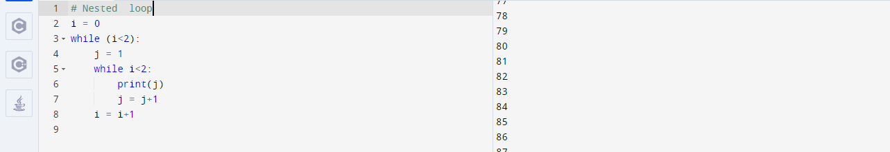As we can see that there is while is nested to while (Loops, 2021).

For Loop

For loop helps to iterate the sequence such as lists, tuples, strings or another iterable object. Traversal is a process when iteration occurs over a sequence (Python For Loops, 2021).
For val in sequence:
statement

Val is the variable that takes the value of each item in the series on each iteration. The loop will continue until it reaches the last item in the sequence. The body of the for loop is separated from the rest of the code by indentation.
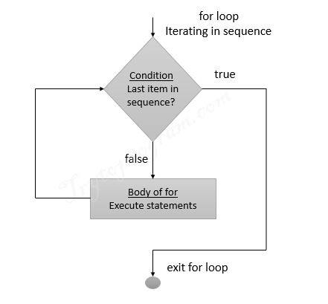
Fig: For loop Flowchart
Now, let’s take an example of for loop.
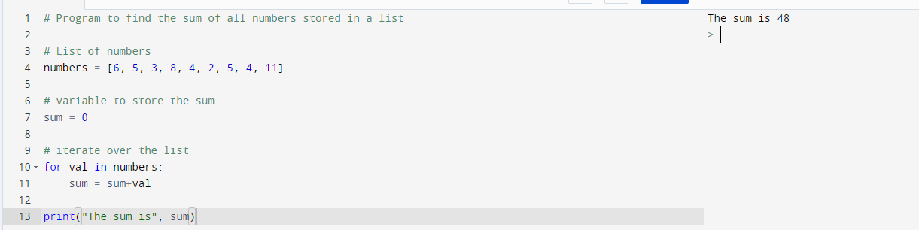
There is a function which is called the range() function and it helps to generate numbers sequence. If we take range(5) then it will print 0 to 4. We can also initiate the start, stop and step size of the sequence. It takes 1 step size by default when step size is not provided. It does not store any value and it only prints values on the basis of start, stop and step size. List() function can be used to powered range() function to print all the values.
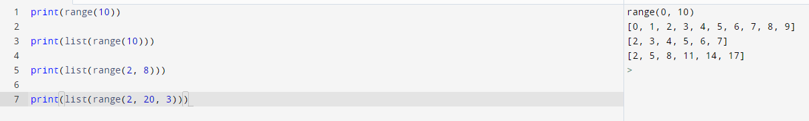
This screenshot shows us how the list() function helps to generate the values. Range() function can be used in for loop to iterate the values in sequence. Len() function can also be merged with this to print the values in sequence along with their indexes. Now, we’ll see an example:
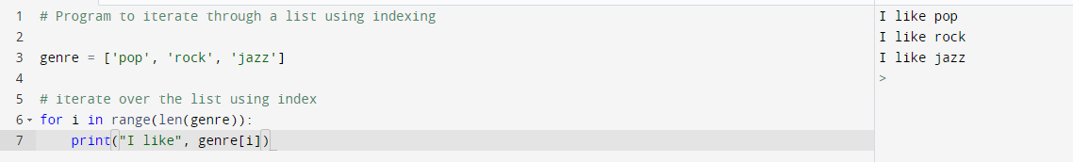
Else block is optional for using in for loop. When for items of loop block exhausts then else block is executed. In the following screenshot, we printed the values from 0 to 5 by using for loop and we used nested loop by inserting else loop inside for loop, here if for loop fails to execute then else loop will be executed.
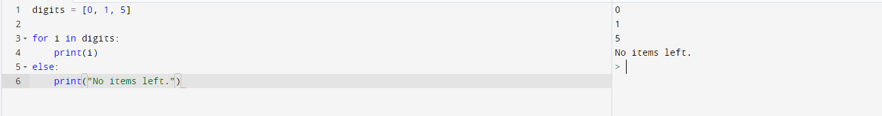
A3: Explain the list and how it is different from simple variables? Conclude how can we access the list values?
Python has four built-in data types such asset, tuple, dictionary and list are one of them. In python, we can create a list by putting values in [], these values can be of different data types like integer, string, float and these elements are spilt by commas. It is used to store different data types in a single variable. Lists are mutable, so the values of lists can be altered even after the creation. It is also ordered, it can have also duplicate values. Ordered means elements have pre-defined order and cannot be changed, it takes 0 as the first index. If we append something in the list then it will be added at the end. Mutable means we can add, delete and change the values in the existing list. As we know it is indexed, so lists can have elements with similar values. Every element of the list has its specific place, that’s why it allows duplicate values (Python Lists - GeeksforGeeks, 2021).
Features of Lists:
◦ Lists are ordered.
◦ Lists are not homogeneous and this feature makes it a strong tool in python.
◦ We can access the values of lists by index.
◦ Lists are mutable.
◦ Lists allow us to store different data types.
The list provides us with so many methods that we can use. In-built methods are given below:
1) append() – We can add a new value at end of the list by using this method. We can add only one element by using this append() method, we can use loops to add multiple items in the list with the help of the append() method.
2) sort() – It helps to sort the existing lists.
3) clear() – We can delete all values from the list.
4) reverse() – It allows us to reverse the order.
5) copy() – It returns a list’s copy.
6) pop() – We can remove the element at a described place.
7) count() – It returns the counting of total items.
8) insert() – We can add an item at a specific place. It allows us to enter the item at the desired place in the list. There is one basic difference between insert() and append() is insert() takes two arguments (position, value) whereas append() takes only one argument, it does not take a position.
9) index() – It gives the index of the first item with described value.
10) extend() – We can add items of one list at end of the current list. It allows us to add multiple items at the end at the same time.
As we know, lists are mutable and we can change them anytime but variables are immutable it means we can modify items of lists but we can’t change variable values. Variables are kind of a storage place with a name. Variables can hold only a single data type but lists can hold multiple data types at a time.

Access List elements
Python provides different accessing methods which are given below:
1) We can access the items on the list by referring to their index.
2) We can give range by detailing the start item and end time and access the specified values from a list. It returns a new list of specified values.
3) Negative index starts from the end of the list in python for example -1 means last element of the list, -2 means second last item of the list etc. We can also this negative indexing when we want to traverse the list from the end.
I am giving a screenshot of accessing the items of python in different ways.
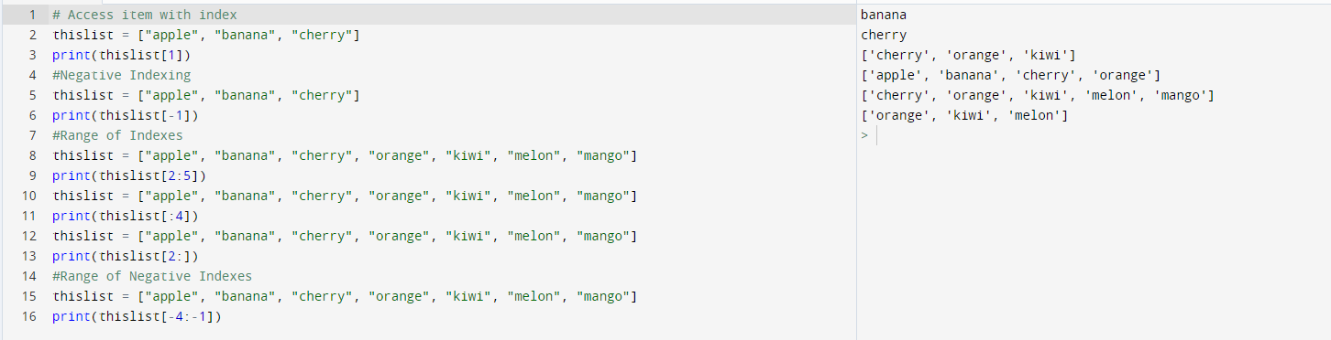
Accessing the items on list
In the above screenshot, we took a list named “this list” and stored some fruits names in this list. After that, I access the elements of this list in different ways such as negative indexes, range of elements’ indexes and access the elements by using a range of negative indexes also.

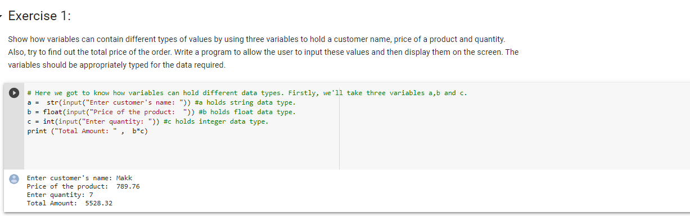
Part B
As we can see in the above screenshot how a, b and c hold the different types of data types like a stores string data type, b holds float value and c is holding integer value. As per requirement, the user can enter the customer’s name, product price and quantity of the product. In the end, it returns the total amount.
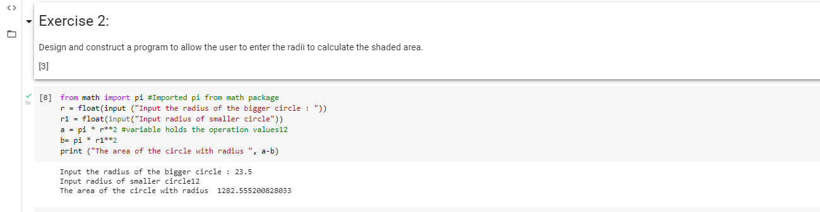
To solve this problem, firstly we’ll insert the radiuses by a user. According to the problem we need to take R1 and R2 of radiuses of both the circles respectively but here we use R2 and r1 instead of R2. As this screenshot displays that r holds the radius of the bigger circle and r1 hold the radius of the smaller circle. After that, a and b hold the areas of both the circles. In the end, it prints the area of the shaded region by subtracting the area of a smaller circle
from are oof bigger circle.
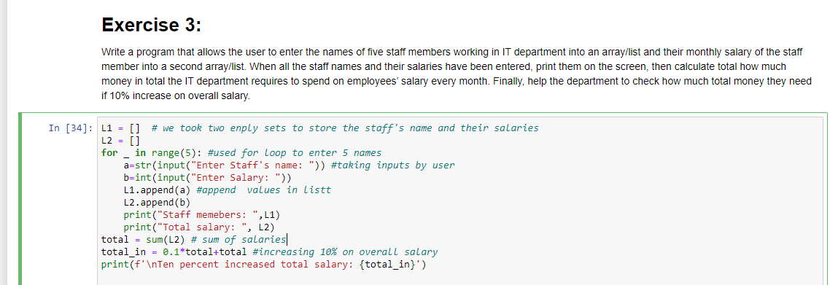
Here, we can see that we took two different empty lists L1 and L2. Then, I used for loop to print five staff members and store them in L1 and L2. After, I took two variables a and b to take the input by the user. As we can notice, a is of string data type and b is of integer data type. Then, I used the append() method to add the values in both lists. At last, I print the total amount of salaries and increase 10% of overall salary. Now, we’ll look at to output of this code.
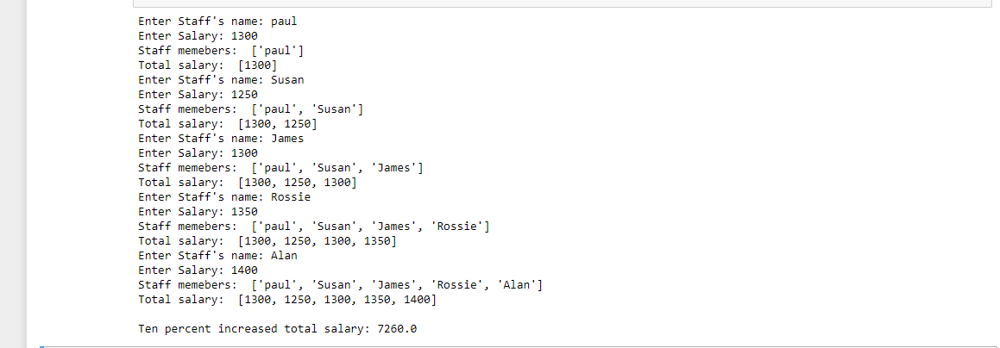
Here, we entered five staff’s name and their salaries. At last, it printed the total amount spent by the company and it also printed 10% increased value on overall salary as per the requirement.
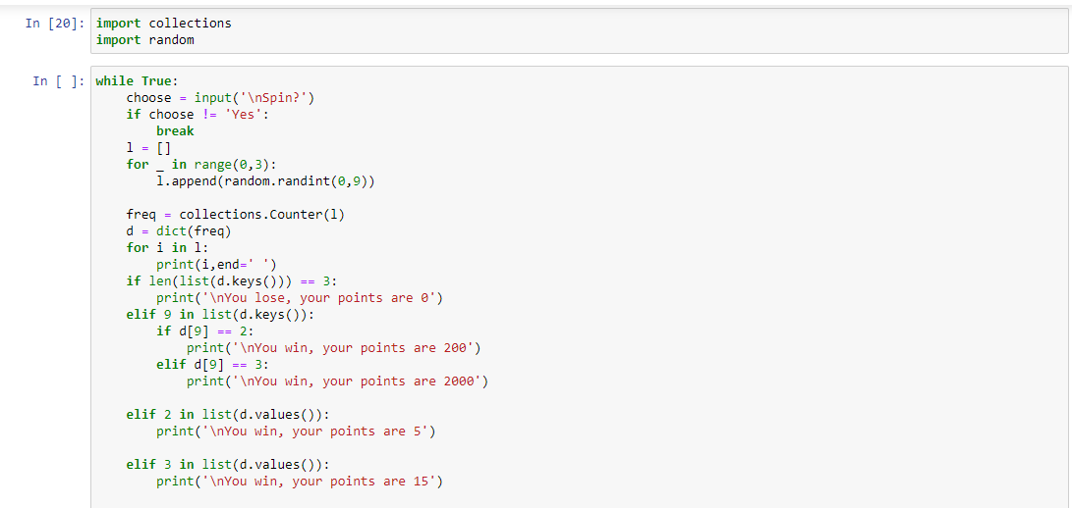
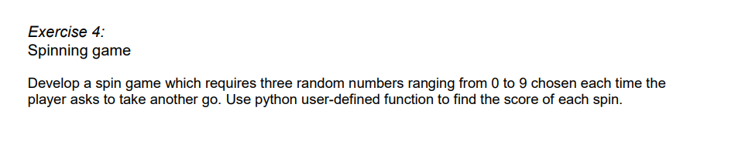
As we can see in this screenshot that I imported some packages such as collections and random, collections package helps to store the collection of data like list, tuple, set etc. This module helps to enhance the functionality of python. The random package is used to generate random variables, it allows us to generate random numbers, to choose random values from the list etc. I used nested loop by using if into while. Then, I used a loop to generate random numbers continuously. I converted frequency into the dictionary and used the dictionary to store these values.
Then, I set points to specific numbers for each spin. As per requirement, if two same numbers occur then the user will get 5 points, three same numbers occur then the user will get 15 points, two 9 numbers occur then it gave 200 bonus points to the user and if three 9 occur then it gave 2000 jackpot points to the user.
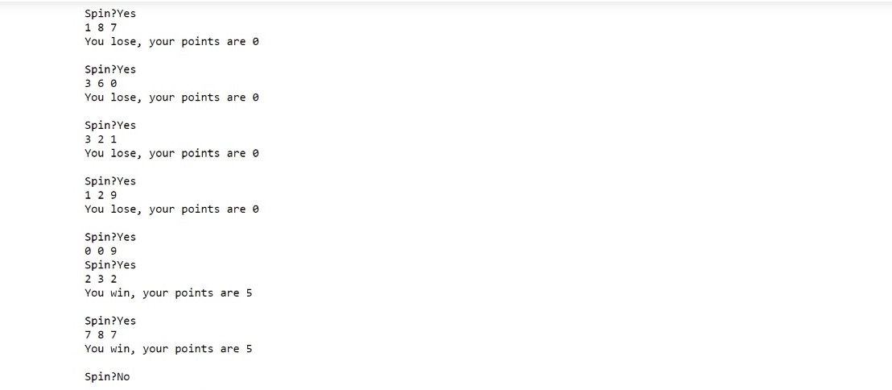
This is the output of this problem. It is a random number generation spin game and it gives bonus points as per the requirement. Here, we could not win the jackpot point because it is printing numbers randomly.

Reference
Tutorialspoint.com. 2021. Python nested loops - Tutorialspoint. [online] Available at: <https://www.tutorialspoint.com/python/python_nested_loops.htm> [Accessed 26 July 2021].
GeeksforGeeks. 2021. Python Lists - GeeksforGeeks. [online] Available at: <https://www.geeksforgeeks.org/python-list/#ael> [Accessed 26 July 2021].
GeeksforGeeks. 2021. Python Language Introduction - GeeksforGeeks. [online] Available at: <https://www.geeksforgeeks.org/python-language-introduction/#:~:text=Python%20is%20a%20widely%20used,in%20fewer%20lines%20of%20code.> [Accessed 26 July 2021].
W3schools.com. 2021. Python For Loops. [online] Available at: <https://www.w3schools.com/python/python_for_loops.asp> [Accessed 26 July 2021].
Programiz.com. 2021. Python while Loop. [online] Available at: <https://www.programiz.com/python-programming/while-loop> [Accessed 26 July 2021].
Loops, P., 2021. Python Nested Loops | Complete Guide To Nested Loops in Python. [online] EDUCBA. Available at: <https://www.educba.com/python-nested-loops/> [Accessed 26 July 2021].
Askanydifference.com. 2021. Difference Between For loop and While loop (With Table). [online] Available at: <https://askanydifference.com/difference-between-for-loop-and-while-loop/> [Accessed 26 July 2021].

