Virtual Production Reflective Account
Andrew Foxall 2517335
Animation & VFX BA (Hons) – Introduction to Virtual Production
Link to MP4 After Effects Video: https://uowtsd-my.sharepoint.com/personal/2517335_student_uwtsd_ac_uk/_layouts/15/stream.aspx?id=%2Fpersonal%2F2517335_student_uwtsd_ac_uk%2FDocuments%2FMP4VFXShot2517335%2Emp4&nav=eyJyZWZlcnJhbEluZm8iOnsicmVmZXJyYWxBcHAiOiJPbmVEcml2ZUZvckJ1c2luZXNzIiwicmVmZXJyYWxBcHBQbGF0Zm9ybSI6IldlYiIsInJlZmVycmFsTW9kZSI6InZpZXciLCJyZWZlcnJhbFZpZXciOiJNeUZpbGVzTGlua0NvcHkifX0

Initial Ideas
For my visual effects shot I had lots of freedom with the requirements being techniques I need to use. Although I had lots of creative freedom, I wanted my shot to be simple but effective, my initial design ideas were:
- A character being tracked moving through many different environments. The character would move through these scenes using a range of transition techniques.
- A projectile shot through a hallway where the camera tracked it rotating in slow motion. The hallway would include images of different topics and a range of items.
- A chess game is played in an environment where the game is highlighted by a spotlight, and the camera moves around the game. The shot would include features out of the spotlight which would add to the environment.
I chose to do the chess shot as it allowed me to meet the VFX technique requirements. After choosing this idea I had to come up with the details and plan my idea out. I then needed to choose a game to base my shot off. Initially I came up with some of the most iconic chess games of all time:
- The Immortal game – Anderssen vs Kieseritzky (1851)
- The Opera game – Morphy vs Karl (1858)
- Game of the Century – Fischer vs Byrne (1956)
- Reykjavik Iceland Rapid Tournament – Carlsen vs Kasparov (2004)
These were all significant games, but I also needed a game that was short and that I could animate to under 60 seconds. The shortest game was The Immortal Game, so that’s what I decided on.

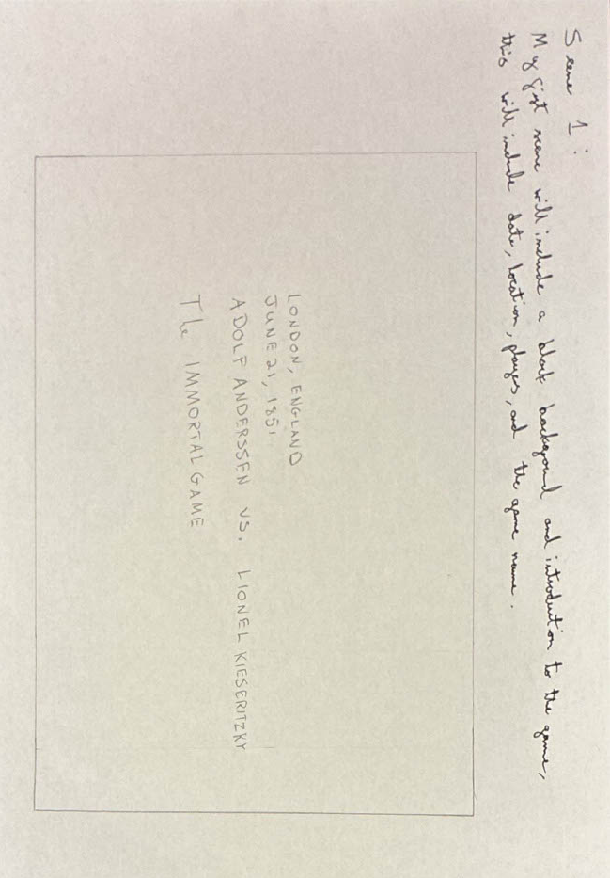
Storyboard
I then produced a storyboard to plan out what my video would look like:
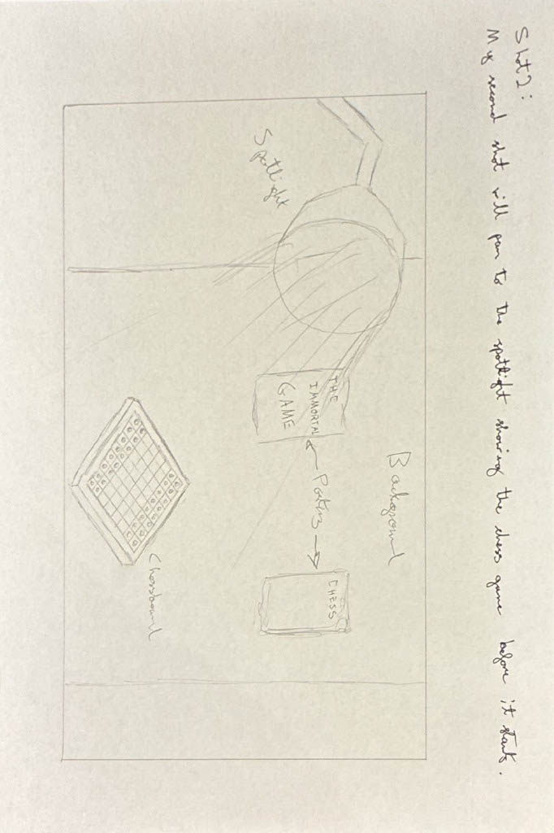
The first part of my shot will introduce the video, this will include information about the game like the location, date, names of the players, as well as the name of the game.

My second part will show the main scene with the chess board, spotlight, and other features.

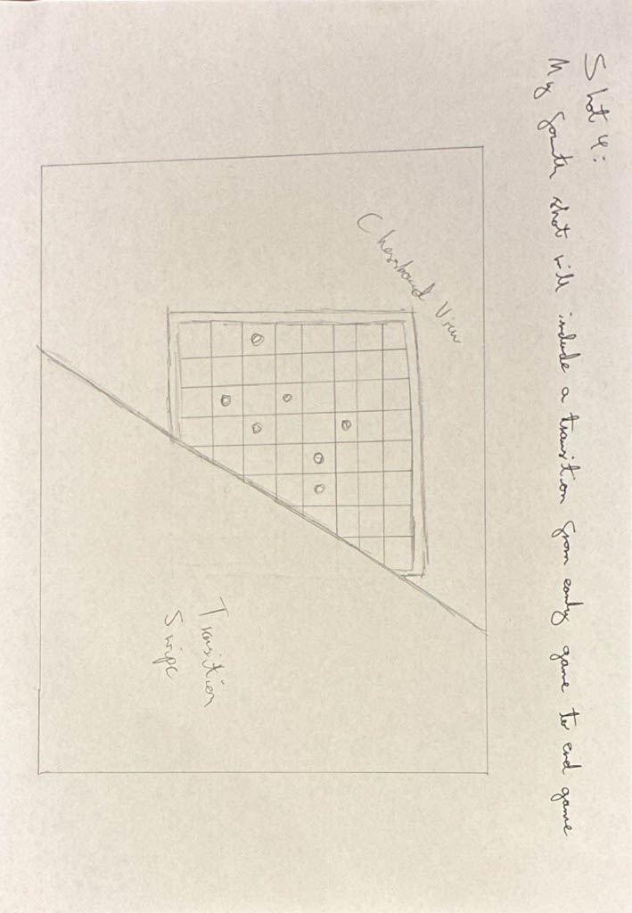
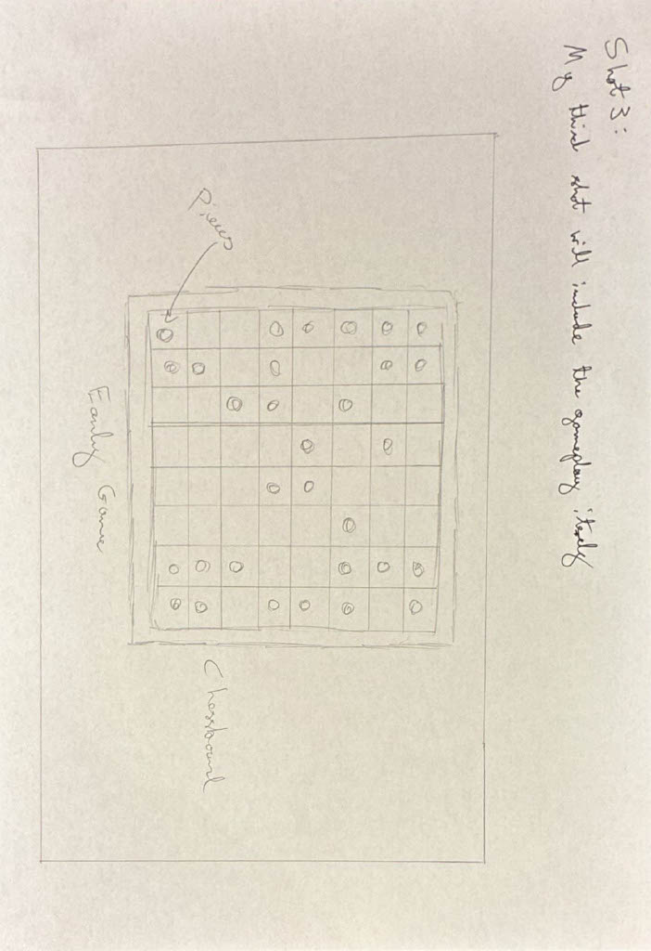
The third part of my video will pan around the gameplay showing the early game and position.

My fourth part will be a transition going from early game to endgame.
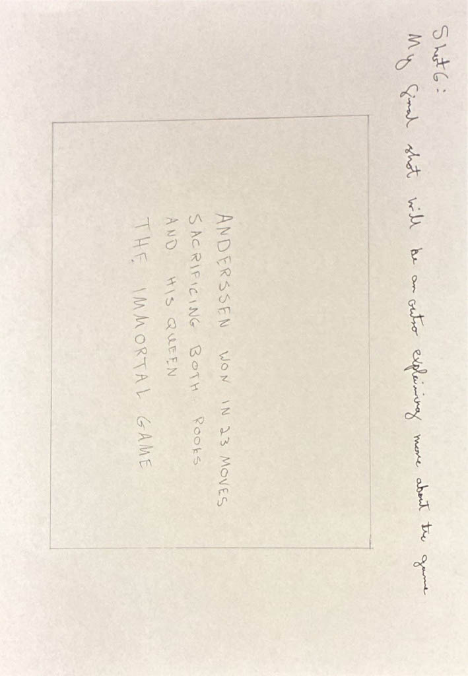
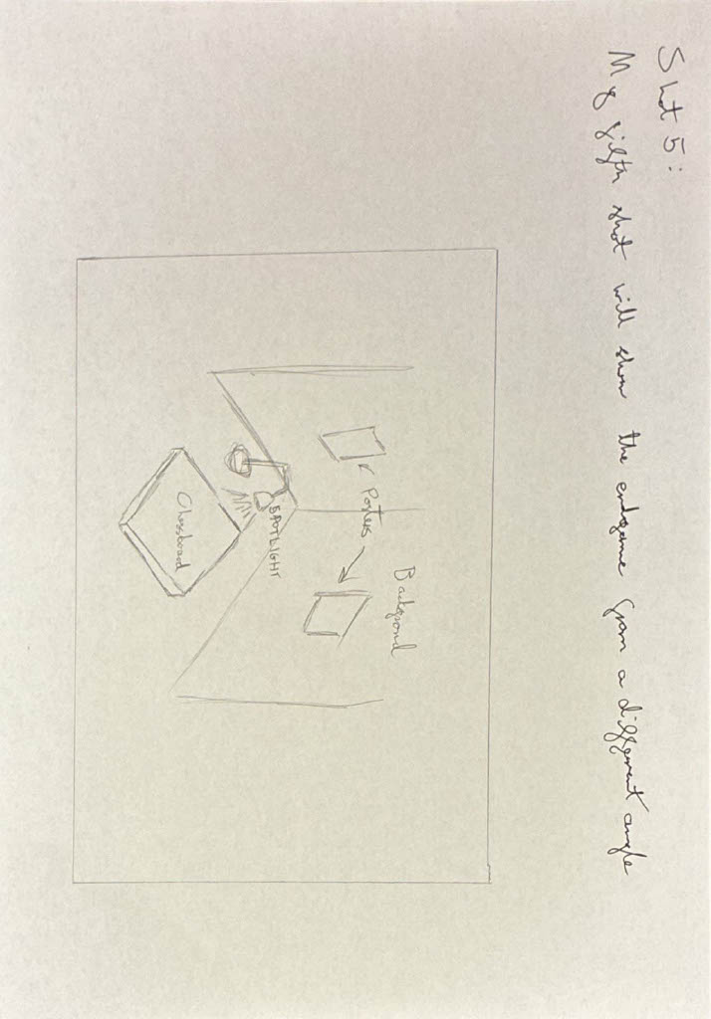
My fifth part will be the endgame itself, showing the full scene from a different angle than previous.

My final part will be an outro giving more context about the game.

Design Brief
My aim is to produce a 30-60 second VFX shot integrating 3D and 2D assets into a video composition. I will use Adobe After Effects, Adobe Premier, and Autodesk Maya to complete all the techniques required for my project.
The required techniques were:
- Rotoscoping, Keying, and 2D Tracking
- 3D Camera Tracking
- Using Adobe After Effects Camera in Autodesk Maya
- Colour Correcting
- Having a Rendered Final output
My concept is a cinematic VFX shot of the ‘Immortal Game’ in chess. I am aiming for a darker environment to make the shot more dramatic with a strong centre spotlight. The chess game is meant to be the focal point, but I am adding smaller features around the scene.

Tutor Feedback
My tutor Mr Masih gave me feedback on my idea; the feedback was mostly positive however he stated that having more of a narrative would improve my shot. Reflecting on this I decided to add an introduction to the start of the shot and decided to not show the entire game, but only the key parts which in this case where the start of the game and how the game ended.

Production
For production I needed an animation of the chess game, a background video, and other features to add to the design.
The first piece of content I produced was the background shot with a DSLR camera. I took multiple videos of a desk lamp acting as a spotlight in different dark environments. I ran into some difficulties whilst filming as the camera kept losing focus, automatically changed visual settings, and I kept shaking the camera too much. This caused me to have to film lots of takes to end up with one that was usable. I completed the shot reverse as the camera would blur when it came around the corner going to refocus, this didn’t happen when the shot ended moving around the corner.
I then moved onto creating the chess animation, I started by modelling all the chess pieces using reference photos for the board itself and all the pieces [1] [2]. However, for the knight piece I did use a 3D model I found online and base my design off that mesh, as the knight design is quite complicated [3]. After modelling I had to animate all the pieces, this took me a long period as it was my first time using the animating feature. I also assigned materials to the models for the final rendered animation. The final stage was importing the camera from Adobe After Effects to Maya so I could get a rendered video that matched the background. For this I used the 3D camera tracking feature. I used the Maya Live Link extension to allow the Adobe After Effects 3D camera to link to Autodesk Maya, I rendered using Arnold through the camera and exported animation to an image sequence of JPGs.

The features I found were 2D posters of chess, one was about the Immortal Game [4], whilst the other was an abstract piece [5]. I also got pictures of the two playing the game A. Anderssen [6] and L. Kieseritzky [7]. The final thing I found online was a clock timer counting for the game to make it seem more tense [8].

Postproduction
The first thing I did in post-production was import my background and animations image sequence. From here I added the introduction and outro part where both used a blocky text and dark background. The introduction text used a 2D tracker targeting a point on the background, so it made the appearance the text was being moved away from. In the outro however I just cut straight to it using a black shape to act as the background. I also used a black shape for the introduction background and manually moved it over time to give the shot a cleaner look.
2D Tracking:
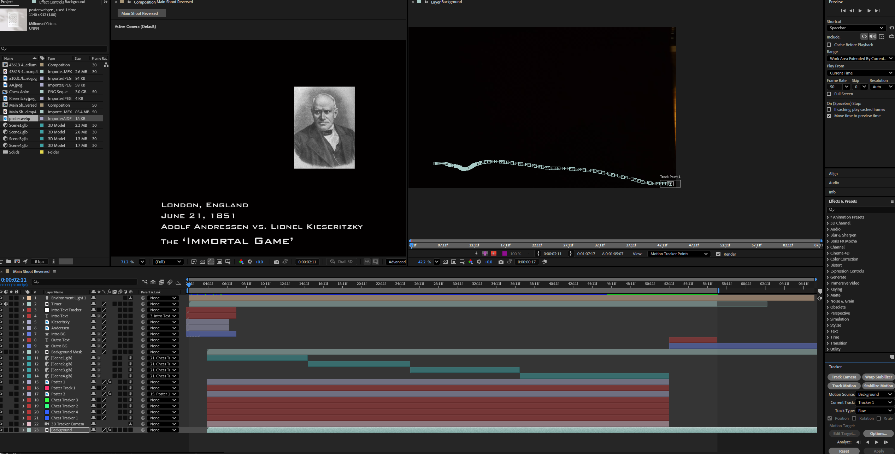
Adding background assets was my next task. I ensured that the poster features used the 3D tracking camera points to make it look like they were moving with the rest of the scene. I had lots of difficulties however with the 3D camera tracking, this was due to the scene being so dark, so I didn’t have many reference target points. This led to me having to do lots of manual adjusting of the assets 3D positioning and rotation. To the introduction I also added the pictures of the two chess players which I faded out using opacity over time. The final feature I added was a stop clock to the bottom of the screen; this was to attempt to build a more dramatic scene.
3D Camera Tracking:
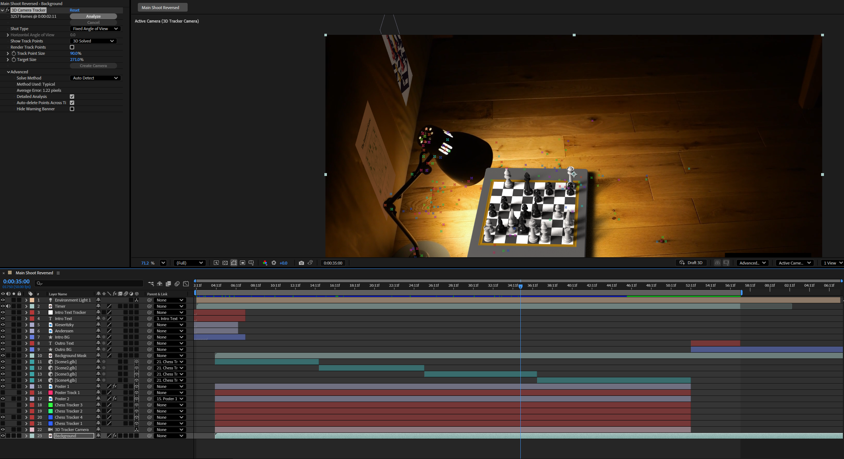
I then moved onto lots of rotoscoping for the background so that all the features were behind objects in the original video, this made everything look a lot more natural. I made two masks which covered both posters from the lamp and backdrop object. Colour correcting was another tool I used, as my scene was so dark the colours were very different for my assets, had to make them darker and increase the blue. I used the colour correcting on the posters only.
Rotoscoping:
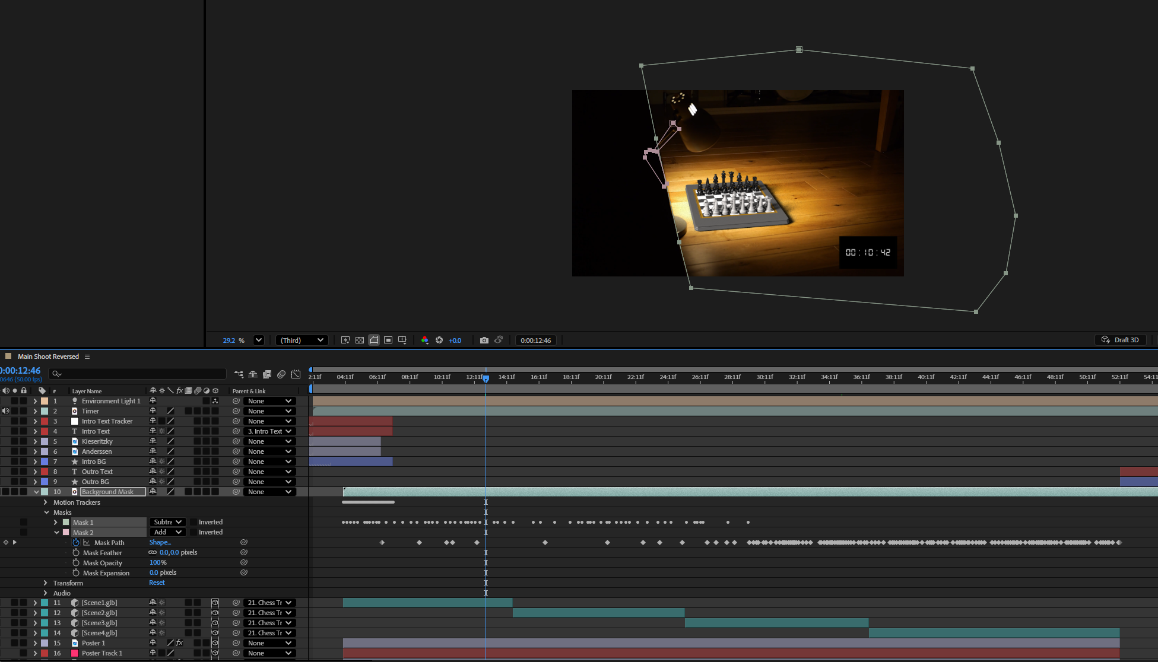
Colour Correcting:
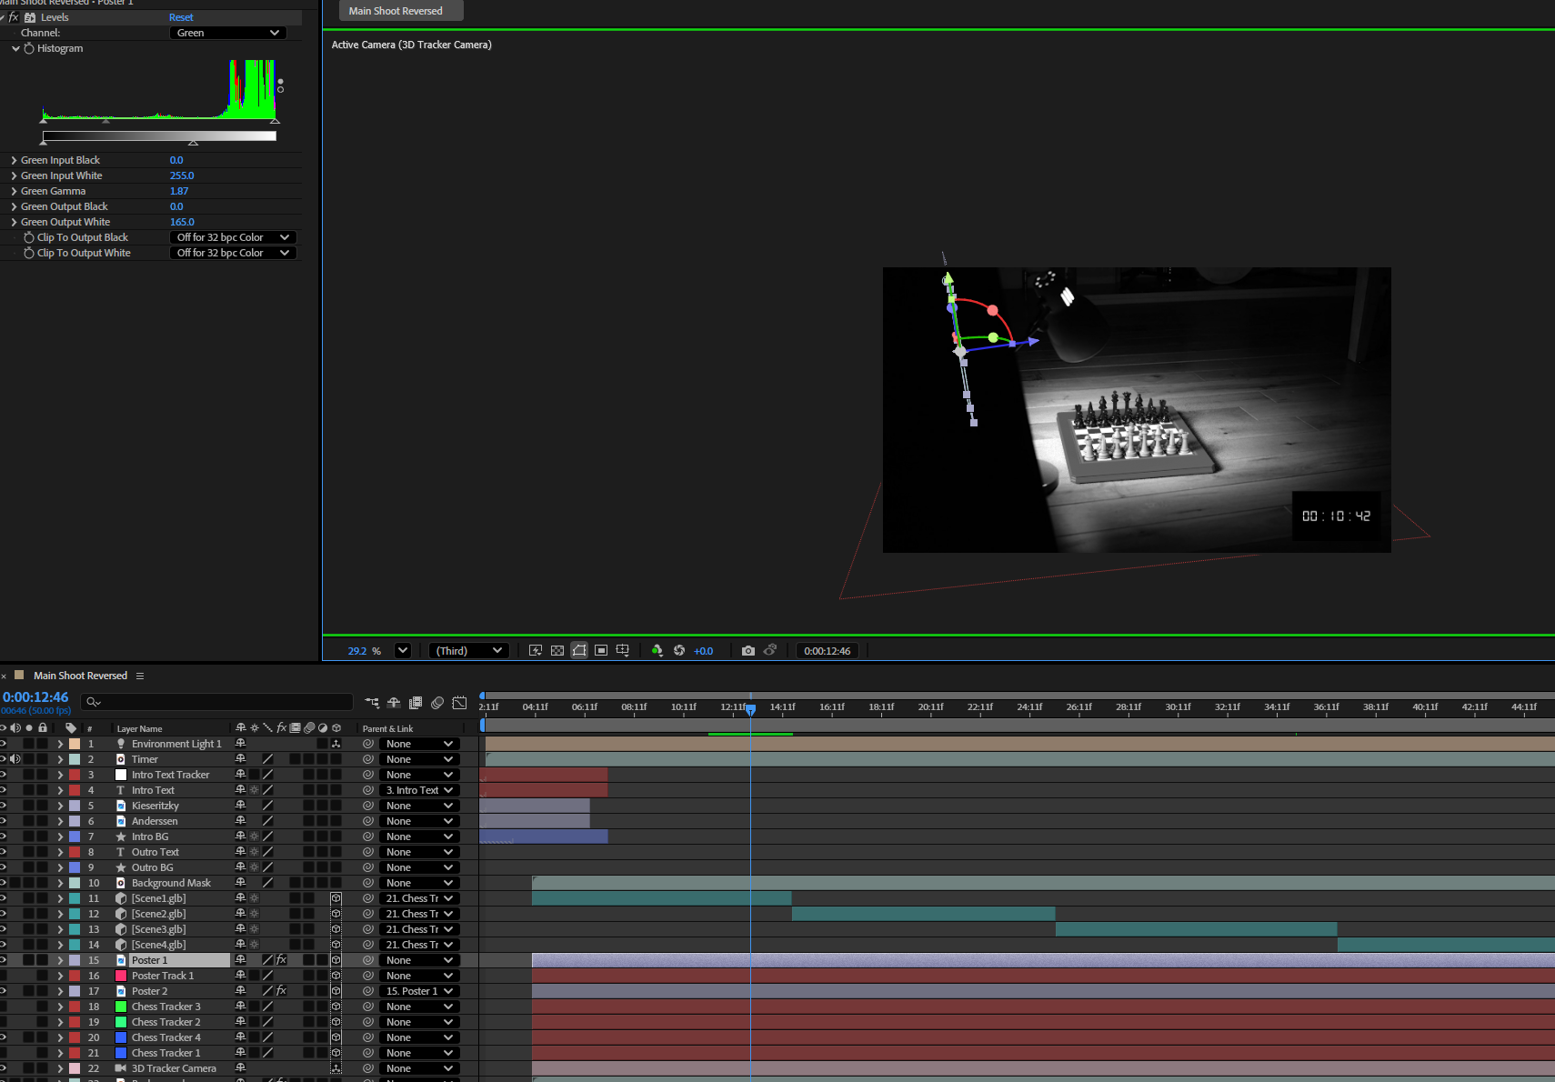
For my chess animation, I exported it as a JPG sequence with a green background as this would allow me to simply Keylight the green out, and adjusting Keylight matte features allowed me to be extremely accurate whilst removing the background. After doing this I assumed the animation would follow the camera track as I had used the imported camera from Adobe After Effects. The animation however was off track with the camera, so I attempted to do this for a second time, and it still didn’t work out. As each animation took hours to render, I decided to import 3D scenes instead of an animation. This took a couple positions from the game instead of an entire animation, I worked on these by adding shadows to the design and tracking them.
Keying: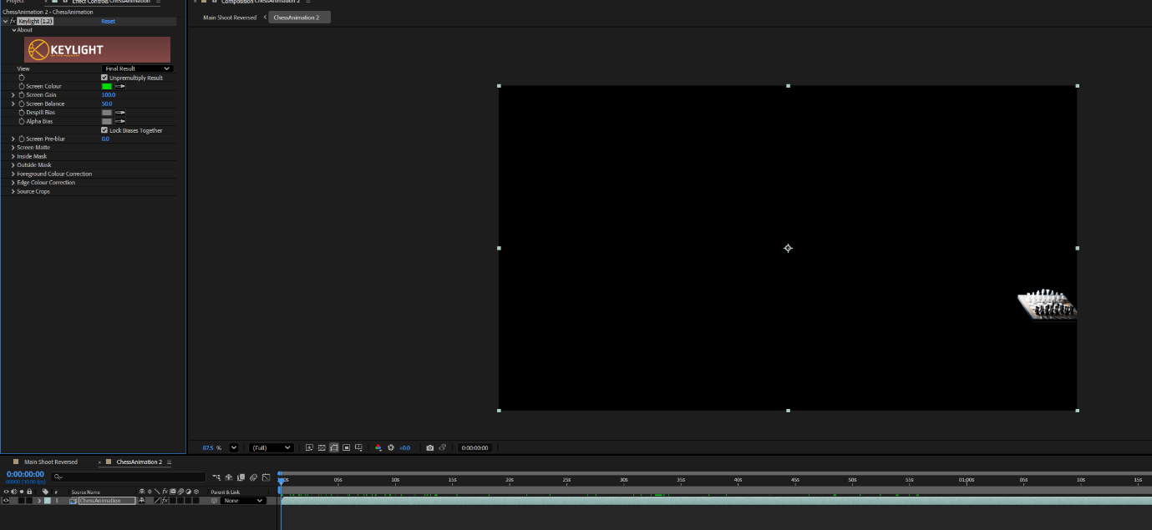
Maya Scene with Exported Camera:
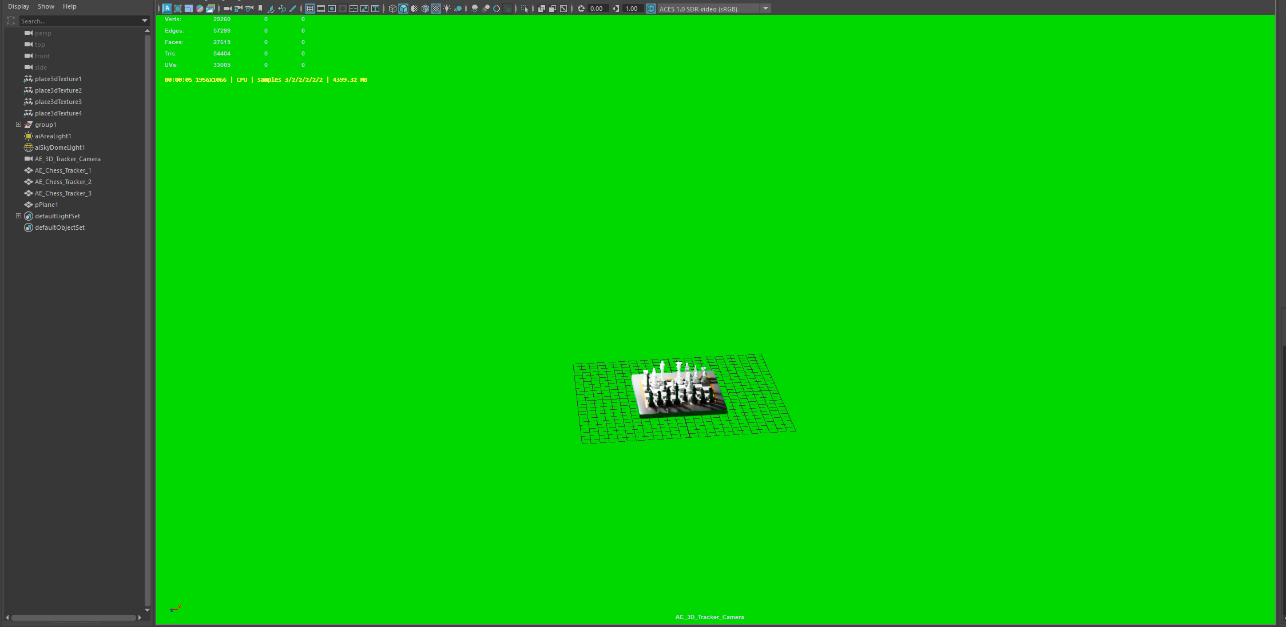

Finally, to create my MP4 file I used Adobe Media Encoder to output my video at 49 seconds long.
Media Encoder Workspace:

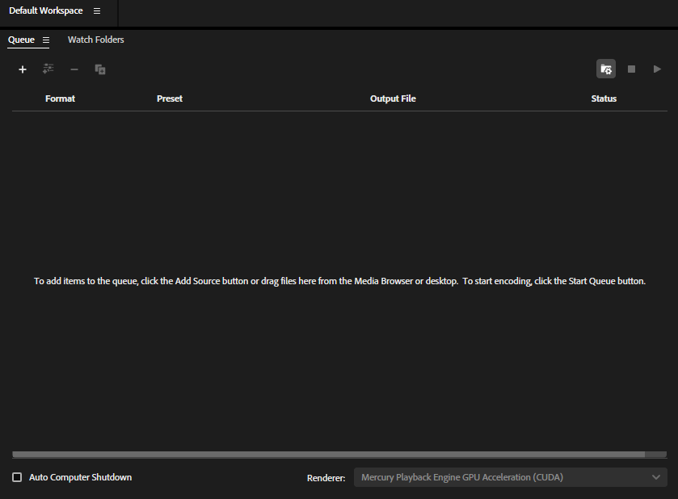

Outcome
Reviewing my video, I feel that there are many things I could have improved upon. I feel that if I worked on the audio I could have made the scene more dramatic by adding orchestral music. I was also unable to get the 3D animation of the chess scene into the shot; this caused the transitions from each part of the chess game to be blocky and didn’t show the narrative I wanted it to. I will work on how I can get the After Effects camera working in Maya, also next time I will come up with a better way to transition the gameplay.
However, I was able to produce a shot that included all required techniques and was of a high quality. I was able to develop my skills in Adobe After Effects and Autodesk Maya becoming a lot more efficient and having a much better grasp of the user interface.

References
[1] J. Stamp, ‘How the Chess Set Got its Look and Feel’, Smithsonian Magazine, April. 03, 2013. [Online]. Available: https://www.smithsonianmag.com/arts-culture/how-the-chess-set-got-its-look-and-feel-14299092/. [Accessed: 13/11/25].
[2] ‘Helena Solid Walnut Chess Board – Medium’, Farrar Tanner, n.d. [Online]. Available: https://www.farrar-tanner.co.uk/solid-walnut-chess-board-40-x-40cm. [Accessed: 13/11/25].
[3] Zoe, ‘Low Poly Chess Knight’, Sketchfab, March. 26,2023. [Online] Available: https://sketchfab.com/3d-models/low-poly-chess-knight-8ba2c5367c5c410fb20057e4225c3486. [Accessed: 14/11/25].
[4] D. Mullen, ‘The Immortal Game (1851) – famous Chess Game Art Print’, Etsy, n.d. [Online]. Available: https://www.etsy.com/uk/listing/1624165023/the-immortal-game-1851-famous-chess-game?gpla=1&gao=1&. [Accessed: 21/11/25].
[5] ‘Strategic Style: Chess Posters for the Modern Man’, Pinterest, n.d. [Online]. Available: https://uk.pinterest.com/pin/1148840186199968864/. [Accessed: 08/12/25].
[6] L. Rage, ‘Anderson, Adolf’, Chess.com, March. 09, 2024. [Online]. Available: https://www.chess.com/blog/Lava_Rage/anderson-adolf. [Accessed: 09/12/25].
[7] ‘Immortal Game between Adolf Anderssen and Lionel Kieseritzky’, Opening Master, January. 10, 2023. [Online]. Available: https://www.openingmaster.com/improve-chess/24-general-talk/149-immortal-game-between-adolf-anderssen-and-lionel-kieseritzky. [Accessed: 09/12/25].
[8] C. Stock, ‘Timer, clock, alarm free stock video’, Pixabay, n.d. [Online]. Available: https://pixabay.com/videos/timer-clock-alarm-ticking-43613/. [Accessed: 12/12/25].

