Radio Frequency Systems

Investigating the Effect of Noise in DSB-SC and FM Systems

Embedded Electronic Systems
Contents
Introduction 3
Background research 4
Amplitude Modulation 4
Double Sideband – Suppressed Carrier 5
Frequency Modulation 5
Task 1 – Amplitude Modulation 6
Block Diagram 6
Circuit design 6
Transmitter and Receiver Architectures 6
Simulated Outputs and Results 7
Task 2 – Double Sideband - Suppressed Carrier Amplitude Modulation 11
Block Diagram 11
Circuit design 12
Transmitter and Receiver Architectures 12
Simulated Outputs and Results 12
Multimedia Circuit design 16
Multimedia Simulated Outputs and Results 16
Task 3 – Frequency Modulation 20
Block Diagram 20
Circuit Design 20
Transmitter and Receiver Architectures 20
Simulated Outputs and Results 21
Conclusion 25
Analysing the Results 25
Figure of Merit 25
Recommendations on future work 26

Introduction
In this report I will model two types of analog modulation to research the effects of noise when applied to a transmitted signal. I will produce two models on Simulink to represent a Double Sideband – Suppressed Carrier modulator and demodulator and for a Frequency Modulation modulator and demodulator. Using these models, I will transmit a modulated and receive a demodulated multimedia file to establish what effect the additive noise has on the input wave.

Background research
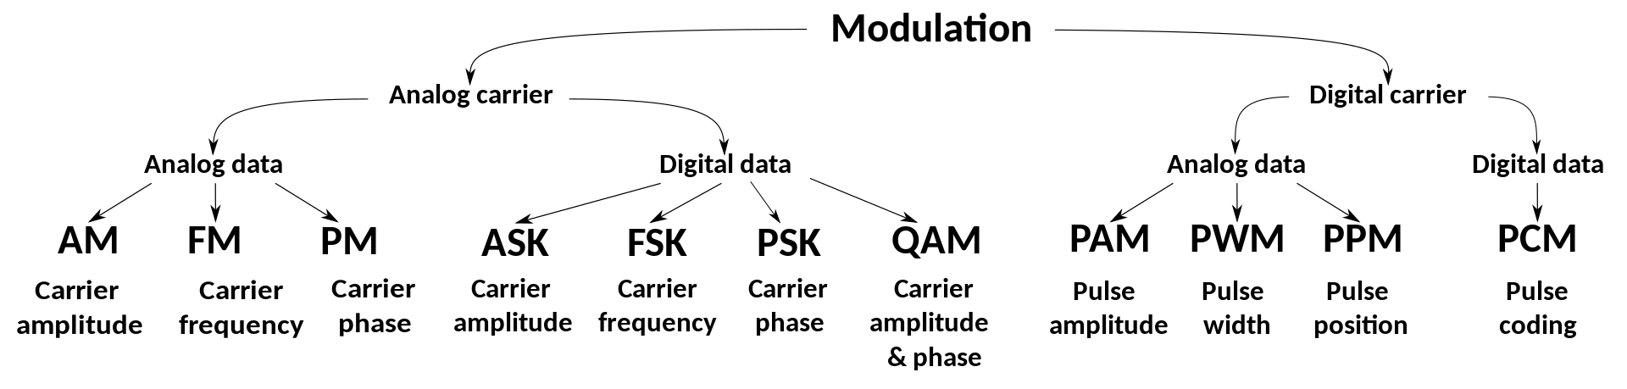
Figure 1 – Modulation Techniques^{[1]}
Both Amplitude and Frequency Modulation are analog data-carrier modulation techniques meaning both the modulating and carrier waves are analog in nature. This means that the two waves are superposed when frequency mixing occurs in both up and down conversion.
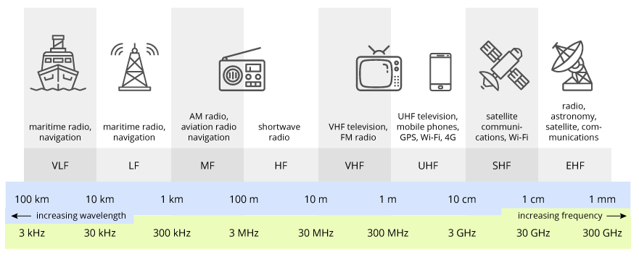
Figure 2 – Radio Frequency Bands^{[2]}

Amplitude Modulation
Amplitude modulation refers to the continuous variation of instantaneous amplitude of a carrier wave in accordance with a modulating signal. This produces a high frequency transmission with a varying amplitude determined by the message signal being transmitted; which is generally used in radio and telecommunication broadcasts.^{[3]}
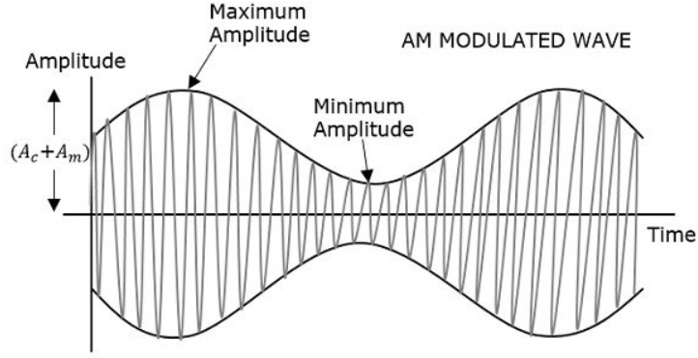
Figure 3 – Amplitude Modulated Signal
Amplitude modulation operates in the Medium Frequency band at 300-3,000kHz – specifically between 535-1605kHz. AM is capable of a 10kHz bandwidth allowing for 106 possible bands.^{[4]} most notably early radio broadcasts were transmitted as AM waves because it was cheaper to transmit and could be transmitted over long distances but is more susceptible to noise interference due to the information being stored as an amplitude. AM also has lower bandwidth allowing for more stations in the given frequency range and the bandwidth of a message is twice the highest modulating frequency.^{[5]}

Double Sideband – Suppressed Carrier
In amplitude modulation a message signal is split over two sidebands at a fixed distance from a carrier wave; this is known as Double Sideband Full Carrier. DSBFC is considered inefficient as two-thirds of the total power is dedicated to the carrier wave, therefore typically AM is transmitted in a suppressed carrier format such as Double Sideband – Suppressed Carrier.
DSB-SC is a type of amplitude modulation which suppresses the carrier wave by using the power of the carrier to provide more power to the two sidebands which are situated either side of the carrier. This is more efficient as each message signal has more power so is less affected by noise and very little power is used in the transmission of a carrier wave containing no information.^{[6]}

Frequency Modulation
Frequency modulation varies the frequency of the carrier against the amplitude of the modulating signal. The frequency of the signal is a linear function of the modulating signal, this makes it possible to see variations in amplitude. FM is also widely used in radio and telecommunication broadcasting.^{[7]}
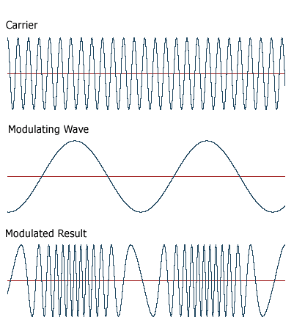
Figure 4 – Frequency Modulated Signal
Frequency modulation operates in the Very High Frequency band at 30-300 MHz – specifically between 88.1-108.1MHz. FM is capable of a 200kHz bandwidth allowing for 100 possible bands.^{[4]}
FM has mostly replaced AM in broadcasting as it is less susceptible to noise as the message information is stored as a varying frequency not as an amplitude. FM broadcasts also have a higher bandwidth (allowing for better sound quality) equalling twice the sum of the modulating frequency and frequency deviation. However, FM transmissions are affected by physical barriers due and cannot transmit over long distances.^{[5]}

Amplitude Modulation

Block Diagram
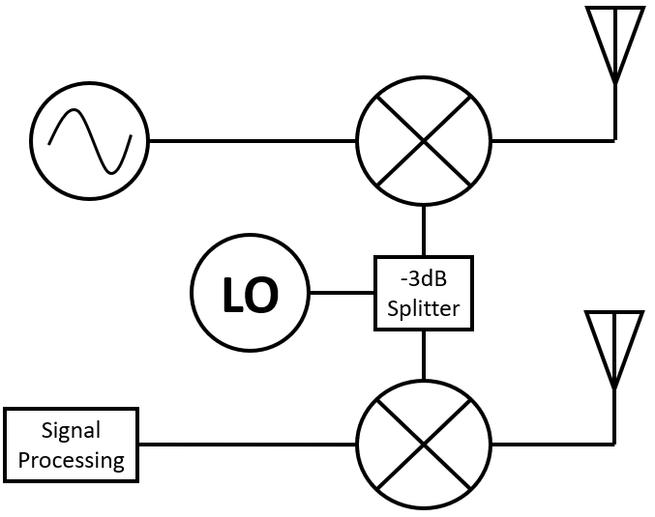
Figure 5 – Block Diagram of Transmitter and Receiver

Circuit design
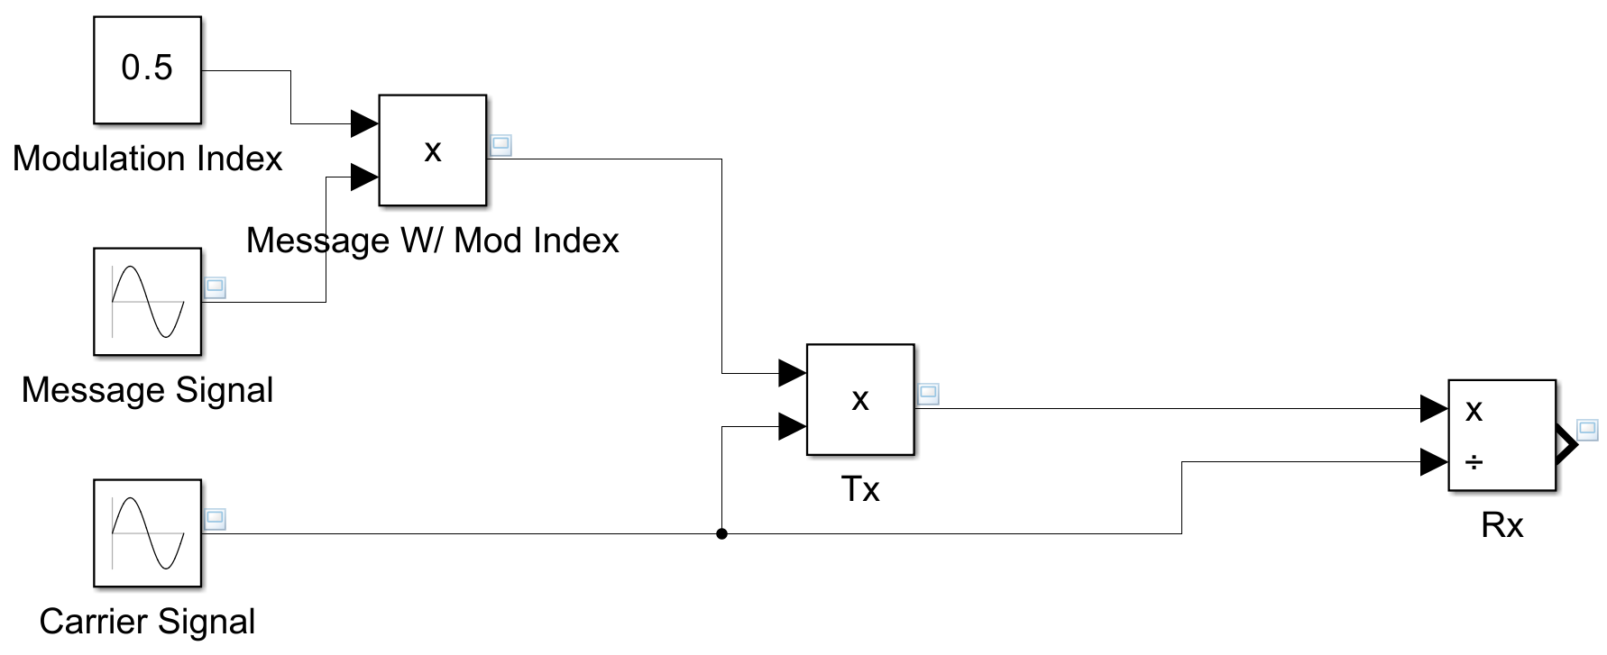
Figure 6 – Amplitude Modulation Model

Transmitter and Receiver Architectures
In this model the message and carrier signals are represented by the sine wave function blocks. A modulation index is provided by multiplication of the message sine wave by a constant – 0.5 in this instance. The modulation then occurs when the modulating signal from the initial product block is then multiplied with the carrier wave at the second product block. I have used the same wave signal for the carrier function to ensure they are the same.
The connection between the product and division block represents the transmission of the waveform either through a coaxial cable or free space. The demodulation occurs at the division block when the modulated signal is divided by the carrier waveform, from this block a representation of the original message is output.

Simulated Outputs and Results
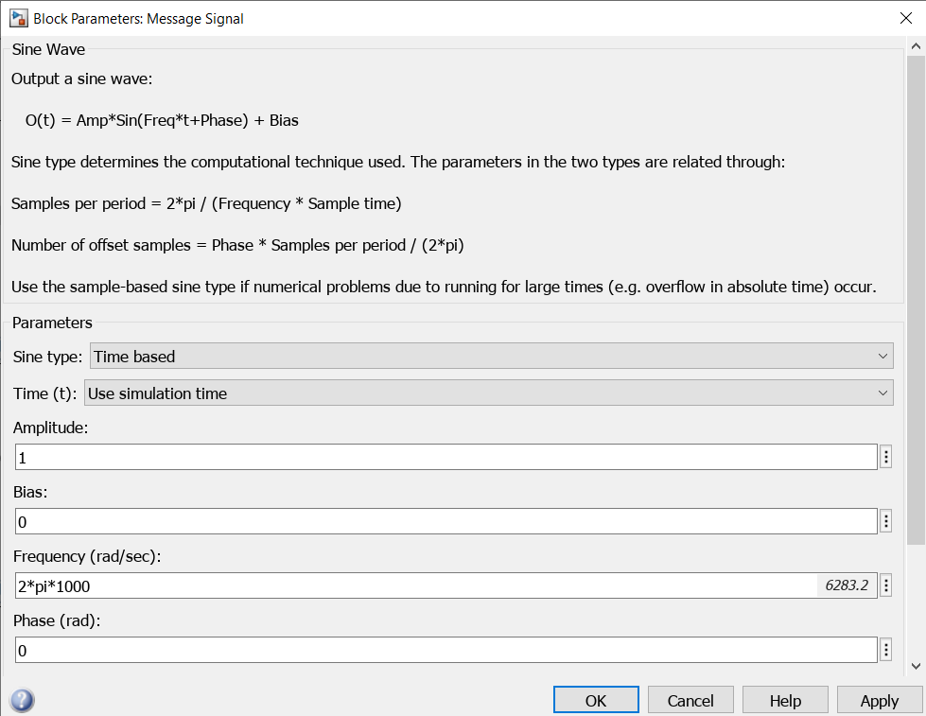
Figure 7 – Message Signal Parameters
Using the sine wave function blocks a message and carrier wave were produced and set at 1kHz and 10kHz respectively. This is done by inputting the equation 2pi x f to convert from rads⁻¹ to Hz.
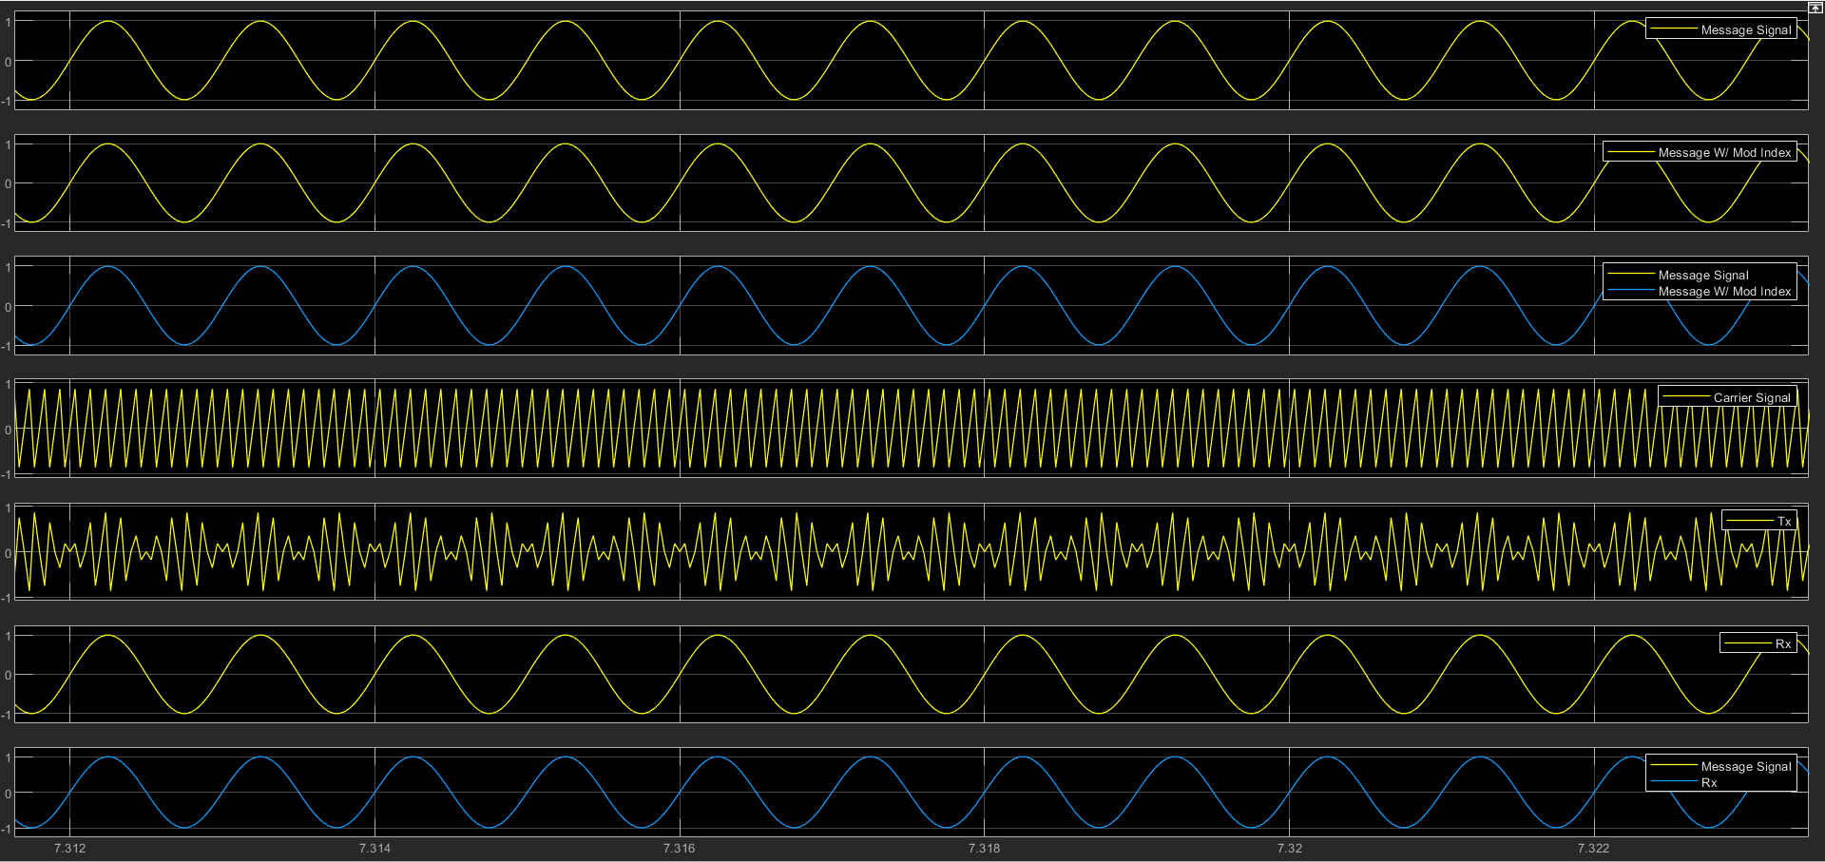
Figure 8 - Amplitude Modulation
Figure 9 shows critical modulation with a modulation index of 1, this produces a modulating wave that is at the same amplitude as the original message source and leads to a correctly modulated wave when combined with the carrier wave.
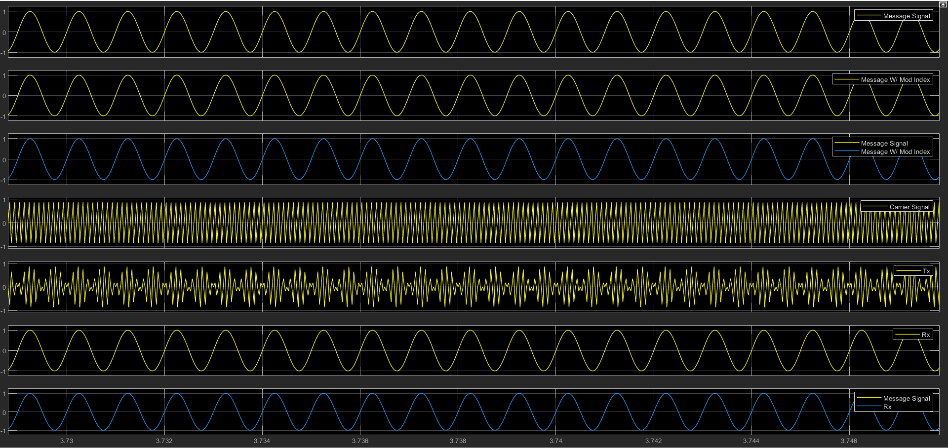
Figure 9 – Amplitude Modulation Index of 1
Figure 10 shows the effects of under modulation on a wave with a modulation index of 0.8, the effect of under modulation is shown in figure 10 but is not as noticeable as the example in figure 11.
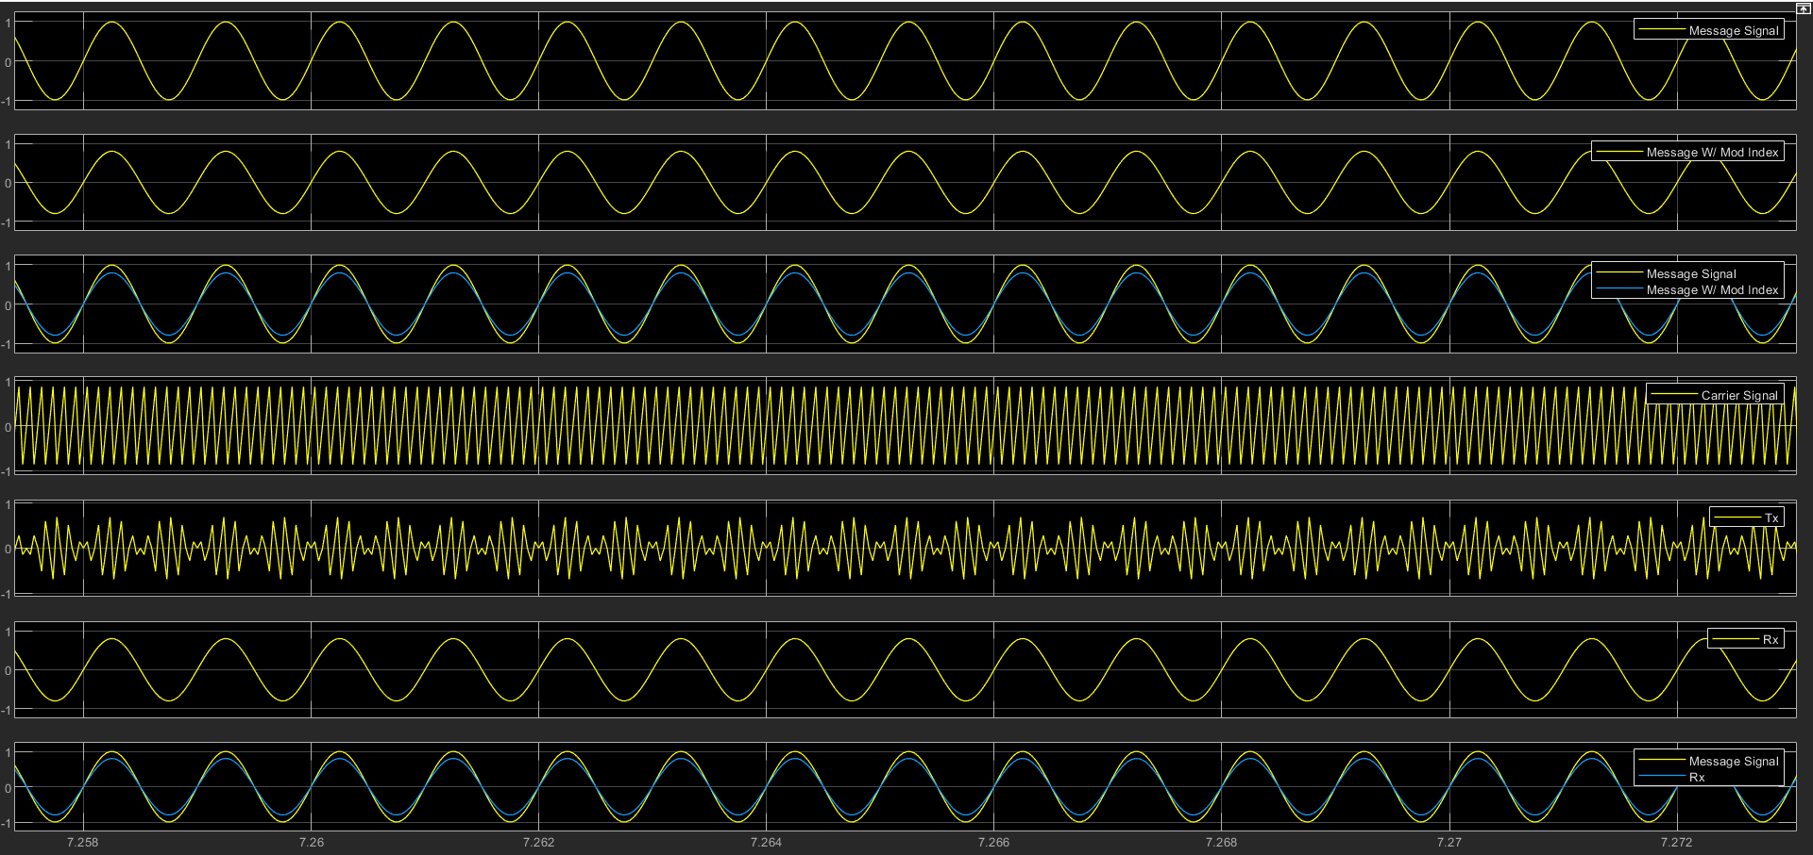
Figure 10 – Amplitude Modulation Index of 0.8
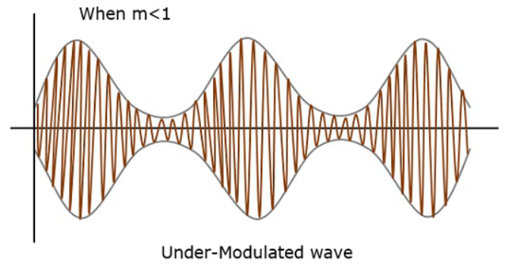
Figure 11 – Under Modulated AM Wave ^{[3]}
Figure 12 shows the effects of over modulation on a wave with a modulation index of 2, the effect of the over modulation is not as apparent in the model as with examples as displayed by figure 13.
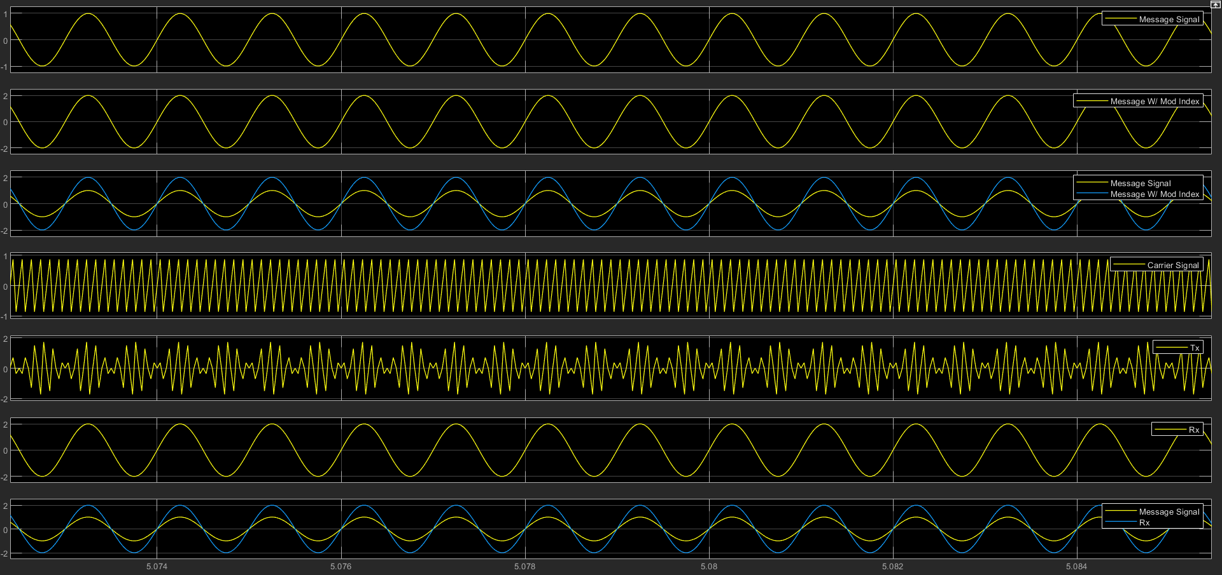
Figure 12 – Amplitude Modulation Index 2
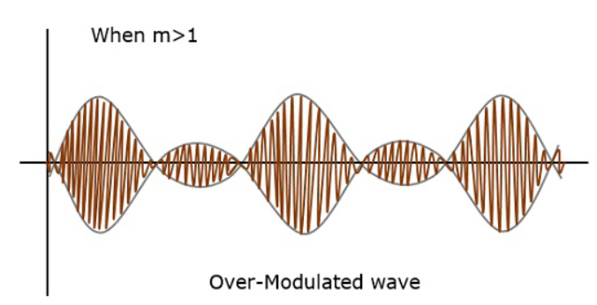
Figure 13 – Over Modulated AM Wave ^{[3]}

Double Sideband - Suppressed Carrier Amplitude Modulation

Block Diagram
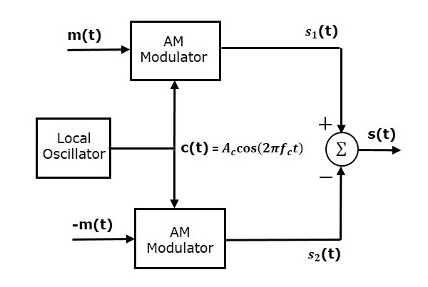
Figure 14 – Block Diagram of DSB-SC Modulator
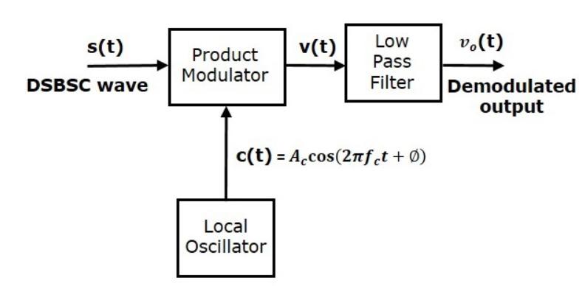
Figure 15 – Block Diagram of DSB-SC Demodulator

Circuit design
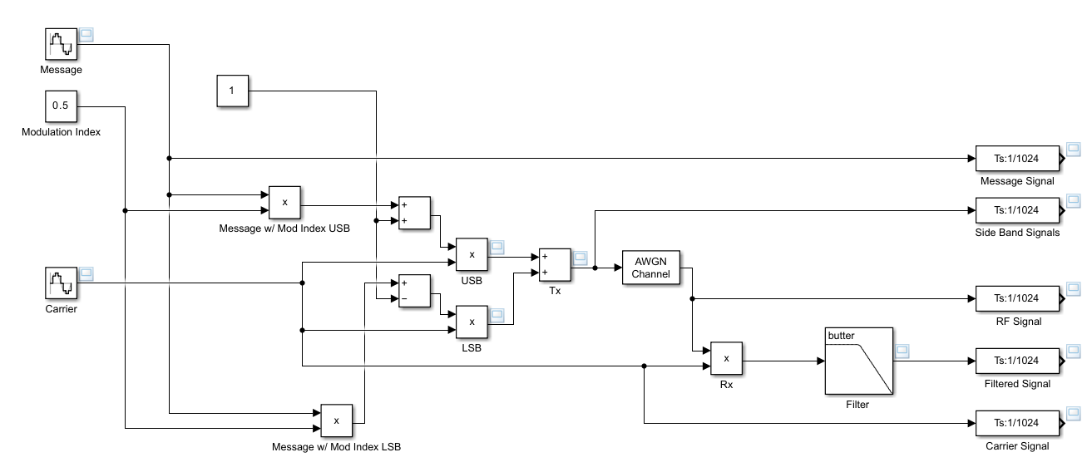
Figure 16 – DSB-SC Amplitude Modulation Model

Transmitter and Receiver Architectures
In this model the message and carrier signals are represented by the sine wave function blocks. A modulation index is provided by multiplication of the message sine wave by a constant. I have then separated the upper and lower side bands into two individual equation functions, there are two message signals to which I have added and subtracted one respectively to produce the upper and lower side bands these have then tied to the carrier by multiplying each by the carrier wave and then the two signals have been added in the addition block to represent a Double Sideband-Suppressed Carrier transmission.
An Additive White Gaussian Noise block has been added to provide a real-world noise approximation, to ensure that the received message is representative of what would be received for demodulation. The received signal is then demodulated as the carrier is then mixed out of the incoming transmission at the multiplication function, the received message is then filtered to remove excess noise using a Butterworth lowpass filter.
The signal specification blocks on the right-hand side of the model act to ensure the signals are at the correct sample rate for the spectrum analyser.

Simulated Outputs and Results
Carrier – 11Hz, 5V
Message – 2Hz, 1V
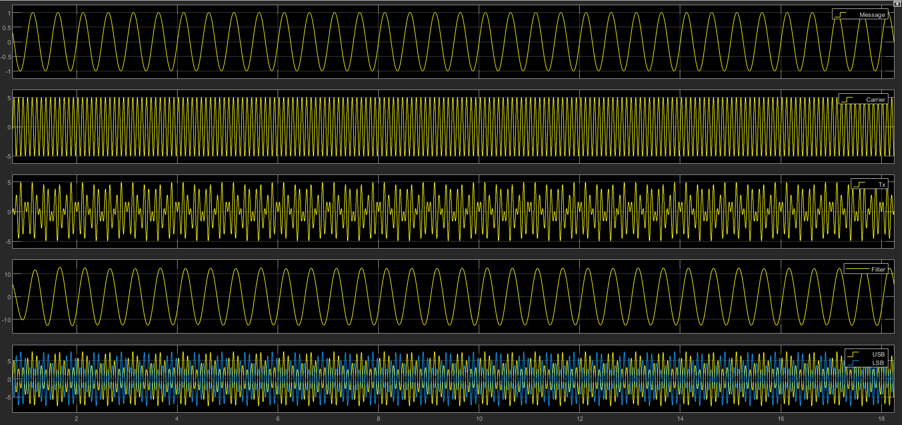
Figure 17 – DSB-SC Amplitude Modulation Time Domian
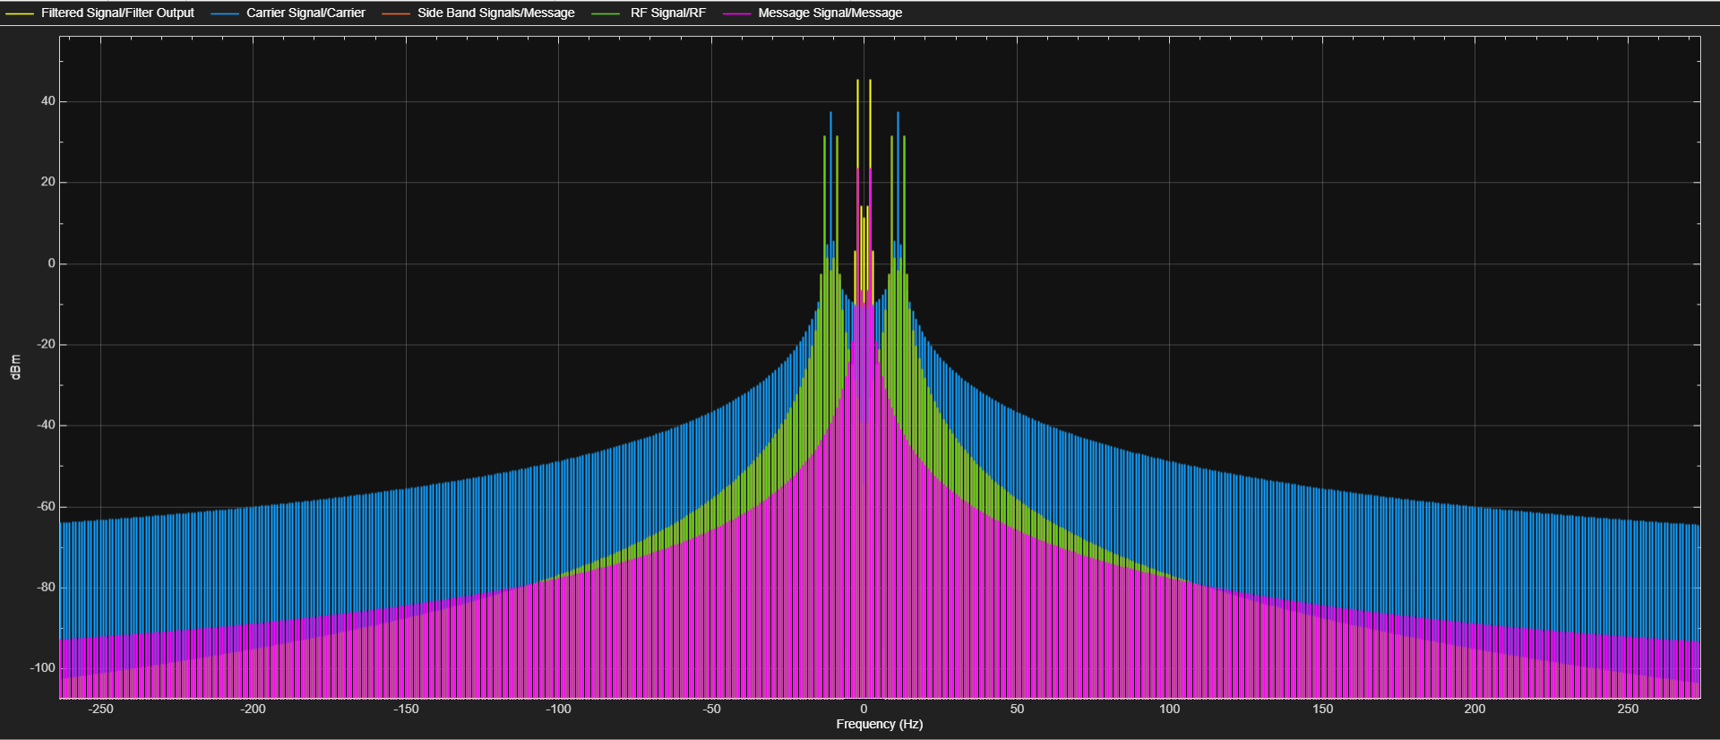
Figure 18 – DSB-SC Amplitude Modulation Frequency Domain

Multimedia Circuit design
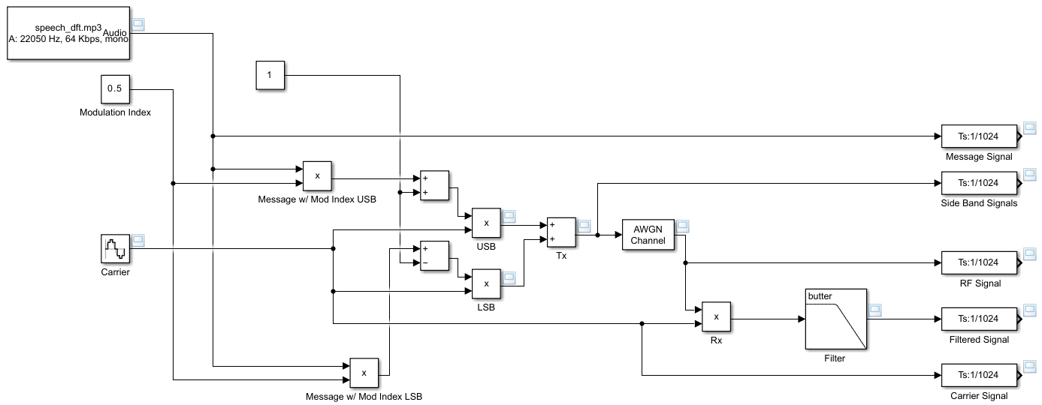
Figure 19 – DSB-SC Amplitude Modulation Multimedia Message Model

Multimedia Simulated Outputs and Results
Carrier – 112kHz, 7V
Message – 22.05kHz, 1V
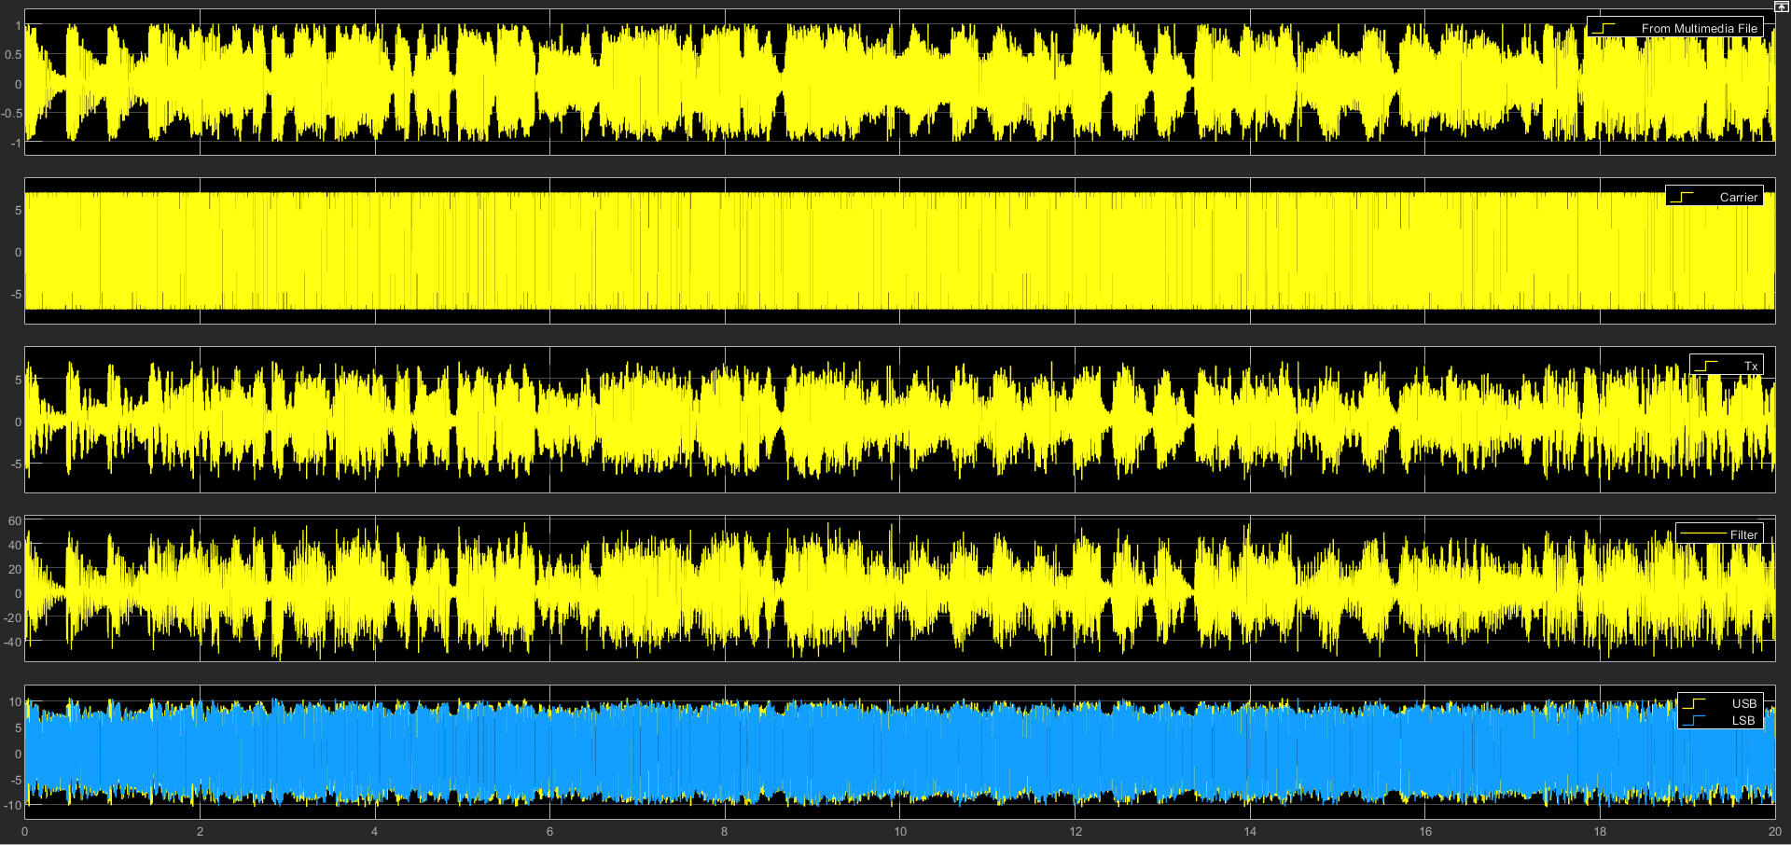
Figure 20 – DSB-SC Amplitude Modulation Multimedia Message Time Domain
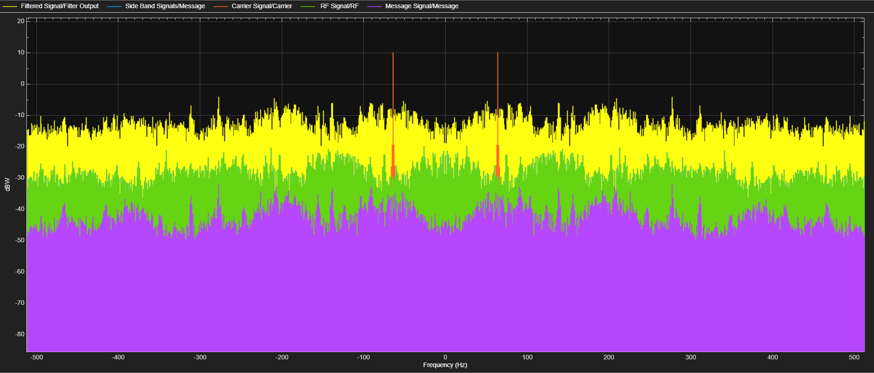
Figure 21 – DSB-SC Amplitude Modulation Multimedia Message Frequency Domain
Two signals were then modelled with an Additive White Gaussian Noise function block, the SNR was set to 60dB and 10dB respectively for each instance.
$P_{m}= \frac{{A_{m}}^{2}}{2}=\frac{1^{2}}{2}=0.5W$
$$P_{c}= \frac{{A_{c}}^{2}}{2}=\frac{7^{2}}{2}=24.5W$$
$P_{DSB-SC}= {2P}_{SB}=2×({2.824229597×10}^{-3})=5.65×{10}^{-3}W$
Equation 1 - Power in DSBSC AM Transmissions [8]
Table 1 - Power Calculations for Multimedia Amplitude Modulation
Power Measurement | Watts (W) | Decibels (dBm)
P_{m} | 0.5W | -3.01dBm
P_{c} | 24.5W | 13.89dBm
P_{DSB-SC} | 5.65x10⁻³W | -22.48dBm

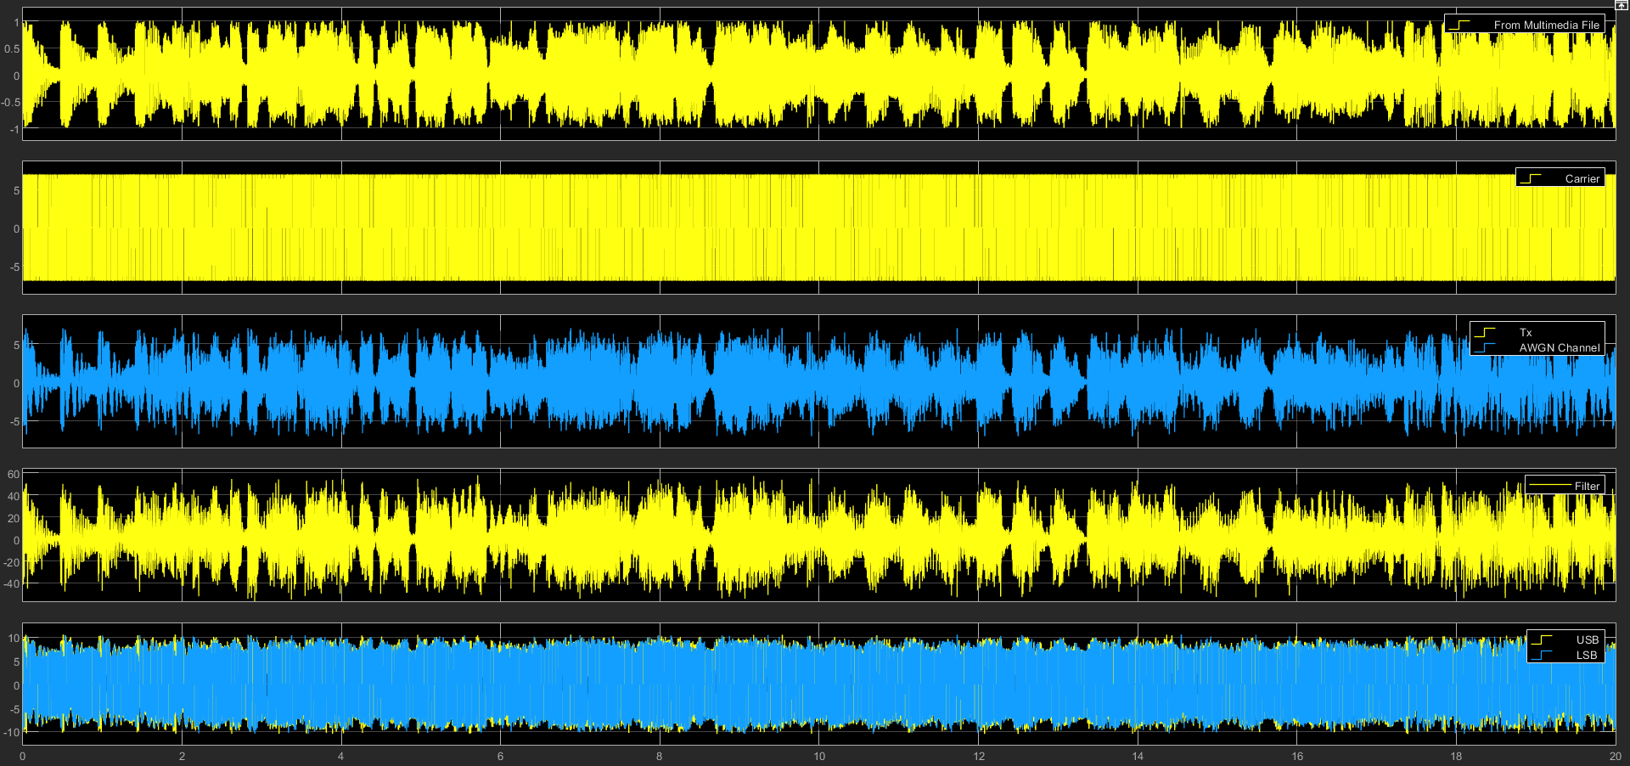
Figure 22 - DSB-SC Amplitude Modulation Multimedia Message Time Domain in the presence of 60dB SNR
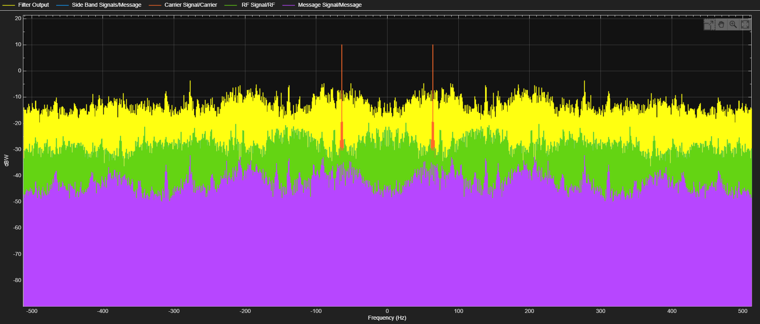
Figure 23 - DSB-SC Amplitude Modulation Multimedia Message Frequency Domain in the presence of 60dB SNR
AWGN Channel SNR Value: 60dB
Equation 2 - Output and Channel SNR equations [8]
$$SNRO= \frac{Signal Power}{Noise Power}={10Log}_{10}\left(\frac{7.116394248}{0.0000233572}\right)=61.87269311dB$$
$$SNRC= \frac{Signal Power}{Noise Power}={10Log}_{10}\left(\frac{35.94926372}{0.0000233572}\right)=46.37779311dB$$
Equation 3 – Watts to Decibel Watts equations [9]
$$Watts-dBm→P_{W}={10}^{\left(\frac{P_{dBm}-30}{10}\right)}$$
$$Decibels-Watts→ P_{dBm}={10Log}_{10}\left(\frac{P_{S}}{P_{N}}\right)$$
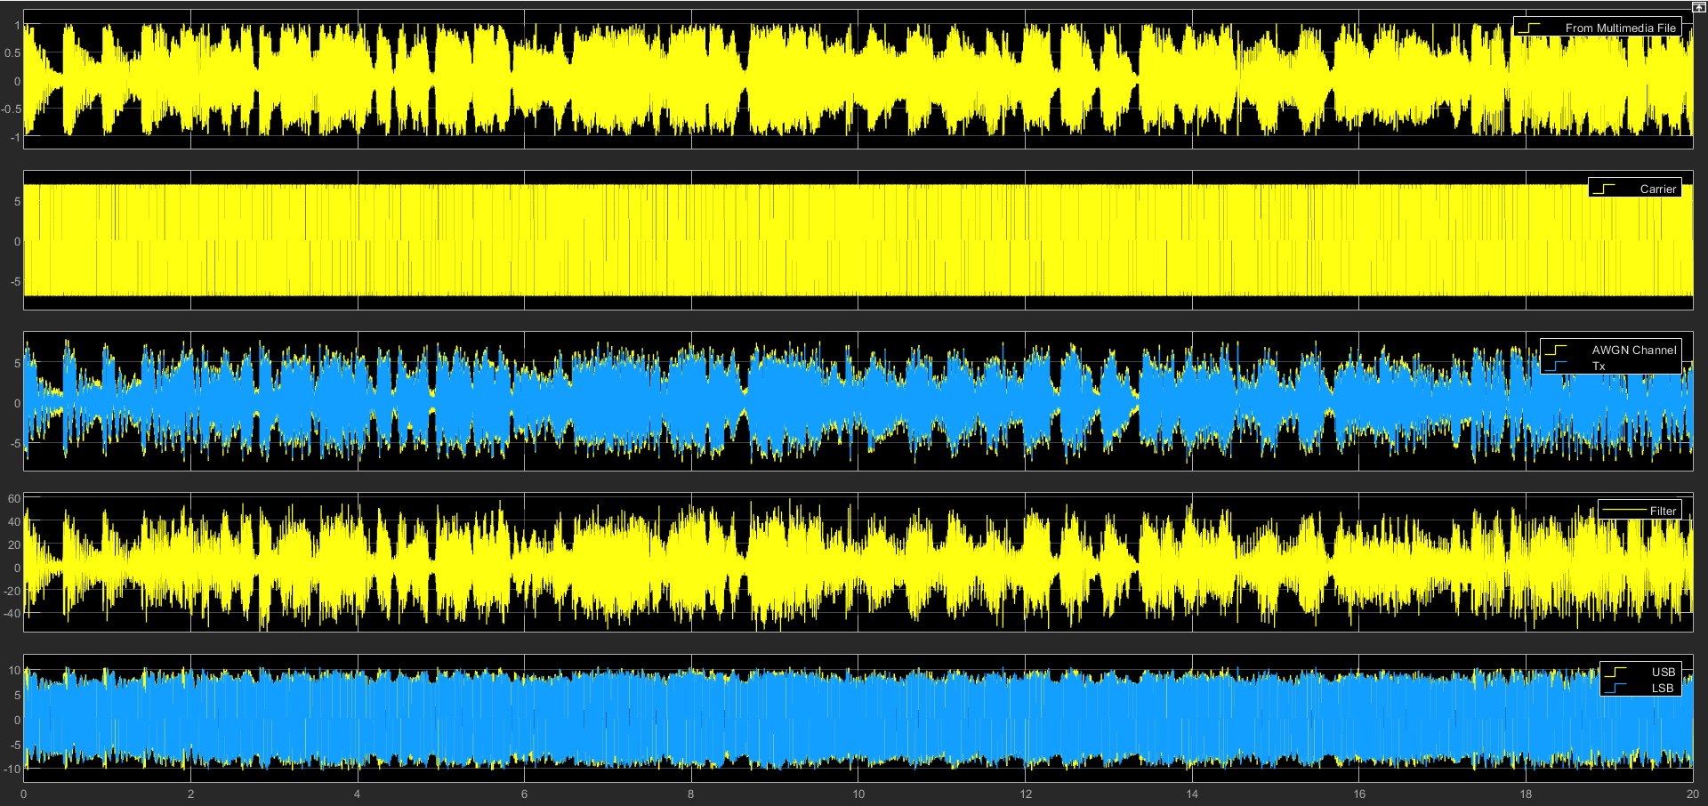
Figure 24 – DSB-SC Amplitude Modulation Multimedia Message Time Domain in the presence of 10dB SNR
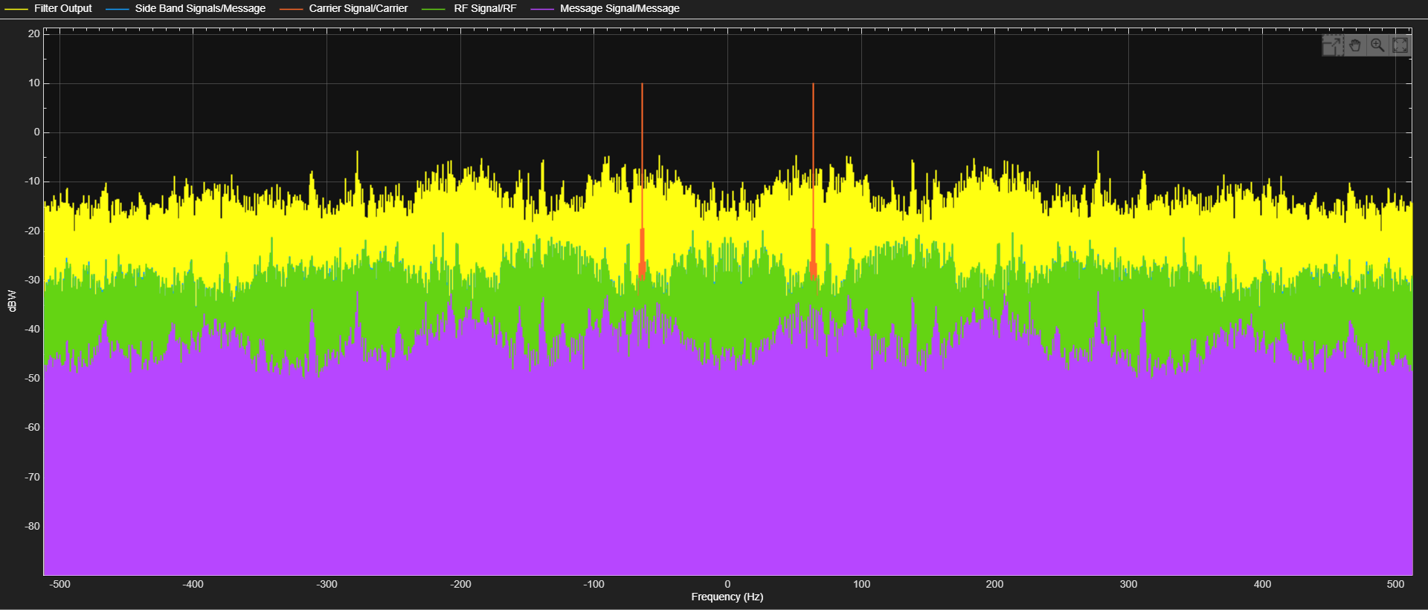
Figure 25 – DSB-SC Amplitude Modulation Multimedia Message Frequency Domain in the presence of 10dB SNR
AWGN Channel SNR Value: 10dB
${SNR}_{O}= \frac{Signal Power}{Noise Power}={10Log}_{10}\left(\frac{36.23764783}{0.039765726}\right)=29.59651083dBW$
${SNR}_{C}= \frac{Signal Power}{Noise Power}={10Log}_{10}\left(\frac{1.014378417}{0.039765726}\right)=14.06691083dBW$

$$Watts-dBm→P_{W}={10}^{\left(\frac{P_{dBm}-30}{10}\right)}$$
$$Decibels-Watts→ P_{dBm}={10Log}_{10}\left(\frac{P_{S}}{P_{N}}\right)$$

Frequency Modulation

Block Diagram
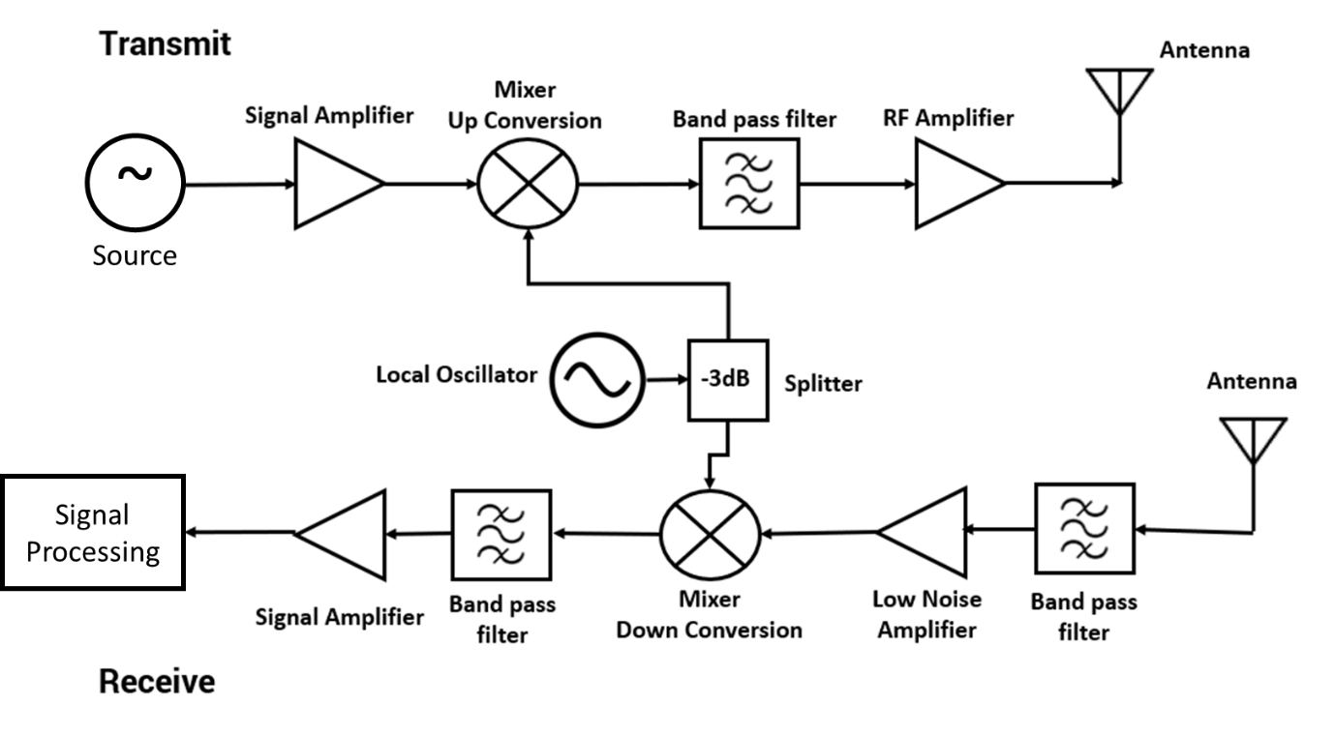
Figure 26 – Block Diagram of Transmitter and Receiver

Circuit Design
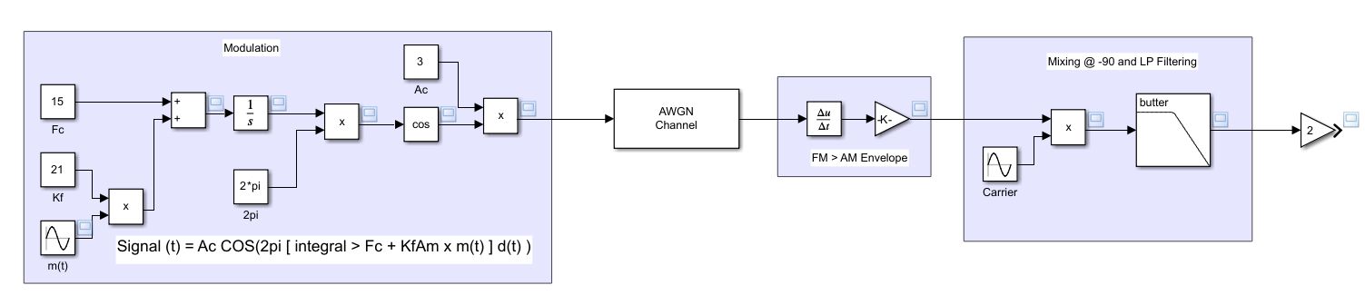
Figure 27 – Frequency Modulation Model

Transmitter and Receiver Architectures
In this model the message and carrier signals are represented by the sine wave function blocks. A modulation index is provided by multiplication of the message sine wave by a constant k_{f} and then the addition of the carrier wave frequency which is represented by the constant f_{c} – this represents the equation: $β=\frac{A_{m}k_{f}}{f_{m}}= \frac{∆f}{f_{m}}$
The rest of the modulation of the message signal is performed by the integrator and the multiplication of that output by 2pi, that result is the input to a cosine trigonometric function, which is then multiplied by the Carrier Wave amplitude constant (A_{c}).
The AWGN channel provides the noise approximation in an effort to distort the transmitted signal. The received signal is then demodulated in two stages, firstly the differentiation function forms the amplitude modulation envelop – the gain reduces the signal else it would be too large based on the maths operations being performed – the carrier wave is then mixed out at -90˚ to the incoming wave, the resulting wave is then passed through a Butterworth lowpass filter to extract the initial message signal.

Simulated Outputs and Results
Carrier – 15Hz, 5V
Message – 2Hz, 1V
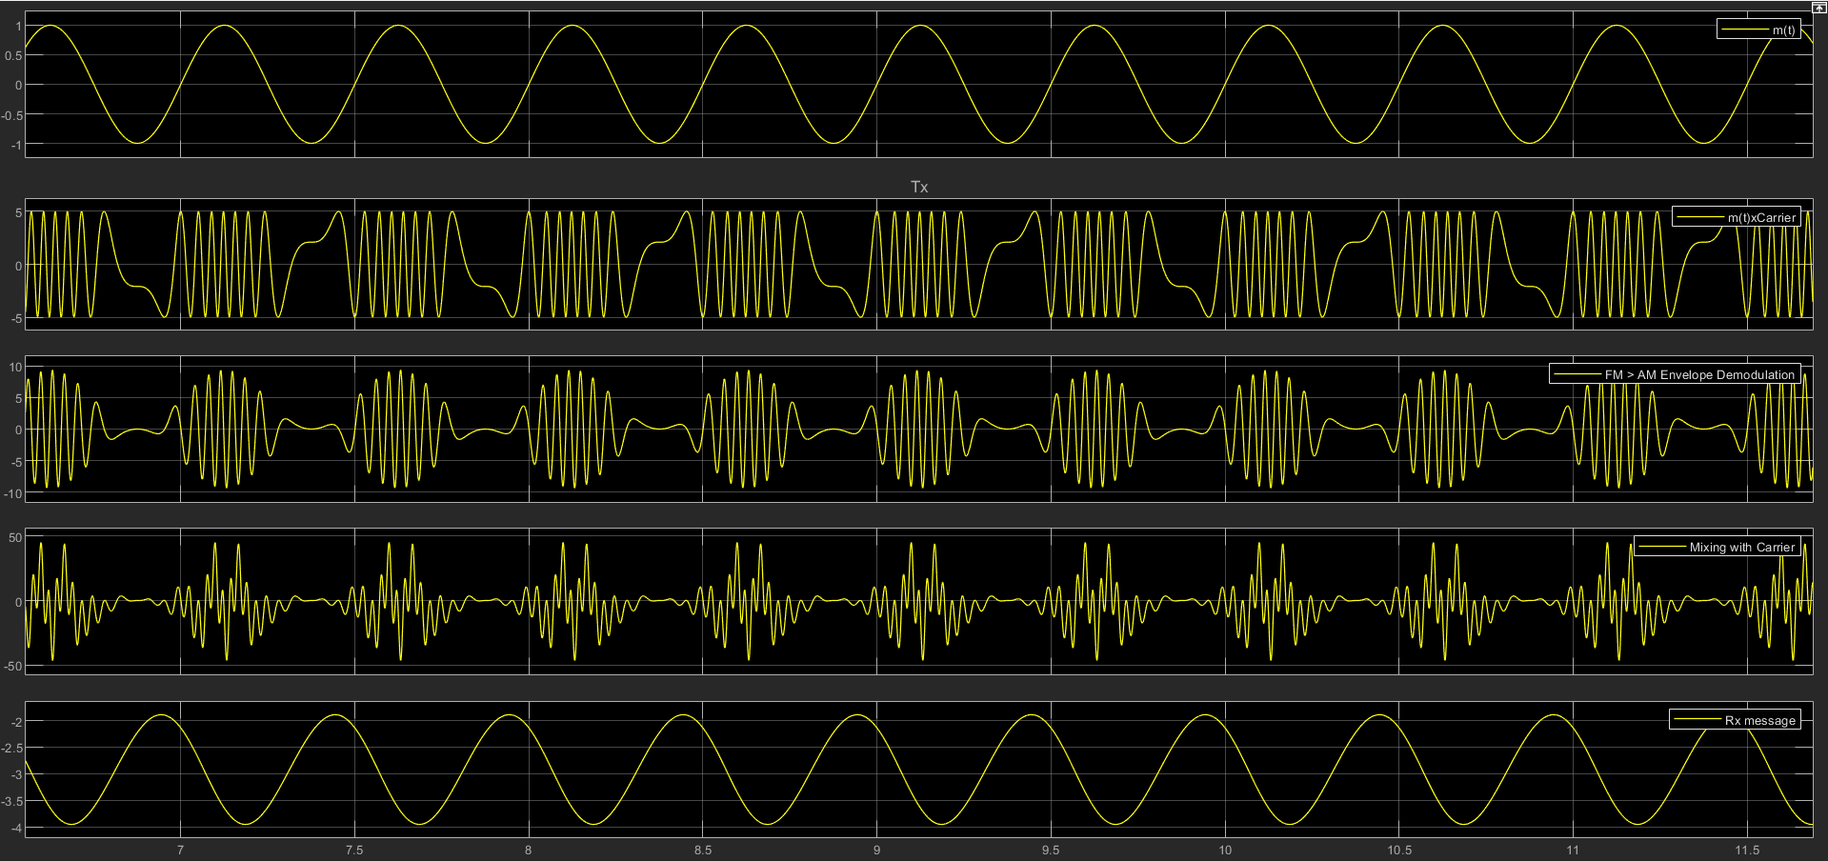
Figure 28 – Frequency Modulation and Demodulation in the Time Domain
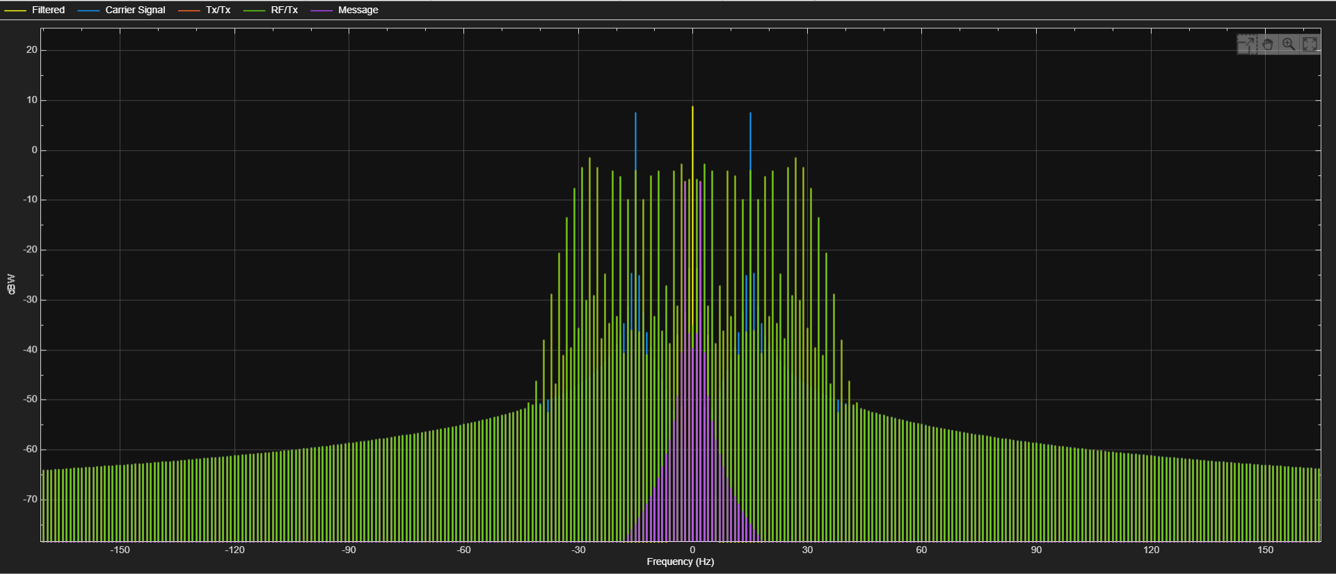
Figure 29 – Frequency Modulation in the Frequency Domain

Multimedia Circuit design
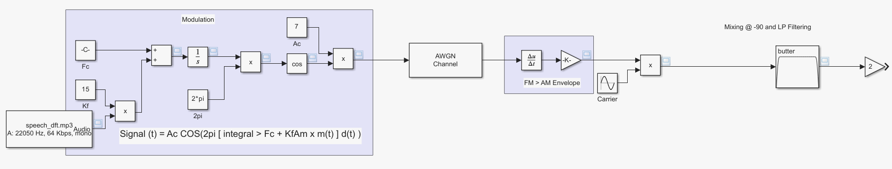Figure 30 – Frequency Modulation Multimedia Message Model

Multimedia Simulated Outputs and Results
Carrier – 40kHz, 7V
Message – 8kHz, 1V
$P_{m}= \frac{{A_{m}}^{2}}{2}=\frac{1^{2}}{2}=0.5W$
$$P_{c}= \frac{{A_{c}}^{2}}{2}=\frac{7^{2}}{2}=24.5W$$
Equation 4 – Power in FM transmission equation [10]
$P_{FM}= P_{C}$
Table 2 - Power Calculations for Multimedia Frequency Modulation
Power Measurement | Watts (W) | Decibels (dBm)
P_{m} | 0.5W | -3.01dBm
P_{c} | 24.5W | 13.89dBm
P_{FM} | 24.5W | 13.89dBm

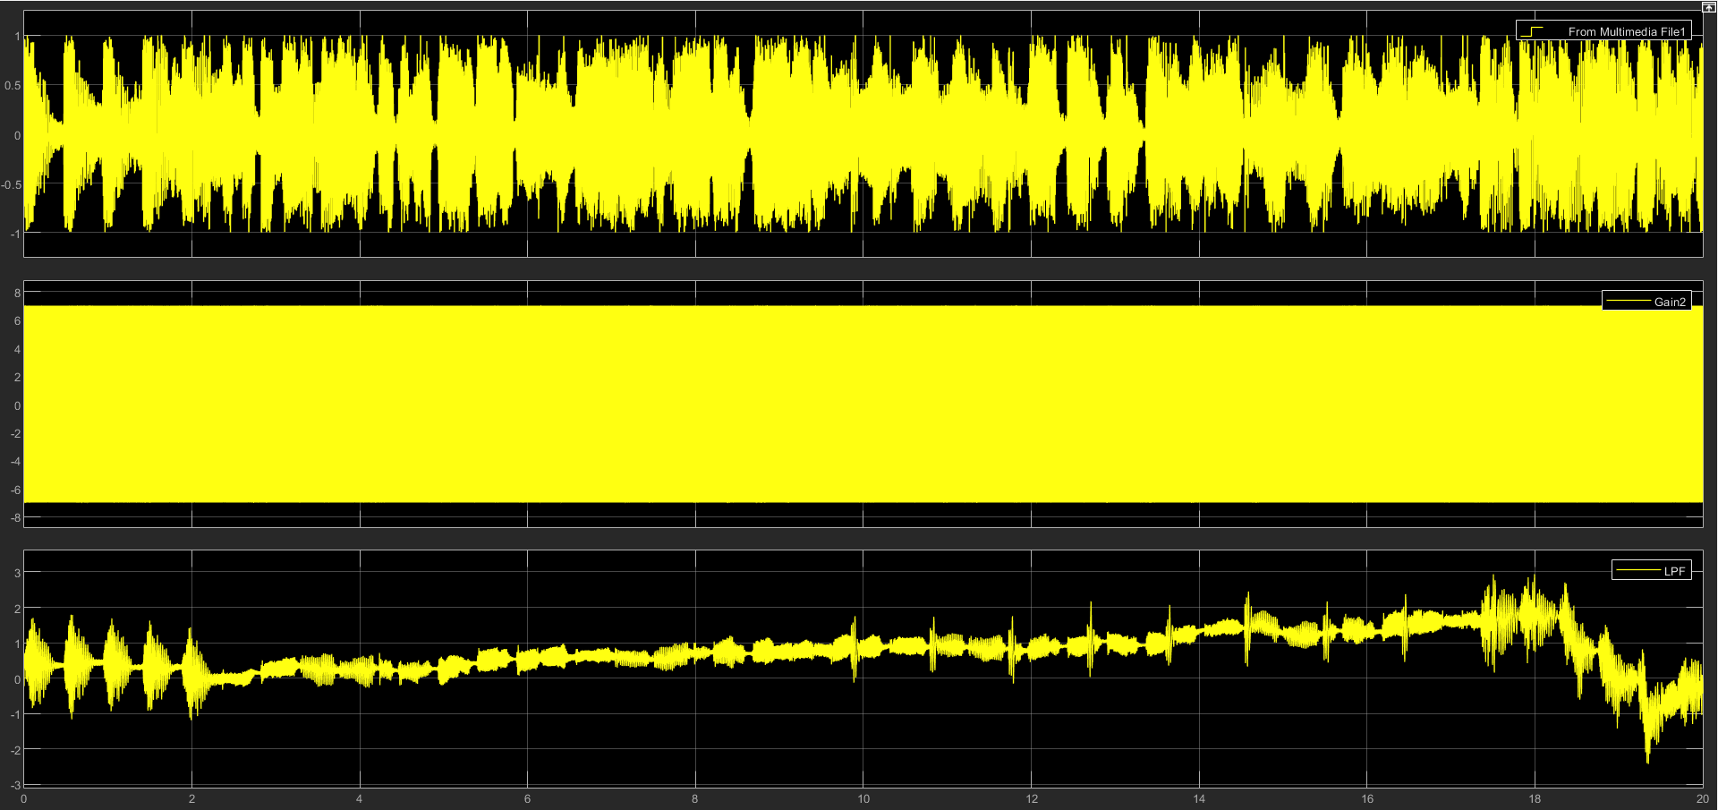
Figure 31 – Frequency Modulation Multimedia Message Time Domain in the presence of 60dB SNR
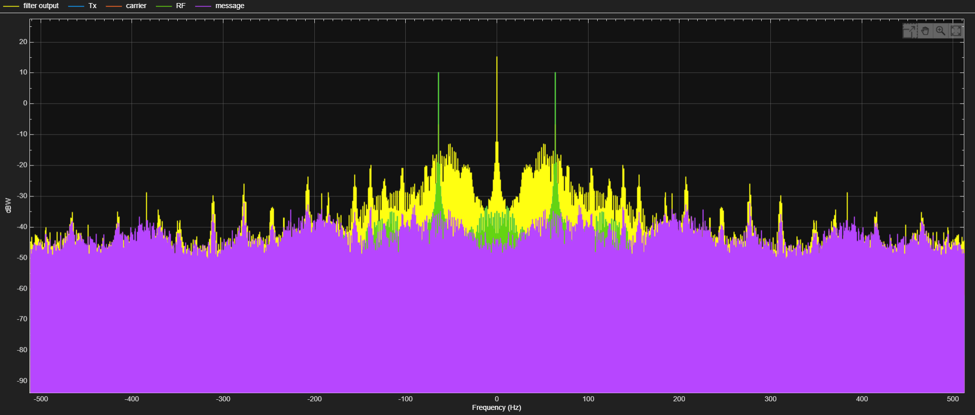
Figure 32 – Frequency Modulation Multimedia Message Frequency Domain in the presence of 60dB SNR
AWGN Channel SNR Value: 60dB
$$SNRO= \frac{Signal Power}{Noise Power}={10Log}_{10}\left(\frac{18.13635466}{0.000243445}\right)=48.72149311dB$$
$$SNRC= \frac{Signal Power}{Noise Power}={10Log}_{10}\left(\frac{10.57279959}{0.000243445}\right)=46.37779311dB$$

$$Watts-dBm→P_{W}={10}^{\left(\frac{P_{dBm}-30}{10}\right)}$$
$$Decibels-Watts→ P_{dBm}={10Log}_{10}\left(\frac{P_{S}}{P_{N}}\right)$$
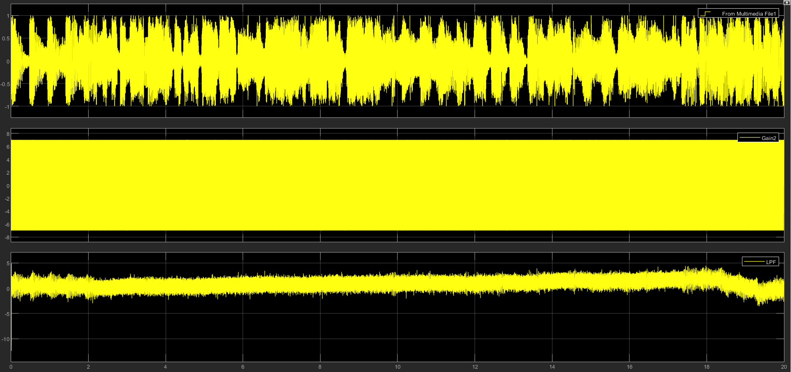
Figure 33 – Frequency Modulation Multimedia Message Time Domain in the presence of 10dB SNR
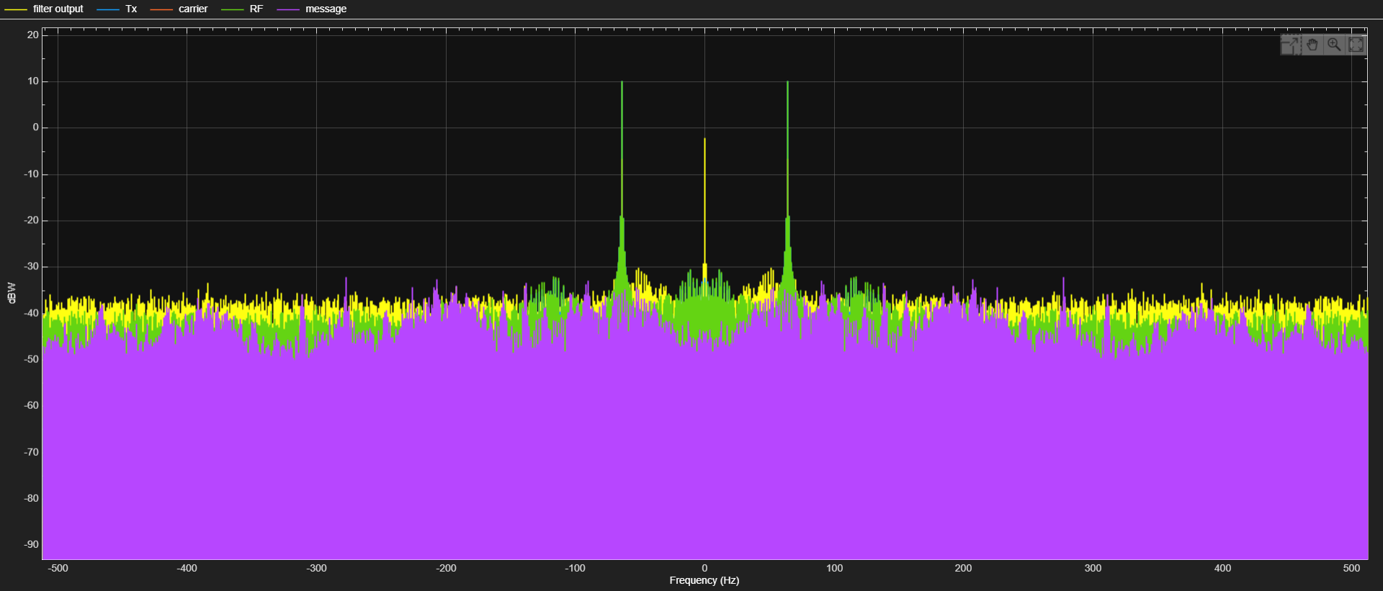
Figure 34 – Frequency Modulation Multimedia Message Frequency Domain in the presence of 10dB SNR
AWGN Channel SNR Value: 10dB
$$SNRO= \frac{Signal Power}{Noise Power}={10Log}_{10}\left(\frac{0.479457371}{0.025592935}\right)=12.72629906dB$$
$$SNRC= \frac{Signal Power}{Noise Power}={10Log}_{10}\left(\frac{10.57279959}{0.025592935}\right)=26.16069906dB$$

$$Watts-dBm→P_{W}={10}^{\left(\frac{P_{dBm}-30}{10}\right)}$$
$$Decibels-Watts→ P_{dBm}={10Log}_{10}\left(\frac{P_{S}}{P_{N}}\right)$$

Conclusion

Analysing the Results

Figure of Merit
Equation 5 - Figure of Merit equations [8]
Input SNR ${SNR}_{I}= \frac{Average Power of Modulating Signal}{Average power of Noise at Input}$
Output SNR ${SNR}_{O}= \frac{Average Power of Demodulated Signal}{Average power of Noise at Output}$
Channel SNR ${SNR}_{C}= \frac{Average Power of Modulated Signal}{Average power of Noise in Message Bandwidth}$
The figure of merit for a device is given by $\frac{{SNR}_{O}}{{SNR}_{I}}$ and for a receiver is $\frac{{SNR}_{O}}{{SNR}_{C}}$ because the channel is considered as the input to the receiver.

Double Sideband – Supressed Carrier

$${SNR}_{I,DSBSC}= \frac{Average Power of DSBSC Modulating Signal}{Average power of Noise at Input}$$
$${SNR}_{O,DSBSC}= \frac{Average Power of DSBSC Demodulated Signal}{Average power of Noise at Output}$$
$${SNR}_{C,DSBSC}= \frac{Average Power of DSBSC Modulated Signal}{Average power of Noise in Message Bandwidth}$$
$$Figure of Merit= \frac{{SNR}_{O,DSBSC}}{{SNR}_{C,DSBSC}}$$
Equation 6 – AM SNR output and channel equations [8]
${SNR}_{O\left(Theoretical\right)}= \frac{{A_{c}}^{2}{k_{a}}^{2}P}{2N_{0}BW}= \frac{7^{2}{×0.5}^{2}×0.5}{2×\left(1W\right)×\left(2×22050Hz\right)}=6.944444444×{10}^{-5}W≈-41.58dBW$
${SNR}_{C\left(Theoretical\right)}= \frac{{A_{c}}^{2}\left(1+{k_{a}}^{2}\right)P}{2N_{0}BW}= \frac{7^{2}\left(1+{0.5}^{2}\right)0.5}{2×\left(1W\right)×\left(2×22050Hz\right)}=6.25×{10}^{-4}W≈-32.04dBW$
Equation 7 - DSBSC AM Bandwidth equation [6]
$$BW=f_{c}+f_{m}-\left(f_{c}-f_{m}\right)={2f}_{m}$$
(N₀ refers to the input signal power the equation is as follows: $N_{0}=kT_{e}=1$ in the model produced the value of N₀ is taken as 1W.)
$${Figure of Merit}_{Theoretical}= \frac{-41.58}{-32.04}=1.30$$

AWGN SNR Value 10dB:
SNR_{O} = 29.60dB SNR_{C} = 14.07dB
${Figure of Merit}_{Simulation}= \frac{29.59651083}{14.06691083}=2.10$
This value is higher than the expected 1.3 provided by the theoretical figure of merit, this is due to the calculation of the output SNR being incorrect. As shown the SNR_{O} is given as 22.57dB when the AWGN channel is set to 10dB, as such the signal power is more than it should be – due to a simulation error – as such the figure of merit value for this simulation scenario is larger than it should be. Had the SNR_{O} sat around ~11dB this figure of merit value would be ~1.7, which falls more in line with the expected 1.3 of the theoretical.

AWGN SNR Value 60dB:
SNR_{O} = 61.87dB SNR_{C} = 46.38dB
$${Figure of Merit}_{Simulation}=\frac{61.87269311}{46.37779311}=1.33$$
This figure of merit is slightly larger than the theoretical value but is far closer than the value from the 10dB SNR simulation. This is likely due to the larger signal power of 61.99dB, the simulation seemed to run as expected and provide a realistic SNR_{O} value unlike the previous simulation. This ensured that the figure of merit produced was much closer at 1.43 for this simulation.

Frequency Modulation

$${SNR}_{I,FM}= \frac{Average Power of FM Modulating Signal}{Average power of Noise at Input}$$
$${SNR}_{O,FM}= \frac{Average Power of FM Demodulated Signal}{Average power of Noise at Output}$$
$${SNR}_{C,FM}= \frac{Average Power of FM Modulated Signal}{Average power of Noise in Message Bandwidth}$$
$$Figure of Merit= \frac{{SNR}_{O,FM}}{{SNR}_{C,FM}}$$
Equation 8 – FM SNR output and channel equations ^{[11]}
${SNR}_{O\left(Theoretical\right)}= \frac{{A_{c}}^{2}}{2N_{0}BW}= \frac{7^{2}}{2×\left(1W\right)×(2\left(15Hz+2Hz)\right)}= 0.001528384W≈-28.16dBW$
${SNR}_{C\left(Theoretical\right)}= \frac{{A_{c}}^{2}{k_{f}}^{2}P}{2N_{0}{BW}^{3}}= \frac{7^{2}×{15}^{2}×0.5}{2×\left(1W\right)×{\left(2\left(15Hz+2Hz\right)\right)}^{3}}= {6.69142×10}^{-10}W≈-91.74dBW$
Equation 9 - FM Bandwidth equation ^{[12]}
$$BW=2\left({∆f}_{C}+f_{m}\right)$$
$${Figure of Merit}_{Theoretical}= \frac{-28.16}{-91.74}=0.31$$

AWGN SNR Value 10dB:
SNR_{O} = 12.73dB SNR_{C} = 26.16dB
${Figure of Merit}_{Simulation}= \frac{12.72629906}{26.16069906}=0.49$
Having simulated the multimedia message at 10dB in the frequency modulation models an output SNR of 12.73dB and a channel SNR of 26.16dB were calculated, giving a figure of merit of 0.49. This is quite close to the theoretical figure of merit calculated for the system, which means the simulation was close to the intended value and therefore was simulating correctly.
AWGN SNR Value 60dB:
SNR_{O} = 48.72dB SNR_{C} = 46.38dB
${Figure of Merit}_{Simulation}= \frac{48.72149311}{46.37779311}=1.05$
The simulation of FM at 60dB SNR seemed to produce a lower output SNR than expected, meaning the simulation did not run efficiently and the process of adding noise reduced the fidelity and therefore the calculated SNR. This in turn impacts the figure of merit associated with this simulation producing an FoM or 1.05 which is much greater than the 0.31 value of the theoretical calculation.

Recommendations on future work
In future work the models need to become more robust and able to handle larger noise value and multimedia files because as can be heard in the multimedia files the model struggles to sample the input wave at the correct rate.

References
[1] ‘Amplitude-shift keying’, Wikipedia. Jun. 23, 2023. Accessed: Oct. 13, 2023. [Online]. Available: https://en.wikipedia.org/w/index.php?title=Amplitude-shift_keying&oldid=1161574964
[2] ‘Radio Frequency Bands | TeraSense’. Accessed: Nov. 13, 2023. [Online]. Available: https://terasense.com/terahertz-technology/radio-frequency-bands/
[3] ‘Amplitude Modulation’. Accessed: Nov. 13, 2023. [Online]. Available: https://www.tutorialspoint.com/analog_communication/analog_communication_amplitude_modulation.htm
[4] ‘Radio Broadcast Signals’. Accessed: Nov. 13, 2023. [Online]. Available: http://hyperphysics.phy-astr.gsu.edu/hbase/Audio/radio.html
[5] ‘AM vs FM - Difference and Comparison | Diffen’. Accessed: Nov. 14, 2023. [Online]. Available: https://www.diffen.com/difference/AM_vs_FM
[6] ‘Analog Communication - DSBSC Modulators’. Accessed: Nov. 14, 2023. [Online]. Available: https://www.tutorialspoint.com/analog_communication/analog_communication_dsbsc_modulators.htm
[7] ‘What is FM, Frequency Modulation » Electronics Notes’. Accessed: Nov. 13, 2023. [Online]. Available: https://www.electronics-notes.com/articles/radio/modulation/frequency-modulation-fm.php
[8] ‘Analog Communication - SNR Calculations’. Accessed: Nov. 30, 2023. [Online]. Available: https://www.tutorialspoint.com/analog_communication/analog_communication_snr_calculations.htm
[9] ‘dBW (Decibel-Watt)’. Accessed: Nov. 30, 2023. [Online]. Available: https://www.rapidtables.com/electric/dBW.html
[10] ‘Numerical Problems 2’. Accessed: Nov. 30, 2023. [Online]. Available: https://www.tutorialspoint.com/analog_communication/analog_communication_numerical_problems_2.htm
[11] ‘Signal-to-noise ratio’, Wikipedia. Nov. 10, 2023. Accessed: Nov. 28, 2023. [Online]. Available: https://en.wikipedia.org/w/index.php?title=Signal-to-noise_ratio&oldid=1184390748
[12] ‘Frequency modulation’. Accessed: Nov. 30, 2023. [Online]. Available: https://www.slideshare.net/Akanksha_Seth/frequency-modulation-12759213

