
HTML & CSS Web development
ACCA4023

24 March 2026
NAME: CHRIS ANTWI BOASIAKO STUDENT nO. 2432249
LECTURER NAME: SADHANA JHA

Contents
Introduction 2
Requirements 3
Purpose: 3
Subject matter 4
Intended audience 4
Implementation 5
Screenshots of the Webpages 5
Validation 8
HTML Validation 8
CSS Validation 9
Evaluation 9
Part A 9
Website usability- 9
Website accessibility: 10
Search engine optimisation 10
Part B 10
Usefulness (Usability and Utility) 11
Search Engine Optimisation (SEO) 11
Accessibility: 11
Part C 11
References: 12
Appendix 12

Introduction
This report presents the design and development of a tourism website based on tourist attractions in Ghana. The website was created to provide information about important places of interest and to promote Ghana as a destination for tourism. It focuses on presenting attractions in a simple, attractive, and organized way so that users can easily learn about them. The report describes the main purpose of the website, the features included in its design, and the type of audience that may benefit from using it. It also explains how the website was structured into different pages, namely the Home page, Description page, and Contact page, to make navigation easier for users. In addition, the report outlines how images, colours, text, and links were used to improve the appearance and function of the website.
Furthermore, this report discusses important web design concepts such as usability, accessibility, and search engine optimisation. These areas are important because they help determine how effective the website is in meeting the needs of its users. The report also includes validation and evaluation of the HTML and CSS used in building the site, showing how errors were corrected to improve the overall quality of the website.
Overall, the report provides an overview of how the tourism website was planned, created, and improved to present information about Ghana’s tourist attractions in a clear and appealing manner.

Requirements

Purpose:
In this section, showcase the purpose of why the website was created
This website is created to share information with people in a simple and organized way. It will help users learn about a topic, service, product, or place without needing to search in many different sources. In this case, the website was created to present information about tourist attractions in Ghana and to help visitors understand the beauty, history, and culture of the country.
Another reason of creating this website is to make information available to many people at any time. Anyone with internet access can visit the website, read about the attractions, and view images of important places in Ghana. This makes the website a useful tool for promoting tourism and creating awareness about famous destinations.
It was also created to attract and guide a target audience. For this tourism website, the target audience includes tourists, students, researchers, and anyone interested in visiting or learning about Ghana. By providing clear descriptions, pictures, and contact information, this website helps users find what they need easily.
In addition, this website can be used to advertise and promote the country’s heritage and natural attractions. This tourism website highlights places such as Manhyia Palace, Kakum National Park, Kwame Nkrumah Memorial Park and the Black Star Gate Ghana to encourage more people to visit them. In this way, this website supports tourism development and helps showcase Ghana to the world.

Subject matter
In this section, you write about the features of the website. What you are showcasing through the website.
This website includes several features designed to help visitors learn about tourist attractions in Ghana. The home page introduces the website and displays images of famous tourist sites such as Manhyia Palace, Kakum National Park, Elmina Castle, and Kwame Nkrumah Memorial Park. The description page provides brief information about each location so visitors can understand their historical and cultural importance. The website also includes a contact page where users can send messages or inquiries.

The website showcases Ghana’s rich culture, history, and natural beauty. Through pictures and short descriptions, visitors can explore important landmarks, national parks, and historical sites. The goal of the website is to promote tourism in Ghana and help people discover some of the country’s most interesting and educational places to visit.

Intended audience
In this section, write about what do you feel who will be probably getting benefitted from your website or who may use your website purposefully
This website will be useful for people who are interested in learning about tourist attractions in Ghana. Tourists and travelers can use the website to discover important places to visit, such as Manhyia Palace, Kakum National Park, Elmina Castle, and Kwame Nkrumah Memorial Park. Students and researchers may also benefit from the website because it provides basic information about Ghana’s history, culture, and natural landmarks.
In addition, travel planners and people who want to explore new destinations can use the website to get ideas about visiting Ghana. The website helps promote tourism and allows users to easily learn about some of the country’s most famous attractions.

Implementation

Screenshots of the Webpages

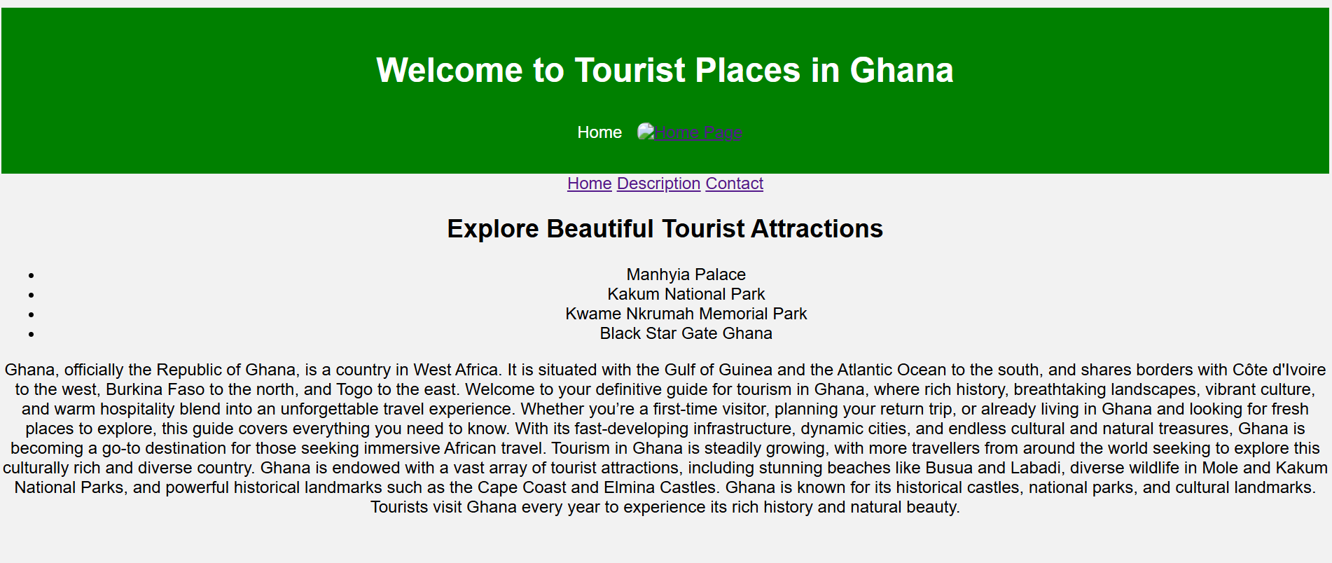

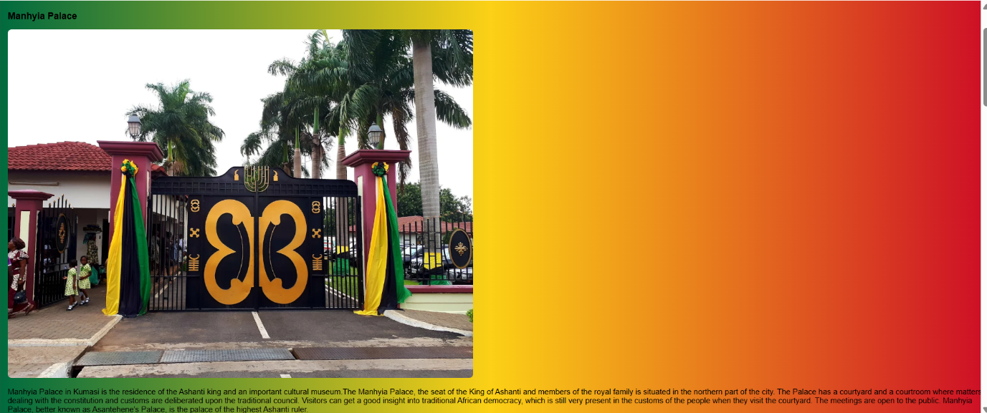

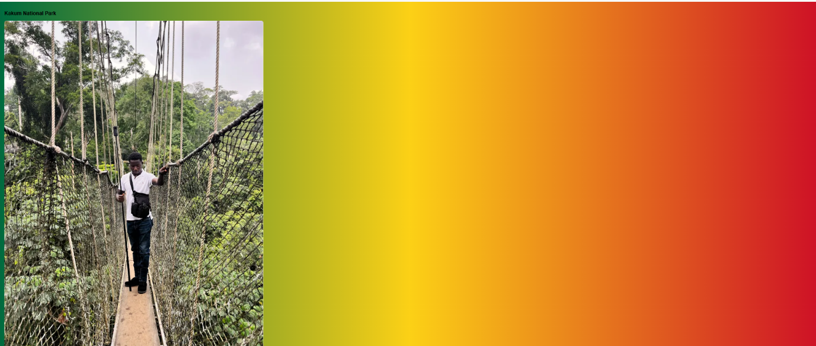

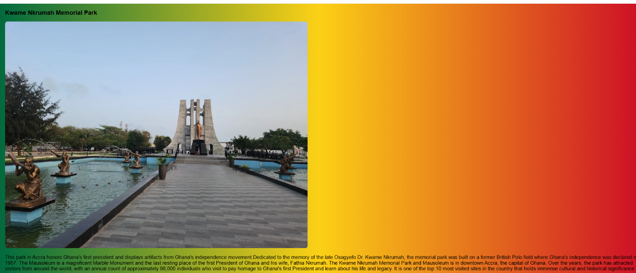

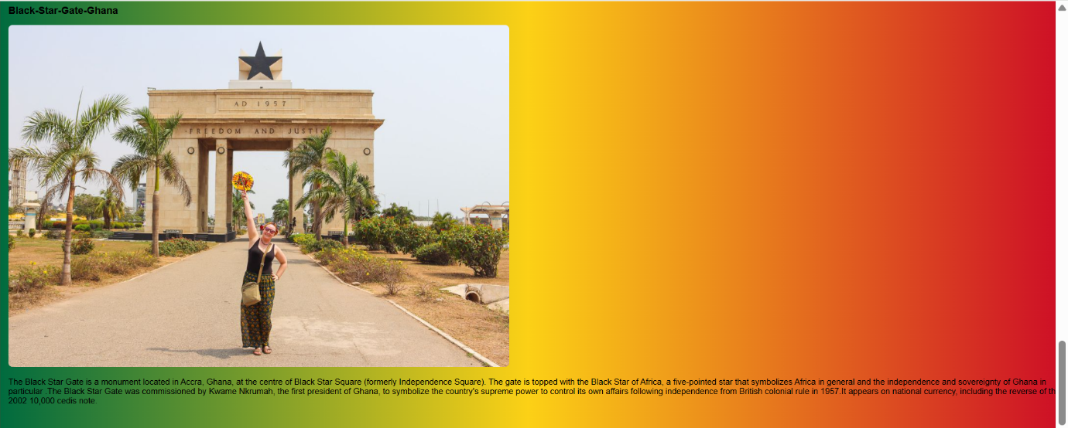

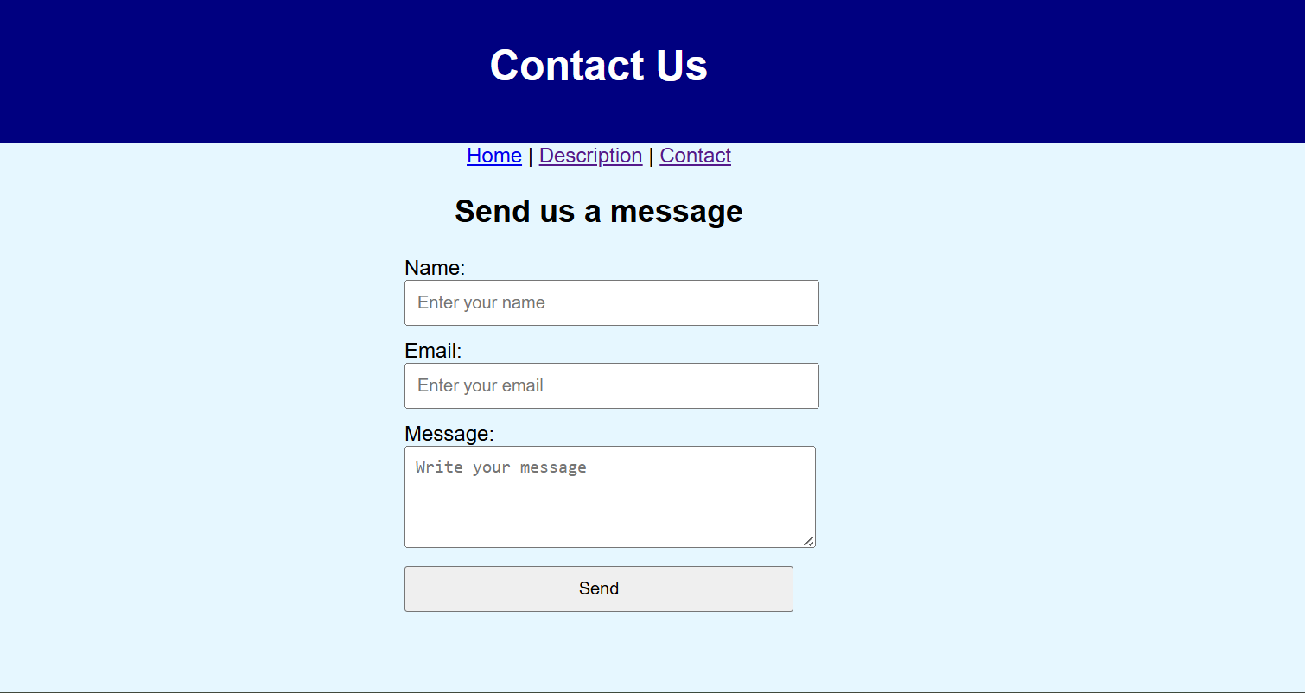

Validation

HTML Validation
In this section, include the screenshot of the HTML validation of your homepage
If you have any error in the validation, describe how you corrected that error and re-validate your home page and put the new screenshot here

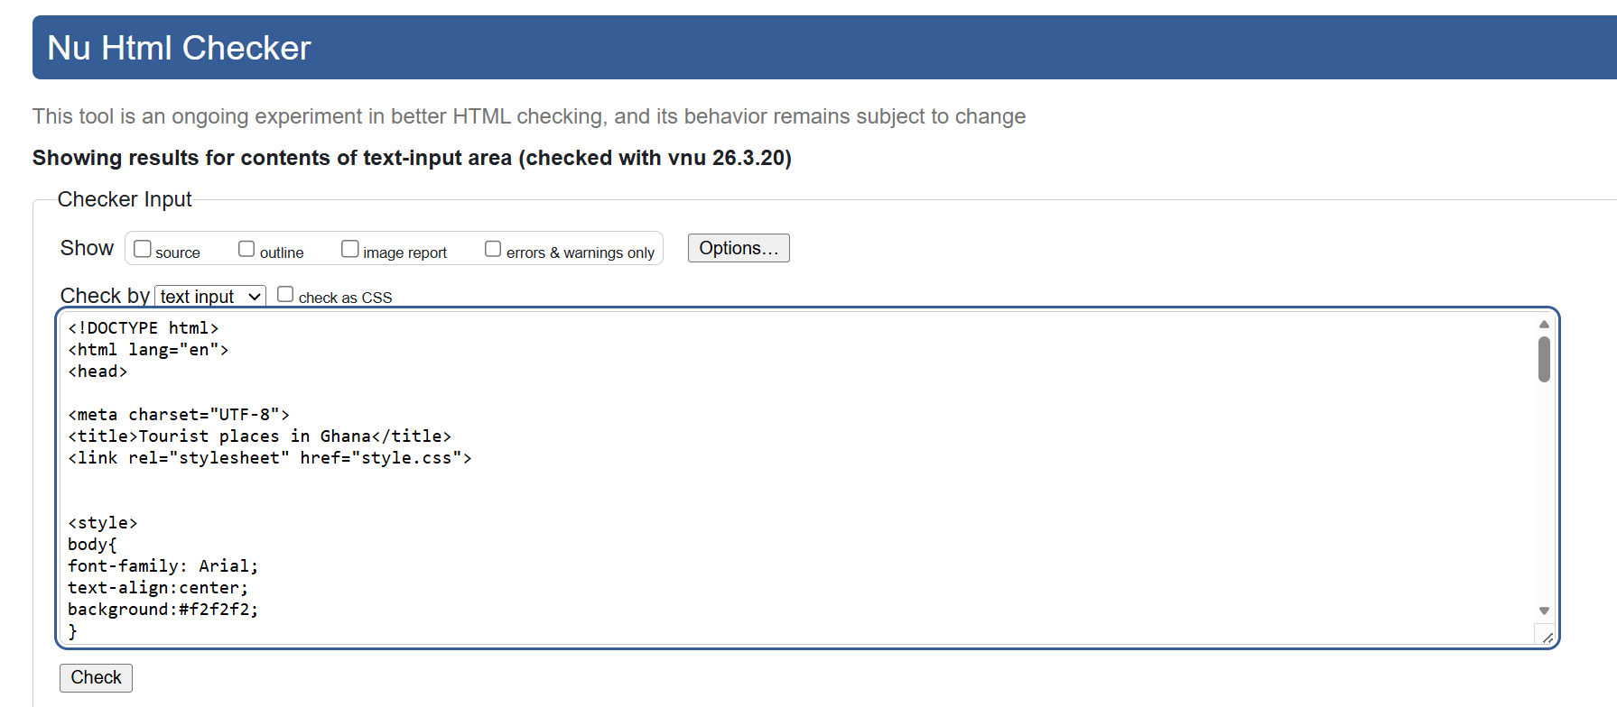
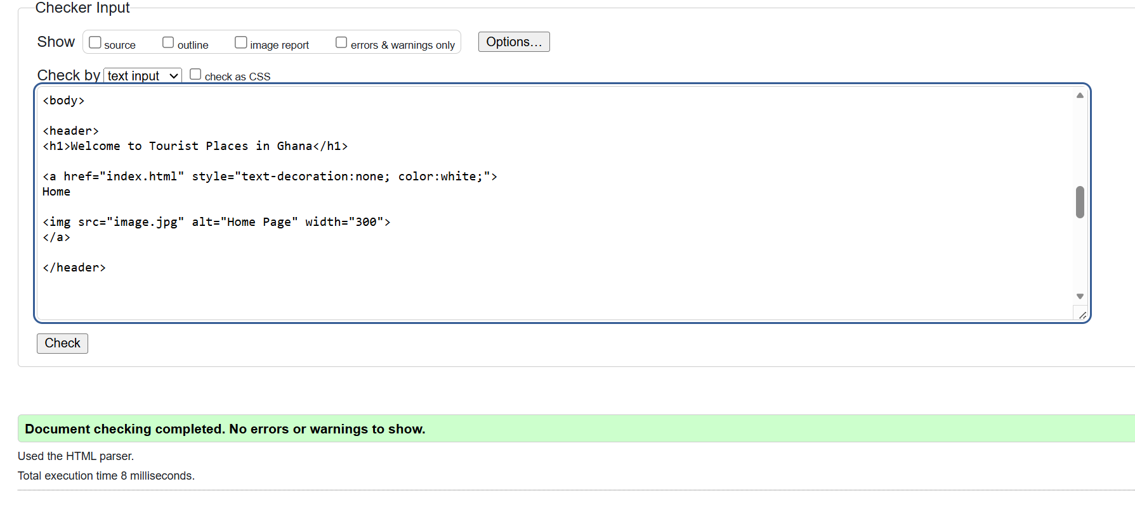

CSS Validation
In this section, include the screenshot of the validation of your CSS page
If you have any error in the validation, describe how you corrected that error and re-validate your home page and put the new screenshot here

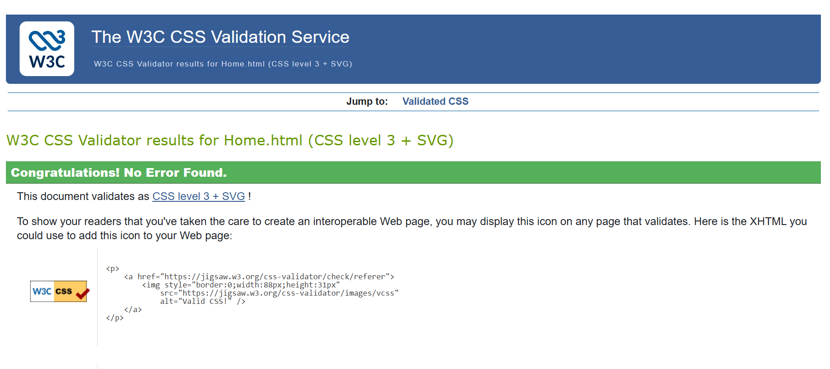

Evaluation

Part A (In this section explain your research on the following topics)

Website usability-
Describe and explain what website usability
When we talk about Website Usability, it describes how easy and efficient a website is for users to navigate, understand, and interact with. A website with good usability allows visitors to quickly find information, move between pages, and complete tasks without confusion or difficulty [1]. A good website usability is designed to make a clear and simple design so that users can easily understand how the website works. This includes having an organized layout, readable text, clear navigation menus, and fast loading pages. Considering the tourism website about Ghana, it should allow users to easily access pages like Home, Description, and Contact to learn more about attractions they need to explore. Website usability is important because it improves the user experience. When a website is easy to use, visitors are more likely to stay longer, explore more pages, and will love to visit again in the future. Good usability also helps users find the information they need quickly and makes the website more effective for its purpose.

Website accessibility:
Describe and explain website accessibility
Website Accessibility refers to designing and developing websites so that all people can use them, including individuals with disabilities. The goal of accessibility is to make sure that everyone, regardless of physical or technical limitations, can access and understand the content of a website. Websites that are accessible consider the needs of people who may have visual, hearing, motor, or cognitive impairments [2][5]. For example, users with visually impaired may rely on screen readers to read the text on a website. Because of this, web developers include features such as alternative text for images, clear headings, readable fonts, and good colour contrast to help users navigate the website easily. Accessibility also improves usability for many other users, like people using mobile devices, slow internet connections, or older computers. In short, website accessibility ensures that websites are inclusive and usable for everyone, allowing more people to access information and interact with online content

Search engine optimisation
Describe search engine optimization
Search Engine Optimization (SEO) is the process of improving a website so that it appears higher in the results of search engines such as Google Search. The main purpose of SEO is to make a website easier for search engines to understand and easier for users to find when they search for information online [3]. SEO involves using relevant keywords, clear titles, headings, and well-structured content so that search engines can index the website properly [4]. It also includes adding descriptions, optimizing images, improving page speed, and making the website mobile-friendly. These practices help search engines decide that the website contains useful and relevant information. In summary, SEO helps increase a website’s visibility on search engines, attract more visitors, and make the website more effective in sharing its information with users.

Part B

Usefulness (Usability and Utility)

Search Engine Optimisation (SEO)

Accessibility:

This website can be evaluated based on usefulness, search engine optimisation, and accessibility.

In terms of usefulness, the website is both usable and practical because it provides clear information about tourist attractions in Ghana. The navigation links make it easy for users to move between the Home, Description, and Contact pages, while the images and short explanations help visitors quickly understand the attractions being presented. Its utility is shown in the fact that it serves a real purpose by informing tourists, students, and other users about important places such as Manhyia Palace, Kakum National Park, Elmina Castle, and Kwame Nkrumah Memorial Park.

Regarding search engine optimisation, the website includes relevant content related to tourism in Ghana, which can help search engines understand its purpose. Using clear page titles, headings, and keywords such as “tourist places in Ghana”.

In terms of accessibility, the website has some useful features such as text content, headings, and images with alternative text, which can help users with different needs. Clear navigation also makes the website easier to use.

Part C (Provide the comparison of two Live Websites)

Area | Website 1 | Website 2
Weblink of the Website | visitghana.com | southafrica.net
Usability | Easy to use with clear menus such as places to explore | Focuses more on general categories and audiences that detailed attractions.
Accessibility | Has text headings, navigation labels and useful travel information that support accessibility. | Website appears more simpler and text based making it easier for users to read and navigate.
SEO | Strong in SEO because it contains more tourism related keywords. | Homepage shows less keyword-rich tourism content.
Mobile Friendliness | Mobile friendly because it has organised structure, sections and menu layout. | Mobile friendly with a clean layout and evidence of attention to digital user experience and platform performance.
Conclusion | Stronger in directly presenting tourist attractions and travel information. | More polished in its digital structure and overall organisation.

References:

[1] J. A. García-Berná, G. Pandiarajan, S. Ouhbi, J. Gross, and J. Nicolás, “Structured framework for joint software quality and environmental sustainability assessment: A case study in sports websites,” The Journal of systems and software, vol. 236, Art. no. 112798, June 2026, doi: 10.1016/j.jss.2026.112798.
[2] P. D. Parthasarathy and S. Joshi, “Accessibility Education for Software Engineers: Evaluating the Impact of Game-Based Learning,” ACM transactions on computing education, vol. 26, no. 2, pp. 1–47, June 2026, doi: 10.1145/3785367.
[3] J. V. N. Lakshmi, Integrating UX Design Principles into SEO strategies: From clicks to conversions, vol. 12, Dec. 2025.
[4] O. E. AJAYI, “Effect of Search Engine and Pay-Per-Click Strategies on Customer Engagement in Air Peace Nigeria,” International Journal of Management Research and Emerging Science, vol. 15, no. 4, Dec. 2025, doi: 10.56536/ijmres.v15i4.849.
[5] S. Shovkoplias, “Automated Semantic Alignment Assessment for Web Accessibility using large language models,” 2026.

Appendix
Provide the screenshots of HTML and CSS coding.



