Assessment 2 market research & website
BMSW4003 Digital Skills & Research Methods

Website login details
Email address: 1922307jc@gmail.com
Password: skippyDo05

Introduction

This report will include research conducted in preparation of my business plan and why the importance of market research can benefit my business idea. I will include findings of a questionnaire I composed and shared with family and friends and how those findings influenced my designing and creating a website for my business. I will analyse my results to make decisions with the designing of my website such as keywords to include and the prices of products that I will be offering.

Questionnaire design & analysis

Primary research can be an important start to helping you develop your potential business idea; it can help you form the basis of where your business is likely to sit in the market and future proof it before you even start. Although it can be more time consuming than secondary research, it can give first-hand information as to what it is people are looking for. It can also help to identify what is not so important to them and your potential customers. Knowing your market from the start can save you money in the long term. When doing primary research, you want to find out as much as you can about the customers that are likely to use your business. You will need to make sure your own preconceived ideas do not influence your potential market. When researching for a potential start up business, questionnaires are a great way of doing this. There are many ways and sites that can help you put a questionnaire together, you can download (Office 365) for a small fee and get access to questionnaires as well as other additional forms. Social Media is a great way to get questionnaires out for your research. A good selection of both quantitative and qualitative questions should be asked, you need a good selection to analyse accordingly. People’s opinions matter just as much as geographic data and having both of this type of Primary research can give you firsthand information, it allows you to analyse your market for your potential business growth. Questionnaires are a great way of doing primary research, and by analyzing the results it will give you a great starting block to work with, once a business has started or established it is still important to continue carrying out primary research to keep up with trends and competition. (Ackoff R 1989) Formulated a system known as DIKW for purposes to gain Data, Information, Knowledge, and Wisdom, and looking at his models you can see how to use your research to get the best from it. From my questionnaire findings I can see that people would rather have a customized homemade cake made for themselves or family compared to a shop bought one, although this can be more expensive, they are prepared to pay it. My business is based for allergy free goods, the bonus for me in this type of business is that supermarkets sell very limited cakes for those special occasions, they only offer a small choice for people with allergies. My questionnaire was generated to the public, and it was interesting to see that unless you have an allergy, most people do not know that much about allergies in general, so when doing more primary research going forward I will need to hit the people and market with allergies to be able to see the demand for my business. I will have to include a bit of secondary research to get a rough idea of statistics and numbers for potential customers especially when it comes to my local area before I do my primary research. My results from my small questionnaire also found that gluten and nut allergies are the two most known allergies, knowing this information gives me a good idea of what I am most likely to be asked to provide for my customers, it will help when I am buying stock as I do not want to over stock on items that are not likely to sell and potentially go to waste, resulting in me losing money. The results of my questionnaire can also help me when expanding as I can use this research to potentially access the gluten and nut allergy social media sites to advertise my business, this should help to get my business advertised and is a great way of gaining more primary research for the future of my business if I decided to expand.

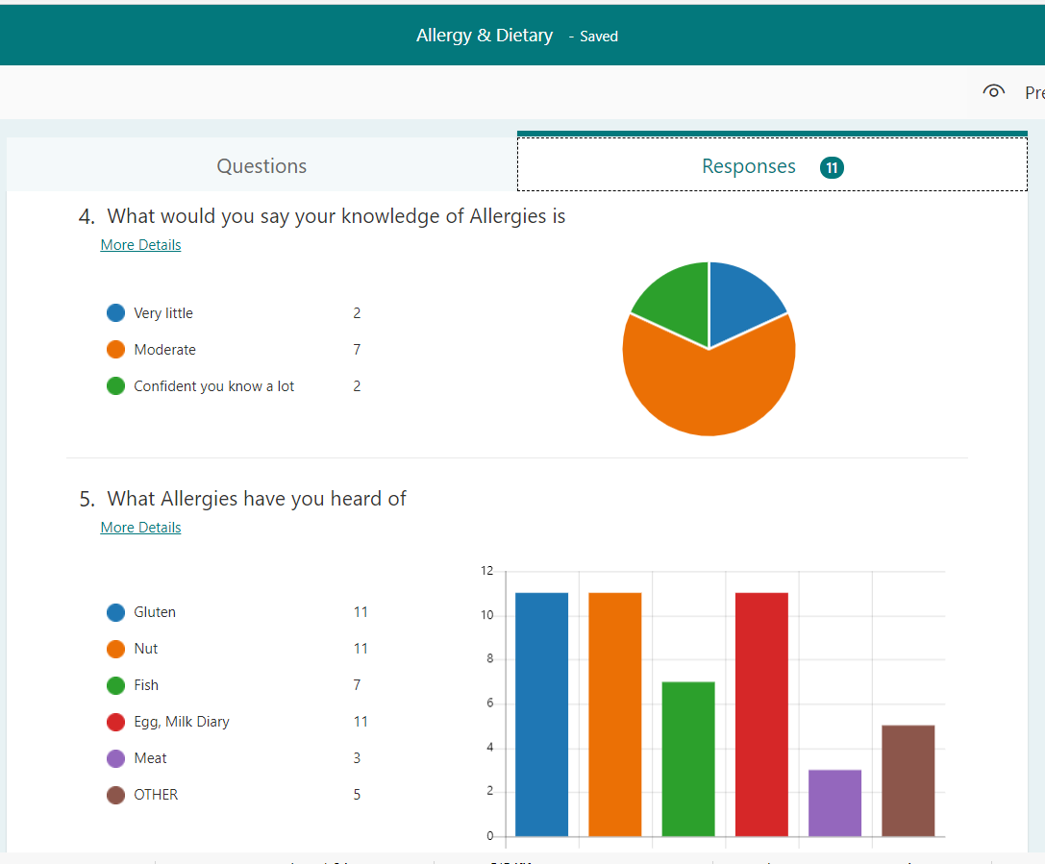

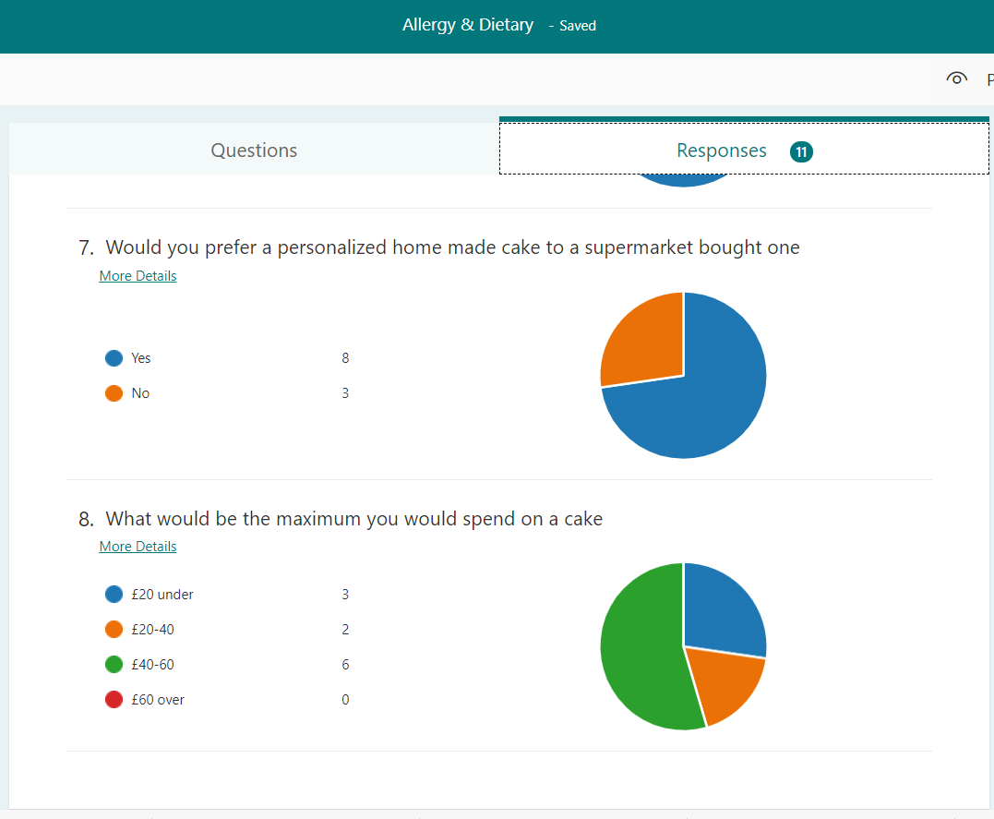

Website design

When creating my website, I looked at my questionnaire data to help me with how I should market products and pricing. The results of this have showed that people are willing to pay for homemade cakes, I have offered a selection of these and starting at low end for anything from a Victoria sponge to a bespoke homemade cake made for that special occasion. With Gluten, nut and dairy allergies being the three most heard of allergies, I have advertised these on my home page but also emphasized that I can cater for all allergies on the description of my products. My costings have also stated a starting price as my research indicates that I can charge more for that bespoke homemade cake especially for allergies that you cannot get in your local supermarket. My findings indicate people’s knowledge of allergies is not that good unless they themselves have or know of someone with an allergy. According to an article published by (verywellhealth) allergies are not something people are naturally born with and can take years to be diagnosed, this information should mean my business will hopefully only ever become more successful and keep gaining new customers as well as retaining current customers. I have imputed a contact and queries form on the website for customers to be able to contact me to also send in any questions direct to me for myself to be able to answer.
I have focused my website on all allergies and not just the most popular ones as I want to help anyone with any food allergy. Having coeliac disease, I have no choice but to follow a gluten free diet. I want to be able to give anyone in the same situation as me the opportunity to not miss out on being able to enjoy the same treats as any other person. My pictures and descriptions are to catch the eye of anyone with allergies, this might not seem like anything different from other bakeries but for someone with a food allergy who cannot just go and pick up anything they want in a supermarket it will be such a lovely treat. I waited 5 years to enjoy a birthday cake after my diagnoses and even longer to eat other treats. I have kept the website simple, but with mouthwatering descriptions of what they can have and hope they capture my love and enthusiasm of the goods and service I can provide. I have mentioned my background in having an allergy as I feel this is important, it also gives my customers awareness that I am in the same situation as them and shows my passion and love for my products. My key words used on the website are Allergies, location (Cardiff & Vale), products I offer (Cake, Brownies, Doughnuts etc.), homemade and social media, these are all words that will tell anyone who searches for me what the business is about and anyone who searches the internet using my keywords will have my website come up as an option so this will help me to gain customers.

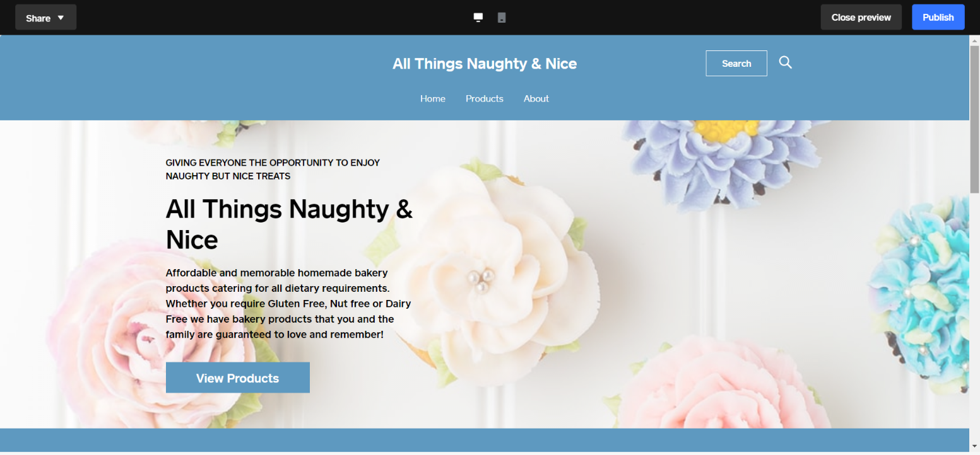

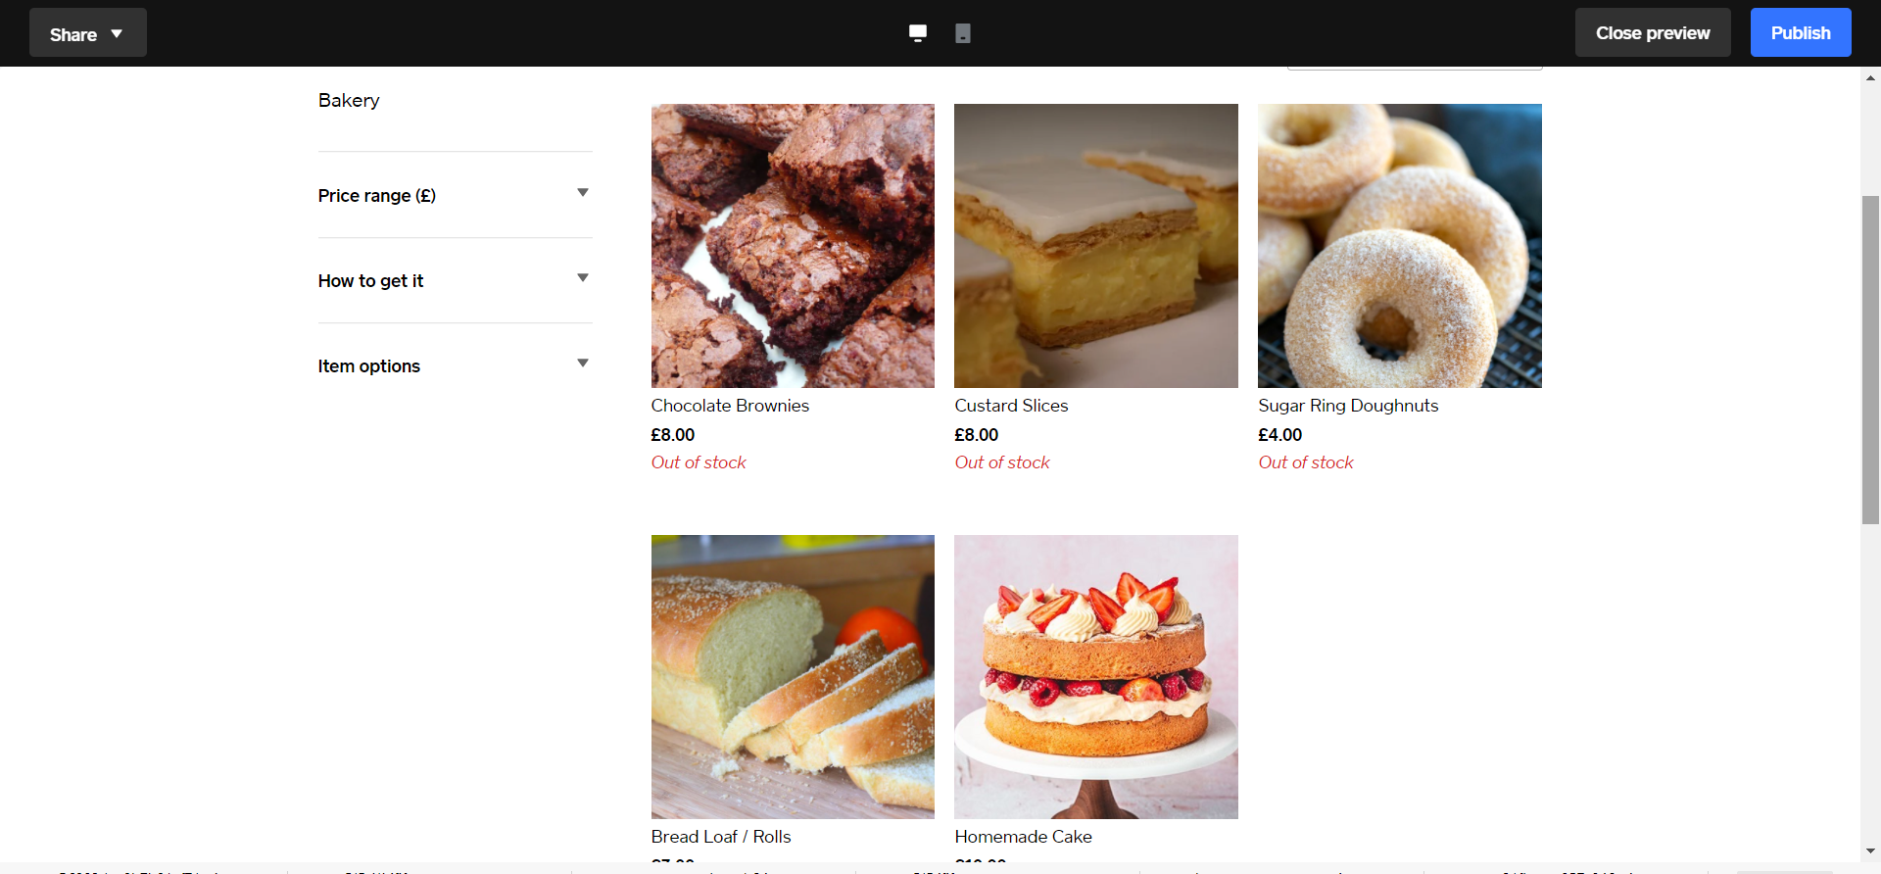
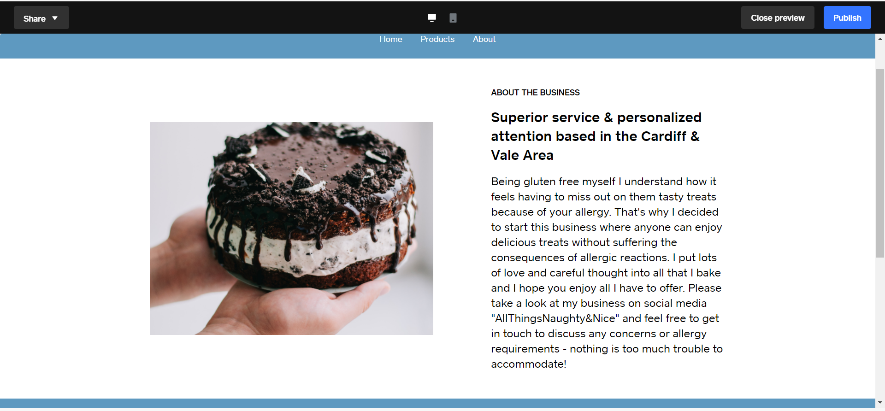

Conclusion

My primary research played a huge part in preparing to start up my business and designing my website, specifically my questionnaire which informed me of the most popular allergies and those I needed to focus on more as target customers. The information obtained helped me to decide on keywords and final prices of products for the design of my website and I have managed to create a business plan with the potential to be very successful and design an eye catching website to capture the attention of my target audience.

References

Compare All Microsoft 365 Plans | Microsoft

The DIKW model for knowledge management and data value extraction (i-scoop.eu)

You Can Develop a Food Allergy at Any Age (verywellhealth.com)

