Assignment One
Conference Research Paper

Sustainability in terms of Food waste and its efficacy

Title: Sustainability in Terms of Food Waste and Its Efficacy in the Hospitality Industry

Student Name: Daniel Fieraru
Student ID: 2232199

Module Title: Contemporary Themes in the Hotel and Hospitality Sector

Module Code: BMIH6001

Lecturer:
Natalie Brailsford,
Chris Wilkin,
Lola Vilard-Coles

Submission Date: 30/10/2025

Abstract:

Food waste in the hospitality industry is detrimental to the economy, society, and the environment. This study investigates many solutions for achieving transparency in the supply chain for food waste management, including blockchain technology, composting, waste-to-energy conversion, and intelligent inventory management in hotels and restaurants. The findings of academic research, reports from the industry, and case studies indicate that these solutions minimise the amount of food that is wasted, enhance operational efficiency, and exceed the expectations of customers about sustainability. Using the technologies that are already available, the findings show that larger businesses are able to reduce waste, whereas smaller organisations are limited in both their operational and financial capabilities. The education and conduct of consumers are the primary focusses of these campaigns. Several studies have demonstrated that the hospitality business may enhance its environmental and economic sustainability by reducing food waste through the utilisation of technology, consumer participation, and partnerships between the government and hotels.

Table of Contents
Abstract: 2
1. Introduction: 4
2. Literature Review: 5
Overview of Sustainability in the Hospitality Industry: 5
Food Waste in Hospitality: 5
Current Food Waste Reduction Strategies: 6
Effectiveness of Food Waste Management Practices: 6
3. Method: 7
Research Approach: 7
Analysis Tools: 7
4. Theme Impact Analysis: 8
5. Conclusion: 10
6. Recommendations: 10
Technological Innovation: 10
Consumer Education: 11
Government and Industry Collaboration: 11
7. References: 12

1. Introduction:

In the hotel industry, sustainability is of the utmost importance, particularly with regard to food waste. According to Ford and Sturman's (2020) research, hotels throw away thirty percent of the food that is produced by humans. Decreases in food waste contribute to increased corporate sustainability, the conservation of resources, and the reduction of emissions of greenhouse gases. According to Batabyal and Das (2019), the hotel industry needs to reduce food waste in order to achieve the sustainability goals of its customers.
In the hospitality industry, waste includes trash from customers as well as waste from meal preparation and serving (Zhang, Liu, & Lee, 2020). Both Nguyen and Tan (2021) Emissions of carbon dioxide and landfills caused by food waste are harmful to the environment. Food waste from hospitality establishments has an impact on the environment because it wastes resources and incurs disposal costs (Young et al., 2017). A company's image can be improved, money can be saved, and compliance with legislation can be achieved through environmentally responsible management of food waste, according to Trinh and Aung (2019). This report investigates the practises that hotels use to reduce food waste, as well as their effectiveness and the ways in which they might be improved to make them more sustainable (Costa & Costa, 2022).

2. Literature Review:

Overview of Sustainability in the Hospitality Industry:

Demands both now and in the future can be satisfied by sustainable hospitality. Therefore, it is necessary for the corporation to take into account economic, social, and environmental aspect (Batabyal & Das, 2019). Due to the fact that they serve both their clients and the environment, hotels, restaurants, and caterers are able to engage in sustainable practices. Sustainable hotel management is driven by the environmental concerns of customers and the limits imposed by the law. In accordance with the findings of the 2020 study conducted by Ford and Sturman, this sector places a premium on energy, waste, water, and food efficiency. Because of the changes that are occurring in the hotel industry, businesses need to make sustainability and profitability their top priorities (Costa & Costa, 2022). Because of these programs, less food is wasted.

Food Waste in Hospitality:

Both the economy and the ecology suffer when hotels throw away food. The majority of the world's food waste is produced by the hotel business, according to Nguyen and Tan (2021). This results in the emission of methane from landfills and the depletion of resources. According to Trinh and Aung (2019), the hospitality industry wastes between 10 and 30 percent of its food supply. Both businesses and the environment suffer when food is thrown away. The hospitality industry's carbon footprint and the amount of food that is wasted both increase as a result of the increased use of energy and water during manufacturing, transportation, and preparation (Zhang et al., 2020).
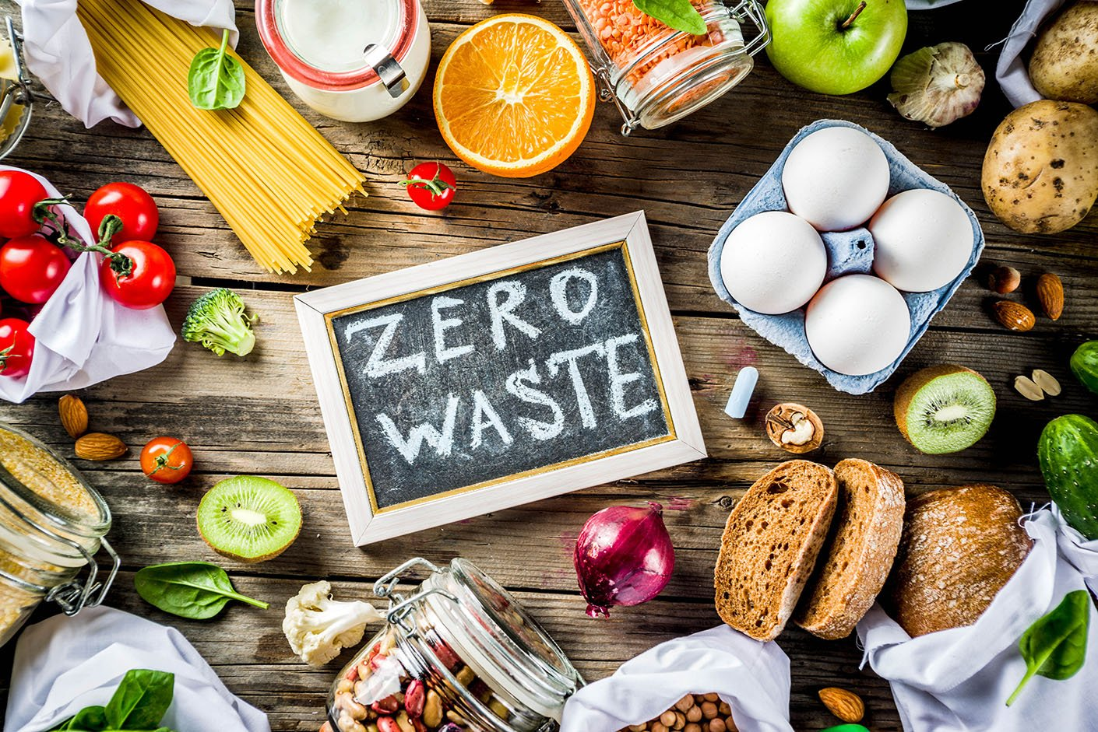
Figure 1: Zero waste (Hospitalityinsights.ehl.edu, 2020)
During the procurement, storage, preparation, and service of food, there is waste that does occur (Martin-Rios, Hofmann and Mackenzie, 2020). Buffet-style meals, excessive production, and inadequate inventory management are the three factors that contribute to food waste in hotels and restaurants, according to research conducted by De Laurentiis and colleagues in the year 2020. Due to the fact that consumers are looking for greener products, sustainable businesses need to reduce food waste. According to a study conducted by Ford and Sturman in 2020, small and medium-sized hospitality firms are responsible for the waste of food. Food that is wasted at hotels is detrimental to both the economy and the environment.

Current Food Waste Reduction Strategies:

Food waste is reduced, efficiency is improved, and sustainability is promoted through the hospitality industry. Composting, recycling of food, and converting trash into electricity are all ideas that have been presented. Beginning in the year 2020, include De Laurentiis. It reduces the amount of waste sent to landfills. It reduces the price of hotel rubbish management as well as the impact on the environment.
Composting food waste and recycling trash from hospitality establishments are two practices that Jiang et al. (2024) suggest for use in agriculture and gardening. Reducing food waste in landfills in a sustainable manner! Food that is reused and rotated is less likely to be wasted. According to Papargyropoulou et al. (2014), contemporary food inventory systems monitor consumption as well as information regarding expiration dates in order to reduce waste and overordering.
According to Jang and Lee (2022), businesses contribute or reuse any food that is left over. In addition to enhancing corporate social responsibility, it helps cut down on waste. Practice is necessary for these strategies to be effective. As a result of activities that require a significant amount of resources, Goossens et al. (2019) demonstrated that smaller businesses may have difficulty reconciling sustainability with profitability. Eco-friendly hospitality is supported by these solutions.

Effectiveness of Food Waste Management Practices:

The efficiency of reducing food waste is determined by both the scope and the approach. There are long-term environmental benefits associated with waste-to-energy and composting, according to Zhang et al. (2020), but these processes demand a significant initial investment and a commitment that is ongoing. This may be out of reach for businesses that are on a lesser scale. Goossens et al. (2019) state that intelligent inventory management has the potential to save money over time; however, small businesses who do not have the financial resources to invest in new technologies may be at a disadvantage from this perspective (Zeng, 2025).
It is possible that these initiatives will be hampered by a lack of customer participation and awareness. At the point of service, De Laurentiis et al. (2020) suggest instructing customers on how to regulate their portion sizes and reduce food waste. It is suggested by Jang and Lee (2022) that in order to foster sustainability, customers should be educated about the environmental consequences of food waste. However, the coordination of the supply chain is important. Despite the fact that there has been progress, it is necessary to evaluate sustainability strategies through the lens of their initial costs as well as their long-term benefits to the environment and the economy (Sarker et al., 2024).
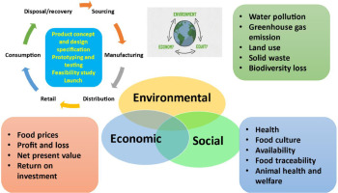
Figure 2: The three spheres of sustainability (Manzoor et al., 2024)

3. Method:

Research Approach:

The utilisation of case studies, industry reports, and journals are all components of qualitative research. in order to find sustainable solutions and to raise awareness about food waste in hotels. This research utilised secondary data in order to evaluate several strategies for reducing food waste in the hospitality industry as well as other food-related industries (Batabyal & Das, 2019; Costa & Costa, 2022). Studies that are currently being conducted on composting, the conversion of waste into energy, and consumer behaviour are mentioned.

Analysis Tools:

Food waste reduction strategies are evaluated using the PESTEL framework (Ford & Sturman, 2020). The PESTEL framework is utilised by Nguyen and Tan (2021) in order to assess the political, economic, social, technological, environmental, and legal aspects that have an impact on the management of hotel food waste. In the year 2020, case studies will highlight the measures that hospitality companies have taken to reduce the amount of food waste (De Laurentiis et al.). Jiang et al. (2024) thoroughly investigated and presented a wide variety of approaches to the management of food waste.

4. Theme Impact Analysis:

Environmental Impact:
Methane is produced by dumps located in hotels. For the sake of the ecology, hotels need to reduce the amount of food waste they produce. Composting results in a significant reduction in both the amount of food waste and the emissions of methane. Compost, much like synthetic fertiliser, is beneficial to soil. The authors Liu et al. (2023) suggest that composting lessens the impact that agriculture has on the environment and the carbon footprint of businesses. Food waste can be used to produce power through a waste-to-energy process, which converts methane from food bins into electricity. Tech: Scientists from De Laurentiis et al in 2020 This technology’s been found to create renewable energy and reduce waste, about making hospitality greener.
Food waste and pollution can be prevented using forecasting, portion control, charity. (Apparent overfitting was also observed when analyzing animals sacrificed in 24 hrs; data not shown) [53] and De Laurentiis et al. (2020), waste audits and pre-emptive planning were reported to have achieved a 50 percent reduction in the quantity of both wasted food and associated GHG emissions. According to Papargyropoulou et al. (2014) hotel industry is using this technology to achieve sustainability goals imposed by the government and demanded by the customers. Hotels have a role in reducing food waste to mitigate environmental impact (Mouat, 2022).
Economic Impact:
The expenses that hotels incur as a result of food waste are significant. Zhang et al. (2020) have estimated that the cost of food waste, manufacture, and disposal in hotels and restaurants will amount to billions of dollars. Spend less money on food waste by reducing it (Elisavet Angouria-Tsorochidou et al., 2023).
The reduction of food waste and expenses can be accomplished by the use of inventory control, surplus food reuse, and portion control (Ford & Sturman, 2020). According to Trinh and Aung (2019), hospitality businesses use technology that track and analyse food waste in order to evaluate waste and make decisions regarding food preparation and storage that are driven by data. By lowering the costs of waste disposal and increasing efficiency, technology is beneficial (Goossens, Wegner and Schmidt, 2019).
There is a possibility that this financial incentive will not be sufficient to convince small and medium-sized businesses to implement composting or trash-to-energy technology. Goossens et al. (2019) state that the decrease of rubbish, the generation of energy, and the loyalty of consumers to sustainable businesses all contribute to the offset of early expenses. Subsidies from the government for environmentally friendly technologies and practices might bring down these costs (Read and Muth, 2021). The cost of sustainability is high, but the benefits of decreasing food waste are substantial.
Social Impact:
Food waste reduction in the hotel industry is beneficial to society. Ethical and environmental issues are the driving forces behind sustainable behaviour strategies. Considering that consumers are concerned about the environment, decreasing food waste can be beneficial to the image of a company (Simone et al., 2015).
Education of consumers raises awareness of sustainable businesses and reduces the amount of food that is wasted (Jang & Lee, 2022). Customers should be encouraged to consume less food and to take leftovers in order to enhance sustainability. In the hospitality industry, reducing food waste helps firms attract customers who are ethical and environmentally sensitive (Ding, 2022). Increased social awareness improves the industry and alters the attitude of customers regarding sustainability.
Industry Responses:
Innovative approaches are used by hotels to cut down on food waste. Both Marriott and Hilton were pioneers in the reduction of food waste. Reduced food waste is one of the goals of the Marriott Serve 360 sustainability program. (Papargyropoulou et al., 2014) This is accomplished by optimising inventory and utilising extra food for the purpose of providing meals to employees or donating it to local charities. Travel with Purpose by Hilton has made a commitment to minimise food waste by fifty percent by the year 2030 and to invest in real-time tracking (Costa & Costa, 2022). This initiative is currently being implemented across all buildings.
This contributes to better industry sustainability. Miniature hotels are inspired by larger hotels. The reduction of food waste not only lowers operational expenses but also benefits the environment, which satisfies the expectations of consumers about sustainability (Sundin et al., 2024).

5. Conclusion:

Waste of food is detrimental to the economic, social, and environmental sustainability of the hospitality industry. Food waste can be reduced by the use of hotel composting, waste-to-energy, and inventory management; however, the effectiveness of these methods is contingent on the size of the hotel and the resources available (De Laurentiis et al., 2020; Costa & Costa, 2022). Food waste management was shown to be economical, environmentally friendly, and ideal for customer sustainability in the study that Zhang et al. conducted in 2020.

6. Recommendations:

Technological Innovation:

Food waste in hotels should be reduced via technology. Real-time food waste tracking systems, according to Omar et al. (2024), increase the efficiency of resource management and decrease waste. In the year 2020, De Laurentiis and colleagues discovered that utilising perishable commodities prior to their expiration date helps prevent waste and over-ordering. It is believed by Omar et al. (2024) that blockchain technology can record leftover food before it is transported to food banks and composters, so ensuring transparency along the food supply chain. According to Costa and Costa (2022), these technologies reduce waste and boost operational efficiency, which makes sustainability a strategy to hospitality that is both cost-effective and socially responsible.
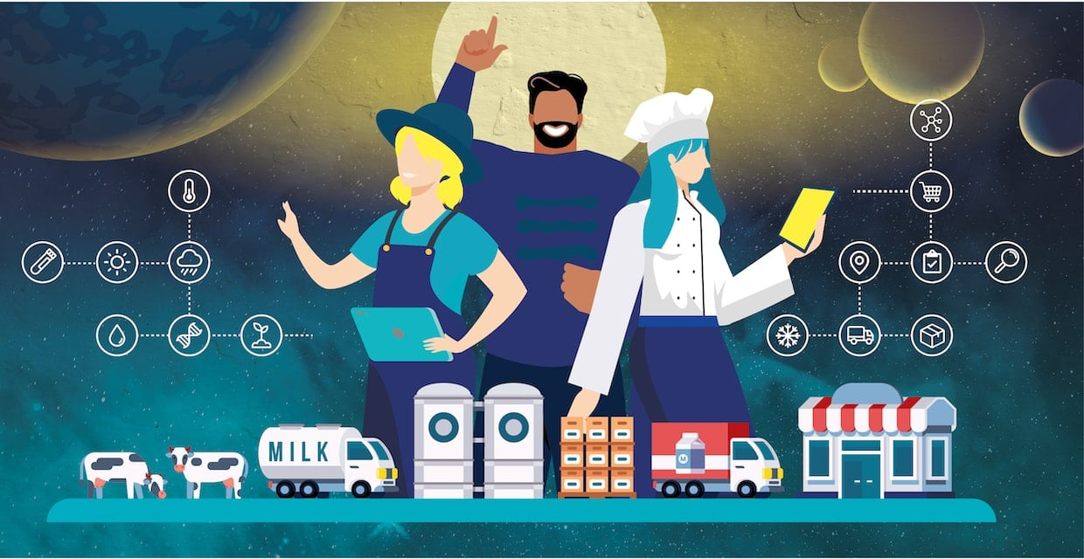
Figure 3: Sustainable food system (Foodnotify, 2022)

Consumer Education:

It is possible to reduce waste by encouraging ethical consumption and educating consumers about the environmental impact of food waste in the hotel industry. It is possible for restaurants and hotels to promote portion control, the separation of food waste, and the environmental impact of overeating by working with local communities and non-governmental organisations (Jang & Lee, 2022). Green businesses are popular among consumers; consequently, the reduction of food waste is dependent on these businesses. Educating people about sustainability is necessary in order to reduce food waste among consumers (Ding, 2022).

Government and Industry Collaboration:

Food waste prevention in the hotel business requires rules and incentives from both the company and the government. According to Goossens et al. (2019), small and medium-sized businesses have the ability to reduce food waste and segregate garbage by accepting tax incentives or receiving government subsidies. It is imperative that industry leaders advocate the decrease of food waste. (Papargyropoulou et al., 2014) Research has shown that composting and waste-to-energy conversion are beneficial to the hospitality industry, hotel chains, and local businesses. Collaboration transforms the competitive disadvantage that businesses face in terms of sustainability into a shared purpose, which in turn stimulates the industry (Despoudi et al., 2021). In the year 2020, De Laurentiis and colleagues discovered that sustainability awareness initiatives supported by the government can assist in reducing food waste in the hospitality industry.

7. References:

Batabyal, D. & Das, D.K. (eds.), 2019. Global Trends, Practices, and Challenges in Contemporary Tourism and Hospitality Management. Hershey, Pennsylvania: Business Science Reference.
Costa, V. & Costa, C. (eds.), 2022. Sustainability and Competitiveness in the Hospitality Industry. Hershey, Pennsylvania: Business Science Reference.
De Laurentiis, V., Caldeira, C. & Sala, S., 2020. No time to waste: assessing the performance of food waste prevention actions. Resources, Conservation and Recycling, 161, p.104946.
Despoudi, S., Bucatariu, C., Otles, S. & Kartal, C., 2021. Food waste management, valorization, and sustainability in the food industry. Food Waste Recovery, pp.3-19.
Ding, L., 2022. The effects of self-efficacy and collective efficacy on customer food waste reduction intention: the mediating role of ethical judgment. Journal of Hospitality and Tourism Insights..
Elisavet Angouria-Tsorochidou, Walk, S., Körner, I. & Thomsen, M., 2023. Environmental and economic assessment of household food waste source-separation efficiency in a German case study. Cleaner Waste Systems, 5, pp.100092-100092.
Ford, R.C. & Sturman, M.C., 2020. Managing Hospitality Organizations. 2nd ed. London: Sage.
Foodnotify. 2022. Sustainable Food System in Hospitality | FoodNotify Hospitality Blog. [online] www.foodnotify.com. Available at: https://www.foodnotify.com/en/blog/sustainable-food-system-hospitality. (Accessed on: Oct 10th, 2025).
Goossens, Y., Wegner, A. & Schmidt, T., 2019. Sustainability Assessment of Food Waste Prevention Measures: Review of Existing Evaluation Practices. Frontiers in Sustainable Food Systems, 3(3).
Hospitalityinsights.ehl.edu. 2020. Food waste management innovations in the foodservice industry. [online] Available at: https://hospitalityinsights.ehl.edu/food-waste-management-innovations. (Accessed on: Oct 10th, 2025).
Jang, H.-W. & Lee, S.-B., 2022. Protection Motivation and Food Waste Reduction Strategies. Sustainability, 14(3), p.1861.
Jiang, S., Chen, H., Shan, P. & Wang, X., 2024. Efficacy of informational intervention on food waste: Evidence from a randomized controlled trial. Journal of Cleaner Production, 443, pp.141106-141106.
Liu, X., Li, S., Chen, W., Yuan, H., Yong, M., Muhammad Ahmar Siddiqui & Iqbal, A., 2023. Assessing Greenhouse Gas Emissions and Energy Efficiency of Four Treatment Methods for Sustainable Food Waste Management. Recycling, 8(5), pp.66-66.
Martin-Rios, C., Hofmann, A. & Mackenzie, N., 2020. Sustainability-Oriented Innovations in Food Waste Management Technology. Sustainability, 13(1), p.210.
Manzoor, S., Fayaz, U., Dar, A.H., Dash, K.K., Shams, R., Bashir, I., Pandey, V.K. and Abdi, G. (2024). Sustainable Development Goals Through Reducing Food Loss and Food Waste: A Comprehensive Review. Future foods, 9(100362), pp.100362–100362. doi:https://doi.org/10.1016/j.fufo.2024.100362.
Mouat, A.R., 2022. Sustainability in food-waste reduction biotechnology: a critical review. Current Opinion in Biotechnology, 77, p.102781.
Nguyen, T. & Tan, S., 2021. Food waste in the hospitality industry: A global perspective. Journal of Sustainable Tourism, 29(1), pp. 54-75.
Omar, I.A., Hasan, H.R., Jayaraman, R., Salah, K. & Omar, M., 2024. Using blockchain technology to achieve sustainability in the hospitality industry by reducing food waste. Computers & Industrial Engineering, 197, p.110586.
Papargyropoulou, E., Lozano, R., Steinberger, J., Wright, N. & Ujang, Z. bin, 2014. The food waste hierarchy as a framework for the management of food surplus and food waste. Journal of Cleaner Production, 76(76), pp.106-115.
Read, Q.D. & Muth, M.K., 2021. Cost-effectiveness of four food waste interventions: Is food waste reduction a ‘win–win?’ Resources, Conservation and Recycling, 168, p.105448.
Sarker, A., Ahmmed, R., Ahsan, S.M., Rana, J., Ghosh, M.K. & Nandi, R., 2024. A comprehensive review of food waste valorization for the sustainable management of global food waste. Sustainable Food Technology, 2.
Simone, M., Jorge, C.G., Cristina, Michele, G., Alessandro, V., Sala Serenella, Saouter Erwan & Tuomisto Hanna Leena, 2015. Improving Sustainability and Circularity of European Food Waste Management with a Life Cycle Approach.
Sundin, N., Malefors, C., Strotmann, C., Orth, D., Kaltenbrunner, K., Obersteiner, G., Scherhaufer, S., Sjölund, A., Persson Osowski, C., Strid, I. & Eriksson, M., 2024. Sustainability assessment of educational approaches as food waste prevention measures in school catering. Journal of Cleaner Production, 481, p.144196.
Trinh, T.T. & Aung, D., 2019. Sustainable practices in hospitality: A review of current research. International Journal of Hospitality Management, 73(4), pp.120-130.
Timur Liwinski, Bocek, I., Schmidt, A., Kowalinski, E., Frieder Dechent, Franziska Rabenschlag, Moeller, J., Sarlon, J., Brühl, A.B., Nienaber, A., Lang, U.E. & Huber, C.G., 2024. Sustainability initiatives in inpatient psychiatry: tackling food waste. Frontiers in Psychiatry, 15.
Young, C.W., Russell, S.V., Robinson, C.A. & Chintakayala, P.K., 2017. Sustainable Retailing - Influencing Consumer Behaviour on Food Waste. Business Strategy and the Environment, 27(1), pp.1-15.
Zhang, H., Liu, M., & Lee, Y., 2020. Reducing food waste in hospitality industry: A framework for sustainable practices. Tourism Management, 81, pp. 92-104.
Zeng, T., 2025. A Realist Review of the Effectiveness of Sustainable Food Packaging Interventions in Food Waste and Healthy Eating. Journal of Food Quality, 2025(1).

