Task 1

Relevant areas of the National Policing Curriculum:
Wellbeing and Resilience

Having achieved Independent Patrol Status, reflect on the impact of organisation culture within policing on your wellbeing and resilience (organisation change, retaining personal values in a wider organisational culture).

Consider the risks of conforming to organisational culture.

Illustrate your strategies for maintaining wellbeing and resilience.

1250 words (+/- 10%: include your actual word count at the end of each section)

ANSWER:

A both proud and iconic moment in my life came when I had achieved Independent Patrol Status as a police officer. Given my past knowledge and everything I had learned about the police all over the world, the experiences I had had as both a Special Constable, during initial training to become a regular officer and my meagre four to five weeks of tutorship, I believe that I gained valuable lessons in what some of the cultures within policing were.

As a generally outspoken, passionate, friendly, and approachable individual, I have always enjoyed and will continue to enjoy introducing myself to new people, regardless of any characteristics, lifestyles or beliefs.

I have also always been extremely aware of some people’s hostility towards police, given that it is a worldwide institution, that has been in place for centuries, dating back to the use of ‘prefects’ in ancient China.

These hostilities, I have always believed, may have stemmed from a combination of an individual’s experiences or how they may have been treated by police, bad publicity, or even austerity caused by ‘word of mouth’ leading to negative public perception.

Like any organisation that has ever been established and has had a long tenure, policing has had its fair share of bad publicity through the centuries. UK policing is no different, being plastered over tabloid newspapers and other media outlets on a regular basis, painting the police as a racist, sexist, misogynist, secretive or murderous institution.

According to Handy’s model of ‘Organisational Culture’, any given company or organisation is categorised into four types (‘Power culture’, ‘task culture’, ‘person culture’ and ‘role culture’) where the Police force falls into the ‘role culture’, essentially entailing that all police officers and staff are assigned roles and responsibilities based on their expertise or skills.

Given my own unique set of personal values, coupled with my blessed common sense and often cautious-speaking nature, I am fully aware of the pitfalls of not knowing one’s ‘audience’ and always treating my words and actions with a certain degree of tact, rationality and vast respect.

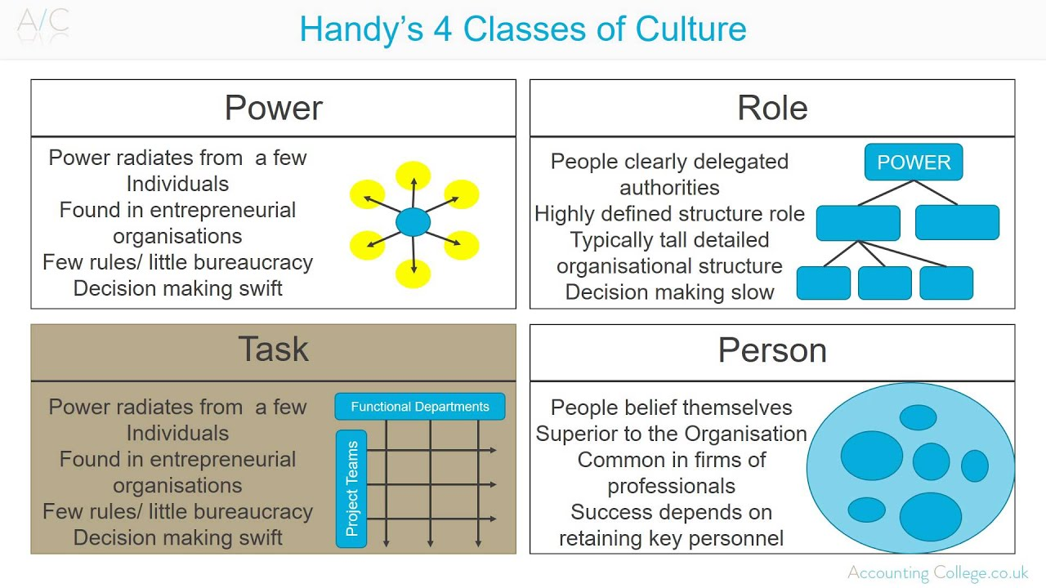
Diagram detailing categories and sub-categories of Charles Handy’s Organisational Culture Model

One such example of this is conveyed by one such experience that I was recently involved in. This incident involved a much older, and so-called ‘experienced’ colleague, where they had made reference to a quote from a well-known show that used to air on British television back in the early 2000’s. They made this quote while we were all gathered as a team one night after a particularly tough shift in which we had had no choice but to be as proactive and constantly focused as possible, with G1-graded calls coming in seemingly endlessly. Due to the nature of some of the calls, as is with the character of our team and how we deal and cope with some of the grief and anguish that the workload can sometimes place upon us, it is, more often than not, thought of as a ‘go-to’ to inject levity and a touch of comedy into our day-to-day conversations.
The quote itself had been delivered off the back of a few hearty comments from colleagues and I, which had all seemed to have had a positive impact, and the mood up until a point had seemed to have lifted in the room. It seemed that the grey cloud had parted somewhat, until the moment the quote was spoken.
I felt immediately awkward, given the palpable tension I could feel, which had struck like a bombshell, leaving samples of sour-taste around the room like shrapnel.
The impact of the comment was made known about its inappropriate context immediately by myself and others to our brazen colleague, and they seemed at first quite pensive about admitted their wrong doing. I attempted to speak my mind in their direction, underlining the use of ‘banter’ in the workplace whilst keeping them informed of how certain words and terms, while might not holding any malice, might be deemed malicious to some.
I would like to think I handled this particular situation quite well, and I had seemed to open up a proverbial can of worms when I had started to speak my mind, inviting other colleagues to invest their own thoughts and feelings into the matter, weighing in and seeming to assist our colleague.
My colleague made it obvious in the immediate aftermath of the incident that they did not want to converse with me and I took this in my stride, but some weeks later they took me aside and we were able to amicably resolve any dispute, with them explaining they felt embarrassed at the time, but that they held no grudge given one of the core values of what we represent is to ‘challenge inappropriate behaviour’.
Given both my former tutor and colleague’s feedback, I believe that I handled the situation reasonably well, and would be happy to challenge anyone who makes inappropriate or out-dated references or comments, whether they might believe them to be just or unjust. I do however think that maybe speaking with my colleague while we are separated from the group might have also been a viable option and may consider this should something similar occur in the future.

I have experienced both first and second-hand conformity to another person’s behaviour throughout my life and have been guilty on more than one occasion of mimicking the behaviours of others, or even recycling the odd joke I have heard from a different social circle or even off the television.
I believe that I have garnered a significant amount of life experience and believe that contrary to a famous quote, imitation is not always the most sincere form of flattery.
It is my belief that the role and honour of being a serving police officer comes with not simply a great amount of power, but an even greater amount of responsibility and I shall always strive to be my best self, ignoring the lures of peer-pressure and any social ‘status-quo’, instead choosing to follow my own paths.
I believe that this does now and will forever be the way I conduct myself, which I also believe I use subconsciously to maintain my own immense pride, thus informing my positive outlook on life, a healthy sense of wellbeing and a belligerent, undying resilience.
It is also my belief that those who may conform to any culture, not just the police culture, lose a huge part of their souls and of themselves along the way.
There is a lot to be said for those who let others dictate the way they become in their lives and it is my strong belief that a police officer should be a shepherd, rather than the sheep. They should be beacon of light for the public in their hours of darkness and I believe that it is dangerous for a rotten apple to be placed in an otherwise healthy orchard.
Personally, as I move forward and hope to progress into the future as a police officer, my strategies to ensure my wellbeing are (aside from always conducting myself in a proud, positive and professional manner) to never be afraid to seek the assistance and approval of my peers and loved-ones, to challenge adversity inside and outside of the workplace, and to keep doing what I love doing for as long as I physically and mentally can.

(1,220 words)

Task 2

Relevant areas of the National Policing Curriculum:
Decision-making and Discretion, Vulnerability and Risk, Public Protection.

You must choose an incident, for example a domestic related incident, and reflect on how you made decisions in complex and unpredictable circumstances using dynamic risk assessment.

Give a brief description of the problem including social and legislative contexts and any relevant cultural, ethnicity and language issues.

Evaluate decisions made during the incident and your use (or otherwise) of the National Decision Model. Explain the rationale behind your decisions and your considerations when recording details of the incident. Consider your ethical approach to the decision. Outline the consequences of your decision making.

1750 words (+/- 10%: include your actual word count at the end of each section)

ANSWER:

‌ The following essay shall consist of an account of an emergency call that I have recently attended. I shall be documenting and referring to steps I have taken at the scene, whereby I have used dynamic risk-assessment of any threats posed.

I shall explain and convey my knowledge of domestic incidents and also the regularity of domestic incidents that are reported in England and Wales.

I shall also refer to and utilise the ‘Borton Development Framework’ in order to analyse the incident and to reflect on any learnings I have gained.

I shall also reference to the National Decision Model (N.D.M.) to underline my thought process while dealing with the situation and mentally processing what I was faced with. I shall also allude to the police code of ethics, as well as the Police and Criminal Evidence (P.A.C.E.) act 1984 and any relevant legislation that refers to individual aspects of the incident itself.

I recently attended a call that was reported as a male assaulting another male in a private address, situated in a particularly well-known area of Swansea.

The area in question is a well-known ‘hot-spot’ for incidents involving crime, ranging from criminal damage to incidents of residential and commercial burglary, to vehicles which are taken without owner’s consent, and, perhaps the most frequent of incidents, which are ‘domestic-related’.

The report for the incident stated that the males were father and son, with the latter being the reporting person, stating that he had attended at his father’s home and had subsequently been punched by him after entering the home.

According to the Home Office, ‘domestic abuse related crimes are defined as any incidence of threatening behaviour, violence or abuse (psychological, physical, sexual, financial or emotional) between adults, aged 16 years and over, who are or have been intimate partners or family members, regardless of gender or sexuality.’

As a serving police officer dealing with many response calls – many of which are related to emergency calls of a domestic nature (including domestic abuse, stalking and harassment) – I am often tasked with attending a call involving reported violence committed by one family member toward another, or from one party to another that have somehow been intimately connected in the past.

Many calls, when attended, transpire to not actually involve any domestic-related violence which a police officer may deem warrants an arrest (where the officer acts in accordance with section 24 of the Police and Criminal Evidence act 1984), where an offence is committed, grounds to arrest are determined, as well as a necessity to arrest exists, therefore deeming the arrest ‘lawful’.

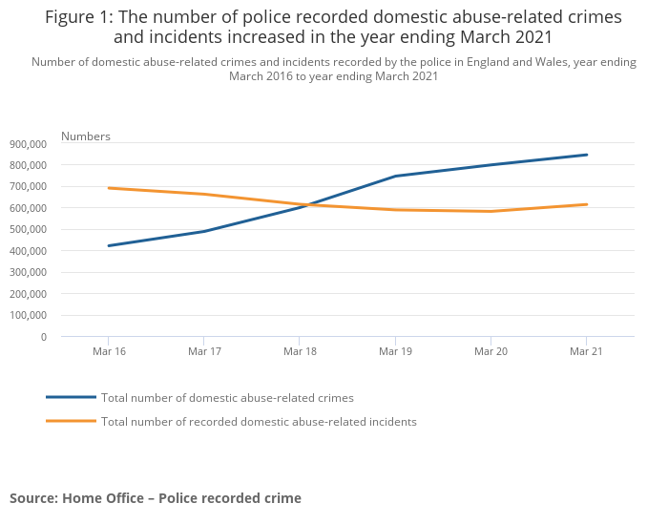

When dealing with any incident involving reported domestic abuse, police officers have a duty to take what is referred to as ‘positive action’. This often means making an arrest of one or multiple parties but can also mean simply separating parties where no offences are disclosed. The option to take the latter approach is something we as officers must justify, such is our sometimes ‘risk averse’ culture.

Upon attendance at the aforementioned incident, the reporting person (I shall refer to simply as ‘Mikey’) was stood outside the address with what appeared to be a very agitated German Shephard dog, which was barking violently towards my colleague and me.

I considered the immediate risk posed by the aggressive animal present. Subconsciously, I immediately began to process the ‘National Decision Model’ and began to quickly develop both a working strategy while identifying the options I had at my disposal.

These options, I decided, ranged from unholstering my PAVA spray in an attempt to pacify the dog, to simply speaking toward the owner to calm the dog down.

As the thoughts flowed through my head, I rapidly decided that the administering of PAVA was at the very worst case-scenario-end of my scale, so I decided, that with an increase in the volume of my voice so as to be heard over the dog’s barking, that my best option was to simply converse with Mikey.

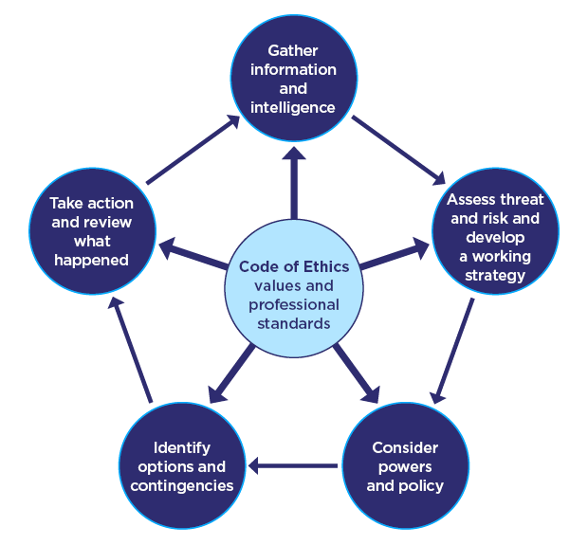

The National Decision Model – www.college.police.uk

Mikey was able to gain control of the dog rather easily and so a civilised conversation was achieved shortly thereafter. The smell of alcohol was emanating from Mikey, and this was acknowledged by a telling nod from my colleague as our eyes met briefly, although Mikey was able to make sense in what he said, as he disclosed to us his version of events leading up to him calling 999.

My colleague entered the address to speak with whoever was inside at my request, as I carefully observed the dog’s behaviour begin to calm and diminish, and I had noted that Mikey had a strong grip on the reinforced lead attached to the dog’s collar, should its behaviour escalate again. Using the NDM again in my head, I knew that my colleague was taser trained so as to enter the property alone, but I also asked that they try to remain near the open front door so that I could keep my eyes on them at all times.

My colleague emerged from the property, which transpired to be the address of Mikey’s father (who I shall refer to as ‘Frank’). My colleague quietly disclosed to me that Frank had sustained a rather large became apparent rather large bite mark on his forearm, which was bleeding under the kitchen towel that he was applying to the site of the wound.

It eventually transpired, given the accounts of both parties that Mikey had barged his way into Frank’s address with his dog in tow. Mikey had currently been homeless and had recently been given a place to stay at Frank’s but this had “turned sour” in Frank’s words, and that the temporary living arrangement had become inviable.

What had begun as a slight verbal altercation between father and son had resulted in Mikey’s dog having a seizure, before awaking from a fit in a disorientated state and sinking its teeth into Frank’s arm.

Mikey broke down into tears, telling us that he had made up the alleged assault from his father, his heart appeared to be breaking as he informed us that he was living in a homeless shelter and had an overbearing alcohol addiction that was slowly “destroying him”.

I had had time while my colleague spoke with Mikey, to assess my options in how to best deal with the situation, and how to provide ‘positive action’.

Given the little previous knowledge of the ‘Dangerous Dogs Act’ from a previous incident, combined with the prospect of what other police services could assist and the love I have for animals (particularly dogs), I decided along with my colleague, that we should gain the expertise of our sergeant, and the assistance of our dog handlers.

Frank had also become upset by this point, repeatedly crying out that he did not want to pursue a complaint as he loved his son dearly and was also a “huge dog person”.

The possibility of a huge risk to other members of the public was quite obvious to me, but I decided to call in our dog-handler colleagues, known as ‘DTO’s’.

My colleague and I devised a plan with our specialist colleagues. Following their intervention and advice, it was decided that we were to convey the dog to a local out-of-hours veterinarian clinic. Here, under the dog handlers’ supervision, our hands were tied as we had to watch as the veterinarians put the 6-month-old dog down, as it was explained to us that the seizure had likely been the root-cause for the dog’s uncharacteristic outburst.

In conclusion I believe that I dealt with the incident quite well, given I had gained a reasonable amount of experience dealing with domestic abuse at this point, and that my knowledge of legislature surrounding dangerous dogs was very limited. The emotional effects of witnessing Mikey being informed by our specialist colleagues that the decision had been made to euthanise his dog stuck with me for a number of weeks following the incident and the psychological effects of witnessing the dog slip away following the veterinary injections still resonate with me today. I have found that taking a human approach and trying to see the funnier side of any harrowing situation I endure has always helped me to process complex emotions in my own way and spending time with my family – my own dog in particular – has helped me to grieve the death of the German Shephard. In relation to the incident itself, I believe I conveyed myself in an extremely professional manner and was able to adequately process all the information, intelligence, and first-hand observations I had gathered both en-route to the incident and upon initial attendance. I believe I used a combination of common sense, in conjunction with an internal processing of the NDM to take the best possible courses of action at every step as I did not deem an arrest necessary and taking the decisions to provide my colleague directions and also making the decision to involve specialist colleagues.

In reflection, I believe that given the chance to deal with this situation again I would conduct myself in much the same regard. I believe there was plenty of opportunity for something to go awry, and was pleased with my actions and conduct while dealing with the incident, despite the depressive emotional aftermath caused by the tragic event that had unfolded. I did not consider medical assistance at scene for Frank’s bite mark, as my colleague had stated it was bleeding but seemed quite negligible, so perhaps I would assess this situation differently given the time again.

(1,594 words)

‌

Task 3

Relevant areas of the National Policing Curriculum:
Maintaining Professional Standards, Leadership and Team-working

Evaluate theories of team dynamics as a means of developing team cohesion (reasons why some teams cannot function, theories and models relating to team dynamics, ways to improve team cohesion).

Consider why inter-personal conflict can occur within a team and outline what strategies can be adopted to enhance individual and team performance.

Consider how team dynamics within the police service can result in failing to comply with professional standards requirements (Code of Ethics, policies, procedures, protocols or legislation).

1750 words (+/- 10%: include your actual word count at the end of each section)

ANSWER:

The following essay will focus on certain theories of team dynamics as a means of developing team cohesion and shall include reasoning behind why certain groups or teams of individuals do not function as well as others.

I shall utilise and explain theories and models relating to team dynamics such as the ‘Tuckman Model’, the ‘Drexler/Sibbet Team Performance’ model and the ‘DISC’ model which focuses more on conflict management. I shall also allude to the police Code of Ethics and shall be aiming to delve into other topics such as team-building, collaboration and performance, as well as the prospect of team dynamics and how all of these elements are incorporated into working within the police force.

It is my intention and hope that I take any learnings from my writing and apply them to my own personal journey within the police force, building and collaborating with my current team and any team I am inducted into in the future, as well as passing on my learnings and views to others going forward.

Within a specified group setting, where individuals collaborate to achieve set objectives such as the completion of a task, plan or project is what is commonly referred to as ‘team dynamics’. Each member of the group brings their own unique characteristics and skill sets into the equation and the team dynamics dictate how each member communicates with each other. A barometer of good team dynamics is the effectiveness of the relationships built between members and how clear and concise the communication between each member is.

Team cohesion can form both positive and negative results, with the negative including the team believing they are faced with unrealistic goals, individuals within the team feeling alienated as the team splinters into sub-groups or ‘cliques’ and an increased sense of competitiveness with those outside of the team.

On a more positive note, a positive team cohesion can lead to team members feeling valued and recognised for their contribution. A positive and vibrant team that is cohesive can make each individual feel as though they have all played their own unique, albeit vital roles towards achieving the objective.

One of the most popular theories relating to group dynamics and development (which acts as an umbrella for many things such as team building and cohesion) was created by American Psychological Researcher Bruce Tuckman in 1965, this theory is colloquially referred to as ‘Tuckman’s Stages of Group Development’- or more simply – ‘Tuckman’s Ladder’ or more commonly the ‘Tuckman Model’.
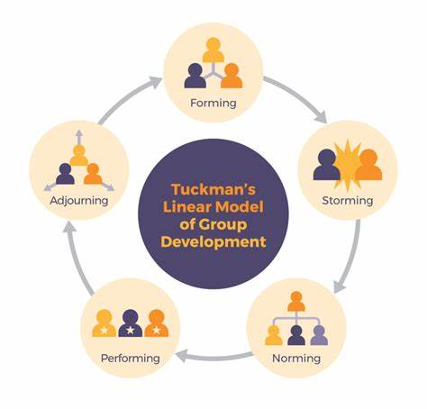

Tuckman’s Stages of Group Development Model – kpu.pressbooks.pub

The model, which upon inception had consisted of four-stages, now consists of five, with the addition of the ‘adjourning’ stage.

The model essentially a way of how teams can develop and/or grow over time. The five stages, as detailed in the above diagram, relate to how members of the team communicate and interact with the task at hand, with each other, and with their ‘leaders’.

The ‘Forming’ stage – The first step in any group or team, where they are initially ‘put together’ and are anxious about what lays ahead, or unsure about what the team’s vision or objective may be.

A strong, empathetic, enthusiastic and experienced leader is always the most appropriate to be put in the position of ‘leader of the pack’

The ‘Storming’ stage – This stage is commonly at an early stage in the process and is commonly where the individual characteristics or traits of the individual come to light, which can sometimes lead to negative interpersonal relationships within the team

It is common at this stage for members within the group to challenge or rebel against any objectives set by their superiors or leaders, so it is important for those leaders to monitor their members closely.

The ‘Norming’ stage – Commonly, and more often than not, naturally, the team will begin to ‘gel’ at this stage, overcoming and setting aside their differences.

The team, according to Tuckman begins to settle into a ‘comfort zone’ and start to abide by ‘norms’.

The ‘Performing’ stage – Generally where interdependencies formed during the previous two stages start to pay dividends and where the team will focus more on team effectiveness as opposed to interpersonal dynamics, thus improving the team’s overall productivity and creative output.

The ‘Adjourning’ (or ‘mourning’ stage) – The most recent addition to the theory (which was added in 1977 by Tuckman and Mary Ann Jensen) is where the team’s objective or project ends, or when a team disbands. It is common for those within a team who have built strong relationships or friendships with others, to find this stage extremely difficult.

In terms of adapting this theory to members of the police force, new teams and ever-evolving teams form a persistent theme. When a new officer begins their journey they are provided with so much information in the initial training phase and are usually plucked from a plethora of different backrounds. When put together with either new people during training, or through their careers being introduced to new members, new departments or inducted into new roles, any member of the police force will hit a ‘reset’ buttong depending on what stage of Tuckman’s model they find themselves at, and will revert back to the ‘forming’ stage, in order to be set new targets, align themselves with new sergeants, constables fresh out of training, special constables or PCSO’s they may not have met before before having new targets to achieve.

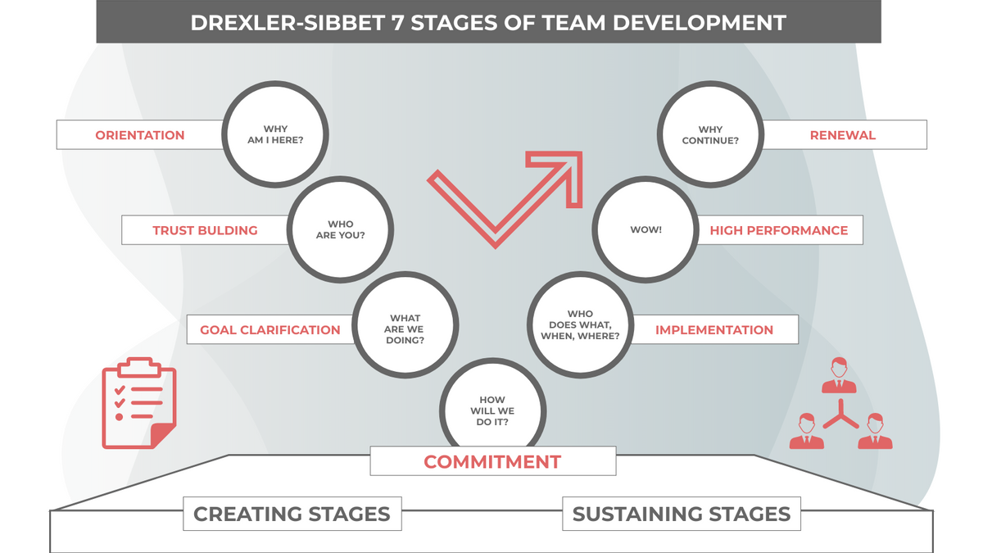
The Drexler-Sibbett Model – online.visual-paradigm.com

The Drexler-Sibbet Team Performance model was created and developed during the 1980’s by Allan Drexler and David Sibbet and is comprised of seven stages that are divided into two groups (these being ‘creative stages’ (comprised of ‘orientation’, ‘trust-building’, ‘goal definition’ and ‘commitment’) and ‘sustaining stages’ (comprised of ‘implementation’, ‘high-performance’ and ‘renewal’).

The creative stages of the Drexler-Sibbet model are comprised of the first step (which is ‘orientation’) where a new member of a team is inducted into a group and the objectives, vision or ultimate goal of the team is provided to them. The second step (trust-building) is where the new member of a team is analysed to see what skills they possess and can offer a team, it is also where that member may question who they are working with or what the task at hand/job itself will be like. The ‘goal clarification’ step is self-explanatory as this is where the objectives and aims of a business or corporation are spelled-out to employees and any contingencies may be considered or explored.

The ‘commitment’ step acts as a bridge between ‘creative’ and ‘sustaining’ stages and explores how the team works together after the finer points such as a budget and resources may be explained.

The sustaining stages of the model are then comprised of the ‘implementation’ step, which is where a team put all of their learnings of the objectives needed into use so that they can get the preverbial ball rolling. The ‘high-performance’ (or ‘WOW’) step is where all teams should aspire to be for as long as possible and is where the team operates at optimul performance, works with a high-level of cohesion and requires little intervention or support from their peers. The last step ‘renewal’ offers the many challenges any team faces in relation to sustainability and continued success, such as changes to the team (new additions, members leaving either temporarily or permanently etc) or changes to the working environment (costs being cut, targets changing, rival businesses etc).
Much like with Tuckman’s model, a police officer will find themselves unconsciously passing through stages of the Drexler-Sibbet model. Unlike the former model, which is more of a cyclonic model, the latter seems to form more of a ‘ladder’ whereby a new officer will begin in the ‘creative’ stages (from the halcyon days of new beginnings, learning to adapt the code of ethics into everything they do in and outside of work) before eventually evolving through the ‘sustaining stages’ where they being choeseive with their colleagues and peers, become somewhat self-sufficient in the knowledge they have gathered and become both confident and competent.

Next I shall look at team dynamics and will be using the ‘DISC’ model. This model was created by psychologist William Moulton Marston in the 1920’s and was created to assess behavioural styles and preferences.

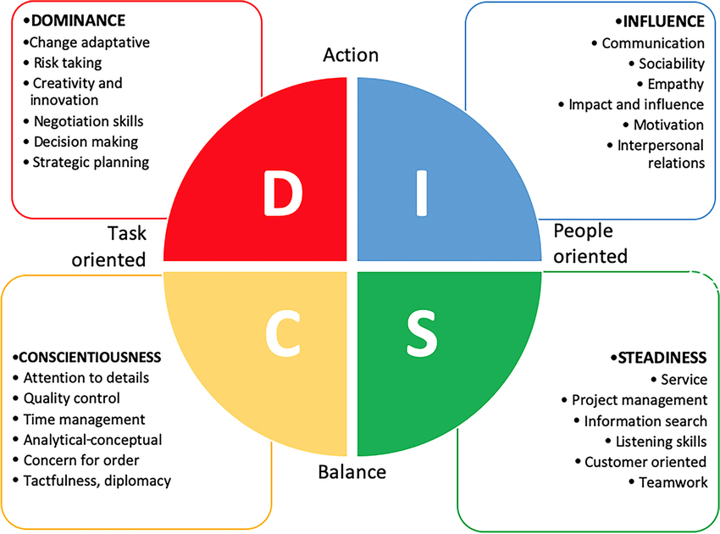

The DISC model is comprised of four categories (or ‘personality profiles’) and these are:

Dominant personalities – These tend to be the more confident people within a team who place emphasis on achievements and the accomplishment of results.

Influential personalities – These members of a group are those that are much more socially-aware and put more time and effort into building friendships or meaningful relationships as well as unfluencing or persudading others into becioming their ‘best-selves’

Steady personalities – These are the members of the group that place more emphasis on being the dependable ‘go-to’ members and thrive on cooperation.

And lastly,

Conscienscious personalities – Those who prioritise competency, high-quality results and accuracy in their work.

Within any team environment, and in particular a policing environment many different people with differeing working styles, opinions and personal characteristics are offered and contribute to the overall make-up of a group.

In summary, within this essay I believe that I have outlined the importance of team dynamics and team cohesion and have provided evidence of these by referencing the diagrams I have chosen. These models can be applied to any team or group that works towards goals, and can be utilised to calculate and gage the team’s successes and failures.

I have alluded to examples and diagrams and have found that the aforementioned models all seem to be fundamentally similar, with the initial stages of Tuckman’s model encompassing the ‘creative stages’ of then Drexler-Sibbett model (although the latter stages of both seem to be quite different to each other, aside from the ‘performing stage’ of Tuckman’s model seemingly similar to the ‘high-performance’ stage of the Drexler-Sibbet model).

I particularly found the DISC model to be very interesting and have determined myself to be more of a ‘consciencious’ and ‘steady’ personality as I have always been someone who aims to accomplish work of a high-standard and have always adores the feeling of being someone who conveys a sense of openness, honesty and the utmost integrity. Transversely, I feel I aspire to be a more ‘influencing’ personality, constantly pushing myself to escape my comfort zone and become more social.

Within my essay, I have mentioned briefly what it means for a team to have a compassionate leader in charge of the team and I believe this is paramount to both a team’s successes, and it’s failures or shortcomings. Effective leadership can yield improved communication, a much higher level of motivation for employees and can produce a much healthier and vibrant workplace culture, whereas ineffective leadership can lead to negative team dynamics and an overall lack of cohesiveness between members of the group. Within this essay I have transitioned the above into how these characteristics can effect dynamics and creative output within the police force and how any positive or negative aspect can have either a likewise effect which could be detrimental in terms of public perception.

(1,838 words)

Task 4
Relevant areas of the National Policing Curriculum:
Policing the roads, information and intelligence and conducting investigations.

Explain how information and intelligence can be used in the disruption of the more prevalent criminal activity (e.g. drug smuggling, human trafficking, child sexual exploitation, counterfeit goods, organised crime groups and ‘county lines’) by effective policing of the roads.

Outline how ANPR can be used as investigative resource when disrupting criminal activity.

1750 words (+/- 10%: include your actual word count at the end of each section)

ANSWER:

This essay shall outline my knowledge and learnings surrounding roads policing and will focus on how the police in England and Wales plan and implement the disruption of criminal activity. It shall also outline how UK police enforce the law with regards to the Road Traffic act 1988 as well as other legislation. I shall also be looking in depth at the use of automatic number plate recognition (ANPR), as well as the processing and dissemination of information and intelligence to aid in any investigation of both minor and major crime. I shall outline challenges facing the policing of the UK’s roads throughout and highlight detrimental effects caused by budget cuts and staff shortages caused as a result of these cuts.

The main objectives of roads policing in England and Wales are primarily to detect illegal and potentially dangerous activity on UK roads by enforcing road traffic laws. Policing the roads forms an integral and extremely important part of policing itself and – as with any other aspect of policing today – comes with its fair share of challenges. The police in England and Wales do not police the roads alone and must often look to the partnerships they form with local authorities and road safety partnerships.

A police officer possesses many ‘powers’ when dealing with road users and can stop any vehicle with the use of legislation including section 163 of the Road Traffic act 1988 (where by law, any motorist must stop their vehicle when ordered to do so by any constable in uniform or any other traffic officer), section 4 of the Police and Criminal Evidence (PACE) act 1984 (where, again by law, any vehicle that meets a specific criteria within a specific area must stop – this is subject to authorisation by police inspectors and is usually used to detect and arrest any suspects of serious crime such as kidnapping, serious sexual offences or even murder) and sections 43, 44 and 45 of the Terrorism act 2000 (which gives officers preventative stop & search powers wherever terrorist activity is anticipated within a specific location).

In addition to these there are many more, as well as the plethora of other pieces of individual legislation under each ‘act’.

Police use techniques such as proactive patrols and offering a strong visible presence in marked police vehicles, although roads policing often also relies heavily on the best available information and intelligence in the detection and disruption of criminality and these vital ‘leads’ are obtained from a variety of sources, from internal or external databases, to CCTV systems and dashcams, to the use of covert human intelligence sources (CHIS) and (in particular to roads policing) ANPR systems.

The ANPR system was invented in Great Britain in 1976 at the Police Scientific Development Branch (known today as the Home Office Scientific Development Branch) and had prototype systems working as early as 1979 and the first recorded arrest attributed to the use of an ANPR system came in 1981 in Dartford, UK. Today, ANPR is utilised by many Law Enforcement Agencies which include the police, but it is also used across England and Wales by private companies and local authorities such as supermarkets and privately owned car parks.

Today, ANPR is utilised in police vehicles as well as being in fixed locations and is used to automatically read a vehicle’s number plate, which in turn will automatically be checked against a national database or a ‘hot list’, with ‘hot list’ vehicles being requested specifically by police officers at certain locations, to indicate a vehicle’s whereabouts and direction of travel. The sharing of any data generated via the use of ANPR is governed by the National ANPR Standards for Policing and Law Enforcement (NASPLE) and the National Compliance and Audit Standards for Law Enforcement ANPR.

Public perception of the police has always been particularly newsworthy and with each passing year, negative news articles centring around negative Police conduct published in the media seem to be a daily occurrence. This only proves to add fuel to the fire in relation to the austerity facing police, and is even further exacerbated by other detrimental public events such as ‘Kill the Bill’ protests. The negative perception of the police which is generated by transgressing officers only adds to how distrusting the public are towards police, but also augments just how difficult the task of ‘policing by consent’ becomes.

Policing UK roads, by extension, is no easy task either. One consideration and contributing factor is the ever-expanding road system across the UK, although as the below diagram shows, only 13% of UK roads as recent as 3 years ago were considered motorways and ‘A’ roads. Despite these distances amounting to approximately 31,800 miles, this is still a considerable number of roads with which ANPR is generally used, as it is not usually implemented on roads classified as ‘B’ and ‘C’.

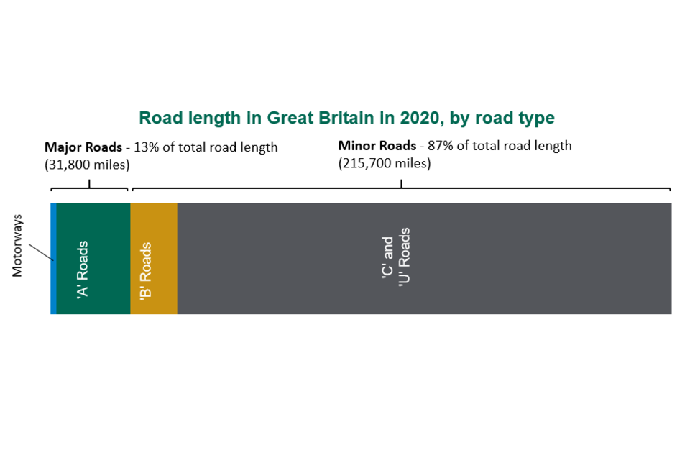
Road Lengths in Great Britain: 2020 - GOV.UK (www.gov.uk)

According to GOV.UK statistics, in 2020, it was estimated that roads in England and Wales cover a total area of 189,000 miles (in England) and 21,000 miles (in Wales) respectively. According to the same source, the most recent amount of Full Time Officers (FTE’s) in both England and Wales combined in 2020 was 140,228. If I combine the total amounts of miles and it is calculated at 210,000 miles, in comparison to the amount of officers, that equates to 1 police officer to cover every 1.5 miles. This is of course without taking into account that not all of the employed officers are traffic and response officers, are not all in work all of the time and a fraction of which are PCSO’s or are in other departments in which policing of the roads is not included.

In addition to the vast area covered by roads in the UK, the demand placed upon police to deter and eradicate criminality is further undermined by the sheer amount of vehicles on the roads today, which is displayed in the table below, and indicates a steady incline since the COVID-19 pandemic in 2019/2020. According to the Office for National Statistics (ONS), the number of non-roads related crime across England and Wales dropped by 8% overall.

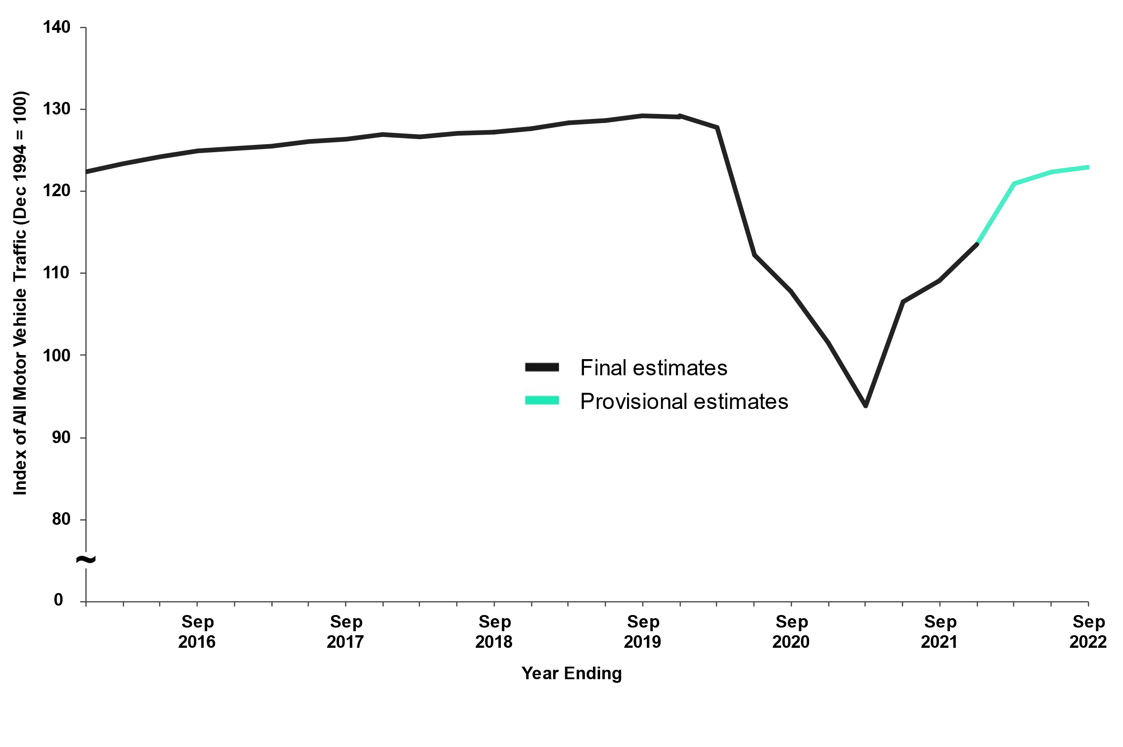
Table displaying amount of road users across United Kingdom between September 2016 and (provisional estimates for) September 2022

The major motorways and ‘A’ roads of England and Wales form a circulatory system across the country, providing many motorists (in particular, criminals) routes between major cities and a streamlined access to smaller cities and towns. One of the most prevalent aspects of crime that relies on road use is ‘County Lines’, which is titled this due to members of Organised Criminal Groups (OCG’s) using phone ‘lines’ to deliver drugs between their home ‘counties’ across the UK to a wide number of other towns and cities. County Lines is predominantly overseen by well-organised gangs based within the major cities of the UK and it is a common theme for them to prey on vulnerable members of society, recruiting naïve, impressionable youths into their ranks to do their bidding and via the use of ‘cuckooing’ whereby OCG members infiltrate the houses of vulnerable people and use their places of abode to deal drugs and conduct other nefarious activities.

To combat ‘County Lines’, as well as human trafficking and Child Sexual Exploitation (CSE) and other serious offences, the National Police Chiefs’ Council (NPCC) implemented a ‘Roads Policing Strategy’ to run between the years 2022 and 2025. This is in support of the aims of the NPCC Strategic Plan 2021-2025 and has many aims and objectives. As mentioned in the presentation by Chief Constable Jo Shiner, one of the four ‘key pillars of activity’ to build towards ‘Policing Our Roads Together’ is ‘Tackling Crime’. Chief Constable Alan Pughsley of the NPCC Crime Operations Committee states within this report that it is the aim of the police to use technology (ANPR), intelligence from our partners and the public and the “coercive powers” of other agencies with a view to “make our roads a hostile place” for those who wish to commit criminality.

(https://www.police.uk/SysSiteAssets/media/downloads/central/advice/road-safety/npcc-roads-policing-strategy-2022-25.pdf)

The intelligence we gather from partners and the public, often begins as simple ‘information’ before being analysed and ‘disseminated’ into intelligence that we can implement towards conducting working strategies and the assessment of risk, among many other things. The intelligence is the end-product of a standardised system utilised within policing and is today referred to as the ‘3x5x2’ system (simplified from the previous 5x5x5 system), as seen below.

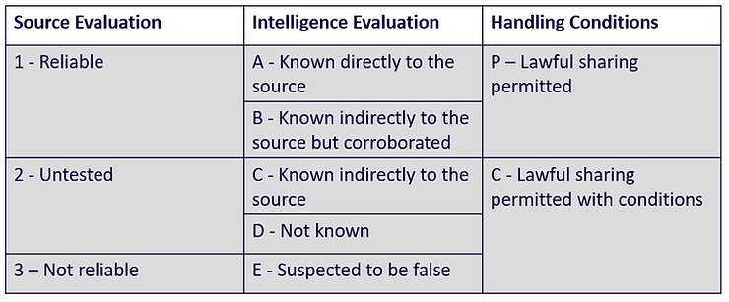

The ‘3’ represents an evaluation of the source information and is symbolised in the final equation by a number 1, 2 or 3 (this tends to be a reliability rating of whoever provides the information). When the information is ‘sanitised’ into intelligence, the ‘5’ represents five categories of how reliable the info/intel itself and is symbolised in the final equation by a letter (a, b, c, d or e) and finally the ‘2’ represents a ‘condition’ code’ where the final piece of intelligence is given a grading of ‘P’ or ‘C’ depending on its sensitivity) where the sharing or implementation of the intelligence may compromise an investigation or could lead to the loss of life (as with a CHIS, for example).

In conclusion, within this essay, I believe that I have outlined the overwhelming challenge facing roads policing today, taking into account the ever-expanding road system in England and Wales and the sheer volume of road users increasing year-on-year, as well as the massive demand on police where dwindling staffing numbers, austerity from the public and government budgetary cuts are concerned. I have outlined some of the techniques police use in attempts to stem the flow of criminality that exploits English and Welsh roads and have outlined how police obtain and sanitise information into a format that can be used to aid risk assessments and investigations, and eventually lead to the arrest and entry into the judicial system of the criminal elements of society. I have explained a brief history of ANPR and how it is utilised today to identify suspect vehicles and to disrupt and slow the progress of criminal activity.

(1,659 words)

Task 5
Individual Learning Plan

The second learning outcome identified in the accompanying module descriptor (BMPP 5000D) asks that you create an individual learning plan to meet your identified needs through reflection upon your continuing practice. This shows confidence in your ability to manage your own learning in response to evolving circumstances in the workplace.

This task differs from the PDPs that you have completed in your previous workbooks in that this learning plan allows you to assess what level you believe you are in key knowledge, skills and experience against where you believe you (and the force) consider you should be – now and in the coming 6 to 12 months of your placement. This should then be used to target future development need.

1500 words equivalent. Please note that this is not the actual number of words used in completing the table, the count reflects the thought and research behind it.

It will count towards the overall equivalent word count of 8000 words expected from this module.

ANSWER:

Knowledge, Skills and Experience Assessment

 | REQUIRED |  |  | RATING |  |  | DEVELOPMENT NEED
KNOWLEDGE | Low  1-4 | Med  5-7  x | High  8-10 | Low  1-4 | Med  5-7  x | High  8-10 | It is my belief that the South Wales Police may expect my knowledge to be in the ‘high’ requirement, given I served as a Special Constable for a year before becoming a regular officer.  As I am a very self-deprecating person who always pushes and drives themselves to become their best self, I would rate myself as a middling-high ‘medium’.  I believe I fall into this category as, given the multitude of avenues Policing veers down, I believe my knowledge at this extremely early stage in my career to be about adequate.  I am currently learning the crux of the judicial system and what part I play in bringing offenders to justice.  I found that, during initial training, when given the plethora of acts and offences to revise and learn for exams, I found I utilised certain techniques such as flash cards to try and bore them into my brain.  I did this as I had not been a part of a professional learning environment at that stage since attempting to become an electrician about seven years prior, and I found during studying towards exams then, that I used repetition, or ‘Rote learning’ to jog my memory and to retain complex information.
SKILLS | Low  1-4 | Med  5-7  x | High  8-10 | Low  1-4 | Med  5-7  x | High  8-10 | As previously mentioned within the ‘knowledge’ section, it is my belief that my organisation should hold higher expectations of my gathered policing skills when compared to other ‘junior’ officers, due to my limited experiences as a Special Police Constable prior to joining on a full-time basis.  I find that I come away and return home from work after certain shifts and I feel like my skills have been well-utilised and that I have made a real difference, both on shift and to the wider community.  Transversely, I can sometimes find myself self-reflecting and becoming harsh on myself because I have implemented certain things (i.e. handcuffing a suspect) and I have either not performed a certain technique to my own high standard or I have struggled with taking them off in a manner which is both timely, smooth and would look professional to the untrained eye.  Likewise, there are days where I feel that paperwork I have submitted could be excellent one day and on the second ay I could feel like I haven’t put everything into a certain summary of an incident.  It is down to me to ensure that I keep practicing skills that require both my hands and my mind, all while remembering that I have only been ‘on the job’ less than six months from an operational perspective.  I shall strive to become a better and more diligent officer while trying to focus on things that I deem I am not so good at, while trying to not become complacent with those that I deem myself to be very good at at present.
EXPERIENCE | Low  1-4 | Med  5-7  x | High  8-10 | Low  1-4  x | Med  5-7 | High  8-10 | Combining ‘knowledge’ and ‘skills’ in order to summarise how I would rate my own level of ‘experience’ at this stage was not as easy as I first thought.  On one hand, I feel like I have experienced an awful lot of incidents in my limited time as a police officer and have dealt with things that the average person does not see and would likely choose not to see in their daily lives, but on the other, I know that there is a myriad of things that I am yet to experience.  These future experiences I cannot wait for and will be sure to try to embrace them and learn from them as best I can.  I have decided here to critically mark myself as ‘low’, as I am fully aware of the path that lays ahead of me, and I am at present, barely entering the frame of the bigger picture and there are a lot of times at the moment where I feel I am engaged in challenging conversations with people but I need a more experienced colleague to step in to perhaps fill voids in my rationale, and to add things I have missed when speaking with victims, witnesses and suspects.  As an extremely naturally confident person, I have often thrown myself into situations that are not within my ‘comfort zone’ in order to boost my knowledge, as I know that I will not always have a proverbial ‘safety blanket’ to fall back on. I was made aware of this during my tutorship and the words of wisdom given to me by my tutor and soon-to-be sergeant will always resonate with me.  I am a firm believer that the best way to learn something is to make an error with it to begin with, and rather than think the absolute worst will happen as a result, I believe that, in keeping with the code of ethics, it is my solemn vow to make myself accountable, and to learn from my mistakes.

Bibliography
The bibliography should only include sources referenced within the workbook using the Harvard referencing system. Information about referencing in written assignments and how to avoid plagiarism can be found on Moodle. It is important that you are aware of the importance of ensuring that the work submitted is your original work.

Task 1

Mind Tools Content Team (2022). MindTools | Home. [online] www.mindtools.com. Available at: https://www.mindtools.com/ass7geb/handys-four-types-of-culture. – (Accessed 10/04/2023)

Today, P. (2023). What are the models of organisational culture? [online] Personnel Today. Available at: https://www.personneltoday.com/hr/what-are-the-organisational-culture-models/. – (Accessed 17/04/2023)
‌

Task 2

www.ons.gov.uk. (n.d.). Domestic abuse in England and Wales overview - Office for National Statistics. [online] Available at: https://www.ons.gov.uk/peoplepopulationandcommunity/crimeandjustice/bulletins/domesticabuseinenglandandwalesoverview/november2021#main-points. – Accessed 10/04/2023

College Of Policing (2014). National Decision Model. [online] College of Policing. Available at: https://www.college.police.uk/app/national-decision-model/national-decision-model. – Accessed 10/04/2023

Transform Justice. (2019). Should all domestic abuse suspects be arrested? [online] Available at: https://www.transformjustice.org.uk/should-all-domestic-abuse-suspects-be-arrested/#:~:text=In%20fact%20College%20of%20Policing%20guidance%20calls%20for - (Accessed 17/04/2023)

GOV (2019). Dangerous Dogs Act 1991. [online] Legislation.gov.uk. Available at: https://www.legislation.gov.uk/ukpga/1991/65/contents.- (Accessed 17/04/2023)

Quittance Legal Services. (n.d.). Dog bites, dog attacks and UK law | Quittance.co.uk®. [online] Available at: https://www.quittance.co.uk/personal-injury/advice/general/dog-bites-dog-attacks-and-uk-law. – (Accessed 17/04/2023)

Task 3

Gleeson, P. (2008). Advantages & Disadvantages of Group Cohesiveness & Productivity. [online] Chron.com. Available at: https://smallbusiness.chron.com/advantages-disadvantages-group-cohesiveness-productivity-25046.html. – (Accessed 17/04/2023)

Anon, (n.d.). Drexler/Sibbet Team Performance Model – Kaizenko. [online] Available at: https://www.kaizenko.com/drexler-sibbet-team-performance-model/. – (Accessed 17/04/2023)

Mind Tools Content Team (2022). Forming, Storming, Norming, and Performing. [online] www.mindtools.com. Available at: https://www.mindtools.com/abyj5fi/forming-storming-norming-and-performing. – (Accessed 23/03/2023)

www.mindtools.com. (n.d.). MindTools | Home. [online] Available at: https://www.mindtools.com/aussi4e/the-disc-model. – (Accessed 17/04/2023)
‌

www.mindtools.com. (n.d.). MindTools | Home. [online] Available at: https://www.mindtools.com/aussi4e/the-disc-model. – (Accessed 17/04/2023)

Task 4

Brake. (n.d.). Roads policing. [online] Available at: https://www.brake.org.uk/get-involved/take-action/mybrake/knowledge-centre/roads-policing#:~:text=Roads%20policing%20enforces%20road%20traffic%20laws%20and%20seeks. – (Accessed 18/04/2023)
College of Policing. (n.d.). Roads Policing Constable. [online] Available at: http://production-cop-web-elb-883774526.eu-west-2.elb.amazonaws.com/professional-profile/roads-policing-constable/#:~:text=Provide%20a%20visible%20presence%20on%20the%20roads%20by – (Accessed 18/04/2023)
College of Policing (2015). Intelligence collection, development and dissemination. [online] College of Policing. Available at: https://www.college.police.uk/app/intelligence-management/intelligence-collection-development-and-dissemination. - (Accessed 18/04/2023)
‌reglocker (2021). A Brief Introduction, History, Uses & Benefits of ANPR. [online] Reg Locker. Available at: https://reglocker.co.uk/uses-benefits-of-anpr. – (Accessed 18/04/2023)

Brake. (n.d.). Roads policing. [online] Available at: https://www.brake.org.uk/get-involved/take-action/mybrake/knowledge-centre/roads-policing#:~:text=The%20National%20Police%20Chiefs%27%20Council%20%28NPCC%29%20plays%20a – (Accessed 18/04/2023)
GOV.UK. (2021). Road Lengths in Great Britain: 2020. [online] Available at: https://www.gov.uk/government/statistics/road-lengths-in-great-britain-2020/road-lengths-in-great-britain-2020. – (Accessed 18/04/2023)
Home Office (2022). Police workforce, England and Wales: 31 March 2022. [online] GOV.UK. Available at: https://www.gov.uk/government/statistics/police-workforce-england-and-wales-31-march-2022/police-workforce-england-and-wales-31-march-2022. – (Accessed 18/04/2023)
Crime drops by 8% during year of lockdowns, says ONS. (2021). BBC News. [online] 13 May. Available at: https://www.bbc.co.uk/news/uk-57098807. – (Accessed 18/04/2023)
The Children's Society (2022). What Is County Lines? | The Children’s Society. [online] www.childrenssociety.org.uk. Available at: https://www.childrenssociety.org.uk/what-we-do/our-work/child-criminal-exploitation-and-county-lines/what-is-county-lines. – (Accessed 18/04/2023)
Adams, S. (2020). The 5-minute guide to the intelligence grading process and its application in OSINT. [online] IWS Training. Available at: https://www.intelligencewithsteve.com/post/the-5-minute-guide-to-the-intelligence-grading-process-and-its-application-in-osint. – (Accessed 18/04/2023)

