
BA in business management
Assessment 1: Essay (Project Plan)
Module: Project Management (LCBB5005)

Professor’s Name: Xavier Matieni
University: Trinity Saint David
Student Name: Darinka Corman (2029004)


CRITICAL EVALUATION OF THE HINKLEY POINT C PROJECT

Table of Contents
Introduction 2
The Hinkley Point C Project 2
Project Scope 4
Development Objectives 4
Project Deliverables 4
Costs 5
Schedule 6
Project Implementation 7
Stakeholder Engagement 9
Risk Management Plan 12
Quality Improvement 13
Conclusion 13
Recommendation 14
Bibliography 15

Introduction
The UK government focuses on combining renewables and nuclear energy in facilitating its transition from the high-carbon economy to the net-zero carbon economy. Specifically, the government observes that nuclear energy offers reliable, low-carbon, and safe electricity to households, businesses, industries, and offices. Recent reports indicate that nuclear energy accounts for approximately 20% of electricity in the UK power grid. The government considers that cost-effective nuclear energy projects facilitate net-zero carbon transition and promote affordable electricity provision to consumers (EDF Group, 2023). Notably, collaborative and risk management tactics have enabled the UK government to reduce the cost of building nuclear power plants by 30% (Gogan & Ingersoll, 2020). The strategy aligns with the government’s desire to make nuclear technology cost-competitive with diverse renewable energy sources. Specifically, the Hinkley Point C project incorporates cost-reduction, partnership, and risk-management tactics to make nuclear energy sustainable, affordable, and reliable.

The Hinkley Point C Project
The Hinkley Point C (HPC) refers to a nuclear power plant that is currently under construction in Somerset county, England. The nuclear power plant is the first to be constructed in Europe since the Japanese Fukushima disaster occurred in 2011. The power plant is constructed on a 175-hectare piece of land located near Hinkley Point B and A power plants. Hinkley Point A represents a 500MW UK nuclear power plant that was functional between 1965 and 2000 (NS Energy, 2023). Similarly, Hinkley Point B refers to a 965MW UK nuclear power plant with a lifespan of 47 years (1976-2023). Unlike Hinkley Point B and A, Hinkley Point C is expected to generate 3,260MW within 60 years after its commissioning in 2026 (EDF Group, 2023). The UK government expects the facility to generate low-carbon, reliable, and safe electricity to address the growing energy demand among households, industries, and businesses (Jones, 2017). Essentially, factors that make Hinkley Point C dependable and sustainable are proper ground conditions, proper planning procedures, safety conditions, and adjacent nuclear operations.
Key aspects of the HPC plant are safety systems, nuclear reactors, nuclear waste and fuel management facilities, and ancillary buildings. The nuclear power plant has two EPRs (European pressurised reactors) that can generate a combined electrical power of 1,630MW each (Guillaume, 2018). Every 1,630MW EPR takes the form of a 7,000 square metre nuclear island comprising a conventional island, an access tower, a fuel building, four safeguard buildings, and a reactor building (NS Energy, 2023). The conventional island is designed to accommodate ancillary buildings and the turbine hall for this nuclear power plant. The EPR unit depends on a technology that promotes efficiency in nuclear fuel utilisation, which would slow nuclear waste generation. The nuclear power plant has different safety systems in preventing future disasters, including protective barriers, defence-in-depth, and safe reactor shutdown. For instance, the protective barrier exists as a leak-tight barrier between the environment and radioactive materials. The waste building holds and secures radioactive waste and spent fuel from the EPRs. Finally, ancillary buildings accommodate support functions for the reactors, including ventilation systems, workshops, water treatment plants, and offices.

Project Scope

Development Objectives
The Hinkley Point C project involves constructing two EPR units with a cumulative power generation capacity of around 3,260MW. The nuclear facility is designed to provide the highest level of operational efficiency, quality, and safety. Project management focuses on utilising construction strategies that minimise disruptions and optimise efficiency in resource utilisation (Dyrda & Morrison, 2021). Instead, the project is expected to offer the local community economic and social benefits like engagement in the supply chain, employment, and training. The project is expected to create a positive impact on the UK, Somerset county, and England through unemployment rate reduction and electricity supply. The positive outcome aligns with the goal of creating infrastructure with a sustainable and long-term beneficial role to the local community (NAO, 2017). In this regard, the project design integrated different safety features with the nuclear power plant to safeguard the environment and local inhabitants. Furthermore, the management focuses on addressing UK citizens’ views and needs during the construction period and after commissioning the nuclear power plant.

Project Deliverables
Various deliverables for nuclear power plants are electricity generation, carbon footprint reduction, employment opportunities, revenue, and environmental conservation. The UK government recognizes the importance of this project in addressing the growing energy demand due to increased industrialisation, real estate business expansion, population explosion, and increased urbanisation. For example, Hinkley Point C is expected to generate approximately 6 percent of the overall power in the UK’s electrical grid (EDF Group, 2023). Current estimates that the generated power from the nuclear facility can power approximately 6 million homes within its 60-year lifespan (EDF Group, 2023). The project is expected to create 1,000 apprenticeships, 25,000 job opportunities, and pump approximately £100 million annually into the UK economy in the peak construction period and £40 annually after commissioning (EDF Group, 2023). The nuclear power plant is expected to generate low-carbon electricity that will reduce carbon dioxide emissions by around 600 million tonnes between 2025 and 2085. In addition, the management will plant more than 20,000 trees at the facility to improve the decarbonisation process through carbon sink development.

Costs
The project management team considers that budget certainty and proper schedule reduce implementation costs for projects. Notably, the China General Nuclear Power (CGNP) and Électricité de France (EDF) were allowed to fully finance all activities related to the Hinkley Point C project. CGNP promised to allocate $7.89 billion (£6 billion) to the nuclear energy project in 2015 while the UK government agreed to provide a $2.6 billion debt guarantee within the same year. The project was also guaranteed at a $156 (£92.50) stroke price for each MWh (megawatt hour) generated within a 35-year duration (Harvey, 2021). An estimate generated in 2016 indicated that the project implementation process would occur at a total cost of $59.8 billion (£45.5 billion), which includes decommissioning, construction, nuclear waste management, and operation. Specifically, the estimate developed in 2016 indicated that the construction process for the nuclear power plant would occur at a total cost of $23.66 billion (£18 billion) (Harvey, 2021). However, the cost has increased to $28 billion (£22.5 billion) because of UK’s broader economic challenges, including inflation and cost overruns (NS Energy, 2023). Cossins-Smith (2023) stresses that inflation could further increase the HPC implementation cost to around £33 billion ($40 billion) in the future.
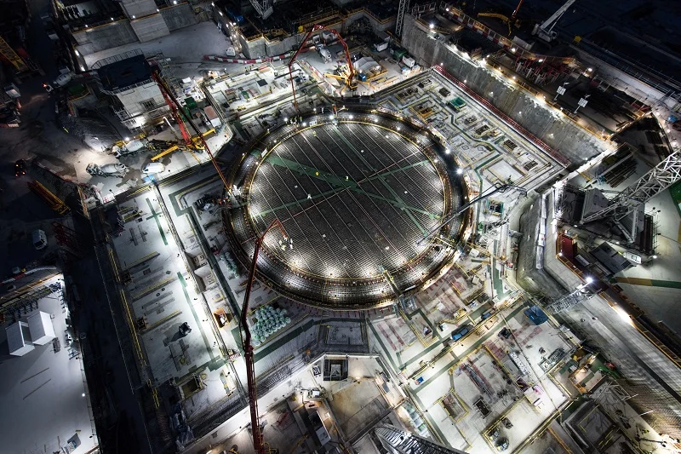
The HPC Project Aerial View (Cossins-Smith, 2023)

Schedule
The HPC plant was designed with a 60-year operational period and a 10-year construction duration. The construction process for this nuclear power plant started in 2017 with site clearance and excavation processes (Cossins-Smith, 2023). The groundbreaking date implies that the construction process for Hinkley Point C was expected to occur between 2017 and 2025. The first concrete pouring process for the substructures of various HPC structures occurred in March 2017 (Comptroller and Auditor General, 2017). The concrete pouring process for the first EPR unit’s foundation for this nuclear power plant was finalised in June 2019. The foundation construction process was accompanied by the placement of a steel containment liner for this EPR unit (J-zero) using a land-based crane in December 2019 (NS Energy, 2023). In 2021, the project management team indicated that 49% of the scheduled project activities had been done within a 5-year duration. Nonetheless, the management observed that COVID-19-related interventions like social distancing created a six months’ delay in project implementation. Current progress reports indicate that the commissioning for this nuclear power plant will occur in June 2026 and not the originally stated date (2025).
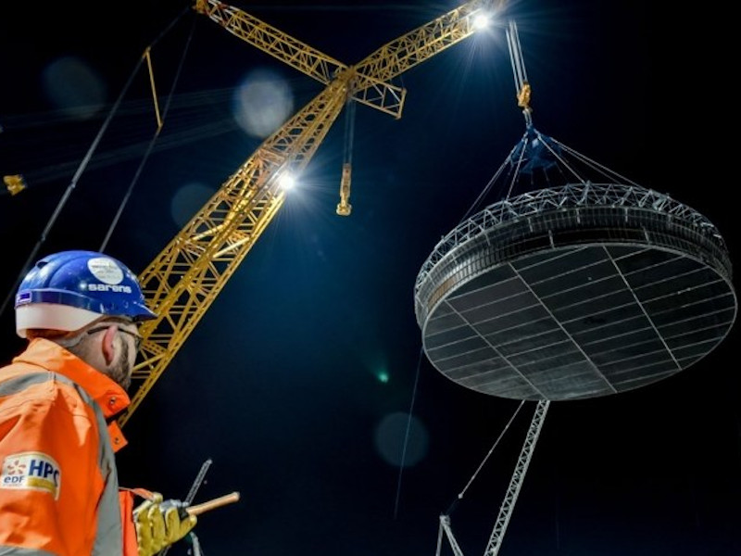
Steel Containment Line for J-zero (NS Energy, 2023)

Project Implementation
The Hinkley Point C is categorised among the most technologically intricate and biggest construction projects in the United Kingdom. Various activities for the project are broadly categorised into planning, associated development, and construction process. The planning process for the development project featured activities like licensing, design, contractor engagement, and regulatory justification. Noticeably, the ONR (Office for Nuclear Regulation) provided the site license for the HPC project in November 2012 to facilitate the implementation process (ONR, 2022). The ONR observed that the design and planning team provided the necessary operational, management, commissioning, and construction plans for the nuclear power plant. AREVA and EDF Energy submitted the UK HPC design to the environmental and safety authorities for the Generic Design Assessment procedure. The ONR provided the Design Acceptance Confirmation for the design in December 2012, which indicated that the project complied with strict safety standards for nuclear power plants.
The associated development procedure for the nuclear power station comprises activities like on-site associated development, off-site associated development, and preliminary works. The on-site associated development revolves around the design of cooling water tunnels, waste storage facilities, a sea wall, workshops, accommodation facilities, and transmission infrastructure. The implementation team planned on off-site associated developments, including road improvement, storage facilities, accommodation facilities, park facilities, and landscape integration. At this stage, the implementation team developed landscape integration plans to ensure that the site attained desired aesthetic design standards. Afterwards, the implementation team undertook preliminary works for the HPC project, including jetty, site preparation, and sea wall construction. Preliminary works for this nuclear power plant project were done prior to the major DCO application for the construction project. Contractors sought development consents for preliminary works from the West Somerset Council, the Department of Transport, and the Marine Management Organisation.
The construction process for this nuclear power plant features activities like assessing land use requirements and construction activities. The assessment procedure is based on the consideration that the project requires some land for temporary application scenarios like accommodation campus construction, contractor office setup, and spoil storage. In this regard, contractors selected the land adjacent to the HPC for temporary usage purposes during construction. For example, EDF Energy constructed a temporary accommodation facility for approximately 700 employees involved in the project’s construction activities. Construction activities for this nuclear power plant are plant installation, building construction, and preliminary construction works. Mainstream construction activities entailed erecting various structures for the facility, including ancillary buildings, nuclear reactors, waste management facilities, and protective barriers. Contractors were expected to deliver electrical and mechanical elements of the HPC plant to the site approximately a year prior to the initial structural concrete pouring procedure.
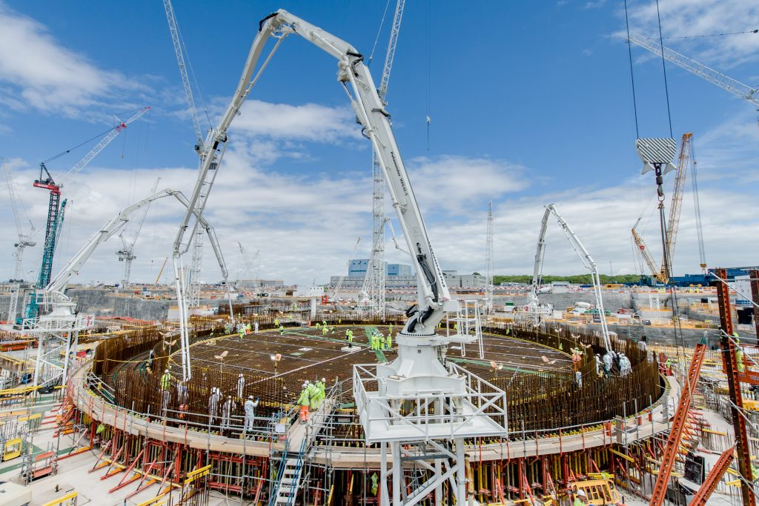
Hinkley Point C Steel Works (Horgan, 2019)

Stakeholder Engagement
The management team understands that stakeholder engagement plays a central role in the project implementation process. Specifically, key stakeholders for the Hinkley Point C project are the UK government, contractors, suppliers, the public, and employees. First, the project addressed the government’s desire to utilise low-carbon energy in achieving economic growth objectives. In this project, the NNB HPC has focused on engaging local partners and government agencies in executing different development plans. The government has collaborated with different contractors in reviving the nuclear industry to facilitate the construction of the HPC power plant. In the HPC project, the government facilitated the development of a four-part agreement to facilitate the HPC project implementation, including £2 billion bond guarantee, £7.3 billion revenue allocation to decommissioning and nuclear waste management, CfD (contract for difference), and NNBG compensation in a situation involving government policy variation. The government perceives the HPC power plant as a supportive element for renewables in its 21st Century low-carbon electricity generation agenda.
Second, the UK government focused on engaging different multinational contractors in the implementation process for the HPC project. Various contractors involved in the design and implementation process for this project are Framatome/Areva NP, Laing O’Rourke, Bouygues, GE, CGN, EDF, BAM Nuttall, Kier Group, Vallourec, Ovivo, Nuvia, Rolls-Royce, AECOM, Weir Group, KBR, and Cavendish Boccard Nuclear. Notably, the UK government tasked NNBG (NNB Generation Company) with constructing and operating the Hinkley Point C plant, which CGN (33.5%) and EDF (66.5%) (NS Energy, 2023). In, Laing O’Rourke and Bouygues were awarded a £1.5bn contract for the nuclear power plant construction. In 2015, Kier Group and BAM Nuttall won a £210m for earthworks. Framatome got a £4.5 billion contract for manufacturing and installing two EPRs for the nuclear power plant in 2016 (Černoch & Zapletalová, 2015.) GE got a £1.5 billion contract for providing equipment, generators, and steam turbines for the HPC plant within the same year (NS Energy, 2023). Additional contractors engaged in the construction project are Axima Concept, Renfrew and Crawley, COMECA, Wood, Tunzini Nucleaire, and Doosan Babcock.
Company | Contract Won | Price | Date
Laing O’Rourke and Bouygues | Construction and civil engineering | £1.5bn | 2013
Kier Group and BAM Nuttall | Earthworks | £210m | 2015
Framatome | Manufacturing and installing two EPRs | £4.5bn | 2016
GE | Providing equipment, generators, and steam turbines | £1.5bn | 2016
NG Bailey and Balfour Beatty | Electrical package | £477m | 2016
NG Bailey and Balfour Beatty | Three marine tunnels construction | £207m | 2017
Siemens, Balfour Beatty, and J. Murphy & Sons | Transmission cables provision | £300m | 2019
Bilfinger | Fabricating and installing piping systems | £58m | 2020
Bouygues | Warehouse and training centre construction | £36m | 2018
Ovivo | Cooling system design and provision | £27.8m | 2017
Nuvia | Nuclear sampling system construction and design | £20.6m | 2017
Rolls-Royce | Heat exchangers provision | _ | 2018
AECOM | Geotechnical design | _ | _
ABB | Transmission structure construction | £102m | 2017
COMECA | Design, production, and shipping of power distribution systems | €130m | 2018
Table 1: Contractors for the HPC Project
Third, the project management team recognises the significance of multidisciplinary collaboration in facilitating timely project completion. The management team focused on creating a workforce comprising highly experienced and skilled professionals with different background characteristics. In particular, the project management team sought experienced individuals from intricate infrastructure projects like Heathrow Terminals 5, the Olympic Park, and the nuclear industry. The management team created a strong nuclear engineering team to facilitate the maintenance, assessment, operation, and construction of EPR units. The management adopted cross-functional structures and strong compensation programs to retain and attract skilled professionals to the project. For instance, the management offers employees proper accommodation near the site to promote their welfare and gratification (Mcintyre, 2018). Fourth, the management collaborates with suppliers in maintaining the highest quality and safety standards during project implementation.
Lastly, the project management team utilises different strategies in engaging and supporting the local community, including community fund provision, employment and apprentice opportunities provision, inspiring education programs, training programs creation, and sports facilities provision. The management further encourages local community members to visit and learn about the nuclear energy generation process. In particular, the project management team for HPC has improved the public engagement procedure through its newly launched Hinkley Point Visitor Centre. The initiative encourages visitors to explore electricity generation in the plant in interactive and fun-filled ways. The initiative allows individuals of all ages to acquire knowledge on low-carbon energy generation and decarbonisation associated with the nuclear power plant. Furthermore, the engagement strategy enlightens the visitors on the supportive role of the HPC on renewable sources like solar power and wind in reducing carbon emissions and preventing climate change.

Risk Management Plan
The project management team implemented different risk management strategies to promote the success of the HPC project. The intervention procedure addressed probable risks for this construction project, including design risks, public objections, environmental risks, delays, project team conflicts, and cost overruns (Daniel & Daniel, 2019). For instance, an assessment conducted before project approval ensured that the project designs were free from omissions and erroneous figures. Proper public support and engagement enabled the management team to prevent public engagement. High-quality designs and proper workmanship has minimised the project’s impact on the natural ecosystem. Strong compensation programs, accommodation, and development opportunities have helped in preventing employee turnover problems and team conflicts (Putti & Tóth, 2017). Proper communication channels, effective scheduling, and realistic goals have helped in preventing contractor delays and cost overruns. The current progress indicates that the project’s commissioning will occur in 2026, which is within the estimated 10-year construction period.

Quality Improvement
Current ONR inspection has revealed inadequacies in quality management systems for the nuclear power plant. The inspection report shows that the project management team has been implementing substandard quality management systems in inconsistent ways. Notably, ONR performed the assessment after uncovering falsified documents in a company owned by Framatome named Cresuot Forge. The fact that Framatome is the supplier for the project creates the need for the supply chain systems’ re-evaluation. Although ONR observed that the management team had implemented a good quality control system in the past, it stressed that various key areas require improvement. Nonetheless, the statutory corporation considers that Areva Creusot Forge and NNB GenCo have implemented improvement programmes, namely quality culture, management system arrangement, manufacturing processes, and safety culture. Therefore, ONR observes that robust independent inspection can promote the maintenance of the highest quality and safety standards among suppliers for this project.

Conclusion
The UK government views the Hinkley Point C project as an opportunity to increase low-carbon electricity generation. The HPC is a 3,260MW nuclear power plant with a 60-year service life and a 10-year construction duration. The nuclear power plant comprises elements like two nuclear reactors, a waste management facility, ancillary buildings, and safety systems. An estimate produced in 2016 indicated that the HPC plant would be constructed between 2017 and 2025 at approximately £18 billion. The project implementation process was expected to occur in multiple phases, including planning, associated development, and construction process. The management team has effectively engaged stakeholders like contractors, employees, the government, and the public to promote project success. The project management team has also focused on managing different risks for the project, including public objections, cost overruns, environmental risks, delays, design risks, and project team conflicts.

Recommendation
Current progress assessments indicate that the HPC project has effective risk mitigation, collaboration, and cost reduction strategies. The UK government observes that integrating these strategies with project implementation procedures can help in making nuclear energy sustainable, affordable, and reliable. Nonetheless, there exist various recommendations that can improve the project implementation process, including strengthening the supply chain, maintaining delivery consistency, and mobilising the workforce. Building supply chain experience can support the management team in preventing implementation delays and avoiding cost overruns. The strategy requires the procurement department to maintain coordinated action during project implementation. Proper coordination and teamwork can support the management team in maintaining delivery consistency and reducing delays. The HRM team should strengthen the HPC project’s benefits and compensation program to improve workforce mobilisation.

Bibliography

Černoch, F. and Zapletalová, V., 2015. Hinkley point C: A new chance for nuclear power plant
construction in central Europe?. Energy Policy, 83, pp.165-168.
Comptroller and Auditor General, 2017. Hinkley Point C. National Audit Office.
Cossins-Smith, A., 2023. Cost of EDF’s Hinkley Point C nuclear project rises to $40bn. Power
Technology. https://www.power-technology.com/news/hinkley-point-c-project-costs-rise-again/
Daniel, E. and Daniel, P.A., 2019. Megaprojects as complex adaptive systems: The Hinkley
point C case. International Journal of Project Management, 37(8), pp.1017-1033.
Dyrda, J. and Morrison, R., 2021. Overview of the Hinkley Point C EPR Project ‘J0’and Beyond.
In EPJ Web of Conferences (Vol. 247, p. 20001). EDP Sciences.
EDF Group, 2023. About Hinkley Point C. EDF.
https://www.edfenergy.com/energy/nuclear-new-build-projects/hinkley-point-c/about
Fiona Mcintyre, F., 2018. Hinkley Point C quality management needs improvement, says nuclear
regulator. New Civil Engineering. https://www.newcivilengineer.com/archive/hinkley-point-c-quality-management-needs-improvement-says-nuclear-regulator-16-03-2018/
Gogan, K., & Ingersoll, E., 2020. Drivers of Cost and Risk in Nuclear New Build Reflecting
International Experience. LucidCatalyst.
Guillaume, N., 2018. Hinkley Point C: the biggest construction site in Europe is on track. Revue
Generale Nucleaire, pp.54-57.
Harvey, D., 2021. Hinkley nuclear power station on track for 2026 opening. BBC News.
https://www.bbc.com/news/uk-england-somerset-58724732
Jones, L., 2017. Nuclear family [Hinkley Point C power station construction]. Engineering &
Technology, 12(3), pp.58-61.
NAO, 2017. Report-Value for money: Hinkley Point C. The National Audit Office.
https://www.nao.org.uk/reports/hinkley-point-c/
NS Energy, 2023. Hinkley Point C Nuclear Power Station. NS Energy.
https://www.nsenergybusiness.com/projects/hinkley-point-c-nuclear-power-station-uk/
ONR, 2022. Hinkley Point C assessment reports. Office for Nuclear Regulation.
https://www.onr.org.uk/hinkley-point-c/assessment-reports.htm
Putti, K., & Tóth, Z., 2017. Economic analysis of the Hinkley Point C nuclear power plant based
on the available data. 2017 6th International Youth Conference on Energy (IYCE).

