Marketing Essentials

BMIH4005

LEVEL 4

Component A

Marketing Plan

Student Name: Shamim Kabir Chowdhury
Student ID: 2234243
Word Count: 1362
Contents
Introduction 3
Situation Analysis 4
5 C’s 4
Objectives 5
Strategy 5
Tactics 6
Marketing Mix 6
Action 7
Control 7
Conclusion 8
References 9
Appendices 11

Introduction
This marketing strategy has been developed to provide Travelodge with a detailed overview of how they may boost their social media presence and interaction. The plan is customised to the current situation, taking both micro and macro elements into consideration. The course will examine in detail the 5C's, 4P's, Gannt Chart, as well as important theorists such as Philip Kotler, who suggested the four Ps of marketing: product, price, place/distribution, and promotion. Ultimately, this plan aims to assist Travelodge in identifying novel approaches to boost their exposure and participation on social media in order to better serve their customers in the future.

Situation Analysis

5 C’s
Company: Travelodge is a hotel chain with more than 500 locations in the United Kingdom and Europe. The company has had consistent growth in recent years while providing clients with comfortable and inexpensive accommodations (Jobber and Ellis-Chadwick, 2020). They have an outstanding reputation for customer service and award-winning employees. In addition, the organisation has introduced unique technological solutions for its guests, such as mobile check-in. However, the company faces a significant obstacle in the form of rising competition from new entrants who offer identical services at a cheaper price.
Customers: To correctly target customers, Travelodge's marketing plan should include segmentation and audience targeting based on their wants and preferences. For instance, businesses can target families with children by highlighting family-friendly features such as extra bedrooms, cots, and child-friendly activities at local locations (Smith and Zook, 2020). Moreover, their proximity to airports and workplaces enables them to target business travellers. Lastly, they can target budget-conscious travellers who are looking for accommodations that offer good value.
Competitors: Travelodge faces intense competition from rival hotel brands, such as Premier Inn and Holiday Inn Express, that offer comparable amenities at lower prices. To remain competitive in the hotel sector, Travelodge must separate itself from its rivals through several methods, such as product diversification or pricing strategy by giving discounted rates or customer loyalty programmes for repeat stays (Ryan, 2012).
Collaborators: Successful businesses in the hospitality industry must cultivate strong relationships with B2B partners, such as travel agents or corporate clients, who can supply recommendations or contracts for rooms/services during peak demand periods (Kotler and Kartajaya, 2017). Moreover, partnerships with local businesses/attractions near hotel locations could benefit both businesses by forming mutually beneficial relationships that would result in increased customer footfall for both parties, as customers may choose to stay nearby due to attractive discounts offered by local businesses/attraction tickets when booking rooms at Travelodge hotels located near those attractions etc.
Climate: Companies must perform a PESTLE analysis (Political Economic Social Technological Legal Environmental) on a regular basis in order to assess the external factors that may present an opportunity or risk for a business like Traveldoge operating in this sector. For example, technological advancements over the past few years have transformed the way people book hotels, particularly through mobile devices (Kotler et al., 2020). Similarly, changes brought about by Brexit could pose a political risk if immigration and workplace rules become more stringent, resulting in a lack of labor dedicated to the hospitality sector, which would have a negative impact on the availability and cost of Traveldoge's accommodations (Ferrell et al., 2021).

Objectives
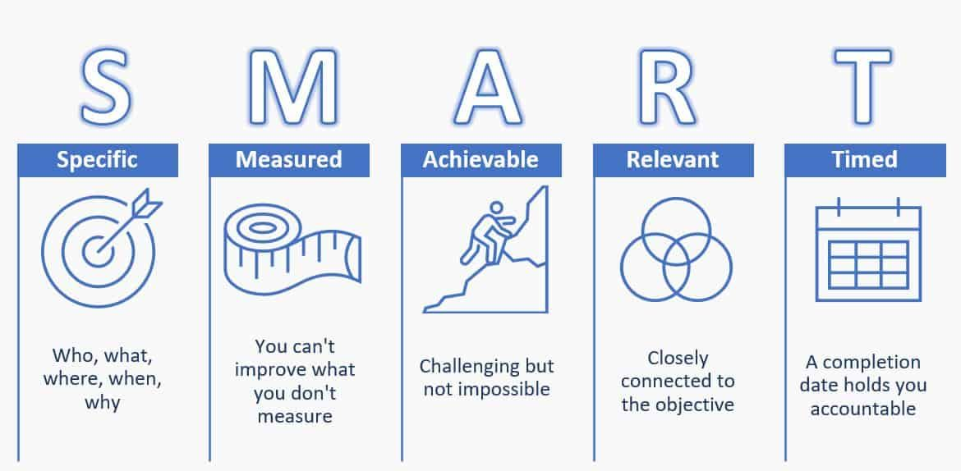

S | M | A | R | T
Specific | Measurable | Achievable | Relevant | Time-Bound
Within the next nine months, increase Travelodge's visibility and engagement on social media channels by at least 25 percent. | Monitor the number of followers and interactions on the social media accounts of Travelodge, such as Facebook, Instagram, and Twitter, to ensure that the boost in brand visibility is sustained over time. Utilize existing analytic tools such as Google Analytics to track this marketing plan's objectives. | Utilize various strategies, such as optimising website content for SEO and paid advertising campaigns, constructing engaging content with proper hashtags and graphics, creating connections with influencers in relevant industries, take part in frequent interactions with clients and responding to reviews promptly, regularly updating profile information to maximise accessibility, inspiring customer reviews via sponsored posts or email campaigns, targeting new ad placements, and targeting new ad placements with remarketing campaigns. | The aims of this social media marketing plan align with Travelodge's general business objectives of boosting brand visibility and customer involvement. By employing successful social media methods, Travelodge hopes to reach a broader audience and increase their clientele. | This plan should be implemented within the following nine months so that Travelodge may reach its goals by the end of 2021. Throughout implementation, regular progress checks will be undertaken in order to correctly quantify success rate per target.

Strategy
The core proposition of Travelodge is to provide customers with inexpensive accommodations and outstanding customer service. To convey this, the organisation must concentrate on individualised marketing efforts that emphasise ease and price, while also showcasing the hotels' particular benefits (Housden 2008). This should be accomplished by targeted digital campaigns on social media platforms like Facebook, Instagram, YouTube, and Twitter. In addition, Travelodge can promote its offers through email marketing and other direct advertising channels, such as print magazines and radio spots. In addition, they could collaborate with travel influencers with extensive reach in order to develop credibility and visibility among prospective passengers.

Tactics

Marketing Mix
Product: Travelodge has a variety of hotel rooms at different price points at each of its locations. They have rooms that are good for people on a budget and rooms that are good for people who want a more luxurious stay. Depending on where the hotel is, it usually has a free breakfast buffet, Wi-Fi internet access, a reception desk that is open 24/7, laundry facilities, and other services (Ghauri, 2014).
Place (Distribution): Travelodge uses online travel agencies (OTAs), metasearch engines (like Google Hotels), and direct bookings through their website or app to get their rooms in front of people (Clow and Baack, 2013). Travelodge has a physical presence in major cities around the world in addition to these online channels. This lets them reach potential customers who are planning trips locally or abroad.
Price: Travelodge uses a pricing strategy that is competitive with similar hotels in the same area based on quality, services offered, and the size of the room(s) booked (Chaffey and Smith, 2013). As part of their strategy to offer competitive prices, they offer discounts during certain times of the year, like the summer holiday season, and special packages during busy times, like New Year's Eve, to encourage people to plan ahead or take advantage of short-term savings (Lamb et al., 2012).
Promotion: In order to effectively market its goods and services, Travelodge makes use of a variety of channels, such as social media (primarily Facebook and Instagram), email campaigns, online display ads (Google Ads), search engine optimization (SEO) strategies like pay-per-click (PPC) ads on Google Adwords & Bing Ads, etc., engagement activities on travel forums & blogs like commenting & responding to questions from customers regarding hotel locations, etc (Chaffey and Ellis- Chadwick, 2019).

Action
It is necessary to build a Gannt chart of activities that explains when specific tasks will be completed. It should encompass duties like as social media promotion and content production, email campaigns, and other digital advertising methods. To ensure that these operations are effectively conducted and synchronised with one another to maximise their impact, it is essential to determine when they will occur.
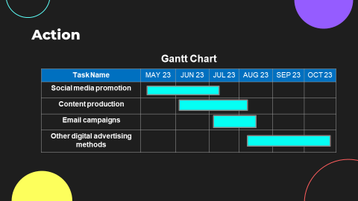

Control
Before initiating a campaign or activity, we must identify its objectives in order to gauge its performance. These objectives may include generating earnings, acquiring new consumers, or just improving brand awareness (Bowie et al., 2017). Once these objectives have been established, we must develop key performance indicators (KPIs) at each level to measure the success of our efforts thus far. Travelodge will measure success by using a variety of metrics that include customer satisfaction surveys, customer retention rates, and financial performance (Strauss et al., 2014). To gain new customers, Travelodge will use targeted marketing campaigns and loyalty programs to attract potential customers. Furthermore, the company will focus on increasing positive attitudes towards the brand through strategic collaborations with key influencers. Lastly, it will track profit growth consistently in order to monitor the effectiveness of its strategies (Chaffey and Smith, 2017). By leveraging these methods, Travelodge can achieve success in each area of its business.

Conclusion
In conclusion, Travelodge's marketing plan proposes an effective way to improve exposure and engagement on social media platforms. By analysing both the micro- and macro-environments, it has been determined that the key components of this plan are a focus on maximising user engagement through content creation, optimising advertising and promotional campaigns, and employing the most cutting-edge innovative technologies and features. By following this plan in its existing environment, Travelodge may boost its visibility and audience engagement. This will ultimately result in enhanced brand awareness, client loyalty, and sales growth for the organisation. In addition, by continually revaluating the external environment, Travelodge can guarantee that its strategies align with the most recent industry trends and best practises.

References
- Bowie,D. Buttle,F. Brookes,M & Mariussen,A (2017), Hospitality Marketing. 3rd ed, Routledge, London
- Chaffey, D and Ellis- Chadwick, F. (2019) Digital Marketing. 7th ed, Pearsons, London.
- Chaffey, D. and Smith, P.R. (2013) eMarketing eXcellence: Planning and optimizing your digital marketing. Routledge.
- Chaffey, D. and Smith, P.R. (2017) Digital marketing excellence: planning, optimizing and integrating online marketing. Routledge.
- Clow, K & Baack, D (2013), Integrated Advertising, Promotion and Marketing Communications. 6th ed, Pearson, London
- Ferrell, O.C., Hartline, M. and Hochstein, B.W. (2021) Marketing strategy. Cengage Learning.
- Ghauri, P N (2014) International Marketing, 4th Ed, McGraw Hill, London
- Housden M (2008), Marketing Research & Information, Butterworth Heinemann, Oxford.
- Jobber, D. and Ellis-Chadwick, F (2020), Principles and practice of marketing. 9th ed. London:
- Kotler, P., Armstrong, G., Harris, L. and He, H., (2020) Principles of marketing. 8th European ed, London: Pearson Education Limited.
- Kotler,P and Kartajaya, H. Marketing 4.0 Moving from Traditional to Digital (2017) Wiley. New York.
- Lamb, C.W., Hair, J.F. and McDaniel, C. (2012) Marketing. Cengage Learning.
- Ryan, D. (2012) Understanding Digital marketing: Marketing Strategies for Engaging The Digital Generation. Kogan Page, London.
- Smith PR & Zook ZE (2020) Marketing Communications. 7th ed, Kogan Page, London
- Strauss, J., Frost, R. and Sinha, N. (2014) E-marketing (p. 496). Upper Saddle River, NJ: Pearson.

Appendices
Slide 1

Hi I am _.
Slide 2
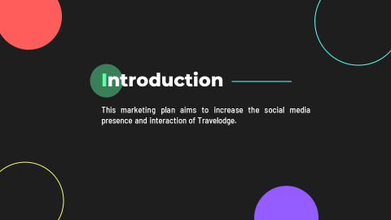
This marketing plan aims to increase the social media presence and interaction of Travelodge. The plan takes both micro and macro elements into consideration, as well as examining the 5C's, 4P's, Gannt Chart in detail. The aim is for Travelodge to identify new approaches that will better serve their customers on social media in the future.
Slide 3
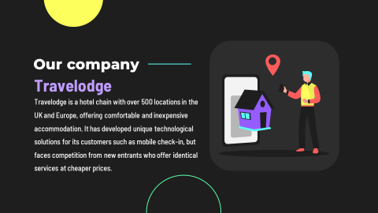
Travelodge is a hotel chain with over 500 locations in the UK and Europe, offering comfortable and inexpensive accommodation. It has developed unique technological solutions for its customers such as mobile check-in, but faces competition from new entrants who offer identical services at cheaper prices (Jobber and Ellis-Chadwick, 2020).
Slide 4

Now we will look through the situation analysis of Travelodge.
Slide 5
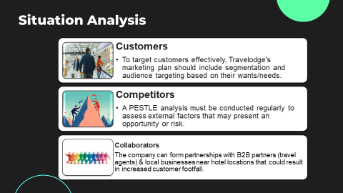
Customers: To target customers effectively, Travelodge's marketing plan should include segmentation and audience targeting based on their wants/needs (Smith and Zook, 2020).
Competitors: Travelodge must compete against rival brands such as Premier Inn & Holiday Inn Express by diversifying products or adjusting pricing strategies through discounts etc (Ryan, 2012).
Collaborators: The company can form partnerships with B2B partners (travel agents) & local businesses near hotel locations that could result in increased customer footfall.
Slide 6
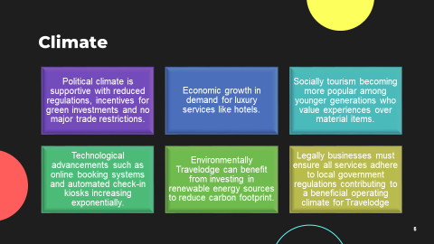
According to PESTEL analysis, the political climate in which Travelodge operates is quite supportive. The government has eased travel sector rules and created incentives for businesses that invest in environmentally friendly technologies and practises. The worldwide market is thriving economically, and there is an increase in demand for luxury services such as hotels (Kotler et al., 2020). The business has witnessed a meteoric rise in digital innovations, like as internet booking systems and automated check-in kiosks. Environmentally, Travelodge might profit from investing in renewable energy sources, such as solar electricity and wind turbines, which would minimise their carbon footprint.
Slide 7
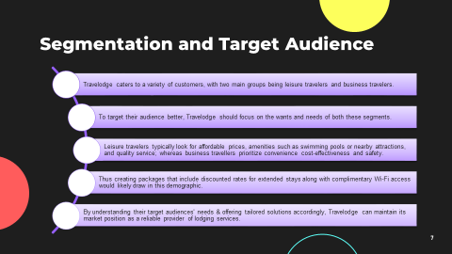
Customers served by can be separated into two main categories for segmentation: leisure travellers and business travellers. Leisure travellers often seek out accommodations with reasonable rates, features like swimming pools, easy access to the beach or local attractions, and top-notch service. Business travellers put convenience, economy, and safety first. Therefore, offering packages with reduced rates for long stays, free Wi-Fi, and business centres with conference rooms would probably appeal to this market.

Slide 9
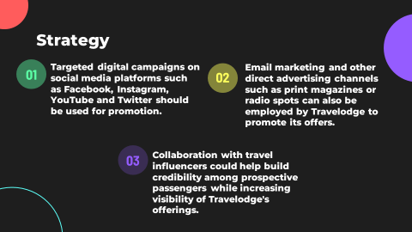
Targeted digital campaigns on social media platforms such as Facebook, Instagram, YouTube and Twitter should be used for promotion. Email marketing and other direct advertising channels such as print magazines or radio spots can also be employed by Travelodge to promote its offers. Collaboration with travel influencers could help build credibility among prospective passengers while increasing visibility of Travelodge's offerings (Housden 2008).

Slide 10
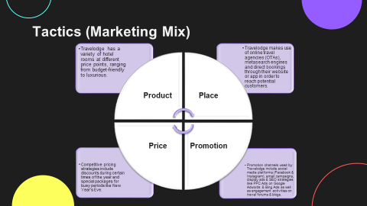
Product: Travelodge has a variety of hotel rooms at different price points, ranging from budget-friendly to luxurious (Ghauri, 2014).
Place: Travelodge makes use of online travel agencies (OTAs), metasearch engines and direct bookings through their website or app in order to reach potential customers (Bowie et al., 2017).
Price: Competitive pricing strategies include discounts during certain times of the year and special packages for busy periods like New Year's Eve (Clow and Baack, 2013).
Promotion: Promotion channels used by Travelodge include social media platforms (Facebook & Instagram), email campaigns, display ads & SEO strategies like PPC Ads on Google Adwords & Bing Ads as well as engagement activities on travel forums & blogs (Chaffey and Ellis- Chadwick, 2019).

Slide 11
It is necessary to build a Gannt chart of activities that explains when specific tasks will be completed.
Slide 12
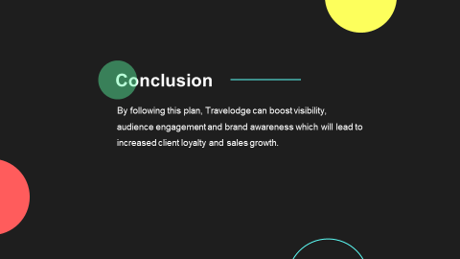
By following this plan, Travelodge can boost visibility, audience engagement and brand awareness which will lead to increased client loyalty and sales growth.
Slide 13
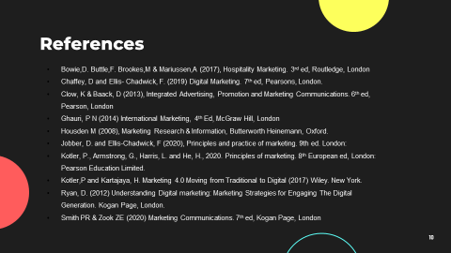
Bowie,D. Buttle,F. Brookes,M & Mariussen,A (2017), Hospitality Marketing. 3rd ed, Routledge, London
Chaffey, D and Ellis- Chadwick, F. (2019) Digital Marketing. 7th ed, Pearsons, London.
Clow, K & Baack, D (2013), Integrated Advertising, Promotion and Marketing Communications. 6th ed, Pearson, London
Ghauri, P N (2014) International Marketing, 4th Ed, McGraw Hill, London
Housden M (2008), Marketing Research & Information, Butterworth Heinemann, Oxford.
Jobber, D. and Ellis-Chadwick, F (2020), Principles and practice of marketing. 9th ed. London:
Kotler, P., Armstrong, G., Harris, L. and He, H., 2020. Principles of marketing. 8th European ed, London: Pearson Education Limited.
Kotler,P and Kartajaya, H. Marketing 4.0 Moving from Traditional to Digital (2017) Wiley. New York.
Ryan, D. (2012) Understanding Digital marketing: Marketing Strategies for Engaging The Digital Generation. Kogan Page, London.
Smith PR & Zook ZE (2020) Marketing Communications. 7th ed, Kogan Page, London.
Slide 14
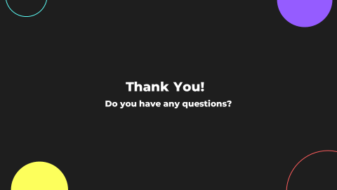
Thank You!

