


Computer Forensics (CF)

Introduction Labs/Prerequisites

Faculty of Science and Art
Applied Computing
I.Q Building, Room 205
Swansea
SA1 8EW

Lecturer: Assoc. Professor Carlene Campbell
Email: carlene.campbell@uwtsd.ac.uk
Website: https://www.knowledgewithprofit.com

  - Lab Prerequisites

Setting Up a Forensic Analysis Environment on Ubuntu
Before conducting any digital forensic investigation, it is essential to work in a controlled, isolated, and repeatable forensic environment.
This lab guides you through creating a forensic analysis workstation on Ubuntu Linux, which will be used throughout the semester to analyze digital evidence related to multiple investigation activities.
By the end of this lab, you will have:
- A fully functional forensic workstation
- Core forensic tools installed and verified
- A clean baseline snapshot for recovery
- Set up a new VM with the given ISO file and install Ubuntu OS completely. These are located on a global file network share \\192.168.135.16\NOSSISOS2627$ Ensure that the network adapter is set to either Bridged or NAT Adapter by checking the Network Settings of your Ubuntu VM in VirtualBox.
After the installation is complete, open the terminal on Ubuntu and update the system.
sudo apt update
sudo apt upgrade -y
Now, begin installing the following tools, which shall form the foundation of your digital forensic analysis.

Autopsy

Purpose
Autopsy is a graphical digital forensics platform used to:
- Analyze disk images
- Recover deleted files
- Examine timelines, emails, and browser artifacts

Installation
sudo snap install autopsy

Start Autopsy
autopsy
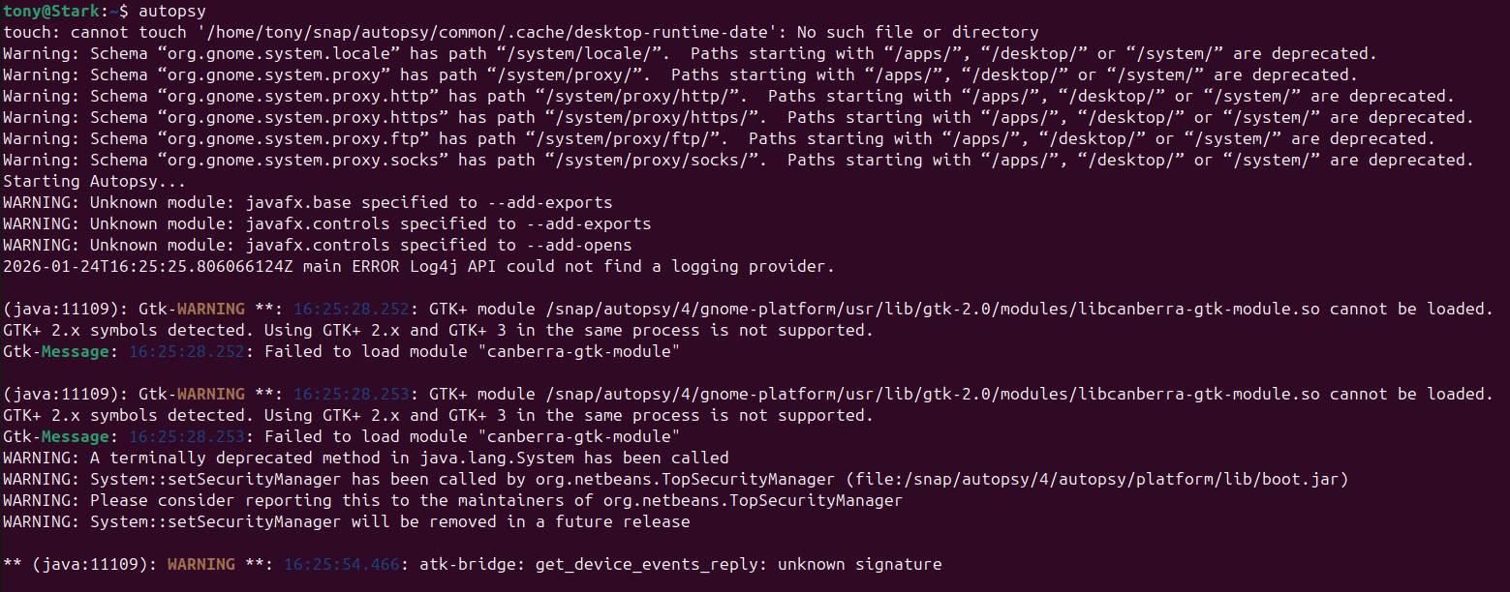
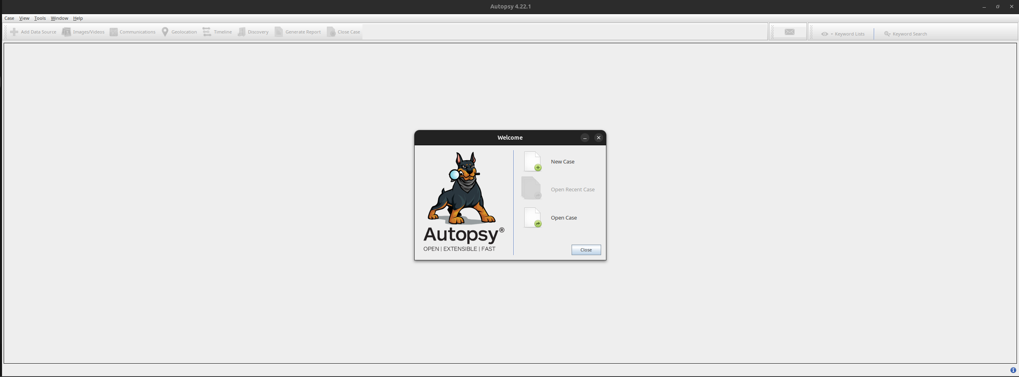

Sleuth Kit

Purpose
The Sleuth Kit provides command-line forensic utilities used to:
- Examine file systems
- List files, including deleted ones
- Extract files from disk images

Installation
sudo apt install sleuthkit -y
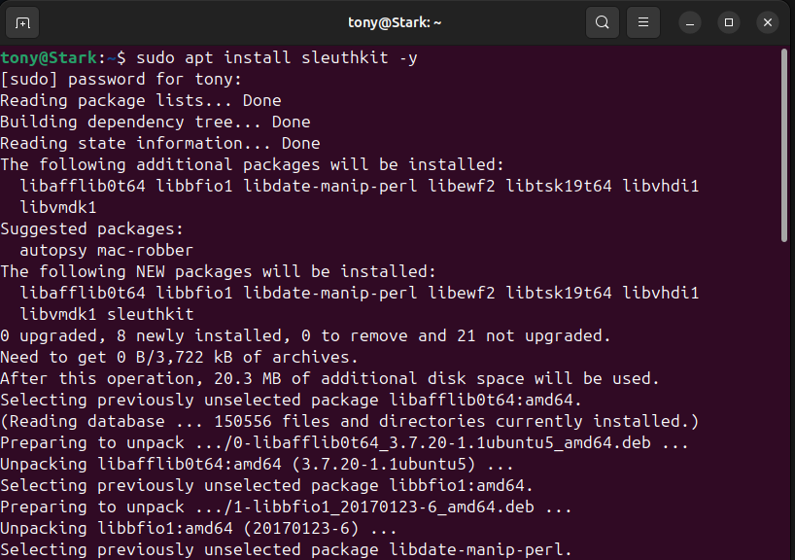

Usage
Check its version
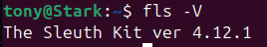
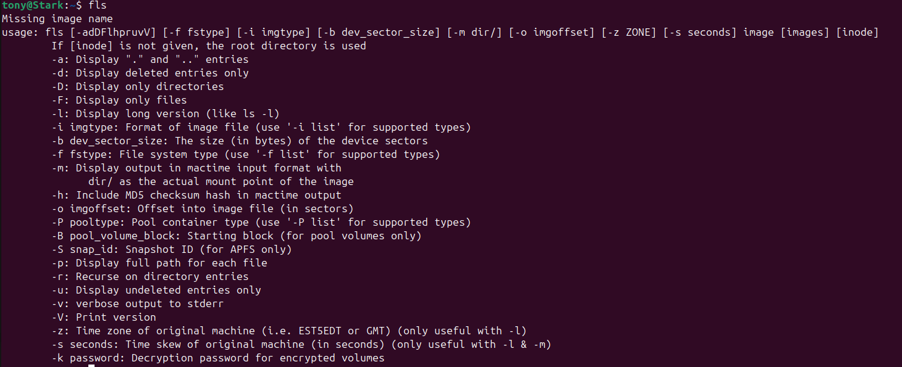

EWF Tools (Expert Witness Format)

Purpose
Used to handle E01 forensic images, with image verification and conversion between formats.

Installation
sudo apt install ewf-tools -y
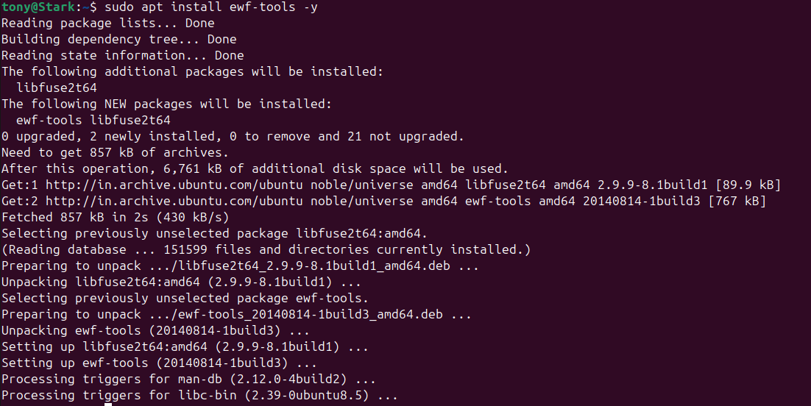
Validate installation
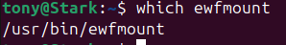

Hashing Tools

Purpose
Hashing ensures evidence integrity and legal defensibility.

Installation
sudo apt install coreutils hashdeep -y
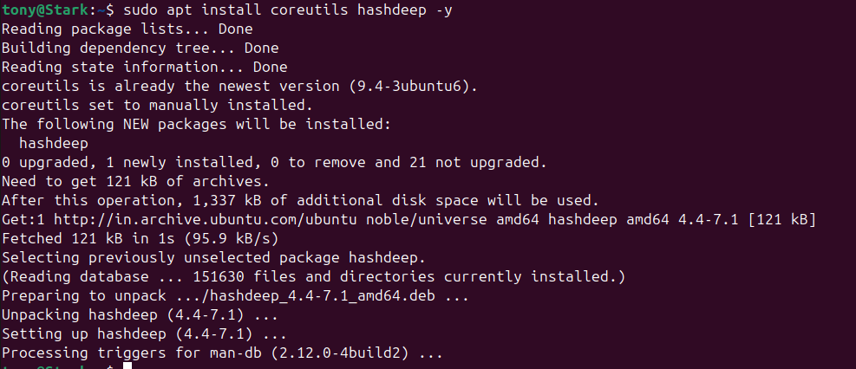
Check what is installed
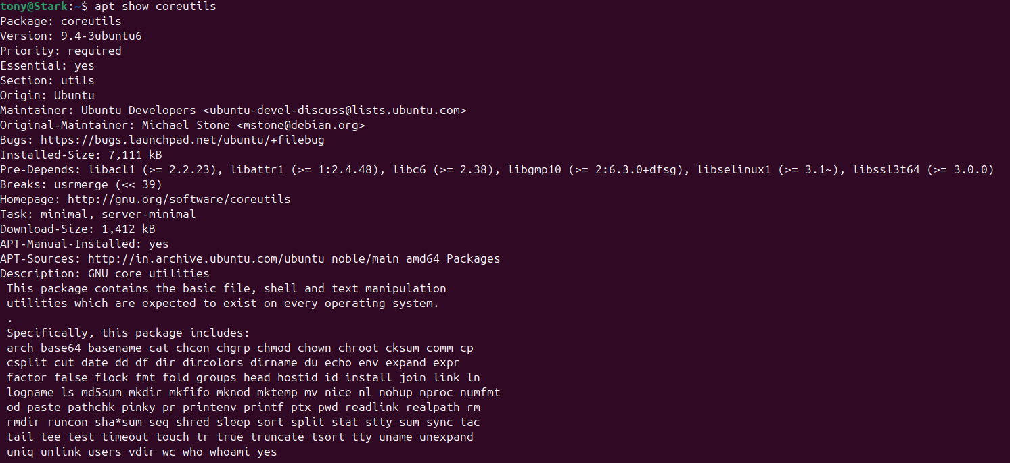

Steganography Tools

Purpose
Used to detect and extract hidden data inside image files.

Installation
sudo apt install steghide -y
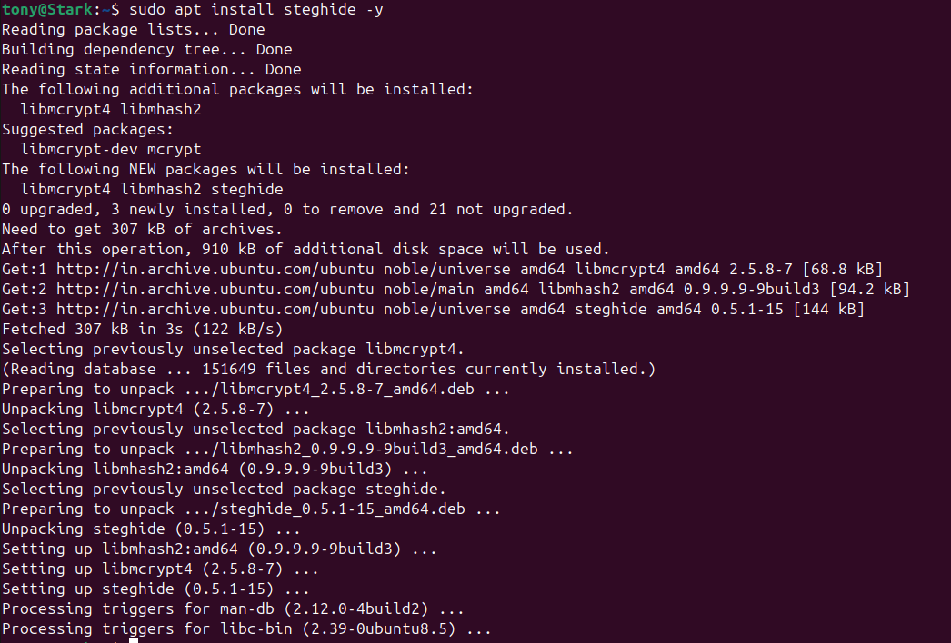
Validate installation
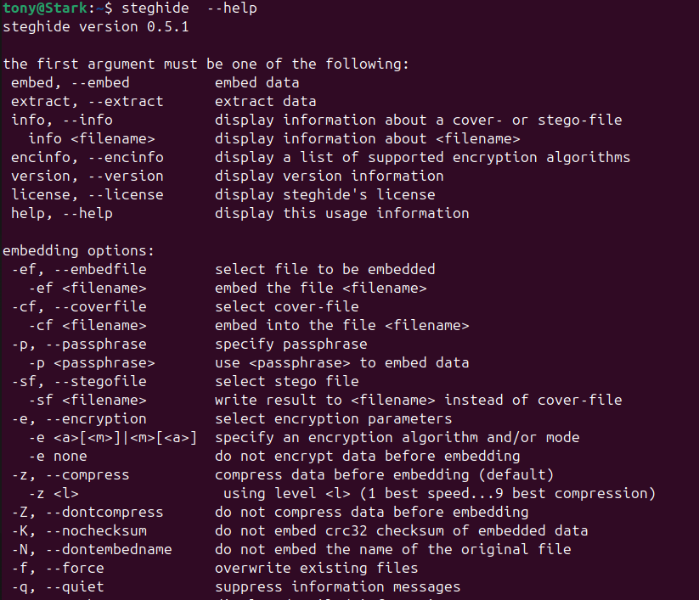

Metadata & String Analysis Tools

Purpose
These tools help identify:
- Embedded metadata
- Human-readable strings inside binaries

Installation
sudo apt install libimage-exiftool-perl
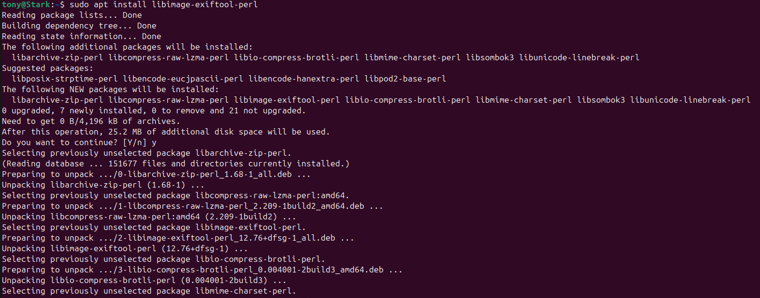
Validate installation
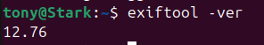

Metadata & String Analysis Tools

Purpose
Guymager is a Linux-based forensic imaging tool designed to acquire digital evidence in a forensically sound and legally defensible manner. Its primary purpose is to create bit-for-bit copies of storage media while ensuring data integrity and evidence preservation.
Specifically, Guymager is used to:
- Acquire disk and partition images without altering the original media
- Generate forensic image formats such as E01 (Expert Witness Format) and RAW (dd)
- Calculate and verify cryptographic hashes (MD5, SHA-1, SHA-256) during and after acquisition
- Prevent accidental writes by enforcing read-only access to source devices
- Provide reliable documentation for chain of custody and forensic reporting

Installation
sudo apt install guymager -y
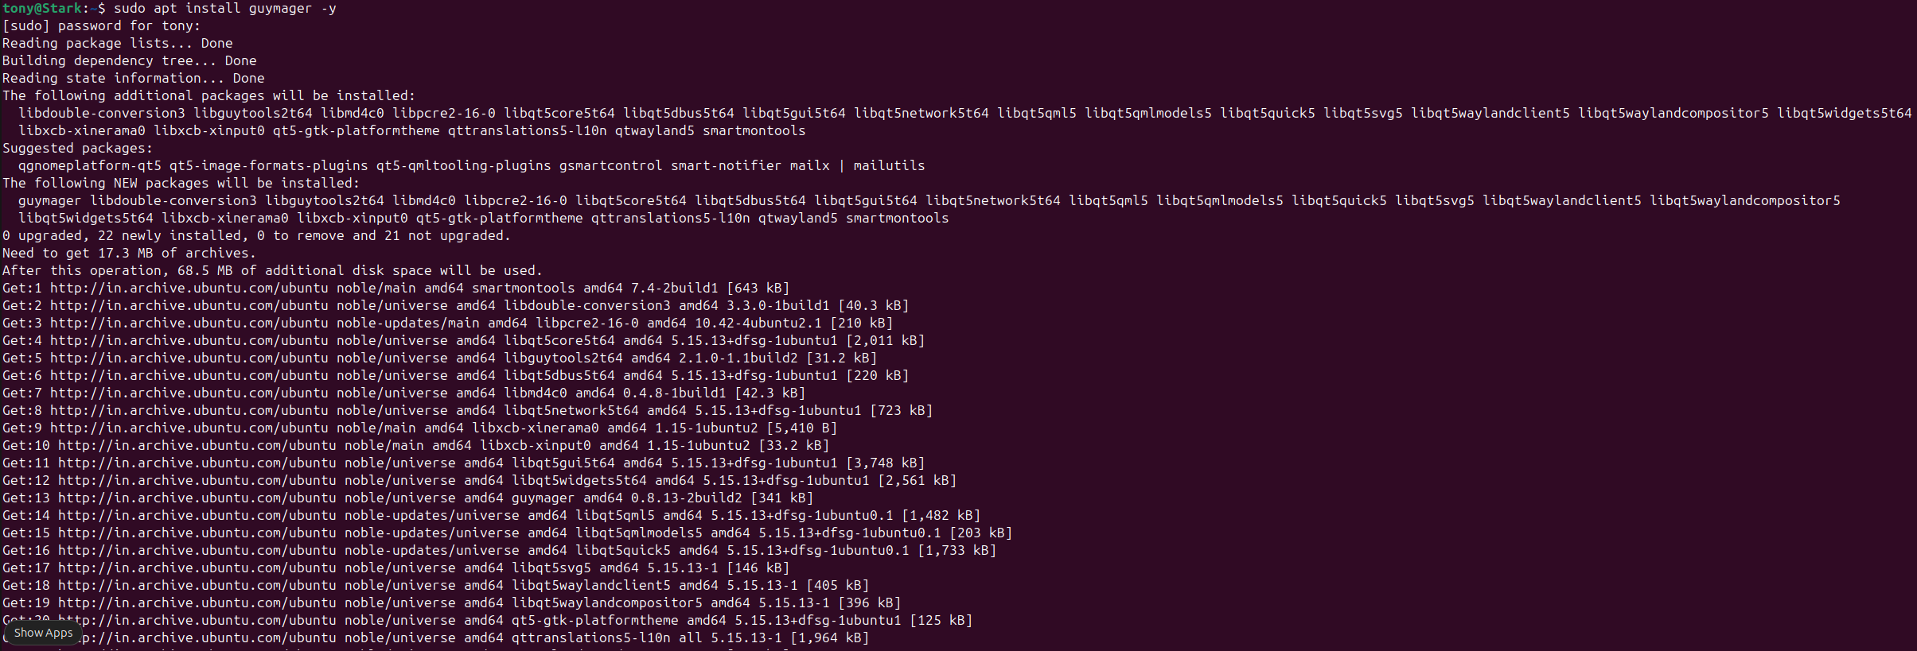

Usage
guymager
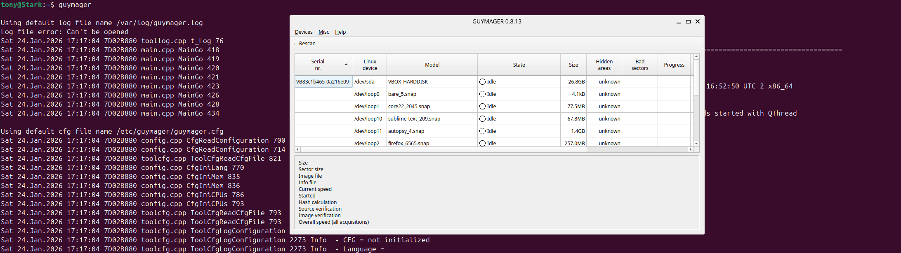

After all the tools are installed, you must secure the forensic environment by disabling networking services. This prevents accidental Internet access, avoids malware communication to CnC servers, and preserves forensic integrity
sudo nmcli networking off
Now create a baseline snapshot in VirtualBox. Power off the VM and create snapshot named: Clean_Forensic_Baseline. This allows rollback before each lab, ensures repeatability, and supports troubleshooting.

Introduction

The Computer Forensics investigation is a methodological approach of preparing for an investigation, collecting and analyzing digital evidence. It is also managing the case from the reporting of the crime until the case’s conclusion. The process takes place in a computer forensic lab.

Computer forensics play a vital role in the investigation and prosecution of cyber criminals. The process includes acquisition, inspection, and reporting of information stored across computers and networks related to a civil or criminal incident. Forensic investigators are trained professionals who can extract, analyze, report, and investigate cases that involve technology as the source or the victim of a crime.

As a computer forensics investigator, it is important to have knowledge of the process involved during a forensics investigation, such as collecting digital evidence, building a computer forensics lab, recovering the deleted data, etc.

There are number of tools and websites that have many hands-on lab exercises such as:
- AWS
- Azure
- Tryhackme
- Cybrary
- www.freecodecamp.org
- www.udemy.com

Apart from EC-Council and Exterro FTK that will be adapted it is important to familiarize yourself with other platforms.
Today’s task will allow you to familiarize yourself with tryhackme.

Create a login account on www.tryhackme.com

The tryhackme.com website is a learning cybersecurity platform where you can develop your skills by working through hands-on guide tasks and supporting videos. You can also learn and test your skills with gamified, real-world cybersecurity challenges.

- Go to the website https://tryhackme.com/ and select Join now for FREE highlighted in Green
- Fill out the relevant details such as username, email and password to join.
- Once you have created your login details, please sign in.
- Once you have sign go to learn
- Each week you will get the chance to have a go by choosing any of their Hands-on activities by going into the Learn menu and search for a Forensics lab of your choice.

- To select a free walk through task, select
  - Go to Walkthroughs as shown below

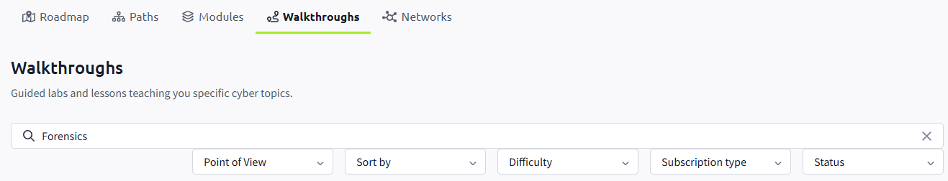
  - Type Forensics

  - In the drop-down menus below the search, select the following in red circle:

  - Chose any of the free walkthrough exercises and give it a go. However, I would recommend to start with “Intro to Digital Forensics”.

There are many other similar site. If you are using a different one please share it to the class. We will use a number of the free walkthrough exercise but the option is yours if you want to subscribe (pay).

Exterro FTK
FTK software tools help law enforcement officials, corporate security, and IT professionals access and evaluate the evidentiary value of files, folders, and computers.
The admissibility of digital evidence in a court of law, can be dependent on preserving the integrity of the source data when it is acquired. When digital evidence is acquired, forensic examiners create clones of the digital evidence to prevent any possibility of the digital evidence being changed or modified in any way. This acquired duplication is called a forensic image. If there is question to the authenticity of the evidence, the image can be compared to the original source data to prove or to disprove its reliability.
To create a forensic image, the data must be acquired in such a way that ensures that no changes are made to the original data or to the cloned data. The acquired data must be an exact “bit-by-bit” duplication of the source data. You can use AccessData’s Imager tool to acquire exact duplicates of digital evidence. Preserving the evidence is accomplished both in the method of acquisition and the storage of the acquired data. Creating an exact replica of the original source is critical in forensic investigations. Keeping that replica safe from any source of corruption or unauthorized access involves both physical and electronic security. Once a case is created and the evidence is added to it, the case becomes just as critical. Acquired 001, E01, S01, and AD1 images can be encrypted using AD Encryption.

Creating your login

- Click the shortcut icon on the desktop to open the application.
- In the log in dialog box, log into the database using
  - Username: cisco
  - Password: Password

- Click Database > Administer Users > Create User.
- In the Add New User dialog, enter information for the following:
  - User Name: Enter the name that the user is known as in program logs and other system information.
  - Full Name: Enter the full name of the user as it is to appear on case reports.
  - Password: Enter and verify a password for this user.
  - Email Address: Enter a valid email address; this will be used for any notifications.
  - Role: Assign rights to the selected user name using roles.
    - The default role is Application Administrator - Can perform all types of tasks, including adding and managing users.
    - Case/Project Administrator: Can perform all of the tasks an Application Administrator can perform with the exception of creating and managing users.
    - Case Reviewer: Cannot create cases, can only process cases.
- Click OK to apply the selected role to the new user.
- Click OK to exit the Add New User dialog.



