

Course: Certificate of Higher Education in Skills for the Workplace - Level 4
Student: Faduma Awad nº 191660
Module: Effective Teamworking and Communication skills
Module Code: BMSW4002
Lecturer: Toyin

Table of Contents:
- Introduction …………………………………………………………………………………………….. 3
- Written communication and professional writing ……………………………………. 3
- Communication in the work-place ……………………………………………………………
- Types of communication models ……………………………………………………………..
- Shannon and Weaver Communication Model …………………………………………
- Conclusion ………………………………………………………………………………………………
- References …………………………………………………………………………………………….
- Appendix ………………………………………………………………………………………………..

Effective teamwork and communication skills; A Report

Introduction
Communication involves the exchange of information and understanding between individuals. In this modern-day communication plays a big part in our society, as every task requires direct or indirect communication (Luneburg, 2010). In this module we have explored a range of different communication styles, which fit different scenarios and this essay will discuss these communication styles, communication modules and how communication can be improved in a work setting.
There is the verbal and the nonverbal communication. The difference between these two is that the Verbal communication is the spoken one and nonverbal is the unspoken communication like body language, sings and signals. The verbal and the nonverbal communication should flow with each other which means for example if you say that you are angry and your body language shows that you are very happy and you are smiling, you can get misunderstood very easily. For professional and personal connection communication plays a big factor as it is not only the spoken communication which plays a major role but the unspoken (nonverbal) communication speaks louder. Through the body language people can express themselves (Segal, Smith, Robinson, Boose June 2019).
Written communication and professional writing
There are 3 different types of written communication such as letters, memos or reports. These types of written communication can be either informal, formal, internal or external. The main factors of successful written communications are the words we use, the tone, sentences or paragraphs. This can be seen in the class activity we had done earlier where we wrote examples of professional emails in comparison to nonprofessional emails (see appendix 1 and 2).
In appendix 1 I was writing an email back to my friend. She had asked to borrow some money however I was running out. That is the reason I told her to ask me in two weeks’ time again so when I got paid, I could give her the money she needed. As she is a good friend of mine, the language I used such as “say hi to all” or “I miss you” is informal and very personal. In comparison to the email, I wrote to the Prime Minister my language was very formal as I do not know the Prime Minister personally. I was concerned about how the elderly is affected by Covid-19. Due to this, I requested a way to help them out in this Coronavirus crises and asked about what else we could do for them.
I used sentences such as “this email is regarding a concern about the coronavirus” instead of “I am worried about the coronavirus” as this language is more formal. I used formal language so that I can be taken seriously whilst I am showing that I am staying focused and professional. In the class activities we spoke about how to end a letter or an email if it is formal. The email I wrote for the Prime minister had the ending of “yours faithfully” which is a term or a discharge you use for someone you do not know personally. Compared to the email for my friend, I said “Miss you” to end it and this made it personal.
Effective communication is needed in the workplace especially when writing emails to your work colleagues. Formal language must be used to avoid misunderstandings to keep two professional boundaries. It is important to keep in mind that you are representing your workplace so the written communication skills should reflect this as sometimes you may need to send letters or emails to other organizations. A person must be careful not to include sensitive information when sending emails or letters in the workplace due to data protections laws and this this in with being professional. However, it is not only writing communication that is importance in a work environment, verbal communication is just as needed. An example of this can be seen in an experience that my friend had in her place of work.
Communication in the workplace
During the hiring process a company will be able to see an employee’s communication skills through their CV (writing skills). They will also be able to see this in the job interview when they are asking them questions. Below is an example of how communication had gone in my friends work experience.
The company ASOS which my friend was working for is a huge global online shopping company. ASOS is a very diverse company. The models on the online shop are from different races, cultures, sizes and sexuality. The Name ASOS stands for “As Seen On Screen” and was made by a British guy named Nick Robertson back in 2002. My friend worked at this company for 8 months and attended all the training necessary. However, she was not given a detailed explanation of how the absences were marked. She had taken two 6 days off. Intern this was recorded as eight absences. This was because she was on a rotational rota which was 4 nights on and 4 nights off. Once she called in sick for one shift, they recorded the remaining three shifts in the week as absent. Therefore, she had 8 absences in the work system even though she attended the shifts.
English is not my friends first language. At ASOS she was communicating in German with the customers. Due to her language barrier and the fact that her team leader for the German market was absent, she had to communicate with the performance managers in English. This may have played a part in her not completely understanding how ASOS’s system worked. As a result, her probation was extended, and she ultimately got fired.
My friend could have encouraged herself to look out for some help if she felt like there was certain things she did not understood in the training. She has a lot of friends who were working in ASOS too. If she would ask them about any topics, they would help her out by asking the management to clarify the topics she misunderstood. Sometimes if you do not ask, the other person will never know if you have really understood it or not.
Due to the fact that she was working in the German market, but she was trained in the English market, the company could have given here better suited training for her language market. The person who was doing the training could have assisted her more during her probation. If the management had a talk with her and generally and asked how she is getting along and given her feedback much earlier than they did, then the issue could have been avoided and she may have passed her probation instead of just having it extended. All – in all, if both sides (my friend and ASOS management team) had come together and used effective communication and followed the communication models, this all may have been avoided.
Types of communication models
In the in-class activities we learned about different communication models like for example the Schramm model which was made in 19, the Shannon Weaver model 1948 and Berlo’s model of communication was first published in 1960. In my friends’ case the most appropriate communication model to use would be Berlo’s model. Berlo’s communication model is the easiest communication model.
Communication skills play a decisive role here. Other aspects like history, awareness and a clear mindset are important too. For certain cultures what might be called disrespectful may be normal in other cultures. Communication is not quite as easy as it might seem. It takes a lot of effort and understanding to have good communication with strangers or with someone else.
Different communication models exist which can educate people on how effective communication should be done. Using these models, attempts can be made to improve interactions. In the class activities we spoke about the different communication models which are the Shannon Weaver model, the Berlo’s model and Schramm’s model of communication. All these communication models have something in common; the sender (the decoder) who sends the message through the channel and the encoder who is the receiver of the message.
Shannon and Weaver Communication Model
This report will discuss the Shannon and Weaver communication model as an example which was found in 1948 by Claude Elwood Shannon and Warren Weaver. I chose this communication model because it is very clear to understand, and it is known as the “mother of all models”.
The concept can be seen in appendix 3 and takes the following steps: If you are communicating with someone (for example) person A asks person B in a loud classroom “Can you please pass me the bottle of water?”. In this case person A is the sender and the encoder because person A sends a message to person B which means person A transmits a message to person B. The channel is always the medium that person A uses to send the message. Person B is going to be the decoder or the receiver of this message which is sent by person A. Once the receiver (person B) gets the message, the message has gone to the destination. The noise is the disturbance from which in some cases leads to a misunderstanding between encoder and decoder.
The benefits of this model are that communication takes a two-way method. The noise definition helps the communication to be efficient by removing noise or noise causing problems and the Shannon and Weaver model is also able to produce quantifiable data in comparison to other models (Businesstopia, 2018).
The limitation of this model is that human individual communication can be used rather than group communication. In the communication process, the receiver plays a passive part while the sender plays a primary function that send out the messages. The feedback compared with the messages sent by the sender is taken as less significant. Several critics take the model as “misleading or misrepresentation of the essence of human communication” (Businesstopia, 2018).
Conclusion
Overall, the benefits of successful communication are that it makes the conversations clear. There is less misunderstandings and it helps to solve problems in daily life or in business. Good communication skills are demonstrating professionalism which is needed in the workplace. Almost every employer is looking for employees with good communication skills, so they can work in a team or to finish the tasks successfully. The first thing an employer is going to look at are the writing skills which for example is shown in the CV. The next step would be the job interview. In the job interview the employer will have a good eye on the communication skills the job seeker is coming with. From the body language to the way the spoken language comes through. In this century it is essential to have good written and spoken communication in any branch. The difference between a normal conversation with friends and conversations (like email) within the workplace or a formal letter are that individuals can not speak the same way they speak with friends or people in their circle the same way as they would speak with authorities. Authorities are respected, the language used is formal and keeps a healthy distance between the person and for example the government, force or the council. Individuals can be upset, frustrated or angry about different things in life, communication helps other people understand the problem and how to solve the issue (Thompson, 2012).

References
Businesstopia. 2018. Shannon And Weaver Model Of Communication - Businesstopia. [online] Available at: <https://www.businesstopia.net/communication/shannon-and-weaver-model-communication> [Accessed 5 May 2020].
Janse, B. (2018). Berlo’s https://www.toolshero.com/communication-skills/berlo’s-smcr-model-of-communication/
Luneburg, F., 2010. Communication: The Process, Barriers, And Improving Effectiveness. [online] Nationalforum.com. Available at: <http://www.nationalforum.com/Electronic%20Journal%20Volumes/Lunenburg,%20Fred%20C,%20Communication%20Schooling%20V1%20N1%202010.pdf> [Accessed 5 May 2020].
Segal, J., Smith, M., Robinson, L. and Boose, G., 2019. Nonverbal Communication. [online] HelpGuide.org. Available at: <https://www.helpguide.org/articles/relationships-communication/nonverbal-communication.htm> [Accessed 5 May 2020].
Thompson, D., 2012. 3 Ways Communication Can Solve Problems. [online] Business 2 Community. Available at: <https://www.business2community.com/health-wellness/3-ways-communication-can-solve-problems-0144929> [Accessed 5 May 2020].

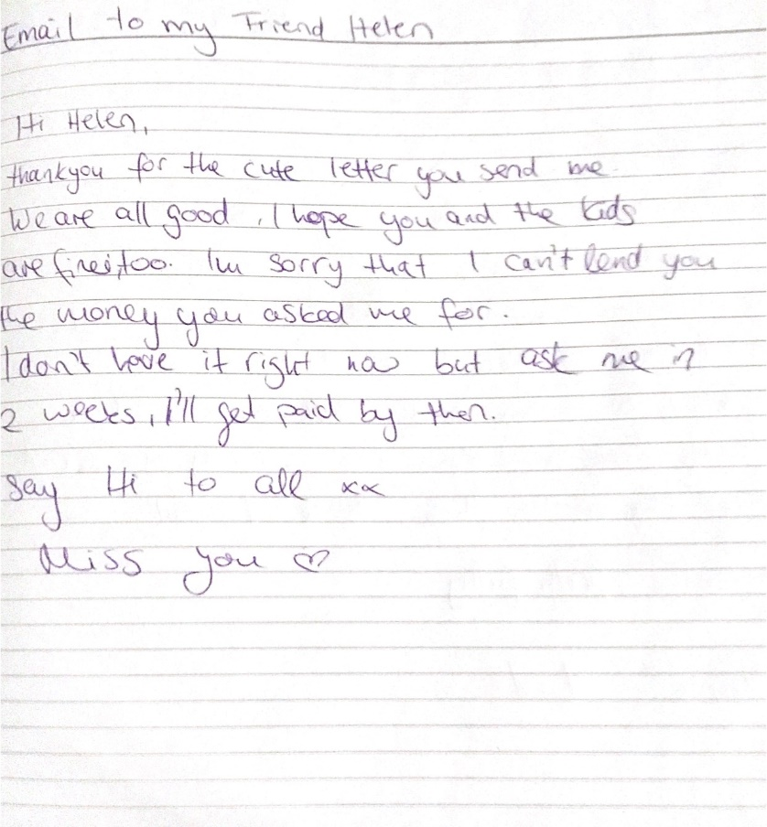
Appendix

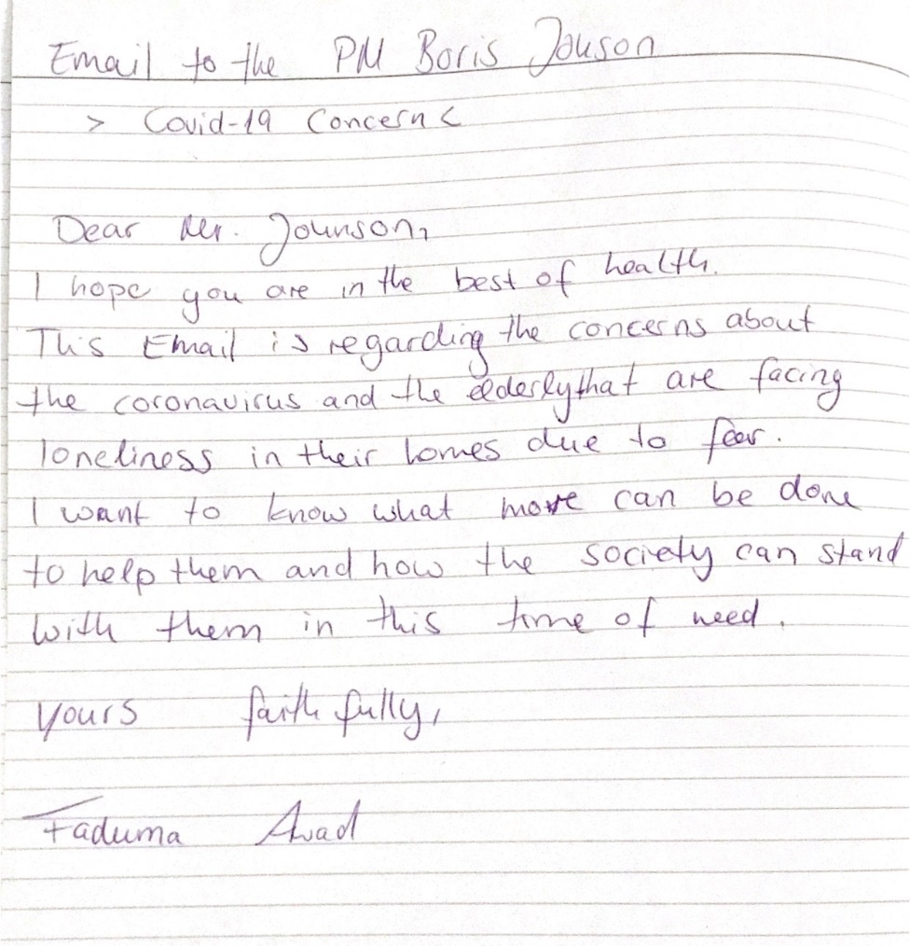
Appendix 1, Email to my friend

Appendix 2, Email to the Prime Minister

Appendix 3, Shannon Weaver Model.

