
An investigation of business’ readiness to adapting to future AI and business automation.

Dissertation submitted as part of the requirements for the award BA Business and Management.

Name: Judith Churcher
Student Number: 2101153
Sustainable Business Dissertation (BMSP6018)

Word count: 7,882

Declaration

This work has not previously been accepted in substance for any degree and is not being concurrently submitted in candidature for any degree.

This Dissertation is being submitted in partial fulfilment of the requirements for the degree of BA Business and Management.

This Dissertation is the result of my own independent work/investigation, except where otherwise stated. Other sources are acknowledged by footnotes giving explicit references. A Bibliography is appended.

I hereby give consent for my Dissertation, if accepted, to be deposited in the School Dissertation Library.

Name: ………Judith Churcher……………..
Date of Submission: ……………30/04/2024……………..
Signature: ………………J. A. Churcher..……...

Acknowledgements
I would like to extend my heartfelt gratitude to all those who have been instrumental in this investigation. To University of Wales Trinity St David Carmarthen and all lecturers where I've spent the past three years, your unwavering support and dedication to excellence have provided me with the foundation upon which this work stands.

Special thanks are due to my dissertation supervisor, Roisin Mullins whose guidance, wisdom, and patience have been invaluable throughout this journey. Roisin’s mentorship has challenged me to grow both academically and personally, and I am deeply grateful for the insights and encouragement.

To my class, especially Glyn, his friendship and support have been a source of strength during the highs and lows of this endeavour. His belief in me, along with his willingness to lend a helping hand, has been integral to reaching the finish line.

Lastly, but certainly not least, I extend my heartfelt appreciation to my family. Their love, encouragement, and understanding have sustained me through the challenges and uncertainties of this academic journey. The believed in my abilities and their support have been the driving force behind my success. I am deeply grateful for the sacrifices they have made and the endless encouragement they have provided.

To all those mentioned and to countless others who have played a part, directly or indirectly, in shaping this investigation, I extend my sincerest thanks. Their contributions have not gone unnoticed, and I am forever grateful for the knowledge, experiences, and relationships I have gained along the way.

Abstract
Advancements in artificial intelligence (AI) and automation technologies continue to reshape industries, businesses face a pressing imperative to adapt and integrate these innovations into their operations. This dissertation examines the concept of business readiness in the context of AI and automation adoption, seeking to develop a comprehensive framework for evaluating and enhancing organizational preparedness.
The study begins by analysing the current landscape of AI and automation technologies, exploring their potential impact on various business functions and industries. Through a review of literature, key factors influencing successful adoption and integration are identified, including technology organisational theory and the adoption of theory. Through exploring these theories, they will be explained whilst finding changes and barriers are already there.
Drawing on qualitative research methodologies, primary data is gathered from a diverse sample of businesses across different sectors. Through interviews, the research investigates the readiness levels of organizations and identifies critical challenges, opportunities, and best practices in navigating the transition towards AI and automation-driven operations.
Based on the findings, a comprehensive framework for assessing and enhancing business readiness is proposed. This framework integrates technological capabilities assessment, organizational culture analysis, workforce skill readiness evaluation, regulatory compliance considerations, and strategic alignment with business objectives. It emphasises the importance of change management strategies, stakeholder engagement, and continuous learning mechanisms to foster a culture of innovation and adaptation.
The dissertation contributes to both theoretical understanding and practical implications for businesses seeking to use AI and automation technologies effectively. By providing a structured approach to assessing readiness and guiding implementation strategies, it offers valuable insights to business leaders, policymakers, and researchers navigating the complex landscape of technological disruption and organizational transformation in the digital age.

Table of Contents
Chapter 1: Introduction 7
1.2 Purpose of Research 7
1.3 Research Aims and Objectives 7
Chapter 2: Literature Review 9
2.1 Introduction – What is Artificial Intelligence? 9
2.2 Alan Turing & John McCarthy 9
2.3 AI Adoption in Small Businesses 10
2.4 Current State of the AI Market & AI Advantages 11
2.5 Barriers and Challenges to AI Adoption 13
2.6 Role of Leadership and Strategic Planning 14
Chapter 3: Methodology 15
3.1 Introduction 15
3.3 Research Philosophy 15
3.4 Research Type 16
3.5 Research Strategy 16
3.6 Time Horizon 17
3.7 Data Collection Method 17
3.8 Data Analysis Methods & Techniques 18
3.9 Sampling Strategy 18
3.10 Methodological Limitations 19
3.11 Ethical & Logistical Consideration 19
3.12 Methodology Conclusion 20
Chapter 4: Findings, Discussion and Analysis 21
4.1 Theme 1: Resistance to Change 21
4.2 Theme 2: Business Culture. 22
4.3 Theme 3: Financial Budget 23
4.4 Theme 4: Integration Challenges 24
4.5 Theme 5: Future Benefits of AI and Future Automation 24
4.6 Theme Discussions 25
Chapter 6: Conclusion. 27
6.1 Recommendations 27
6.2 Further Study 27
Chapter Eight: Appendices 29

List of Figures
Figures | Name and reference | Page number
Figure 1 | The Integration Model of RBV and AI. | 11
Figure 2 | Share of businesses adopting by sector. | 12
Figure 3 | Share of businesses adopting by size. | 13
Figure 4 | The main bottleneck holding back further AI Adoption | 14
Figure 5 | AI Integration Phases and Associated Challenges in CRM | 15

Chapter 1: Introduction
Artificial intelligence has become a crucial and more accepting factor in many industries and now many views it as a fundamental component of corporate strategy and organisational decision-making processes. In McKinsey Global Survey on AI, 2022, it has shown that there has been a significant growth within the last 5 years, adoption rates have more than doubled since 2017 and from the results they can see that certain companies achieving the greatest financial gains from AI are maintaining a lead over their competitors. Although AI has been used for years, it is ever changing at a rapid rate. The increasing complexity makes it harder for the end user to understand how it makes decisions, then becoming harder for people to trust the systems. In this report, it investigates how ready people are for the future AI to reshape industries and their operations.
Statista, 2024, says that the projected growth of the AI market indicates an increase from $241.8 billion in 2023 to nearly $740 billion by 2030. he substantial projected growth indicates a growing demand for AI technologies across various sectors and industries. It implies that businesses and organizations are increasingly recognizing the potential benefits and value of AI solutions, leading to increased investment and adoption. Moreover, the forecasted market size highlights the transformative impact that AI is expected to have on economies, industries, and societies globally, indicating opportunities for innovation, efficiency gains, and competitive advantage. AI holds the promise of enhancing productivity, streamlining operations, and revolutionizing various aspects of work. However, its adoption also brings forth challenges and concerns related to job roles, skill requirements, and ethical considerations. AI may take over some roles and decide what roles need human qualities (Janssen, 2024). Companies should be understanding the change and be ready for it.

Purpose of Research
The purpose of this research is to investigate the readiness of businesses to adapt to future advancements in AI and business automation. This study aims to understand managers of companies or small business owners’ current knowledge and skills in preparation for current and future implementation of AI and automation.
In a time with rapid technological evolution, understanding the preparedness of organizations for the integration of AI and automation is crucial for their sustainable growth and competitiveness.
This topic is of particular interest as there is much conflict between the pros and cons of AI in workplaces. AI and automation become increasingly integrated into various aspects of business operations, there is a growing urgency for organizations to assess their readiness and capabilities in harnessing the potential benefits while mitigating potential risks. Understanding and addressing the implications of AI and automation readiness can be instrumental in shaping strategic decision-making and positioning for long-term success.

Research Aims and Objectives
The aim of this study is understanding their current readiness of AI and future automation and to analyse the barriers and challenges faced by small businesses and managers in adopting AI and automation technologies, thereby assessing their readiness for future integration.

Research Objectives:
- To identify and examine the key barriers and challenges hindering small businesses and managers in adopting AI and automation technologies.
- To analyse the impact of organizational size, resource constraints, and managerial capabilities on business readiness for AI and automation.
- To explore the perceptions, attitudes, and knowledge gaps of small business owners and managers regarding AI and automation integration.
- To devise a strategic plan for future readiness in the short term and long term, incorporating adaptable approaches for implementing AI and automation in small businesses.
- To evaluate the effectiveness and feasibility of the proposed strategic plan in addressing the evolving needs and challenges of AI and automation integration in small businesses.
These objectives will guide the research in comprehensively examining the readiness of small businesses and managers for AI and automation, and in developing practical strategies to enhance their preparedness for future technological advancements.

Chapter 2: Literature Review

2.1 Introduction – What is Artificial Intelligence?
AI is often heavily publicized, but this publicity can be confusing and misleading, leading to widespread misunderstanding of what AI truly entails. This confusion extends even to those working within the field of AI. The media often exaggerates stories around AI and tend to focus on the potential opportunities, risks, capabilities, and threats of AI in a way that may not align with the actual technical conditions. On the other hand, scientific results are more realistic, but sometimes criticized for being overly cautious, or they will sometimes overlook risks. Saying this means there's a big difference between how the media talks about AI and what experts say (Hagendorf, et al, 2019).
AI now holds a significant place in industries worldwide. It has come a long way in the last few decades. At first, it mainly used rules to make decisions. Now, it's more about learning from data, thanks to machine learning and deep learning. We can see AI applications increase across various industries, including healthcare, finance, transportation, and entertainment, revolutionizing how we work and interact with technology.

2.2 Alan Turing & John McCarthy
The term AI came around in the 1950’s with Alan Turing and John McCarthy laying the groundwork for AI with their theories. However, practical applications were limited because the technology wasn't advanced enough to support them. The focus was more on developing theories rather than creating usable AI systems.
In 1956 McCarthy conducted a research project on artificial intelligence. The study was to find explore the idea that every aspect of learning and intelligence could potentially be described so precisely that a machine could imitate it. They planned to investigate how to teach machines to use language, think abstractly, solve complex problems, and even improve themselves. They believed that significant progress could be achieved in these areas if a group of scientists collaborated on the project for a summer (McCarthy, et al , 2026). The findings of the study, which was called the Dartmouth Conference, laid the foundation for the field of artificial intelligence AI. While the study didn't produce immediate tangible results, it sparked interest and research in AI by establishing key concepts and goals.
Turing is widely recognized for establishing the groundwork in several fields including Computer Science, Automated Decryption, Systems Biology, and the Turing Test, which evaluates a machine's ability to exhibit human-like intelligence. The conclusion of his paper is that people often turn to computers or smartphones when faced with difficult questions, relying on the collective knowledge of the internet. As computers can quickly search vast amounts of information, recognize objects in images, learn user behaviours, and translate text, thanks to techniques developed in AI research, Turing findings contributes not only to the concept of the Universal Turing machine, which put down the foundation for the computer industry, but also to the development of intelligent machines, which inspired much of the software powering modern digital assistants (Muggleton, 2014).
Fast forward to the 2000’s to present, we are now in the era of big data. They have seen significant advancements in recent years, particularly due to increases in processing power, especially with the use of Graphics Processing Units (GPUs). This enhanced processing power allows DNNs to handle large datasets and perform computations required for training and inference more efficiently, leading to improved performance in various tasks such as image recognition, natural language processing, and speech recognition (Arvind, 2023).

2.3 AI Adoption in Small Businesses
Similar studies have been done to investigate the adoption of AI and automatic technologies. A research paper published by Nascimento, et al, 2022, looked at the factors that influenced AI in small businesses. The interviews covered people in multiple industries, with consulting, retail, tourism & entertainment being the most represented. This shows that a wide range of business types was considered in the analysis. The research was also conducted though a qualitative interview method. Though this they were able to analyse the data and categorise the responses and find nine key factors. These factors include performance expectancy, business model, effort expectancy, self-efficacy, trust, business compatibility, social influence, trial ability, and technical support. From the reasearch, the interviews said that they would have better job performance if they had a system to help them but said that the process would have to be easy to learn as they do not have the spare time adapt and learn. The study concluded by suggesting easy-to-use solutions to help the adoption of AI into small businesses, and that system suppliers should give a reasonable trial period on their services and technical support. Overall, the study provides valuable insights for both small businesses seeking to adopt AI into their everyday roles.
From a theoretical perspective we look at the Resource-Based View (RBV), which suggests that an organisations resources and capabilities are key determinants of having a competitive advantage.
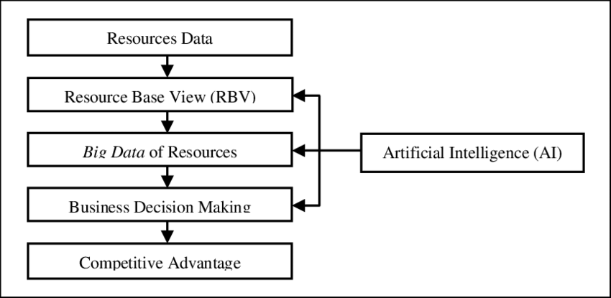

Figure 1 : The Integration Model of RBV and AI. (Ristyawan, 2020)

A research article looking at the impact of AI on business performance, Chen, et al, 2022, they state that using AI to improve business performance is becoming more common, but there is not much research looking at how AI skills, management practices, decision making based on data, and overall business success are connected. A research model was proposed based on RBV theory as shown in the above image, aiming to explain and predict business performance in the context of AI application in e-commerce businesses. They did their data collection through surveys with their target audience being e-commerce associations. The study's results showed that the model they came up with could accurately explain and predict how well a company performs when using AI. They found that the ability to use AI influenced how well a company did, but not directly. Instead, it affected things like how creative the company was, how well it was managed, and how it made decisions based on data. These factors, in turn, influenced the company's overall performance.

2.4 Current State of the AI Market & AI Advantages
Outside of the US and China, the UK is the largest tech hub with London employing around 23.8k people in AI companies (Indernational Trade Administration, 2023).
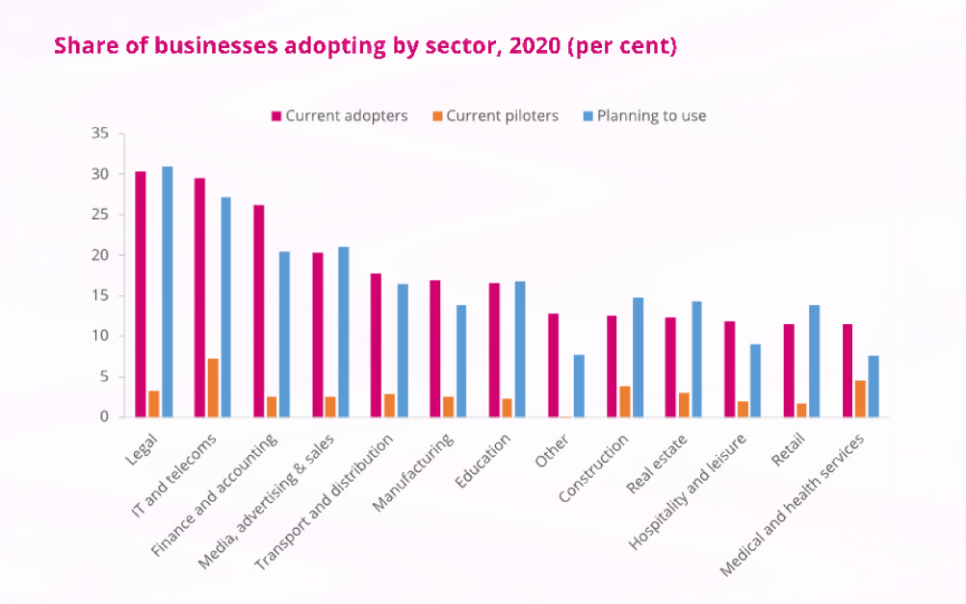
Figure 2: Share of businesses adopting by sector. (UK Gov, 2022)
The UK Government produced a report in 2022, that in which they have conducted research in AI activity within UK businesses, the results are from 5 types of AI which include machine learning, natural language processing and generation, computer vision and image processing/generation, data management and analysis, and hardware. The above figure shows that the sectors with the highest adoption rates of AI are IT and telecommunications (29.5%) and legal (29.2%), while hospitality (11.9%), health (11.5%), and retail (11.5%) have the lowest adoption rates. They also measured that 68% of large companies, 34% of medium-sized companies, and 15% of small companies have adopted at least one AI technology. This tells us that smaller businesses are slower to the adoption of AI in the workplace, but it cannot factor in lack of resources, expertise or any other barriers.
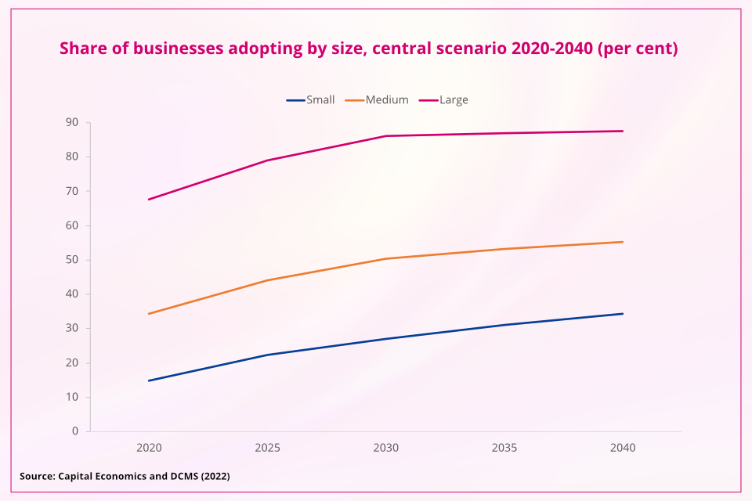
Despite this, it had been noted that small businesses that the adoption rate to AI in small businesses is rising rapidly each year.
Figure 3: Share of businesses adopting by size. (UK Gov, 2022)
For those business that have already made changes and have started to bring AI and automation into their businesses, will find it see that they will benefit from the change. AI provides many benefits for all industries.
AI tools can have a positive impact on businesses if used correctly. Choosing the right AI tools for the business is important to consider key factors. Bell, 2024, says that AI in small businesses can improve efficiency as it can reduce peoples task loads. It also provides a benefit of better customers service, though chatbots for automated customer interactions. Increased growth opportunities can impact a small business positively, AI programmes can learn customer behaviour and buying habits and customer relationship management software to store data on things like value and frequency allowing AI to access inventory and automatically order stock. Through better decision-making and identifying potential threats AI and automatic automation can prove to be saving cost and improve sales and revenue growth.
Amazon, which is now a leading online retailer and technology provider, started out as an online bookstore. Jeff Bezos was primarily driven to build a technology company prepared to lead the anticipated surge in online retail. He used predictive analysis and in 2014 the company started using deep learning algorithms to enhance personalised shopping experiences. The technology is mimicking us, as humas, to spot pattens so you will get the pop ups like “most frequently bought” or “other people also bought”. From the success of this small ‘online bookstore’ it now produces many other products and services (Marr, 219).

2.5 Barriers and Challenges to AI Adoption
AI does not come without its challenges, Cubric, 2020, study on the adoption of AI adoption in business and management concluded that there are many barriers. He explained that the most common was of economic, referring to cost time and performance. Barriers also contained some of a technical nature and social which included the safety, job security and lack of knowledge.
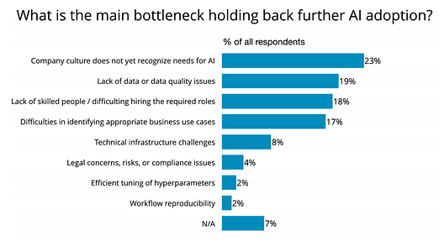

Figure 4: The main bottleneck holding back further AI Adoption. (O'Reilly, 2019)

O’Reilly, 2019, found that 23% of respondents in surveys said that company culture does not yet recognise the need for AI. To be able to successfully implement AI and further automation into workplaces, owners and managers need to have a good understanding of current AI technologies with not only their benefit but also their limitations. Educating the management team, so it can effectively be shared with the teams. Polachowska, 2019, says that it is important to have a member of the team who can use the AI tools correctly and to the business’ advantage as most CEO’s and managers lack the technical knowledge.
In addition to lack of knowledge, some organisations will dive into AI initiatives, being overly optimistic but lack a solid strategy. To make AI work well, it's important to have a careful plan, including setting goals, figuring out what to measure (KPIs), and keeping a close eye on how much value it brings compared to the investment. Without this plan, it's hard to know if AI is really making a difference or not.
In another study by Pumplun, et al, 2019, they find that there is an issue with the user and the AI Software supplier. They find that there is a disconnect between what AI users expect and what AI providers offer, which creates a gap between supply and demand for AI technology. To bridge this gap and enable management to address the issue, they said it is essential to make them aware of the differences and establish the necessary conditions for successfully implementing AI within their company. This involves aligning expectations, clarifying needs, and ensuring that both users and providers are on the same page regarding AI implementation.

2.6 Role of Leadership and Strategic Planning
A study conducted by Ledro, et al, 2023, shows the importance of strong leadership and strategic planning in driving AI and future automation in businesses successfully. It reveals that in leadership and strategic planning it set on making clear, shared and long-term business objectives. It is crucial for the hight members of the organisation to define the objectives of AI initiatives and understanding what the organization wants to achieve through AI implementation. Strategic planning involves performing a thorough assessment of all possible AI applications and their associated value propositions. This assessment helps in identifying areas where AI can have the most significant impact and aligning AI initiatives with strategic goals. From this, the management should understand that they need to priorities AI solutions that offer clear benefits and improvement for the business.
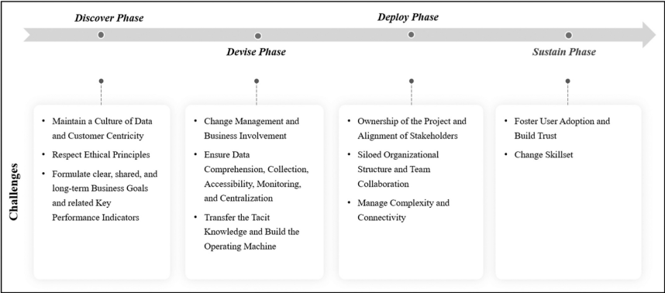
Data collection can sometimes face resistance or challenges from users within the organization. Management should encourage and incentivize participation in data collection efforts among employees. This might involve providing training, tools, or creating a culture that values data-driven decision-making. Management plays a crucial role in fostering an environment where data is valued, invested in, and effectively utilized to drive the organization forward.
Figure 5: AI Integration Phases and Associated Challenges in CRM. (Ledro, et al, 2023)

Although the study is manly on AI integration in CRM, it offers a detailed framework of challenges specific to AI-powered CRM, providing managers with practical guidance for successful integration. It not only contributes to the existing knowledge but also offers actionable insights that can assist companies in designing, implementing, and sustaining AI-driven innovation projects within their CRM strategies. It also mentions that addressing ethical concerns in AI integration. This suggests that individuals need to be aware of ethical implications associated with AI software and may need to change their approach or decision-making processes to ensure ethical considerations are prioritized.

Chapter 3: Methodology

3.1 Introduction
This chapter explains the aim of the chosen methodology in relation to investigating business’ readiness for AI and future automation. It helps create a strong approach to analyse and make decisions systematically (Igwenagu, 2016). As AI becomes increasingly widespread, there's a growing need to research it for better understanding of its importance. The literature review has helped set the stage for this study, showing that while our work adds to the field, it only covers part of it. Additionally, the review has been helpful in comparing our findings with existing research. Below are the objectives of the study, which this chapter aims to achieve the method to 1 & 2.
- To identify and examine the key barriers and challenges hindering small businesses and managers in adopting AI and automation technologies.
- To analyse the impact of organizational size, resource constraints, and managerial capabilities on business readiness for AI and automation.
- To explore the perceptions, attitudes, and knowledge gaps of small business owners and managers regarding AI and automation integration.
- To devise a strategic plan for future readiness in the short term and long term, incorporating adaptable approaches for implementing AI and automation in small businesses.
- To evaluate the effectiveness and feasibility of the proposed strategic plan in addressing the evolving needs and challenges of AI and automation integration in small businesses.

3.3 Research Philosophy
The research philosophy is the belief in which studies should be conducted. The interpretivism approach is one that emphasizes in this study, understanding social phenomena from the perspectives of the individuals involved. Understanding people's perspectives and meanings. It recognizes that individuals interpret the world differently and aims to explore these interpretations through methods like interviews and observations. This approach sees reality as shaped by social and cultural factors, emphasizing the importance of context in understanding phenomena.
Pragmatism is another research philosophy that focuses on practical action and problem-solving. Pragmatist research emphasises on addressing real-world problems and finding practical solutions to inform future practice. Researchers value knowledge that enables successful actions. The research design and strategy in pragmatist research are determined by the research problem and question, with a focus on achieving practical outcomes (Saunders, et al, 2009)
In this study, there will be an interpretivism and pragmatism approach. They both emphasise context, which is needed to understand if the AI is being adopted and implemented in small businesses to help identify the challenges and opportunities. Pragmatism will show the importance of adapting research approaches based on the problem at hand. In constant changing topic like AI and automation, where new technologies and challenges change, a pragmatic approach allows the research to remain adaptable in addressing emerging issues and providing relevant insights.
In order to understand the results and understand recommendations, pragmatism helps by focusing on practical action and problem-solving. In this study, this will help with finding practical solutions to the challenges businesses face in adopting AI and automation technologies. This approach aligns well with the goal of informing future practices and decision-making in businesses.

3.4 Research Type
In this study the research conducted will be deductive. It adopts a qualitative approach which involves starting with a theory or hypothesis and then testing it through the collection and analysis of qualitative data. The research will start with ideas or expectations from previous studies or theories. Then, they use interviews to check if these ideas match up with real-life experiences.
Through interviews, a deductive approach will involve starting with theoretical assumptions or hypotheses about factors influencing businesses' readiness. These could include theories about the importance of organizational culture, leadership support, or technological infrastructure in enabling or hindering the adoption of AI and automation. The interview questions had been created to try and explore the theories. Then, by analysing the interview responses, it can be seen if theories are correct or need challenging. Deductive reasoning helps you go from big theories to specific details, helping to refine the understanding of how things work. Using a deductive approach in qualitative research through interviews provides a structured framework for investigation, allowing us to systematically explore theoretical concepts and how they hold up in the context of real-world experiences and perspectives (Streefkerk, 2022).

3.5 Research Strategy
In this study, qualitative data will be gathered through interviews to explore businesses' readiness for AI and future automation. By collecting real-world data directly from businesses, it aims to provide empirical evidence that can inform understanding and decision-making in this area. Therefore, the research strategy can be classified as empirical, as it involves the systematic collection and analysis of data to address research questions (Calfee, et al, 2004).
There are some common elements to empirical research, which align with this study.
- A research question
- Planned design for the research
- Literature review for primary research
- The qualitative questionnaire methodology approach
- Limitations, time scale & reliability
- Generalising findings (The University of Memphis, 2024)

3.6 Time Horizon
Cross-sectional studies involve gathering data from a diverse group of participants or subjects at one specific time point or over a short period of time, researchers choose cross-sectional studies when they aim to grasp the present status or distribution of variables among a population, without focusing on changes over time. (Levin, 2006). For this study, cross-sectional time horizon is beneficial for studying business’ readiness for AI and future automation. The data will be gathered from multiple sectors at a single point of time. This approach helps provide a look at their current readiness allowing for comparisons and generalisations to be made about trends and patterns. The study is about understanding businesses' current perceptions, attitudes, and experiences related to AI and automation, a cross-sectional approach allows the capture of a diverse range of perspectives. It will examine the readiness levels across various industries providing a comprehensive understanding of the phenomenon.
Additionally, a cross-sectional study is needed as it is not only the efficient and cost-effective way, but it is needed as this is part of an academic research project. The timescale for the gathering of this information is to complete 10 interviews across no more than 3-4 different sectors within 3 months. This time includes, participant recruitment, interview preparation, scheduling interviews, conducting interviews and the transcribing of the interviews. This time frame allows the gathering of rich qualitative data which will contribute valuable findings to the research project.

3.7 Data Collection Method
It has been recognised that qualitative data collection has become more and more popular as it gives an insight into people actions and engagement (Rosenthal, 2016). Before choosing the proposed data collection method, it was important to carefully consider which option would give the best possible information for the research.
Although quantitative data collection through surveys can allow you to have a larger sample size and are usually much faster to complete for both researcher and respondents (Keyserling, 2023) for the study of business’ readiness for AI and automation, data will be collected through interviews. Interviews allow for open-ended questions, which allows for more detailed response form participants where prompts can be made to make sure that they understand the question that is being asked. To obtain this primary information, semi-structured interviews will be conducted. Semi-structured interviews allowing flexibility in collecting the information, this means that the questions can be slightly adjusted based on the participants responses. Using this method allows more probing into certain areas to explore their meaning as they provide a dynamic and interactive approach to gathering qualitative data (Kakilla, 2021).
Participants will be interviewed from small independent business to managers of larger business or sectors. Each interview will last around 30 minutes to allow for in depth exploration of the participants perspective (Green, 2017).

3.8 Data Analysis Methods & Techniques
Data will be analysed using a thematic approach due to its flexibility in identifying, analysing, and reporting patterns within qualitative data (Terry, Hayfield , et al, 2017). A thematic analysis will help give a deeper understanding of participants perspective on their readiness for AI and future automation and aligns well with the research question due to its aim in identifying themes or patterns related to business perceptions, challenges, strategies and impacts. The thematic analysis is particularly suitable for analysing interview transcripts allowing systemic analysis on the data while retaining the context and nuances of participants responses (Guest, et al, 2012). The participants will be asked 10 open ended questions with some probing questions where needed. Please refer to appendix 1 for the research questions.
Before analysis the results, the data will be prepared. First, they will be transcribed ensuring accuracy and completeness of transcription before data cleaning will begin reviewing for any errors like missing words or unclear passages. It is then good practice for researchers to become familiar with the data, and take notes of ideas (Lester, et al, 2020). A coding scheme will be used based the research questions and objectives. This involves manually identifying key concepts, themes, or patterns that emerges from the data. The data will be catogorised into a table, highlighting the voice of the participants, meaning or interpretation and concept or themese identified.

3.9 Sampling Strategy
A purposive method will be used to conduct this research. This is a method in which qualitative research has specific individuals, that have been chosen for analysis based on the criteria required, rather than randomly selecting (Heath, 2023).
This method is being used as the participants have been chosen specifically from small business, which could be business owners of manager of SME’s. Purposive sampling was needed as businesses were selected from in the Carmarthenshire area due to travel constraints. This method allowed me to deliberately choose participants based on their location to ensure feasibility and accessibility for data collection.

3.10 Methodological Limitations
We can acknowledge that the literature review may have some limitations, although research has been taken from reliable sources, its hard to say that there is enough evidence on the adoption of AI in businesses today, as it is always changing (Lords H.O, 2018).
The primary data relies on self-reported data, which could be subject to bias. Using a thematic analysis approach is often on the researcher’s judgment, therefore it’s important to recognise that this could affect the results (Jones, 2022). To help mitigate these risks, there will be reflection on the researchers own biases assumptions and preconceptions.
The sample size and selection bias may limit the findings for the study. For this research paper, the sample size is 10 interviewees from different sectors ranging from small business owners to managers in larger organisations. Due to travel constraints, as interviews were needed to be conducted on a face-to-face basis to get emotional and behavioural clues (Jennings, 2005), they were only taken from in and around the Carmarthenshire area. While acknowledging that a larger sample size would likely enhance findings, the quality and depth of analysis are equally as important to consider.
The 4-month time constraints may impact the depth of data collection and analysis. Conducting comprehensive interviews with a diverse range of businesses within a limited timeframe may result in incomplete data collection or superficial analysis. Enough data will be collected to ensure that the objectives are addressed, prioritising key areas to make sure they are explored.

3.11 Ethical & Logistical Consideration
Guidelines were established through a research proposal, which was approved by the researcher’s dissertation supervisor, which demonstrated that the study met the academic and ethical guidelines. An ethics form was then submitted detailing the research proposal and its compliance towards the University of Wales Trinity St David’s Research, ethics and integrity code of practice. In research, ethics focuses on the effects of studies, participants' rights to privacy and information, and researchers' duty to act honestly (University of Wolverhampton, 2024).
After its approval, the selected participants, which were carefully selected through research to gain a better insight on their readiness to AI and future automation, will be contacted asking for their participation. Participants will be sent a participant agreement form which needs a signature to confirm agreement in participation. The agreement form ensures that they understand their participation is voluntary, and they can withdraw from the interview at any point. It will also include the format of the procedure through face-to-face interview which will last no longer than 30 minutes. The interview will take place somewhere to their convenience, as trust between interviewer and participant is crucial, ensuring they feel relaxed to gain best results and protect from harm (Morris & Cudworth, 2019). Confidentiality and anonymity will be recognised in the participation form making participants aware of how their information will be used the viewing of their responses.
Information will be kept anonymous and no personal information will be kept. Participants will be recognised as participant 1, 2, 3 etc. Storage of all forms and responses will be kept in the cloud which is stored on the researchers personal one drive and is password protected. Only the researcher will have permission to access these files at any time. After the research has been completed and work submitted, all files will be permanently deleted.

3.12 Methodology Conclusion
In conclusion, this study to find business readiness to AI and future automation used qualitative reasearch method through interviews. The methodology has been chosen to gather a data rich collection, through open ended dialogue to for a comprehensive understanding of the study’s objectives. However, it's important to acknowledge some limitations of the methodology. There can be some bias in self-reporting data, but despite these limitations, efforts will be made reflecting on the researcher’s biases, assumptions, and preconceptions throughout the research process. Overall, the chosen methodology provided a robust framework for addressing the research questions and objectives, generating valuable insights into businesses’ readiness for AI and future automation. Moving forward, future research could explore further afield to gain a better understanding of the study from a larger target area.

Chapter 4: Findings, Discussion and Analysis
The acceleration in the rise of AI in businesses over the past few years has been substantial but it was mainly caused by the Covid-19 pandemic (Orza, 2022). In this chapter, the findings of our study on businesses' readiness for AI and future automation are presented through various themes. The participants came from a diverse range of industries and interviewees included business owners, managers and other decision-makers responsible for driving technology adoption and innovation within their organisations. The participants represented businesses of SMEs from the Carmarthenshire area, and different levels of technological advancement, providing a comprehensive perspective on the readiness for AI and automation across different contexts. The findings will be delivered using thematic analysis, through qualitative data that help recognises themes (Clarke & Braun , 2016). Please refer to Appendix 2 for the themes coding table.

4.1 Theme 1: Resistance to Change
One of the challenges raised from the interviews, was the resistance to change due to the lack of understand to the benefits of AI and future automation. This was mainly from managers, where it may be expected as they are not the point of call for making decisions on new softwawres.

“Being a new business…not really had a formal approach to AI & automation, we are still managing other aspects of the business, AI isn’t a priority” (Participant 1)
“We don’t currently use AI much; we are quite behind on the times regarding technology…we don’t need to change something when it already works so well”
(Participant 2)

“The company is happy with where they are at in regards to AI technology… not much competition around here to have to worry about it currently.” (Participant 4)

The quotes all show from different perspectives, but it does conclude that they are lacking direction from people in higher positions. The participants all claim that they do not need to move further with AI, as it is not yet a priority. Although AI has proven to boost productivity and simplify processes and is a key component to businesses (Kirton, 2024). There is not much research to say that the lack of AI in businesses in a more secluded area works better, but many to say that it can boost your marketing, communication, productivity and worker efficiency. Turner, 2019, conducted a survey on AI replacing workers, and 41% of managers agreed that they want to replace staff with cheaper AI tools. It’s possible to assume that in the Carmarthenshire area, small businesses do not know the benefits of AI or are not in a place to adapt to them.

“We do use AI in work every day without realising it…we don’t currently have any initiatives in place as it’s hard to integrate AI software into the workplace while we still have the older generation at the desks” (Participant 8)

“…ageing workforce…getting them to adopt to new technologies and processes…approach it by selling the benefits of how it will benefit them in their roles.” (Participant 9)

The above say that they are aware of the struggle for the older generation to adapting to change. This is causing a problem for businesses to move forward with their AI and automation strategies as re-skilling can be more of a struggle than beneficial. This supports a study showing that the older generation now, struggle to keep up with digitalised processes and that AI could cause age related bias in recruitment (Ferdous, 2023).
Although participant 9 can see the challenge of the ageing workforce they have taken the time to understand and are seeking ways to overcome by explaining the benefits that it could have for them in assisting in their roles.

4.2 Theme 2: Business Culture.
Biwas, 2023, emphasises the importance of recognizing and leveraging the relationship between organizational culture and the integration of AI in order to create positive outcomes for the company. Although some interviewees, which were business owners, agreed that AI and future automation was crucial and currently have initiatives projects underway, the remaining participants fear that lots will be lost with the introduction of technologies.

“The merchant sector as a whole has a cultural barrier to overcome…whole industry is built on people and relationships...customer base has also been slow in the uptake of technological advancements…seeing more advances in construction now more than ever with the introduction of machines and robots to assist.” (Participant 1)

“We know as a business we need to make some changes before it is too late, but customer like to see us face to face sometimes…there is a fear of changing too much.” (Participant 4)

“…changing to new software can really upset people…change can cause a disruption in the workplace so we will only do it when necessary.” (Participant 7)

“…a lot of the older businesses are selling up now because they don’t want to make that change.” (Participant 9)
“…negative stigma around technology…would have an impact when introducing new technology…” (Participant 10)

From these responses it shows a negative culture moving forward with AI and automation in the workplace. They speak about how it will affect the people and that it wont be done until necessary. Like the resistance to change, this could be an answer based on the location of the businesses. In more rural areas, customer may be behind on technology. Changing people’s perspective on AI will start through the culture (Spataro, 2023). The volume of work has increased drastically, and AI and future automation will help elevate the burden. To get our cultured ready for change, Sataro, 2023, suggest that three changes are made. It says that you should not fear the need for change but to embrace it. A survey conducted said that 49% of employees were concerned that more AI will replace jobs. Although it’s understandable to fear the change, the next step is to embrace failure. They need to understand that AI will not always get it right, but if there is a culture where learning from the mistake can be viewed as a good thing, the adoption process will be much easier. Finally, ‘become a learn-it-all’ he states that you only get as good as you put in, so if members of the team are taught that leaning AI is a continuous process, they will be the most engaged an innovative employee.

4.3 Theme 3: Financial Budget
When asking about the challenges, a common theme here was the financial cost involved. Cost barriers associated with AI implementation in businesses can be significant, but they vary depending on factors such as the complexity of the AI solution, the size of the organization, and the industry,

“Now there is a higher demand for certain software’s, the prices have skyrocketed…we are looking to make our own software as it will be cheaper for us to have something that only does what we need it to do.” (Participant 3)

“…we need to update a lot of our technology, but as we have grown there is a lot more things to replace which is just too costly for us at the moment.” (Participant 4)

“The main barrier to utilising AI and automation technologies would definitely be financial…the budget just doesn’t stretch that far and there are different priorities that need to be considered before implementing a new automation system.” (Participant 2)

The interviews revealed that this was a common concern. Businesses are not seeing the full potential and benefits of AI and automation and are not investing due to its cost. In the theme financial budget, it is referring to money organizations set aside specifically for bringing artificial intelligence into their operations (Pumplun , et al, 2019). One participant talks about creating their own software, which could become a problem and stakes could become too high (Smith, 2024). Companies shouldn’t have to spend exessivley on AI and automation softwares to feel the benefit of AI. Businesses should construct a startegic plan to help identify the AI tools based on user-friendliness, provider realability and trajectory that best suit their goals, so that future adoption issues are dminished (Walker, 2023). The participants need to look at the long term goals and financial benefits to adopting to AI and furture automation now to stay ahead of the curve.

4.4 Theme 4: Integration Challenges
In these statements, you can see that they have identifies the practical challenges and limitations, such as time constraints, learning curves and resource constraints.

“Changing to new software takes up a lot of time…when we changed over last time, we didn’t have enough support form the company who supplies it, which left us struggling more than we were before we had it.” (Participant 7)
“…we don’t have enough time to be able learn new AI Technologies…then we would have to rely on one person to teach everyone else.” (Participant 8)
“As a small business, finding the time to get everyone to learn something completely new in a short space of time just isn’t feasible for us right now.” (Participant 1)
“…you have to pay for each process on particular software’s…to get one that suits the businesses will all the add-ons is expensive, on top of that you need to pay for their time to support you in navigating around it.” (Participant 4)

The interviewees express concerns about the time and support required for transitioning to new software or AI technologies. They highlight previous negative experiences where insufficient support from software providers led to difficulties and struggles, indicating a perception that AI adoption may require significant time and resource investments. There is also apprehension regarding the learning curve associated with AI technologies and that relying on a particular individual is not realistic, which could cause disruptions and inefficiencies. It’s shown that larger organisations have a better perception of AI and may already be using new technologies in their field (Tiong, 2023).

4.5 Theme 5: Future Benefits of AI and Future Automation
Despite all the negatives from the interviews surrounding business’ readiness, many participants found that there were many benefits if they were to utilise AI technologies and seek adoption to future automation.

“…would see huge benefits in utilising AI technologies, it will speed up investigations and patient care as well as automating some basic administration processes.” (Participant 2)
“...less staff…more control. More deadlines will be met and will help keep track and prioritise workloads.” (Participant 4)
“...reduce costs of IT related issues…enhance speed and efficiency in which we can complete tasks and create plans for business models.” (Participant 1)

The statements collectively highlight the positive impact of AI adoption in businesses. This suggests that they have at least a basic understanding of how AI can be applied to specific tasks and functions to enhance efficiency and effectiveness. By mentioning how AI can streamline processes, meet deadlines, and prioritize workloads, the statements reflect a recognition of AI's role in boosting productivity and enabling greater control over operations. This suggests that they understand how AI can empower businesses to achieve their objectives more effectively. he statements also suggest an understanding of how AI can impact costs by reducing IT-related expenses and enhancing the speed and efficiency of tasks. This indicates that they recognize the potential cost-saving and operational benefits of AI adoption.

4.6 Theme Discussions
The aim of the research for this dissertation was to investigate business’ readiness to adapting to future AI and business automation. The findings from the primary research showed that despite the challenges and barriers discussed, there is a recognition of the potential benefits of AI adoption, including improved efficiency, productivity, and cost savings. The interviewees acknowledge that AI technologies have the potential to streamline processes, enhance control, and drive business outcomes.
Tiong, 2023, reported that smaller businesses have had a drop in cash flow and working capital, which has made it challenging for them to be more open to adopting to AI and future automation services. He goes on to say that nearly 48% of small businesses, which will consist of 250 people or less, have no plans to integrate AI into their work in that year, but says that only 40% of small businesses believe that those who do not adapt will be overtaken by those who do.
The research has highlighted that the resistance for change and business culture relies on the business owner. There is no evidence to say that businesses should be reliant on a specific person to push the adoption of AI and future automation, but without clear direction and understanding, not all employees will see the benefits and want to integrate it into their working day.
The financial budget to adopting to AI was a strong concern for many participants. The UK Government state that there is pilot programme in which they have a ‘Flexible AI Upskilling Fund’ as they can recognise the potential benefits and opportunities it will create across the UK economy. The participants raise their concerns regarding the initial investment required for AI investment but also the cost that are associated with customising to work with current software or processes. It was not mentioned, but costs will occur when current employees need up-skilling to work with AI technologies. All these factors need to be considered when reviewing the adoption of AI and future automation to their business.
The integration challenges showed as the most common theme. Relating back to the UK Government scheme, it is there to be able to encourage employers to invest more into skills and training related to AI to make the transition as smooth as possible. They have used this programme to determine if SMEs will benefit from the training to maximise the ease of AI adoption (GOV, 2024). Businesses will be able to apply for funding from May 2024, this shows that they have made a substantial commitment to supporting SMEs and a proactive approach to fostering AI skills development and adoption with potential to drive economic growth and competitiveness in the UK. SMEs should view this as a great opportunity to address some of the challenges that have been highlighted to the association of AI adoption.
Throughout the interviews, none of the participants mentioned that they would need to reduce staff members if more AI practices were put in place, whether that be in a positive light or negative. The results showed me that despite some knowledge of the benefits, there was not much concern for the future of AI and automation within their businesses.
Despite understanding the potential advantages, concerns about factors like time, resources, training, and support may be preventing their readiness to embrace AI technologies. Therefore, there seems to be a gap between acknowledging the benefits of AI and feeling prepared to implement it effectively within their businesses. This highlights the importance of addressing barriers and providing support to facilitate smoother transitions to AI adoption in the future.

Chapter 6: Conclusion
In conclusion the key findings to this study were the potential benefits that businesses can recognise to the adoption of AI including increased efficiency, cost savings and improved productivity. There were concerns and barriers to AI adoption raised by the participants including initial investment costs, integration complexities and training requirements. It was found that initiatives like the Flexible AI Upskilling Fund, supported by the UK Government, aimed to address these challenges by providing some financial support and incentives for skills development in AI in an aim to help adoption into small businesses. Despite challenges, there is an awareness for the importance of fostering AI adoption for economic growth and competitiveness.
The research findings provide insights into businesses' perceptions and readiness for AI adoption, highlighting both the potential benefits and challenges associated with AI and future automation adoption. These findings contribute the understanding of the factors influencing AI adoption in business contexts.
The primary research finding highlight the importance of addressing barriers and providing support to help gain a smoother transition when adopting AI and future automation into small businesses. Businesses should consider investing into AI technologies with some urgency to decrease the chances of being ‘left behind’ (Kaplan, 2024).

6.1 Recommendations
Due to the large extent of the reasearch area, it was challenging to maintain focus and depth within scope of this study. In future research projects, the subject would need to be narrowed so the focus can be made to specific aspects. This approach will allow a more targeted analysis and deeper exploration and practical recommendations.

6.2 Further Study
Future research could focus on longitudinal studies to track the progress of AI adoption initiatives over time and assess their impact on business performance. Additionally, comparative studies across industries and regions could provide insights into contextual factors influencing AI adoption decisions. Furthermore, exploring the role of government policies and incentives in promoting AI adoption could offer valuable insights for policymakers and practitioners alike.

References

Chapter Eight: Appendix

8.1 Appendix 1
Questionnaire
- In what sector do you work?
- Can you describe your organization's current approach to AI and automation adoption? What initiatives or projects are currently underway in this regard?
- What are the perceived benefits of integrating AI and automation technologies into your business operations?
- What are the primary challenges or barriers your organization faces in adopting AI and automation?
- How would you describe the organizational culture surrounding technological innovation and change within your company?
- What strategies or approaches has your organization taken to prepare the workforce for AI and automation integration?
- How do you engage with external stakeholders, such as customers, suppliers, or regulators, regarding AI and automation initiatives?
- Can you discuss any ethical or societal considerations that arise from the use of AI and automation technologies within your organization?
- How do you measure the success or effectiveness of any AI and automation implementations you may have within your organization?
- Looking ahead, what are your organization's strategic priorities and plans related to AI and automation integration?

8.2 Appendix 2
Themes Coding Table
Voice of the participants | Meaning/Interpretation (Researcher) | Themes Identified
“Being a new business…not really had a formal approach to AI & automation, we are still managing other aspects of the business, AI isn’t a priority” (Participant 1)  “We don’t currently use AI much; we are quite behind on the times regarding technology…we don’t need to change something when it already works so well”  (Participant 2)  “The company is happy with where they are at in regards to AI technology… not much competition around here to have to worry about it currently.” (Participant 4) | New business, not ready to make changes so early, but possibly needed to do it before opening – could cause future problems  Behind on the times, reluctant to change when there is no need.  Not currently looking ahead to make changes. Reluctant to change due to lack of communication in area. | - Resistance to Change
“We do use AI in work every day without realising it…we don’t currently have any initiatives in place as it’s hard to integrate AI software into the workplace while we still have the older generation at the desks” (Participant 8)  “…ageing workforce…getting them to adopt to new technologies and processes…approach it by selling the benefits of how it will benefit them in their roles.” (Participant 9) | Older generation issue, cause challenge for change.  Staff causing issue for the lack of changes, but business willing to work with them.
“The merchant sector as a whole has a cultural barrier to overcome…whole industry is built on people and relationships...customer base has also been slow in the uptake of technological advancements…seeing more advances in construction now more than ever with the introduction of machines and robots to assist.” (Participant 1)  “We know as a business we need to make some changes before it is too late, but customer like to see us face to face sometimes…there is a fear of changing too much.” (Participant 4)  “…changing to new software can really upset people…change can cause a disruption in the workplace so we will only do it when necessary.” (Participant 7)  “…a lot of the older businesses are selling up now because they don’t want to make that change.” (Participant 9)  “…negative stigma around technology…would have an impact when introducing new technology…” (Participant 10) | Different sectors have different perspectives on AI in the workplace. Culture Is much different.  Stuck in the old times, but people are reluctant to change causing a negative culture on AI in the workplace.  Not willing to change due to upsetting people, not chaining the culture just people pleasing.  Culture did not change, therefore the company failed.  People afraid of changing the culture around the positivity of AI adoption in business due to people avoiding change. | - Business Culture
“Now there is a higher demand for certain software’s, the prices have skyrocketed…we are looking to make our own software as it will be cheaper for us to have something that only does what we need it to do.” (Participant 3)  “…we need to update a lot of our technology, but as we have grown there is a lot more things to replace which is just too costly for us at the moment.” (Participant 4)  “The main barrier to utilising AI and automation technologies would definitely be financial…the budget just doesn’t stretch that far and there are different priorities that need to be considered before implementing a new automation system.” (Participant 2) | Happy with the software they have, not looking to change due to costs.  Too much to change so will cost too much.  Not enough financial to support push the adoption of AI in the workplace. | - Financial Budget
“Changing to new software takes up a lot of time…when we changed over last time, we didn’t have enough support form the company who supplies it, which left us struggling more than we were before we had it.” (Participant 7)  “…we don’t have enough time to be able learn new AI Technologies…then we would have to rely on one person to teach everyone else.” (Participant 8)  “As a small business, finding the time to get everyone to learn something completely new in a short space of time just isn’t feasible for us right now.” (Participant 1)  “…you have to pay for each process on particular software’s…to get one that suits the businesses will all the add-ons is expensive, on top of that you need to pay for their time to support you in navigating around it.” (Participant 4) | Not enough support for external AI software suppliers once system is up and running.  Not enough time to make changes, and only one person would be able to learn at a time – not feasible.  Small business struggle to make changes in short space of time, maybe need to look at long term solutions.  More concerns on financial side and support prior to set up. | - Integration Challenges
“…would see huge benefits in utilising AI technologies, it will speed up investigations and patient care as well as automating some basic administration processes.” (Participant 2)  “...less staff…more control. More deadlines will be met and will help keep track and prioritise workloads.” (Participant 4)  “...reduce costs of IT related issues…enhance speed and efficiency in which we can complete tasks and create plans for business models.” (Participant 1) | Can see the benefits in the workplace by doing simpler tasks to reduce time.  Understand that it will help productivity and efficiency.  Understanding the affect it can have on the financial side of the business long term. | - Future Benefits of AI and Future Automation

