2023
Management accounting
module code: lcbb5002
lecturer name: zainab atta
Student name: lucica barbu
student id.: 2006789

Executive Summary
The entire report has described the management accounting of Amana Ltd. based on the financial value each item. In this case, the values of original budget and actual budget have helps to prepare the flexed budget and budget variance. Along with this, Amana Ltd is going to expand their business in the online market and comparing two decision such as setting up own online shop and selling products on Amazon has been found. The calculation has reflected that once Amana Ltd. focuses on selling their product by setting up their own shop they will be able to generate more profit in the upcoming situation.

Table of Contents
Introduction 3
Part A 3
i) Preparing monthly control reports with flexed, original and variance report 3
ii) Preparation of report determining the performance of Amana 8
iii) Recommendation 9
Part B 10
Calculation of profit after going online and selling their product on Amazon 11
Recommendation 13
Conclusion 14
Reference list 15

Introduction
Management accounting is the most important part of a business organization that helps to understand how to deal with every action and possibility. In this case, Amana Ltd. is a tourist business in England that sells souvenirs to tourists. The purpose of the entire paper is to describe the budgeting system of Amana Ltd which will represent the value variances and lastly it will recommend whether they should sell on Amazon or set up an online shop on their own.

Part A

i) Preparing monthly control reports with flexed, original and variance report
Preparing to budget is a crucial part of a company that helps to lead the improvements in the case of maintaining the quality of the state management system. It would make it possible to effectively monitor and assess how well those in charge of handling budgetary finances are doing. Additionally, it would contribute to better government management standards (Emerging and Wojcik-Jurkiewicz, 2018, p.1), a budget works as a tool to monitor several kinds of organizational activities effectively and evaluate the outcome and government management. In this present case concerning the values of the original amount of and the actual amount of each item original budget, flexed budget and three different variances such as material cost, material price and material usage variances has been calculated.
Original budget
Preparing the original budget is the most effective part for a business to understand each activity that is needed to be maintained by the company to generate profit. Comprehensive budget management is the use of the budget to plan, allocate, control, and analyse diverse financial and non-financial resources of various divisions and units within a firm (Li, 2021, p.2). Original budget helps to use the budget to plan, control and determine various non-financial and financial resources for each department as well units within a firm. Therefore it can state that once a business maintains the original budget it will be able to manage both non-financial factors as well as financial factors efficiently. In this present situation based on the value of each item's original budget has been determined effectively.
“Sales = Units sold* Sales price”
= (100000*25)
=2500000
Total variable Cost = Materials + Labour + Overhead”
= (100000*2.5) + (100000*4) + (100000*1.5)
=250000 + 400000 + 150000
= 800000
“Gross profit = (Sales - Variable cost)”
= (2500000 - 800000)
= 1700000
“Fixed cost = warehouse rental + Insurance + full-time warehouse supervisor salary”
= 200000 + 100000 + 50000
= 350000
“Net Operating profit = (Gross Profit - Variable Cost)”
= (1700000 - 350000)
= 1350000
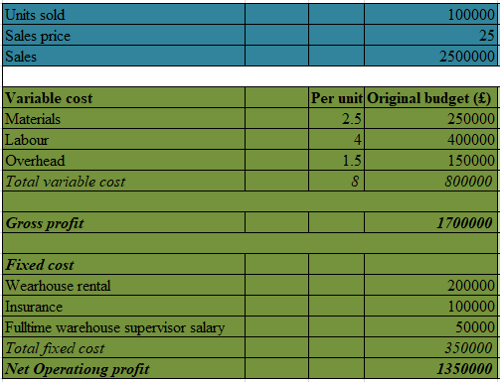
Figure 1: Calculation of original Budget
(Source: Self-developed)
The entire calculation is representing that Amana Ltd. will gain an amount of profit for £1350000 at the end of the financial period as it has been reflected in the original budget. In this case, it has been recognized that Amana Ltd. has made sales for £2500000 over the year 2020.
Flexed budget
Flexing a budget is an advantage in terms of determining the actual performance and company that can be compared with the flexed budget in terms of control as well as a performance control. Future organisational goals and policies are represented financially or quantitatively by a "budget" (Mishra, 2018, p.1), Concerning that, it can state it is important to determine a flexed budget for the company and the flexed budget has been determined for Amana Ltd.
“Sales = Units sold* Sales price”
= (80000*20)
= 1600000
Total variable Cost = Materials + Labour + Overhead”
=280000 + 440000 + 120000
= 840000
“Gross profit = (Sales - Variable cost)”
= (1600000 - 840000)
= 760000
“Fixed cost = warehouse rental + Insurance + full-time warehouse supervisor salary”
= 170000 + 100000 + 35000 +305000
= 305000
“Net Operating profit = (Gross Profit - Variable Cost)”
= 760000 - 305000
= 455000
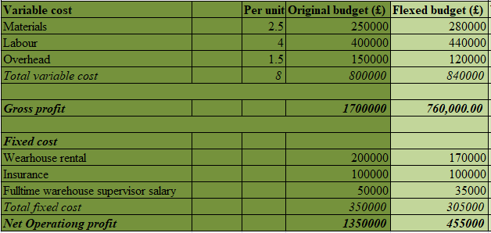
Figure 2: Calculation of Flexed Budget
(Source: Self-developed)
Focusing on the entire calculation of flexed budget it has been found that Amana Ltd. has generated £455000 as net operating profit which has been fluctuated by £895000.
Variance
Budget variance can be identified for the size after the entire preparation of the budget has been realized. Variations in revenue variance and spending variance may have an impact on budget changes (Junita, 2018, p.3) Focusing on that it has been recognized that the calculation of budget variances brings the opportunity to know the amount of effective material cost, material usage and material price. The budget is mainly characterised with misgivings (Duezeh, 2020, p.66). Based on that three different types of variances have been figured out which will help to analyze the organizational performance of Amana Ltd in the upcoming situation.
“Material Cost Variance = (Standard Quantity * Standard Rate) - (Actual quantity * Actual rate)”
= (100000 * 25) - (80000 * 20)
=900000
“Material price variance = {Actual Quantity * (Standard Rate - Actual Rate)}”
= {80000 * (25 - 20)}
= {80000 * 5}
= 400000
“Material usage variance = {Standard Rate X (Standard Quantity - Actual Quantity)}”
= {25*(100000 - 80000)}
= {25 * 20000}
= 500000
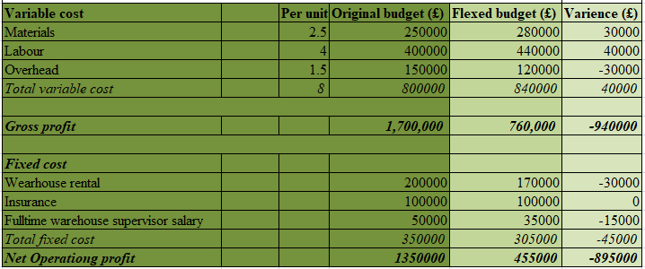
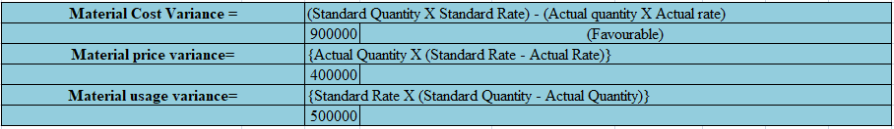
Figure 3: Calculation of Budget Variances
(Source: Developed by the Learner)
Concerning the above calculation, material cost variance has been figured out for £900000. Furthermore, the calculation of material price variance has been calculated for £400000 based on the value of the standard rate, actual rate and actual quantity. Eventually, depending on the value of the standard rate, standard quantity and actual quantity material usage variance has been evaluated for £500000.

ii) Preparation of report determining the performance of Amana
Concerning the organizational activity and the financial performance of Amana Ltd. it has been found that the organization is trying to improve their organizational performance in an effective way. In this case, Amana Ltd. is trying to overcome the fluctuations that have been made in their business due to the pandemic situation of COVID-19 and during the lockdown. As per the case study, it has been reflected that due to the lockdown the total number of tourists reduced and so the total earnings as well as the total quantity of sales has been reduced to 80000 from 100000 as it is shown in the original budget of Amana Ltd. When deciding how to address the COVID conundrum, policymakers may find it helpful to view the situation through the lenses of public policy and administration (Blankenberger and Williams, 2020, p.3). the economic distribution brought out by COVID-19 already has harmed the budgets of each and every organization in this global world. In this aspect, it has been recognized that it is necessary to prepare a flexible budget to determine the amount of each item that has fluctuated in the present situation compared to the original budget.
In this concept, the article “The essential role of integrity and accountability” has explained that budget cuts are magnified to recover the issues that have been created due to the pandemic situation COVID-19. Along with this, the budget cut is only the aspect of getting the outcome of the expected revenue decline. Declining revenues and rising spending requirements lead to stress (Ahmad 2019, 3). Concerning that, it has been found that in the flexed budget Amana Ltd. has reduced the total amount of the fixed budget. In this case, it can be found that the amount of warehouse rental has been reduced to £170000 from £200000. Moreover, the salary of a supervisor who is working full-time has been decreased to £35000 from £50000.
However, concerning the entire calculation of three different variances, it has been found that Amana Ltd. has made £900000 for material cost variance, £400000 for material price and £500000 for material usage variance. In this case, it has been recognised that Amana Ltd. is overpaying £400000 for raw materials and the organization has to reduce the amount for improving their business performance in the upcoming situation. Along with this, Amana Ltd. has used £500000 for extra, which is higher than the expected value that should be used in the process. In this case, it can be found that it is an unfavourable variance for the company and they have to improve it in the upcoming situation for achieving a higher level of success and increasing tidal revenue over the upcoming financial period.

iii) Recommendation
After all of these preparing both the original budget and flexed budget it has been found that Amana Ltd. has faced a revenue decline over the period of the COVID situation. In that case, it has been found that the amount of Net operating profit has been figured out for 455000 in the case of the flexed budget which is lower than the amount of the original budget. In this case, the variance has been calculated for -£895000 therefore it can state that Amana Ltd. needs to adopt appropriate strategies to get an effective outcome at the end of the period. Concerning that, the favourable factor has been recognized that once Amana Ltd. implements appropriate strategies they will get the opportunity to mitigate the issues that they often faced in their business and can face in the upcoming situation.
Keeping flexibility in budgeting
Maintaining flexibility in the case of preparing a budget helps to understand the way of maintaining each activity of the organization. In this case, it has been found that it is the most effective strategy for every organization to maintain a budgeting system appropriately without facing further complexities. Furthermore, each factor of an organization is changing constantly so it is necessary to maintain each thing as per changing requirements. Once Amana Ltd. focuses on preparing budgets only based on old information they can end up building costly and faulty decisions for their business. Therefore it can be stated that building a flexible budget will bring them the opportunity to make a better outcome with more accuracy.
Maintaining better communication by involving everyone during forecasting
Maintaining better communication skills and involving everyone during the time of preparing a budget is the other best strategy for operating an effective budget for a company. However, budgeting is the effort of the team and once everyone will be involved the financial manager will be able to gather effective and accurate information. Along with this, everyone will be able to understand the requirements and resources to complete their task effectively and efficiently. Eventually, it can state that once Amana Ltd. focuses on this strategy they will be able to prepare an effective accurate budget with a great understanding and it will help to improve their business organization with high returns.

Part B
Online marketing brings the opportunity to promote the business and get more opportunities to get high returns. A bigger audience can be reached through internet marketing communication, which promotes the widespread circulation of advertisements (Krizanova et al. 2019, p.1). In this present case, Amana Ltd. is going to expand its business in the online market and based on two different decision calculations have been made.

Calculation of profit after going online and selling their product on Amazon
Online sale in own online shop
Total expenses = Cost of setting up network + cost of upgrading current website + salary of full-time IT programmer
= 150000 + 50000 + 35000
= 235000
Total Income = (100000 * 20)
= 2000000
Profit = (2000000 - 235000)
= 1765000
Online sell on Amazon
Total expenses = Amazon fulfilment fees
= 50000
Total Income = (65000 * 20)
= 1300000
Profit = (1300000 - 50000)
= 1250000
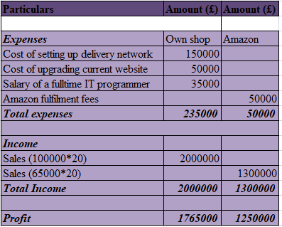
Figure 4: Calculation of profit after going online
(Source: Developed by the learner)
Concerning on the above calculation it has been found that once Amana, the owner of Amana Ltd. takes a decision for selling online by setting up their own online shop they have to maintain three different types of expenses such as cost of setting up a delivery network, cost of upgrading current network and salary of full time IT programmer. Concerning that, each item's total expenses has been determined for £235000 and total income has been determined for £2000000. After deducting total expenses from total income, profit over the financial period has been calculated for £1765000 while they will sell their product by setting up their own online shop.
On the other hand, once Amana Ltd. makes a decision for selling their product on Amazon they have to bear £50000 as Amazon fulfilment fees and the total income will be £1300000. Focusing on that it has been found that Amana Ltd. will generate £1250000 over the financial period.
Comparing both decisions it has been recognized that Amazon will generate a higher level of profit once they take the decision of selling Souvenirs by their own online shop compared to selling on Amazon. In this case, it has been found that the company has three different kinds of expenses but the total amount of revenue will be generated highly compared to the total expenses.

Recommendation
Focusing on the comparison of booth decisions it has been found that Amana will be more profitable once they sell their product by installing their own online shop. In this case, it has been found that though they should take necessary steps to expand their business in online marketing, they have to be concerned with adopting appropriate strategies.
Implementing marketing strategy
Implementing an appropriate marketing strategy is the best option to improve marketing management in the online market. In this case, improving public relations is the most effective marketing strategy in terms of increasing the total number of customers. Maintaining a good relationship also helps to understand things that people mostly like and purchase in large quantities. In this case, they will be able to understand the price range that the customer can bear. Concerning that, it has been recognized that once Amana maintains a good relationship with customers they will be able to understand the requirements as well as the market demand. Consequently, they will be able to maintain their prediction level without facing further complexities. Eventually, the marketing style will be improved and get a higher level of position in the online market with a high return.
Enhancing the branding campaign with the marketing materials
Enhancing brand campaigning is another significant strategy for improving the online marketing style. In this case, once the customer gets branded products at a reasonable price it will bring many opportunities to maintain market competition. In this present case, it has been found that there are a large number of competitors of Amana Ltd. therefore, it can state that once Amana Ltd. improves its brand it will be able to compete with its competitors effectively and efficiently. Along With this, the bend will attract the attention of more customers and so they will be able to generate a higher level of profit.

Optimizing the e-commerce website for SEO
Optimizing an e-commerce website for SEO is one of the strategic activities once a business is going to expand its business in the online market. In this case, it has been found that Amana Ltd. is going to expand its business in the online market so they also need to adopt the strategy of optimizing e-commerce websites. However, once the business organization optimizes their e-commerce website they have to be concerned about making it as simple as easy to access for everyone. Easy access to a website helps customers to understand the things that the company is selling. Along with this, the website should be easy for the customer to find their product with detail easily and within a short period. Moreover, the availability of each product also will attract their attention in the upcoming situation. Consequently, Amana Ltd. will get the opportunity to increase the total number of sales compared to the businesses.

Conclusion
After all of these, in the conclusion it can be concluded that accounting management is the most effective part that helps to manage organizational performance in an effective way. As per the case study, it has been found that Amana Ltd is a business selling Souvenirs in the market and has faced revenue declines due the pandemic situation of COVID. Concerning that it has been found that they have made £455000 net operating profit which is lower than the original budget. Moreover, the business is willing to expand their business in online market and the calculation has reflected that Amana Ltd. will generate high profit while they will sell their product on online by setting up its own shop.

Reference list
Ahmad, M., 2019. Fiqh of Budgeting: Study of Management of the State Budget for People's Welfare in the Perspective of Maqâshid al-Shari'ah. Al-'Adalah, 16(1), pp.177-206.
Blankenberger, B. and Williams, A.M., 2020. COVID and the impact on higher education: The essential role of integrity and accountability. Administrative Theory & Praxis, 42(3), pp.404-423.
Duezeh, E.A., 2020. DELAY IN BUDGET PREPARATION IN NIGERIA; WOUNDS AND HEALINGS. IN AFFILIATION WITH UNIVERSITY OF NIGERIA, NSUKKA, p.76.
Emerling, I. and Wojcik-Jurkiewicz, M., 2018. The risk associated with the replacement of traditional budget with performance budgeting in the public finance sector management. Ekonomicko-manazerske spektrum, 12(1), pp.55-63.
Junita, A., 2018. The effect of budget variances on the local government budget changes with legislature size as moderator. In The effect of budget variances on the local government budget changes with legislature size as moderator: Junita, Afrah.
Krizanova, A., Lăzăroiu, G., Gajanova, L., Kliestikova, J., Nadanyiova, M. and Moravcikova, D., 2019. The effectiveness of marketing communication and importance of its evaluation in an online environment. Sustainability, 11(24), p.7016.
Li, S., 2021, March. What do enterprises pay attention to in the comprehensive budget management?. In IOP Conference Series: Earth and Environmental Science (Vol. 692, No. 3, p. 032113). IOP Publishing.
Mishra, C.R., 2018. A STUDY ON BUDGET AND BUDGETARY CONTROL: ANALYSIS OF CASH BUDGET.

