
Applied Leadership and Management in the Workplace
Module Assignment Submission
Student Name: | Nicky-J Paton-lewis
Student Number: | 2315603
Module No: | BMSK5010
Module Title: | Developing The Learning Organisation

Statement of Confirmation of Authenticity
By the act of making this submission, the student declares that this is the work of the student named above. The work has not, in whole or in part, been knowingly presented elsewhere for assessment, or where assessment has been built on a previous assessment, this has been identified. Where materials have been used from other sources it has been properly acknowledged. If this statement is untrue, the student acknowledges that an assessment offence has been committed.
Attention is drawn to the plagiarism and unfair practice policies of both the University and of ILM.

Table of Contents
Introduction 3
Critically assess the potential benefits to the organisation of the developing individuals in the workplace. 3
Manage an individual's expectations in the respect of personal development. 5
Critically evaluate development vehicles available to an organisation appropriate to the development needs of the individual. 6
Generate a detailed plan to meet identified development needs of an individual in the workplace and evaluate how this would be used to manage performance. 8
Conclusion 9
References 10

Introduction
This report explores how developing individuals in the workplace supports both personal growth and organisational success. It looks at how activities such as training, mentoring, coaching and ongoing learning can improve efficiency, adaptability and motivation across a team. The discussion focuses on a small property management company run by two business partners, showing how employee development can be used to align everyday work with the company’s long term goals. It also shows how expectations are managed, how performance is supported and how continuous learning adds to a positive and productive workplace culture. It also highlights the importance of investing in people as a key factor in achieving sustainable business growth.

Critically assess the potential benefits to the organisation of the developing individuals in the workplace.
Developing people at work through training, mentoring, coaching and continuous learning is important for both employee growth and organisational success. From an organisational view, supporting staff development not only increases skills but also improves efficiency, adaptability and competitive advantage. Armstrong and Taylor (2020) says that organisations gain long term value when employees are supported to learn and develop because they become more committed and capable. Similarly, Becker (1993) shows in his human capital theory that investment in people through education and training produces returns in the form of higher productivity and innovation.
However, some critics suggest that development programmes can be costly and may not deliver immediate results, particularly if employees leave after receiving training Costea et al,(2012). This highlights a tension between short term costs and long term benefits. Despite this, the balance of evidence suggests that the risks of under investing in people are greater. Without ongoing development, organisations risk skill gaps, reduced competitiveness and higher turnover.
The link between developing employees and how organisations are structured is also important. Organising principles such as work specialisation, departmentalisation and span of control shape how individuals apply their skills in practice. If employees are well trained, they can work more effectively within these structures. Robbins and Coulter (2021) note that an organisation’s structure should support its strategy, and people development is a key part of that alignment. In other words, the way people are developed affects how well they fit into and contribute to the organisational design.
While developing individuals supports the wider improvement of workplace structures by linking people more closely with organisational vision, mission and strategy. Senge (2006) argues that organisations thrive when they operate as learning organisations, where employees continuously develop and adapt to meet strategic goals. When individuals grow their skills and understanding, structures such as departmental boundaries and reporting lines can be reshaped to better serve the organisation’s long term direction. This helps ensure that the workforce is not only efficient in current tasks but also prepared to support future change and innovation. In practice,
In a small property management company run by two business partners, employee development plays a central role in aligning the workplace structure with strategic goals. By training staff in customer service, compliance and property maintenance processes, the organisation can report and improve coordination across tasks. This not only strengthens the chain of command but also ensures that the company’s mission of providing reliable property services is consistently supported by well prepared employees. In this way, the structure becomes more flexible and better aligned with the long term vision of sustainable growth and client satisfaction.
A mind map was created to visually represent the key points and their connections. A mind map is a useful tool for organising complex ideas because it allows relationships between concepts to be seen at a glance rather than in text Buzan et al (2010). In this report, the mind map shows how developing individuals in the workplace links to organisational benefits, organisational design elements and alignment.
The diagram shows that individual development does not stand alone but is connected to multiple aspects of organisational performance and design. Investment in training and mentoring supports not only efficiency and adaptability but also helps align employees with organisational vision and strategy. By presenting these relationships visually, the mind map demonstrates the holistic role of employee development and reinforces the argument that people are at the core of effective organisational design.
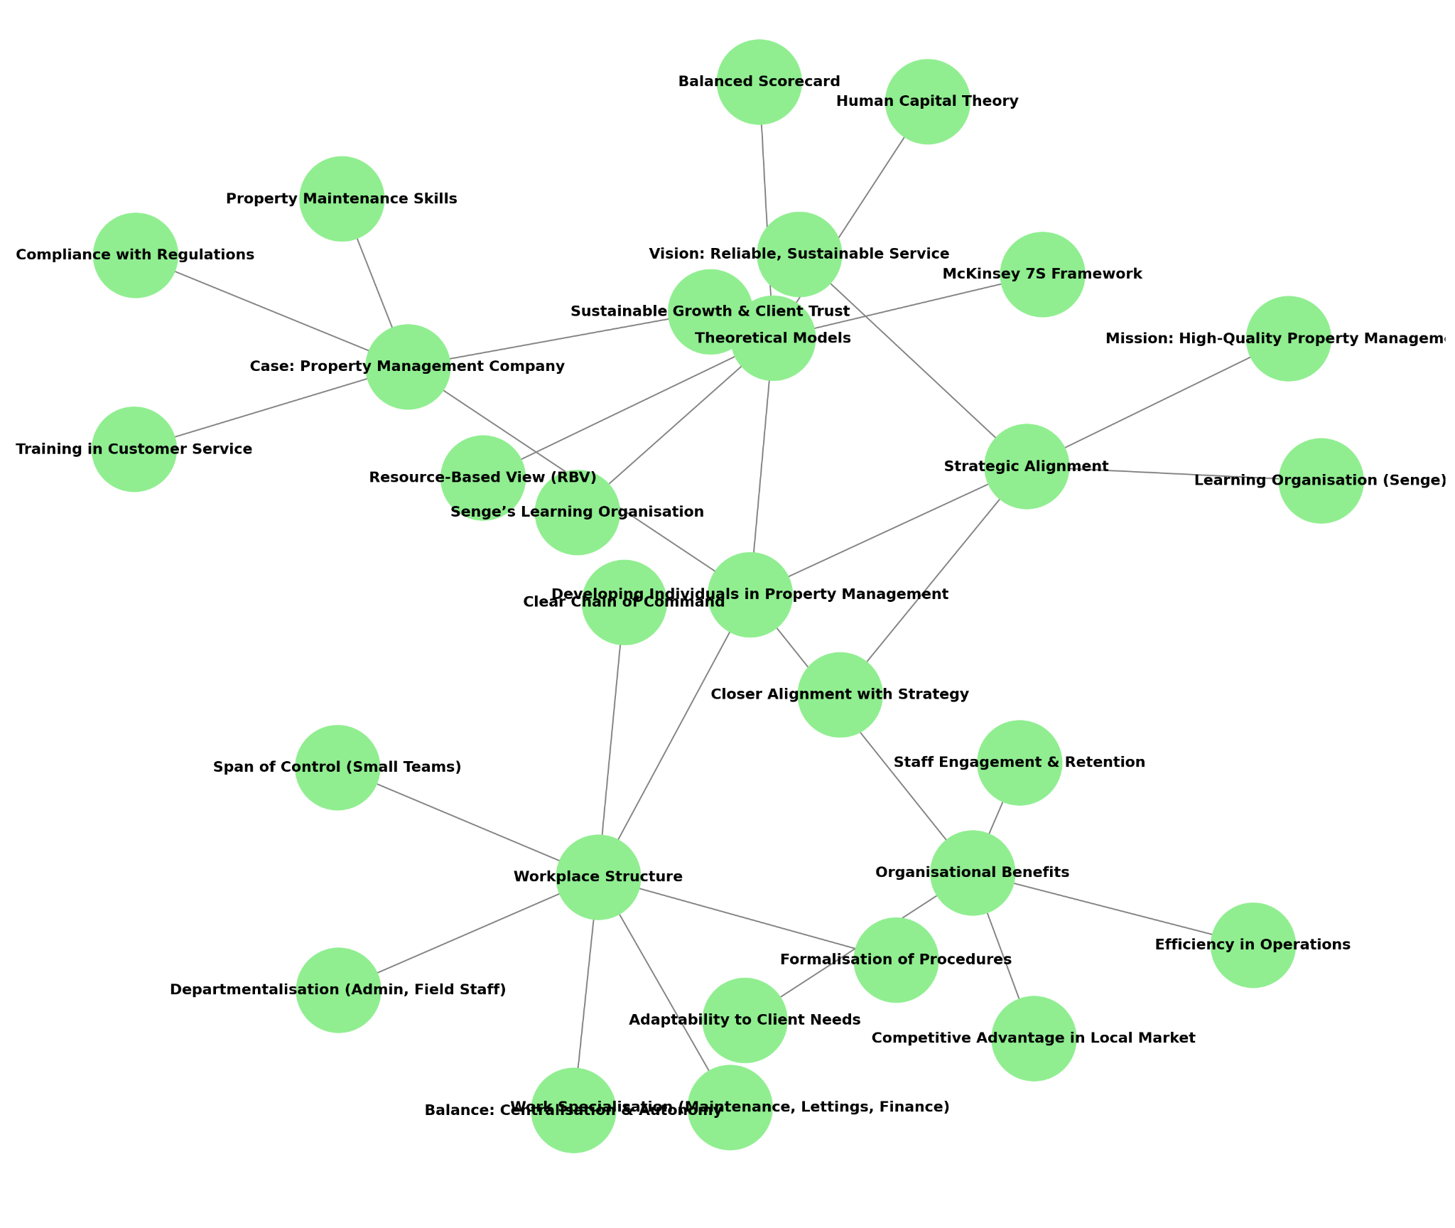

Manage an individual's expectations in the respect of personal development.
When people think about their personal development, their expectations are shaped by what they want and what they actually need. Managing these expectations requires attention to scope, costs and time. If expectations are unrealistic, both the employee and the organisation may become frustrated. As Garavan et al. (2021) says, effective management of development involves balancing employee aspirations with organisational capacity and resources.
In a small property management business, the challenge is greater because formal career ladders may not exist. However, development does not always have to mean expensive training. Opportunities such as coaching, mentoring, job rotation and additional responsibilities can still meet expectations. According to Noe et al. (2021), providing employees with stretch assignments and a key tool for managing expectations and supporting development is the appraisal process.
Appraisals are a great thing for the company as it give employees the chance to discuss their progress, career goals and any support they may need. For managers, they provide an opportunity to recognise good performance, set new objectives and identify skill gaps. As Armstrong (2020) says, appraisals form part of a continuous performance management cycle, linking personal development with organisational goals. In a small business setting, they can also help to maintain open communication between partners and employees, ensuring that ambitions are realistic and aligned with the company’s capacity.
When setting objectives during appraisals, using the smart model is helpful because it ensures goals are clear and achievable. Doran (1981) explains that smart goals are specific, measurable, achievable, relevant and time bound. This makes performance expectations easier to understand and review. Instead of setting a broad goal such as improving customer service, a smart goal might be complete customer service training and increase client satisfaction scores within six months. This approach helps both managers and employees stay focused on realistic outcomes and provides a clear way to measure progress
Goal | Specific | Measurable | Achievable | Relevant | Time
Compliance Knowledge | Complete an accredited tenancy law and property compliance course. | Pass final course assessment and apply knowledge accurately in work. | Training is accessible through online modules and supported by management. | Supports legal compliance and reduces organisational risk. | Within 3 months.
Customer Service | Improve how client enquiries and complaints are handled. | Increase positive client feedback | Mentoring and role play sessions available with senior partners. | Improves client satisfaction and supports company reputation. | Within 6 months.
Problem Solving | Take responsibility for managing routine client issues independently. | Successfully resolve at least five cases with positive supervisor feedback. | Supported by coaching and review meetings. | Builds confidence and reduces workload pressure on managers. | Within 6 months.
Team Collaboration | Strengthen teamwork and communication between admin and maintenance staff. | Complete two joint projects or property inspections as a team. | Supported by cross department mentoring and meetings. | Encourages collaboration and efficient workflow. | Within 4 months.
Leadership Development | Develop supervisory and delegation skills. | Lead one small project and gain feedback from the team and manager. | Opportunities available for shadowing and mentoring. | Builds leadership capability for future growth. | Within 9 months.
Another practical tool for exploring expectations is the swot analysis, which allows managers to map out the internal strengths and weaknesses alongside external opportunities and threats that come with meeting employee development expectations.

Strength  - Strong working relationships make communication easier.  - Development can build trust and loyalty.  - Employees are motivated to grow. | Weakness  - Limited budget for formal training.  - A small company means fewer promotion opportunities.  - Time pressure from daily workload can limit learning.
Opportunity  - Train employees to cover multiple roles.  - Building competitive advantage through customer service and compliance skills.  - Use of mentoring and coaching at low cost. | Threat  - Unrealistic expectations could damage morale.  - Staff may leave if expectations are unmet.  - Competitors may offer clearer career pathways.
By using this tool managers can approach expectation management with a clear view. This then ensures that development is aligned with both the employee’s aspirations and the company’s. Also still identifying opportunities to enhance skills in a suitable way. Humphrey led a research project that was funded by Fortune 500 companies, to find out why corporate planning was failing. During this project, he and his team developed the SWOT framework as a practical tool for strategic analysis (Humphrey, 2005).
Another way of showing expectations is through a simple wants/needs that considers scope, cost and time. This helps managers clarify what can be delivered realistically.
Employee Wants/Needs | Scope | Time | Cost | Possible Response
Promotion to higher role | Limited in a small company | Long term | Low cost | Provide extra responsibilities and leadership tasks instead.
Formal training course | Depends on the budget | Short/medium term | Higher cost | Prioritise essential compliance training and supplement with mentoring.
Recognition and respect | Always possible | Immediate | No cost | Acknowledge achievements and provide feedback.
Develop new skills | Flexible | Medium term | Moderate | Use job rotation and shadowing to build new skills.

Critically evaluate development vehicles available to an organisation appropriate to the development needs of the individual.
Organisations use many ways to support development, but their value depends on how well they match the needs of the individual and the workplace. Development is not a one size fits all process. It involves choosing methods that fit with the organisation’s culture, goals and resources. Bratton and Gold (2017) say’s that employee development should support both personal career growth and the wider aims of the business.
Formal training is one of the most common development methods because it provides recognised skills and helps meet industry standards. In property management, this might include legal or customer service training. This type of learning builds professional credibility but can be expensive and sometimes less relevant to the daily realities of a small company.
Mentoring and coaching are practical and cost effective alternatives. They give employees guidance from experienced colleagues and help build confidence and capability. Megginson and Clutterbuck, (2009). However, this approach can lead to bias or favouritism if not managed carefully, which may create tension in small teams.
Job rotation gives employees the chance to learn by doing new tasks. In a property management business this could involve an administrator joining property inspections or maintenance visits. Kolb (2015) says that this type of hands on experience supports deeper learning because people learn best by doing, reflecting and then applying what they have learned. While effective, job rotation can create short term disruption as staff adapt to new roles.
It is important to make sure development activities are assessed fairly and meaningfully. The General Medical Council (2017) outlines workplace assessment standards that focus on being valid, reliable and fair. Although designed for healthcare, these principles apply in any workplace. In property management they could mean checking that training and mentoring are helping staff grow and that feedback is constructive and consistent.
David Boud (2007) also says that assessment should be seen as part of learning, not just a test at the end. He suggests that people learn more effectively when they reflect on their progress and take responsibility for improving. This kind of reflective approach fits well in small businesses where development often happens through experience and teamwork rather than formal systems.

Stage | Description | Application in Property Management Development
Concrete Experience | Learning through direct involvement in a new task or situation. | An administrator joins a property inspection for the first time.
Reflective Observation | Thinking back on the experience and considering what worked or what was difficult. | The staff member reflects on how they interacted with tenants and what challenges arose during the inspection.
Abstract Conceptualisation | Drawing lessons from the reflection and linking to theory, rules or knowledge. | The employee connects their experience to tenancy law and customer service training.
Active Experimentation | Applying the new knowledge and testing improved approaches in future situations. | On the next inspection, the employee applies better communication strategies with tenants.
Schein (2017) argued that development is influenced by organisational culture at three level artefacts, espoused values and basic underlying assumptions. In the process of development vehicles, this means that even well designed training or mentoring will only succeed if the organisational culture supports learning and open dialogue, if the culture encourages constructive conflict and feedback, employees are more likely to reflect honestly and learn from mistakes.
Conflict itself is often viewed negatively, but it can play a constructive role in development. Jehn (1995) says that there is a difference between relationship conflict, which is harmful and task conflict, which can stimulate critical thinking and innovation. When staff challenge each other’s ideas respectfully, it helps them learn. In property management, debates about how best to handle client complaints, so it can highlight training gaps and lead to better procedures.
Digital and online learning platforms provide a flexible and cost effective way for employees to develop. Staff can access online topics such as compliance or negotiation skills which makes learning convenient and affordable. These tools can become passive if they are not supported by discussion or real workplace practice, Clark & Mayer, (2016). Professional networking and industry events also help employees expand their understanding beyond the organisation by exposing them to new ideas and best practices. Managers need to make sure that what is learned is applied back in the workplace so it has a real impact. Valcour (2015) explains that a sustainable career is dynamic and flexible as it features continuous learning, periodic renewal, the security that comes from employability and a harmonious fit with skills, interests and values. Encouraging ongoing learning through these activities supports both professional growth and long term organisational success.
To make continuous learning more structured and measurable, the company can use a simple continuous personal development table. This helps track how employees keep their knowledge current and apply new skills over time. A continuous personal development plan also encourages reflection and accountability, showing that learning is an ongoing part of everyday work rather than a one off activity. The table below shows the development activities that could be used within the property management organisation to support both individual and organisational development.
Development | CPD Activity | Learning Method | Frequency | Expected Outcome
Compliance and legislation | Attend online webinars on housing law updates | The internet. | Every 3 months. | Improved knowledge of current legal requirements
Customer service | Participate in mentoring sessions and customer feedback reviews | Reflective discussion | Every 2 weeks. | Stronger communication and client relationship skills
Technology and systems | Complete online tutorials on new property management websites. | Online training | When needed. | Confident use of digital tools.
Sustainability awareness | Attend local workshops on energy efficiency in property management | Group meetings. | Twice a year. | Better understanding of sustainability.
Professional growth | Maintain a personal CPD log and review progress during appraisals | Appraisal discussion | Ongoing. | Continuous learning and career development aligned with business goals.

It is important to consider the external factors that influence the organisation. The PESTLE model is a tool used to analyse political, economic, social, technological, legal and environmental influences on an organisation, Johnson et al. (2008). Understanding these factors helps managers design development plans that are realistic, compliant and aligned with the wider business environment.

Factor | Impact on Staff Development | Example
Political | Government housing policies or landlord regulations may change training needs. | Updates to local housing standards require new compliance training.
Economic | Economic pressures can limit training budgets or influence client demand. | Rising costs may reduce available funds for external training.
Social | Changing tenant expectations can affect communication and service skills. | More diverse tenants require improved customer service and awareness training.
Technological | New digital property systems require updated IT and data management skills. | Introduction of property management software or digital inspections.
Legal | Legislation such as GDPR and health and safety law demands continuous training. | Mandatory updates on tenancy law and data protection.
Environmental | Increasing focus on sustainability influences building management practices. | Training on eco friendly maintenance and energy efficiency standards.

This model helps the company look ahead and prepare for future challenges and new opportunities. New housing laws or digital tools might mean staff need extra training, while social changes could cause the need for stronger communication skills. Using the PESTLE method helps the business plan develop activities before problems start, keeping staff ready and adaptable rather than reacting.

Generate a detailed plan to meet identified development needs of an individual in the workplace and evaluate how this would be used to manage performance.
For the property management company, one development need identified is to improve customer service and compliance skills for an administrative staff member who regularly interacts with tenants and landlords. Meeting this need is important because effective communication and legal accuracy are central to business performance. A structured Individual Development Plan can be used to address this.

Objective | Development Actions | Resources | Timescale | Measurement of Success
Improve knowledge of tenancy law and compliance | Enrol in an accredited short course on property legislation | External training provider | 3 months | Pass course assessment and demonstrate correct application in documents
Strengthen customer service skills | Participate in mentoring sessions with business partner on handling client queries | Internal mentoring | Ongoing, fortnightly | Positive feedback from clients and reduction in complaints
Develop confidence in problem solving | Take responsibility for resolving low risk client issues under supervision | Stretch assignment, supervision support | 6 months | Number of cases handled independently and feedback from mentor
Build broader role flexibility | Shadow maintenance staff on property visits |  | 4 weeks | Reflection log on learning gained and ability to explain process
An individual development plan can also act as a performance management tool because it links employee growth with measurable outcomes. The plan supports the psychological contract, by showing the employee that their career growth is valued while making clear the organisation’s expectations (Rousseau, 1995). This reduces the risk of unmet expectations and strengthens commitment.
From a critical perspective, there are risks. If the organisation fails to provide the promised support like mentoring or training, the employee may feel dissatisfied. Performance measures must remain fair, avoiding bias or unrealistic targets. However, when managed effectively, development plans create a structure where growth and performance are aligned.
To see whether the development plan actually works in practice, the Kirkpatrick Model is a useful tool. Donald Kirkpatrick first introduced in 1959 to help organisations measure how effective their training and development efforts are. It’s still widely used today because it connects learning directly to real performance outcomes.
Kirkpatrick (2006) says that training should not be judged by how much people learn, but by how much of that learning they use and how it improves results. This makes the model highly relevant for the property management company, where the aim of development is not just to train staff but to see better client service, fewer compliance issues, and improved overall performance.
This model has four levels, reaction, learning, behaviour and results. Each level looks deeper into how development activities are affecting people and business outcomes.
Level | What it Measures | How it Applies to the Property Management Company | Example of Performance Evidence
Reaction | How staff feel about the training or development activity. | After compliance or customer service training, staff give feedback on how useful and engaging it was. | Short surveys or informal feedback sessions.
Learning | What knowledge, skills or attitudes have improved. | Staff complete a small quiz or show new processes, like handling tenancy issues correctly. | Assessment results or observed improvements.
Behaviour | How much of the learning is actually applied at work. | Managers watch for changes in how staff interact with clients or follow compliance procedures. | Fewer customer complaints or errors in paperwork.
Results | The overall impact on business performance. | The company looks for improvements in client satisfaction, reduced legal risks and stronger team collaboration. | Higher client retention, fewer disputes and better reviews.

Conclusion
Developing individuals in the workplace is essential for both personal growth and organisational success. This has shown that investing in people through training, mentoring and continuous learning builds capability, motivation and adaptability for all. For the property management company, staff development directly supports key business goals such as compliance, customer satisfaction and sustainable growth. Encouraging reflection, feedback and continuous improvement helps align personal goals with the company’s mission and strategy. Lastly, the evidence suggests that organisations gain long term value when they make learning part of their culture. By supporting continuous professional development and creating fair, practical opportunities to learn, the property management company can build a skilled and engaged workforce ready to meet future challenges.

References

- Armstrong, M., & Taylor, S. (2020). Armstrong’s handbook of human resource management practice (15th ed., pp. 102–110). Kogan Page.
- Becker, G. S. (1993). Human capital: A theoretical and empirical analysis, with special reference to education (3rd ed., pp. 15–28). University of Chicago Press.
- Bratton, J., and Gold, J. (2017). Human resource management: Theory and practice (6th ed.). Palgrave.
- Buzan, T., & Buzan, B. (2010). The mind map book: Unlock your creativity, boost your memory, change your life. BBC Active.
- Clark, R. C., & Mayer, R. E. (2016). E-learning and the science of instruction: Proven guidelines for consumers and designers of multimedia learning (4th ed.). Wiley.
- Costea, B., Crump, N., & Amiridis, K. (2012). Managerialism, the therapeutic habitus and the self in contemporary organising. Human Relations, 65(4), 525–548. https://journals.sagepub.com/doi/10.1177/0018726711430558 (Accessed 24th September 2025)
- Doran, G. T. (1981). There’s a S.M.A.R.T. way to write management’s goals and objectives. Management Review, 70(11), 35–36.
- Garavan, T. N., McCarthy, A., & Carbery, R. (2021). Training and development: The role of learning in organisations (3rd ed.). Red Globe Press.
- General Medical Council. (2017). Workplace-based assessment: A guide for implementation. GMC.
- Humphrey, A. S. (2005). SWOT analysis for management consulting. SRI Alumni Association Newsletter.
- Jehn, K. A. (1995). A multimethod examination of the benefits and detriments of intragroup conflict. Administrative Science Quarterly, 40(2), 256–282. https://www.jstor.org/stable/2393638?origin=crossref (Accessed 25th September 2025)
- Johnson, G., Scholes, K., & Whittington, R. (2008). Exploring corporate strategy (8th ed.). Prentice Hall.
- Kolb, D. A. (2015). Experiential learning: Experience as the source of learning and development (2nd ed.). Pearson Education.
- Megginson, D., & Clutterbuck, D. (2009). Further techniques for coaching and mentoring. Routledge.
- Noe, R. A., Hollenbeck, J. R., Gerhart, B., & Wright, P. M. (2021). Fundamentals of human resource management (9th ed.). McGraw-Hill Education
- Robbins, S. P., & Coulter, M. (2021). Management (15th ed., pp. 238–245). Pearson.
- Rousseau, D. M. (1995). Psychological contracts in organizations: Understanding written and unwritten agreements. SAGE Publications.
- Schein, E. H. (2017). Organizational culture and leadership (5th ed.). Wiley.
- Senge, P. M. (2006). The fifth discipline: The art and practice of the learning organization (Rev. ed.). Doubleday.
- Valcour, M., 2015. Craft A Sustainable Career. (online)Harvard Business Review. https://hbr.org/2013/07/craft-a-sustainable-career (Accessed 1st October 2025).

