University of Wales Trinity St David

Pollution Control report

ACMA 6066 – Environmental Pollution Control

BEng Energy & Environment Engineering
DR. Mike Goodfellow-Smith

By Antony Wingate (1904205)

Table of Contents
2. Table of Contents 2
3. Table of Figures 2
Introduction 3
Risk control 4
Legislation requirements 6
Permits 7
Mitigation strategies 8
Compliance vs non-compliance 16
Conclusion 19
Bibliography 20

Table of Figures

Figure 1 Risk matrix (UWTSD,2021) 4
Figure 2 Risk hierarchy chart (tapintosafety,no date) 5
Figure 3Risk assess part 1 6
Figure 4Risk assessment part 3 7
Figure 5Risk assessment part 2 7
Figure 6 spray emission limits. (DEFRA, 2011) 8
Figure 7 BAT for chemical storage (DEFRA, 2011) 10
Figure 8Process management risk controls (DEFRA, 2011) 11
Figure 9 IPPC preventative measures guidance (DEFRA,2011) 12
Figure 10Environmental management system BAT (DEFRA,2011) 15

Introduction

Metal manufacturing engineering plants represent a large industry in England and Wales. As with any production process, there are a number of activities which can have a damaging effect on the workers’ health, surrounding residents’ health, and the environment.
Chemicals such as solvents, can be damaging to the environment, wildlife, and human health. Annually, 300-400 million tonnes of industrial waste are dumped into the world’s oceans and water courses, leading to significant environmental damage and habitat loss (WWT, 2019) However, this figure is likely to be much higher due to undocumented pollution.
This report examines a metal engineering plant which carries out manufacturing, spraying, and coating of metal components using solvents, as well as various metal machining, grinding, and welding operations. All these activities involving pollutants such as solvents, gasses, and wate fluids, pose several hazards. These should be controlled appropriately, with a risk assessment being undertaken, and mitigation plans developed for high-risk activities to comply with relevant legislation.

Solvents, also knowns as VOCS (volatile organic compounds), are organic chemicals which vaporise at room temperature (NetRegs, 2020). They are used in various applications in the construction industry. Solvents pose various threats to health through breathing in vapours, skin contact, eye contact and ingestion (HSE, 2020). Some short-term effects include irritation of the eyes, lungs and skin, headaches, nausea, dizziness, and light-headedness (HSE, 2014). In the UK, between 1985 and 1996, 6 people died due to poor working practises within solvent degreasing tanks(Dick, 2006).
Multiple long-term health effects of solvents include but are not limited to damage to the central nervous system, including memory impairment, slow reflexes and irritability, peripheral neuropathy, loss of senses including taste, smell and sight, neurodegenerative diseases such as Alzheimer’s and Parkinson’s, anaemia, renal disease, leukaemia and scleroderma (Dick, 2006).
When solvents are released into the atmosphere, they react and produce an air pollutant known as ground level ozone. High concentrations of ground level ozone can seriously affect not only humans, but animals and plants, and cause significant air and water pollution as well as land contamination. (NetRegs, 2020).
It is therefore of utmost importance that they are controlled and regulated.

Risk control

To reduce risks, they must be evaluated, and assessments must be carried out, and a risk assessment produced. Risk control is a legal requirement under the Health and Safety at Work Regulations 1999 act, and the minimum requirements are:
- Identify potential causes of injury or illness in your business (hazards)
- Decide how likely it is that someone could be harmed and how seriously (the risk)
- Take action to eliminate the hazard, or if this isn't possible, control the risk.
(HSE, 2003)
There are various methods in which risks can be assessed. For this study, a qualitative assessment is used, and is the most common. It is based on the expertise and personal judgement of the assessor (and is therefore subjective) to categorise risk into different levels, usually low, medium, or high. Risk can be calculated by using the severity multiplied by the likelihood. Here, a 5x5 risk matrix was used to score likelihood and severity from 1-5 (1 being rare likelihood/insignificant severity and 5 being certain likelihood/death severity).
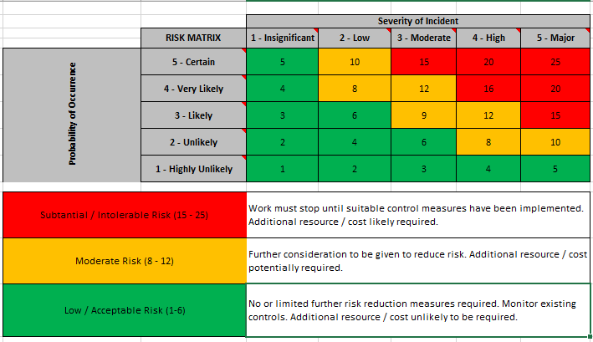
The risk rating is then separated into 3 categories, with ratings from 1-6 deemed low/acceptable, ratings from 8-12 deemed a moderate level of risk, whilst ratings from 15-25 have a high/intolerable risk rating.
Figure 1 Risk matrix (UWTSD,2021)

Low risk rated activities do not require any reduction measures, moderate risk activities should be considered to reduce risk further, whilst high risk activities should be stopped until control measures have been implemented and mitigation strategies put in place.

A risk hierarchy chart is a critical part of evaluating risk and creating a mitigation strategy. The most effective way of dealing with risk is to eliminate it, whilst the least effective method is using Personal Protective Equipment. 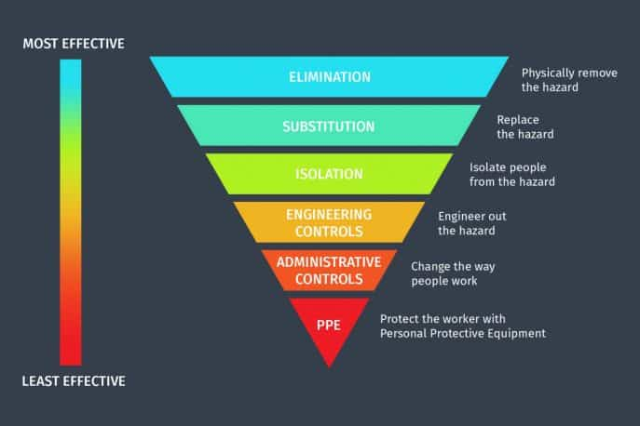
Figure 2 Risk hierarchy chart (tapintosafety,no date)

Risk assessment
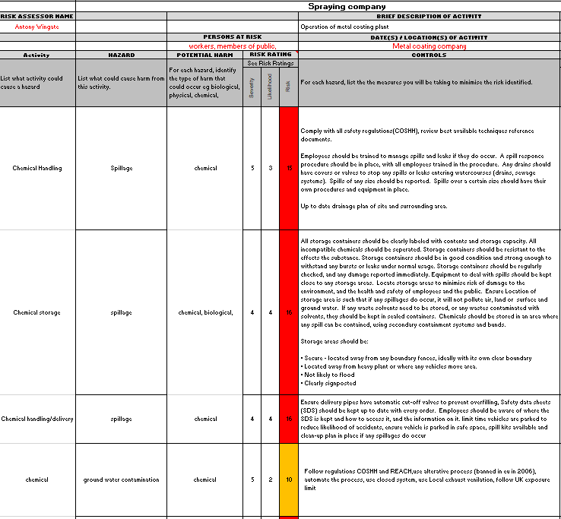
Below is the risk assessment carried out for the engineering plant
Figure 3Risk assess part 1

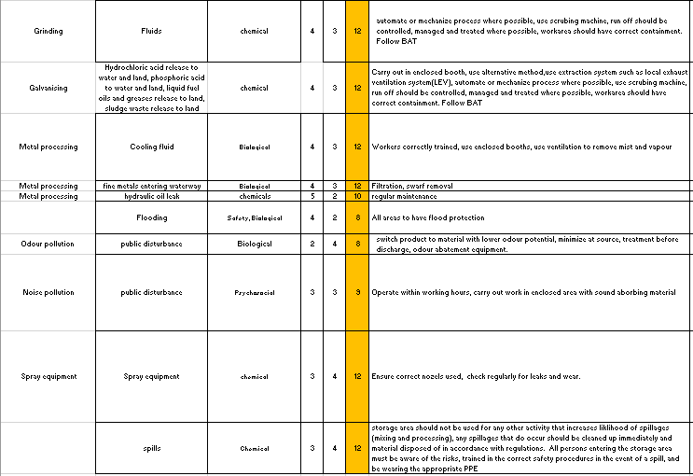
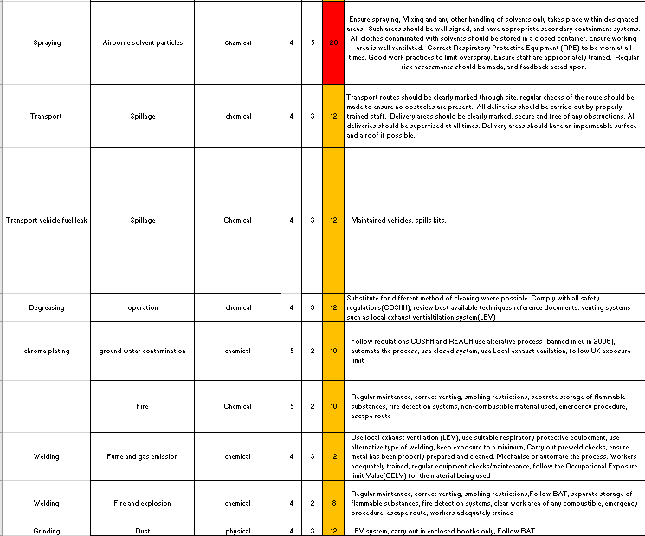
Figure 4Risk assessment part 3
Figure 5Risk assessment part 2

Legislation requirements

The plant operating in this report must comply with the following regulations and legislation.
The Control of Substances Hazardous to Health Regulations (COSHH) – This legislation requires employers to take measures to ensure that exposure to substances hazardous to health are prevented or, where that is not reasonably practicable, adequately controlled (HSE, 2015). Additionally, the law requires that the principles of good practice set out in schedule 2A of COSHH are applied, and these are as follows: any workplace exposure limit must not be exceeded, any substance carrying a risk (R) phrase must have exposure reduced to as low a level as reasonably practicable (HSE, 2015).

Registration Evaluation, Authorisation and Restriction of Chemicals (REACH) - This is used to regulate the supply and use of chemicals (including solvents)(HSE, 2015). REACH includes an obligation for any substances that are supplied in quantities of one tonne or more to be registered with the European Chemicals Agency (ECHA) (HSE, 2015).

Integrated pollution Prevention and Control (IPPC)
The IPPC states that any new paint spray booths should be designed to meet an emission limit of 10 mg/m³ and existing paint spraying operations not exceeding 50mg/m³.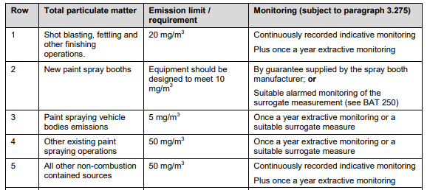
Figure 6 spray emission limits. (DEFRA, 2011)
(DEFRA, 2011)

The IPPC states that solvents should be recovered in one of the following ways: on or off site, as heat on-site, off-site recovery as heat substitute fuel, or incinerated on or off site (DEFRA, 2011).

Groundwater Protection Codes for Wales: Solvents – Solvents, even in small amounts, can cause pollution and seriously impact the quality of groundwater, contaminating drinking water sources.
The ground water protection codes for Wales give guidance to anyone who owns or works at a site where solvents are used, anyone who delivers solvents to such a site, or anyone who might be involved in decommissioning such a site. These codes of practise can reduce the risk of causing groundwater pollution. If a company is found to be causing groundwater pollution, by either discharging solvents directly to groundwater, or disposing of solvents on land without a permit from Natural Resources Wales, it could be subject of an unlimited fine or imprisonment (gov.wales, 2017).

Permits

Any facility that involves solvent emission activities is classed as a regulated facility under the Environmental Permitting (England and Wales) Regulations 2016 and must apply for an environmental permit. The business operator must comply with the conditions of the permit. Regulators have the power to serve various types of notice and the power to prosecute (Newcastle City Council, no date)
The Environmental Permitting Regulations (England and Wales) 2016, schedule 1, part 1, section 6.4, states that “a manufacturing activity, where the process may result in the release into the air of particulate matter or of any volatile organic compound and is likely to involve the use in any 12-month period of— (iv) 5 or more tonnes of organic solvents in respect of any activity not mentioned in sub-paragraph(iii).” (legislation.gov.uk, no date) The company in this report uses more than 5 tonnes and must therefore apply for a part B permit.
The degreasing activities also fall under a part B permit, as there are less than 20 tonnes being used per day.

Mitigation strategies

When producing a mitigation strategy, the first tool that should be used is the risk hierarchy chart. This allows the most effective method of mitigation to be chosen, starting with elimination, and if elimination is not possible, then substitution should be considered instead. To produce an effective mitigation strategy, the relevant Best Available Technique (BAT) should be referenced to, or any other government guidance.
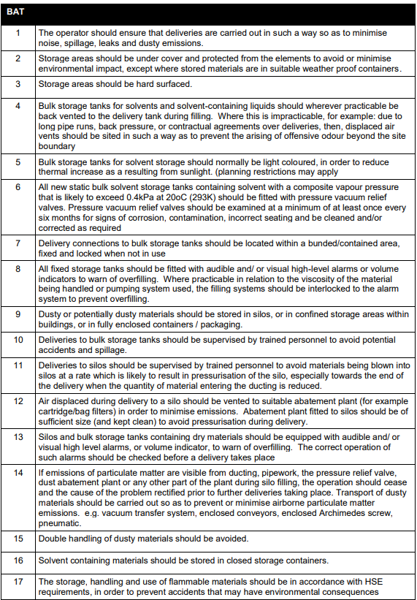
The following are recommended procedures the plant should incorporate to comply with current legislation regarding the determined high risk activities from the carried out risk assessment
Figure 7 BAT for chemical storage (DEFRA, 2011)
Storage and delivery of chemicals BAT should be followed to reduce the risk of pollution. (DEFRA,2011)
To summarize, storage areas should be:
- Weather resistant
- Hard surfaced and under cover
- Clearly labelled

The IPPC gives guidance on process management controls and measures that can be taken to reduce risk. The guidance below suggests that:
- Security systems are used
- All incidents are recorded
- Failsafe control techniques used
- All personnel are suitably trained
- Safe shutdown procedures are followed
- Good communication with local emergency authorities is established.
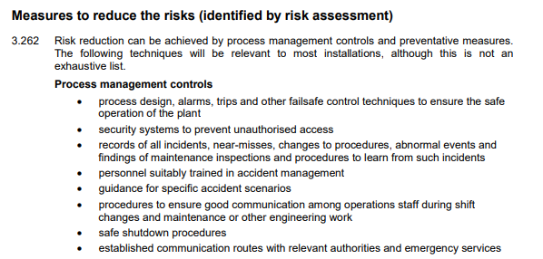
Figure 8Process management risk controls (DEFRA, 2011)

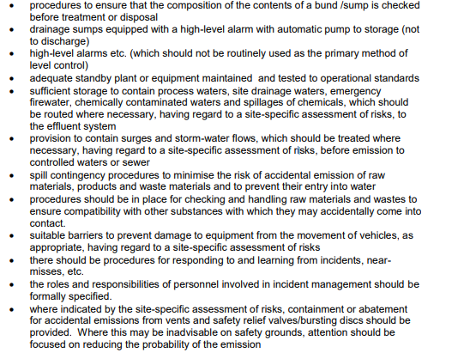
The IPPC also gives guidance on preventative measures that can be taken.
Figure 9 IPPC preventative measures guidance (DEFRA,2011)
To summarize :
- Bund and sumps should be checked before treatment or disposal
- Drainage sumps should be equipped with alarms
- Adequate standby plant and equipment should be available, maintained and tested to Operational standards
- Provisions to contain any surges or storm-water flows

Point Source Emissions to Surface Water and Sewer - the IPPC states that:
- The use of water should be optimised, and wastewater re-used or recycled where possible.
- Wastewater treatment systems should be used to maximise the removal of pollutants (such as metal), using precipitation, sedimentation, and filtration.
- All systems should be engineered to avoid effluent by-passing any treatment plant.

Solvent & Degreasing Operations
There are various control systems that can be used to reduce the emission of harmful VOCs. Some of these are listed below and could be incorporated into the Environmental Management System at the plant in this report.
Eliminate solvent use – Where alternatives exists for traditional solvents, (such as citrus degreaser), a study should be conducted to ascertain if it is an appropriate option to eliminate the use of solvents.
If an alternative or substitute cannot be used, then the following systems should be used to mitigate pollution entering the environment as far as possible:
Cryogenic solvent recovery system - This system separates condensable vapours from an effluent stream to reduce pollution and recovers solvent for reuse or disposal (Comi Polaris Systems, 2022) . The system should contain two condensers to prevent VOC ice crystals being carried away by the gas stream and re-contaminating the purified gas (Process Technology Online, 2021).
Biofiltration - Vents off-gasses containing Volatile Organic Compounds (VOC) through a biologically active material. Studies have shown efficiencies of over 90% (Leson & Winer, 1991).
Activated carbon bed – Uses absorption process to remove contaminants and releases treated gas back into the atmosphere. It can achieve efficiency rates of up for 99.9% for some solvents, which is especially useful when dealing with valuable solvents as they can then be recovered (DEC IMPIANTI, no date). However, this process does require careful monitoring. Once the carbon becomes saturated, it is no longer an effective filter (Envea, 2022). Although activated carbon beds are effective, the spent carbon regeneration can present a secondary pollution issue (Chang & Chern, 2009).
Thermal oxidiser – involves the afterburning of a solvent loaded airflow. Use of ceramic beds can be used to create a regenerative thermal oxidizer to recover heat energy (Pca-air, no date). Used for complex streams of solvents that cannot be recovered (DEC IMPIANTI, no date).
Combustion – This can be carried out via various systems, such as: regenerative combustion system, catalytic combustion system, or direct combustion via flame incineration.
Wet scrubber – Used to remove particulate matter by capturing the particles in liquid droplets. A mist eliminator should be used to achieve high removal efficiency (Klosterman, 2018).
Secondary recovery and recycling – This process uses a distillation process to separate pure solvent from contaminants and impurities, creating Secondary Liquid Fuel which can be used elsewhere in the plant or sold (Veolia, no date).
Vapour Control - Local Exhaust Ventilation (LEV) should be used to remove vapours from the work area (HSE, 2014).
NetRegs gives guidance on solvent degreasing and storage:
- A closed-top system or interlocking system should be used when replacing equipment where appropriate.
- Degreasing machines should be located away from any opening to the outside, such as doors and windows. Components should be removed slowly from the baths to reduce solvent loss (NetRegs, no date).
- Solvent waste should be managed effectively to prevent contamination. Different waste solvents should never be mixed a dangerous reaction could be caused. It could also make solvents unsuitable for reclamation or recycling. Degreasing systems should be filled from fixed pipework lines, reducing risk of spills and contamination (NetRegs, no date).

- Any damaged or defective ventilation equipment or PPE should be reported immediately. (HSE, 2014)

- Unnecessary evaporation of solvents can be prevented by using the minimum amount for the task, keeping lids on containers, and using sealed containers for any solvent contaminated waste (HSE,2014)

- Consider if the activity is necessary, or if an alternative can be used. Multiple alternatives exist for solvent degreasing, such as mechanical cleaning, aqueous cleaning, and biological cleaning. When implementing alternative methods, there are various factors that should be considered, such as if there are other hazards associated with an alternative procedure, and how they can be compared to the current method, and what are the environmental issues related to the method (HSE, 2015).

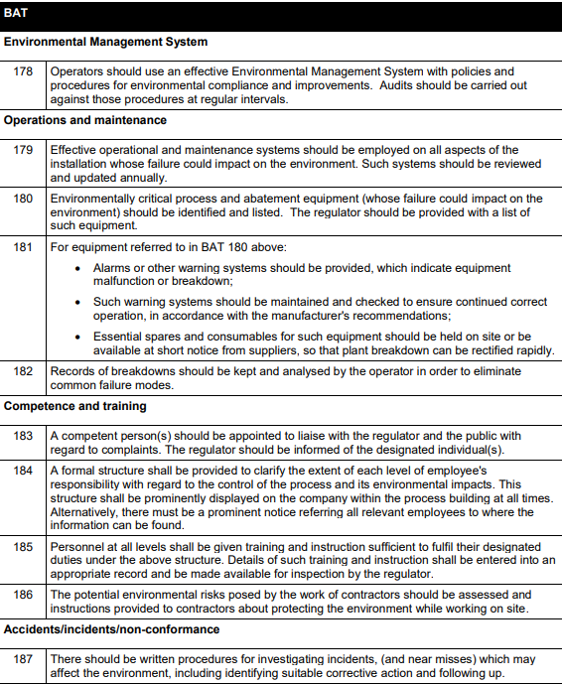
Environmental Management System – an EMS should be implemented to create a suitable strategy to reduce pollution from the plant. The BAT for EMS is shown below highlighting the key areas for operating an EMS
Figure 10Environmental management system BAT (DEFRA,2011)

Compliance vs non-compliance

There are many impacts of non-compliance, such as fines, prosecution, reputation damage and business disruption among others.

An Environmental Management System should be used to manage and reduce the pollution emitted from a plant. The costs of building and operating an Environmental Management System (ISO 14001) can vary greatly depending on the size of the company and what processes are undertaken. According to a Swiss study, for a company with between 1-49 employees, the cost was 44,000 EUR for building the EMS, and 11,000EUR per year to operate it. For a larger company with more than 250 employees, the cost for building was 252,000EUR and 106,000EUR a year to operate (EU COMMISSION , 2007).

The potential costs related to building an Environmental Management System to comply with legislation can be categorised as follows:
Tier 1: £1-£1000
Tier 2: £1000-£50,000
Tier 3: £50,000 - £250,000
Tier 4: £250,000-£1,000,000

The company must apply for a part B environmental permit under the Environmental Permitting (England and Wales) Regulations 2016 and the costs involved are as follows (DEFRA, 2017):
The application for any part B activity: £1650
Subsistence charge: £1747
The Environment Agency charge at an hourly rate of £125 for any work that is carried out by them (DEFRA, 2017). This could be for surveys, inspection, consultation, or any other work required. These costs can be substantial and can fall under the tier 2 category.

An environmental management system will require various emissions control systems to enable the plant to operate under the various legislative and regulatory requirements. The costs will depend on the number of installations required, the type of installation selected, and the quality of the installation.
Most emissions control equipment will fall under tier 2. The following list of equipment is an example of what might be required.
Welding emission control: “Nederman FilterCart Advanced Mobile Welding Extraction Filter” (ducting-express, no date) used for welding fume extraction. £3,805
Dust monitor: “EnergyTech 301 Dust Monitor” £1,457 (ducting-express, no date)
Dust extractor: “New Dust Extraction Filter Type 15M 4kW 3400 M3H” £10,531 (ducting-express, no date).

The equipment mentioned above all fall under the tier 2 category, however when considering a plant of the size discussed in this report, multiple installations might be required, including larger pieces of equipment that could fall under the tier 3 category. The combined cost for setting up an energy management system could fall into the tier 4 category for a plant of this nature.

Costs of noncompliance – one offence could cause a fine within tier 3 and could occur multiple times. Although cost of machinery is initially high, investment will return benefits the long term.

Fines & Prosecution - Under the Environmental Permitting (England and Wales) Regulations 2016, a person guilty of an offence is liable to a fine not exceeding £50,000 or imprisonment for 12 months, or both. And on conviction on indictment, to a fine or imprisonment for 5 years (GOV.UK, 2016).
Recently Southern Water received a £90 million fine for environmental pollution, showing that fines for pollution offences are increasing significantly, and will continue to do so in the future (Salau & Archer, 2021). The average cost of noncompliance has risen more than 45% in 10 years (Gayda, 2022.)
Furthermore, if a company continues to breach regulations, they may be forced to terminate operations resulting in complete revenue loss.

Disruption - When a business is found to be non-compliant, it is not uncommon for operations to be stopped until changes have been implemented. This causes loss of revenue and deadlines not being met/contracts lost.

Reputation loss – breach of regulations or poor pollution control can cause a loss of reputation and trust from clients. Once a reputation has been damaged, it is often irreparable, causing existing clients to end contracts with the company, and any potential new clients to seek an alternative supplier.

Loss of motivation - poor practices and work ethics can cause workers to become unmotivated, resulting in poor workmanship and productivity.

Poor worker safety – regulations and legislation form a critical role in what equipment is needed for the safe operation of the plant. Without compliance, the risk is not controlled and the potential for accidents greatly increases.

Costs of non-compliance: Failing to meet compliance standards can be costly. Implementing a compliance programme can mitigate costs substantially. On average it is estimated that an organisation can save 2.71 times what they would have spent on resolving non-compliance issues by implementing a compliance programme (Purrington, 2022).

Conclusion

Many pollutants were found to be present at the engineering plant.
Rising levels of pollution worldwide continues to be a threat to the environment and the human population. There are many methods for industries to combat pollution. The most effective solution is to eliminate the problem entirely, and this can be achieved by reviewing the current method and evaluating if the same result can be reached via other means. If elimination is not possible, finding a substitute for the current process should be considered.
Many companies fail to comply with regulations due to lack of understanding as to why the regulations have been established. One important factor is that there is a perception that the cost of compliance is higher than potential remedial action for non-compliance.

It is of great benefit for a company to pursue a policy of compliance, as it creates a positive image and will have a positive financial impact in the long term.

Bibliography

WWT (2019) The facts about biodiversity loss: 6 key insights from the 2019 UN ipbes report, WWT. Available at: https://www.wwt.org.uk/news-and-stories/news/biodiversity-loss-report-shows-that-wetlands-are-among-hardest-hit/ (Accessed: December 1, 2022).
NetRegs (2020) What is an organic solvent, NetRegs. Available at: https://www.netregs.org.uk/environmental-topics/air-pollution/solvent-emissions/what-is-an-organic-solvent/ (Accessed: December 1, 2022).
HSE (2020) Construction hazardous substances: Solvents, Solvents - Controlling hazardous substances in Construction. Available at: https://www.hse.gov.uk/construction/healthrisks/hazardous-substances/solvents.htm (Accessed: December 1, 2022).
HSE (2014) Working with solvents A guide to safe working practices, Health and Safety Executive. Health and Safety Executive. Available at: https://www.hse.gov.uk/pubns/indg273.pdf (Accessed: December 1, 2022).
Dick, F.D. (2006) “Solvent neurotoxicity,” Occupational and Environmental Medicine, 63(3), pp. 221–226. Available at: https://doi.org/10.1136/oem.2005.022400.
HSE (2003) Health and Safety Regulation: a short guide, Health and safety regulation - A short guide. Available at: https://www.hse.gov.uk/pubns/hsc13.htm (Accessed: December 1, 2022).
HSE (2015) Solvent vapour degreasing plant - HSE, Solvent vapour degreasing plant Use, maintenance and cleaning. Available at: https://www.hse.gov.uk/pubns/eis47.pdf (Accessed: December 1, 2022).
DEFRA (2011) Surface treatment using solvents: Sector guidance note SG 6, GOV.UK. GOV.UK. Available at: https://www.gov.uk/government/publications/surface-treatment-using-solvents-sector-guidance-note-sg-6 (Accessed: December 2, 2022).
gov.wales (2017) Groundwater protection codes for Wales solvents 2017 - Welsh Government, Groundwater protection codes for Wales: Solvents. Available at: https://gov.wales/sites/default/files/publications/2019-06/groundwater-protection-code-solvents.pdf (Accessed: December 1, 2022).
Newcastle City Council (no date) Pollution Control, inspection and permitting, Pollution control, inspection and permitting | Newcastle City Council. Available at: https://www.newcastle.gov.uk/services/environment-and-waste/environmental-health-and-pollution/pollution-control-inspection-0#Regulated%20activities (Accessed: December 1, 2022).

legislation.gov.uk (no date) The environmental permitting (England and Wales) regulations 2016, The Environmental Permitting (England and Wales) Regulations 2016. Queen's Printer of Acts of Parliament. Available at: https://www.legislation.gov.uk/uksi/2016/1154/schedule/1/part/2/chapter/6/crossheading/coating-activities-printing-and-textile-treatments/made (Accessed: December 2, 2022).
Comi Polaris Systems (2022) Cryogenic solvent recovery can reduce pollution and recover solvents, Comi Polaris Systems. Available at: https://comipolaris.com/cryogenic-solvent-recovery/ (Accessed: December 1, 2022).
Process Technology Online (2021) On the hunt for solvents with liquid nitrogen, process technology online. Available at: https://process-technology-online.com/plant-processing/on-the-hunt-for-solvents-with-liquid-nitrogen/ (Accessed: December 1, 2022).
Leson, G. and Winer, A.M. (1991) “Biofiltration: An Innovative Air Pollution Control Technology for VOC emissions,” Journal of the Air & Waste Management Association, 41(8), pp. 1045–1054. Available at: https://doi.org/10.1080/10473289.1991.10466898.
DEC IMPIANTI (no date) Solvent recovery, eco-innovation for a Sustainable Future - DEC IMPIANTI, DEC IMPIANTI - solvent recovery systems for flexible packaging, tobacco, converting, coating, adhesive tape, rotogravure, lamination, flexo industries. Available at: https://www.decimpianti.com/processes/solvent-recovery_en.html (Accessed: December 2, 2022).
Envea (2022) Abatement of solvent emissions and odors: Online VOC measurements, ENVEA. Available at: https://www.envea.global/abatement-solvent-emissions-and-odors-online-voc-measurement/ (Accessed: December 1, 2022).
Chang, M.-W. and Chern, J.-M. (2009) “Stripping of organic compounds from wastewater as an auxiliary fuel of regenerative thermal oxidizer,” Journal of Hazardous Materials, 167(1-3), pp. 553–559. Available at: https://doi.org/10.1016/j.jhazmat.2009.01.025.
Pca-air (no date) Regenerative thermal oxidation, Regenerative thermal oxidation | PCA Air. Available at: https://pca-air.com/en/technologies/regenerative-thermal-oxidation (Accessed: December 1, 2022).
Pca-air (no date) Regenerative thermal oxidation, Regenerative thermal oxidation | PCA Air. Available at: https://pca-air.com/en/technologies/regenerative-thermal-oxidation (Accessed: December 1, 2022).
Klosterman, F. (2018) What is a wet scrubber?, CECO Environmental. Available at: https://www.cecoenviro.com/blog/what-is-a-wet-scrubber/ (Accessed: December 1, 2022).
Veolia (no date) Solvent Recycling and Recovery, Veolia Ireland. Available at: https://www.veolia.ie/services/solvent-recycling-and-recovery (Accessed: December 1, 2022).
EU COMMISSION (2007) Bat reference documents, Surface Treatment using Organic Solvents. Available at: https://eippcb.jrc.ec.europa.eu/sites/default/files/2019-12/sts_bref_0807.pdf (Accessed: December 2, 2022).
DEFRA (2017) Permits for solvent emission: Fees and charges for applications, Permits for solvent emission: fees and charges for applications. GOV.UK. Available at: https://www.gov.uk/government/publications/permits-for-solvent-emission-fees-and-charges-for-applications (Accessed: December 1, 2022).
ducting-express (no date) Nederman FilterCart Advanced Mobile Welding Extraction Filter Unit 3 meter arm 240v - 12635845: Ducting Express, Ducting Express. Available at: https://www.ducting-express.co.uk/product/welding-extraction-systems-extraction-tables/welding-fume-extraction-filters/nederman/nederman-filtercart-advanced-mobile-welding-extraction-filter-unit-3-meter-arm-240v (Accessed: December 2, 2022).
ducting-express (no date) EnergyTech 301 Dust Monitor: Ducting Express, Ducting Express. Available at: https://www.ducting-express.co.uk/product/dust-monitoring/energytech-301-dust-monitor (Accessed: December 2, 2022).
New dust extraction filter type 15m 4kw 3400 M3H: Ducting Express (no date) Ducting Express. Available at: https://www.ducting-express.co.uk/product/dust-extraction-filter-units/new-dust-extraction-filter-type-15m-4kw-3400-m3h (Accessed: December 2, 2022).
GOV.UK (2016) The environmental permitting (England and Wales) regulations 2016, The Environmental Permitting (England and Wales) Regulations 2016. Queen's Printer of Acts of Parliament. Available at: https://www.legislation.gov.uk/ukdsi/2016/9780111150184/regulation/39 (Accessed: December 2, 2022).
Salau, M. and Archer, J. (2021) Record £90 million fine sends a message to all polluters!, Beale Co. Available at: https://beale-law.com/article/record-90-million-fine-sends-a-message-to-all-polluters/ (Accessed: December 2, 2022).
Gayda, S. (2022) The True Cost of Non-Compliance. Available at: https://community.aiim.org/blogs/sarah-gayda1/2022/06/17/cost-of-non-compliance (Accessed: December 2, 2022).
Purrington, J. (2022) The true cost of non-compliance, Saviynt. Available at: https://saviynt.com/the-true-cost-of-non-compliance/ (Accessed: December 2, 2022).
tapintosafety (no date) Risk hierarchy chart , Workplace Hazards and the Hierarchy of Controls. Available at: https://tapintosafety.com.au/workplace-hazards-and-the-hierarchy-of-controls/ (Accessed: December 2, 2022).

