HOW CAN NON DESTRUCTIVE TESTING TECHNIQUES AND DRONES BE USED TOGETHER TO HELP THE CIVIL ENGINEERING BUILT ENVIRONMENT INDUSTRY?

How can Non Destructive Testing techniques and Drones be useD together to help the Civil Engineering built environment industry?
Contents
1 Introduction 3
2 What is Non Destructive testING 3
2.1 DIFFERENT TYPES? 3
2.2 How it can help in the built environment Industry? 7
2.3 Case Study 7
2.4 How it can be used to help the natural environment? 8
3 What are Drones? 9
3.1 How they help the built environment industry? 10
3.2 How can it used help the natural environment? 11
4 How they can work together? 11
4.1 Case Study 11
5 Other Technology they can be integrated with 11
5.1 Graphical Information Systems 12
5.2 building information management/ modeling 12
6 Conclusion 12
7 Bibliography 13

Introduction
for this research proposal, I will investigate two technologies that can be used together to help the built environment. The technologies and good covers are drones/unmanned vehicles and NTD (that stands for nondestructive testing). I have interest with these two technologies as I personally do want to go to building control or inspection, these technologies help with both via making it easier to inspect element that might be too unsafe using traditional methods and to find faults that human can't normally find on site. Another reason why the two technologies can be useful is that they make projects have a better quality, quantity and cost outcome at the end if values correctly. What to do this I will first talk about nondestructive tests on its own, then I will cover drones, which will lead me into existing projects that use both these technologies already, and lastly, I talk about technologies that these can be integrated with easier.

What is Non Destructive testING
Non-destructive testing is a way to test and inspect materials and structural elements while in use, without destroying the element, though many do this, which we will cover later on in this assignment. The three most common types are ultrasound testing, use of magnetic field testing and infrared testing. All these types are widely used to find defects in major elements of a structure or device. Currently, it's mostly used in the production of cars, planes and other mechanical products. However, it is slowly moving into civil engineering and the built environment with the introduction of the rebound hammer test which tests the hardness of concrete and ultrasound test for testing metal elements in structures, for example, the Decking of the Humber Bridge.

DIFFERENT TYPES?
As I said earlier there are different types of techniques to test materials regarding nondestructive testing. So, in this section, I will cover but main types an NDT engineer/technician may choose to inspect materials and elements of a project or existing structure within civil engineering. Type is:
- ULTRA-SOUND - Ultrasound testing is the most common type of testing for an NDT technician/engineer. It mostly works on fine defects in metallic structures and regarding civil engineering, it is used mostly on the railway by network rail, as I talk about in section 2.3. It works by sending high-frequency pulses through a medium and waiting for the waves from the process to hit the sensor. For this work the transmitter it put perpendicular to the receiver which is 90° away from each other and 45° from the testing surface, this allowance the receiver/ sensor to pick up the rebound waved sent from the transmitter as when the sound hit a defect or the other side of the material it will reflect back at a perpendicular angle which the sensor should pick up if that is upright.
You could use ultrasound to check coverage of concrete over the Rebar cages in reinforced concrete elements. However, it is hard to calibrate the machine for this because of the different compact level of concrete. Also, you can't get a precise measurement of compactness using ultrasound.

- INFRA-RED - Infrared is mostly used as a method to inspect heat loss of materials in the power industry. It works by measuring various levels of heat using cameras that pick up infrared waves. It’s very simple varied materials and thickness of said materials were let out a certain amount of heat energy, so if there is a defect in construction of the element or a defect appears over time, the infrared lens will pick it up and give the engineer visual information on where the defect roughly is and the severity. Using this a lot of bridge managers and engineers to use this to check bridges, however, they can only check surfaces and near surface defects. They cannot check actual internal defects.

- GROUND PENETRATING RADAR- Ground penetrating radar is like ultrasound testing and is typically used on reinforced concrete to look at the Rebar by using high-frequency radar. It works like ultrasound it basic however you do not need any liquids on the surface of the material for the sensor and transmitter to work. However, this can only look at problems and defects which are internal. As well it can be used to see what is under the earth, for example, be if there was anything archeological, environmental or anything that may be hazardous to health. However, it may not pick up a small hairline fracture in the material being testing as well it quick expensive so it used for a massive project.

- PERMEABILITY TEST- This method is used on nonferrous metals and materials; the engineer will use 2 powder/liquid substances sprayed onto the surface of the material is one will be a bright color like a red, blue or green but not white because the second spray tends to be white. Then the engineer or technician will wait a couple of minutes for the color of the first spray to come through the second spay. When this happens, it will show the places that defects are. This method is quick and easy and helps point out surface defects that the engineer may struggle to see by using visual inspection, however, this method will not show any subsurface defects in the material.

- MAGNETIC PARTICLE TESTING- This method works like the permeability test, however only used on ferrous metal because as the name implies use magnets. Like the permeability test, the engineer or technician will splay a substance which contains iron filings onto the surface. After that engineer will get electromagnetic and run down it down the surface, which drag the iron filings. However, some of the filings will get trapped in defects as the electromagnetic move across, as well depending on the strength of some of the filing can trap above a subsurface flaw. Advantages can be that it’s easy and quick to perform the test and you can see defects beneath the surface of the metal, however, ultrasound can give more information on the type and position for the defect than this method. This method can be used on materials such as iron, steel etc.
- VISUAL INSPECTION- Visual inspection has been the longest and most used form of nondestructive testing because it's most simple. All it requires is for the technician/engineer to inspect using cameras and their own eyes. You can only see surface defects with this method and sometimes even they can be missed depending on training, the technology used and the health of the inspector. At this moment a lot of visual inspectors are starting to used drones to carry out the job safety.

- HALF-CELL ELECTRICAL POTENTIAL METHOD- This test is to inspect the corrosion state of the reinforcing cage in reinforced concrete. It works by using electrical potential and resistance between the cage and the surface. The diagram below shows standard set up of this method.
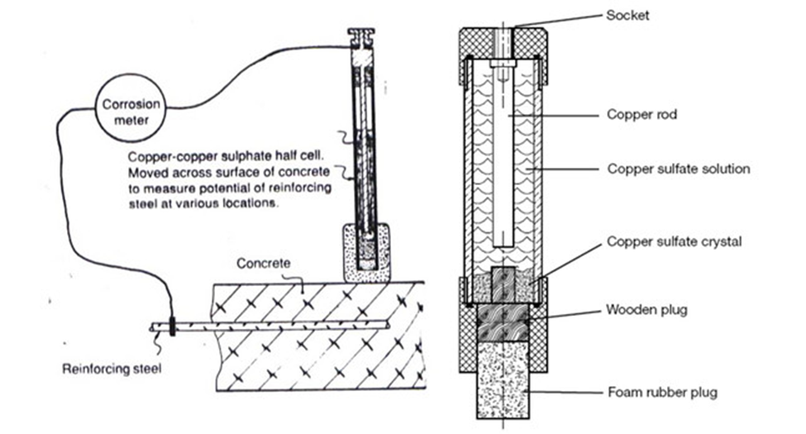
(Ndtconcrete.net. (2018).)
However, this method does not show the rate of corrosion, it shows if there is corrosion already in the cage and tries to indicate where is. However, the test can only inspect roughly 1m3 at a time. As well the method can only work on reinforced concrete.

- COVERMETER TESTING- This test method allows the nondestructive engineer to search through a concrete or masonry material to locate ferrous metals. The principal of this test is that great in a magnetic field will alert the engineer as it passes over the element to identify the positions of metal and any flaw with the element. The common equipment has two parts, one that sends out eddy currents and the other part is a location node. This method is quite a specialized method and quite complex to carry out.

- REBOUND HAMMER TEST- This test is used for inspecting the hardness of concrete, it is used by pushing it into the concrete surface and that pushes back a needle on the scale telling the user the compactness of concrete. It is a quick and simple method which can be carried out by everybody. Below is an example of the device used for this test.
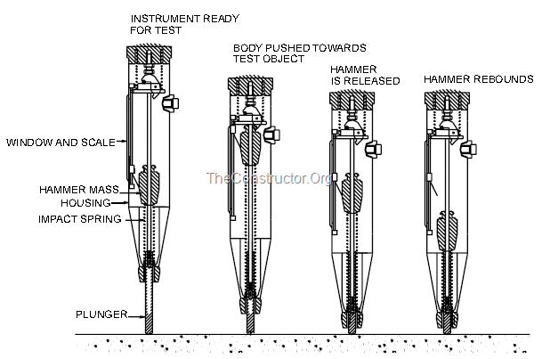
(The Constructor, 2019)

- IMPACT ECHO TESTING- again another method similar to ultrasound but in this case, it works with only a transducer, and something producing a low-frequency impact soundwave (around 1 to 60 kHz). However the principle of it worked same as ultrasound by measuring the displacement of the wave against time, but unlike ultrasound, this method can only find voids, cracks, and delamination of concrete. It is quite a simple test to carry out and it normally has a computer attached to it which shows waveform and spectrum given the operator/ engineer information on site by the faultless. Below this picture basic set up of this.
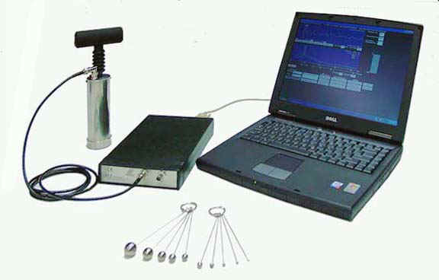
(Impact-echo.com, 2019)
There are other methods you can use however they have not been properly tested with the civil engineer environment (The section I have abbreviated or used facts from all and use pictures from references in the 2.1 section of the bibliography)

How it can help in the built environment Industry?
Non-destructive testing can help the built environment ensuring the quality of any project whether it's a house, road or infrastructure without damaging the resources used to construct it. However, there will be mostly and is mostly used in the civil engineering branch of the built environment to inspect bridge joints and elements, the layers of roads and could be used for assessing the quality of material on delivery.

Case Study
In the UK we have a private company that looks after a railway network, they are called network rail and because of the nature of railways maintains, nondestructive testing works brilliantly to check on the quality of now and old rails. Like other countries railway maintenance, network rail uses two methods to check on the quality of the head and web of the rail as the base does not tend to have any discontinuities without the other two. Both these methods are ultrasound testing with angled transmitters. The first method is the Walker, which is equipment that a technician or nondestructive engineer can place on the railway tracks and walk. After setting the frequency to the grade of steel they can see the reflection of the waves hit in the base, which on most railway tracks are the same quality and design which commonly requires the velocity of a wave to be 5.8928mm per microsecond. Has engineers walk on track with it they get real-time feedback, however, is not most practical, as the engineer or technician will have to take it off tracks and let trains pass. The size of the railway network in the UK covers 9824 miles of total system rails, which is a lot of track for the walker to check. They needed a more efficient method, this method is an inspection train, which is a diesel train that pulls around three inspection carriages at the same speed as a diesel goods train. This allows more area of a track to be scanned and analyzed faster with a bit of loss in accuracy by people within the carriages in real-time like the walker. If a fault or inconsistency is found in the track by the train they will send out the Walker to confirm and get a better idea on the quality of the area of the track. Acting on the report of the technician or engineer will decide if the section/joint will need replacing or repairing. (Below is two pictures, one of a Walker and one of an inspection train as well for the section I abbreviate the paragraph from references in the 2 section other)
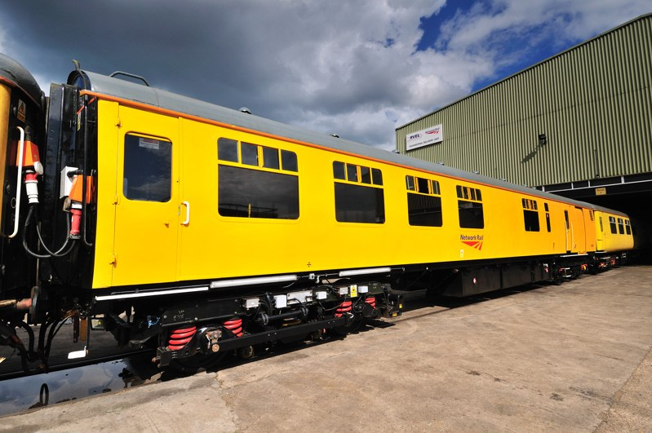
(Network Rail Media Centre, 2019)

How it can be used to help the natural environment?
As seen in many time team episodes you can look under the ground for specific things using deep ground radar and ultrasound. Changing the power/ frequency of the radar can highlight different things, for example change in the density of soil levels will look like defects as waves may reflect small amounts of itself back up if it hits the front density allowing engineer to work out the sizes of the layers, on the monitor, the same as a defect in steel. This could identify any underground threats to the project from archaeological structures which if found allows the archaeologist to enter site before much work has been done. Another thing is if animals burrowed beneath the ground and it will show any potential hazards. Another way nondestructive testing helps the natural environment is by when testing the quality of metals and materials, none of the testing materials are destroyed or altered, and as well with constant inspection using nondestructive testing methods elements may not need to be changed as much.

What are Drones?
Drones are robots with can be used to inspect and capture information at height and below the water surface or space that human cannot get to. There are many types:
- Aerial drones/ quadcopter
Aerial drones are the most common of drones used recently and a lot of companies have started using them for many different things. For example, in civil engineering you could use it for inspection of high or hard reach elements, monitoring big sites etc. Typically most drones work via gyros and four individually working rotors so can get lift. Ones used in industry and have a camera onboard which allow the engineering or manager to get a visual look at elements that they could not before. An example of a drone below (DJI Mavic Pro)
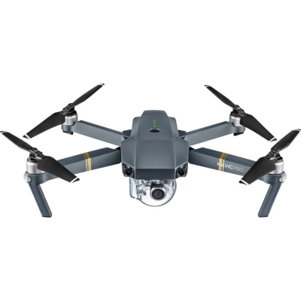(Dronesforless.co.uk, 2019)

- Underwater drones
This an expensive one-use type drone. The company called open Rov have a drone called Trident which costs will around $2049 in the US, as well the drone has a range of hundred meters due to its tether cable as IF and Radio wave can easy be reflexed of the surfaced of the water. This will allow nondestructive test engineers and bridge engineers to better inspect the underwater elements and coastal structures.
.

How they help the built environment industry?
Drones can help the built environment industry by minimizing health, safety and welfare risks when inspecting because they can get into the locations where they are needed at heights or weird angles that may risk the health of the inspector. For example, when inspecting bridges the inspector will have to abseil and use climbing gear to get to all the points they need to inspect unless the bridge has an inspection train built into it. but the Humber bridge, this will put the inspector at risk of falling if the equipment fails. The company would have to inspect all the equipment each time they go up. The drone can eliminate this risk because it's only four motors and a camera that could fall from height meaning that only be a financial risk for the company. However after saying that there is always a risk of the drone colliding with a member of the public or the bridge itself, but with correct training for the operator/inspector/engineer, this hazard would be reduced.

HOW CAN IT use HELP THE NATURAL ENVIRONMENT?
Drones can help the natural environment by inspecting hazards for example animals, plants and hazardous landscapes via inspecting from the sky or water at a distance. As well they can be used to check on cliff sides for any erosion that is made mechanically by animals and plants, this allows the operator to check the local environment for any problems with the ecosystem or potential problems of finding an endangered species. However, the drone may course some endangered life to hide or without the area due to the noise it produces.

How they can work together?
Nondestructive testing and drones can be used together very efficiently in areas where testing can be hazardous to health and safety, for example, substations, power lines, bridges, and et cetera. As well as this allows a better view and analysis of the condition of the structure from many different aspects and work together, an example of this would be a quadcopter with an infrared camera to look up look at the concrete structure at high, allowing the engineer to see more defect faster and safer. And research more drones whether robotic, quadcopter or underwater use to inspect more areas safer, like using a subversive with an ultrasound sensor to check on the quality of the oil rigs steel elements without sending deep sea divers in.

Case Study
Currently, if you companies are working on powerlines inspecting robots one of which was 2012 EPRI's Transmission Line Inspection Robot based off a robot tested in Japan. The robot will have many different sensors on it which allowed it to collect information on the cable quality, they bring from high definition cameras to GPS and accelerometer to weather sensors and light detecting and ranging sensors (youtube 2012), however over time robot was less advantageous than the Powerline inspection UAVs/ drones as well these drones could repair minor damages and be completely automated. However, in 2018 Hydro-Québec's research institute (IREQ) unveiled an automated robot/ drone that does the same as the UAVs w with prototype clock in around 20 km per day of inspection and maintenance. (Transmission & Distribution World, 2018)

Other Technology they can be integrated with
Both drones and NDT can be used with the following either to make graphical data of a position of flaws for a database or to mark and find a correct element that is failing, which help with the feasibility study of a repair/ maintain or identifying structural weakness for maintaining or demolition stages.

Graphical information Systems
You can use information collected from non-destructive testing and drones to create data layer of an electronic of the condition of the structure by overlaying or add the visual data (photos, IR picture, and radar scans). as well as next to the structure you could attach the Data from the other test that does not give visual information, this could help the engineer writing the report identify developing or developed problems that will get into a feasibly report/ study. Also, you could have the BIM file link to next to the structure.

building information management/ modeling
Regarding BIM (BUILDING INFORMATION MANAGEMENT/ MODELING) which is a massive file that has in it CAD (computer Aid Drawing) model within and the list of element within the structure with the measurement and their positions on the x, y and z axis. An NDT engineer while on-site or in office could add notes to the BIM file and attachment to the BIM file so that the owner of the structure or file can see the problem and make a choice on the next step depending on the information given from the engineer. They may see a minor problem and just monitor the problem, or they may have to take steps to companies and their local council for a solution.

Conclusion
my conclusion is that both drones and nondestructive testing can be used brilliantly together for both the built environment and the natural environment to ensure new projects whether it's a small maintenance job or a big capital intensive project, can help the safety of the public and the workers via collecting accurate and conclusive data for the engineer or technician turn into viable information on the quality and condition of the element or structure. I think more companies will start using both drones and nondestructive testing as they can save time and material which helps decrease the cost, effectively lowering the three cornerstones of project management (quantity, quality, and cost.) As well if local authorities a.k.a. local councils and planning department uses this technology they could ensure that companies are building to their building works quicker and easier, also they could inspect their own infrastructure for faults/defects and do their own risk analysis and feasibility study on that structure, this will save time, money and ensures that that infrastructure is not a public health risk. Also if companies used it to check the quality of the stock as it can then, they could prove if something happens after construction has finished that the project was to standard, effectively covering their backsides. However for these technologies to become more efficient and cost-effective there needs to be more research into how to bring them together projects like the one in America and current research going on within the British Institute of nondestructive testing (BINTD) and the Welding Institute (TWI) could further the science and practice of nondestructive testing to be more efficient with drones and within the built environment industry mainly civil engineering. And lastly, if people kept up-to-date databases and graphical Information Systems, these technologies could help via a date status of the structure allowing decisions close to the maintenance or end of the structure of life to be done more accurately.

Bibliography
Reference for section 2.1-DIFFERENT TYPES?
NON-DESTRUCTIVE TESTING AND NDT INSPECTION SERVICES | ELEMENT
Element.com. (2018). Non-destructive Testing and NDT Inspection Services | Element. [online] Available at https://www.element.com/materials-testing-services/non-destructive-testing-and-inspection [Accessed 5 Jun. 2018]
GROUND PENETRATING RADAR FOR NDT & CONCRETE TESTING
Geophysical.biz. (2018). Ground Penetrating Radar for NDT & Concrete Testing. [online] Available at http://www.geophysical.biz/gpr3.htm [Accessed 5 Jun. 2018].

NDTCONCRETE.NET - HALF � CELL POTENTIOMETER TEST
Your Bibliography: Ndtconcrete.net. (2018). ndtconcrete.net - Half � Cell Potentiometer Test. [online] Available at: http://ndtconcrete.net/index.php?option=com_content&task=view&id=66701&Itemid=50 [Accessed 5 Jun. 2018].
NON-DESTRUCTIVE TESTING
NON-DESTRUCTIVE TESTING | NDT | GROUND PENETRATING RADAR | GPR | IMPACT ECHO TESTING | COVER METER TESTING | ULTRASONIC PULSE VELOCITY | HALF CELL POTENTIAL TESTING | ATLANTA, GEORGIA (ASSESSED 22/01/2019)
Tecservices.com. (2018)
Tecservices.com. (2018). Non-Destructive Testing | NDT | Ground Penetrating Radar | GPR | Impact Echo Testing | Cover Meter Testing | Ultrasonic Pulse Velocity | Half Cell Potential Testing | Atlanta, Georgia. [online] Available at http://www.tecservices.com/Engineering/NonDestructiveTesting.aspx [Accessed 6 Jun. 2018].
IMPACT ECHO TEST FOR CONCRETE || NON-DESTRUCTIVE TESTING METHODS (NDT) #9
In-text: (YouTube, 2019)

Your Bibliography: YouTube. (2019). Impact echo Test for Concrete || Non-Destructive Testing Methods (NDT) #9. [online] Available at: https://www.youtube.com/watch?v=Dif-hj1eCM4 [Accessed 22 Jan. 2019].
IMPACT-ECHO METHOD
In-text: (Impact-echo.com, 2019)
Your Bibliography: Impact-echo.com. (2019). Impact-Echo Method. [online] Available at: http://www.impact-echo.com/Impact-Echo/impact.htm [Accessed 22 Jan. 2019].

REBOUND HAMMER TEST ON CONCRETE - PRINCIPLE, PROCEDURE, ADVANTAGES & DISADVANTAGES
In-text: (The Constructor, 2019)
Your Bibliography: The Constructor. (2019). Rebound Hammer Test on Concrete - Principle, Procedure, Advantages & Disadvantages. [online] Available at https://theconstructor.org/concrete/rebound-hammer-test-concrete-ndt/2837/ [Accessed 22 Jan. 2019].

section 2 other references
NETWORK RAIL LAUNCHES NEW ULTRASONIC TEST UNIT
In-text: (Network Rail Media Centre, 2019)
Your Bibliography: Network Rail Media Centre. (2019). NETWORK RAIL LAUNCHES NEW ULTRASONIC TEST UNIT. [online] Available at https://www.networkrailmediacentre.co.uk/news/network-rail-launches-new-ultrasonic-test-unit [Accessed 22 Jan. 2019].
RAIL INSPECTION USING NDT ULTRASONIC TECHNOLOGIES
In-text: (YouTube, 2019)
Your Bibliography: YouTube. (2019). Rail Inspection Using NDT Ultrasonic Technologies. [online] Available at https://www.youtube.com/watch?v=oaRDLrE5doc [Accessed 22 Jan. 2019].
Section 3 references
DJI MAVIC PRO 4K QUADCOPTER DRONE: DRONESFORLESS
In-text: (Dronesforless.co.uk, 2019)
Your Bibliography: Dronesforless.co.uk. (2019). DJI Mavic Pro 4K Quadcopter Drone: DronesForLess. [online] Available at http://dronesforless.co.uk/drones/dji-mavic-pro-4k-quadcopter-drone/ [Accessed 22 Jan. 2019].
Section 4 references
LATEST DEVELOPMENT OF EPRI'S TRANSMISSION LINE INSPECTION ROBOT
In-text: (YouTube, 2012) Your Bibliography: YouTube. (2012). Latest Development of EPRI's Transmission Line Inspection Robot. [online] Available at https://www.youtube.com/watch?v=nWOfQeiWylM [Accessed 22 Jan. 2019].
HYDRO-QUÉBEC ANNOUNCES MILESTONE IN DEVELOPMENT OF POWER LINE INSPECTION ROBOTS
In-text: (Transmission & Distribution World, 2018)
Your Bibliography: Transmission & Distribution World. (2018). Hydro-Québec Announces Milestone in Development of Power Line Inspection Robots. [online] Available at https://www.tdworld.com/overhead-transmission/hydro-qu-bec-announces-milestone-development-power-line-inspection-robots [Accessed 22 Jan. 2019].

