
Joseph Omar (1902433)
BEng Energy and Environmental Engineering
Module : Independent project
(ACMA6013)
School of engineering

Table of Contents
1. Preface 2
2. Introduction 3
3. Literature survey 4
3.1. Carbon Capture 4
3.2. Techniques used and their limitations 4
3.3. Future work 4
4. Results 5
5. Conclusion 5
Bibliography 6
Appendices 7
Appendix A. 7

Table of figures
Figure 1: (a) Simplified CO2 separation and compression/liquefaction process schematic for a simplified CO2 and N2 flue gas combination; (b) Minimum energy per metric tonne of CO2 captured as a function of CO2 concentration in a CO2 and N2 mixture. 7
Figure 2 image of a composite membrane under an electron microscope 7
Figure 3 Potential applications for membranes in CO₂ separation: (A) post-combustion, (B) pre-combustion, and (C) natural gas processing. The corresponding 8
Figure 3 Absorption – Desorption is a cyclical process that collects CO2 using a solvent, recovers the CO2, and reuses the solvent and waste heat. 11
Figure 4 Diagram of the processes 14

Preface

Introduction

Literature survey

Carbon Capture

Why do we need carbon capture?
Pollution has become a much-discussed topic among the world governments and environmental groups, a major area of concern is greenhouse and industrial pollution including carbon dioxide and gaseous elements.

A new global agreement - the Glasgow Climate Pact - was reached at the COP26 summit.
It aims to reduce the worst impacts of climate change - but some leaders and campaigners say it does not go far enough.
The agreement - although not legally binding - will set the global agenda on climate change for the next decade.
It was agreed countries will meet next year to pledge further cuts to emissions of carbon dioxide (CO₂) - a greenhouse gas which causes climate change.

(Cop26, 2021)
Most of the attention in response to these issues is to make use of renewable energies however, the author believes that the world can’t run solely on renewable energies alone and in addition certain industries are always going to generate these undesirable gaseous elements.
In the opinion of the author utilisation of carbon capture and resulting captured carbon in conjunction with renewable energies will help in mitigating the ongoing struggle with pollution

What is carbon capture?
The Cambridge dictionary defines carbon capture as (CC) “a way of catching the carbon produced by machines and processes so that it is not released into the environment”
(Cambridge university press , 2022)
However, there are further depth to (CC) such as carbon capture and storage (CCS) and Carbon capture utilisation and storage (CCUS) in these regards then capture carbon is either stored or utilised.
The intergovernmental panel for climate change (IPCC) states that carbon capture and storage include the capture of carbon dioxide produced from the burning of fossil fuels (such as those produced in industry E.G., gas processing or generation of power). Other industrial processes that can incorporate carbon capture include
- Production of hydrogen
- Production of ammonia
- Production of Iron and steel
- Production of cement
Carbon capture can also be applied to the combusting of biomass-based fuels.

(IPCC, 2005)

Historical overview of carbon capture
As early as the 19th century some scientists where beginning to investigate the possibility that some gaseous elements in the air could cause a greenhouse effect that could impact the planets temperature and that the level of carbon dioxide being reduced could have been responsible for ice ages.
Early in the 19 hundred Svante Arrhenius proposed that industrial emissions may one day cause a raise in temperature known as global warming, however, this was generally viewed as a flawed theory and was largely dismissed by contemporary scientists
G.S Callendar made a case in 1938 that the amount of carbon dioxide in the air was indeed increasing and was causing a rise in temperature on a global scale, however, this was again dismissed by other researchers of the time
It was not until the 1950s that global warming began to be excepted as a possibility.in the first half on the 1960s C.D Keeling began taking measurements of how much carbon dioxide was present in the atmosphere and discovered that it was rapidly increasing this led to other scientists and researchers investigating how carbon dioxide levels had changed over time and what forces influenced this. It was at this point that the influence of CO₂ on climate change was established and how it could affect the future.
(Spencer Weart and the American Institute of Physics, 2021)

(Centre for climate and energy solutions , n.d.)

What are the Techniques and limitations for carbon capture?
“It is much easier and cheaper to implement CCS on the smokestacks of power plants and factories than on the tailpipe of an automobile or the chimney of a house.”
(Herzog, 2018)
To capture carbon dioxide, it must be separated from the other gaseous elements resulting from whichever industrial process that is being performed. The separated carbon dioxide must then be relocated to a site for storage (this involves storing the Carbon dioxide in an environment which will keep it from re-entering the atmosphere for a long period of time. The chosen storage reservoirs must be very large if they are to have an effect on the amount of CO₂ that an industrial process will release into the atmosphere (the size of the storage medium must be relative to the number of emissions produced by the process).
(IPCC, 2005)
Some of the techniques utilised for carbon capture include the following:
Post-combustion capture. This technique captures carbon dioxide resulting from exhaust emissions caused by process involving combustion. There are several methods for separating carbon dioxide including:
- Filtration through a high-pressure membrane (“Membrane filtration process is a physical separation method characterized by the ability to separate molecules of different sizes and characteristics.”)
(Alfa Laval , 2015)
The membrane is constructed of a UV-responsive polymer and a UV-responsive substance that can absorb and release CO₂ when exposed to UV light. This method is a less energy-intensive of CO₂ release than using heat or pressure.
(West, 2018)
Membrane separation is a pressure-driven process, and the economics of the process are determined by the permanent equipment investment and the parasitic energy drawn from the power plant to provide the transmembrane driving force. The capital cost is proportional to the system footprint, and thus inversely proportional to the membrane's CO₂ permeance. However, the energy penalty is largely dictated by membrane selectivity and process design. The minimum effort for separation is described in this part in order to understand the energy demand for post-combustion carbon capture and the necessity of membrane selectivity.
Several studies have looked into the least amount of labour required to remove CO₂ from flue gas using a simplified procedure like the one shown in Figure 1a.
The minimum work for separation, on the other hand, increases as the feed CO₂ concentration or the capture rate decreases. For a coal-fired power station in the United States with an average CO₂ content of 13% in the flue gas, capturing 90% of the CO₂ takes a minimum of 42.1 kWh/ton of labour. For 90 percent carbon capture from natural gas-derived flue gas with 4% CO₂, a more demanding minimum work of 62.6 kWh/ton is required.
(Yang Han, 2022)

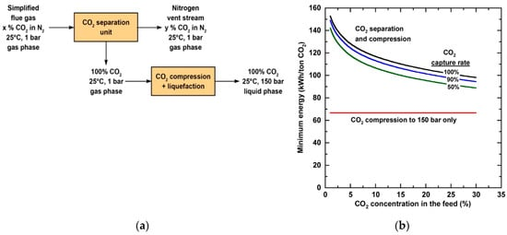
Figure 1: (a) Simplified CO₂ separation and compression/liquefaction process schematic for a simplified CO₂ and N₂ flue gas combination; (b) Minimum energy per metric tonne of CO₂ captured as a function of CO₂ concentration in a CO₂ and N₂ mixture.

(Yang Han, 2022)
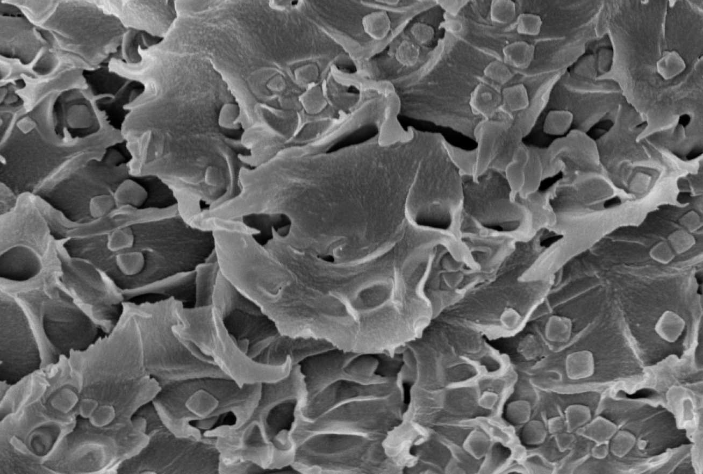
Figure 2 image of a composite membrane under an electron microscope
(West, 2018)
Global attempts to reduce carbon emissions from diverse industrial processes have been bolstered by increased attention to environmental sustainability. As a result, carbon dioxide (CO₂) separation must be used in at least three areas: pre-combustion to remove CO₂ from the main fuel (CO₂/H₂ separation), post-combustion to separate CO₂ from flue gases (CO₂/N₂ separation), and oxy-fuel combustion to produce a high concentration CO₂ gas stream from a fuel and pure oxygen combustion process. In addition, CO₂ separation (CO₂/CH₄ separation) is necessary in natural gas processing and biogas upgrading.
(Nicholaus Prasetya, 2020)

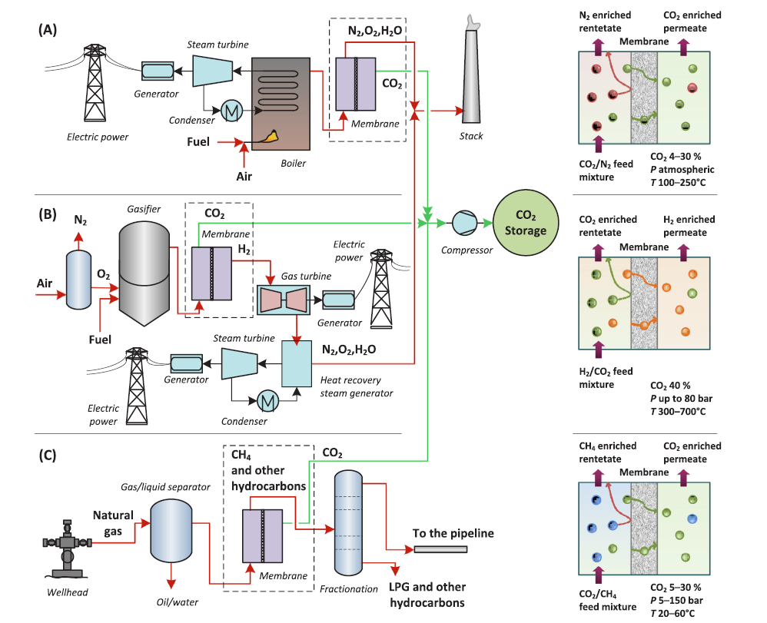

Figure 3 Potential applications for membranes in CO₂ separation: (A) post-combustion, (B) pre-combustion, and (C) natural gas processing. The corresponding
(X. Zou, 2018)

Absorption process “involves the use of solvents such as carbonates, ammonia, amine, amino acid salts, ionic liquids, phase change absorbents, nanofluids and phenoxide salts.”
(Friday O. Ochedi, 2020)
Solvent-based absorption is a method of absorbing carbon dioxide from a gas stream by combining a liquid solvent, such as an amine such as monoethanolamide (MEA), with waste heat. Carbonates and bicarbonates are among the other solvents used, although they are all used in large quantities. The removal of contaminants such as fly ash, soot, nitrogen oxides (NOX), and sulphur oxides (SOX), which can diminish the solvent's absorption capacity, necessitates a substantial amount of electricity during the solvent's recovery, or regeneration, for reuse. The CO₂ is extracted from the regenerated liquid, and the gas stream is released into the atmosphere. In post-combustion capture, absorption is used.
(Young-Lorenz, 2013)
(IPCC, 2005)
Desorption processes (“Desorption is the release of one substance from another, either from the surface or through the surface. Desorption can occur when an equilibrium situation is altered”)
(Chromatography today, 2022)
Adsorption is a physical or chemical process in which CO₂ molecules are adsorbed from a gas stream and attracted to collect on the surface of a solid or liquid (adsorbent). Silica gels and aluminas, metal organic frameworks, various organic-inorganic hybrids, mineral zeolites, and meso-porous carbons are examples of adsorbents. Amines can be added to the pores of an adsorbent to attract CO₂ molecules, increasing the material's adsorption capacity. Pre- and post-combustion capture, which both include hot and moist flue gases, require adsorption. Adsorption of CO₂, elimination of impure gases, and desorption are the three processes in adsorption systems.
(Young-Lorenz, 2013)
Desorption is the process of extracting, recovering, and releasing CO₂ from a liquid solvent adsorbent using membranes, temperature, and pressure variations. This can be accomplished in a variety of ways, including:
- Thermal Swing Adsorption
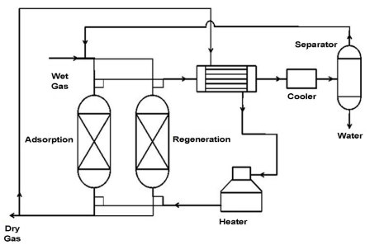
(Wahedi, 2020)
- Vacuum Swing Adsorption
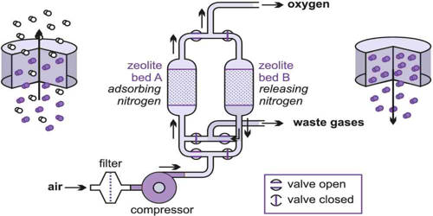
(MSR blog, 2022)
- Pressure Swing Adsorption
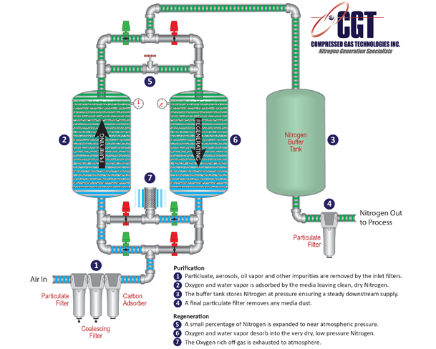
(CGT, 2022)
- Electrical Swing Adsorption
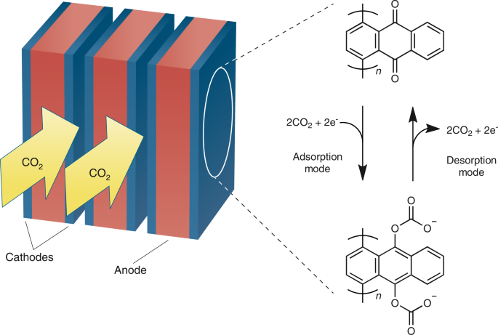
(Wilcox, 2020)
all examples of different types of adsorptions
(Young-Lorenz, 2013)
(IPCC, 2005)

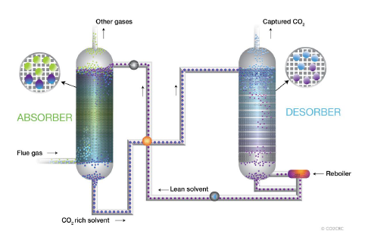
Figure 3 Absorption – Desorption is a cyclical process that collects CO₂ using a solvent, recovers the CO₂, and reuses the solvent and waste heat.
(Young-Lorenz, 2013)
The most established method is solvent scrubbing (multiple facilities amine solvents to capture carbon dioxide). After these techniques have been employed the carbon dioxide that has been absorbed is then compressed and sent to a storage facility
(IEA, 2009)
Cryogenic separation (“Cryogenic process for separation involves cooling of the gas to a very low temperature so that CO₂ can be liquefied and separated”)
(Mohammad Reza Rahimpour, 2020)
(Science direct , 2022)
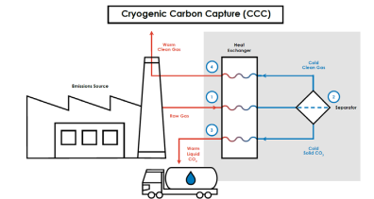
- Condensation and desublimation features are used in cryogenic technologies to separate CO₂ flue gases with high CO₂ recovery (99.99 percent) and purity (99.99 percent). Water obstruction is one of the major concerns.
- The cryogenic packed beds employ a steel framework chilled by liquefied natural gas to separate H₂0 and CO₂ using the dew point and sublimation methods. In the packed bed, clogging and pressure decrease may be prevented. Because the amount of frozen CO₂ is calculated, Chemical adsorbents and excessive temperatures are not required because of the cold energy of the packing. The limits include the need for improved packed bed insulation and H₂S removal efficiency, as well as higher running expenses.
- The external cooling loop cryogenic carbon capture (CCCECL) system combines drying and chilling the flue gas, compressing it to a temperature above sublimation, expanding the gas for further cooling, precipitating CO₂ as a solid, and pressurising and warming the CO₂. By transmitting a decreased parasitic load to the grid, this approach absorbs CO₂ in a liquid phase while using cold waste energy from an industrial source.
- Cryogenic distillation is a separation process in which the input gas is chilled and precooled before being transported to a distillation column with several vapor-liquid contact trays or packings. The post-distillation stream is separated into two streams: condensed CO₂ at the bottom and methane at the top, with the bottom stream being recycled through a re-boiler. The process's key problems are the high energy needs, which necessitate analysis and implementation of energy saving solutions.
(Mohammad Reza Rahimpour, 2020)

Gasification is the partial oxidation of a feedstock (such as coal) in steam and oxygen/air at high temperature and pressure to produce synthesis gas. This synthesis gas, often known as syngas, is made up of hydrogen, carbon monoxide, CO₂, and trace quantities of other gaseous components including methane. The water-gas shift process may then be used to transform CO and water (H₂O) to H₂ and CO₂, resulting in an H₂ and CO₂-rich gas mixture. The CO₂ content in this combination can range from 15 to 50%. After that, the CO₂ may be caught and separated, transferred, and eventually sequestered, while the H₂-rich fuel can be burned.
(Office of Fossil Energy and Carbon Management, 2022)
Pre-combustion capture employs a gasification process to convert any form of fuel into a mixture of carbon dioxide and hydrogen. Once this gasification process is complete hydrogen fuel gas is separated from the carbon dioxide, the hydrogen can be used for multiple applications such as power production while the CO₂ can be compressed and transported for storage as seen in the previous technique. This capture technology has been employed across several industrial processes including powerplants.
(IPCC, 2005)
Post-Combustion Carbon Capture: Chemical solvents are commonly used to remove carbon dioxide from the flue gas produced by fossil fuel combustion. This technology is anticipated to be used in carbon capture retrofits of existing power stations.
(Centre for climate and energy solutions , n.d.)
In theory, post-combustion capture systems can be used to catch flue gases released during the burning of any fuel. The design and expense of the entire plant, however, depend greatly on the impurities in the fuel. In addition to CO₂, N₂, O2, and H₂O, coal combustion produces air pollutants such SOx ( Sulphur oxides), NOx (Nitrous oxides), particulates, HCl(Hydrochloride), HF (Hydrogen fluoride), mercury, other metals, and other trace organic and inorganic contaminants in the flue gases.
(IPCC, 2005)
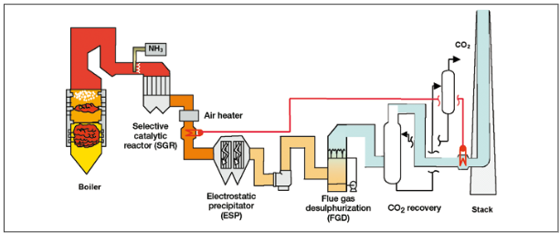
Figure 4 Diagram of a pulverised coal-fired power plant with different pollution controls, including an amine-based CO2 collecting system.
(IPCC, 2005)
The following factors are crucial in determining a CO₂ absorption system's technical and financial performance:
- Flue gas flow rate—The size of the absorber will be determined by the flue gas flow rate, and the absorber contributes significantly to the overall cost.
- Due to the fact that flue gas is typically at atmospheric pressure, the partial pressure of CO₂ can range from 3 to 15 kPa. Aqueous amines (chemical solvents) are the best absorption solvents in these low CO₂ partial pressure situations.
- Removal of CO₂ - In actuality, typical CO₂ recoveries range from 80% to 95%. A higher recovery will result in a longer absorption column, larger energy penalties, and hence higher costs. The exact recovery decision is an economic trade-off.
- With the exception of the absorber, the size of most pieces of equipment is determined by the solvent flow rate. The aforementioned variables, along with the selected CO₂ concentrations in the lean and rich solutions, will determine the flow rate for a given solvent.
- Energy needed - The total energy used by the process is made up of the thermal energy used to regenerate the solvents, electrical energy used to power the liquid pumps, and thermal energy used to run the flue gas blower or fan. Compressing the CO₂ collected to the necessary final pressure for transportation and storage also requires energy.
(IPCC, 2005)
In oxygen fuel combustion gaseous emissions from the flue are enriched with oxygen prior to combustion to produce a stream of carbon dioxide. This technique provides a stream which is easier to purify and creates some interesting business opportunities due to its high-level efficiency. This method has been utilised in the steel making industry in plants with capacity less then/equal to 250 MW
(IEA, 2009)
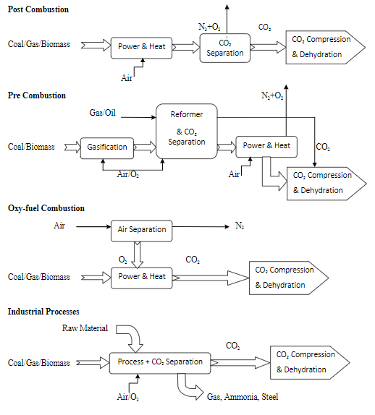
Figure 5 Diagram of the processes
(IPCC, 2005)
(Zhang, 2013)
The process of eliminating water from a gas stream is known as gas dehydration. Certain water criteria of the produced/captured gas must be met before CO₂ may be exported from the production region to the consuming areas. Because all gas streams are totally or partially saturated in their initial state, they must be dehydrated before being sold to the commercial market. The major goal of this procedure is to prevent corrosion and the production of hydrates in transportation equipment.
In most cases, the CO₂ dehydration operations are carried out using.
- Liquid desiccants absorb moisture (Triethylene glycol)
- Solid desiccants adsorb moisture (Molecular sieve)
- Membrane functions
- Refrigeration
(Rai, 2016)
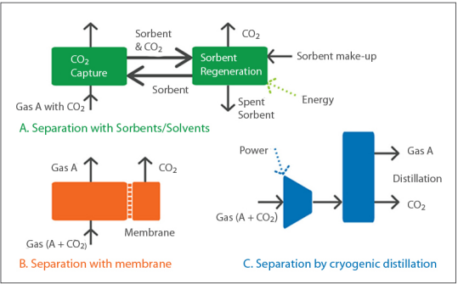
There are three main ways to separate gases
Through use of solvents/sorbents
- Amine scrubbing method was developed in the oil and chemical sectors over 60 years ago to remove hydrogen sulphide and CO₂ from gas streams. Commercially, it is the most well-established of the CO₂ capture systems available, albeit actual experience has been limited to chemically reducing gas streams, as opposed to the oxidising environment of a flue gas stream.
- Today, amines are employed to capture CO₂ from flue gas streams at a number of facilities, one of which is the Warrior Run coal-fired power plant in the United States, which captures 150 t/d of CO₂.
- Mono-ethanolamine (MEA) is a common amine utilised in CO₂ capture. CO₂ recovery rates of up to 98 percent and product purity of up to 99 percent are possible. However, there are concerns concerning its rate of degradation in an oxidising flue gas environment and the amount of energy required for regeneration.
Sorbents
- CO₂ can be separated from gas mixtures using solid adsorbents like zeolites and activated carbon. The gas mixture runs through a packed bed of adsorbent at high pressure until the concentration of the target gas approaches equilibrium in pressure swing adsorption (PSA). By lowering the pressure, the bed is rejuvenated.
- The adsorbent is renewed by raising its temperature in temperature swing adsorption (TSA). PSA and TSA are commercially available gas separation technologies that are utilised in the production of hydrogen and the removal of CO₂ from natural gas.
- Because the capacity and CO₂ selectivity of current adsorbents are poor, adsorption is not yet deemed suitable for large-scale CO₂ extraction from flue gas. It may, however, be successful when used in conjunction with another capture technology.
Membranes
- Membranes for gas separation allow one component of a gas stream to pass through faster than the others. Gas separation membranes come in a variety of shapes and sizes, including porous inorganic membranes, palladium membranes, polymeric membranes, and zeolites.
Cryogenics
- Cooling and condensation can separate CO₂ from other gases. Cryogenic separation is frequently utilised in industry for streams with high CO₂ concentrations (usually >90%), but it is not employed for streams with lower CO₂ concentrations.

Storage and utilisation
The chief purpose of carbon capture and storage technologies is to reduce or offset carbon emissions which are cause through the burning of fossil fuels this can be achieved through two basic approaches.
- Approach one involves catching carbon dioxide produced by industry then compressing this and injecting into deep geological formations such as depleted oil fields deep ocean could also be used for carbon storage. This approach is most useful for heavy industry, power plants, oil refineries and steelworks.
- Approach two involves the use of natural biological activities to take carbon dioxide from the air and store it in plant soils and various marine sediments this approach can be applied to capturing carbon dioxide from any source its most useful in capturing emissions from mobile or small-scale sources such as emissions from vehicles which is difficult to capture from the source.
(surles, 2006)
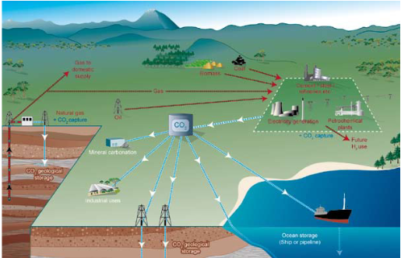
“Schematic diagram of possible CCS systems showing the sources for which CCS might be relevant, transport of CO₂ and storage options”
(IPCC, 2005)
To capture and storage carbon dioxide a four-step process must be conducted.
- The emissions must be separated to obtain the carbon dioxide within them and condense it into its purest form (emissions from fossil fuel burning plants can contain up to 4% to 14% of carbon dioxide)
- Collected carbon dioxide is then compressed to approximately 100 bars of pressure then reduce it to a liquid state
- Carbon dioxide is then transported by road, pipeline, or ship
- Once the carbon dioxide arrives at its desired destination it can be stored deep underground or deep ocean
(surles, 2006)
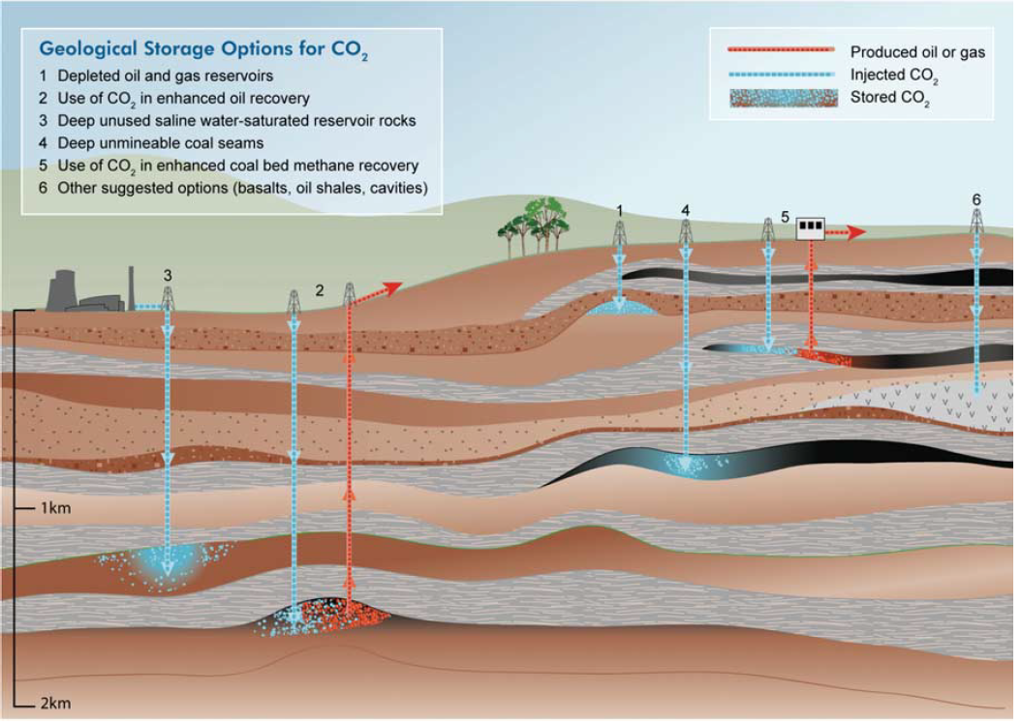
(surles, 2006)
CO₂ is either pumped to the desired pressure after being liquefied at lower pressures using refrigeration systems or compressed to the desired pressure using a gas compressor. Liquid pumps are fundamental to the liquefaction strategy because they can boost pressure with a lot less electricity and for a lot less money than gas compressors.
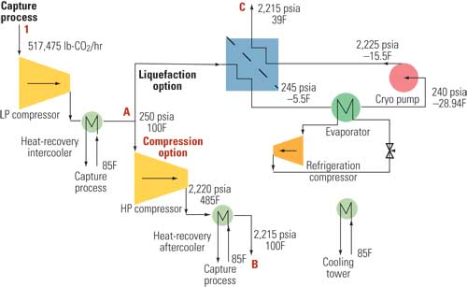
Figure 6 This flowchart shows two common design options for a carbon capture system: the standard compression process (from A to B) and the typical liquefaction process (from A to C). A heat-recovery intercooler and low-pressure compressor are used in the beginning of both processes (1 to A).
(Baldwin, 2009)
If the temperature of the gaseous CO₂ is below the critical point, which is 31 °C (87,8 °F), the gas can liquefy under pressure. A colourless fluid with a density close to that of water is created when the material is squeezed and cooled below the critical point.
No matter how much pressure is applied, CO₂ will remain in the liquid state as long as its temperature stays below the critical point, but if it rises above this threshold, it will revert to the gaseous state.
Liquid CO₂ can be kept indefinitely at either high or low pressure using the following methods:
CO₂ at High Pressure
In order to create high pressure liquid CO₂, gaseous CO₂ must first be compressed using multistage compressors to pressures approximately 69 bar (1000,76 psi), then cooled to roughly 18 °C (64,4 °F). Typically, it is poured into steel cylinders that have been particularly built. Liquid CO₂ may be weighed, much like water, and this is how it is typically measured.
CO₂ at Low Pressure
A different way to store CO₂ is in low pressure liquid, which can be made by either refrigerating or expanding high pressure CO₂ to a lower pressure. In order to maintain the internal tank pressure at or below 21 bar (304,58 psi) and -18 °C (-0.4 °F), it is kept in specially constructed storage tanks that are highly insulated and furnished with refrigeration units. Electrical alarms are installed to release tank pressure and sound an alert in the case of a refrigeration malfunction. Pressure switches are also built into the refrigeration units to manage the safety mechanisms.
Insulated road tankers or trailers are used to transport low pressure liquid CO₂ (sometimes known as "bulk") from one location to another (or, in some countries, by rail tank wagons), readily transported by pumping or gravity feed from mobile tank to stationary tank. Carbon dioxide, unlike water, cannot exist in liquid form in the open atmosphere. To maintain its liquid condition, it needs to be kept under pressure, under refrigeration, or both.
(ASCO, 2022)
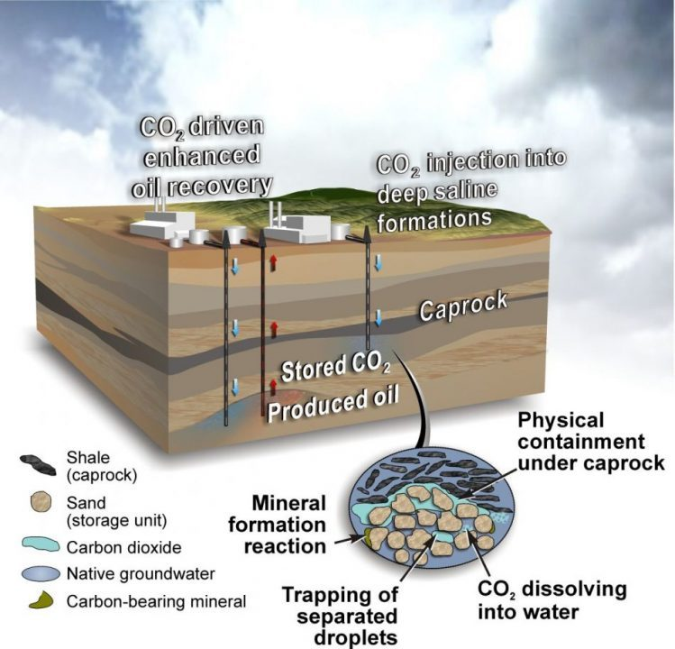
(Centre for climate and energy solutions , n.d.)
There are several potential options for storing carbon dioxide within the earth’s geology
- Aquifers
- Depleted gas and oil fields
- Mineral rocks, basalt and shale rocks and coal fields
Basalt formations have been proposed but it is not fully understood. Saline aquifers are a proven method as seen in the Sleipner demonstration project inject 1 million tonnes (Mt) of carbon dioxide per year since 1996 into a saline aquifer in the North Sea
(Malti Goel, 2018)
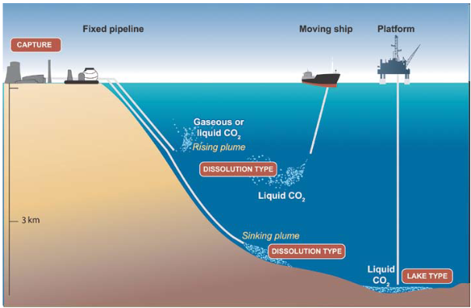
(IPCC, 2005)
To enable locking of carbon dioxide in the ocean for long term storage (between one hundred - several thousand year) the carbon dioxide must be injected to depths of up to 3000 meters overtime this carbon dioxide would be dissolved and relocated in line with the oceanic currents before being released back into the atmosphere. The ocean has the capacity to hold several thousand billion tonnes of carbon dioxide however there is the possibility that the CO₂ will be released back into the atmosphere much faster than CO₂ that has been locked into the geology. There are also concerns about the injection of CO₂ into the ocean for biological and ecosystem-based reasons and this has affected public perception on this method
(surles, 2006)
once carbon dioxide has been dispersed into the ocean it will ultimately become part of the carbon cycle, over time it is postulated that this would reduce the amount of co₂ in the atmosphere at any one time .This has been backed up by numerous experiments and modelling techniques, however, as mentioned in the previous paragraph there may be an impact on biological ecosystems due to chemical changes in the ocean such as increased acidity.
(IPCC, 2005)
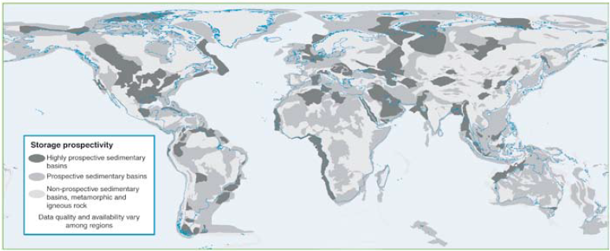
(IPCC, 2005)
areas associated with gas or coal fields are formed from the appropriate sedimentary and saline geology for carbon storage the figure above is an estimate of where this appropriate geology will exist however it must be noted that this is based on partial data (data visualised here is based on known fields for fossil fuels) as such it would be expected for this overview to change as new data becomes available.
(IPCC, 2005)

Add sections on injection process and utilisation (Section subject to possible change)

Calculating the necessary quantity of injection wells and the size of the subterranean CO₂ plume is crucial in order to determine the cost of CO₂ injection. The maximum injection rate per well, which depends on the unique features of a target reservoir, can be used to determine the number of injection wells (e.g., thickness, pressure, porosity, and permeability).
Deep saline aquifers and depleted gas reservoirs are the two geologic reservoir types most frequently thought of for long-term storage of CO₂ without increased recovery.
A typical CO₂ injection site includes surface equipment and injection wells (e.g., distribution pipelines and headers). The wellhead injection pressure that is necessary for each well may occasionally demand the use of compressors or pumps. site characterization, surface equipment, permitting, and Drilling wells are all costs.
The maximum injection rate for a target aquifer can be calculated using flow equations given reservoir and injection characteristics.
The injection rate, which can range from tens to thousands of tonnes of CO₂ per day, is extremely sensitive to variations in specific reservoir properties including permeability and thickness. Several studies set a 2500–3400 t/day daily injection rate cap for each well.
The majority of research on CO₂ injection into depleted gas reservoirs concentrates on type I reservoirs, where natural gas is created through pressure depletion. These reservoirs are desirable because they have been thoroughly defined, are known to be long-term geologic traps for gas storage and contain gas production infrastructure that might be modified for CO₂ injection.
Type I reservoirs, where natural gas is produced by pressure depletion, are the focus of the majority of research on CO₂ injection into depleted gas reservoirs. These reservoirs are sought-after due to their extensive definition, reputation as long-term geologic gas storage traps, and presence of gas production infrastructure that might be converted for CO₂ injection.
In comparison to saline aquifers, depleted gas reservoirs provide a number of advantages, but there are also some drawbacks. First, a lot of gas production wells have been drilled into these reservoirs, and if the abandoned wells are not properly sealed, there is a danger of leakage. Second, the estimated bottom hole CO₂ injection pressure (15-35 MPa) is much higher than the pressures seen in depleted type I gas reservoirs, which are generally 2-5 MPa.
(Maroto-Valer, 2010)
investigates methods for lowering BHIP but comes to the conclusion that to keep the flow going, a high-tech flow control device will be needed at the base of the tube. The requirement for this equipment may provide a significant technological barrier to injecting CO₂ into depleted gas reserves.
(S.Hughes, 2009)
In order to store CO₂, both saline aquifers and depleted gas reservoirs require essentially the same technology. The flow control equipment that will probably be needed for the former is the exception. Since the characteristics of depleted gas reservoirs can vary greatly, a wide range of injection rates are also possible. Two injection rates—150 and 1500 tonnes per day—are modelled in order to account for the effects of various injection rates on costs. These rates allow for the estimation of the number of injection wells and the calculation of storage expenses.
(Maroto-Valer, 2010)
Concrete and other building materials, such as aggregates, are leading the way in creative CO2 utilisation, with numerous commercial initiatives now in progress. There are currently few manufacturers who have successfully designed high-quality items that include some CO2 gas, and those who have actively commercialised such products at a high Technology Readiness Level are even fewer.
(Zhu, 2019)
Novel CO2 utilisation technologies now confront two difficulties: first, achieving a net decrease in CO2 emissions over the course of their lifetimes; and second, offering high-quality carbon commodities at a cost that is both reasonable and sustainable. It is important to take into account the amount of CO2 extracted from the atmosphere, the source of energy being used, and the CO2 emissions incurred in the conversion and incorporation processes to guarantee that the process of innovative CO2 usage remains carbon negative. As with any manufacturing processes, it can be difficult to establish cost-competitiveness for novel CO2 use products in the first few years of operation, especially if less expensive options already exist. For instance, industry experts claimed in a Bloomberg magazine article that customers are hesitant to choose ecologically friendly cement kinds with low carbon footprints since standard cement offers a better price. Financiers are less likely to invest in relatively risky hardware technologies since software technologies offer a safer field of investment where the likelihood of sunk costs is minimal. Redesigning software's codes can be far easier than reconstructing hardware in the event that intermittent modifications are required, which is frequently the case with innovation.
(de Coninck, 2018)
(Zimmermann, 2018)
(Dezem, 2019)
(Warsi, 2020)
By generating a return on investment for financial input, commercialising CO2 removal through innovative use can spur large-scale deployment. While delivering an economic value proposition to justify expedited deployment, an integrated process flow combining CO2 removal and innovative usage in place of geological storage can increase CDR sustainability in terms of land use, cost, and environmental effect. Novel CO2 usage provides a significant advantage over traditional CCS approaches in terms of potential traction, pace of adoption, and growth because it has the potential to be commercially successful and can be influenced by free market dynamics. The collection of present CDR strategies and their related advancements are working on a few MtCO2 per year elimination scale, making it especially vital to accelerate CDR growth in the form of novel CO2 utilisation.
Concrete and other building materials, such as aggregates, are leading the way in creative CO2 utilisation, with numerous commercial initiatives now in progress. There are currently few manufacturers who have successfully designed high-quality items that include some CO2 gas, and those who have actively commercialised such products at a high Technology Readiness Level are even fewer. The understanding of costs and CDR capacities is institution- and process-specific because to the novelty of these technologies. As a result, it is unknown how much CO2 will be captured overall and how it will be used. This lack of understanding has hampered organisations like the IPCC from considering novel CO2 use in their IAMs for climate mitigation in addition to the mystery surrounding CO2 conversion pathways for producing value-added products. Several research paths are being pursued to further identify and build industrially applicable products that can replace traditional materials, even if the existing mix of novel CO2 usage technologies is sufficient to offset just 10% of anthropogenic CO2 emissions.
It is critical to extrapolate lessons from other hardware-intensive technology industries that have scaled successfully around the world and to analyse their historical genesis, evolution, and development cycles in order to assess the plausible pathways that the novel CO2 utilisation market may take. This section examines the growth of two distinct and prosperous technology sectors: solar and automotive. These specific industries were picked for research because their development and deployment have taken place at scales and under conditions that are very different from one another, utilising various resources and trends to sustain rapid expansion. Moving forward, either of these routes to commercialization and upscale—or a mix of them—may be taken through new CO2 usage at an industrial level.
(Warsi, 2020)

Future work

Significant consumer behaviour change is necessary to support the successful industrial deployment of innovative CO2 utilisation technologies in order to achieve scaled-back carbon emission reductions. A transparent and unified methodology on all suggested CDR pathways must be developed and disseminated throughout the system in order to inspire behavioural modification and adoption.
Any CO2 usage technology and related businesses must take into account the deployment capability, economic viability, and the permanence of carbon fixation in the new goods and materials in order to effectively solve these difficulties. Cross-disciplinary cooperation, innovative science, and engineering are needed to tackle the collecting and deconvolution of enormous data in order to replace conventional approaches. For the scale-up and commercialization of novel CO2 utilisation technologies, as with many other hardware technologies, a coordinated effort between public and private support of vetted technology projects is essential to overcome the impeding inertia of high cost, poor production quality, and small-scale.
(Warsi, 2020)

Results

Conclusion

Bibliography
Alfa Laval , 2015. What is membrane filtration ?. [Online]
Available at: https://www.alfalaval.com/products/separation/membranes/what-is-membrane-filtration/
[Accessed 23 Febuary 2022].
ASCO, 2022. GENERAL INFORMATION ABOUT CO2. [Online]
Available at: https://www.ascoco2.com/us/co2-production-and-co2-recovery-plants/general-information-about-co2
[Accessed 7 March 2022].
Baldwin, P., 2009. Capturing CO2: Gas Compression vs. Liquefaction. [Online]
Available at: https://www.powermag.com/capturing-co2-gas-compression-vs-liquefaction/
[Accessed 8 March 2022].
Cambridge university press , 2022. Carbon capture. [Online]
Available at: https://dictionary.cambridge.org/dictionary/english/carbon-capture
[Accessed 20 February 2022].
Centre for climate and energy solutions , n.d. Carbon capture. [Online]
Available at: https://www.c2es.org/content/carbon-capture/
[Accessed 21 February 2022].
CGT, 2022. What is a Pressure Swing Adsorption (PSA) Generator?. [Online]
Available at: https://nitrogen-generators.com/what-is-a-psa-nitrogen-generator/
[Accessed 21 february 2022].
Chromatography today, 2022. Adsorption, Absorption and Desorption - What's the Difference?. [Online]
Available at: https://www.chromatographytoday.com/news/hplc-uhplc/31/breaking-news/adsorption-absorption-and-desorption-whats-the-difference/31397
[Accessed 23 February 2022].
Cop26, 2021. Cop26. [Online]
Available at: https://ukcop26.org/
[Accessed 19 February 2022].
Friday O. Ochedi, J. Y. H. Y., 2020. Carbon dioxide capture using liquid absorption methods: a review. Environmental chemistry letters , Volume 19, p. 77–109.
Herzog, H. J., 2018. Carbon Capture. 1st ed. Cambridge : MIT Press.
IEA, 2009. World energy outlook. 1st ed. France: IEA.
IPCC, 2005. Carbon capture and storage. 1st ed. New York: Cambridge University Press.
Malti Goel, M. S. a. R. S., 2018. Carbon capture storage and utilization. 1st ed. London : Routledge.
Maroto-Valer, M. M., 2010. Developments and innovation in carbon dioxide (CO2) capture and storage technology. (CO2) capture and storage technology, Volume 1, pp. 45-55.
Mohammad Reza Rahimpour, M. F. a. M. A. M., 2020. Advances in Carbon Capture. Oxford : Brain Romer .
MSR blog, 2022. Vacuum swing adsorbtion (VSA). [Online]
Available at: http://msrblog.com/assign/science/chemistry/vacuum-swing-adsorption-vsa.html
[Accessed 20 February 2022].
Nicholaus Prasetya, B. P. L., 2020. A review on emerging organic-containing microporous material membranes for carbon capture and separation. Chemical Engineering Journal, Volume 291, p. 18.
Office of Fossil Energy and Carbon Management, 2022. Pre-Combustion Carbon Capture Research. [Online]
Available at: https://www.energy.gov/fecm/science-innovation/carbon-capture-and-storage-research/carbon-capture-rd/pre-combustion-carbon#:~:text=Pre%2Dcombustion%20capture%20refers%20to,pressure%20to%20form%20synthesis%20gas.
[Accessed 30 February 2022].
Rai, B., 2016. CO2 dehydration after CO2 capture. Porsgrunn: University College of Southeast Norway.
S.Hughes, D., 2009. Carbon storage in depleted gas fields: key challenges. Aberdeen , Energy Procedia, p. 3007–3014.
Science direct , 2022. Cryogenic Separation. [Online]
Available at: https://www.sciencedirect.com/topics/engineering/cryogenic-separation#:~:text=Cryogenic%20process%20for%20separation%20involves,in%20the%20natural%20gas%20stream.
[Accessed 23 February 2022].
Spencer Weart and the American Institute of Physics, 2021. The Carbon Dioxide Greenhouse Effect. [Online]
Available at: https://history.aip.org/climate/co2.htm
[Accessed 20 February 2022].
surles, S. B. &. T., 2006. Carbon Dioxide Capture and Storage: An Overview With Emphasis on Capture and Storage in Deep Geological Formations. proceedings of the IEEE, V 94(I 10), pp. 1795-1894.
Wahedi, F. S. A., 2020. Black Powder in Sales Gas Pipelines: Sources and Technical Recommendations. Department of Chemical and Petroleum Engineering, Volume 8, pp. 60-73.
Warsi, Y., 2020. Novel Carbon Dioxide Utilization Technologies: A Means to an End. Calgary, University of Calgary.
West, S., 2018. New CO2 separating membranes could make carbon capture more efficient. [Online]
Available at: https://www.imperial.ac.uk/news/187886/new-co2-separating-membranes-could-make/
[Accessed 12 February 2022].
Wilcox, J., 2020. An electro-swing approach. Nature Energy, Volume 5, pp. 121-122.
X. Zou, G. Z., 2018. Microporous Organic Materials for Membrane-Based Gas separation. Advanced Materials , 20(3).
Yang Han, W. H., 2022. Polymeric Membranes for CO2 Capture. [Online]
Available at: https://encyclopedia.pub/entry/3404
[Accessed 1 March 2022].
Young-Lorenz, J. D., 2013. Portfolio analysis of carbon sequestration technologies and barriers to adoption . Thesis (M.Sc. (Geo)). s.l.:University of Western Australia.
Zhang, T. a. S. R., 2013. Carbon capture and storage for mitigating climate changes. 1st ed. Reston: ASCE.

Appendices

Appendix A.

Enid Fertilizer Plant, Koch Nitrogen Company, Oklahoma, 1982. Carbon dioxide is supplied to oil fields in southern Oklahoma by this fertiliser manufacturing plant.
Wyoming's Exxon Shute Creek Gas Processing Facility, built in 1986. This natural gas processing plant services the carbon dioxide pipeline systems of ExxonMobil, Chevron, and Anadarko Petroleum to oil fields in Wyoming and Colorado, and it is the world's largest commercial carbon capture facility, with a capacity of 7 million tonnes per year.
Great Plains Synfuels Plant, Dakota Gasification, North Dakota, 2000. Synthetic natural gas, fertiliser, and other by-products are produced at this coal gasification factory. As of 2015, it had delivered over 30 million tonnes of carbon dioxide to Cenovus and Apache's EOR operations in southern Saskatchewan.
2003: Michigan's Core Energy/South Chester Gas Processing Plant. Core Energy has captured over 2 million metric tonnes of carbon dioxide from natural gas processing for EOR in northern Michigan.
The Arkalon Bioethanol plant in Kansas, built by Chaparral/Conestoga Energy Partners in 2009. It is the first ethanol plant to incorporate carbon capture, supplying 170,000 tonnes of CO2 per year to Chaparral Energy, which uses it for enhanced oil recovery (EOR) in Texas oil fields.
The Century Plant of Occidental Petroleum in Texas in 2010. This natural gas processing facility's carbon dioxide stream is compressed and delivered to the Permian Basin for usage.
Air Products in 2012 Texas's Port Arthur Steam Methane Reformer Project. This refinery's two hydrogen production machines create a million tonnes of carbon dioxide per year for usage in Texas oilfields.
Conestoga Energy Partners/Petro Santander built the Bonanza Bioethanol plant in Kansas in 2012. This ethanol facility absorbs and sends over 100,000 tonnes of CO2 to a Kansas EOR field each year.
ConocoPhillips' Lost Cabin plant in Wyoming, in 2013. Denbury Resources' Greencore pipeline compresses and transports the carbon dioxide stream from this natural gas processing facility to the Bell Creek oil production in Montana.
In Kansas, Chaparral/CVR Energy built the Coffeyville Gasification Plant in 2013. The carbon dioxide stream from a nitrogen fertiliser production process based on gasification of petroleum coke is caught, compressed, and transferred to a Chaparral-operated oil field in northeastern Oklahoma (about 850,000 tonnes per year).
The Antrim Gas Plant in Michigan in 2013. Carbon dioxide from a DTE Energy gas processing plant is gathered at a rate of about 1,000 tonnes per day and pumped into a nearby oil field operated by Core Energy in the Michigan Basin's Northern Reef Trend.
CCS offshore of Brazil, Petrobras Santos Basin Pre-Salt Oil Field, 2013. In the Lula and Sapinhoá oil fields, this project involves extracting carbon dioxide from natural gas processing for use in enhanced oil recovery.
SaskPower's Boundary Dam project in Saskatchewan, Canada, was completed in 2014. SaskPower accomplished the first commercial-scale carbon capture technology upgrade of an existing coal-fired power station, selling carbon dioxide locally for EOR in Saskatchewan.
Shell Quest is a project in Alberta, Canada, that began in 2015. Shell has started up a bitumen upgrader complex that absorbs and injects about one million tonnes of CO2 per year from hydrogen generating units into a deep saline formation.
Saudi Arabia's Uthmaniyah CO2-EOR Demonstration in 2015. The carbon dioxide from the Hawiyah natural gas liquids recovery plant is captured in this project. In the Ghawar oil field, the captured carbon dioxide is used to improve oil recovery.
NRG's Petra Nova project in Texas was completed in 2017. NRG completed a project to collect 90% of the carbon dioxide from a 240 MW slipstream of flue gas from its existing WA Parish plant, or around 1.6 million tonnes of CO2 per year, on schedule and on budget. The carbon dioxide is carried to a nearby oil field.
ADM Illinois' Industrial Carbon Capture and Storage Project was completed in 2017. Archer Daniels Midland started trapping carbon dioxide from an ethanol plant and storing it in a deep saline deposit nearby. The project has the potential to capture up to 1.1 million tonnes of CO2 per year.
2020: The Boundary Dam 3 facility in Saskatchewan, Canada, captured and stored nearly 4 million tonnes of carbon dioxide.
In the year 2020, the Shell Quest project in Alberta, Canada, which absorbs carbon dioxide from a hydrogen production unit at the Scotford refinery, will have captured more than 5 million tonnes of CO2.
Due to the decline of West Texas crude oil prices early in the COVID-19 pandemic, the NRG Petra Nova project in Texas was shut down in 2020.
All information above comes from the reference shown below
(Centre for climate and energy solutions , n.d.)

