14/08/2026
Video Link: A presentation on Self-Evaluation^J Professional Development Plan ^0 Learning to Learn_Final.mp4

UNIVERSITY OF WALES TRINITY SAINT DAVID
LONDON CAMPUS
Module Name: Learning in the Digital Era
Module Code: ACCA 4025

Student Name: Samuel Ojok
Student ID: 2539235
Group: 3

Lecturer’s Name: Anees Baqir

Table of Contents
Introduction 2
Main Body 2
Conclusion 9
References 10

Introduction.
This report focuses on self-reflection, personal development and lifelong learning as important aspects of my academic and professional development. It covers three tasks: using Gibbs’ Reflective Cycle to evaluate my strengths and weaknesses, developing a Professional Development Plan (PDP) and setting goals, and exploring lifelong learning and learning agility. Overall, the report explains what I have learned from these tasks, the personal traits I have developed, and how these experiences can support my future studies and career development.

Slide 1: COVER PAGE.
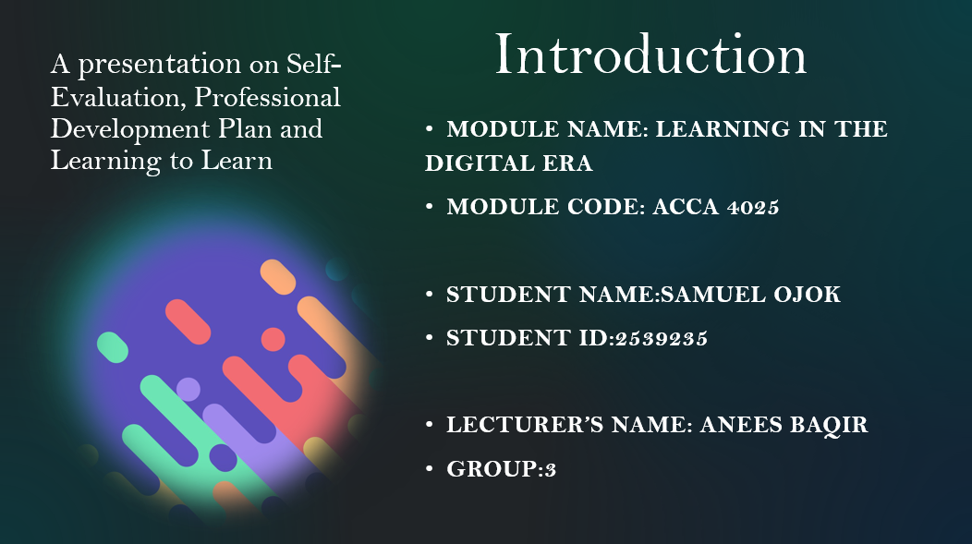
Slide 2: CONTENTS.
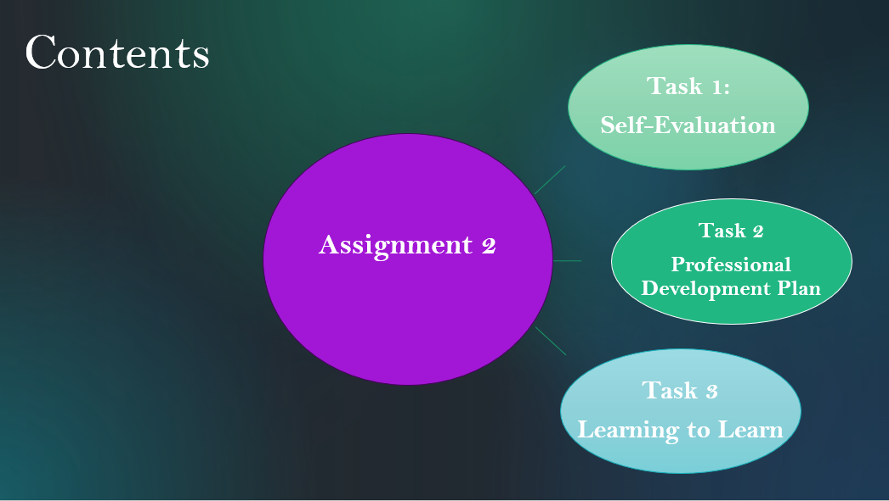
The presentation has three connected parts. The self-evaluation that reveals my strengths and weaknesses, practical development plan with SMART goals and agile learning to support my future development.

Slide 3: MAIN BODY. 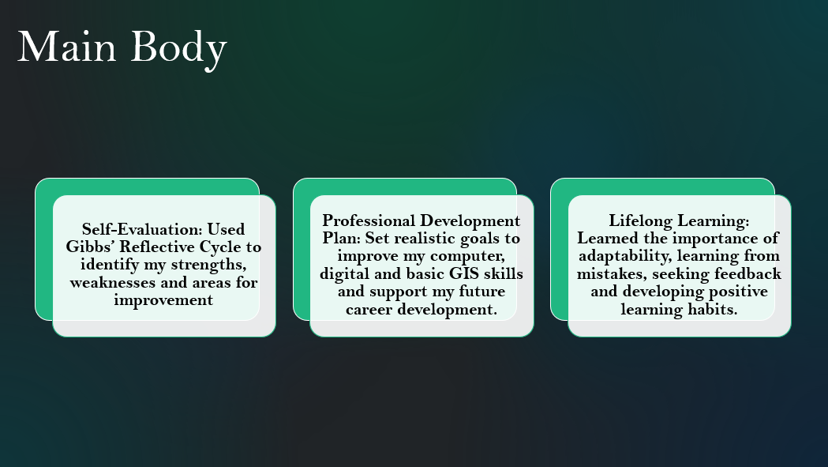
Across the three tasks, I reflected on my strengths, weaknesses, goals and learning development. Task 1 helped me develop self-awareness through Gibbs’ Reflective Cycle. Task 2 helped me to develop a professional development plan with realistic goals necessary for my both academic and career growth and Task 3 taught me the importance of lifelong learning, adaptability and learning from mistakes. Overall, the three tasks helped me become a more confident, responsible, reflective and adaptable learner, prepared for my future studies and career.
Slide 4: GIBB’s REFLECTIVE MODEL.
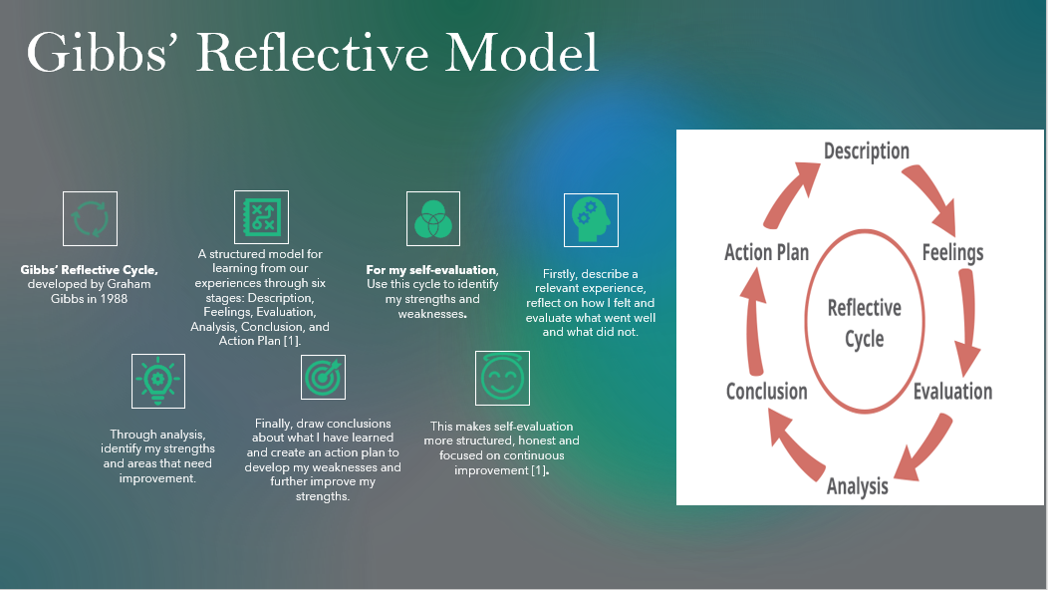
Gibbs’ Reflective Cycle, developed by Graham Gibbs in 1988, is a structured model that helps us learn from our experiences through six stages: Description, Feelings, Evaluation, Analysis, Conclusion, and Action Plan [1].
For my self-evaluation, I will use this cycle to identify my strengths and weaknesses. Firstly, I will describe a relevant experience, then reflect on how I felt and evaluate what went well and what did not. Through analysis, I will identify my strengths and areas that need improvement. Finally, I will draw conclusions about what I have learned and create an action plan to develop my weaknesses and further improve my strengths. This makes self-evaluation more structured, honest and focused on continuous improvement [1].

Slide 5 TASK 1: SELF EVALUATION.
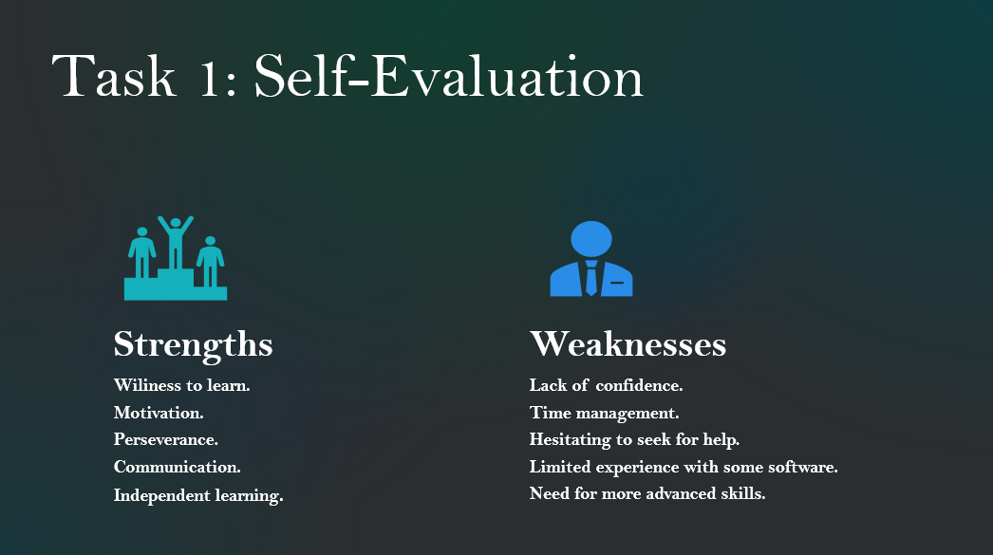
As student studying Computer Skills for the Workplace, my main strengths are motivation, perseverance and willingness to learn. Self-assessment has helped me recognise my progress and take more responsibility for my learning. Research shows that self-assessment can support self-awareness, goal-setting and continuous development [ 2. 3]
My main weaknesses are confidence with unfamiliar technology, time management and sometimes hesitating to ask for help. Through self-reflection, I am learning to recognise these areas and use feedback to improve. Overall, self-assessment has helped me become more reflective, resilient and responsible as a student [4].

Slide 6: TRAITS GAINED FROM THE SELF EVALUATION.
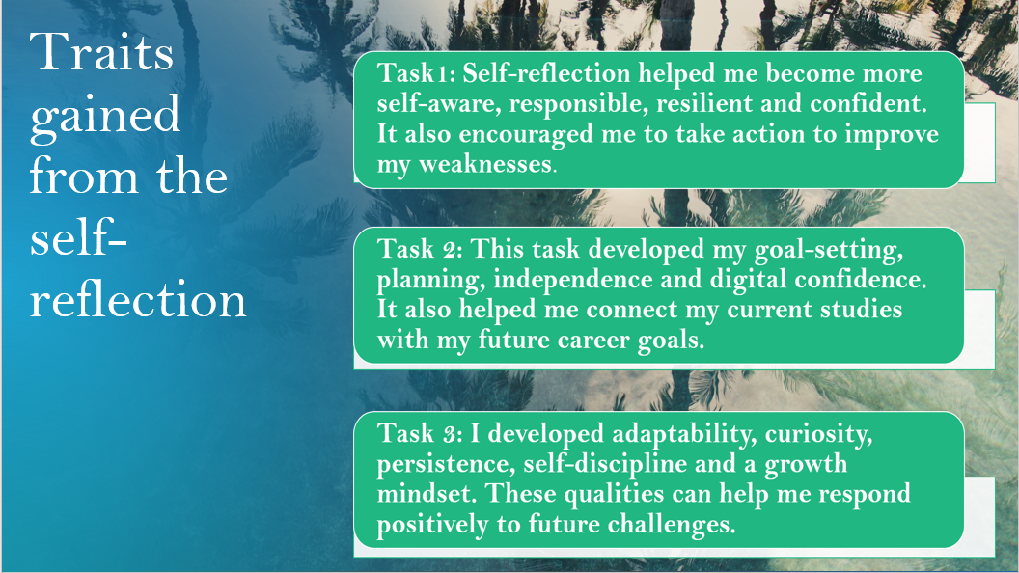
Self-reflection helped me become more self-aware, responsible, resilient, confident, independent, disciplined, adaptable, and goal-oriented, preparing me for future challenges and career goals.
Overall, the assignment connected my reflection with action. Self-reflection showed me what I need to improve, the PDP gave me realistic goals, and lifelong learning showed me how to keep developing continuously. Regular practice, feedback and goal setting are important for building both skills and confidence.
Slide 7: PROFESSIONAL DEVELOPMENT PLAN.
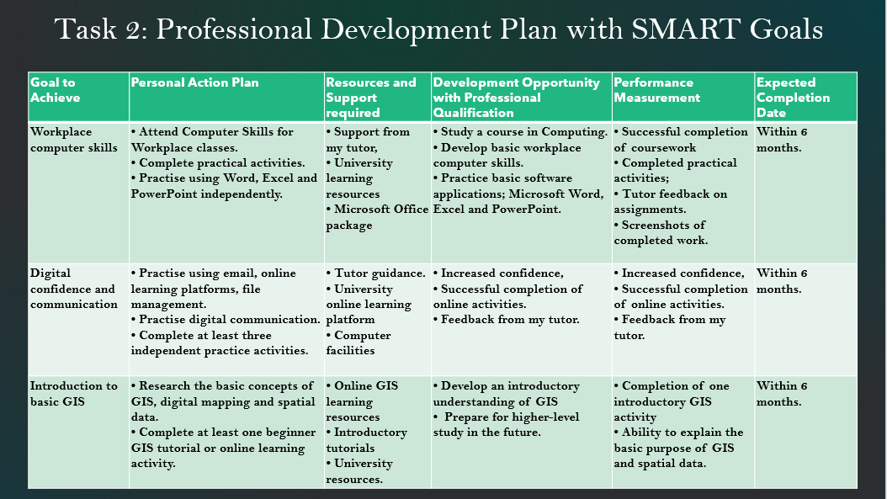
a). Reflection & Goals.
I used Gibbs’ Reflective Cycle to reflect on my current skills and identify areas for development. As a Semester I student studying Computer Skills for the Workplace, I am still developing my basic digital skills.
My strength is my willingness to learn and practise, but I sometimes lack confidence when using unfamiliar applications. My immediate goal is to improve my skills in Word, Excel, PowerPoint, file management and digital communication.
In the future, I would like to study GIS at a higher level, so I see my current computer skills as a foundation for that goal. Research also suggests that GIS education develops specialist and transferable skills useful for employment [5].
b). Professional Development Plan.
My Professional Development Plan focuses on three main areas. First, I want to improve my workplace computer skills, especially Microsoft Word, Excel, PowerPoint and Access by attending classes, completing activities and practising independently.
Second, I want to develop my digital confidence and communication by improving my use of email, online learning platforms and file management.
Finally, because I am interested in studying GIS at a higher level in the future, I plan to develop a basic understanding of GIS, digital mapping and spatial data through an introductory tutorial.
I will measure my progress through completed activities, tutor feedback and practical evidence. I look forward to completing these goals within 6 months of my studies to prepare me further to specialist in GIS fields.
c). Goal progress.
Evidence of Progress: Introduction to Basic GIS.
The screenshots show my progress towards my PDP goal of developing an introduction to basic GIS on YouTube. Through this learning activity, I explored the basic concepts of GIS, digital mapping and spatial data. This has increased my understanding and confidence in GIS and has given me a useful foundation for my future goal of studying GIS at a higher level. 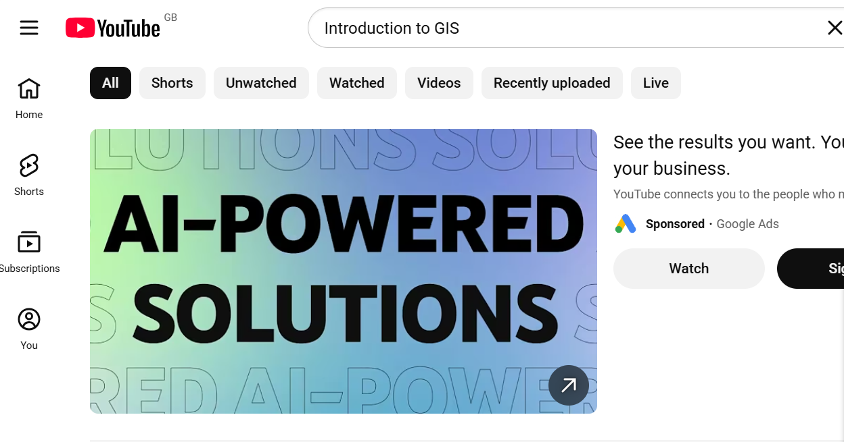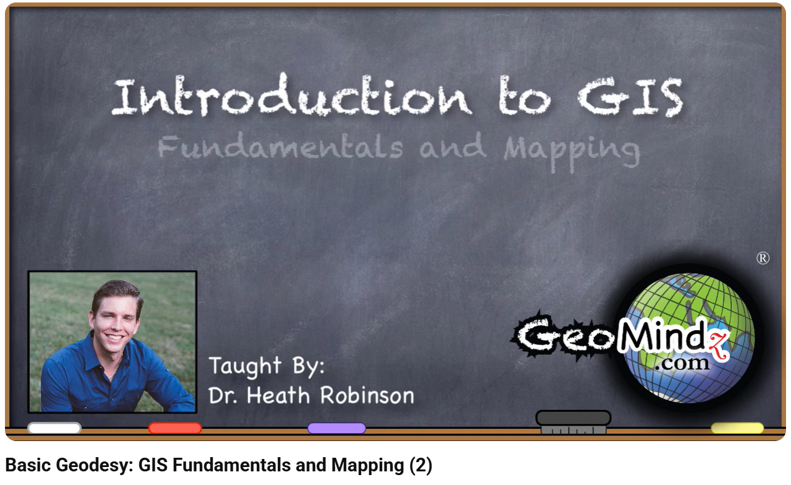
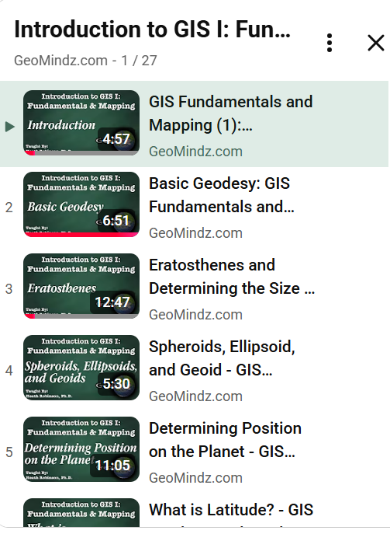
Slide 8 UNIT 4: TOPIC SUMMARY
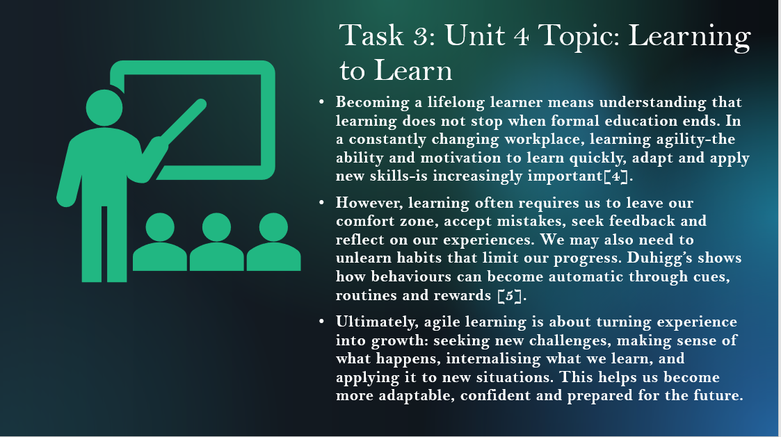
Learning to learn means developing learning agility: the ability to adapt to change, learn from experience, seek feedback and apply new knowledge to unfamiliar situations [6]. It also involves recognising and changing unhelpful habits by understanding the cue–routine–reward cycle, helping us move beyond our comfort zone and continue growing as lifelong learners [7].

Slide 9: CONCLUSION.
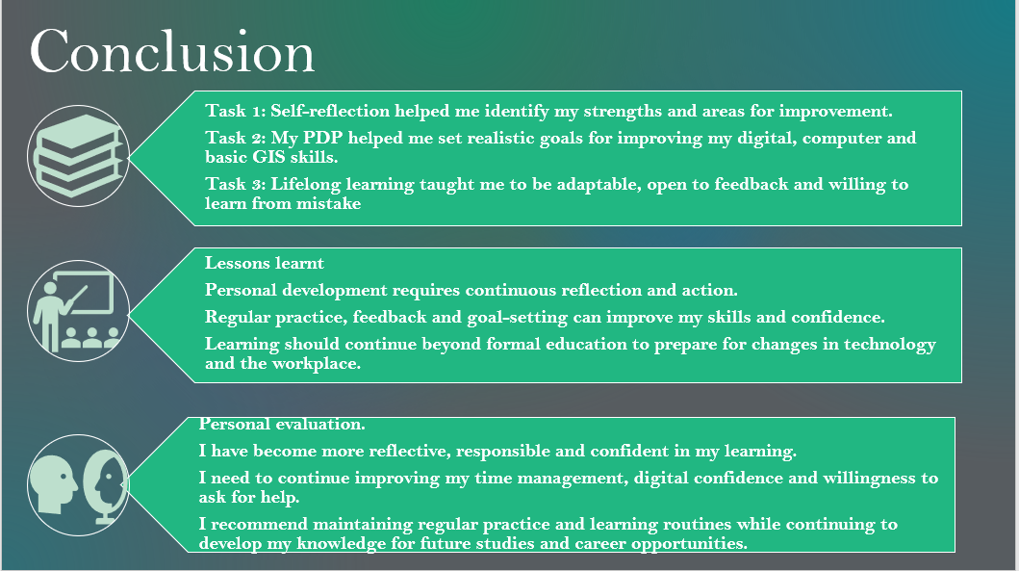
This assignment has helped me understand where I am now, where I want to go and what I need to do to achieve my goals. The skills of reflection, goal setting, adaptability and lifelong learning will continue to support me throughout my academic journey and future professional career.
In summary, the three tasks have helped me understand the importance of self-reflection, personal development and lifelong learning. Task 1 showed me how Gibbs’ Reflective Cycle can be used to evaluate my experiences, recognise my strengths and identify weaknesses. I learned that I am motivated, willing to learn and persistent, while I still need to improve my confidence with unfamiliar technology, time management and willingness to ask for help.

Slide 10: Reference.


