Module Name: Population Health and Digital Health Promotion
Module Code: LCHS7009

Lecturer: Dr. Besty Jose
Program Name: MSc Public Health and Social Care in Practice

Name: Talaviya Hemanshi Rameshbhai
Student ID: 2430270

Blog 1 - Smoking
Quitting the smoking Habit with the help of digital technology
Smoking and its global toll
Smoking is one of the common preventable diseases which mainly causes premature death in the current scenario (Ritchie & Roser, 2023).
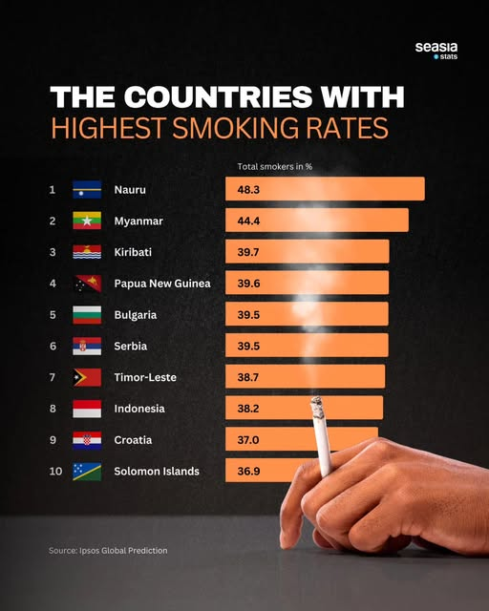
Figure 1: High smoking rates among countries
(Source: SeaStats Facebook post, 2025)
Nauru has seen the highest smoking rates globally (SeaStats Facebook post, 2025).
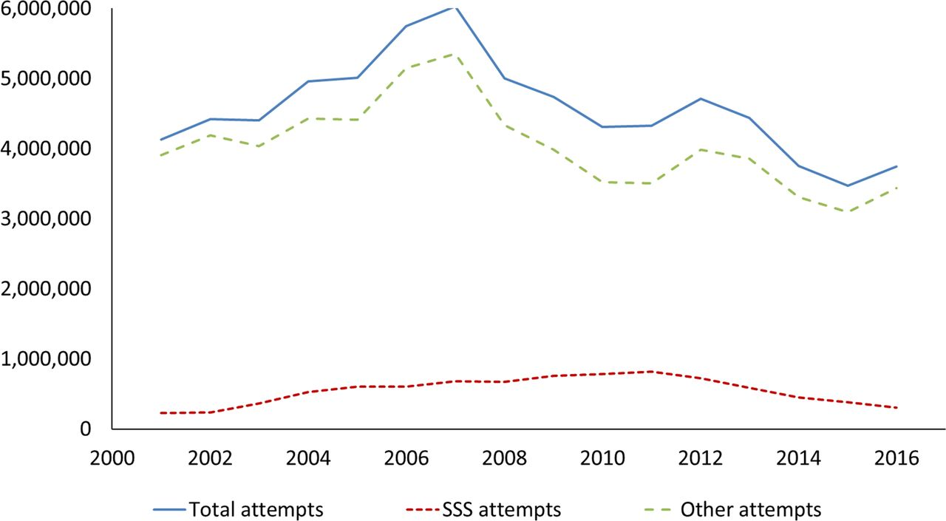
Figure 2: Smoking quit attempts in England between 2001 and 2016
(Source: Song, Elwell-Sutton, & Naughton, 2020)
The death rates from smoking are high in Eastern Europe and Asia, and smoking is the third most common risk factor in the world (Kent County Council Facebook post, 2025).
Digital health promotion
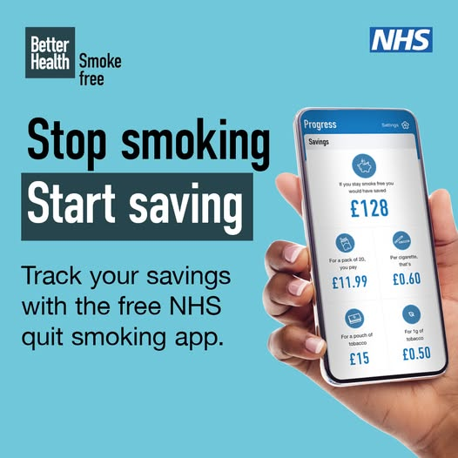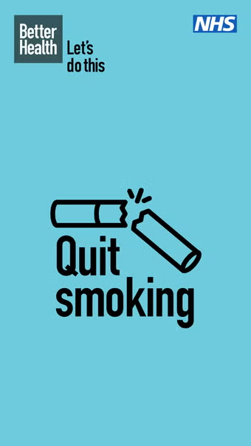
Figure 4: NHS application
(Source: NHS Quit Smoking Android app, 2025)
Using digital health technologies such as mobile apps can help to make personalised and interactive health interventions and track progress (NHS Quit Smoking Android app, 2025).
The SmokeFree App:
The smokefree app is one of the standout technologies developed to take the initiative on behavioral insights and real-time feedback (Facebook Group post, 2025).
Process of working
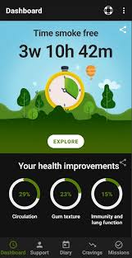
Figure 5: Smokefree dashboard
(Source: Facebook Group post, 2025)
- Using the SmokeFree App helps with better evidence-based behavioural change management (DroidViews, 2024).
- Using the goals for setting quit dates and developing motivational milestones (Rigotti et al., 2024).
- This app tracks days smoke-free and health improvement for self-monitoring (Dai et al., 2022).
- Giving instant feedback from real-time health progress (SeaStats Facebook post, 2025).
- Provide motivational messages (Kent County Council Facebook post, 2025).
The study of Facebook Group posts (2025) highlights that the use of the SmokeFree App can help to make money as well as manage a smoke-free lifestyle.
Advantages
Scalability and Accessibility: Apps such as SmokeFree can reach millions of users immediately, regardless of geographic or socioeconomic barriers (Ritchie & Roser, 2023).
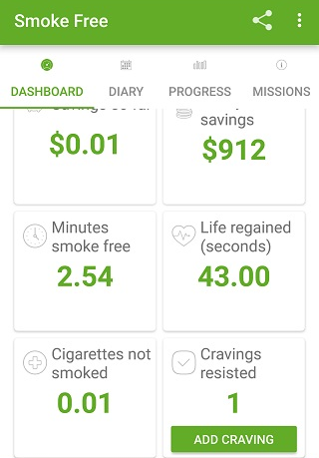
Figure 6: Dashboard of Smokefree App
(Source: DroidViews, 2024)
- Personalisation: The messages that the algorithm is grounded on are tailored to the person’s performance metrics, extra stimulating both engagement and motivation
- Cost-effectiveness: Digital interventions are cost-saving compared to in-person quit-smoking programs
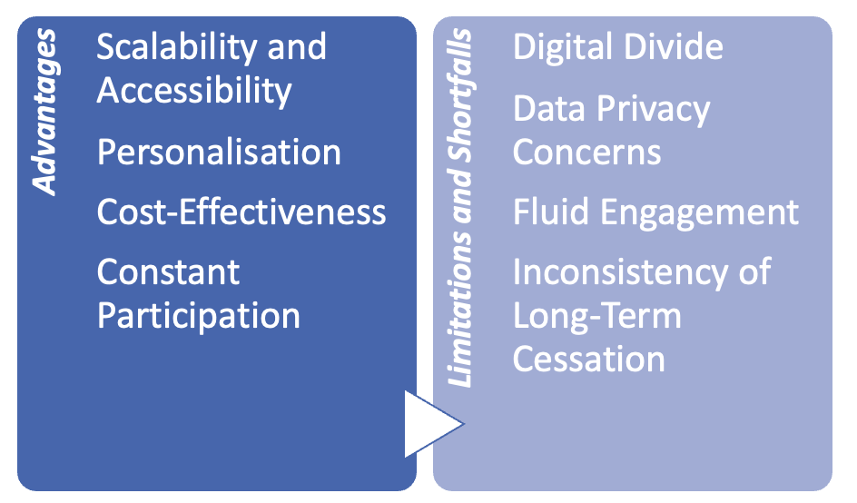
Figure 7: Advantages and disadvantages of this app
(Source: Self-developed)
Limitations and Shortfalls
- Digital divide: Low-income populations, and adults over 55 may not use smartphones or have limited digital literacy (SeaStats Facebook post, 2025).
- Data privacy: Collecting sensitive health records may include some unlawful practices from an ethical and regulatory perspective (SeaStats Facebook post, 2025).
- Inconsistency of Long-Term cessation: Insufficient evidence about long-term cessation beyond 12 months (NHS Quit Smoking Android app, 2025).
Addressing the Shortfalls
In order to improve the performance of digital smoking cessation tools, developers and public health agencies can:
- Incorporate personalisation with AI: Adaptive learning systems have the potential to modify content using user engagement patterns (SeaStats Facebook post, 2025).
- Hybrid models: The digital app with short-term assistance of healthcare professionals can enhance long-term adherence rates (Dai et al., 2022).
This way powerful evaluation of the public health promotion through the DSmokeFree App will be helpful for making better engagement with larger audiences.

Conclusion
The utilisation of digital technology for quitting smoking with the application of the SmokeFree app can be quite helpful. The shortfalls of conventional procedures can be adjusted with such modern-age technologies as well. However, the requirement of proper supervision and control also stays at large in this regard.

Reference List
Dai, X., Gil, G.F., Reitsma, M.B., Ahmad, N.S., Anderson, J.A., Bisignano, C., Carr, S., Feldman, R., Hay, S.I., He, J. and Iannucci, V., (2022). Health effects associated with smoking: a Burden of Proof study. Nature medicine, 28(10), pp.2045-2055. https://www.nature.com/articles/s41591-022-01978-x.pdf
DroidViews. (2024) Top 3 apps to help quit smoking. Available at: https://www.droidviews.com/top-3-apps-help-quit-smoking/ (Accessed: 30 October 2025).
Facebook Group post. (2025) [Facebook group post, unnamed]. Available at: https://www.facebook.com/groups/707621863012993/posts/2195866374188527/ (Accessed: 30 October 2025).
Kent County Council Facebook post. (2025) Did you know that if you stop smoking for 28 days, you are five times more likely… Available at: https://www.facebook.com/KentCountyCouncil/posts/did-you-know-that-if-you-stop-smoking-for-28-days-you-are-five-times-more-likely/1166686665502971/ (Accessed: 30 October 2025).
NHS Quit Smoking Android app. (2025) NHS Quit Smoking – Android app. Available at: https://nhs-quit-smoking.en.softonic.com/android (Accessed: 30 October 2025).
Rigotti, N.A., Kruse, G.R., Livingstone-Banks, J. and Hartmann-Boyce, J., (2022). Treatment of tobacco smoking: a review. Jama, 327(6), pp.566-577.https://rethinktobaccoindiana.org/wp-content/uploads/2022/03/treatment-of-tobacco-smoking-jama_rigotti_2022.pdf
Ritchie, H. & Roser, M. (2023) Smoking. Our World in Data. Available at: https://ourworldindata.org/smoking (Accessed: 30 October 2025). Our World in Data+2Our World in Data+2
SeaStats Facebook post. (2025.) Nauru leads the world in smoking rates; Southeast Asia is high on the list — a recent report. Available at: https://www.facebook.com/seastats/posts/nauru-leads-the-world-in-smoking-rates-southeast-asia-high-on-the-lista-recent-r/666215645750290/ (Accessed: 30 October 2025).
Song, F., Elwell-Sutton, T., and Naughton, F. (2020). Impact of the NHS stop smoking services on smoking prevalence in England: a simulation modelling evaluation. Tobacco control, 29(2), 200-206. https://tobaccocontrol.bmj.com/content/tobaccocontrol/29/2/200.full.pdf

Blog 2 - HIV
The HIV Connect: A Digital Innovation that enables Safer Choices.
Practising the Public Health Challenge.
HIV remains a major priority for society, despite advances worldwide (Statista, 2025).
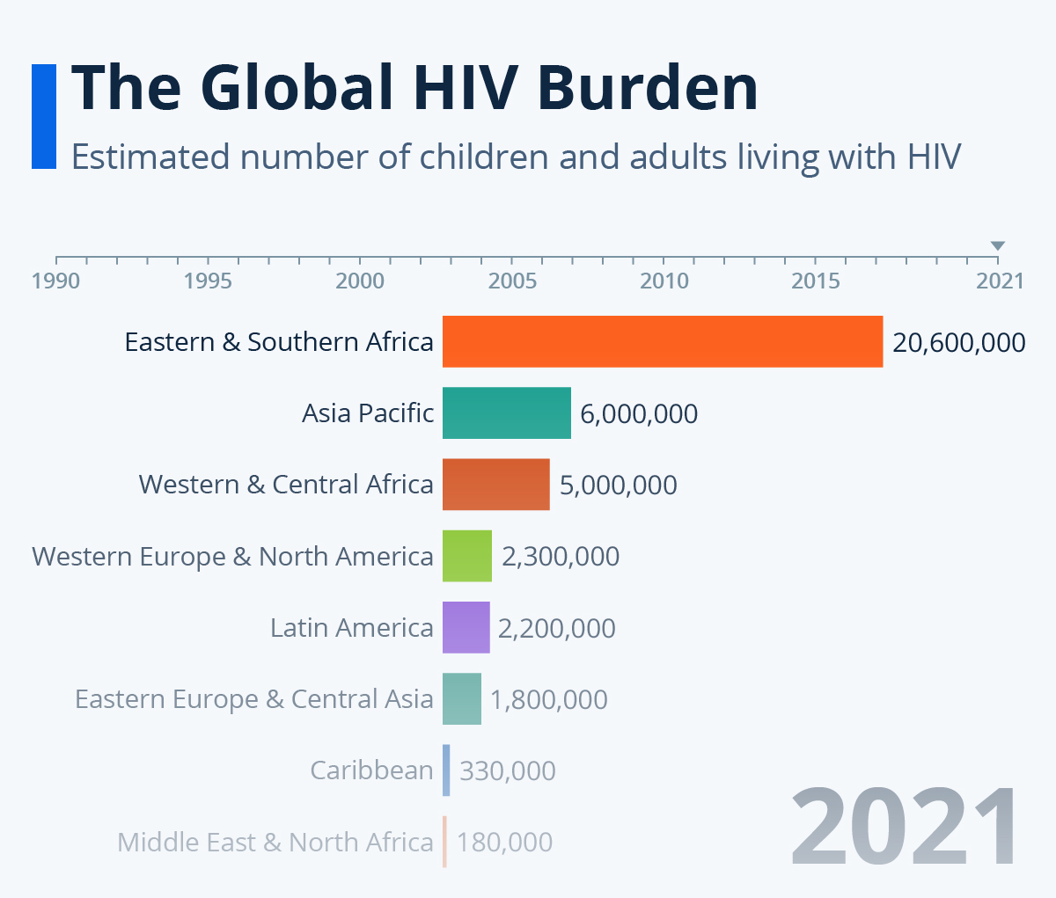
Figure 1: Number of people living with HIV across the world
(Source: Statista, 2025)
Based on the above diagram, Eastern and Southern Africa faced a high level of HIV burden.
The factors that increase transmission are stigma, misinformation and poor access to testing, especially among young adults, men who have sex with men (MSM), and migrants (Shacham et al., 2023).
HIV Connect: A Digital Health Promotion Solution.
To overcome these difficulties, developing a mobile health app, named HIV Connect, will empower users with information, access, and community services to prevent the spread of HIV and encourage people to start a test (World Health Organization, 2021).
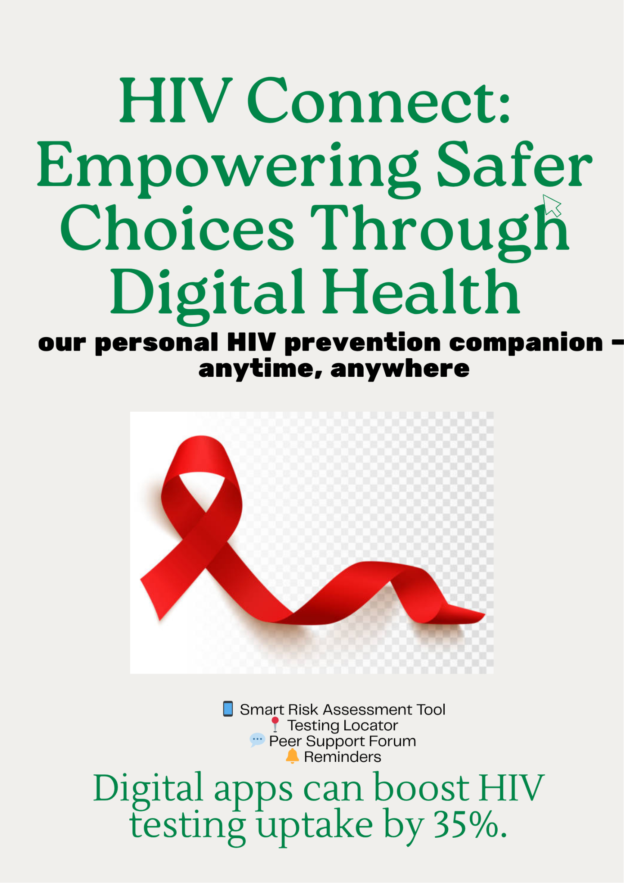
Figure 2: Newly designed digital technology for HIV
(Source: Self-developed)
Core features of HIV Connect:
- Smart Risk Assessment Tool by developing a scoring system that is confidential and an artificially intelligent (AI) questionnaire, (Periáñez et al., 2024).
- Virtual Peer Support Forum: A chatroom where users can anonymously talk with peers or HIV educators (World Health Organization, 2021).
- Reminder System: Alerts concerning the regular HIV checkups, condom use, or taking PrEP medication (Perianez et al., 2024).
Comparison
Applications such as HealthMpowerment and MyChoices have numerous features of education and test-remind actually. Similar to HIV reminders, this organisation will facilitate the incorporation of AI-enhanced risk assessment and real-time testing locator, the adoption of the improved personalisation, engagement, and accessibility, and provide more individualised, user-oriented method of HIV prevention and digital health promotion (Perianez et al., 2024).
Promotion of Health via Digital Interviews
- HIV Connect aims to improve the information-action gap. This will encourage safer decisions and access to testing and prevention interventions, such as Pre-Exposure Prophylaxis (PrEP) through provision of instant and personalised information (Statista, 2025).
- HIV Connect is based on these accomplishments and supplements them with AI-based personalisation, as well as real-time location features that are more accessible and relevant to users.
Potential Impact and Shortfalls

Figure 3: Potential impact of newly designed app
(Source: Self-developed)
Advantages:
- Accessibility Free, multilingual, and available on mobile platforms.
- Confidentiality: Minimises stigma through the provision of discreet access to HIV information and HIV testing (World Health Organization, 2021).
- Personalisation: AI-based advice presents advice to risk and user behaviour (Shacham et al., 2023).
Limitations:
- Digital Divide: Low-income or rural populations may be left without access to important groups due to limited smartphone access (Shacham et al., 2023).
- Confidentiality: The privacy of sensitive sexual health information is a sensitive ethical issue.
- Lasting Use: Users can lose interest without constant updates and encouragement.
Addressing the Gaps
- Share collaborations with local health departments to ensure privacy and trustworthiness.
- Provide offline services and SMS SMS-based versions to users who lack consistent access to the internet (World Health Organization, 2021).
HIV Connect reinvents HIV prevention via digital empowerment - connecting people to the information, resources and community they require to become in control of their health (Shacham et al., 2023).

Conclusion
The application of HIV Connect can prove to be a milestone in the process of mitigation HIIV threats. The features and the empowering provisions of the process can also be improved with the integration of adequate technology and public awareness.

Reference List
Periáñez, Á., Fernández Del Río, A., Nazarov, I., Jané, E., Hassan, M., Rastogi, A. and Tang, D., (2024). The digital transformation in health: How AI can improve the performance of health systems. Health Systems & Reform, 10(2), p.2387138.https://www.tandfonline.com/doi/pdf/10.1080/23288604.2024.2387138
Shacham, E., Scroggins, S.E. and Ellis, M., (2023). Implementing geospatial science and technology to get to zero new HIV infections. Current HIV/AIDS Reports, 20(3), pp.139-147.https://www.academia.edu/download/103085443/s11904-023-00658-w.pdf
Statista. (2025) Number of people living with HIV. Statista. Available at: https://www.statista.com/chart/28854/number-of-people-living-with-hiv/?srsltid=AfmBOopbTq8cEw0DDHq-Cm3LBxWxA8gsM6X4wdDf9FJeKizy_z1Au (Accessed: 30 October 2025).
World Health Organization, (2021). Consolidated guidelines on HIV prevention, testing, treatment, service delivery and monitoring: recommendations for a public health approach. World Health Organization. https://books.google.co.in/books?hl=en&lr=&id=vItUEAAAQBAJ&oi=fnd&pg=PR8&dq=HIV+Connect,+will+empower+users+with+information,+access,+and+community+services+to+prevent+the+spread+of+HIV+and+encourage+people+to+start+a+test&ots=QbU9ZWwUPf&sig=b9Z0yl2q225QLihU6WqFXrf3-ME&redir_esc=y#v=onepage&q&f=false

