Thermodynamic analysis of the modern positive displacement supercharger and associated charge-air-cooling systems for automotive applications using computer-aided methods
Major Project – Dissertation Final Report (M6X00417)

University of Wales Trinity Saint David, School of Engineering
BEng Motorcycle Engineering (4 Year Course)
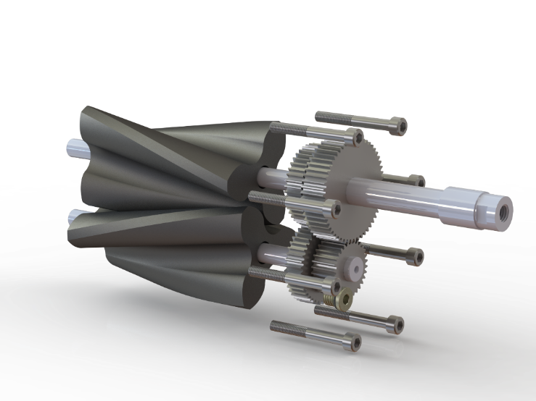
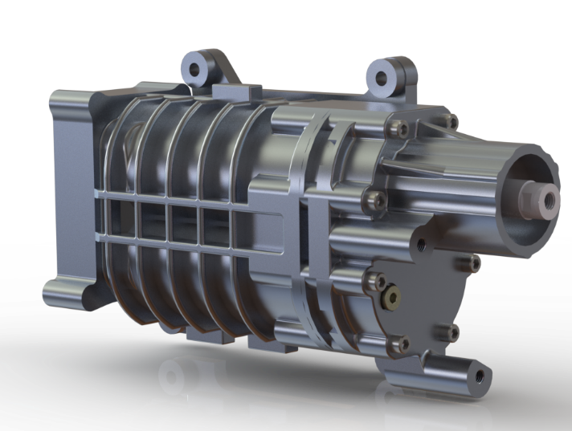
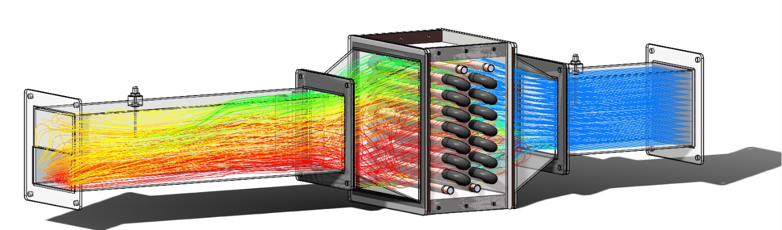




Abstract
This paper provides a brief investigation into forced induction techniques and is made up of two distinct parts:
Firstly, the analysis of traditional, Roots-style, positive displacement supercharging in comparison to the currently popular turbo-supercharging method of forced induction. Secondly, the development of a methodology to carry out thermodynamic analysis on heat exchanger systems associated with automotive forced induction is presented.
This comparison/analysis was carried out on a family of positive displacement superchargers (Eaton 5th generation “M-series”), and a selection of turbo-superchargers (Mitsubishi Heavy Industries, TD series) of comparable performance. The work comprised of analysis/calculation related to the “isentropic compressor efficiency”, air flow performance and thermodynamic characteristics of each method of supercharging using Excel and MATLAB.
The analysis of the heat exchanger was carried out through the use of computational fluid dynamics in Solidworks 2019 Flow Simulation Add-In and corroboration with a real-world heat exchanger experiment produced by TecQuipment to develop a method allowing the specification and selection of intercooler dimensions based off a real world intercooler system taken from a TX4 taxi-cab platform.
To conduct this investigation the basic principles surrounding compressive work and heat exchange are explored through content-specific literature and in the case of the heat exchanger work guidelines and experimental methodology was utilised from TecQuipments literature surrounding the “TX1007 Heat Exchanger Experiment”.
The investigation carried out in this paper highlights key thermodynamic trends seen during supercharger operation showing relationship such as the greater more aggressive curve of compressor efficiency seen in a turbo- supercharger in relation to a positive displacement system. The drastic effect that humidity has on heat transfer mechanisms and the visualisation of the effect of flow separation in heat exchanger designs. Overall, this provides a snapshot of the thermodynamic processes involved in forced induction processes for automotive applications.

Acknowledgements
I would like to express my deepest gratitude to my ever-encouraging research supervisors Mr Malcolm McDonald and Dr Owen Williams for patiently guiding me along the journey that has been this body of work. I would also like to thank Mr Mark Fall for his assistance in setting up and running the heat-exchanger experiment and for many discussions on the subjects surrounding forced-induction systems. I also wish to extend my sincerest thanks to my oldest of friends Mr Jack Devlin and my father Dr Jon McCalmont for helping me ensure that the literary aspects of this work were not awry prior to submission.
I would also like to offer thanks to my family, colleagues, and friends for always being supportive and encouraging during my work. And finally, Antonio for always aiming to keep me professional and intellectual, Paul for the mightiest of craic under pressure and William, for being there since day one.
  - Declaration of Authenticity

This thesis is the result of the author’s original research. It has been composed by the author and has not been previously submitted for examination which has led to the award of a degree.

Signed: Date: 3rd of May 2020
Table of Contents
Abstract I
Acknowledgements I
1 Introduction 2
2 Literature Review 3
2.1 Supercharging History and Basics of the “Roots Blower” 3
2.1.1 Overview 3
2.1.2 Operation 4
2.1.3 Thermodynamics 5
2.2 Intercooler Basics 6
2.2.1 Basic Principles 6
2.2.2 Effect on Density 7
3 Methodology 8
3.1 Overall Methodology for Supercharger (Roots vs Turbo) Analysis 8
3.2 Overall Methodology for Intercooler Analysis 8
4 Timing Plan 9
5 Work Carried Out 10
5.1 Supercharging Analysis & Comparison 10
5.1.1 Eaton M-Series Comparative Performance Analysis 10
5.2 Results: Comparative performance of Roots-style supercharging with like flow rate turbo-supercharging in the pressure ratio range Π1.2-2 18
5.3 Replicating a real-world heat exchanger experiment in Solidworks Flow Simulation CFD solver 22
5.3.1 Overview of Heat Exchanger/Experimentation/Correlation work 22
5.3.2 Results: Real-world Experimental Work 24
5.3.3 Methodology: Creating the CFD model in Solidworks 2019 Flow Simulation 30
5.3.4 Results: Analysis of results from CFD model 32
5.3.5 Analysis and comparison/correlation to real-world data 40
6 Further Work and Pandemic Impact 43
7 Conclusion 44
8 References 45
9 Appendices 47
9.1 Appendix 1.1: Roots Outlet Port Geometry Comparison 47
9.2 Appendix 1.2: Example of spreadsheet relating to thermodynamic interactions of compressive work. 48
9.3 Appendix 1.3: “Experiment 2” methodology used for the “real-world” portion of the intercooler work shown in section 4.3 49
9.4 Appendix 1.4: Full input settings used for generation of CFD model generated directly by Solidworks 2019 Flow Simulation software 51
9.5 Appendix 1.5: Raw Performance Maps for Eaton M-series superchargers 63
9.6 Appendix 1.6: Raw Performance Maps for MHI TD Series turbo-superchargers 65
9.7 Appendix 1.7: M-series comparison at differing pressure ratios 66
9.8 Appendix 1.8: The London Taxi Company TX4 Intercooler Spec Sheet 71

Table of Figures
Figure 1: Descriptive diagram of the operation of "Roots" style positive-displacement pumps/superchargers (Heisler, 1995) 4
Figure 2: Pressure-Volume diagram of Roots supercharger operation (top) (Uthoff & Yakimow, 1987) compared to an “Ideal” heat cycle Pressure-Volume diagram (bottom) (HyperPhysics, 2000) 5
Figure 3: Example of supercharger performance map provided by Eaton (M45 model) and shown with overlaid grid for data extraction (Eaton, 2020) 10
Figure 4: Graph of η_{s-I,C} against V̇ through a range of Π 1.2-2 for Eaton M45 model of supercharger produced using Excel (Microsoft, 2019), curves graded light to dark, light representing lower Π value dark representing higher Π value. 12
Figure 5: Graph of η_{s-I,C} against V̇ through a range of Π 1.2-2 for Eaton M62 model of supercharger produced using Excel (Microsoft, 2019), curves graded light to dark, light representing lower Π value dark representing higher Π value. 13
Figure 6: Graph of η_{s-I,C} against V̇ through a range of Π 1.2-2 for Eaton M90 model of supercharger produced using Excel (Microsoft, 2019), curves graded light to dark, light representing lower Π value dark representing higher Π value. 13
Figure 7: Graph of η_{s-I,C} against V̇ through a range of Π 1.2-2 for Eaton M112 model of supercharger produced using Excel (Microsoft, 2019), curves graded light to dark, light representing lower Π value dark representing higher Π value. 14
Figure 8: 3D Surface map of η_{s-I,C} against V̇ through a range of Π 1.2-2 for Eaton M45 model of supercharger produced using Matlab 9.6 (MathWorks, 2019), darker colouring representing lower compressor efficiency, lighter colouring representing higher efficiency 15
Figure 9: 3D Surface map of η_{s-I,C} against V̇ through a range of Π 1.2-2 for Eaton M62 model of supercharger produced using Matlab 9.6 (MathWorks, 2019), darker colouring representing lower compressor efficiency, lighter colouring representing higher efficiency 15
Figure 10: 3D Surface map of η_{s-I,C} against V̇ through a range of Π 1.2-2 for Eaton M90 model of supercharger produced using Matlab 9.6 (MathWorks, 2019), darker colouring representing lower compressor efficiency, lighter colouring representing higher efficiency 16
Figure 11: 3D Surface map of η_{s-I,C} against V̇ through a range of Π 1.2-2 for Eaton M112 model of supercharger produced using Matlab 9.6 (MathWorks, 2019), darker colouring representing lower compressor efficiency, lighter colouring representing higher efficiency 16
Figure 12: Extrapolated 3D Surface maps of η_{s-I,C} against V̇ through a range of Π 1.2-2 for Eaton M24 model of supercharger using a 2nd order polynomial extrapolation, produced using Matlab 9.6 (MathWorks, 2019), darker colouring representing lower compressor efficiency, lighter colouring representing higher efficiency. 17
Figure 13: Extrapolated 3D Surface map of η_{s-I,C} against V̇ through a range of Π 1.2-2 for Eaton M24 model of supercharger using a 3rd order polynomial extrapolation, produced using Matlab 9.6 (MathWorks, 2019), darker colouring representing lower compressor efficiency, lighter colouring representing higher efficiency 17
Figure 14: Extrapolated 3D Surface map of η_{s-I,C} against V̇ through a range of Π 1.2-2 for Eaton M24 model of supercharger using a linear extrapolation, produced using Matlab 9.6 (MathWorks, 2019), darker colouring representing lower compressor efficiency, lighter colouring representing higher efficiency 18
Figure 15: Comparison of raw supercharger performance maps for Roots-style (Right) (Eaton, 2020) and Turbo-style (Left) (Mitsubishi Heavy Industries, 2005) Superchargers 19
Figure 16: Graph of η_{s-I,C} against V̇ through a range of Π 1.2-2 for MHI TD04-13G model of turbo-supercharger produced using Excel (Microsoft, 2019), curves graded light to dark, light representing lower Π value dark representing higher Π value. 20
Figure 17: Graph of η_{s-I,C} against V̇ through a range of Π 1.2-2 for MHI TD04H-15G model of turbo-supercharger produced using Excel (Microsoft, 2019), curves graded light to dark, light representing lower Π value dark representing higher Π value. 20
Figure 18: Graph of η_{s-I,C} against V̇ through a range of Π 1.2-2 for MHI TD06H-20G model of turbo-supercharger produced using Excel (Microsoft, 2019), curves graded light to dark, light representing lower Π value dark representing higher Π value. 20
Figure 19: Graphs of ρ_{2A} against V̇ through an example value of Π 1.5 for MHI TD models of turbo-supercharger (represented in orange) against Eaton’s M-series Roots-style superchargers (represented in blue) produced using Excel (Microsoft, 2019). 21
Figure 20: TecQuipment TD1007 Water-to-Air Heat Exchanger Experiment (TecQuipment, 2014) 22
Figure 21: TX4 Intercooler Model geometry (The London Taxi Company, 2004) for CFD analysis, drafted using Solidworks 2019 (Dassault Systemes, 2019) 23
Figure 22: TD1007 Heat Exchanger Model geometry for CFD analysis, drafted using Solidworks 2019 (Dassault Systemes, 2019) 23
Figure 23: Example of configuration of sensors and orientation of fluid flows for "Experiment 2" (TecQuipment, 2014), the system features five sensors in total, two water circuit sensors and three air circuit sensors (the T_{A3} sensor being an “ambient” air temperature sensor for reference use). Airflow moves through the heat exchanger section (consisting of a removable section containing a pair of 16 tube banks positioned in series) which sits in an “expansion chamber” seen between T_{A1} and T_{A2}. 24
Figure 24: Graph of Heat Energy Transfer Rates from calculated parameters from conditions recorded during the TD1007 physical heat exchanger experiment (TecQuipment, 2014) 28
Figure 25: Graph of Heat Energy Transfer Rates from experiment guidelines of the TD1007 heat exchanger experiment (TecQuipment, 2014) 28
Figure 26: Graph of Heat Energy Transfer Coefficient from calculated parameters from conditions recorded during the TD1007 physical heat exchanger experiment (TecQuipment, 2014) 29
Figure 27: Graph of Heat Transfer Coefficient from experiment guidelines of the TD1007 heat exchanger experiment (TecQuipment, 2014) 29
Figure 28: Example of different fluid domains seen in the CFD model, shown in blue, the top image displaying the water subdomain seen in the copper tubes and silicone joiners and the bottom image showing the air subdomain in the system (excluding the ambient air subdomain as this is automatically defined during setup).Drafted using Solidworks 2019 (Dassault Systemes, 2019) 30
Figure 29: Cutaway image of experiment geometry showing Air flow in (RED arrows right of image) and pressure opening at outlet (BLUE arrows left of image). Drafted in Solidworks 2019 (Dassault Systemes, 2019) 30
Figure 30: Example of the mesh used for the CFD model (including both Global and Local meshes and automatic refinements to the meshes seen during calculation/solving). Applied using Solidworks Flow Simulation Add-in (Dassault Systemes, 2019) 31
Figure 31: Close-up example of mesh refinement seen around water system pipes during calculation/solving. Applied using Solidworks Flow Simulation Add-in (Dassault Systemes, 2019) 32
Figure 32: Example of flow separation seen at entrance of heat exchanger portion. Turbulence intensity shown on the left, flow velocity on the right. Calculated using Solidworks Flow Simulation Add-in (Dassault Systemes, 2019) 32
Figure 33: Temperature colour plot (scale in image) displaying the effects of eddy/vortex formation due to boundary separation on air temperature using Solidworks Flow Simulation Add-in (Dassault Systemes, 2019) 33
Figure 34: Air Circuit Temperatures seen in CFD model (Solidworks Flow Simulation add-in (Dassault Systemes, 2019)) of TD1007 heat exchanger experiment at ΔP 249Pa (600 seconds run time) 34
Figure 35: Water Circuit Temperatures seen in CFD model (Solidworks Flow Simulation add-in (Dassault Systemes, 2019)) of TD1007 heat exchanger experiment at ΔP 249Pa (600 seconds run time) 34
Figure 36: Air Circuit Temperatures seen in CFD model (Solidworks Flow Simulation add-in (Dassault Systemes, 2019)) of TD1007 heat exchanger experiment at ΔP 198Pa (930 seconds run time) 35
Figure 37: Water Circuit Temperatures seen in CFD model (Solidworks Flow Simulation add-in (Dassault Systemes, 2019)) of TD1007 heat exchanger experiment at ΔP 198Pa (930 seconds run time) 35
Figure 38: Air Circuit Temperatures seen in CFD model (Solidworks Flow Simulation add-in (Dassault Systemes, 2019)) of TD1007 heat exchanger experiment at ΔP 151Pa (1260 seconds run time) 36
Figure 39: Water Circuit Temperatures seen in CFD model (Solidworks Flow Simulation add-in (Dassault Systemes, 2019)) of TD1007 heat exchanger experiment at ΔP 151Pa (1260 seconds run time) 36
Figure 40: Air Circuit Temperatures seen in CFD model (Solidworks Flow Simulation add-in (Dassault Systemes, 2019)) of TD1007 heat exchanger experiment at ΔP 99Pa (1590 seconds run time) 37
Figure 41: Water Circuit Temperatures seen in CFD model (Solidworks Flow Simulation add-in (Dassault Systemes, 2019)) of TD1007 heat exchanger experiment at ΔP 99Pa (1590 seconds run time) 37
Figure 42: Air Circuit Temperatures seen in CFD model (Solidworks Flow Simulation add-in (Dassault Systemes, 2019)) of TD1007 heat exchanger experiment at ΔP 50Pa (1920 seconds run time) 38
Figure 43: Water Circuit Temperatures seen in CFD model (Solidworks Flow Simulation add-in (Dassault Systemes, 2019)) of TD1007 heat exchanger experiment at ΔP 50Pa (1920 seconds run time) 38
Figure 44: Air Circuit Temperatures seen in CFD model (Solidworks Flow Simulation add-in (Dassault Systemes, 2019)) of TD1007 heat exchanger experiment at ΔP 25Pa (2250 seconds run time) 39
Figure 45: Water Circuit Temperatures seen in CFD model (Solidworks Flow Simulation add-in (Dassault Systemes, 2019)) of TD1007 heat exchanger experiment at ΔP 25Pa (2250 seconds run time) 39
Figure 46: Graphs displaying comparison of virtual (bottom) (CFD model) (Dassault Systemes, 2019) and physical (top) (TD1007 real-world experiment) (TecQuipment, 2014) relationship of data for water temperature against heat energy transfer rate. Blue curves representing T_{W1}, Green curves representing T_{W2} and Grey curves representing Q̇_{W}. 40
Figure 47: Mass Flow Rate against change in Water Temperature comparison graph between physical experiment data (TecQuipment, 2014) and CFD model data (Dassault Systemes, 2019) using Excel (Microsoft, 2019) 41
Figure 48: Mass Flow Rate against change in Air Temperature comparison graph between physical experiment data (TecQuipment, 2014) and CFD model data (Dassault Systemes, 2019) using Excel (Microsoft, 2019) 41
Figure 49: Air Temperature against Heat Energy Transfer Rate made using Excel (Microsoft, 2019) of physical experiment data (TecQuipment, 2014) 42
Figure 50: Air Temperature against Heat Energy Transfer Rate graph made using Excel (Microsoft, 2019) of virtual experiment data (Dassault Systemes, 2019) 42
Figure 51: 0% Humidity Air Circuit Temperatures seen in CFD model (Solidworks Flow Simulation add-in (Dassault Systemes, 2019)) of TD1007 heat exchanger experiment at ΔP 25Pa (2250 seconds run time) 43
Figure 52: 50% Humidity Air Circuit Temperatures seen in CFD model (Solidworks Flow Simulation add-in (Dassault Systemes, 2019)) of TD1007 heat exchanger experiment at ΔP 25Pa (2250 seconds run time) 43
Figure 53: Comparison of basic Roots outlet port design over time (Heisler, 1995) 47
Figure 54: Comparison of outlet designs to reduce backflow compression noise (Uthoff & Yakimow, 1987) 47
Figure 55: Example of spreadsheet calculations for compressive work 48
Figure 56: Page 1: Experiment methodology for "Experiment 2" taken from TD1007 Operators manual (TecQuipment, 2014) 50
Figure 57: Page 2: Experiment methodology for "Experiment 2" taken from TD1007 Operators manual (TecQuipment, 2014) 51
Figure 58: M45 Performance Map 64
Figure 59: M62 Performance Map 64
Figure 60: M90 Performance Map 65
Figure 61: M112 Performance Map 65
Figure 62: MHI TD-series Turbo Performance Maps 66
Figure 63: M-Series Performance Comparison at 1.2Π 67
Figure 64: M-Series Performance Comparison at 1.3Π 67
Figure 65: M-Series Performance Comparison at 1.4Π 68
Figure 66: M-Series Performance Comparison at 1.5Π 68
Figure 67: M-Series Performance Comparison at 1.6Π 69
Figure 68: M-Series Performance Comparison at 1.7Π 69
Figure 69: M-Series Performance Comparison at 1.8Π 70
Figure 70: M-Series Performance Comparison at 1.9Π 70
Figure 71: M-Series Performance Comparison at 2.0Π 71
Figure 72: The London Taxi Company TX4 Intercooler Spec Sheet 72

Table of Tables
Table 1: Example values to demonstrate effects of charge air cooling 7
Table 2: Table of M-series supercharger models and their capacities 10
Table 3: Table of input values for further thermodynamic calculations 11
Table 4: Table of Roots and Turbo Superchargers for thermodynamic comparison (each colour denotes a pair of superchargers that were compared due to their comparable air flow performance) 18
Table 5: Table of input conditions used for calculations relating to the results recorded during the TD1007 physical heat exchanger experiment (TecQuipment, 2014) 24
Table 6: Table of flow conditions recorded during the TD1007 physical heat exchanger experiment (TecQuipment, 2014) 26
Table 7: Table of temperature conditions recorded during the TD1007 physical heat exchanger experiment (TecQuipment, 2014) 27
Table 8: Table of calculated parameters from conditions recorded during the TD1007 physical heat exchanger experiment (TecQuipment, 2014) 27
Table 9: Results table of data seen in CFD model (Solidworks Flow Simulation add-in (Dassault Systemes, 2019)) of TD1007 heat exchanger experiment at ΔP 249Pa (600 seconds run time) 34
Table 10: Results table of data seen in CFD model (Solidworks Flow Simulation add-in (Dassault Systemes, 2019)) of TD1007 heat exchanger experiment at ΔP 198Pa (930 seconds run time) 35
Table 11: Results table of data seen in CFD model (Solidworks Flow Simulation add-in (Dassault Systemes, 2019)) of TD1007 heat exchanger experiment at ΔP 151Pa (1260 seconds run time) 36
Table 12: Results table of data seen in CFD model (Solidworks Flow Simulation add-in (Dassault Systemes, 2019)) of TD1007 heat exchanger experiment at ΔP 99Pa (1590 seconds run time) 37
Table 13: Results table of data seen in CFD model (Solidworks Flow Simulation add-in (Dassault Systemes, 2019)) of TD1007 heat exchanger experiment at ΔP 50Pa (1920 seconds run time) 38
Table 14: Results table of data seen in CFD model (Solidworks Flow Simulation add-in (Dassault Systemes, 2019)) of TD1007 heat exchanger experiment at ΔP 25Pa (2250 seconds run time) 39

Table of Equations
Equation 1: Relationship between Density, Mass, and Volume 6
Equation 2: Ideal Gas Law 6
Equation 3: Description of density using the Ideal Gas Law 6
Equation 4: Temperature increase during Compression (Hiereth & Prenninger, 2003) 7
Equation 5: Pressure Ratio 7
Equation 6: "Perfect" Outlet Temperature Equation 11
Equation 7: "Actual" Outlet Temperature Equation 11
Equation 8: "Perfect" Outlet Density Equation 11
Equation 9: "Actual" Outlet Density Equation 11
Equation 10: Isobaric Specific Heat Capacity Equation 25
Equation 11: Specific Heat Capacity Equation for Water using empirical datasets 25
Equation 12: Density of Air 25
Equation 13: Density of Water at a given temperature of water using empirical datasets 25
Equation 14: Heat Energy Transfer Rate Equation for Water 25
Equation 15: Heat Energy Transfer Rate Equation for Air 25
Equation 16: Energy balance coefficient equation 25
Equation 17: Temperature efficiency equation for Water Circuit 25
Equation 18: Temperature efficiency equation for Air Circuit 25
Equation 19: Logarithmic Mean Temperature Difference Equation 25
Equation 20: Heat Transfer Coefficient Equation 25
Equation 21: Mass flow rate for water equation 26
Equation 22: Mass flow rate for air equation 26
Equation 23: Velocity from mass flowrate equation 26

Abbreviations
f Degrees of freedom
Subscripts
1 Initial Condition, Inlet of System
2 Final Condition, Outlet of System

a “Actual”
d Discharge
i Internal
m Molar
p “Perfect”
s Isentropic
t Temperature

av Mean Average

A Air Circuit
C Compressor, Compression
O Orifice
P Pressure
T Temperature
W Water Circuit

EB Energy Balance
LA Lost to Ambient
m Mass
ṁ Mass flow rate
n Number of moles of a given substance, Polytropic process
v Velocity

A Area
C Coefficient
M Molar Mass
P Total Pressure
Q Heat Energy
Q̇ Heat Energy Transfer Rate
R Specific Gas Constant
T Total Temperature
U Energy Balance Coefficient
V Total Volume
V̇ Volumetric Flow Rate

Ru Universal Gas Constant

Ø Diameter

γ Ratio of Specific Heats for an Ideal Gas
η Efficiency
κ Ratio of Specific Heats for a Real Gas
ρ Density

Δ Difference between values
Π Pressure Ratio

CAD Computer Aided Design
CFD Computational Fluid Dynamics
ICE Internal Combustion Engine
LMTD Logarithmic Mean Temperature Difference
TVS Twin Vortices Series

Introduction
The correlation between efficiency/performance and the mass of charge entering the cylinder has been a key consideration since the advent of the internal combustion engine.The simplest way to increase this mass is to force the fluid into the induction tract of the engine using a form of pumping device, hence the term “forced induction”.
This paper aims to provide an overview of the design and performance considerations seen in or required by a modern, positive displacement, “Roots” style pumping system (a design originally known as the “Roots Blower”) when employed as a forced induction, performance enhancement system on an automotive internal combustion engine. The results and methodology are presented across two distinct areas:
Firstly, the analysis of an existing product family and its comparison to commonly utilised, systems of “turbo-supercharging” of comparable performance.
Secondly, the analysis and corroboration of heat exchanger experiments in a classical, virtual, and real-world sense to allow specification of an “Intercooler’ to accompany each supercharging model in the family.
The aim of the first part of this project was to explore the basic concepts of forced induction in internal combustion, particularly the design considerations of a “Roots” supercharger and, how the overall design has developed through the products lifetime. This is presented as a case study on the Eaton M series of superchargers with an analysis of the “factory-provided” performance of each supercharger in the family (with different extrapolation methods for missing data to estimate performance for a model in the same family). The performance of this family of superchargers in comparison to Mitsubishi Heavy Industries TD series turbo-superchargers of comparable air flow performance that are found in common usage in modern road vehicles.
Secondly, this project aims to explore the heat exchanger, its role in the forced induction system in the “Intercooler”, and the corroboration of a real-world experiment, classical calculation and simulation using Solidworks Flow Simulation software. This work will be carried via the real-world TecQuipment TD1007HX Water-to-Air Heat Exchanger Experiment.

Literature Review

Supercharging History and Basics of the “Roots Blower”

Overview
One of the most important relationships utilised to increase specific-output or performance in the Internal-Combustion Engine (ICE) system, is the use of increased inlet charge density to improve combustion performance. The principle of this is simple, if air (or fuel-air mixture) is compressed into the inlet manifold rather than drawn in via the natural “swallowing” action of the intake stroke of the engine, the density of air entering the cylinder will be greater than that of the density entering in a naturally aspirated application. (Heywood, 1988)
With greater density of air comes the opportunity for increased energy density of charge taken into the cylinder during each cycle due to the greater number of oxygen molecules per unit volume to take part in the combustion reaction (provided fuelling, timing and other parameters are modified to accommodate the change). This means the possibility for greater work done/power per cycle by comparison to the un-aided induction scenario (Hiereth & Prenninger, 2003). This is the principle that underlies all forced-induction or “supercharging” in ICE systems and can be explained by the Collision Theory first described by Trautz and Lewis (International Union of Pure and Applied Chemistry , 2014) which states that the number density of reactant components per unit volume of a fluid is directly related to the number of collisions (Collision Density).
Therefore, if the performance output can be increased via this increase in density of charge, the overall system can be made smaller for the same comparative performance as a naturally aspirated system, in essence the performance/energy density of the system has been increased, also colloquially known as “downsizing” (Heisler, 1995) (Patil, et al., 2017).
The idea of supercharging the gasoline engine was officially birthed by Gottlieb Daimler with his under-piston-compression, “Grandfather Clock” engine (Daimler, 2020) and was aggressively developed in automotive and aero engines (for increased performance at altitude) during the 1900s-1940s (Schey, 1932). The “Roots Blower” positive displacement style of pumping studied in this paper was first developed in the 1860s by the “Roots Blower Company” as a forced induction device for iron foundry blast furnaces and in 1900 was adapted and patented for motorcars by Gottlieb Daimler (MINI-BLOWERS.com, 2020).

Operation
Turbo-superchargers use exhaust gases to drive a bladed pumping device to force air through a progressively smaller cross section port, this compresses the intake charge.

Essentially this geometry takes the form of tapered tube wrapped around an exhaust-gas driven helical fan.
With a Roots blower inlet, pumping and exhaust volumes are all “equal” meaning that compressive work does not, technically, occur in the device itself, (unlike in turbo-supercharging, twin-screw supercharging, oscillating superchargers etc. ) rather, the compressive work occurs in the engine inlet manifold on the outlet side of the blower. Essentially, positive displacement blowers work by just forcing more fluid into the same volume rather than a reduction in volume in the device itself.
The operation of a Roots-style positive displacement blower can be seen below in Figure 1, a diagram taken from Heisler’s Advanced Engine Technology (Heisler, 1995):
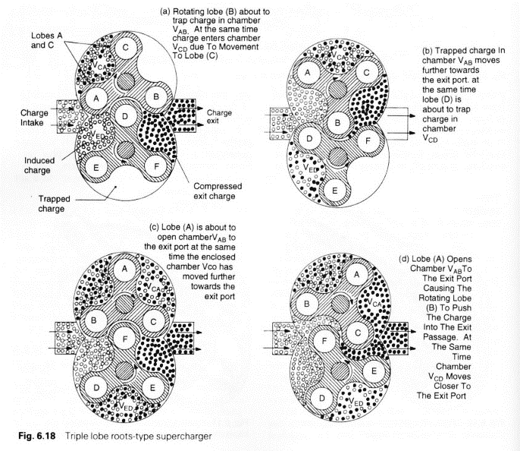
Figure 1: Descriptive diagram of the operation of "Roots" style positive-displacement pumps/superchargers (Heisler, 1995)

Thermodynamics
Thermodynamically the cycling of the Roots blower follows the “Ideal Cycle” whereby two pairs of “Ideal” processes occur. A pair of Isobaric events as the transfer volumes between the lobes progress around the case between inlet and outlet. And a pair of Isochoric events, once during the exposure of the transfer volumes to the high pressure “boosted” engine inlet manifold known as “backflow-compression” (the actual compressive work that is undergone during positive-displacement supercharging) and once during the exposure of the transfer volumes at inlet to take in air to begin the cycle again. (Uthoff & Yakimow, 1987)
Isochoric: A thermodynamic process where no volume change is undertaken.

Isobaric: A thermodynamic process where no pressure change occurs.
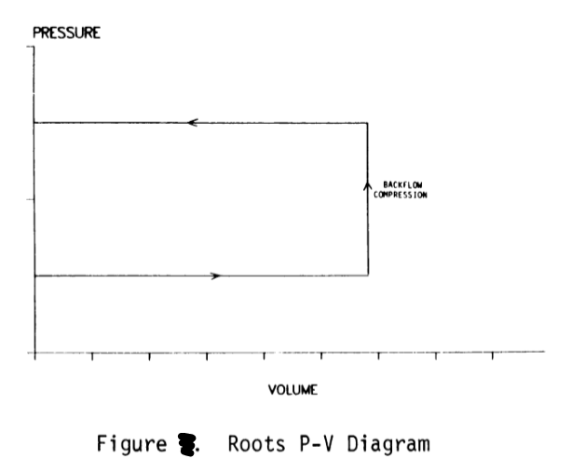
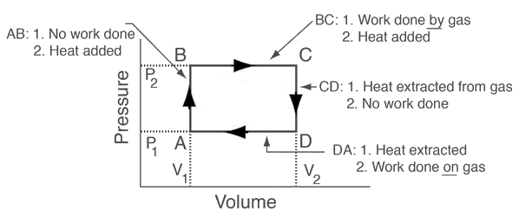
Figure 2: Pressure-Volume diagram of Roots supercharger operation (top) (Uthoff & Yakimow, 1987) compared to an “Ideal” heat cycle Pressure-Volume diagram (bottom) (HyperPhysics, 2000)

Intercooler Basics

Basic Principles
The definition of a Heat Exchanger is given in Kuppan’s “Heat Exchanger Design Handbook” as:
“…a heat transfer device that exchanges heat between two or more process fluids.” (Kuppan, 2000)
In the case of the automotive intercooler this transfer takes place in-series as the pressurised airflow from the forced-induction device travels to the intake manifold of the engine.
Commonly this is in the form of an air-to-air, single pass, crossflow heat exchange element with a plate-fin, extended surface construction of an alloy or metal with a high thermal conductivity such as copper or an aluminium alloy. (Kuppan, 2000)
The overall principle of an intercooler is to increase air density by reducing temperature of the pressurised flow leaving the forced-induction device. The physics of this (for an idealised theoretical system) can be described by the re-arrangement of the Ideal Gas Law and the relationship of density to mass and volume as can be seen below in Equations 1, 2 and 3 (Cengel, 2008):
Equation 1: Relationship between Density, Mass, and Volume
$$ρ=\frac{m}{V}$$
Equation 2: Ideal Gas Law
$$PV=nR_{u}T or PV=mRT$$
Equation 3: Description of density using the Ideal Gas Law
$$ρ=\frac{P}{RT}$$
As can be seen above if the temperature of the air can be reduced then the density will increase (if there is no volume change), therefore there will be a greater density of oxygen molecules present per unit volume of air in a “cooled” system as opposed to an “un-cooled”. (Heisler, 1995)

Effect on Density
The equations shown here (Equations 4 & 5) describe the relationship of the thermodynamic parameters that drive the temperature change seen during compressive work on a “Real” gas:
Equation 4: Temperature increase during Compression (Hiereth & Prenninger, 2003)
$$T_{2}=T_{1}\left\{1+\frac{1}{η_{s-i,C}}\left[Π^{\frac{(κ-1)}{κ}}-1\right]\right\}$$
Equation 5: Pressure Ratio
$$Π= \frac{P_{2}}{P_{1}}$$
The effects of this charge air cooling effect are demonstrated clearly in the example shown below considering an “ideal”, isentropic, system taken from Hiereth & Prenningers book “Charging the Internal Combustion Engine” (Hiereth & Prenninger, 2003):
Table 1: Example values to demonstrate effects of charge air cooling
Pressure Ratio | 2.5
Inlet Pressure | 1 bar
Inlet Temperature | 20 °C
Inlet Density | 1.19 kg•m⁻³
Isentropic Compressor Efficiency | 70%
The input values shown in Table 1 will give an Outlet temperature (T₂) of 418K when applied to Equations 4 and 5.
If the engine is considered as naturally aspirated the relationship of air density reaching the back of the intake valve (discounting any forms of pressure wave supercharging caused by pressure differentials at valve opening/closing) is as given by:
$$ρ_{1}= ρ_{2}=1.19kg•m^{-3} (100\% Intake Density)$$
Now if this is considered using the above compression system with and without charge cooling the density increase is as follows:
$$Without charge cooling: { ρ}_{2}=2.09kg•m^{-3} (175\% Intake Density)$$
$$With charge cooling to 313K: ρ_{2}=2.78kg•m^{-3} \left(234\% Intake Density\right)$$
These results taken from Hiereth & Prenninger (2003) demonstrate how great the effect of charge cooling can be on engine intake conditions. The reduction of temperature (and consequent increase in density) provides a multitude of advantages to the performance of the engine. These include; an increase in power due to the possibility for greater oxygen per unit volume of air, a reduction in NO_{x} production due to decreased (in relation to un-cooled) in-cylinder temperature during combustion and, most importantly for high-performance engines, a reduction in “knock” for a given octane value.

Methodology
The following sections 3.1 and 3.2 give a brief overview of the methodology used, specifics of the methods employed for each task have been included in the work itself seen in section 5.

Overall Methodology for Supercharger (Roots vs Turbo) Analysis
The basic methodology for this first section of work was the interpretation and analysis of each of the performance maps to develop a spreadsheet dataset for the blower family, once determined these data were then utilised to determine further information such as outlet parameters, operating conditions and trends. From this a comparison was drawn (using the same technique) against a set of turbo-superchargers of comparable flow specifications.
Finally, a short comparison of methods to extrapolate for the missing blower in the family (M24) to see the most accurate method to estimate a useable performance map using Excel (for comparison of values) and MATLAB surface plots (to provide 3D visual analysis of trends).
Additionally, as an exercise in computer aided design (CAD), the smallest in the family of superchargers has been drafted from real world components. This was done using empirical measurements and Solidworks 2019 CAD drafting software (Dassault Systemes, 2019).

Overall Methodology for Intercooler Analysis
The process for this section of work was to run a real-world experiment with similar geometry and operation to the intended component (using a crossflow heat exchanger experiment to approximate a crossflow intercooler component). From this experiment, a CAD model is developed to correct dimensions that can be used to produce a computational fluid dynamics (CFD) model using inputs and estimates to corroborate and validate the virtual model against the real-world experiment.
Validation within a reasonable range would demonstrate the suitability of the methodology to produce a comparable CFD model to apply to an intercooler model generated from a real-world component (Intercooler from a TX4 platform developed by The London Taxi Company).
Although this method is assumptive it provided a number of insights into the thermodynamic behaviour of the crossflow heat exchanger system and the methods required to improve the experimental correlation further in future.

Timing Plan
For the purposes of this work a rough week-by-week guide was created to aid timing and planning of the project throughout its timeline to its planned fruition for the original deadline of the 20th of April 2020.
Firstly, the academic calendar was examined, and it was decided that there were 20 available weeks in which to carry out the work and allow a balance with other academic commitments. These weeks were split into two phases, prior to the winter break and university closure and from this point up to the submission date on 20/03/2020. The first phase would focus on the supercharging portion of the work and the second phase would focus on the heat exchanger (intercooler) portion. Each week would consist of one, two or three full days to carry out work related to the project dependant on time constraints for other academic modules and work. A breakdown of the rough timing plan can be seen below:
- Research and analysis of supercharging systems and the phase 1 matter as a whole.
- Further, more detailed, research and analysis of Roots supercharging systems.
- Acquisition of performance maps and Roots supercharger information.
- Conversion of maps from image format to useable data using Excel and Solidworks.
- Data processing and construction of calculation spreadsheets.
- Analysis of data and trend graph creation.
- Extrapolation and collation of M-Series Roots family data and trends.
- Research and analysis of turbo-supercharging systems.
- Conversion and data processing of maps.
- Comparative analysis of performance data and calculations, CAD work.
Winter Closure and Break
- Research and analysis of intercooling systems and the phase 2 matter as a whole.
- Further, more detailed, research and analysis of heat exchanger systems.
- Running of real-world experiment and data gathering.
- Research and creation of CFD model.
- Calculation of CFD model and data comparison to real world experiment.
- Analysis of issues surrounding corroboration of the virtual and real experiments.
- Explore options for improvement of method.
- Re-running CFD or real-world experiment as applicable.
- Corroboration of data, definition of assumptive CFD method for intercooler.
- Application of learned method to carry out CFD experiment on intercooler geometry.
Original Deadline Date – 20th April 2020
*The timing shown here was relaxed slightly from March 20th due to the Pandemic outbreak and the university’s closure. Weeks shown in ITALICS and UNDERLINED were affected by the outbreak and have been documented in section 6.

Work Carried Out

Supercharging Analysis & Comparison

Eaton M-Series Comparative Performance Analysis
This section of this paper will cover the analysis of the 5th generation M series of Roots-style superchargers (Table 2) offered by Eaton for modern Automotive applications.
These superchargers can be considered to be a reasonable representation of modern Roots style supercharging technology, incorporating a pair of 3 lobe rotors, 60° lobe rotation about the axis of each rotor, a casing design that inlets through the rear of the casing and exhausts downward out of the casing into the engine inlet manifold through a ported plate designed to lengthen the backflow compression event to reduce the noise created through outlet pressure fluctuations.
Table 2: Table of M-series supercharger models and their capacities
Model | Capacity
M24 | 24cu in (0.393l)
M45 | 45cu in (0.737l)
M62 | 62cu in (1.016l)
M90 | 90cu in (1.475l)
M112 | 112cu in (1.835l)

For blowers M45 through M112 “performance” maps have been provided by Eaton (Eaton, 2020) detailing Inlet Flow Volume against Pressure Ratio, with Isentropic Compressor Efficiency arranged in “contours” or “islands” as shown in the example below (Figure 2).
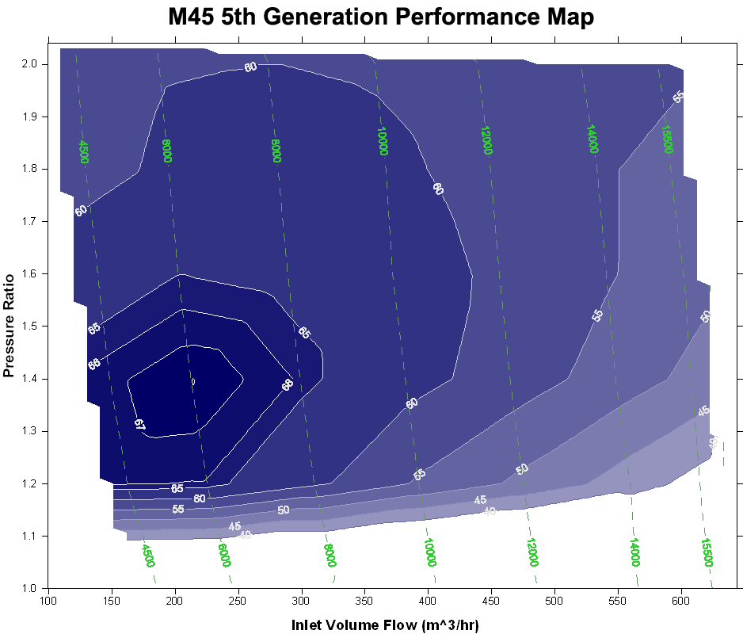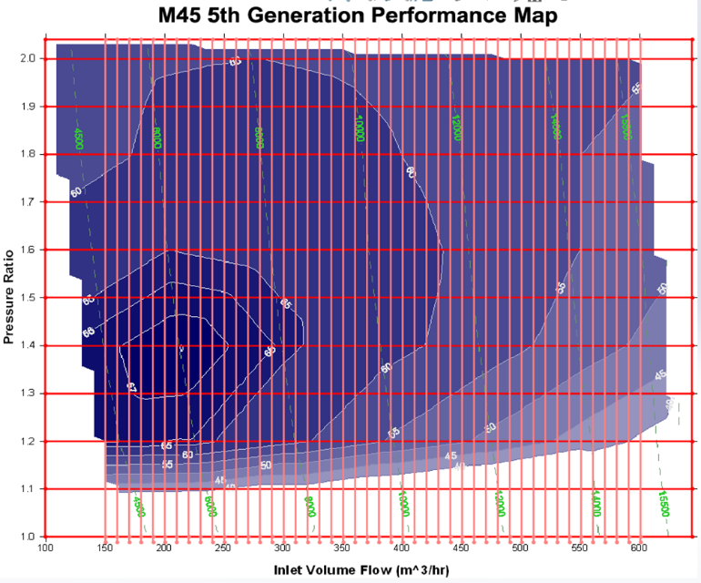
Figure 3: Example of supercharger performance map provided by Eaton (M45 model) and shown with overlaid grid for data extraction (Eaton, 2020)
For each sizing of supercharger with an applicable performance map (M45 through M112) several thermodynamic parameters were calculated using the following input parameters:
Table 3: Table of input values for further thermodynamic calculations
Temperature at Inlet (T₁) | 20 °C
Pressure at Inlet (P₁) | 101325 Pa
Density at Inlet (ρ₁) | 1.20473 kg•m⁻³
Ratio of Specific Heats (γ) | 1.4
Specific Gas Constant for “Dry” air | 287.058 J•kg⁻¹K⁻¹
The parameters in Table 3 have been assumed as reasonable figures as Eaton did not provide a specification for the test conditions seen when generating the performance map. Additionally, as the backflow compression process has been considered as an “Isochoric” process the volume and polytropic index at the moment of compression can be considered to be constant.
The equations used to generate the output parameters seen were as follows (McDonald, 2019):
Equation 6: "Perfect" Outlet Temperature Equation
$$T_{2p}=T_{1}Π^{\frac{γ-1}{γ}}$$
Equation 7: "Actual" Outlet Temperature Equation
$$T_{2a}= T_{1}+\left(\frac{T_{2p}-T_{1}}{η_{s-i,C}}\right)∙100$$
Equation 8: "Perfect" Outlet Density Equation
$$ρ_{2p}=\frac{P_{2}}{RT_{2p}}$$
Equation 9: "Actual" Outlet Density Equation
$$ρ_{2a}=\frac{P_{2}}{RT_{2a}}$$
Using the above parameters and calculations along with some ”common-sense” relationships such as difference between “Perfect” and “Actual”, and change seen across the supercharger. Several tables of values related to Π values 1.2 - 2 through each range of volumetric flow rates for each supercharger were created. As these tables are rather large and cumbersome, they have been omitted for the most part, an example of the format can be seen at Appendix 1.2.

Results: Efficiency-Flow rate Trends
Over the range of pressure ratios and flow rates seen for each supercharger some trends could be highlighted with the use of comparative graphs. The first of these series of graphs shows the trend seen with efficiency plotted against volumetric flow rate for each capacity of supercharger over the range of pressure ratios:
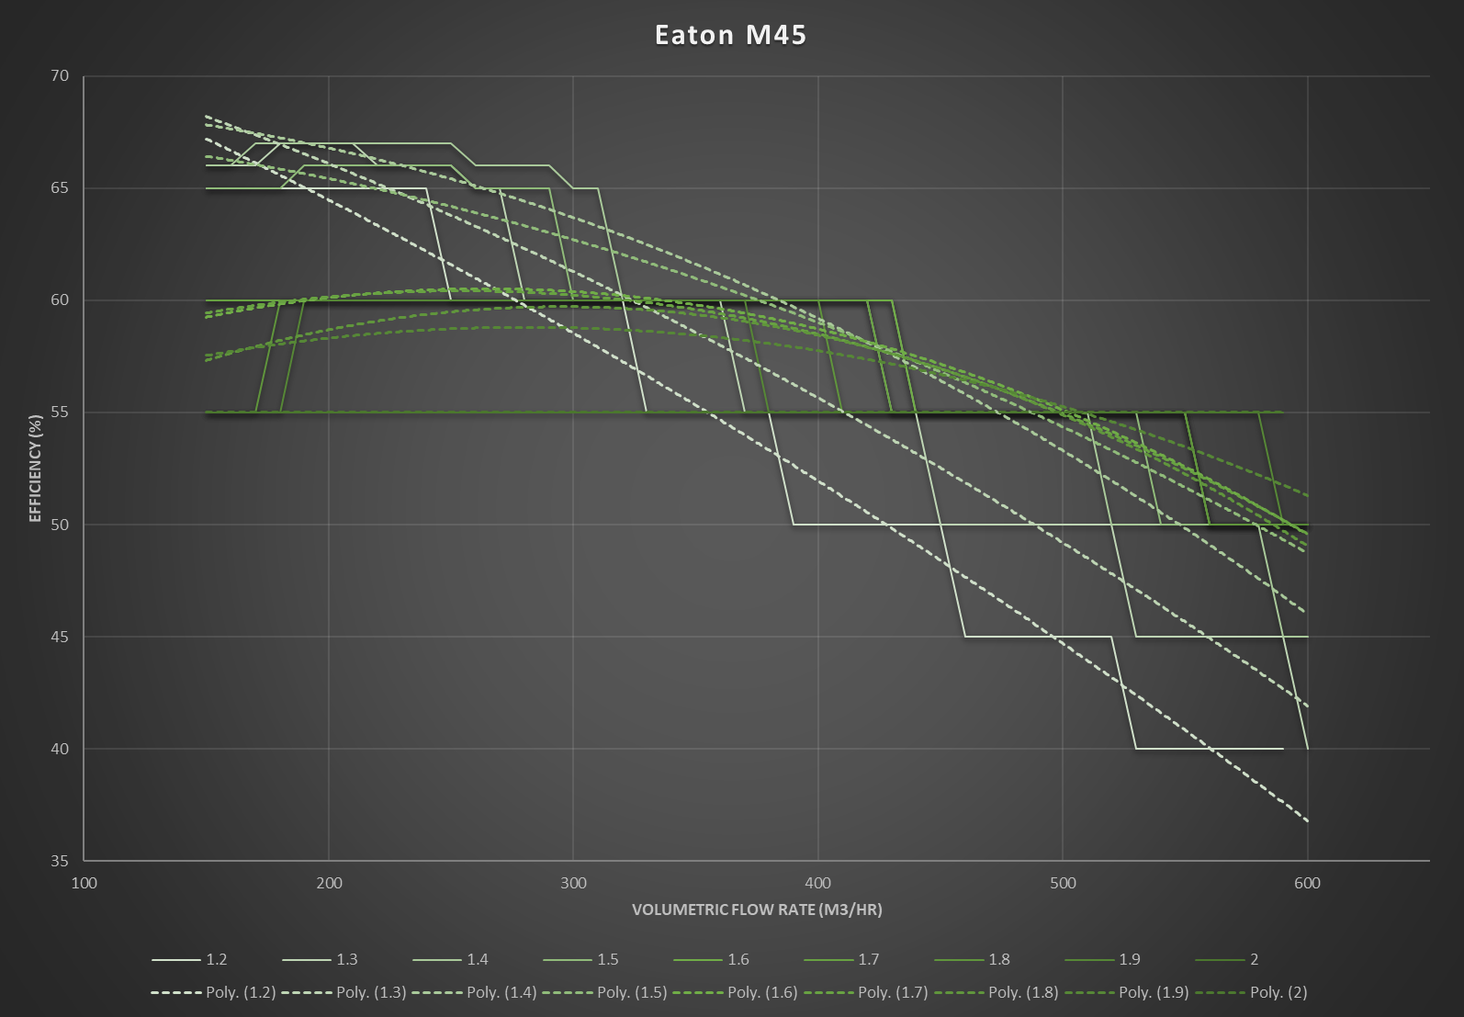
Figure 4: Graph of η_{s-I,C} against V̇ through a range of Π 1.2-2 for Eaton M45 model of supercharger produced using Excel (Microsoft, 2019), curves graded light to dark, light representing lower Π value dark representing higher Π value.
The gradients of these graphs are graded light to dark, the lighter the curve colour the lower the pressure ratio, to give a visual representation of the change in gradient throughout the range. As displayed above each of the curves also has a trendline applied (Polytropic Fit to the 2nd order) to easier display the overall trend of the curve.
The change in gradient as pressure ratio is increased displays a “peak” at around 1.3/1.4 where the supercharger is operating within its greatest “efficiency island” and as the pressure ratio increases further the gradients tend to flatten and reduce showing that if a wide range of flow rates is required a higher pressure ratio will provide a greater predictability of performance while sacrificing overall efficiency. This trend can be seen throughout the different capacities (shown overleaf) with less exaggeration of the trend seen in the larger superchargers.
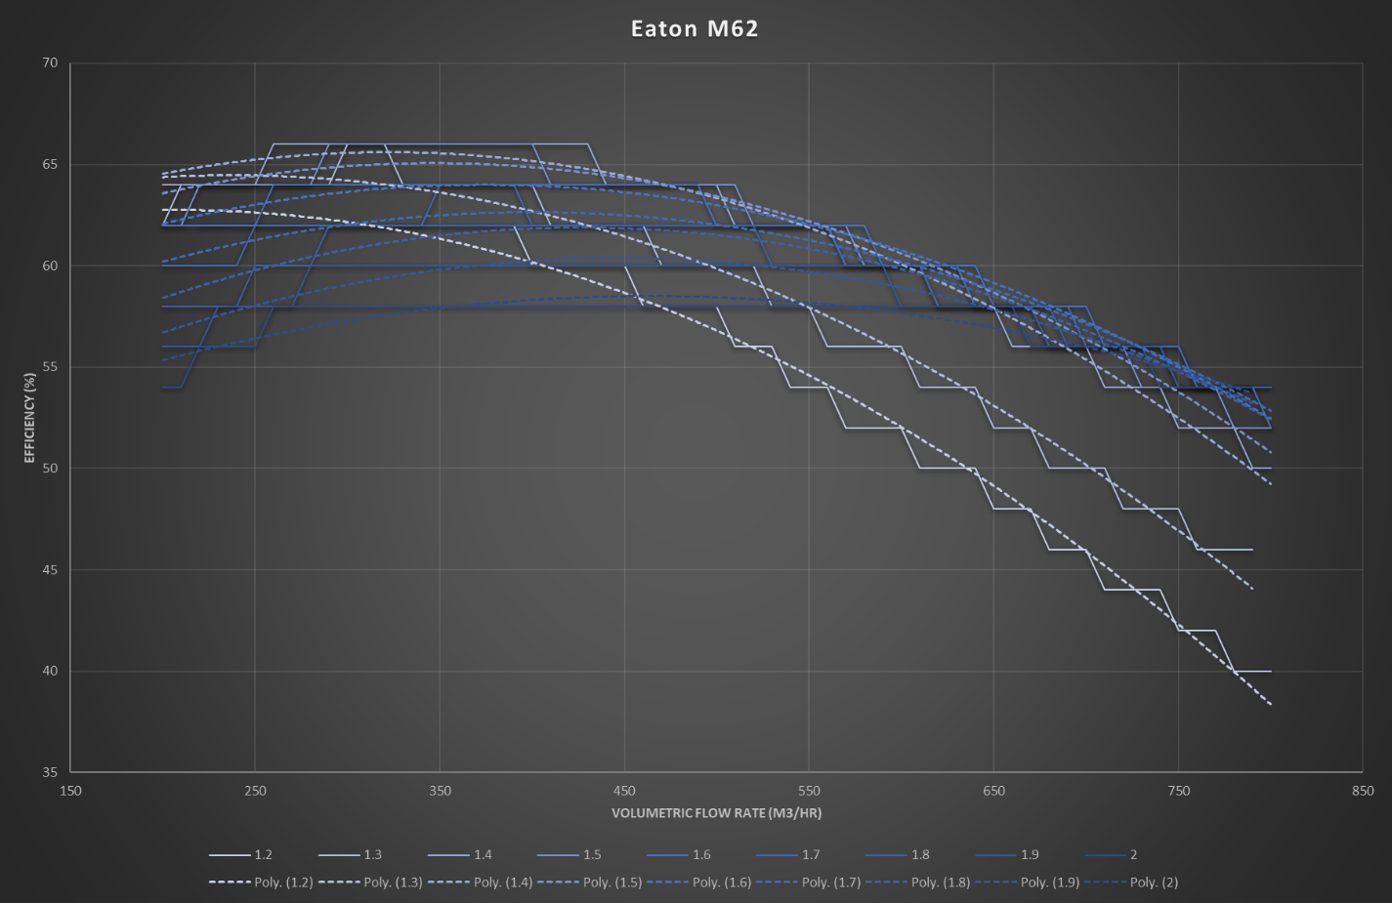
Figure 5: Graph of η_{s-I,C} against V̇ through a range of Π 1.2-2 for Eaton M62 model of supercharger produced using Excel (Microsoft, 2019), curves graded light to dark, light representing lower Π value dark representing higher Π value.
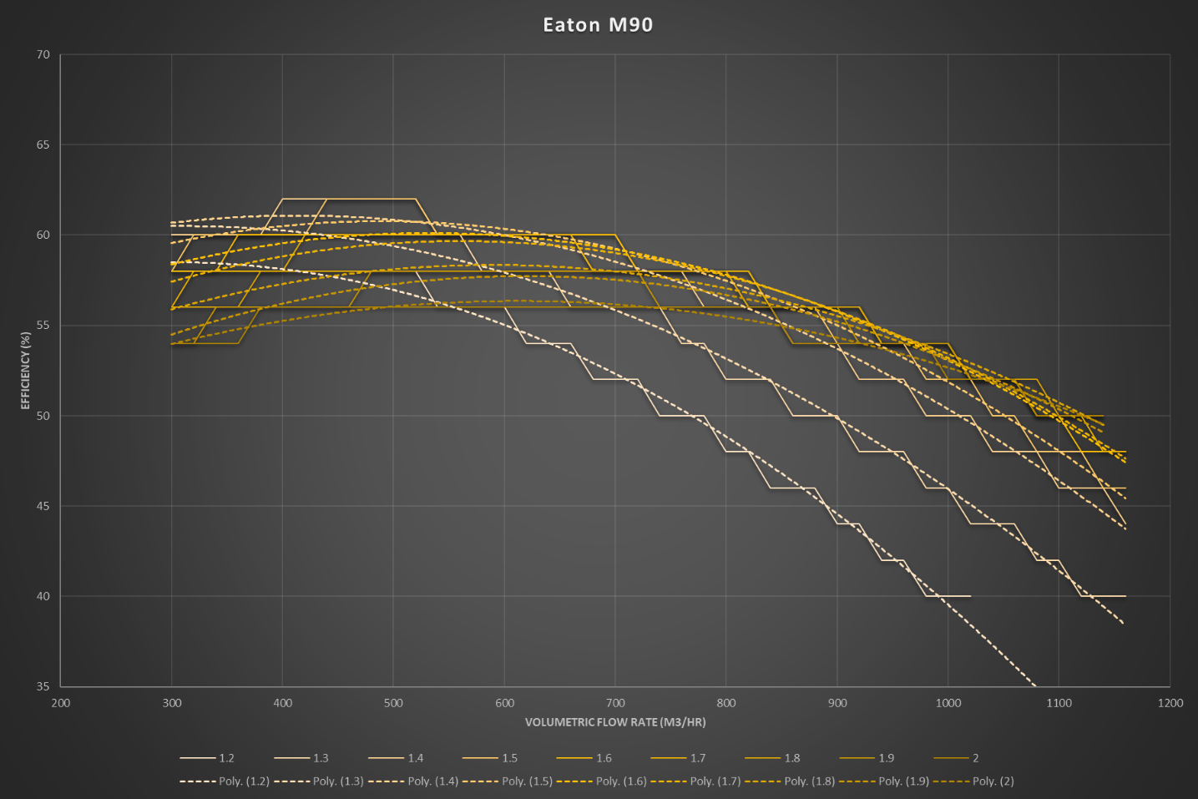
Figure 6: Graph of η_{s-I,C} against V̇ through a range of Π 1.2-2 for Eaton M90 model of supercharger produced using Excel (Microsoft, 2019), curves graded light to dark, light representing lower Π value dark representing higher Π value.
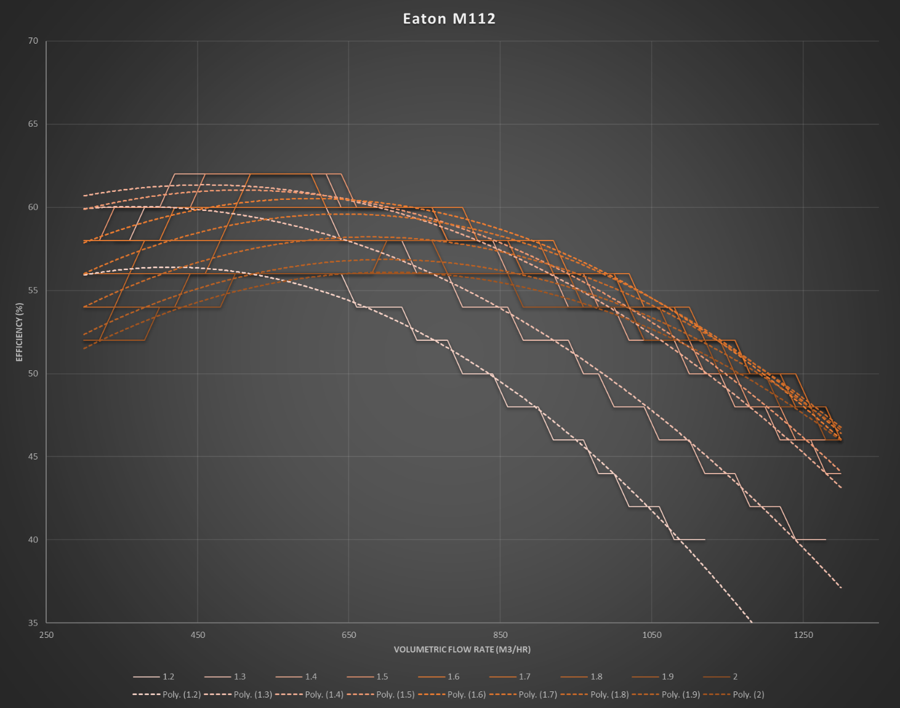
Figure 7: Graph of η_{s-I,C} against V̇ through a range of Π 1.2-2 for Eaton M112 model of supercharger produced using Excel (Microsoft, 2019), curves graded light to dark, light representing lower Π value dark representing higher Π value.
The reasoning for this decrease in gradient of the efficiency curve with increased pressure ratio is related to the thermodynamic relationships displayed in Equations 7 & 8 (Pg. 11), whereby, an increase in pressure (or in this case the relationship of pressures across the compression even) will result in an increase in temperature and therefore reduce the efficiency of the process through the change in balance found in Equation 7.
It is also worth noting that the achievable pressure ratio of a positive displacement supercharger is independent of the rotor speed but entirely dependent on the design of the system, therefore beyond a certain pressure ratio (commonly around Π2) there will be a drastic change in efficiency due to geometric conditions (choking etc) and thermo-fluid dynamics that can lead to a change seen in the actual polytropic process occurring in the system.

Results: Three-dimensional surface maps and extrapolation to a smaller capacity
As can be seen below and overleaf (Figures 8 - 11), when brought into a three dimensional “surface” using Matlab the “efficiency islands” mentioned previously can be clearly noted.
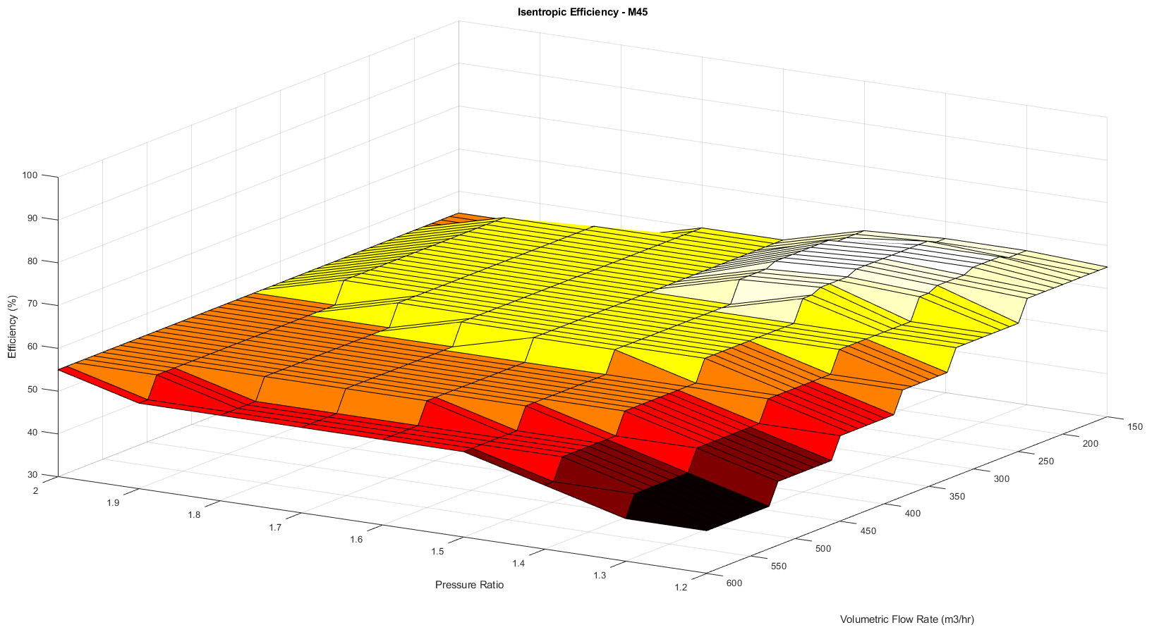
Figure 8: 3D Surface map of η_{s-I,C} against V̇ through a range of Π 1.2-2 for Eaton M45 model of supercharger produced using Matlab 9.6 (MathWorks, 2019), darker colouring representing lower compressor efficiency, lighter colouring representing higher efficiency
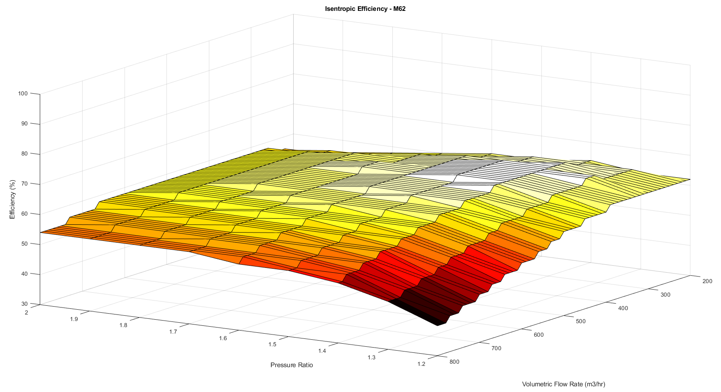
Figure 9: 3D Surface map of η_{s-I,C} against V̇ through a range of Π 1.2-2 for Eaton M62 model of supercharger produced using Matlab 9.6 (MathWorks, 2019), darker colouring representing lower compressor efficiency, lighter colouring representing higher efficiency
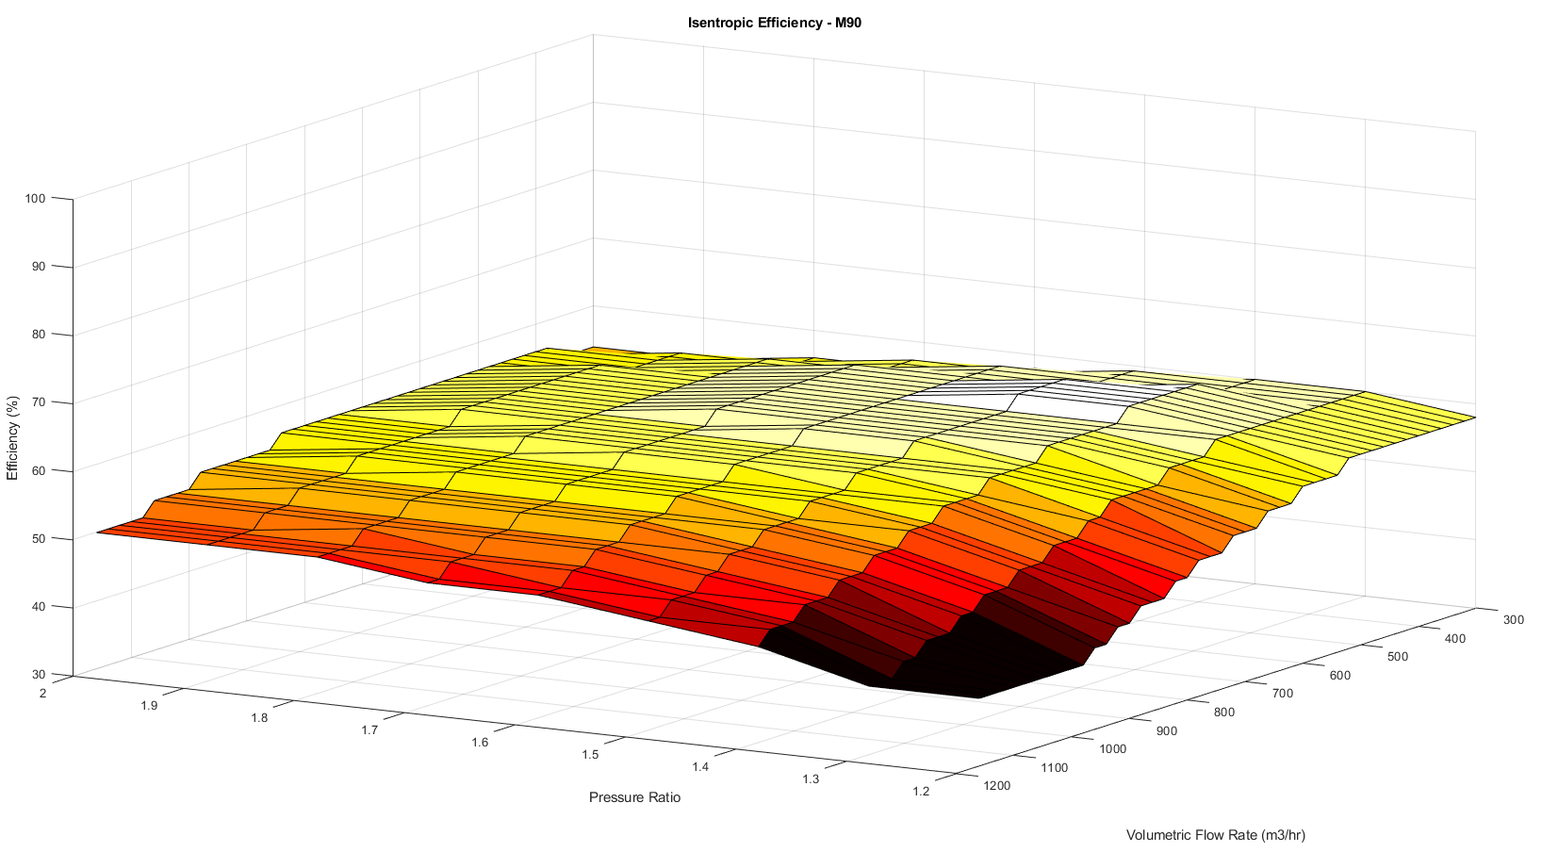
Figure 10: 3D Surface map of η_{s-I,C} against V̇ through a range of Π 1.2-2 for Eaton M90 model of supercharger produced using Matlab 9.6 (MathWorks, 2019), darker colouring representing lower compressor efficiency, lighter colouring representing higher efficiency
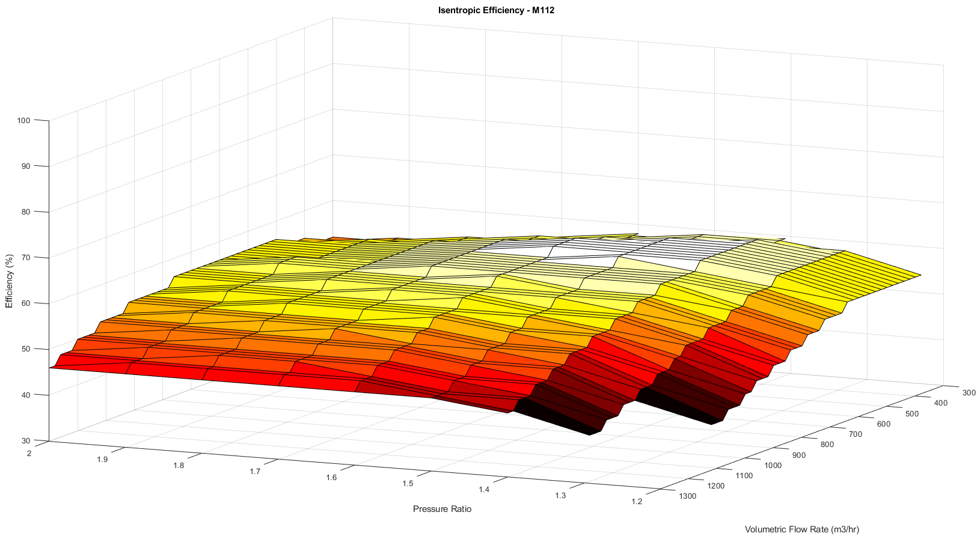
Figure 11: 3D Surface map of η_{s-I,C} against V̇ through a range of Π 1.2-2 for Eaton M112 model of supercharger produced using Matlab 9.6 (MathWorks, 2019), darker colouring representing lower compressor efficiency, lighter colouring representing higher efficiency
As can be seen above (Figures 8 - 11) the maps show some very clear trends throughout, similar positioning of the peak efficiency island and a drastic drop (the darker red area) towards the viewer at low pressure ratio and high flow. These map “characteristics” were used to aid the extrapolation to the M24 capacity performance map shown overleaf.
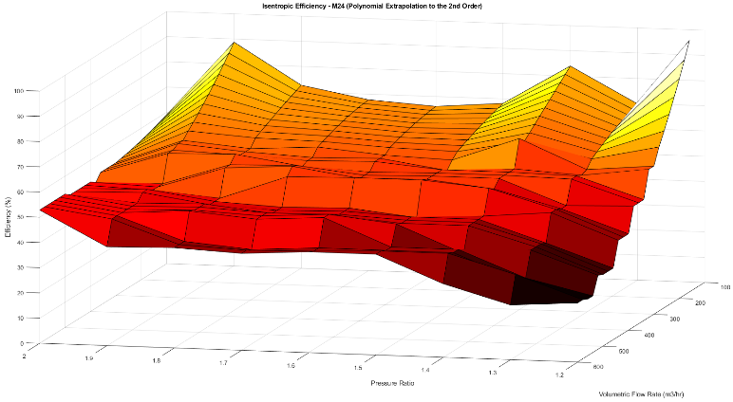
Figure 12: Extrapolated 3D Surface maps of η_{s-I,C} against V̇ through a range of Π 1.2-2 for Eaton M24 model of supercharger using a 2nd order polynomial extrapolation, produced using Matlab 9.6 (MathWorks, 2019), darker colouring representing lower compressor efficiency, lighter colouring representing higher efficiency.
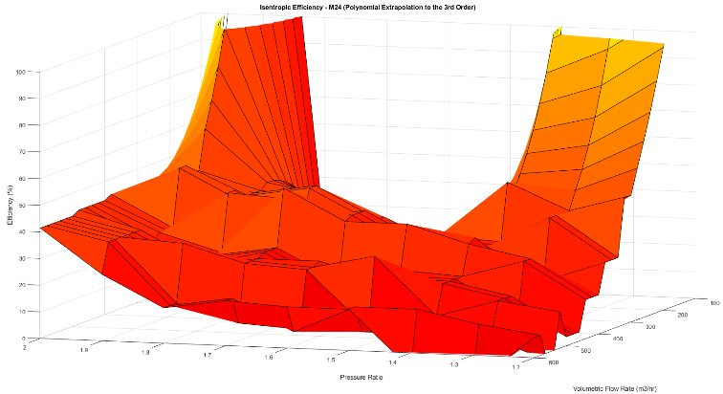
Figure 13: Extrapolated 3D Surface map of η_{s-I,C} against V̇ through a range of Π 1.2-2 for Eaton M24 model of supercharger using a 3rd order polynomial extrapolation, produced using Matlab 9.6 (MathWorks, 2019), darker colouring representing lower compressor efficiency, lighter colouring representing higher efficiency
As can be seen above in Figures 12 and 13 the first attempt to extrapolate to the M24 capacity using the dataset generated from the other capacities proved fruitless. As can be observed the edges of the curves (particularly highlighted in Figure 13 (3rd order polynomial)) display a rather extreme oscillation, this is very similar to something called “Runge’s Phenomenon”. This phenomenon is seen when interpolating using polynomials to a high degree over equi-spaced interpolation points (much like the points spaced about the pressure ratio axis) and shows that errors found through the use of polynomial interpolation are exacerbated at higher orders (partly the reasoning behind applying a 3rd order fit to demonstrate the phenomenon, despite the prior order displaying inaccuracies). (Corless & Sevyeri, 2018). To this end it was decided that the most pertinent method to estimate the smaller capacity would be a simple linear extrapolation, and as can be seen in Figure 14, the trends displayed are much closer to the expected values and distributions seen in Figures 8 - 11.
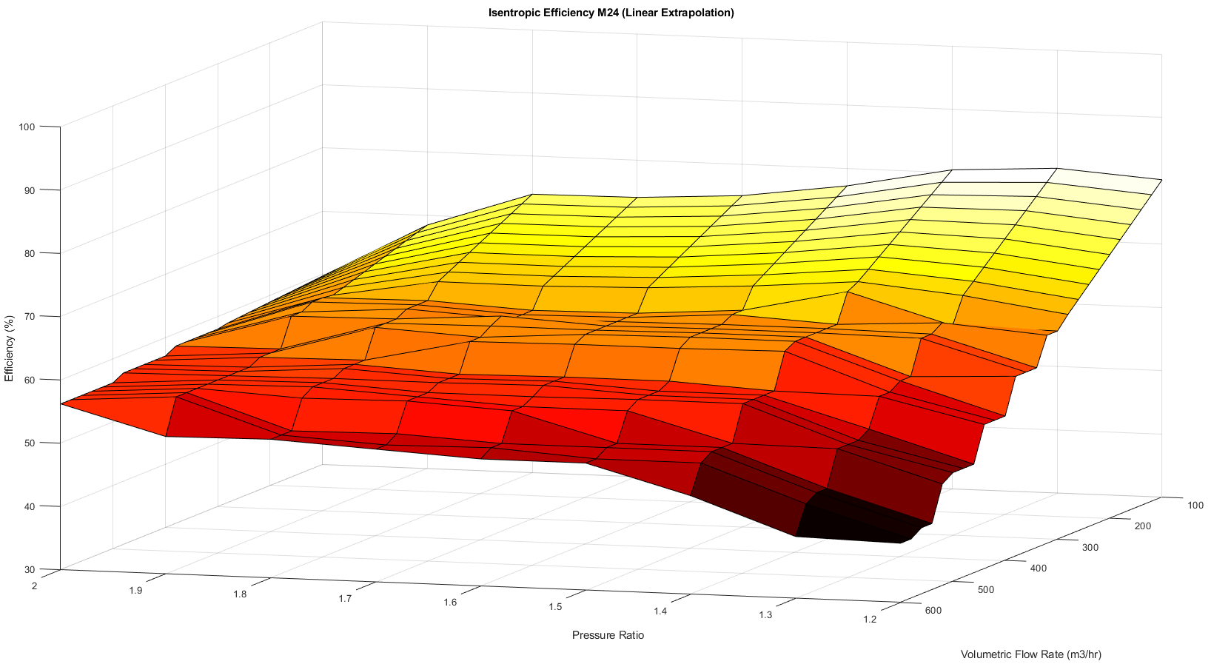
Figure 14: Extrapolated 3D Surface map of η_{s-I,C} against V̇ through a range of Π 1.2-2 for Eaton M24 model of supercharger using a linear extrapolation, produced using Matlab 9.6 (MathWorks, 2019), darker colouring representing lower compressor efficiency, lighter colouring representing higher efficiency

Results: Comparative performance of Roots-style supercharging with like flow rate turbo-supercharging in the pressure ratio range Π1.2-2
This section of work covers the comparison of Roots-style supercharging and exhaust gas driven turbo-supercharging of similar flow performance (the pairing of Roots and turbo-superchargers or comparable flow performance are shown below in Table 4 with differing shades denoting each comparison).
Following the previous work on the performance maps provided by Eaton, (overlay grid, extract data, spreadsheet and calculate further etc seen in section 5.1.1) but here the turbo maps have been cropped to the same range of pressure ratios as the Roots-style data and a turbo specification has been chosen based on comparative range that relates to each model of the Eaton M-series family.
All models of turbo have been selected from the “TD” series of turbos by Mitsubishi Heavy Industries with the original maps being provided by MHI themselves (Mitsubishi Heavy Industries, 2005). Three capacities were chosen to provide a broader view of the differences seen between the methods of forced induction.
Table 4: Table of Roots and Turbo Superchargers for thermodynamic comparison (each colour denotes a pair of superchargers that were compared due to their comparable air flow performance)
Model of Supercharger | Eaton M45 | MHI TD04-13G | Eaton M62 | MHI TD04H-15G | Eaton M90 | MHI TD06H-20G
Flow Rate (m³•hr⁻¹) | 150-600 | 100-600 approx. | 200-800 | 170-73 approx. | 300-1160 | 170-1020 approx.
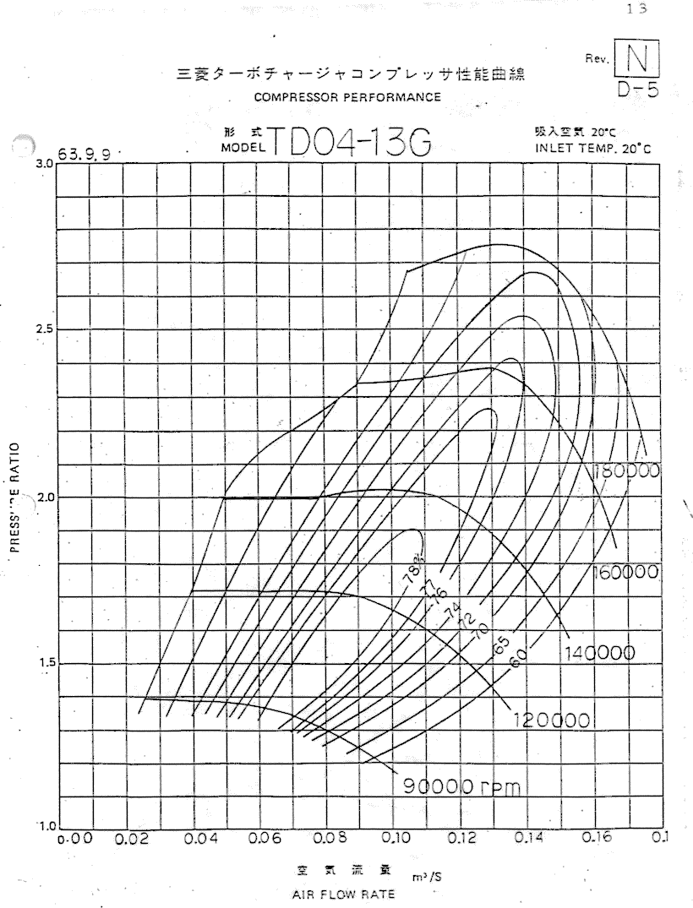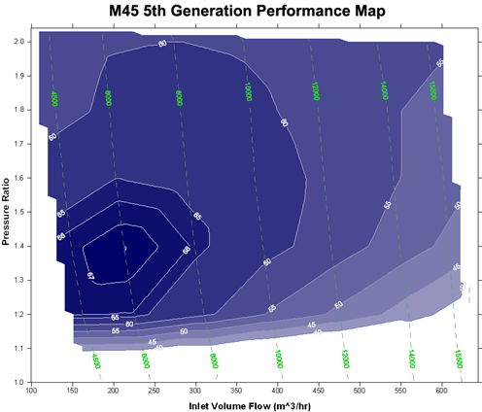
Figure 15: Comparison of raw supercharger performance maps for Roots-style (Right) (Eaton, 2020) and Turbo-style (Left) (Mitsubishi Heavy Industries, 2005) Superchargers
As can be seen overleaf (Figures 16, 17 and 18) the turbo-supercharging solution works in a higher range of efficiencies than the Roots alternative with efficiencies reaching upwards of 75% in the centre of the pressure ratio range (1.5Π-1.75Π). Despite the higher overall value of the range of efficiency, the turbos display a more aggressive efficiency curve than the Roots-style system meaning that to operate at optimum efficiency (within their greatest “efficiency island”) meaning the turbos must be within a narrower band of volumetric flow rates than the Roots alternative. This is, in part, due to the mechanical efficiency advantage the exhaust-gas driven Turbo has over the Roots’ gear driven system.
This characteristic of operation could be a contributing factor to the usability of each supercharger with regards to application, for example, the turbo solution will provide more potential performance gain at the cost of smooth operation when compared to a supercharger in an automotive application. This could make the powerplant feel “peaky” or “aggressive” in power delivery in high performance applications when compared to the overall smoother performance characteristics seen in the Roots unit.
This trend is further displayed here in Figure 19 where at a pressure ratio of 1.5Π (Used as an example as it most clearly displays this difference in characteristics), the aggressive profile of “density loss” due to temperature increase of the turbo-supercharger can be seen in orange alongside the less aggressive but overall greater density losses associated with the Roots system, seen in blue. The trends displayed in Figure 19 have been calculated through difference seen between the “Actual” outlet density of the device and the “Perfect” outlet density expected due to the Ideal Gas Law relationships.
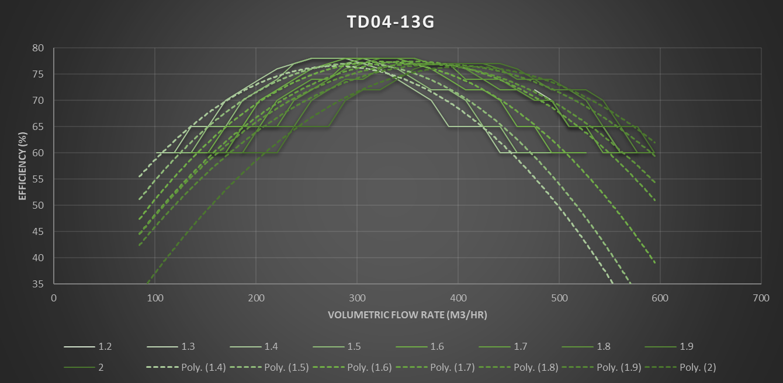
Figure 16: Graph of η_{s-I,C} against V̇ through a range of Π 1.2-2 for MHI TD04-13G model of turbo-supercharger produced using Excel (Microsoft, 2019), curves graded light to dark, light representing lower Π value dark representing higher Π value.
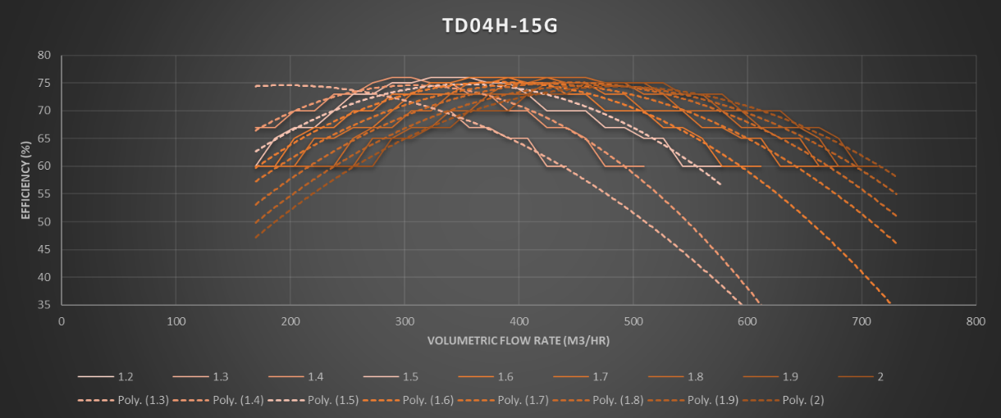
Figure 17: Graph of η_{s-I,C} against V̇ through a range of Π 1.2-2 for MHI TD04H-15G model of turbo-supercharger produced using Excel (Microsoft, 2019), curves graded light to dark, light representing lower Π value dark representing higher Π value.
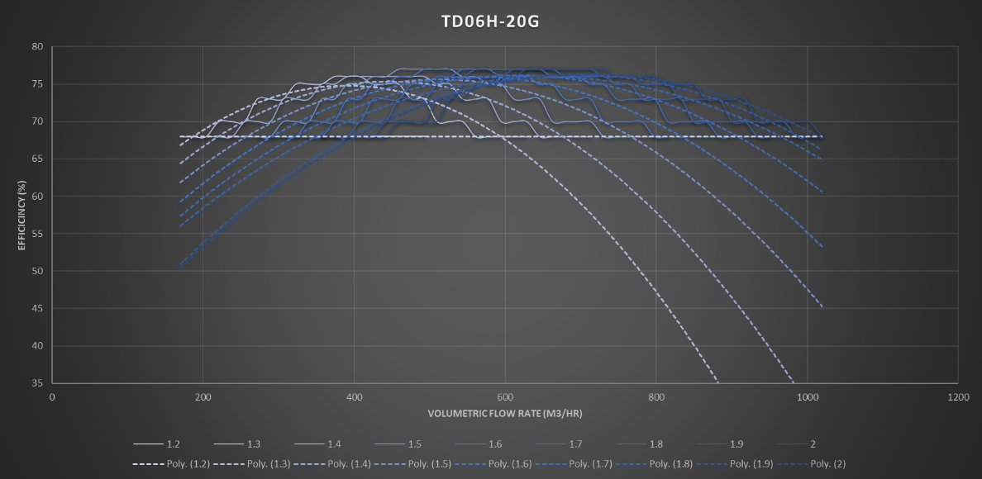
Figure 18: Graph of η_{s-I,C} against V̇ through a range of Π 1.2-2 for MHI TD06H-20G model of turbo-supercharger produced using Excel (Microsoft, 2019), curves graded light to dark, light representing lower Π value dark representing higher Π value.
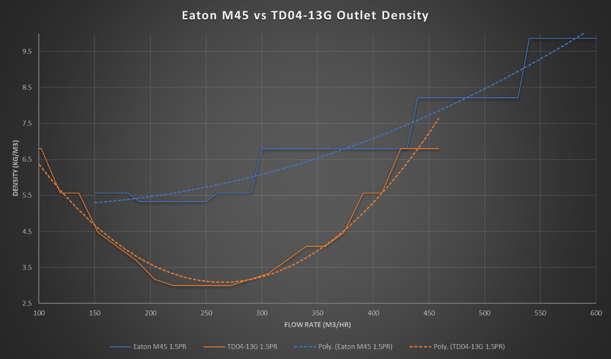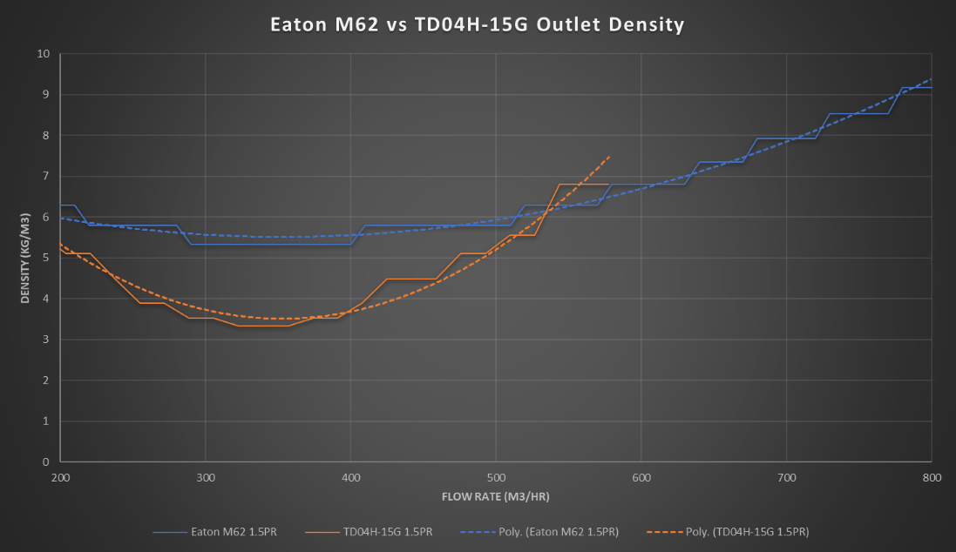
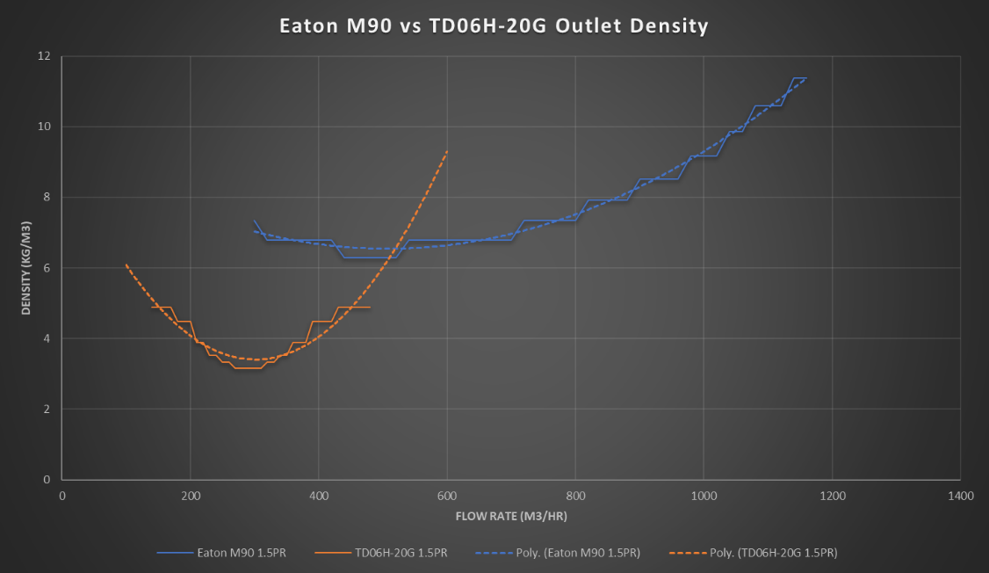
Figure 19: Graphs of ρ_{2A} against V̇ through an example value of Π 1.5 for MHI TD models of turbo-supercharger (represented in orange) against Eaton’s M-series Roots-style superchargers (represented in blue) produced using Excel (Microsoft, 2019).

Replicating a real-world heat exchanger experiment in Solidworks Flow Simulation CFD solver

Overview of Heat Exchanger/Experimentation/Correlation work
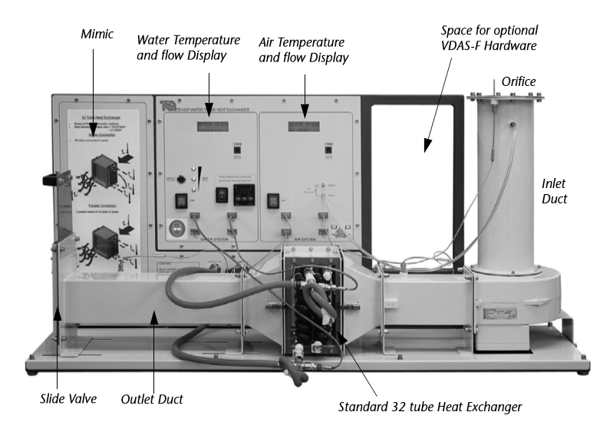
Figure 20: TecQuipment TD1007 Water-to-Air Heat Exchanger Experiment (TecQuipment, 2014)
If an accurate real-world experiment (TecQuipment TD1007 Water to Air Heat Exchanger experiment in the “32 tube” configuration) can be replicated in the CFD solver software that method can then be transferred to a similar virtual experiment of similar geometry describing a real-world intercooler (Intercooler sourced from a The London Taxi Company TX4 model) system and operation to provide analytical assumption where a physical test would be unfeasible, to recreate the conditions seen in the real-world application of the component.
To achieve this, the TD1007 experiment and the real-world intercooler were accurately measured and translated into the Solidworks 2019 CAD package (Dassault Systemes, 2019) and correct materials applied to be able to carry out; firstly, the correlation of the study between real-world experiment and then secondly (provided the correlation was reasonably conclusive) to replicate the real world scenario seen in the intercooler in the CFD solver to extract key values that can be used in conjunction with the findings in Section 4.1.
The CAD drafting work of both the real-world experiment and intercooler can be seen below in Figures 21 and 22:
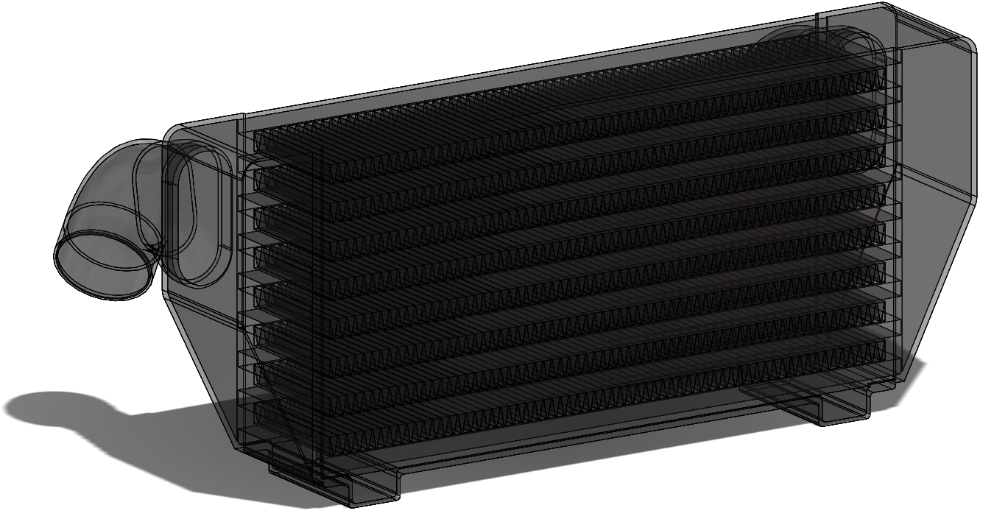
Figure 21: TX4 Intercooler Model geometry (The London Taxi Company, 2004) for CFD analysis, drafted using Solidworks 2019 (Dassault Systemes, 2019)
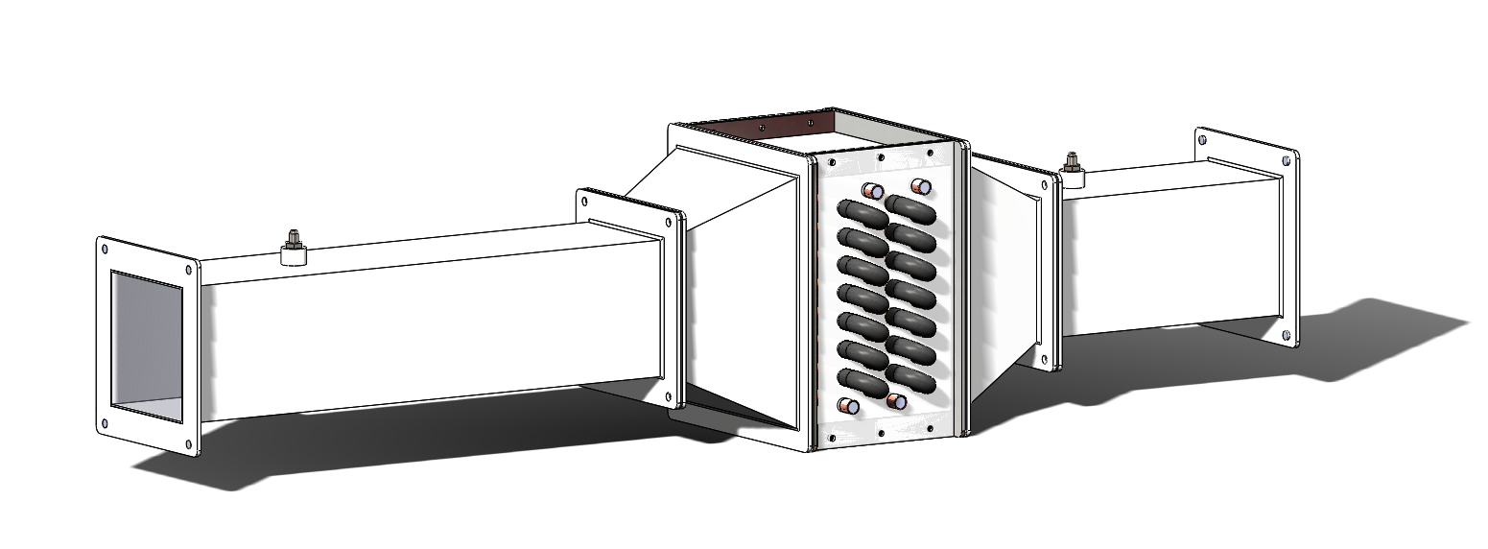
Figure 22: TD1007 Heat Exchanger Model geometry for CFD analysis, drafted using Solidworks 2019 (Dassault Systemes, 2019)
Firstly, the two parts shown above were drafted in the CAD package using a combination of physical hand measurements and literature (such as specification sheets and handbooks) and drawings provided by each manufacturer.
Then the models were prepared for CFD simulation by creating geometries to allow flow conditions at the inlet and outlet.
Once inlet and outlet conditions were defined, a set of ambient conditions, fluid sub-domains for the “hot” and “cold” flows and each geometry was meshed (using the FEM rule-of-thumb “three elements in the thinnest geometry section”). Following this testing runs were carried out to achieve the rough behaviour expected from each system, to set up results/data gathering methods and to provide an approximation of the solve times that would be seen for each geometry/system.

Results: Real-world Experimental Work
The real-world work undertaken follows “Experiment 2” documented in the TecQuipment (TecQuipment, 2014) materials provided with the heat exchanger system, which explores the effects of varying cooling air flow rate on heat exchange in the system.
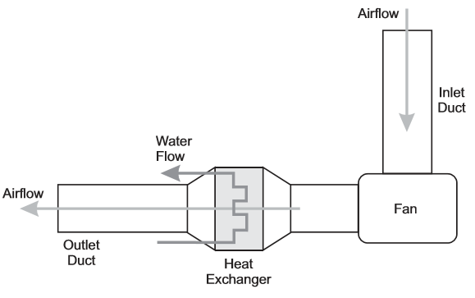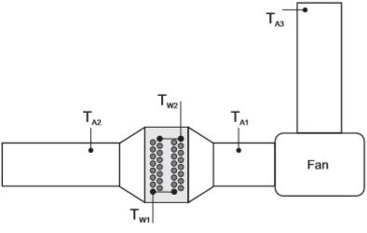
Figure 23: Example of configuration of sensors and orientation of fluid flows for "Experiment 2" (TecQuipment, 2014), the system features five sensors in total, two water circuit sensors and three air circuit sensors (the T_{A3} sensor being an “ambient” air temperature sensor for reference use). Airflow moves through the heat exchanger section (consisting of a removable section containing a pair of 16 tube banks positioned in series) which sits in an “expansion chamber” seen between T_{A1} and T_{A2}.
The path of heat transfer seen in this system is as follows: As the high temperature (approx. 60°C) water flow enters the copper tubes of the heat exchanger forced convective heat transfer occurs due to the lower temperature of the inner wall of the tube material. Then through conductive heat transfer, the heat energy is translated through the wall thickness of the copper tubing to raise the temperature of the tubes. As the air flow contacts the copper tubes containing the heated water flow forced convective heat transfer occurs again as heat is transferred into the air system. Additionally, there is a similar process through the steel ducting to the surrounding ambient conditions, although, this process is a forced convective heat transfer from the air flow into the steel ducting, again a conductive heat transfer through the steel ducting material and then a free convective heat transfer into the surroundings.
Calculation for the results seen in Tables 5, 6 and 7 using the equations 10 - 23 used the input values shown below in Table 8:
Table 5: Table of input conditions used for calculations relating to the results recorded during the TD1007 physical heat exchanger experiment (TecQuipment, 2014)
Ambient Pressure | P_{amb} | Pa | 101367
Gas Constant of Air | R_{A} | J•kg⁻¹•K | 287.05
Coefficient of discharge | C_{d} | - | 0.6
Orifice Diameter | Ø_{O} | m | 0.10011
Orifice Area | A_{O} | m² | 0.00787127
Total surface area | A | m² | 0.1558
The equations for the values shown in Table 7 can be seen in Equations 13 - 23 (TecQuipment, 2014):
Equation 10: Isobaric Specific Heat Capacity Equation
$$c_{P}=\frac{Q}{∆T}$$
Equation 11: Specific Heat Capacity Equation for Water using empirical datasets
$$c_{PW}=\left(0.996185+0.0002874{\left(\frac{T+100}{100}\right)}^{5.26}+0.01116×{10}^{-0.036T}\right)4185.5$$
Equation 12: Density of Air
$$ρ_{A}=\frac{P}{RT}$$
Equation 13: Density of Water at a given temperature of water using empirical datasets
$$ρ_{W}= \frac{\left(999.839+16.952T-7.990×{10}^{-3}T^{2}-46.241×{10}^{-6}T^{3}+105.846×{10}^{-9}T^{4}-281.030×{10}^{-12}T^{5}\right)}{\left(1+16.887×{10}^{-3}T\right)}$$
Equation 14: Heat Energy Transfer Rate Equation for Water
$$\dot{Q_{W}}={\dot{m}}_{W}×c_{PW}×∆T_{W}$$
Equation 15: Heat Energy Transfer Rate Equation for Air
$$\dot{Q_{A}}={\dot{m}}_{A}×c_{PA}×∆T_{A}$$
Equation 16: Energy balance coefficient equation
$$CEB= \frac{{\dot{Q}}_{A}}{{\dot{Q}}_{W}}$$
Equation 17: Temperature efficiency equation for Water Circuit
$$η_{TW}= \frac{T_{W1}- T_{W2}}{T_{W1}- T_{A1}}×100$$
Equation 18: Temperature efficiency equation for Air Circuit
$$η_{TA}= \frac{T_{A2}- T_{A1}}{T_{W1}- T_{A1}}×100$$
Equation 19: Logarithmic Mean Temperature Difference Equation
$$LMTD= \frac{\left(T_{W2}-T_{A2}\right)-(T_{W1}-T_{A1})}{\ln\left(\frac{T_{W2}-T_{A2}}{T_{W1}-T_{A1}}\right)}$$
Equation 20: Heat Transfer Coefficient Equation
$$U=\frac{{\dot{Q}}_{W}}{A ×LMTD}$$
The format of this experiment was to follow the “Experiment 2” methodology (which can be viewed at Appendix 1.3) for varying airflow rate through the system using a movable slat at the exhaust of the experiment. Results were then taken for temperatures in and out for both the air and water circuits, ambient air temperature and flow rates of both water and air. Once the flow rate of water and air had settled at the correct values the experiment was allowed to equalise for approximately 300 seconds before the readings were taken, this was repeated in six airflow increments calculated from the pressure change seen at the inlet (between an “in-flow” pitot tube in the Inlet Duct to the fan and an ambient reading of the surrounding pressure).The results for the flow conditions and temperature readings seen during the experiment can be seen below in Table 5 and 6 respectively:
Table 6: Table of flow conditions recorded during the TD1007 physical heat exchanger experiment (TecQuipment, 2014)
Recorded Change in Pressure | Volumetric Flow Rate Water | Mass Flow Rate Water | Mass Flow Rate Air | Velocity of Airflow at Inlet | Goal Change in Pressure
ΔP | V̇_{W} | ṁ_{W} | ṁ_{A} | v_{A} | ΔP
Pa | l•min⁻¹ | kg•s⁻¹ | kg•s⁻¹ | m•s⁻¹ | Pa
249.00 | 1.14 | 0.01871864 | 0.11523250 | 12.25 | 250.00
198.00 | 1.14 | 0.01871771 | 0.10269535 | 10.93 | 200.00
151.00 | 1.14 | 0.01871490 | 0.08968229 | 9.54 | 150.00
99.00 | 1.14 | 0.01871068 | 0.07256752 | 7.73 | 100.00
50.00 | 1.14 | 0.01870263 | 0.05152367 | 5.50 | 50.00
25.00 | 1.14 | 0.01869738 | 0.03638066 | 3.89 | 25.00
The calculation of mass flow and velocity of flow used the following equations (Equations 10 - 12):
Equation 21: Mass flow rate for water equation
$${ṁ}_{W}=\frac{{\dot{V}}_{W}}{60000× ρ_{W}}$$
Equation 22: Mass flow rate for air equation
$${\dot{m}}_{A}=C_{d}×A_{O}\sqrt{∆P×2×ρ_{A}}$$
Equation 23: Velocity from mass flowrate equation
$$v= \frac{\dot{m}}{ρ×A_{O}}$$
Table 7: Table of temperature conditions recorded during the TD1007 physical heat exchanger experiment (TecQuipment, 2014)
Recorded Change in Pressure | Temp Water 1 (Inlet) | Temp Water 2 (Outlet) | Change in Temp Water | Average Temp Water | Temp Air 1 (Inlet) | Temp Air 2 (Outlet) | Change in Temp Air | Average Temp Air | Temp Air 3 (Ambient)
ΔP | T_{W1} | T_{W2} | ΔT_{W} | T_{W,av} | T_{A1} | T_{A2} | ΔT_{A} | T_{A,av} | T_{A3}
Pa | °C | °C | °C | °C | °C | °C | °C | °C | °C
249.00 | 60.5 | 51.5 | -9.00 | 56.00 | 19.60 | 25.20 | 5.60 | 22.40 | 19.00
198.00 | 60.4 | 51.8 | -8.60 | 56.10 | 19.90 | 25.60 | 5.70 | 22.75 | 19.10
151.00 | 60.5 | 52.3 | -8.20 | 56.40 | 19.70 | 25.80 | 6.10 | 22.75 | 18.80
99.00 | 60.7 | 53.0 | -7.70 | 56.85 | 19.80 | 26.50 | 6.70 | 23.15 | 19.30
50.00 | 61.1 | 54.3 | -6.80 | 57.70 | 19.90 | 27.50 | 7.60 | 23.70 | 18.70
25.00 | 61.3 | 55.2 | -6.10 | 58.25 | 20.20 | 28.90 | 8.70 | 24.55 | 18.70
Once the parameters in Table 6 were recorded several calculations (using the equations found in Equations 13-23) were performed to provide values and relationships that could be used to better understand the system and correlate to the CFD in later work, shown below in Table 7.
Table 8: Table of calculated parameters from conditions recorded during the TD1007 physical heat exchanger experiment (TecQuipment, 2014)
Recorded Change in Pressure | Mean Temperature Efficiency Water | Mean Temperature Efficiency Air | Overall Efficiency | Average Density of Water | Average Density of Air | Specific Heat Capacity of Water | Specific Heat Capacity of Air | Heat Energy Transfer Rate Water | Heat Energy Transfer Rate Air | Rate of Energy Loss to Environment | Energy Loss Percentage | Energy Balance Coefficient | Logarithmic Mean Temperature Difference | Heat Transfer Coefficient
ΔP | $$η_{TW}$$ | $$η_{TA}$$ | $$η_{T,av}$$ | ρ_{W} | ρ_{A} | C_{pA} | C_{pA} | Q̇_{W} | Q̇_{A} | Q_{LA} | Q_{LA} | CEB | LMTD | U
Pa | % | % | % | kg.m⁻³ | kg.m⁻³ | J.kg⁻¹K⁻¹ | J.kg⁻¹K⁻¹ | W | W | W | % | - | - | W.m⁻²K⁻¹
249.00 | 22.00 | 13.69 | 17.85 | 985.19 | 1.20 | 4182.46 | 1005.50 | 704.61 | 648.85 | 55.76 | 7.91 | 0.92 | 33.06 | 136.78
198.00 | 21.23 | 14.07 | 17.65 | 985.14 | 1.19 | 4182.50 | 1005.50 | 673.27 | 588.58 | 84.68 | 12.58 | 0.87 | 32.83 | 131.62
151.00 | 20.10 | 14.95 | 17.52 | 984.99 | 1.19 | 4182.61 | 1005.50 | 641.87 | 550.07 | 91.80 | 14.30 | 0.86 | 33.14 | 124.33
99.00 | 18.83 | 16.38 | 17.60 | 984.77 | 1.19 | 4182.79 | 1005.50 | 602.62 | 488.88 | 113.75 | 18.88 | 0.81 | 33.18 | 116.57
50.00 | 16.50 | 18.45 | 17.48 | 984.35 | 1.19 | 4183.13 | 1005.50 | 532.00 | 393.73 | 138.27 | 25.99 | 0.74 | 33.49 | 101.97
25.00 | 14.84 | 21.17 | 18.00 | 984.07 | 1.19 | 4183.36 | 1005.50 | 477.13 | 318.25 | 158.88 | 33.30 | 0.67 | 33.15 | 92.38
From the values calculated a series of graphs were then created that could be verified against examples found in the TD1007 guidelines handbook to ensure that the experiment and calculations were successful and following the intended trends. The graphs generated and the example graphs provided by TecQuipment in the guidelines can be seen below in Figures 24 to 27:
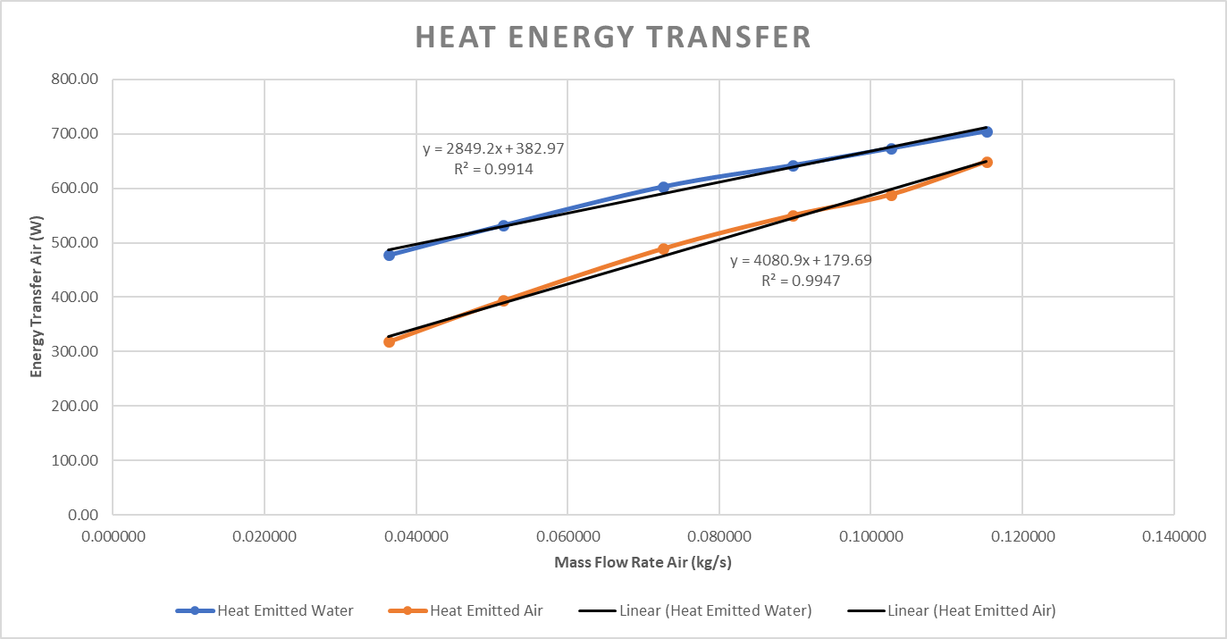
Figure 24: Graph of Heat Energy Transfer Rates from calculated parameters from conditions recorded during the TD1007 physical heat exchanger experiment (TecQuipment, 2014)
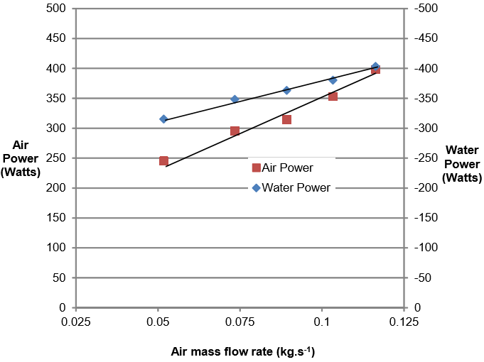
Figure 25: Graph of Heat Energy Transfer Rates from experiment guidelines of the TD1007 heat exchanger experiment (TecQuipment, 2014)
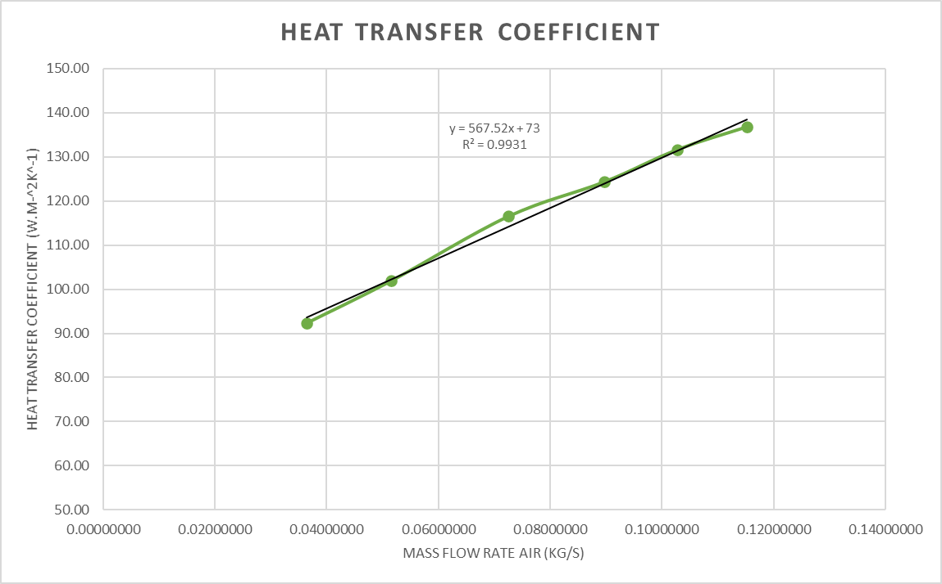
Figure 26: Graph of Heat Energy Transfer Coefficient from calculated parameters from conditions recorded during the TD1007 physical heat exchanger experiment (TecQuipment, 2014)
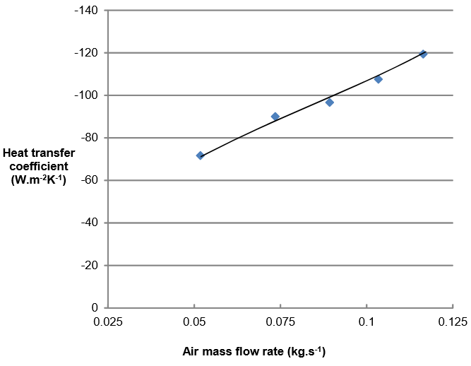
Figure 27: Graph of Heat Transfer Coefficient from experiment guidelines of the TD1007 heat exchanger experiment (TecQuipment, 2014)
As seen in Figures 24 - 27 despite the overall values seen being of a greater numerical value in the real-world test than the experiment guidelines the overall trends are an extremely close match (linear fit R-squared values of +0.99 in all experimental cases showing an almost exact fit) meaning the experimental method and calculations have been followed correctly and have provided useable data.
Due to this “confirmation of the experimental method the CFD phase of the correlation process could begin, this is shown overleaf in section 5.3.3.

Methodology: Creating the CFD model in Solidworks 2019 Flow Simulation
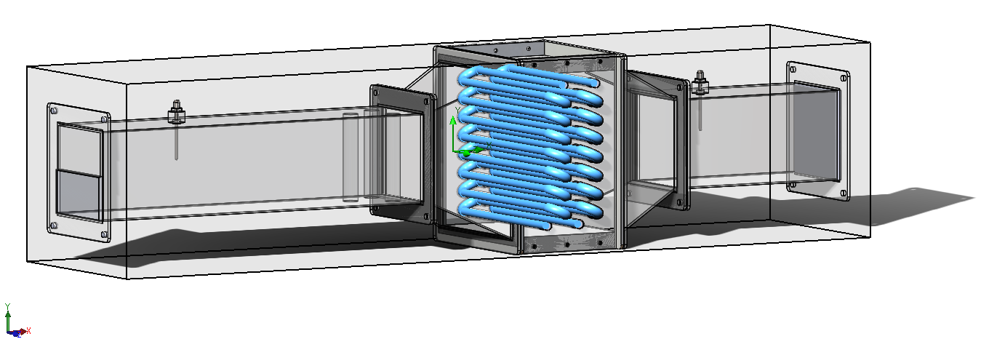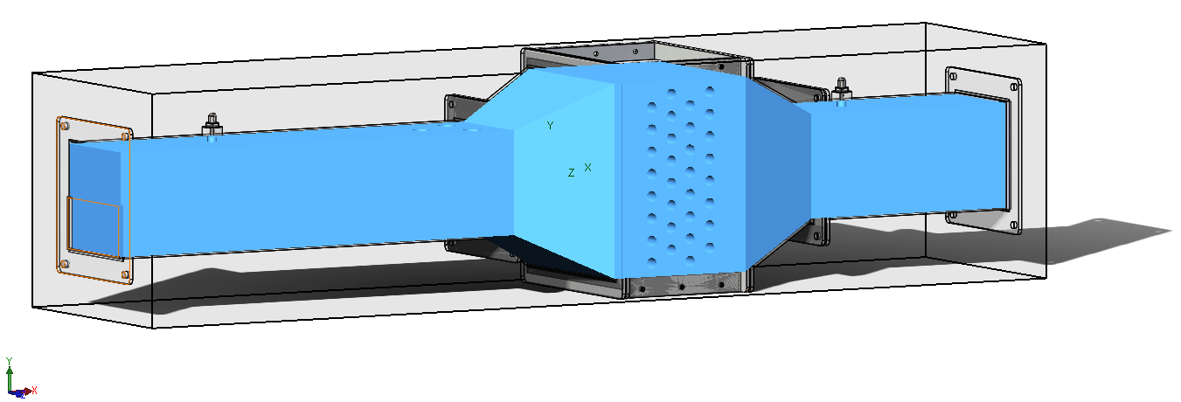
Figure 28: Example of different fluid domains seen in the CFD model, shown in blue, the top image displaying the water subdomain seen in the copper tubes and silicone joiners and the bottom image showing the air subdomain in the system (excluding the ambient air subdomain as this is automatically defined during setup).Drafted using Solidworks 2019 (Dassault Systemes, 2019)
The first steps taken in constructing the CFD model of the real-world experiment were importing the 90 components required to assemble the geometry in the in-built Solidworks 2019 (Dassault Systemes, 2019) fluid-dynamics solver “Flow Simulation”, as can be seen above in Figure 28 the geometry drafted does not include the fan and intake duct (refer to Figure 23 for full geometry), this is due to the complex nature of the components and Flow Simulations inability to model moving geometry in a CFD model. Once this had been carried out the computational domain could be defined shown in Figure 28 as the grey box outlining the experiment geometry. Next, the fluid subdomains seen in the real-world experiment were defined as seen in Figure 28.
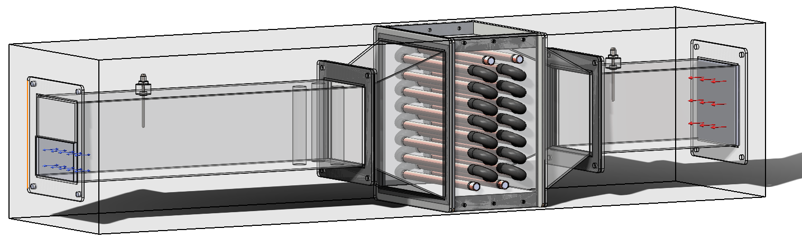
Figure 29: Cutaway image of experiment geometry showing Air flow in (RED arrows right of image) and pressure opening at outlet (BLUE arrows left of image). Drafted in Solidworks 2019 (Dassault Systemes, 2019)
Following the definition of the overall computational and individual fluid domains a set of boundary conditions for inlet and outlet flow were created. This was carried out by defining inlet conditions with parameter dependency based off the results from the real-world experiment results. These inlet boundary conditions were defined as a table (see Appendix 1.4) of mass flow rate values linked to the CFD solver to create a transient scenario.
The outlet conditions were also defined by a dependency upon tabulated values, but the outlet boundary condition for airflow was specified as an “environmental pressure’ opening to mimic the exhaust to the ambient atmospheric conditions of the lab where the experiment took place in the real-world. The water outlet condition was specified as an outlet mass flow rate linked to tabulated values also, but with no control over temperature as to allow analysis of whether the experiment and heat transfer was occurring correctly due to the temperature at the outlet being determined by the models heat transfer conditions.
These input parameters can be seen in the “Full input settings used for generation of CFD model” seen in Appendix 1.4
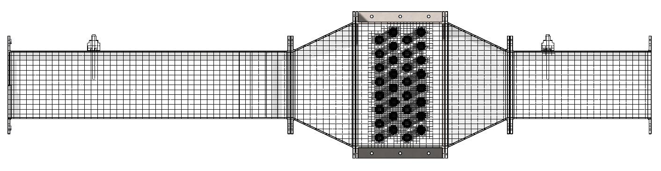
Figure 30: Example of the mesh used for the CFD model (including both Global and Local meshes and automatic refinements to the meshes seen during calculation/solving). Applied using Solidworks Flow Simulation Add-in (Dassault Systemes, 2019)
Once the boundary conditions had been applied, the final step before initiating the actual calculations was to define a “mesh” of elements for calculation to be carried out on. In the case of this particular study the basic mesh was defined using the rule-of-thumb “three elements in the smallest geometry” (Lake, 2020) this mesh totalled approximately 500,000 elements across the entire computational domain and was uniform in nature.
Additionally, to improve the quality of results a local mesh was applied to the copper tube components, following the same “three elements” rule-of-thumb, this was done to improve the accuracy of the “heat conduction in solids” method of solving for the CFD model.
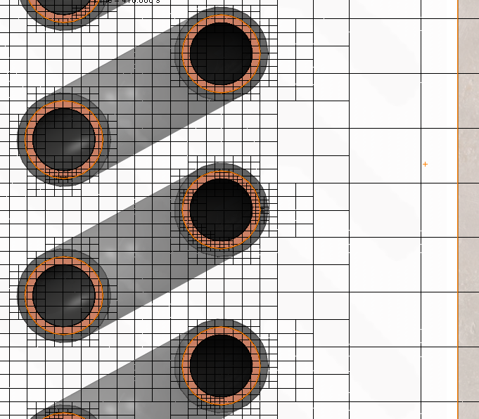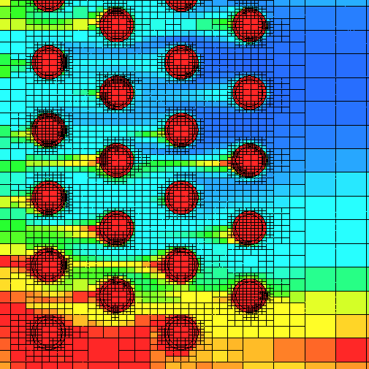
Figure 31: Close-up example of mesh refinement seen around water system pipes during calculation/solving. Applied using Solidworks Flow Simulation Add-in (Dassault Systemes, 2019)
At this point ambient conditions and overall solving parameters were set, for the purposes of this model a set of automatic mesh refinements were applied to automatically increase mesh resolution (particularly around the copper pipes where the water-to-air heat exchange was occurring as can be seen above in Figure 31) up to six times denser than the global element resolution based on particle cycles seen through the model geometry.
Once these refinements had been applied and all conditions had been confirmed the model was set to calculate/solve. Once solved the results from this study were opened in the post-process analysis component of the “Flow Simulation” software to view the findings of the CFD model.

Results: Analysis of results from CFD model
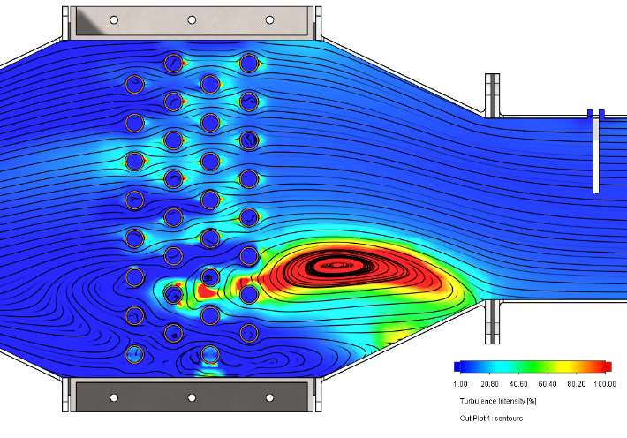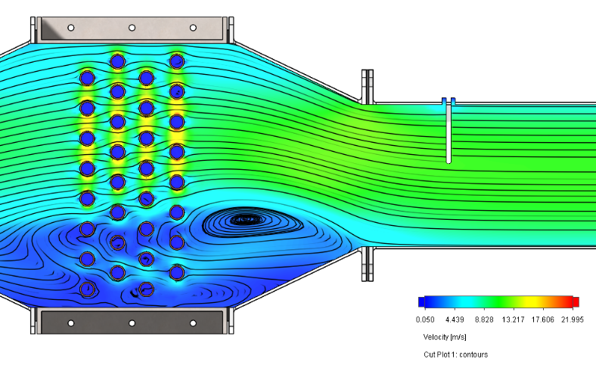
Figure 32: Example of flow separation seen at entrance of heat exchanger portion. Turbulence intensity shown on the left, flow velocity on the right. Calculated using Solidworks Flow Simulation Add-in (Dassault Systemes, 2019)
As mentioned previously (section 5.3.2 footnote 16) one of the first visual indicators that the flow characteristics of the CFD model were acting correctly was boundary layer/flow separation upon entry to the heat exchanger. Prominent boundary layer separation can be seen in both Figure 32 and Figure 33, at multiple points during the virtual experiment’s timeline.
Firstly, Figure 32 displays an example of an aggressive flow separation forming a large turbulent eddy, the image on the left of the figure displays turbulence intensity and the image on the right of the figure displays the velocity of fluid flow. As expected, the aggressively turbulent flow caused by this separation causes a reduction in velocity along the flow path as the flow moves away from a laminar regime.
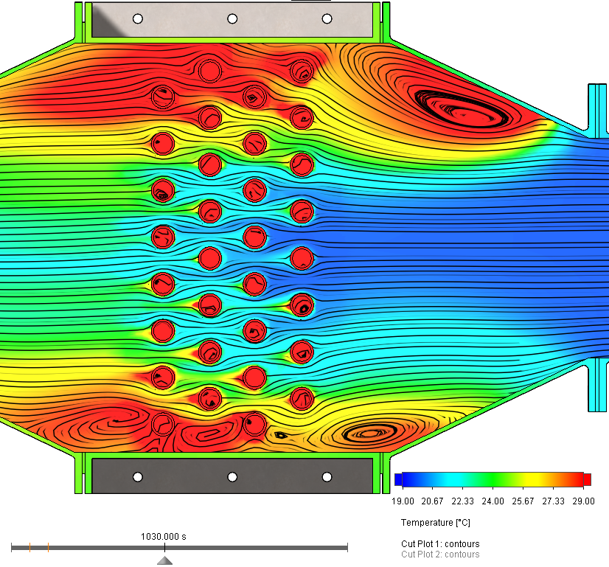
Secondly, as can be seen in Figure 33 to the left, this increase in turbulence drives an increase in temperature as there is increased time for heat transfer into the air from the water system whilst the eddies/vortices sit in the vicinity of the pipes.
Figure 33: Temperature colour plot (scale in image) displaying the effects of eddy/vortex formation due to boundary separation on air temperature using Solidworks Flow Simulation Add-in (Dassault Systemes, 2019)

On the following pages in Figures 34 to 45 and Tables 9 to 14 there appears the colour plots (for temperature observed, scale in the bottom right of each figure) and results tables associated with each pressure change step seen during the virtual experiment. The steps shown are linked to the re-world experiment as seen previously in Tables 5,6 and 7.
The reasoning for the timing steps included in the captions seen in the result is that they show the attempt to run the virtual experiment in a similar manner to the real-world experiment. The timing and method used for both the real-world event was as follows:
- Initiate the experiment using 5 second timesteps between reporting results.
- Allow 600 seconds for the experiment to equalise at the flow rates for each fluid subdomain.
- Take reading then allow 30 second for transition to next flow rate increments.
- Wait 300 seconds then repeat Step 3.
- Continue repeating Steps 3 and 4 until all flow rates have been recorded.
This totalled a 2,250 second study in the virtual experiment which, due to being broken into 5 second calculation intervals allowed for a transient animation of the results which could be paused and analysed as seen on the following pages.

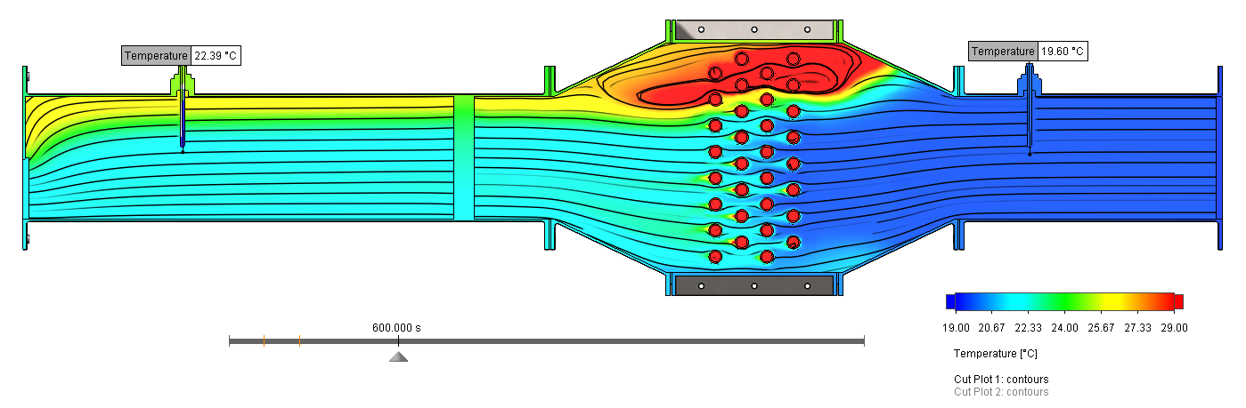
Figure 34: Air Circuit Temperatures seen in CFD model (Solidworks Flow Simulation add-in (Dassault Systemes, 2019)) of TD1007 heat exchanger experiment at ΔP 249Pa (600 seconds run time)
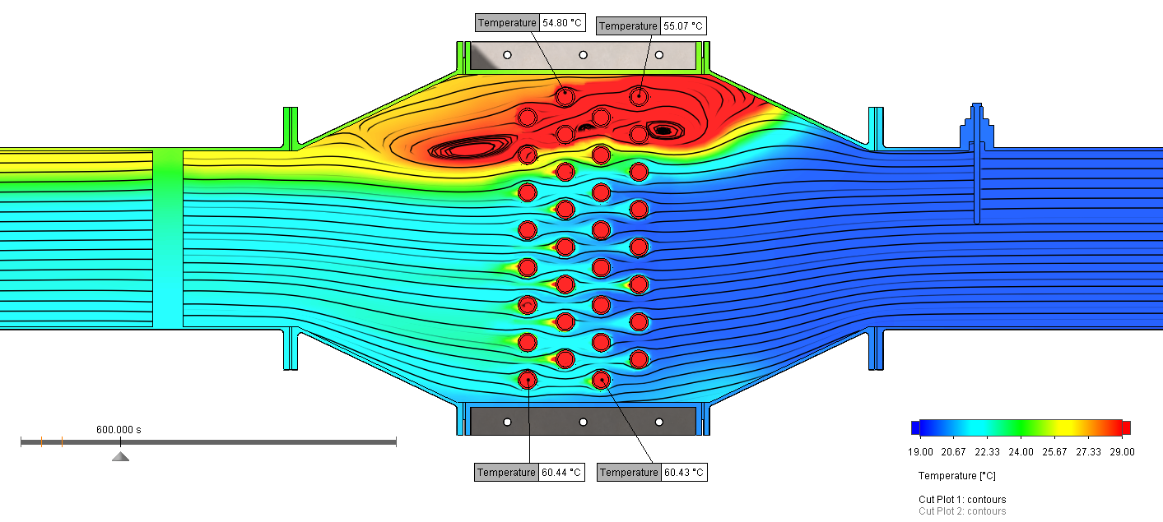
Figure 35: Water Circuit Temperatures seen in CFD model (Solidworks Flow Simulation add-in (Dassault Systemes, 2019)) of TD1007 heat exchanger experiment at ΔP 249Pa (600 seconds run time)

Table 9: Results table of data seen in CFD model (Solidworks Flow Simulation add-in (Dassault Systemes, 2019)) of TD1007 heat exchanger experiment at ΔP 249Pa (600 seconds run time)

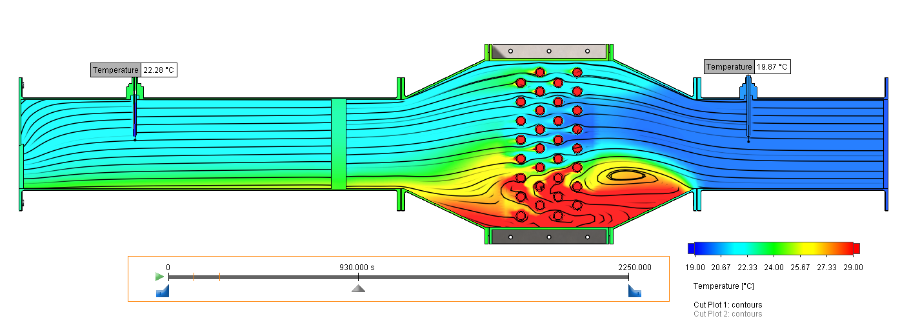
Figure 36: Air Circuit Temperatures seen in CFD model (Solidworks Flow Simulation add-in (Dassault Systemes, 2019)) of TD1007 heat exchanger experiment at ΔP 198Pa (930 seconds run time)
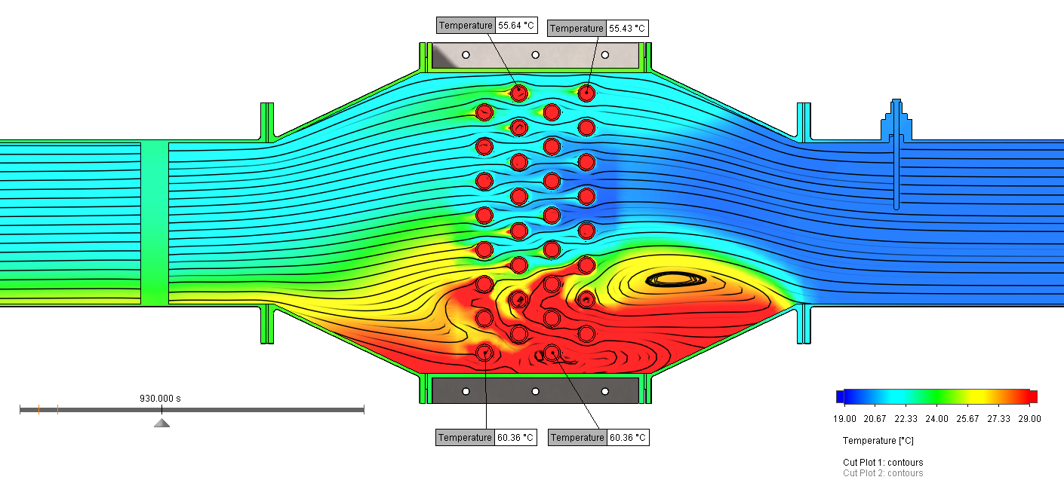
Figure 37: Water Circuit Temperatures seen in CFD model (Solidworks Flow Simulation add-in (Dassault Systemes, 2019)) of TD1007 heat exchanger experiment at ΔP 198Pa (930 seconds run time)

Table 10: Results table of data seen in CFD model (Solidworks Flow Simulation add-in (Dassault Systemes, 2019)) of TD1007 heat exchanger experiment at ΔP 198Pa (930 seconds run time)

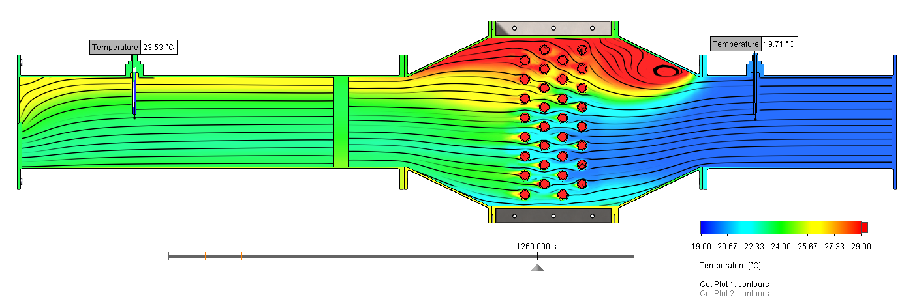
Figure 38: Air Circuit Temperatures seen in CFD model (Solidworks Flow Simulation add-in (Dassault Systemes, 2019)) of TD1007 heat exchanger experiment at ΔP 151Pa (1260 seconds run time)
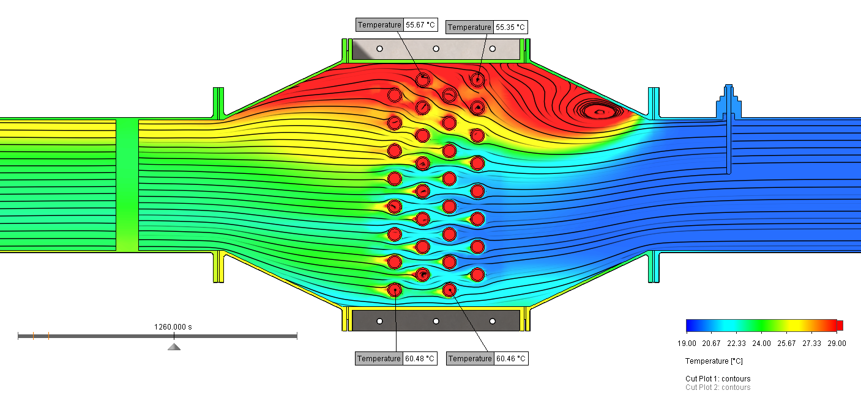
Figure 39: Water Circuit Temperatures seen in CFD model (Solidworks Flow Simulation add-in (Dassault Systemes, 2019)) of TD1007 heat exchanger experiment at ΔP 151Pa (1260 seconds run time)

Table 11: Results table of data seen in CFD model (Solidworks Flow Simulation add-in (Dassault Systemes, 2019)) of TD1007 heat exchanger experiment at ΔP 151Pa (1260 seconds run time)

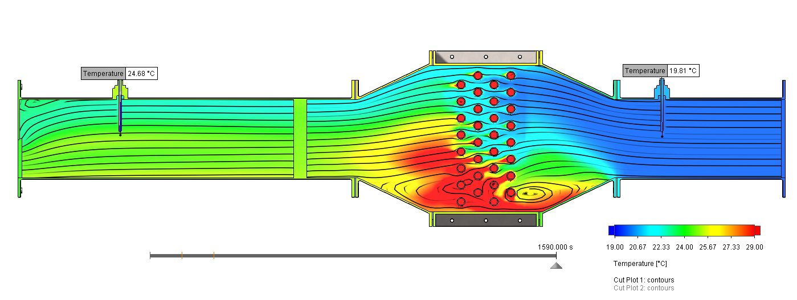
Figure 40: Air Circuit Temperatures seen in CFD model (Solidworks Flow Simulation add-in (Dassault Systemes, 2019)) of TD1007 heat exchanger experiment at ΔP 99Pa (1590 seconds run time)
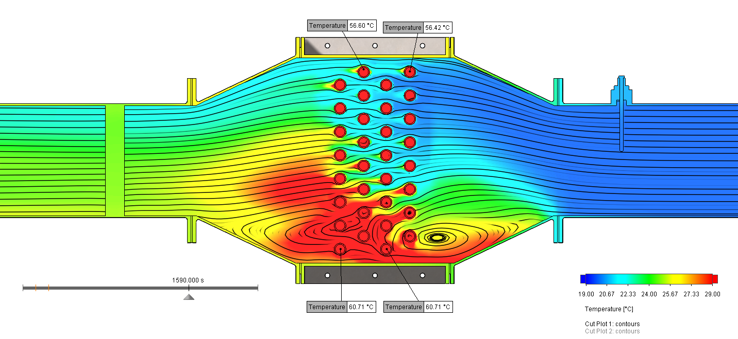
Figure 41: Water Circuit Temperatures seen in CFD model (Solidworks Flow Simulation add-in (Dassault Systemes, 2019)) of TD1007 heat exchanger experiment at ΔP 99Pa (1590 seconds run time)

Table 12: Results table of data seen in CFD model (Solidworks Flow Simulation add-in (Dassault Systemes, 2019)) of TD1007 heat exchanger experiment at ΔP 99Pa (1590 seconds run time)

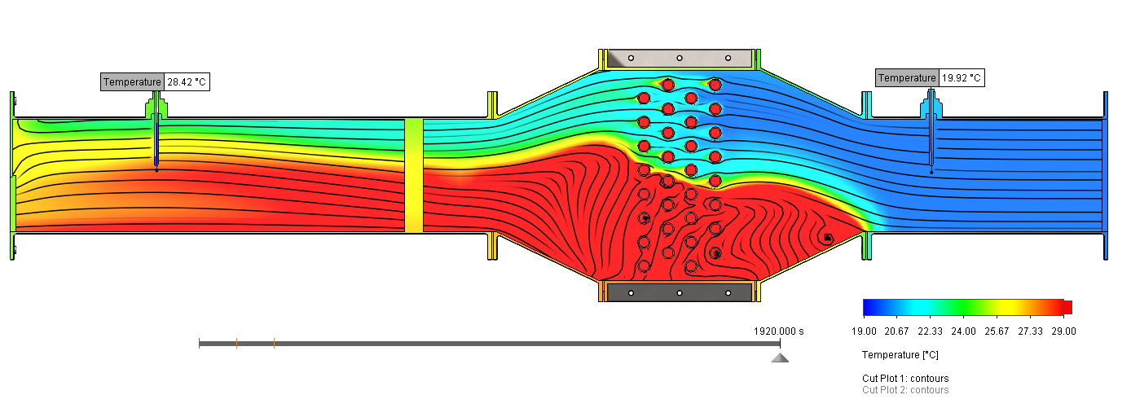
Figure 42: Air Circuit Temperatures seen in CFD model (Solidworks Flow Simulation add-in (Dassault Systemes, 2019)) of TD1007 heat exchanger experiment at ΔP 50Pa (1920 seconds run time)
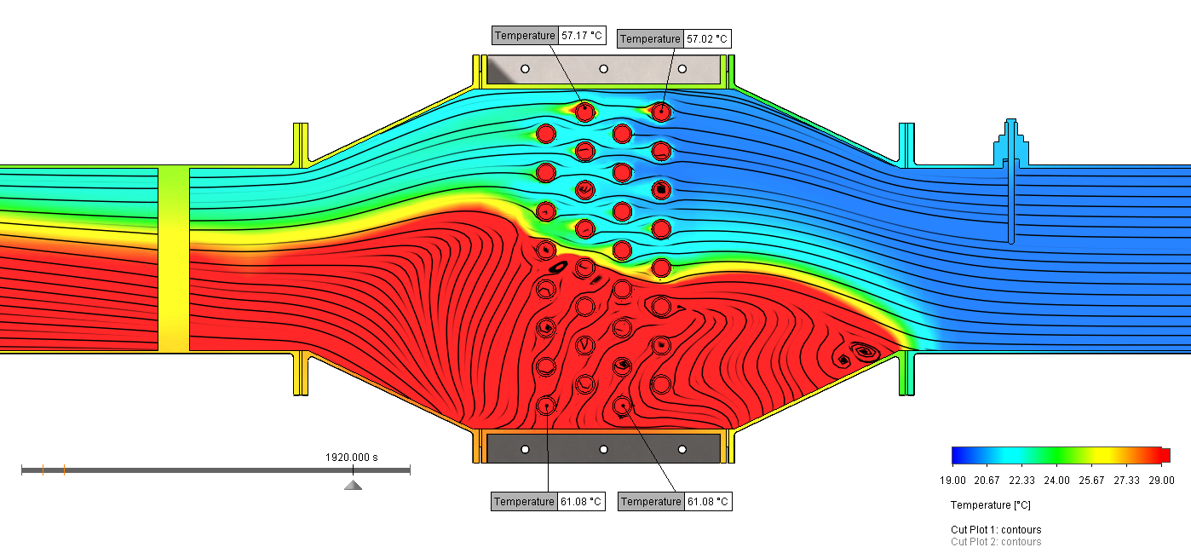
Figure 43: Water Circuit Temperatures seen in CFD model (Solidworks Flow Simulation add-in (Dassault Systemes, 2019)) of TD1007 heat exchanger experiment at ΔP 50Pa (1920 seconds run time)

Table 13: Results table of data seen in CFD model (Solidworks Flow Simulation add-in (Dassault Systemes, 2019)) of TD1007 heat exchanger experiment at ΔP 50Pa (1920 seconds run time)

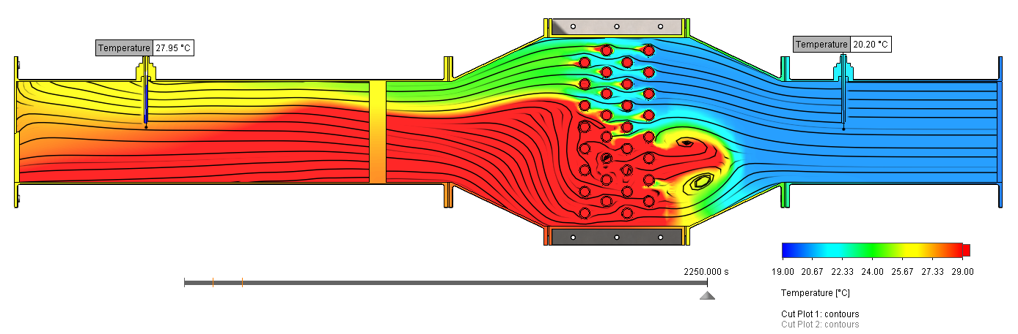
Figure 44: Air Circuit Temperatures seen in CFD model (Solidworks Flow Simulation add-in (Dassault Systemes, 2019)) of TD1007 heat exchanger experiment at ΔP 25Pa (2250 seconds run time)
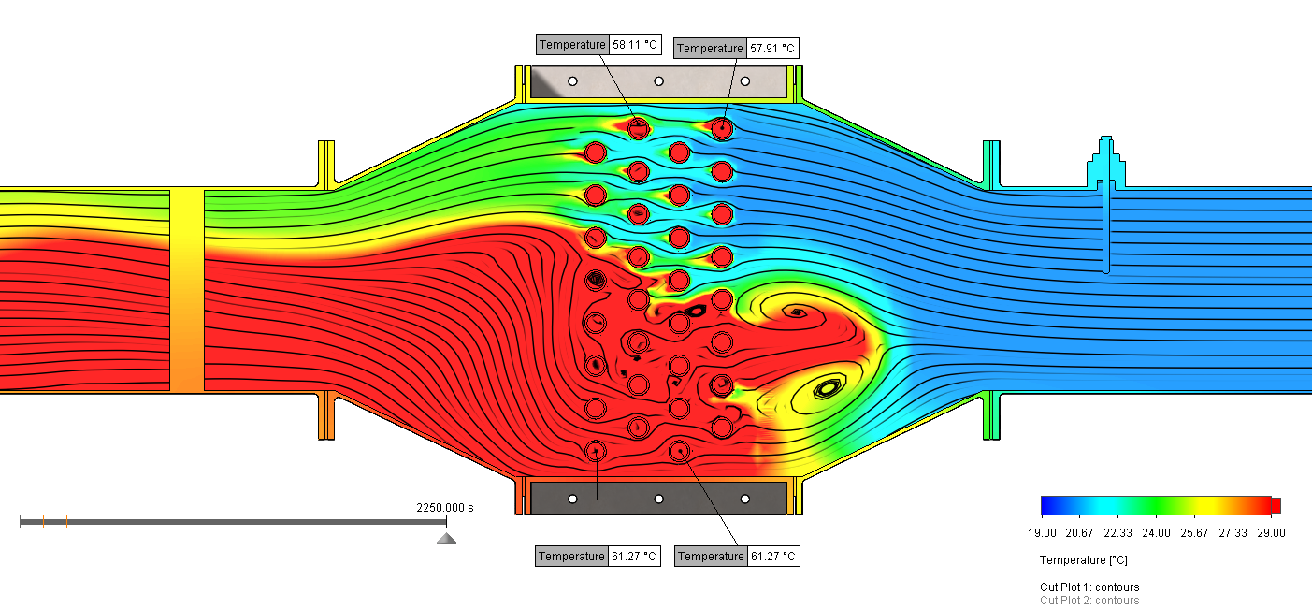
Figure 45: Water Circuit Temperatures seen in CFD model (Solidworks Flow Simulation add-in (Dassault Systemes, 2019)) of TD1007 heat exchanger experiment at ΔP 25Pa (2250 seconds run time)

Table 14: Results table of data seen in CFD model (Solidworks Flow Simulation add-in (Dassault Systemes, 2019)) of TD1007 heat exchanger experiment at ΔP 25Pa (2250 seconds run time)

Analysis and comparison/correlation to real-world data
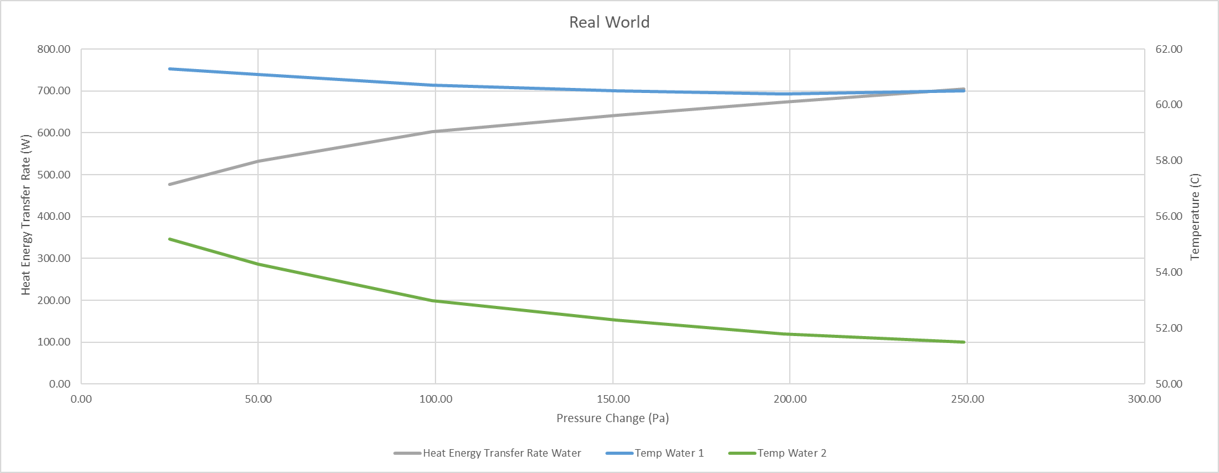
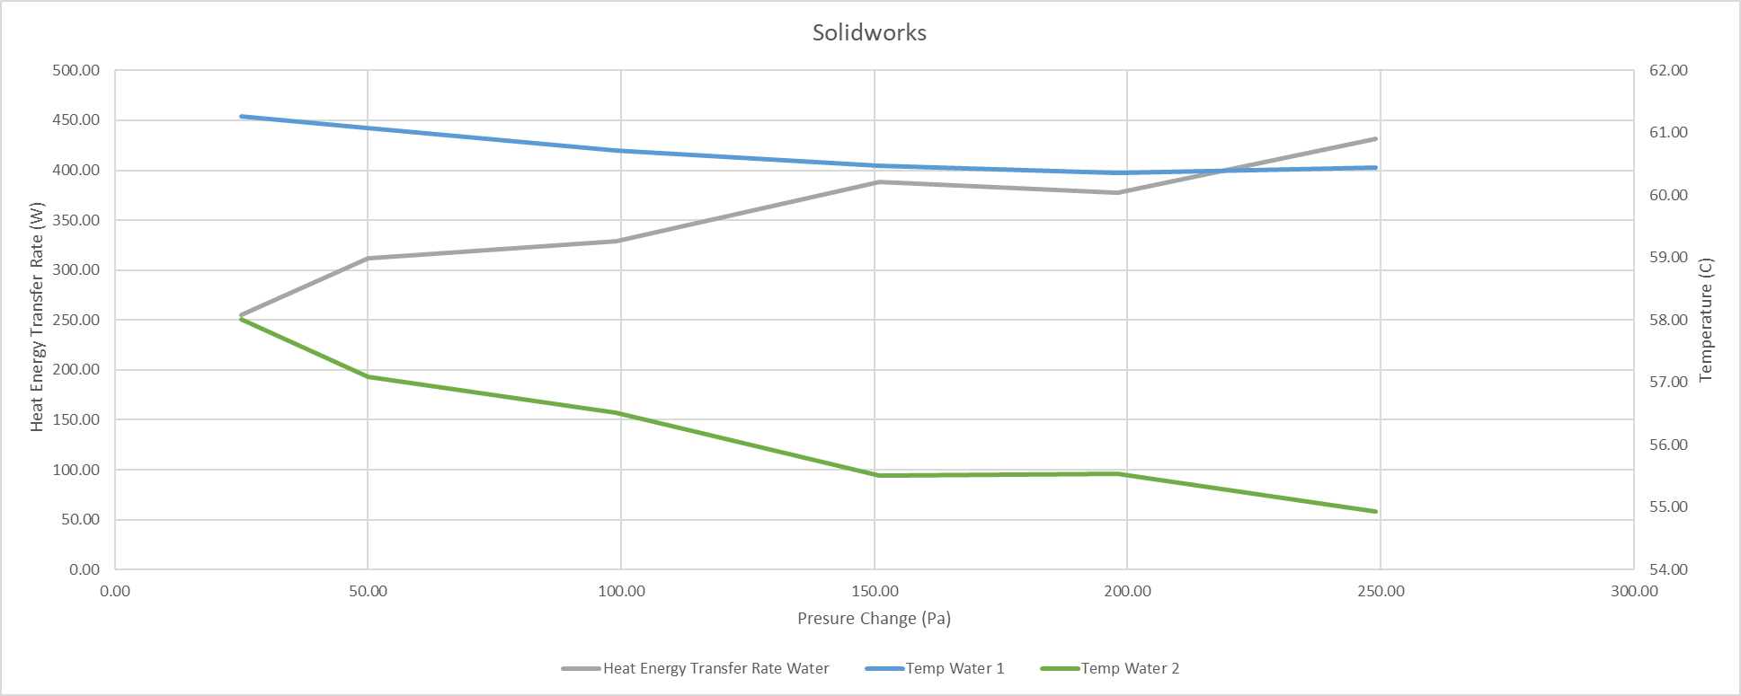
Figure 46: Graphs displaying comparison of virtual (bottom) (CFD model) (Dassault Systemes, 2019) and physical (top) (TD1007 real-world experiment) (TecQuipment, 2014) relationship of data for water temperature against heat energy transfer rate. Blue curves representing T_{W1}, Green curves representing T_{W2} and Grey curves representing Q̇_{W}.
For the purposes of correlation and analysis the two systems (air and water) have been split into two separate areas of comparison to allow easier identification of issues driving the disparity between the real world data and the virtual experiment data. As can be seen above in Figure 46, the overall trends of temperature and heat transfer rate relationships seen in the water circuit of the virtual and real-world experiments are very similar. The T_{W1} curves are virtually identical due to them being a defined parameter in both tests (a percentage difference of -0.046% between the real and virtual tests). As can be seen, the overall trends are correct, but the values are out by an average of 6.146% for T_{W2} and -42.60% for Q̇_{W}. Showing that heat transfer rate out of the water system is too slow meaning that the outlet temperature is not high enough. Essentially this shows that the change in temperature across the water system is not great enough in the CFD model. Mass flow rate of the water system can be eliminated as a cause using the graph shown below in Figure 47, Mass flow rates are exactly the same (the real-world results are completely obscured) due to their definition during the model setup and the temperature curves display a distinct difference.
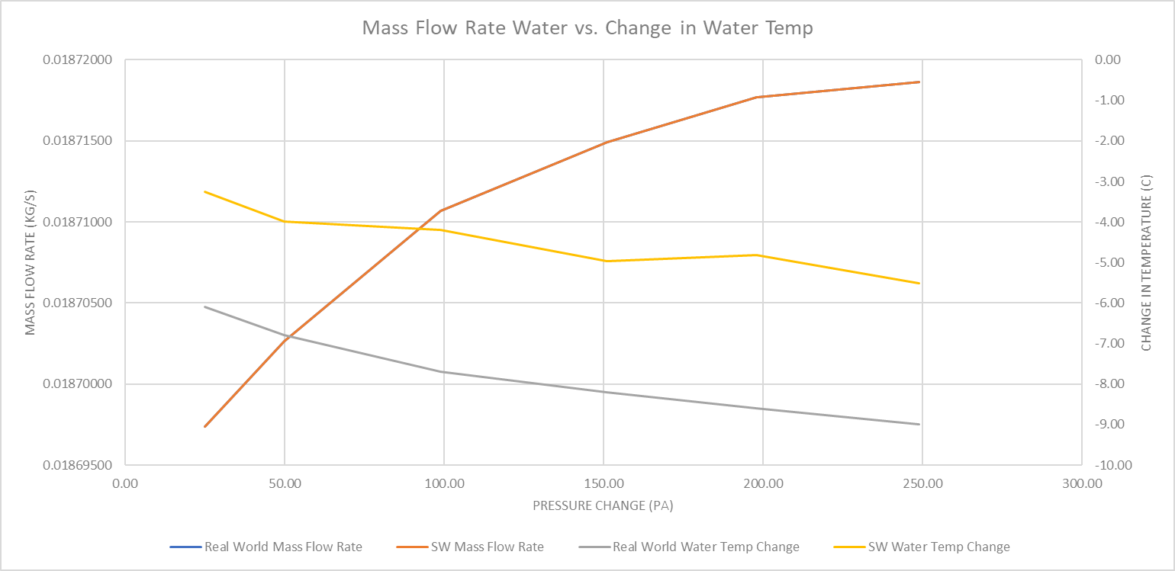
Figure 47: Mass Flow Rate against change in Water Temperature comparison graph between physical experiment data (TecQuipment, 2014) and CFD model data (Dassault Systemes, 2019) using Excel (Microsoft, 2019)
This observation of reduced heat transfer being the issue can be further reinforced by viewing the average change in the water temperature across the model in comparison to the real world change in water temperature, -42.61%, which when viewed alongside the value of average percentage difference in heat transfer rate across the CFD model of -42.6% can be seen as a reasonable assumption that they are directly linked. Logically this assumption is further supported, as for a decrease or increase in temperature through the system to occur the rate of heat energy transfer in or out of the system must change. This can also be noted in the average mean temperature efficiency which, for the water circuit, is -42.56%. All of this presents a strong case that there is an issue in either the conduction element of the CFD model between the two systems or a problem with the output or uptake of heat energy into one or both of the systems. To further problem solve this issue the air circuit must be analysed.
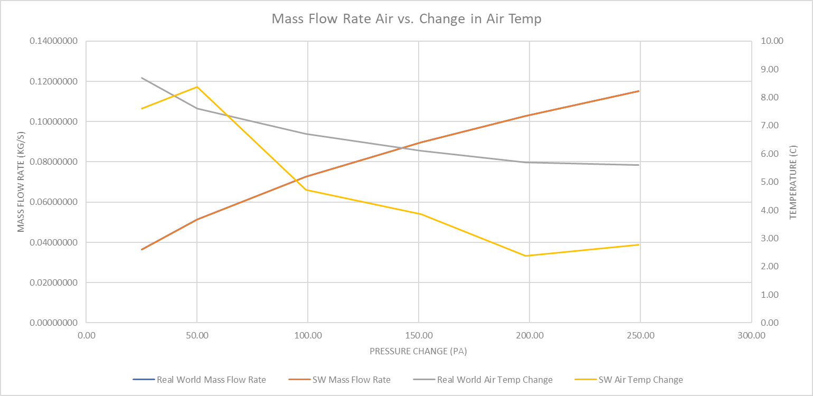
Figure 48: Mass Flow Rate against change in Air Temperature comparison graph between physical experiment data (TecQuipment, 2014) and CFD model data (Dassault Systemes, 2019) using Excel (Microsoft, 2019)
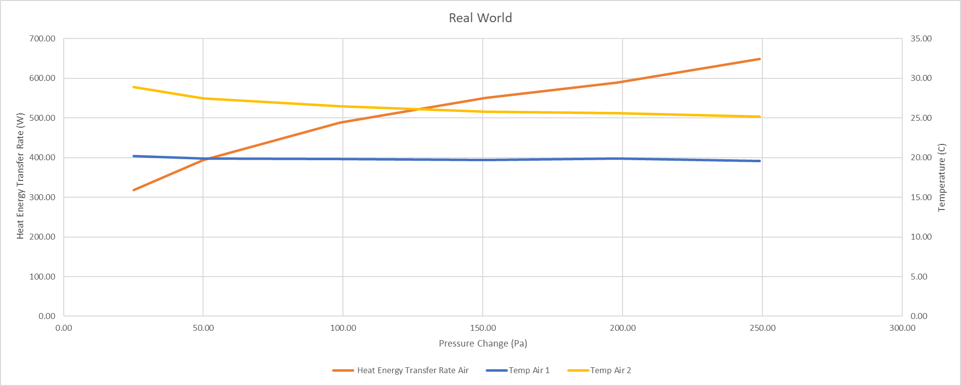
Figure 49: Air Temperature against Heat Energy Transfer Rate made using Excel (Microsoft, 2019) of physical experiment data (TecQuipment, 2014)
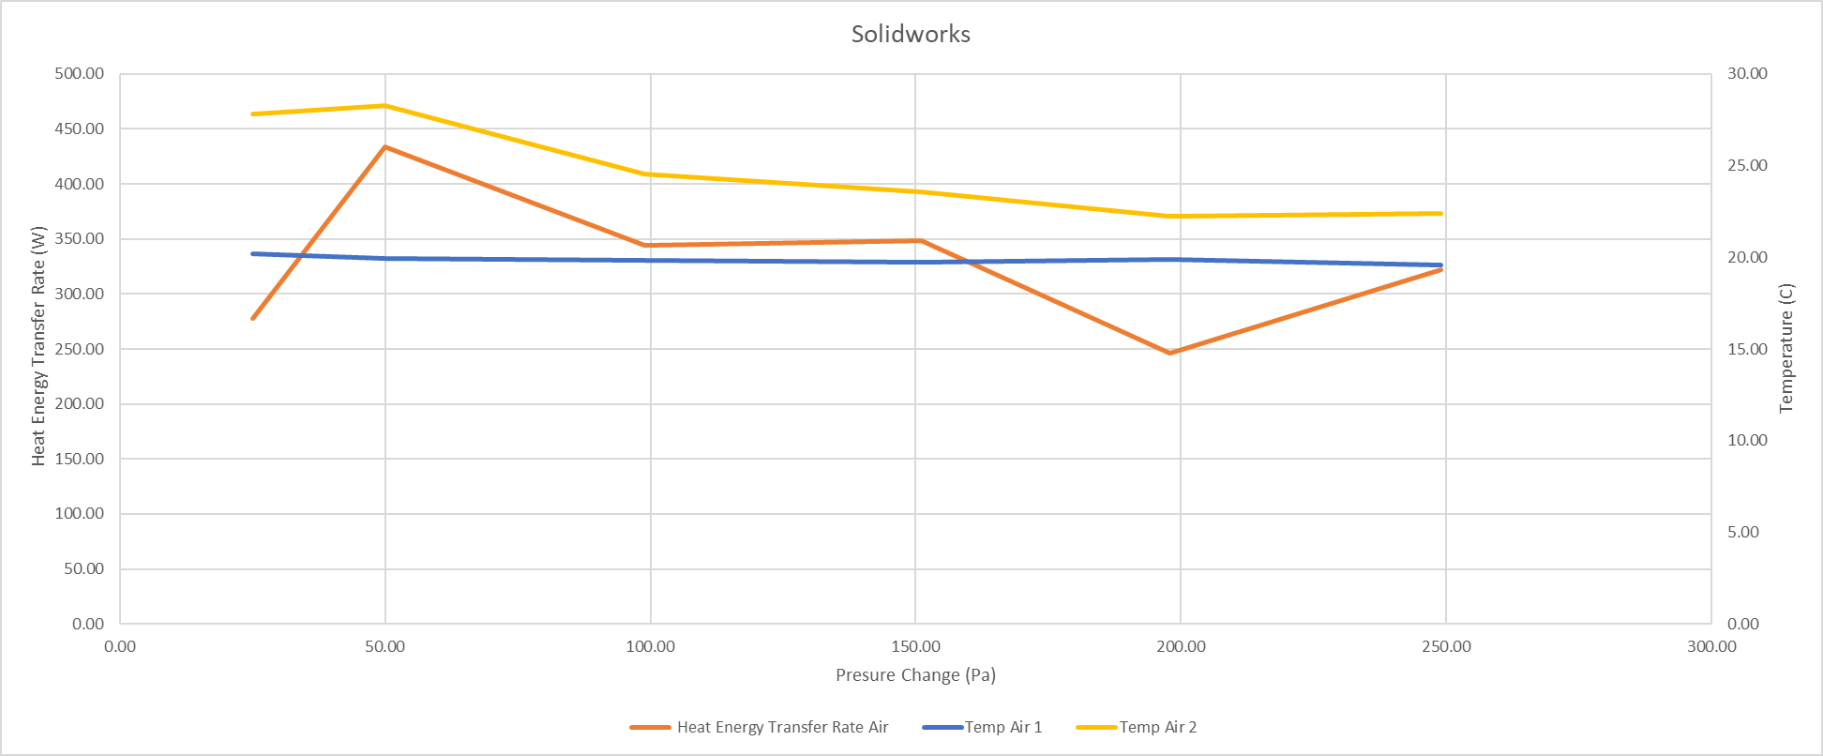
Figure 50: Air Temperature against Heat Energy Transfer Rate graph made using Excel (Microsoft, 2019) of virtual experiment data (Dassault Systemes, 2019)
If the air circuit is scrutinised in the same manner as the water circuit a similar trend can be seen to emerge. Whilst the mass flow shown in Figure 48 shows a direct, exact, match with the real-world data, due to its dependency, the change in temperature seen in relation to the real-world data is even further departed from the real-world data curve than the water circuit trends. Equally, if the average percentage difference of the change in water temperature (-29.57% difference), mean temperature efficiency (-29.51% difference) and heat transfer rate (-29.57% difference) are scrutinised as with the water system it can be observed that the three values display a direct link and are characteristically slower or lower than the real-world values, once again showing that there is an issue in the rate of energy transmission from one system to the other in the virtual model.
Unfortunately, it was at this point during the process (20/03/2020) that the outbreak of SARS CoV-2 closed the university campus and physical experiments had to cease…

Further Work and The Impact of the SARS CoV-2 Pandemic
Despite the closure of the university campus putting an end to the ability to carry out physical, real-world testing on March 20th, efforts were still made to try and identify the cause of the reduced rate of heat transfer seen in the CFD in comparison to the real-world experiment and provide a plan to move forward. The main theory explored to try to explain this disparity in values was the effect of air humidity on heat transfer rate into the air flow system. The reasoning for this is that the thermal conductivities of water and dry air are 0.5674W•m⁻¹•K⁻¹ and 0.025W•m⁻¹•K⁻¹ (at 10°C at atmospheric pressure (Dincer & Zamfirescu, 2016)) respectively, and from these values common-sense would dictate that if there is liquid water in suspension in the air the thermal conductivity of the humid mixture as a whole would decrease, due to the water requiring a greater amount of energy to increase temperature than the dry air would alone. The setting used for the CFD model displayed in section 5.3 was an air humidity of 50% as this is Solidworks’ default setting for humidity in air. If the theory shown above proves correct, then re-running the CFD model at a lower humidity value should garner a much higher rate of heat transfer which should be instantly recognisable as an increase in the T_{A2} value observed.
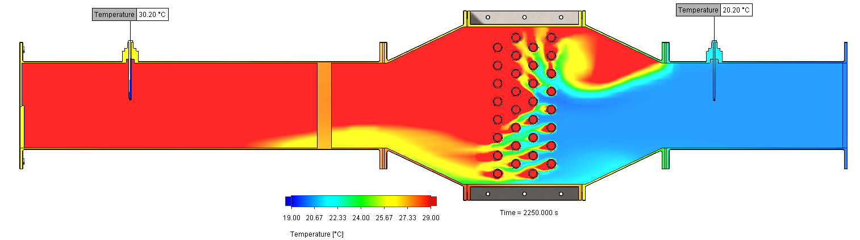
Figure 51: 0% Humidity Air Circuit Temperatures seen in CFD model (Solidworks Flow Simulation add-in (Dassault Systemes, 2019)) of TD1007 heat exchanger experiment at ΔP 25Pa (2250 seconds run time)

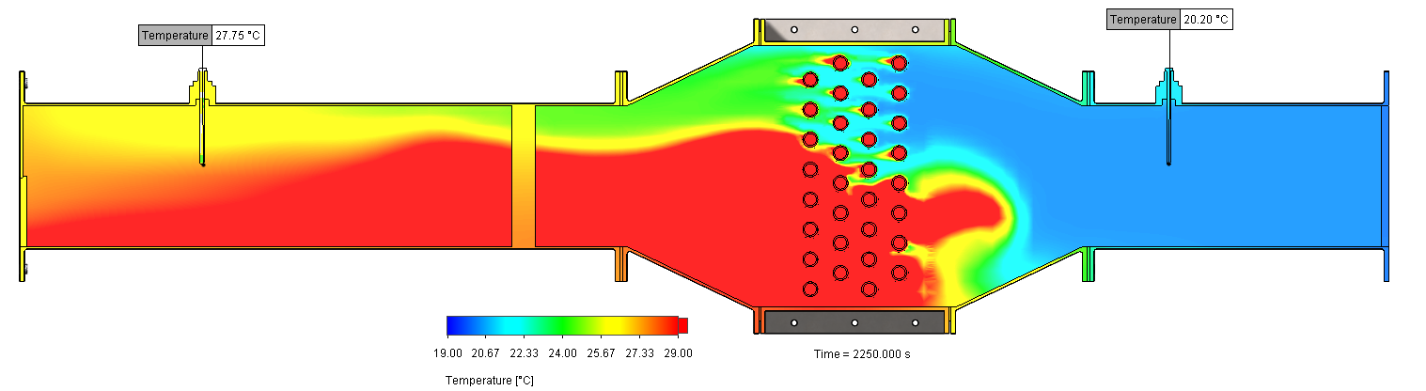
Figure 52: 50% Humidity Air Circuit Temperatures seen in CFD model (Solidworks Flow Simulation add-in (Dassault Systemes, 2019)) of TD1007 heat exchanger experiment at ΔP 25Pa (2250 seconds run time)
As can be seen above in Figures 51 and 53 an exact repeat of the CFD experiment at 0% air humidity demonstrated a much higher rate of heat transfer as expected. T_{A2} values seen were 27.75°C for the 50% humidity iteration and 30.20°C for the 0% humidity iteration.
Unfortunately, due to the inability to carry out the physical test again with a proper humidity reading the corroboration of data cannot progress further than this ‘identification of the problem” shown here. Any further work would be in the realm of purely making academic “guesses” at humidity values by trial and error using the CFD software. Due to the inaccuracy of the model in relation to the real-world data it was felt that it would not be a fair assumption to continue to base further work off the information gather and the CFD model in its current state. As such, the future work from this point on would be to:
- Re-run the real-world experiment with an accurate humidity measurement.
- Re-evaluate the CFD model based on information gathered from this more accurate test.
- Apply this refined CFD model method to an intercooler geometry model as originally planned.
- Carry out multiple runs of this test based off data calculated in the first part of the work relating to the output temperatures seen in the M-series of superchargers.
- Based off the results of these tests specify adequate intercooler dimensions in relation to the geometry used for the Intercooler CFD model (20% larger, 50% smaller etc).

Conclusion
To conclude, this work has proven to be an interesting learning experience in the world of “forced induction”, despite not being able to fully complete the heat exchanger portion of the work and provide the final summation of Roots supercharger paired to an Intercooler of correct efficiency and specification (due to the pandemic), several key areas were highlighted throughout the study process:
The importance of humidity in heat transfer into air systems through forced convection (the often espoused rhetoric that “it’s negligible don’t worry about it” is incorrect), the stark contrast seen between turbo and Roots supercharging system trends in efficiency below pressure ratio values of Π2, the development of experimental method in the pursuit of correlation between a real-world and virtual experiment using multiple methods and finally the development of skills and knowledge surrounding the subjects of thermo-fluid-dynamics, compressive work, supercharging methods, computational fluid dynamics and heat exchangers.
The CFD methodology developed here was greatly streamlined in relation to initial work near the start of the project phase, in total well over 200GB of CFD work (around 100 hours of solve time) was carried out alone due to lack of dynamic refinement and setup attributes developed later in the project. Further work as proposed in section 6 would be much more efficient and show a greatly decreased timescale by comparison to previous work.

References
Cengel, Y. A., 2008. Introduction to Thermodynamics and Heat Transfer. 2nd ed. s.l.:McGraw-Hill.
Connor, N., 2019. What is Polytropic Process - Definition. [Online]
Available at: https://www.thermal-engineering.org/what-is-polytropic-process-definition/
[Accessed 13 April 2020].
Corless, R. M. & Sevyeri, L. R., 2018. The Runge Example for Interpolation and Wilikinson's Examples for Rootfinding. SIAM Review, Volume 62, pp. 231-243.
Daimler, 2020. 3 April 1885: Gottlieb Daimler applies for a patent for his “grandfather clock” engine. [Online]
Available at: https://media.daimler.com/marsMediaSite/instance/ko.xhtml?oid=9914656&filename=3-April-1885-Gottlieb-Daimler-applies-for-a-patent-for-his-grandfather-clock-engine
[Accessed 30 March 2020].
Dassault Systemes, 2019. Solidworks 2019. Velizy-Villacoublay: Dassault Systemes.
Dincer, I. & Zamfirescu, C., 2016. Drying Phenomena - Theory and Applications. 1st ed. Oshawa: Jon Wiley & Sons, Ltd.
Eaton, 2020. Supercharger Boosting. [Online]
Available at: https://www.eaton.com/Eaton/ProductsServices/Vehicle/markets/performance-aftermarket/Superchargers/PCT_2000122#tabs-2
[Accessed October 2019].
Heisler, H., 1995. Advanced engine technology. 1st ed. London: Elsevier Ltd..
Heywood, J., 1988. Internal Combustion Engine Fundamentals. 1st ed. Cambridge Mass.: McGraw-Hill Inc..
Hiereth, H. & Prenninger, P., 2003. Charging the Internal Combustion Engine. Vienna: Springer-Verlag.
HyperPhysics, 2000. Heat Engine Cycles. [Online]
Available at: http://hyperphysics.phy-astr.gsu.edu/hbase/thermo/engcyc.html
[Accessed 27 March 2020].
International Union of Pure and Applied Chemistry , 2014. Compendium of Chemical Terminology. Gold Book ed. s.l.:International Union of Pure and Applied Chemistry .
Kuppan, T., 2000. Heat Exchanger Design Handbook. 1st ed. Madras: Marcel Dekker Inc..
Lake, K., 2020. Lectures on Creating a CAE FE Model [Interview] (January 2020).
MathWorks, 2019. MATLAB 9.6 (R2019a). Natick: MathWorks.
McDonald, M., 2019. Discussions on Thermodynamics of Real-World Compressive Work [Interview] (1-31 October 2019).
Microsoft, 2019. Excel (Office 365). Redmond: Microsoft.
MINI-BLOWERS.com, 2020. Roots Blower History. [Online]
Available at: http://www.mini-blowers.com/roots-blower-history.php
[Accessed 30 March 2020].
Mitsubishi Heavy Industries, 2005. Turbocharger Compressor Flow Maps. [Online]
Available at: http://stealth316.3sg.org/2-3s-compflowmaps.htm
[Accessed October 2019].
Patil, C., Varade, S. & Wadkar, S., 2017. A Review of Engine Downsizing and its Effects. International Journal of Current Engineering and Technology, Issue 7, pp. 319-324.
Roberts, J. K. & Miller, A. R., 1928. The Students Physics: Heat and Thermodynamics. 4th ed. Glasgow: Blackie & Son Ltd..
Schey, O., 1932. The Comparative Perfeomance of Superchargers, -: NASA (formerly. National Advisory Comittee for Aeronautics).
TecQuipment, 2014. TD1007 Water to Air Heat Exchanger User Guide. s.l.:TecQuipment.
The London Taxi Company, 2004. TX4 Intercooler Spec Sheet, -: The London Taxi Company.
Tudor, T., 2020. Discussion on CFD Basics and Aerodynamic Principles [Interview] (20 January 2020).
Uthoff, L. H. & Yakimow, J. W., 1987. Development of the Eaton Supercharger. SAE Transactions, Section 5: ALTERNATIVE ENGINES AND ENGINE COMPONENTS AND SYSTEMS, 96(1), pp. 474-483.

Appendices

Appendix 1.1: Roots Outlet Port Geometry Comparison

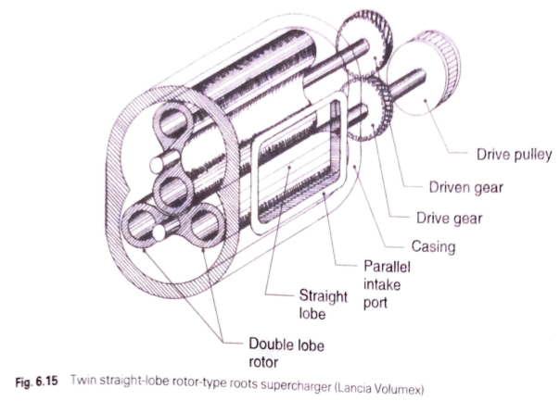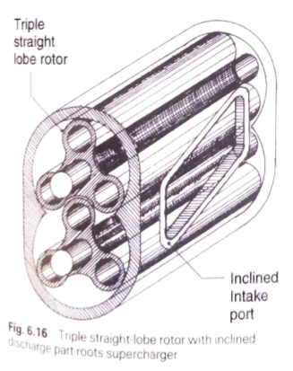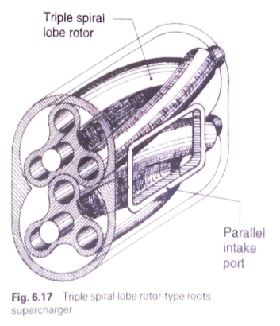
Figure 53: Comparison of basic Roots outlet port design over time (Heisler, 1995)
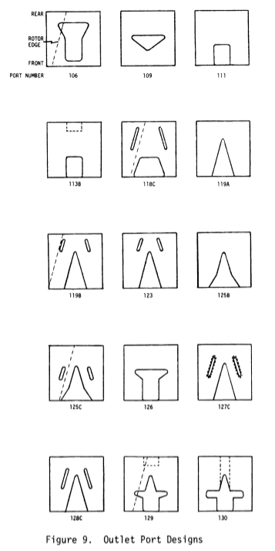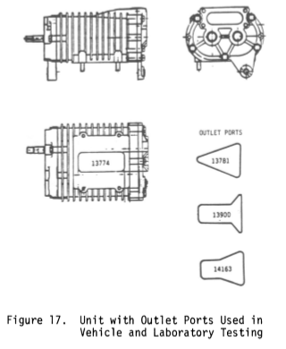
Figure 54: Comparison of outlet designs to reduce backflow compression noise (Uthoff & Yakimow, 1987)

Appendix 1.2: Example of spreadsheet relating to thermodynamic interactions of compressive work.
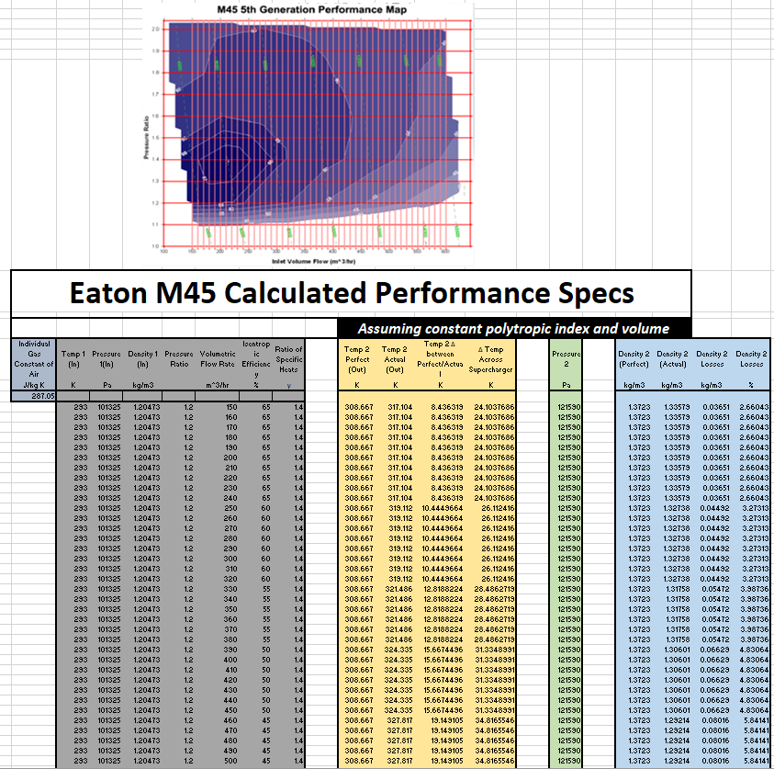
Figure 55: Example of spreadsheet calculations for compressive work

Appendix 1.3: “Experiment 2” methodology used for the “real-world” portion of the intercooler work shown in section 4.3
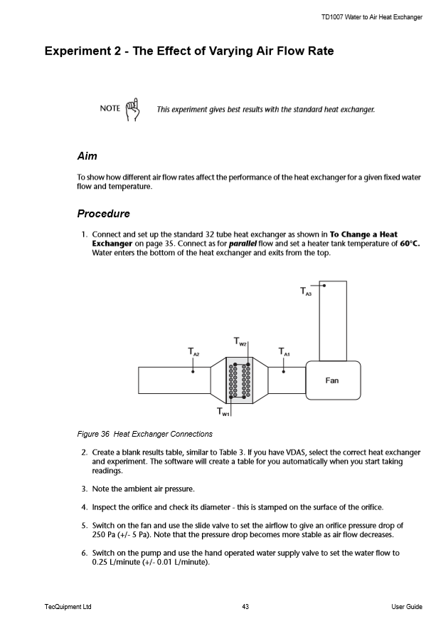
Figure 56: Page 1: Experiment methodology for "Experiment 2" taken from TD1007 Operators manual (TecQuipment, 2014)
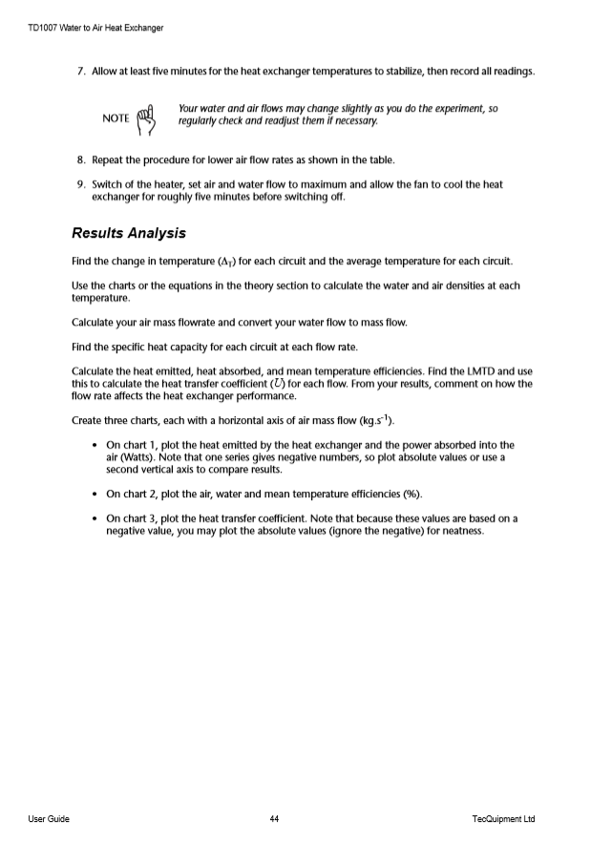
Figure 57: Page 2: Experiment methodology for "Experiment 2" taken from TD1007 Operators manual (TecQuipment, 2014)

Appendix 1.4: Full input settings used for generation of CFD model generated directly by Solidworks 2019 Flow Simulation software
INPUT DATA
Global Mesh Settings
Automatic initial mesh: Off
Basic Mesh Dimensions
Number of cells in X | 100
Number of cells in Y | 30
Number of cells in Z | 15
Control Planes
Control planes in X direction
Name | Minimum | Maximum | Number of cells | Ratio
X1 | -0.469 | 0.447 | - | 1.0000000
Control planes in Y direction
Name | Minimum | Maximum | Number of cells | Ratio
Y1 | -0.104 | 0.106 | - | 1.0000000
Control planes in Z direction
Name | Minimum | Maximum | Number of cells | Ratio
Z1 | -0.099 | 0.120 | - | 1.0000000
Solid/Fluid Interface
Small Solid Feature Refinement Level | 0
Curvature Level | 0
Curvature Criterion | 0.318 rad
Tolerance Level | 0
Tolerance Criterion | 0.002 m
Refining cells
Refine fluid cells | Off
Refine partial cells | Off
Refine solid cells | Off

Local Mesh Settings
Local Mesh 1
Components | Water Tubes-18@Heat Exchanger Assembly Water Tubes-55@Heat Exchanger Assembly Water Tubes-45@Heat Exchanger Assembly Water Tubes-22@Heat Exchanger Assembly Water Tubes-37@Heat Exchanger Assembly Water Tubes-16@Heat Exchanger Assembly Water Tubes-35@Heat Exchanger Assembly Water Tubes-24@Heat Exchanger Assembly Water Tubes-39@Heat Exchanger Assembly Water Tubes-30@Heat Exchanger Assembly Water Tubes-47@Heat Exchanger Assembly Water Tubes-49@Heat Exchanger Assembly Water Tubes-1@Heat Exchanger Assembly Water Tubes-20@Heat Exchanger Assembly Water Tubes-28@Heat Exchanger Assembly Water Tubes-53@Heat Exchanger Assembly Water Tubes-43@Heat Exchanger Assembly Water Tubes-6@Heat Exchanger Assembly Water Tubes-8@Heat Exchanger Assembly Water Tubes-41@Heat Exchanger Assembly Water Tubes-12@Heat Exchanger Assembly Water Tubes-4@Heat Exchanger Assembly Water Tubes-26@Heat Exchanger Assembly Water Tubes-2@Heat Exchanger Assembly Water Tubes-65@Heat Exchanger Assembly Water Tubes-57@Heat Exchanger Assembly Water Tubes-61@Heat Exchanger Assembly Water Tubes-14@Heat Exchanger Assembly Water Tubes-63@Heat Exchanger Assembly Water Tubes-51@Heat Exchanger Assembly Water Tubes-59@Heat Exchanger Assembly Water Tubes-32@Heat Exchanger Assembly
Solid/fluid interface | Small Solid Feature Refinement Level: 0  Curvature Level: 0  Curvature Criterion: 0.318 rad  Tolerance Level: 0  Tolerance Criterion: 0.002 m
Refining cells | Refine fluid cells: Off  Refine solid cells: Off  Refine partial cells: Off
Narrow channels | Advanced narrow channel refinement: Off
Computational Domain
Size
X min | -0.469 m
X max | 0.447 m
Y min | -0.104 m
Y max | 0.106 m
Z min | -0.099 m
Z max | 0.120 m
X size | 0.916 m
Y size | 0.210 m
Z size | 0.219 m
Boundary Conditions
2D plane flow | None
At X min | Default
At X max | Default
At Y min | Default
At Y max | Default
At Z min | Default
At Z max | Default
Physical Features
Heat conduction in solids: On
Heat conduction in solids only: Off
Radiation: Off
Radiation in gases: Off
Time dependent: On
Gravitational effects: Off
Rotation: Off
Flow type: Laminar and turbulent
Cavitation: Off
High Mach number flow: Off
Free surface: Off
Default roughness: 0 micrometer
Default outer wall condition
Heat transfer coefficient: 0 W/m^2/K
External fluid temperature: 20.05 °C
Initial Conditions
Thermodynamic parameters | Static Pressure: 101367.00 Pa  Temperature: 19.00 °C
Velocity parameters | Velocity vector  Velocity in X direction: 0 m/s  Velocity in Y direction: 0 m/s  Velocity in Z direction: 0 m/s
Solid parameters | Default material:Steel (Mild)  Initial solid temperature: 19.00 °C

Material Settings
Fluids
Air, Water
Solids
Steel (Mild), Silicone, Acrylic (Medium-high impact), Plain Carbon Steel, AISI Type 316L stainless steel, Copper
Fluid Subdomains
WATER SUB-DOMAIN
Fluids | Water
Faces | Face<1>@Tube Joiners-1 Face<1>@Tube Joiners-30
Coordinate system | Global coordinate system
Reference axis | X
Thermodynamic Parameters | Static Pressure: 101367.00 Pa  Temperature: 19.00 °C
Velocity Parameters | Velocity in X direction: 0 m/s  Velocity in Y direction: 0 m/s  Velocity in Z direction: 0 m/s
Turbulence parameters type: | Turbulence intensity and length
Intensity | 2.00 %
Length | 4.800e-04 m
Flow type | Laminar and Turbulent
Cavitation | Off
AIR SUB-DOMAIN
Default fluid type | Gas/Steam/Real Gas
Fluids | Air
Faces | Face<1>@Heat Exchanger to Duct Taper-1
Coordinate system | Face Coordinate System
Reference axis | X
Thermodynamic Parameters | Static Pressure: 101367.00 Pa  Temperature: 19.00 °C
Velocity Parameters | Velocity in X direction: 0 m/s  Velocity in Y direction: 0 m/s  Velocity in Z direction: 0 m/s
Turbulence parameters type: | Turbulence intensity and length
Intensity | 2.00 %
Length | 4.800e-04 m
Flow type | Laminar and Turbulent
Humidity | On
Relative humidity | 50.00 %
Solid Materials
Silicone
Components | Tube Holder to Frame Gasket-6@Heat Exchanger Assembly Tube Joiners-26@Heat Exchanger Assembly Tube Joiners-8@Heat Exchanger Assembly Feedside Tube Joiners-18@Heat Exchanger Assembly Tube Joiners-24@Heat Exchanger Assembly Tube Joiners-10@Heat Exchanger Assembly Feedside Tube Joiners-16@Heat Exchanger Assembly Tube Joiners-28@Heat Exchanger Assembly Tube Joiners-12@Heat Exchanger Assembly Tube Joiners-2@Heat Exchanger Assembly Feedside Tube Joiners-6@Heat Exchanger Assembly Heat Exchanger to Duct Taper Gasket-1@Heat Exchanger Assembly Heat Exchanger to Duct Taper Gasket-2@Heat Exchanger Assembly Tube Holder to Frame Gasket-4@Heat Exchanger Assembly Feedside Tube Joiners-1@Heat Exchanger Assembly Feedside Tube Joiners-28@Heat Exchanger Assembly Feedside Tube Joiners-4@Heat Exchanger Assembly Feedside Tube Joiners-24@Heat Exchanger Assembly Feedside Tube Joiners-12@Heat Exchanger Assembly Tube Joiners-30@Heat Exchanger Assembly Duct Taper to Duct Gasket-1@Heat Exchanger Assembly Duct Taper to Duct Gasket-2@Heat Exchanger Assembly Tube Holder to Frame Gasket-2@Heat Exchanger Assembly Feedside Tube Joiners-2@Heat Exchanger Assembly Tube Joiners-4@Heat Exchanger Assembly Tube Holder to Frame Gasket-1@Heat Exchanger Assembly Tube Joiners-22@Heat Exchanger Assembly Tube Joiners-18@Heat Exchanger Assembly Tube Joiners-20@Heat Exchanger Assembly Feedside Tube Joiners-14@Heat Exchanger Assembly Tube Joiners-16@Heat Exchanger Assembly Tube Joiners-1@Heat Exchanger Assembly Feedside Tube Joiners-10@Heat Exchanger Assembly Feedside Tube Joiners-8@Heat Exchanger Assembly Tube Joiners-14@Heat Exchanger Assembly Feedside Tube Joiners-22@Heat Exchanger Assembly Feedside Tube Joiners-20@Heat Exchanger Assembly Tube Joiners-6@Heat Exchanger Assembly
Solid substance | Silicone
Plain Carbon Steel
Components | Heat Exchanger to Duct Taper-1,2, Fan Side Duct-1, Atmos Side Duct-1, Heat Exchanger Frame-1,
Solid substance | Plain Carbon Steel
AISI Type 316L stainless steel
Components | Probe Simulation-1, Probe Simulation-6
Solid substance | AISI Type 316L stainless steel

Acrylic (Medium-high impact)
Components | Perspex Tube Mounts-1
Solid substance | Acrylic (Medium-high impact)
Acrylic (Medium-high impact) 2
Components | Perspex Tube Mounts-2
Solid substance | Acrylic (Medium-high impact)
Copper
Components | Water Tubes-1 to 32
Solid substance | Copper
Boundary Conditions
AIR IN
Type | Inlet Mass Flow
Faces | LID28-1/Imported1//Face
Coordinate system | Face Coordinate System
Reference axis | X
Flow parameters | Flow vectors direction: Normal to face  Mass flow rateTable #1  Fully developed flow: Yes
Thermodynamic parameters | Approximate pressure: 101367.00 Pa  Temperature type: Temperature of initial components  TemperatureTable #2
AIR OUT
Type | Environment Pressure
Faces | LID37-1/Imported1//Face
Coordinate system | Face Coordinate System
Reference axis | X
Thermodynamic parameters | Environment pressure: 101367.00 Pa  Temperature type: Temperature of initial components  TemperatureTable #3
Turbulence parameters | Boundary layer parameters
Boundary layer type: Turbulent
WATER IN
Type | Inlet Mass Flow
Faces | LID30-1/Imported1//Face LID32-1/Imported1//Face
Coordinate system | Global coordinate system
Reference axis | X
Flow parameters | Flow vectors direction: Normal to face  Mass flow rateTable #4  Fully developed flow: Yes
Thermodynamic parameters | Temperature type: Temperature of initial components  TemperatureTable #5
WATER OUT
Type | Outlet Mass Flow
Faces | LID29-1/Imported1//Face LID31-1/Imported1//Face
Coordinate system | Global coordinate system
Reference axis | X
Flow parameters | Flow vectors direction: Normal to face  Mass flow rateTable #6
Calculation Control Options
Finish Conditions
Finish Conditions | If one is satisfied
Maximum physical time | 2250.000 s
Solver Refinement
Refinement level | 3
Approximate maximum cells | 1500000
Refinement strategy | Tabular refinement
Units | Travels
Relaxation interval | 0.200
Refinements | 1, 2
Results Saving
Save before refinement | On
Periodic Saving | Units: Iterations  Period: 5
Advanced Control Options
Manual time step (Freezing): Off Manual time step: 5.000 s
Engineering Database
Solids
Steel (Mild)
Path: Solids Pre-Defined\Alloys
Density: 7870.00 kg/m^3
Specific heat: 472.0 J/(kg*K)
Conductivity type: Isotropic
Thermal conductivity: 51.9000 W/(m*K)
Electrical conductivity: Conductor
Resistivity: 1.7400e-07 Ohm*m
Radiation properties: No
Melting temperature: Yes
Temperature: 1400.00 °C
Silicone
Path: Solids Pre-Defined\Building Materials\Insulating Materials
Density: 700.00 kg/m^3
Specific heat: 1004.0 J/(kg*K)
Conductivity type: Isotropic
Thermal conductivity: 0.1800 W/(m*K)
Electrical conductivity: Dielectric
Radiation properties: No
Melting temperature: Yes
Temperature: 726.85 °C
Acrylic (Medium-high impact)
Path: Solids User Defined\SOLIDWORKS Material
Density: 1200.00 kg/m^3
Specific heat: 1500.0 J/(kg*K)
Conductivity type: Isotropic
Thermal conductivity: 0.2100 W/(m*K)
Electrical conductivity: Dielectric
Radiation properties: No
Melting temperature: No

Plain Carbon Steel
Path: Solids User Defined\SOLIDWORKS Material
Density: 7800.00 kg/m^3
Specific heat: 440.0 J/(kg*K)
Conductivity type: Isotropic
Thermal conductivity: 43.0000 W/(m*K)
Electrical conductivity: Dielectric
Radiation properties: No
Melting temperature: No
AISI Type 316L stainless steel
Path: Solids User Defined\SOLIDWORKS Material
Density: 8027.00 kg/m^3
Specific heat: 450.0 J/(kg*K)
Conductivity type: Isotropic
Thermal conductivity: 14.6000 W/(m*K)
Electrical conductivity: Dielectric
Radiation properties: No
Melting temperature: No
Copper
Path: Solids User Defined\SOLIDWORKS Material
Density: 8900.00 kg/m^3
Specific heat: 390.0 J/(kg*K)
Conductivity type: Isotropic
Thermal conductivity: 390.0000 W/(m*K)
Electrical conductivity: Dielectric
Radiation properties: No
Melting temperature: No

Gases
Air

Path: Gases Pre-Defined
Gases
Air
Path: Gases Pre-Defined
Specific heat ratio (Cp/Cv): 1.399
Molecular mass: 0.0290 kg/mol

Liquids
Water
Path: Liquids Pre-Defined

Cavitation effect: Yes
Temperature: -273.15 °C
Saturation pressure: 0 Pa
Radiation properties: No

Dependencies

Appendix 1.5: Raw Performance Maps for Eaton M-series superchargers
Figure 58: M45 Performance Map
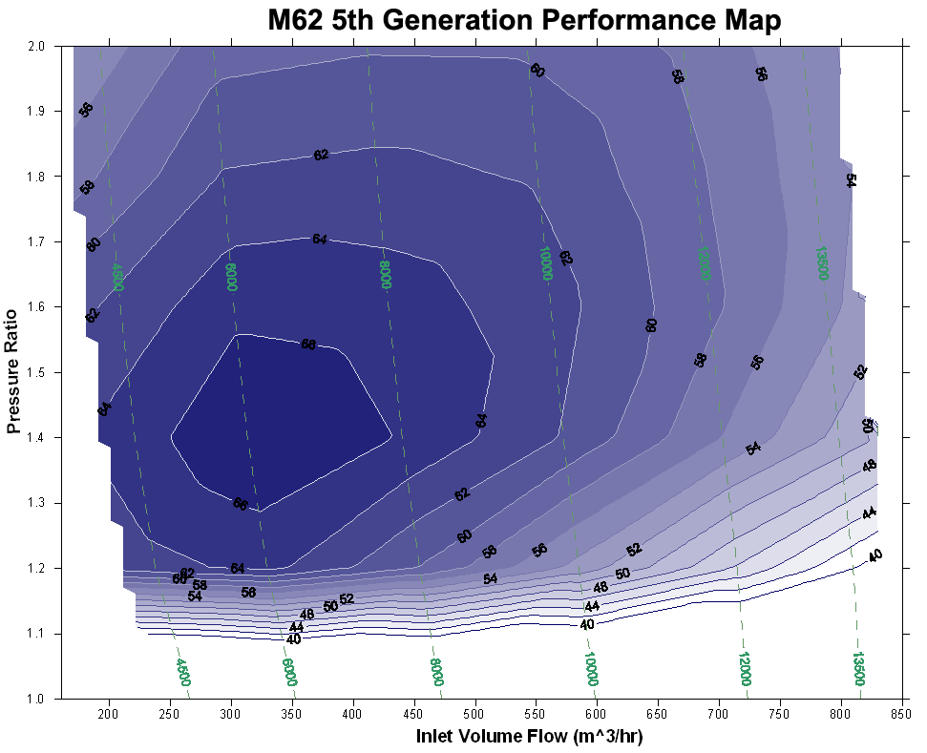
Figure 59: M62 Performance Map
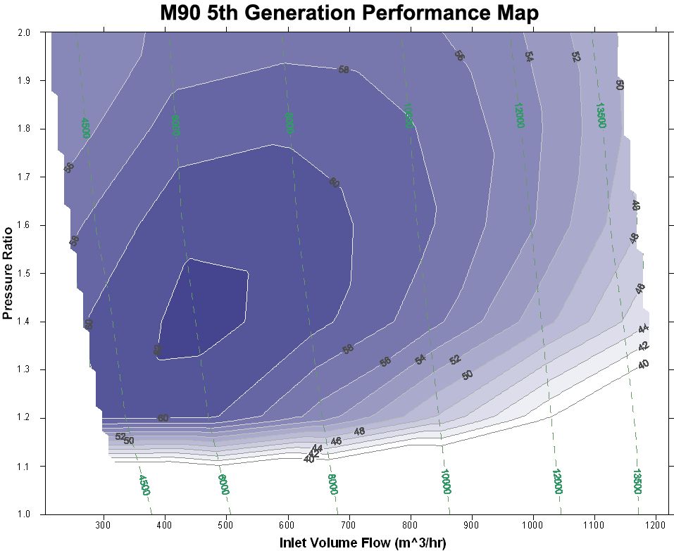
Figure 60: M90 Performance Map
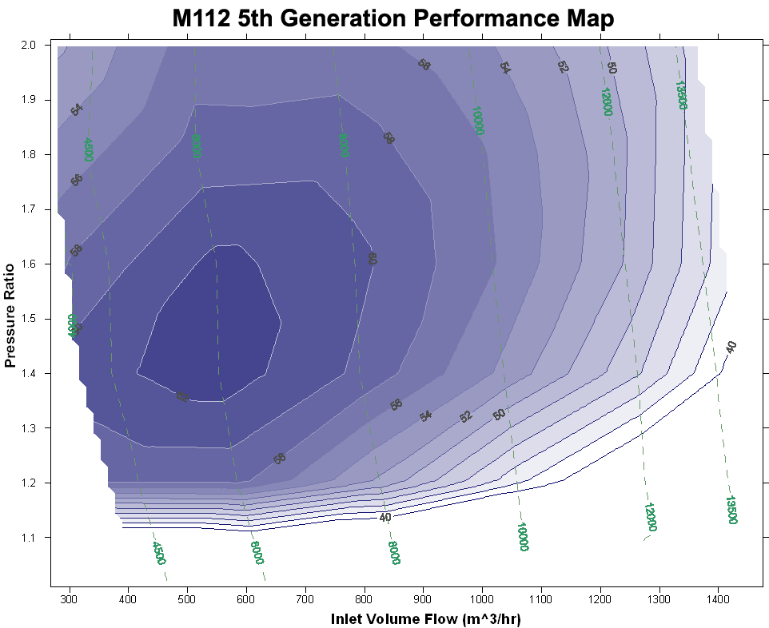
Figure 61: M112 Performance Map

Appendix 1.6: Raw Performance Maps for MHI TD Series turbo-superchargers
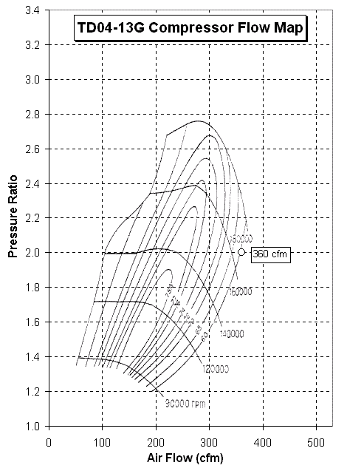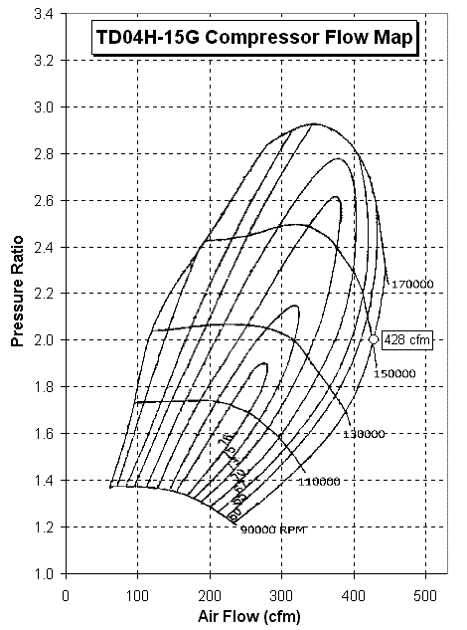
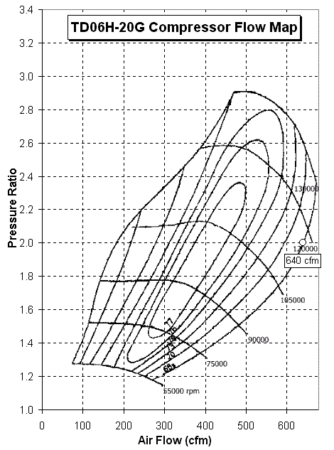
Figure 62: MHI TD-series Turbo Performance Maps

Appendix 1.7: M-series comparison at differing pressure ratios
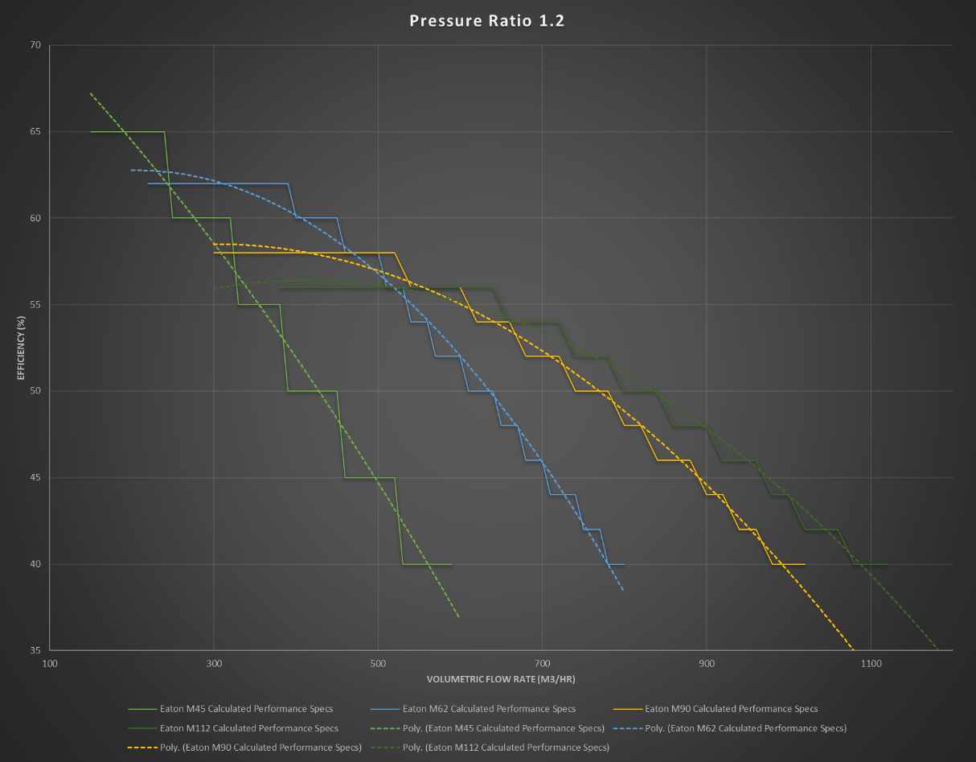
Figure 63: M-Series Performance Comparison at 1.2Π
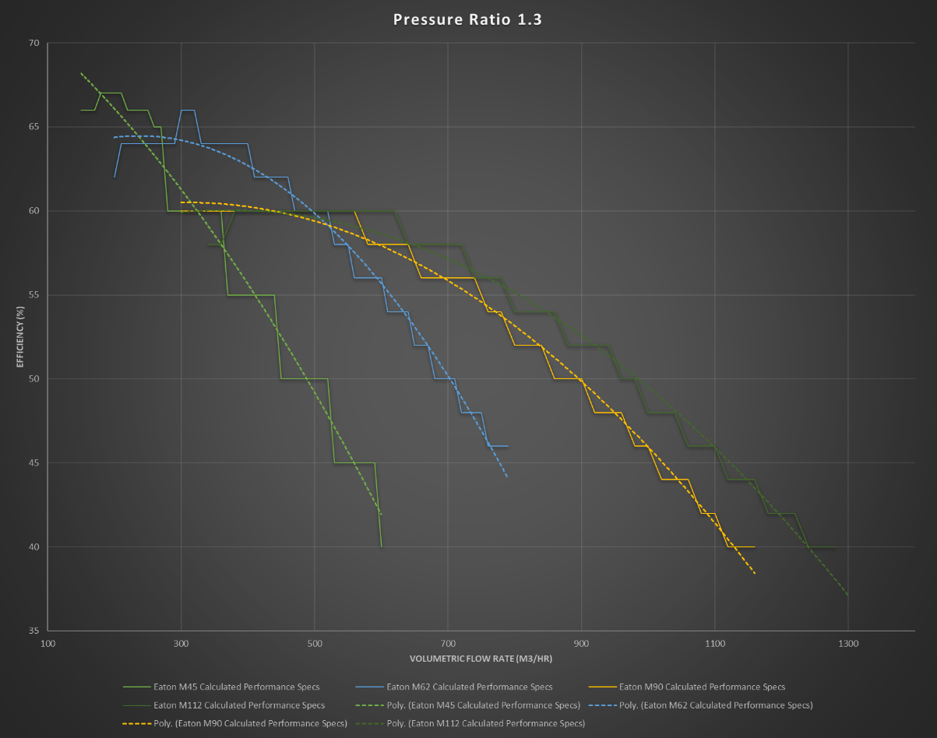
Figure 64: M-Series Performance Comparison at 1.3Π
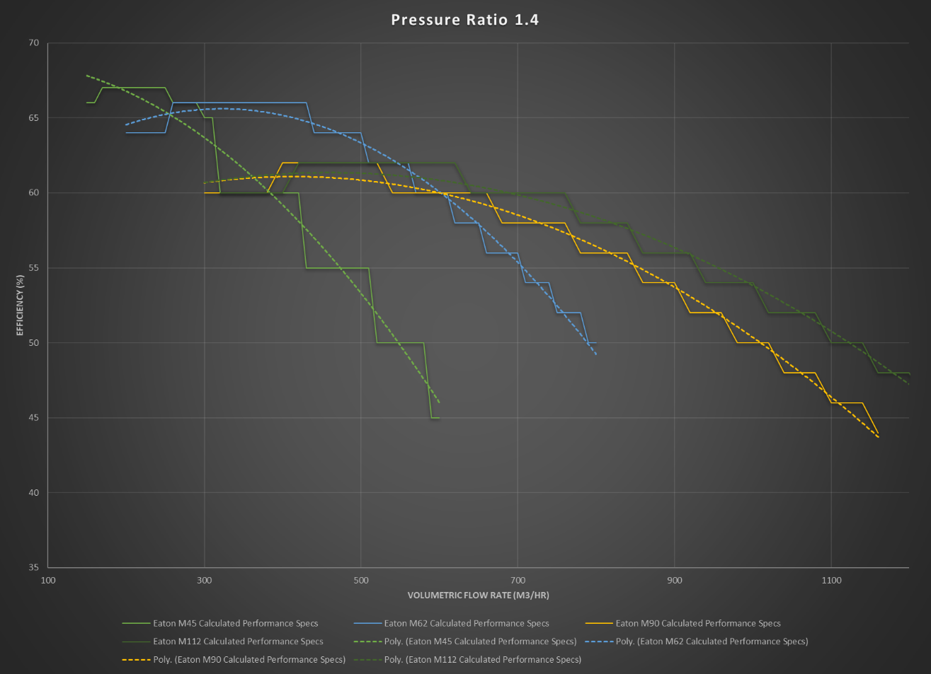
Figure 65: M-Series Performance Comparison at 1.4Π
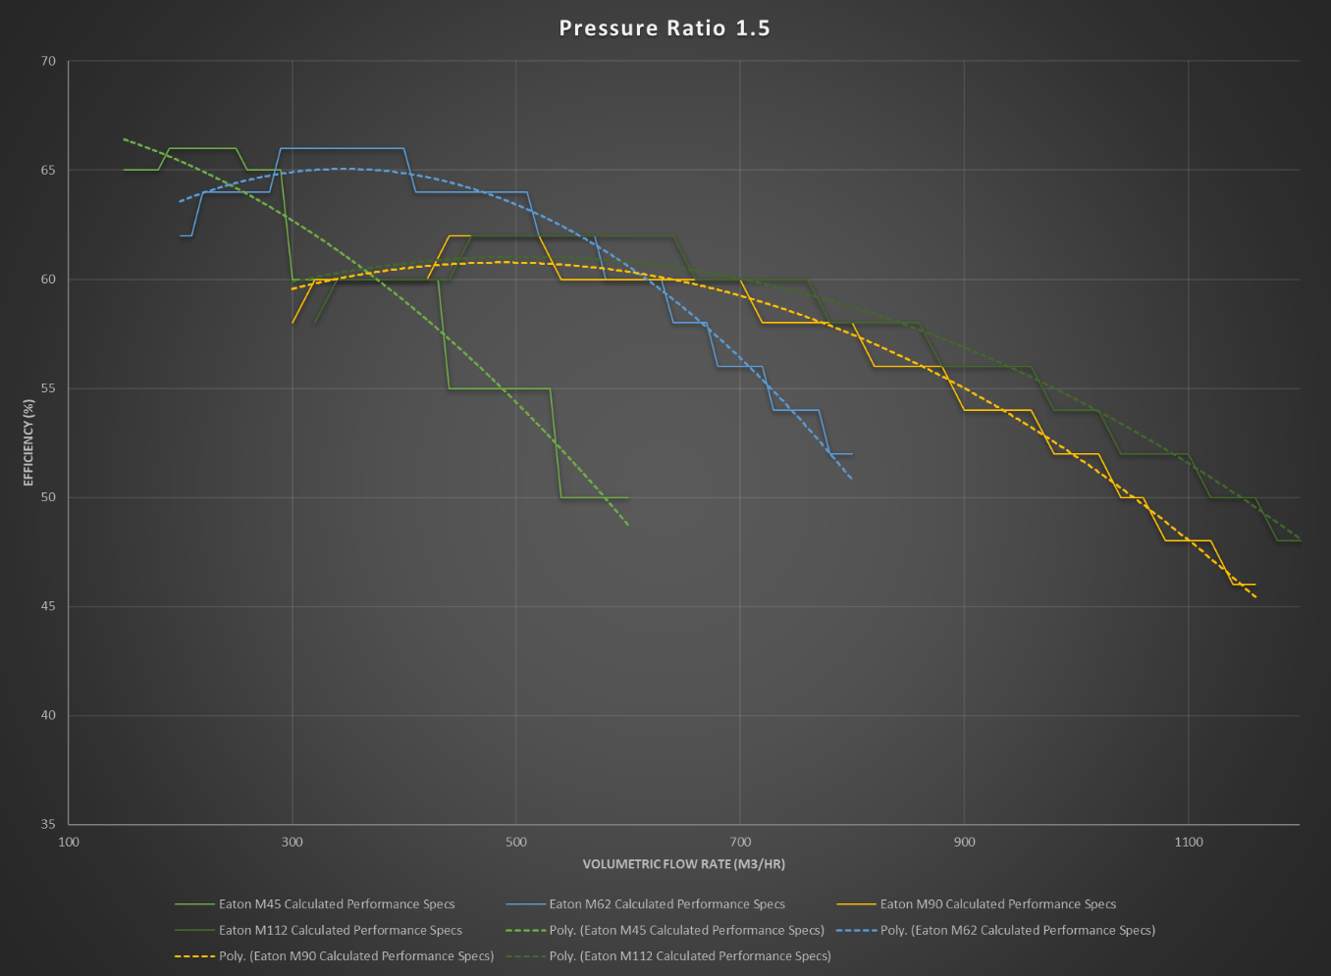
Figure 66: M-Series Performance Comparison at 1.5Π
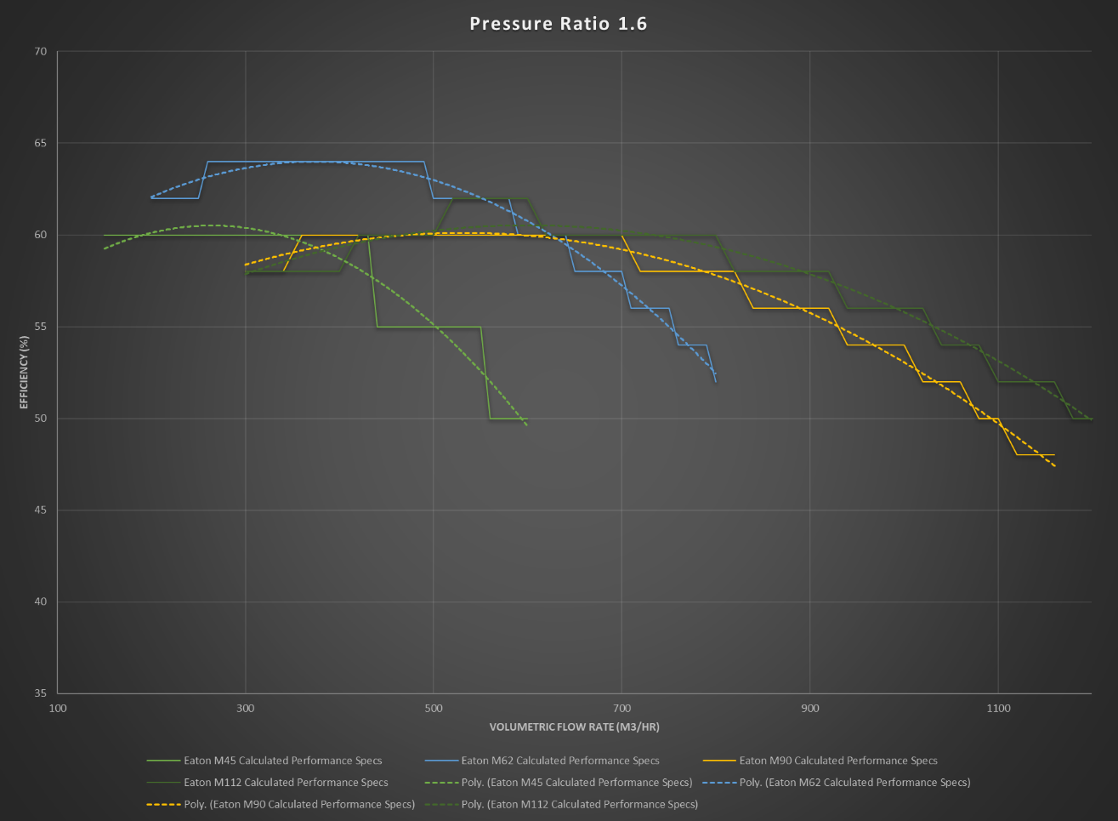
Figure 67: M-Series Performance Comparison at 1.6Π
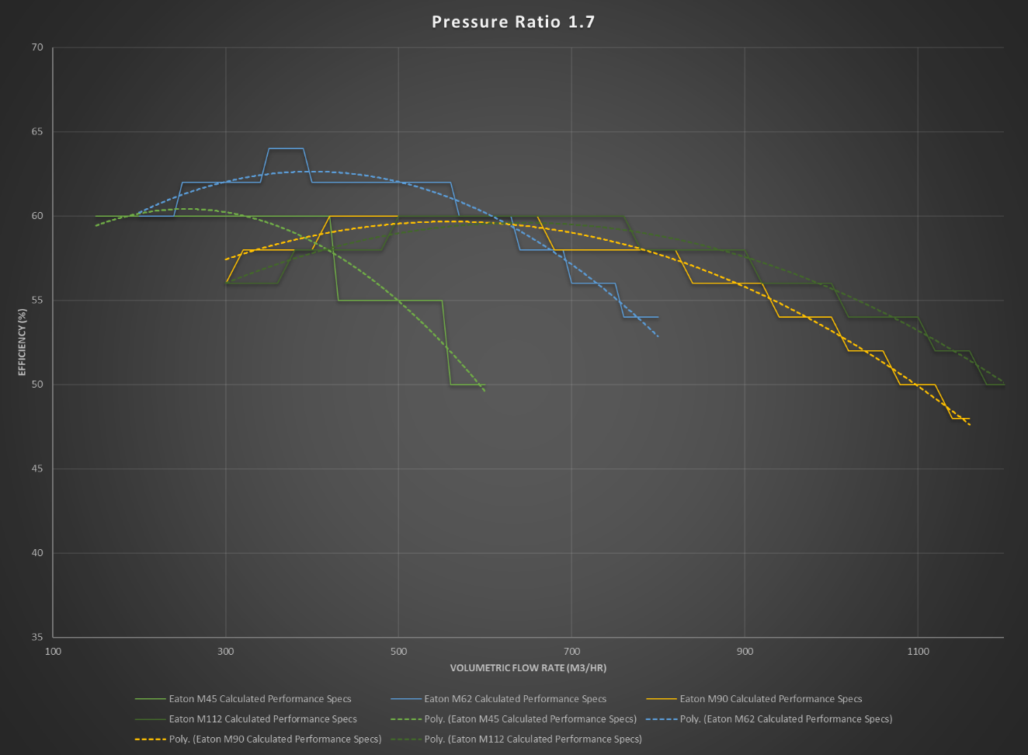
Figure 68: M-Series Performance Comparison at 1.7Π
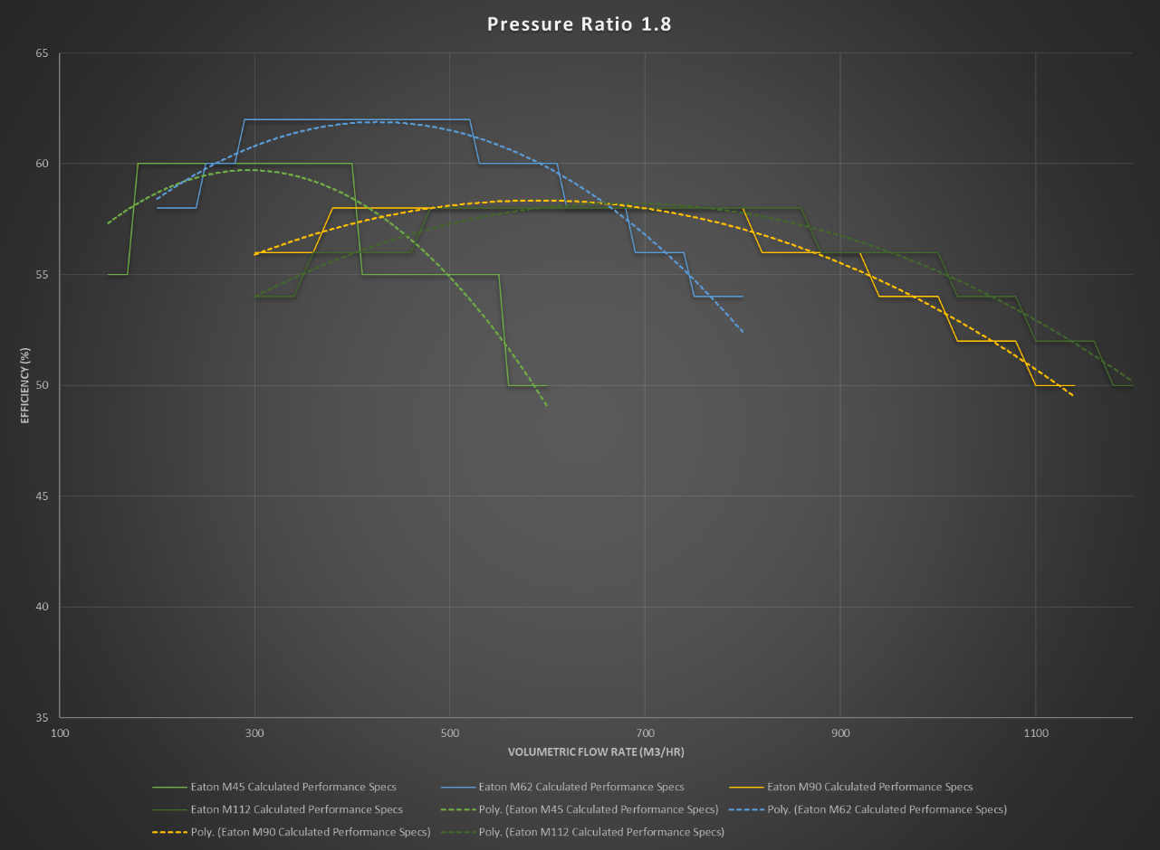
Figure 69: M-Series Performance Comparison at 1.8Π
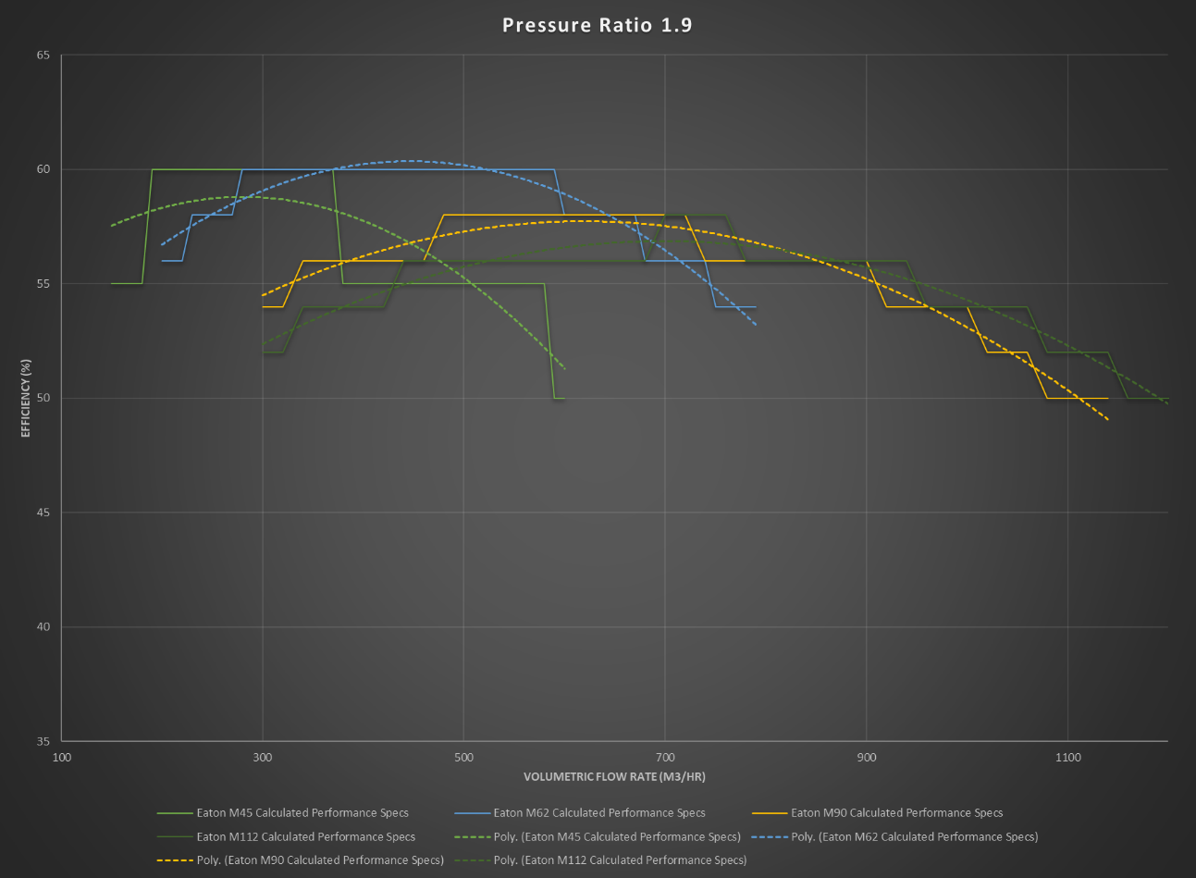
Figure 70: M-Series Performance Comparison at 1.9Π

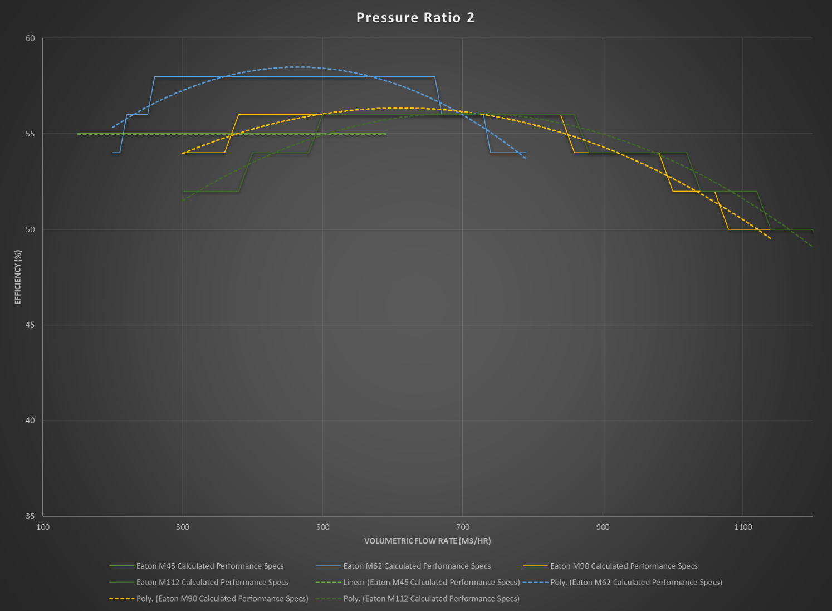
Figure 71: M-Series Performance Comparison at 2.0Π

Appendix 1.8: The London Taxi Company TX4 Intercooler Spec Sheet
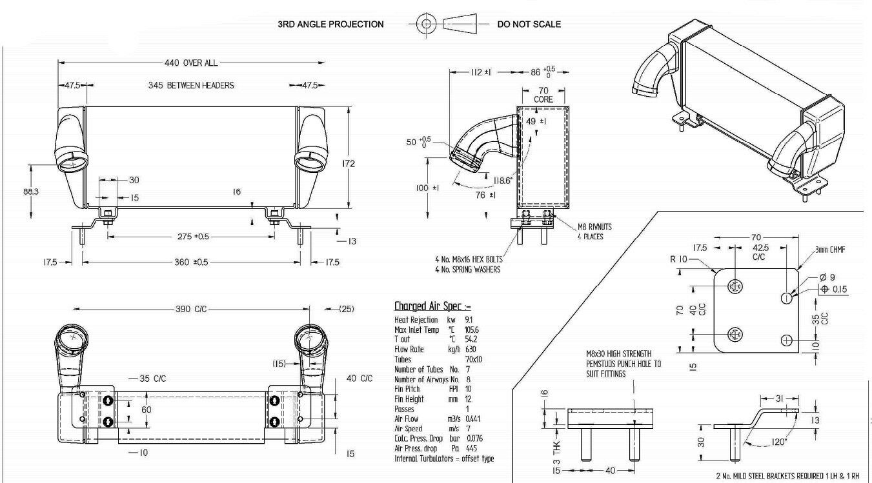
Figure 72: The London Taxi Company TX4 Intercooler Spec Sheet]

For the purposes of the work shown in this paper the “Internal Combustion Engine” (ICE) considered will be that of the reciprocating piston, spark ignition, “Otto Cycle” engine.
Hereafter referred to as “turbos” or “turbo-superchargers”.
1916 and 1918 respectively, both are credited with the founding of the theory, although due to The First World War they were unaware of each other’s work.
Patented 1st April 1886, DRP34926, although a four-stroke engine, the supercharging operates in the manner of a two stroke with compressive work occurring below the piston and then being transferred to the combustion chamber above the piston via valved port.
Meaning that the two fluid flows travel roughly perpendicular to each other in separate sub-domains and only intersect once rather than one or more of the subdomains travelling back and forth across the opposing sub-domain. (Sub-domain referring to the separate systems of fluids in the heat exchanger itself)
If this is to be applied to a more realistic scenario the Van der Waals Equation of State $\left(P+\frac{a}{V^{2}}\right)\left(V-b\right)=RT$ (Roberts & Miller, 1928) must be considered. For the purposes of this work it will be assumed that the gas is “Ideal” not “Real” (where “a” and “b” are constants related to the given constants related to the gas being studied).
A combination of Avogadro’s, Boyle’s, Charles’ and Gay-Lussac’s Laws relating to “Ideal” Gases.
Due to the relationships shown in Cengel’s book: $R= \frac{R_{u}}{M}$ and $m=Mn$
Using the $PV=mRT$ relationship.
This area of study was affected by the outbreak of (SARS-CoV-2) and the premature closure of the university campus and the effects of this will be further explored in “Further Work and Pandemic Impact”
To see a comparison of port geometries over the development lifetime of the Roots supercharger see Appendix 1.1
For an isochoric process the value of “n” can be considered to be +∞ as there is no volume change and the curve of the graph will intersect the x-axis perfectly perpendicular (Connor, 2019).
“Perfect” meaning an idealized case at 100% efficiency, “Actual” meaning a more realistic case accounting for empirically garnered compressor efficiency. No heat transfer work out of the system has been considered here due to the complex nature of the systems boundaries and as air is primarily composed of diatomic gases with 5 degrees of freedom the value of γ can be considered as $\frac{7}{5}=1.4$ due to the relationship $γ=1+\frac{2}{f}$ .
The justification for this method of work is that to design an experiment to accurately understand the thermodynamic behaviour of a real-world intercooler in the second half of the degree year would have proved costly and uneconomical from a time standpoint.
This second point of work was unfortunately interrupted by the events surrounding the outbreak of the global Pandemic of SARS CoV-2 (Covid-19). The details of this are further explained in section 6 “Further Work and Pandemic Impact”.
This work was mostly carried out on the Heat Exchanger experiment as the Intercooler work was intended to happen primarily after the real-world experiment had be correlated to the CFD.
The angle of expansion and reduction seen in the heat exchanger chamber is approximately 25° from the normal plane of flow each side meaning that, if the CFD model is displaying the correct flow characteristics, boundary layer separation should occur upon the airflows ingress into the heat exchanger section of the geometry. Typically flow separation occurs at anything greater than a 5-7° degree change in geometry (Tudor, 2020).
This was set to be modified due to complexity issues just prior to the outbreak of the pandemic and is detailed further in section 6.
The recorded ΔP values not matching the “goal” values or repeated to provide averages is arbitrary as these were used as inputs for the CFD model and for further calculations. The goals are solely to follow the official experiment methodology and the values are purely to provide a corroboration benchmark for the CFD model.
Seen in the leftmost image of Figure 23.
This is due to the nature of “meshing” a CFD model, the geometry is considered as a static set of boundaries with fluid and solid regions, to create a movable component the system would have to calculate an iterative set of meshes for each increment of movement of the solid geometry and then accommodate with changes in the fluid mesh per increment of movement. One can imagine this would take an extremely complex and large set of calculations if it is considered that this particular “static study” saw approximately 750,000 cells/elements alone.
This was done in the hope that replicating the time-steps and conditions seen in the real-world experiment would provide similar results from the CFD model to those seen at the different time steps as the real-world experiment.
An important note here is that this was a learning process, it took many iterations and modifications of the process described here to produce the results seen in this work.
In the representation of percentage difference for these results a negative value implies that the value seen in the virtual experiment was lesser than, colder or slower than the real-world experiment.

