Student name: | Ethan Tom Smith | Student ID number: | 2311689
Programme: | Foundation Degree Inclusive Education
Module: | Learning in the Digital Era
Module code: | ECIE4009 | Contribution to Overall Module Assessment (%): | 50%
Lecturer: | Heike Griffiths | Internal Verifier: | C Hunt
Assignment Title: | Evidence of Learning E-Portfolio (2 elements) | Word count (or equivalent): | 1500
Submission deadline: | 29.10.2023 | Return date of provisional marks & written feedback: | 24.11.2023

Contents Page.

Page 1 – Title Page.
Page 2 – Contents Page.
Page 3 – 4 – Element 1.
Page 5 – Element 1 Reference List.
Page 6 – Element 2.
Page 7 – Element 2 Reference List.

Element 1: Blog – What is good time management?

The meaning and importance of good time management.
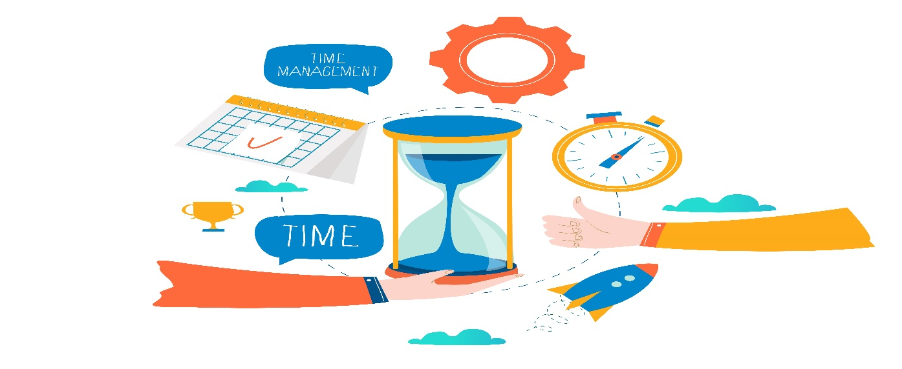(Vecteezy, N.D)

“Time management is the co-ordination of tasks and activities to maximise the effectiveness of individuals efforts” (Lutkevich, 2023).

It is not uncommon for people to feel like there is not enough time for them to complete the tasks that they intend to for fill throughout the day, and it is in situations like these that emphasize the importance of proper time management.

Time management can present itself in different ways depending on the work or setting that you encounter daily.

So, what does good time management look like to you?
Good time management is the ways you input different strategies into your daily routine that will help you get the things you need done in enough time, you can do this by planning and organising your day to ensure that you leave enough time for jobs or tasks that you need to complete and how much time you should spend on each individual task to ensure time is saved. This ensures that you are able to get more done in less time all thanks to good time management! (CPD, 2020)!

Anyone can implement these strategies into their planning. By making these changes and understanding how to manage your time more efficiently can change your outcomes produced. Everyone needs to make the change and become a good time management!

Good time management can be learnt by anyone, you today can help develop your time management skills which will benefit you in your daily life.

Strategies that you could develop on to ensure that you have the best time management to help you along the way could be for example, setting time goals, this is to ensure you understand the tasks needed to be completed by a certain time/date ready for you to move onto the next task.
You could write a daily plan that allows you to know what you are doing on that day to ensure these tasks are done. This allows you to see daily plans and ensure that you have the tasks needing to be completed sooner. Being completed on the soonest day possible.
Also prioritizing tasks depending on the timeframe you must complete it. If you have a book you need to write about within two weeks and one that needs to be done within 5 days ensure you prioritize the that needs to be written about sooner to ensure you have enough time to complete both. (Skills You Need, 2020).

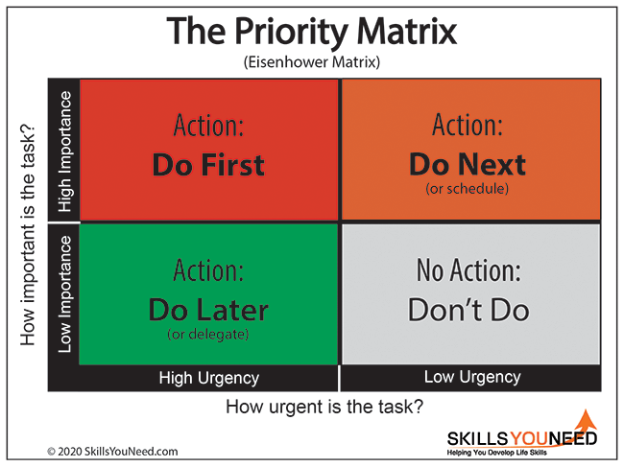
Good time management is a professional skill that nearly everyone needs to include in their daily routine. As you can see from the article written by Indeed, they say “Managing your time effectively is an important professional skill to develop” this makes us as the reader understand that having good time management can lead us to accomplishing our key goals in life. (Keiling, 2023).
In my opinion good time management helps me daily, as I work in a school setting, I have lots of tasks that need to be completed daily or within a certain timeframe. By implementing these strategies that I have previously spoken about I am able to get the tasks done within time and stress free, this ensures that my daily routine runs smoothly and that’s the best way to be, Isn’t it?
Lastly, to conclude I think we all need to take this information and use it to become at time management, as seen we could all benefit from this in our daily routines and would ensure a lot of aspects of our work and our home life runs a lot smoother.
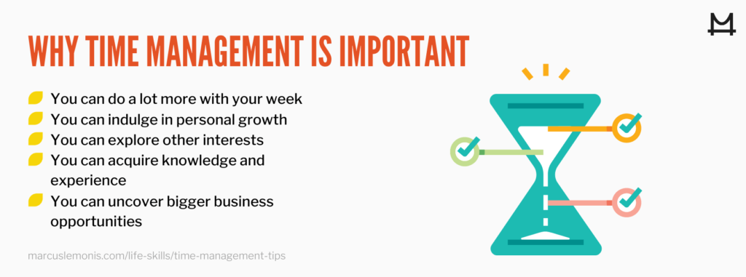 (Team, N.D)

References
CPD. (2020). What is good time management? Retrieved from CPD: https://cpduk.co.uk/news/what-is-good-time-management
Keiling, H. (2023, July 31). 9 Key Time Management Skills and How To Improve Them. Retrieved from Indeed.com: https://www.indeed.com/career-advice/career-development/time-management-skills
Skillsyouneed.com. (2020). Skills You Need. Retrieved from Time Management Skills: https://www.skillsyouneed.com/ps/time-management.html
Team, M. L. (N.D). Business Learning. Retrieved from Essential Time Management Tips: https://marcuslemonis.com/life-skills/time-management-tips
Vecteezy. (N.D). Time management Pro Vector. Retrieved from https://www.vecteezy.com/vector-art/272070-time-management
Whatls.com. (2023). Time Management. Retrieved from Whatls.com: https://www.techtarget.com/whatis/definition/time-management

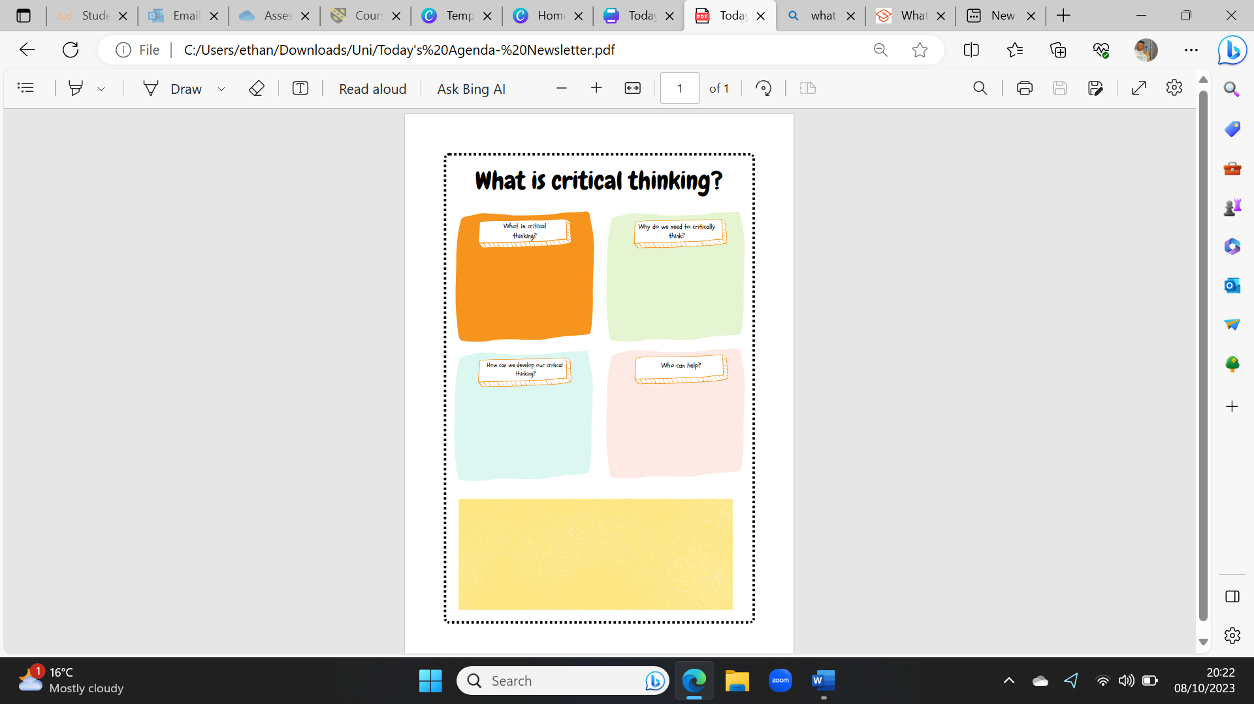
Element 3: Academic Poster – What is critical thinking and how can it be developed?

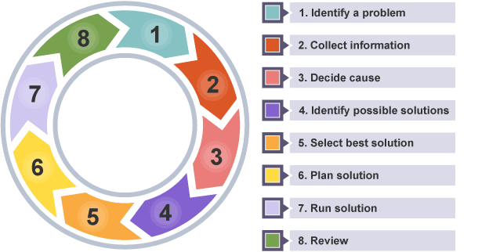
“Critical thinking is the ability to effectively analyse information and form a judgment.” (Ryan, 2022)
This means that the person can look in depth at the information and understand how they feel about the information that has been provided. This is a much in-depth way of just reading information.
(BBC Bitesize, N.D)

Why do we need to be able to critically think you ask? Well, the importance of critical thinking can help you ready for when you start to work this is because it allows you to gain a better judgement of the information that you were able to analyse. It also helps younger people who are doing exams as it helps them understand the information more as they can analyse the information in much more depth ready to sit exams. Overall, it is a great skill to have that can be used daily to help us all. (Holley, 2022)

Who can help you? Only YOU can help develop your critical thinking. If you want to improve the way you critically think, use this poster and the information to make a start. This will all help you change the way you think about these situations and how you use the information provided!
Ways that we can help develop our critical thinking are:
- Formulating your question, this is to approach the situation and outcome you want and decide if the information suits your needs.
- Gather information which will make sure you look at more than just the information provided.
- Think of the outcomes before you use the information you have gathered to ensure the situation will work.
- Explore different points of views to ensure you look at the information from how others would too, this ensures that all aspects have been thought about. (Agoos, 2016)

(Literacy Pathway, 2020)
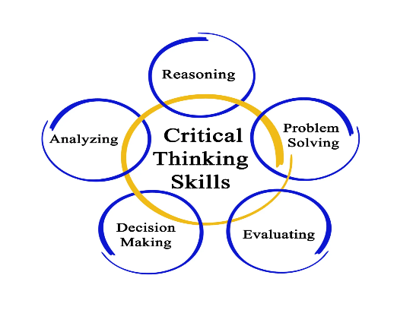

References
Agoos, S. (2016, 15 March). 5 tips to improve your critical thinking. Retrieved from Ted-Ed YouTube: https://www.youtube.com/watch?v=dItUGF8GdTw
BBC Bitesize. (N.D). Critical thinking and problem solving. Retrieved from BBC Bitesize: https://www.bbc.co.uk/bitesize/guides/zcjhfcw/revision/1
Holley, M. (2022, March). The Importance of Critical Thinking. (TEDxYouth, Interviewer)
Literacy Pathway. (2020, January 20). Literacy Pathway. Retrieved from Critical Thinking Skills: https://literacypathway.com/critical-thinking-skills/

