

PROGRAMME: BSC HEALTH AND SOCIAL CARE
MODULE: INTRODUCTION TO PHYSIOLOGY
MODULE CODE: BMHP5023
COMPONENT 1: WRITTEN ASSIGNMENT

STUDENT NAME: Sunitha Peeter
STUDENT No. : 2421161
LECTURER NAME: Robert Nartowski

Abstract
This report discusses the management of Type 2 diabetes, including the process of controlling blood sugar level, the role played by lifestyle management, which includes diet and exercise, smoking cessation and weight management. It underscores evidence-based guidelines to self-managing effectively and achieving a better health outcome. Addressing issues observed due to the Type-2 diabetes can become easier with adequate focus on the strategy and consequences are observed in achieving success.

Table of Contents
1. Overview of Risk Factors and Diabetes 4
2. Control of the Body's Blood Sugar Levels 6
3. Cellular Metabolism: The Function of Glucose and Oxygen in the Generation of Energy 7
4. The Value of Monitoring and Documenting Blood Sugar Levels 8
5. Lifestyle Elements and Research-Based Suggestions 9
Evaluation of the importance of nutrient dense foods 10
Understanding the strategy of successful Carbohydrate intake 11
6. Conclusion 11
Reference List 12

1. Overview of Risk Factors and Diabetes
Diabetes is a chronic disease where there is high concentration of blood sugar owing to the lack of enough insulin production or incompetent use. Type 2 diabetes is the most common variety, primarily affecting adults but also increasingly affecting younger generations. It is strongly linked to lifestyle choices (Misra et al. 2023). It has implications on the body system to control the level of glucose in the body causing long-term complications. Type 2 diabetes develops when the body becomes insulin resistant or fails to produce the necessary amount of insulin to ensure that the sugar levels in the blood are normal.
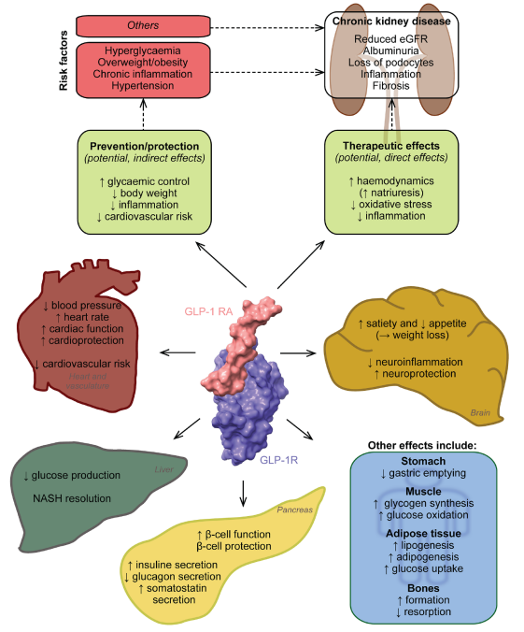
Figure 1: GLP-1 receptor agonists' possible kidney-protective and other effects
(Source: Banerjee, 2023)
Regulation of blood glucose is a complex process and includes the participation of complex hormonal processes, including the effect of GLP-1 and other gut peptides on the regulation of glycaemic levels. The knowledge of these processes, such as the impact of amendments to the lifestyle, might improve management of Type 2 diabetes (Tzeravini et al. 2026). This leads to high glucose levels, which lead to a variety of health problems. Although genetics cause individuals to be predisposed to diabetes, lifestyle, particularly diet, exercising as well as weight control are the most important factors. The most important risk factors of Type 2 diabetes are the age thus it is more prevalent among people older than 45 years. Obesity is another significant risk factor, particularly abdominal obesity, which has an impact on insulin sensitivity (Jurczewska et al. 2023). Genetic predisposition may predispose one to develop Type 2 diabetes particularly when close relatives have the disorder. Poor diet, physical inactivity and smoking lifestyle choices also increase the risk.
Risk factors related to Type 2 Diabetes include physical inactivity, an increase in BMI, weight gain, an increase in lipid profile, and an enhancement in dietary fibre. High blood sugar level has the potential to damage blood vessels, creating a risk of heart attack, stroke, kidney failure, and nerve failure. Diabetic retinopathy has the potential to cause eye damage, and peripheral artery blockage creates the risk of stroke (Jabbar et al. 2024). Type 2 diabetes is a chronic condition categorised by a high level of sugar due to insufficient insulin production. In the case of GP surgery, identification of risk factors is essential to determine the opportunity for better healthcare outcomes. Lifestyle conditions and daily activity evaluation are crucial to deal with the barriers observed in achieving adequate outcomes to deal with Type 2 Diabetes. Therefore, increased blood sugar can create complications in the determination of the overall well-being of an individual.

2. Control of the Body's Blood Sugar Levels
The body majorly obtains energy in the form of glucose that is utilised in normal cellular processes. It is taken in via food and carried by the blood to the tissues where it is either used or stored. Blood glucose metabolism is a fundamental factor that is needed to maintain metabolic stability and energy supply (Yedjou et al. 2023). The pancreas is a major player in the process of maintenance of blood glucose. It secretes insulin, a hormone that reduces the blood glucose levels by making the glucose be absorbed into the cells.
Beta cells are responsive to high blood glucose levels by producing insulin that is the release of insulin following a meal. On the other hand, low levels of blood glucose cause the pancreas to secrete glucagon, which causes the liver to secrete stored glucose to the blood stream thereby increasing the level of glucose (Gunst et al. 2023). Blood sugar balance is a manifestation of homeostasis, where the body is able to maintain a stable internal environment. Insulin and glucagon are linked in a positive feedback mechanism that maintains the blood sugar level in a small range. The strict control maintains normal levels of glucose (non-hyperglycaemic and non-hypoglycaemic). This balance is essential to the normal functioning of the body and especially during such conditions as diabetes.
A safe blood sugar level is maintained with focus on consistent, low-glycemic eating, regular physical activity, and active lifestyle management. Having a low-glycemic diet and regular physical activity can help to determine the scope of well-being by reducing refined sugar. Safe dietary management can become easier with emphasis on the level of fiber in food, and ensure success in overall well-being (Hu, 2024). Stress management needs to focus on cortisol and adrenaline to achieve success in terms of controlling sugar levels. Prevention of high blood sugar levels can help to develop insulin sensitivity and lowering the glucose level can turn out to be possible. Managing carbohydrate intake can help to manage low-glycemic index, and successful monitoring of the blood sugar level becomes easier. It is required to deal with the existing challenges and incorporate the required measures to control Type-2 diabetes. Henceforth, it is required to address the level of insulin and achieve success in the prevention of Type-2 Diabetes in the human body.

3. Cellular Metabolism: The Function of Glucose and Oxygen in the Generation of Energy
Cellular respiration is conducted to convert nutrients into energy by cells, which use oxygen and glucose as the main substances. This occurs in the mitochondria whereby glucose is converted into pyruvate by a process called glycolysis. The pyruvate is then converted in the Krebs cycle to produce the molecules rich in energy such as NADH and FADH2 that are used to drive the electron transport chain. Oxygen is a very essential element in cellular respiration as it is the last electron acceptor in the electron transport chain (Kukurugya et al. 2024). This is necessary to enable the generation of ATP that is the energy currency of the cell that is used to support many functions. Lack of adequate oxygen will result in anaerobic conditions and inability of the cells to produce ATP, hence less energy. The primary energy source for cellular respiration and the supply of the carbon backbone required for energy production is glucose (Long, 2022). ATP is required in various important cellular processes, such as protein synthesis, cell division, and active transport that guarantee the overall functioning and survival of the cell.
The cell creates energy by combining glucose and energy through a process named aerobic cellular respiration, and the process starts at Mitochondria. Oxygen plays a crucial role in cell metabolism in collaboration with the final electron acceptor and helps to produce adenosine triphosphate (ATP). The successful breakdown of nutrients helps in generating energy, and managing the flow of the stages concerned with cell metabolism becomes easier (Chen et al. 2025). Oxygen production with the help of Oxidative Phosphorylation depends on the presence of necessary nutrients in the cell cycle. In the case of nurses working in GP surgery, tracking the level of cell metabolism is one of the crucial components to be considered. Adenosine triphosphate (ATP) serves as the energy currency of the cell, and the adequate breakdown of nutrients appears to be easier (Ouyang et al. 2025). Thus, it is necessary to manage a balance in the energy flow and increase coordination in the energy production in human cells.

4. The Value of Monitoring and Documenting Blood Sugar Levels
Loud glucose is important in the treatment of Type 2 diabetes. Frequent monitoring enables them to see the effects of their lifestyle habits on the level of sugars in the blood. Regularly monitoring blood glucose levels, patients can determine patterns and trends and can be of great importance in determining how food, physical activity, and drugs influence that condition (Pleus et al. 2022). Physical activities, and medication, it is necessary to identify such patterns to make sound judgments regarding dietary changes. It allows people to be proactive and avoid the unsafe drops and spikes in blood sugar levels, which might cause complications.
Blood glucose monitoring also enables patients to work with healthcare providers to adjust their care plans (Ni et al. 2024). Frequent data gathering will result in improved communication with the medical teams, and any alterations of the treatment course can be made on the basis of credible information. Finally, tracking blood sugar is one of the pillars of safe self-management of Type 2 diabetes that enables patients to have the means to sustain good health over time and avoid complications.
Blood sugar tracking in Type 2 diabetes is based on using a glucometer and a Continuous Glucose Monitor (CGM) with enabled logging. Typically, the recording is done within 1-2 hours of having a meal, and managing a 70–180 mg/dL range becomes easier. Management of structured timing is one of the most crucial strategies to track Type 2 diabetes, and insulin intake frequency can be reduced (Boonpattharatthiti et al. 2024). Continuous Glucose Monitoring provides an opportunity to track the parameters in high-stress scenarios, and increasing insights into the process can become possible. It requires the adoption of required measures and determines the opportunity to deal with the constraints in reducing the issue of Type-2 diabetes. It is necessary to address issues observed, and implication is found in dealing with the existing challenge while reducing the consequences of Type-2 diabetes. Therefore, the need is to conduct systematic tracking, and the consequences are observed in determining successful results that can be easier with a focus on the implications of Type-2 diabetes.
The advanced continuous glucose monitoring strategy at present is linked with a pain-free strategy of tracking with SMART technologies. Glucose measurement is associated with the strategy to deal with the barriers and improve the overall performance accuracy (van Leersum et al. 2024). A1C Test helps in tracking the level of fasting Plasma Glucose, and key metrics need to remain within 6.5%. Random Blood Sugar Test helps in ensuring early detection of Type-2 Diabetes, and implication is observed in managing well-being. Furthermore, daily monitoring of finger-prick glucose meters creates an opportunity to increase coordination in tracking the process. Henceforth, the need is to address barriers observed in the detection of challenges and increase understanding of the process of early detection.

5. Lifestyle Elements and Research-Based Suggestions
Management of Type 2 diabetes makes use of diet and nutritional management. Low glycaemic index foods make up a balanced diet that makes it easy to regulate the level of blood sugar. Fiber-rich foods such as vegetables, whole grains and legumes boost insulin sensitivity and stop blood sugar spikes.
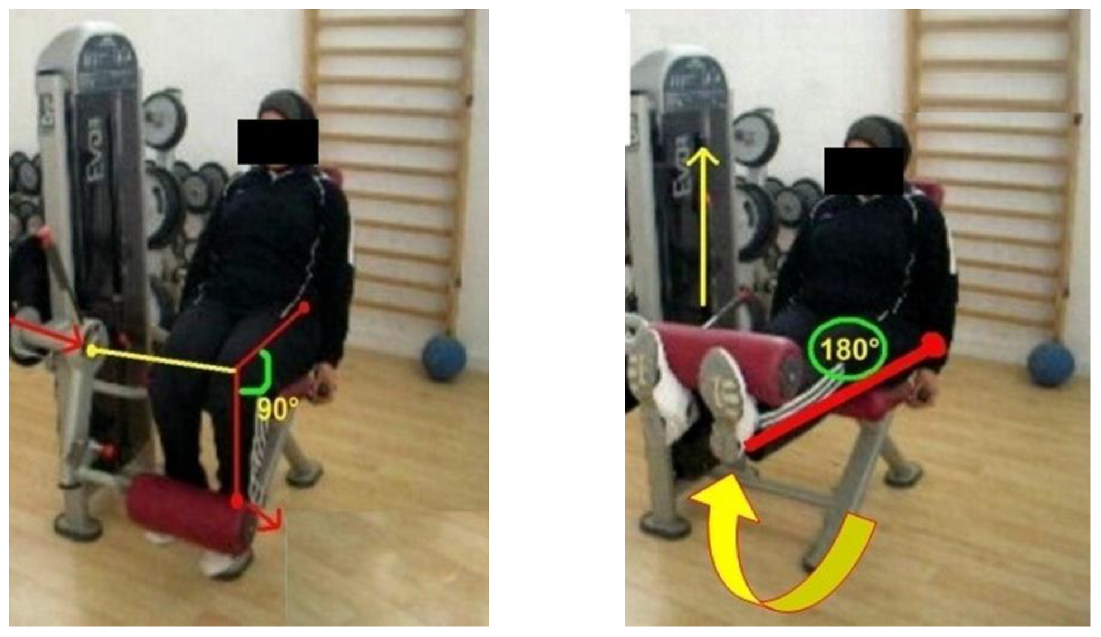
Figure 2: Knee extensor muscle 1-RM prediction
(Source: Mezghani et al. 2022)
Exercise and physical activity are important in the management of Type 2 diabetes. Aerobic exercises (walking or cycling) can be performed regularly to make insulin more sensitive and manage the weight (Mezghani et al. 2022). Exercises of strength training also enhance muscle functions, which facilitate the uptake of glucose in the cells.
The smoking cessation process is very useful in the management of blood sugar. There is the problem of insulin resistance caused by smoking, which puts one at the risk of getting complications. Cessation of smoking leads to better health and decreases cardiovascular risks, and blood sugar control (Okorare et al. 2023). The management of diabetes depends on weight management. A healthy weight maintained by eating well and exercising enhances insulin receptiveness and then medication is not necessary. These lifestyle modifications are evidence-based on stabilising the level of blood glucose.

Evaluation of the importance of nutrient dense foods
It is recommended to manage an adequate balance of nutrients in food to deal with the challenges due to Type-2 diabetes. Adherence to continuous medication and nutrient-dense food intake are two crucial stages to deal with Type-2 diabetes (Iwasaki et al. 2025). Inclusion of vegetables and whole grains in the diet can be helpful to deal with the consequences of Type-2 diabetes on the human body. It is recommended to increase the level of nutrients in foods to deal with the challenges observed due to Type-2 diabetes.

Understanding the strategy of successful Carbohydrate intake
It is suggested to ensure adequate carbohydrate intake to determine well-being and ensure success in preventing Type-2 diabetes. Adoption of adequate preventive measures creates an opportunity to address the issues and gain progress (Arshad et al. 2025). It is recommended to focus on managing a balanced carbohydrate intake and achieving success in determining the well-being of an individual. Thus, it is necessary to increase insights regarding the level of carbohydrate intake and ensure well-being.

6. Conclusion
The treatment of Type 2 diabetes needs to be holistic, with regular blood sugar levels checks, healthy lifestyle, and medical assistance. The implementation of evidence-based approaches such as appropriate diet, physical activity, quitting smoking, and managing weight, one will be able to manage blood sugar and, consequently, live better. It can be concluded from the above evaluation that an appropriate strategy of detection and implementation of required measures is necessary. Type-2 diabetes needs to be addressed with the adoption of precise measures, and consequences are observed in reaching a successful outcome in an easy manner. Therefore, the need is to deal with the barriers and include proactive measures to achieve the desired results in preventing the issue.

Reference List
Arshad, M.T., Maqsood, S., Altalhi, R., Shamlan, G., Mohamed Ahmed, I.A., Ikram, A. and Abdullahi, M.A., (2025). ‘Role of dietary carbohydrates in cognitive function: a review’. Food Science & Nutrition, 13(7), p.e70516. Available at: https://doi.org/10.1002/fsn3.70516
Banerjee, M., (2023). Epicardial fat paradox and differential effects of GLP-1 receptor agonists across heart failure phenotypes. Circulation: Heart Failure, 16(12), p.e010966. Available at: DOI: 10.1161/CIRCHEARTFAILURE.123.010966
Boonpattharatthiti, K., Songkla, P.N., Chantara, J., Koomsri, C., Krass, I., Chaiyakunapruk, N. and Dhippayom, T., (2024). ‘Prevalence of adherence to oral antidiabetic drugs in patients with type 2 diabetes: A systematic review and meta‐analysis’. Journal of Diabetes Investigation, 15(11), pp.1614-1625.Available at: https://doi.org/10.1111/jdi.14285
Chen, Z.F., Shen, Y.F., Gao, D.W., Lin, D.F., Ma, W.Z. and Chang, D.G., (2025). ‘Metabolic pathways and male fertility: Exploring the role of Sertoli cells in energy homeostasis and spermatogenesis’. American Journal of Physiology-Endocrinology and Metabolism, 329(1), pp.E160-E178. Available at: https://doi.org/10.1152/ajpendo.00074.2025
Gunst, J., Debaveye, Y., Güiza, F., Dubois, J., De Bruyn, A., Dauwe, D., De Troy, E., Casaer, M.P., De Vlieger, G., Haghedooren, R. and Jacobs, B., (2023). ‘Tight blood-glucose control without early parenteral nutrition in the ICU’. New England Journal of Medicine, 389(13), pp.1180-1190. Available at: DOI: https://doi.org/10.1056/NEJMoa2304855
Hu, F.B., (2024). ‘Diet strategies for promoting healthy aging and longevity: An epidemiological perspective’. Journal of internal medicine, 295(4), pp.508-531. Available at: https://doi.org/10.1111/joim.13728
Iwasaki, H., Yagyu, H. and Shimano, H., (2025). ‘A comprehensive analysis of diabetic complications and advances in management strategies’. Journal of Atherosclerosis and Thrombosis, 32(5), pp.550-559. Available at: https://doi.org/10.5551/jat.65551
Jabbar, A., Liaqat, H.B., Akram, A., Sana, M.U., Azpíroz, I.D., Diez, I.D.L.T. and Ashraf, I., (2024). ‘A lesion-based diabetic retinopathy detection through hybrid deep learning model’. IEEE access, 12, pp.40019-40036. Available at: https://doi.org/10.1109/ACCESS.2024.3373467
Jurczewska, J., Ostrowska, J., Chełchowska, M., Panczyk, M., Rudnicka, E., Kucharski, M., ... and Szostak-Węgierek, D. (2023). ‘Abdominal obesity in women with polycystic ovary syndrome and its relationship with diet, physical activity and insulin resistance: a pilot study’. Nutrients, 15(16), 3652. Available at: https://doi.org/10.3390/nu15163652
Kukurugya, M.A., Rosset, S. and Titov, D.V., (2024). ‘The Warburg Effect is the result of faster ATP production by glycolysis than respiration’. Proceedings of the National Academy of Sciences, 121(46), p.e2409509121. Available at: https://doi.org/10.1073/pnas.2409509121
Long, F., (2022). ‘Glucose metabolism in skeletal cells’. Bone Reports, 17, p.101640. Available at: https://doi.org/10.1016/j.bonr.2022.101640
Mezghani, N., Ammar, A., Boukhris, O., Abid, R., Hadadi, A., Alzahrani, T.M., Trabelsi, O., Boujelbane, M.A., Masmoudi, L., Ouergui, I. and Jamoussi, K., (2022, December). The impact of exercise training intensity on physiological adaptations and insulin resistance in women with abdominal obesity. In Healthcare (Vol. 10, No. 12, p. 2533). MDPI. Available at: https://doi.org/10.3390/healthcare10122533
Misra, S., Ke, C., Srinivasan, S., Goyal, A., Nyriyenda, M.J., Florez, J.C., Khunti, K., Magliano, D.J. and Luk, A., (2023). Current insights and emerging trends in early-onset type 2 diabetes. The Lancet Diabetes & Endocrinology, 11(10), pp.768-782. Available at: https://doi.org/10.1016/S2213-8587(23)00225-5
Ni, K., Tampe, C.A., Sol, K., Cervantes, L. and Pereira, R.I., (2024). ‘Continuous glucose monitor: reclaiming type 2 diabetes self-efficacy and mitigating disparities’. Journal of the Endocrine Society, 8(8), p.bvae125. Available at: https://doi.org/10.1210/jendso/bvae125
Okorare, O., Evbayekha, E.O., Adabale, O.K., Daniel, E., Ubokudum, D., Olusiji, S.A., Antia, A.U., Olusiji, S. and Antia, A., (2023). ‘Smoking cessation and benefits to cardiovascular health: a review of literature’. Cureus, 15(3). Available at: DOI: 10.7759/cureus.35966
Ouyang, B., Zhang, Z., Chen, F., Li, F., Fu, M.L., Lan, H. and Yuan, B., (2025). ‘Energy production and denitrogenation performance by sludge biochar based constructed wetlands-microbial fuel cells system: Overcoming carbon constraints in water’. Water Research, 273, p.123024. Available at: https://doi.org/10.1016/j.watres.2024.123024
Pleus, S., Freckmann, G., Schauer, S., Heinemann, L., Ziegler, R., Ji, L., Mohan, V., Calliari, L.E. and Hinzmann, R., (2022). ‘Self-monitoring of blood glucose as an integral part in the management of people with type 2 diabetes mellitus’. Diabetes Therapy, 13(5), pp.829-846. Available at: https://doi.org/10.1007/s13300-022-01254-8
Tzeravini, E., Simati, S., Anastasiou, I.A., Dalamaga, M. and Kokkinos, A., (2026). ‘Gut Peptide Alterations in Type 2 Diabetes and Obesity: A Narrative Review’. Current Obesity Reports, 15(1), p.8. Available at: https://doi.org/10.1007/s13679-026-00687-7
van Leersum, C.M., Konrad, K.E., Bults, M. and den Ouden, M.E., (2024). ‘Living with my diabetes–introducing eHealth into daily practices of patients with type 2 diabetes mellitus’. Digital Health, 10, p.20552076241257052. Available at: https://doi.org/10.1177/20552076241257052
Yedjou, C.G., Grigsby, J., Mbemi, A., Nelson, D., Mildort, B., Latinwo, L. and Tchounwou, P.B., (2023). ‘The management of diabetes mellitus using medicinal plants and vitamins’. International journal of molecular sciences, 24(10), p.9085. Available at: https://doi.org/10.3390/ijms24109085

