UWTSD
BA Business Management
Community Engagement

Student Name: Silviya Petkova Group 1
Module code: LCBB4002
Lecturer Name: Akinseye Aluko
Date: 22/11/2022
Table of Contents
Introduction 3
Main body 4
Conclusion 11
References 12

Introduction
Community engagement refers to the activities so that the members of the community have access to valued social activities and that social contributions are ensured (Hicks Peterson, 2017). Community engagement enables individuals to develop the functional capabilities to participate effectively and efficiently. The two projects held in Birmingham the creative city program and cycling for everyone have been chosen based on the case study of the success of the common-wealth games and the pragmatic evaluations. For creating values and promoting the well-being of the people of the Commonwealth, various projects have been run by the authority. Cycling for everyone, first of all, is a project aimed at addressing equality of who has access to cycling and who cycles. Secondly, the creative city programs which are supported by the Birmingham city council consisted of 106 events across the West Midlands which are featuring home talents to showcase the vibrant diversity of the region. The reflective assignment covers the importance of community engagement, the difference between the two projects, community mapping and social media engagement.

Main body
Based on the pragmatic evaluations and case study of the success of the common-wealth games which are held in Birmingham, the two projects cycling for everyone and the creative city program have been chosen (Mehdi & AbouNaaj, 2017). The projects have been run for creating values and promoting the well-being of the people of the Commonwealth. First of all, the cycling for every one project is a project aimed at addressing equalities of those who access cycling and who cycle. For people who are disabled people as well as Black and Minority Ethnic communities and who live within the 20% disadvantaged areas, the cycling project will Centre on working with the communities. The activities will be delivered by the programs like adult cycle training and child that improves access to adapted bike as well as active travel events.
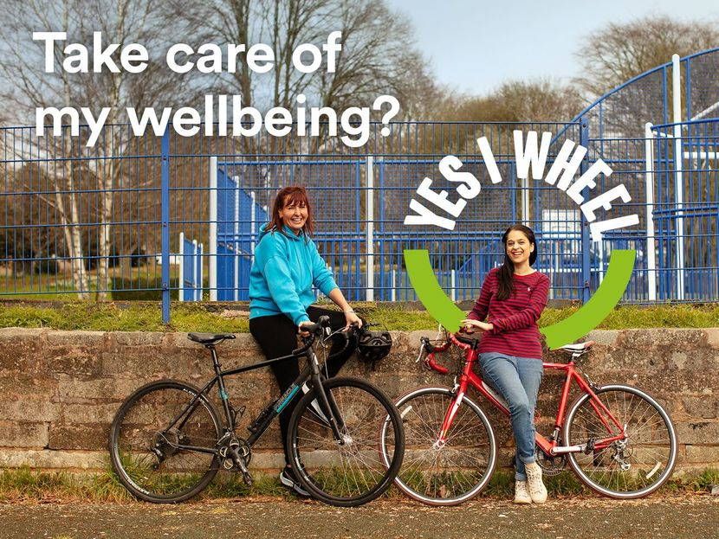
Figure 1: Cycling for everyone (Project-1)
Sources: (Nepper Larsen, 2020)
Over the last six months, the cultural celebration of Birmingham 2022 is being recognized as the heart of the Festival’s creative city project program which is founded by the Birmingham city council. Featuring home talents to showcase the vibrant diversity of the region, the creative city programs are supported by the Birmingham city council, consisting of 106 events across the West Midlands.
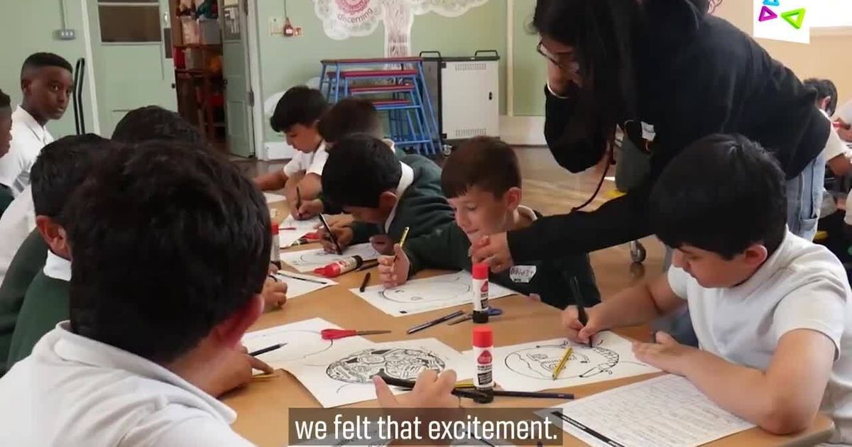
Figure 2: Festival city project program
Sources: (Currie & Miranda Correa, 2021)
The six months celebrations of creativity include various types of programs by which the innovations of the locals are encouraged. The programs include the festival of flying, boxer beat, Journeys of Hope, drowning of winter, Queering the city, and Coffee Beans growing in my head.
The significant difference between the two projects is that the first project focuses on inequalities and the second project encourages innovative projects led by the Birmingham city council (Hassall, 2020). People from different states get together at the commonwealth games. Besides, the commonwealth values of humanity, destiny and equality are embraced. T throughout the West Midlands and beyond, a world of difference for everyone will be made by the commonwealth games through a fast-paced sport, a festival of thrilling, dynamic business and the exhilarating culture of the country. To leave a lasting positive impact, the enormous gathering has a clear purpose as visitors flock from across the globe and Athletes go for the golds by participating in various games held in Birmingham. The mission of the commonwealth games includes,
- Bringing people together
- Improving health and well-being
- Be a catalyst for changing the world
- To grow and succeed, help the region
The authority of Common-wealth games follows an effective community engagement model by which All types of information can be shared and the activities of the program can be accomplished successfully. The community engagement approach depends on the initiatives which are taken for getting the outcome of the programs and the groups of stakeholders being consulted (Akland, 2021). In order to communicate with a range of stakeholders, the engagement model is basically used. The ideal framework for the stakeholder engagement initiatives, all the available resources like objectives, issues, and shareholder mix will be contributed to determining it. The Birmingham city council conducted the following community engagement model which is analysed as follows,
Community meetings: A valuable way of sharing information can be the Town hall or public meetings. A great opportunity is provided by the face-to-face nature of these events to demonstrate transparency and openness to stakeholders. What will encourage attendance and make the event compelling to stakeholders need to be considered (Wilmer, 2018). The authority of the common-wealth games can organise the community meeting by which, significant information regarding the organisation can be shared. Now, the strengths and weaknesses of the community meetings are provided as follows,
Strengths | Weaknesses
- At the beginning of an initiative to explain the outcomes and process, the community meeting can be utilised properly and efficiently to gather feedback and deliver information  - To demonstrate transparency, it is great for meeting stakeholders.  - To attract media attention, it can be useful for community outreach. | - Unless the stakeholders feel personally affected by outcomes, they are not likely to attend which are related to the commonwealth projects or programs.  - If the meeting is not handled well or is confrontational, Media publicity may be negative.  - For engagement, it may not be the right method, if a project or issue is controversial particularly.

Focus Group: When reaching out to marginalised or smaller groups, the Birmingham city council can encourage the method. A comfortable environment is created, and the members are enhanced when the focused questions are asked as the active dialogue of focus groups (Hennink, 2016). Now, the strengths and weaknesses of the focus group are as follows,
Strengths | Weaknesses
- Using resources and identifying important issues, the small group setting can be an efficient way in the dynamic environment  - To reach a specific group of shareholders or developed around a particular group, the second strategy can be organised and planned which would be more effective for the Birmingham city council.  - It can be handled in a smaller group more easily if any conflict occurs. | - To ensure the process runs smoothly, it must involve an experienced facilitator  - To ensure all perspectives and stakeholders are represented, the strategy may not be effective.

Surveys: In order to identify community opinion, the questionnaires or surveys can be an effective part of taking any type of feedback regarding the commonwealth games in 2022 (Jones et al., 2019). If the council would like to outreach large groups of people, the method would be more useful. Now, the strengths and weaknesses of the method are as follows,
Strengths | Weakness
- The method is more useful to collect and collect quantitative data.  - From another period or against different stakeholder groups, this data is more effective to compare results.  - To communicate with large groups of people, the method is a cost-effective and quick way. | - To identify the reasons behind stakeholder's opinions, the method may not be useful.  - In developing dialogue or establishing community relationships, the focus group is not an as effective way.  - Survey rates are often less than 20% and response rates may be limited.

Web-based engagement: To reach and manage many stakeholders, online public participation can be a useful way for the Council of the commonwealth games in 2022. The council can use various platforms like social media, online discussions platform, and web-based survey systems to outreach a large number of people through online communication (Oluwajana et al., 2021). Now the strengths and weaknesses of web-based engagement are as follows,
Strengths | Weaknesses
- Collecting data and reaching large groups of people, can be an effective way  - When the location and time are a barrier, it encourages participation and is flexible and convenient for participants.  - Encouraging reflection and discussion regarding complex topics can be an effective way for the Birmingham city council.  - Taking time to develop the right set of questions is one practice by which the outcomes of the consultation will be improved. | - Unless a special accommodation is made for them, the stakeholders will be excluded from access to the internet.  - To respond to the questions promptly and manage the process, A moderator should be allocated.  - To encourage participation, Privacy concerns should be addressed.

The impacts of consultation: In the context of the commonwealth games, Consultation is a process of discussing with someone regarding a matter for getting opinions or advice. Consulting with stakeholders in a specific matter requires an effective and detailed plan by which the whole activities can be conducted (Wilting & Puusepp, 2018). Every situation has a different perspective. So, the consultation process should be context and objective oriented. Poor and ineffective consultation planning and process cause the loss of trust among the stakeholders of the project or program. To determine the needs and goals of the stakeholders and the process involved, the preliminary activity is accomplished. Making the consultation process needs to follow the below steps First of all, the situation needs to be assessed carefully. Secondly, the mission, vision, goals and objectives need to be set. After that, effective planning needs to be made before consulting a matter with stakeholders. Fourthly, the event management process needs to be conducted appropriately. Eventually, For the success of engagement strategies, the evaluation metric should be designed.
The impacts of communication: Communication is the process of sharing beliefs, thoughts, opinions and values by which an individual can share various types of information with others. In the context of community engagement in a project, effective communication helps to increase the active participation of individuals. To achieve the community’s goals and objectives, effective communication skills enable individuals and further the community development process (Cotton, 2019). When the communication process is effective, no misunderstandings can be taken place from the community engagement perspective.
The impacts of Stakeholder participation: The stakeholder’s participation in the community engagement process enables the whole program to establish more effectively and efficiently. The stakeholder of the huge project includes accommodation service providers, volunteers, spectators, athletes, sponsors, the community, government, partnerships, BBC & outside agencies, managers, suppliers of various products like drinks, foods, clothes, etc and companies. All of the stakeholders have various types of roles and responsibilities in the Commonwealth games. For instance, the managers try to monitor and control the operations of the project so that the guests from different countries get the best advantages while staying in Birmingham.
The impacts of inclusion: The theory of inclusion represents that every person has a specific role and responsibilities in society by which social contribution is ensured. By reducing barriers, engaging in supportive and meaningful ways and creating connections, people get the opportunities to participate (Kuklenski, 2021). In the context of the commonwealth games, various benefits can be raised including an increased social network, increased safety by reducing isolation, and more respect for others.

Conclusion
At the end of the discussion, community engagement is the modern practice which contributes more to society. The Birmingham city council should make effective planning and conduct deep research so that the whole activities of the projects can be accomplished effectively and efficiently. Besides, community mapping and social media engagement help them to attract a vast amount of people for the Commonwealth games. Eventually, the authority should maintain and control all the stakeholders related to the projects or programs that give them competitive success in the dynamic environment.

References
Akland, G. (2021) “Community engagement: A Model Mental Health Partnership,” Journal of Community Engagement and Scholarship, 4(1). Available at: https://doi.org/10.54656/gfcl6486.
Cotton, I.W. (2019) “Perspective on trends in electronic communication,” Electronic Communication: Technology and Impacts, pp. 7–18. Available at: https://doi.org/10.4324/9780429051876-2.
Currie, M. and Miranda Correa, M. (2021) “Introduction: The global festival city,” The Culture and Communities Mapping Project, pp. 1–13. Available at: https://doi.org/10.1007/978-3-030-88651-6_1.
Hassall, G. (2020) “The Commonwealth Local Government Pacific Project: Seeking ‘most significant change,’” Commonwealth Journal of Local Governance, pp. 176–188. Available at: https://doi.org/10.5130/cjlg.v0i5.1476.
Hennink, M.M. (2016) “Introducing focus group discussions,” Understanding Focus Group Discussions, pp. 1–34. Available at: https://doi.org/10.1093/acprof:osobl/9780199856169.003.0001.
Hicks Peterson, T. (2017) “Community engagement outcomes and activities,” Student Development and Social Justice, pp. 157–185. Available at: https://doi.org/10.1007/978-3-319-57457-8_5.
Jones, J., Snijkers, G. and Haraldsen, G. (2019) “Surveys and business surveys,” Designing and Conducting Business Surveys, pp. 1–38. Available at: https://doi.org/10.1002/9781118447895.ch01.
Kuklenski, J. (2021) “Inclusion and organizational culture,” Diversity and Organizational Development, pp. 103–112. Available at: https://doi.org/10.1108/978-1-83982-592-720211009.
Mehdi, R.A. and AbouNaaj, M.S. (2017) “Academic program assessment: A case study of a pragmatic approach,” Creative Education, 04(01), pp. 71–81. Available at: https://doi.org/10.4236/ce.2013.41010.
Nepper Larsen, S. (2020) “Becoming a cyclist,” Cycling - Philosophy for Everyone, pp. 27–38. Available at: https://doi.org/10.1002/9781444324679.ch3.
Oluwajana, D., Adeshola, I. and Clement, S. (2021) “Does the use of a web-based collaborative platform reduces cognitive load and influence project-based student engagement?” Available at: https://doi.org/10.21203/rs.3.rs-405894/v1.
Wilmer, H.A. (2018) “Examples of community meetings.,” Social psychiatry in action: A therapeutic community., pp. 150–180. Available at: https://doi.org/10.1037/13177-007.
Wilting, P. and Puusepp, A. (2018) “Jervis Forcemain no. 2, public consultation and managing impacts,” Proceedings of the Water Environment Federation, 2012(9), pp. 6262–6270. Available at: https://doi.org/10.2175/193864712811710155.

