The Benefits and Challenges of Digital Health Technologies for Older Adults in the UK: Implications for Health and Social Care Practice

Name: Nabeela Begum
Student Number: 2216501
Module Code: LCHS7008
Module: Practice-Based Research
Assignment Title: Component 2: Research Proposal
Lecturer Name: Dr Zeno Leung

Table Of Content

Prevalence of the Problem…………………………………………………………..3
Introduction and Literature-Based Background……………………………………3
Benefits of Digital Health Technologies…………………………………………….4
Challenges and Barriers……………………………………………………………..4
Implications for Health and Social Care……………………………………………5
Rationale………………………………………………………………………………5
Research Questions, Aims, Objectives…………………………………………….6
Research Methodology………………………………………………………………6
Research Design……………………………………………………………………..7
Recruitment, Sampling and Study Participants……………………………………8
Data Collection Methods……………………………………………………………..8
Data Analysis………………………………………………………………………….9
Ethical Considerations………………………………………………………………..10
Implications of the Research………………………………………………………...10
Plan of Work and Time Schedule (Gantt Chart)…………………………………..11
Reference List………………………………………………………………………12-14

- Prevalence of the Problem
Digital technologies are increasingly integrated into health and social care systems worldwide. In the United Kingdom, the NHS has accelerated the adoption of digital health technologies, including telemedicine, mobile health applications, remote monitoring devices, and online consultation platforms (NHS England, 2022). These technologies aim to improve efficiency, accessibility, and patient outcomes within healthcare systems.
However, the rapid expansion of digital healthcare has also raised concerns regarding accessibility for certain population groups, particularly older adults. According to the UK Office for National Statistics, approximately 18% of adults aged 65 and over remain digitally excluded, meaning they do not regularly use the internet or digital technologies (ONS, 2023). This digital divide can significantly affect access to healthcare services that increasingly rely on digital platforms. Older adults often face barriers such as limited digital literacy, cognitive decline, physical impairments, and limited access to digital devices (Seifert, Cotten and Xie, 2021; Age UK, 2024). These barriers may prevent them from fully benefiting from digital health interventions such as online appointment systems, telehealth consultations, and digital prescription services.
At the same time, the UK population is ageing rapidly. It is projected that by 2040, nearly one in four people in the UK will be aged 65 or over (Age UK, 2022). This demographic shift will place increased pressure on healthcare systems and highlights the importance of effective digital health solutions that support ageing populations. Digital health technologies have the potential to support independent living, improve chronic disease management, and reduce healthcare costs (WHO, 2021). However, without addressing accessibility challenges, these innovations may unintentionally widen health inequalities among older adults.
Understanding both the benefits and barriers of digital health technologies for older adults is therefore critical for developing inclusive healthcare systems and informing future health and social care policies.

- Introduction and Literature-Based Background
Digital health technologies refer to the use of information and communication technologies to support healthcare delivery and improve health outcomes (WHO, 2021). Examples include telemedicine consultations, wearable health monitoring devices, mobile health applications, electronic health records, and digital prescription systems.
In recent years, the NHS has invested heavily in digital transformation as part of the NHS Long Term Plan, which emphasises expanding digital healthcare services to improve efficiency and patient access (NHS England, 2019). The COVID-19 pandemic accelerated this transition, leading to widespread adoption of remote consultations and online health services. However, while digital health technologies have expanded rapidly, concerns remain regarding whether these services are equally accessible to all population groups, particularly older adults who may face barriers related to digital literacy, accessibility, and confidence when using technology (Department of Health and Social Care, 2022).
- Benefits of Digital Health Technologies
Research suggests that digital health technologies can significantly improve access to healthcare and quality of care for older adults. Telehealth services allow patients to consult healthcare professionals remotely, reducing travel barriers and improving access to care for those with mobility limitations (Kruse et al., 2020).
Digital monitoring devices, such as wearable sensors and remote monitoring systems, can support chronic disease management by enabling continuous monitoring of health conditions such as diabetes, cardiovascular disease, and respiratory disorders (Peek et al., 2019). These technologies can reduce hospital admissions and enable earlier intervention when health issues arise. Despite these reported benefits, some studies suggest that the effectiveness of digital health technologies may depend heavily on users’ technological confidence and access to digital resources, which can vary significantly among older populations (NHS England, 2023).
Additionally, digital technologies can support ageing in place by enabling older adults to remain independent in their own homes for longer periods (Sixsmith et al., 2022). For example, remote monitoring systems can alert healthcare providers or family members if unusual health patterns are detected.
- Challenges and Barriers
Despite these benefits, significant challenges remain. One major concern is the digital divide, which refers to inequalities in access to digital technologies and digital skills (Seifert et al., 2021). Older adults are disproportionately affected by digital exclusion due to limited technological experience, financial barriers, and a lack of digital training. Another key barrier is usability. Many digital health technologies are designed without considering the specific needs of older adults, such as visual impairments, reduced dexterity, or cognitive limitations (Mitzner et al., 2019; Van Dijk, 2019). Poorly designed interfaces can discourage adoption and limit the effectiveness of digital interventions.
Privacy and security concerns also influence technology adoption. Older adults may feel uncomfortable sharing personal health information online due to concerns about data breaches or the misuse of personal data (Czaja et al., 2018). These challenges suggest that while digital health technologies offer significant potential to improve healthcare delivery, their benefits may not be fully realised without targeted strategies to address digital exclusion among older adults.
- Implications for Health and Social Care
These challenges highlight the need for inclusive digital healthcare strategies that consider the unique needs of older adults. Health and social care professionals must ensure that digital services are accessible, user-friendly, and supported by adequate training and support systems (Kruse, 2020). Research into the experiences of older adults with digital health technologies is essential to identify practical solutions that can improve accessibility and reduce inequalities. This research should encompass a diverse range of participants to capture different perspectives and the barriers they face, ultimately informing policy changes that promote equitable access to digital health resources.
- Rationale
The increasing reliance on digital health technologies within the NHS has created both opportunities and challenges for older adults. While digital tools can enhance healthcare delivery by facilitating remote consultations, improving access to medical records, and enabling health monitoring, they may also exacerbate healthcare inequalities if vulnerable populations, particularly older adults, are unable to access or use these technologies effectively (The King's Fund, 2022). Consequently, there remains a need for research that explores older adults’ lived experiences with digital health technologies to better understand both the opportunities and limitations of their use within contemporary healthcare systems.
Current literature highlights the potential benefits of digital health technologies, such as reduced wait times and increased patient engagement (National Audit Office, 2020; Health Foundation, 2022). However, it also emphasises barriers such as digital literacy, lack of access to the necessary devices and internet, physical disabilities, and varying levels of trust in technology (Peek et al., 2019). These barriers can prevent older adults from fully participating in their own healthcare, ultimately affecting their health outcomes.
Furthermore, limited research exists exploring how older adults perceive these technologies and their willingness to adopt them. Factors such as prior technology experience, social support systems, and individual health literacy significantly shape these perceptions (Czaja et al., 2019; Centre for Ageing Better, 2023). Understanding the experiences and perspectives of older adults is, therefore, essential for informing future digital health policies. By addressing the concerns and needs of this demographic, healthcare innovations can be tailored to remain inclusive, ultimately improving health equity and healthcare outcomes for older adults (Nuffield Trust, 2021). Active engagement and involvement of older adults in the development and implementation of digital health solutions may also enhance their acceptability and effectiveness.
- Research Question, Aim and Objectives
Research Question
What are the benefits and challenges of digital health technologies for older adults in the UK, and how can health and social care services improve accessibility and inclusion?
Research Aim
To explore the benefits and challenges of digital health technologies for older adults in the UK and identify implications for health and social care practice.
Research Objectives
- To explore how older adults use digital health technologies.
- To identify perceived benefits of digital healthcare services.
- To examine barriers that limit the use of digital health technologies among older adults.
- To explore strategies that could improve digital inclusion in healthcare.

- Research Methodology
This study will adopt a secondary research methodology, specifically a systematic literature review. Secondary research involves analysing existing published data rather than collecting primary data from participants (Creswell, 2018). A literature review approach is appropriate for this study as it enables a comprehensive examination of existing evidence regarding digital health technologies and their impact on older adults. It enables the identification of key themes, patterns, and gaps in current research, providing a broader understanding of the topic.
Furthermore, secondary research eliminates the need for direct participant involvement, making it more practical within the time constraints of this project while still producing academically robust findings. However, it is important to acknowledge that secondary research relies on existing studies, which may vary in quality and context (Booth, Sutton and Papaioannou, 2016). Therefore, careful selection and critical appraisal of sources will be essential to ensure the reliability and validity of the findings.

- Research Design
The study will adopt a systematic literature review design, guided by a structured and transparent process for identifying, selecting, and analysing relevant academic sources.
A systematic approach ensures that the review is comprehensive, reproducible, and minimises bias (Bryman, 2016). The study will follow key stages, including:
• Defining inclusion and exclusion criteria
• Conducting database searches
• Screening and selecting relevant studies
• Critically appraising selected literature
• Synthesising findings
This design is suitable as it allows for the integration of findings from multiple studies, providing a well-rounded understanding of the benefits and challenges of digital health technologies for older adults.
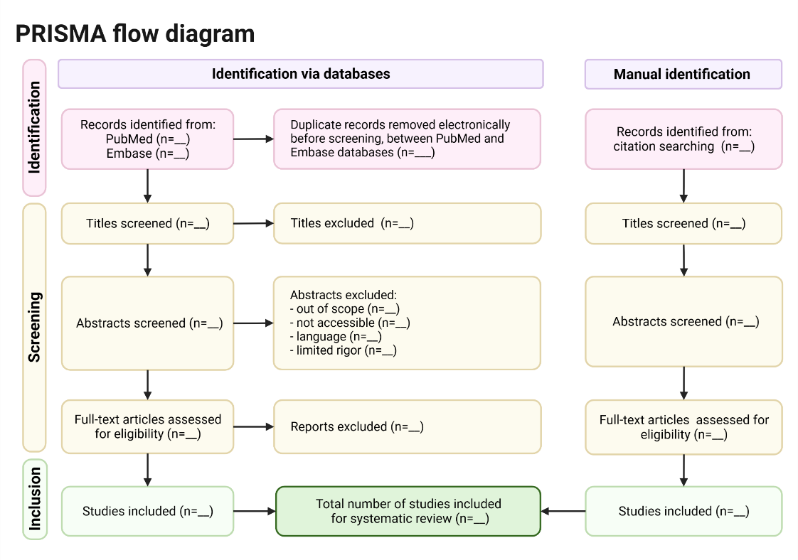
Figure 1. PRISMA-style flow diagram showing the planned study selection process for the literature review (Rosalba Lopez, 2026).
- Recruitment, Sampling and Study Participants
As this study is based on secondary data, no participants will be recruited directly.
Instead, the “sample” will consist of academic literature and published studies.
10.1 Inclusion Criteria for Literature
Studies will be included if they:
• Focus on adults aged 65 years and over
• Explore digital health technologies (e.g., telehealth, apps, remote monitoring)
• Are conducted within the UK or comparable healthcare systems
• Are published in peer-reviewed journals
• Are written in English
• Were published within the last 10 years
10.2 Exclusion Criteria
• Studies focusing on younger populations
• Non-peer-reviewed sources
• Studies not related to healthcare
A purposive sampling strategy will be used to select the most relevant and high-quality studies.
- Data Collection Methods
Data will be collected through a systematic and structured search of electronic databases, including PubMed, UWTSD, and Google Scholar. These databases have been selected to ensure comprehensive coverage of high-quality, peer-reviewed literature relevant to digital health technologies and older adults within healthcare contexts. In addition, UK-specific sources such as NHS England, the National Institute for Health and Care Excellence (NICE), and the Office for National Statistics (ONS) will be incorporated to ensure the inclusion of contextually relevant policy, clinical guidance, and population-level data. The inclusion of these UK-focused sources strengthens the applicability of the findings to the UK health and social care context, enhancing the relevance and transferability of the study.
A clearly defined search strategy will be employed using a combination of key terms, including “digital health technologies”, “older adults”, “elderly”, “telehealth”, “digital exclusion”, and “UK healthcare”. Boolean operators (AND/OR) will be applied to refine and combine search terms, thereby improving the precision and relevance of retrieved studies. For example, search strings such as “digital health AND older adults AND UK” and “telehealth OR digital care AND elderly AND barriers” will be used.
The study will adopt a PRISMA-informed approach to guide the identification, screening, and selection of relevant literature, ensuring transparency and reproducibility throughout the review process. This will involve systematically recording the number of studies identified, screened, excluded, and included at each stage (Kukreja, 2025). Following the screening process, data extraction will be conducted using a structured approach to ensure consistency across all included studies. Key information to be extracted will include study aims, research methodology, sample characteristics, key findings, and the identified benefits and challenges associated with digital health technologies.
However, it is important to acknowledge that the quality and scope of the findings are dependent on the available literature, which may vary in methodological rigour and context. Therefore, a critical approach will be adopted when interpreting the findings to ensure a balanced, evidence-informed synthesis (Care Quality Commission, 2023; NICE, 2026). This systematic and transparent approach strengthens the review's reliability. It enables meaningful comparison across studies, supporting a robust analysis of the benefits and challenges of digital health technologies for older adults.
To ensure the quality and reliability of the included studies, a structured critical appraisal process will be undertaken. The CRAAP framework (Currency, Relevance, Authority, Accuracy, and Purpose) will be used to evaluate the credibility and suitability of each source. This tool enables a systematic assessment of whether the literature is up-to-date, relevant to the research question, produced by credible authors or organisations, supported by accurate and evidence-based findings, and free from bias or conflicting interests (Writing Commons, 2023).
- Data Analysis
Data will be analysed using thematic analysis, following the framework outlined by Braun and Clarke (2006). This approach enables the systematic identification, organisation, and interpretation of patterns across the selected literature.
The process will involve several key stages. Initially, the selected studies will be familiarised with through repeated reading. This will be followed by generating initial codes to capture key findings relevant to the research question. These codes will then be organised into broader themes, which will be reviewed, refined, and clearly defined to ensure coherence and relevance (Van Dijk, 2019). Finally, the findings will be synthesised into a structured narrative that highlights key patterns across the literature.
This method is particularly suitable for secondary research as it allows for the integration of findings from multiple studies while maintaining a clear analytical structure. However, it is acknowledged that thematic analysis involves a degree of researcher interpretation, which may introduce subjectivity (Greenhalgh, 2017). To mitigate this, a transparent and systematic approach will be maintained throughout the analysis process.
- Ethical Considerations
As this study is based on secondary research, the level of ethical risk is minimal, as it does not involve direct interaction with human participants or the collection of primary data. Nevertheless, ethical considerations remain essential to ensure the integrity, transparency, and credibility of the research. All data will be obtained from publicly available, peer-reviewed sources, ensuring that the information analysed has already undergone ethical scrutiny (Government Digital Service, 2025; NHS Digital, 2022). In line with principles of academic integrity, all sources will be appropriately cited using Harvard referencing to avoid plagiarism and acknowledge original authorship.
Careful attention will be given to the accurate representation of findings, ensuring that data is reported honestly and without selective interpretation. A balanced and critical approach will be adopted to minimise bias and ensure that conclusions are supported by robust evidence. Although no personal or identifiable data will be used, the study will adhere to relevant data governance frameworks, including the UK General Data Protection Regulation (UK GDPR) and the Data Protection Act 2018 (Harper James, 2024). Ethical approval will be sought in accordance with university requirements (PG2 form) to ensure full compliance with institutional guidelines.
It is also recognised that the ethical and methodological quality of the original studies may influence the reliability of the review. Therefore, critical appraisal tools will be applied to ensure that only high-quality and ethically conducted research informs the findings.
- Implications of the Research
This research has several important implications for health and social care practice. It will provide a comprehensive synthesis of existing evidence on the benefits and challenges of digital health technologies for older adults, contributing to a clearer understanding of the current evidence base (Health Foundation, 2022). The findings will help identify gaps within the literature, informing future research priorities and supporting the development of more inclusive health and social care policies. Additionally, the study may enhance healthcare professionals’ understanding of the barriers faced by older adults, enabling the development of targeted interventions to improve digital inclusion (Cabinet Office, 2022; UK Health Security Agency, 2023).
Furthermore, this research may contribute to the design and implementation of more accessible and user-centred digital health solutions, helping to ensure that technological advancements do not exacerbate existing health inequalities. However, it is important to recognise that the translation of research findings into practice may be influenced by wider systemic factors, including resource availability, workforce capacity, and variability in digital infrastructure across healthcare settings (NHS England, 2019; NICE, 2026). These constraints may limit the extent to which recommended changes can be implemented in real-world contexts.
- Plan of Work and Time Schedule (Gantt Chart)
The research will be undertaken over 12 weeks using a structured secondary research approach. The Gantt chart below illustrates a detailed weekly timeline, mapping each stage of the systematic review process, from initial search strategy development and database searching to data synthesis and final submission. This structured approach ensures a transparent, systematic, and methodologically rigorous progression in line with recommended systematic review practices.

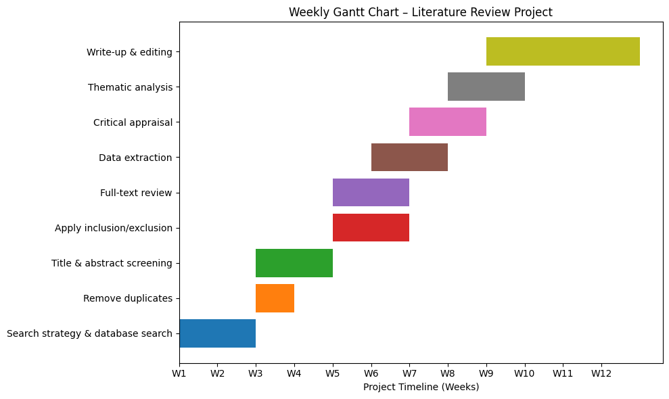

- Reference List

Age UK (2024) Digital inclusion and older people. Available at: https://www.ageuk.org.uk/siteassets/documents/reports-and-publications/reports-and-briefings/active-communities/internet-use-statistics-june-2024.pdf (Accessed: 2nd February 2026).
Age UK (2022) Later life in the United Kingdom. Available at: https://www.ageuk.org.uk (Accessed: 17 March 2026).
Braun, V. and Clarke, V. (2006) ‘Using thematic analysis in psychology’, Qualitative Research in Psychology, 3(2), pp. 77–101.
Booth, A., Papaioannou, D. and Sutton, A. (2016) 'Systematic approaches to a successful literature review,' ResearchGate [Preprint]. Available at: https://www.researchgate.net/publication/235930866_Systematic_Approaches_to_a_Successful_Literature_Review (19 March 2026).
Bryman, A. (2016) Social Research Methods. Available at: www.google.co.uk/books/edition/Social_Research_Methods/N2zQCgAAQBAJ?hl=en&gbpv=1&dq=inauthor:%22Alan+Bryman%22&printsec=frontcover.
Cabinet Office (2022) Government digital inclusion strategy. Available at: https://www.gov.uk/government/publications/government-digital-inclusion-strategy (Accessed: 6 February 2026).
Centre for Ageing Better (2023) The digital age: new approaches to supporting older people. London: Centre for Ageing Better. Available at: https://ageing-better.org.uk/publications/digital-age-supporting-older-people (Accessed: 3 February 2026).
Creswell, J.W. (2018) Research Design: Qualitative, Quantitative and Mixed Methods Approaches. Available at: https://www.google.co.uk/books/edition/Research_Design/335ZDwAAQBAJ?hl=en&gbpv=1&dq=inauthor:%22John+W.+Creswell%22&printsec=frontcover (Accessed: 17 March 2026).
Czaja, S.J., Boot, W.R., Charness, N. and Rogers, W.A. (2019) Designing for older adults: Principles and creative human factors approaches. 3rd edn. Boca Raton: CRC Press.
Care Quality Commission (2023) Digital transformation in health and social care. Available at: https://www.cqc.org.uk/guidance-providers/adult-social-care/digital-record-systems-adult-social-care-services (Accessed: 2 February 2026).
Department of Health and Social Care (2022) A plan for digital health and social care. Available at: https://www.gov.uk/government/publications/a-plan-for-digital-health-and-social-care (Accessed: 6 February 2026).
Government Digital Service (2025) Data protection. Available at: https://www.gov.uk/data-protection (Accessed: 11 March 2026).
Greenhalgh, T. et al. (2017) ‘Beyond adoption: a new framework for theorising digital health technologies’, Journal of Medical Internet Research, 19(11), e367.

Harper James (2024) Essential GDPR compliance for apps. Available at: https://harperjames.co.uk/article/data-privacy-for-app-developers/ (Accessed: 6 March 2026).
Health Foundation (2022) What does good digital health care look like?. Available at:
https://www.health.org.uk/publications/long-reads/what-does-good-digital-health-care-look-like (Accessed: 4 February 2026).
Kruse, C.S., Fohn, J., Wilson, N., Nunez Patlan, E., Zipp, S. and Mileski, M. (2020) Utilisation barriers and medical outcomes of telehealth in the elderly population: A systematic review. JMIR Medical Informatics, 8(4), e20359. https://doi.org/10.2196/20359
Kukreja, J. (2025) How to enhance the transparency of systematic Reviews using PRISMA. https://doi.org/10.4135/9781036213107.
Mitzner, T. et al. (2019) ‘Older adults talk technology’, Computers in Human Behaviour, 26(6), pp. 1710–1721.
NHS England (2019) The NHS Long Term Plan. Available at: https://www.longtermplan.nhs.uk (Accessed: 9 February 2026).
NHS England (2022) Digital transformation in health and care. Available at: https://www.england.nhs.uk/digitaltechnology (Accessed: 9 February 2026).
NHS England (2023) Digital inclusion guide for health and social care. Available at:
https://www.england.nhs.uk/long-read/digital-inclusion-guide (Accessed: 3 February 2026).
National Audit Office (2020) Digital transformation in the NHS. Available at: https://www.nao.org.uk/reports/digital-transformation-in-the-nhs/ (Accessed: 6 February 2026).
National Audit Office (2023) Addressing digital exclusion in public services. Available at: https://www.nao.org.uk/reports/addressing-digital-exclusion-in-public-services/ (Accessed: 8 February 2026).
Nuffield Trust (2021) Digital technology in health and care. Available at: https://www.nuffieldtrust.org.uk/research/digital-technology-in-health-and-care (Accessed: 4 February 2026).
NICE (2026) Evidence standards framework (ESF) for digital health technologies. Available at: https://www.nice.org.uk/what-nice-does/digital-health/evidence-standards-framework-esf-for-digital-health-technologies (Accessed: 18 March 2026).
Office for National Statistics (2021) Internet users, UK: 2021. Available at:
https://www.ons.gov.uk/businessindustryandtrade/itandinternetindustry/bulletins/internetusers/2021 (Accessed: 3 February 2026).
Office for National Statistics (2023) Overview of the UK population: January 2023. Available at:
https://www.ons.gov.uk/peoplepopulationandcommunity/populationandmigration/populationestimates (Accessed: 7 February 2026).
Peek, S.T.M., Wouters, E.J.M., van Hoof, J., Luijkx, K.G., Boeije, H.R. and Vrijhoef, H.J.M. (2014) ‘Factors influencing acceptance of technology for ageing in place’, International Journal of Medical Informatics, 83(4), pp. 235–248. doi:10.1016/j.ijmedinf.2014.01.004.
Seifert, A., Cotten, S. and Xie, B. (2021) ‘A double burden of exclusion? Digital and social exclusion of older adults, Journal of Gerontology, 76(3), pp. 99–103.
Sixsmith, A. et al. (2022) ‘Technologies for ageing in place’, Gerontology, 67(1), pp. 1–10.
The King’s Fund (2022) The digital transformation of health and social care. Available at: https://www.kingsfund.org.uk/insight-and-analysis/press-releases/digital-health-care-plan-2022 (Accessed: 6 February 2026).
UK Health Security Agency (2023) Health inequalities: digital access and inclusion. Available at: https://ukhsa.blog.gov.uk/2023/11/08/achieving-more-equitable-outcomes-ukhsa-health-equity-for-health-security-strategy/ (Accessed: 3 February 2026).
Van Dijk, J.A.G.M. (2019) 'The digital divide,' ResearchGate [Preprint]. Available at: https://www.researchgate.net/publication/336775102_The_Digital_Divide (Accessed: 19 March 2026).
Writing Commons (2023) The CRAAP Test - Currency, relevance, Authority, Accuracy, purpose. Available at: https://writingcommons.org/section/information-literacy/information-evaluation/the-craap-test/ (Accessed: 15 March 2026).
World Health Organisation (2021) Global strategy on digital health 2020–2025. Available at:
https://www.who.int/publications/i/item/9789240020924 (Accessed: 4 February 2026).

