Maths Assessment Josh Ede:
I’ve tried to indicate my answers by putting ans before or at least nearby them, apologies for the scrawling.
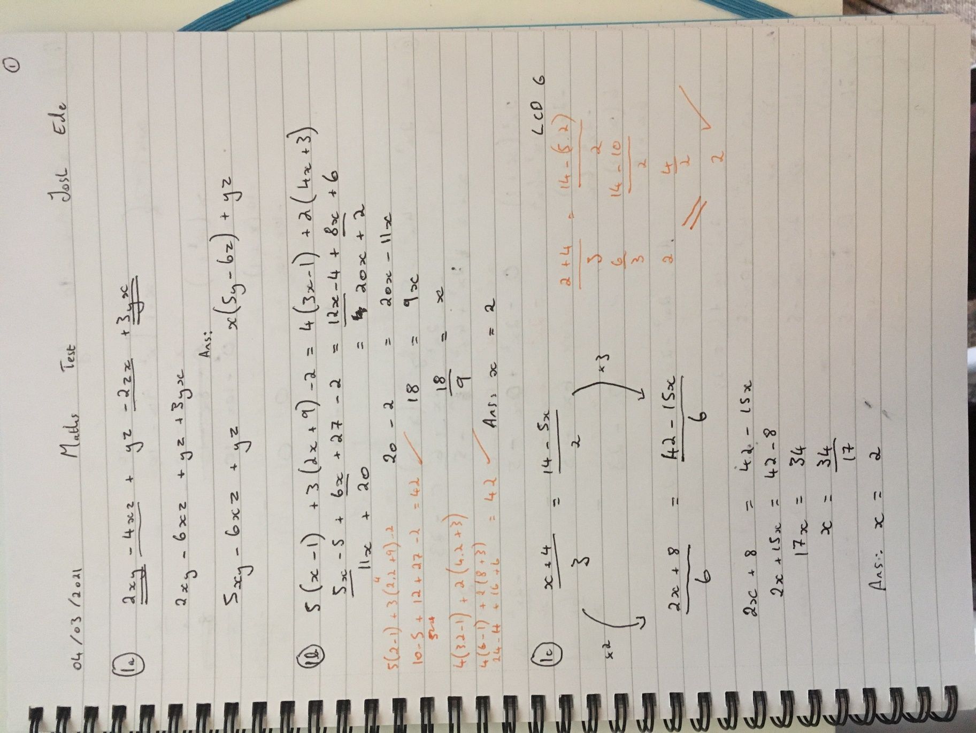
.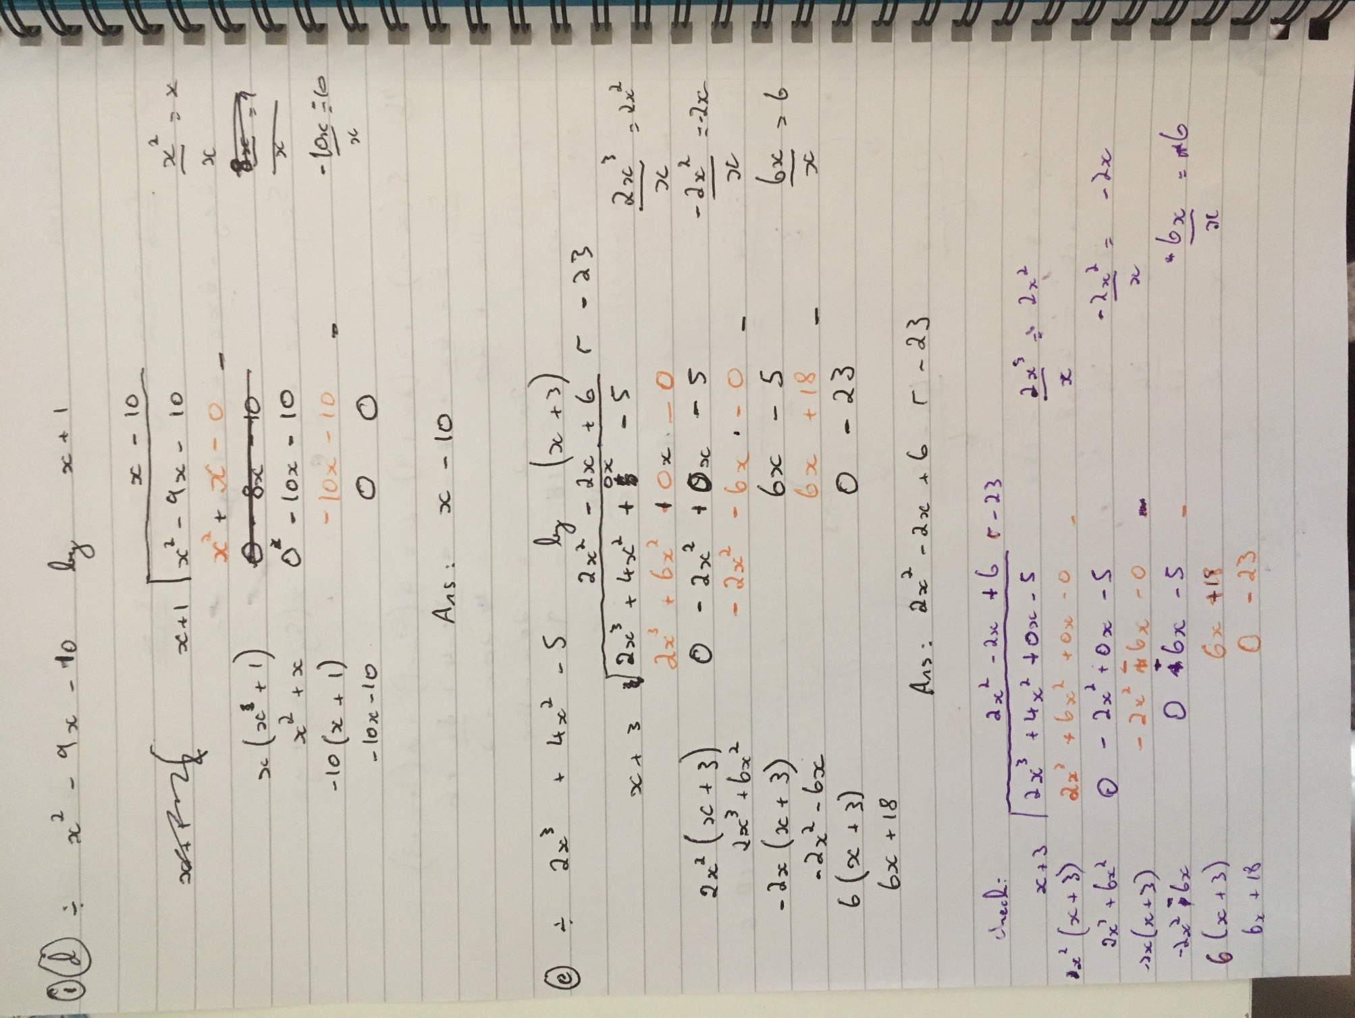
I left space at the bottom because I wanted the 3 variable simultaneous on one/two pages together for ease of viewing. I came back to the work out space for question4C when trying to differentiate my answer.
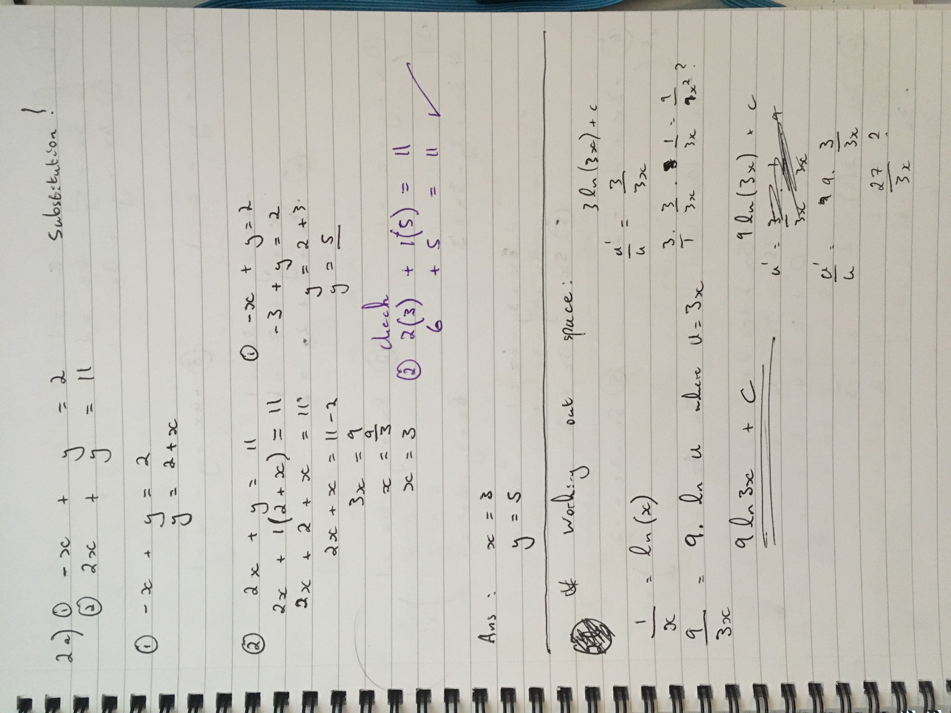

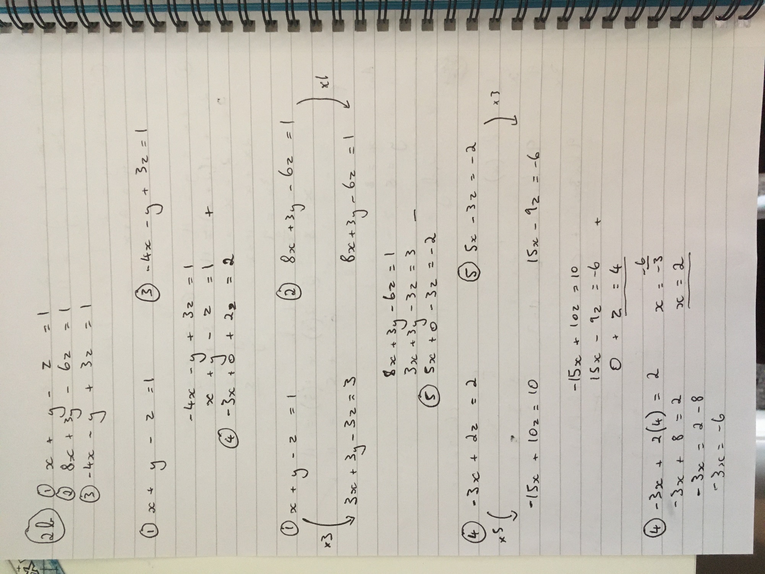

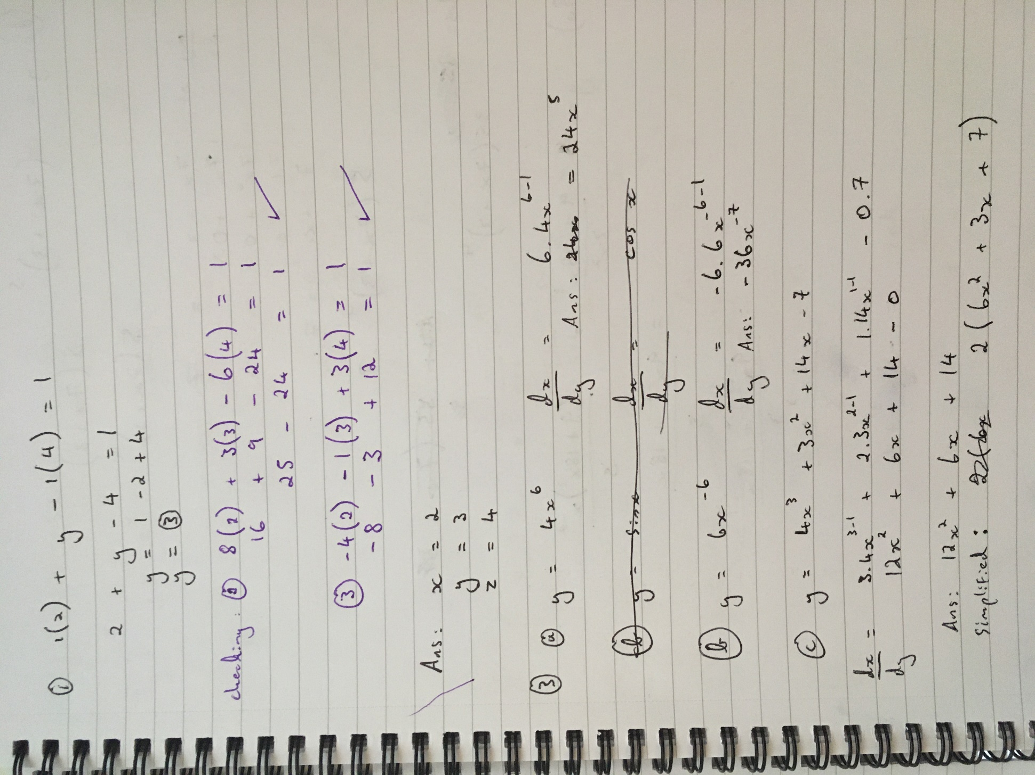

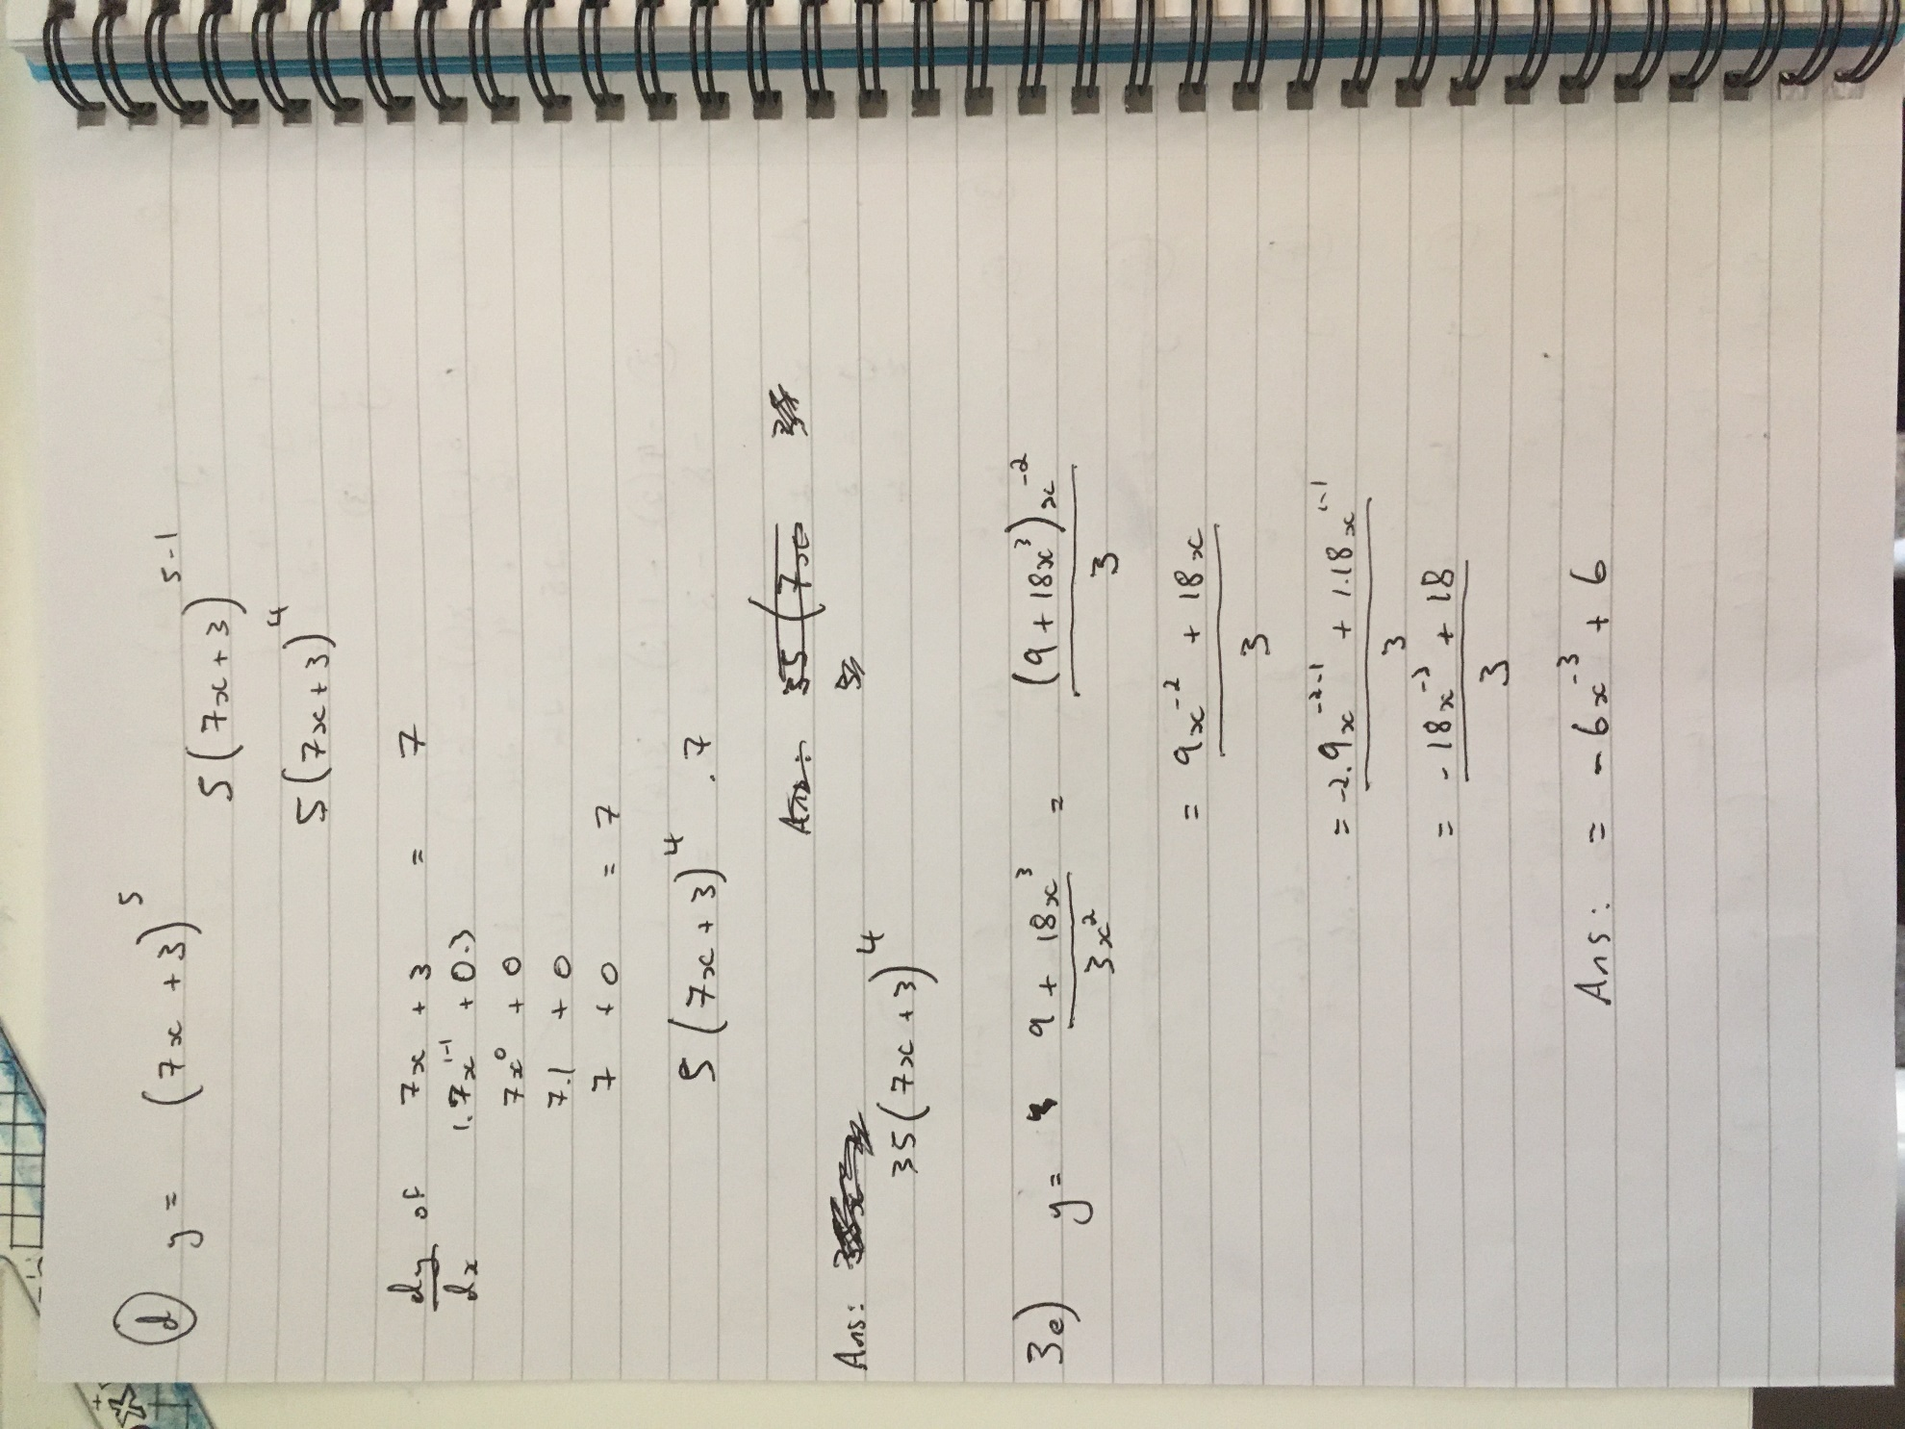

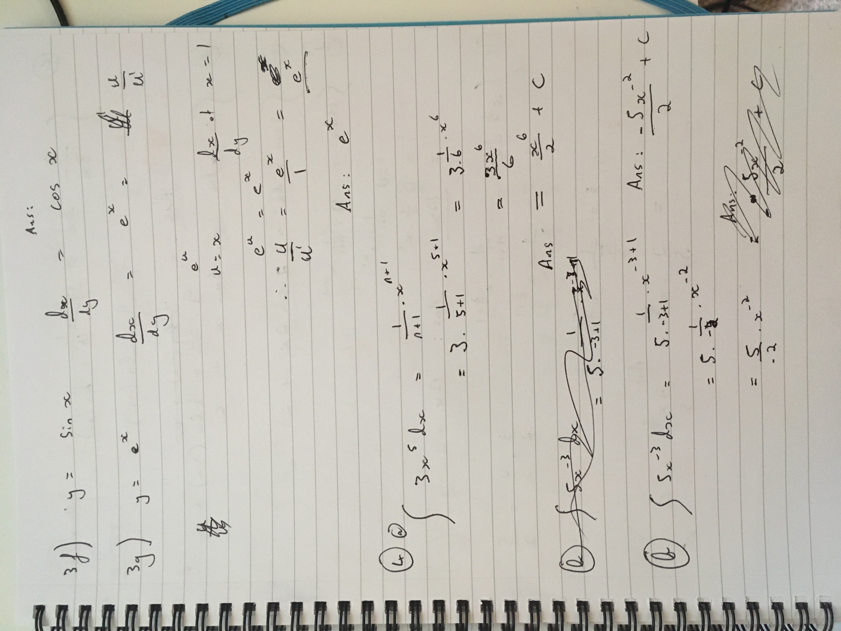
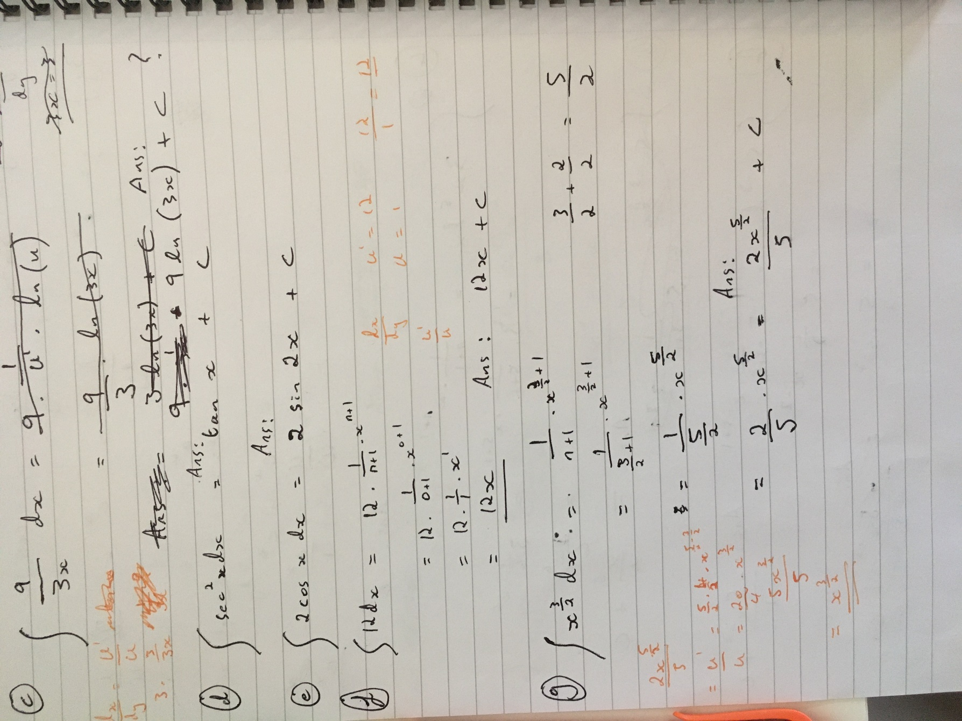

Just to be absolutely clear my answer for 4C) is 9ln(3x) +C, 4D) tan x + C. I wasn’t sure if they were clearly labelled.



