HERITAGE AND ARCHAEOLOGY OF CONFLICT
HPHE5003
ASSIGNMENT THREE – ESSAY
1902832 – DAVID LEWIS

Q. HOW CAN BATTLEFIELD ARCHAEOLOGY CONTRIBUTE POSITIVELY TO THE PROCESS OF BEREAVEMENT, COMMEMORATION AND RECONCILIATION.

Battlefield archaeology has emerged as a legitimate field of enquiry in the fields of archaeology, history and anthropology. There has been an evolutionary change in how the issue of those who have gone missing has been addressed after conflict and disasters. These advances have been driven by broader movements to rebuild peaceful societies following conflict via strategies of transitional justice and rule of law initiatives and can be interpreted as an attempt to redress the legacy of abuses of human rights and conflict. Scientific and technological advances in the use of modern forensic methods, genetics and informatics mean that it is possible to locate missing persons more effectively than was possible before. This has resulted in the role of conflict archaeology being transformed in relation to bereavement, commemoration, reconciliation; particularly since the 1990’s. In this essay I will examine the role and development of conflict archaeology since the 1990’s and its role in post conflict reconstruction and reconciliation and how it can contribute positively to bereavement, commemoration, and reconciliation; by exploring the specific skills of archaeologists; the nature of grief, loss and bereavement; the tension in commemoration; and its role in transitional justice, reconstruction and reconciliation.
The archaeology of excavating battlefields, sites of conflict and interpreting the effects of conflict have formed part of the foundations of the discipline of archaeology. This can also be seen in the research literature of archaeology and use of the descriptive terms such as “hillforts” which is in common usage in relation to bronze age and iron age hilltop sites. The word “hillfort” echoes sites of war and conflict, although very few sites contain specific evidence of conflict. Archaeology is a discipline that explores the past through excavation and the analysis of the material remains of people. This has meant that archaeologists have developed specialist skills that are directly relatable to sights of conflict and forensic contexts. Archaeological method and techniques have developed over time which makes them suited to read landscapes, excavate human remains, finding and interpreting grave sites of missing people. They are trained to produce detailed excavation records, and record the relationships between objects, bodies and soil features as they excavate. They have expertise in ensuring that buried artifacts and human remains can be fully recovered. Archaeologists are trained to interpret excavation sites, artifacts and their relationship to human and natural features, and build a sequencing picture of when objects were deposited. Buchli and Lucas have commented in relation to the role of archaeology of the contemporary past that “the archaeological act, in addressing the absent present, addresses the silent and painful lacunae in our understanding of recent experience”. It is these set of specific skills that have increasingly been called upon in excavating sites of recent conflict and have meant that archaeological skills and practice have become important elements in post conflict reconstruction and reconciliation.
Locating the missing and exhumation are important elements in post conflict reconstruction and reconciliation efforts. The negotiating of comprehensive peace agreements has become a common response of conflict resolution since the end of the Cold War. As has the establishment of Truth Commissions and War Crimes Tribunals with an explicit intent of promoting post conflict reconciliation. Reconciliation is often a key cited goal of these peace agreements. Central to this notion of reconciliation is to establish an objective and historical record about the conflict and previous atrocities; and recognition of truth is commonly seen as a fundamental condition so that individuals and civil society can come to terms with the past. Simpson has stated that without there being a commitment “to an excavation of the past in all its ugliness,” transitional societies are left “unedifying, dislocated and fragmented conceptions of the past.”Therefore, conflict / forensic archaeology along with forensic anthropology, finding the missing, reunited the missing with their families which allows them to grief and mourn, can be seen to have become valuable instruments for the understanding and analysis of the recent past in countries that have been subject to political and civil conflict. It can be argued that it is the specific training, skills, understanding and analysis that the disciplines of conflict archaeology, forensic archaeology and forensic anthropology brings that underpins the process of reconciliation.
Guatemala faced an internal armed conflict which lasted 36 years from 1960 to 1996, between the Government of Guatemala and guerrilla forces. This resulted in approximately 200,000 victims, 160,000 deaths and 40,000 missing. The conflict included state and guerrilla sponsored terror campaigns against the civil population as well as disappearances, arbitrary executions, rape of woman, and cultural destruction of the indigenous Mayan people. Cultural destruction included the destruction of ceremonial centres, sacred places and cultural symbols. Dress, language and other elements of cultural identification were also targeted. A peace process was established with the Accord of Oslo (1994) which led to the establishment of the Commission for Historical Clarification (CEH) which produced a report with conclusions and recommendations to promote peace and national harmony in Guatemala. As a part of the peace process the Congress of the Republic of Guatemala passed motions that recognised that “historical memory forms part of the social culture” and recognised the importance of achieving a “better future and achieve a firm and lasting peace” and the need for “Guatemalan society to commemorate these events, which are part of the history of Guatemala”. Locating the missing and returning these to their families and allowing families and local communities to grieve was seen as one of the essential elements in the peace process as well as establish what had happened and find ways of suitable commemoration.
Following the peace agreements in Guatemala the Forensic Anthropology Foundation of Guatemala (FAFG) was established by using forensic archaeology and forensic sciences to search, investigate, exhume, and identify the victims of Guatemala’s internal armed conflict.
FAFG aim is the recovery of human remains, together with any physical evidence and any associated objects and undertake a site assessment and the circumstances of how the remains were buried and deposited. All these elements contribute to the identification process. A key aim of FAFG is to locate the missing and return their remains to their families in order to bring closure. FAFG use a “Multidisciplinary Human Identification System” which includes forensic archaeology, genetics and anthropology. In the system used by FARG, the recovery of the human remains, genetic information and their analysis, are essential to the identification process.
Archaeological practice is embedded within this process. FAFG has recovered 8189 individuals and identified 3704 missing people and returned these to their families. They have also taken 16,224 DNA samples.
Similar arrangements and organisations have also formed part of peace agreements in other civil conflicts. In Cyprus the Committee on Missing Persons (CMP) was established in 1981 by the leaders of the Turkish and Greek Cypriot communities with the support of the United Nations. The CMP has an object to recover, identify and return to their families the remains of those who went missing during intercommunal violence between 1963 – 64 and war in 1974. The CMP have identified and returned 2002 individuals to their families (492 Turkish Cypriots and 1,510 Greek Cypriots). The CMP can be viewed as establishing a model for further developments in the 1990’s.
The International Commission on Missing Persons (ICMP)was created in 1996 as part of the Dayton Peace Agreement which ended the fighting in the former Yugoslavia whose initial mandate was to locate the 40,000 individuals who were missing during the civil conflict from 1991 to 1995. In 2014 the ICMP became a treaty based international organisation. Of the 40,000 missing in the former Yugolslavia 27,000 have been identified.
Conflict archaeological skills and practice underpin and form essential components of the work of FAFG, ICMP and the CMP and in their objectives of finding those individuals who are missing and bringing closure to families of the missing which has been previously stated can be seen to underpin the process of reconciliation. Within Accord of Oslo and other peace agreements there is a recognition that of the importance of bringing closure to families of the missing, providing answers as to what happened and is seen as integral to reconciliation and providing the basis of finding a lasting peace. It is in considering grief, loss and bereavement that archaeological practice makes its most visible positive contribution. Grief is a normal human response to a separation, bereavement or loss” and particularly to the loss of a person to which you have a close personal relationship with. Bereavement is a state of having experienced loss and relates to the period of time of grieving and mourning following a loss. Bereavement can be seen to be dually constituted in relation to an individual’s personal reactions to loss and the social construction of practices, emotions and ideologies. There are many theories of grief and commonly consist of a 4 / 5 stage model. Parkes identifies four phases of bereavement: shock or numbness, Yearning and pining, disorganisation and despair and recovery. Parkes describes the transition from “incomprehension and denial” through a state of distress and confrontation with reality and then to a form of resolution. In Parkes model the phases were not linear and could be re-experienced due to reminders of loss or trigger events. For Parkes grief was a process.
Rituals and mourning in the grief process are important in restoring normalcy and relieve a sense of uncertainty and allows the bereaved to readjust to the sense of loss. In the case of the missing the normal processes of bereavement and rituals around mourning cannot take place and have an unresolves loss that means that families cannot get closure or a resolution to their grief. Boss defined unresolved loss as “ambiguous loss”. As ambiguous loss implies unconfirmed loss it resists closure and therefore means that grief cannot be solved. It is this lack of closure for individuals and communities that can also be seen to act as a significant barrier to achieving lasting peaceful outcomes following civil conflict and emphasizes the importance of finding the missing for post conflict reconciliation. Kissane has stated that “memories of civil war need to be given a dynamic form: otherwise, they will ossify and become destructive”. It can be argued that this is also true of unresolved loss. It can therefore be argued that the finding the missing and dealing with unresolved loss is an essential building block of reconciliation.

Wafa Ali Mustafa’s father disappeared in Syria in 2013 and has run a campaign seeking to find what has happened to her father. She has stated that “not knowing the fate of your loved one is a form of death. ” ““But I know that till I die, I will never give up seeking the truth of my father's fate. My dad went missing eight years ago and I will never stop searching for answers”

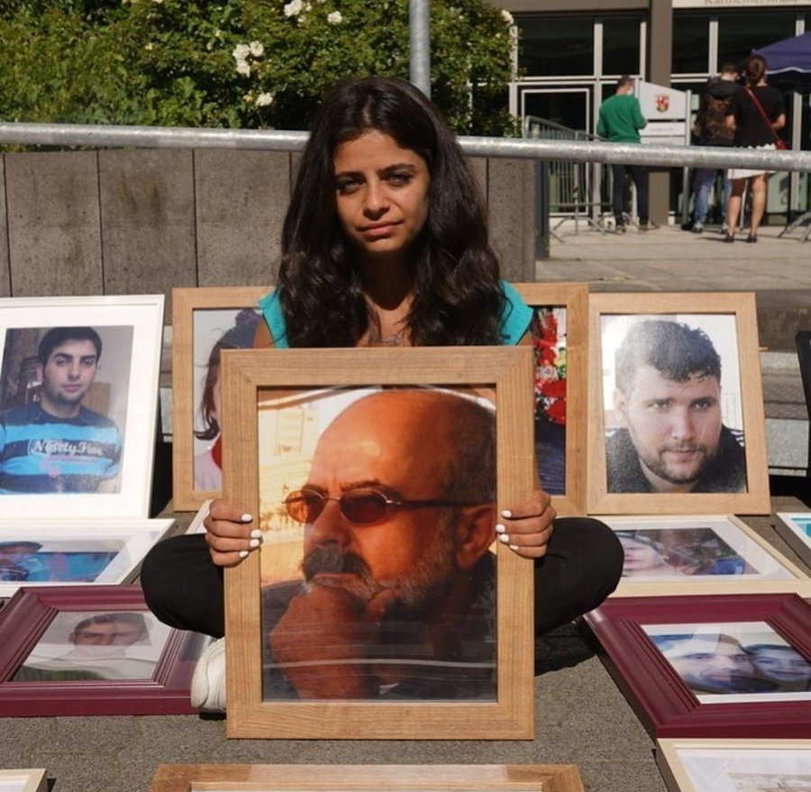
Fig 1. Wafa Ali Mustafa with picture of her father who was abducted in 2013, Syria. (ITV.com).

Although archaeology can make a positive contribution to bereavement, commemoration and reconciliation it is important to acknowledge that archaeology can also have a negative impact. Archaeology can trace its foundations back to the antiquarianism and the birth of the modern nation state. Its establishment and development can be seen to be influenced by a sense of local pride national identity, national exceptionalism, and supremacy of white European culture. It has been asserted that archaeology has had a long “historical relationship with nationalism” and hasn’t been “immune to politicisation”, and “reinterpretation and manipulation of the past”. This is exemplified by the founding of the research institute Ahnenerbe in 1935 whose aim was to unearth evidence of the deeds and accomplishments of Germanic ancestors by “using exact scientific methods.” Archaeology has at times been “mobilised as a weapon of war.” Pollack has talked about archaeology being “instrumentalized” and can become an “activist handmaiden to specific interests” and itself can be “deployed as a weapon of war and structural violence,” and cites examples of conflicts over Silvan area in Jerusalem and in the media campaign in the build-up to the wars in Iraq.
This possible tension between the positive and negative role of archaeology is especially pertinent in relation to commemoration. Commemoration and acts of commemoration can be seen to be culturally determined and are also in a constant state of flux and change. This can be evidenced in the current debates on the Colston statue in Bristol, the Picton memorial in Carmarthen and the American Civil War monuments in the USA. Commemoration is both politically and socially charged with meaning. Questions as to what is commemorated and how and in what form commemoration takes place can be highly contested. This is especially so in relation to civil war and post conflict reconciliation.
Commemoration is intrinsically linked to concepts of identity, and memory. Landscapes of war, violence and conflict are significant historical markers and can be seen to form part of the iconography of the modern state. This is especially so in relation to the former constitute parts of Yugoslavia, where within a process of reconciliation and reconstruction there is a process of forming new national identities and mythmaking. Reinish has highlighted the “existence of clashing reconstruction agendas” that emerge when there is a “focus on national identity.”Reconstruction and by inference reconciliation are policy and ideological domains where conceptions of identity compete for hegemony between one another. The nation being an ideological category that the state seeks to promote after civil war and the nation being “invoked in acts of commemoration with civil society that lead to rival interpretation of these conflicts”. The mutability of memory also makes it possible for there to be conflicting and multiple versions of events to co-exist. Gillis states that “what is remembered is defined by an assumed identity” and that identity is itself constructed by “creating a specific kind of memory” and that memorising helps us to make sense of the world but are “embedded in complex class, gender and power relations and determine which is remembered (or forgotten), by whom and for what end”. It can be argued that there is a conflict between the processes of forgetting and remembering and these are expressed through the “personal vs the collective; the private vs the public and simply us and them”.
Therefore commemoration, like reconciliation and identity can be seen as a contested term which has multiple meanings. However the importance of mediating the conflicting discourses around commemoration can be seen to be intrinsic to post conflict reconciliation. Archaeological practice can provide the foundations on which this contested discourse around commemoration can take place and act as a positive contribution to the discourse and to find a way to a shared understanding.
Bulchi and Lucas have stated that archaeology “allows an insight into the personal, the emotive, the identification of individual death and tragedy.” This is perhaps no truer than when dealing with battlefield archaeology and exhumation of human remains following conflict. I agree with Trouillot when he stated that the strengths of post-conflict societies is not how dominant political groups manage heritage, history and memory “via fabrication of constricting master narratives and partisan political iconography but how well they are to confront the discomforting legacy of the past. At the basis of bereavement, commemoration and reconciliation is the search for truth and the search for answers. It is the specific skills of archaeologists and forensic archaeology in helping to locate and find the missing which can help bring closure to the families of the missing and allow families and others to grieve and commemorate their loved ones and move on. It also lets civil society and its institutions to engage with the past and deal with the more difficult and at times contentious issues of commemoration and reconciliation and in words of Trouillot to “confront the discomforting legacy of the past”.

Bibliography.

Arnould, V. (2006). Justice after civil wars: Truth Commissions and War Crimes Tribunals contribution to Post- conflict reconciliation. Studio Diplomatica. Vol 59. No.2. The EU’s Eastern Neighbourhood Peace and Justice. pp 141-158.

Buchli, V & Lucas, G. (2001). Archaeologies of the Contemporary Past. London. Routledge.
Buglass, E. (2010) Grief and Bereavement Theories. Nursing Standard. Vol 24. No 41, pp. 44-47
Carver, M. (2009). Archaeological Investigation. London. Routledge.
Drewett, P. (1994). Field Archaeology. An Introduction. London. Routledge.
Greene, K (1995). Archaeology. An Introduction. London. Batsford:
Guatamala Memory of Silence. Report of the Commission for Historical Clarification Conclusions and Recommendations. Available at https://hrdag.org/publications/guatemala-memory-of-silence-report-of-the-commission-for-historical-clarification-conclusions-and-recommendations/ (accessed 30/01/22).

Hardy-Bougere, M. (2008). Cultural manifestations of Grief and Bereavement: A Clinical perspective. Journal of Cultural Diversity. Vol 15 No.2. pp. 66-69.

Kissane, B. (2015) After Civil War. Division, Reconstruction and Reconciliation in Contemporary Europe. Philadelphia, Pennsylvania. University of Pennsylvania Press.

Parkes,C,M. (1998). Bereavement in Adult Life. British Medical Journal 317:518. doi: https://doi.org/10.1136/bmj.317.7157.538a (accessed 30/01/22).
Pollock, S. (2016). Archaeology and Contemporary Warfare. Annual Review of Anthropology. Vol. 45, pp 215-231.
Pringle, H. (2006). Hitlers Willing Archaeologists. Archaeology. Archaeological Institute of America Vol 59 No 2. pp 44-49.
Richardson, L. (2020). “Now even archaeology is being used in the constitutional battle”. The Herald 11th October 2020. Available at https://www.heraldscotland.com/news/18784405.now-even-archaeology-used-constitutional-battle/ (accessed 03/02/2022).

Schauble, M (2011). How history takes place. Sacralised Landscapes in the Croatian- Bosnian Border Region. History and Memory, Vol.23, No.1 (Spring/Summer 2001).

Simpson, K. (2009). Truth Recovery in Northern Ireland. Manchester. Manchester University Press.
Sarkin. J, Nettelfield. L, Matthews. M, & Kosalka. R. Bosnia and Herzegovina Missing Persons from the Armed Conflicts of the 1990s: A Stocktaking. ICMP, Available at: www.icmp-mp.org (2014). (accessed 20/01/22.)
Scott, D, Babits, L & Haecker C. (2009). Battlefield Archaeology from the Korean Empire to the Korean War. Washington, D.C. Potomac Books.
Testoni I, Franco C, Palasso L, Iacona E, Zamperini A & Wieser A (2020). The Endless grief in Waiting: A Qualitative Study of the Relationship between Ambiguous Loss and Anticipatory Mourning amongst Relatives of Missing Persons in Italy. Behavioural Science Vol 10 doi: 103390/bs1007011
Alcock, S, E and Van Dyke, R, M. (2003) Archaeologies of Memory: An Introduction. Malden, MA. Blackwell Publishers Ltd.
Weiss, M. (1997). Bereavement, Commemoration and Collective Identity in Contemporary Israeli Society. Anthropological Quarterly. Vol. 70. No. 2 pp.91-101

Websites

The Commission for Historical Clarification 23 June 1994. Available at https://www.usip.org/publications/1997/02/truth-commission-guatemala (accessed 01/02/22)
Committee on Missing Persons in Cyprus available at: https://www.cmp-cyprus.org/who-we-are (accessed 30/01/22.)
Dayton Peace Agreement (General Framework Agreement for Peace in Bosnia and Herzegovina). 14 December 1995. United Nations. (accessed 01/02/22 at https://www.un.org)
FAFG available at: https://fafg.org (accessed 01/02/22).
The Guardian. The day Bristol dumped its hated slave trader in the docks and a nation began to search its soul. Available at : https://www.theguardian.com (accessed 02/02/22)
ITV.com. My dad went missing eight years ago and I will never stop searching for answers. Available at: https://www.itv.com/news/2021-03-15/my-dad-went-missing-eight-years-ago-i-will-never-stop-searching-for-answers (accessed 01/02/22).
ITV.com. Carmarthen’s Thomas Picton monument to stay but with new sign referencing slavery links. Available at: https://www.itv.com (accessed 02/02/22)
National Geographic. Toppling statues is a first step toward ending Confederate myths. Available at: https://www.nationalgeographic.com (accessed 02/02/22)

Scott, D, Babits, L & Haecker C. (2009). Battlefield Archaeology from the Korean Empire to the Korean War.Potomac Books
Futurelearn
Sarkin, J, Nettelfield, L, Matthews, M & Kosalka, R. Bosnia and Herzegovina Missing Persons from the Armed Conflicts of the 1990s: A Stocktaking
Ibid
Buchli, V & Lucas, G. (2001). Archaeologies of the Contemporary Past. Routledge. London
The Commission for Historical Clarification 23 June 1994, Dayton Peace Agreement (General Framework Agreement for Peace in Bosnia and Herzegovina). 14 December 1995,
Arnould, V. (2006). Justice after civil wars: Truth Commissions and War Crimes Tribunals contribution to Post- conflict reconciliation. Studio Diplomatica. Vol 59. No.2. The EU’s Eastern Neighbourhood Peace and Justice. pp 141-158
Ibid 141
Ibid 141
Simpson, K. (2009). Truth Recovery in Northern Ireland. Manchester University Press. p. 101
Buchli, V & Lucas, G. (2001). Archaeologies of the Contemporary Past. Routledge. London p.139
Commission for Historical Clarification
Guatamala Memory of Silence. Report of the Commission for Historical Clarification Conclusions and Recommendations
ibid
Ibid. p45
ibid
Forensic Anthropology Foundation of Guatemala (FAFG) available at: https://fafg.org
ibid
ibid
ibid
Committee on Missing Persons in Cyprus, available at: https/www. Cmp-cyprus.org/who-we-are
International Commission on Missing Persons (ICMP), available at: https://www.icmp.int/about-us/history
Sarkin, J, Nettelfield, L, Matthews, M & Kosalka, R. Bosnia and Herzegovina Missing Persons from the Armed Conflicts of the 1990s: A Stocktaking
Buglass, E. (2010) Grief and Bereavement Theories. Nursing Standard. Vol 24. No 41, p.44
Ibid
Weiss, M. (1997). Bereavement, Commemoration and Collective Identity in Contemporary Israeli Society. Anthropological Quarterly, The George Washington University Institute for Ethnographic Research. Vol. 70. No. 2, p.91.
Lindermann (1944), Parkes (1998), Worden (1991), Bowlby (1973), Kubler-Ross (1980).
Parkes,C,M. (1998). Bereavement in Adult Life. British Medical Journal 317:518. doi: https://doi.org/10.1136/bmj.317.7157.538a
Buglass, E. (2010) Grief and Bereavement Theories. Nursing Standard. Vol 24. No 41, p.46
Yeong N,B. In
Boss, P. in Testoni I, Franco C, Palasso L, Iacona E, Zamperini A & Wieser A (2020). The Endless grief in Waiting: A Qualitative Study of the Relationship between Ambiguous Loss and Anticipatory Mourning amongst Relatives of Missing Persons in Italy. Behavioural Science Vol 10
Testoni I, Franco C, Palasso L, Iacona E, Zamperini A & Wieser A (2020). The Endless grief in Waiting: A Qualitative Study of the Relationship between Ambiguous Loss and Anticipatory Mourning amongst Relatives of Missing Persons in Italy. Behavioural Science Vol 10
Wafa Ali Mustafa interviewed on 7pm Channel Four News 13/01/22 whose father Ali Mustafa who was abducted from his home and disappeared in July 2013 in Syria.
Wafa Ali Mustafa. ITV.com.
Richardson, L. in an article entitled “Now even archaeology is being used in the constitutional battle”. The Herald published 11th October 2020.
Pringle, H. (2006). Hitlers Willing Archaeologists. Published in Archaeology. Archaeological Institute of America Vol 59 No 2 March/April 2006
Pollock, S. (2016). Archaeology and Contemporary Warfare. Annual Review of Anthropology. Vol. 45, p.216
Ibid. p. 217
The day Bristol dumped its hated slave trader in the docks and a nation began to search its soul. theguardian.com; Carmarthen’s Thomas Picton monument to stay but with new signs referencing slavery links. ITV.com;Toppling statues is a first step toward ending Confederate myths. Nationalgeographic.com
Schauble, M (2011). How history takes place. Sacralised Landscapes in the Croatian- Bosnian Border Region. History and Memory, Vol.23, No.1 (Spring/Summer 2001). p.24
Reinisch, J. (2006). Comparing Europe’s Post-War Reconstruction in Kissane, B. (2014) After Civil War. Division, Reconstruction and Reconciliation in Contemporary Europe. University of Pennsylvania Press.
Kissane, B. (2014) After Civil War. Division, Reconstruction and Reconciliation in Contemporary Europe. University of Pennsylvania Press. p.274
Alcock, S, E and Van Dyke, R, M. (2003) Archaeologies of Memory: An Introduction. Blackwell. p.3
Gillis 1994 in Kissane, B(2014) After Civil War. Division, Reconstruction and Reconciliation in Contemporary Europe. University of Pennsylvania Press. p.216.
Buchli, V & Lucas, G. (2001). Archaeologies of the Contemporary Past. Routledge. London p.82
Hughes, J in Kissane, B. (2014) After Civil War. Division, Reconstruction and Reconciliation in Contemporary Europe. University of Pennsylvania Press. p.262.
Buchli and Lucas. p.191
Trouilot in Simpson, K. (2009). Truth Recovery in Northern Ireland. Manchester University Press. p.101
Ibid p.101.

