
ACFA7004
Research Methods and Professional Development
Lecturer: Dr. Suresh Shanmugasunadaram

Project Name: Enhancing Cyber Security Incident Response through Digital Forensic Readiness.
Submitted by :
MD. Mahmudul Hassan.
ID : 2504534

Submission Deadline - Wednesday, 29TH april 2026.

Table of Contents.
Abstract 3
1. Introduction 3
2. Research Aim and Objectives 5
Aim 5
Objectives 5
3. Research Questions 5
4. Literature Review (Critical Analysis) 5
5. Research Methodology 7
5.1 Research Philosophy 7
5.2 Research Approach 7
5.3 Research Design 7
5.4 Data Collection 7
5.5 Sampling Strategy 7
5.7 Reliability and Validity 7
5.8 Ethical Considerations 7
6. Expected Contribution 9
Theoretical Contribution 9
Practical Contribution 9
7. Timeline 9
8. Conclusion 10

Abstract

The complexity and frequency of cyber threats have increased, revealing significant limitations in traditional cyber security systems that rely largely on preventive controls. Recent study suggests that businesses should create resilience-based strategies that combine both prevention and reactive capabilities [6]. This study looks at the role of digital forensic readiness (DFR) in boosting cyber security incident response in UK businesses. While the existing literature acknowledges the significance of cyber security and digital forensics individually, there is a scarcity of integrated frameworks that combine proactive security measures with forensic preparation [5].
A qualitative case study was employed in this investigation.
study methodology to analyze organizational practices, roadblocks, and strategic gaps in DFR adoption. The findings are expected to demonstrate that forensic readiness is a strategic competency necessary for effective cyber threat management, rather than a reactive strategy.

1. Introduction
The rapid digital transformation of organizations has increased their vulnerability to cyber threats, making cyber security a critical issue for both the public and private sectors [6]. The growing reliance on interconnected systems, cloud computing, and digital infrastructures has resulted in new vulnerabilities, allowing hackers to exploit system faults more sophisticatedly [5]. Despite large investments in preventive security measures, cyber attacks continue to occur, highlighting the flaws of traditional security approaches.
Cybersecurity is primarily concerned with preventing unwanted access and attacks on systems, networks, and data, whereas digital forensics is concerned with detecting, preserving, analyzing, and presenting digital evidence following an incident.
Although these areas are interconnected, they are frequently managed separately within organizational hierarchies, resulting in fragmented security policies and inefficient incident response processes [5].
To deal with this fragmentation, the concept of digital forensic readiness (DFR) has emerged. DFR refers to an organization's proactive preparedness to efficiently capture and use digital evidence while minimizing investigative costs. Despite its theoretical importance, many businesses have yet to fully incorporate forensic readiness into their cyber security frameworks [4].
One of the biggest obstacles to DFR implementation is the contradiction between security and privacy. Data protection regulations like the General Data Protection Regulation (GDPR) may be in conflict with enhanced monitoring and data collecting, which are crucial for forensic preparedness [4].
This puts firms in a tough position when attempting to balance compliance with effective security procedures.
This study contends that the absence of integration between cyber security and digital forensics is a fundamental gap in current organisational strategy. By critically analyzing DFR's role, this study aims to help the UK create cyber security regimes that are more robust and effective.

2. Research Aim and Objectives

Aim
To critically evaluate the impact of digital forensic preparation in improving cyber security incident response in UK companies.

Objectives
A critical examination of current cyber security threats and response constraints [6].
Determine the significance of digital forensic readiness frameworks [3].
[5] investigated the use of digital forensics in cyber security methods. Identify organizational, legal, and technological barriers [4].
Provide a framework for improving incident response.

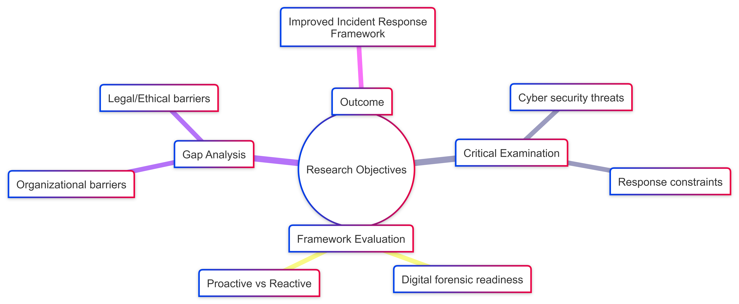

Figure: Research Goals and Project Outcomes Mind Map

3. Research Questions
How much do current cyber security strategies consider digital forensic readiness ?
How does DFR affect incident response efficacy [5]? What are the main hurdles to implementing forensic readiness [4]?
How should organizations reconcile forensic readiness with legal and ethical standards [2]?

4. Literature Review (Critical Analysis)

The research indicates a shift away from traditional preventive cyber security strategies in favor of more adaptable and resilient approaches. According to[5], preventive procedures are insufficient to tackle modern hazards such as advanced persistent threats (APTs) and zero-day attacks. Similarly, [6] highlights the increasing sophistication of cybercrime and the necessity for more effective incident response systems.
Digital forensics has emerged as a significant component of cyber incident management.[2] highlights the need of evidence integrity, particularly in legal contexts, whereas [5] discuss challenges related to cloud-based forensic investigations.
However, these investigations are mostly focused with post-incident analysis, ignoring the proactive potential of forensic preparation.
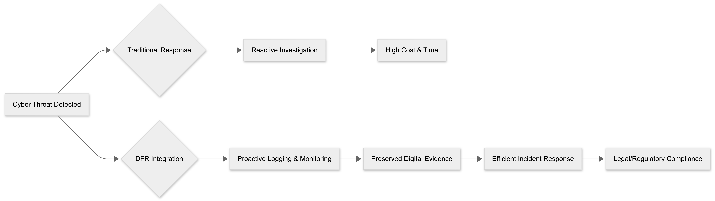
Figure: Comparing Proactive Digital Forensic Readiness (DFR) Integration with Conventional Reactive Incident Response
[5] introduced the concept of digital forensic readiness, saying that companies should plan ahead of time in order to efficiently manage digital evidence. While this concept has grown in popularity, it has been critiqued for its lack of empirical validation in modern digital environments [5]. emphasizes the importance of forensic preparation but does not address emerging technologies like IoT or cloud computing.
A major gap in the literature is the lack of collaboration between cyber security and digital forensics. Most studies treat these categories separately, resulting in fragmented strategies that do not address the complete lifespan of cyber incidents [4]
Furthermore, there has been minimal research focused on UK firms, particularly in terms of regulatory compliance and GDPR.
Another hotly disputed issue is the balance between security and privacy. While increased logging and monitoring are necessary for forensic preparation, they may conflict with data protection criteria such as data reduction [4]. This is a major issue for businesses looking to use DFR efficiently.
This report addresses these shortcomings by undertaking a critical and integrative analysis of cyber security and digital forensic readiness in the UK.

5. Research Methodology

5.1 Research Philosophy
This study takes an interpretivist approach, acknowledging that organizational practices and human aspects influence cyber security solutions [3].

5.2 Research Approach
A qualitative technique is chosen to investigate complex organizational behaviors and perspectives [3].

5.3 Research Design
A multiple case study design will be used to provide detailed insights into organizational practices.

5.4 Data Collection
Conduct semi-structured interviews with cyber security specialists [3] recommends analyzing organizational policies using documents.

5.5 Sampling Strategy
Purposive sampling will be utilized to identify people with relevant skills.

5.6 Analysis of Data
We'll use thematic analysis to identify themes and patterns [1].

5.7 Reliability and Validity
Triangulation improves credibility and validity.

5.8 Ethical Considerations
Informed consent. Confidentiality. Ensure GDPR compliance [4]

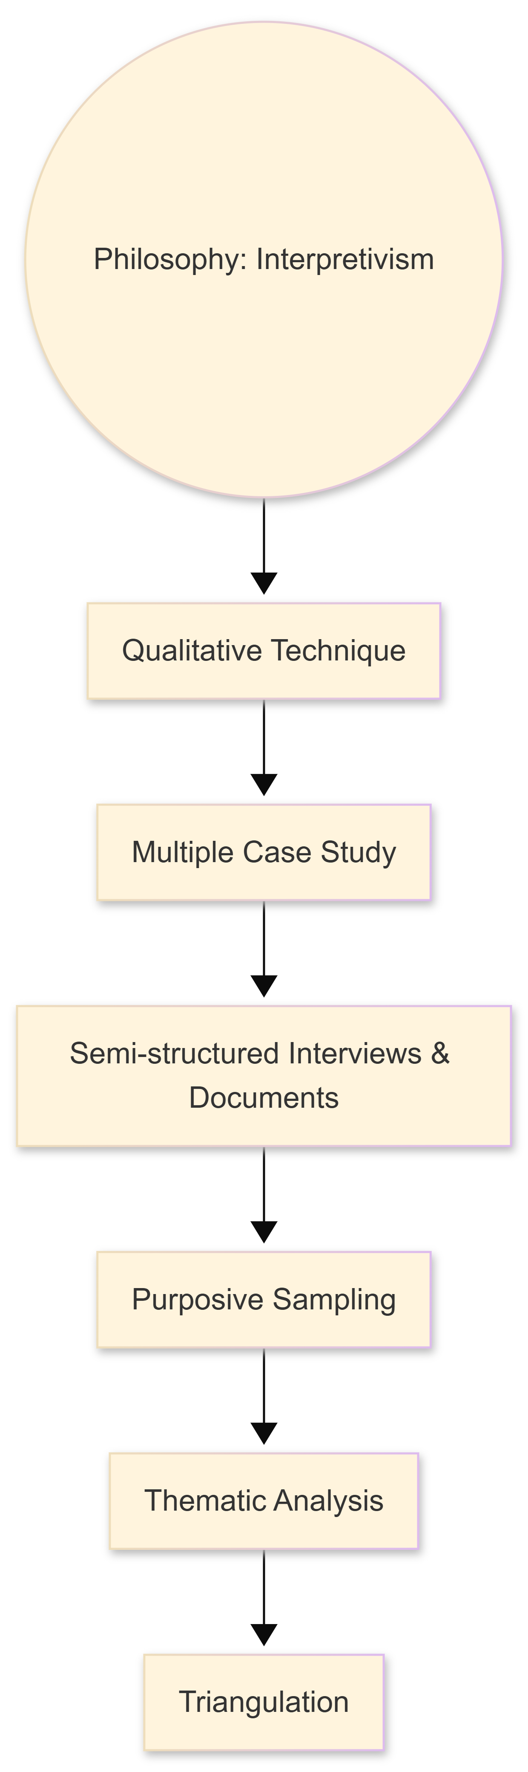
Figure: The Qualitative Study on Digital Forensic Readiness's Methodological Framework.

6. Expected Contribution

Theoretical Contribution
This study adds to academic understanding by combining cyber security and digital forensic readiness in a single framework [5].

Practical Contribution
The study makes practical recommendations for enhancing incident response techniques.

7. Timeline
Phase | Duration
Proposal | 2 weeks
Literature Review | 4 weeks
Data Collection | 4 weeks
Analysis | 3 weeks
Writing | 3 weeks

During the roughly two-week proposal phase, the research topic, aim, and objectives will be precisely defined and approved.
After that, a four-week literature review will be carried out in order to evaluate current scholarly research and pinpoint pertinent research gaps. The study's theoretical framework will be formed during this phase.
After that, the data collection phase will take place over the course of four weeks, during which time pertinent data will be collected using the chosen research techniques. The three-week data analysis phase will come next, during which the gathered data will be methodically reviewed and interpreted to produce insightful conclusions. Finally, the writing phase will take three weeks, during which the research findings will be compiled into a well-structured academic report, including discussion, conclusions, and recommendations.

8. Conclusion
Cyber threats are always developing, bringing new challenges to existing security measures and stressing the significance of integrated approaches. This study examines the importance of digital forensic readiness in improving cyber security incident response. The study adds to theoretical and practical achievements in cyber security by filling major gaps in the literature and focusing on UK organisational practices. The integration of cyber security and digital forensics is crucial for developing resilient companies capable of responding to modern cyber threats [6; 4].

Reference:

[1]. V Braun, V Clarke - Qualitative research in psychology, 2006 - Taylor & Francis
[2]. Casey, E. (2011) Forensic Science, Computers, and the Internet: Digital Evidence and Computer Crime. Third ed. The Academic Press, London.

[3]. Creswell, J.W. (2014) Research Design: Qualitative, Quantitative, and Mixed Methods Approaches. 4th edn. Thousand Oaks, CA: Sage Publications.

[4]. Threat Landscape 2023, ENISA (2023). Luxembourg: Agency for Cybersecurity, European Union.
[5]. Rowlingson, R. (2004) International Journal of Digital Evidence, 2(3), pp. 1–28, "A Ten Step Process for Forensic Readiness." Big Digital Forensic Data: Volume 1: Data Reduction Framework and Selective Imaging, Quick, D. and Choo, K.-K.R. (2018). Springer in Singapore.
[6]. Economics of Artificial Intelligence in Cybersecurity," Kshetri, N. (2021), IT Professional, 23, pp. 73-77

