Max Morton-Lewis
Lectuer name: Paul John
Assignment 2: Mobile-enabled website utilising REST services (JSON)

Contents
1 How I developed my API 3
1.2 HTML 3
1.3 JavaScript 4
1.4 jQuery 4
1.5 AJAX (Asynchronous JavaScript and XML) 4
1.6 Development Challenges 4
1.7 Styling and Label Changes 5
1.8Final Touches 5
2 Know Issues with the APIs/Mobile app 5
3 What I would do differently 5
Bibliography 6
Appendix 8
Reference For the images on the website 8

Introduction
In this assignment, I'll be discussing how I developed my Mobile API. I will discuss how I came up with the idea for the API how I designed the mobile app (I'll just be covering my API pages), How the design evolved, and talking bout the final product. After this I will then be discussing know issues with the API/Mobile site, then finally how I would approach the task differently if done again.

Read This before using the mobile app!
The best way to view this app is through a phone and on the Chrome browser, the exact phone that's best viewed through is the iPhone 14 plus. If you have on the computer mobile simulator extension select iPhone 14 plus, if not please download the extension. I’m also using Wamp for my website and I’m using MySQL version 8.3.0 and PHP version 8.2.18.

1 How I developed my API
For the development of the mobile app I messed around with “stick mobile”, this is what the foundation of my website is built on [1]. I used the "page-travel-home-1" as a template for the search API, and I noticed that each part of the search element when pressed on could be interacted with but led nowhere. I got the idea then for the search API and the dynamically loaded page, later I started coding the PHP for talking to the database and displaying it on a page. At this point I also designed the layout for most of the pages, this would help visualize the pages better and would allow me to better see my vision.
See Figures 1-4 in the appendix for the early drawing of my pages.

After this, I then coded the response to output JSON which it did, but the styling was off and wasn't what I wanted it to look like, spent a few iterations just trying to nail that down. Upon completing this I realized that my approach to this whole thing was wrong and was not an "API" To make it a proper API I would need a combination of JAVASCRIPT, PHP, HTML, and JQUERY to get it to properly function. I later spent time on these languages and thinking of how I would incorporate them into my API design. At this point, I spent time looking over YouTube videos and websites for information on coding languages to have a better understanding when coding and also used in the development of the website. I used it for information and to help in development, these are some of the sources. First w3school introduction to Ajax [2], Then information on GET request [3] and Understanding basics Json [4]. The other Platform I used for understanding was YouTube, I used Videos for JavaScript [5], Which is also for JavaScript knowledge [6], another video on getting started with jQuery [7], and a video on what Ajax is [8].

1.2 HTML
We use HTML for the “div” tag that’s incorporated the page the user gets sent to but also what would later be the ship name parameter, it includes the CSS and/or JS files as well for some of the sticky mobile elements.
See Figure 5 in the appendix for an example

1.3 JavaScript
JavaScript is the core scripting language running in the browser. It controls logic like reading URL parameters [9], parsing the JSON response [10], and dynamically updating the DOM (Document Object Model). We also use it to parse the JSON response from the server, this converts the response to a JavaScript object model, and I used JSON.parse() to achieve this.
See Figure 6 in the appendix for an example

1.4 jQuery
jQuery is used for running functions after the page is fully loaded [11], sending an Ajax request to shipDetails.php with parameters, updating an element with the Ship-details ID and updating its text, dynamically creating an <img> element using jQuery, and selecting an element if the class name Json-element and appends an image to it. I used jQuery because it helps simplify JavaScript for tasks like DOM manipulation and AJAX requests.
See Figure 7 in the appendix for an example

1.5 AJAX (Asynchronous JavaScript and XML)
Finally, AJAX (Asynchronous JavaScript and XML) rather than using XML I have used JSON instead which is more commonly used for APIs with it being asynchronous it allows for non-blocking requests keeping the page responsive while data is being loaded. In my API I have used AJAX to make a GET request [12] to ship Details using the ship name parameter and receive and process the JSON response of the server.
See Figure 8 in the appendix for an example

1.6 Development challenges
Moving on, I started the development of the new "API", this was what caused me the most problems and errors, one not understanding the language well enough, two rushing in and just coding the problem rather than planning and methodically working on the idea and three I should have spent more time messing around/playing with stick mobile. Once I got through the coding problem, I could finally test it. I came across some problems where the page had to be reloaded page wasn’t sending the request to the database etc, I fixed this problem by testing my query in MySQL to see if it was correct, and then I added a try-catch for debugging the server response and a few more console logs for debugging. For debugging, I used information from W3schools to help with console.log [13], console. Error [14], I also used W3school for a try-catch [15], and finally, for error handling, I used medium.com [16].

1.7 Styling and label changes
The styling for the pages once again had to be changed because the content was being shifted to the right side of the page rather than the center of the page. I then also changed the labels of the data for example having one of the fields be "Kills" is not appropriate, so I had to change it to "Number of ships sank", I also changed some of the other labels as well.

1.8Final Touches
I did revisit the code later to add a simple piece of code, this could use the ship name parameter and search the image file for the image with that name, this is the image you see under all the information about the ship. I also used W3schools for some assistance on this part as well [17].

2 Know Issues with the APIs/Mobile app
There are some known issues that I was unable to fix with the time given, first one is all APIs require a refresh when the page is loaded. For example, in the search API when a ship is selected the page will say loading ship details, but never load ship details, to see them it requires a refresh of the page, some goes for weather and location API.
The second problem is the settings, when a page is refreshed the settings can no longer be used and require the user to move to the home page or the search page again to use them.
Thirdly you cannot scroll down on the search bar which hides the final ship on there.

3 What I would do differently
If I were to do this differently, I would probably plan the whole website more. I was adding a lot of features last minute and did implement them fast and rushed them causing more problems than they were worth. I would also have loved to spend more time with stick mobile, there was so much more that it had to offer but with time I was unable to go through it all. I also have a feeling that sticky mobile is what caused a lot of the issues that I may have experienced because I didn’t spend the time going through it.

Bibliography

[1] | N/A, "Sticky Mobile," themeforest, N/A N/A N/A. [Online]. Available: https://themeforest.net/item/sticky-mobile-mobile-template/23229237?gad_source=1&gbraid=0AAAAADf3e4G4UqsNmRRldvxdkEbNzfm9p&gclid=Cj0KCQjwh_i_BhCzARIsANimeoHjOuZEiVDMqlgeGMOfxmdBv_2x4AoRiRXIrbXgeORTKE-T4L9nIvwaAuI1EALw_wcB. [Accessed 18 February 2025].
[2] | N/A, “AJAX Introduction,” W3school, N/A N/A N/A. [Online]. Available: https://www.w3schools.com/xml/ajax_intro.asp. [Accessed 20 March 2025].
[3] | N/A, “jQuery - AJAX get() and post() Methods,” W3schools, N/A N/A N/A. [Online]. Available: https://www.w3schools.com/jquery/jquery_ajax_get_post.asp. [Accessed 22 March 2025].
[4] | N/A, N/A N/A N/A. [Online]. Available: https://www.w3schools.com/js/js_json.asp. [Accessed 22 March 2025].
[5] | SuperSimpleDev, “JavaScript Tutorial Full Course - Beginner to Pro,” YouTube, N/A, 2024.
[6] | P. w. mosh, “JavaScript Course for Beginners – Your First Step to Web Development,” YouTube, N/A, 2018.
[7] | D. Krossing, “1: How to Get Started With | jQuery Tutorial | Learn jQuery | jQuery Tutorial For Beginners,” YouTube, N/A, 2017.
[8] | L. Learning, “JavaScript Tutorial - What is AJAX?,” YouTube, N/A, 2013.
[9] | B. Inventions, “How to Access URL Parameters with JavaScript: Super Easy,” YouTube, N/A, 2024.
[10] | N/A, “JSON.parse(),” W3schools, N/A N/A N/A. [Online]. Available: https://www.w3schools.com/js/js_json_parse.asp. [Accessed 26 March 2025].
[11] | N/A, “jQuery - Get Content and Attributes,” W3schools, N/A N/A N/A. [Online]. Available: https://www.w3schools.com/jquery/jquery_dom_get.asp. [Accessed 20 March 2025].
[12] | N. Ninja, “Asynchronous JavaScript #2 - AJAX Requests,” YouTube, N/A, 30.
[13] | N/A, “Console log(),” W3schools, N/A N/A N/A. [Online]. Available: https://www.w3schools.com/jsref/met_console_log.asp. [Accessed 5 April 2025].
[14] | N/A, “Console error(),” W3schools, N/A N/A N/A. [Online]. Available: https://www.w3schools.com/js/js_errors.asp. [Accessed 5 April 2025].
[15] | N/A, “JavaScript Errors,” W3schools, N/A N/A N/A. [Online]. Available: https://www.w3schools.com/js/js_errors.asp. [Accessed 5 April 2025].
[16] | S. Hough, "How to return the response from an asynchronous call?" Medium, 25 April 2021. [Online]. Available: https://medium.com/analytics-vidhya/how-to-return-the-response-from-an-asynchronous-call-2ef494308423. [Accessed 6 April 2025].
[17] | N/A, “jQuery append() Method,” W3schools, N/A N/A N/A. [Online]. Available: https://www.w3schools.com/jquery/html_append.asp. [Accessed 2 April 2025].
[18] | P. K. Allan, “The Santisima Trinidad,” N/A, N/A N/A N/A. [Online]. Available: https://www.philipkallan.com/single-post/2019/06/10/the-santisima-trinidad. [Accessed 15 April 2025].
[19] | N/A, “Eight Facts about HMS Victory,” Hattons of London, 23 October 2023. [Online]. Available: https://hattonsoflondon.co.uk/eight-facts-about-hms-victory/. [Accessed 15 April 2025].
[20] | N/A, “English ship Revenge (1577),” Wikipedia, N/A N/A N/A. [Online]. Available: https://en.wikipedia.org/wiki/English_ship_Revenge_%281577%29. [Accessed 15 April 2025].
[21] | N/A, “Zeven Provinciën,” Gordon Fickes, N/A N/A 1999. [Online]. Available: https://frickers.co.uk/art/marine-and-maritime-paintings/warship-maritime-paintings/zeven-provincien-royal-netherlands-navy/zeven-provincien-royal-netherlands-navy-extra-info/. [Accessed 15 April 2025].
[22] | N/A, “HMS Royal William,” Shaffer's Maritime Museum, N/A N/A N/A. [Online]. Available: https://www.shaffers-ships.com/royal-william.html. [Accessed 15 April 2025].
[23] | N/A, “The Vasa Museum,” Visitstockholm, N/A N/A N/A. [Online]. Available: https://www.visitstockholm.com/o/the-vasa-museum/. [Accessed 15 April 2025].
[24] | N/A, “The Destruction of 'L'Orient' at the Battle of the Nile, 1 August 1798,” Royal Museums Greenwich, N/A April 2021. [Online]. Available: https://www.rmg.co.uk/collections/objects/rmgc-object-12001. [Accessed 15 April 2025].
[25] | N/A, “English ship Sovereign of the Seas,” Wikipedia, N/A N/A N/A. [Online]. Available: https://en.wikipedia.org/wiki/English_ship_Sovereign_of_the_Seas. [Accessed 15 April 2025].
[26] | N/A, “French ship Foudroyant (1724),” Wikipedia, N/A N/A N/A. [Online]. Available: https://en.wikipedia.org/wiki/French_ship_Foudroyant_%281724%29. [Accessed 15 April 2025].

Appendix

Reference For the images on the website
Santisima Trinidad- [18]
HMS Victory- [19]
Revenge- [20]
de Zeven provincien- [21]
Royal William – [22]
Vasa- [23]
l orient- [24]
sovereign of the seas naval ship- [25]
Foudroyant- [26]

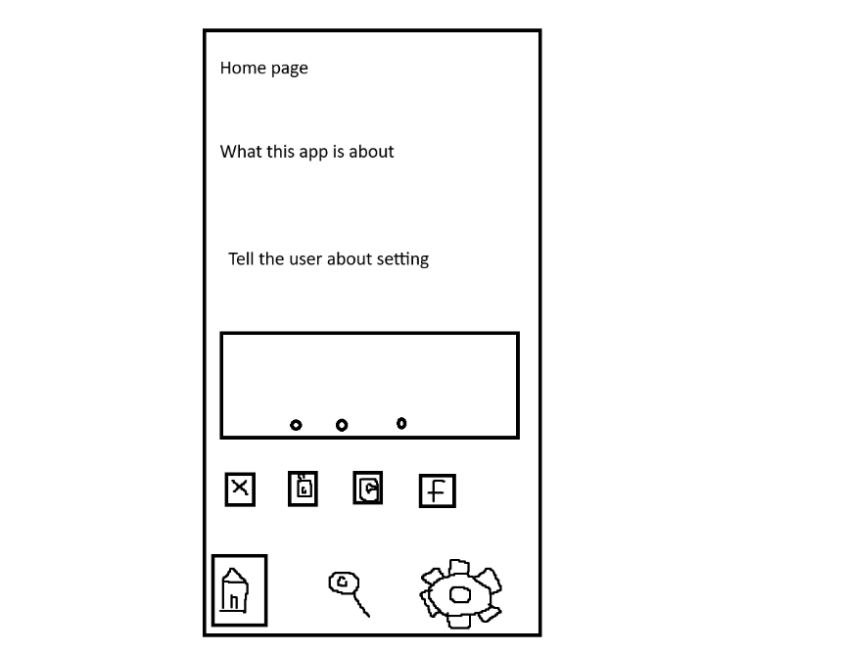
Figure 1 is an early drawing of my home page on Paint.

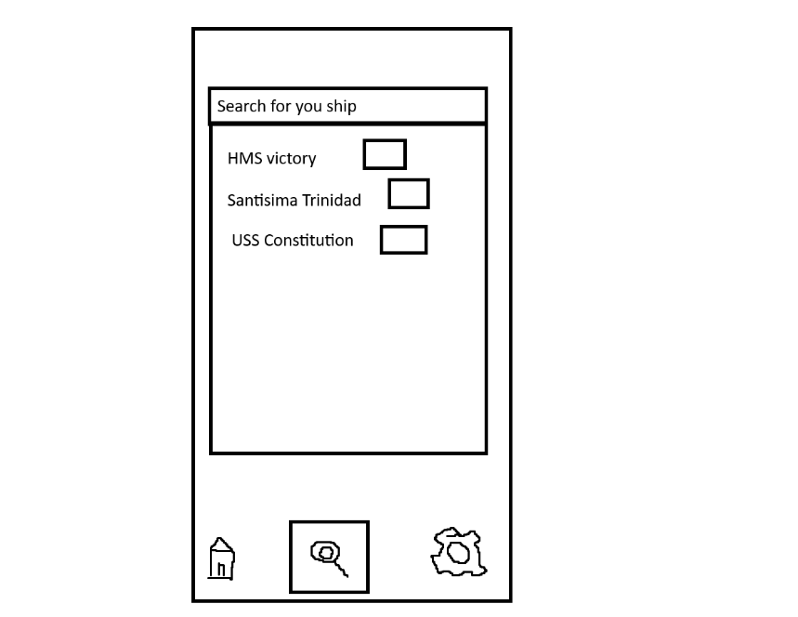
Figure 2 is an early drawing of my search page on Paint.

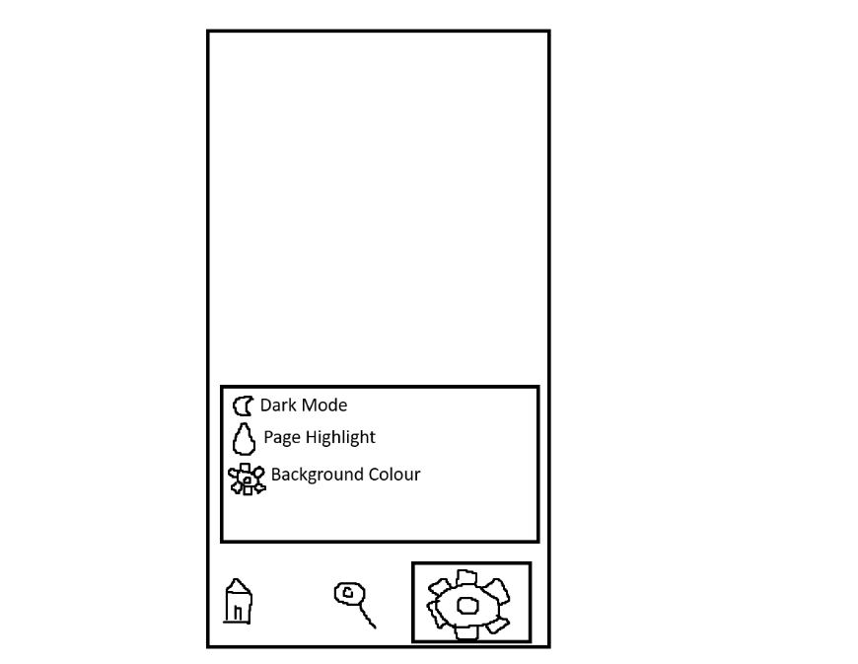
Figure 3 This is an early drawing of my settings in paint.
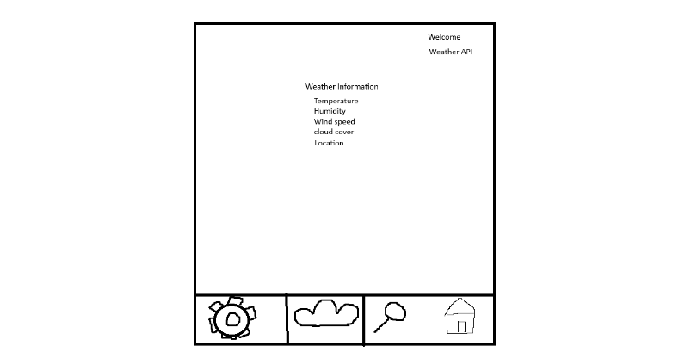
Figure 4 This is an early drawing of the weather API
This is the parameter where the ship name is taken.
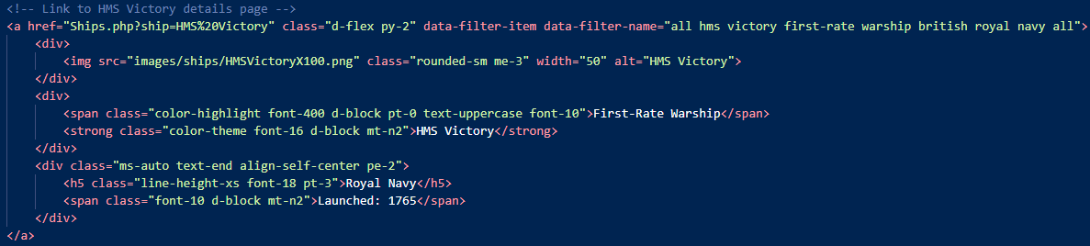

Figure 5 HMS Victory on the search bar

Figure 6 using parse to covert the response from the server to the JavaScript object

Figure 7 After the loop replace the ship details with the text from the details.

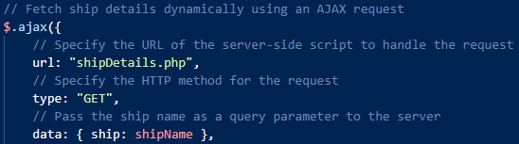
Figure 8 This is an Ajax request where we are sending a GET request to shipDeatils.php and passing the ship name as a parameter.

