
Assessment 2: Written Assignment

Student name: PORTIA BOATENG TURKSON
Student ID: 2122363
Module name: Mental Disorders and Psychopathology
Module code: BMHP6006
Lecturer name: Bianca Sanfilippo

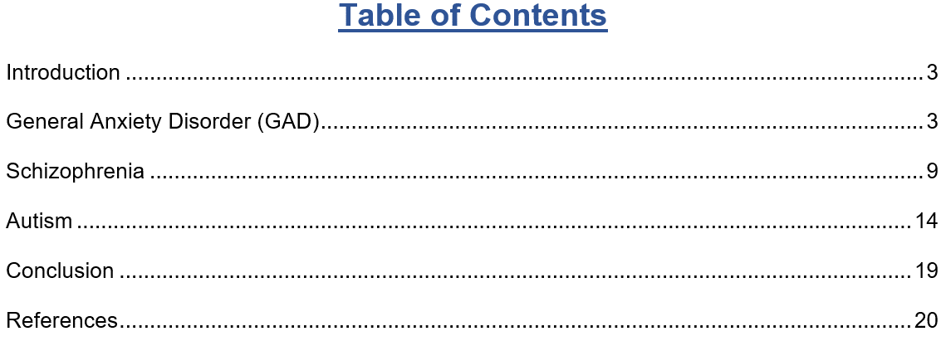

Introduction
Mental illnesses afflict people of all ages and populations worldwide. ICD-10, issued by the World Health Organisation (WHO) in 2010, provides a thorough framework for studying as well as categorising various illnesses. This report will critically evaluate three common ICD-10 mental disorders, for instance, General Anxiety Disorder, schizophrenia, and Autism. In this report, a clarification of their management and improved clinical practices and interventions will be provided by studying their categorization, diagnosis, treatment methods, and rehabilitation strategies. Also, acknowledging these illnesses' complexity significantly improves patient treatment and public health measures to reduce mental illness globally (Archer, 2022). Besides, recommendations will be provided for improvement in the setting of each mental disorder.

Definition
Generalised Anxiety Disorder, which is also known as GAD, is a chronic psychiatric illness that causes excessive as well as persistent concern or anxiety about jobs, health, relationships, and everyday life (Roest, 2012). Furthermore, GAD sufferers frequently have increased stress, anxiousness, irritability, muscular strain, and sleeplessness. Also, it is characterised by uncontrolled anxiety for at least six months, unlike phobias or panic disorders. In addition, this condition severely impacts everyday activity as well as the standard of life, requiring full examination and treatment with medications, therapy, and lifestyle changes (Tio, 2016).

Classification
ICD-10 classifies GAD as an anxiety disorder (F41). Furthermore, this category classifies it as F41.1. In addition, the ICD-10 classifies mental and behavioral diseases, standardizing diagnosis as well as treatment throughout medical facilities. Diagnostic criteria describe Generalised Anxiety Disorder in the ICD-10 (Kerslake, 2022). In this regard, as per ICD-10, GAD is diagnosed when a person has excessive anxiety as well as worries about a range of things or activities for a minimum of six months, making it hard to regulate. Besides, worry and anxiety can cause restlessness, weariness, irritability, muscular strain, and sleep difficulties (DeMartini, 2019). Most importantly, unlike phobias, anxiety as well as concern are not limited to a single scenario.

Diagnosis
According to NHS, (2024), in England, 6 in 100 persons have been diagnosed with GAD each week, in 2023. Furthermore, Mental Health UK reports that approximately 8 million people have anxiety disorders in the UK. In addition to this, generalised anxiety disorder therapy is less than 50%. Moreover, the Health and Safety Executive estimates that 822,000 people experience work-related stress, despair, or anxiety annually.
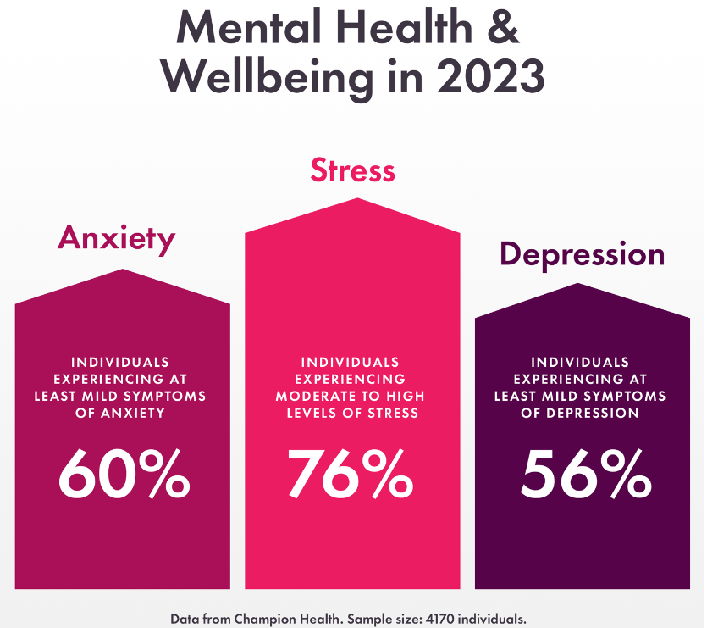
Figure: Mental Health and Wellbeing in 2023 in the UK
Source: (Davies, 2023)
The below picture shows that 60% of workers had at least moderate anxiety symptoms. On the other hand, nearly a fifth of workers have ‘clinically relevant symptoms’ that need medical attention.
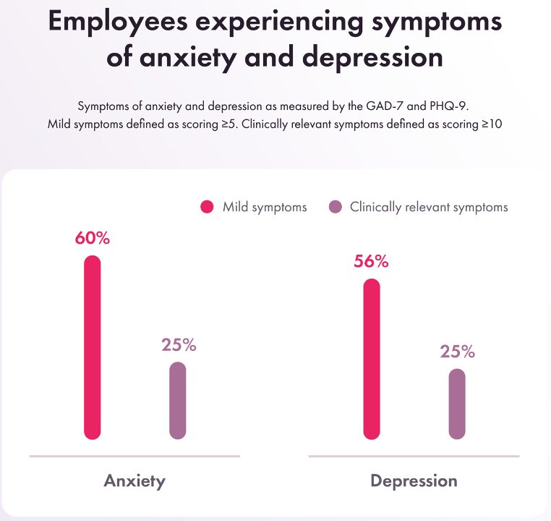
Figure: Employees experience symptoms of anxiety and depression
Source: (Archer et al. 2022)

Causes of Anxiety
Genetic, biochemical, environmental, and psychological variables frequently cause anxiety disorders including GAD. Although reasons vary by person, numerous common factors have been discovered (Roest, 2012). For instance, anxiety disorders are strongly linked to genetics. In this case, studies reveal that people with a family record of anxiety-related illnesses are more likely to develop them. Furthermore, this shows a hereditary propensity that can affect stress-related neurotransmitters and brain circuitry. Moreover, as per WHO, (2010), biological variables including serotonin, norepinephrine, and GABA abnormalities can also cause anxiety disorders. In addition to this, anxiety results from neurotransmitter system dysregulation, affecting mood, mental processes, and stress response (Tio, 2016).
Environmental variables including trauma, developmental hardship, and persistent stress can cause and progress anxiety disorders (Kerslake, 2022). Furthermore, trauma or persistent stress can sensitise the brain's response to stress mechanisms, rendering anxiety symptoms more likely.

Signs and Symptoms
Different anxiety disorders have different symptoms, but they usually involve cognitive, emotional, and somatic symptoms (Adwas et al. 2019). In this case, worry, restlessness, irritation, trouble focusing, muscular tension, exhaustion, sleeplessness, sweating, palpitations, and gastrointestinal abnormalities are typical anxiety disorder symptoms.

Diagnosis Time of Anxiety
Anxiety is characterised by persistent as well as excessive concern about many parts of life and particular symptoms from ICD-10 diagnostic criteria. Furthermore, the diagnostic requirements for GAD involve extreme anxiety as well as concern about various incidents or actions for at least six months, restlessness, tiredness, irritability, and sleep difficulties (Altunoz, 2018). In addition, anxiety and worry must also impede social, vocational, and other vital functions. Moreover, mental health professionals must do a thorough clinical assessment to identify as well as treat anxiety disorders.

Treatment
Positive: CBT is excellent in teaching coping skills as well as challenging illogical ideas.
Negative: Few skilled therapists can limit access (Crocq, 2017).
Positive: SSRIs/SNRIs relieve symptoms.
Negative: Discontinuation consequences as well as symptoms of withdrawal can dissuade some (Davies, 2023).
Positive: CBT with medicine frequently improves results (Archer, 2022).
Negative: Side effects can make some people avoid medicine.

Measurements
Generalised Anxiety Disorder (GAD) therapies are evaluated using many rehabilitative measures. They are as follows.

Positive
The self-report GAD-7 questionnaire is frequently used to evaluate GAD symptoms (Roest, 2012). Furthermore, clinical progress and therapy adjustments can be tracked using its quantitative assessment of symptom severity.

Negative
While GAD-7 is useful, it cannot capture all GAD symptoms or take into consideration individual symptom presentation (Tio. 2016). In this case, it ought to be used alongside clinical evaluation as well as other outcome indicators to evaluate therapy efficacy.

Recommendations
Complementary treatments can help control anxiety by improving well-being as well as reducing symptoms. Some recommendations for using alternative treatments to treat anxiety have been provided below.
Meditation along with prolonged breathing can significantly decrease anxiety and increase present-moment awareness (Adwas et al., 2019). Furthermore, recommending mindfulness meditation via guided seminars or smartphone applications can help people manage stress and relax.

Yoga
Yoga blends physical postures, breathing practices, and meditation to reduce anxiety as well as increase relaxation (Altunoz et al., 2018). Also, regular yoga lessons can greatly improve physical as well as mental health and help manage anxiety.
Chamomile, passionflower, and valerian root supplements can rapidly alleviate anxiety. To guarantee safety and efficacy, people need to contact a doctor before adding herbal remedies to a treatment plan (Davies et al., 2023).

Exercise
Walking, running, and swimming generate endorphins, which eventually lessen anxiety (Roest et al., 2012). In this regard, this is necessary to encourage everyday exercise to boost mood, energy, and well-being.

Nutritional Support
A dietary regimen rich in vegetables, fruits, healthy grains, and lean meats can reduce anxiety as well as improve health (Archer et al., 2022). Furthermore, nutritional advice and supplements like omega-3 fatty acids and magnesium can boost response to stress as well as resilience to emotion.

Schizophrenia

Definition
The severe mental condition schizophrenia disrupts thought, perceptions, emotions, and behaviour. Furthermore, schizophrenia includes hallucinations, delusions, disorganised thinking, and social as well as vocational problems (McCutcheon et al., 2020). Moreover, it usually starts in early adulthood or late adolescence and goes through remission as well as recurrence.
The WHO estimates that 20 million individuals worldwide have schizophrenia. Furthermore, this represents 0.3%–0.7% of the world population. Also, due to variables including healthcare availability, cultural attitudes, and socioeconomic situations, rates of prevalence vary by location and demographic (McCutcheon et al., 2023). Additionally, schizophrenia is somewhat more common in the UK. Moreover, schizophrenia affects 1 in 100 UK residents, according to NHS statistics. It indicates approximately 1% of the population. Besides, the current incidence of schizophrenia in the UK matches worldwide estimates as well as highlights its considerable effect on people, families, and communities (Rantala et al., 2022).

Classification
Schizophrenia is a Mental and Behavioural Disorder (F20-F29) in ICD-10. Furthermore, this method specifically classifies it as F20 (Kahn, 2020). In addition, the ICD-10 standardises mental illness diagnosis as well as classification, improving healthcare professional communication research and treatment.

Causes of Schizophrenia
Schizophrenia may be caused by genetic issues. It has been said that people with a family record of schizophrenia, are more likely to develop it (Dabiri et al., 2022). Nevertheless, having an immediate family member with schizophrenia does not predict schizophrenia, suggesting genetic variables cooperate with other factors.
Schizophrenia can be caused by dopamine as well as glutamate imbalances in the brain. Also, schizophrenia patients have enlarged ventricles and reduced grey matter volume (Mosolov and Yaltonskaya, 2022).
Maternal illnesses, prenatal malnutrition, and delivery difficulties significantly raise the chance of schizophrenia later in life.
Trauma, drug addiction, and social variables can potentially cause or worsen schizophrenia symptoms in susceptible people (Goff, 2021). Moreover, environmental stresses can raise disease risk by interacting with genetic predispositions as well as neurobiological sensitivities.
Symptoms of schizophrenia include the following.
Perceptual disruptions like hallucinations provide false feelings (Correll and Howes, 2021). Furthermore, auditory hallucinations, for instance, hearing voices or noises others do not, are the most prevalent in schizophrenia.

Delusion
Delusions are persistent erroneous beliefs notwithstanding evidence. Moreover, delusions in schizophrenia frequently entail paranoid thoughts like feeling victimised or that others are scheming against them (Watzke et al., 2018).
Schizophrenia can be caused by fragmented or irrational thinking. Furthermore, their words, which can be confusing and irrelevant, demonstrate this.
Schizophrenia can produce restlessness, agitation, and catatonia, a lack of motion or reaction (McCutcheon et al., 2020).
Negative symptoms include decreased functioning as well as behaviour (McCutcheon et al., 2023). Furthermore, schizophrenia can cause decreased emotional expressiveness, social isolation, inspiration, self-care, and cleanliness.

Cognitive Impairments
Schizophrenia can impair recall, focus, and ability to concentrate. Moreover, people may struggle to concentrate, organise, and digest information (Kahn, 2020).

Diagnosis
According to WHO, about 24 million individuals (0.32%) globally have schizophrenia. Furthermore, this rate is 0.45% among adults. Also, fewer people have it than other mental illnesses. In addition to this, the latter stages of adolescence as well as the twenties are the most common starting times, and males start earlier than women (Rantala et al., 2022). Besides, schizophrenia often causes severe suffering as well as disability in personal, familial, social, professional, educational, and other aspects of life.
Moreover, schizophrenia patients die 2–3 times earlier than the average population. In addition, this is commonly caused by cardiovascular, metabolic, and viral problems (Dabiri et al., 2022). Apart from these, schizophrenia patients sometimes face human rights breaches in mental health facilities as well as the community. Also, this disorder is often stigmatised, creating social isolation and affecting relationships with family and friends (Mosolov and Yaltonskaya, 2022). Besides, discrimination can impede access to medical care, housing, education, and job opportunities.
As per the National Institute for Health and Clinical Excellence, psychotic diseases like schizophrenia are serious. In this regard, schizophrenia in children as well as young people, final scope 2 groups in the UK have a 0.7% expected prevalence (Goff, 2021). Also, in the UK, schizophrenia and schizophrenia-related diseases have a lifetime prevalence of 14.5 per 1000 persons.
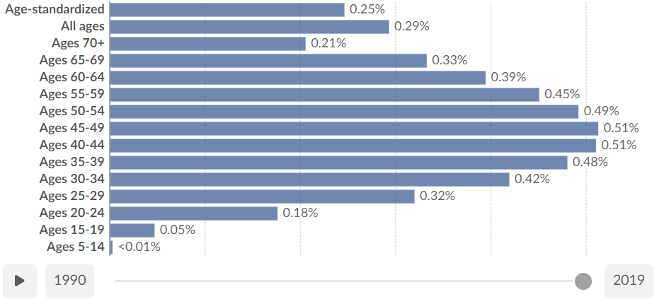
Figure: Schizophrenia prevalence, by age, in the United Kingdom
Source: (Correll and Howes, 2021)

Current Treatments
Schizophrenia is treated in the UK using medication, psychotherapy, social assistance, and community services. An explanation of the current treatment for schizophrenia has been provided below.
- Antipsychotics are the mainstay of schizophrenia therapy. Furthermore, these drugs reduce hallucinations, delusions, and disorganisation (Watzke et al., 2018).
- Also, they are divided into normal (first-generation) and atypical (second-generation). In addition, atypical antipsychotics are chosen because they cause fewer movement problems.
- Individual variables, such as disease intensity, reaction to prior therapies, and adverse effects determine medication choice (McCutcheon et al., 2020). Furthermore, healthcare practitioners must assess drug efficacy and side effects often.
- Psychological therapies like CBT as well as family therapy are regularly used with schizophrenia medication (McCutcheon et al., 2023).
- Besides, CBT helps people recognise as well as confront incorrect ideas and beliefs, learn coping skills, and solve problems. In addition, family therapy helps families comprehend schizophrenia as well as improve communication and coping.
- These interventions significantly enhance symptom management, relapse rates, and social and occupational performance (Kahn, 2020).
- Schizophrenia patients need social assistance as well as rehabilitation to reintegrate into society, develop self-sufficient skills, and find work and education (Rantala et al., 2022).
- Moreover, supported housing, jobs, and aggressive outreach programs help schizophrenia patients recover (Dabiri et al., 2022).

- Schizophrenia significantly increases the risk of diabetes, heart disease, and obesity. Furthermore, fitness, including metabolic markers as well as lifestyle variables, must be monitored regularly (Mosolov and Yaltonskaya, 2022).
- Coordinated care pathways as well as liaison activities between mental wellness and primary care facilities provide comprehensive physical and mental wellness treatment.
Rehabilitation courses for people with schizophrenia are evaluated using the Quality Indicator for Rehabilitative courses (QuIRC-SA) (Correll, and Howes, 2021). Also, rehabilitative care includes home environment, therapies and interventions, therapeutic connections, and recovery orientation among 145 components in 8 phases. Waltzke et al., (2018) says QuIRC-SA examines tailored social inclusion and mental health rehabilitation. Moreover, QuIRC-SA refines schizophrenia rehabilitation, analyses best practices, and assesses therapies.

Recommendations
- This is highly recommended to care professionals to provide recovery-oriented therapies that help schizophrenia patients set and achieve goals via strengths, perseverance, and community integration (McCutcheon et al., 2023).
- This is essential to decrease stigma to combat negative attitudes as well as promote schizophrenia tolerance and social inclusion.
- To reduce untreated psychosis duration as well as enhance long-term consequences, early intervention programs must be improved for prompt detection along with treatment after the first psychotic episode (McCutcheon et al., 2020).
- Researchers should study schizophrenia's etiology, enhance treatment efficacy, and develop novel medicines to fulfil unmet needs as well as improve outcomes (Kahn, 2020).

Autism

Definition
Autism Spectrum Disorder, which is also known as ASD, is a neurodevelopmental illness that causes social interaction as well as communication issues and limited, repetitive behaviour, interests, and hobbies (Hirota and King, 2023). Furthermore, autism makes it hard to grasp and use nonverbal clues like movements and facial expressions, as well as sustain relationships and comprehend social standards. More than one in 100 people are on the autism spectrum and there are around 700,000 autistic adults and children in the UK. Moreover, autism sufferers frequently have restricted interests and repeat habits, resisting change.

Classification
ASD is classified as Disorders of Psychological Development (F80-F89) in ICD-10. Furthermore, this category includes ASD as F84. Also, the ICD-10 standardises neurodevelopmental disorder diagnosis as well as classification, helping with diagnosis and therapy (Lord et al. 2020). According to the ICD-10, ASD includes a variety of disorders characterised by chronic social communication as well as interaction deficiencies and confined, repetitive behaviour, hobbies, or activities. Besides, Asperger syndrome, autistic disorder, and PDD-NOS are subcategories of the categorization, reflecting the variability of autism spectrum presentations (Hyman et al. 2020). In addition to this, ASD ICD-10 criteria emphasise social communication problems, particularly,

Causes of Autism
Genetic predisposition significantly contributes to ASD. In this case, studies demonstrate that those with family records of ASD are more likely to develop it (Salari et al., 2022). Furthermore, genomic studies have also shown several ASD-related genetic variants as well as mutations that affect neuronal development, synapse function, and brain connection.
Prenatal as well as initial postnatal environmental variables can greatly increase ASD risk. In this case, prenatal infections, poisons, pollutants, problems, and stress have been linked to ASD (Aishworiya et al., 2023). Furthermore, the environmental factors as well as their effects on genetic susceptibilities are still being studied.
ASD patients often have brain anatomy, function, and connection changes. In addition, ASD is linked to brain circuit disruptions in social interaction, perception, and executive function (Willsey et al., 2022). Moreover, neurotransmitter abnormalities including dopamine, serotonin, and oxytocin can potentially cause ASD symptoms.

Symptoms of Autism
ASD sufferers struggle with motions, glances, and tone of speech (Bougeard et al., 2021). Also, they can have trouble starting as well as sustaining discussions, reading social signs, and comprehending people.
Many ASD patients have repetitive behaviours, routines, or hobbies. Furthermore, these involve hand-flapping, swaying, insistence on routines, extreme focus on certain themes or things, and rigorous rituals (Hirota and King, 2023).

Sensitivity
Many ASD patients are hypersensitive to sensory stimuli. In addition, a sensory overload or rejection can result from their hypersensitivity to noises, textures, scents, and lights (Lord et al., 2020).
ASD patients struggle to build as well as sustain connections (Hyman et al., 2020). Moreover, they struggle to make friends, grasp social conventions, and read social signs, leading to social exclusion as well as loneliness.

Diagnosis
There were 161,827 open autism referrals in September 2023. Furthermore, these included 137,174 (85%) with 13-week-old referrals. In September 2023, 766 suspected autism referrals were diagnosed, compared to 1,058 in 2022 (Salari et al., 2022).
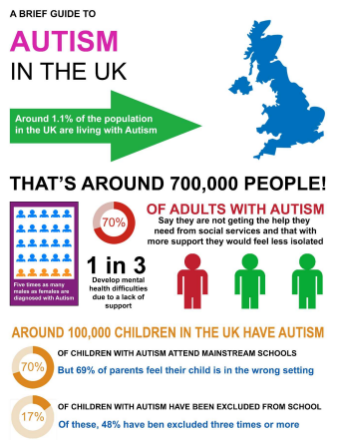
Figure: Autism in the UK
Source: (Aishworiya et al., 2023)
From the above picture, in the UK, the autism rate of adults is 70%. It indicates that around 700,000 people have autism due to a lack of support. In addition to this, approximately 100,000 children have autism in the UK (Wang et al., 2023). Among them, 70% of them attend mainstream schools and 17% of them have been excluded from school.
Autism is diagnosed using standardised diagnostic criteria like The Autism Diagnostic Interview-Revised (ADI-R. It is used to examine behaviour, speech, and social interaction (Willsey et al., 2022). Furthermore, the ADI-R is a semi-structured interview with autism patients' parents or carers. Moreover, clinical experts provide thorough questions regarding early development, interaction with others, repeated behaviours, and interests throughout the ADI-R exam. Also, the interview includes language, interaction, mutual social connections, play, imagination, and constrained and repetitive behaviours (Salari et al., 2022).

Current Treatments
Applied Behaviour Analysis is a common autism intervention that teaches as well as reinforces adaptive behaviors while minimising problematic ones (Bougeard et al., 2021). Furthermore, other behavioural approaches like social skills instruction, as well as cognitive behavioral therapies, can address problems.
Structured teaching techniques, IEPs, and inclusion programs assist autistic students acquire academic, interpersonal, and life abilities in positive educational contexts (Hirota and King, 2023).
Language as well as speech therapy helps autistic people develop linguistic, social, practical, and nonverbal abilities (Lord et al., 2020).
Occupational therapy promotes independence as well as everyday activity by enhancing functional abilities, sensory processing, motor skills, and adaptive behaviours.

Medication
Autism-related anxiety, sadness, ADHD, and aggressiveness can be treated with medication. Furthermore, personal requirements determine pharmaceutical choices, which can include SSRIs, antipsychotics, stimulants, or others (Hyman et al., 2020).
The Childhood Autism Rating Scale (CARS) as well as the Autism Diagnostic Observation Schedule are used to evaluate autism rehabilitation progress. In this regard, clinicians score autistic symptoms on the CARS based on parent and carer observations (Hodges et al., 2020). Furthermore, it assesses behaviour, speech, and social interaction for autism symptoms. Also, trained experts perform the semi-structured ADOS observational evaluation. In this regard, close examination of the individual's behaviour in varied social as well as communication circumstances allows therapists to measure autism-related social communication abilities, repetitive behaviours, and social interaction tendencies (Salari et al., 2022). Besides, these tools help autism patients track progress, evaluate therapy efficacy, and plan interventions.

Recommendations
Yoga should be demonstrated to improve behaviour, reduce anxiety, and enhance wellness in children with autism (Aishworiya et al. 2023). Furthermore, yoga, involving gentle motions, exercises for breathing, and awareness, can assist autistic people manage their emotions, tension, and concentration.
Sensory integration treatment addresses autism-related sensory processing issues (Willsey et al. 2022). In this regard, jumping, swinging, and touching increase sensory input, interpreting, and self-regulation.
Communication, socialisation, and expressive emotions in autism are addressed by music therapy (Wang et al., 2023). Furthermore, musical instruments, singing, and rhythmical pursuits can help autistic people express feelings, communicate, and socialise.
Therapists use trained animals to improve emotional, social, and sensory control. In this case, autism sufferers find comfort, friendship, and social interaction with therapy dogs and horses.

Conclusion
This report has covered three prevalent ICD-10 mental diseases, such as autism, schizophrenia, and general anxiety disorder. In the setting of these three mental disorders, definition, classification, causes, symptoms, diagnosis, current treatments, measurement of rehabilitation, and recommendations for improvement have been included in this report.

References
Adwas, A. et al. (2019) ‘Anxiety Insights into signs,’ symptoms, etiology, pathophysiology, and treatment’, East African Scholars Journal of Medical Sciences, 2(10), pp.580-591.
Aishworiya, R. et al. (2023) ‘An update on psychopharmacological treatment of autism spectrum disorder’, Neurotherapeutics, 19(1), pp.248-262.
Altunoz, U.et al.(2018) ‘Clinical characteristics of generalized anxiety disorder’, older vs. young adults. Nordic Journal of Psychiatry, 72(2), pp.97-102.
Archer, C.et al. (2022) ‘Trends in the recording of anxiety in UK primary care’, a multi-method approach. Social psychiatry and psychiatric epidemiology, 57(2), pp.375-386.
Bougeard, C. et al. (2021) ‘Prevalence of autism spectrum disorder and co-morbidities in children and adolescents’, a systematic literature review. Frontiers in psychiatry, 12, p.744709.
Correll, C.et al. (2021) ‘Treatment-resistant schizophrenia’, definition, predictors, and therapy options. The Journal of clinical psychiatry, 82(5), p.36608.
Crocq, M.et al. (2017) ‘The history of generalized anxiety disorder as a diagnostic category’, Dialogues in clinical neuroscience, 19(2), pp.107-116.
Dabiri, M.et al. (2022) ‘Neuroimaging in schizophrenia’, A review article. Frontiers in neuroscience, 16, p.1042814.
Davies, M.et al. (2023) ‘Factors associated with anxiety disorder comorbidity’, Journal of Affective Disorders, 323, pp.280-291.
DeMartini, J.et al. (2019) ‘Generalized anxiety disorder’, Annals of internal medicine, 170(7), pp. ITC49-ITC64.
Goff, D.et al. (2021) ‘The pharmacologic treatment of schizophrenia—2021. Jama, 325(2), pp.175-176.
Hirota, T. et al. (2023) ‘autism spectrum disorder’, A review. Jama, 329(2), pp.157-168.
Hodges, H.et al. (2020) ‘autism spectrum disorder’, definition, epidemiology, causes, and clinical evaluation. Translational paediatrics, 9(Suppl 1), p.S55.
Hyman, S.et al. (2020) ‘Identification, evaluation, and management of children with autism spectrum disorder. Paediatrics, 145(1).
Kahn, R.et al. (2020) ‘On the origins of schizophrenia’, American Journal of Psychiatry, 177(4), pp.291-297.
Kerslake, R.et al. (2022) ‘Diagnosis and ICD-10 Classification Codes’, In Revision Guide for MRCPsych Paper A (pp. 198-215). Routledge.
Lord, C.et at. (2020) ‘autism spectrum disorder’, Nature Reviews Disease Primers, 6(1), pp.1-23.
McCutcheon, R.et al. (2023) ‘Cognitive impairment in schizophrenia’, etiology, pathophysiology, and treatment. Molecular psychiatry, 28(5), pp.1902-1918.
McCutcheon, R.et al. (2020) ‘Schizophrenia—an overview. JAMA psychiatry, 77(2), pp.201-210.
Mosolov, S.et al.( 2022) ‘Primary and secondary negative symptoms in schizophrenia’, Frontiers in psychiatry, 12, p.766692.
NHS, 2024. Anxiety and panic attacks. Available at: Anxiety and panic attacks- NHS (www.nhs.uk) (Accessed: 16 April 2024).
Rantala, M.et al.(2022) ‘Schizophrenia’, The new etiological synthesis. Neuroscience & Biobehavioral Reviews, 142, p.104894.
Roest, A.et al (2012) ‘Myocardial infarction and generalised anxiety disorder’,10-year follow-up. The British Journal of Psychiatry, 200(4), pp.324-329.
Salari, N.et al. (2022) ‘The global prevalence of autism spectrum disorder’, a comprehensive systematic review and meta-analysis. Italian Journal of Pediatrics, 48(1), p.112.
Tio, P.et al. (2016) ‘Mapping the manuals of madness’, Comparing the ICD‐10 and DSM‐IV‐TR using a network approach. International journal of methods in psychiatric research, 25(4), pp.267-276.
Wang, L.et al. (2023)’autism spectrum disorder’, neurodevelopmental risk factors, biological mechanism, and precision therapy. International journal of molecular sciences, 24(3), p.1819.
Watzke, S.et al. (2018) ‘A longitudinal study of learning potential and rehabilitation outcome in schizophrenia’, Psychiatric Services, 59(3), pp.248-255.
WHO, 2010. ICD-10 VERSION. Available at: https://icd.who.int/browse10/2010/en#/F30-F39 (Accessed: 16 December 2021).
Willsey, H.et al. (2022) ‘Genomics, convergent neuroscience and progress in understanding autism spectrum disorder’, Nature Reviews Neuroscience, 23(6), pp.323-341.

