MASTER OF BUSINESS ADMINISTRATION
Task 1: Marketing Environmental Analysis 2
Factor 1 – Government decisions to reduce GHG and carbon emissions 2
Initiatives by the Indian Government to reduce GHG emissions 3
Initiatives by the UK Government to reduce GHG emissions 4
Factor 2 – Social and economic perspectives 5
Marketing Information System 7
Internal data 7
Market research 7
Commitments by the governments of India and the United Kingdom 7
Competitor analysis 7
Task 2: Strategic Growth and Competitive Positioning 9
Strategic growth approach 9
Achieving competitive positioning 10
Benefits of lower-carbon business model in achieving competitive advantage 11
Cost efficiency 11
Brand differentiation 12
SERVQUAL Model 12
Task 3: Critical Reflection on AI Usage 14
Tool disclosure 14
Critical evaluation of AI output 14
Contribution analysis 15
Ethical and professional reflection 15

Task 1: Marketing Environmental Analysis

Factor 1 – Government decisions to reduce GHG and carbon emissions
It is evident that reducing carbon emissions and greenhouse gas (GHG) emissions have become one of the topmost priorities for the governments of different countries as the mining sector has been a significant contributor. According to the findings by Tomaňová (2026), the mining and metal sector has contributed 11% which is equivalent to 6Gt CO2Eq in the global greenhouse gas emissions. In such a scenario, active steps from the concerned governments of different countries to combat the increasing environmental concern is completely justified.
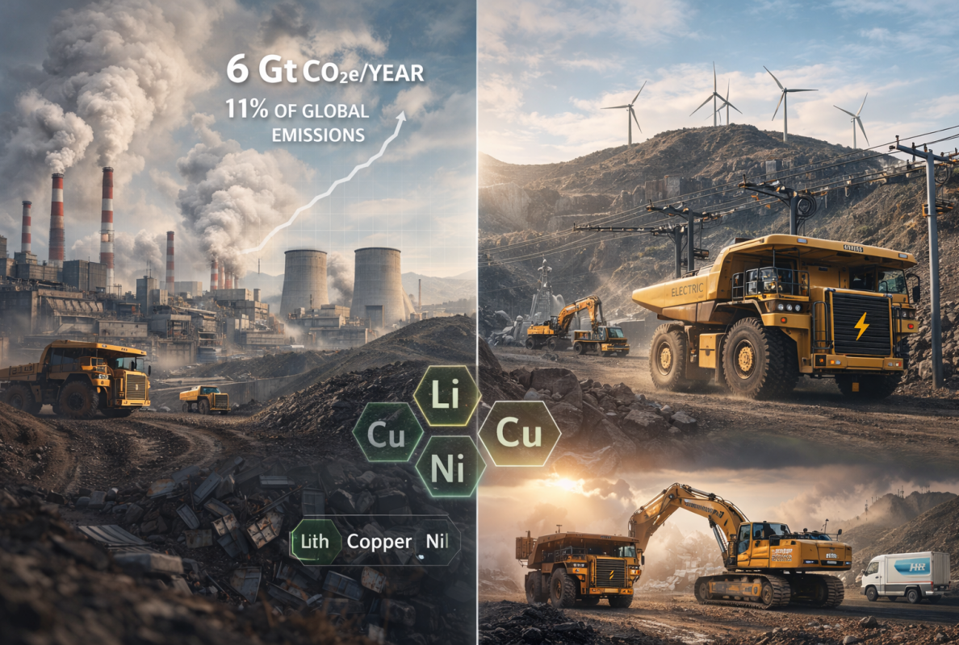
Figure 1: Contribution of mining and metal sector in global GHG emissions
(Source: Tomaňová, 2026)
Considering Tata Steel, it is evident that the company is all set to reduce 40% of its carbon and greenhouse emissions by 2030 while targeting to become net zero by 2045 (Tata Steel, 2024). This strategy by Tata Steel certainly violates the deadline of 2030 set in the Paris Climate Agreement by the United Nations. UNFCCC (2026) clearly states that the global GHG emissions need to decline by 43% by the end of 2030 so that the global average temperature can be maintained under 2°C by limiting the same to 1.5°C. According to Grand View Research (2026), the metal mining sector is set to reach $711.1 billion in 2033 from $555.3 billion in 2025 with of CAGR of 3.1% per annum. In such a situation, this factor will certainly become an opportunity for Tata Steel in the upcoming days.
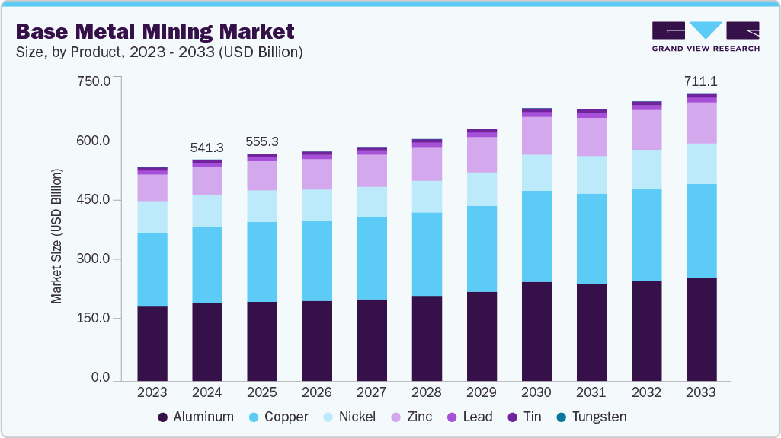
Figure 2: Metal mining market size and growth
(Source: Grand View Research, 2025)

Initiatives by the Indian Government to reduce GHG emissions
The government of India has taken some active steps towards curbing the greenhouse gas emissions from the iron and steel sector by amending the Greenhouse Gases Emission Intensity (GEI) Target (Amendment) Rules, 2025 that covers all the 255 iron and steel units so that the commitments of 2015 Paris Climate Agreement can be met. According to the reports of The Economic Times (2026), failure to meet the GEI target will attract an environmental compensation of twice the amount of average carbon credit per year. On the other hand, PIB (2026) has claimed that in order to achieve the target capacity of 500MT of steel production by 2047, the Indian government has postponed the decarbonisation target of the steel sector to net-zero emissions to 2070. Hence, the target of Tata Steel to become net-zero by 2045 is certainly fulfilling the deadline set by the Indian government. In this context, it is also claimed that India’s steel exports have increased from 0.45MT in 2025 to 0.58MT in 2026 while the imports have decreased from 0.58MT to 0.52MT (PIB, 2026).
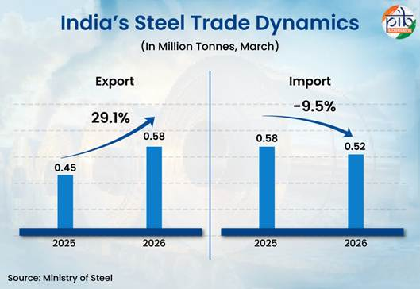
Figure 3: Trade dynamics of India’s steel
(Source: PIB, 2026)

Initiatives by the UK Government to reduce GHG emissions
Considering the initiatives and policies by the UK government to reduce greenhouse emissions, it can be observed that a target of 2050 has been set in order to become net zero (Gov.UK, 2026). In this context, the concerned government has also taken some steps considering the steel sector and set a target of reducing 95% emissions from steelmaking by 2050 which also violates the deadline set in the Paris Climate Agreement (UK Steel, 2022). Therefore, the net zero target of Tata Steel by 2045 will surely meet the UK standards despite failing to meet the deadline of 2030 as per the Paris Climate Agreement. As per the reports by Grand View Research (2026), the mining sector in the UK is expected to reach $7,073.5 million in 2033 from $5,265.8 million in 2026 with a CAGR of 4.3% per year. Hence, Tata Steel needs to abide by the policies and initiatives of the UK government for better operations in the concerned market.
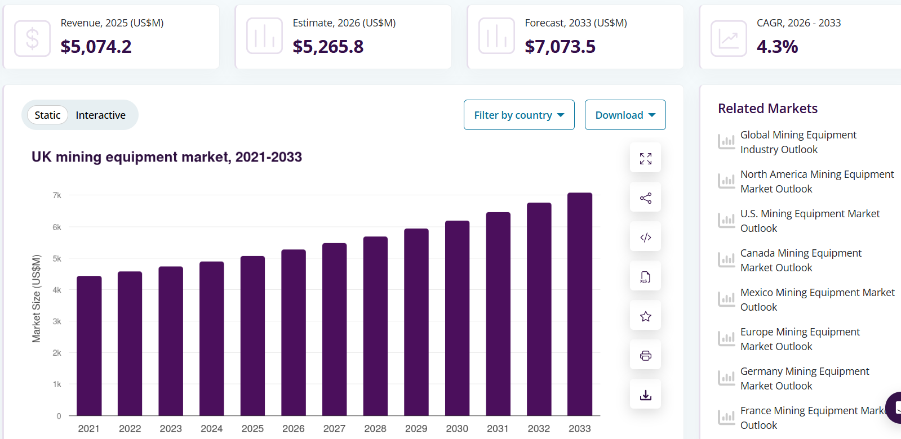
Figure 4: UK metal mining market size and growth
(Source: Grand View Research, 2026)

Factor 2 – Social and economic perspectives
Social and economic aspects can also play a crucial role in influencing the transition of companies towards lower carbon products. According to the reports of Carboncopy (2025), 89% of the Indian citizens have experienced a serious climate change and want the government to act and intervene in this matter. On the other hand, 78% of the citizens in India are of the opinion that the concerned government needs to act fast to combat the seriousness of the degrading climate condition. The fact is, consumer perspectives and opinions can be quite influential in compelling an organisation to revamp its strategies towards being more sustainable (Chen, 2024). Further, it is observed that failing to meet the needs and demands of consumers can be quite consequential in terms of instigating economic losses for an organisation in the form of loss of brand image and sales simultaneously (Hautamäki and Aarikka-Stenroos, 2026).
In the United Kingdom as well, the consumers have become extremely aware about the importance of climate change and degradations. According to the findings of Office for National Statistics (2025), the net greenhouse gas emissions in the United Kingdom have reduced by 54% from 1990 to 371 million tonnes of CO₂ in 2024.
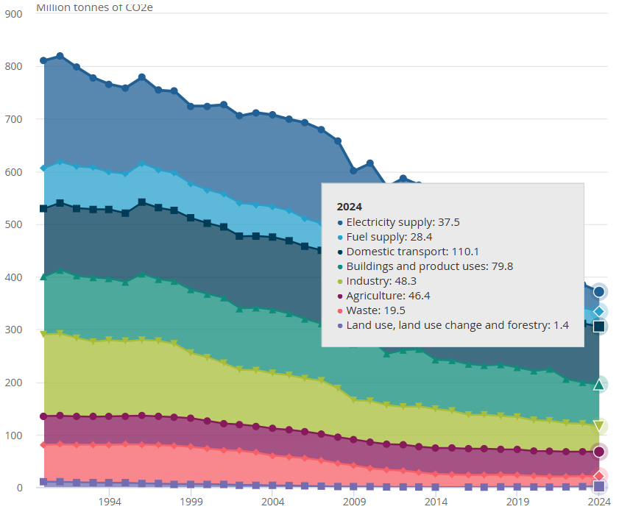
Figure 5: Reduction in greenhouse gas emissions in the United Kingdom
(Source: Office for National Statistics, 2025)
In this context, the reports by KPMG (2024) have found that almost 49% of the adults in the United Kingdom are looking forward to a low-carbon home so that overall emissions of carbon and greenhouse gases can be reduced. Further, YouGov (2025) has claimed that 60% of the UK adults are influenced by the brand reputation and 17% of them consider packaging materials in case of purchasing products. Therefore, consumer behaviour is certainly a key factor that can influence the transition of Tata Steel towards more sustainability.
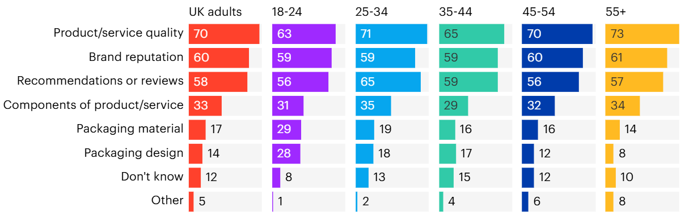
Figure 6: Factors influencing the purchasing decisions of UK adults
(Source: YouGov, 2025)

Marketing Information System

Internal data
In this case, internal data such as sales, profit earnings, revenue generations and customer data will allow Tata Steel to gather proper understanding about the current situations and possible risks in future.

Market research
Appropriate market research will be beneficial for Tata Steel in terms of analysing data about both the Indian as well as the UK markets and the concerned customer groups in the same.

Commitments by the governments of India and the United Kingdom
Analysing the commitments by both the governments of India and the United Kingdom has helped Tata Steel to set its own target so that compliance with the standards in both the markets can be maintained.

Competitor analysis
Analysing the competitors in both India and the United Kingdom such as JSW Steel, Steel Authority of India Ltd (SAIL), British Steel, and Celsa Steel UK will help Tata Steel in understanding their strategies and policies to remain competitive in the concerned markets.
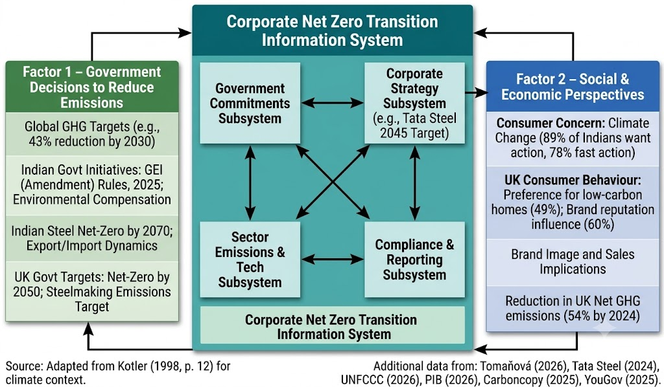
Figure 7: Marketing Information System
(Source: Kotler, 2015)

Task 2: Strategic Growth and Competitive Positioning
It is observed that proper strategic planning can be quite effective and beneficial in terms of ensuring growth for an organisation while achieving competitive position simultaneously (Gandrita, 2023).

Strategic growth approach
Since Tata Steel will be operating in the existing market with its existing product, market penetration from this framework will be applicable in this case. In case of market penetration, the main aim of Tata Steel will be to focus on encouraging the existing customers to buy the same product in more volumes. In the words of Natasiah (2024), proper encouragement for the customers can prove to be quite effective in influencing their purchasing decisions. In this case, relationship marketing can be extensively used by Tata Steel through the means of personalised cross-selling and upselling for meeting the customer expectations and requirements. As per the viewpoints of Vatavwala, Kumar and Sharma (2023), personalised cross-selling and upselling can be crucial in meeting the needs and requirements of the customers in the market. Moreover, fulfilling customer needs through proper personalisation can certainly fuel strategic growth as well as competitive positioning (Tojiri, 2023). Apart from relationship marketing, the strategies of customer loyalty incentives and expanded distribution channels can also be incorporated by Tata Steel in case of both Indian and the UK markets. As found by Machine Edge Global (2024), Tata BlueScope Steel has launched ShelterChamps loyalty program in order to empower fabricators. Tata Steel has also launched Shaktee Kosh Rewards for different stakeholders, fabricators and dealers where they will receive points for purchasing products from different Tata brands. Tata Steel can certainly use such loyalty programs for its customers in both the Indian as well as UK markets for ensuring better market penetration in the long run.
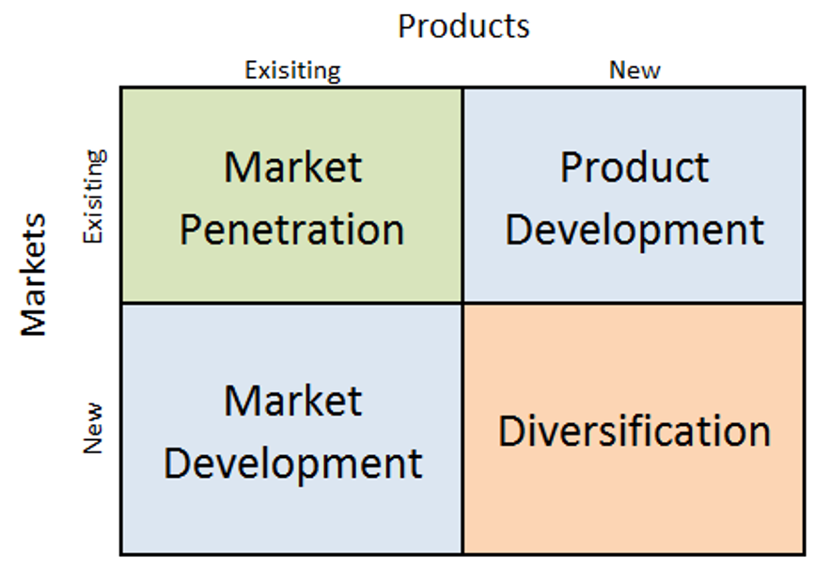
Figure 8: Ansoff Matrix
(Source: Lecture 2; Slide 11)

Achieving competitive positioning
In order to achieve competitive positioning, Tata Steel can also implement differentiation from Porter’s Generic Strategies so that its products can be easily differentiated by the customers. As per the viewpoints of Butarbutar, Purnamasari and Safitri (2023), differentiation strategy can be quite effective for an organisation in terms of making its product unique in the market. Hence, this strategy can surely make Tata Steel able to retain the existing customers as well as attract new ones in both India and the United Kingdom. In case of differentiation, Tata Steel can take some aggressive steps towards revising its emission targets and goals so that the completion period can be reduced by at least 5 years, i.e. 2040. In this case, strategies such as ethical sourcing of raw materials and sustainable usage of energy sources can be quite beneficial for the company in reducing its emission levels. As mentioned by Herrington and Gordon (2024), ethical usage of energy sources and ethical sourcing of raw materials can be crucial in maintaining sustainability and lowering carbon emissions. On the other hand, strategies such as incorporation of a circular economy can also be initiated by Tata Steel so that the level of wastage can be reduced through the means of recycling and reusage. In this regard, Aiguobarueghian et al. (2024) have argued that circular economy can be crucial in reducing wastes with the help of recycling and reusing used products. All the above strategies can certainly benefit Tata Steel to differentiate its product line and enhance its brand image in both Indian and the UK markets.
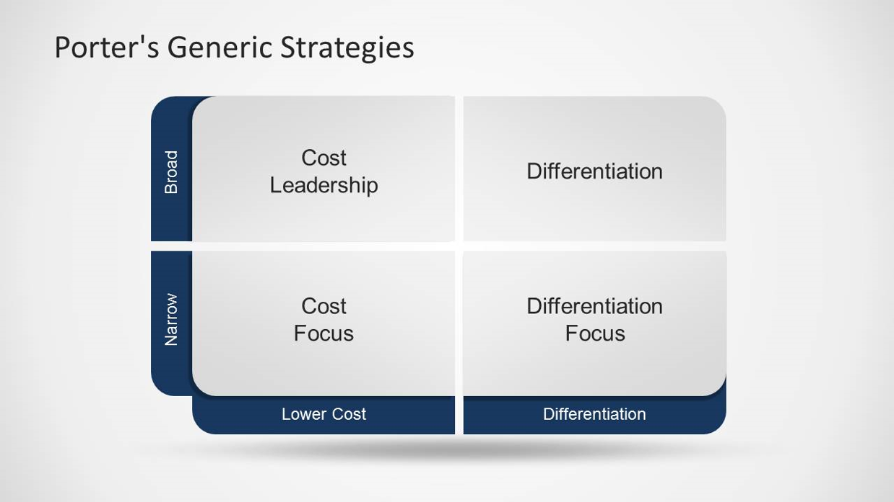
Figure 9: Porter’s generic strategies
(Source: Lecture 11; Slide 15)

Benefits of lower-carbon business model in achieving competitive advantage

Cost efficiency
A low-carbon business model can certainly benefit Tata Steel in terms of being cost efficient in several ways. For example, incorporation of a circular economy will not only help in reducing wastes but also reusing the used products to lower the cost of production in an effective way. In this regard, the findings by Russell and Nasr (2023) argue that processing of used products for reusing can cut production costs of new products quite significantly. In this case, controlling the costs of the products and making it affordable for the customers, hence earning a competitive edge in both the Indian and the UK markets.

Brand differentiation
In case of brand differentiation, Tata Steel will certainly be able to earn the trust and loyalty of its customers by ensuring ethical sourcing of raw materials and ethical usage of energy for executing its production process. As mentioned by Celestin, Sujatha and Kumar (2024), ethical sourcing of raw materials and sustainable production can be crucial in earning trust and loyalty of the consumers. Therefore, brand differentiation will certainly become effective in terms of earning Tata Steel with a competitive positioning and advantageous position in both the markets.

SERVQUAL Model
Reliability: The COMPASS platform of the organisation can provide it with effective supply chain transparency (Tata Steel, 2026). It was launched by the firm for the B2B segment and it has assisted the firm in improving supply chain visibility for consumers resulting in improved customer relationships. It is noted that the company has 83.3 out of 100 regarding Customer Satisfaction Index.
Responsiveness: The governance structure of the firm consists of cross-functional teams known as impact centres that focuses on structural issues and effective usage of materials, reducing spending and optimising supply chain (Tata Steel, 2024). There are about 21 impact centres, and the firm also has TQM initiatives such as small group activities (kaizens) as well as Suggestion management that focuses on improvements, resulting in enhanced responsiveness increasing Customer satisfaction index to 86.1 in 2024 (Tata Steel, 2025).
Assurance: The digital e-DRIVE VAVE workshops plays a crucial role for TATA Steel in instilling confidence, offering expert virtual engineering assistance (Tata Steel, 2024).
Empathy: The firm can focus on providing highly personalised services through AI utilisation to consumers to improve this factor (Inavolu, 2024).
Tangibles: The Deming Prize for TQM indicates the firm’s high physical excellence (Dhurandhar and Kumar, 2024). On the other hand, the firm can focus on replicating the Luchiana Scarp-based EAF model as it operates on about 50% renewable energy resulting in a low carbon footprint of less than 0.3 tCO₂/tcs (Tata Steel, 2026).
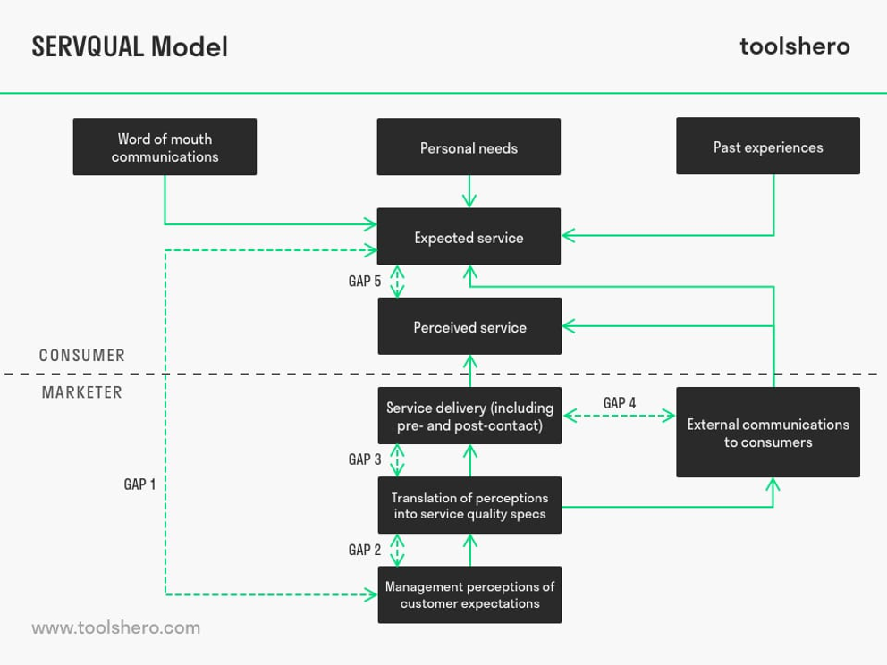
Figure 10: SERVQUAL Model
(Source: Mulder, 2026)

Task 3: Critical Reflection on AI Usage

Tool disclosure
In order to execute this task, Google Gemini has been used for generating pictures and surfing information regarding different points of this report. Further, this particular AI tool is also used for finding out basic information regarding factors such as benefits of low carbon business model, market penetration and brand differentiation. Using this AI tool has certainly been quite effective and useful in ensuring low time-consumption accessing information and explanations, though later the same was cross-checked and justified through appropriate citations.
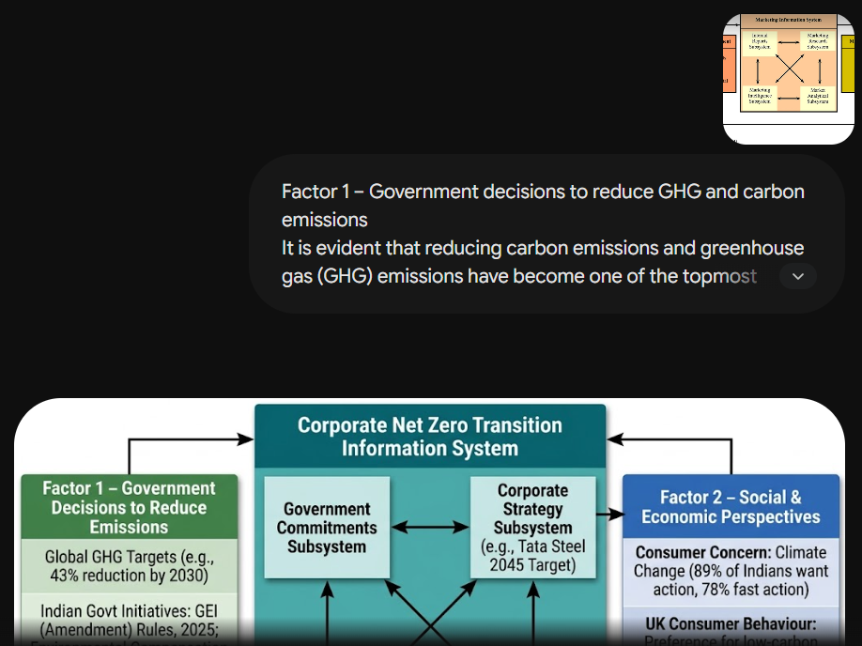
Figure 11: Prompt 1 on Google Gemini
(Source: Google Gemini)

Critical evaluation of AI output
In several cases, it has been observed that Google Gemini has answered in a generic way where the references used were not authentic in nature. In such a situation, a cros-checking of the facts and statistics was prioritised so that proper authenticity and reliability can be maintained in the most appropriate manner. In certain instances, it is also observed that the numerics and statistics were wrong while compared to the authentic sources such as news websites, annual reports, company reports and sustainability reports. Hence, it can be concluded that AI tools can be helpful in finding out the basic information but cannot be blindly trusted as far as the numericals and statistics are concerned.

Contribution analysis
Considering the structure created by Google Gemini, it can be observed that an introduction was included in the structure even if there were no such instructions mentioned in the brief. Further, the AI-generated structure also did not provide any detailed guidance but only repeated the same words mentioned in the assignment brief. On the other hand, considering my own critical structure, I have considered both the factors from the external environment while incorporating the market information system at the same time based on the two factors. Further, in strategic growth and competitive positioning I have extensively used market penetration from Ansoff Matrix and differentiation from Porter’s Generic Strategies for justifying the benefits in context of Tata Steel in both India and the United Kingdom. Apart from the mentioned models in the brief, I have also incorporated some extra models from the lecture notes such as the SERVQUAL model which Gemini has not suggested in any way.

Ethical and professional reflection
Considering the ethical implications of using artificial intelligence in marketing analysis activities, it can be observed that the data and numericals provided by the AI tool needs to be re-checked and justified through authentic sources such as news articles, websites, annual reports, and other authentic sources. Failing to perform these fact checks may lead to false information which can further degrade the quality of the entire report. In this case, being ethical in using own research and analysis instead of AI-generated content is also another professional term that needs to be maintained. Failure to adhere to these aspects can certainly result in academic misconduct in future.
Reference List
Aiguobarueghian, I., Adanma, U.M., Ogunbiyi, E.O. and Solomon, N.O. (2024). Waste management and circular economy: A review of sustainable practices and economic benefits. World Journal of Advanced Research and Reviews, 22(2), pp.1708-1719.
Available at: https://consulting.tatasteel.com/wp-content/uploads/2024/03/VAVE.pdf [Accessed on: 03 July 2026]
Butarbutar, I.P., Purnamasari, N. and Safitri, K. (2023). An analysis on five forces dan bcg matrix for apple inc. companY. Maker: Jurnal Manajemen, 9(2), pp.229-240.
Carboncopy (2025). About 89% of Indians in a Survey Say They’ve Experienced Climate Change, Want Government Action. [Online]. Available at: https://www.carboncopy.info/about-89-of-indians-in-a-survey-say-theyve-experienced-climate-change-want-government-action [Accessed on: 02 July 2026]
Celestin, M., Sujatha, S. and Kumar, A.D. (2024). Analyzing the role of ethical business practices in building consumer trust and long-term brand loyalty: Leveraging corporate ethics as a competitive advantage. World, 1.
Chen, C.W. (2024). Utilizing a hybrid approach to identify the importance of factors that influence consumer decision-making behavior in purchasing sustainable products. Sustainability, 16(11), p.4432.
Dhurandhar, F.K. and Kumar, H. (2024). A Review on Business Excellence Models and its impact on Industries. Asian Journal of Management, 15(2), pp.196-204.
Gandrita, D.M. (2023). Improving strategic planning: The crucial role of enhancing relationships between management levels. Administrative Sciences, 13(10), p.211.
Gov.UK (2026). DESNZ Public Attitudes Tracker: Net Zero and climate change, Winter 2025, UK. [Online]. Available at: https://www.gov.uk/government/statistics/desnz-public-attitudes-tracker-winter-2025/desnz-public-attitudes-tracker-net-zero-and-climate-change-winter-2025-uk [Accessed on: 02 July 2026]
Grand View Research (2025). Base Metal Mining Market (2025 - 2033). [Online]. Available at: https://www.grandviewresearch.com/industry-analysis/base-metal-mining-market [Accessed on: 03 July 2026]
Grand View Research (2026). UK Mining Equipment Market Size & Outlook, 2026-2033. [Online]. Available at: https://www.grandviewresearch.com/horizon/outlook/mining-equipment-market/uk [Accessed on: 03 July 2026]
Hautamäki, P. and Aarikka-Stenroos, L. (2026). B2B sales management in a circular economy: multilevel implications and future directions. Journal of Personal Selling & Sales Management, 46(2), pp.234-258.
Herrington, R. and Gordon, S. (2024). Delivering critical raw materials: Ecological, ethical, and societal issues. In Geoethics for the Future (pp. 235-247). Elsevier.
Inavolu, S.M. (2024). Exploring AI-driven customer service: Evolution, architectures, opportunities, challenges and future directions. International Journal of Engineering and Advanced Technology, 13(3), pp.156-163.
Kotler, P, (2015) Marketing. 9th ed., Frenchs Forest, N.S.W., Pearson Australia, New South Wales.
KPMG (2024). Half of consumers would prefer to buy a low carbon home. [Online]. Available at: https://kpmg.com/uk/en/media/press-releases/2024/09/half-of-consumers-would-prefer-to-buy-a-low-carbon-home.html [Accessed on: 02 July 2026]
Machine Edge Global (2024). Tata BlueScope Steel Launches ShelterChamps Loyalty Program to Empower Fabricators. [Online]. Available at: https://machineedgeglobal.com/2024/05/06/tata-bluescope-steel-launches-shelterchamps-loyalty-program-to-empower-fabricators/ [Accessed on: 03 July 2026]
Mulder, P. (2026). SERVQUAL Model of Service Quality. [Online]. Available at: https://www.toolshero.com/quality-management/servqual-model/ [Accessed on: 03 July 2026]
Natasiah, U. (2024). Brand image, brand trust, and brand ambassador on purchase decisions of shopee E-commerce users in Pekanbaru City. Jurnal Manajemen Bisnis, 11(1), pp.120-134.
Office for National Statistics (2025). Measuring UK greenhouse gas emissions. [Online]. Available at: https://www.ons.gov.uk/economy/environmentalaccounts/methodologies/measuringukgreenhousegasemissions [Accessed on: 02 July 2026]
PIB (2026). India’s Steel Sector Advances Towards Self-Reliance. [Online]. Available at: https://www.pib.gov.in/PressReleasePage.aspx?PRID=2258028&reg=3&lang=1 [Accessed on: 02 July 2026]
Russell, J.D. and Nasr, N.Z. (2023). Value-retained vs. impacts avoided: the differentiated contributions of remanufacturing, refurbishment, repair, and reuse within a circular economy. Journal of Remanufacturing, 13(1), pp.25-51.
Tata Steel (2024). Climate Change Report - 2024. [Online]. Available at: https://www.tatasteel.com/investors/integrated-report-2023-24/climate-change-report.html [Accessed on: 30 June 2026]
Tata Steel (2024). Social and Relationship Capital. [Online]. Available at: https://www.tatasteel.com/investors/integrated-report-2023-24/social-and-relationship-capital.html [Accessed on: 03 July 2026]
Tata Steel (2024). Web resultsValue Analysis & Value Engineering (VAVE). [Online].
Tata Steel (2025). Intellectual Capital. [Online]. Available at: https://www.tatasteel.com/investors/integrated-report-2024-25/intellectual-capital.html [Accessed on: 03 July 2026]
Tata Steel (2026). Integrated Report and Annual Accounts 2025-26. [Online]. Available at: https://www.tatasteel.com/media/25904/tatasteel-iar-2025-26.pdf [Accessed on: 03 July 2026]
Tata Steel (2026). Social and Relationship capital. [Online]. Available at: https://www.tatasteel.com/investors/integrated-report-2020-21r/social-and-relationship-capital.html [Accessed on: 03 July 2026]
The Economic Times (2026). Environment Ministry proposes targets to curb iron and steel sector emissions. [Online]. Available at: https://infra.economictimes.indiatimes.com/news/urban-infrastructure/environment-ministry-proposes-targets-to-curb-iron-and-steel-sector-emissions/132179494 [Accessed on: 30 June 2026]
Tojiri, Y. (2023). Product differentiation strategy for organizational financial profitability: Enchancing market share and profitability-A comprehensive literature review. Atestasi: Jurnal Ilmiah Akuntansi, 6(2), pp.856-876.
Tomaňová, P. (2026). Mining and Metals industry drives 11 percent of global emissions. [Online]. Available at: https://lectura.press/en/article/mining-and-metals-industry-drives-11-percent-of-global-emissions/68647 [Accessed on: 30 June 2026]
UK Steel (2022). UK steel industry sets out vision for Net Zero transition, securing green jobs and investment. [Online]. Available at: https://www.uksteel.org/steel-news-2022/net-zero-steel [Accessed on: 02 July 2026]
UNFCCC (2026). The Paris Agreement. [Online]. Available at: https://unfccc.int/process-and-meetings/the-paris-agreement [Accessed on: 30 June 2026]
Vatavwala, S., Kumar, B. and Sharma, A. (2023). Enhancing upselling and cross-selling in business-to-business markets: The critical need to integrate customer service and sales functions. In Customer Centric Support Services in the Digital Age: The Next Frontier of Competitive Advantage (pp. 199-216). Cham: Springer International Publishing.
YouGov (2025). What drives British shoppers: quality, brand reputation, or sustainable packaging? [Online]. Available at: https://yougov.com/en-gb/articles/53417-what-drives-british-shoppers-quality-brand-reputation-or-sustainable-packaging [Accessed on: 03 July 2026]

