Organisational Change as a Tool for Enhancing Organisation Development at Coca Cola Company

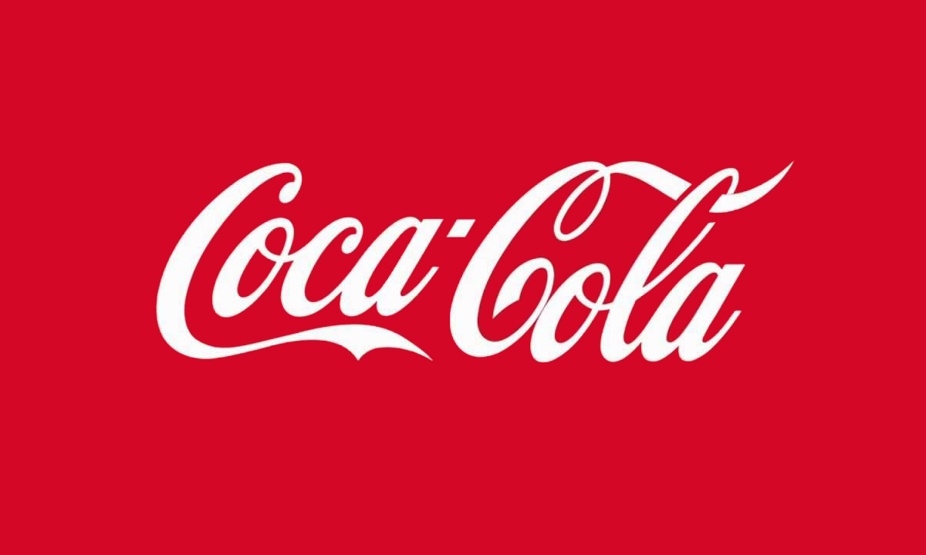

MODULE NAME: Organisational Consultancy (M6X01422)
student Name: HAROON TERIA
Student Number: 1704624
lecturer: Dr: Gareth Hughes

Table of Contents
1.0 Introduction and Background of the Project 3
2.0 Problem Statement and study Significance 5
3.0 Objective of the Study 6
4.0 Research Questions 6
5.0 Literature Review: 7
5.1 Organisational Change 7
5.2 Success Factors in Management of Change 8
6.0 Methodology 9
7.0 Project Period 9
References 10

1.0 Introduction and Background of the Project
Modern business environments are largely defined by change processes that will practically be considered valuable to the same companies remaining competitive in the respective industries that the companies are operating (Armstrong, 2010, p. 176). For there to be development and success in an organization, change is a process that must be undertaken under all costs and situations. Change makes an organisation as competitive as possible because the company is able to drastically respond to the changes in the market shifts and movements in the levels of demand and supply. The company is therefore able to respond to the respective changes that are created from the basis of the customer and all the other external factors (Siddiqui, 2012, p. 32). The speed with which the current business environment has been able to leave companies on the verge of being overstretched in terms of the frequency with which they are supposed to make changes to their strategies. In that case, it therefore becomes relevant that organisations will need to make changes to their respective strategies from time to time to make sure that value and sufficiency is relatable to what is needed in the market as relating to the customer needs (Odhong, Were and Omolo, 2014, p. 76). Change is usually driven by factors that may be business or economically oriented; competition or globalization and technological advancement among many other relatable factors. It can therefore be deciphered every company will need to adjust its human resources management aspects to meet these changes at the very points they are happening. From the basis of Fewings and Henjewele (2019), the issue of change will naturally revolve around a company taking up initiatives that may take the form of mergers and divergence restructuring of the existing business processes and re-organisation of the different business activities associated with the company operations. At the end of each of these strategic plans it is clear that sufficiency is obtained from having to deal with retaining the company position in the market as well as well as satisfying the needs and demands of the stakeholders in maintaining profitability (Cameron and Green, 2019, p. 78).
Every change that does occur in an organisation will need the presence of a change agent to make it as successful as possible. The change agent creates a link between the needs of the organisation and the effective commitments of the stakeholders that are associated with the company. In that case, the management proposals to initiate change will be required to be part of the stakeholders’ approvals as well as their assignment of the required financial boost to necessitate the same process (Segal, 2017, p. 87). There are several objectives that may be seen to be useful in defining the values of the organisation and then making the same as successful as possible. The first is that of improving the health of the organisation helping the organisation develop its ability to solve problems and also helping the organisation to cope with the changing environment. Moreover, the goals are associated with changing the value systems, development of the methods that are used in resolution of conflicts and interpersonal levels of competence as well as development of a system that is organic.
Coca Cola Company is one of the companies that have been involved in many of these changes and that is one of the reasons it has emerged to be the best in the beverage industry across the world. Mwendwa (2016) documented several challenges that faced Coca Cola Company, leading to the need to initiate a change process by the management at the company. One of the challenges that the company had to deal with was the bottle challenge. In this case, it is notable that the company bottle was not making sense to the consumers and they had the challenge of changing the way the bottle looked like. There were other challenges such as the Pepsi Challenge (1939), the Sugar challenge and the diet challenge among many others over the lifestyle of the company. It is in this sense that there is always understanding of the ideas relatable to there being a successful need to enhance development and progress of the company brand through the effective changes that do happen throughout the industry. It is also notable that research such as this is reliably useful in making sure that there is understanding of the respective responses that have made the company remain relevant over time in such a challenging environment (Stuckler, Ruskin and McKee, 2018, p. 19).

2.0 Problem Statement and study Significance
All organisations are confronted with the urge and need to change as quickly as possible in response to the changes in the respective market environments. From the basis of Atkinson et al (2017), it has become an inevitable aspect that organisations implement change processes. This is because the survival of the organisations largely based on the way they can adapt to these new situations. Coca Cola Company is one of the companies that have implemented change at the product level without the need to consider other aspects of the organisation. Quite significantly, the company has been able to do away with some of the products and reintroduce new ones based on the need to adapt to these changes (Sarhaye and Marendi, 2017, p. 76). This is a company that has remained adamant to change and research has not yet revealed the reason the company remains adamant to any of the changes that are need change its operating strategy. Several hypothetical aspects have been levelled towards trying to explain this reasoning and one of the major considerations is that the company is satisfied with its level of operation as just being resistant to the fear of redundancy. All these are hypothetical statements that have not yet found proof in reality (Steele et al, 2019, p. 273). This is the problem that has made it important to carry out a research of this nature to be able to ascertain the different types of the beneficial outcomes associated with change to the growth of the company which would be significant in shaping policy initiatives associated with the company.

3.0 Objective of the Study
This project is guided by a collection of objectives that are quite significant in making sure that value and sufficiency of the results are synonymous with the requirements of the topic. In this case there is therefore the need to undertake a clearly set group of objectives that will significantly increase the level of dependence of the information associated with this process. The objectives associated with this project therefore are;
- To identify and make an evaluation of the drivers of organisational change for the Coca cola company.
- To make an assessment of the organisational changes that have already been implemented by the Coca Cola Company.
- To make an examination of the forms of resistance associated with the Coca Cola Company
- To ascertain the effective developments that have already occurred and continue to occur in the Coca Cola Company as regarding the organisational change factor.

4.0 Research Questions
The objectives as have been determined are implemented through consideration of a clearly set group of research questions as defined below;
- What are the identifiable drivers of organisational change associated with Coca Cola Company?
- What is the identity of the different types of changes that are being implemented or have been implemented at the company?
- What are the associated forms of resistance associated with the process of implementing any of the identified changes?
- What organisational development changes will need to be enhanced at the company to be able to realise progressive changes?

5.0 Literature Review:

5.1 Organisational Change
According to Armstrong (2010), this makes reference to a new state of affairs in a company as influenced by the external and internal forces affecting a company. External activities such as the steps taken by the competitors to enhance production and distribution are all very important in making sure that value is added to the current products so as to make sense in the market. Any decision aimed at implementing change could be as a result of bad experiences by the firm or a pre-empted decision by the top management to implement the same (Cameron and Green, 2019, p. 86). It is still understandable from the basis of Fewings and Henjewele (2019) that there are environmental threats emanating from the external environment that will naturally lead to the need to have the organisation change its strategies. Ideally, very little from the internal perspectives will change the structure of the operations in the company because the final verdict in any company is done by the customers. For instance, the case of Coca Cola will have the customers preferring Pepsi products which will trigger the need to make effective change to match or surpass the competing firm (Morris, 2014, p. 65).
Changes can take many forms and it all depends on the reason that instigated the change process. For instance, technical changes are likely to happen in an organisation where there will be needed to make amendments to the technology, changes to the cultural and physical environments of the company as a whole. From the basis of Odhong, Were and Omolo (2014), it all depends on the respective issues that the company would like to work on. The table below indicates the relationships between the state and direction of organisational change in a company;
Changes in organisation (the state) | Strategic changes (the direction)
Culture | The vision
Structure | The position
Systems | Programs
The people | The facilities
Having realised and identified the need for change the project needs to focus on the prospective success factors associated with the change process within the company systems.

5.2 Success Factors in Management of Change
- Abundant and purposeful level of participation
Participatory strategies are considered to be the main determinants of a successful implementation of any given strategy in any given company. In this case, all the stakeholders affected by the change process can actively engage in the change process (Siddiqui, 2012, p. 117).
- Support by the Management
This is an issue that can be taken from the basis of the Kotter leadership model and theory through consideration of the fact that companies operate in systems that are constantly challenging. This considers aspects such as the power of the position, the available expertise to implement the change process, the group credibility and the skilful level of the available leadership (Segal, 2017, p. 71).
- Communication and Clarity of the Set Goals
Proponents of change such as Sarhaye and Marendi (2017) have been able to decipher that it is difficult to have too much communication in any change process without confusing the other people that are taking part in the change process. Communicating the goals in the correct manner is an issue that leads to there being a successful implementation of the same in the most categorical manner.

6.0 Methodology
Collection of the relatable information to this basis is based on having access to the company data through its website, related journal articles on the issue of change and change management and other secondary sources of information relating to the same basis. Quite identically the application of Saunder’s Onion (Saunders and Lewis, 2012, p. 117) will be a key issue of defining the level to which value is added to the data collection method in this case. However, the main focus will be on secondary application of information.

7.0 Project Period
This is a project that is likely to take a period of just one month to collect the information based on the fact that it all makes reference to secondary information. It is therefore important that all the sections are put in order so that the defined periods within which the information is collected is defined and known (Saunders and Lewis, 2012, p. 118). This project therefore focusses on Coca Cola being a company that is need of implementing change process in other areas apart from the product aspects as has been the norm over the years.

References

Ahmad, M.H., Ismail, S., Rani, W.N.M.W.M. and Wahab, M.H., 2017, October. Trust in management, communication and organisational commitment: Factors influencing readiness for change management in organisation. In AIP Conference Proceedings (Vol. 1891, No. 1, p. 020019). AIP Publishing LLC.
Armstrong, M., 2010. Armstrong's essential human resource management practice: A guide to people management. Kogan Page Publishers.
Atkinson, R., Dörfler, T., Hasanov, M., Rothfuß, E. and Smith, I., 2017. Making the case for self-organisation: Understanding how communities make sense of sustainability & climate change through collective action. International Journal of Sustainable Society, 9(3).
Cameron, E. and Green, M., 2019. Making sense of change management: A complete guide to the models, tools and techniques of organizational change. Kogan Page Publishers.
Fewings, P. and Henjewele, C., 2019. Construction project management: an integrated approach. Routledge.
Morris, P.W., 2014. Project management: a profession with a hole in its head or, why a change in the culture of academic support is needed for the profession. Engineering project organization journal, 4(2-3), pp.147-151.
Mwendwa, K.F., 2016. Factors influencing strategic change management practices at Coca Cola Company in Kenya. Unpublished MBA Project). University of Nairobi, Kenya.
Odhong, A.E., Were, S. and Omolo, J., 2014. Effect of human capital management drivers on organizational performance in Kenya. A case of investment and mortgages bank ltd. European Journal of Business Management, 2(1), pp.341-356.
Sarhaye, S.A. And Marendi, D.P.N., 2017. Role of green procurement on organizational performance of manufacturing firms in Kenya: A case ff Cocacola Company. The Strategic Journal of Business and Change Management, 4(3), pp.85-102.
Saunders, M.N. and Lewis, P., 2012. Doing research in business & management: An essential guide to planning your project. Pearson.
Segal, S., 2017. The existential dimensions of the paradox of becoming in the process turn in organisation studies. Management Learning, 48(4), pp.471-486.
Siddiqui, F., 2012. Human capital management: An Emerging human resource management practice. International Journal of Learning & Development, 2(1).
Steele, S., Ruskin, G., McKee, M. and Stuckler, D., 2019. “Always read the small print”: a case study of commercial research funding, disclosure and agreements with Coca-Cola. Journal of public health policy, 40(3), pp.273-285.
Stuckler, D., Ruskin, G. and McKee, M., 2018. Complexity and conflicts of interest statements: a case-study of emails exchanged between Coca-Cola and the principal investigators of the International Study of Childhood Obesity, Lifestyle and the Environment (ISCOLE). Journal of public health policy, 39(1), pp.49-56.

