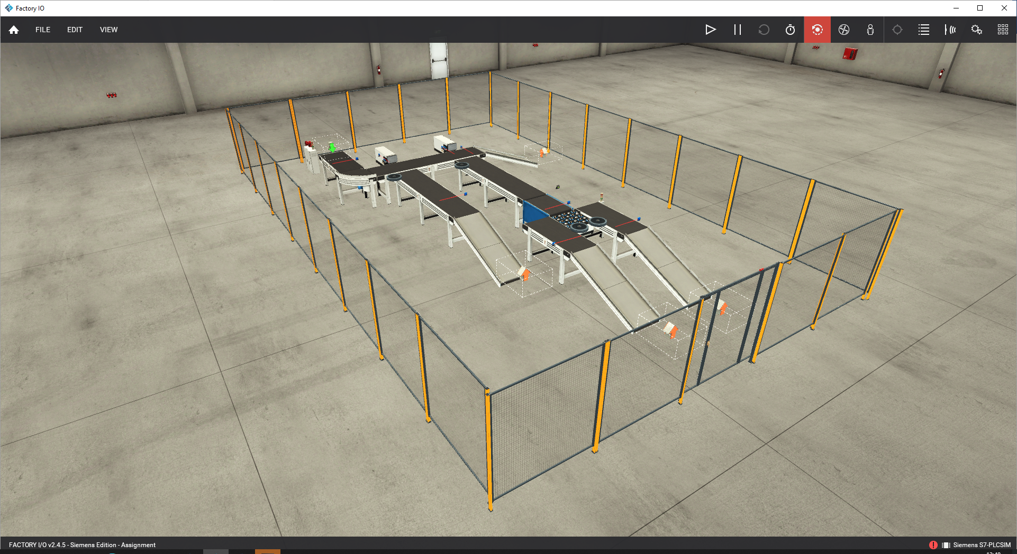  Factory Control 1  Jessica Williams | soactaster12  Control Technology

Introduction
‘PLC is a special form of microprocessor- based controller. It includes a programmable memory to store instructions and to implement functions such as logic, sequencing, timing, counting and arithmetic’ (Lashin, 2014, pg.27).
A formal report has been produced to detail the control of a factory system that organises packages based on size and weight. It contains operator interaction, controls and displays. Faults and warnings are able to be recognised and displayed clearly and as discussed below, an operational flow chart, alarm/warning strategy and discussion of a ladder logic program will be considered.
Literature Review
The section below will discuss some examples of PLC (programmable logic controllers) currently used in industry and an evaluation of each.
Modular PLC is the first example of industrial PLC in this assignment. The hardware architecture of the Modular Process Simulator guarantees stability, precision, and smooth transitions. A common digital language and the linking of PLCs enables these capabilities. The PLC replaces the sequencing control circuits in cable logic and is used to automate industrial operations (Dumitru et al, 2009). However, as Kandare, Strmcnik and Godena (2010) state, because of the high expectations for control software quality and dependability, the process of developing PLC software is not simple. Furthermore, PLC programming languages offer a rather low degree of abstraction. Because of this, PLC programming languages are inadequate for complicated systems.
Small programmable controllers are used with the compact kind of PLC. The power supply, CPU, memory, and input/output devices are typically included. It could hold up to 1000 instructions, for instance. The issue of having a limited number of input and outputs is to connect additional boxes to them, some have the ability to increase their level of competency and manage more inputs and output signals (Bolton, 2015). Compact PLCs are around the size of the largest laptop computer. You can use their remote access, without taking up a great deal of space.
When using a medium PLC, plug-in modules which are mounted on rack mounting systems or back plane systems prevail in modular architecture. As Thirumurugan et al (2018) states, this design makes it easy to upgrade or expand the system by adding more I/O cards to the racks because most rack systems have room for numerous more function cards. In order to provide dependable operation in a variety of situations, boards are often ruggedized. The most expensive PLCs are often rack-mounted, but they are also the easiest to modify and replace component by component. Rack mounted are often a metal structure with a backplane made of printed circuit boards, which offers a place to install the processor and input/output (I/O) modules for PLCs. Through the backplane, the mounting rack connects the processor and modules with power and data. The rack also houses the modular power supply for CPUs without built-in power sources. In certain configurations, the CPU is installed independently and linked to the rack by a wire. PLC programming languages are grouped into five major standards based on the International Electrotechnical Commission (IEC) standard.
- Sequential function charts
- Instruction Lists
- Ladder diagram
- Structured Text
- Function Block Diagram
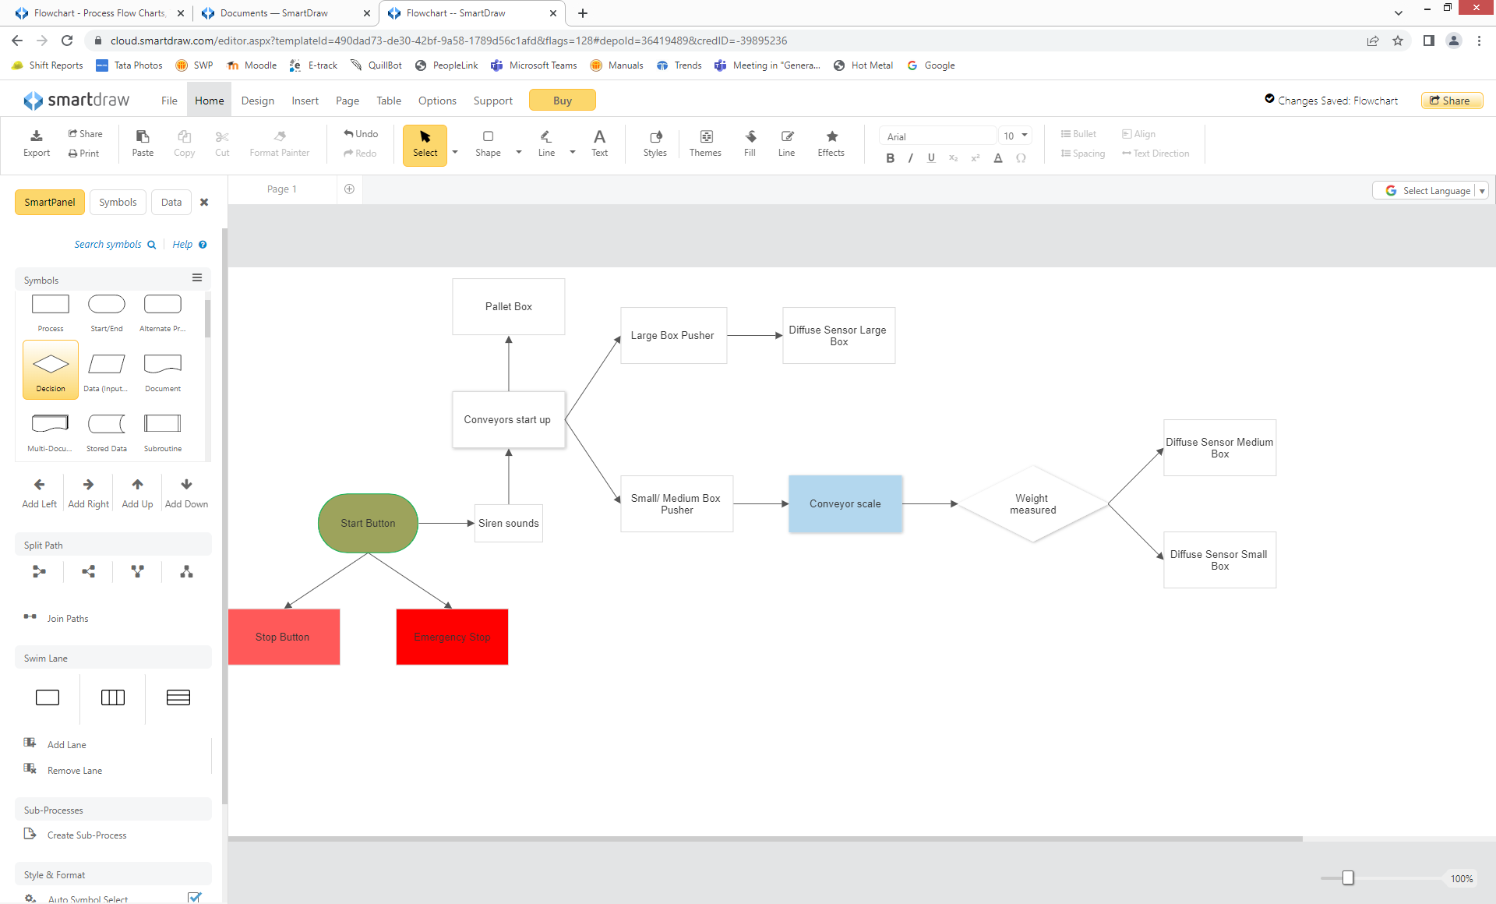
Design a factory process

For this assignment a factory process was designed to sort packages into size and weight using 6 conveyor belts to transport the boxes. The emitter at the start of the process produced 4 different types of boxes- Pallet box, small box, medium box and a large box. The two pusher activations were determined by difuse sensors that sorted the boxes. The large box activated pusher one, the small and medium boxes activated pusher 2 where they were sorted in to small and medium by weight until the boxes reached the package removers. Start and stop buttons were programmed, with the use of a siren for start-up of the conveyors an emergency stop button and stack lights (more details shown below). Components from the software Factory IO were utilised to develop an operation that was simple to control and ran smoothly.

Control of process using a ladder logic program
A ladder logic program was developed to represent the process by a graphical diagram. The program is shown below:
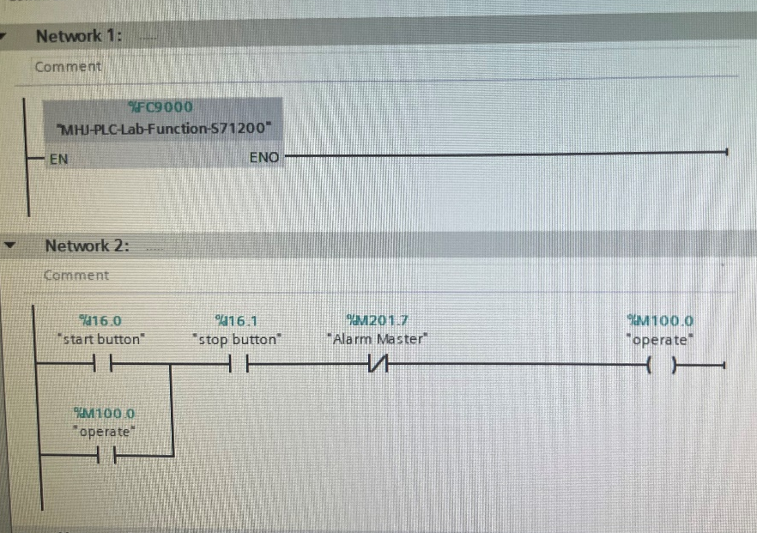
Start and stop buttons implemented to run and stop the system.

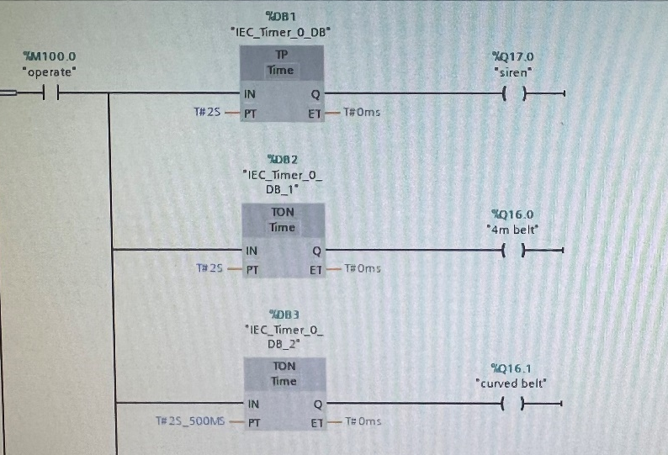

A siren was implemented to sound after the start button was pressed, then shortly after started all 6 belts up gradually in sequence at allocated times with the 4m belt (1) running first.

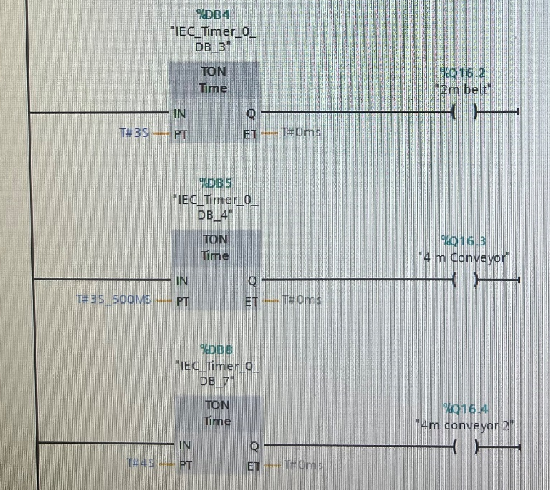

The times were adjusted and changed to suit the smooth running of the system.

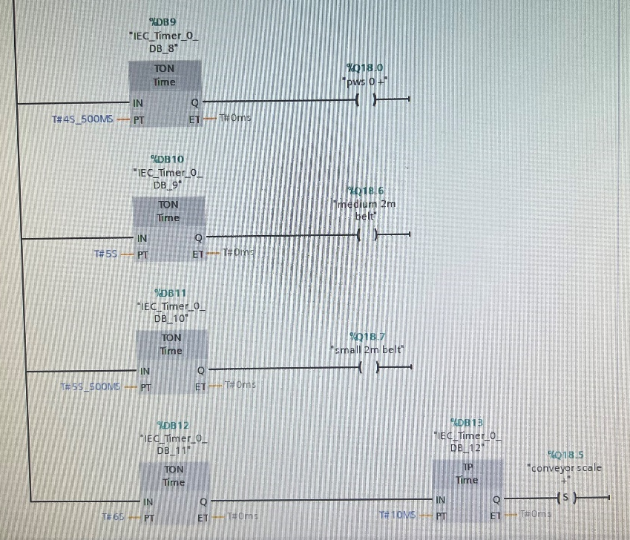
To separate the small and medium boxes sent down the 4m conveyor a conveyor scale was entered to send the desired weight down the correct 2m conveyor for the weight of the package.

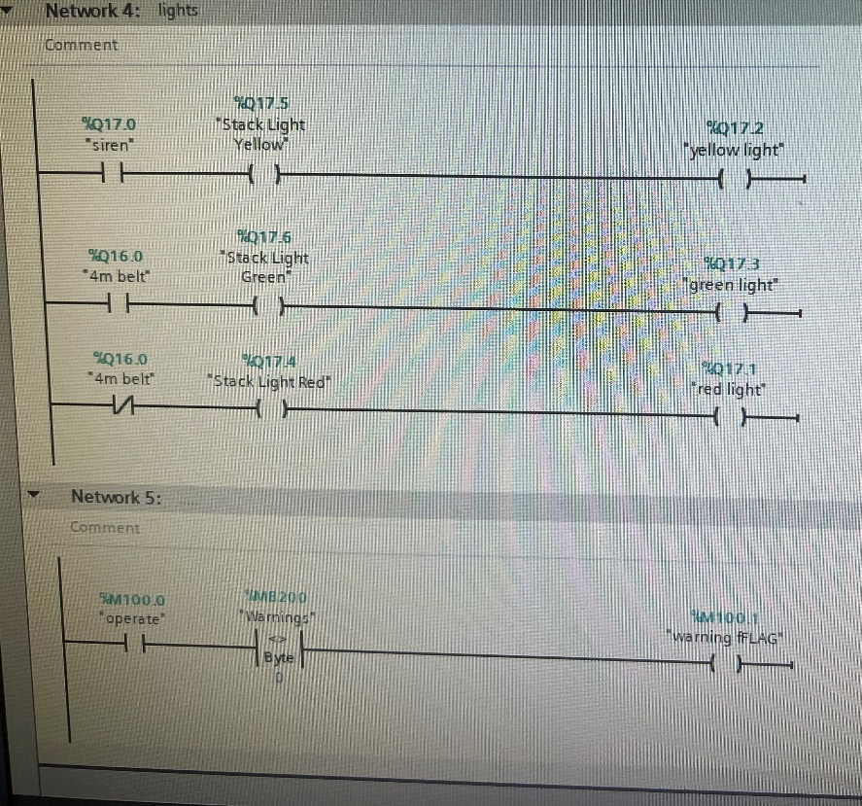

At this next step two sets of stack lights were programmed. Green light when the operation stated up by using the first conveyor to run, yellow light just before start up and red light when the conveyors stop.

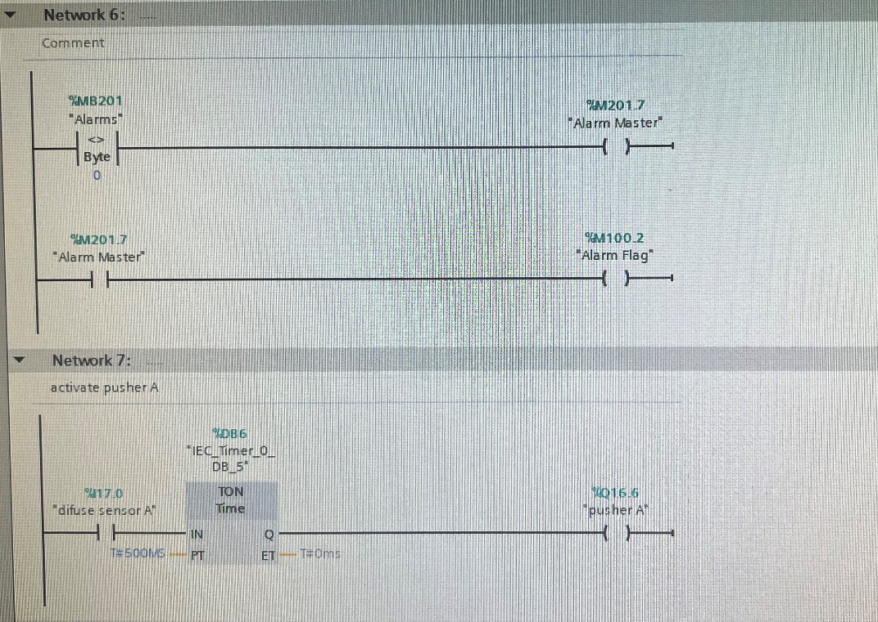

Alarm master was created to use on one of the screens later on to be displayed with the warnings and alarms. The output was to create an alarm that the operator would notice if conditions were not satisfied.

Then, pusher activations were set-up, once difuse sensor A was activated, Pusher A would push the large boxes down the conveyor.

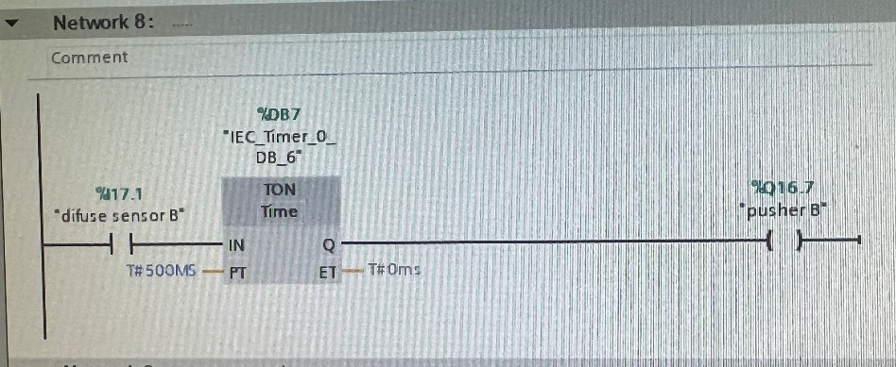
Difuse sensor B when activated the output allowed pusher B to activate after 500 milliseconds as shown in the image. (Sending small and medium boxes towards the conveyor scale for sorting.

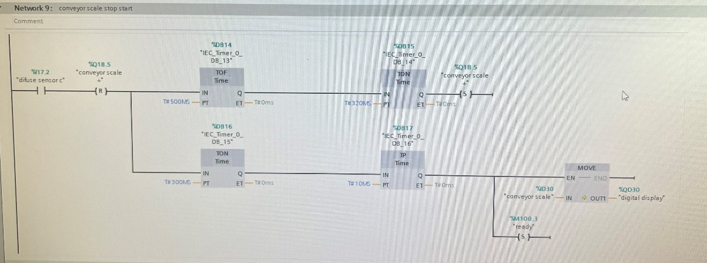
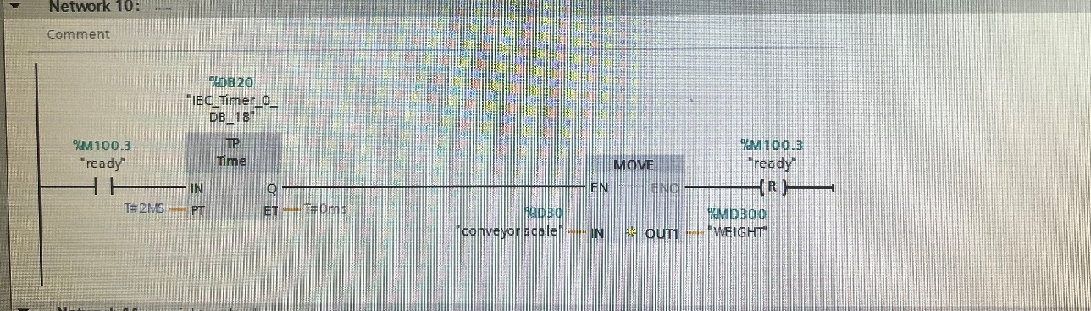
Diffuse sensor C was used to stop the boxes to be weighed on the scale for a period of time and a digital display presented the weight of the box.

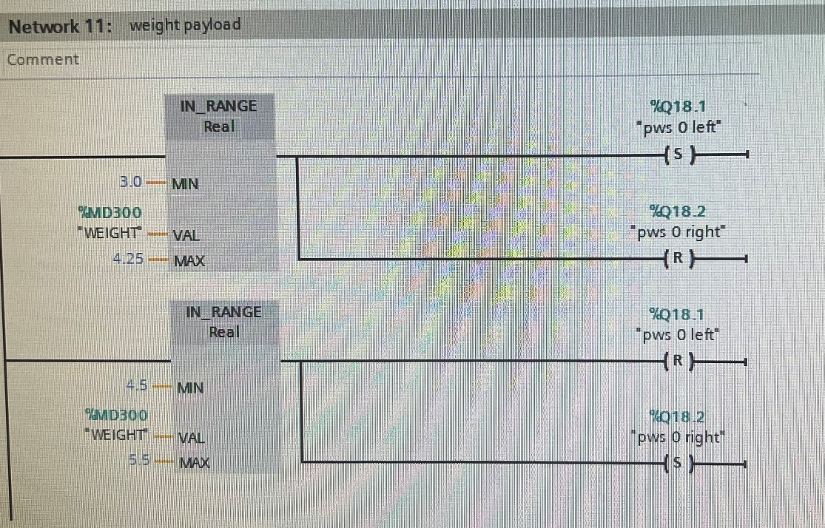

As shown in networks 10 and 11, the movement of the conveyor scale was determined on the weight of the box. The wight of the small boxes (between 3.0 and 4.25) and medium (between 4.5 and 5.5). This allowed the boxes to be sorted down separate conveyors to the left or to the right.

Counters
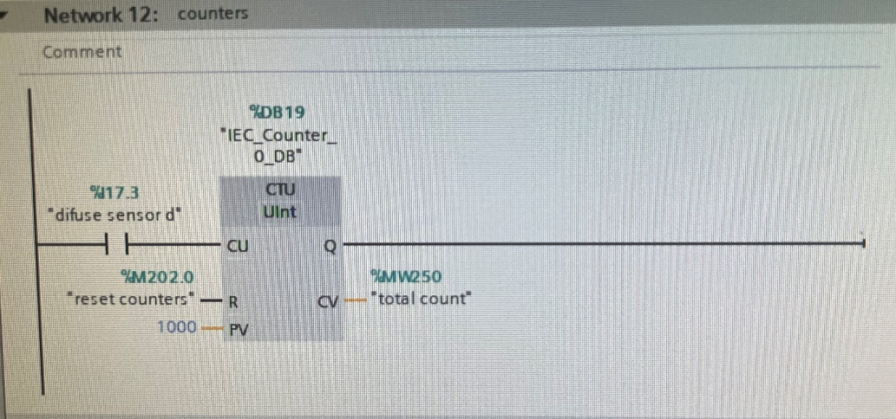
The first counter created in the program was a total count of boxes that were dispatched(using difuse sensor d found at the start of the process). A reset counters was used for all counters if the process was to be restarted.
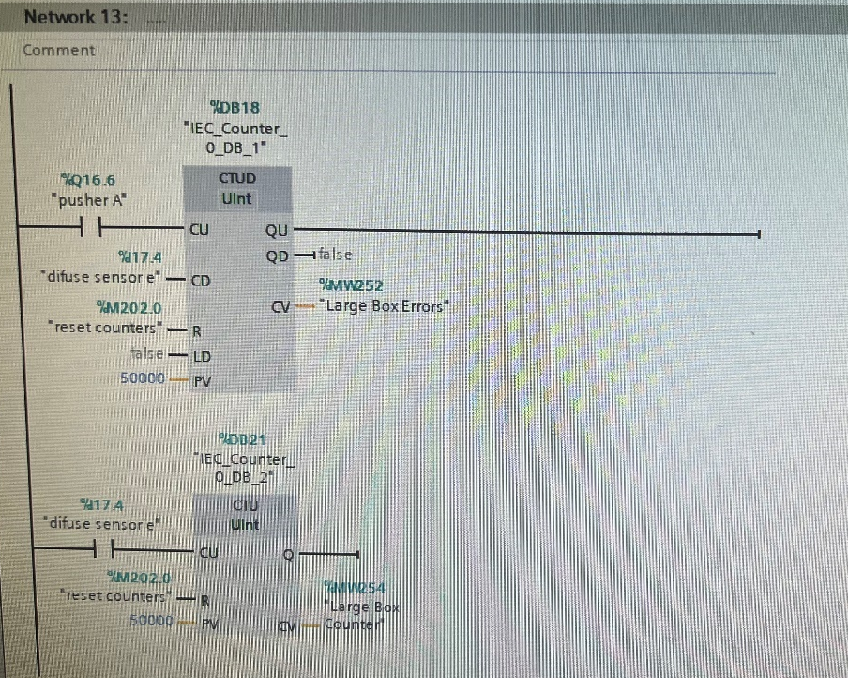

The large boxes were counted by using pusher A and difuse sensor e. If the box did not get picked up by difuse sensor e and error would be displayed. When errors occur for large boxes, warning 1 and alarm 1 are activated from the alarm and warning set indicators (meaning a lost package or package did not complete transverse).

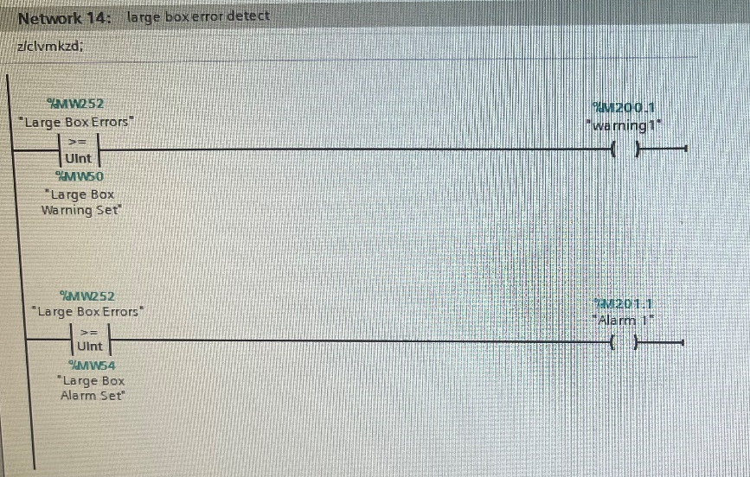

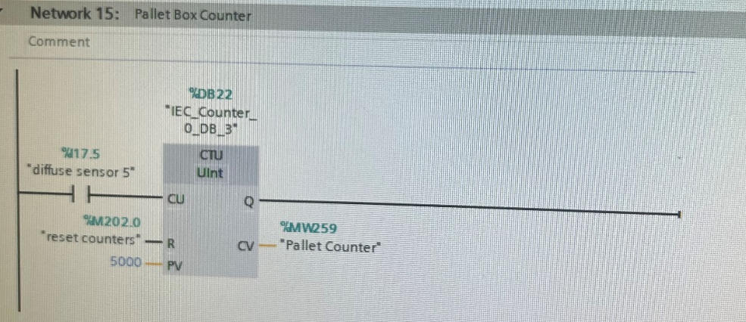
A pallet box counter was created using a difuse sensor.

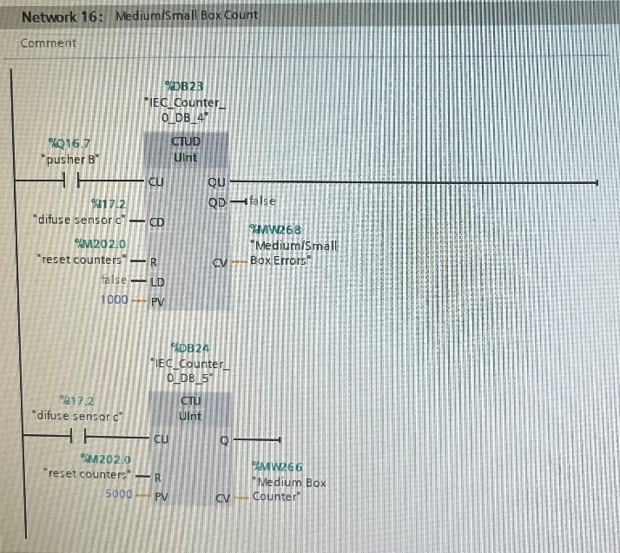

For the medium/small box counters it was created the same way as the large boxes (using pusher B and difuse sensor c) to account for any missing boxes along the conveyors. The warning used was warning and alarm 2.

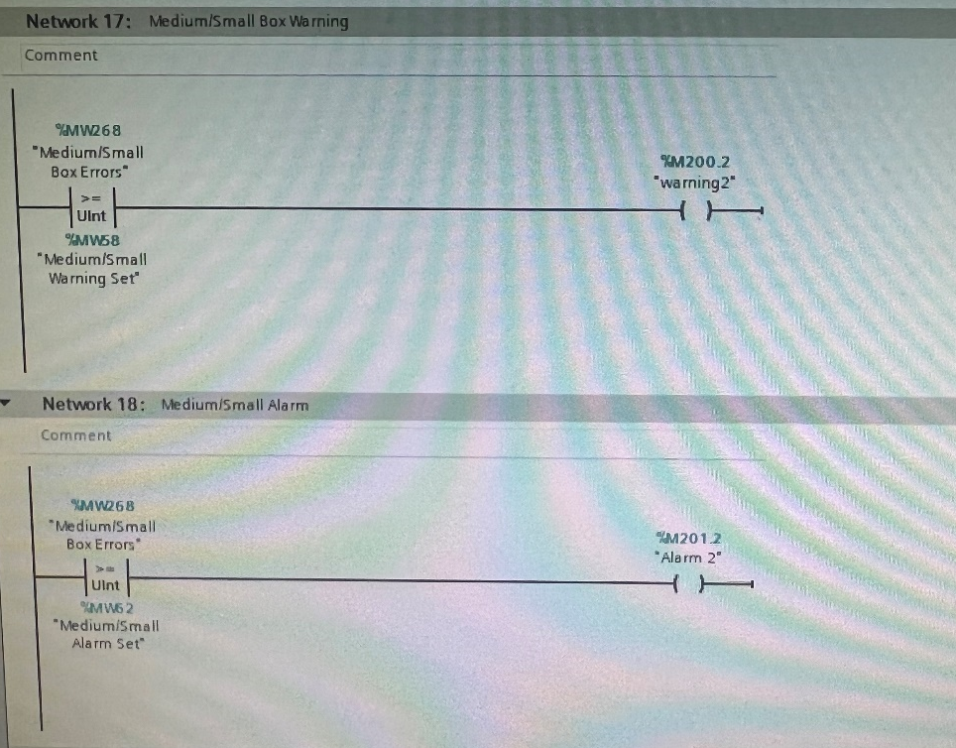

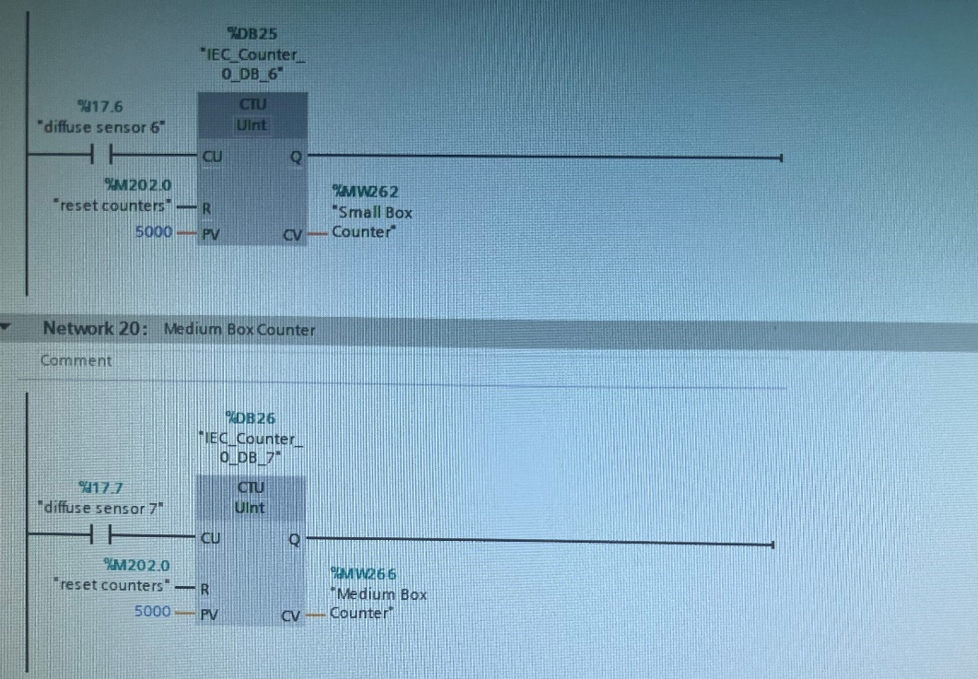
The total number of small/medium boxes was determined by using 2 difuse sensors on at each end of the conveyors after the small and medium boxes were sorted by weight.

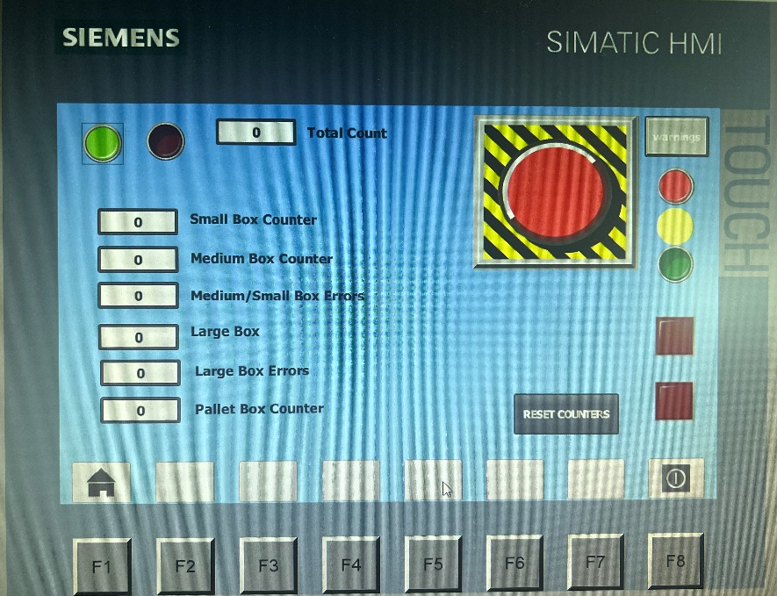
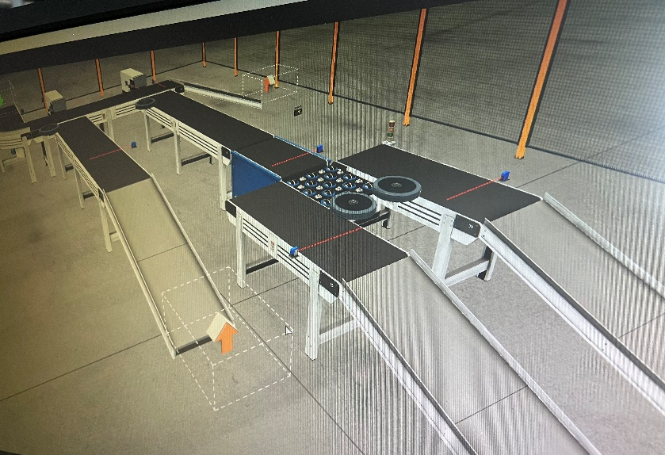
HMI device for operators

The HMI device allows operators to use the start and stop buttons to control the system. An emergency stop button and a button to reset all of the counters created. If there was an issue with the box sorting prosses, the emergency stop can manually stop all equipment with human interaction. All counters are displayed on this screen as shown above and are constantly running if the start button is pressed. A replication of the stack lights was created on this page for the operator to be able to identify what the process is currently executing. Fault and warning indicators are also displayed to provide a quick reaction off operators if there was an issue.

Screens and navigation controls on HMI
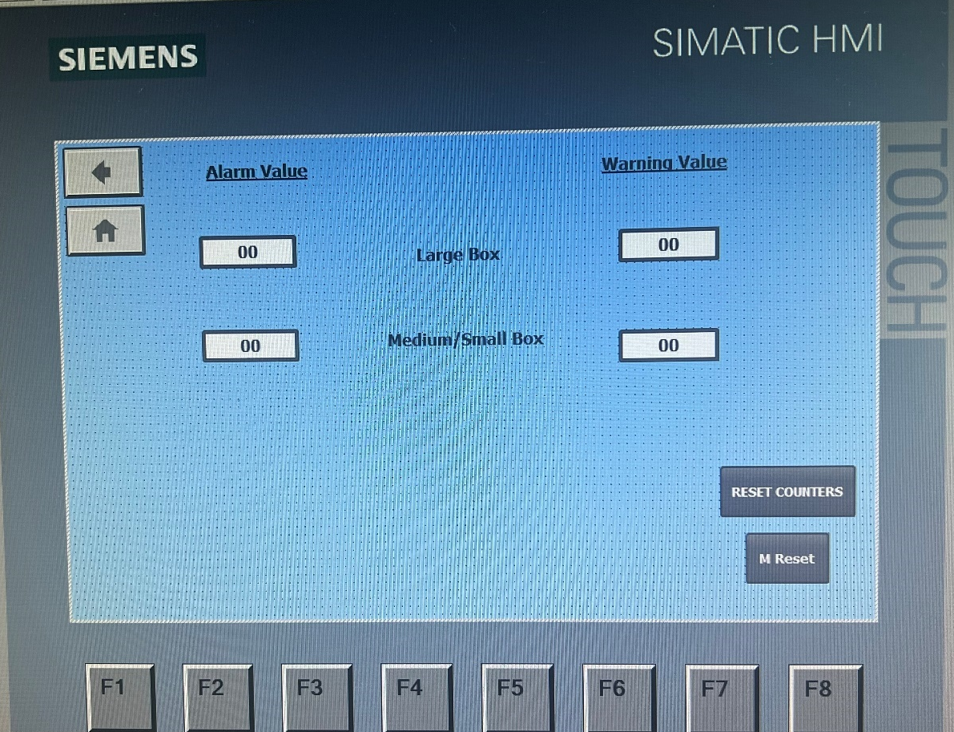
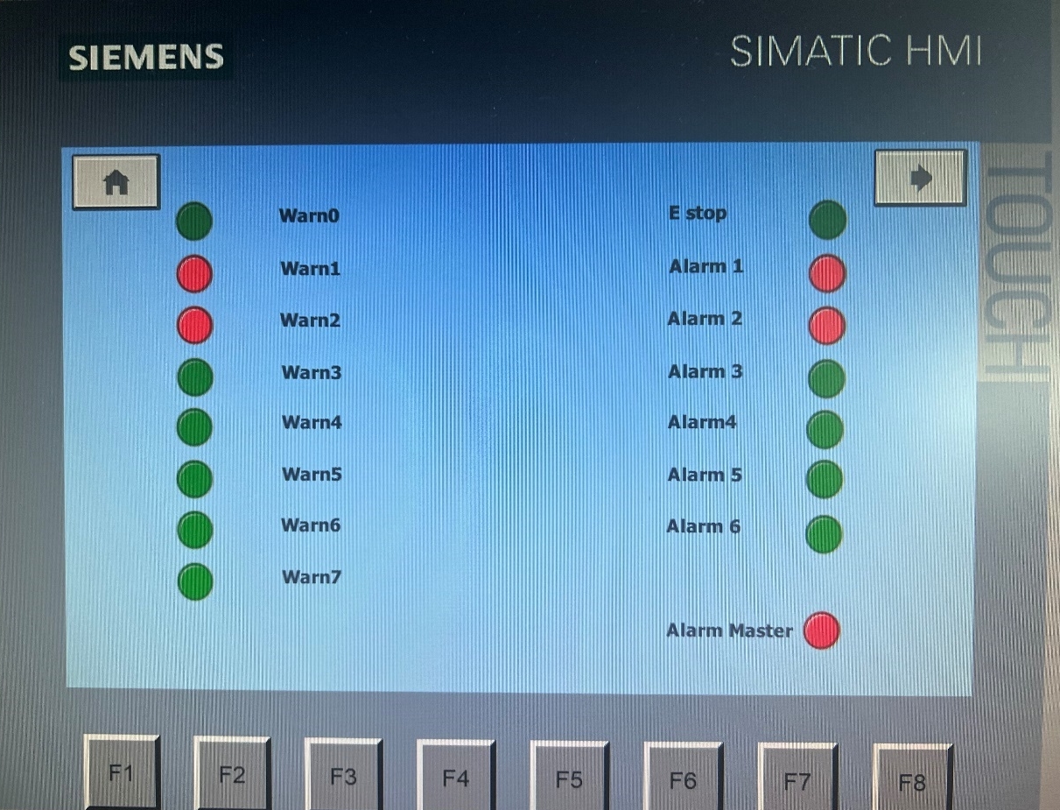

The alarm and warning screen displays the number of warnings and alarms active in the process. As shown above warn1 and alarm1 link to an error with large boxes, whereas warn2 and alarm 2 appear when there are errors with the small and medium boxes. For example, if the package did complete its transverse. The error count will increase if a package is lost and display a warning and alarm if there is an exceeding number of errors. The engineering screen allows data entry points for pre setting the counters for warnings and alarms. A manual reset can be found on this page to reset the system once the issue in production has been resolved.
Conclusion
To conclude this report, PLC allows the operator to manage input and output signals, an alarm and warning strategy with operational parameters was created using a ladder logic program. The advantages and disadvantages of PLCs were discussed showing how different types of PLCS can be more useful or beneficial depending on the use/process that it is needed for. This assignment was able to utilise a range of components within Factory IO to control a factory system that sorts packages on their size and weight efficiently while displaying warnings and alarms if parameters are missed.

Reference List
Bolton, W. (2015) Programmable Logic Controllers. 6th edn. Newnes: London.
Dumitru, I. Fagarasan, I., St. Iliescu, S., Stamatescu, G., Arghira, N. Barbulea, V. (2009) ‘A modular process simulator with PLC’, Proc. 9th WSEAS International Conference on Simulation, Modelling and Optimization, pp.391-394.
Hackworth. J. R. and Hackworth. F. D. (2004) ‘Programmable logic controllers-programming methods and applications’, India: Dorling Kindersley,2, pp. 49-62.
Kandare, G., Strmcnik, S. and Godena, G. (2010) ‘Domain specific model-based development of software for programmable logic controllers’, Computers in Industry, 61 (5), pp. 419–431.
Lashin, M. (2014) ‘Different applications of programmable logic controller (PLC), International Journal of Computer Science, Engineering and Information Technology, 4(1), pp. 27-32.
Thirumurugan, P., Aravind, R., Kumar, A., Manjunath, D. and Kalaiselvan, R. (2018) ‘Automatic Sorting in Process Industries using PLC’, GRD Journals- Global Research and Development Journal for Engineering, 3(3, February), pp.8-13.

