University of Wales Trinity Saint David
Wales Institute of Science and Art


Electronic Circuits Testing and Applications
Electrical Control Systems
ACHA4010

Nevin Jyothis
2205181
Contents
1 Task 2 1
1.1 Scope Time Division Calculations (4) 1
1.2 Function Generator output sine wave (3) 1
1.3 Unsmoothed Rectifier Wave (3) 1
1.4 Smoothed Rectifier Wave with capacitor (3) 2
1.5 Drop in Voltage Question (4) 2
1.6 Different Voltage Readings Question (5) 2
1.7 Rectifiers use in Automotive applications Question. (4) 2
1.8 Probing Question (4) 3
1.9 Scope Time Division Calculations (4) 3
1.10 Function Generator output square wave (3) 3
1.11 Capacitor charge and discharge wave marked at correct points. (3) 4
1.12 Basic Capacitor Calculations (3) 4
1.13 Capacitor discharge table (4) 5
1.14 Gradient Plot and calculations (4) 5
1.15 Capacitor Uses (5) 5
1.16 Inaccuracies Question (4) 6
2 References 7

Task 2

Scope Time Division Calculations (4)
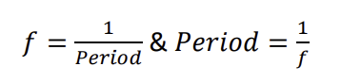 period =1/10
Time division calculation = 1/10*1 = 1

Function Generator output sine wave (3)
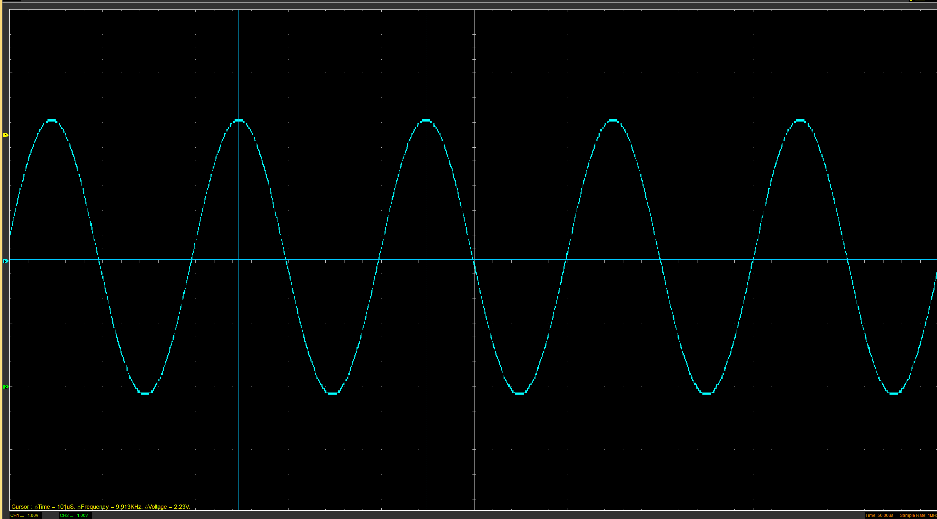

Unsmoothed Rectifier Wave (3)
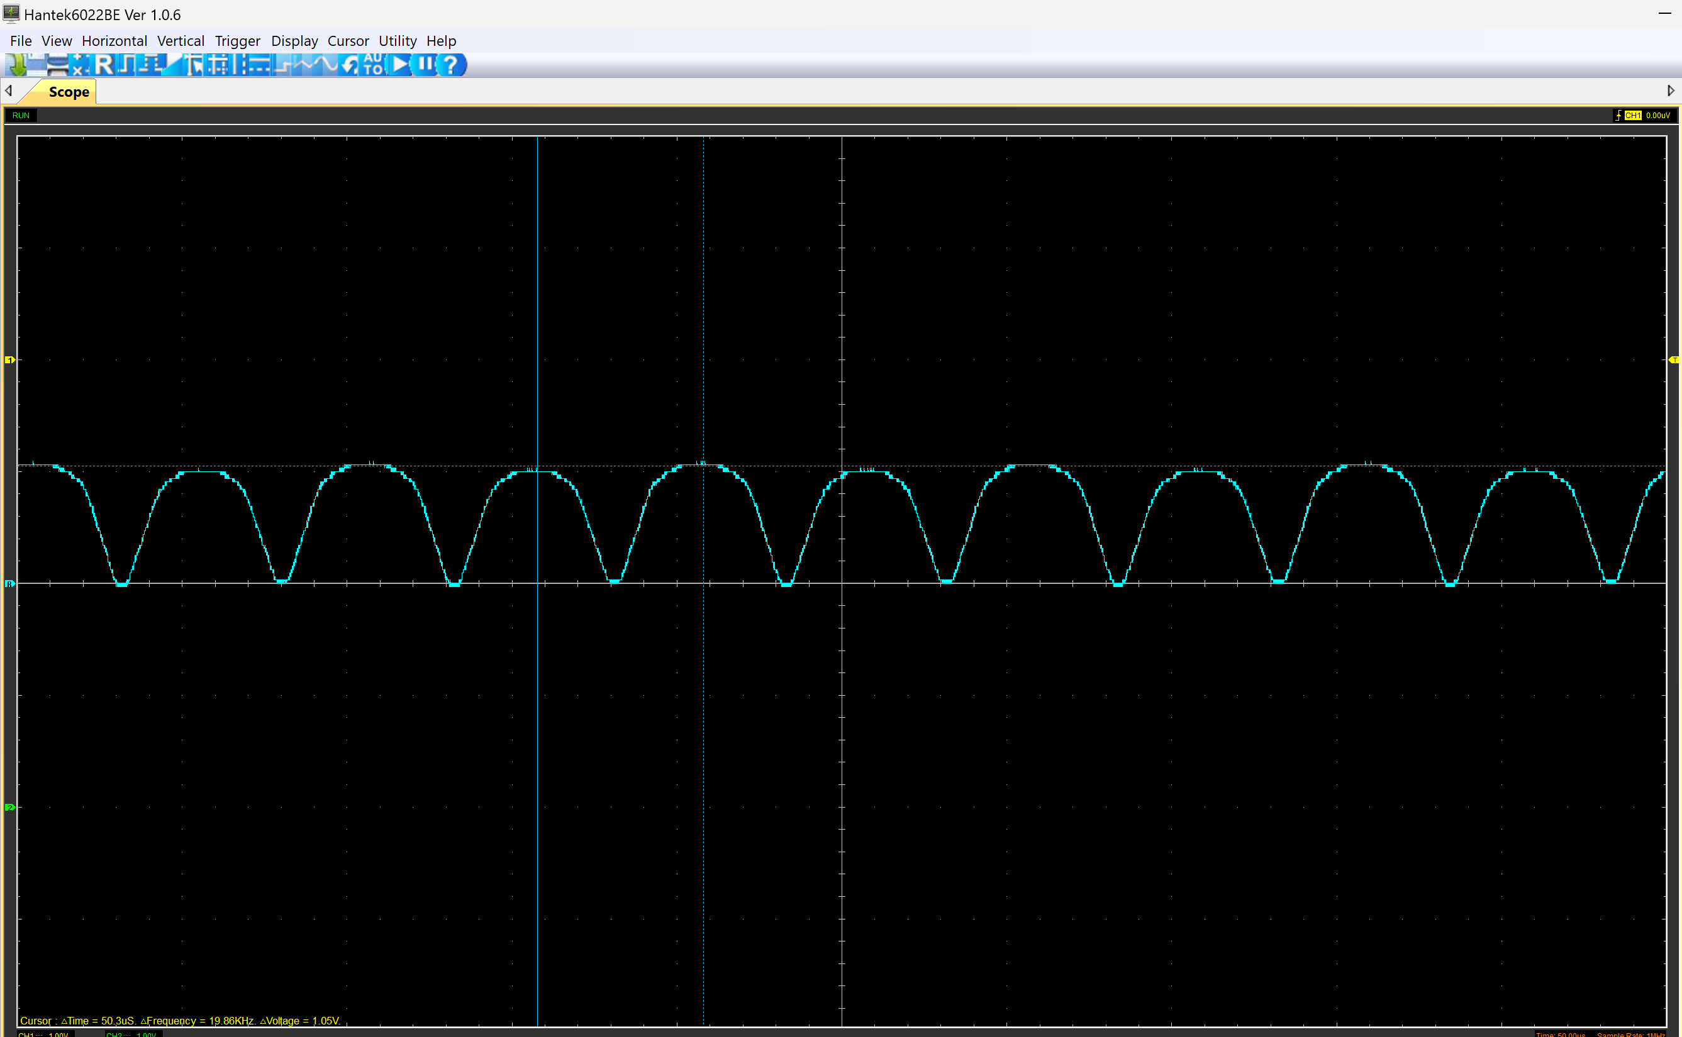

Smoothed Rectifier Wave with capacitor (3)
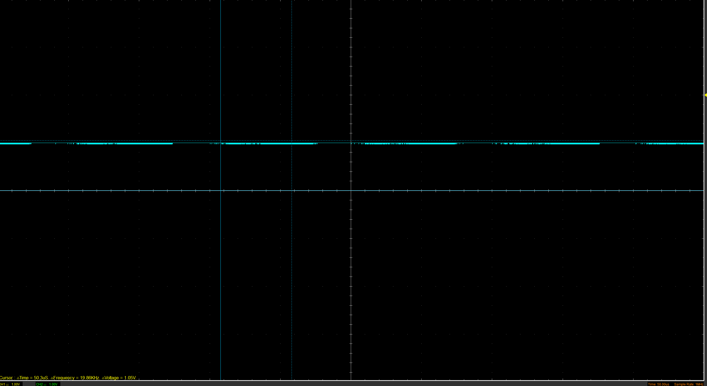

Drop in Voltage Question (4)
The DC output of a rectifier is lower than the peak of the input sine wave due to several factors. One reason is the voltage drop across the diode used in the rectifier; A silicon diode has a forward voltage drop of about 0.7V, which reduces the peak output of voltage. Additionally, real-world components and circuits have inherent resistances and inefficiencies that can cause power losses. These factors combined result in a DC output that is lower than the peak of the input sine wave

Different Voltage Readings Question (5)

Rectifiers use in Automotive applications Question. (4)
Rectification is an essential process in vehicles, particularly in their electrical systems. It involves converting alternating current, produced by the alternator, into direct current that can be used by the vehicle’s electrical components. In vehicles, rectifiers are typically found in the alternator. The alternator generates AC power from the engine’s mechanical energy. This AC power is then converted to DC by the rectifier, allowing it to be used to charge the battery and power the electrical systems. The importance of rectification in vehicles cannot be overstated. Without it, the alternator’s AC output couldn’t be used to charge the battery or power the vehicle’s electrical systems. This would result in a drained battery and non-functional electrical components. Moreover, rectification ensures the reliability and efficiency of the vehicle’s electrical system. It allows for the smooth operation of systems such as the ignition system, lighting and onboard computers. In conclusion rectification plays a vital role in the operation of vehicles, guaranteeing the functionality of their electrical systems and overall performance.

Probing Question (4)
The inability to probe the input of the function generator and the rectifier’s output simultaneously could be due to a grounding issue. (Problem with full wave rectifier when function generator is used as input, 2006)

Function generators and oscilloscopes usually share a common ground, and if the circuit isn’t designed with this in mind t can create a short circuit. When the function generator is connected to the circuit, and the oscilloscope probes the circuit at another point, they form a ground loop12. If the circuit’s ground is not the same as the oscilloscope’s ground, it can lead to incorrect measurements or even damage the equipment. To allow simultaneous probing which you can use a differential probe - Differential probes measure the voltage difference between two points in a circuit, eliminating the ground loop problem.
Task 3

Scope Time Division Calculations (4)
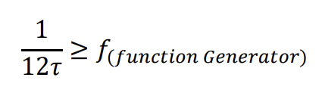

Function Generator output square wave (3)
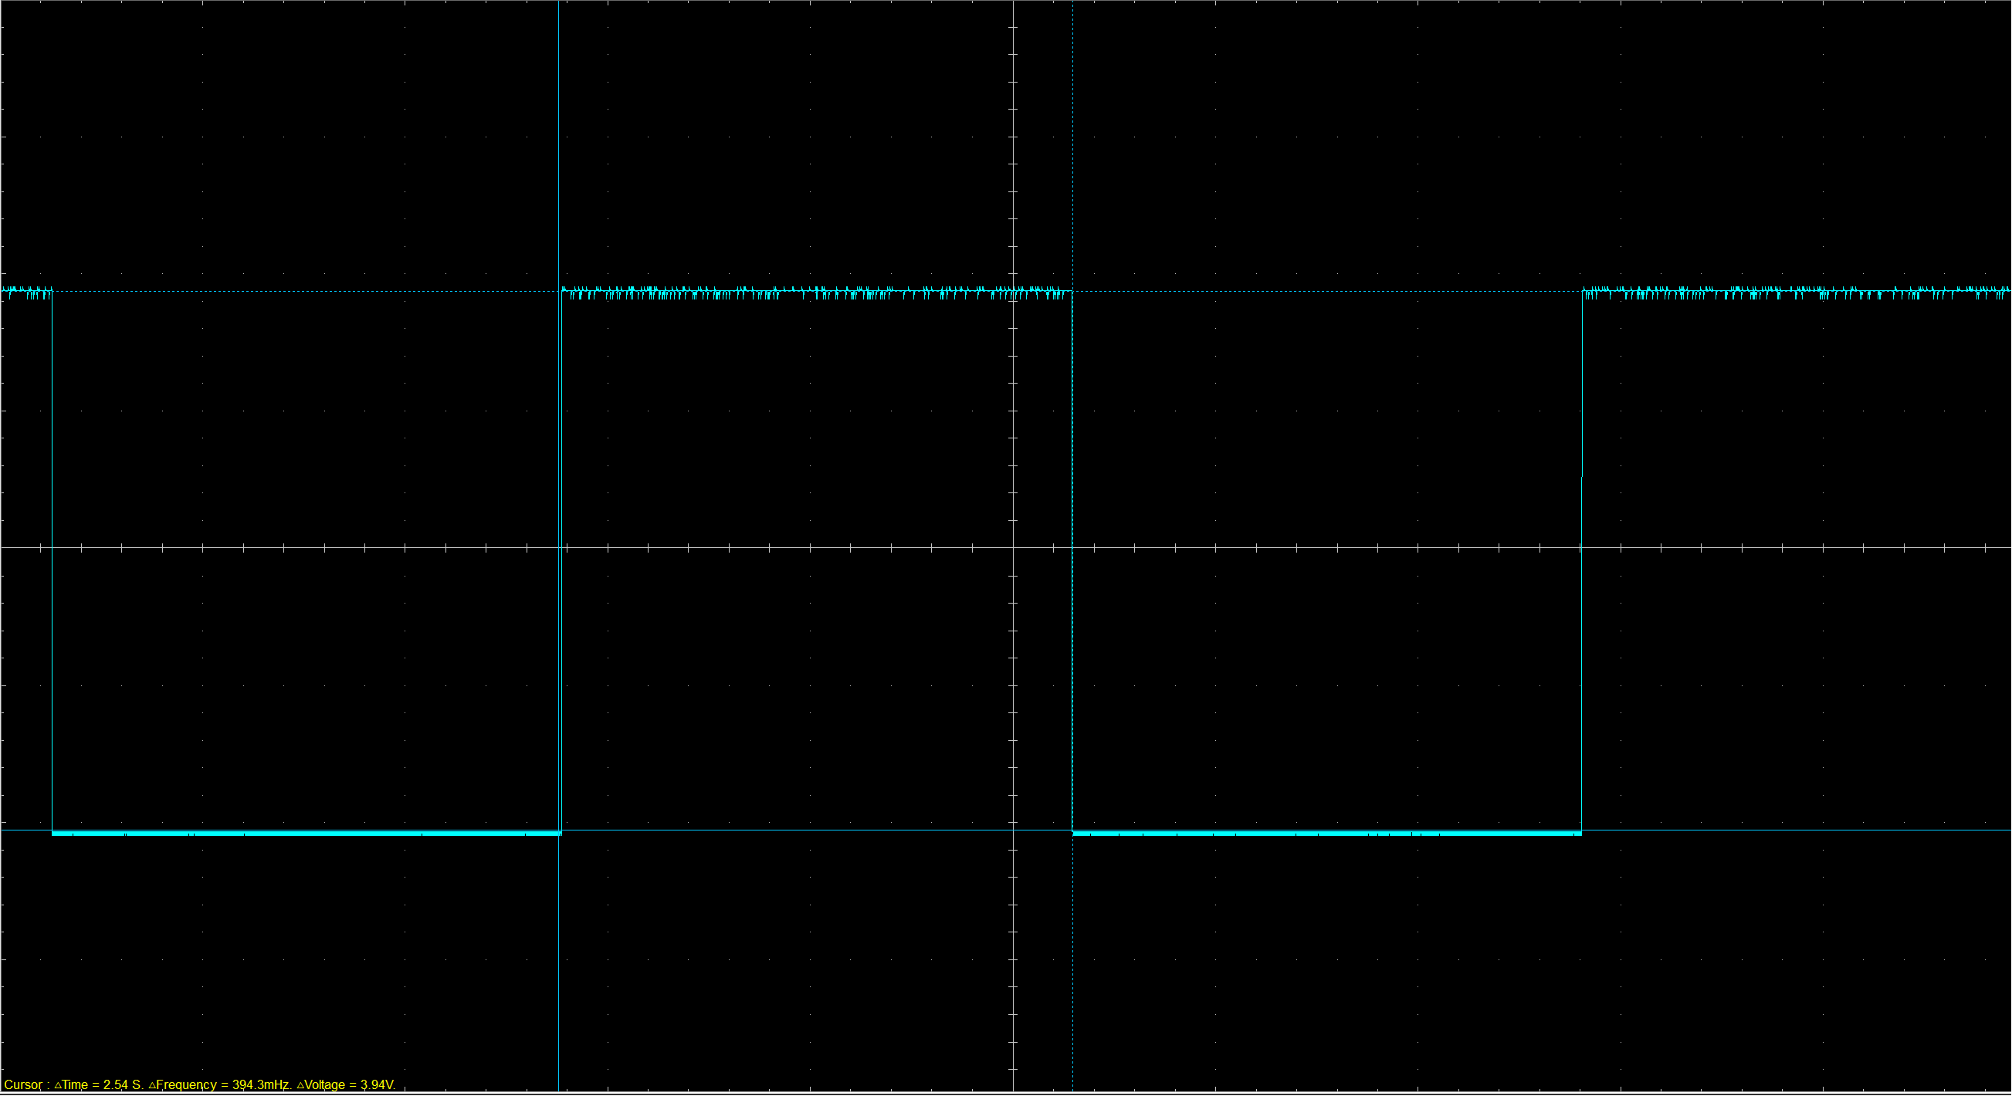

Capacitor charge and discharge wave marked at correct points. (3)
Charge wave :
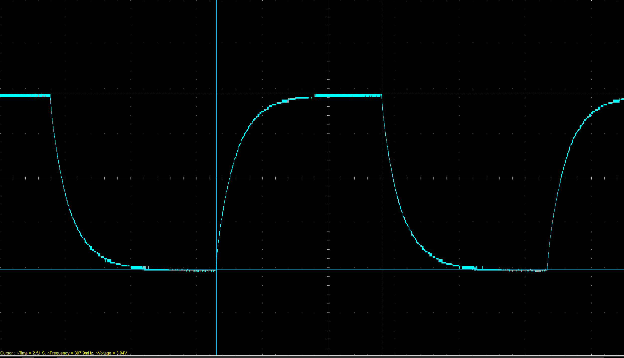

Discharge wave:
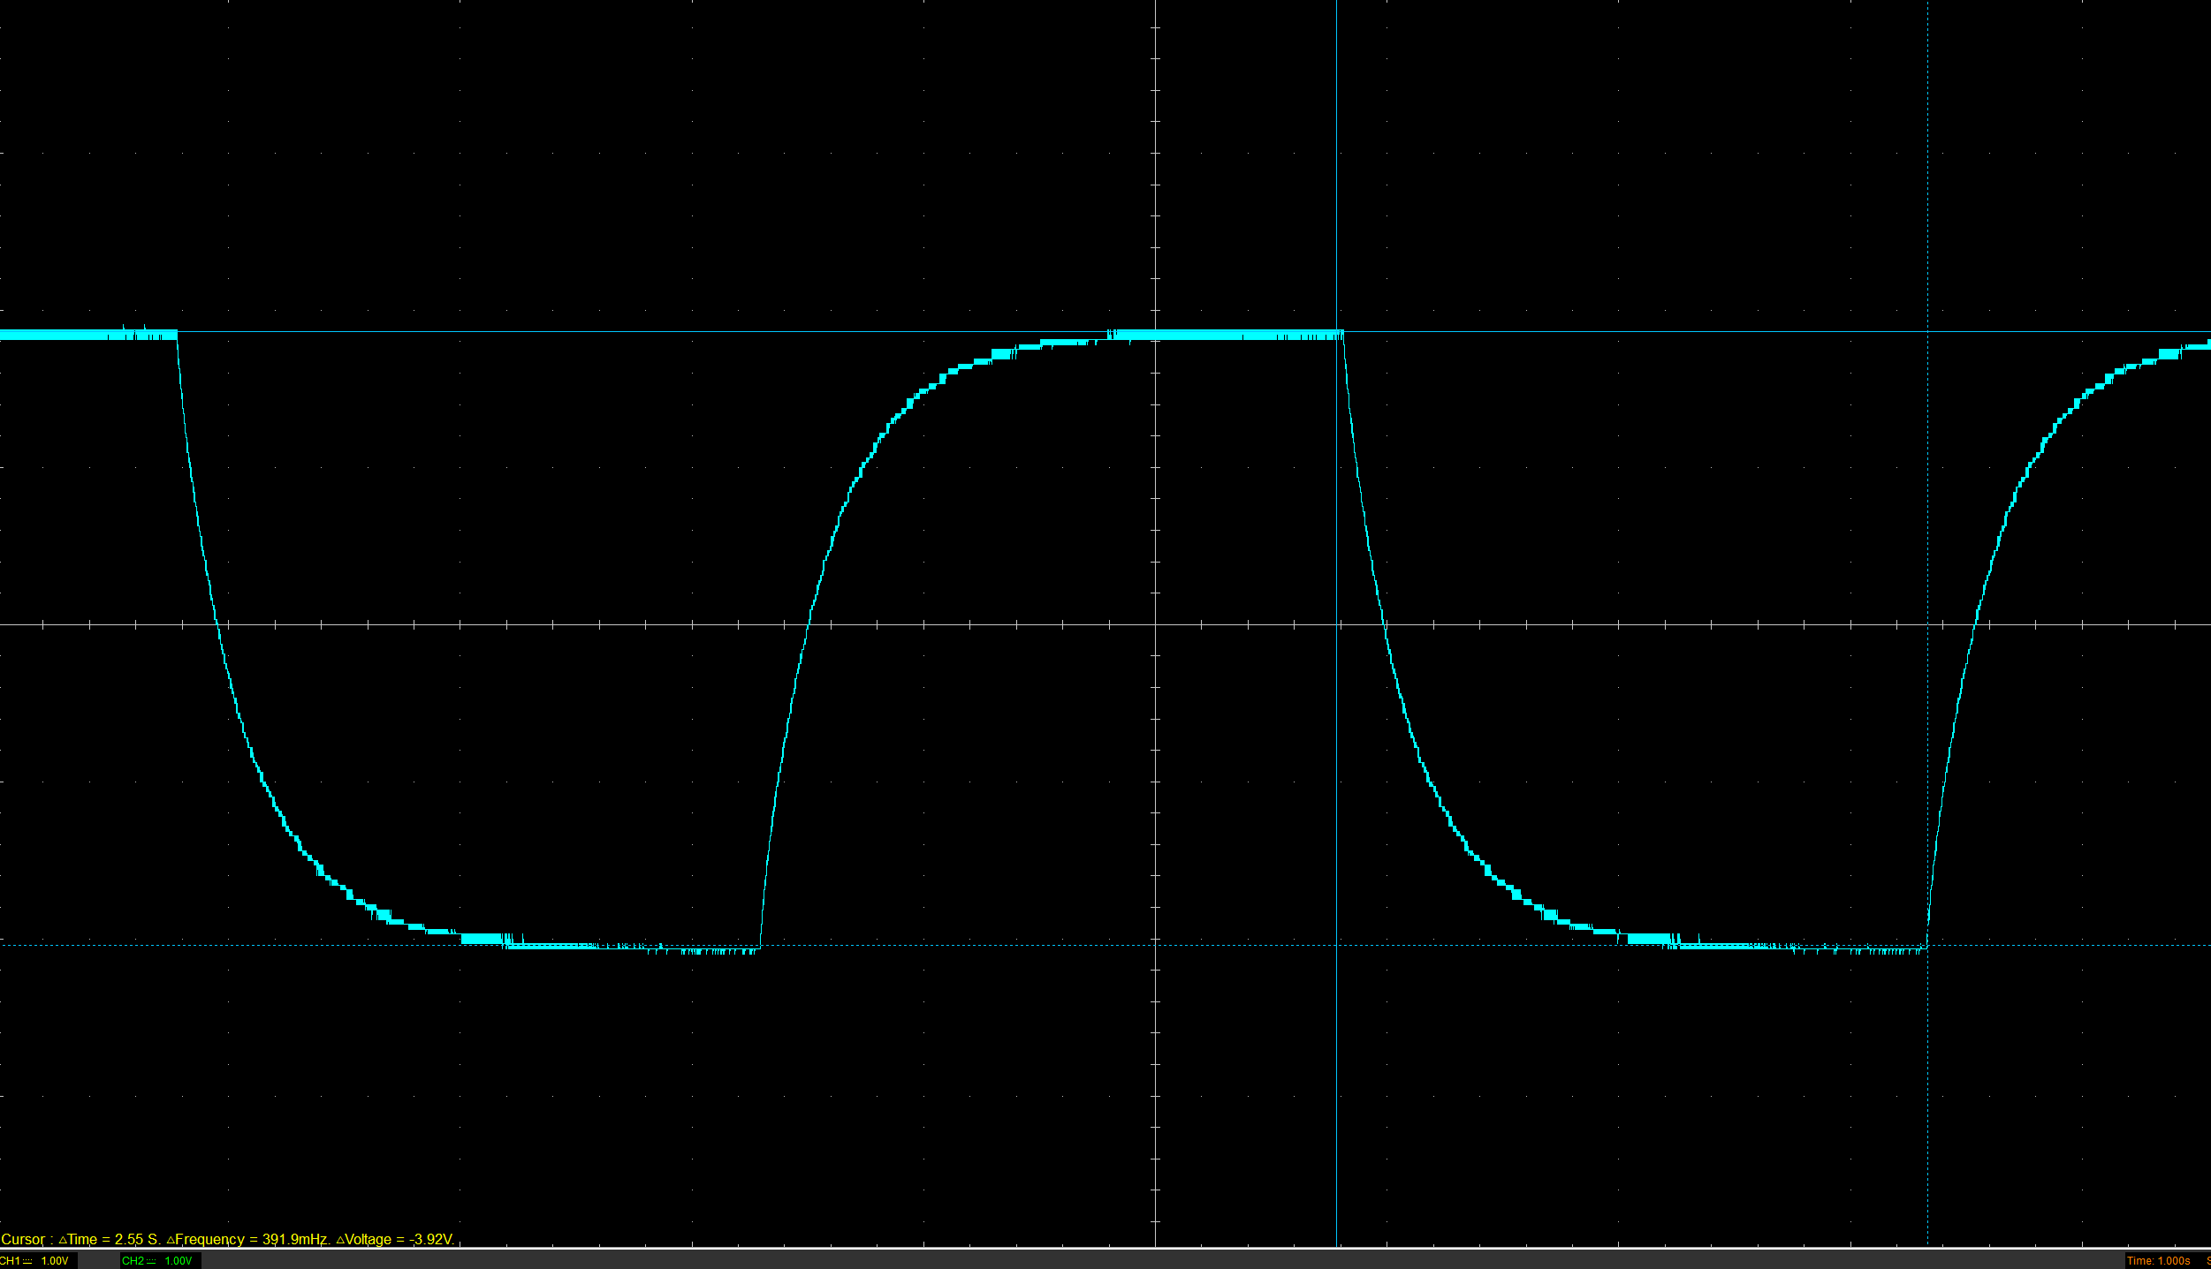

Basic Capacitor Calculations (3)
peak = 3.97v
Start = 2V
3.97 – 2 * 63.2% + 2 = 3.25v

Capacitor discharge table (4)
Time (s) | Voltage (V) | ln (V) | dy = y2 – y1  dy = ln(V)2-ln(V)1 | dx = x2- x1  dx = Time2 – Time1 | dy/dx
 |  |  | x | x | x

Gradient Plot and calculations (4)

Capacitor Uses (5)
Electrical applications :
- Filtering - Capacitors filter out unwanted signals meaning they remove noise and ripple from power supplies or blocking DC signals while allowing AC signals to pass.
- Timing - Capacitors can create time delays in electronic circuits by charging slowly through a resistor and then discharging rapidly.
- Coupling - Capacitors can couple two stages of an amplifier together, allowing AC signals to pass while blocking DC signals.

- Energy Storage - Capacitors store electrical energy, making them useful in power supplies to smooth out voltage fluctuations.
- Signal Processing - Capacitors are commonly used in audio and radio frequency circuits to tune resonant circuits and frequency response.
Automotive Applications:

6) Regenerative Braking Systems - Capacitors store energy from braking, which can then be used to power the vehicle. (Electricalvoice, 2023)

7) Power Conditioning - Capacitors stabilize electrical system output in vehicles, ensuring a steady supply of power to all components. (Electricalvoice, 2023)
8) Engine Downsizing - Capacitors assist in emissions reduction by providing a temporary power boost, allowing for smaller, more efficient engines. (Electricalvoice, 2023)

Motorcycle Applications:
9) Starting Engines - Capacitors provide a surge of current to start; helping the motor overcome the inertia of the load and get up to speed more quickly.
10) Lighting Systems - Capacitors power lights when the engine fails, ensuring safety and visibility. (Electricalvoice, 2023)

Inaccuracies Question (4)
In measurements, errors are inevitable because they are discrepancies between the actual and measured values.
Two types of errors exist: systematic and random. Systematic errors, also known as biases, are consistent variations in one direction. They often result from an imperfect calibration of devices or flawed observation methods. (Gurus, 2023)

On the other hand, random errors are unpredictable variations in readings. They vary from one measurement to another and are often caused by unpredictable fluctuations in the readings of a measurement device or in the users interpretation of the instrumental reading. While it’s impossible to completely eliminate these errors, understanding their sources and how to minimize them can enhance the precision and reliability of the taken measurements(Gurus, 2023)

References
Electricalvoice (2023) 'List of 25 Applications of Capacitors | Uses of Capacitors | ElectricalVoice,' Electricalvoice, 1 January. https://electricalvoice.com/applications-of-capacitors-uses/.
Problem with full wave rectifier when function generator is used as input (2006). https://www.edaboard.com/threads/problem-with-full-wave-rectifier-when-function-generator-is-used-as-input.73212/

Gurus, Q. (2023) 'Understanding measurement errors: types and how to minimize them,' Quality Gurus, 2 June. https://www.qualitygurus.com/understanding-measurement-errors-types-and-how-to-minimize-them/.
223 Physics Lab: The RC Circuit (no date). https://science.clemson.edu/physics/labs/labs/223/rc/index.html.

