Module Title – Contemporary Challenges – Making a Difference
Module Code - BMSP4008
Assignment Number – Personal Blog – Assignment 1
Name - Glyn Gainard
Student ID – 2114234
Word Count – Blog 1 – 461
Blog 2 – 472
Blog 3 – 433

Obesity and the threat it poses to human kind
Where do we go next?
Studies have shown that by 2035 the number of adults classed as overweight should start to decrease, however according to (Revels, Kumar, & Ben-Assuli, 2017) this will be due to a rise in obesity with a staggering 45% of the world’s population classed as obese.

Obesity around the world
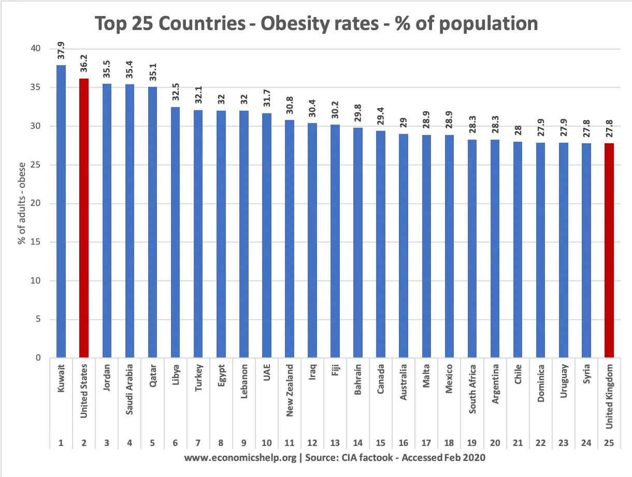

The above table by (Pettinger, 2020) shows the extend of the obesity epidemic and how its distributed across the world, based on percentage of population you can clearly see that there is a trend towards middle eastern countries (Rouhani, Mirseifinezhad, Omrani, Esmaillzadeh, & Azadbakht, 2012).

What can I do to make a change?
Personally if you are overweight or obsess its good to start with your diet, cut out high energy meals and increase your intake of fruits and vegetables, it is also suggested by (WHO, 2021) that we should take up more exercise with roughly 150 minutes a week being the recommended amount.

What can ‘they’ do?
The food industry needs to look at how it works, with more children than ever become obese there needs to be a global effort to reduce fat, sugar and salt content of foods, make the ‘healthy choice’ the affordable option and help to promote the participation in regular physical activity (WHO, 2021).

According to (Ryan, 2019) there are three main threats to humankind, these are Obesity, Undernutrition and Climate Change. Obesity is a very real problem for the world, with a third of the world’s population considered to be overweigh (Fox, 2017) it isn’t something that’s going away anytime soon.

What is Obesity?
There is a difference between being overweight and obese, to be classed as overweight you must have a BMI of 25 and above, however to be classed as obese your BMI must be over 30 (WHO, 2021).

Is this a new problem?
Obesity has been on the rise since the mid 1970’s, by 2016 the number of adults classed as obsess had tripled from 200 million in the 1970’s to over 650 million (WHO, 2021) that is equivalent to 13% of the global adult population being obese and a further 39% or 1.9 billion adults being classed as overweight (WHO, 2021).

What is the cause?
“traditionally” it is accepted that lack of exercise make you gain weight, however studies are starting to show that the food we eat is more to blame than the exercise we do (Fox, 2017). With ‘fast food’ being such a high source of saturated fats it can lead to a whole host of additional problems (Rouhani, Mirseifinezhad, Omrani, Esmaillzadeh, & Azadbakht, 2012). Although it’s clear that we are what we eat, inactivity is also a huge cause of obesity worldwide (WHO, 2021).

What skills will I need to be a Project Manager?
Project managers will need a range of skills, (Teamwork.com, n.d.) lists these as
- Communication
- Organisation
- Adaptability
- Empathy
- Unflappability
- Leadership

This is not an exhaustive list of the skills of a project manager, I feel that the most important skills from this are as follows

Communication
Good communication according to (Kissflow.com, 2021) is vital to the role of a project manager and they state that a study conducted in the UK finance industry showed failures in communication were the cause of 57% of the project failures. This is further backed up by (Teamwork.com, n.d.) who suggest that in a 2018 study 29% of projects failed due to poor communication skills.
Communication is more than just speaking, it is important to listen and offering both positive and negative feedback, it stated by (Teamwork.com, n.d.) that most people link feedback with career progression, so being able to communicate well and provide good quality feedback is a very important skill.

Leadership
Good leadership is subjective and depends heavily on the individual as much as the ‘leader’ (Teamwork.com, n.d.). To be a good leader it is vital to be able to communicate your ideas, be relatable, empathic and be able to manage both the good and bad bits of the project.
The best way to lead is to look at others, what do they do well, what do they do badly and to try and create a hybrid leadership style that can fit with my team (Kissflow.com, 2021).

There are many skills to be a good project manager and I hope this has given you and insight into my chosen field.

What skills do I need to be a Project Manager?

My current role is that of a Trainer and Project Co-ordinator for Carmarthenshire Citizens Advice, previously I have been a Trail Manager for a clinical trials unit. These are both roles I have enjoyed, going forward I would like to opportunity to focus on my Project Management skills.

What is Project Management?
According to (Miller, 2019) a project manager is responsible for any project from the point of ‘inception to completion’. The duties of a Project Manager vary depending on the industry, organisation and the project itself (Miller, 2019).

How important are Project Managers?
The role of a project manager has become more important over the last 20 years, in 2007 only 55% of organisation had a project manager and by 2027 it is estimated that 87.7 million people will work in a project management role worldwide (Miller, 2019).
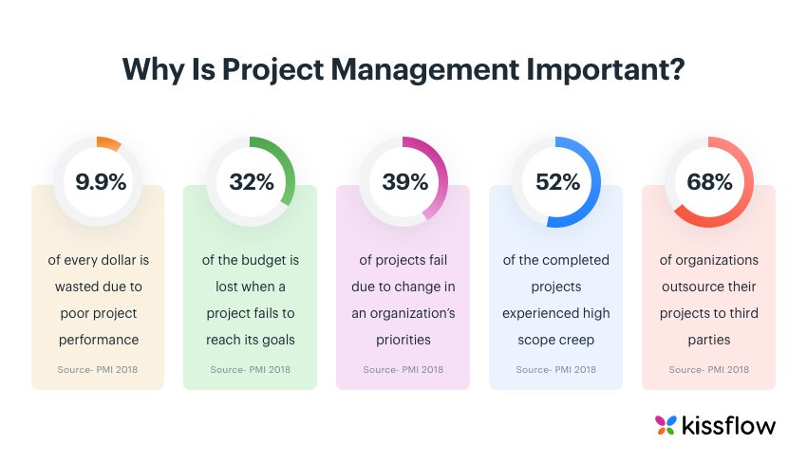The above table from (Kissflow.com, 2021) shows the importance of good project management, the table shows that 9.9% of the money spent on a project is lost through poor project management skills and 32% of a budget is lost if the project doesn’t meet its intended goals.
The 5 Stages
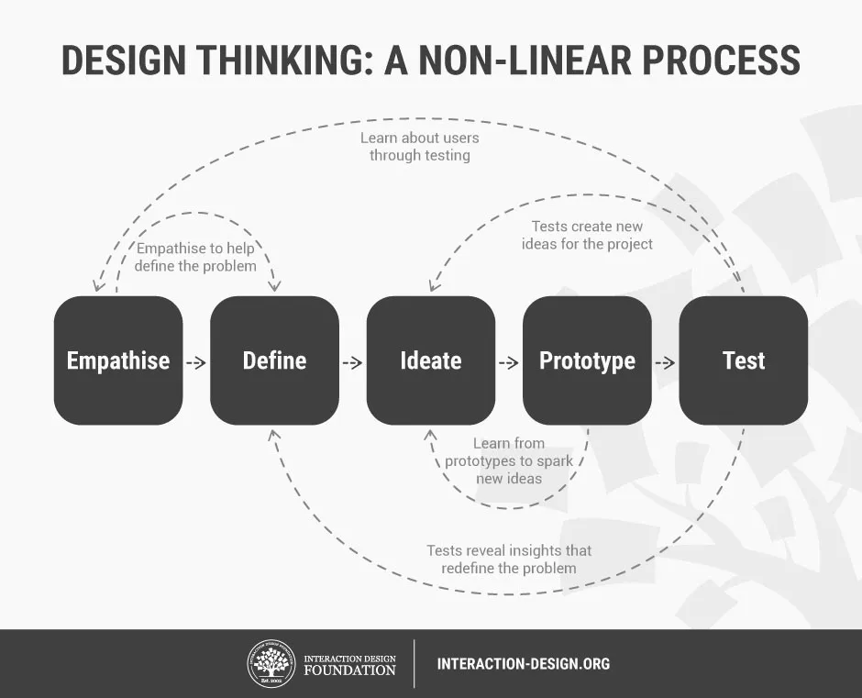
Stage 1 is all about understanding the team and what problems needs to be solved, Stage 2 is about using the findings from stage 1 to understand what barriers you might come up against. Stage 3 is when you start to look at potential solutions and then in Stage 4 is about experiment and creating something tangible that can then in Stage 5 be tested. As shown by (Dam, 2021) test isn’t always the final stage.

Design thinking in Business
Design thinking can be considered too structured and linear (Liedtka, 2018), however it is also suggested that when you are trying to change the way a team is run that additional structure can be vital.
More benefits of Design Thinking are it can reduce time-to-market, reduce costs and help to create a more innovative working environment (Stevens, 2021), however (Tsoi, 2021) suggests that the flaws of Design Thinking are that it needs the team to buy into it and commit, it is suggested that it can take longer than a more problem-based approach and there are limitations to the system.

Conclusion
In conclusion, Design Thinking is a fantastic concept that can create a innovation and reduce costs, however it must be implemented correctly for the team to fulfil their potential.
Design Thinking

What is Design Thinking?
According to (Dam, 2021) Design Thinking is way of interpreting a problem to find an alternative strategy to solve it. It is also considered to be a way of solving problems using a solutions-based system.
(Stevens, 2021) states that Design Thinking is

“an ideology and a process, concerned with solving complex problems in a highly user-centric way”

What is a solution-based thinking?
Solution-based thinking is a way focusing on the solutions of a problem rather than looking at potential obstacles or limitations (Stevens, 2021).

What are the Principles of Design Thinking?
Design Thinking is based on four main principles, these are (Stevens, 2021)

The Human Rule – mean that all design activity needs to focus on human centric point of view.

The Ambiguity Rule – You have to work to your own limits to see things differently

The Redesign Rule – We need to continually redesign the way we do things to be able to keep improving

The Tangibility Rule – Creating something that can be touch enable better communication of ideas.

How do we use Design Thinking?
According to (Dam, 2021) there are five steps in the design thinking process, this is not a linear system and you can easily jump steps or go backwards if the process requires it to be able to truly be solutions-based.

Reference List

