Rebecca Reynolds (1701301)
Intercultural communication

Key challenges of intercultural communication in China and Dubai

Table of Contents
1.Introduction 2
1.2. Cultural communication 2
2.China 2
2.1. An overview of China 2
2.2. Power distance 3
2.3. Individualist vs collectivist culture 3
2.4. Masculine vs Feminist Culture 4
2.5. Uncertainty avoidance index 4
2.6. Long term/ short term orientation 4
3.Business code and conducts in China 5
3.1. Greetings 5
3.2. Gifts and Business cards 5
3.3. Negotiations 5
3.4. Communication 5
4. An overview of Dubai. 6
4.1. Power distance 6
4.2. Individualistic v collectivist society 6
4.3. Masculine vs Feministic culture 7
4.4. Uncertainty avoidance 7
5. Business code and conducts in Dubai 8
5.1. Greetings 8
5.2. Dress code 8
5.3. Negotiations 8
5.4. Communication 9
6. Recommendations 10
7. Conclusion 10

1.Introduction
This briefing paper highlights the cultural challenges for the approaching business trip to China and Dubai. This report will firstly discuss Hofstede’s five dimensions in reference to China and Dubai in and will also compare this with America whilst showing how this relates to business. Secondly, the business code of conduct will be discussed between the two countries. This report will also offer recommendations to the head of marketing of TBG Tours Ltd to ensure success ahead of business congregation.

1.2. Cultural communication
Cultural differences are evident in the cultural identity of humans. Cultural identity can have an effect on people’s behaviour including one’s values. According to Thomas and Peterson (2018), culture conveys the interaction of values, perspectives and behavioural presumptions of a society. The importance of intercultural communication outlined by Bahang (2018) highlights that the contacts made with others in the business world have increased dramatically. However, there are differences in intercultural communication such as the differences in language, values and in the way in which cultures communicate. The belief that one set of cultural norms are more superior to those from other cultures is not uncommon. This is called ethnocentrism. Geert Hofstede investigated cultural differences based on six cultural dimensions which represent individualistic predilection from one state of affairs over another which differentiate countries from one another.

2.China

2.1. An overview of China
China is the world’s third largest country and has the highest population in the world with 1.4 billion people (United States census 2018). There is a major overcrowding issue and tourists should be aware of the lack of personal space. According to Brown (2013), the Chinese language has maintained its standing within Chinese culture for over four thousand years and remains central to the Chinese identity today.
Hofstede’s cultural dimension related to business

2.2. Power distance

According to Hofstede and G-J Hofstede (2005), power distance can be defined as members of society or organisations that accept that there is an uneven distribution of power. The Americans are lower on the PDI dimension as they believe that everyone is equal in the work place. However, China sits substantially higher on the PDI scale as seen on figure 1. The Chinese acknowledge that hierarchy is very significant in an organisation. The unequal distribution in power is common and approved in the Chinese culture and has a momentous conclusion for individuals and organisational practices as highlighted in Yao (2014).

2.3. Individualist vs collectivist culture

As studied by Hofstede, China is a collectivist country as they place great importance on assurance and value of building relationships in business. A component to a successful negotiation in doing business in China is relationship building. Although, Moran et al (2014) claims that actually the Chinese aversion of collectivism is due to years of communist reign compelling social groups. In the United States, organisations conduct business according to their own interests (Hofstede, 2005). Individualism is treated as egoistic in China (Lu, 2003) and is considered an undesirable way to operate both within personal and business circles. This could result in conflicts when working together as it is not considered a very good way to operate (Khan 2014). According to Haley, Valey, & Tan (2004) cited in Mingyu Li, when conducting business with Chinese organisations, there needs to be crafting and maturity in gaining a strong personal relationship between American and Chinese mangers.

2.4. Masculine vs Feminist Culture
In terms of business, China is a success orientated country and will therefore want to achieve success. Business comes first, therefore the Chinese will sacrifice their own leisure and families to achieve the best possible outcome (Hofstede, 2018). Both China and America want the best results in business and therefore will be rewarded for the equity.

2.5. Uncertainty avoidance index

The dimension uncertainty avoidance (UAI) relates to how society deals with factors that are not known yet. China received a low score in uncertainty avoidance just like the Americans (Figure 1). From the website Hofstede insights (2018), scoring low in UAI suggest that countries have a more relaxed approach in negotiation in meetings which practice counts extra than principles.

2.6. Long term/ short term orientation

In Hofstede’s fifth dimension, long term orientation refers to the encouragement of integrity position towards future rewards. As opposed to the Chinese, the American scored low as they tend to analyse new information to check if it is true or false (Jawad, C, 2018). According to Hofstede cited in Usunier et al (2017), short term orientation relates to the past and the present such as social obligations. As shown in Figure 1, China scores highly in this dimension which indicates its pragmatic culture. The Chinese focus on job security and stability and long-term business goals highlighted by Yao (2014).
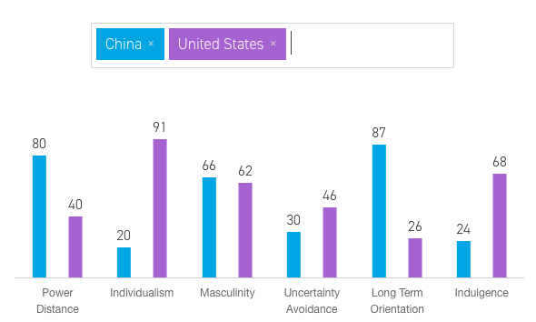
China and America
Figure 1. Source: Hofstede-insights.com

3.Business code and conducts in China

3.1. Greetings
Prior to a business meeting, Chinese business leaders will want to know who to address first before entering the meeting room as this is considered to be respectful. Punctuality is very important, being late to a meeting is seen as rude and meetings will begin on time. The Chinese tend to bow rather than shake hands as it is seen as more appropriate (Gestland 2002). To address the business attendee, surnames and titles are used as it is portrayed to be disrespectful if not to do so. Compared with America, formal titles in China are more typical. Addressing people by official titles is preferred in China according to Xuan (2010).

3.2. Gifts and Business cards
At the start of meetings, business cards are exchanged. Gifts are also common for business protocol; in America this has negative connotations (Dumbravă, 2010).

3.3. Negotiations
In China, negotiations tend to be ‘face to face’ and take a long period of time. Before the meeting, there needs to be a clear negotiating strategy (Perkowski 2011). The American negotiating style is straight forward and informal (Shippey,1995). In America, the value of transaction comes first, and relationships are formed more freely according to Thomas and Peterson (2018). The Chinese tend to business with well-known business organisations. The Chinese term Guanxi refers to social networks and the commitment to relationships which assists with business deals (Moran et al, 2014).

3.4. Communication
According to Hall theory, Low and High context culture alters through the way messages are transmitted. In low context cultures, messages need to be precise of the spoken or written word, as opposed to high context cultures, when the communication is where the information is physical or to accept the idea in person (Thompson and Peterson,2018). The Chinese High-context culture places more attention to body language. Frost (2013) suggests that high context countries can be seen as vague and blunt which can be misunderstanding for a low context culture. Similarly, Dubai also puts emphasis on non-verbal communication and relationships. Nollen (1984) highlights that seventy percent of communication between people in similar language class is non-verbal. Therefore, this shows how this method of communication can add meaning to verbal messages.

4. An overview of Dubai.
Dubai is situated on the Eastern coast of the Arabian Peninsula, in the south west corner of the Arabian Gulf (Dubai, G 2018). Dubai is the second largest emirate in the UAE. Dubai has a developing business section and is full of cultural heritage.
Hofstede’s cultural dimensions related to business

4.1. Power distance
All three countries sit high on the PDI score. As seen in figure 3, Dubai sits high on this dimension which demonstrates that people accept hierarchy order where everyone has a place within the organisation. Hierarchy in organisations shows the importance of reflecting inherit equalities with subordinates preferring to be told what to do by the manager who has the authority (Bouazzi & Lawal, 2018). Joiner et al (2007) retain that the principles in Confucius of interpersonal relationships underpin the importance of the subordinate’s dependence of their superiors (Khan, 2014).

4.2. Individualistic v collectivist society
For the American, the country is one of the most individualist cultures in the world. Managers rely on their employees for their skills and help with information (Jawad, C, 2018). The United Arab Emirates scored 25 in this dimension which therefore evidences that the society is collectivist. Collectivism, as the opposite to individualism, implies that Dubai places great significance on building cohesive, strong groups in exchange for loyalty. This is similar in approach to that within Chinese society.
4.3. Masculine vs Feministic culture
As seen on figure 3, there are differences between America and UAE in this dimension. Masculinity and femininity refer to the extent that male orientation of the emphasis on ambition and achievement compared to the traditional female orientation is emphasised on the importance of caring for quality of life (Peterson & Thomas, 2018). With a score of 50, it cannot be considered a masculine or feminine society. Whereas America strive for success and their achievements in life.

4.4. Uncertainty avoidance
United Arab Emirates has a high preference for avoiding uncertainty with a score displayed on figure 2. The Arab Emirate culture is clearly opposite to the relaxed American approach as this culture has an emotional need for rules and will follow these in business. This will impact the American behaviour and will let them be open to new business ideas and concepts (Jawad, C, 2018). Countries that display high UA continue adamant codes of belief that are not tolerant to different behaviours and concepts (Hofstede et al., 2010).
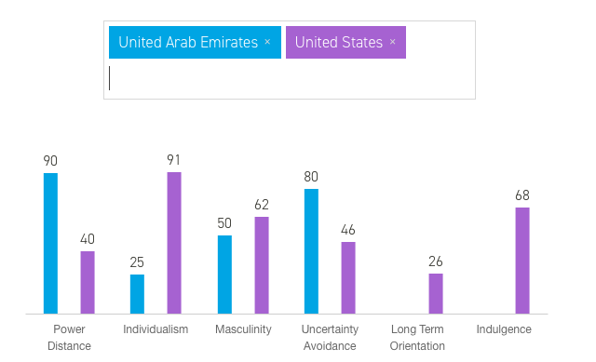
Figure 2. Source: Hofstede-insights.com Dubai and America

5. Business code and conducts in Dubai

5.1. Greetings

When entering for a meeting, general introductions will begin with a gentle handshake and eye contact. An important feature in introductions of Arab hospitality is to be offered tea or coffee and it is impolite not to accept this (Gesteland,2005). In the Arab culture, people and relationships are seen as more important than time. It is important to be informed that you may well be kept waiting. In America, time is seen as money in business whereas in the Arab culture the importance of relationship building takes precedent. Usually, People are addressed as Mister Manssur, Sheikh Hamad or Prince Said followed by their name.

5.2. Dress code
In Dubai, if you are going to visit a public place, knees and chest should be covered. For meetings, dress code for men is typically a suit and tie. Quality accessories can be worn to enhance status. For women, loose-fitting and modest clothing can be worn (Gesteland,2005).

5.3. Negotiations
In the United Arab Emirates, before starting negotiations personal connections and references are fundamental in order to receive the first interview. Other ways to get an interview is via client and social relations (Jawad, 2018). Decisions tend to take time, so press hard for a brief outcome and accommodate expectations suitably. Once everything is confirmed, make sure everything is written down to avoid misunderstanding (Gesteland,2005). It is also important to keep in contact with your business partners.

5.4. Communication
Most Arabs involved in foreign business can speak fluent English. Though, be inclined to employ an interpreter. Developing personal relationships is crucial and similarities can be seen with the way in which the Chinese conduct business. However, in the United States this is disapproved as personal life should be kept private. Always begin with a verbal outline of your message and always be an active listener. Gallois and Callan (1997) support that many Americans speak much more directly than Arabs. In the United States, effective verbal communication is expected to be direct and straightforward (Thomas & Peterson, 2018) Also, stated by Gesteland (2005) in the Muslim culture, the left hand is treated as unclean.
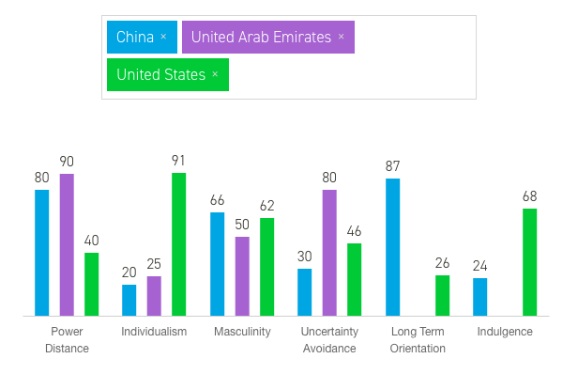
Figure 3. Source: Hofstede-insights.com

6. Recommendations
Recommendations for this upcoming business trip are designed to solve the barriers between representatives from each country with the aim of preventing intercultural clashes. A mistake as simple as performing the wrong hand gesture could result in serious problems for business relationships and this highlights the importance of sound intercultural knowledge. Consistently use your right hand when dining and passing objects over such as exchanging business cards.
The main barrier is language between the two cultures. The way to overcome the issues is to bring a translator and to educate the American before travelling. There are recommendations outlined throughout the report to avoid any misunderstanding for the upcoming business trip. Therefore, for the American travelling to China, it is advised that you show respect for the Chinese superiors without defence against their abuse of power.

7. Conclusion
The cultural differences that are outlined in this report between China and Dubai will guide the head of marketing on how best to prepare for the upcoming business trip. The important information regarding how to adjust to the cultural differences in these two countries will determine the success in the business deal.
8. References
Bahang, M. Dahlan, 2018. Professional Role of Tour Guides and Theoretical Consequences of Intercultural Communication. Journal of Language Teaching & Research, 9(4), pp.832–840.
Bouazzi, C. & Lawal, S.N., (2018). Building Trust in a Cross-Cultural Context: The National Investor in United Arab Emirates and Egypt.
Brown, K. (2013)., Contemporary China (Contemporary states and societies). Basingstoke: Palgrave Macmillan.
Daily, S., (2017). How to succeed in China: Learn the culture. Shanghai Daily, pp.Shanghai Daily, 2017–11-26.
Daily, S., (2017). Pathways to successful business negotiations in China. (2017). Shanghai Daily, pp. Shanghai Daily, 2017-12-09.
Dumbravă, G., (2010). the concept of framing in cross-cultural business communication. Annals of the University of petsrosani: Economics, (1), pp.83-90.
Frost, A (2013). High context and low context culures. Available: http://restaurantkyoto.dk/blog/en/high-context-and-low-context-cultures/ Accessed: (21.11.18)
Gesteland, R.R., (2005). Cross-Cultural Business Behaviour : Negotiating, Selling, Sourcing and Managing Across Cultures (4th ed), Frederiksberg, Copenhagen, DNK: Copenhagen Business School Press.
Government of Dubai.ae ‘ Dubai’ [Online]. Available: http://www.dubai.ae/en/aboutdubai/Pages/default.aspx (Accessed:20.11.18).
Hofstede insights.com (2018) ‘Hofsted insights’ [Online]. Available : https://www.hofstede-insights.com/models/national-culture/ (Accessed 20.11.18).
Hofstede, G., Hofstede, G., & Minkov, M. (2010). Cultures and Organizations, Software of the mind. Intercultural Cooperation and Its Importance for survival. Netherlands, Europe: McGraw Hill.
Hofstede, G., & Hofstede, Gert Jan. (2005). Cultures and organizations : Software of the mind. New York ; London: McGraw-Hill.
Jawad, C., (2018) Intercultural communication M5X02108, Intercultural communication. University of Wales Trinity St.davids.
Khan, A., (2014). Effects of cultural assimilation on the performance of a construction project - evidence from UAE. Benchmarking, 21(3), pp.430–449.
Mingyu Li., (2016). Considering Chinese philosophy, business, and western education. Allied Academies International Conference: Proceedings of the Academy of Strategic Management (ASM), 15(2), 41-47.
Moran, T.R., Abramson, N.R., Moran, S.V., (2014) Managing Cultural Differences. (9th ed). London and New York: Routledge.
Perkowski, J., (2011). Negotiating in China: 10 rules for success. Available: https://www.forbes.com/sites/jackperkowski/2011/03/28/negotiating-in-china-10-rules-for-success/ (Accessed: (17.11.18).
Shippey, C-S., (1995) USA Business: The Portable Encyclopedia for Doing Business with the United States: World trade press. Available : https://books.google.co.uk/books?id=EHLUyBTpPxgC&printsec=frontcover&source=gbs_atb#v=onepage&q&f=false (Accessed:21.11.18)
Thomas, D., & Peterson, M. (2018). Cross-cultural management : Essential concepts (4th ed, International student ed.). London: SAGE Publications, inc.
Thompson, V. "American Vs. Chinese Business Culture." Small Business - Chron.com, http://smallbusiness.chron.com/american-vs-chinese-business-culture-59039.html. (Accessed 18 November 2018.)
United States census.gov (2018) [Online]. Available: https://www.census.gov/popclock/world/ch (Accessed: 21.11.18)
Usunier, J., Van Herk, H., & Lee, J. (2017). International and cross-cultural business research: London:Sage Ltd

Xuan Liu., (2010). Study on Addressing Terms and Relevant Culture in America and China. Journal of Language Teaching & Research, 1(5), pp.753–757.
Yao, Christian,. (2014). The impact of cultural dimensions on Chinese expatriates' career capital. International Journal of Human Resource Management, 25(5), 609-631.

