  Figure 1 https://goo.gl/VyiB3b  Synthesize a Solution to a Potential Real-Life Scenario  Edward Patch (1801492) | Abstract  The background of the report will analyse and mention any security issues with the BYOD (Bring Your Own Device) scheme that a company called Hyper-fort offers. This scheme enables staff and clients to bring their own devices such as, mobile phones, laptops and tablets.  The company offers this scheme to allow employees to access the internet to make any payments for services like services, email, blogging, social interaction, shopping, entertainment, research and a lot more.  Dr Carlene Campbell  Internet Technology and Security (ACCA4018)

Table of Contents
Introduction 2
Related Work 2
Literature Review Focus 2
Software Developer 2
Problem Formulation 3
Investigation and Implementation 3
Security Issues 3
Implementation 7
Results and Discussions 7
Results 7
Discussions 7
Recommendations 7
Conclusion 7
Appendices 8
Related Work 8
Research Aspect 8
References 8
Bibliography 10

Introduction
This report will exploit any security issues and mention any potential solutions or alternatives to fix these problems. There will be a list of recommended guidelines to help keep Hyper-fort safe from any potential threats or attacks.

Related Work
For further information refer to Related Work [Page 8]. [1] The security issues based on the BYOD scheme shows that the employee’s device may have potential security threats such as a virus, which could pose a threat on the data shared to the user. The employee may use public networks, which makes the data stored on or shared to the device may be compromised. The employee may lose their phone meaning that there is a risk of that data being stolen or used.
[2] Suggestions such as Office 365 or other cloud-based software was mentioned. Office 365 links it’s cloud service directly to the Microsoft program. This makes it easier to track and control where the data goes. The software enables admin access to delete data on a certain device. For example, if an employee loses their device, they can notify their place of work and the IT administrator team can back up data and remove files off their lost device (only if there was internet access to the device).
This helps with securing data and prevents any data loss. The employee will have time to change any passwords and set up their new device before retrieving the files again.
Lucía Alvargonzález [3] mentions that bring your own device increases staff and clients ‘productivity, satisfaction, reduces the time spent and saves money.’ The author also mentions that the biggest con of bringing your device is the security aspect.

Literature Review Focus

Software Developer
Companies that create software would think twice before using a BYOD (Bring your own Device) scheme. This is due to the security factor of BYOD. However, BYOD gives a software engineer a chance to work on a project in their own time creating software quickly, which saves time and money. If the software were to be lost or stolen on the employees’ device, then the company would have lost their product, wasting time and money. This mean companies like Google would have to take precautions when sharing data to employees and clients.

[4] Google has used a hierarchy permission system to limit the risk of their products. The hierarchy system enables Google to control what information can be shared with an employee’s device. They use four levels in the hierarchy system, which are:
  - Untrusted – No Google data or corporate services are shared.
  - Basic Access – Services that are not confidential or have high importance.
  - Privileged Access – Services that are confidential and have high importance.
  - Highly Privileged Access – Access to all services.
By using this system, it will make sure that if an employees’ or clients’ device was intercepted, the information lost would not be a big loss to the company.
Software companies may share data with employees or client’s devices by using online tools. Using online tools enables companies to control the content and permissions of the data they share. For example, if an employee’s device went missing, the employee can report it then the company can change the file sharing permissions to stop sharing to that individual. The files should then be removed from the device.
Sometimes the device may not sync to a cloud service due to no internet access or other reasons. To prevent unwanted access to the information, the data could be encrypted with an AES Encryption Key preventing any information from being leaked.

Problem Formulation

Investigation and Implementation

Security Issues
The BYOD (bring your own device) scheme would create problems like data loss and leakages, insecure access, malicious applications or rogue applications and exposure. The points below will display any potential issues that could arise.

Data
Data control is vital in Hyper-Fort, especially when sharing data to their employees and client’s devices. Employees that have access to data, also have the ability to lose the data shared to them, which could mean that the data can get into the wrong hands. For example, a similar company to Hyper-Fort could gain access to the lost data, which then it will let their competition become one step ahead. Hyper-Fort would suffer a backlash if an incident like this were to happen.

Having enough data control over employees’ devices would help prevent anything like this to happen. Simply, Hyper-Fort would be able to delete any information of the employees’ lost device. Although, the device may not have internet access meaning the data would not be removed from the device. This takes most of the control away from Hyper-Fort.
Encryption can be added to the data files shared to employees’ devices using AES encryption. That means if the employees’ device was to go missing, the user who gains access to the device would find it hard to read the data.

Insecure Access
Hyper-Fort would like their clients and employees’ to be able to connect their own devices to the companies’ network. This creates a new security risk as both employees and clients would have potential access to the main network.

WIFI Passwords
In order to prevent any insecure or unwanted access, it is best to create a few extra access points. By doing this, the clients won’t be able to connect to the employee’s devices and vice versa. Access points should be set up with WPA2-Enterprise encryption, to prevent any hackers from being able to use tools such as password crackers or wireless network sniffers to gain access to the network. This would enable employee devices to be connected via a username and password.

WPA2 Encryption Method
[5] WPA2 uses AES (Advanced Encryption Standard) procedures and CCMP (Count Cipher Mode with Block-Chaining Message Authentication Protocol). These encryption methods improve security for both home users and business users. The WPA2 password encryption offers two modes.
PSK (Pre-Shared Key) mode protects home Wi-Fi networks. Users can connect to the network using the SSID and a password. The password is encrypted with AES.
Enterprise mode protects organisations by using a username and a password. There are multiple usernames and passwords created for different users. This helps protects the network from being accessed by unauthorised users.

WPA2 Authentication
Although there are other Wi-Fi encryption options like [6] Wired Equivalent Privacy, WEP, Wi-Fi Protected Access or WPA. WPA2 offers better password encryption, to prevent nearby devices from brute forcing a potential password to gain access. WPA2-Enterprise encryption will allow devices to log in to the network automatically if the Windows user account credentials match up. This would work well with Hyper-Fort’s BYOD policy, as workers will be able to log onto the network stress-free.

Exec and Config Passwords
Any routers or switches on the Hyper-Fort network would have internal passwords to prevent users from switching to EXEC or Config mode. Adding a MOTD (Message of the Day) banner is required to state that if a user unauthorised got passed that point, they will be liable in court. This is to make sure that any potential intruder won’t get away with it if court.
The EXEC or Config mode on any router or switch enables the user to have different access to the router. EXEC will enable the user to [7] view basic information with the switch/router and be able to communicate with other devices on the network. Whereas Config will let the user change how the switch or router works to their advantage, for example, they could close important ports or open others that give the user control of what devices can be connected to the network.

Malicious Applications
Malicious applications are found on many devices downloaded from many parts of the internet. Application stores, adult sites and other areas of the internet can make the device vulnerable to most malicious applications. Even innocent emails or SMS’s etc. can include malware applications. [8] Urmee Khan from the Telegraph reported that:
“12 million people have had their computer affected by a virus, hacker, malware or spyware in the past month.”
These types of applications are found on all different type of devices and platforms. Malware is designed to spread from device to other devices. This can be done by infecting devices on the local area network.

Types of Malware
[9] Malware can use any form such as trojans, ransomware and spyware etc. Malware is created to steal data, documents and/or add new software without the user’s permission.

Trojan Horse
A trojan horse is created to look like a genuine piece of software. Underneath the interface, it is secretly in control of your computer. They can be designed to deliberately steal, damage or disrupt. Trojan horses can have the ability to control other devices on a network meaning that any data stored in the network will be vulnerable.
Hyper-Fort would need to be careful when letting employers and clients bring their own device. If an employee’s or client’s device contained a trojan horse then the company’s data would possibly be compromised, as well as other employees and clients that use the network. This would potentially fall under the Data Protection Act 1998.

Ransomware
Ransomware is a type of malware. It is designed to restrict user access from there device. The malware usually encrypts user files which is hard to decrypt. The malware can be downloaded or even transferred through a vulnerable network service.
This type of malware will normally demand money in return for access to your files and full control to the device. Although some cases, the intruders will take the money and leave the device in the same state.

Staff and Client Security

Staff
Offering or recommending staff an antivirus system will help reduce the malware the device might gain. Staff can be trained on the dangers and how to prevent them when using their own devices that affect both themselves and others.
Hyper-Fort may want to use cloud services like Office365 or similar online based software, to control their software. Using cloud services will mean that devices that are located in Hyper-Fort offices won’t need a high volume of storage space. The staff members would access their user files on the cloud. Cloud services offer admin access which gives Hyper-Fort total control over the information they share over to their staff members. Services like Office365 offer security for both the company and the companies’ users.
When creating access points, it is important that Hyper-Fort uses WPA2-Enterprise for their staff members. This allows them to log in to the network using their credentials. These credentials can be reset by a tool called Microsoft Identity Manager. This will change the member of staff’s Microsoft services password and the credentials to their work account.

Client
Make sure the access point for the clients is isolated away from the staffs and company network. This is done by added another router or switch, then an access point attached to it. This is to prevent clients from connecting to client’s devices and vice versa.
The access point security could be set to public (with online authorisation) or private with WPA2-Encryption. When setting the access point to the public, it is important to keep in mind that other users that are nearby the access points, can communicate to Hyper-Fort’s clients, which are connected to the access point.

Exposure
Having no security in places such as firewalls, anti-virus or password protection, Hyper-Fort will be open to any malware. If anything like this would happen, then Hyper-Fort’s data will be exposed. This could mean things like crucial project data, bank details, personal information of employee’s and clients could be leaked on to the World Wide Web.

Implementation
Below shows a diagram of how Hyper-Fort’s network should be set up:
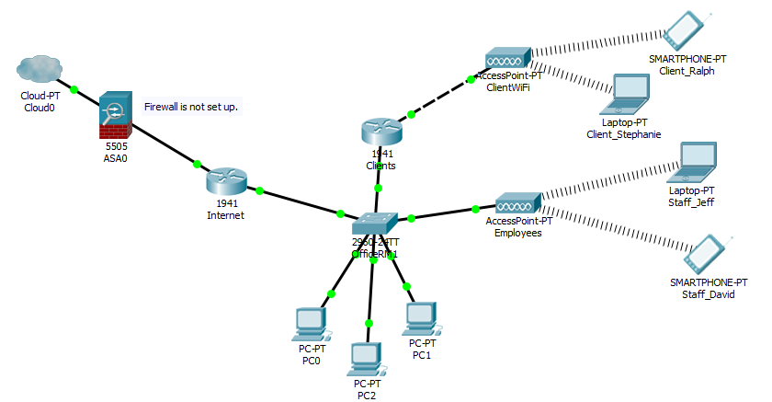
The screenshot below shows that there are an internal password and banner used on the routers and switches to prevent unauthorised users from accessing the EXEC and Config mode of the switches and routers in the network. The MOTD (Message of the Day) banner below states that any unauthorised access would be prosecuted. This means if a hacker would penetrate Hyper-Fort’s network, then they would be allowed to be prosecuted.
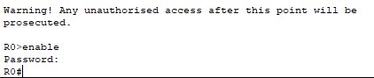

The screenshot below shows s the access points are set up with WPA2-Personal encryption on the Client’s access point. However, for a better and safer network, the Client’s access point could use a WPA2-Enterprise giving each client an identity.
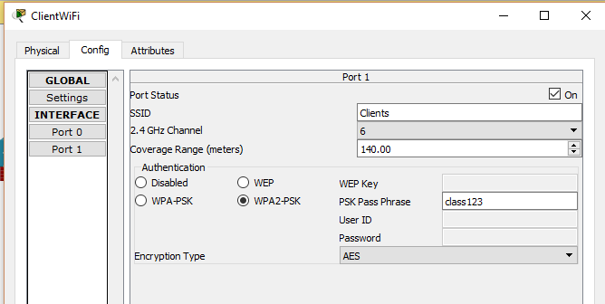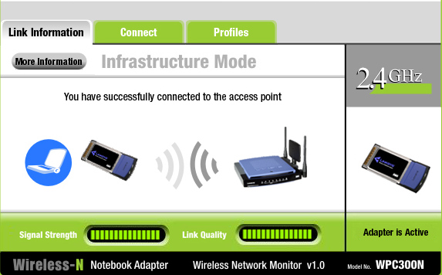

Results and Discussions

Results
The research used in this report has indicated what advantages and disadvantages the BYOD scheme offers. The bullet points below briefly mention the key points the research helped covered.
(Research that wasn’t referenced is found on Bibliography (Page: 10)
- Security Issues (References: Business [5], Dell [1], TechoPedia [9] )
  - Malware
  - WiFi Hacking
  - Router/Switch Hacking
- Management Tools (References: N. Kladakis [2] )
  - Office 365

Discussions
The issues and solutions raised have helped develop security aspects that Hyper-Fort would have to consider. The research that is included in the report has mentioned BYOD management tools like Office 365 and other cloud tools that will help Hyper-Fort control and share their data.
Security research explains the different types of malware, WiFi hacking tools, WiFi encryption types and their advantages. This research enables the ability to suggest ideas to create a better and safer network for both clients and employees of Hyper-Fort.

Conclusion
This report has suggested tools and other ideas based on related work to help Hyper-Fort create their BYOD policy to work effectively and safely without causing financial, data and other issues down the line. It provides security issues like malware, data loss and unauthorised network access.

Appendices

Related Work

Research Aspect

Security
Dell [1] mentions that the BYOD scheme is getting popular as it creates a better workflow but there are many security issues that arise like data loss, viruses, and malware. Employees are allowed to bring in their devices, which could be riddled with viruses, malware or other types of security threats. This means any organisation data that are shared and stored to the employee’s device could be vulnerable.
This data may become vulnerable if an employee uses a public network to access their work files. Public networks are known to lack security and the organisation data shared to the employee would be at risk.
Employees devices can be lost or stolen. Any work data that was stored to the device would be unsafe.

References
[1] | Dell, “Bring Your Own Device (BYOD) and its affect on data security.,” Dell UK, 6 November 2014. [Online]. Available: https://www.youtube.com/watch?v=WmR6YkZ_w1w. [Accessed 18 November 2018].
[2] | N. Kladakis, “Beyond MDM — How to protect your data with BYOD and SaaS implemented,” Microsoft Mechanics, 19 August 2015. [Online]. Available: https://www.youtube.com/watch?v=_X3-LEYc8Y8. [Accessed 18 November 2018].
[3] | L. Alvargonzález, “BYOD - Bring Your Own Device,” Lucia A.A., 19 January 2016. [Online]. Available: https://www.youtube.com/watch?v=bRSoq0IeYXQ. [Accessed 18 November 2018].
[4] | P. Hoelscher, “BYOD Security: What are the risks and how can they be mitigated?,” CompariTech, 5 November 2017. [Online]. Available: https://www.comparitech.com/blog/information-security/byod-security-risks/#Google. [Accessed 3 December 2018].
[5] | Business, “Wireless Security In The Enterprise: Deploying WPA2-Enterprise,” 11 July 2018. [Online]. Available: https://www.business.com/articles/deploying-wpa2-enterprise-encryption/. [Accessed 16 December 2018].
[6] | K. Lee, “What is WPA2 Encryption?,” It Still Works, [Online]. Available: https://itstillworks.com/wpa2-encryption-2469.html. [Accessed 16 December 2018].
[7] | E. Tetz, “Cisco Networking: User EXEC Operating Mode,” Dummies, [Online]. Available: https://www.dummies.com/programming/networking/cisco/cisco-networking-user-exec-operating-mode/. [Accessed 16 December 2018].
[8] | D. a. M. C. Urmeee Khan, “12 million people suffered a computer virus attack in the last six months,” Telegraph, 13 May 2009. [Online]. Available: https://www.telegraph.co.uk/technology/news/5317908/12-million-people-suffered-a-computer-virus-attack-in-the-last-six-months.html. [Accessed 17 December 2018].
[9] | TechoPedia, “Malicious Software (Malware),” TechoPedia, [Online]. Available: https://www.techopedia.com/definition/4015/malicious-software-malware. [Accessed 17 December 2018].

Bibliography
P. Hoelscher, “BYOD security: What are the risks and how can they be mitigated?,” CompariTech, 5 November 2017. [Online]. Available: https://www.comparitech.com/blog/information-security/byod-security-risks/. [Accessed 10 November 2018].
B. MacInnes, “Tools for BYOD Success,” MicroScope, no date. [Online]. Available: https://www.computerweekly.com/microscope/feature/Tools-for-BYOD-success. [Accessed 18 November 2018].
Technavio, “Top 21 Company in the BYOD Market,” Infiniti Research Limited, 19 March 2015. [Online]. Available: https://www.technavio.com/blog/top-21-companies-in-the-byod-market. [Accessed 2 December 2018].
P. Shankdhar, “20 Popular Wireless Hacking Tools,” INFOsSEC INSTITUTE, 20 March 2018. [Online]. Available: https://resources.infosecinstitute.com/20-popular-wireless-hacking-tools-updated-for-2016/. [Accessed 16 December 2018].
J. Desert, “How Google for Work Makes your BYOD Policy Simples,” 28 August 2015. [Online]. Available: https://www.cloudsolutions.co.uk/news/how-google-for-work-makes-your-byod-policy-simple/. [Accessed 2 December 2018].
BullGuard, “Android malicious apps – Mobile Security - BullGuard,” BullGuard, [Online]. Available: https://www.bullguard.com/bullguard-security-center/mobile-security/mobile-threats/android-malicious-apps.aspx. [Accessed 17 December 2018].
W. Kelly, “The threat of risky mobile apps to BYOD,” Tech Republic, 26 January 2015. [Online]. Available: https://www.techrepublic.com/article/the-threat-of-risky-mobile-apps-to-byod/. [Accessed 17 December 2018].
N. DuPaul, “Common Malware Types: Cybersecurity 101,” VeraCode, 12 October 2012. [Online]. Available: https://www.veracode.com/blog/2012/10/common-malware-types-cybersecurity-101. [Accessed 17 December 2018].
Symantec, “What is a Trojan? Is it a virus or is it malware?,” Norton, [Online]. Available: https://us.norton.com/internetsecurity-malware-what-is-a-trojan.html. [Accessed 2018 December 2018].
Microsoft, “Enterprise Mobility + Security,” [Online]. Available: https://www.microsoft.com/en-gb/cloud-platform/microsoft-identity-manager. [Accessed 20 December 2018].

