

MODULE CODE: Digital Skills for Personal Development and Business Growth BMSW4008

ASSESSMENT COMPONENT: PORTFOLIO

STUDENT NAME: MARIA STETCO

STUDENT NUMBER: 2 5 3 0 4 6 4

LECTURER: MANJIT BIANT

DATE: 16 MARCH 2026
Contents

Task 1 – Assessment of Digital Skills .................................................. 3
Task 2 – LinkedIn Learning Certificates (Office 365) .......................... 4
Task 3 – Essay: Relevance of Microsoft Excel in Professional and Personal Life ............................................................................................................ 5
Task 4 – Reflective Presentation ............................................. 6
References ..........................................................................................7

JISC Digital Capability Tool 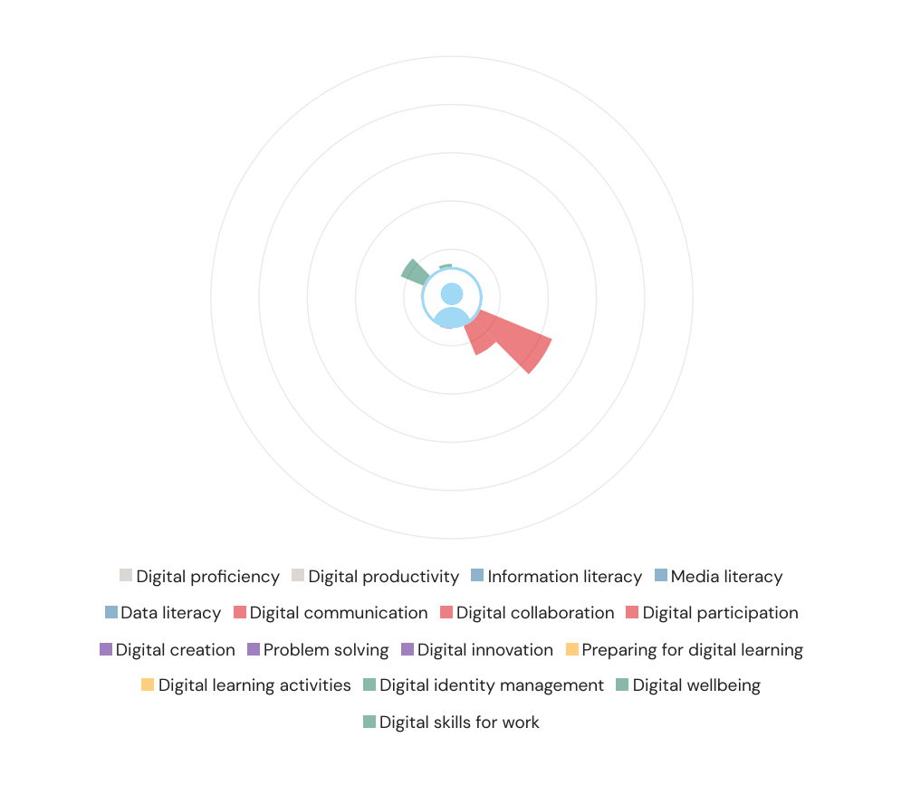
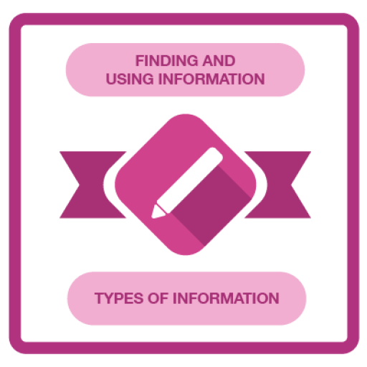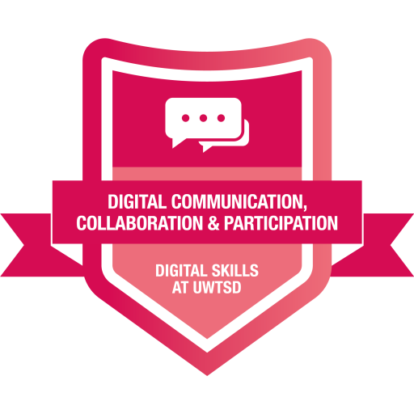

Task 1 - Assessment of Digital Skills Essay (700 words)

I initially completed a digital capability self-assessment to assess my digital abilities, including critical areas of proficiency, productivity, information literacy, communication and collaboration. The results indicated that most of my skills were at a beginner level, with digital communication showing to be my strongest area. This reflection led me to the goal setting I completed towards the aim of improving my digital tools as an academic student. Digital proficiency is knowing what digital tools are and how to use them effectively, as well as how to solve technical problems. Student digital competence varies widely between students, and as Ma and Ismail (2025) point out, higher education institutions are central to providing students with the means to develop these skills. My technical competence was fairly average at the beginning of this course, but my confidence when using unfamiliar tools was low. Over time through lessons and guided practice, my skill in learning to use digital apps and troubleshooting improved. Digital productivity is managing work efficiently through technology, including work organisation, time management and task completion. Literature suggests that digital capability plays an important role in encouraging effective learning and productivity in higher education (López-Nuñez et al., 2024). I struggled for a while with setting up files and deadline management using digital calendars. However, as I began using cloud storage and planning tools in lessons and online courses, my confidence increased.

Information literacy is the ability to find, examine and use information on the internet in a critical manner. This skill is considered a vital aspect of digital competence and essential to academic work (Zhao et al., 2021). My first self-evaluation showed that I needed to improve when identifying reliable information online. Since then, I have enhanced this ability by utilising academic databases and referencing sources using Harvard style. Digital communication involves using tools such as email, messaging apps and video conferencing to communicate with others. I felt confident about this because I already communicated regularly with classmates and lecturers online. Communication and collaboration through digital tools are recognised as core competencies in digital competence literature (Rodríguez-García et al., 2022). Both online and offline presentations helped me develop my organisational skills and improve the way I present arguments using digital media.

Alongside these areas, I have also developed abilities in digital innovation and creativity, which are increasingly important in academic and professional environments. This involves experimenting with new digital tools and platforms to improve productivity or find new solutions. For example, I explored online mind-mapping and project management tools to support group work. Evidence shows that students involved in digital innovation are more able to solve problems and adapt to different learning situations (López-Nuñez et al., 2024). Through this process I became more comfortable using software that was previously unfamiliar and gained confidence in independent learning.

Management of digital identity has also been part of my development. In today’s job market it is important to have a professional online presence. I created a LinkedIn profile where I could present my skills, completed courses and projects so that employers can easily see my experience. I also learned the importance of managing my digital footprint and protecting my privacy online. Digital well-being has also become an important aspect of my development. Balancing screen time, avoiding digital overload and managing online distractions are important for maintaining focus, mental health and productivity (Scheel et al., 2022). For example, I began taking regular breaks during online tasks and planning my work using digital scheduling tools. These habits improved my efficiency and helped me concentrate better during busy academic periods.

After the first assessment, I continued working on my digital competences day by day. Participating in lessons, online classes and practical tasks helped me make progress each week. My information literacy improved as I learned how to locate reliable sources and organise information more effectively. This focus on digital innovation, identity and well-being supported my overall improvement in proficiency, productivity and information literacy. These areas provide a strong set of digital skills that will support my academic studies and future career. The digital capability self-assessment helped me recognise areas that needed improvement and motivated me to develop my skills further. Through reflection and practice I improved my abilities in communication, information literacy, productivity and digital well-being. I will continue developing these skills during my university studies and in my future professional life.

References

Ma, H. and Ismail, L., 2025. Bibliometric analysis and systematic review of digital competence in education. Humanities and Social Sciences Communications, 12, p.185. Available at: https://www.nature.com/articles/s41599-025-04401-1 (Accessed 14 march 2026).

López‑Nuñez, J.A., Alonso‑García, S., Berral‑Ortiz, B. and Victoria‑Maldonado, J.-J., 2024. A Systematic Review of Digital Competence Evaluation in Higher Education. Education Sciences, 14(11), p.1181. Available at: https://www.mdpi.com/2227-7102/14/11/1181 (Accessed 14 march 2026)

Zhao, Y., Sánchez Gómez, M.C., Pinto Llorente, A.M. and Zhao, L., 2021. Digital Competence in Higher Education: Students’ Perception and Personal Factors. Sustainability, 13(21), p.12184. Available at: https://www.mdpi.com/2071-1050/13/21/12184 (Accessed 14 march2026)

Rodríguez‑García, A.M., Cardoso‑Pulido, M.J., De la Cruz‑Campos, J.C. and Martínez‑Heredia, N., 2022. Communicating and Collaborating with Others through Digital Competence: A Self‑Perception Study. Education Sciences, 12(8), p.534. Available at: https://www.mdpi.com/2227-7102/12/8/534 (Accessed 14 March 2026)

Scheel, L., Vladova, G. and Ullrich, A., 2022. The influence of digital competences, self‑organization, and independent learning abilities on students’ acceptance of digital learning. International Journal of Educational Technology in Higher Education, 19, p.44. Available at: https://educationaltechnologyjournal.springeropen.com/articles/10.1186/s41239-022-00350-w (Accessed 14 march 2026)

Task 2 - LinkedIn Learning Certificates for Office365


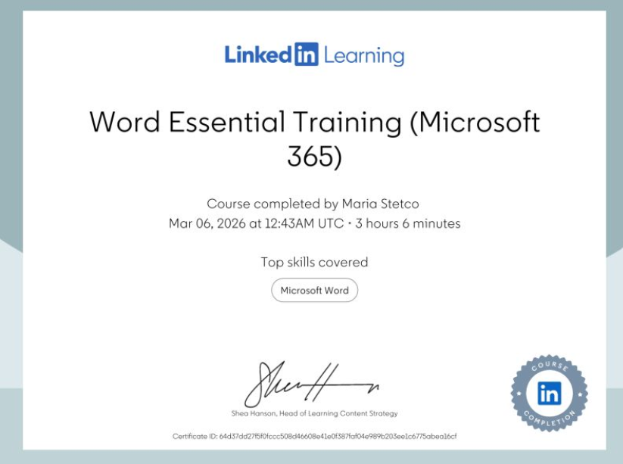

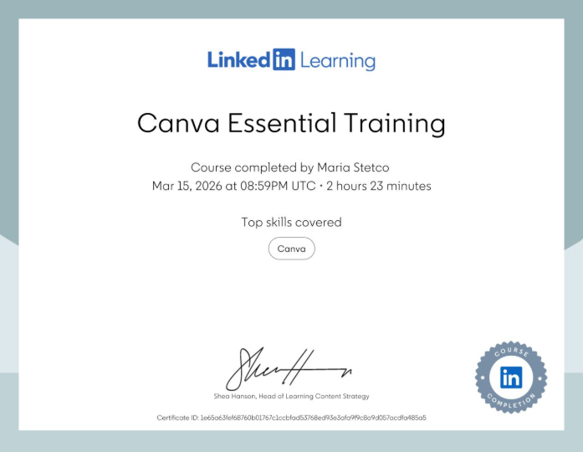

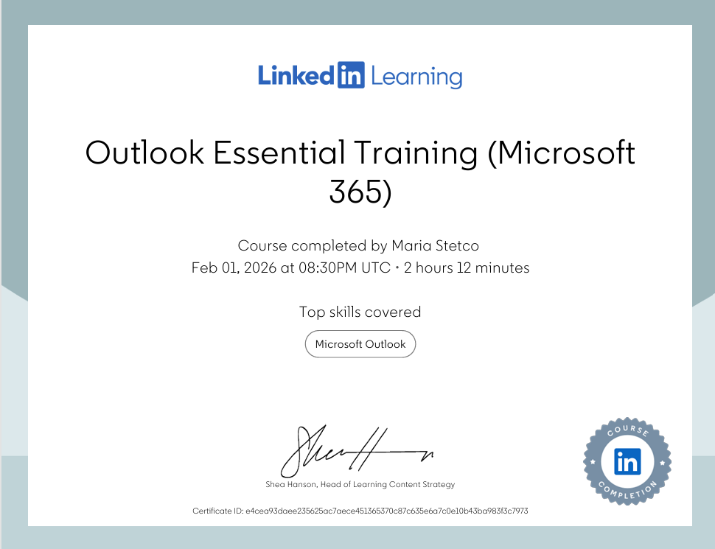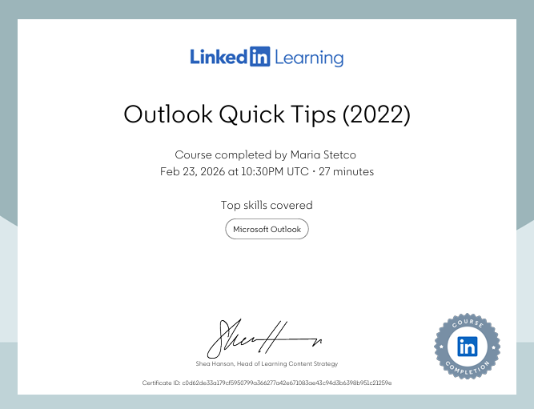

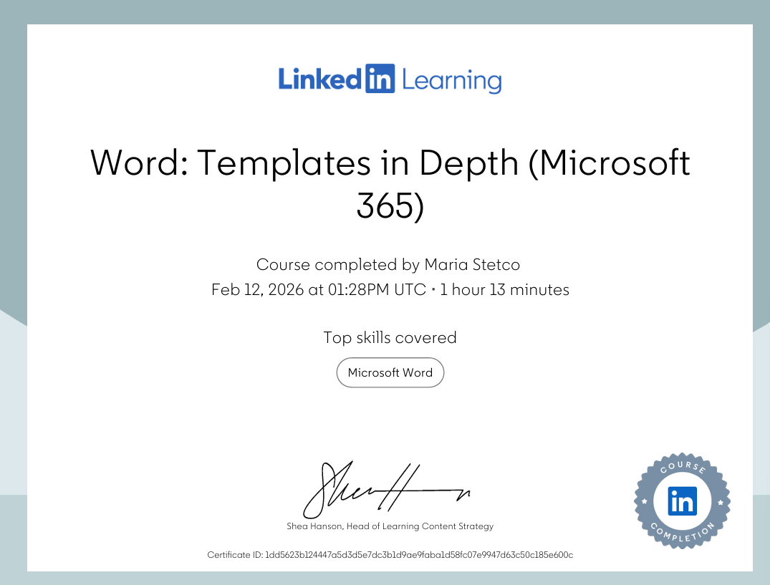

Task 3 - The Relevance and Importance of Microsoft Excel

Introduction
With all the tools used in education, business and everyday life, Microsoft Excel is perhaps the most recognisable. It helps users organise the data, do calculations, analyse information and present it in a clearer manner. These capabilities and the work in Excel make this one of the most valuable tools to both students and professionals who deal with data. Digital competence research demonstrates that learning, productivity, and decision-making are all dependent on skill and application of tools, specifically spreadsheets (Ma and Ismail, 2025; Ferrari, 2013). This essay demonstrates the significance and importance of using Microsoft Excel. It describes how Excel can help you in data organisation, budgeting, reporting and decision making. A working example is also provided for the use of a household income and expenditure spreadsheet generated for this purpose.

Main Body
Excel for Data Organisation
Getting organised is one of the key functions of Microsoft Excel. The organisation of all the stored data in a structured format is in rows and columns. A table-based system lets users easily sort, filter and analyse their data. The research indicates that digital competence in higher education involves the ability to manage and organise digital information effectively (Zhao et al., 2021). Excel facilitates this process by storing thousands of data in a standardised form in Excel in an organised and structured manner. There are spreadsheets to put financial data, customer data and even to research the results. Structured layouts also facilitate the discovery of consistent patterns or cross-benchmarking patterns. Without Excel, management of large volumes of information would be a whole lot harder.

Excel for Budgeting
Excel is also used for budgeting. Spreadsheets have helped a lot of people track their income and expenditure. Budgeting helps people understand where money comes from and how it is spent, which helps in greater financial planning. This assignment involved a spreadsheet for my household, for the income and expenditure. The spreadsheet comes with rent or mortgage, council tax, utilities, food, fuel and other monthly charges. The purpose of this is to show in very simple terms where the money goes each month. Regularly tracking income and spending can also help individuals identify unnecessary expenses and make better financial decisions. Over time, this can support more responsible money management. Budgeting in Excel enables users to track their spending and identify potential savings. Based on the data of López-Nuñez et al. (2024), digital applications can improve efficiency and aid in the administration, even financial, of tasks.

Excel for Data Analysis
Excel also has a role when analysing data. Formulas and functions in the program help with fast and precise calculations. SUM, AVERAGE and COUNT are just three specific functions in Excel which are designed to help people perform computational functions to analyse their numerical data and prevent the need for users to perform calculations manually. Research, commercial, and finance require analysis of data. When data is interpreted properly, it is much easier to pick up patterns or trends. This enables people and organisations to make better and informed decisions. Calculating total expenses and comparing spending between categories is done with formulas in the household spreadsheet utilised in this paper. By looking at this analysis, a client may be able to determine which expenses constitute the total of a month’s budget.

Excel for reporting and visualisation
Excel’s main advantage is the visual representation of information by using charts and graphs, and numerical information becomes visual and easy to understand. For this assignment, a pie chart was created to show the distribution of monthly household expenditures. The chart shows how spending varies across these categories. For instance, large sections might refer to substantial expenses like housing or council tax, and small sections mean the other costs. This way, the communication of the data should be as clear as possible. It is an important digital skill (Rodríguez-García et al., 2022; Selwyn, 2016), which is highlighted in digital competence research, which means that the presentation of information should be effective. Charts are widely used in reports, presentations and financial summaries because they allow people to digest complex information quickly. Visual presentation of data also helps decision-makers quickly identify trends and patterns. This makes charts a very useful tool when communicating financial information or summarising results.

Excel for decision-making
Excel is a great help in making decisions. When information is organised and analysed, well-being is a factor as it reduces the need for second-guessing and so on. For instance, viewing a household budget in Excel can reveal wasteful spending. Excel is a data store used most in the business environment for analysing sales data, tracking performance, and projecting future sales to generate sales. According to Scheel et al. (2022), digital tools that support organisation and analysis in the workplace make learning and productivity possible. Excel, due to its analytical and visual skills, is still widely used in professional domains.

Conclusion
In conclusion, Microsoft Excel is a practical and powerful digital tool that supports data organisation, budgeting, reporting and decision-making. It allows users to store and manage information efficiently, analyse numerical data using formulas, and present results visually through charts and graphs.
The household income and expenditure spreadsheet created for this assignment demonstrates how Excel can be used in everyday life to manage finances. When organising expenses into categories and displaying them using a pie chart, it makes it easier to understand spending patterns. That is why developing Excel skills is an important part of digital competence. These skills are valuable not only for academic work but also for professional environments where data management and analysis are essential.

References
Ferrari, A. (2013) DIGCOMP: A framework for developing and understanding digital competence in Europe. Luxembourg: Publications Office of the European Union.
López-Núñez, M.I., Rubio-Valdehita, S. and Díaz-Ramiro, E.M. (2024) ‘Digital tools and productivity in organisational environments’, Journal of Digital Learning, 12(2), pp. 45–58.
Ma, J. and Ismail, A. (2025) ‘Digital competence and productivity in higher education learning environments’, International Journal of Educational Technology, 19(1), pp. 33–48.
Rodríguez-García, A.M., Raso-Sánchez, F. and Ruiz-Palmero, J. (2022) ‘Digital competence in higher education: A systematic review’, Education Sciences, 12(3), pp. 1–15.
Scheel, H., Madabhushi, A. and Backhaus, A. (2022) ‘The impact of digital tools on productivity and learning in organisations’, Technology in Society, 68, pp. 1–9.
Selwyn, N. (2016) Education and technology: Key issues and debates. 2nd edn. London: Bloomsbury Academic.
Zhao, Y., Pinto Llorente, A.M. and Sánchez-Gómez, M.C. (2021) ‘Digital competence in higher education teaching and learning’, Education and Information Technologies, 26(5), pp. 1–16.

My Excel File

